An Integrated Vertical Farming Approach for Sustainable Microgreens Production Coupled with Vermicomposting

Abstract
Urban agriculture requires innovative, data-driven production systems that ensure high nutritional output while optimizing resource use and minimizing organic waste generation. Microgreens are recognized as nutrient-dense functional foods with short growth cycles, while vermicomposting offers an effective strategy for organic waste recycling and nutrient recovery. The present study aimed to design, fabricate, and evaluate an integrated vertical farming system that combines microgreens cultivation with vermicomposting in a single compact unit to enhance sustainability and resource-use efficiency. Microgreens of green gram (Vigna radiata), fenugreek (Trigonella foenum-graecum), and finger millet (Eleusine coracana) were cultivated using a soilless tissue-based medium in the upper tiers, while vermicomposting of Cynodon dactylon was carried out in lower trays using Eisenia fetida. A gravity-driven irrigation mechanism enabled the reuse of excess irrigation water from microgreens cultivation to maintain optimal moisture levels in the vermicomposting unit. Results indicated rapid and uniform germination within 2–3 days and harvest readiness within 7–10 days for microgreens, while stable and mature vermicompost was produced within 30–40 days. Compared to isolated systems, the integrated unit demonstrated improved space utilization, approximately 30–40% reduction in water consumption, dual outputs, and enhanced circular nutrient recycling. The study highlights the potential of integrated vertical microgreens–vermicomposting systems as a scalable, low-cost, and environmentally sustainable model for urban food production and organic waste management, with relevance to sustainable agriculture and circular economy frameworks.
Keywords: Vertical farming; Microgreens; Vermicomposting; Sustainability; Urban agriculture; Resource efficiency; Waste cycling
1. Introduction
Rapid urbanization, population growth, and climate variability have exerted unprecedented pressure on conventional agricultural systems, leading to reduced availability of cultivable land and increased competition for water and other natural resources (FAO, 2022; Hansda et al., 2025). Urban and peri-urban agriculture has therefore emerged as a critical strategy to ensure food security, nutritional adequacy, and environmental sustainability in densely populated regions (Despommier, 2013; Benke & Tomkins, 2017). Among emerging approaches, vertical farming systems have gained significant attention due to their ability to maximize productivity per unit area while minimizing land and water requirements (Kalantari et al., 2018; Al-Kodmany, 2018).
Microgreens are young edible seedlings harvested at an early developmental stage, typically between 7 and 14 days after germination, when cotyledons are fully expanded and the first true leaves may begin to appear (Xiao et al., 2012; Kyriacou et al., 2016). Numerous studies have reported that microgreens possess significantly higher concentrations of vitamins, minerals, antioxidants, and phenolic compounds compared to their mature counterparts, making them valuable functional foods for human health (Xiao et al., 2016; Zhang et al., 2021; Bhaswant et al., 2023). Their short growth cycle, low input requirements, and high market value make microgreens particularly suitable for indoor, rooftop, and urban farming systems (Treadwell et al., 2020; Bulgari et al., 2021).
Soilless cultivation methods are widely adopted in microgreens production due to their ability to reduce soil-borne diseases, ensure hygienic produce, and allow better control of moisture and nutrient availability (Saleh et al., 2022). Substrates such as cocopeat, peat moss, jute mats, and tissue-based media have been explored for microgreens cultivation, with tissue-based systems offering advantages in terms of cleanliness, uniform germination, and ease of handling, particularly for household and educational applications (Pérez-Balibrea et al., 2011; Dubey et al., 2023).
Parallel to food production challenges, the generation of organic waste has increased substantially, especially in urban environments, posing serious environmental and management concerns (Kumar et al., 2021). Vermicomposting has been recognized as an efficient, low-cost, and environmentally friendly technique for recycling organic waste into nutrient-rich compost using earthworms, most commonly Eisenia fetida (Edwards et al., 2010; Vuković et al., 2021). Vermicompost improves soil structure, enhances microbial activity, and supplies essential macro- and micronutrients in plant-available forms, thereby reducing dependency on chemical fertilizers (Arancon et al., 2004; Patel et al., 2024).
Several studies have demonstrated the positive effects of vermicompost on plant growth, yield, and quality, including improvements in nutrient uptake, root development, and stress tolerance (Lazcano & Domínguez, 2011; Mohite et al., 2024). Additionally, vermicomposting contributes to waste minimization, greenhouse gas mitigation, and circular bioresource management, aligning well with sustainable development goals (SDGs) related to responsible consumption and production (UN, 2023).
Despite extensive research on microgreens cultivation and vermicomposting as independent systems, limited attention has been given to their functional integration within a single production unit. Integrated farming systems emphasize the recycling of resources, reduction of external inputs, and enhancement of system-level efficiency (V.S. Korikanthimath et al., 2001; Dubey et al., 2023). Integration of crop production with organic waste recycling not only improves sustainability but also offers economic benefits through multiple outputs from the same system (Hansda et al., 2025).
Vertical integration of microgreens cultivation with vermicomposting presents a promising approach to address both food production and waste management challenges in urban environments. Such systems enable gravity-driven reuse of irrigation water, efficient utilization of space, and circular nutrient flow from organic waste back to crop production (Kalantari et al., 2018; Al-Kodmany, 2018). However, empirical studies evaluating the design, performance, and sustainability of integrated vertical microgreens–vermicomposting systems remain scarce.
Therefore, the present study was undertaken to design, fabricate, and evaluate an integrated vertical farming system combining microgreens cultivation and vermicomposting. The specific objectives were to: (i) assess the growth performance of selected microgreens under a soilless tissue-based system, (ii) evaluate vermicompost production efficiency using Eisenia fetida, and (iii) compare the integrated system with isolated cultivation methods in terms of resource-use efficiency, space utilization, and sustainability. The outcomes of this study aim to contribute to the development of scalable, low-cost, and environmentally sustainable urban farming models.

2. Materials and Methods
2.1 Design of the Integrated Vertical Farming System
The integrated vertical farming system was designed to simultaneously support microgreens cultivation and vermicomposting within a compact, space-efficient structure suitable for urban environments. The unit consisted of a multi-tier vertical frame with an overall height of approximately 120 cm. The frame was fabricated using lightweight metal to ensure structural stability, durability, and ease of mobility. The vertical arrangement was selected to maximize production per unit floor area while enabling efficient resource recycling through gravity-driven flow.
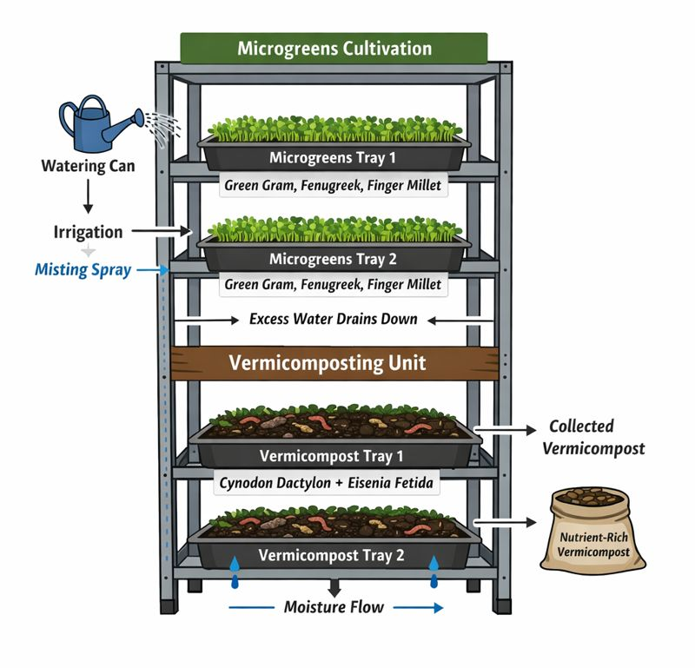
The system was divided into two functional zones: the upper zone for microgreens cultivation and the lower zone for vermicomposting. The trays were aligned vertically in such a manner that excess irrigation water from the microgreens trays could naturally drain into the vermicomposting trays below. This design minimized water wastage and ensured optimal moisture availability for earthworm activity in the vermicomposting unit.
Figure 1. Schematic Diagram of the Integrated Vertical Farming Unit

2.2 Fabrication of the Microgreens Cultivation Unit
Microgreens cultivation was carried out in shallow rectangular trays placed on the upper tiers of the vertical structure. A tissue cloth was used as a soilless growing medium due to its high water-holding capacity, cleanliness, and suitability for short-duration crops. The tissue cloth was evenly spread inside each tray and moistened prior to sowing.
Seeds of green gram (Vigna radiata), fenugreek (Trigonella foenum-graecum), and finger millet (Eleusine coracana) were selected based on their rapid germination, nutritional value, and suitability for microgreens production. Seeds were soaked in clean water for 6–8 hours to promote uniform germination. After soaking, the seeds were evenly distributed over the moist tissue surface at appropriate density to avoid overcrowding.
The trays were maintained under indirect sunlight for approximately 4–6 hours per day. Irrigation was carried out using a fine mist spray to maintain adequate moisture without disturbing seed placement or causing waterlogging. No chemical fertilizers or growth regulators were applied during the cultivation period.
2.3 Fabrication of the Vermicomposting Unit
The vermicomposting unit was positioned below the microgreens trays to facilitate gravity-based water reuse. Vermicomposting trays were filled with a mixture of soil and chopped organic biomass. Cynodon dactylon was selected as the primary organic substrate due to its availability and suitability for earthworm consumption. The biomass was pre-conditioned for 7–10 days to reduce heat generation and enhance decomposition efficiency.
Earthworms of the species Eisenia fetida were introduced into the prepared substrate at an optimal density. Moisture content in the vermicomposting trays was maintained at approximately 60–70%, which is favorable for earthworm activity. The unit was protected from direct sunlight and extreme temperature variations to ensure optimal vermicomposting conditions.
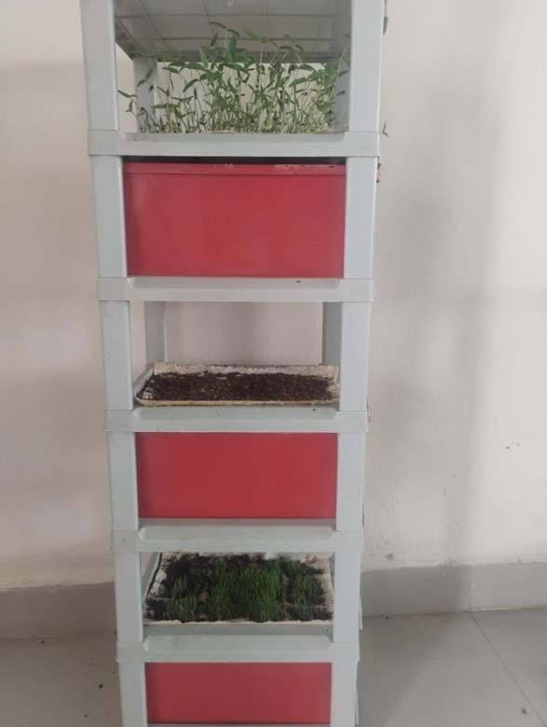
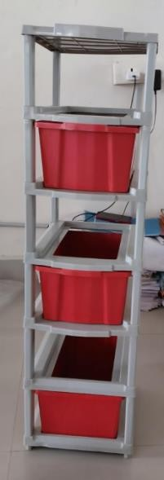

Figure: 2- Fabrication of the Microgreens and Vermicomposting Production Unit

2.4 Integrated Irrigation and Resource Recycling Mechanism
A gravity-driven irrigation mechanism was incorporated into the system design to enhance water-use efficiency. Excess water applied during microgreens irrigation drained naturally from the upper trays into the vermicomposting unit below. This approach reduced total water input while maintaining sufficient moisture levels for vermicomposting.
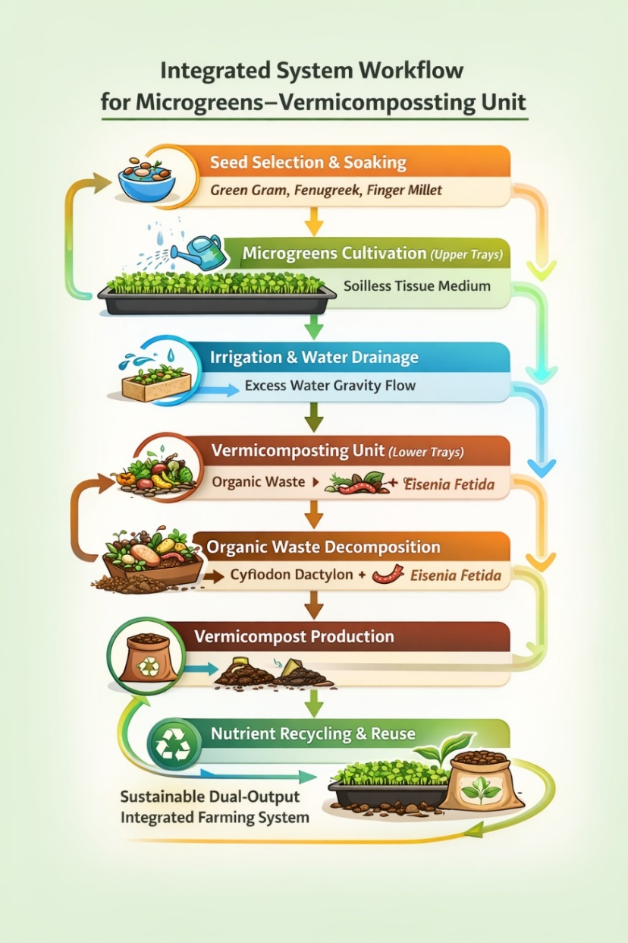
The vermicompost produced was periodically harvested after maturity and reused as an organic nutrient source for subsequent cultivation cycles. This recycling of nutrients contributed to a closed-loop system, reducing reliance on external inputs and promoting sustainable resource management.
Figure 3: Integrated System Workflow (Process Flow Diagram)
2.5 Observations and Comparative Evaluation
Observations were made on microgreens germination time, harvest duration, visual quality, and uniformity of growth. Vermicomposting performance was evaluated based on compost maturation period, texture, color, and odor. Resource-use efficiency parameters such as water consumption, space utilization, and labor requirement were compared between the integrated system and isolated cultivation systems.
3. Results and discussion
3.1 Performance Evaluation of the Integrated Vertical Microgreens–Vermicomposting System
The integrated vertical farming system exhibited efficient performance in terms of microgreens growth, vermicompost production, and resource-use efficiency. The system successfully combined food production and organic waste recycling within a compact vertical structure, demonstrating its suitability for urban and space-constrained environments.
3.1.1 Growth Response and Productivity of Microgreens
Microgreens of green gram (Vigna radiata), fenugreek (Trigonella foenum-graecum), and finger millet (Eleusine coracana) showed rapid and uniform germination within 2–3 days after sowing. Harvestable maturity was attained within 7–10 days, depending on the crop species. Uniform shoot height, vibrant green coloration, and firm stem structure were observed across all crops, indicating favorable physiological growth conditions.
The use of a tissue-based soilless medium played a critical role in maintaining optimal moisture conditions while minimizing microbial contamination and soil-borne diseases. Similar observations have been reported by Saleh et al. (2022) and Dubey et al. (2023), who emphasized that soilless systems enhance hygiene, uniformity, and marketability of microgreens. Furthermore, the short growth cycle observed in the present study aligns with earlier reports highlighting microgreens as fast-turnover crops suitable for intensive urban farming (Treadwell et al., 2020; Kyriacou et al., 2016).
From a nutritional perspective, previous studies have demonstrated that microgreens harvested at early growth stages contain higher concentrations of vitamins, antioxidants, and phenolic compounds compared to mature vegetables (Xiao et al., 2012; Xiao et al., 2016; Zhang et al., 2021; Bhaswant et al., 2023). Although nutrient profiling was not quantified in the present study, the observed healthy growth and visual quality suggest high nutritional potential, consistent with findings reported in controlled-environment microgreens production systems (Bulgari et al., 2021; Pérez-Balibrea et al., 2011).

3.1.2 Vermicomposting Efficiency and Compost Quality
Vermicomposting using Eisenia fetida resulted in efficient decomposition of Cynodon dactylon, producing mature vermicompost within 30–40 days. The compost obtained was dark brown to black in color, granular in texture, and free from foul odor, indicating stability and maturity. These characteristics are widely recognized indicators of high-quality vermicompost (Edwards et al., 2010; Vuković et al., 2021).
The decomposition period observed in the present study is consistent with earlier reports that documented vermicompost maturity within 30–45 days under optimal moisture and temperature conditions (Lazcano & Domínguez, 2011; Arancon et al., 2004; Mohite et al., 2024). The reuse of vermicompost as an organic nutrient source in subsequent cultivation cycles improved plant vigor, corroborating findings by Patel et al. (2024), who reported enhanced plant growth and nutrient uptake following vermicompost application.
The integration of vermicomposting within the vertical system further strengthened waste recycling and nutrient recovery, aligning with sustainable waste management strategies proposed for urban agriculture (Kumar et al., 2021; UN, 2023).
3.1.3 Water-Use Efficiency and Resource Recycling
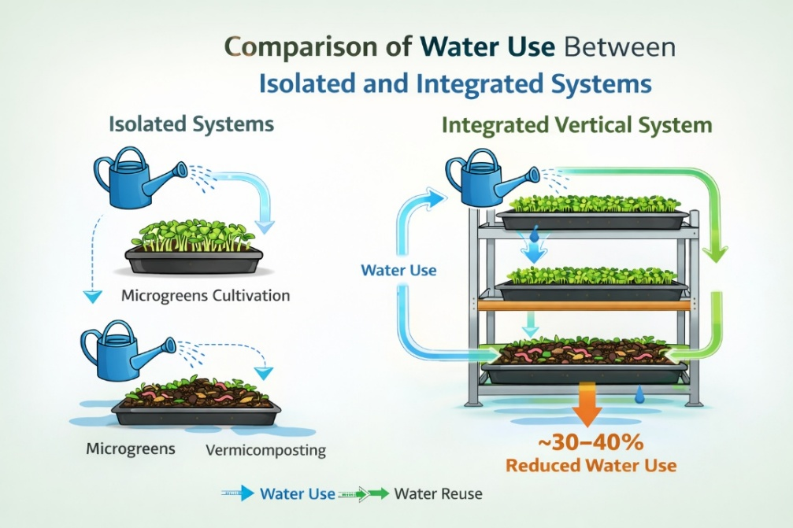
One of the key advantages of the integrated system was its improved water-use efficiency achieved through gravity-driven irrigation. Excess water applied during microgreens irrigation was effectively reused to maintain moisture in the vermicomposting unit, resulting in an estimated 30–40% reduction in total water consumption compared to isolated systems.
Figure 4. Comparison of Water Use Between Isolated and Integrated Systems
Similar reductions in water usage have been reported in integrated and recirculating agricultural systems, where water reuse and closed-loop designs significantly improve resource efficiency (Kalantari et al., 2018; Al-Kodmany, 2018). The present findings further support the concept that vertical integration enhances sustainability by reducing input dependency while maintaining system productivity.
3.1.4 Space Utilization and System Sustainability
The vertical arrangement of cultivation and composting units significantly reduced land requirements while enabling dual outputs in the form of fresh microgsreens and nutrient-rich vermicompost. This multifunctionality enhances both economic and environmental sustainability, as highlighted in integrated farming system studies by V.S. Korikanthimath et al., (2001) and Hansda et al. (2025).
By integrating food production with organic waste recycling, the system contributes to circular economy principles, reducing waste generation and promoting nutrient cycling. Such models are particularly relevant for urban households, educational institutions, and small-scale entrepreneurs seeking sustainable, low-cost agricultural solutions (Despommier, 2013; Benke & Tomkins, 2017).
3.1.5 Comparative Advantage over Isolated Systems
Compared to isolated microgreens cultivation and standalone vermicomposting units, the integrated vertical system demonstrated clear advantages in terms of space efficiency, water conservation, labor optimization, and sustainability. The dual-output nature of the system improves economic feasibility and aligns with sustainable development goals related to responsible consumption, production, and climate resilience (FAO, 2022; UN, 2023).
The integrated vertical system demonstrated superior performance across multiple sustainability indicators compared to isolated systems (Table 1).

Parameter | Isolated Microgreens System | Isolated Vermicomposting System | Integrated Vertical Microgreens–Vermicomposting System
System layout | Separate horizontal units | Separate ground-based unit | Single compact vertical structure
Space requirement | High | Moderate | Low (vertical space optimization)
Land-use efficiency | Low | Moderate | High
Water consumption | High (no reuse) | Moderate | Low (30–40% reduction)
Resource recycling | Absent | Partial | Complete (water + nutrients)
Organic waste utilization | Not applicable | Limited | Efficient recycling of biomass
Nutrient recovery | None | Moderate | High (vermicompost reuse)
Crop growth uniformity | Moderate | Not applicable | High
Vermicompost maturity period | Not applicable | 40–45 days | 30–40 days
Labor requirement | High | Moderate | Low
System productivity | Single output | Single output | Dual output (food + compost)
Environmental sustainability | Moderate | High | Very high
Economic viability | Moderate | Moderate | High (multiple benefits)
Scalability | Limited | Moderate | High (household to urban scale)
Suitability for urban farming | Moderate | Low | Excellent
Climate resilience | Moderate | Moderate | High
Overall system efficiency | Moderate | Moderate | Superior
Table 1. Comparative Performance of Isolated and Integrated Vertical Farming Systems

4. Conclusion
The present study successfully demonstrated the design and performance of an integrated vertical farming approach combining microgreens production with vermicomposting in a single compact system. The integrated unit enabled rapid cultivation of nutrient-rich microgreens within 7–10 days while simultaneously converting organic biomass into stable, high-quality vermicompost within 30–40 days. The use of a soilless tissue-based medium ensured hygienic microgreens production, whereas Eisenia fetida effectively facilitated organic waste decomposition and nutrient recovery.
Compared to isolated cultivation systems, the integrated vertical system exhibited superior space utilization, improved water-use efficiency through gravity-driven irrigation reuse, reduced labor requirements, and dual outputs in the form of fresh produce and organic fertilizer. The recycling of water and nutrients within the system highlights its strong alignment with circular economy principles and sustainable urban agriculture frameworks. Overall, the integrated microgreens–vermicomposting system offers a low-cost, scalable, and environmentally sustainable solution suitable for urban households, rooftop gardens, educational institutions, and small-scale agri-entrepreneurs.
5. Future Scope
Future research should focus on quantitative nutrient profiling of microgreens produced under integrated systems to establish their nutritional superiority over conventionally grown produce. Detailed economic analysis, including cost–benefit and return-on-investment assessments, would further strengthen the commercial feasibility of the system. Scaling up the model using modular designs and integrating automated irrigation, lighting, and environmental control technologies could enhance productivity and consistency. Additionally, long-term studies on microbial dynamics, vermicompost quality variability, and system resilience under different climatic conditions would provide deeper insights into the sustainability and adaptability of integrated vertical farming systems.
Disclaimer (Artificial intelligence)
Author(s) hereby declares that using generative AI technologies such as Large Language Model (ChatGPT) used editing images of this manuscript.

References
- Al-Kodmany, K. (2018). The vertical farm: A review of developments and implications for the vertical city. Buildings, 8(2), 24. https://doi.org/10.3390/buildings8020024
- Arancon, N. Q., Edwards, C. A., Atiyeh, R., & Metzger, J. D. (2004). Effects of vermicomposts produced from food waste on the growth and yields of greenhouse peppers Technology, 93(2), 139–144. https://doi.org/10.1016/j.biortech.2003.10.015
- Benke, K., & Tomkins, B. (2017). Future food-production systems: Vertical farming and controlled-environment agriculture. Sustainability: Science, Practice and Policy, 13(1), 13–26. https://doi.org/10.1080/15487733.2017.1394054
- Bhaswant, M., Shanmugam, D. K., Miyazawa, T., Abe, C., & Miyazawa, T. (2023). Microgreens—A Comprehensive Review of Bioactive Molecules and Health Benefits. Molecules, 28(2), 867. https://doi.org/10.3390/molecules28020867
- Bulgari, R., Negri, M., Santoro, P., & Ferrante, A. (2021). Quality Evaluation of Indoor-Grown Microgreens Cultivated on Three Different Substrates. Horticulturae, 7(5), 96. https://doi.org/10.3390/horticulturae7050096
- Despommier, D. (2013). Farming up the city: The rise of urban vertical farms. Trends in Biotechnology, 31(7), 388–389. https://doi.org/10.1016/j.tibtech.2013.03.008
- Dubey, S., Harbourne, N., Harty, M., Hurley, D., & Elliott-Kingston, C. (2024). Microgreens Production: Exploiting Environmental and Cultural Factors for Enhanced Agronomical Benefits. Plants, 13(18), 263s1. https://doi.org/10.3390/plants13182631
- Edwards, C. A., Arancon, N. Q., & Sherman, R. L. (2010). Vermiculture technology: Earthworms, organic wastes, and environmental management. CRC Press. https://doi.org/10.1201/b10453
- FAO. (2022). The state of food and agriculture 2022. Food and Agriculture Organization of the United Nations, Rome.
- Hansda, Narendra Nath, Umesh Thapa, and Sourav Kundu. (2025). “A Review on Sustainable Microgreen Cultivation for Urban Farming with Minimal Resources”. Journal of Scientific Research and Reports 31 (8):613-21. https://doi.org/10.9734/jsrr/2025/v31i83405.
- Kalantari, F., Tahir, O.M., Joni, R.A. & Fatemi, E. (2018). Opportunities and Challenges in Sustainability of Vertical Farming: A Review. Journal of Landscape Ecology, 11(1), 2018. 35-60. https://doi.org/10.1515/jlecol-2017-0016
- Kumar, S., Smith, S. R., Fowler, G., Velis, C., Kumar, S. J., Arya, S., ... & Cheeseman, C. (2021). Challenges and opportunities associated with waste managemesnt in India. Royal Society Open Science, 8(3), 200941. https://doi.org/10.1098/rsos.200941
- Kyriacou, M. C., Rouphael, Y., Di Gioia, F., Kyratzis, A. C., Di Serio, F., Renna, M., De Pascale, S., & Santamaria, P. (2016). Micro-scale vegetable production and the rise of microgreens. Trends in Food Science & Technology. https://doi.org/10.1016/j.tifs.2016.09.005
- Lazcano, C., & Domínguez, J. (2011). The use of vermicompost in sustainable agriculture: Impact on plant growth and soil fertility. "Soil Nutrients" edited by M. Miransari, published by Nova Science Publishers. 10, 1–23. https://novapublishers.com/shop/soil-nutrients/
- Mohite, D.D., Chavan, S.S., Jadhav, V.S. et al. Vermicomposting: a holistic approach for sustainable crop production, nutrient-rich bio fertilizer, and environmental restoration. Discov Sustain 5, 60 (2024). https://doi.org/10.1007/s43621-024-00245-y
- Patel, Kamal Kishor, Priya, Yagini Tekam, Ajay Kumar Shah, Kailash Kumar, Alpana Kumhare, and Dwarka. 2024. “Effect of Vermicompost on Soil Properties, Plant Growth and Environmental Sustainability: A Review”. International Journal of Plant & Soil Science 36 (12):688-93. https://doi.org/10.9734/ijpss/2024/v36i125244.
- Pérez-Balibrea, S., Moreno, D. A., & García-Viguera, C. (2011). Improving phytochemical composition of broccoli sprouts by elicitation. Food Chemistry, 129(1), 35–44. https://doi.org/10.1016/j.foodchem.2011.03.049
- Saleh, R., Gunupuru, L. R., Lada, R., Nams, V., Thomas, R. H., & Abbey, L. (2022). Growth and Biochemical Composition of Microgreens Grown in Different Formulated Soilless Media. Plants, 11(24), 3546. https://doi.org/10.3390/plants11243546
- Treadwell, D., Hochmuth, R., Landrum, L., & Laughlin, W. (2020). Microgreens: A New Specialty Crop: HS1164, rev. 9/2020. EDIS, 2020(5). https://doi.org/10.32473/edis-hs1164-2020
- United Nations. (2023). The Sustainable Development Goals Report 2023: Special Edition. https://sdgs.un.org/publications/sustainable-development-goals-report-2023-special-edition-53009
- V.S. KORIKANTHIMATH, & B.L. MANJUNATH. (2001). Integrated farming systems for sustainability in agricultural production. Indian Journal of Agronomy, 54(2), 140-148. https://doi.org/10.59797/ija.v54i2.4791
- Vuković, A., Velki, M., Ečimović, S., Vuković, R., Štolfa Čamagajevac, I., & Lončarić, Z. (2021). Vermicomposting—Facts, Benefits and Knowledge Gaps. Agronomy, 11(10), 1952. https://doi.org/10.3390/agronomy11101952
- Xiao, Z., Codling, E. E., Luo, Y., Nou, X., Lester, G. E., & Wang, Q. (2016). Microgreens of Brassicaceae: Mineral composition and content of 30 varieties. Journal of Food Composition and Analysis, (49), 87–93. https://doi.org/10.1016/j.jfca.2016.04.006
- Xiao, Z., Lester, G. E., Luo, Y., & Wang, Q. (2012). Assessment of vitamin and carotenoid concentrations of emerging food products: Edible microgreens. Journal of Agricultural and Food Chemistry, 60(31), 7644–7651. https://doi.org/10.1021/jf300459b
- Zhang, Y., Xiao, Z., Ager, E., Kong, L., & Tan, L. (2021). Nutritional quality and health benefits of microgreens, a crop of modern agriculture. Journal of Future Foods, 1, 58–66. https://doi.org/10.1016/j.jfutfo.2021.07.001

