Evaluation of Cherry Tomato Entries Under Southern Telangana Conditions, India

ABSTRACT
The present study was carried out to know the performance of local cherry tomato entries and check varieties for different traits attributing for growth, yield and quality during Kharif, 2021-22 and Kharif, 2022-23 at Vegetable Research station, Sri Konda Laxman Telangana Horticultural University, Rajendranagar. The study consisted of 4 local cherry tomato entries viz., RNCT-1, RNCT-2, RNCT-3, RNCT-4 and two checks viz., swaran ratan and pusa cherry tomato-1. Among the genotypes, RNCT-1 recorded highest plant height (191.76 cm), minimum days taken to first flowering (29.39) and days taken to first fruit harvest (73.83), maximum fruit girth (3.10 cm) and average fruit weight (22.95 g). The entry RNCT-4 recorded maximum fruit length (6.42 cm), more number of fruits/plant (194.18), highest fruit yield/plant (4.41 kg) as well as fruit yield/hectare (39.71 tonnes) than checks viz., swaran ratan and pusa cherry tomato-1. Based on their performance RNCT-1 and RNCT-4 can be used for further breeding programme and varieties could be exploited for cultivation in cherry tomato.
Key words: Cherry tomato, Growth, Yield, Quality and Evaluation
INTRODUCTION
“Cherry tomato (Solanum lycopersicum L. var. cerasiforme) is a cultivated variety of tomato belonging to the family Solanaceae. It originated in Peru and northern Chile and is considered the probable ancestor of all cultivated tomatoes” (Prema et al., 2011; Hansda et al., 2023). Cherry tomatoes produce small fruits of varying shapes, ranging from spherical to slightly oblong, and sizes from a thumb tip to that of a golf ball. The fruits are typically sweet, with intense colour and flavour, and weigh between 10 and 30 g each. They grow in clusters along the plant stems and are primarily consumed fresh rather than used as a vegetable; hence, cherry tomatoes are often referred to as “salad tomatoes.” Owing to their small fruit size, they are less susceptible to blossom end rot compared to other tomato varieties. Most cherry tomato cultivars are indeterminate in growth habit, allowing continuous vine growth and an extended harvesting period.
“Cherry tomato is a high value vegetable in the world and the demand for cherry tomato has increased in the market, chiefly due to the recognition of their high quality and good taste” (Kobryn and Hallmann, 2005; Yadav et al., 2023). “Consumers' demands and competition imposed by the globalized market have forced the provision of high standard foods, with better sensory characteristics and nutritional value” (Rocha et al., 2013). “Cherry tomato is cultivated both for fresh consumption and as a raw material for processed products such as sauce, soup, ketchup, canned fruits, purée, curries, paste, powder, and rasam” (Anonymous, 2009). Unripe green fruits are also used in the preparation of pickles and chutneys. In addition, cherry tomato is utilized for the production of value-added products like tomolive and tomatina, which have high industrial significance. Owing to their superior quality and consumer preference, cherry tomatoes are gaining popularity in retail chains and are marketed at a premium price compared to regular tomatoes.
“Cherry tomato is beneficial to human health due to its high content of antioxidants and phytochemical compounds. It is rich in dry matter, vitamin C (13 mg per 100 g), dietary fibre (2.0 g), vitamin A (25 %) and vitamin K, and is also a good source of vitamin E (α-tocopherol), thiamine, niacin, vitamin B6, folate, soluble solids, phosphorus, copper, potassium and manganese” (Anonymous, 2009). Cherry tomatoes of high nutrition can increase the market value (Hussain et al., 2021). Cherry tomatoes possess good nutritional value, providing carbohydrates, sugars, proteins, calcium, and iron. They contain high levels of bioflavonoids, which aid in alleviating joint soreness associated with conditions such as arthritis. Additionally, cherry tomatoes are suitable for diabetic patients, as their potassium content helps in lowering blood cholesterol levels. The presence of dietary fibre and high water content contributes to weight management (Chang et al. 2024). Lycopene present in cherry tomatoes offers protection against various cardiovascular diseases. Furthermore, high levels of vitamins C and A, along with potassium and iron, support normal blood health, while abundant antioxidants help reduce the risk of cancers, particularly lung, stomach, and prostate cancers.
Cherry tomato is widely cultivated in Telangana, particularly in the districts of Karimnagar and Adilabad. “Considering the potential of this crop, there is a need for improvement and the development of varieties suited to specific agro-ecological conditions” (Rahul et al., 2018). Therefore, efforts are being made to introduce and evaluate additional cherry tomato lines in Telangana. The present investigation was undertaken to evaluate four local cherry tomato lines with two checks for their growth, yield, and quality performance under the agro-climatic conditions of Telangana.
MATERIAL AND METHODS
Field experiments were conducted during two consecutive seasons of Kharif, 2021-22 and Kharif, 2022-23 at Vegetable Research Station, Hyderabad, Sri Konda Laxman Telangana Horticultural University, Telangana, India, which is at an altitude of 494 meters above mean sea level and at 78°39’93’’E longitude and 17°32’27” N latitude. The experimental soil was clay loam in texture, neutral in reaction, low in available nitrogen and phosphorous, high in potassium and belongs to the order Alfisol of shallow to medium depth. The experiment was laid out in Randomized Block Design (RBD) with four local entries (RNCT-01, 02, 03 and 04) and 2 check varieties (swaran ratan and Pusa cherry tomato -1) and four replications.
The detail of source of origin and characteristics of local entries is given in Table 1 and images in fig. 1

Table 1- Origin and Characteristic features of local entries
Entries | Origin | Characteristic features
RNCT-01 | Collection from Karimnagar district of Telangana | - Fruits is Round shaped red colour fruit with stripes,  - Tolerant to blight,  - Average yield is 35-40 t/ha
RNCT-02 | Collection from Adilabad district of Telangana | - Fruits is Round shaped and Pinkish Red color fruit  - Tolerant to blight and shoot & fruit borer  - Average yield is 30-35 t/ha t/ha
RNCT-03 | Collection from Adilabad district of Telangana | - Fruits is Round shaped and Bright Yellow coloured fruit  - Average yield is 20-25 t/ha t/ha
RNCT-04 | Collection from Karimnagar district of Telangana | - Fruits is Oval shaped yellow coloured fruit with pointed tip  - Average yield is 35-40 t/ha t/ha

The land was properly prepared by ploughing with a disc plough followed by a tractor drawn cultivator to bring the soil to a fine tilth. After preparation of the land, the recommended dose of farm yard manure was applied at the rate of 20-25 tonnes/ha as a basal dose and recommended dose of NPK was 100:60:60 kg/ha. The total N was split into three doses and each was applied at 30, 45 and 60 DAT. Total phosphorus and potash were applied at the last ploughing as a basal dose.
Cherry tomatoes having small seeds were usually first sown in the pro-trays having 98 cells having coco peat as potting media and then 28 days old healthy seedlings were planted in the main field at 4.8 m x 4.0 m plots at 60 cm spacing between rows and 50 cm between plants. Recommended cultural and plant protection measures were followed when required.
The data on the growth and yield parameters of the crop were recorded at harvest.
Plant height (cm): It was measured from ground level to the tip of the main shoot with the help of a scale in five randomly selected plants at 90 days after transplanting and expressed in centimeters.
Days to first flowering: The number of days was counted from the date transplanting to the date when the first flower bud opens or the first flower appears on each plant and the mean was calculated.
Days to first fruit harvest: It was measured by counting the days from the day of transplant seedlings to the days until fruits reach your desired ripeness (mature green, pink, or red) for the first harvest.
Fruit length and width (cm): Five fruits were selected randomly from each treatment and the length and width of fruit were measured with measuring scale and mean was calculated in centimeters.
Fruit weight (g): The weight of 5 fruits selected randomly from each treatment and weighed in grams with a digital balance and their mean was determined and expressed as grams.
Fruits per plant: Five plants were selected randomly from each treatment at every picking. The total number of fruits picked were counted and then averaged to number of fruits plant⁻¹.
Fruit yield (tons ha⁻¹): Total weight of all the harvested fruits from each picking was weighed and fruit yield per hectare was calculated and expressed as t/ha.
The total soluble solids of fresh cherry tomatoes was measured at room temperature with the help of a hand refractometer and expressed in ºBrix
The data pertaining to all characters studied were subjected to statistical analysis by using variance techniques as described by Panse and Sukhatme (2000). The critical difference was calculated when the difference between the treatments were found significant by the ‘F’ test at 0.05 level of significance.
RESULTS AND DISCUSSION
The analysis of variance revealed that significant differences were observed among the genotypes for all the traits. The per se performance of pooled data of local and check varieties for different traits like growth, yield and quality parameters is presented in Table 4.
Entries differed significantly among themselves for plant height and it ranged from 133.87 cm (Swaran ratan) to 191.76 cm (RNCT-1). Among the six entries, the entry RNCT-1 (191.76 cm) was showed highest plant height when compared to swaran ratan (133.87 cm) and pusa cherry tomato-1 (160.68 cm). “Results revealed that highest plant height in RNCT-1 might be due to more number of branches results in more production of leaves, the size of the leaf and number of leaves per plant decides the efficiency of photosynthesis activity which contributed towards better growth” which were in confirmation with Deepa and Thakur (2008). Olaniyi et al. (2010) also found that “plant height varied due to the varietal differences”.
Results from the Table-4 revealed that significant differences were observed in days to first flowering and days to first fruit harvest. Among the six entries, the entry RNCT-1 showed minimum days to first flowering (29.39) as well as minimum days to first fruit harvest (73.83).
Significant difference was revealed on fruit length with cherry tomato local and checks entries. Among the genotypes, the maximum fruit length (6.42 cm) and more number of fruits per plant (194.18) were recorded in the entry RNCT-4 than checks viz., swaran ratan (4.46 cm) and Pusa cherry tomato-1 (4.44 cm) (Table 4). The present findings agree with the report of Bhangu and Singh (1993).
Results related to fruit girth, the entry RNCT-1 recorded maximum fruit girth (3.10 cm) and highest average fruit weight (22.95 g) when compared with checks viz., swaran ratan (2.47 cm and 10.90 g) and Pusa cherry tomato-1 (2.47 cm and 13.08 g) respectively (Table 4). Highest value of average fruit weight in RNCT-1 might be due to maximum fruit length and fruit girth. “Varietal influence on fruit diameter” was reported by Bhangu and Singh (1993). These results are in line with the findings of Prema et al. (2011) and Islam et al. (2011) in cherry tomato.
“The result of the experiment revealed that the local cherry tomato lines showed significant variation for yield/plant and yield/ha. Among the entries, highest fruit yield per plant (4.41 kg) and fruit yield per hectare (39.71 tonnes/ha) was observed in RNCT-4 when compared with checks viz., swaran ratan (2.63 kg/plant and 23.68 t/ha) and Pusa cherry tomato-1 (2.97 kg/plant and 26.74 t/ha) respectively (Table 4). The variations of yield may also depend on genetic differences among the varieties, since they were grown under the same environmental conditions. Yield per plant directly contributed towards increase in the total yield of crop” which was in agreement with findings of Deepa and Thakur (2008), Shivakumar (2000).
There is significant difference observed among the entries on Total soluble sugars(TSS). Among the entries RNCT-4 showed highest TSS (8.15 Brix) compared checks swaran ratan (5.11 Brix) and Pusa Cherry tomato-1 (5.82 Brix).
Table 2: Evaluation of cherry tomato lines for growth, yield and quality traits during 2021-22
Germplasm entry | Plant height (cm) 90DAT | Days to first flowering | Days to first fruit harvest | Fruit length (cm) | Fruit girth (cm) | Avg Fruit weight (g) | No. of fruits /Plant | Fruit Yield /Plant (Kg) | Fruit Yield /ha (t) | TSS (Brix) | Fruit Colour | Fruit Shape
RNCT – 01 | 195.23 | 29.03 | 72.18 | 6.23 | 3.18 | 23.80 | 191.65 | 4.58 | 41.20 | 6.20 | Red with white stripes | Round
RNCT – 02 | 177.45 | 29.43 | 75.08 | 5.98 | 3.08 | 19.05 | 175.60 | 3.33 | 29.99 | 5.58 | Red | Round
RNCT – 03 | 153.25 | 31.13 | 79.90 | 4.88 | 2.70 | 12.72 | 188.65 | 2.40 | 21.59 | 4.68 | Yellow | Round
RNCT – 04 | 168.25 | 32.05 | 74.63 | 6.63 | 2.35 | 22.48 | 191.13 | 4.29 | 38.65 | 8.10 | Yellow | Oval with pointed tip
Check (swarna ratan) | 127.88 | 30.15 | 68.63 | 4.28 | 2.61 | 10.72 | 248.78 | 2.67 | 24.01 | 5.20 | Red | Oval
Check Pusa cherry tomato -1 | 163.25 | 28.70 | 73.50 | 4.63 | 2.30 | 12.43 | 229.33 | 2.85 | 25.63 | 5.98 | Red | Round
SE(m) | 4.96 | 0.88 | 1.05 | 0.17 | 0.08 | 1.35 | 5.60 | 0.27 | 2.45 | 0.14
C.D. | 14.94 | 2.64 | 3.15 | 0.52 | 0.26 | 4.06 | 16.87 | 0.82 | 7.38 | 0.41
CV | 6.04 | 5.83 | 2.83 | 6.31 | 6.29 | 15.97 | 5.48 | 16.23 | 16.23 | 4.54

Table 3: Evaluation of cherry tomato lines for growth, yield and quality traits during 2022-23
Germplasm entry | Plant height (cm) 90DAT | Days to first flowering | Days to first fruit harvest | Fruit length (cm) | Fruit girth (cm) | Avg Fruit weight (g) | No. of fruits /Plant | Fruit Yield /Plant (Kg) | Fruit Yield /ha (t) | TSS (Brix) | Fruit Colour | Fruit Shape
RNCT – 01 | 188.29 | 29.75 | 75.48 | 6.04 | 3.03 | 22.10 | 184.65 | 4.08 | 36.69 | 6.38 | Red with white stripes | Round
RNCT – 02 | 175.15 | 31.25 | 72.85 | 5.67 | 3.44 | 19.40 | 179.85 | 3.49 | 31.40 | 5.60 | Red | Round
RNCT – 03 | 165.45 | 30.53 | 80.63 | 4.50 | 2.60 | 13.48 | 204.85 | 2.76 | 24.85 | 4.28 | Yellow | Round
RNCT – 04 | 176.88 | 31.55 | 77.08 | 6.22 | 2.41 | 22.95 | 197.23 | 4.53 | 40.78 | 8.20 | Yellow | Oval with pointed tip
Check (swarna ratan) | 139.86 | 30.63 | 71.58 | 4.65 | 2.33 | 11.08 | 233.95 | 2.60 | 23.36 | 5.01 | Red | Oval
Check Pusa cherry tomato -1 | 158.10 | 29.03 | 76.55 | 4.25 | 2.65 | 13.74 | 225.23 | 3.09 | 27.85 | 5.66 | Red | Round
SE(m) | 1.94 | 0.94 | 0.99 | 0.17 | 0.08 | 0.48 | 4.07 | 0.14 | 1.22 | 0.19
C.D. | 5.86 | 2.84 | 2.99 | 0.51 | 0.23 | 1.46 | 12.26 | 0.41 | 3.68 | 0.57
CV | 2.32 | 6.19 | 2.62 | 6.44 | 5.51 | 5.65 | 3.98 | 7.92 | 7.92 | 6.41

Table 4: Evaluation of cherry tomato lines for growth, yield and quality traits (Pooled data)
Germplasm entry | Plant height (cm) 90DAT | Days to first flowering | Days to first fruit harvest | Fruit length (cm) | Fruit girth (cm) | Avg Fruit weight (g) | No. of fruits /Plant | Fruit Yield /Plant (Kg) | Fruit Yield /ha (t) | TSS (Brix) | Fruit Colour | Fruit Shape
RNCT – 01 | 191.76 | 29.39 | 73.83 | 6.13 | 3.10 | 22.95 | 188.15 | 4.33 | 38.95 | 6.29 | Red with white stripes | Round
RNCT – 02 | 176.30 | 30.34 | 73.96 | 5.82 | 3.26 | 19.23 | 177.73 | 3.41 | 30.70 | 5.59 | Red | Round
RNCT – 03 | 159.35 | 30.83 | 80.26 | 4.69 | 2.65 | 13.10 | 196.75 | 2.58 | 23.22 | 4.48 | Yellow | Round
RNCT – 04 | 172.56 | 31.80 | 75.85 | 6.42 | 2.38 | 22.71 | 194.18 | 4.41 | 39.71 | 8.15 * | Yellow | Oval with pointed tip
Check (swarna ratan) | 133.87 | 30.39 | 70.10 | 4.46 | 2.47 | 10.90 | 241.36 | 2.63 | 23.68 | 5.11 | Red | Oval
Check Pusa cherry tomato -1 | 160.68 | 28.86 | 75.03 | 4.44 | 2.47 | 13.08 | 227.28 | 2.97 | 26.74 | 5.82 | Red | Round
SE(m) | 2.53 | 0.61 | 0.79 | 0.12 | 0.07 | 0.69 | 3.52 | 0.16 | 1.42 | 0.12
C.D. | 7.64 | 1.84 | 2.39 | 0.36 | 0.20 | 2.08 | 10.62 | 0.48 | 4.28 | 0.35
CV | 3.06 | 4.02 | 2.12 | 4.53 | 4.97 | 8.11 | 3.45 | 9.31 | 9.31 | 3.99

The overall assessment of the genotypes revealed that all local varieties showed superiority performance over check variety both in growth, fruit yield and quality attributes. Among the local entries, RNCT-1 and RNCT-4 were the most suitable alternative genotype as it performed better among all other genotypes regarding highest yield hectare it might be due to more number of fruits per plant, maximum fruit length, fruit width, and average fruit weight. The results also revealed that RNCT-4 was the best source of total soluble solids among all other genotypes.
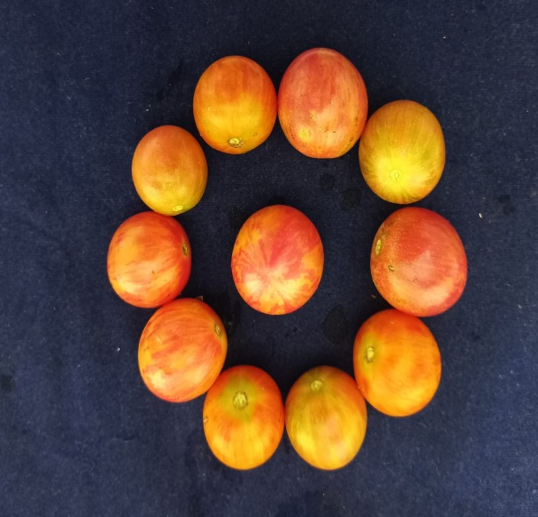  RNCT-1 | 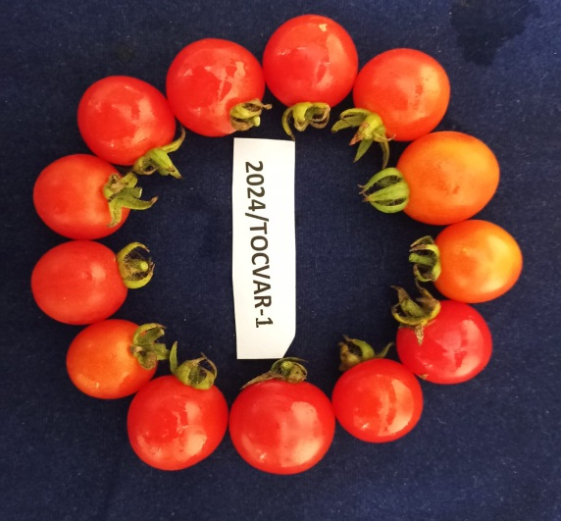  RNCT-2
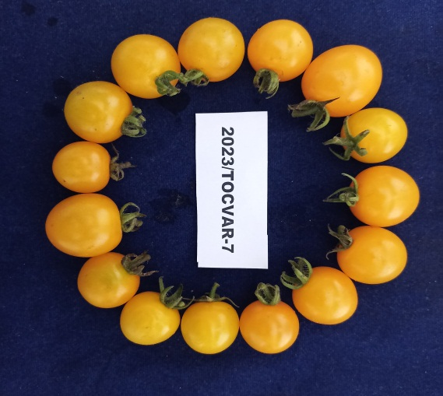  RNCT-3  Fig 1-Photographs of Local Cherry tomato entries | 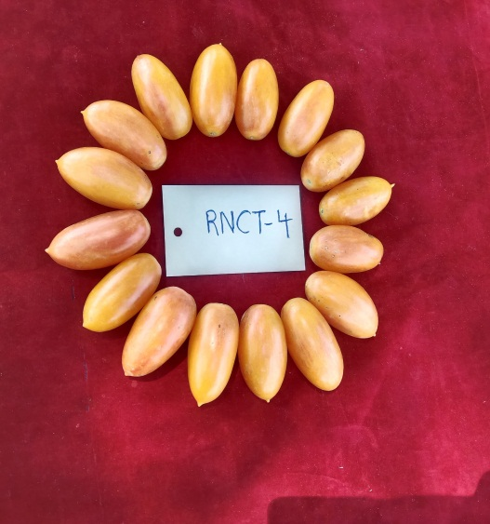  RNCT-4

CONCLUSION
This study has definitively determined that the superior fruit yield per hectare in RNCT-4 results from improved vegetative growth, an increased number of fruit clusters per plant, the highest average fruit weight, a greater fruit set percentage, and taller plants compared to the other lines. The cherry tomato varieties examined exhibited considerable differences in the observed traits under Southern Telangana Conditions. RNCT-1 and RNCT-4 emerged as the top selections among the 6 cherry tomato varieties examined for all the parameters, based on yield, and are therefore suggested for cultivation in Telangana.

Disclaimer (Artificial intelligence)

Author(s) hereby declare that NO generative AI technologies such as Large Language Models (ChatGPT, COPILOT, etc.) and text-to-image generators have been used during the writing or editing of this manuscript.

REFERENCES
- U.S. Department of Agriculture. (2009). Cherry tomato nutritional information. USDA National Nutrient Database for Standard Reference. https://fdc.nal.usda.gov/ (USDA FoodData Central, which includes SR Legacy data)
- Bhangu, J. and Singh, S. (1993). Comparative performance of tomato cultivars under rainfed conditions of kandi area (Panjab). Panjab Horticulture Journal, 33(1/2): 123-126.
- Chang, Y., Zhang, X., Wang, C., Ma, N., Xie, J., & Zhang, J. (2024). Fruit Quality Analysis and Flavor Comprehensive Evaluation of Cherry Tomatoes of Different Colors. Foods, 13(12), 1898. https://doi.org/10.3390/foods13121898
- Deepa, S. and M. C. Thakur (2008). Evaluation of diallel progenies for yield and its contributing traits in tomato under mid-hill conditions. Indian J. Hort., 65(3) : 297-301.
- Hussain, K., Lone, S., Malik, A., Masoodi, K. Z., Dar, Z. A., Nazir, N., Ali, G., & Farwah, S. (2021). Genetic variability studies in cherry tomato for growth, yield, and quality traits in open field conditions. International Journal of Agricultural and Applied Sciences, 2(2), 60–64. https://doi.org/10.52804/ijaas2021.229
- Islam, M. S., Mohanta, H. C., Ismail, M. R., Rafii, M. Y., & Malek, M. A. (2012). Genetic variability and trait relationship in cherry tomato (Solanum lycopersicum L. var. cerasiforme (Dunnal) A. Gray). Bangladesh Journal of Botany, 41(2), 163–167. https://doi.org/10.3329/bjb.v41i2.13443
- Kobryn, J., & Hallmann, E. (2005). The effect of nitrogen fertilization on the quality of three tomato types cultivated on rockwool. Acta Horticulturae, 691, 341-348. https://doi.org/10.17660/ActaHortic.2005.691.40
- Olaniyi, J. O., Akanbi, W. B., Adejumo, T. A., & Akande, O. G. (2010). Growth, fruit yield and nutritional quality of tomato varieties. African Journal of Food Science, 4, 398-402. https://doi.org/10.5897/AJFS.9000154
- Panse VG, Shukhatme PV. Statistical Methods for Agricultural Workers (2nd Ed).(1967). ICAR, Publications, New Delhi.
- Prema, G., Indiresh, K. M., & Santhosha, H. M. (2011). Evaluation of cherry tomato (Solanum lycopersicum var. Cerasiforme) genotypes for growth, yield and quality traits. Asian Journal of Horticulture, 6(1), 181-184. https://www.hindagricultural.org/journal/TAJH/Vol6No1/27.pdf
- Rocha, M. D. C., Deliza, R., Corrêa, F. M., do Carmo, M. G., & Abboud, A. C. (2013). A study to guide breeding of new cultivars of organic cherry tomato following a consumer-driven approach. Food Research International, 51(1), 265-273. https://doi.org/10.1016/j.foodres.2012.12.019
- Shivakumar, K. C. (2000). Evaluation of tomato hybrids for growth, yield and quality parameters under Bangalore condition. M. Sc. Thesis, UAS, GKVK, Bangalore.
- Rahul, S., Rahman, M. M., Rakibuzzaman, M., Islam, M. N., & Uddin, A. F. M. J. (2018). Study on growth and yield characteristics of twelve cherry tomato lines. Journal of Bioscience and Agriculture Research, 17(01), 1403-1409.
- Hansda , Narendra Nath, Umesh Thapa, Shubham Kumar Kulshreshtha, and Sourav Kundu. 2023. “Assessing the Growth, Yield, and Quality of Different Varieties of Cherry Tomato (Solanum Lycopersicum Mill. Var. Cerasiforme) Under Polyhouse”. International Journal of Environment and Climate Change 13 (11):1418-32. https://doi.org/10.9734/ijecc/2023/v13i113294.
- Yadav , P., Singh , D., & Wesley , C. J. (2023). Evaluation of Cherry Tomato [Solanum lycopersicum (L) var. cerasiforme Mill.] Genotypes for Yield and Quality in Polyhouse in Prayagraj Agro-climatic Condition . International Journal of Plant & Soil Science, 35(18), 564–573. https://doi.org/10.9734/ijpss/2023/v35i183321

