Hydroponics: Green Growth Without Soil
Abstract
Hydroponics is an advanced soilless cultivation technique that supports plant growth through nutrient-enriched water under controlled environmental conditions. In the face of global challenges such as climate change, soil degradation, water scarcity, and rapid urbanisation, conventional agriculture increasingly struggles to sustain food production. Hydroponic farming presents a viable alternative by improving water-use efficiency, reducing land dependency, limiting pest and disease incidence, and enabling year-round crop production. This review provides a comprehensive overview of hydroponics, covering its definition, historical development, necessity, working principles, system classification, growing media, and essential operational requirements, including pH, electrical conductivity, nutrient management, and light regulation. Recent technological advancements and emerging applications in urban and controlled environment agriculture are also briefly highlighted. The advantages and limitations of hydroponic systems are discussed to evaluate their role in sustainable agriculture. Overall, hydroponics emerges as a promising technology for enhancing future food security, particularly in resource-limited and urban regions.
Keywords: Controlled environment agriculture; hydroponics; nutrient solution; soilless culture; sustainable agriculture and urban farming
Introduction
Modern agriculture faces major challenges, including climate change, declining soil fertility, water scarcity and rapid urbanisation. Conventional soil-based farming often suffers from nutrient losses, pest incidence and inefficient water use. Hydroponics overcomes these limitations by growing plants without soil and supplying nutrients directly to plant roots in a controlled environment. Since plants require water, nutrients and oxygen, not soil (Kumar et al., 2022) itself hydroponic systems allow faster growth, efficient resource use and higher productivity, making them increasingly important in greenhouses, urban farming and research facilities.
Definition
Hydroponics, the science of cultivating plants without soil, is becoming increasingly relevant as urban areas face rapid population growth, limited arable land and water scarcity(Beheraet al., 2025; Dodiya et al., 2025). The term 'Hydroponics' was derived from Greek word 'hydro' means water and 'ponos' meaning labour (Beibel, 1960). Hydroponics is the science of growing plants without soil, where essential nutrients are supplied through a nutrient solution, with or without the use of inert substrates such as cocopeat, perlite or vermiculite. The nutrientsolutions containing crop-specific nutrient components in the right concentration with balanced pH and EC aredelivered to the roots in a highly soluble format and a controlled environment (Pretty, 2020).

Historical development of hydroponics

Soilless culture dates back centuries, but modern hydroponics emerged in the early 20th century. In the 1860s, Knop and Sachs formulated the first standardised plant nutrient solution to grow crops without soil (OSU Extension, 2021). The term hydroponics (“water-working”) was coined by plant physiologist William F. Gericke in the 1930s (Despommier, 2010). The earliest published study on growing plants without soil is in Francis Bacon’s book “Sylva Sylvarum”, which was released in 1627, a year after his death (Ghatageet al., 2019).
Need for hydroponics
The world’s population is increasing rapidly (~8 billion presently, rising to ~9.7 billion by 2050) and conventional agriculture may not be able to meet future food demand due to limited land and natural resources. Hydroponics allows crops to be grown in small spaces and indoor environments, helping to increase food production without expanding agricultural land. This system uses much less water than soil-based farming (already uses roughly 70% of global freshwater withdrawals (FAO, 2024)because water is supplied directly to plant roots and reused, making it suitable for water-scarce regions. Hydroponics also provides precise control over nutrients, light and environmental conditions, which results in faster plant growth, higher yields and uniform crop quality. Since crops are grown without soil, problems related to soil-borne pests and diseases are reduced, lowering the need for pesticides. In addition, hydroponics enables year-round cultivation and crop production in difficult environments such as urban areas and regions with poor or degraded soils. Therefore, hydroponics is an important technology for sustainable agriculture and future food security.

Working
Hydroponic systems work on the principle of supplying plants with a precise amount of water, nutrients, light and oxygen under controlled environmental conditions. Nutrient solutions are prepared according to crop requirements and delivered directly to the plant roots, allowing efficient nutrient uptake. Important factors such as temperature, pH, electrical conductivity and light duration can be continuously monitored and adjusted to optimise plant growth. By eliminating soil, hydroponics reduces problems associated with soil-borne diseases, pests and environmental variability. The absence of mechanical resistance from soil allows roots to grow freely, resulting in faster plant growth and earlier maturity. Since the growing environment is controlled, the need for pesticides is minimised, leading to healthier and higher-quality produce. Overall, hydroponics ensures uniform growth, improved productivity and reduced risks compared to conventional soil-based cultivation.
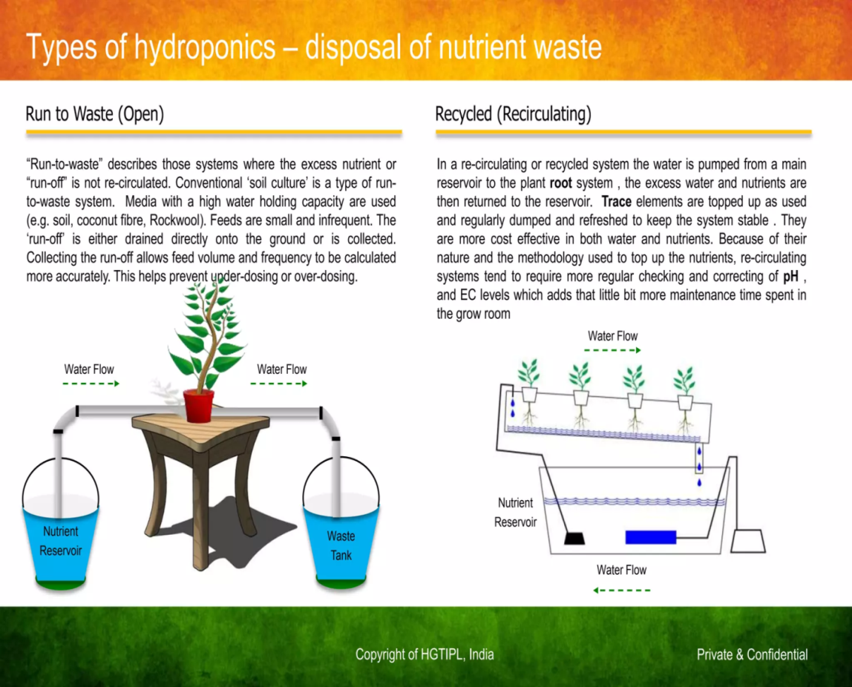
CLASSIFICATION OF HYDROPONIC SYSTEMS:
1.BASED ON THE NUTRIENT USAGE
Opensystem (Drain to Waste)

Fig 1-Open Hydroponic system

It is a system where the excess nutrient solution is not recirculated after irrigation. Freshly prepared nutrient solution is supplied to the plant roots or growing medium during each irrigation event, and the excess runoff is drained or collected and discarded (Mabokoet al., 2011). Growing media with high water-holding capacity are commonly used in this system. Although collecting the runoff helps in estimating irrigation volume and frequency, proper management of the discarded nutrient solution is essential to minimise nutrient loss and environmental pollution.

Closed System (Re-circulated)
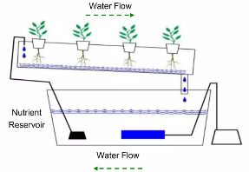

Fig 2-Closed Hydroponic System
In a recirculating or recycled hydroponic system, nutrient solution is pumped from a main reservoir to the plant roots and the excess solution is collected and reused. Nutrients are replenished as they are used, and the solution is periodically replaced to maintain system stability. This system is cost-effective in terms of water and nutrient use, but it requires regular monitoring and adjustment of pH and EC levels. Closed-loop re-circulating systems are environmentally efficient and can achieve up to 35% higher water use efficiency compared to non-recirculating systems (Fayezizadeh et al., 2021).

2. BASED ON SYSTEM DESIGN
Wick System
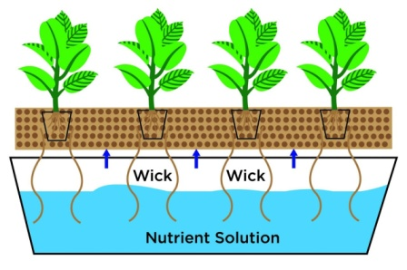

Fig 3-Wick hydroponic system
It is the simplest method of a hydroponic system, which does not require any electricity, pump or aerators (Sharma et al., 2018). In this system, a wick made of cotton or nylon draws nutrient solution from a reservoir to the growing medium through capillary action, supplying nutrients directly to plant roots. It is suitable for small plants such as herbs and spices. Studies have shown that the wick system can produce good yields and plant quality, particularly when coconut coir is used as a growing medium (Ferrarezi and Testezlaf, 2016).
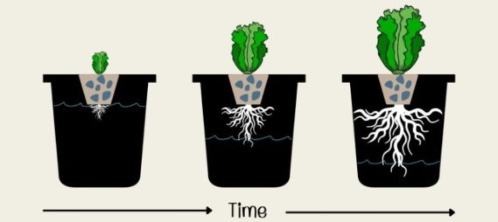
Non-recirculating Air-Gap System (Kratky)

Fig 4- Kratky hydroponic system
Kratky is a non-circulating, passive hydroponic method. Plants are placed in net pots suspended over a tank of nutrient solution. The bottom part of the roots stays in the solution for absorbing nutrients. The upper part of the roots remains exposed to an air gap, which provides oxygen. As plants grow, the nutrient level drops, naturally increasing the air gap. No pumps, no electricity is a completely static system.

Deep Water Culture (DWC)
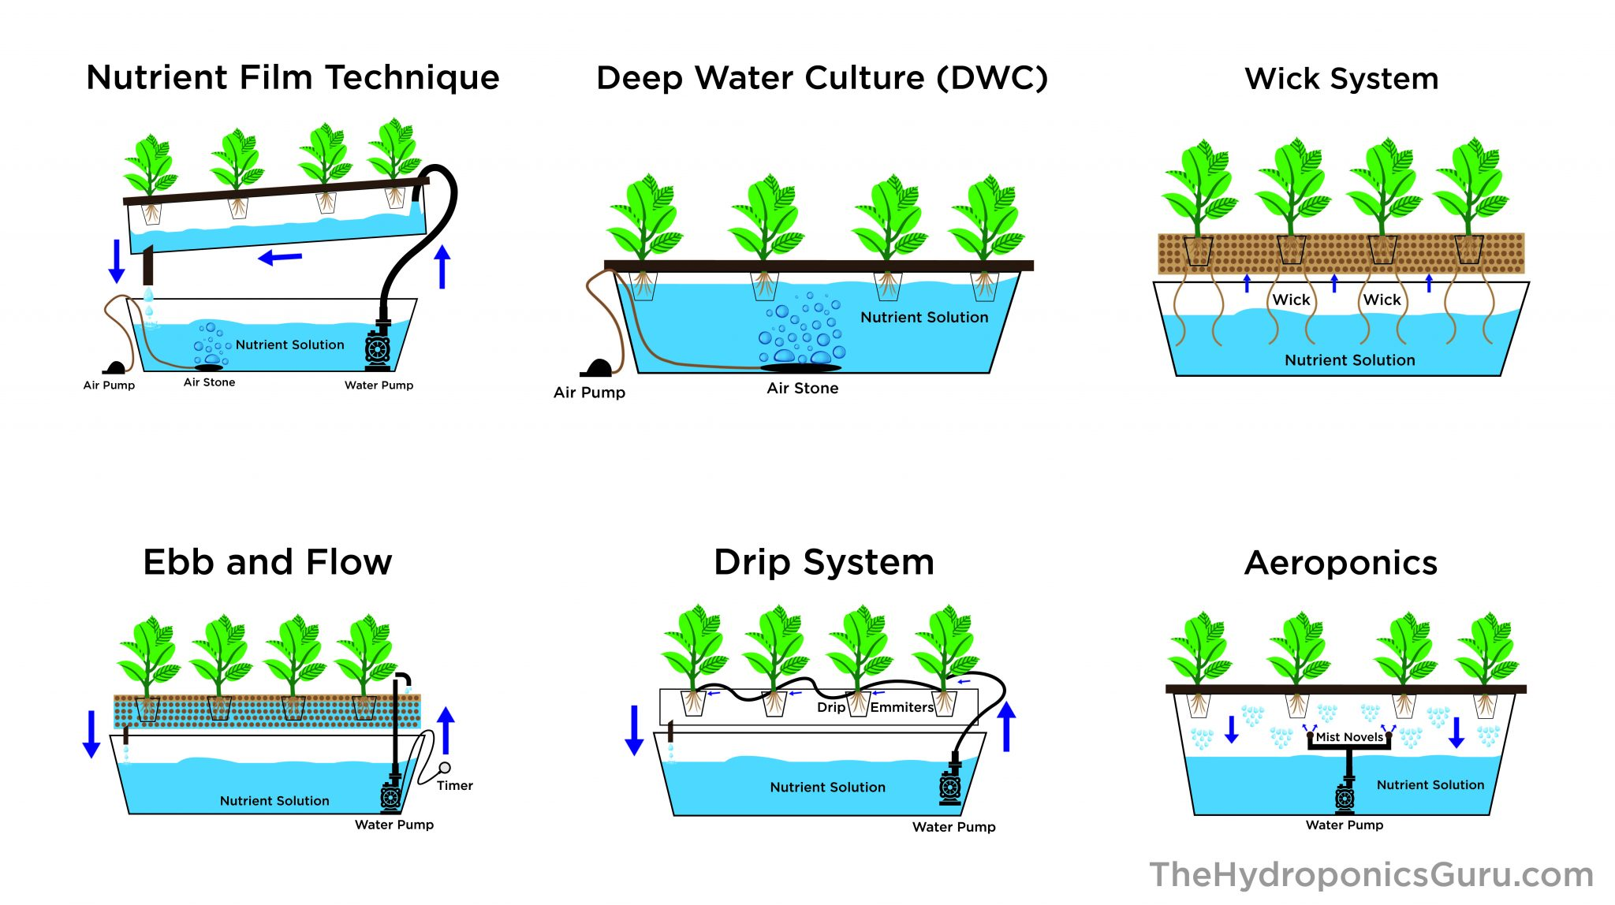

Fig 5-Deep water culture hydroponic system
In the deep water culture system, plant roots are fully suspended in an oxygenated nutrient solution. Air pumps and air stones supply oxygen to prevent root suffocation and support healthy growth. The large volume of solution helps maintain stable pH and EC, but regular monitoring of oxygen levels, nutrients, salinity and pH is essential to prevent algae and mould growth (Domingueset al., 2012). This system is suitable for larger fruiting crops such as tomato and cucumber.

Aggregate Culture (cocopeat, perlite, etc.)

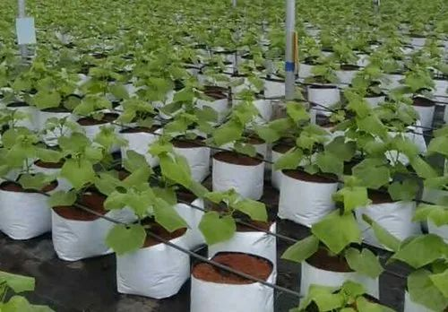

Fig 6-Aggregate hydroponic system

Used in grow bags or pots with media like cocopeat/perlite. Nutrient solution is supplied via drip irrigation. Media holds moisture but also keeps enough air pockets for oxygen. Excess solution either drains out (open system) or is collected again (closed system). Suitable for capsicum, tomato, cucumber, etc.

Dutch / Bato Bucket System
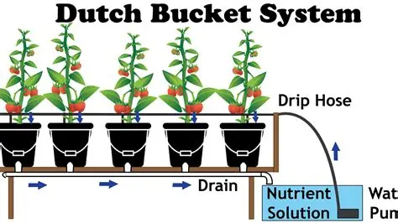

Fig 7-Bato bucket hydroponic system

The Dutch or Bato bucket system was first used in the Netherlands for growing crops such as tomatoes, cucumbers and roses (Boini, 2024). It is mainly used for large fruiting crops, where plants are grown in individual buckets (about 2.5 gallons) filled with media such as cocopeat or perlite. Nutrient solution is supplied to each bucket through drip emitters, and excess solution is drained and recirculated back to a storage tank using a pump (George and George, 2016). This system provides good root support and continuous moisture supply and is suitable for crops like capsicum, tomato and cucumber. The successful cultivation of Cucurbita moschata Duchesne “Loche” using this system has also been reported (Vasquez and Vasquez, 2017).
Nutrient Film Technique (NFT)
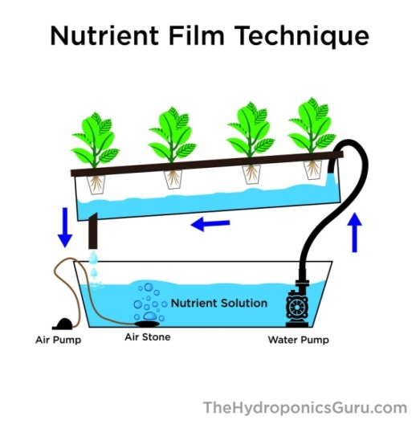

Fig 8-Nutrient Film Technique (NFT) hydroponic system
The Nutrient Film Technique (NFT) was developed by Dr. Allen Cooper in the mid-1960s in England. In this system, a thin film of nutrient solution is continuously circulated through sloped, inverted‘V’-shaped channels using a water pump, allowing plant roots to absorb nutrients while remaining partially exposed to oxygen (Sharma et al., 2018; George and George, 2016). The nutrient solution drains back into the reservoir and is reused. NFT is widely used for small, fast-growing crops such as lettuce, baby greens and herbs (Dholwa et al., 2018). Studies have shown that a flow rate of 20 Lh⁻¹results in better lettuce growth compared to 10 or 30 Lh⁻¹ (Tawahaet al., 2018).
Drip system
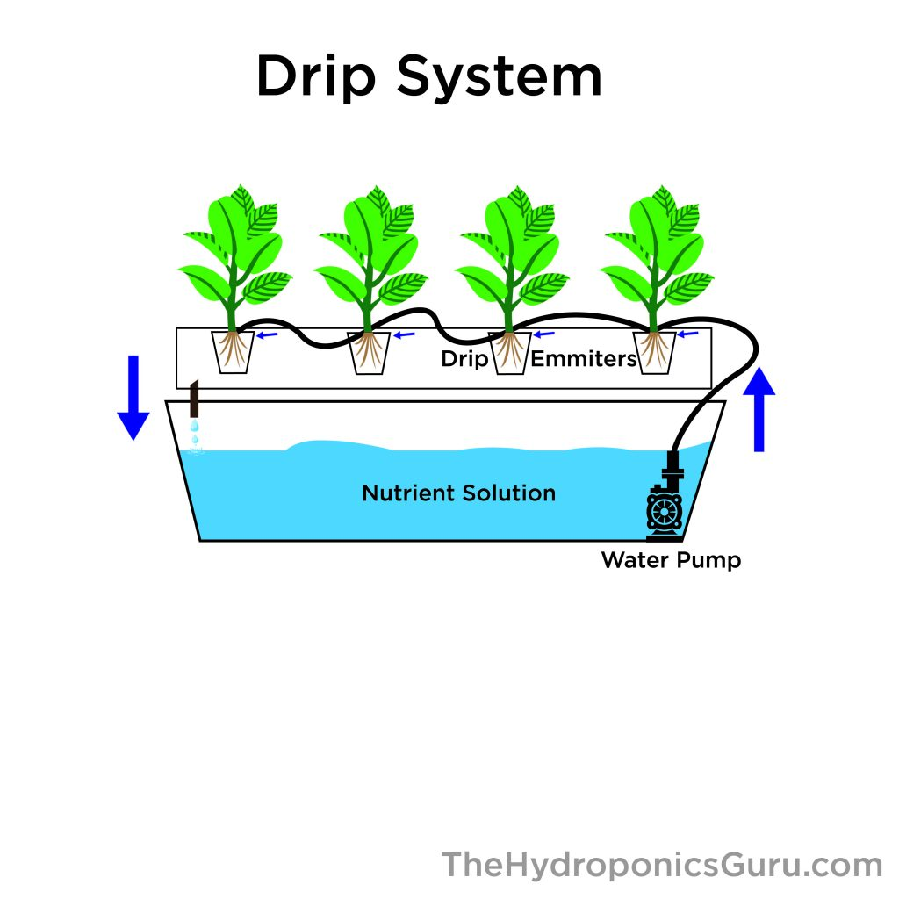

Fig 9-Drip hydroponicsystem
The main benefits of a drip system are its increased water conservation over other options and its resilience to sudden power outages or equipment failures. The fact that the solution supply is timed makes this system potentially highly costly and challenging to set up. With the help of a pump, water or nutrients solution from the reservoir is delivered to individual plant roots in an appropriate proportion (Rouphael and Colla, 2005). It is frequently used to grow peppers and tomatoes, producing exceptionally high-quality yields (Sharma et al., 2018).
Ebb and Flow (flood and drain system)
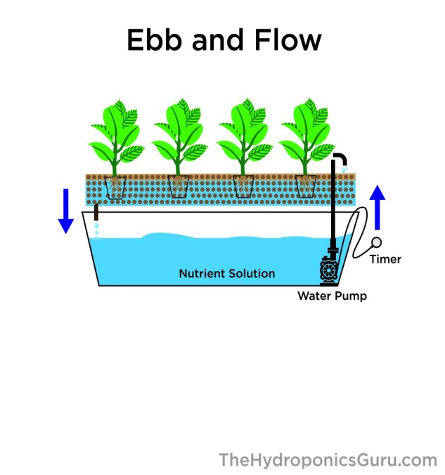

Fig 10-Ebb and Flow system
Because ofit’sslow-maintenance and inexpensive set-up, it has been proved to be a popular system. The plants are placed in the pots in the growing tray. Then a timer is used to maintain the flow of water. As the timer starts, a submerged pump in the reservoir begins pumping water to the container placed above. The pumping continues for short periods to provide nutrients to the plants (Ebb/flood cycle). As soon as the timer goes off, the pump halts. Due to the gravitational pull, the liquid nutrients drain back to the reservoir. Aeration is permitted from above the tube or through an air pump.

Aeroponics
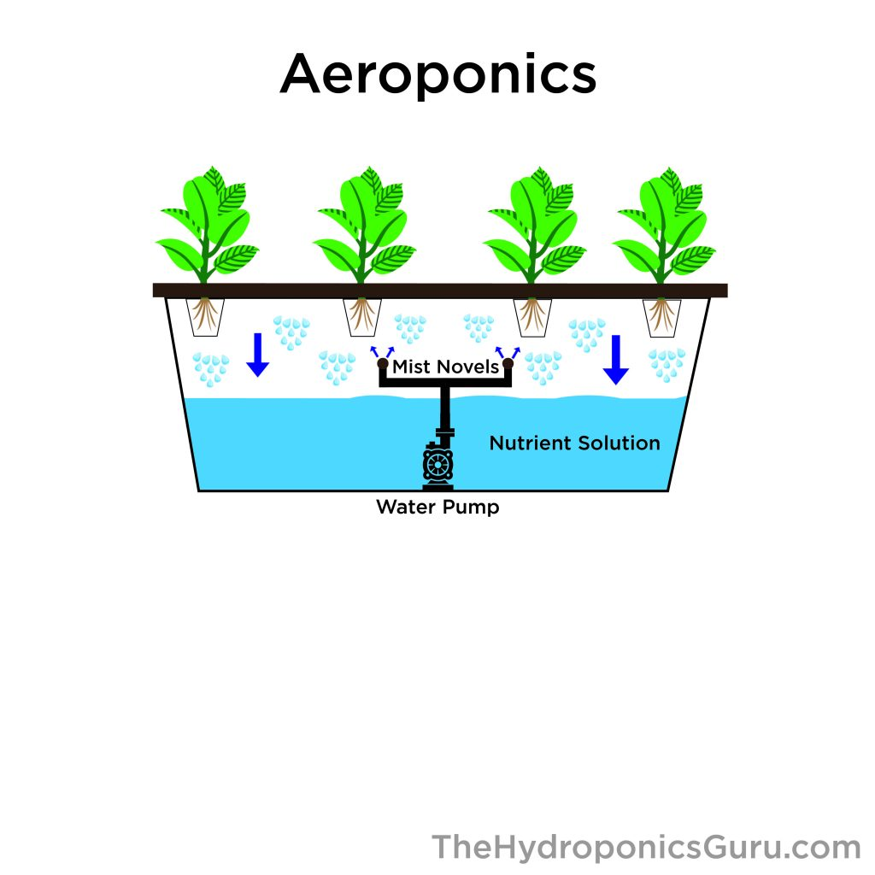

Fig 11-Aeroponic system
The aeroponic system works on the principle of growing plants with their roots suspended in air and exposed to a fine mist of nutrient solution (Zobel et al., 1976). In this method, plants are grown without soil or any solid substrate, while essential growth parameters such as temperature, pH, humidity and electrical conductivity are carefully controlled (Kaur and Kumar, 2014). Aeroponic culture is well suited for leafy vegetables such as lettuce and spinach (Khan, 2018). It is considered the most advanced form of hydroponics and has gained recognition from NASA scientists for its efficiency and potential in controlled-environment agriculture.
3. BASED ON WATER FLOW
Continuous Flow Solution Culture
In continuous flow solution culture, the nutrient solution flows continuously over plant roots, making the system easy to automate. Key parameters such as temperature, pH and nutrient concentration are monitored and adjusted in a single large reservoir that can supply to many plants. A common example of this system is the Nutrient Film Technique (NFT), where a thin stream of nutrient solution flows through channels containing bare roots, while the upper root surface remains exposed to air, ensuring adequate oxygen supply (Featherstone, 2022).

Static Solution Culture
In static solution culture, plants are grown in containers such as jars, pots, buckets or tanks filled with nutrient solution. The solution may be gently aerated or left unventilated and its level is usually kept low so the lower roots remain above the solution to access sufficient oxygen. Containers often have perforated lids or tops made of foil, paper, wood or metal and each reservoir typically serves a single plant or system. As plants grow, the size of the reservoir can be increased to accommodate larger root systems (Featherstone, 2022).
4.BASED ON SUBSTRATE
Substrates are materials used alone or in combination to provide better root growth conditions than agricultural soil. Soilless cultivation systems can be divided into:
Liquid culture, where roots grow directly in a nutrient solution and Solid culture, where substrates support the plant roots. An ideal substrate should support the plant, provide adequate air, water, and nutrients to the roots, and be free from pathogens and phytotoxic effects.
Clay Balls (Hydrotons / LECA)
Clay balls or LECA (Lightweight Expanded Clay Aggregate) are lightweight, porous pellets made by heating clay at about 1200 °C and are commonly used in hydroponic systems. They are inert, pH-neutral, reusable and do not compact, but some experts advise against reuse because roots can grow into the pellets and be hard to remove.
Coconut Coir
Coconut coir is a natural, eco-friendly fiber from coconut husks that retains water well, provides good aeration and has a stable pH. It can be used alone or mixed with other media and is commonly used as coco peat, which looks like soil but contains no minerals (Giddel and Jivan, 2007).
Perlite
Perlite is a lightweight, porous medium made by heating volcanic rocks until they expand into glass-like particles (Hussain et al., 2014; George and George, 2016). It offers good water retention and drainage, is sterile and inertand can be used alone or mixed with other growing media.
Vermiculite
Vermiculite is a lightweight mineral that holds more water than perlite and helps transport water and nutrients to plant roots. It also aids in the uptake of nutrients like magnesium, calcium and potassium and is often mixed with perlite or pumice for better aeration.
Sand
Sand is an inexpensive and easily available growing medium but is rarely used in modern hydroponics due to poor water retention and high density. Coarse sand is preferred over fine sand to improve aeration and can be mixed with other materials to increase water-holding capacity (Olleet al., 2012).
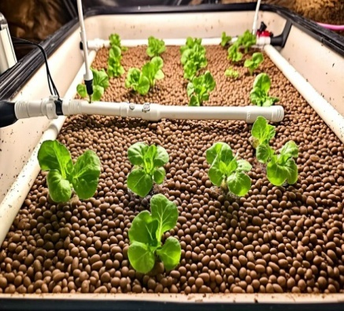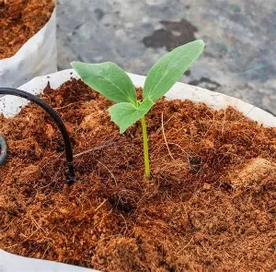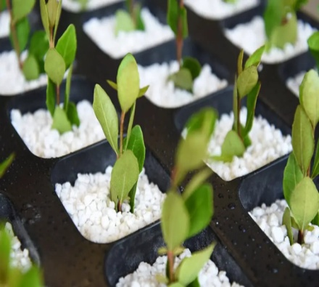
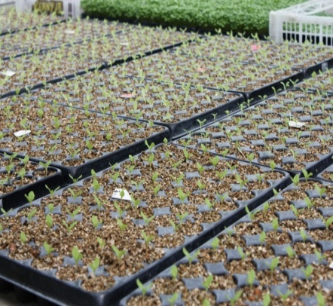
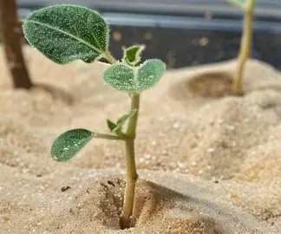

Fig 12: Different types of growing media used in hydroponic system: Clay balls, Coconut coir, Perlite, Sand and Vermiculite.
Based on the growing medium
Hydroponics can be broadly classified into media culture and water culture based on the method used to support plant roots.
Media culture involves growing plants in inert materials such as coco peat, perlite, vermiculite, sand, gravel, rockwool or expanded clay pellets instead of soil. These media support the plant roots, retain moisture and oxygen and are easy to manage, making them suitable for many crops.
Water culture,involves growing of plants directly in a nutrient solution without any solid growing medium. The roots are suspended in water containing dissolved nutrients, with oxygen supplied through aeration or continuous flow of the solution. This method allows fast plant growth but requires careful control of oxygen and nutrient levels.
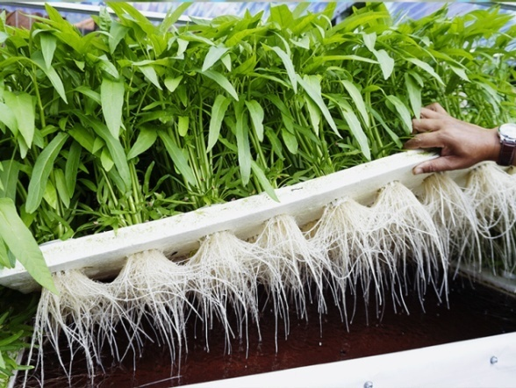
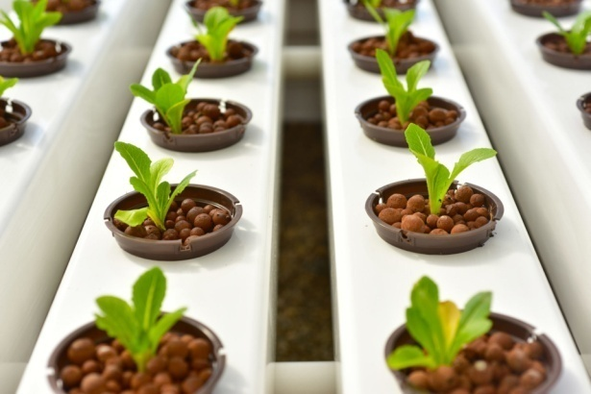
Fig 13: Schematic representation of water culture and media culture systems in hydroponics

Essential requirements of the hydroponics

pH
Most hydroponic grown plants prefer slightly acidic water (pH 5.5 to 6.5), as this range ensures optimal nutrient solubility and uptake. Plain water normally has a pH of 7.0–8.2. Most nutrient solutions are acidic, and once added to the water source, will decrease the pH.According to Mayavanet al. (2017), maintaining an appropriate pH range is essential to ensure the availability of all required nutrients.In simple terms:pH makes nutrients available or locks them out.
(Electrical Conductivity)
EC measures the total salt concentration and nutrient strength of a hydroponic solution. Too high EC indicates higher nutrient concentration, can burn plants, while too low EC can cause nutrient deficiencies (Grattan and Grieve, 1998). The ideal EC level varies depending on the crop, growth stage, and environmental conditions (Van et al., 2021; Sonneveldand Voogt, 2009).In simple terms:EC tells you if your plant is getting enough food or too much.
Table 1: Optimal pH and Electrical Conductivity (EC) for common hydroponic vegetables
Vegetable | EC | pH
Cauliflower | 0.5-2.0 | 6.0-6.5
Lettuce | 0.8-1.2 | 6.0-7.0
Cucumber | 1.7-2.5 | 5.5-6.5
Egg plant | 2.5-3.5 | 5.5-7.5
Tomato | 2.0-5.0 | 5.5-6.5
(Source: Mehboob et al., 2019)
Nutrient solution

Hydroponics is a method of growing plants without soil, where all essential macronutrients (N, P, K), secondary nutrients (Ca, Mg, S), and micronutrients (Fe, Mn, Zn, Cu, B, Mo, Cl)nutrients are supplied directly to plant roots through a nutrient-rich water solution (Resh, 2013), allowing better nutrient absorption, faster growth, efficient water use, and year-round cultivation (Jones,2016). These nutrients can be supplied through premade solutions, which are convenient and balanced or homemade solutions, which offer flexibility and customization but require proper knowledge and careful mixing (Bugbee, 2004). Nutrient solutions must be prepared using clean water, mixed according to recommended ratios, and maintained at an ideal pH range of about 5.0–6.5 and suitable electrical conductivity (EC) to ensure optimal nutrient availability (Hochmuth and Hochmuth,2012).
Light
Lighting is very important in hydroponics because it provides the energy plants need for photosynthesis and growth (Resh, 2013). In indoor hydroponic systems, artificial lights replace sunlight and help regulate plant growth and temperature (Jones, 2016). When choosing lights, factors like plant type, size of growing area, light intensity and duration must be considered, as leafy vegetables like lettuce and spinach need less light than fruiting crops, and larger areas require higher light output (Bugbee, 2004). LED lights are popular because they are efficient, long-lasting, produce little heat, and can provide specific wavelengths for different growth stages (Sonneveld and Voogt, 2009).

Essential guidelines for balanced hydroponic solution
- Testing, adjusting and balancing pH and EC in a hydroponic system is essential for healthy plant growth.
- Before testing, the pumps should be turned off and the nutrient solution allowed to settle for about 15 minutes.
- The pH and EC are then measured using a meter or test strip, with the ideal pH range being 5.5–6.5 and EC levels varying according to crop type, usually 1.2–2.4 mS/cm for leafy vegetables and slightly higher for fruiting crops.
- Meters should be rinsed with distilled water after use and pH should always be adjusted after mixing nutrients since nutrients can alter pH.
- If the pH is too low, small amounts of pH Up are added, if the pH is too high, making adjustments slowly and retesting after mixing.
- Nutrient strength is corrected by adding nutrients when EC is low or diluting with clean water when EC is high, while keeping a record of changes made.
- When preparing a new nutrient solution, nutrients should always be added to water, mixed thoroughly, allowed to rest briefly, and then tested for pH and EC before use.
- The nutrient solution should be flushed and replaced whenever pH or EC fluctuates excessively or plants show stress symptoms, and as a routine practice every 2–4 weeks to prevent salt buildup and maintain system efficiency.
- Common signs of pH and nutrient problems in hydroponics include yellowing of leaves (chlorosis), which occurs when pH is out of range and blocks nutrient uptake, especially iron (Taiz et al., 2015).Leaf tip burn is usually caused by high EC due to excess nutrients.
- Stunted plant growth may result from low nutrient levels or micronutrient deficiencies caused by pH lockout. Purple or red stems indicate possible phosphorus deficiency, while browning of roots may be due to poor oxygen supply or high EC causing root damage.

Technological Innovations in Advancing Hydroponic Farming
Modern technologies like automation, AI and IoT have greatly improved hydroponic farming efficiency. These systems enable real-time control of nutrients, lighting and pH levels. As a result, farms achieve higher yields, lower costs, and improved sustainability.

Advanced Lighting Systems
Advanced lighting solutions optimize plant growth by delivering precise light spectrums with high energy efficiency. Technologies such as LED, CMH and smart lighting controls reduce heat output and energy use. They also adapt lighting schedules to plant growth stages for better results.

LED Grow Lights
LED grow lights provide customizable light spectrums that support all plant growth phases. They consume less energy and produce minimal heat compared to traditional lights. This makes them cost-effective and safer for delicate crops.

CMH (Ceramic Metal Halide) Grow Lights
CMH grow lights closely mimic natural sunlight with a balanced full spectrum. They promote strong plant structure and healthy development. Their inclusion of UV light enhances plant quality and resilience.

Smart Lighting Controls
Smart lighting systems use AI and IoT to automate and optimize lighting conditions. They adjust light intensity and duration based on plant type and environmental data. This improves growth efficiency while reducing energy waste.

Automated Nutrient Delivery Systems
These systems precisely mix and deliver nutrients according to plant needs. Sensors monitor nutrient levels in real time to prevent deficiencies or excesses. Automation ensures consistent feeding and reduces manual labor.

Monitoring and Control Systems
Monitoring systems collect real-time data on temperature, humidity, CO₂, and nutrients. Analytics tools convert this data into actionable insights for growers. Remote access allows farmers to manage farms efficiently from anywhere.

Environmental Sensors
Environmental sensors track critical growth factors continuously. They help maintain optimal growing conditions by alerting growers to changes. This leads to healthier plants and improved yields.

Data Analytics
Data analytics processes large volumes of sensor data to identify growth patterns and inefficiencies. It helps predict plant needs and optimize system performance. This supports smarter decision-making and higher productivity.

Remote Monitoring
Remote monitoring enables growers to oversee hydroponic systems via mobile or computer devices. It allows quick responses to issues without being on-site. This increases convenience, control, and operational efficiency.

Advantages
Hydroponics produces healthier crops with higher yield per unit area (Solanki et al., 2017).Hydroponic farming conserves water by using 80–90% less water than conventional agriculture (Biswas and Das, 2022; Debangshi, 2021).Precise control of nutrient supply reduces fertilizer use and enables nutrient recycling, thereby lowering input costs (Pandey et al., 2009).Hydroponic systems allow high-density planting and require less land, making them space efficient (KKRet al., 2012).Continuous cropping without crop rotation is possible, enabling year-round production of high-demand crops (Shrestha and Dunn, 2010).Hydroponics experiences fewer pest and disease incidences, which simplifies crop management (Sousa et al., 2024).Thecontrolled growing environment reduces environmental impact and transportation-related emissions by enabling production in the vicinity of consumers.Weeding is not required in hydroponic systems, reducing labour requirements (Singh and Davidson, 2016).Hydroponic systems can be established on infertile and non-arable land, expanding agricultural use of unproductive areas (Ghorbelet al., 2022).Hydroponics reduces carbon footprint and labour needs, making it environmentally and economically sustainable, especially for fodder production (Quagrainieetal., 2018).Direct nutrient supply to roots results in faster plant growth, smaller root systems, closer spacing, and use of only1/5thland space and 1/20th water compared to soil cultivation (Silberbushand Ben-Asher, 2001).Hydroponics is particularly suitable for regions with limited arable or fertile land resources (Sonneveld, 2000).

Disadvantages
Hydroponics needs high initial investment and maintenance cost making it is suitable mainly for high-value crops (Solanki et al., 2017).It requires technical knowledge and continuous monitoring to manage nutrients and systems properly (Pomoni et al., 2023). Large-scale commercial use needs high capital and skilled labour, even though returns are good (Sonneveld, 2000).Hydroponic fodder is highly perishable in hot climates and can suffer from oxygen deficiency if not properly stored.The system is sensitive to temperature and humidity, increasing the risk of fungal and microbial diseases.Poorly controlled conditions may lead to mould and bacterial growth.Common nutrient solutions can spread water-borne diseases from one plant to another (Ghorbel et al., 2022).

Conclusion
Hydroponics represents a transformative approach to modern agriculture by enabling efficient crop production without soil through precise control of nutrients, water and environmental conditions. The technology addresses key challenges faced by conventional agriculture, including land scarcity, water limitations, soil degradation and climate variability. Various hydroponic systems such as NFT, DWC, drip systems and aeroponics offer flexibility for cultivating a wide range of crops, while different substrates further enhance root support and nutrient availability. Although the initial investment and technical expertise required for hydroponics can be limiting factors, its advantages such as higher yields, reduced water use, efficient nutrient management, and year-round productionoutweigh the constraints. With continued technological advancements and increased awareness, hydroponics has immense potential to support sustainable food production, especially in urban areas and resource-poor regions, contributing significantly to future food security.

Basis of classification | Type | Description | Examples
Based on nutrient usage (Jayachandranet al.,2022) | Open (Non-re-circulating) System | Nutrient solution is supplied once and excess solution is discarded; simple but less water-efficient | Open drip system
Based on nutrient usage (Jayachandranet al.,2022) | Closed (Re-circulating) System | Excess nutrient solution is collected, monitored and reused; high water and nutrient efficiency | NFT, DWC, Aeroponics
Based on system design | Wick System | Passive system where nutrients move to roots by capillary action suitable for small plants | Wick System
Based on system design | Deep Water Culture | Roots suspended in aerated nutrient solution | Floating raft system
Based on system design | Nutrient Film Technique | Thin film of nutrient solution flows continuously over roots | NFT channels
Based on system design | Drip System | Nutrient solution dripped directly to root zone | Drip irrigation system
Based on system design | Ebb and Flow | Nutrient solution periodically floods and drains the root zone | Flood and drain system
Based on system design | Aeroponics | Roots suspended in air and misted with nutrient solution | High-pressure aeroponics
Based on water flow | Continuous Flow System | Nutrient solution flows continuously over roots | NFT
Based on water flow | Static Solution System | Plants grow in stagnant nutrient solution with aeration | DWC
Based on growing medium | Media Culture | Roots supported by inert media that hold moisture and air | Cocopeat, Perlite
Based on growing medium | Water Culture | Roots directly immersed or suspended in nutrient solution | DWC, Aeroponics
Based on the level of technology | Low-tech Systems | Simple design, low cost, minimal automation | Wick system
Based on the level of technology | High-tech Systems | Automated control of nutrients, pH, EC and climate | Aeroponcis
Table 2: Summary table showing the classification of hydroponics

Disclaimer (Artificial intelligence)
Author(s) hereby declare that NO generative AI technologies such as Large Language Models (ChatGPT, COPILOT, etc.) and text-to-image generators have been used during the writing or editing of this manuscript.

References

Behera, A., Mohanty, A., Tripathy, P., Kumar, S., Dash, S. D., Baisnabi, D and Pradhan, S. S. 2025. Future farming in water: A comprehensive review on hydroponics. International Journal of Advanced Biochemistry Research. 9(6): 219-224. https://doi.org/10.33545/26174693.2025.v9.i6c.4512

Beibel, J. P. 1960. Hydroponics-The Science of Growing Crops Without Soil. Florida Department of Agriulture. Bull, 180.

Biswas, S and Das, R. 2022. Hydroponics: A promising modern intervention in Agriculture. Agriculture and Food: e-Newsletter. 4(1): 334-338. https://agrifoodmagazine.co.in/2022/01/
Boini, S. 2024. Fluid farms: Elevating agriculture through hydroponics. Just Agriculture e-Newsletter. 4 (6): 102–105. https://www.justagriculture.in
Bugbee, B. 2004, February. Nutrient management in re-circulating hydroponic culture. In South Pacific Soilless Culture Conference-SPSCC 648: 99-112. https://doi.org/10.17660/ActaHortic.2004.648.12
Debangshi., U. 2021.Hydroponics- An overview. Chronicle of Bioresource Management. 5(3): 110-114. https://www.pphouse.org/index.php/cbrm/issue/view/21
Despommier D. 2010. The vertical farm: Feeding the world in the 21st century. New York: Picador.
Dholwani, S.J., Marwadi, S.G., Patel, V.P and Desai, V.P. 2018. Introduction of Hydroponic system and it’s methods. International Journal of Recent Technology Engineering. 3(3): 69-73. https://www.ijrti.org/papers/IJRTI1803011.pdf
Domingues., D.S., Takahashi., H.W., Camara, C. A and Nixdorf., S. L .2012. Automated system developed to control pH and concentration of nutrient solution evaluated in hydroponic lettuce production. Computers and Electronics in Agriculture. 84: 53-61. https://doi.org/10.1016/j.compag.2012.02.006
Fayezizadeh, M. R., Ansari, N. A. Z., Albaji, M and Khaleghi, E. 2021. Effects of hydroponic systems on yield, water productivity and stomatal gas exchange of greenhouse tomato cultivars. Agricultural Water Management: 258: 107171. https://doi.org/10.1016/j.agwat.2021.107171
Featherstone., R. 2022. Hydroponics in modern agriculture. Global Journal of Agricultural Research and Reviews. 10(2): 01. https://doi.org/10.15651/2437-1858.22.10.7
Ferrarezi R.S and Testezlaf, R. 2016. Performance of wick irrigation system using self-compensating troughs with substrates for lettuce production. Journal of Plant Nutrition. 39(1): 147-161. https://doi.org/10.1080/01904167.2014.983127
Food and Agriculture Organization (FAO). 2024, AQUASTAT database: Global water statistics. Rome. https://www.fao.org/aquastat/en/
George, P and George, N. 2016. Hydroponics-(soilless cultivation of plants) for biodiversity conservation. International Journal of Modern Trends in Engineering and Science. 3(6): 97- 104.
Ghatage, S. M., Done, S. R., Akhtar, S., Jadhav, S and Havaragi. 2019. A hydroponic system for indoor plant growth. International Research Journal of Engineering and Technology. 6(6): 1279-1286. https://www.irjet.net/archives/V6/i6/IRJET-V6I6220.pdf
Ghorbel, R., Chakchak, J., Kosum, N and Cetin, N. S. 2022. Hydroponic technology for green fodder production: concept, advantages, and limits. In 6th International Students Science Congress Proceedings. 1-10 https://doi.org/10.1016/S0304-4238(98)00192-7
Giddel, M.R and Jivan, A.P. 2007. Waste to wealth, potential of rice husk in India a literature review. In International conference on cleaner technologies and environmental Management. PEC, Pondicherry, India. 4(2): pp. 4-6.
Grattan, S and Grieve, C. M. 1998. Salinity–mineral nutrient relations in horticultural crops. Scientia horticulturae. 78(1-4): 127-157. https://doi.org/10.1016/S0304-4238(98)00192-7
Hochmuth, G and Hochmuth, R. 2012. Nutrient Solution Formulation for Hydroponic (Soilless) Systems. University of Florida IFAS Extension Publication. https://doi.org/10.32473/edis-cv216-1990
Hussain, A., Iqbal, K., Aziem, S., Mahato, P and Negi, A.K. 2014. A review on the science of growing crops without soil (soilless culture)-a novel alternative for growing crops. International Journal of Agriculture and Crop Sciences. 7(11): 833-842. http://ijagcs.com/wp-content/uploads/2014/08/833-842.pdf
Jayachandran, A., Jain, S., Saini, S., Maurya, P., Subhasmita, S., Shukla, K. K and
Bhargav, K. 2022. Hydroponics: An art of soil-less farming. The Pharma
Innovation Journal. 11(9): 1049- 1053.
Jones, J. B. 2016. Hydroponics: A Practical Guide for the Soilless Grower (3rd ed.). CRC Press, Taylor & Francis Group. https://doi.org/10.1201/9780849331671
Kaur, G and Kumar, D. 2014. Aeroponic technology: blessing or curse. International Journal of Engineering Research & Technology. 3(7): 691-692. https://doi.org/10.17577/IJERTV3IS070692
Khan, F. A. 2018. A review on hydroponic greenhouse cultivation for sustainable agriculture. International Journal of Agriculture Environment and Food Sciences. 2(2): 59-66. https://doi.org/10.31015/jaefs.18010
KKR, L., Kasturi, K and KRS, S. R. 2012. Role of hydroponics and aeroponics in soilless culture in commercial food production. Journal of Agricultural Science and Technology. 1(1): 26-35. https://doi.org/10.37591/rrjoast.v1i3.800
Kumar., R, Chaudhary., P.L, Kumari., S and Chauhan., S. 2022. Agritecture: Hydroponics and vertical farming technology. Just Agriculture e-Newsletter. Article ID 004. 3 (1):1-3.
Maboko, M. M., Du Plooy, C. P and Bertling, I. 2011. Comparative performance of tomato cultivars cultivated in two hydroponic production systems. South African Journal of Plant and Soil. 28(2): 97-102. https://doi.org/10.1080/02571862.2011.10640019
Mehboob, A., Ali, W., Rafaqat, T and Talib, A. 2019. Automation and control system of EC and PH for indoor hydroponics system. In 4th international electrical engineering conference. https://ieec.neduet.edu.pk/2019/Papers_IEEC_2019/IEEC_2019_33.pdf
Mayavan, R. R. S., Jeganath, R and Chamundeeswari, V. 2017. Automated hydroponic system for deep water culture to grow tomato using atmega328. In Proceedings of Technoarete International Conference. Chennai, India.
Olle, M., Ngouajio, M and Siomos, A. 2012. Vegetable quality and productivity as influenced by growing medium: A review. Agriculture. 99 (4): 399-408. https://staffsites.sohag-univ.edu.eg/uploads/487/1540386592%20-%20Vegetable%20quality%20and%20productivity.pdf
Pandey, R., Jain, V and Singh, K. P. 2009. Hydroponics agriculture: Its status, scope and limitations. Division of Plant Physiology, Indian Agricultural Research Institute, New Delhi, 20. https://www.researchgate.net/publication/287200900_Hydroponics_Agriculture_Its_Status_Scope_and_Limitations
Pomoni, D. I., Koukou, M. K., Vrachopoulos, M. G and Vasiliadis, L. 2023. A review of hydroponics and conventional agriculture based on energy and water consumption, environmental impact, and land use. Energies. 16(4): 1690. https://doi.org/10.3390/en16041690
Pretty, J. 2020. New opportunities for the redesign of agricultural and food systems. Agriculture and Human Values. 37(3): 629-630. https://doi.org/10.1007/s10460-020-10056-2
Quagrainie, K. K., Flores, R. M. V., Kim, H and Mc Clain, V. 2018. Economic analysis of aquaponics and hydroponics production in the US Midwest. Journal of Applied Aquaculture. 30(1): 1-14. https://doi.org/10.1080/10454438.2017.1414009

Resh, H. M. 2013. Hydroponic Food Production: A Definitive Guidebook for the Advanced Home Gardener and the Commercial Hydroponic Grower (7th ed.).CRC Press, Boca Raton, Florida. https://doi.org/10.1201/b12500
Rouphael, Y and Colla, G. 2005. Growth, yield, fruit quality and nutrient uptake of hydroponically cultivated zucchini squash as affected by irrigation systems and growing seasons. Scientia Horticulturae. 105(2): 177-195. https://doi.org/10.1016/j.scienta.2005.01.025
Sharma, N., Acharya, S., Kumar, K., Singh, N and Chourasia, O.P. 2018. Hydroponics as an advanced technique for vegetable production: An overview. Journal of Soil and Water Conservation. 17(4): 364-371. https://doi.org/10.5958/2455-7145.2018.00056.5
Shrestha, A., & Dunn, B. (2013). Hydroponics. Oklahoma Cooperative Extension Service, Oklaoma State University, Division of Agricultural Sciences and Natural Resources.
Silberbush M and Ben-Asher J 2001. Simulation study of nutrient uptake by plants from soilless cultures as affected by salinity buildup and transpiration. Plant and Soil. 233: 59–69. https://doi.org/10.1023/A:1010382321883
Singh, D. J and Davidson, J. 2016. Introduction to Hydroponics-Growing Your Plants Without Any Soil. Mendon Cottage Books. https://gardening-books.com/products/introduction-to-hydroponics-growing-your-plants-without-any-soil

Solanki, S., Gaurav, N., Bhawani, G and Kumar, A. 2017. Challenges and possibilities in hydroponics: An Indian perspective. International journal of advanced research. 5(11): 177-182. https://doi.org/10.21474/IJAR01/5752

Sonneveld C. 2000. Effects of salinity on substrate grown vegetables and ornamentals in greenhouse horticulture. Ph.D Thesis. University of Wageningen, The Netherlands. https://doi.org/10.18174/121235

Sonneveld, C and Voogt, W. 2009. Plant nutrition in future greenhouse production. In Plant Nutrition of Greenhouse Crops. pp. 393-403. https://doi.org/10.1007/978-90-481-2532-6_17
Sousa, D. R., Braganca, L., Silva, M.V.D and Oliveira, R. S. 2024. Challenges and solutions for sustainable food systems: The potential of home hydroponics. MDPI, Sustainability. 16(2): 817. https://doi.org/10.3390/su16020817
Taiz, L., Zeiger, E., Moller, I. M and Murphy, A. 2015. Plant Physiology and Development (6th ed.). Sinauer Associates. https://global.oup.com/academic/product/plant-physiology-and-development-9781605352558
Tawaha, A. R., Al-Karaki, G., Al-Tawaha, A. R., Sirajuddin, S. N., Makhadmeh, I., Megat Wahab, P. E and Massadeh, A. 2018. Effect of water flow rate on quantity and quality of lettuce (Lactuca sativa L.) in nutrient film technique (NFT) under hydroponics conditions. Bulgarian Journal of Agricultural Science. 24(5): 793-800. https://agrojournal.org/24/05-09.pdf
Van, H. T., Le, S. H., Nguyen, T. H., Nguyen, H. T., Lan, N. T., Pham, Q. T and Hoang, T. K. 2021. Production of hydroponic solution from human urine using adsorption–desorption method with coconut shell-derived activated carbon. Environmental Technology and Innovation. 23: 101708. . https://doi.org/10.1016/j.eti.2021.101708
Vasquez, E. F and Vasquez, D. A. 2017. A preliminary study for cucurbita moschata Duchesne (Loche) crop production under the hydroponic dutch bucket system. Agrotechnology. 6 (173): 1-4. https://doi.org/10.4172/2168-9881.1000173
Zobel, R.W., Del Tredici, P and Torrey, J. G. 1976. Method for growing plants aeroponically. Plant Physiology. 57(3): 344-346. https://doi.org/10.1104/pp.57.3.344
Dodiya, B. A., Vahoniya, D. R., Rajwadi, A., & Bagda, B. (2025). Hydroponics: A Sustainable Way of Farming. Journal of Scientific Research and Reports, 31(7), 312–321. https://doi.org/10.9734/jsrr/2025/v31i73249

