Sustainable and eco-friendly soilless media effects on physiological and ornamental quality of potted syngonium

ABSTRACT
Studies were carried out to find the effect of sustainable and eco-friendly soilless media on the physiology and quality of syngonium during 2023-2024 and 2024-2025. The experiment was laid out in a completely randomized design replicated thrice with thirteen treatments. The physiological parameters viz., the maximum leaf area index (2.47, 2.46 and 2.47), specific leaf weight (g/cm²) (0.008, 0.007 and 0.008) and the minimum specific leaf area (cm²/g) (129.89, 135.41 and 132.64) was recorded in T₉: Cocopeat + Vermiculite + FYM + Vermicompost (1:1:1:1 V/V) during 2023, 2024 and pooled respectively. In case of quality parameters the highest chlorophyll content (SPAD units) (52.17, 51.87 and 52.02), visual plant grade (4.80, 4.80 and 4.80), visual colour grade (4.87, 4.60 and 4.73), vase life of cut foliage (days) (35.73, 36.13 and 35.93) and insitu longevity of leaves (days) (90.97, 91.27 and 91.07) was recorded in T₉: Cocopeat + Vermiculite + FYM+ Vermicompost (1:1:1:1 V/V) during 2023, 2024 and pooled respectively.
Keywords: Syngonium, media, physiology, biochar, vermiculite.

INTRODUCTION
A wide range of growing media is used in commercial indoor plant production around the world, and they are known to have a significant impact on the value of potted ornamentals. A good potting media must offer a suitable environment, good anchorage for plant growth, serve as a reservoir of moisture and nutrients, and allow oxygen diffusion to the roots and exchange of gases between the atmosphere and the roots. Nowadays soil-based media are not permitted for export purposes, because of the weight of the media and the risk of soil-borne pathogens. It is easier to handle soilless growing media in contrast to the soil environment and is beneficial for the growth and development of plants (Yasmeen et al., 2012; Ahmed et al., 2022). The demand for lightweight media has become more desirable due to easy portability and shipment during flower shows and exhibitions. Different soilless media generally include peat moss, coir, rock wool, sand, vermiculite, perlite, shredded bark, leaf mold, garden soil, compost, etc (Fig. 1). Soilless media like biochar are also gaining popularity. Biochar is a carbon-rich, charcoal-like substance that is gaining popularity for use as a component in horticultural growing media. it helps to improve soil physical and chemical properties. Hence, there is a need to standardize a suitable soilless medium for easy transport in the domestic market and export of potted ornamental foliage plants. So the present experiment was done to evaluate the sustainable and eco-friendly soilless media on the physiological and quality traits of Syngonium.
MATERIALS AND METHODS
The present investigation was conducted at College Of Horticulture – Rajendranagar, SKLTGHU during 2023 and 2024. The experiment was laid out in completely randomized design replicated thrice with thirteen treatments (Fig. 2). The treatment details include different combination of media viz., T₁: Cocopeat + Sand + FYM (2:1:1 V/V), T₂: Cocopeat + Sand + Vermicompost (2:1:1 V/V), T₃: Cocopeat + Sand + FYM + Vermicompost (1:1:1:1 V/V), T₄: Cocopeat + Paddy Straw Biochar + FYM (2:1:1 V/V), T₅: Cocopeat + Paddy Straw Biochar + Vermicompost (2:1:1V/V), T₆: Cocopeat + Paddy Straw Biochar + FYM + Vermicompost (1:1:1:1 V/V), T₇: Cocopeat + Vermiculite + FYM (2:1:1 V/V), T₈: Cocopeat + Vermiculite + Vermicompost (2:1:1V/V), T₉: Cocopeat + Vermiculite + FYM+ Vermicompost (1:1:1:1 V/V), T₁₀: Cocopeat + Wood Biochar + FYM (2:1:1V/V), T₁₁: Cocopeat + Wood Biochar + Vermicompost (2:1:1V/V), T₁₂: Cocopeat + Wood Biochar + FYM + Vermicompost (1:1:1:1 V/V) and T₁₃: Red soil (control). The following observations were recorded.
Physiological parameters
Leaf area index
Applying the formula proposed by Williams (1946), the leaf area index was determined.
Leaf area of the entire plant (cm²)
LAI = ----------------------------------------------------
Ground area occupied by the plant (cm²)

Specific leaf area (cm² g⁻¹)
Specific leaf area was calculated by dividing the leaf area by dry weight of leaf and expressed in centimetre square per gram. Proposed by Kvet (1971).
Leaf area (cm²)
SLA = --------------------------------------
Dry leaf weight (g)
Specific leaf weight (g/cm²)
Specific leaf weight is derived as suggested by Pearce et al. (1968)
Leaf weight (g)
SLW = --------------------------------------
Leaf area (cm²)
All the parameters were recorded at 135 days after planting.
Quality parameters
Chlorophyll content (SPAD)
Chlorophyll content was measured at 135 DAP with SPAD meter by placing the five fully developed leaves of 5 tagged plants per treatment per replication and average values were calculated. The averages of top, middle and base values were expressed as SPAD (Soil Plant Analysis Development) value.
Visual plant grade
The plants were rated at the end of the experiment, according to their fullness, growth and visual appearance viz., texture, shape, pattern and size of the foliage during the growth period. Visual plant grade was determined by following 1-5 scale grading system where,
1 = dead; 2 = poor quality; 3 = Fair quality; 4 = Good quality
and 5 = Excellent quality (Poole and Conover, 1982).
Visual colour grade
Syngonium plants were rated at the end of the experiment, according to colour and pigmentation by following the grading system as,
1= poor colour; 3 = good, light green and 5 = excellent dark green and silver contrast.
Vase life of cut foliage (days)
Fresh leaves with petioles were kept in normal tap water at room temperature at the end of the experiment and the vase life of cut foliage was evaluated by counting the number of days taken for leaf to turn yellow and wither.
In situ longevity of leaves (Days)
At the end of the experiment, longevity was measured in days from the day the leaf is fully unfurled to the day the leaf became unfit (as indicated by drying, wilting, twisting, drooping, yellowing, blackening etc.).

RESULTS AND DISCUSSIONS
Physiological parameters
Leaf area index
Leaf area index as influenced by different growing media was found to be significant (Table 1) and the maximum leaf area index (2.47, 2.46, 2.47) was recorded in T₉: Cocopeat + Vermiculite + FYM+ Vermicompost (1:1:1:1 V/V) which is on par with T₁₂: Cocopeat + Wood Biochar + FYM + Vermicompost (1:1:1:1 V/V) (2.45, 2.44, 2.44) during 2023, 2024 and pooled respectively. The plant-based media composed of higher total pore space and high organic matter supporting production of a larger number of leaves. Organic matter has capacity to store and release plant nutrients for a prolonged time, which would be responsible for an increased leaf area and the leaf area index Sahni et al. (2008)
Specific leaf area (cm²/g)
Specific leaf area as influenced by different growing media was found to be significant (Table 1) and the minimum Specific leaf area (cm²/g) (129.89, 135.41, 132.64) was recorded in T₉: Cocopeat + Vermiculite + FYM+ Vermicompost (1:1:1:1 V/V) which is on par with T₁₂: Cocopeat + Wood Biochar + FYM + Vermicompost (1:1:1:1 V/V) (139.97, 145.49, 142.68) during 2023, 2024 and pooled respectively.
Specific leaf weight (g/cm²)
Specific leaf weight as influenced by different growing media was found to be significant (Table 1) and the maximum Specific leaf weight (g/cm²) (0.008, 0.007, 0.008) was recorded in T₉: Cocopeat + Vermiculite + FYM+ Vermicompost (1:1:1:1 V/V) which is on par with T₁₂: Cocopeat + Wood Biochar + FYM + Vermicompost (1:1:1:1 V/V) (0.007, 0.007, 0.007) during 2023, 2024 and pooled, respectively.
Although cocopeat was used as a basal component in all treatments, the marked increase in leaf area index and specific leaf weight observed in the cocopeat + vermiculite + FYM + vermicompost (1:1:1:1 v/v) medium can be attributed to the additive and synergistic effects of the accompanying organic and inorganic amendments. Cocopeat primarily provides a favourable physical framework with high porosity and water-holding capacity; however, it is relatively low in readily available nutrients. The inclusion of vermiculite further improves the physical environment by enhancing moisture retention, buffering fluctuations in water availability and increasing cation exchange capacity, thereby reducing nutrient leaching and improving nutrient availability in the rhizosphere (Sahni et al., 2008).
The incorporation of FYM and vermicompost significantly enriches the biological and chemical properties of the growing medium. FYM contributes to improved microbial activity, gradual mineralization of nutrients and enhanced soil aggregation, while vermicompost supplies readily available macro and micronutrients, plant growth–promoting substances and beneficial microorganisms. This integrated nutrient supply ensures sustained availability of nitrogen and other essential elements, which are critical for chlorophyll synthesis, photosynthetic activity and assimilate production.
The combined effect of improved substrate structure, enhanced nutrient retention and continuous nutrient release likely promoted efficient assimilate synthesis and its preferential allocation to leaves, resulting in greater leaf expansion and increased dry matter accumulation per unit leaf area, as reflected by higher specific leaf weight. Thus, the superiority of treatments T₉ and T₁₂ at 135 days after planting can be attributed to the balanced interaction between physical, chemical and biological properties of the growing medium rather than the effect of cocopeat alone. Similar synergistic responses of leaf area and leaf biomass parameters to integrated growing media have been reported in Petunia hybrida (Chamani et al., 2008) and Zinnia elegans (Sultana et al., 2015), supporting the present findings.
Media components viz., cocopeat, FYM and vermicompost, might have improved the nutrient status of the growing media, resulting in more nutrient uptake Moghadam et al. (2012) and production of more metabolites and thereby increasing fresh and dry weights of leaves Swetha et al. (2014) in aglaonema.
Quality parameters
Chlorophyll content (SPAD units)
Chlorophyll content (SPAD units) as influenced by different growing media was significant (Table 2) and (Fig. 1) and the maximum (52.17, 51.87, 52.02) was recorded in T₉: Cocopeat + Vermiculite + FYM+ Vermicompost (1:1:1:1 V/V) as plants could have absorbed more nitrogen from such media with higher plant-based compost or organic matter facilitating greater accumulation of chlorophyll (Ghazali et al., 2018) and was on par with T₁₂: Cocopeat + Wood Biochar + FYM + Vermicompost (1:1:1:1 V/V) (50.72, 50.54, 50.63) during 2023, 2024 and pooled respectively (Fig. 3).
Visual plant grade
The visual plant grade as influenced by different growing media during was significant (Table 2) and the highest plant grade (4.80, 4.80, 4.80) was noted in T₉: Cocopeat + Vermiculite + FYM+ Vermicompost (1:1:1:1 V/V), which was on par with T₁₂ (4.67, 4.60, 4.63) during 2023, 2024 and pooled respectively.
Visual colour grade
The visual colour grade as influenced by different growing media during was significant (Table 2) and the highest visual colour grade (4.87, 4.60, 4.73) was recorded in T₉: Cocopeat + Vermiculite + FYM + Vermicompost (1:1:1:1 V/V), which was on par with T₁₂ (4.73, 4.47, 4.60) during 2023, 2024 and pooled respectively. T₉ recorded maximum visual plant grade and visual colour grade because improved nutrition from compost could have changed biochemical properties like synthesis of chlorophyll, enzymes and proteins (Tomati et al., 1988) which could be the reasons for higher visual plant grade. High nitrogen content of compost might have resulted in better vegetative growth, leading to higher leaf production persisting for a longer period of time and improved colour grade.
Vase life of cut foliage (days)
The vase life of cut foliage (days) as influenced by different growing media was found to be significant (Table 3) and T₉: Cocopeat + Vermiculite + FYM+ Vermicompost (1:1:1:1 V/V) recorded the maximum (35.73, 36.13, 35.93) vase life of cut foliage which is on par with T₁₂ (35.13, 34.93, 35.03) during 2023, 2024 and pooled, respectively.
In situ longevity of leaves (days)
Insitu longevity of leaves (days) as influenced by different growing media was found to be significant (Table 3) and maximum (90.97, 91.27, 91.07) in situ longevity was recorded in T₉ followed by T₁₂ (88.87, 88.67, 88.77) during 2023, 2024 and pooled, respectively.
The maximum in situ longevity of leaves recorded in T₉ may be attributed to the creation of a physiologically stable root-zone environment that delays leaf senescence and maintains functional leaf activity for a longer duration. Cocopeat provides high porosity and moisture-holding capacity, ensuring uninterrupted water supply and reducing transient water stress, which is a major trigger for premature leaf senescence. Vermiculite further enhances water retention and cation exchange capacity, thereby improving nutrient buffering and minimizing fluctuations in nutrient availability.
The incorporation of FYM and vermicompost substantially improves the chemical and biological status of the growing medium by supplying both slowly mineralizable and readily available forms of nutrients, particularly nitrogen, potassium and micronutrients that are closely associated with chlorophyll stability and membrane integrity. Vermicompost is also known to contain humic substances and plant growth-promoting compounds that enhance antioxidant activity and delay senescence processes. Sustained nutrient availability and improved microbial activity under such organic amendments help maintain higher chlorophyll content, photosynthetic efficiency and cellular turgidity, thereby prolonging leaf functional life.
The synergistic interaction of improved physical structure, enhanced nutrient retention and continuous nutrient release in the T₉ medium likely reduced physiological stress and slowed down catabolic processes associated with ageing, resulting in extended in situ leaf longevity. Similar observations of increased leaf longevity and delayed senescence due to organic amendments and improved growing media have been reported in ornamental crops by Atiyeh et al. (2000), Arancon et al. (2004) and Chamani et al. (2008), supporting the present findings.

CONCLUSION
The present investigation could be concluded that syngonium plants grown in the media containing cocopeat + Vermiculite + FYM+ Vermicompost (1:1:1:1 V/V) outperformed with respect to physiological and ornamental quality parameters and can be replaced by generally used soil. As this media is superior in improving growth and quality parameters for potted Syngonium it can be recommended for commercial nursery production of potted Syngonium.
ACKNOWLEDGEMENT
The corresponding author is thankful to the SKLTGHU for providing the necessary research facilities.

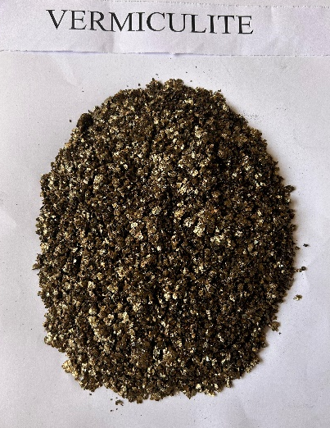
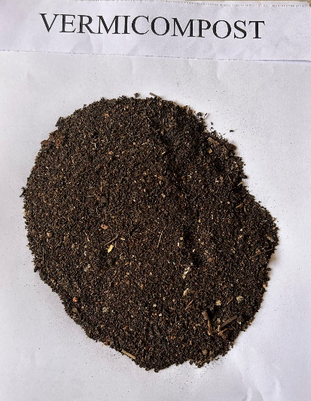
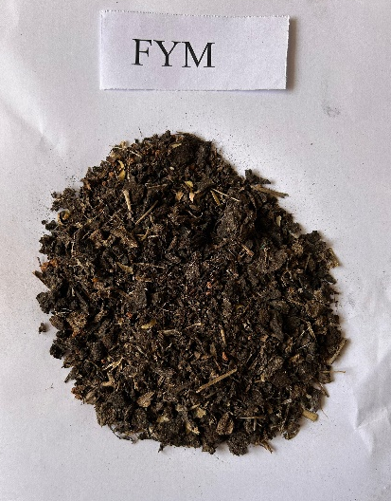
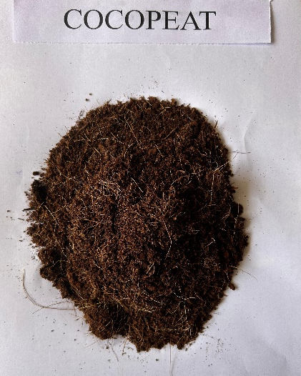

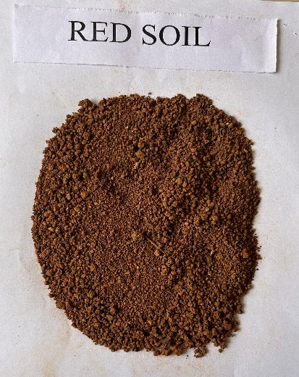
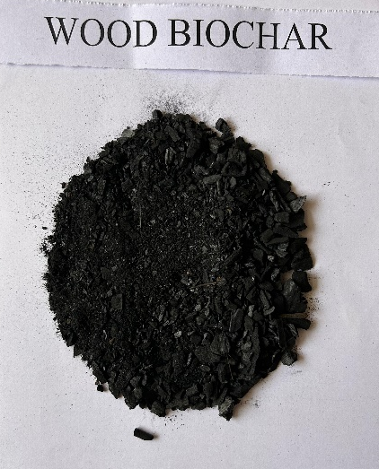
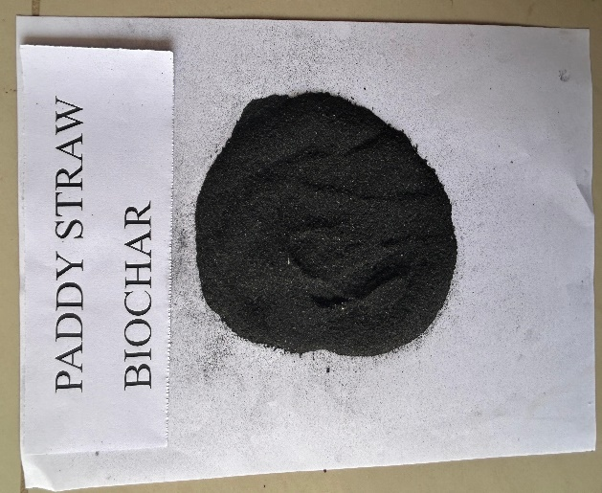
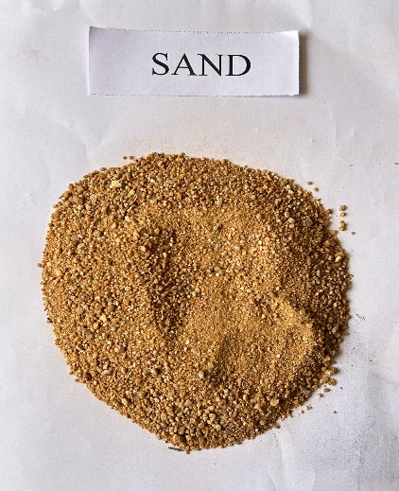

Fig 1. Growing media used for experiment.

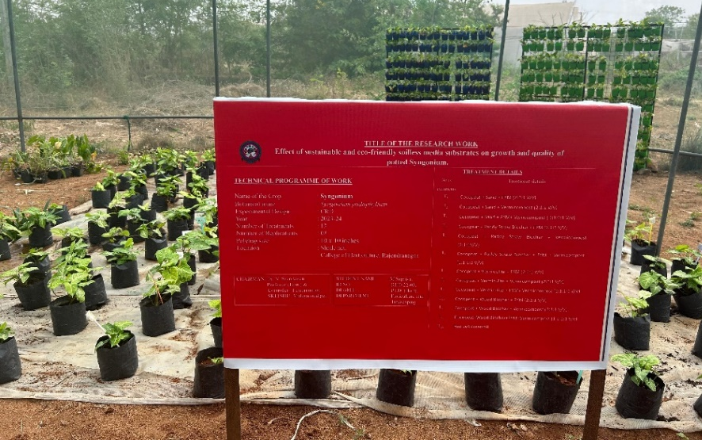

45 Days after planting

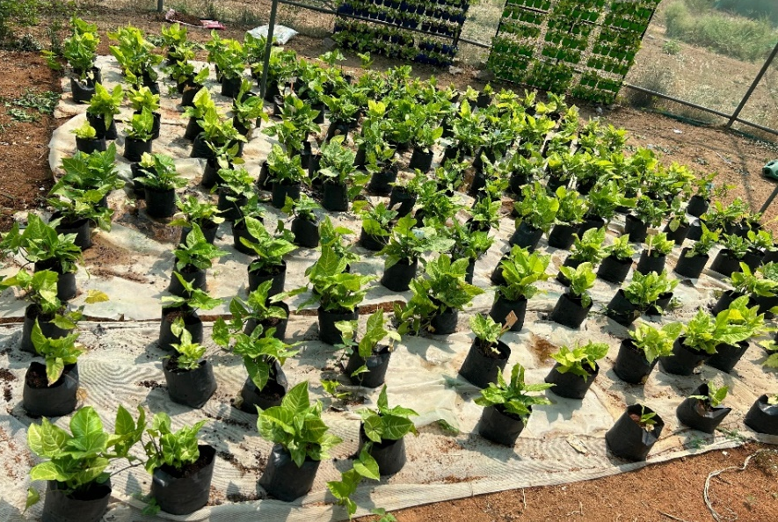

90 Days after planting

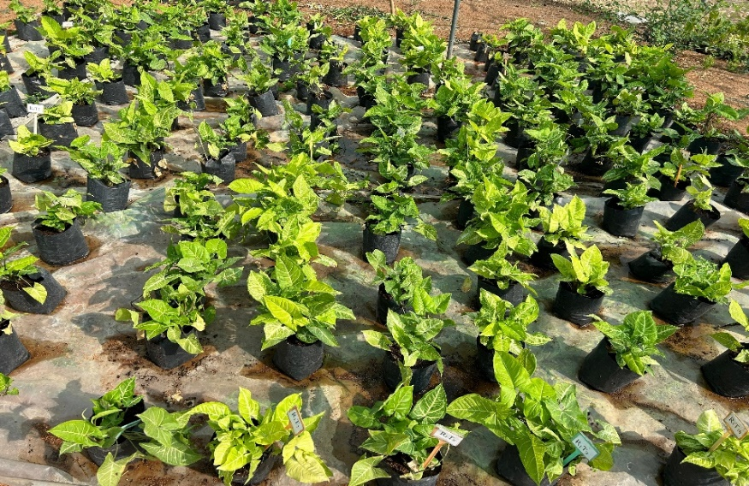

Fig 2. Field view of syngonium at different stages of crop growth as influenced by different growing media

135 Days after planting

Table 1: Effect of different soilless media substrates on Leaf area index, Specific leaf area and Specific leaf weight at 135 DAP of potted syngonium

Treatmets | Leaf area index |  |  | Specific leaf area (cm²/g) |  |  | Specific leaf weight (g/cm²)
Treatmets | 2023 | 2024 | Pooled | 2023 | 2024 | Pooled | 2023 | 2024 | Pooled
T₁ | 2.25 | 2.25 | 2.25 | 408.47 | 417.72 | 413.04 | 0.002 | 0.002 | 0.002
T₂ | 2.35 | 2.34 | 2.35 | 258.20 | 266.88 | 262.48 | 0.004 | 0.004 | 0.004
T₃ | 2.41 | 2.40 | 2.40 | 171.34 | 176.56 | 174.24 | 0.006 | 0.006 | 0.006
T₄ | 2.23 | 2.22 | 2.22 | 486.50 | 502.35 | 494.31 | 0.002 | 0.002 | 0.002
T₅ | 2.28 | 2.28 | 2.28 | 337.53 | 350.86 | 344.08 | 0.003 | 0.003 | 0.003
T₆ | 2.39 | 2.38 | 2.38 | 191.47 | 195.15 | 193.29 | 0.005 | 0.005 | 0.005
T₇ | 2.34 | 2.33 | 2.33 | 265.35 | 274.51 | 274.24 | 0.004 | 0.004 | 0.004
T₈ | 2.42 | 2.42 | 2.42 | 152.95 | 158.87 | 155.86 | 0.007 | 0.006 | 0.006
T₉ | 2.47 | 2.46 | 2.47 | 129.89 | 135.41 | 132.64 | 0.008 | 0.007 | 0.008
T₁₀ | 2.31 | 2.30 | 2.30 | 315.84 | 328.11 | 321.87 | 0.003 | 0.003 | 0.003
T₁₁ | 2.37 | 2.36 | 2.36 | 219.53 | 226.01 | 222.73 | 0.005 | 0.004 | 0.004
T₁₂ | 2.45 | 2.44 | 2.44 | 139.97 | 145.49 | 142.68 | 0.007 | 0.007 | 0.007
T₁₃ | 1.91 | 1.94 | 1.93 | 666.02 | 634.32 | 648.85 | 0.002 | 0.002 | 0.002
SEm ± | 0.02 | 0.01 | 0.02 | 24.84 | 24.00 | 25.23 | 0.0002 | 0.0002 | 0.0002
CD at 5% | 0.05 | 0.04 | 0.04 | 72.2 | 69.76 | 73.34 | 0.0004 | 0.0004 | 0.0006

Fig 3. Effect of soilless media substrates on chlorophyll content at 135 DAP of potted Syngonium

Table 2: Effect of different soilless media substrates on chlorophyll content (SPAD value), Visual plant grade and Visual colour grade at 135 DAP of potted syngonium
Treatment | Chlorophyll content |  |  | Visual plant grade |  |  | Visual colour grade
Treatment | 2023 | 2024 | Pooled | 2023 | 2024 | Pooled | 2023 | 2024 | Pooled
T₁ | 38.52 | 38.46 | 38.49 | 3.13 | 3.13 | 3.13 | 2.73 | 2.73 | 2.73
T₂ | 44.03 | 43.93 | 43.98 | 3.60 | 3.47 | 3.53 | 3.93 | 3.93 | 3.93
T₃ | 48.13 | 48.05 | 48.09 | 3.87 | 3.93 | 3.90 | 4.33 | 4.33 | 4.33
T₄ | 36.50 | 36.36 | 36.43 | 3.27 | 3.27 | 3.27 | 2.73 | 2.73 | 2.73
T₅ | 40.22 | 40.10 | 40.16 | 3.00 | 3.00 | 3.00 | 3.53 | 3.53 | 3.53
T₆ | 46.98 | 46.74 | 46.86 | 3.87 | 3.73 | 3.80 | 4.07 | 4.07 | 4.07
T₇ | 42.79 | 42.61 | 42.70 | 3.40 | 3.33 | 3.37 | 3.80 | 3.80 | 3.80
T₈ | 49.69 | 49.47 | 49.58 | 4.40 | 4.47 | 4.43 | 4.60 | 4.47 | 4.53
T₉ | 52.17 | 51.87 | 52.02 | 4.80 | 4.80 | 4.80 | 4.87 | 4.60 | 4.73
T₁₀ | 41.62 | 41.56 | 41.59 | 3.40 | 3.40 | 3.40 | 3.40 | 3.40 | 3.40
T₁₁ | 45.85 | 45.69 | 45.77 | 3.60 | 3.53 | 3.57 | 3.93 | 3.93 | 3.93
T₁₂ | 50.72 | 50.54 | 50.63 | 4.67 | 4.60 | 4.63 | 4.73 | 4.47 | 4.60
T₁₃ | 29.77 | 28.97 | 29.37 | 1.67 | 1.67 | 1.67 | 0.73 | 0.60 | 0.67
SEm ± | 0.69 | 0.68 | 0.68 | 0.15 | 0.14 | 0.14 | 0.11 | 0.11 | 0.11
CD at 5% | 1.99 | 1.96 | 1.97 | 0.43 | 0.42 | 0.41 | 0.33 | 0.32 | 0.31

Table 3: Effect of different soilless media substrates on Vase life of cut foliage (days) (135DAP) and insitu longevity of leaves at 135 DAP of potted syngonium

Treatment | Vase life of cut foliage (days) |  |  | Insitu longevity of leaves (days)
Treatment | 2023 | 2024 | Pooled | 2023 | 2024 | Pooled
T₁ | 26.67 | 23.27 | 24.97 | 72.60 | 69.20 | 70.90
T₂ | 29.67 | 29.87 | 29.77 | 80.60 | 80.80 | 80.70
T₃ | 33.07 | 33.07 | 33.07 | 85.67 | 85.67 | 85.67
T₄ | 25.53 | 24.13 | 24.83 | 70.07 | 68.67 | 69.37
T₅ | 27.60 | 26.40 | 27.00 | 75.20 | 74.00 | 74.60
T₆ | 32.00 | 31.80 | 31.90 | 83.73 | 83.53 | 83.63
T₇ | 29.13 | 28.73 | 28.93 | 79.40 | 79.00 | 79.20
T₈ | 33.87 | 33.67 | 33.77 | 87.53 | 87.33 | 87.43
T₉ | 35.73 | 36.13 | 35.93 | 90.87 | 91.27 | 91.07
T₁₀ | 28.73 | 28.33 | 28.53 | 76.93 | 76.53 | 76.73
T₁₁ | 30.73 | 30.53 | 30.63 | 82.13 | 81.93 | 82.03
T₁₂ | 35.13 | 34.93 | 35.03 | 88.87 | 88.67 | 88.77
T₁₃ | 21.47 | 18.47 | 20.13 | 64.47 | 61.47 | 62.97
SEm ± | 0.76 | 0.75 | 0.72 | 0.60 | 0.58 | 0.55
CD at 5% | 2.22 | 2.17 | 2.10 | 1.74 | 1.67 | 1.60

Disclaimer (Artificial intelligence)
Author(s) hereby declare that NO generative AI technologies such as Large Language Models (ChatGPT, COPILOT, etc.) and text-to-image generators have been used during the writing or editing of this manuscript.

REFERENCES
- Atiyeh, R. M., Subler, S., Edwards, C. A., Bachman, G., Metzger, J. D., & Shuster, W. (2000). Effects of vermicomposts and composts on plant growth in horticultural container media and soil. Pedobiologia, 44, 579-590. https://doi.org/10.1078/S0031-4056(04)70073-6
- Arancon, N. Q., Edwards, C. A., Atiyeh, R., & Metzger, J. D. (2004). Effects of vermicomposts produced from food waste on the growth and yields of greenhouse peppers. Bioresource Technology, 93(2), 139-144. https://doi.org/10.1016/j.biortech.2003.10.015
- Chamani, E., Joyce. D. C., & Reihanytabar, A. (2008). Vermicompost effects on the growth and flowering of Petunia hybrida ‘Dream Neon Rose’. American Eurasian Journal of Agricultural and Environmental Sciences, 3 (3): 506-512.
- Ghazali, M. R., Shahrum, S. A., Sabd, M., Elias, A., & Ahmad, A. (2018). Application of empty fruit bunches (EFB) and cow manure (CM) compost as planting medium on the growth and yield of chilli (Capsicum annum) treated with different fertilizer. International Journal of ChemTech Research, 11(10), 135-141. https://doi.org/10.20902/IJCTR.2018.111017
- Květ, J., Ondok, J. P., Nečas, J., & Jarvis, P. G. (1971). Methods of growth analysis. In Z. Šesták, J. Čatský, & P. G. Jarvis (Eds.), Plant photosynthetic production: Manual of methods (pp. 343–391). Dr. W. Junk N.V. Publishers. https://books.google.com/books/about/Plant_Photosynthetic_Production.html?id=tD54yAEACAAJ

- Moghadam, A. R. L., Ardebili, Z. O., & Saidi, F. (2012). Vermicompost induced changes in growth and development of Lilium Asiatic hybrid var. Navona. African Journal of Agricultural Research, 7(17), 2609-2621. https://doi.org/10.5897/AJAR11.1806
- Pearce, R. B., Brown, R. H., & Blaser, R. E. (1968). Photosynthesis of Alfalfa Leaves as Influenced by Age and Environment. *Crop Science*, *8*(6), 677-680. https://doi.org/10.2135/cropsci1968.0011183x000800060011x
- Poole, R. T., & Conover, C. A. (1982). Influence of Leaching, Fertilizer Source and Rate, and Potting Media on Foliage Plant Growth, Quality, and Water Utilization. Journal of the American Society for Horticultural Science, 107(5), 793-797. https://doi.org/10.21273/JASHS.107.5.793
- Sahni, S., Sarma, B. K., Singh, D. P., Singh, H. B., & Singh, K. P. (2008). Vermicompost enhances performance of plant growth-promoting rhizobacteria in Cicer arietinum rhizosphere against Sclerotium rolfsii. Crop Protection, 27(3-5), 369-376. https://doi.org/10.1016/j.cropro.2007.07.001
- Sultana, S., Kashem, M., & Mollah, A. (2015). Comparative assessment of cow manure vermicompost and NPK fertilizers and on the growth and production of Zinnia (Zinnia elegans) flower. Open Journal of Soil Science, 5, 193-198. https://doi.org/10.4236/ojss.2015.59019
- Swetha, S., Padmalatha, T., Dhanumjaya Rao, K., & Siva Shankar, A. (2014). Effect of potting media on growth and quality in Aglaonema. Journal of Horticultural Sciences, 9(1), 90-93. https://doi.org/10.24154/jhs.v9i1.231
- Tomati, U., Grappelli, A., & Galli, E. (1988). The hormone-like effect of earthworm casts on plant growth. Biology and Fertility of Soils. https://doi.org/10.1007/BF00262133
- Williams, R. F. (1946). The physiology of plant growth with special reference to the concept of net assimilation rate. Annals of Botany, 10(37), 41-72. https://doi.org/10.1093/oxfordjournals.aob.a083119
- Yasmeen, S., Younis, A., Rayit, A., Riaz, A., & Shabeer, S. (2012). Effect of different substrates on growth and flowering of Dianthus caryophyllus cv. ‘Chauband Mixed’. American-Eurasian Journal of Agricultural & Environmental Sciences, 12(2), 249–258. https://www.idosi.org/aejaes/12(2)12/1.pdf
- Ahmed, W., Ali, B., Kumar, S., Memon, N.-U.-N., Wahocho, N. A., Miano, T. F., & Memon, M.-U.-N. (2022). Seed Germination, Vegetative Growth and Flowering Performance of Cockscomb (Celosia cristata L.) in Response to Different Potting Media. Asian Journal of Agricultural and Horticultural Research, 9(2), 13–22. https://doi.org/10.9734/ajahr/2022/v9i230138

