Original Research Article

Earthworm Casts for Improving Soil Biological Quality in Daloa (Côte d’Ivoire)

.
ABSTRACT

Aims: Intensive agriculture in sub-Saharan Africa, particularly Côte d’Ivoire, degrades soils through physical and biological erosion, reducing their productive capacity. This study explores sustainable fertilization using earthworm casts to enhance soil fertility.
Methodology: Four localities of the city of Daloa (Côte d’Ivoire), namely the neighborhoods “Abattoir”, “Tazibouo Université”, “Tagoura” and “Soleil” were investigated on February 2025. In each neighborhood study site, two composite samples (earthworm casts and surrounding soil) were collected, totalizing for all sites, eight composite samples. Analyses focused on (i) the fungal and bacterial diversity of the casts and soil and (ii) the effect of different quantities of these casts on the physicochemical characteristics and biomass of the soil. For the latter, varying amounts of earthworm casts were mixed with soil to obtain substrates enriched at 0% (T0), 5% (T5), 10% (T10), 15% (T15) and 20% (T20).
Results: Several fungal genera, including Aspergillus, Trichoderma, Mucor, Rhizopus, Neurospora, Sclerotinia, as well as Pseudomonas bacteria, were identified in the collected earthworm casts and soil. The highest and lowest pH value in experimental substrates were 7.16 and 6.7 respectively. Titratable acidity varied between 0.004% and 0.1%. Experimental substrates T5 and T10 enriched with 5% and 10% casts exhibited the highest bacterial biomasses, with 3.4 × 10⁵ CFU/g and 2.5 × 10⁵ CFU/g, respectively.
Conclusion: Earthworm casts and the surrounding soil demonstrated fungal and bacterial diversity of agricultural interest. Experimental substrates T5 and T10 presented the highest bacterial biomasses. These substrates provide improved conditions for soil fertilization.

Keywords: Agriculture, sustainable fertilization, Aspergillus, Pseudomonas, soil health

1. INTRODUCTION

Soil is an ecosystem located at the interface of four major Earth spheres such as the atmosphere, hydrosphere, biosphere and lithosphere that continuously interact with one another. It is both an organic and mineral medium, harboring the greatest diversity of terrestrial organisms, most of which, particularly microorganisms, are closely linked to major biogeochemical cycles and thus to soil functioning (Basu et al., 2021; Timmis & Ramos, 2021). Soil is a non-renewable resource on a human timescale that provides multiple ecosystem services, among which supporting and provisioning services draw particular attention due to their direct connection with food security (Anikwe & Ife, 2023). Indeed, as the foundation of agricultural production, soil is increasingly pressured by the continuous growth of the global population. This pressure is manifested through the expansion of intensive agriculture, developed in response to rising food demand and economic needs associated with demographic growth (Sial et al., 2021; Timmis & Ramos, 2021). The trend is further accentuated in many African countries experiencing high demographic growth rates (Mugizi & Matsumoto, 2020). Intensive agricultural practices are characterized by the massive use of inputs (chemical fertilizers, pesticides, irrigation, improved seeds) and mechanized techniques aimed at achieving high yields on limited land areas (Ouina et al., 2025).
In Côte d’Ivoire, a Sub-Saharan African country, intensive agriculture was the main driver of the first economic miracle during the 1970s and 1980s (WBG, 2019). However, although it significantly increased agricultural productivity, this intensive production system resulted in serious concerns both nationally and globally due to its negative environmental impacts, particularly soil degradation (Bayata, 2024; Sudarshan et al., 2024). Soil degradation is the decline of vital soil properties that enable it to perform its natural roles of storing water and nutrients, supporting roots and plants, serving as a biodiversity reservoir, filtering pollutants and sequestering carbon (Ghisman et al., 2025). Excessive use of chemical fertilizers, pesticides and unsustainable farming practices accelerate the loss of soil fertility, deplete soil biodiversity and compromise the sustainability of agricultural ecosystems (Bayata, 2024). Intensive agricultural dynamics, especially in high-production areas such as the Daloa region (central-west Côte d’Ivoire), place mounting pressure on soils, leading to both physical and biological erosion that reduces soil capacity to sustain agricultural production (Ouina et al., 2025). In this context, the concept of soil biological quality emerges as a central indicator of soil health. It refers to the soil’s ability to maintain stable and functional biological activity, largely ensured by microorganisms and soil macrofauna (Bünemann et al., 2018). These living organisms play a key role in ecological processes such as organic matter decomposition, nutrient cycling regulation and improvement of soil physical properties. Among this macrofauna, earthworms occupy a prominent place. Rightly called “ecosystem engineers,” earthworms influence soil structure, facilitate aeration, accelerate organic matter mineralization and actively regulate microbial communities (Lehmann et al., 2020; Abbas et al., 2025). Their excreta, known as casts, are rich in organic matter and microorganisms. These casts constitute distinct microhabitats, biologically dynamic and favorable to fungal and bacterial diversity (Aira et al., 2019; Lejoly et al., 2024), thus representing an excellent support for microbial activity. The bacterial communities present in fresh casts of the earthworm Aporrectodea caliginosa Savigny were dominated by amplicon sequence variants belonging to the phyla Bacteroidetes and Proteobacteria, which together accounted for 62% of the sequences. In contrast, five other phyla such as Acidobacteria, Actinobacteria, Chloroflexi, Planctomycetes and Verrucomicrobia contributed more modestly, representing 36% of the community composition (Aira et al., 2019). The microbial diversity associated with earthworm casts is considerable and may vary across localities. In Daloa, despite the economic importance of agriculture, biological soil analyses—ideally required before plantation establishment—are often not conducted. Earthworm casts play crucial ecological roles that remain often undervalued within farming systems. This situation hinders the adoption of more sustainable practices, even though casts could serve as relevant tools to improve soil fertility. This study, aligned with Sustainable Development Goal 2 “Zero Hunger” (UN, 2025), aims to reconcile agricultural productivity with environmental preservation. The general objective of this study is to contribute to biological soil fertilization in Daloa through the use of earthworm casts. Specifically, the fungal and bacterial diversity of earthworm casts and surrounding soil was determined and the effects of different quantities of casts on soil physicochemical characteristics and biomass were evaluated.

2. material and methods

2.1 Study site

This study was conducted in Daloa, a city located in the western part of Côte d’Ivoire (Figure 1). The soil there is ferrallitic and the climate is tropical with four well-defined and consecutive seasons (Adjiri et al., 2019). Samples of earthworm casts and soils used for the various analyses were collected specifically in the neighborhoods “Abattoir”, “Tazibouo Université”, “Tagoura” and “Soleil” with respective geographic coordinates “6.8283333 and -6.4375”, “6.9075 and -6.436944”, “6.9325 and -6.46555” and “6.8782248 and -6.491246". Furthermore, work by Toure et al. (2023) indicated Millsonia lamtoiana Omodeo & Vaillaud, M. omodeoi Omodeo, Dichogaster baeri Sciacchitano, D. terraenigrae Omodeo & Vaillaud, D. saliens Beddard, D. erhrhardti Michaelsen, D. papillosa Omodeo, D. eburnean Csuzdi & Tondoh, Dichogaster sp., Hyperiodrilus africanus Beddard, Stuhlmannia zielae Omodeo, S. palustris Omodeo and Gordiodrilus paski Stephenson as species of earthworms found in the Daloa area.

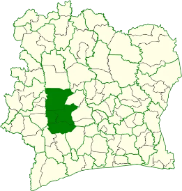

a-Map of Côte d’Ivoire

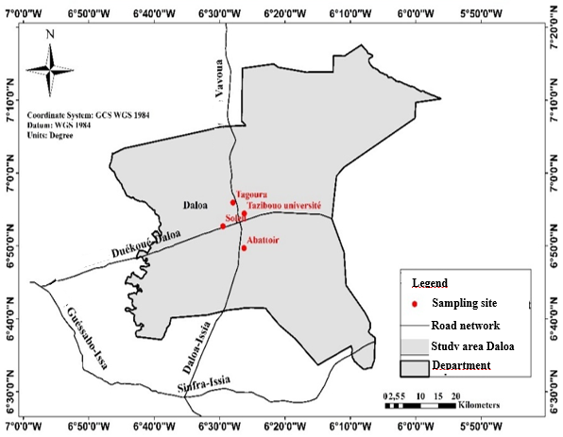

b-Map of Daloa showing different sampling sites

Fig. 1. Geographic distribution of sampling sites

2.2 Sampling

Soil and earthworm cast sampling was carried out during February 2025 following the method described by Ouina et al. (2020) (Figure 2). On a circular area of approximately 6 m in diameter, five elementary samples of earthworm casts (each weighing between 4 and 5 g) and two elementary samples of surrounding soils were collected. The sampling points of the elementary samples were spaced at least about 2 m apart. The casts were collected from the soil surface, while the soil was sampled at a depth of about 15 cm. The soil excavations were carried out with dimensions of 25 × 20 × 15 cm (length × width × depth) using a hoe and a machete, after removing plant and animal debris from the soil surface. The soil masses obtained (approximately 400 g from each excavation) were thoroughly homogenized by hand while wearing protective gloves. From each homogenized mass, a soil sample of about 50 g was collected for analysis. The different elementary samples of casts and soils collected were mixed in the laboratory to obtain, for each site, a composite sample of soil and casts. In total, eight composite samples—4 soil samples and 4 cast samples—were prepared and subjected to subsequent analyses.

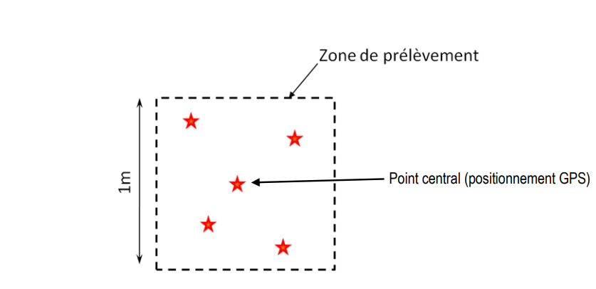
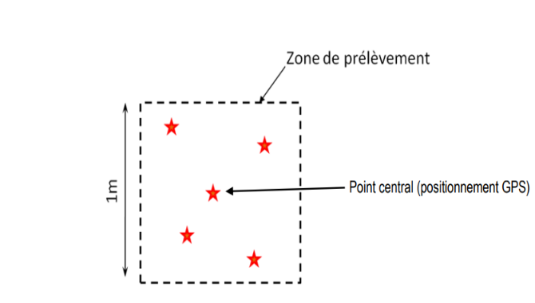
Elementary sample of earthworm cast
Elementary sample of soil
Legend
Fig. 2. Diagrammatic presentation of sampling method followed for earthworm casts and soil at a site
Sampling area diameter
6 m

2.3 Isolation of micro-organisms

Microbiological analysis were carried out using culture media buffered peptone water, Luria–Bertani (LB), Sabouraud with chloramphenicol, Plate count agar (PCA) and Cetrimide agar. These culture media were prepared according to the manufacturers' instructions.
For bacterial isolation, a stock suspension was prepared from earthworm cast and soil samples followed by serial dilutions in accordance with the applicable standard methods. Briefly, for stock suspension, 10 g of each sample were aseptically mixed in 90 mL of buffered peptone water (Difco, Becton Dickinson, Sparks, MD, USA); the whole were stirred for 30 minutes, then allowed to stand for 15 minutes. Volumes (1 mL and 100 µL) of stock suspension or tenfold serial dilution were respectively inoculated into the depth on PCA for isolation of total aerobic mesophilic bacteria and spreaded on Cetrimide agar for Pseudomonas isolation. Cultural conditions were 30°C/24h-48h (ISO 4833-1:2013/Amd 1, 2022; Ouina et al., 2025). After incubation phase, presumptive colonies of Pseudomonas sp. with fluorescent appearances and exhibiting distinct macroscopic characteristics were identified through a series of morphological observations and conventional biochemical reactions. Several characteristics such as morphology, coloration, catalase and oxidase reactions, respiratory type and ability to ferment glucose on Kligler-Hajna media were examined on purified isolates (Ouina et al., 2025).
Fungi were isolated from earthworm cast and soil samples through soil plating technique. Practically, 5 mg of each sample collected from study site were placed in Petri dishes without ergot. Twenty milliliters of Sabouraud with chloramphenicol, previously prepared and kept at 45-50°C, were added thereto. Weighed earthworm cast and soil were immediately dispersed in culture medium with gentle stirring until solidification. Petri dishes were incubated for 72–168 hours at 30°C. Morphologically different fungal colonies were purified and phenotypically identified based on their macroscopic characteristics (shape, relief and colour of the colonies, surface characteristics, culture time) and microscopic characteristics (hyphal partitioning, presence of chlamydospores, shape and size of conidia, phialides) (Ouina et al., 2020).
Micro-organisms (total aerobic mesophilic micro-organisms, Pseudomonas and molds) isolated on media culture were enumerated according to ISO 4833-1:2013/Amd 1, 2022 and ISO 21527-2 (2008). The isolation frequency for fungi was calculated using Walder formula and the diversity of fungal species was assessed using the Shannon–Weaver diversity index (H’) and Pielou’s evenness index (E) as indicated by Tapwal et al. (2023).

2.4 Evaluation of heat resistance in Pseudomonas isolates

The heat resistance of Pseudomonas sp. isolated from earthworm cast samples was evaluated to determine their ability to survive or grow after exposure to elevated temperatures, following the protocol described by Montanari et al. (2015) with minor modifications. Isolates were initially cultivated in LB broth at 30 °C for 24 h. For each isolate, two cultures were prepared, yielding two sets of 24 h broth cultures. One set (test cultures) was subjected to heat treatment by immersion in a water bath at 80 °C for 20 min, while the second set (control cultures) remained untreated. Subsequently, aliquots from both treated and untreated cultures were surface‑inoculated onto cetrimide agar plates. The plates were incubated at 30 °C for 24–48 h, after which colony counts were performed to evaluate survival and growth. This experiment was conducted in triplicate.

2.5 Physicochemical and microbial analysis of soils enriched with earthworm casts

To assess the influence of earthworm castings on soil biological activity, five experimental substrates were formulated by incorporating graded proportions of castings into a homogeneous soil matrix. The treatments consisted of soils enriched with castings at rates of 0%, 5%, 10%, 15% and 20% codified T0, T5, T10, T15 and T20 respectively. Each mixture was prepared to yield 750 g of substrate. For each experimental condition, enriched soil was subjected to a series of biological and physicochemical analyses at three time points: Day 0 (initial), Day 5 (5 days after initial point) and Day 10 (10 days after initial point corresponding to final point). pH and titratable acidity were determined in accordance with standard ISO 10390 (2021) and ISO 14388-3 (2014) respectively. The bacterial biomass was evaluated by enumerating the total aerobic mesophilic flora. Enumeration was performed using the mass seeding method described in Section 2.3. Experiments were performed in triplicate.

2.6 Statistical analyses

The data collected during the laboratory experiments were entered into Microsoft Excel (version 2021) and analyzed using R (version 4.4.1). A generalized linear model (GLM) with a Gaussian distribution and identity link function was used to assess the effect of different proportions of casts on bacterial biomass, pH and titratable acidity of the experimental soil substrates. The significance of the effects was evaluated using an analysis of deviance with the χ² test, with a significance threshold set at p < 0.05.

3. results

3.1 Morphological characteristics of fungi isolated from earthworm casts and soil

Mycological analysis of the different matrices (earthworm casts and soil) led to the isolation of molds belonging to six genera: Aspergillus, Trichoderma, Mucor, Rhizopus, Neurospora and Sclerotinia. The description of the macroscopic and microscopic characteristics of these fungi is presented in the table 1 below.

Table 1. Micromycetes isolated from soil and earthworm casts
Molds | Macroscopic features |  | Microscopic features
Aspergillus sp₁. | 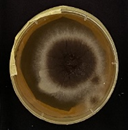  4,5 cm | Circular black colony with white border, black reverse, powdery appearance, moderate growth with low/flat mycelium | 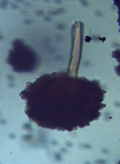  10 µm | Presence of black aspergillar heads at maturity; Long conidiophores
Aspergillus sp₂ | 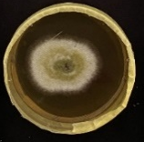  4,5 cm | Greenish colony with a white margin, beige reverse, floccose appearance and moderate growth with low mycelium |   8 µm | Erect conidiophores terminating in a vesicle bearing phialides; chains of round conidia
Aspergillus sp₃. | 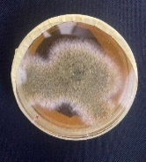  4,5 cm | Greenish to yellowish colony with a beige reverse, floccose to powdery appearance and moderate growth with low mycelium | 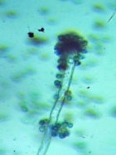  8 µm | Short, smooth, hyaline conidiophores with a progressive widening of the aspergillar heads
Aspergillus sp₄. | 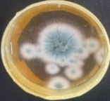  4,5 cm | Whitish colony, becoming entirely green by the 5th day, with a striated beige reverse; floccose texture and moderate growth, low, appressed mycelium | 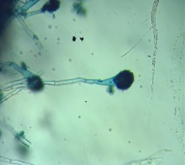  8 µm | Septate hyphae bearing erect, elongated conidiophores that terminate in swollen aspergillar heads
Mucor sp. | 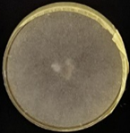  4,5 cm | Whitish colony with beige reverse, cottony appearance and rapid growth with aerial and invasive mycelium | 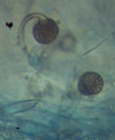 | Conidia enclosed within a sac; presence of a few conidiospores
Rhizopus sp. | 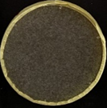  4,5 cm | Whitish colony turning grayish by the 5th day, with a beige reverse. cottony texture and rapid growth, aerial and invasive mycelium | 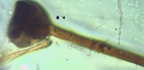  8 µm  10 µm | Sporangiophores arranged in clusters arising from well-developed rhizoids; absence of chlamydospores
Trichoderma sp. | 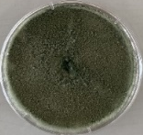  4,5 cm | Colony initially whitish, becoming greenish by the 5th day, with a beige reverse; floccose texture, rapid growth, low, appressed mycelium | 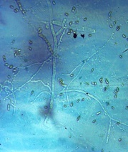  8 µm | Conidiophores with branching; conidia arranged in chains
Neurospora sp. | 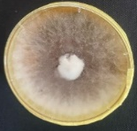  4,5 cm | Colony initially whitish, becoming orange by the 5th day, with a beige reverse, cottony texture and rapid growth, invasive mycelium | 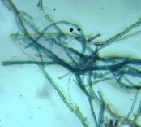  8 µm | Hyphae with fine, transparent filaments intertwine to form a mat
Sclerotinia sp. | 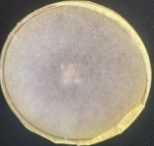  4,5 cm | Colony whitish‑gray with a beige reverse, cottony appearance, rapid growth and aerial, invasive mycelium | 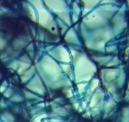  8 µm | Chlamydospores occasionally observed. Filaments in the form of axons intertwine to form a mat

3.2 Fungal diversity in earthworm casts and soils

3.2.1 Species richness

In the neighborhoods of “Tazibouo Université”, “Abattoir” and Tagoura—representing 75% of the study sites—the earthworm cast samples exhibited a higher fungal species richness compared to the surrounding soils. Conversely, at neighborhood ‘’Soleil’’, the soil contained more fungal genera than the casts. The “Abattoir” site displayed the greatest fungal richness, with five species identified in casts and four in soils. Fungal species isolated on Sabouraud medium supplemented with chloramphenicol potentially belonged to six genera of micromycetes: Mucor, Rhizopus, Trichoderma, Aspergillus, Neurospora and Sclerotinia (table 2).

Table 2. Species richness of earthworm casts and soils across sites
Moulds | Tazibouo université |  | Abattoir |  |  | Tagoura |  |  | Soleil
 | Casts | Soil |  | Casts | Soil |  | Casts | Soil | Casts |  | Soil
Aspergillus sp₁ | + | - |  | + | - |  | + | - | - |  | +
Aspergillus sp₂ | + | + |  | - | - |  | + | + | + |  | +
Aspergillus sp₃ | + | + |  | + | - |  | - | - | - |  | -
Aspergillus sp₄ | - | - |  | - | - |  | - | - | + |  | +
Mucor sp. | - | - |  | - | - |  | + | - | - |  | +
Rhizopus sp. | - | - |  | + | + |  | - | - | - |  | -
Trichoderma sp. | - | - |  | + | + |  | - | - | - |  | -
Neurospora sp. | - | - |  | + | + |  | - | - | - |  | -
Sclerotinia sp. | - | - |  | - | + |  | - | + | - |  | -
Richness | 3 | 2 |  | 5 | 4 |  | 3 | 2 | 2 |  | 4
+ or - : fungal presence or absence

3.2.2 Isolation frequency and ecological diversity metrics of fungal communities

In this study, the isolated micromycetes (Aspergillus, Mucor, Rhizopus, Trichoderma, Neurospora and Sclerotinia) exhibited variable isolation frequencies depending on the site and the matrix (Figures 3). The genus Aspergillus was detected at nearly all sites, both in earthworm casts and in soil samples. It was followed by Sclerotinia (present at 75% of sites) and then by Trichoderma and Mucor (each present at 50% of sites). The genera Mucor and Rhizopus, belonging to the class Zygomycota, were particularly abundant in the casts from the Abattoir site. Trichoderma was found exclusively in the casts from Tagoura and Abattoir, with a moderate relative abundance. The assessment of ecological diversity indices associated with the mycoflora of earthworm cast samples yielded the data presented below (Table 3). Shannon indices are approximately similar across sites, with values ranging between 1 and 2. Equitability for each site tends toward 1.

Table 3. Diversity indices of earthworm casts across sites
Ecological indices | Tazibouo Université |  | Abattoir |  |  | Tagoura |  |  | Soleil
H’ | 1.05 |  |  | 1.67 |  |  | 1.24 |  |  | 1.47
E | 0.96 |  |  | 0.93 |  |  | 0.90 |  |  | 0.91
H’: Shannon index; E: Pielou’s evenness

b-Tagoura
a-Tazibouo Université

c-Abattoir
d-Soleil
Legend : |  | Casts |  | Soil
Fig. 3. Fungal isolation frequency in earthworm cast and soil samples across sites
Asp. sp. : Aspergillus sp., Muc. sp. : Mucor sp., Rhi. sp. : Rhizopus sp., Tri. sp. : Trichoderma sp., Neu. sp. : Neurospora sp., Scl. sp. : Sclerotinia sp.

3.4 Thermoresistance of Pseudomonas sp. isolates

Among the morphologically distinct bacterial strains isolated on cetrimide medium from earthworm casts, ten colonies exhibited the biochemical characteristics of Pseudomonas. The thermoresistance assay applied to these isolates (Pseudomonas sp. 1 to Pseudomonas sp. 10) revealed growth only for isolate Pseudomonas sp. 2, corresponding to a survival rate of 10% after treatment.

3.5 Effect of earthworm casts on the biological and physicochemical characteristics of soil

Bacterial biomass, pH and titratable acidity evaluated in the experimental substrates (soils enriched with different proportions of earthworm casts) are presented in figure 3. The analysis of variance revealed that these microbiological and physicochemical parameters varied significantly according to the proportion of earthworm casts (p < 0.05), the treatment duration (p < 0.05) and their interaction (p < 0.05) (Table 4). The data indicate that at day 0, the T0 proportion exhibited the highest bacterial load. Between day 0 and day 5, a marked increase in biomass was observed exclusively in the T5 and T10 proportions, reaching their respective peaks values at 3.4 × 10⁵ CFU/g and 2.5 × 10⁵ CFU/g for substrates. By day 10, a decline in biomass was recorded across all experimental substrates. Regarding physicochemical parameters, pH and acidity levels evolved inversely in all substrates. Except for substrate T10, pH decreased between day 0 and day 10 in substrates T0, T5, T15 and T20. The highest and lowest pH value recorded were 7.16 and 6.7 respectively. Titratable acidity varied between 0.004% and 0.1% with high values observed on day 5 for T5 and T10.

Table 4. Parameters in GLM Analysis
Source of variance | Degrees of freedom (DF) | Deviance (D) | Residual degrees of freedom (DF-res) | Residual deviance (D-res) | Pr (>chi)
Bacterial biomass
NULL | - | - | 44 | 15.75 | -
Proportion | 4 | 55.25 | 40 | 12.86 | < 2.2 x 10⁻¹⁶ ***
Day | 2 | 35.75 | 42 | 0.75 | < 2.2 x 10⁻¹⁶ ***
Proportion: Day | 8 | 7.40 | 36 | 0.016 | < 2.2 x 10⁻¹⁶ ***
***: p < 0.001
pH
NULL | - | - | 44 | 2.89 | -
Proportion | 4 | 5.67 | 40 | 2.45 | < 0.0057**
Day | 2 | 1.23 | 42 | 0.44 | < 0.0011**
Proportion: Day | 8 | 3.56 | 36 | 0.16 | < 0.0017**
**: p < 0.01
Titratable acidity
NULL | - | - | 44 | 0.016 | -
Proportion | 4 | 0.45 | 40 | 0.015 | < 2.2 x 10⁻¹⁶ ***
Day | 2 | 0.05 | 42 | 0.001 | < 2.2 x 10⁻¹⁶ ***
Proportion: Day | 8 | 0.002 | 36 | 0.0017 | < 2.2 x 10⁻¹⁶ ***
***: p < 0.001

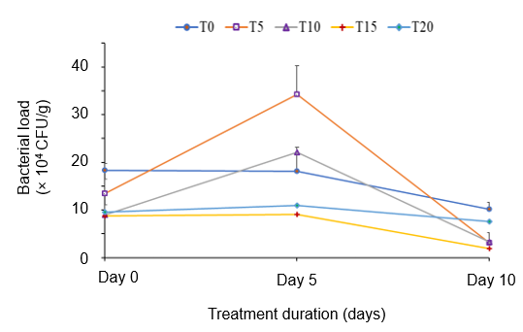
a-Bacterial biomass

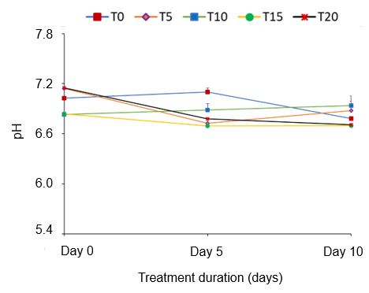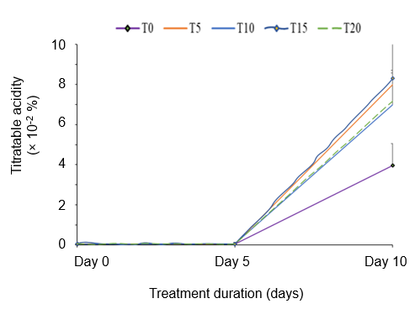
b-pH
c-Titratable acidity
Fig. 4. Biological and physicochemical characteristics of soil substrates enriched with castings
a- Bacterial biomass, b-pH, c-Titratable acidity
T0, T5, T10, T15 and T20: Treatments corresponding to soils enriched with castings at rates of 0%, 5%, 10%, 15%and 20% respectively
;

4. DISCUSSION

Intensive agricultural zones of Daloa exert increasing pressure on soils. This pressure, manifested through both physical and biological erosion, compromises the ability of soils to provide ecosystem services, particularly their capacity to sustain agricultural production (Zhang et al., 2022). Earthworm casts, functioning as unique and biologically active microhabitats (Aira et al., 2019), have the potential to restore and enhance fungal and bacterial diversity within soils.
The mycological analysis conducted on earthworm casts and surrounding soils in Daloa revealed a notable fungal diversity. The six fungal genera identified can be grouped into three categories. The first category comprises fungi of agricultural interest that may serve as biocontrol agents against phytopathogenic organisms, including Aspergillus (García-Conde et al., 2023), Trichoderma and Neurospora (Guzmán-Guzmán et al., 2023; Fofana et al., 2025). This group exhibited the greatest richness. The second category, represented by Sclerotinia, includes phytopathogenic fungi (Zhu et al. 2024). The third category, encompassing Rhizopus and Mucor, is associated with post-harvest rots (Souza et al., 2025). This composition reflects the varied fungal communities typical of tropical soils rich in organic matter. However, under the cultural approach employed, the detected fungal diversity represents only a small fraction of the overall fungal diversity (Wijayawardene et al., 2024). Dominance of the genus Aspergillus corroborates the work of Revathy et al. (2024) who highlighted the predominance of this genus in enriched terrestrial ecosystems. Its high isolation frequency in earthworm casts represents a favorable factor for their valorization as biological fertilizers, owing to the biocontrol capacities associated with these fungi (Ngo et al., 2021). Furthermore, earthworm casts act as “microbial hotspots” due to their high organic matter content, moisture and aeration structure, which favor fungal colonization (Lejoly et al., 2024). Regarding species richness, these structures have a selective effect on microbial communities. Only at the Soleil site, the reduced fungal diversity was observed in earthworm casts. This may be attributed to inter‑microbial competition within the casts, particularly the limitation of fungal resource access by Pseudomonas bacteria as well as to the ecological selection pressures exerted by earthworms (Alattas et al., 2024). In general, the analyzed cast samples exhibited both high and well balanced fungal diversity. For instance, the Shannon index reached 1.67 at the Abattoir site, while evenness values (J) approached or attained unity at several sites. These findings are consistent with the conclusions of Gardi & Jeffery (2013), who identified earthworm casts as significant ecological niches in tropical soils.
The ten Pseudomonas isolates reflect the genus’ well‑known presence in agricultural soils and a range of ecosystems, including earthworm casts (Dolai et al., 2025). Comparative microbial analyses of different types of earthworm casts collected in Ikenne, Ogun State, Nigeria, indicated the presence of several microorganisms, among which Pseudomonas was prominent (Van-Capelle et al., 2012). These bacteria are considered among the most important members of the rhizosphere. Several studies have demonstrated the presence and significance of Pseudomonas in the rhizosphere of plants such as Musa paradisiaca L., Glycine max (L.) Merrill and Zea mays L. (Lal, 2020; FAO et al., 2020). Fluorescent Pseudomonas is rhizobacteria engaged in cooperative interactions with plants. They possess a wide range of phytobeneficial functions with diverse modes of action on plant development, nutrition and health (Ouina et al., 2025). Their occurrence in earthworm casts collected from the investigated sites is therefore of agronomic interest for improving soil fertility. The low survival rate (10%) following heat treatment of Pseudomonas isolates indicates limited heat tolerance, possibly related to the inability of Pseudomonas to form spores, among other factors (Iseppi et al., 2020). However these bacteria are also capable to produce under certain conditions heat-shock proteins such us FtsH and ClpXP, HslVU and Lon to overcome the cellular stresses. These proteases function hierarchically during growth arrest (Basta et al., 2020)
The enrichment of experimental soils with earthworm casts resulted in variations in both biological and physicochemical parameters, namely bacterial biomass, pH and titratable acidity. T0, which exhibits the highest bacterial load, is composed solely of soil. As such, it provides a greater diversity of micro‑habitats and a stable availability of nutrients (Wang et al., 2024), in contrast to the other substrates based on earthworm casts, which represent secondary environments where biomass is reduced due to digestion and transformation by earthworms (Medina-Sauza et al. 2019). Earthworm casts mixed with soil provide readily available nutrients that stimulate microbial activity (Edwards & Arancon, 2022), explaining the peaks in bacterial biomass 3.4 × 10⁵ CFU/g and 2.5 × 10⁵ CFU/g respectively observed in substrates T5 and T10 during the first five days, favored by near‑neutral pH conditions (6.7-7.16). Microbial biomass, composed primarily of bacteria and fungi, plays a central role in decomposing crop residues and organic matter in soils. This decomposition process releases essential nutrients such as nitrogen, potassium, phosphorus and sulfur, which become available for plant uptake (FAO et al., 2020). A high microbial biomass is therefore a key indicator of a healthy soil ecosystem, where microorganisms drive nutrient cycling and decomposition processes. However, at higher proportions (T15 and T20), they may also contain inhibitory factors or microbial competitors, such as actinomycetes or fungi producing antimicrobial compounds (Nwankwo et al., 2023), thereby rendering the environment less conducive to bacterial growth. Furthermore, the accumulation of organic acids in all experimental substrates between day 5 and day 10 contributed to creating an unfavorable environment for bacterial development (Shindu et al., 2022).

4. Conclusion

This study highlights the richness and diversity of fungal and bacterial communities in earthworm casts and surrounding soils from the investigated localities in Daloa. These matrices represent true microhabitats conducive to the establishment of organized, diverse and functionally active microbial communities. The presence of agronomically relevant fungi such as Aspergillus, Trichoderma and Neurospora, along with Pseudomonas spp. strains in earthworm casts, underscores their potential role in pathogen biocontrol and soil health improvement. The experimental soil–cast substrates T5 and T10, characterized by the highest microbial biomasses (3.4 × 10⁵ CFU/g and 2.5 × 10⁵ CFU/g respectively), emerging as the most effective mixtures with optimal cast proportions. Thus, earthworm casts should not be regarded merely as residues, but rather as essential agents of soil regeneration and microbial ecosystem stimulation, contributing to the sustainability of agricultural production.

DISCLAIMER (ARTIFICIAL INTELLIGENCE)

Author(s) hereby declare that NO generative AI technologies such as Large Language Models (ChatGPT, COPILOT, etc) and text-to-image generators have been used during writing or editing of this manuscript.

References

Abbas, G., Hasnain, M., Umm-E-Haseeba, Sarwar, A., Altaf, J., Ghayyur, S., Jameel, R., Iqbal, M.K., Wahid, M., & Rahul, F. (2025). Earthworms enhance the soil fertility, soil structure and facilitate nutrient cycling. In R. Kausar, Z.U. Nisa, M. Jamil & I. Bashir (Eds.), Integrated Health and Sustainability: Plants, Wildlifeand Genetic Resilience (pp. 197-202). Unique Scientific Publishers. https://doi.org/10.47278/book.HH/2025.413
Adjiri, O. A., Kone, B., Aka, N., Djabakate, I., & Dibi, B. (2019). Caractérisation physico-chimique et source de la minéralisation des eaux souterraines des départements de Daloa et Zoukougbeu, Côte d'Ivoire. International Journal of Biological and Chemical Sciences. https://doi.org/10.4314/ijbcs.v13i4.40
Aira, M., Pérez-Losada, M., & Domínguez, J. (2019). Microbiome dynamics during cast ageing in the earthworm Aporrectodea caliginosa. Applied Soil Ecology, 139, 56-63. https://doi.org/10.1016/j.apsoil.2019.03.019
Alattas, H., Glick, B. R., Murphy, D. V., & Scott, C. (2024). Harnessing Pseudomonas spp. for sustainable plant crop protection. Frontiers in Microbiology, 15, 1485197. https://doi.org/10.3389/fmicb.2024.1485197
Anikwe, M. A. N., & Ife, K. (2023). The role of soil ecosystem services in the circular bioeconomy. Frontiers in Soil Science. https://doi.org/10.3389/fsoil.2023.1209100
Basta, D. W., Angeles-Albores, D., Spero, M. A., Ciemniecki, J. A., & Newman, D. K. (2020). Heat-shock proteases promote survival of Pseudomonas aeruginosa during growth arrest. Proceedings of the National Academy of Sciences, 117 (8), 4358-4367. https://doi.org/10.1073/pnas.1912082117
Basu, S., Kumar, G., Chhabra, S., & Prasad, R. (2021). Role of soil microbes in biogeochemical cycle for enhancing soil fertility. In J. P. Verma, C. A. Macdonald, V. K. Gupta & A. R. Podile (Eds.), New and future developments in microbial biotechnology and bioengineering (pp. 149–157). Elsevier. https://doi.org/10.1016/B978-0-444-64325-4.00013-4
Bayata, A. (2024). Soil degradation: Contributing factors and extensive impacts on agricultural practices and ecological systems- systematic review. Journal of Agriculture and Environmental Sciences, 13, 16-34. https://doi.org/10.15640/ijhs.v13a2
Bünemann, E. K., Bongiorno, G., Bai, Z., Creamer, R. E., De Deyn, G., de Goede, R., Fleskens, L., Geissen, V., Kuyper, T. W., Mäder, P., Pulleman, M., Sukkel, W., van Groenigen, J. W., & Brussaard, L. (2018). Soil quality – A critical review. Soil Biology and Biochemistry, 120, 105–125. https://doi.org/10.1016/j.soilbio.2018.01.030
Dolai, S., Rejaul, S. K., Bera, M., Moulick, D., Chatterjee, G., Barua, S., & Tripathi, S. (2025). Exploring different Pseudomonads strains with efficient cellulolytic, pectinolytic, proteolytic, and lipolytic activity in consortia for bioaugmentation of sustainable urban organic waste composting. Cleaner Waste Systems, 12, 100405, https://doi.org/10.1016/j.clwas.2025.100405
Edwards, C. A., & Arancon, N. Q. (2022). Interactions between earthworms, microorganismsand other invertebrates. In C. A. Edwards & N. Q. Arancon (Eds.), Biology and ecology of earthworms (4th ed., pp. 275-301). Springer US, New York (USA). https://doi.org/10.1007/978-0-387-74943-3_9
FAO, ITPS, GSBI, SCBD, & EC. (2020). State of knowledge of soil biodiversity – Status, challenges and potentialities, Summary for policy makers. https://doi.org/10.4060/cb1929en
Fofana, O., Voko Bi, R. D. R., & Kouassi, K. C. (2025). Evaluation of Biocontrol of Mycosphaerella fijiensis by five Species of Rhizosphere Fungi of Plantain. Journal of basic microbiology, 65(9), e70020. https://doi.org/10.1002/jobm.70020.
García-Conde, K. B., Cerna-Chávez, E., Ochoa-Fuentes, Y. M., & Velázquez-Guerrero, J. J. (2024). Aspergillus oryzae: An opportunity for agriculture. Mexican Journal of Phytopathology, 42(1) https://doi.org/10.18781/R.MEX.FIT.2302-2
Gardi, C., Jeffery, S., & Saltelli, A. (2013). An estimate of potential threats levels to soil biodiversity in EU. Global Change Biology, 19(5), 1538–1548. https://doi.org/10.1111/gcb.12159
Ghisman, V., Muresan, A. C., Bogatu, N. L., Herbei, E. E. & Buruiana, D. L. (2025). Recent advances in the remediation of degraded and contaminated soils: A Review of Sustainable and Applied Strategies. Agronomy, 15(8), 1920. https://doi.org/10.3390/agronomy15081920
Guzmán-Guzmán, P., Kumar, A., de los Santos-Villalobos, S., Parra-Cota, F. I., Orozco-Mosqueda, M. d. C., Fadiji, A. E., Hyder, S., Babalola, O. O., & Santoyo, G. (2023). Trichoderma species: Our best fungal allies in the biocontrol of plant diseases—A review. Plants, 12(3), 432. https://doi.org/10.3390/plants12030432
Iseppi, R., Sabia, C., Bondi, M., Mariani, M., & Messi, P. (2020). Virulence Factors, Drug Resistance and Biofilm Formation in Pseudomonas Species Isolated from Healthcare Water Systems. Current Microbiology, 77(8), 1737–1745. https://doi.org/10.1007/s00284-020-01990-9
International Organization for Standardization. (2021). Soil, treated biowaste and sludge – Determination of pH (ISO 10390:2021). https://standards.iteh.ai/catalog/standards/sist/f2ca1637-a0cb-47a8-a868-cd68a9defd91/iso-10390-2021
ISO. (2014). Soil quality — Acid-base accounting procedure for acid sulfate soils — Part 3: Suspension peroxide oxidation combined acidity and sulfur (SPOCAS) methodology. https://standards.iteh.ai/catalog/standards/sist/559b1549-ab77-4bfe-9edd-b575435c82e2/iso-14388-3-2014
ISO. (2008). Microbiology of food and animal feeding stuffs — Horizontal method for the enumeration of yeasts and moulds — Part 2: Colony count technique in products with water activity less than or equal to 0,95. https://standards.iteh.ai/catalog/standards/sist/2b0fca40-f356-488a-8b9b-bd2ae5e787bd/iso-21527-2-2008
International Organization for Standardization. (2022). Microbiology of the food chain — Horizontal method for the enumeration of microorganisms — Part 1: Colony count at 30 °C by the pour plate technique — Amendment 1: Clarification of scope (ISO 4833-1:2013/Amd 1:2022). https://www.iso.org/standard/53728.html
Lal, R. (2020). Soil organic matter content and crop yield. Journal of Soil and Water Conservation, 75(2), 27-32. https://doi.org/10.2489/jswc.75.2.27A
Lehmann, J., Bossio, D. A., Kögel-Knabner, I., & Rillig, M. C. (2020). The concept and future prospects of soil health. Nature Reviews Earth & Environment, 1(10), 544–553. https://doi.org/10.1038/s43017-020-0080-8
Lejoly, J.D.M., Quideau, S.A., Laganière, J., Karst, J., Martineau, C., Samad, A. (2024). Earthworm cast microbiomes differ across soil types in northern forests. Applied Soil Ecology, 200, 105466. https://doi.org/10.1016/j.apsoil.2024.105466
Medina-Sauza, R. M., Álvarez-Jiménez, M., Delhal, A., Reverchon, F., Blouin, M., Guerrero-Analco, J. A., Cerdán, C. R., Guevara, R., Villain, L., & Barois, I. (2019). Earthworms building up soil microbiota, a review. Frontiers in Environmental Science, 7, 81. https://doi.org/ 10.3389/fenvs.2019.00081
Montanari, C., Serrazanetti, D. I., Felis, G., Torriani, S., Tabanelli, G., Lanciotti, R., & Gardini, F. (2015). New insights in thermal resistance of staphylococcal strains belonging to the species Staphylococcus epidermidis, Staphylococcus lugdunensis and Staphylococcus aureus, Food Control, 50, 605-612. https://doi.org/10.1016/j.foodcont.2014.09.039
Mugizi, F. M. P., & Matsumoto, T. (2020). Population pressure and soil quality in Sub-Saharan Africa: Panel evidence from Kenya. Land Use Policy, 94, 104499. https://doi.org/10.1016/j.landusepol.2020.104499
Ngo, M. T., Nguyen, M. V., Han, J. W., Kim, B., Kim, Y. K., Park, M. S., Kim, H., & Choi, G. J. (2021). Biocontrol potential of Aspergillus species producing antimicrobial metabolites. Frontiers in Microbiology, 12, 804333. https://doi.org/10.3389/fmicb.2021.804333
Nwankwo, I. U., Edward, K. C., & Udensi, C. G. (2023). Screening of bacteria isolates from earthworm cast for antibacterial activities. Scientia Africana, 22 (2), 83-94. https://doi.org/10.4314/sa.v22i2.9
Ouina, T. S. T., Voko Bi, R. D. R., Ya, K. C., Kouamé, P. E. W., Koussemon-Camara, M., & Konate, I. (2025). Isolation of Fluorescent Pseudomonas spp. from Degraded Agricultural Soils in the Daloa Region: Salt Stress Resistance Capacity. Journal of Applied & Environmental Microbiology, 13(1), 33-40. https://doi.org/10.12691/jaem-13-1-5
Ouina, T. S., Panoff, J.-M., Gente, S., Garon, D., Rioult, J.-P., Gonnety, T. J., & Koussémon, M. (2020). Cropping practices and fungal contamination in banana plantations in Côte d'Ivoire. Research Journal of Microbiology, 15(3), 98-108. https://doi.org/10.3923/jm.2020.98.108
Revathy, M. R., Mohan, A. S., Kesavan, D., Sarasan, M., & Rosamma P. (2024). Endophytic fungi of spurred mangrove, Ceriops tagal and its bioactivity potential: Predominance of Aspergillus species and its ecological significance. The Microbe, 4, 100144. https://doi.org/10.1016/j.microb.2024.100144
Sial, A. K., Shankar, T., Praharaj, S., Sahoo, U., & Maitra, S. (2021). Intensive Farming: It's Effect on the Environment. Indian Journal of Natural Sciences, 12(69), 37480-37487. https://www.tnsroindia.org.in/journals.html
Sindhu, S. S., Sehrawat, A. & Glick, B. R. (2022). The involvement of organic acids in soil fertility, plant health and environment sustainability. Archives of Microbiology, 204, 720. https://doi.org/10.1007/s00203-022-03321-x
Souza, A. E. de A., Santiago, A. L. C. M. de A., Brito, A. C. de Q., Melo, J. A. da S., Souza-Motta, C. M., & Machado, A. R. (2025). New reports of Rhizopus and Mucor (Mucorales, Mucoromycota) causing postharvest rot in tropical fruits in Brazil. Journal of Plant Diseases and Protection, 132(1), 5. https://doi.org/10.1007/s41348-024-01035-4
Sudarshan, S., Niveditha, M.P., Alekhya, G., Supriya, Chethan Babu, R.T., & Chethan Kumar, K.B. (2024). Effects of intensive agricultural management practices on soil biodiversity and implications for ecosystem functioning: A review. International Journal of Research in Agronomy, 7(9), 166-169. https://doi.org/10.33545/2618060X.2024.v7.i9Sc.1446
Tapwal, A., Kumar, A., & Sharma, S. (2023). Diversity of arbuscular mycorrhizal fungi in the rhizosphere of Angelica glauca and Valeriana jatamansi in NW Himalaya, India. Asian Journal of Forestry, 7 (2), 89-98. https://doi.org/10.13057/asianjfor/r070203
Timmis, K., & Ramos, J. L. (2021). The soil crisis: the need to treat as a global health problem and the pivotal role of microbes in prophylaxis and therapy. Microbial Biotechnology, 14(3), 769-797. https://doi.org/10.1111/1751-7915.13771
Toure, B., Zro Bi, G. F., & Guéi, A. M. (2023). Involvement of earthworm populations in indicating the physico-chemical state of soil under three types of perennial crops in the department of Daloa (Centre-West of Ivory Coast). International Journal of Innovation and Scientific Research, 67(1), 119-128.
UN (United Nations). (2015). Sustainable Development Goals: 17 Goals to Transform Our World. United Nations. https://www.un.org/sustainabledevelopment/
Van-Capelle, C., Schrader, S., & Brunotte, J. (2012). Tillage-induced changes in the functional diversity of soil biota – A review with a focus on German data. European Journal of Soil Biology, 50, 165–181. https://doi.org/10.1016/j.ejsobi.2012.02.005
Wang, X., Chi, Y., & Song, S. (2024). Important soil microbiota’s eects on plants and soils: a comprehensive 30-year systematic literature review. Frontiers in Microbiology, 15, 1347745. https://doi.org/10.3389/fmicb.2024.1347745
Wijayawardene, N. N., Bahram, M., Sánchez-Castro, I., Dai, D.-Q., Ariyawansa, K. G. S. U., Jayalal, U., Suwannarach, N., & Tedersoo, L. (2021). Current insight into culture-dependent and culture-independent methods in discovering ascomycetous taxa. Journal of Fungi, 7(9), 703. https://doi.org/10.3390/jof7090703
World Bank Group. (2019). Republic of Côte d'Ivoire: Agricultural Sector Update. https://documents1.worldbank.org/curated/en/452631564064496467/pdf/Cote-d-Ivoire-Agricultural-Sector-Update.pdf
Zhang, S., Hu, W., Xu, Y., Zhong, H., Kong, Z., & Wu, L. (2022). Linking bacterial and fungal assemblages to soil nutrient cycling within different aggregate sizes in agroecosystem. Frontiers in Microbiology. https://doi.org/10.3389/fmicb.2022.1038536
Zhu, Y., Wu, C., Deng, Y., Yuan, W., Zhang, T., & Lu, J. (2024). Recent advances in virulence of a broad host range plant pathogen Sclerotinia sclerotiorum: a mini-review. Frontiers in Microbiology. https://doi.org/10.3389/fmicb.2024.1424130

