Development and Evaluation of a Mechanized Destalking System for Dry Chilli Processing

ABSTRACT
India is the leading global producer, consumer, and exporter of chilli (Capsicum annuum), yet the destalking of dry chilli remains a labor-intensive and health-hazardous operation. Manual removal of the calyx and stalk increases labor costs, exposes workers to respiratory ailments, and limits the adoption of post-harvest mechanization. To overcome these challenges, this research aimed to develop and evaluate the performance of a mechanized destalking system for dry chilli processing. The system consists of a perforated rotating trammel cylinder, a fixed sharp blade, internal baffles, collectors, and a 1.5 HP motor regulated through a variable frequency drive. As chillies rotate inside the perforated cylinder, the stalks entangle and are slit by the blade, allowing continuous separation. The machine achieved a maximum capacity of 60.83 kg/h, 83.80% destalking efficiency, 4.4% breakage, and 0.62 kWh energy consumption. Optimal performance occurred at 10.37% moisture content, 61.67 kg/h feed rate, 5° inclination, and 15 rpm, with an overall desirability of 0.78.
Keywords: chilli, health-hazardous operation, labor-intensive, mechanized destalking system
INTRODUCTION
Chilli (Capsicum annuum) holds the prominent position in Indian agriculture, with India being the world’s largest producer, consumer, and exporter. Dry chilli is an important raw material for a wide range of food, spice, and value-added industries, thereby significantly contributing to improving the rural livelihoods and the national economy. Despite its economic importance, chilli harvesting and post-harvest operations continue to depend heavily on manual labor. Among these operations, destalking—the removal of the calyx and stalk from the pod is particularly labor-intensive and time-consuming [1].
Traditionally, destalking is carried out either in the field during harvest or manually during processing. This dependence on labor has created multiple challenges. Rising labor costs compel farmers to shift to less profitable and less labor-demanding crops, reducing the cultivation of potential crops such as chilli. Additionally, destalking chilli manually exposes workers to its dust, leading to respiratory health problems such as asthma and tuberculosis [2]. These issues not only affect worker safety but also limit the scalability and mechanization potential of chilli processing units. On the other hand, the lack of an efficient destalking technology has discouraged growers and processors from adopting mechanized systems, as manual destalking merely shifts labor from the field to post-harvest operations. To address these pressing limitations, the development of a dedicated destalking machine becomes essential. Mechanizing the destalking operation can significantly reduce drudgery, improve processing efficiency, and provide economic benefits to both farmers and processors by reducing dependency on manual labor.
Based on the reviewed literature, the development of chilli destalking machines has evolved from simple manual mechanisms to advanced sensor and vision-based systems. Early work demonstrated a manual batch-type destalker based on controlled cutting force, suitable for small-scale operation [3]. Subsequent studies focused on automation using laser sensors and machine vision for precise stem identification and removal [4, 5]. Modeling approaches such as DEM were successfully applied to predict destemming efficiency and impurity levels for grapes [6]. Recent research integrates high-speed GPU algorithms and semi-automatic machine designs to improve capacity, accuracy, and energy efficiency [7, 8] indicating scope for developing cost-effective, efficient destalking machines for agricultural processing. Further, a grape destemming mechanism was developed [9] using the screw, i.e., destemming blades and barrel mechanism along with sieve to destem the grapes stalk and separate the fruits from stalk.
In response to these needs, an attempt to mechanize the destalking process of dry chilli that should be a portable and low-cost was developed. The machine integrates a perforated rotating trammel cylinder, a sharp fixed blade, internal baffles, and a 1.5 HP motor with VFD control to ensure uniform and controlled operation. Its performance demonstrates promising results, offering an efficient and economical alternative to manual destalking and paving the way for wider adoption of chilli post-harvest mechanization.
METHOD
The research on the chilli destalking machine was carried out following a systematic and structured methodology for its development and evaluation. Initially, data were collected through field observations, interactions with chilli processors, and a comprehensive review of existing literature related to chilli processing technologies. Based on these inputs, the conceptual and engineering design of the chilli destalking machine was undertaken, fabricated, performance evaluation and formulation was carried out. The machine components and assembly were modelled using SolidWorks software. In accordance with established product development principles, the complete design process was planned at the early stages of development [10]. Accordingly, the design procedure comprised three major stages: study of the engineering properties of chilli, conceptual design and detailed design of the machine.
Before initiating fabrication, a detailed work plan was formulated to evaluate the engineering properties of dry chilli required for defining suitable machining parameters. The geometric properties studied included length (L, mm), width (W, mm), thickness (T, mm), stalk length (Sl, mm), stalk width (Sw, mm), and crown height (Ch, mm). In addition, gravimetric properties such as true density and bulk density, frictional properties including coefficient of friction and textural properties of the stalk, particularly hardness, were determined to support machine design [12, 14, 15].
Material and machine parameters essential for fabrication were finalized. Stainless steel (SS 304) was selected for all components that are in contact with food material. A pulley–belt system was employed for power transmission from the motor to the shaft and a three-phase, 1.5 HP electric motor was used as the power source. Safety protocols and a sequential manufacturing plan were incorporated to ensure smooth and efficient fabrication.
The performance of the developed chilli destalking machine was optimized using Response Surface Methodology (RSM), a statistical tool for analysing complex processes. Four independent variables such as moisture content, feed rate, cylinder speed and cylinder inclination were studied at five levels using a Central Composite Rotatable Design (CCRD) with 30 experimental runs. The responses considered were destalking capacity, destalking efficiency, broken chilli percentage and energy consumption. Optimization aimed to maximize capacity and efficiency while minimizing breakage and energy use. Experimental data were analyzed using Design-Expert 10.7 software and model significance was evaluated through ANOVA at a 95% confidence level. Based on these tests, the functional suitability and operational efficiency of the machine were evaluated. The data obtained from the tests were used to compute key performance indicators such as destalking capacity [11], destalking efficiency [12] and amount of chilli broken [13] was calculated using Eq. 1, 2 and 3 respectively.
$\text{Capacity of the machine (kg/h) =}\frac{\text{Quantity of feed (kg)}}{\text{Time taken for destalking (min)}}\text{ …(1)}$
$$\text{ Destalking efficiency (\%), }\text{∈}\text{ = }\frac{{\text{W}}_{\text{p}}}{W_{f}}\text{ × 100 …(2)}$$
$${\text{ Amount of chilli broken (\%), P}}_{\text{b}}\text{= }\frac{W_{b}}{W_{f}}\text{ ×100 …(3)}$$
Where, ∈ = Destalking efficiency, (%)
W_{p} = Quantity of actual feed destalked, (kg)
W_{m}= Total feed weight, input (kg)
W_{b} = Weight of chilli broken (kg)
RESULT AND DISCUSSION
This section presents and discusses the engineering properties of dry chilli evaluated for the development of a destalking machine. The results are interpreted in relation to machine design requirements, operational parameters and performance considerations, highlighting how the measured physical, mechanical, frictional and aerodynamic properties influence the efficiency, functionality and reliability of the developed chilli destalking machine. These properties were measured at the moisture content of 8-9% on dry basis.
Table 1: Geometrical properties of dry chilli
Variables | Minimum value | Maximum value | Mean value with standard deviation
Whole length (L), mm | 97.37 | 124.9 | 109.40 ± 14.1
Width (W), mm | 13.81 | 19.56 | 16.72±2.88
Thickness (T), mm | 5.77 | 7.01 | 6.30±0.64
Stalk length (S_{l}), mm | 23.67 | 32.33 | 27.55±4.39
Stalk thickness (St), mm | 2.76 | 3.05 | 2.90 ± 3.06
Da (arithmetic mean diameter) mm | 38.98 | 50.20 | 44.14±5.66
Dg (geometric mean diameter) mm | 19.21 | 23.87 | 21.85±2.39
S (Surface area), mm² | 11.59 | 17.89 | 15.11±3.21
Ø ( Spericity index) | 0.19 | 0.21 | 0.20±0.01
The geometric properties (Table 1) indicated considerable variation in chilli size, with mean values of length (109.40 mm), width (16.72 mm) and thickness (6.30 mm), highlighting the need for adequate clearances and flexible feeding mechanisms. Stalk length (27.55 mm) and thickness (2.90 mm) are critical for determining the cutting or shearing action required for effective stalk removal. The low sphericity value (0.20) confirms the elongated shape of chilli, necessitating a machine capable of handling random orientation.
Table 2. Gravimetric properties of dry chilli
Variables | Minimum value | Maximum value | Mean value with standard deviation
True density (kg/m³) | 240 | 300 | 270±3
Bulk density (kg/m³) | 100 | 160 | 130±4
Porosity (%) | 33.33 | 61.54 | 50.51±15.07

Gravimetric properties (Table 2) showed a mean true density of 270 kg/m³ and bulk density of 130 kg/m³, resulting in high porosity (50.51%), which favors free movement and tumbling of chillies within the perforated cylinder.

Table 3 Other functional properties of dry chilli
Variables |  | Minimum value | Maximum value | Mean value with standard deviation
Hardness (N/mm²) | Pod | 34.33 | 46.57 | 40.44 ± 6.12
Hardness (N/mm²) | Stalk | 60.45 | 72.33 | 66.06 ± 5.95
Coefficient of friction | Stainless steel | 0.33 | 0.39 | 0.36 ± 0.02
Coefficient of friction | Mild steel | 0.38 | 0.42 | 0.40 ± 0.2
Coefficient of friction | Galvanic iron | 0.50 | 0.58 | 0.54 ± 0.4
Terminal velocity (m/s) |  | 3.20 | 4.60 | 3.66 ± 0.86
The other functional properties (Table 3) such as mechanical property (Textural analysis revealed that stalk hardness (66.06 N/mm²) was significantly higher than pod hardness (40.44 N/mm²), justifying selective force application. Lower coefficients of friction on stainless steel (0.36) support its use for smooth material flow and the terminal velocity (3.66 m/s) provides guidance for air-assisted separation of stalks and impurities, ensuring efficient and damage-free destalking.
Based on the engineering properties discussed in above section the design of individual components of prototype chilli destalking machine was developed.
Power Requirement for Rotating Cylinder
The power requirement of the destalking machine was determined based on the torque developed by the rotating cylinder, standard design procedure [16]. The calculated torque was 223.6 N·m, corresponding to a cylinder speed of 25 rpm, a cylinder diameter of 570 mm, and a combined load (cylinder and chilli mass) of 883 N. Accordingly, the power requirement was estimated as 731.8 W. Considering a factor of safety of 1.25 [6], the total power requirement was calculated as 1.22 HP. Hence, based on availability in the market a 1.5 HP gear motor was selected for the developed machine. A variable frequency drive (VFD) was incorporated to regulate the rotational speed of the motor.
Shaft
The shaft material selected was mild steel with a carbon content of 0.2–0.3%. The shaft diameter designed was 25 mm [17], and the shaft length was fixed at 2695 mm. Square keyways of 8 mm × 8 mm were machined on both ends of the shaft to facilitate proper locking with bearings. One bearing was connected to a rocker arm to allow limited movement with the shaft, while the other end was directly coupled to the 1.5 HP gear motor.
Feeding Tray
A gravity-fed, open-type hopper was developed [18] to facilitate smooth feeding of chillies into the destalking cylinder. The hopper volume was determined according to the rated machine capacity. The coefficient of friction for stainless steel was found to be 0.36 ± 0.02, and the hopper inclination angle was fixed at 19.7°, ensuring uninterrupted material flow.
Development of Rotating Cylinder
The perforated rotating cylinder forms the core of the destalking assembly and is directly driven by the 1.5 HP geared motor. The design was adopted to ensure adequate strength for transmitting rotary motion and withstanding operational loads.

Volume of Rotating Drum
The volume of the drum was determined based on a target machine capacity of 60 kg/h, suitable for small and marginal farmers with typical harvest quantities of 50–70 kg. Thus, drum volume was calculated as 0.49 m³ [19].
Based on the material property study of dry chilli and overall design of indivial component, a chilli destalking machine was developed and fabricated with overall dimensions of 3530 mm in length, 960 mm in width, and 1401 mm in height. The complete design of the chilli destalking machine, modelled using Solid Works software, is presented in Fig. 1, while the assembled view of the fully fabricated machine is shown in Fig. 2.
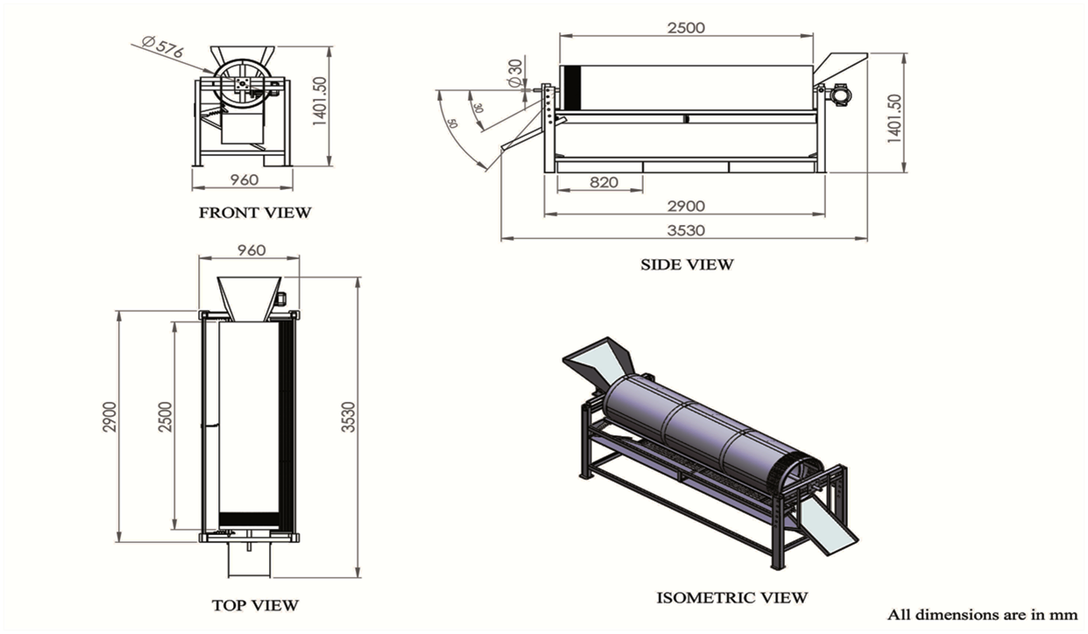
Fig. 1 Design of destalking machine
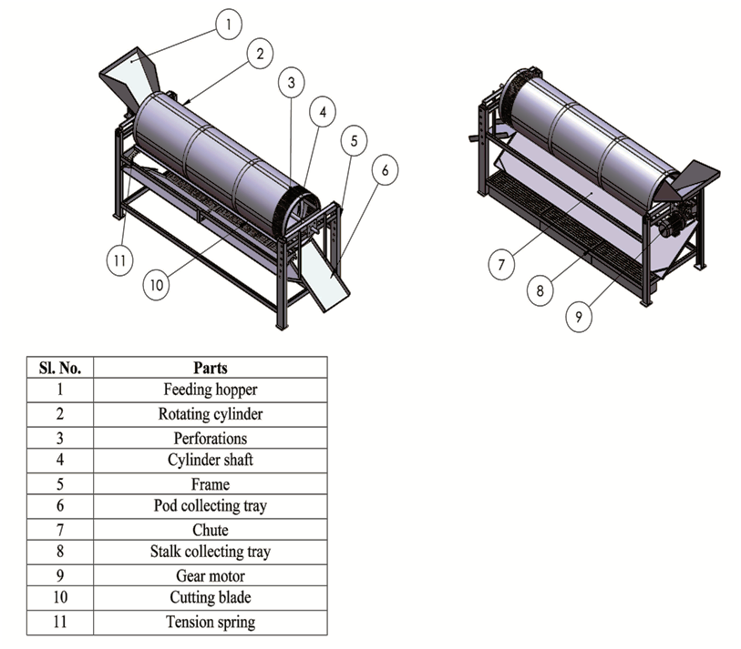
Fig. 2 The Assembly of chilli destalking machine
The developed chilli destalking machine offers several advantages that enhance safety, efficiency, and operational performance. The machine is equipped with a variable frequency drive (VFD), allowing the operator to adjust the speed of the rotating trammel cylinder by simply regulating the frequency. A protective transmission cover is provided to ensure operator safety by preventing accidental contact with moving components during operation. The clearance between the fixed blade and the perforated cylinder can be adjusted by loosening or tightening the fixing bolts, enabling efficient stalk cutting while minimizing chilli breakage. The frame is designed with vibration-resistant support, ensuring stable performance even when the rotating cylinder operates at higher speeds.
The working principle of the chilli destalking machine involves feeding dried chillies into the hopper, from where they enter the rotating perforated cylinder. As the cylinder rotates, the stalks get trapped in the rectangular perforations and are slit by the fixed sharp blade. The internal baffles facilitate the forward movement of chillies, ensuring continuous processing. The chipped stalks fall through the perforations and are collected below, while the destalked chillies exit at the discharge end of the cylinder. This separation mechanism ensures efficient removal of stalks with minimal damage to chilli pods.
The chilli destalking machine was developed following a structured Work Preparation (WP) process, covering machining parameters, safety guidelines, and manufacturing steps. The machine is powered by a 1.5 HP three-phase motor operated through a VFD. Performance testing showed smooth functioning under various operating conditions. During the test, the machine successfully destalked approximately 60.83 kg of dry chilli per hour with an efficiency of 83.80%, while maintaining minimal breakage of 4.4%. Similar, results were reported for the grape destemming mechanism [9]
Based on the performance data, the destalking capacity and efficiency of the machine were calculated as:
$$\text{Capacity of the machine (kg/h) =}\frac{\text{60.83 (kg)}}{\text{60 (min)}}\text{ = 60.83 kg/h}$$
$$\text{ Destalking efficiency (\%), }\text{∈}\text{ = }\frac{\text{50.28}}{60}\text{ × 100 = 83.80 \% }$$
These results confirm the machine’s suitability for efficient chilli destalking operations. Fig. 3 shows the developed of destalking machine. Table 4 shows the performance of the machine under various operating parameters.
Table 4 The performance of the destalking machine
S No | Performance Parameters | Result
1. | Capacity | 60.83 kg/h
2. | Efficiency | 83.80%
3 | Energy Consumption | 0.62kWh
4 | Breakage of chilli | 4.4 %

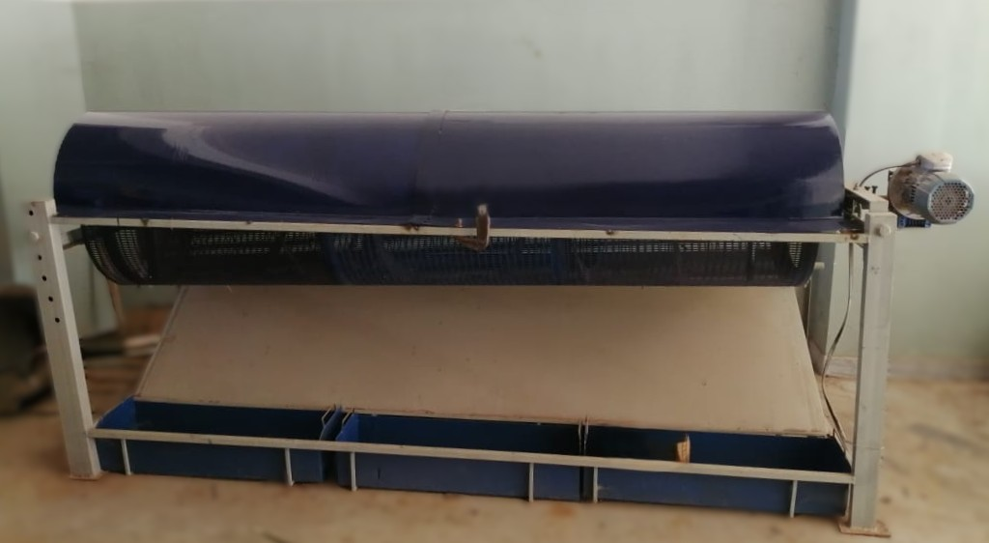
Fig. 3 Developed chilli destalking machine

CONCLUSION
The evaluation of engineering properties of dry chilli provided a scientific basis for the design of the destalking machine. The measured geometric, gravimetric, functional and aerodynamic properties enabled appropriate selection of machine dimensions, materials, and operating parameters, ensuring efficient stalk separation, smooth material flow, reduced pod damage, and reliable machine performance.
The design of the chilli destalking machine was developed using Solidworks software. The machine achieved a maximum capacity of 60.83 kg/h, 83.80% destalking efficiency, 4.4% breakage, and 0.62 kWh energy consumption. Optimal performance occurred at 10.37% moisture content, 61.67 kg/h feed rate, 5° inclination of perforated rotating cylinder , and 15 rpm, with an overall desirability of 0.78.
The machine has overall dimensions of 3530 mm in length, 965 mm in width, and 904 mm in height. It operates with a total power requirement corresponding to a 1.5 HP three-phase motor, regulated by a variable frequency drive (VFD) for precise speed control. These specifications confirm that the developed chilli destalking machine is efficient, stable, and suitable for small-scale and medium-scale chilli processing applications.
Disclaimer (Artificial intelligence)
Author(s) hereby declare that NO generative AI technologies such as Large Language Models (ChatGPT, COPILOT, etc.) and text-to-image generators have been used during the writing or editing of this manuscript.

REFERENCE:
- Walker, S. J., & Funk, P. A. (2014). Mechanizing Chile Peppers: Challenges and Advances in Transitioning Harvest of New Mexico's Signature Crop. HortTechnology. https://doi.org/10.21273/HORTTECH.24.3.281
- Singh, V., & Meena, S. S. (2021). Occupational health hazards faced by workers in the minor chilli processing industry. The Pharma Innovation Journal, 10(8), 1499-1502. http://www.thepharmajournal.com/archives/2021/vol10issue8/PartV/10-8-10-777.pdf
- Mangraj, S., Singh, A., Samuel, D. V. K. and Singhal, O. P. 2001. Comparative performance evaluation of different drying methods for chillis. Journal of Food Science and Technology, 38: 296-299
- Knorr, R. J., & Victor, J. (2008). *Pepper de-stemming* (U.S. Patent Application No. US 2008/0289515 A1). https://patents.google.com/patent/US20080289515A1
- Herbon, R. P., Cillessen, D. E., Gamillo, E. M., & Hyde, A. M. (2010). Designing a High Volume Chile De-stemming Machine. American Society of Agricultural and Biological Engineers. https://doi.org/10.13031/2013.30000
- Coetzee, C. J., & Lombard, S. G. (2013). The destemming of grapes: Experiments and discrete element modelling. *Biosystems Engineering*, *114*(3), 232–248. https://doi.org/10.1016/j.biosystemseng.2012.12.014
- Gunes, M., & Badem, H. (2016). Detecting Direction of Pepper Stem by Using CUDA-Based Accelerated Hybrid Intuitionistic Fuzzy Edge Detection and ANN. Journal of Sensors. https://doi.org/10.1155/2016/4052101
- Nguyen Thanh Phong, Le Anh Dec, & Bui Ngọc Hung. (2018). Study on designing, manufacturing and testing a chilli de-stemming semi-automatic machine. Journal of Technical Education Science, 13(1), 34–42. https://www.jte.edu.vn/index.php/jte/article/view/348
- Lyaruu, H M., Warwa, G.M., Yuda, B.L & Makage N.R. (2025). Design and Evaluation of Grapes Crusher De-Stemmer Machine for Small to Medium-Scale Grape Producers. Sumerianz Journal of Scientific Research. 8. 1-14
- Gesudraj, 2012. Unpublished thesis on “Development and performance evaluation of dehusker for foxtail millet (setariaitalica)”. Department of PFE, College of Agricultural Engineering, UAS, Raichur.
- Muto, K., Kimita, K., & Shimomura, Y. (2015). A Guideline for Product-Service-Systems Design Process. Procedia CIRP, 30, 60-65. https://doi.org/10.1016/j.procir.2015.02.188
- Agrawal, Y. C. 1987. Ginger peeling machine parameters. Agricultural Mechanization in Asia, Africa and Latin America 18: 2; 59 – 62.
- Balami, A. A.; Mohammed, I. A.; Adebayo, S. E.; Adgidzi, D.; Adelemi, A.A. 2012. The Relevance of Some Engineering properties of Cocoyam (Colocasia Esculenta) in the Design of Post-harvest processing Machine. Acad. Res. Int, 2: 53–59.
- Mohsenin, N. N. (1970). Physical properties of plant and animal materials. Gordon and Breach Science Publishers. https://books.google.com/books/about/Physical_Properties_of_Plant_and_Animal.html?id=2_4PAQAAMAAJ
- Dash, A. K., Pradhan, R. C., Das, L. M., & Naik, S. N. (2008). Some physical properties of simarouba fruit and kernel. International Agrophysics, 22(2), 111-116. https://www.international-agrophysics.org/artykuly/issue-2-2008-vol-22/some-physical-properties-of-simarouba-fruit-and-kernel
- Fadeyibi, A., & Ajao, O. F. (2020). Design and Performance Evaluation of a Multi-Tuber Peeling Machine. AgriEngineering, 2(1), 55-71. https://doi.org/10.3390/agriengineering2010004
- Khurmi, R. S. and Gupta, J. K., 2005. A textbook of machine design, Eurasia publishing House (Pvt.) Limited; New Delhi, India : 261.
- Ashaolu, M. O. 1989. Design and construction of a cassava chipping machine. Unpublished M.Sc. Thesis, Department of Agricultural Engineering, University of Ibadan, Ibadan, Nigeria.
- Ademosun, O. C., Jimoh, M. O., & Olukunle, O. J. (2012). Effect of physical and mechanical properties of cassava tubers on the performance of an automated peeling machine. *International Journal of Development and Sustainability, 1*(3), 810–822. https://www.isdsnet.com/ijds/volume1/IJDS12080704.pdf

