Production of commercial-quality tomatoes on two different types of substrate

Asbtract
The quality of tomatoes is determined by factors such as appearance, hue, texture, nutritional value, ripeness of consumption, and flavor, the latter of which is quantified through the measurement of soluble solids and organic acids. This study aimed to observe and quantify the phenotypic response of the crop and evaluate the potential of these materials and use them as an alternative in protected agriculture. This research was carried out in a greenhouse within the facilities of the Faculty of Agricultural and Livestock Sciences of the Benemérita Autonomous University of Puebla, during the months of March - July 2024. The vegetative material evaluated was the saladette INKA® tomato genotype, which was acquired from a commercial nursery approximately 30 days after germination. The tomato seedling was transplanted into 40 x 40 cm bags filled with substrates (mixtures of tepojal and vermicompost in proportions of 100:0, 50:50 and 75:25, % by volume) at three densities of (3.0 plants, 4.5 plants and 6.0 plants m-2). The substrate that maximized the parameters regarding fruit quality was the one made up volumetrically of tepojal and vermicompost in the proportion (%) 75:25, however, with the 50:50 substrate the results were similar, but in this one the quantity of vermicompost used was double, which increases production costs, so the use of vermicompost mixed with tepojal favors the quality of tomato fruits in terms of size, weight and uniformity, important parameters that define the commercial standards of the fruit. The use of vermicompost in mixture with tepojal favors the quality of tomato fruits in terms of size, weight and uniformity, important parameters that define the commercial standards of the fruit. Therefore, the use of tepojal and vermicompost mixtures was an effective strategy for the production of saladette tomatoes in greenhouse conditions.

Keywords: Greenhouse, substrates, Solanum lycopersicum L.; saledette tomato

Introduction

Greenhouse tomato production faces multiple challenges, including the excessive use of nonrenewable substrates that are difficult to dispose of after use. Currently, most growers propagate tomatoes in rockwool, but there is an increasing demand for sustainable media. Several environmental factors, including temperature, humidity, light conditions, growing media, irrigation, and nutrient concentrations, affect germination and establishment. The selection of a proper growing media or substrate is crucial as it serves as a reservoir of moisture and nutrients around the plant’s roots, and the pore space of the substrates also provides oxygen, which is essential for seed germination and establishment (Chandni et al., 2020; Chowdhury et al., 2024). In Mexico, tomato production has both economic and social relevance. In 2023, the saladette tomato harvest under protected conditions reached a total of 1,842,265 tons in 12,200 hectares planted, generating a value of 10,456 million pesos (SIAP, 2023). Protected cultivation aid to create favourable micro-climate near the crop and also help to achieve independence of weather and enables the farmers to fetches the higher earnings per unit area with additional benefit like earlier maturity, increase yield, better quality, reduced diseases and pest infestation, increase crop growth period causing longer harvesting duration which ensure off-season supply of produce (Sinha et al., 2020).

In some countries in Europe and the United States, production systems have been implemented, where ball-type cultivars of indeterminate growth are used, using densities of 2 to 3 plants per m2, allowing the plants to reach more than 7 meters in height with the aim of harvesting around 20 and 25 bunches during a period of 10 to 11 months from transplantation to harvest achieving good yield per hectare in high-tech greenhouses (Peet & Welles, 2005; Resh, 2004).

In Mexico, the Autonomous University of Chapingo has developed a system for the production of tomatoes in hydroponics under greenhouses, which consists of reducing the crop cycle to less than four months with early trimming techniques and, in combination with a transplant of adult seedlings, maintaining population densities of 8 and 12 plants per m2, Sánchez-del Castillo et al. (2012),

The quality of tomatoes is determined by factors such as appearance, hue, texture, nutritional value, ripeness for consumption, and flavor, the latter of which is quantified through the measurement of soluble solids and organic acids (Kader, 2002). The post-harvest quality and shelf life of the fruits depend on the degree of ripeness at the time of harvest (Alam et al., 2006), although Kolota and Adamczewska, 2001; Raiola et al., 2015 mention that the quality of the fruit in vegetables is influenced by their genetic inheritance, whether it is a variety or some type of hybrid; in addition to factors that play an important role such as climatic conditions, fertilization, production method, irrigation and plant development.

Vermicompost improves soils, stimulates crop production and provides essential nutrients to plants (Ruiz-Morales, 2011), in the same way pumice or tepojal stone has physical properties that can be beneficial for agriculture and its cost is affordable (Cruz Crespo et al., 2019).

In the present research, the quality of tomato fruits in tepojal and vermicompost substrates was evaluated at different densities, higher than those commonly established in the cultivation of saladette tomatoes in greenhouse conditions, to observe and quantify the phenotypic response of the crop and evaluate the potential of these materials and use them as an alternative in protected agriculture.

Materials and methods

This study was carried out in a greenhouse of the Faculty of Agricultural and Livestock Sciences, belonging to the Meritorious Autonomous University of Puebla, during the months of March - July 2024 which is located in the auxiliary board of San Juan Acateno, Teziutlán, Puebla, Mexico, its coordinates: 19º 49' 04'' North latitude and 97° 21' 39'' West longitude, it is located at an elevation of 1,675 meters above sea level (INEGI, 2024).

The vegetative material evaluated was the genotype of INKA® saladette tomato, which was acquired from a commercial nursery approximately 30 days after germination. The tomato seedling was transplanted in 40 x 40 cm bags filled with substrates (tepojal and vermicompost mixtures in proportions of 100:0, 50:50 and 75:25, % by volume) in three densities (3.0 plants, 4.5 plants and 6.0 plants ^{m-2}). A directed irrigation system with microtubings and 4.0 L h-1 drippers was used; each plant was supplied by two drippers. In addition, an automatic timer was installed to carry out four irrigations per day at specific times (8:00 a.m., 12:00 a.m., 15:00 p.m. and 18:00 p.m.). The amount of irrigation used was around 2.4 L per plant per day. The crop was worked on a single stem having on average eight bunches with approximately five fruits each, the plants were limited in their growth to a height of 2m since it reached the height of the localized tutoring system, a phytosanitary control was carried out which was carried out within the framework of integrated pest and disease management, that is, control was included through organic products and only in cases of severity were chemical synthesis products used.

The nutrient solution used was Steiner (1984) handling different concentrations according to the phenological stage, 50% in the vegetative stage and 100% in the reproductive stage, with a concentration (mEq L-1): 12.0 NO₃-, 1.0 H2PO4-, 7.0 SO42-, 7.0 K+, 9.0 Ca2+ and 4.0 Mg2+, for the elaboration of this nutrient solution the following fertilizers were used in g L-1 quantities: KNO3 (0.303), Ca (NO₃)₂·4H₂O (1.062), KH2PO4 (0.136), MgSO₄·7H2O (0.492) and K2SO4 (0.261), it is important to note that sulfuric acid was used throughout the crop cycle in order to adjust and maintain a pH of 5.5 favors better nutrient absorption. An optimal pH for vegetable production is between 5. 3 and 6. 5, in a slightly acidic range (Abad et al., 2001).

Experimental design
It was established by means of a Completely Randomized Design with a 3x3 factorial arrangement, taking into consideration the factors: Mixtures (M) and Densities (D) of plant ^{m-2}, with three levels each, resulting in 9 treatments of the combination of factors and levels.

Study factors
The following study factors were established (Table 1).
Study factors
D: Densities | S: Substrate (Tepojal : Vermicompost, v : v)
D1: 3 plants per square meter | S1: Witness (Tepojal)
D2: 4.5 plants per square meter | S2:75:25
D3: 6 plants per square meter | S3: 50:50
Table 1. Description of the study factors.

Treatments
The treatments evaluated and their description are shown in Table 2.

Table 2. Description of treatments.
Treatment | Combination of factors | Description
1 | D1S1 | 3 plants ^{m-2} and tepojal as substrate
2 | D1S2 | 3 plants ^{m-2} and as substrate  75 % Tepojal : 25 % Worm compote
3 | D1S3 | 3 plants ^{m-2} and as substrate  50 % Tepojal : 50 % Vermicompote
4 | D2S1 | 4.5 ^{M-2} and Tepojal plants as substrate
5 | D2S2 | 4.5 plants ^{m-2} and as substrate  75 %Tepojal: 25 % Worm compote
6 | D2S3 | 4.5 plants ^{m-2} and as substrate  50 % Tepojal : 50 % Vermicompote
7 | D3S1 | 6 ^{m-2 plants} and tepojal as substrate
8 | D3S2 | 6 plants ^{m-2} and as substrate  75 %Tepojal: 25 % Worm compote
9 | D3S3 | 6 plants ^{m-2} and as substrate  50 % Tepojal : 50 % Vermicompote

The experimental unit was made up of 4 plants where 3 replications were had, the experimental plot covered an area of 2 m2.

Statistical analysis
The results obtained were analyzed with the response variables of each treatment, analysis of variance (ANDEVA) and multiple comparisons of Tukey means (P≤ 0.05) were performed using the SAS statistical package version 9.0

Variables evaluated
To determine the yield and quality of fruits, they were evaluated from the first harvest of fruit, starting 68 days after transplantation, the weight (g) of each fruit was determined with an electronic scale of the VELAB brand with an accuracy of 0.1 g, for the polar and equatorial diameter of the fruit (mm) a Steren digital vernier was used with an accuracy of 0.2mm, in the number of fruits harvested the number of fruits present in the plant was counted at the time it reached its physiological maturity and was ready to harvest and for the degrees brix (°brix) it was measured with an ATAGO digital refractometer model PR-101.

Results and discussion

Table 3 presents the statistical significance (Pr > F) of the analyses of variance performed for the quality parameters of the harvested fruits such as: equatorial diameter, polar diameter, fruit weight and total soluble solids.

Table 3. Summary of the analysis of variance for the growth parameters of the harvested fruits of tomato plants (Solanum lycopesicum L.) due to the effect of plant density (D), the substrate used and the interaction (D x S).
Variable | F.V. | G.L. | Statistical significance (Pr > F)
 |  |  | First | 2nd | Third | 4th | 5th | 6th | 7th | 8th | Prom,
 | D | 2 | 0.6500 | 0.9743 | 0.5123 | 0.4455 | 0.5711 | 0.8845 | 0.4828 | 0.1976 | 0.8137
OF | S | 2 | 0.3098 | 0.4309 | 0.1612 | <.0001 | <.0001 | 0.0005 | 0.6297 | 0.3972 | 0.0539
 | D x S | 4 | 0.8550 | 0.1543 | 0.9675 | 0.0008 | 0.1621 | 0.5532 | 0.3882 | 0.4758 | 0.9202
 | D | 2 | 0.7634 | 0.0003 | 0.7991 | 0.9168 | 0.2727 | 0.8138 | 0.4420 | 0.1173 | 0.0322
DP | S | 2 | 0.6282 | <.0001 | 0.1706 | 0.0368 | 0.0531 | 0.1263 | 0.5591 | 0.1812 | 0.0004
 | D x S | 4 | 0.7787 | 0.2876 | 0.9755 | 0.4521 | 0.5672 | 0.1306 | 0.4956 | 0.3521 | 0.8753
 | D | 2 | 0.7253 | 0.0686 | 0.4852 | 0.2273 | 0.1808 | 0.2273 | 0.5852 | 0.8278 | 0.8923
PF | S | 2 | 0.1671 | 0.0015 | 0.0471 | 0.4186 | 0.2180 | 0.0002 | 0.1964 | 0.1647 | 0.0004
 | D x S | 4 | 0.5250 | 0.2808 | 0.8120 | 0.4303 | 0.4960 | 0.3915 | 0.6489 | 0.8374 | 0.9588
 | D | 2 | 0.9307 | Nd | Nd | Nd | Nd | Nd | Nd | 0.6554 | 0.8507
TSS | S | 2 | 0.0021 | Nd | Nd | Nd | Nd | Nd | Nd | 0.0812 | 0.0029
 | D x S | 4 | 0.9924 | Nd | Nd | Nd | Nd | Nd | Nd | 0.4658 | 0.9680
SD = Equatorial diameter; DP = Polar diameter; PF = Fruit weight; TSD = Total Dissolved Solids; Nd = not determined.

Equatorial diameter (SD)
The DE showed a great variability in each of the eight harvested bunches (Table 3), according to the summary of the analysis of variance it had a highly significant effect on the 4th, 5th and 6th bunches due to the substrate used, which influenced the general average of each treatment (Table 4), the substrate with a proportion of 75:25 resulted with the highest ED in the fruits reaching an average (52.75 mm), while the 50: and 100:0 substrates presented statistically equivalent and lower averages (51.79 mm). In relation to what was obtained, De la Cruz et al., (2010) reported an average diameter of 56 mm when investigating the impact of three composts and three vermicomposts combined in different proportions (100, 75 and 50 %) with sand, in greenhouse conditions.
Substrate (%)  T : V | Average
100 : 0 | 51.57 b
75 : 25 | 52.75 a
50 : 50 | 51.58 b
DMS | 1.10
Table 4. Equatorial diameter by effect of the substrate used (% Tepojal : % Vermicompost) and in each harvested bunch.
Means with the same letter per column are not significantly different (Tukey, p≤0.05).
T = Tepojal : V = Vermicomposta

The variation in the DE of each harvested bunch and due to the effect of the type of substrate used is presented in Figure 1, where an increase from 1° to 5° cluster can be observed for substrates with proportions 75:25 and 100:0, however, the DE in the last harvested bunches tend to decrease. on the other hand, in the 100:0 substrate, it shows a very irregular variation trend from 1st to 8th cluster.

Figure 1. Variation of the equatorial diameter due to the effect of the substrate used
(% Tepojal : % Vermicompost) and in each harvested bunch.

Polar Diameter (DP)
The PD of the fruits was evaluated in the 8 harvested bunches, based on the analysis of variance carried out (Table 3) it is observed that the effect of the substrate used was significant in the 2nd, 4th and 5th bunches (Table 5). The substrate with a 75:25 ratio produced fruits that will reach a higher DP (81.31 mm) while the substrates with 50:50 and 100:0 produce fruits with the lowest average PD (78.85 mm).

Table 5. Polar diameter by effect of the substrate used (% Tepojal : % Vermicompost) and in each harvested bunch.
Substrate (%)  T : V | Average
100 : 0 | 78.48 b
75 : 25 | 81.31 to
50 : 50 | 79.34 b
DMS | 1.63
Means with the same letter per column are not significantly different (Tukey, p≤0.05).
T = Tepojal : V = Vermicomposta

Figure 2 shows the variation in the PD of the fruits of the eight harvested bunches, as well as the effect of the type of substrate used, in which a general trend of increase in PD between the 1st and 8th bunches can be observed, although intermediate decreases are recorded in all the substrates evaluated.
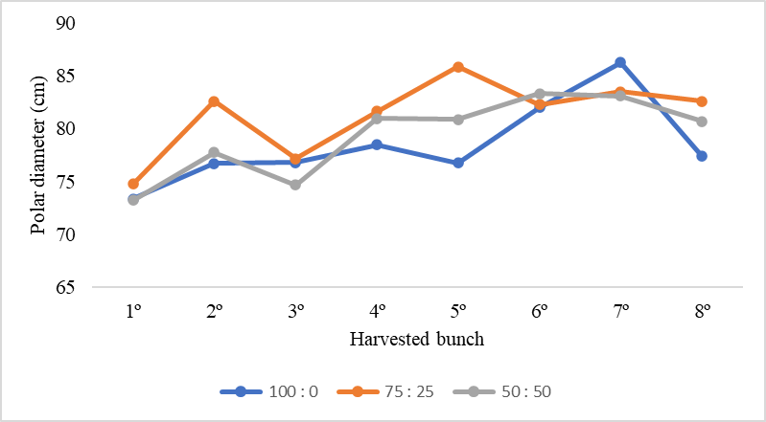

Figure 2. Variation of the polar diameter due to the effect of the substrate used
(% Tepojal : % Vermicompost) and in each harvested bunch.

Fruit Weight (PF)
The PF was evaluated in each of the eight harvested bunches, according to the analysis of variance carried out (Table 3), the effect of the substrate used was significant for the 2nd, 3rd and 6th bunches, in Table 6. It is shown that the proportion of the substrate 75:25 was achieved to obtain the fruits with the heaviest weight, reaching an average of 96.53 g, while with the mixtures 50:50 and 100:0 the fruits with the lowest weight were obtained with an average of 91.48 g. Ashcroft et al., (1993), stated that fruit size is driven by genetic and physiological factors such as ripening, trimming, and defoliation.

Table 6. Weight of the fruit due to the effect of the substrate used (% Tepojal : % Vermicompost) and in each bunch harvested.
Substrate (%)  T : V | Average
100 : 0 | 91.11 b
75 : 25 | 96.53 to
50 : 50 | 91.84 b
DMS | 2.61
Means with the same letter per column are not significantly different (Tukey, p≤0.05).
T = Tepojal : V = Vermicomposta

The fluctuation of each harvested bunch and the effect of the substrate used can be seen in the following Figure 3 a fairly homogeneous trend of the three substrates with a weight that varies from 90 to 100 g, with the substrate being 75:25 obtaining a higher PF
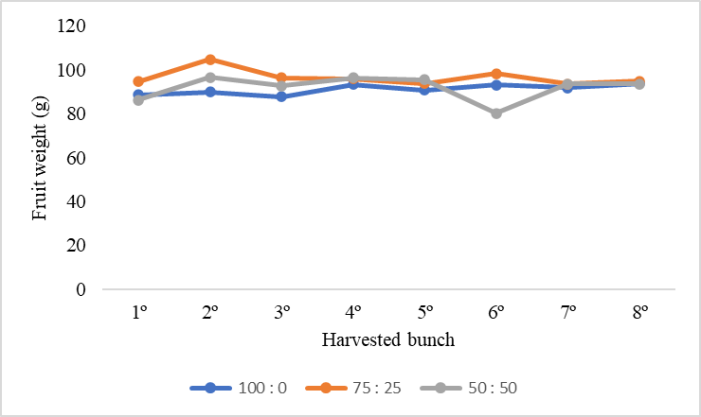

Figure 3. Variation in fruit weight due to the effect of the substrate used
(% Tepojal : % Vermicompost) and in each harvested bunch.

Total, soluble solids (TSS)
The amount of total soluble solids was measured in the 1st and 8th clusters, showing a very noticeable variation in the substrates 100:0 and 75:25 as shown in Figure 4. According to the analysis of variance (Table 3), the impact due to the effect of the substrate used was significant only in the 1st cluster, while Figure 5 shows the average of both evaluations carried out. The substrate of 50:50 proportion made the fruits have 5.29° Brix similar to what was mentioned Moreno-Reséndez et al., 2005 where when analyzing the growth of tomato in combination of sand and vermicompost (50:50, % volume) they reported an average of 5.3°Brix which means an increase of 14.5 % compared to 75:25 and 100:0, whose average was 4.61° Brix similar to that reported by Acosta (2003) where he evaluated the tomato crop in greenhouse conditions and established an average of 4.0° Brix
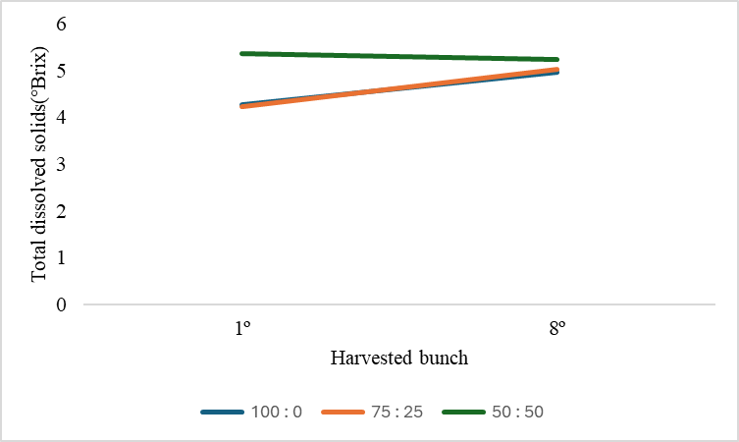

Figure 4. Variation in the total dissolved solids (°Brix) of the fruit due to the effect of the substrate used (% Tepojal : % Vermicompost) and in each bunch harvested.
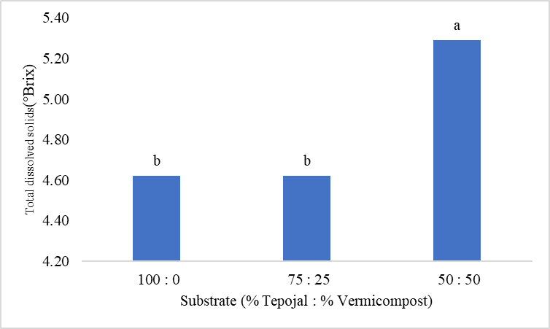

Figure 5. Average total dissolved solids (°Brix) of the fruit by effect
of the substrate used (% Tepojal : % Vermicompost).

Conclusions

The substrate used with mixtures of tepojal and vermicompost generated a highly significant effect (P<0.01) on the quality variables of the harvested fruits, while the effects of the density of plants ^{m-2} and the interaction of these factors were not significant (P>0.05) and therefore, the higher density (6.0 plants ^{m-2}) resulted in the greater size and quality of the fruit.

The substrate that maximized the parameters regarding the quality of fruits was the volumetrically formed by tepojal and vermicompost in the proportion (%) 75:25, however, with the substrate 50:50 the results were similar, but in this one the amount of vermicompost used was doubled, which increases production costs, so the use of vermicompost in mixture with tepojal favors the quality of tomato fruits in terms of size, weight and uniformity, important parameters that define the commercial standards of the fruit. Therefore, the use of tepojal and vermicompost mixtures was an effective strategy for the production of saladette tomatoes in greenhouse conditions.

Disclaimer (Artificial intelligence)
Option 1:
Author(s) hereby declare that NO generative AI technologies such as Large Language Models (ChatGPT, COPILOT, etc.) and text-to-image generators have been used during the writing or editing of this manuscript.

References

Abad B. M.; Noguera P. & Burés S. 2001. National inventory of organic wastes for use as growing media for ornamental potted plant production: case study in Spain. Bioresource Technology 77(2):197 200 p.

Acosta B. B. 2003. Producción orgánica de hortalizas con vermicomposta bajo condiciones de invernadero en la comarca lagunera. Tesis de Licenciatura. UAAAN-UL, Torreón, Coahuila, México.

Alam, M., M. Rahman, M. Mamun, I. Ahmad, and K. Islam. 2006. Enzyme activities in relation to sugar accumulation in tomato. Proc. Pak. Acad. Sci. 43(4): 241-248.

Ashcroft W.; Gurban R.; Wares C. and Nick H. 1993. Arcadia and Goulbum: Determinate fresh market tomatoes for arid production areas. HortiScience 28 (8): 854-857

Cruz-Crespo E.; A. Can-Chulim; J. Pineda-Pineda; D. Moreno-Velázquez; G. Aguilar-Benítez and J. D. García-Paredes. 2019. Relationship between the physical properties of the lombricompost mixtures with tuff, pumice, and rice husk. Agrociencia 53: 1-12.

INEGI (Instituto Nacional de Estadística, Geografía e Informática). 2024. Directorio Nacional de Unidades Económicas. En línea: https://www.inegi.org.mx/app/mapa/denue/Default.aspx?idee= 3481882. Cosultado: 25/09/2025

Kader, A. A. 2002. Quality and safety factors: definition and evaluation for fresh horticultural crops. In: Kader, A. A. (ed). Postharvest Technology of Horticultural Crops. Third edition. University of California, Agriculture and Natural Resources Pub. 3311. USA. pp: 279-286.

Kolota E y Adamczewska SK (2001). Evaluation of new leek cultivars for early growing. Veg. Crops Res. Bull. 54, 29-34.

Moreno-Reséndez A.; Valdés-Perezgasga M. y Zarate-López T. 2005. Desarrollo de tomate en sustratos de Vermicompost/Arena Bajo condiciones de Invernadero. Agricultura técnica de chile. 65 (1): 26:34.

Peet M. & Welles G. 2005. Greenhouse tomato production. In: Tomatoes Heuvelink, E. (Ed). Cambridge, England: CABI Publishing. pp: 257-304.

Raiola A; Tenore GC; Barone A; Frusciante L and Rigano MM (2015). Vitamin E content and composition in tomato fruits: Beneficial roles and bio-fortification. Int. J. Mol. Sci. 16: 29250–29264.
Ruiz-Morales M. 2011. Taller de elaboración de lombricomposta: porque tener lombrices nos beneficia a todos. México: Universidad Iberoamericana. pp: 23.

Sánchez-del Castillo F.; Moreno-Pérez E. C. & Contreras-Magaña E. 2012. Development of alternative crop systems for commercial production of vegetables in hydroponics - I: tomato. Acta Horticulturae 947; 179-187.

SIAP. 2023. Sistema de Información Agroalimentaria y Pesquera. Cultivos de agricultura protegida. Información estadística sobre cultivos, tipo de instalación, superficie cosechada y número de instalaciones. En línea: http://infosiap.siap.gob.mx/gobmx/datosAbiertos.php. Consultado 05/11/23.

Steiner AA (1984) The Universal Nutrient Solution. En Proc 6th Int. Cong. Soilless Cult. pp. 633 649.

Chandni ., Deepti Singh, Shirin Akhtar & Swaraj Kumar Dutta. (2020). Effect of Microclimate on Yield and Quality Attributes of Cherry Tomato (Solanum lycopersicum L. var. cerasiforme) under Open Field and Polyhouse Conditions. International Journal of Environment and Climate Change, 10(4), 24–30. https://doi.org/10.9734/ijecc/2020/v10i430192

Anuradha Sinha, Paramveer Singh, Ajay Bhardwaj & Randhir Kumar. (2020). Evaluation of Tomato (Solanum lycopersicum L.) Genotypes for Morphological, Qualitative and Biochemical Traits for Protected Cultivation. Current Journal of Applied Science and Technology, 39(2), 105–111. https://doi.org/10.9734/cjast/2020/v39i230503

Chowdhury, M., Espinoza-Ayala, A., Samarakoon, U. C., Altland, J. E., & Yang, T. (2024). Substrate Comparison for Tomato Propagation under Different Fertigation Protocols. Agriculture, 14(3), 382.

