Original Research Article

Development of Desktop Based Breast Cancer Symptoms Self-Examination Support System

ABSTRACT
Aims: The early identification of breast cancer is the most significant method for breast cancer prevention. Breast self-examination has received widespread support and promotion from cancer organizations and authorities worldwide. But for it to be effective, women need to be educated and reached out to, in addition to diligent and frequent self-examination. Breast screenings have been used for early detection of breast cancer, before any symptoms like palpable lumps or other symptoms become apparent.
Study design: Since medical practitioners relied mainly on the information supplied by patients regarding any ailment, there is a need to develop a standalone application that can be used for breast cancer self-examination for easy and early detection of cancer in women.
Place and Duration of Study: Radiology Unit, LAUTECH Teaching Hospital, Oyo State, between September and December 2025; Federal Polytechnic Ede, Osun State.
Methodology: A visibility study on breast cancer self-examination was conducted among selected respondents, and a standalone desktop application was then developed using Python and the PyQt library. The application guides users through a structured self-examination questionnaire and captures symptom-related responses. A rule-based logical decision framework was embedded in the system, where predefined clinical rules map reported signs and symptoms such as lumps, nipple discharge, skin changes, or persistent pain to decision outcomes. Based on the combination and severity of responses, the system classifies the user’s results as normal or requires further clinical assessments and recommends follow-up actions.
Results: The results of the physical examination obtained from the respondents show that 18% of the respondents were abnormal and 82% were normal. These earlier symptoms, given by respondents, gave room for further advice to the 82% of respondents to go for mammogram tests. The application does not diagnose breast cancer and is not a substitute for clinical assessment. Rather, it functions as a screening support tool that flags the presence of symptoms or concerning changes that may require further medical evaluation.
Conclusion: The developed desktop based standalone application can be used by female individuals to perform a self-examination and by an expert to determine if there is a need to go for a mammography test or not.

Keywords: Standalone Application, Python, PyQt Library, Mammogram, Mammography, Radiologist

- INTRODUCTION
According to the World Health Organization (WHO), by 2025, breast cancer cases will hit 19.3 million (Manson & Achel, 2023). Any abnormal growth of certain cells in the breast could be breast cancer (Zhou et al., 2020). When breast cancer is detected early, it lowers the mortality rate by providing appropriate treatment, which can improve the chances of recovery and extended life (Ginsburg et al., 2020).
Breast cancer can be detected through screening such as self-examination, clinical examination, which is done by a physician, and mammography (Shahnazi & Khalili, 2010). Breast self-examination is very useful because it is cheap, easy, confidential, uncomplicated, and does not need special equipment. Mammography is a common method that is used to detect breast cancer. It assists in the detection of breast cancer early to avoid further damage to the breast tissues (Ragab et al., 2019). The mammogram is an X-ray image of the breast that is regularly used to detect and treat breast cancer in women (Nicosia et al., 2023).
Mammography is the most sensitive available means for early detection of breast cancer, but both clinical breast examination (CBE) and breast self-examination (BSE) have the potential to advance the diagnosis of breast cancer without the expense of a mammography facility (Indhumathi et al., 2025). Most studies have found that survival after a diagnosis of breast cancer tends to be longer among women who practice BSE than among women who do not (Richard et al., 2020).
Regular screening of all women over a certain age has the potential to sharply increase the proportion of cancer cases that are diagnosed in their earliest stages (Xu & Xu, 2023). There are several approaches to the screening of breast cancer. Breast self-examination has been endorsed and widely promoted by cancer organizations and authorities around the world. Its effectiveness, however, is dependent on education and outreach among women, and upon conscientious and regular self-examination (WHO, 2016). The purpose of breast self-examination is for a woman to learn the topography of her breast, know how her breasts normally feel and be able to identify changes in the breast should they occur in the future (Maitanmi et al., 2023). Breast self-examination consists of two basic steps: visual and tactile examination of the breast (Pippin & Boyd, 2023). For visual examination, no woman has two identical breasts. Once a woman knows what her breasts look like, she can identify any changes in the shape, form, colour or structure of the breast more quickly and can discuss these with the appropriate health care provider (NCI, 2012). From the age of 25, women should have a clinical breast examination as part of her routine check-up every two or three years, increasing to once a year from the age of 40 (Lavoue et al., 2024).
Several works have been done on breast cancer detection, but there are few on self-examination using symptoms related to breast cancer. Hence, this study aims to develop a desktop-based, standalone, symptom-oriented breast self-examination support system for early recognition of breast abnormalities and to encourage timely referral for clinical assessment among women.
Breast cancer is the most diagnosed cancer among women worldwide and a leading cause of cancer-related mortality in Nigeria (Wuraola et al., 2024). In the Nigerian context, late presentation is common, with many women seeking medical care at advanced stages of the disease (Awofeso et al., 2018). This delay has been attributed to limited access to organized screening services, poor awareness of early symptoms, sociocultural beliefs, fear, and inadequate health education (Srinath et al., 2023). Historically, structured monthly breast self-examination was recommended as a screening tool for early breast cancer detection (Diriba et al., 2025).
Studies conducted across Nigerian universities consistently report high awareness of breast cancer and BSE among female undergraduates, with awareness rates often exceeding 80–90% (Ajibola Omobola et al., 2024; Madubogwu et al., 2021). Despite this high level of awareness, regular and correct practice of BSE remains suboptimal. Many students either perform BSE irregularly or lack adequate knowledge of correct techniques and appropriate timing (Alanazi et al., 2025; Gamal et al., 2025). Empirical evidence indicates that although undergraduates often possess general knowledge of breast cancer, their understanding of specific warning signs, such as nipple discharge, skin dimpling, breast asymmetry, and axillary swelling, is limited. Rural women in Nigeria generally exhibit lower awareness and poorer knowledge of breast cancer symptoms compared to urban and student populations (Ijah & Ijah, 2023). Most studies rely on cross-sectional or quasi-experimental designs and measure outcomes such as knowledge and self-reported practice rather than clinical endpoints (WHO, 2016).
Emerging digital and mobile health approaches, including the use of smartphone applications and SMS reminders, have shown promise in improving breast awareness in other low- and middle-income countries. However, empirical research evaluating such tools in Nigerian undergraduate and rural settings remains sparse. There is increasing work on smartphone apps and digital instruction to teach breast awareness/BSE steps, deliver reminders, and raise symptom knowledge. Different researchers have worked on smartphone apps for BSE, such as a systematic review that assessed smartphone application–based technology for Breast Self-Examination or early detection education (Indah et al., 2024). Also, a quasi-experimental study evaluating a breast-awareness app reported increases in knowledge of risk factors, warning signs, and confidence in BSE. A quasi-experimental pre- and post-test research design was conducted with 41 women participants in Kelantan, Malaysia, before and after using the BrAware apps. Participants were given an online, adapted Breast Cancer Awareness Measure questionnaire. The mean age of women was 39.71. The participants' mean knowledge score of BC warning signs differed before using BrAware, which was 70.62, and after using the BrAware app was 79.83 (Yusuf et al., 2022).
Structured instructional design models such as Analysis, Design, Development, Implementation, Evaluation (ADDIE) have been applied to develop breast cancer care and education applications. (Aydin et al., 2023) developed a mobile application for post-breast cancer surgery symptom management using the systematic ADDIE model. This approach involved collaboration with specialists to create a user-friendly tool for improving self-care, enhancing symptom tracking, and supporting patient education, ensuring a structured, evidence-based development process.
In addition, reviews of breast-cancer prevention or education apps highlight variable quality and the need for validated content, privacy, and behaviour-change grounding (Altmannshofer et al., 2024). Mobile Health apps could be a feasible and effective tool to raise awareness for breast cancer prevention and to support women to change their behaviour to a healthier lifestyle (Cai et al., 2021). These authors conducted a systematic search for apps covering breast cancer prevention topics in the Google Play and Apple App Store accessible from Germany and analyzed the characteristics and quality of apps designed for breast cancer prevention and education using the Mobile Application Rating Scale (MARS).
Only apps with a last update after June 2020 were included. The apps identified were downloaded and evaluated by two independent researchers. Associations of app characteristics and MARS rating were analyzed by the authors and identified nineteen (19) apps available in the Google Play Store and seven (7) apps available in the Apple App Store that met all inclusion criteria. The mean MARS score was 3.07 and 3.50, respectively. Functionality was the highest-scoring domain. Operating system, developer (healthcare), download rates and time since the last update were significantly associated with overall MARS score.
In addition, the presence of the following app functions significantly influenced MARS rating: breast self-examination tutorial, reminder for self-examination, documentation feature and education about breast cancer risk factors. Although most of the apps offer important features for breast cancer prevention, none of the apps analyzed combined all functions. The absence of healthcare professionals’ expertise in developing apps negatively affects the overall quality.
(Banihashemi & Brennan, 2023) performed a systematic review was performed using PRISMA methodology. Articles were assessed against eligibility criteria. Data were extracted into evidence tables, risk of bias was assessed, narrative synthesis was performed, and results were described. Eligible studies were original research studies assessing the impact of breast awareness on cancer outcomes (such as stage at diagnosis or survival) in women less than 40 years old. Medline, PubMed, and Cochrane Library were searched, and results after screening the 6,204 abstracts show that no studies met all eligibility criteria. No studies that evaluate the impact of breast awareness exclusively in young women were identified. Limited evidence of the benefit of breast awareness was found.
Symptom-focused evidence syntheses also describe how breast cancer symptoms can change over time and the factors associated with different symptom trajectories. (Cai et al., 2022) further show that breast cancer symptoms may develop and change over time in different ways, which supports using symptom reports as a prompt for timely evaluation while recognizing that absence of symptoms does not rule out disease.
2. METHODOLOGY
This study adopts a behavioral pathway framework in which breast cancer knowledge influences self-efficacy and attitudes, which in turn shape breast awareness and breast self-examination practice. The study was carried out at a female residential hostel of a tertiary institution in Nigeria. A total of 20 questionnaires were administered to consenting female participants within the age ranges 15-20 years, 21-25 years, and 26-30 years. The questionnaire captured basic demographics, which include name, marital status, and age range, and five symptom-focused items related to breast cancer warning signs. Responses were entered into the developed desktop application, which applies a rule-based decision table to identify whether symptom indicators are present and to recommend further medical evaluation where necessary. The system is a supportive tool, not a diagnostic system.
Formulation of Questionnaire
In examining the breast, changes in texture and feel were noted and reported to the physician through the questionnaire. Five symptoms relevant to breast self-examination were identified with input from radiologists and oncologists at LAUTECH Teaching Hospital and used to formulate the questionnaire. These symptoms were prioritised because they represent common early warning changes emphasised in breast self-examination guidance. They are straightforward for non-clinicians to notice without equipment and are clinically meaningful triggers for timely medical evaluation. These symptoms are listed below:
- Is there discharge or bleeding from the nipples?
- Is there a feeling of lumps or thickening in the breast or under the bust?
- Is there any red region in the breast skin?
- Are there any changes in the size of the breasts?
- Are the nipples inverted?
These questions were used for further processing. Table 1 presents the rule-based logical representation of the five questions relating to breast cancer. Since five questions were considered, there is a total of 2⁵ observations, i.e., thirty-two (32) observations. If there is a discharge or bleeding from the nipples, the patient is likely to have breast cancer. There are two conditions to ascertain that the patient has no breast cancer.
Condition 1: If there is a feeling of lumps or thickening in the breast and there is no discharge or bleeding from the nipples, no red region in the breast skin, no changes in the size of the breast and the nipples are not inverted, the patient has no breast cancer.
Condition 2: If there is no feeling of lumps or thickening in the breast, and there is no discharge or bleeding from the nipples, no red region in the breast skin, no changes in the size of the breast and the nipples are not inverted, the patient has no breast cancer.
All other conditions outside these two conditions indicate that the patient is likely to have breast cancer. The questions used to represent the results of the data collected are depicted as Q1, Q2, Q3, Q4 and Q5, while the responses are Y and N as indicated.
Q1: Is there discharge or bleeding from the nipples?
Q2: Is there a feeling of lumps or thickening in the breast or under the bust?
Q3: Is there any red region in the breast skin?
Q4: Are there any changes in the size of the breast?
Q5: Are the nipples inverted?
Y: Yes
N: No

Table 1. Logical Representation of the Data
Observations | Q1 | Q2 | Q3 | Q4 | Q5 | Output
1 | Y | Y | Y | Y | Y | Not Okay
2 | Y | Y | Y | Y | N | Not Okay
3 | Y | Y | Y | N | Y | Not Okay
4 | Y | Y | Y | N | N | Not Okay
5 | Y | Y | N | Y | Y | Not Okay
6 | Y | Y | N | Y | N | Not Okay
7 | Y | Y | N | N | Y | Not Okay
8 | Y | Y | N | N | N | Not Okay
9 | Y | N | Y | Y | Y | Not Okay
10 | Y | N | Y | Y | N | Not Okay
11 | Y | N | Y | N | Y | Not Okay
12 | Y | N | Y | N | N | Not Okay
13 | Y | N | N | Y | Y | Not Okay
14 | Y | N | N | Y | N | Not Okay
15 | Y | N | N | N | Y | Not Okay
16 | Y | N | N | N | N | Not Okay
17 | N | Y | Y | Y | Y | Not Okay
18 | N | Y | Y | Y | N | Not Okay
19 | N | Y | Y | N | Y | Not Okay
20 | N | Y | Y | N | N | Not Okay
21 | N | Y | N | Y | Y | Not Okay
22 | N | Y | N | Y | N | Not Okay
23 | N | Y | N | N | Y | Not Okay
24 | N | Y | N | N | N | Okay
25 | N | N | Y | Y | Y | Not Okay
26 | N | N | Y | Y | N | Not Okay
27 | N | N | Y | N | Y | Not Okay
28 | N | N | Y | N | N | Not Okay
29 | N | N | N | Y | Y | Not Okay
30 | N | N | N | Y | N | Not Okay
31 | N | N | N | N | Y | Not Okay
32 | N | N | N | N | N | Okay

2.1. System Design
The Graphical User Interface (GUI) of the breast self-examination support application was developed using the PyQt library of Python. User responses were entered into the desktop application and evaluated using the rule-based decision framework presented in Table 1. The system outputs “Okay” or “Not Okay” to indicate whether symptom indicators are present and provides guidance on appropriate follow-up. The application does not provide a clinical diagnosis.
2.2. Validation and Testing
Validation focused on content validity, logical correctness, and basic usability rather than clinical diagnosis. First, the five symptom questions and the decision rules were reviewed with input from a radiology clinician to ensure that the wording was clear for end users and that each rule reflected warning signs that should prompt medical review.
Second, the rule base was tested by running all 32 possible Yes/No response combinations and confirming that the application output matched the decision table, as shown in Table 1 for every combination. This step established the internal consistency of the rule implementation.
Third, during the feasibility study, the application was applied to the respondents' data after completing the self-examination. The application output was compared with the recorded physical self-examination findings (normal or abnormal) as a practical consistency check and to identify usability issues. This comparison did not serve as a diagnostic accuracy study because no imaging or histopathology reference standard was applied.

- RESULTS AND DISCUSSION
The Graphical User Interface (GUI) of the developed application is shown in Figure 1. The name, marital status, and age range of the user are captured, and responses to the questions are entered into the system. The application then displays an output that reflects whether symptom indicators are present and provides follow-up guidance.
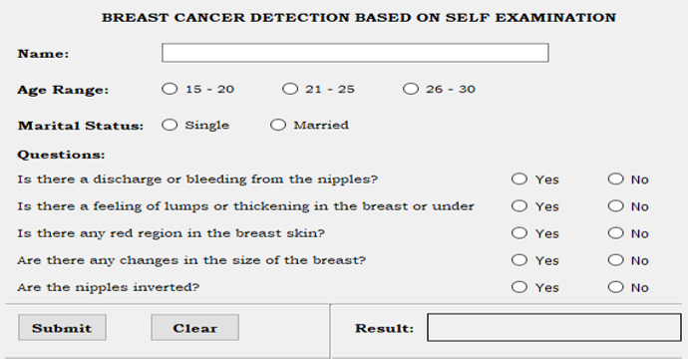
Fig. 1: GUI of the Developed System

Figure 2 shows the results of the physical examination.
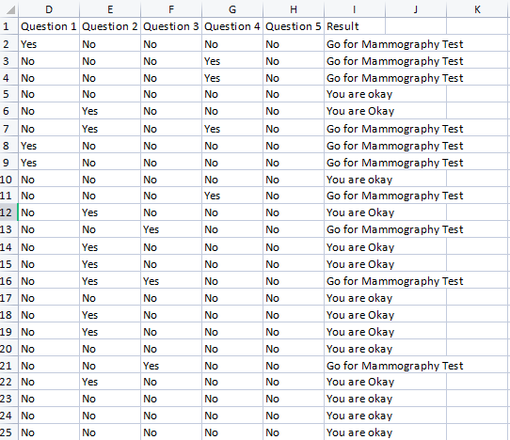
Fig. 2: Results of the Physical Self Examination

The Graphical User Interface (GUI) of the results is shown in Figures 3 and 4.

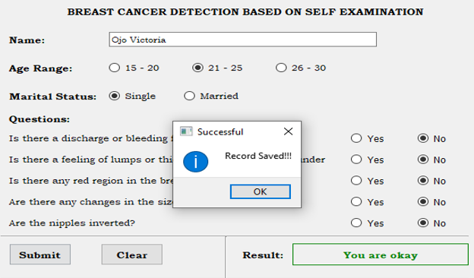

Fig. 3: GUI showing normal test result

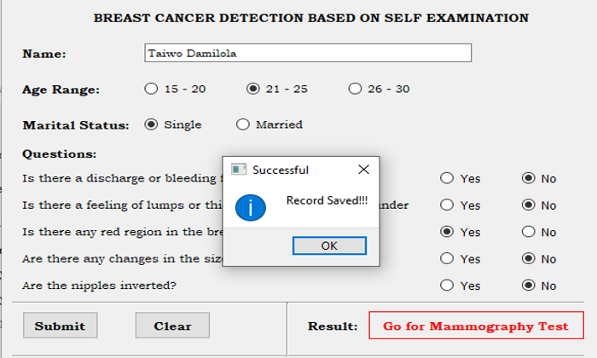

Fig. 4: GUI showing abnormal test result
The results obtained from the data collected from the students were saved in Microsoft Excel format on the Personal Computer, to allow for further reference and comparison. The essence of self-examination is to ascertain if there is a need for a mammogram test. Whenever the results of the self-examination showed symptoms of breast cancer, it displayed on the screen as either “You are Okay” or “Go for Mammography”. The result of the self-examination obtained from the students shows that 18% of the respondents were abnormal and 82% were normal. The respondents with abnormality were advised to go for a mammogram test for further treatment or quick medication.
The symptom-based screening support approach has important limitations. Early breast cancer can be asymptomatic, and several benign conditions may also cause lumps, pain, discharge, skin redness, or nipple inversion. Because the tool relies on self-reported symptoms and user technique, false reassurance and false alarms are both possible. The application, therefore, should be used as an educational aid, not as proof that cancer is present or absent.
In this study, the application output should be interpreted as the presence or absence of symptom indicators that warrant further medical evaluation. A diagnostic pathway requires clinical breast examination, imaging such as mammography or ultrasound, and confirmation through pathology when indicated. Future work could evaluate the tool prospectively against imaging findings and clinical outcomes to quantify performance and refine the rules.

- CONCLUSION
The developed desktop-based standalone application can support female individuals during self-examination by helping them identify symptom indicators that warrant further medical evaluation and possible referral for mammography. It can also support health workers as a structured symptom-check aid during routine screening. The system can be recommended for tertiary institutions during medical tests to examine female students to determine if they have breast cancer or not, as this will limit the occurrence of breast cancer-related disease at an early stage. For Nigerian tertiary institutions, integrating structured breast health education into student health services and orientation programs may strengthen preventive behaviours among undergraduates. Policy efforts should focus on strengthening primary healthcare systems to support and improve early symptom detection, reducing delays in presentation and timely diagnosis in Nigeria.
Declarations
Informed Consent: Informed consent was obtained from all individual participants included in the study.
Conflicts of interest: The authors have no conflicts of interest to declare that are relevant to the content of this article.

Disclaimer (Artificial intelligence)

Author(s) hereby declares that NO generative AI technologies such as Large Language Models (ChatGPT, COPILOT, etc.) and text-to-image generators have been used during the writing or editing of this manuscript.
References
- Ajibola Omobola, O. J. O., Eunice Aramide, A. W. E., & Iyanuoluwa Oreofe, O. J. O. (2024). Awareness of breast self-examination among females in selected secondary schools in Ibadan north local government area, Oyo state, Nigeria. International Journal of Science and Research Archive, 13(2), 4128–4139. https://doi.org/10.30574/ijsra.2024.13.2.2321
- Alanazi, W. N., Mohamed, G. M., Alosaimi, N. S., & Alosaimi, L. M. (2025). Breast cancer awareness, knowledge and self-screening intention among females in Northern Border of Saudi Arabia, Arar City. BMC Public Health, 25(1), 964. https://doi.org/10.1186/s12889-025-22092-w
- Altmannshofer, S., Flaucher, M., Beierlein, M., Eskofier, B. M., Beckmann, M. W., Fasching, P. A., & Huebner, H. (2024). A content-based review of mobile health applications for breast cancer prevention and education: Characteristics, quality and functionality analysis. Digit Health, 10, 20552076241234627. https://doi.org/10.1177/20552076241234627
- Awofeso, O., Roberts, A. A., Salako, O., Balogun, L., & Okediji, P. (2018). Prevalence and Pattern of Late-Stage Presentation in Women with Breast and Cervical Cancers in Lagos University Teaching Hospital, Nigeria. Niger Med J., 59(6), 74–79.
- Aydin, A., Gursoy, A., & Karal, H. (2023). Mobile care app development process: using the ADDIE model to manage symptoms after breast cancer surgery (step 1). Discov Oncol, 14(1), 63. https://doi.org/10.1007/s12672-023-00676-5
- Banihashemi, D., & Brennan, M. E. (2023). The Impact of Breast Awareness on the Early Detection of Breast Cancer in Young Women: A Systematic Review. Breast Care, 18(1), 60–68. https://doi.org/10.1159/000526990
- Cai, T., Huang, Y., Huang, Q., Xia, H., & Yuan, C. (2022). Symptom trajectories in patients with breast cancer: An integrative review. Int J Nurs Sci, 9(1), 120–128. https://doi.org/10.1016/j.ijnss.2021.12.011
- Cai, T., Huang, Y., Zhang, Y., Lu, Z., Huang, Q., & Yuan, C. (2021). Mobile health applications for the care of patients with breast cancer: A scoping review. International Journal of Nursing Sciences, 8(4), 470–476. https://doi.org/https://doi.org/10.1016/j.ijnss.2021.07.003
- Diriba, T. A., Wako, S. G., Nigussie, T., Awol, M., Geleta, R. E., & Wayessa, Z. J. (2025). Knowledge of Breast Cancer, Practice of Breast Self-Examination and Associated Factors Among Rural Reproductive Age Women of Dire Wareda, Borena Zone, Ethiopia. Sage Open, 15(3), 21582440251346554. https://doi.org/10.1177/21582440251346554
- Gamal, A., Awwad, S. A., Abdallfatah, A., Azim, A. A. A., Alhayek, W., Elgamal, H., Omar, S. S., Koura, N. W., Soliman, A. S., Masoud, A. A., Yousef, O., & Abouzid, M. (2025). Knowledge, attitudes, and awareness of breast self-examination among female university students in three Arab countries: a multi-center cross-sectional study. BMC Public Health, 25(1), 2961. https://doi.org/10.1186/s12889-025-23932-5
- Ginsburg, O., Yip, C. H., Brooks, A., Cabanes, A., Caleffi, M., Dunstan Yataco, J. A., Gyawali, B., McCormack, V., McLaughlin de Anderson, M., Mehrotra, R., Mohar, A., Murillo, R., Pace, L. E., Paskett, E. D., Romanoff, A., Rositch, A. F., Scheel, J. R., Schneidman, M., Unger-Saldaña, K.,…Anderson, B. O. (2020). Breast cancer early detection: A phased approach to implementation. Cancer.
- Ijah, R. O. A. F., & Ijah, C. N. (2023). Review Article on Breast Cancer Awareness in Nigeria. Clinical Case Reports: Open Access, 6(2). https://doi.org/10.46527/2582-5038.252
- Indah, N., Nilawati Usman, A., Sanusi Baso, Y., Syarif, S., Ahmad, M., & Agus Mumang, A. (2024). Early detection of self-breast examination using smartphone breast application. Breast Dis, 43(1), 135–144. https://doi.org/10.3233/BD-249004
- Indhumathi, C., Umamaheswari, K., Patil, A. B., & Saravanakumar, S. (2025). Breast Self-Examination as Cancer Breast Prevention Practice and Awareness among Middle-aged Women: A Hospital-based Study. Indian Journal of Public Health, 69(3).
- Lavoue, V., Favier, A., Franck, S., Boutet, G., Azuar, A.-S., Brousse, S., Golfier, F., Uzan, C., Vaysse, C., Molière, S., Boisserie-Lacroix, M., Kermarrec, E., Seror, J.-Y., Delpech, Y., Luporsi, É., Maugard, C. M., Taris, N., Chabbert-Buffet, N., Sabah, J.,…Mathelin, C. (2024). French college of gynecologists and obstetricians (CNGOF) recommendations for clinical practice: Place of breast self-examination in screening strategies. The Breast, 75, 103619. https://doi.org/https://doi.org/10.1016/j.breast.2023.103619
- Madubogwu, C. I., Madubogwu, N. U., & Azuike, E. C. (2021). Practice of Breast Self-Examination among Female Students of Chukwuemeka Odumegwu Ojukwu University, Awka. Journal of Health Science Research, 10–18. https://doi.org/10.7324/jhsr.2021.622
- Maitanmi, J. O., Fadare, O., Kolawole, M., Aduroja, D. M., Faleti, D. M., Maitanmi, B. T., & Akingbade, O. (2023). Awareness and practice of breast self-examination among female staff at Babcock University, Nigeria. Ecancermedicalscience, 17, 1615. https://doi.org/10.3332/ecancer.2023.1615
- Manson, E. N., & Achel, D. G. (2023). Fighting breast cancer in low-and-middle-income countries – What must we do to get every woman screened on regular basis? Scientific African, 21, e01848. https://doi.org/https://doi.org/10.1016/j.sciaf.2023.e01848
- NCI. (2012). Understanding Breast Changes: A Health Guide for Women. National Institutes of Health, 12(3536).
- Nicosia, L., Gnocchi, G., Gorini, I., Venturini, M., Fontana, F., Pesapane, F., Abiuso, I., Bozzini, A. C., Pizzamiglio, M., Latronico, A., Abbate, F., Meneghetti, L., Battaglia, O., Pellegrino, G., & Cassano, E. (2023). History of Mammography: Analysis of Breast Imaging Diagnostic Achievements over the Last Century. Healthcare, 11(1596).
- Pippin, M. M., & Boyd, R. (2023). Breast Self-Examination. In: StatPearls Publishing.
- Ragab, D. A., Sharkas, M., & Attallah, O. (2019). Breast Cancer Diagnosis Using an Efficient CAD System Based on Multiple Classifiers. Diagnostics, 9(4), 165.
- Richard, T. S., Ndopwang, L. C. C., Etet, P. F. S., H., A., Kamdje, N., Mohamadou, H., Bruno, T. P., & Nangue, C. (2020). Breast Cancer Awareness and Detection of Asymptomatic Cases Using Breast Palpation and Fine-needle Aspiration in Bafoussam, Cameroon. Asian Pac J Cancer Care, 5(1), 61–66. https://doi.org/10.31557/APJCC.2020.5.1.61
- Shahnazi, M., & Khalili, A. (2010). Breast cancer screening (breast self-examination, clinical breast exam, and mammography) in women referred to health centers in Tabriz, Iran. Indian Journal of Medical Sciences, 64(4). https://doi.org/10.4103/0019-5359.97355
- Srinath, A., Merode, F. v., Rao, S. V., & Pavlova, M. (2023). Barriers to cervical cancer and breast cancer screening uptake in low- and middle-income countries: a systematic review. Health Policy Plan, 38(4), 496–508. https://doi.org/10.1093/heapol/czad015
- WHO. (2016). Cancer prevention and control in the context of an integrated approach. 70th World Health Assembly (WHA), Geneva.
- Wuraola, F. O., Blackman, C., Olasehinde, O., Aderounmu, A. A., Adeleye, A., Omoyiola, O. Z., Kingham, T. P., Fodero, R. F., Adisa, A. O., Lumati, J., Dare, A., Alatise, O. I., & Knapp, G. (2024). The out-of-pocket cost of breast cancer care in Nigeria: A prospective analysis. Journal of Cancer Policy, 42, 100518. https://doi.org/https://doi.org/10.1016/j.jcpo.2024.100518
- Xu, H., & Xu, B. (2023). Breast cancer: Epidemiology, risk factors and screening. Chinese Journal of Cancer Research, 35(6).
- Yusuf, A., YH, P. I., Ab Hadi, I. S., Nasution, A., & Lean Keng, S. (2022). Breast awareness mobile apps for health education and promotion for breast cancer. Front Public Health, 10, 951641. https://doi.org/10.3389/fpubh.2022.951641
- Zhou, X., Li, C., Rahaman, M. M., Yao, Y., Ai, S., Sun, C., Wang, Q., Zhang, Y., Li, M., Li, X., Jiang, T., Xue, D., Qi, S., & Teng, Y. (2020). A Comprehensive Review for Breast Histopathology Image Analysis Using Classical and Deep Neural Networks. IEEE Access, 8, 90931–90956. https://doi.org/10.1109/ACCESS.2020.2993788

