Adenocarcinoma Arising in an Enteric Duplication Cyst: A Rare Malignancy at an Uncommon Site. Case report

Abstract
Enteric duplication cysts are rare congenital anomalies usually presenting in early childhood. Malignant transformation within these cysts is exceedingly uncommon, particularly in adults. We report a rare case of moderately differentiated adenocarcinoma arising in a jejunal duplication cyst in a 36-year-old adult. This patient was incidentally diagnosed following surgical resection. Histopathological examination revealed dysplastic intestinal and gastric epithelium with invasive adenocarcinoma infiltrating the muscularis propria and lymph node metastasis. This case highlights the malignant potential of enteric duplication cysts and emphasizes the importance of thorough histopathological evaluation.
Keywords: Enteric duplication cyst, Jejunum, Adenocarcinoma, Adult, Rare malignancy

Introduction
“Enteric duplication (ED) cysts are rare congenital malformations characterized by the presence of a well-developed smooth muscle wall and mucosal lining resembling any part of the gastrointestinal tract”. ^{1,2}They may occur anywhere along the alimentary tract, most commonly in the ileum, and usually present during infancy or early childhood. The ileocecal valve area is the most commonly affected site.
Adult presentation is rare, and malignant transformation within duplication cysts is an exceptional occurrence. We present a unique case of adenocarcinoma arising in a jejunal duplication cyst in an adult patient. ¹ “Most of the patients become symptomatic in early childhood and only a few cases of adult patients have been reported in literature”.^{1, 2}
Gastric duplication cysts are relatively rare congenital anomalies that constitute only 2% to 8% of alimentary tract duplications. Associated symptoms often include nausea, vomiting, hematemesis, and abdominal pain, ulceration, bleeding, rupture, and fistula formation are known complications.^{1,2}
“Ladd WE first coined the term ‘alimentary duplication cyst’ and described them as congenital malformations which involve the mesenteric duplication cyst’ which involve the mesenteric side of the associated alimentary tract that share a common blood supply with the native bowel”.² The prevalence is between 1:4500–1:10000.³ “Most enteric duplication cysts are benign; however, neoplastic transformation has been reported in a few cases, with adenocarcinoma being the most common malignant transformation”.⁴

Case Report
We present here a case of 36-year-old patient who underwent surgical exploration for an unrelated abdominal complaint. Intraoperatively, multiple cystic lesions were identified along the length of the small intestine. Segmental resection of small intestine was performed, and the specimen was submitted for histopathological examination.

Gross Examination
Gross examination revealed multiple duplication cysts with blind ends distributed throughout the small intestine. The largest cyst measured 6.9 × 5.1 × 2.7 cm. Cut surface showed a thickened cyst wall with areas of ulceration.
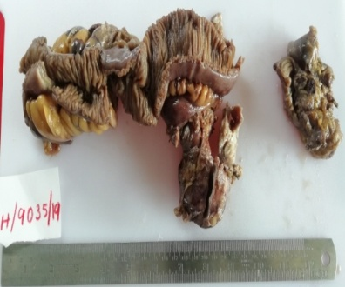
Figure 1: Shows largest cyst measured along the wall of intestine 6.9 × 5.1 × 2.7 cm.

Microscopic Examination
Histopathological examination demonstrated cyst walls composed of all layers of the intestinal wall. The mucosa was lined by both intestinal and gastric-type epithelium, exhibiting areas of severe dysplasia. Tumour cells infiltrated the muscularis propria. The neoplastic cells were arranged in glandular patterns and showed pleomorphic vesicular nuclei, prominent nucleoli, and moderate amounts of cytoplasm. Only two lymph nodes were retrieved and both regional lymph nodes showed metastatic tumour deposits with extracapsular extension. Based on gross and microscopic features diagnosis of moderately differentiated adenocarcinoma arising in a jejunal enteric duplication cyst was made with pT2N2 [ according to AJCC 8th edition ] staging.

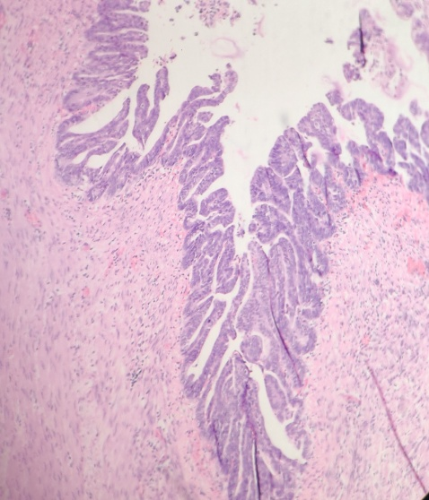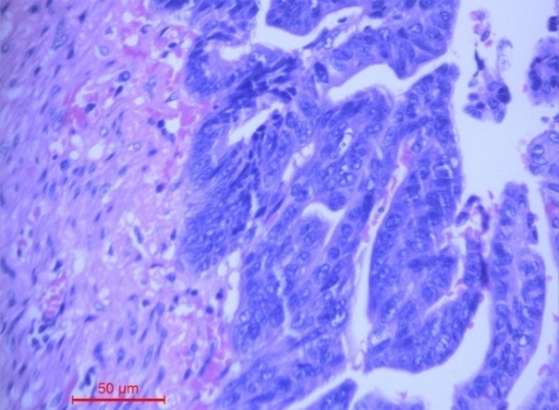
Figure 2 a, b: Shows tumour cells infiltrating muscularis propria.
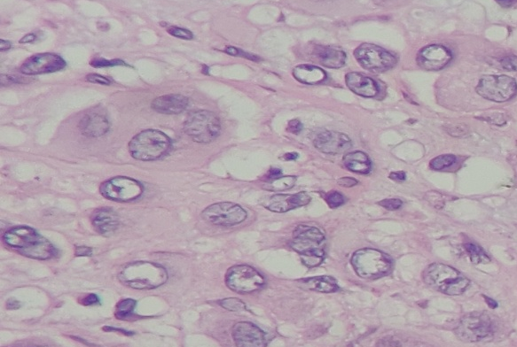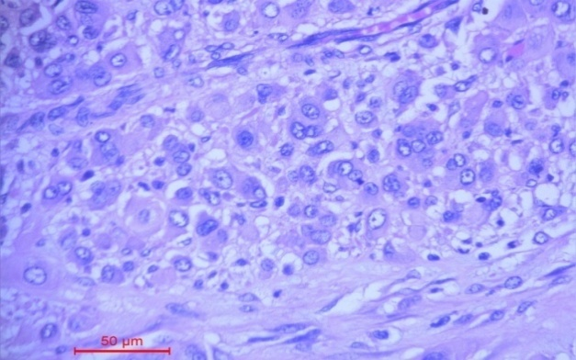
Figure 3 a, b: Shows tumour deposits in the lymph nodes.

Discussion
Enteric duplication cysts often contain heterotopic mucosa, most commonly gastric or pancreatic tissue. Malignant transformation within these cysts is extremely rare, with adenocarcinoma being the most frequently reported malignancy.
Enteric duplication cysts are usually identified in children and infants. Our patient did not present with any symptoms till adulthood and directly when he came to hospital he had adenocarcinoma with lymph node metasatsis.
“Commonly patients present vague symptoms like abdominal pain, nausea, vomiting, bleeding, abdominal distension, abdominal mass, obstruction, intussusceptions which mimic more common pathologies such as volvulus, appendicitis, intussusceptions, pelvic abscess, diverticulitis, achalasia, and Hirschsprung's disease”.⁵Even children and infants can present with similar complaints.
Our patient presented with vague symptoms and only intaoperatively it was found to have cystic lesions present throughout the length of the intestine. Cystic enteric duplication could present symptoms at any time during childhood, mainly before 2 years old, and so a proper management should be considered when suspect it.⁶The aetiology of ED remains unknown. Theories postulated that abnormal recanalization after the solid epithelial stage of embryonic bowel development. Other theories consider persisting embryologic diverticula or 'aborted Gemini', partial twinning, and split notochord theory. However, the most accepted theory is the 'intrauterine vascular accident theory'⁷.
The pathogenesis is thought to be related to chronic inflammation, acid secretion by heterotopic gastric mucosa, and prolonged mucosal irritation. Small bowel duplication cyst malignancies tend to show aggressive behaviour with a high incidence of lymph node metastasis, as seen in the present case.⁸ “The presence of pancreatic tissue or gastric mucosa leads to complications such as peptic ulcers or acute pancreatitis”.⁹
“Gastric duplications are mostly seen in the greater curvature, because gastric duplications usually originate dorsal to the primitive intestine”.¹⁰ “Oesophageal duplication cysts (EDCs) are rare congenital anomalies resulting from aberrant development of the posterior division of the primitive foregut”^{. 11} “In the literature small bowel duplications are frequently the site of malignancy, followed by colonic and rectal duplications”. ¹²
“Completely isolated advanced enteric duplication cysts are cysts which lack a connection to the gastrointestinal tract or the adjacent mesenteric vasculature and have been reported in only ten case reports. In these reports, only two reports showed malignant transformation”. ¹³
In our case only 2 lymph nodes were retrieved both of them showed tumour deposits with extracapsular extension.On follow up patient was very sick and discharged after three weeks. Post surgery he was only on fluids and succumbed to death after 3 month from the time of surgery. Early recognition and complete surgical excision are crucial to prevent malignant transformation and improve prognosis.
“Isolated enteric duplication cysts have lower morbidity prevalence rate”.¹⁴ “Complete removal of the cyst is the treatment of choice to avoid the risk of complications such as obstruction, torsion, perforation, haemorrhage, and malignancy”. ¹⁵

Conclusion
Although enteric duplication cysts are rare in adults, the possibility of malignant transformation should always be ruled out. Thorough histopathological examination is essential, especially when dysplasia or invasive carcinoma is suspected. This case adds to the limited literature on adenocarcinoma arising in jejunal duplication cysts and underscores the need for awareness of this rare entity.
Consent
As per international standards or university standards, patient(s) written consent has been collected and preserved by the author(s).

Disclaimer (Artificial intelligence)
Option 1:
Author(s) hereby declare that NO generative AI technologies such as Large Language Models (ChatGPT, COPILOT, etc.) and text-to-image generators have been used during the writing or editing of this manuscript.

References
- Blank, G., Königsrainer, A., Sipos, B., &Ladurner, R. (2012). Adenocarcinoma arising in a cystic duplication of the small bowel: case report and review of literature. *World Journal of Surgical Oncology, 10, Article 55. https://doi.org/10.1186/1477-7819-10-55
- BISHOP, H C, and C E KOOP. “SURGICAL MANAGEMENT OF DUPLICATIONS OF THE ALIMENTARY TRACT.” American journal of surgery vol. 107 (1964): 434-42. doi:10.1016/0002-9610(64)90210-7
- Macpherson, R. I. (1993). Gastrointestinal tract duplications: Clinical, pathologic, etiologic, and radiologic considerations. Radiographics, 13(5), 1063–1080. https://doi.org/10.1148/radiographics.13.5.8210590
- Fan, M., & Yang, F. (2024). Low-Grade Mucinous Neoplasm Arising in an Enteric Duplication Cyst of Pancreas: A Case Report and Literature Review. *International Journal of Surgical Pathology*, *32*(2), 422-427. https://doi.org/10.1177/10668969231183635
- Kashif, M. M., Satishrao, I., & Sachin, D. V. (2018). Adenocarcinoma arising in a small bowel duplication cyst. J Med Sci Res, 6(2), 59-62. https://doi.org/10.17727/JMSR.2018/6-10
- Lee TB, Cho YH, Kim SH, Kim HY. Cystic Enteric Duplication: Prenatally and Postnatally Diagnostic Group. J Korean Assoc Pediatr Surg. 2015 Dec;21(2):24-27. https://doi.org/10.13029/jkaps.2015.21.2.24
- Favara, B. E., Franciosi, R. A., & Akers, D. R. (1971). Enteric duplications. Thirty-seven cases: A vascular theory of pathogenesis. American Journal of Diseases of Children, 122(6), 501–506. https://pubmed.ncbi.nlm.nih.gov/5145872/
- Kusunoki, N., Shimada, Y., Fukumoto, S., Iwatani, Y., Ohshima, T., Arahi, E., Miyazaki, N., & Maeda, S. (2003). Adenocarcinoma arising in a tubular duplication of the jejunum. Journal of Gastroenterology, 38(8), 781–785. https://doi.org/10.1007/s00535-002-1146-8.
- Kang, H. J., Jang, S. J., & Park, Y. S. (2014). Adenocarcinoma arising in gastric duplication cyst. Korean Journal of Pathology, 48(2), 159-161. https://doi.org/10.4132/KoreanJPathol.2014.48.2.159
- Seijo Ríos, S., LariñoNoia, J., AbdulkaderNallib, I., Lozano León, A., Vieites Pérez-Quintela, B., Iglesias García, J., & Domínguez Muñoz, J. E. (2008). Adult gastric duplication cyst: diagnosis by endoscopic ultrasound-guided fine-needle aspiration (EUS-FNA). Rev EspEnferm Dig, 100(9), 586–590. https://doi.org/10.4321/s1130-01082008000900011
- Narayanan, S., Kumar, S. A., Goyal, H., &Halanaik, D. (2025). Adenocarcinoma Arising in an Esophageal Duplication Cyst With Disseminated Metastases: A Rare Case Detected on 18F-FDG PET/CT. Clinical Nuclear Medicine. https://doi.org/10.1097/RLU.0000000000006135
- Blank, G., Königsrainer, A., Sipos, B., &Ladurner, R. (2012). Adenocarcinoma arising in a cystic duplication of the small bowel: case report and review of literature. World Journal of Surgical Oncology, 10(55) https://doi.org/10.1186/1477-7819-10-55
- Nakashima, S., Yamada, T., Sato, G., Sakai, T., Chinen, Y., Itakura, H., Kato, R., Ueda, M., Tsuda, Y., Ohta, K., Matsuyama, J., &Ikenaga, M. (2019). A case of completely isolated advanced enteric duplication cyst cancer performed partial pancreatectomy. International Journal of Surgery Case Reports, 54, 83-86. https://doi.org/10.1016/j.ijscr.2018.11.060
- Kusunoki, N., Shimada, Y., Fukumoto, S., Iwatani, Y., Ohshima, T., Arahi, E., Miyazaki, N., & Maeda, S. (2003). Adenocarcinoma arising in a tubular duplication of the jejunum. Journal of Gastroenterology, 38(8), 781–785. https://doi.org/10.1007/s00535-002-1146-8
- Mardi, K., Kaushal, V., & Gupta, S. (2010). Foregut duplication cysts of stomach masquerading as leiomyoma. Indian Journal of Pathology and Microbiology. https://doi.org/10.4103/0377-4929.59214

