Diagnostic Utility of Bone Marrow Biopsy in Haematological Malignancies: A Seven Year Retrospective Study from Nigeria

ABSTRACT
Background: Bone marrow aspirate (BMA) and bone marrow biopsy (BMB) are complementary procedures in the evaluation of haematological disorders. While aspirate smears often suffice for diagnosis, trephine biopsy provides additional value in cases with focal lesions, inadequate aspirate yield, or marrow fibrosis.
Aim: This study aims to assess the diagnostic utility of the bone marrow biopsy in haematological malignancies and determine the concordance rate of aspirate and biopsy reports in diagnosing haematological malignancies.
Methods: This retrospective study observed 125 adult cases seen over seven years in which paired BMA and BMB were obtained from the same instance at a Nigerian tertiary center. Clinical indications, full blood count parameters, and final histological diagnoses were recorded. Diagnostic concordance between BMA and BMB was determined, and discordant cases were further characterized.
Results: Anaemia was the predominant indication for marrow evaluation, present in 90.4% of patients. The most frequently diagnosed haematological malignancies on bone marrow biopsy were multiple myeloma and acute myeloid leukaemia, while polycythaemia rubra vera and chronic eosinophilic leukaemia were rare. Overall, concordance between BMA and BMB was 84.8% (106/125), while discordance was 15.2% (19/125), with metastatic bone disease (80%) and myelofibrosis (38.5%) being the highest discordant diagnoses. The data were entered into Microsoft Excel and analyzed using IBM SPSS Statistics version 29 (IBM Corp., Armonk, N.Y., USA) while the concordance between the two diagnostic modalities was assessed using Cohen’s kappa statistic.
Conclusion: This study evaluated concurrent bone marrow aspiration and biopsy, demonstrating their diagnostic value. Biopsy proved superior in detecting focal lesions and in cases of "dry taps" in bone marrow aspirates. Combining both methods enhances diagnostic accuracy, with biopsy being crucial in specific cases.
Keywords: bone marrow aspirate, bone marrow biopsy, cytopenias, diagnostic concordance, haematological malignancies.

INTRODUCTION
Haematological malignancies (HMs) can be primary and secondary. Primary HMs arise from clonal proliferation or failure of differentiation of blood-forming precursors in blood-forming organs, such as the bone marrow and lymphoid tissues¹. The disorders usually involve the myeloid and/or lymphoid progenitor cells and are frequently associated with chromosomal abnormalities¹. These primary malignancies are a group of heterogeneous and diverse diseases composed of infiltrates of mature or immature haemopoietic cells at various stages of differentiation, along the lymphoid and myeloid lineages. Significant variations exist in their incidences, biological behaviours, clinical presentations, treatment options and prognosis.²
Blood cells develop from haematopoietic stem cells giving rise to the different blood cell lines.^{3,4,5} Mutation in this stem cells produce a clonal proliferation of mutated cells which could result in malignancies.⁶ In-utero, initially primitive blood cell formation occurs in the yolk sac; definitive haematopoietic stem cells (HSCs) then emerge from the aorta-gonad-mesonephros (AGM) region and colonise the fetal liver and spleen. ^{4,5}. Over time, the bone marrow becomes progressively colonised. By 10-12 weeks of gestation, bone marrow has begun to show haematopoietic activity, and during the second trimester, it increases in functional importance, such that by late fetal life, the bone marrow is the primary haematopoietic organ. ⁴ The initial fetal haematopoietic site may resume bone marrow production in extra-uterine life in some haematological malignancies.
Bone marrow biopsy (trephine/core biopsy), when used together with bone marrow aspiration (BMA), plays a critical diagnostic role in haematological malignancies⁷. The biopsy allows assessment of marrow architecture, fibrosis, focal infiltrates, and cellularity, which could be under-represented or missed on aspirate alone. In situations such as myelofibrosis or when aspiration yields a “dry tap,” the biopsy is especially valuable.⁸ Comparative studies indicate that while BMA and BMB (biopsy) diagnoses are often concordant in diffuse marrow disorders, significant discordance occurs in disorders with focal or patchy marrow involvement, metastatic infiltration, or pronounced stromal changes.⁹
Haematological malignancies (HM) may occur at any age in life; however, the risk increases with age. Primary HMs are broadly grouped into myeloid and lymphoid malignancies and mostly affect the BM (although this is not always the case, especially in lymphoid malignancies). The prevalence of hematological malignancies in a meta-analysis of different Nigeria studies is reported to be 7.0% and 71.88% in South Africa studies.¹⁰ The overall age-standardized incidence rates for all haematological malignancies per 100 000 in 2008 were 18·0 for males and 12·2 for females in Japan, and 34·9 for males and 23·6 for females in the United States.¹¹
Bone marrow is frequently involved in haematological malignancies as the primary site or as secondary involvement. Therefore, examination of the bone marrow remains an essential tool in the diagnosis of haematological malignancies. There is however paucity of data in our local environment on the utility of BMB in the management of haematological malignancies. This study aims to assess the diagnostic utility of the bone marrow biopsy in HMs and determine the concordance rate of aspirate and biopsy reports in diagnosing haematological malignancies.

METHODS
This was a seven-year retrospective study conducted on 125 bone marrow biopsies at the University of Port Harcourt Teaching Hospital from January 2017 to December 2023 on adult patients 18 years and above. All the bone marrow biopsies done within this period were included in this study. All bone marrow biopsies included in the study were from adult patients who also had an aspirate collected at the same instance, with a diagnosis of HM. Cancer types were classified according to the tenth edition of the International Classification of Diseases (ICD-10). Discordant cases were determined via consensus of both haematologist and haematopathologist. Data retrieved included age, sex, full blood count, aspirate and biopsy diagnoses, which were entered into Microsoft Excel spreadsheets and data were analyzed using predictive analytical software (SPSS).
Simple frequencies were determined for categorical variables and the mean was evaluated for continuous data. Results were expressed in tables and figures.
Data Analysis or Statistical Techniques used in SPSS
Statistical analysis was performed using IBM SPSS Statistics. Associations between categorical variables were assessed using the Chi-square test, with Phi (φ) coefficient applied for 2×2 contingency tables and Cramer’s V used for larger tables to quantify the strength of associations. The magnitude of these association measures was interpreted using standard thresholds, with higher values indicating stronger relationships.
Agreement between bone marrow aspiration and biopsy findings was evaluated using Cohen’s kappa (κ) statistic, which accounts for agreement occurring by chance. Kappa values were interpreted according to conventional criteria, with values indicating poor, fair, moderate, substantial, or almost perfect agreement. Statistical significance was determined using corresponding p-values, with p < 0.05 considered statistically significant³⁴.
Only cases with complete data were included in the analysis, resulting in 125 valid observations.
(Ref/Source: IBM Corp. (2021). IBM SPSS Statistics Algorithms. IBM Documentation)

RESULTS
There were a total of 125 bone marrow biopsies with diagnosis of haematological malignancies within the study period of which 76 (60.8%) were males and 49 (39.2%) were females, with a male to female ratio of 1.6:1. The age groups with the highest number of haematological malignancies (HM) diagnoses were 40 – 49 years (n=33, 26.4%) and 60 – 69 years (18.4%), see Table 1.
Table 1: Age and Sex Distribution
 | AGE group | SEX |  |  |  | Total
 | AGE group | Female n (%) |  | Male n (%)
 | 18-29 | 7 | (5.6) | 7 | (5.6) | 14 | (11.2)
 | 30-39 | 5 | (4.0) | 8 | (6.4) | 13 | (10.4)
 | 40-49 | 11 | (8.8) | 22 | (17.6) | 33 | (26.4)
 | 50-59 | 5 | (4.0) | 13 | (10.4) | 18 | (14.4)
 | 60-69 | 10 | (8.0) | 13 | (10.4) | 23 | (18.4)
 | 70-79 | 9 | (7.2) | 11 | (8.8) | 20 | (16.0)
 | 80-90 | 2 | (1.6) | 2 | (1.6) | 4 | (3.2)
TOTAL | All groups | 49 | (39.2) | 76 | (60.8) | 125 | (100)

The frequency of HM diagnosis across the seven years of study, starting from 2017 to 2023, was 10, 11, 20, 10, 13, 37 and 24, respectively and is shown in Figure 1 below, with the year 2022 having the majority of 37 and 2017 and 2020 having the minority of 10 patients.

Figure 1: Frequency of Biopsy per year of study
The most common indications for bone marrow biopsy BMB were suspected multiple myeloma (n=30, 24%), anaemia (n=18, 14.4%), lymphoproliferative neoplasm with possible bone marrow involvement (n=16, 12.8%) and pancytopenia (n=15, 12.0%). Table 2 and Table 3 shows the various indications for bone marrow biopsy BMB across sex and age groups, while Table 3 gives the full blood count distribution across the indications for BMB.
Table 2: Indications for BMB according to Age distribution

INDICATION | 20-29  n(%) | 30-39  n(%) | 40-49  n(%) | 50-59  n(%) | 60-69  n(%) | 70-79  n(%) | 80-89  n(%) | Grand Total
Anaemia | 3 (2.4) | 3 (2.4) | 3 (2.4) | 2 (1.6) | 3 (2.4) | 4 (3.2) | 0 (0) | 18 (14.4)
Acute Leukaemia, Unspecified | 1 (0.8) | 0 (0) | 0 (0) | 1 (0.8) | 2 (1.6) | 1 (0.8) | 1 (0.8) | 6 (4.8)
AML | 1 (0.8) | 2 (1.6) | 2 (1.6) | 2 (1.6) | 0 (0) | 0 (0) | 0 (0) | 7 (5.6)
Bicytopoenia | 0 (0) | 0 (0) | 3 (2.4) | 0 (0) | 0 (0) | 0 (0) | 0 (0) | 3 (2.4)
CEL | 0 (0) | 0 (0) | 1 (0.8) | 0 (0) | 0 (0) | 0 (0) | 0 (0) | 1 (0.8)
CLL | 0 (0) | 0 (0) | 2 (1.6) | 2 (1.6) | 4 (3.2) | 0 (0) | 0 (0) | 8 (6.4)
ET | 1 (0.8) | 1 (0.8) | 1 (0.8) | 2 (1.6) | 3 (2.4) | 1 (0.8) | 0 (0) | 9 (7.2)
LPN | 3 (2.4) | 3 (2.4) | 4 (3.2) | 1 (0.8) | 1 (0.8) | 2 (1.6) | 2 (1.6) | 16 (12.8)
MDS | 0 (0) | 0 (0) | 0 (0) | 0 (0) | 1 (0.8) | 1 (0.8) | 0 (0) | 2 (1.6)
MM | 0 (0) | 2 (1.6) | 7 (5.6) | 7 (5.6) | 7 (5.6) | 5 (4) | 2 (1.6) | 30 (24)
Myelofibrosis | 0 (0) | 0 (0) | 2 (1.6) | 1 (0.8) | 2 (1.6) | 2 (1.6) | 0 (0) | 7 (5.6)
NHL | 0 (0) | 0 (0) | 1 (0.8) | 1 (0.8) | 0 (0) | 0 (0) | 0 (0) | 2 (1.6)
Pancytopenia | 3 (2.4) | 2 (1.6) | 5 (4) | 0 (0) | 2 (1.6) | 3 (2.4) | 0 (0) | 15 (12)
Polycythaemia Vera | 0 (0) | 0 (0) | 0 (0) | 0 (0) | 0 (0) | 1 (0.8) | 0 (0) | 1 (0.8)
Grand Total | 12 (9.6) | 13 (10.4) | 31 (24.8) | 19 (15.2) | 25 (20) | 20 (16) | 5 (4) | 125 (100)

Table 3: Indications for BMB according to Sex

INDICATION | M (n%) | F (n%) | Grand Total
Anaemia | 8 (6.4) | 10 (8) | 18 (14.4)
Acute Leukaemia, Unspecified | 2 (1.6) | 4 (3.2) | 6 (4.8)
AML | 5 (4) | 2 (1.6) | 7 (5.6)
Bicytopoenia | 1 (0.8) | 2 (1.6) | 2 (2.4)
CEL | 1 (0.8) | 0 (0) | 1 (0.8)
CLL | 6 (4.8) | 2 (1.6) | 8 (6.4)
ET | 6 (4.8) | 3 (2.4) | 9 (7.2)
LPN | 7 (5.6) | 9 (7.2) | 16 (12.8)
MDS | 1 (0.8) | 1 (0.8) | 2 (1.6)
MM | 21 (16.8) | 9 (7.2) | 30 (24)
Myelofibrosis | 5 (4) | 2 (1.6) | 7 (5.6)
NHL | 1 (0.8) | 1 (0.8) | 2 (1.6)
Pancytopenia | 12 (9.6) | 3 (2.4) | 15 (12)
Polycythaemia Vera | 0 (0) | 1 (0.8) | 1 (0.8)
Grand Total | 76 (60.8) | 49 (39.2) | 125 (100)

ALL= Acute lymphocytic leukaemia, AML= Acute myeloid leukaemia, CEL= Chronic eosinophilic leukaemia, CLL Chronic lymphocytic leukaemia, ET= Essential thrombocythaemia, LPN= Lymphoproliferative neoplasm, MDS= Myelodysplastic syndrome, MM= Multiple myeloma, MF= (Primary myelofibrosis),

Table 4 indicates the blood counts indications for different diagnoses.

Table 4: FBC distribution across the indications for BMB
I = Increased, N = Normal, R = Reduced, G.T = Grand Total, RBC = Red Blood Cell, WBC, White Blood cell and the Platelets.
 | RBC |  |  |  |  |  |  |  | WBC |  |  |  |  |  |  |  |  | PLATELETS
INDICATION | I | % | N | % | R | % | G.T | % | I | % | N | % | R | % | G.T | % |  | I | % | N | % | R | % | G.T | %
Anaemia | 0 | 0 | 0 | 0 | 18 | 14 | 18 | 14.4 | 4 | 3 | 9 | 7 | 5 | 4 | 18 | 14 |  | 0 | 0 | 8 | 6.4 | 10 | 8 | 18 | 14.4
AL | 0 | 0 | 0 | 0 | 6 | 5 | 6 | 4.8 | 5 | 4 | 1 | 1 | 0 | 0 | 6 | 4.8 |  | 0 | 0 | 0 | 0 | 6 | 4.8 | 6 | 4.8
AML | 0 | 0 | 0 | 0 | 7 | 6 | 7 | 5.6 | 5 | 4 | 0 | 0 | 2 | 2 | 7 | 5.6 |  | 0 | 0 | 2 | 1.6 | 5 | 4 | 7 | 5.6
Bicytopoenia | 0 | 0 | 0 | 0 | 3 | 2 | 3 | 2.4 | 2 | 2 | 1 | 1 | 0 | 0 | 3 | 2.4 |  | 0 | 0 | 1 | 0.8 | 2 | 1.6 | 3 | 2.4
CEL | 0 | 0 | 0 | 0 | 1 | 1 | 1 | 0.8 | 1 | 1 | 0 | 0 | 0 | 0 | 1 | 0.8 |  | 0 | 0 | 1 | 0.8 | 0 | 0 | 1 | 0.8
CLL | 0 | 0 | 1 | 1 | 7 | 6 | 8 | 6.4 | 8 | 6 | 0 | 0 | 0 | 0 | 8 | 6.4 |  | 0 | 0 | 5 | 4 | 3 | 2.4 | 8 | 6.4
ET | 2 | 2 | 3 | 2 | 4 | 3 | 9 | 7.2 | 3 | 2 | 5 | 4 | 1 | 1 | 9 | 7.2 |  | 9 | 7.2 | 0 | 0 | 0 | 0 | 9 | 7.2
LPN | 0 | 0 | 3 | 2 | 13 | 10 | 16 | 12.8 | 1 | 1 | 11 | 9 | 4 | 3 | 16 | 13 |  | 0 | 0 | 12 | 9.6 | 4 | 3.2 | 16 | 12.8
MDS | 0 | 0 | 0 | 0 | 2 | 2 | 2 | 1.6 | 1 | 1 | 1 | 1 | 0 | 0 | 2 | 1.6 |  | 0 | 0 | 2 | 1.6 | 0 | 0 | 2 | 1.6
MM | 0 | 0 | 0 | 0 | 30 | 24 | 30 | 24 | 0 | 0 | 30 | 24 | 0 | 0 | 30 | 24 |  | 2 | 1.6 | 25 | 20 | 3 | 2.4 | 30 | 24
Myelofibrosis | 0 | 0 | 2 | 2 | 5 | 4 | 7 | 5.6 | 1 | 1 | 3 | 2 | 3 | 2 | 7 | 5.6 |  | 0 | 0 | 3 | 2.4 | 4 | 3.2 | 7 | 5.6
NHL | 0 | 0 | 1 | 1 | 1 | 1 | 2 | 1.6 | 1 | 1 | 1 | 1 | 0 | 0 | 2 | 1.6 |  | 0 | 0 | 2 | 1.6 | 0 | 0 | 2 | 1.6
Pancytopoenia | 0 | 0 | 0 | 0 | 15 | 12 | 15 | 12 | 0 | 0 | 1 | 1 | 14 | 11 | 15 | 12 |  | 0 | 0 | 1 | 0.8 | 14 | 11 | 15 | 12
PV | 1 | 1 | 0 | 0 | 0 | 0 | 1 | 0.8 | 0 | 0 | 1 | 1 | 0 | 0 | 1 | 0.8 |  | 0 | 0 | 1 | 0.8 | 0 | 0 | 1 | 0.8
Grand Total | 3 | 2 | 10 | 8 | 112 | 90 | 125 | 100 | 32 | 26 | 64 | 51 | 29 | 23 | 125 | 100 |  | 11 | 8.8 | 63 | 50 | 51 | 41 | 125 | 100

AL= Acute leukaemia, AML= Acute myeloid leukaemia, CEL= Chronic eosinophilic leukaemia, CLL Chronic lymphocytic leukaemia, ET= Essential thrombocythaemia, NHL Non-Hodgkin lymphoma, MDS= Myelodysplastic syndrome, MM= Multiple myeloma, MF= Myelofibrosis (Primary), PV= Polycythaemia vera

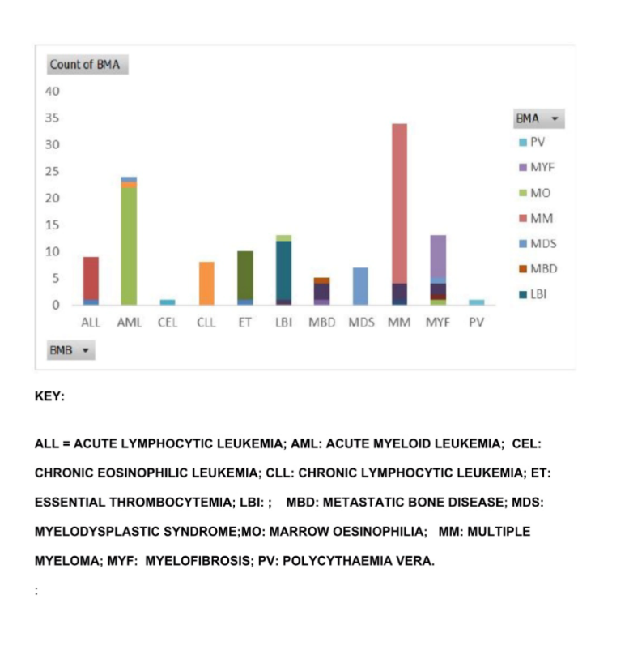
The most common haematological malignancies diagnosed from BMB were multiple myeloma (34 persons) and 24 patients with acute myeloid leukaemia while the least frequent were polycythemia rubra vera (1 person), chronic eosinophilic leukaemia (1 person) as shown in Figure 2.
(ALL= Acute lymphocytic leukaemia, AML= Acute myeloid leukaemia, CEL= Chronic eosinophilic leukaemia, CLL Chronic lymphocytic leukaemia, ET= Essential thrombocythaemia, LBI= Lymphoma
with bone marrow involvement, MBD= Metastatic bone disease, Myelodysplastic syndrome, MM= Multiple myeloma, MF= (Primary myelofibrosis), PV= Polycythaemia vera

Figure 2: Frequency of BMB Diagnoses

A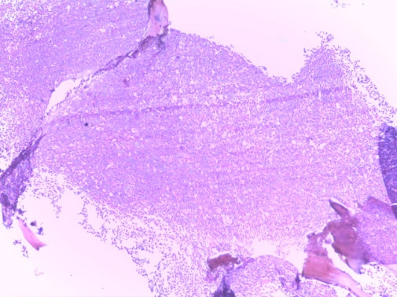 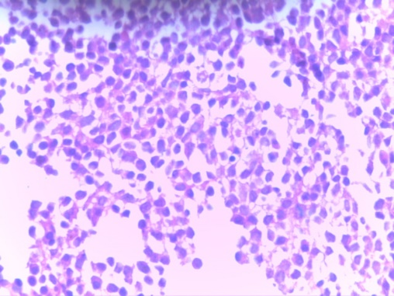B
Fig 3: Photomicrograph (Fig 3A) of haematoxylin and eosin-stained bone marrow sections of acute myeloid leukemia (AML) showing a hypercellular marrow (X100). There are numerous dysplastic myeloblasts replacing the marrow spaces (X400). These myeloblasts are seen to have markedly pleomorphic nuclei that appear hyperchromatic (Fig 3B).

A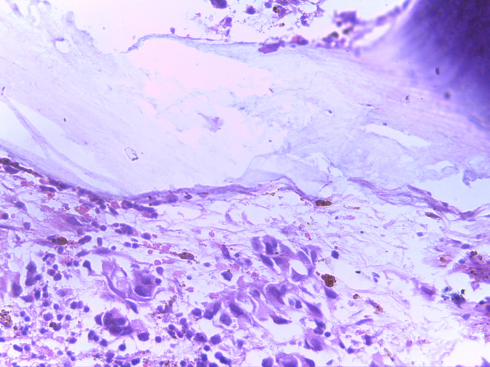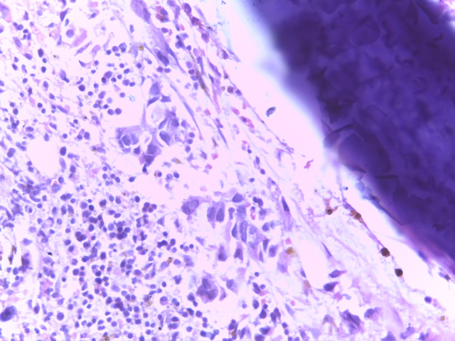B
Figure 4: Photomicrograph of haematoxylin and eosin-stained bone marrow sections of metastatic adenocarcinoma show infiltrating malignant epithelial cells that attempt to form glands diffusely infiltrating the marrow spaces (X400)

A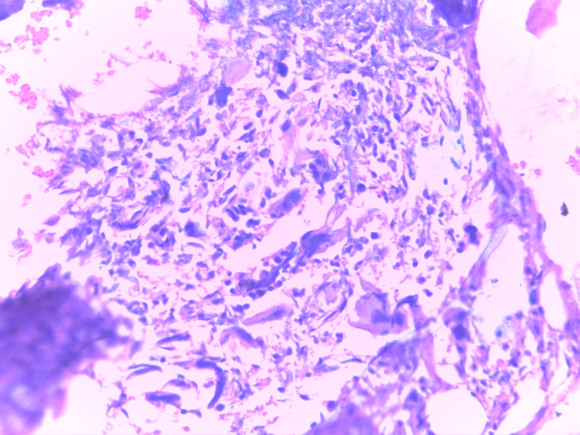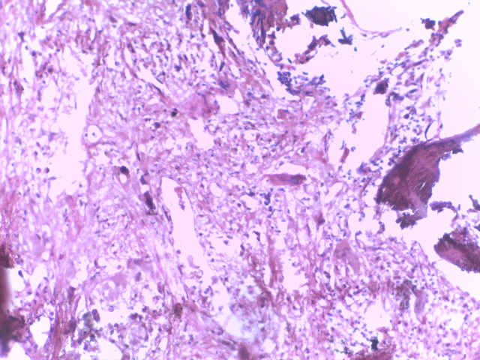B
C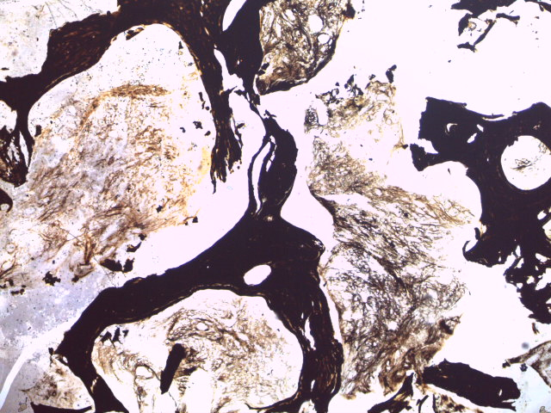
Figure 5: Photomicrograph of haematoxylin and eosin-stained bone marrow sections (X200) of primary myelofibrosis show increased number of abnormal megakaryocytes (Fig 5A). There is fibrosis of the marrow spaces (Fig 5B). The reticulin stain shows grade 2 fibrosis (Fig 5C).

There was concordance between aspirate and biopsy diagnosis for all 8 cases of chronic lymphocytic leukaemia, all 7 cases of myelodysplastic syndrome, and the singular cases of chronic eosinophilic leukaemia and polycythaemia rubra vera. On the other hand, there were 7 haematological malignancies for which discordance occurred and the discordance rates were 8.3% in acute myeloid leukaemia, 10.0% in essential thrombocythaemia, 11.1% in acute lymphoblastic leukaemia, 11.8% in multiple myeloma, 15.4% in lymphoproliferative neoplasm, 38.5% in myelofibrosis and 80% in metastatic bone marrow disease, making a total of 19 cases of discordant diagnoses between aspirate and biopsy (see Figure 6 and Table 6). Table 6 shows the various discordant diagnoses with the final working diagnoses adopted for the specific patient.

Table 5: Concordance between BMB and BMA

ALL= Acute lymphocytic leukaemia, AML= Acute myeloid leukaemia, CEL= Chronic eosinophilic leukaemia, CLL Chronic lymphocytic leukaemia, ET= Essential thrombocythaemia, LBI= Lymphoma with bone marrow involvement, MBD= Metastatic bone disease, MDS= Myelodysplastic syndrome, MM= Multiple myeloma, MF= (Primary myelofibrosis), PV= Polycythaemia vera
A Chi-Square test of association was conducted to examine the relationship between the bone marrow aspiration (BMA) and bone marrow biopsy (BMB) concordance. The symmetric measures presented in Table 7, as seen below, the Phi coefficient was 0.746, while Cramer's V recorded a value of 0.848. The Cohen’s Kappa value of 0.820 (Asymptotic Standard Error = 0.045), followed by the approximate t-value of 12.624 and corresponding significance level (p = 0.0001)
Table 6: Symmetric Measures Showing the Strength of Association between the Bone marrow Aspiration and Bone marrow Biopsy
Measure  Nominal by Nominal | Value | Asymptotic Standard Errorᵃ | Approx. T | Approx. Sig.
Phi | .746
Cramer's V | .848
Kappa | .820 | .045 | 12.624 | .0001
N of Valid Cases | 125
a. Kappa = 0.820 indicates almost perfect agreement between Bone Marrow Aspiration (BMA) and Bone Marrow Biopsy (BMB) results
b. The result is statistically significant (p < 0.05), suggesting that the agreement observed is unlikely due to chance

DISCUSSION
This seven-year retrospective analysis evaluates the diagnostic utility of bone marrow biopsy (BMB) in adults with haematological malignancies (HMs) and its concordance with bone marrow aspirate (BMA) in routine practice at a Nigerian tertiary center. By restricting inclusion to cases in which bone marrow aspiration (BMA) and bone marrow biopsy (BMB) were obtained from the same site, the study directly measures the incremental value of the trephine biopsy in real-world workflows.
In this study males were observed to be affected with haematological malignacies more than females. This is similar to previous studies that found more males affected than females^{9,10,11} except for Nwagu et al.¹² in Southern Nigeria, who reported a slight increase in females more than males. Male predominance in hematological malignancies has been consistently reported in Nigerian and other West African cohorts, and has been partly attributed to higher occupational exposure that predispose them to the development of haematological cancers.^{13,14}
In this study, multiple myeloma (MM) was found to be the most common haematological malignancy with 34 cases diagnosed on bone marrow biopsy. This is consistent with a previous study that points out plasma-cell neoplasms as one of the leading marrow-based cancers encountered in tertiary hematology practice.¹⁵ Abduh et al. described Multiple myeloma as the most common plasma-cell neoplasm¹⁵ emphasizing that MM diagnosis and risk stratification critically depend on bone marrow findings, particularly plasma-cell infiltration, clonality, and cytogenetic abnormalities.
Acute myeloid leukemia (AML) was the second most frequent diagnosis on BMB with 24 cases. Acute myeloid leukemia is fundamentally a bone marrow–based disease, with diagnosis and prognostic classification requiring marrow morphology, immunophenotyping, and cytogenetic/molecular testing.^{15,16}
Lymphoplasmacytic neoplasm (LPN) with bone marrow involvement was identified in 13 patients, which, according to the bone marrow biopsy diagnosis done in the study is the third most common malignancy. This frequency pattern differs from a study done in Abakaliki, South-Eastern Nigeria, where non-Hodgkin lymphoma appears to be the most frequent, as reported by Ugwu Ni et al.¹⁷ This frequency range differences could be as a result of environmental exposures.
The least frequent diagnoses were polycythemia vera (PV) and chronic eosinophilic leukemia (CEL), each seen in one patient. Tefferi et al.¹⁸ in their study reported that PV is usually recognized by a combination of elevated blood counts, JAK2 mutation testing, and marrow morphology, with biopsy confirmation aiding in distinguishing from other myeloproliferative neoplasms¹⁸. CEL, on the other hand, is extremely rare, as reinforced by SEER-based epidemiologic analysis by Wang et al.¹⁹, which documented its very low incidence and emphasized the role of molecular testing (e.g., PDGFRA fusions) for accurate classification and therapy¹⁹.
Cytopenias dominated the haematological phenotype, with anaemia present in 90.4% of patients. This finding is consistent with international and Nigerian reports showing that unexplained anaemia is the most common indication for bone marrow evaluation and frequently reveals causes ranging from nutritional deficiency to marrow failure and myeloid neoplasia^{20,21,22}.
Regional series from Gombe, Ondo, Zaria, and Yola consistently report anaemia as the commonest trigger for marrow evaluation, with diagnoses frequently including megaloblastic anaemia, combined deficiency anaemia, and haematological malignancies.^{23,24,25,26} These findings underscore that significant marrow pathology may be present even with isolated anaemia or normal counts in other lineages.
In this study, there was overall concordance between bone marrow aspirate (BMA) and biopsy (BMB) diagnoses in 106 of 125 paired evaluations, with a discordance rate of 15.2%. The concordance finding according to the Chi-Square and symmetric measures analysis, demonstrated a strong and statistically significant association between bone marrow aspiration (BMA) and bone marrow biopsy (BMB) results. The Phi coefficient (0.746) and Cramer’s V (0.848) both indicate a very strong relationship, suggesting that diagnostic outcomes from both procedures are highly consistent, the Cohen’s Kappa value of 0.820, with an asymptotic standard error of 0.045 which illustrate an excellent level of agreement between the BMB and BMA beyond what would be expected by chance, reflects an almost perfect level of agreement beyond chance, according to the interpretation guidelines by Landis and Koch (1977). The high t-value (12.624) and corresponding significance level (p = 0.0001) indicate that this agreement is statistically significant. Complete concordance was observed in all cases of chronic lymphocytic leukaemia (CLL), myelodysplastic syndrome (MDS), chronic eosinophilic leukaemia and polycythaemia vera, which is consistent with the findings of Thakur et al., who reported high concordance rates for CLL and other conditions characterised by diffuse marrow involvement.²³ Such conditions are generally well represented in aspirate smears, leading to good morphological agreement between aspirate and trephine sections²⁷. These findings support the complementary use of both procedures to ensure accurate diagnosis and guide patient management
In this study, bone marrow biopsy was considered the diagnostic gold standard in cases of discordance between aspirate and biopsy findings, given its ability to evaluate marrow architecture and detect focal or fibrotic lesions. Discordance was observed in 19 cases, with the highest rates seen in metastatic bone disease (MBD; 80%) and myelofibrosis (MF; 38.5%), where biopsy proved more reliable. The particularly high discordance in MBD is unsurprising, as metastatic deposits are often focal and may be missed by aspirate, especially when aspiration is performed at uninvolved sites or when samples are diluted.²⁹ In interpreting these findings, it is important to consider how diagnostic categories were defined in this study. Some diagnostic categories, such as lymphoproliferative neoplasms, were reported as broad groups due to the limitations of routine bone marrow morphology when comprehensive immunophenotypic or molecular studies were not available for all cases³⁰. Although bone marrow aspiration and biopsy can reliably detect lymphoid neoplasms, accurate subclassification often requires ancillary techniques such as immunohistochemistry, flow cytometry, or cytogenetic analysis. To maintain diagnostic consistency and focus on concordance between aspiration and biopsy, cases were therefore analyzed using composite categories, as adopted in similar bone marrow concordance studies³¹
In cases of metastatic bone disease and myelofibrosis, biopsy results altered patient management by confirming diagnoses missed or inconclusive on aspiration alone²⁸. Precise detection of marrow metastases aided accurate cancer staging and informed therapeutic planning, whereas identifying myelofibrosis contributed to prognosis assessment and guided subsequent management choices. These observations highlight the crucial role of bone marrow biopsy as a complementary and confirmatory diagnostic tool in complex hematologic conditions^{8,32}. This suggests that while both methods are valuable, biopsy is the more preferred method, especially in cases where focal lesions or marrow fibrosis are suspected. Previous studies similarly reported low concordance for marrow metastasis, with trephine biopsy proving more reliable for detection^{33,34}. Likewise, MF is notorious for producing “dry taps” due to marrow fibrosis, resulting in inadequate aspirate material and lower diagnostic yield compared to biopsy^{28,36}.

CONCLUSION
This study evaluated bone marrow aspiration and biopsy from a concurrent site, illustrating their diagnostic value in routine practices at a Nigerian tertiary centre. Anaemia was the most frequent clinical indication, present in 90.4% of patients, often triggering marrow evaluation. There was an overall concordance rate of 84.8% between bone marrow aspirate and biopsy results, with complete agreement in chronic lymphocytic leukaemia, myelodysplastic syndrome and notable discordance in metastatic bone disease (80%) and myelofibrosis (38.5%). Biopsy proved superior in identifying localized abnormalities (like cancer metastases) and in cases where the bone marrow is fibrotic or packed with abnormal cells, where aspirates might not yield enough material (a "dry tap"). One limitation of this study is the use of broad diagnostic categories for some entities, despite this limitations, the findings in this study remains clinically relevant and robust as the study primarily aimed to assess diagnostic concordance between bone marrow aspiration and biopsy rather than to provide an exhaustive disease subclassification, In summary, combining aspiration and biopsy enhances diagnostic accuracy, with biopsy being crucial in specific cases.

Ethical approval:
Ethical approval was obtained from the Ethical Committee of the University of Port Harcourt Teaching Hospital to carry out this study.

Consent:
As per international standards or university standards, patient(s) written consent has been collected and preserved by the author(s).

Disclaimer (Artificial intelligence)
Option 1:
Author(s) hereby declare that NO generative AI technologies such as Large Language Models (ChatGPT, COPILOT, etc.) and text-to-image generators have been used during the writing or editing of this manuscript.
Option 2:
Author(s) hereby declare that generative AI technologies such as Large Language Models, etc. have been used during the writing or editing of manuscripts. This explanation will include the name, version, model, and source of the generative AI technology and as well as all input prompts provided to the generative AI technology
Details of the AI usage are given below:
1.
2.
3.
REFERENCE

- Durosinmi, M. A. (2022). A design handbook of haemato-oncology therapy for medical practitioners and resident doctors (4th ed.). Amkra Books.
- Kawthalkar, S. M. (2013). Disorders of white blood cells. Acute leukaemias. In Essentials of haematology (2nd ed., pp. 224–266). Jaypee Brothers Medical Publishers (P) Ltd. https://doi.org/10.5005/jp/books/11810
- Medvinsky, A., & Dzierzak, E. (1996). Definitive hematopoiesis is autonomously initiated by the AGM region. Cell, 86(6), 897-906. https://doi.org/10.1016/S0092-8674(00)80165-8
- Singh R, Sugumar K. Embryology, Hematopoiesis. In: StatPearls [Internet]. Treasure Island (FL): StatPearls Publishing; 2025 Jan–. Updated 2025 May 3. Available from: https://www.ncbi.nlm.nih.gov/books/NBK544245/
- Lewis, K., Yoshimoto, M., & Takebe, T. (2021). Fetal liver hematopoiesis: from development to delivery. Stem Cell Research & Therapy. https://doi.org/10.1186/s13287-021-02189-w
- Chan O, Zhang L. Normal hematopoiesis and diagnosis algorithms for cytopenias and cytoses. In: Sallman DA, Chaudhury A, Saeed H, Zhang L, editors. Handbook of Hematologic Malignancies. 3rd ed. New York: Springer Publishing Company; 2025. p. 1–14
- Thakur, S., Thaker, B., Thaker, K. S., & Anjum, A. (2023). Utility of bone marrow aspiration and trephine biopsy in various haematological malignancies. International Journal of Research in Medical Sciences, 11(4), 1128–1135. https://doi.org/10.18203/2320-6012.ijrms20230693
- Riley RS, Williams D, Ross M, Zhao S, Chesney A, Clark BD, Ben-Ezra JM. Bone marrow aspirate and biopsy: a pathologist’s perspective. II. J Clin Lab Anal. 2009;23(5):259–307. doi:10.1002/jcla.20305. PMID:19774631
- Mulatie, Z., Berta, D. M., Gedefie, A., et al. (2025). Prevalence of hematological malignancies in Africa: A systematic review and meta-analysis. Scientific Reports, 15(9471) https://doi.org/10.1038/s41598-025-94428-w
- Chihara, D., Ito, H., Matsuda, T., Shibata, A., Katsumi, A., Nakamura, S., Tomotaka, S., Morton, L. M., Weisenburger, D. D., & Matsuo, K. (2014). Differences in incidence and trends of haematological malignancies in Japan and the United States. British Journal of Haematology, 164(4), 536–545. https://doi.org/10.1111/bjh.12659
- Joshi S, Wader J, Kanethkar S. Bone marrow aspiration and bone marrow biopsy in hematological disorders. Biomed Pharmacol J. 2020;13(2):799–804. doi:10.13005/bpj/1944.
- Akaba, K., Nwogoh, B., Akpan, I., Bassey, O. B., Ofonime, E., Petters, E., Igwilo, H., Onyeulor, E., & Ushie, G. A. (2019). Epidemiological Pattern of Adult Haematological Malignancies in a Tertiary Hospital in Cross River State. International Research Journal of Oncology, 2(1), 16-24. https://journalirjo.com/index.php/IRJO/article/view/18
- Kagu, M. B., Ahmed, S. G., Bukar, A. A., Mohammed, A. A., Mayun, A. A., & Musa, A. B. (2013). Spectrum of haematologic malignancies and survival outcomes of adult lymphomas in Maiduguri, north eastern Nigeria - a fourteen-year review. African Journal of Medicine and Medical Sciences, 42(1), 5-14. https://www.ajms.org/index.php/ajms/issue/view/10
- Amu, H., Dickson, K. S., Kumi-Kyereme, A., & Darteh, E. K. M. (2018). Understanding variations in health insurance coverage in Ghana, Kenya, Nigeria, and Tanzania: Evidence from demographic and health surveys. PLOS ONE, 13(8), e0201833. https://doi.org/10.1371/journal.pone.0201833
- Ugwu NI, Okoye AE, Ugwu CN, Iyare FE, Edegbe FO, Ugwu GC, Chukwurah EF, Richard IC, John DO, Nnadozie UU, Nwokwu EU. Distribution pattern and prevalence of haematological cancers among adults in Abakaliki, South-Eastern Nigeria: an 8-year retrospective study. Niger Postgrad Med J. 2021;28(4):266–272. doi:10.4103/npmj.npmj_636_21. PMID: 34850754.
- Akaba K, Nwogoh B, Akpan I, Bassey OB, Ofonime E, Petters E, Igwilo H, Onyeulor E, Ushie GA. Epidemiological pattern of adult haematological malignancies in a tertiary hospital in Cross River State. Int Res J Oncol. 2019;2(1):16–24. Available from: https://journalirjo.com/index.php/IRJO/article/view/18
- Kagu, M. B., Ahmed, S. G., Bukar, A. A., Mohammed, A. A., Mayun, A. A., & Musa, A. B. (2013). Spectrum of haematologic malignancies and survival outcomes of adult lymphomas in Maiduguri, North eastern Nigeria—a fourteen year review. African Journal of Medicine and Medical Sciences, 42(1), 5-14. http://www.ajmms.com/index.php/ajmms/issue/view/10
- Abduh MS. An overview of multiple myeloma: A monoclonal plasma cell malignancy’s diagnosis, management, and treatment modalities. Saudi J Biol Sci. 2024;31(2):103920. doi:10.1016/j.sjbs.2023.103920. PMID:38283805.
- Percival ME, Lai C, Estey E, Hourigan CS. Bone marrow evaluation for diagnosis and monitoring of acute myeloid leukemia. Blood Rev. 2017;31(3):185–192. doi:10.1016/j.blre.2017.01.003.
- Shimony S, Stahl M, Stone RM. Acute myeloid leukemia: 2023 update on diagnosis, risk-stratification, and management. Am J Hematol. 2023;98(3):502–526. doi:10.1002/ajh.26822. PMID: 36777149.
- Ugwu, N. I., Okoye, A. E., Ugwu, C. N., Iyare, F. E., Edegbe, F. O., Ugwu, G. C., et al. (2021). Distribution pattern and prevalence of haematological cancers among adults in Abakaliki, South-Eastern Nigeria. Niger Postgrad Med J, 28(4), 266–272. https://doi.org/10.4103/npmj.npmj_636_21
- Kaseb, H., Gonzalez-Mosquera, L. F., Parsi, M., & Mewawalla, P. (2023). Lymphoplasmacytic lymphoma/Waldenström macroglobulinemia. In: StatPearls [Internet]. Treasure Island (FL): StatPearls Publishing. https://www.ncbi.nlm.nih.gov/books/NBK513356/
- Tefferi A, Barbui T. Polycythemia vera: 2024 update on diagnosis, risk-stratification, and management. Am J Hematol. 2023;98(9):1465–1487. doi:10.1002/ajh.27002.
- Wang J, Lin M, Wang F. Epidemiology and prognostic nomogram for chronic eosinophilic leukemia: a population-based study using the SEER database. Sci Rep. 2024;14:11073. doi:10.1038/s41598-024-55432-8. PMID: 38701892. (pubmed.ncbi.nlm.nih.gov)
- Raskin, R. E., & Messick, J. B. (2012). Bone marrow cytologic and histologic biopsies: indications, technique, and evaluation. Veterinary Clinics of North America: Small Animal Practice. https://doi.org/10.1016/j.cvsm.2011.10.001
- Hasserjian, R. P. (2008). Reactive versus neoplastic bone marrow: problems and pitfalls. Archives of Pathology & Laboratory Medicine, 132(4), 587–594. https://doi.org/10.5858/2008-132-587-RVNBMP
- Babatunde, A. S., Durotoye, I. A., Shittu, A. O., Omokanye, K. O., Ogunfemi, M. K., & Owoeye, O. A. (2020). Evaluation of the indications and diagnostic value of bone marrow examination in haematological disorders in Ilorin, Nigeria: A review of 496 cases. Tropical Journal of Health Sciences, 27(1), 27-33. https://www.ajol.info/index.php/tjhc
- Bain, B. J. (2001). Bone marrow trephine biopsy. Journal of Clinical Pathology https://doi.org/10.1136/jcp.54.10.737
- Yuguda S, Girei AI, Pindiga KM, Dachi RA, Lawan AI, Abdullahi YM. Indications and diagnostic utility of bone marrow aspiration cytology: a 12-year experience at a tertiary health center in Gombe, Northeastern Nigeria. Ann Trop Pathol. 2020;11(2):119–122. doi:10.4103/atp.atp_15_20
- Swerdlow SH, Campo E, Harris NL, et al. WHO classification of tumours of haematopoietic and lymphoid tissues. Revised 4th ed. Lyon: IARC; 2017.
- Treaba DO, Hasserjian RP. The diagnostic utility of bone marrow examination in hematologic disorders. Arch Pathol Lab Med. 2011;135(3):294–306.
- Osho, P. O., Ojo, M. A., Koledoye, V., Okunnuga, A. N., & Oni, O. I. (2021). Diagnostic outcome of bone marrow aspiration in a tertiary hospital in Ondo State, Nigeria. American Journal of Laboratory Medicine, 6(2), 17-21. https://doi.org/10.11648/j.ajlm.20210602.11
- Awwalu, S., Hassan, A., Dogara, L. G., Musa, A. U., Waziri, A. D., & Babadoko, A. A. (2016). Bone marrow aspiration (BMA) in Zaria: A three-year retrospective review. Borno Medical Journal, 13(1), 50–55. https://www.bornomedicaljournal.com/index.php/bomj/article/view/109/109
- Jasini, J., Egesie, O. J., Damulak, O. D., Jatau, E. D., Zakari, A., Okeke, C. N., Nathan, C. G., Bornoma, A., & Sayi, A. J. D. (2021). Indications and outcomes of bone marrow aspiration cytology in a Nigerian tertiary hospital: The Federal Medical Centre, Yola experience. Highland Medical Research Journal, 21(1). https://www.ajol.info/index.php/hmrj/article/view/212009
- IBM Corp. (2021). IBM SPSS Statistics algorithms. IBM Documentation.
https://www.ibm.com/docs/en/spss-statistics
- Babatunde AS, Durotoye IA, Shittu AO, Omokanye KO, Ogunfemi MK, et al. Evaluation of the indications and diagnostic value of bone marrow examination in haematological disorders in Ilorin, Nigeria: a review of 496 cases. Trop J Health Sci. 2020;27(1):27-33.

