Maxillary Sinus Elevation Using the Modified Summers Technique: Report of Two Clinical Cases with More Than 10 Years of Follow-up

.
ABSTRACT

Aims:
To report the long-term clinical outcomes of maxillary sinus floor elevation performed using a modified Summers osteotome technique in sites with residual bone height below that traditionally recommended, through the presentation of two clinical cases with follow-up periods of 14 and 9 years.
Study Design:
Clinical case reports with long-term follow-up.
Place and Duration of Study:
Brazilian Dental Association – Regional Santos, Santos, São Paulo, Brazil. Case 1: October 2009 to October 2023. Case 2: April 2015 to April 2024.
Methodology:
Two female patients presenting posterior maxillary edentulism and residual bone height ranging from 3 to 6 mm underwent transcrestal maxillary sinus floor elevation using a modified Summers technique. The surgical protocol included strategic palatal positioning of drills, reduced-depth sequential drilling, use of osteotomes, and grafting with hydroxyapatite, associated with autogenous bone in one case. Implants were placed simultaneously, and prosthetic rehabilitation was performed after a 6-month osseointegration period.
Results:
Primary stability values of 43 and 45 N·cm were achieved in Case 1, and 35 N·cm in Case 2.The transcrestal technique demonstrated expressive bone gain, exceeding the initial native bone height in all evaluated regions, with a 100% success rate and no reported complications or implant loss after 14 and 9 years of follow-up, respectively.
Conclusion:
The modified Summers technique proved to be a safe, predictable and minimally invasive approach for implant placement in posterior maxillary regions with residual bone height below 6 mm when adequate planning and case selection are applied.

Keywords: Maxillary Sinus Floor Elevation; Osteotome Technique; Dental Implants; Bone Grafting; Modified Summers Technique ;

1. INTRODUCTION

Posterior teeth are the first to be affected by periodontal disease, according to classical studies such as that by Hirschfeld and Wasserman (1978). The loss of posterior maxillary teeth is frequently associated with progressive resorption of the alveolar ridge and pneumatization of the maxillary sinus, resulting in a significant reduction in residual bone height, which imposes limitations on rehabilitation with dental implants (Testori et al., 2012; Rahate et al., 2023). In such situations, maxillary sinus floor elevation procedures become necessary to re-establish adequate bone volume and to allow the predictable placement of osseointegrated implants.In order to make implant rehabilitation feasible, an increase in the bone perimeter through regenerative techniques is required, which are currently considered very safe and predictable (Corbella, Taschieri and Del Fabbro, 2015). Among the various alternatives, the first and most extensively documented is the Tatum technique, introduced in 1986, which proposes access to the maxillary sinus through an osteotomy in the lateral wall, followed by elevation of the Schneiderian membrane, creating space for the insertion of biomaterial. However, this is a more invasive procedure, associated with greater surgical morbidity and a relevant incidence of complications, such as perforation of the sinus membrane due to its thickness, the presence of septa, excessive intraoperative bleeding owing to the arterial supply of the maxillary sinus, and prolonged postoperative recovery time (Starch-Jensen et al., 2023).Therefore, the advent of maxillary sinus elevation requires the surgeon to have in-depth knowledge of the regional anatomy in order to avoid major surgical complications, which may extend the treatment time and, in rarer cases, make the procedure unfeasible (Testori, 2000; Valente, 2016).The complexity of paranasal sinus anatomy is related to its pyramidal cavity shape, with dimensions of approximately 2.50 cm in width, 3.75 cm in height, and 3 cm in anteroposterior depth (Smiler, 1992; Anon, 1996).With the aim of reducing surgical morbidity and, in many cases, allowing the simultaneous placement of implants, transcrestal techniques for maxillary sinus floor elevation have been widely studied. Among them, osteotome-mediated sinus floor elevation (OSFE) stands out as a minimally invasive alternative to the lateral approach, presenting high implant survival rates when properly indicated (Rahate et al., 2023; Ye et al., 2021).Traditionally, the osteotome-mediated Summers technique has been indicated for situations in which the residual bone height to the maxillary sinus cortical wall is 5–6 mm. However, recent studies have shown that, through modifications in the surgical protocol, careful case selection, and appropriate use of biomaterials, OSFE can be performed predictably even in areas with reduced bone height, maintaining high clinical success rates (Sansupakorn et al., 2024).The modified Summers technique shows a high long-term success rate, as demonstrated in the clinical cases reported below, in which the available bone height ranged from 3 to 5 mm (lower than that recommended in the literature by Summers). In order to demystify the complexity of the crestal approach, this procedure is described sequentially, with progressive drilling, use of osteotomes and biomaterials, achieving significant sinus elevation and follow-up periods of 14 and 9 years, respectively. The preoperative planning was meticulous, exploring the advantages of the bone perimeter of each patient described below.
2. Presentation OF CASES

2.1 Case Report 1:
A 43-year-old female patient was examined at the Brazilian Dental Association – Regional Santos, in the city of Santos, State of São Paulo, Brazil, on 10/10/2009, seeking an alternative to rehabilitate regions 26 and 27, where the teeth had been lost more than 10 years earlier due to periodontal disease. For the initial diagnosis, a periapical radiograph and intraoral photographs were obtained, and a panoramic radiograph was requested.

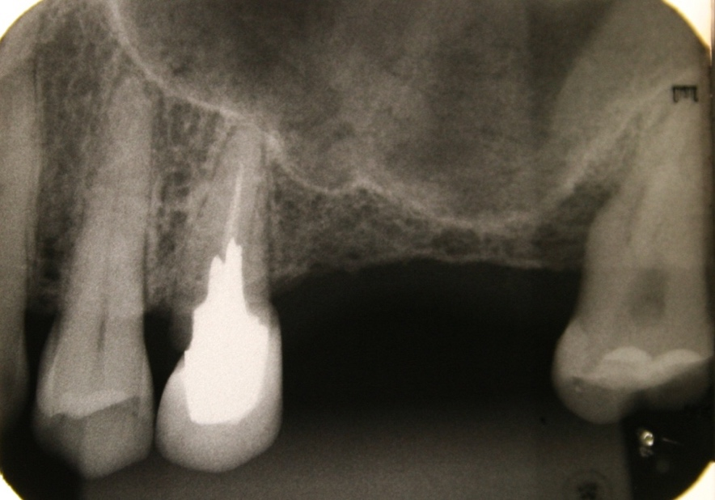

Fig. 1. Periapical radiographs showing preoperative conditions

After clinical and radiographic evaluation, the need for subgingival scaling to remove infectious focus prior to rehabilitation with dental implants was identified. Preoperative laboratory tests were requested to assess the patient’s systemic health status. Coagulation profile, fasting blood glucose, glycated hemoglobin, calcium and phosphorus levels were all within normal limits, as well as the complete blood count. Preoperative photographs were obtained together with a periapical radiograph, which clearly revealed the initial level of the alveolar crest and the maxillary sinus floor. Preoperative instructions were provided to the patient, in addition to the prescription of amoxicillin 500 mg, one tablet every 8 hours for 7 days, starting 2 days prior to the procedure, and two tablets of dexamethasone 4 mg one hour before surgery. On 26/10/2009, the patient attended the postgraduate center for the procedure and was instructed to perform intraoral antisepsis with a 1-minute rinse using 0.12% chlorhexidine, in addition to extraoral antisepsis with 2% chlorhexidine. Infiltrative anesthesia was performed with two cartridges of 4% articaine hydrochloride from regions 23 to 28 in both buccal and lingual aspects. A supracrestal incision was made from regions 25 to 28, with a releasing incision on the mesial aspect of region 25. After syndesmotomy, a large bone protuberance was observed in region 25; therefore, the bone in this area was scraped and collected using a Neodent bone scraper to be used as an autogenous graft in association with the planned hydroxyapatite (HA) graft material. The first 2.0-mm drill was strategically positioned more palatally rather than at the center of the prosthetic space, and drilling was performed up to the sinus cortical floor, seeking maximum available bone height. In region 26, drilling was performed up to 5 mm, and in region 27 up to 3 mm.
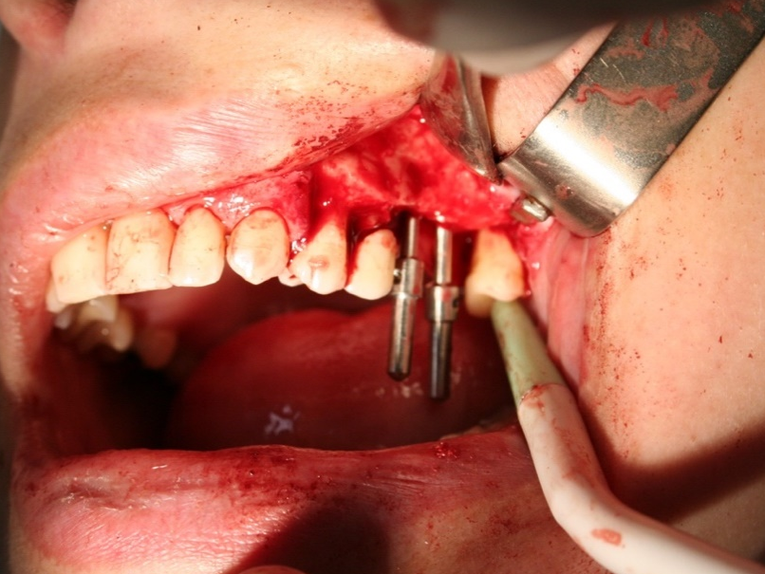
Fig. 2. First drilling and tunnel check instrument

The subsequent drilling with a 2.3-mm bur was carried out 2 mm shorter than the first drill. After this process, 2.5-mm osteotomes were used to fracture the cortical bone of the sinus floor, followed by a 2.8-mm osteotome to increase the width of the access, allowing insertion of the graft, without exceeding the initial measurement of 5 mm obtained during drilling. Together with the collected autogenous bone, hydroxyapatite (HA) graft material (Osteogen®, Intra-Lock) was mixed with saline solution, and graft insertion was performed using a bone carrier, followed by compaction with osteotomes, also without exceeding the measurement of the first drilling, thus allowing sinus elevation to occur through graft compaction. H.I. connection implants measuring 3.8 × 13 mm (SIN) were placed in region 26, and H.I. implants measuring 3.75 × 11 mm (DENTOFLEX) were placed in region 27. Primary stability achieved at insertion torque for both implants was fully satisfactory (43 N·cm in region 26 and 45 N·cm in region 27), even using the modified technique when the available bone height from the crest to the sinus cortical floor was less than 6 mm
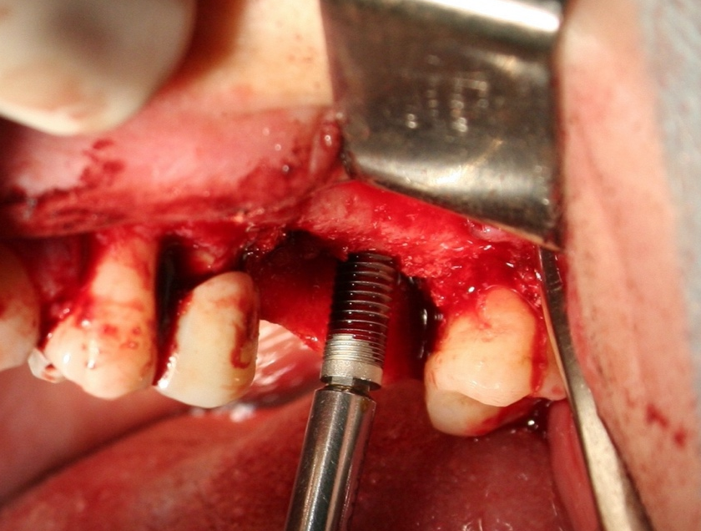
Fig. 3. Implants placement, after OSFE

After 6 months of osseointegration, the patient returned for revaluation, measurements and second-stage surgery, which was performed under infiltrative anesthesia with one cartridge of 2% lidocaine hydrochloride and a short supracrestal incision without papillary involvement. Healing abutments with a diameter of 3.5 mm were placed, and a 1-week healing period was allowed. After this period, the patient returned for implant impression using condensation silicone. Two weeks later, the splinted copings were tried in. The prostheses were finally cemented after applying a torque of 32 N·cm, according to the manufacturer’s instructions, with protection of the intermediary screws.
Following clinical procedures, measurements between the first and second surgical stages were performed using the ImageJ software as follows: periapical radiographic images were imported into the program and calibrated using the “Set Scale” function. Calibration was carried out based on the known height of the inserted implants prior to all measurements. This procedure ensured accurate measurements, allowing the difference in millimeters between the initial height from the alveolar crest to the maxillary sinus floor to be determined at the preoperative period (T1) and at 6 months postoperatively (T2), as shown in Figs. 5–8. The linear measurements at T1 and T2 and the bone gain obtained are presented in Table 1.
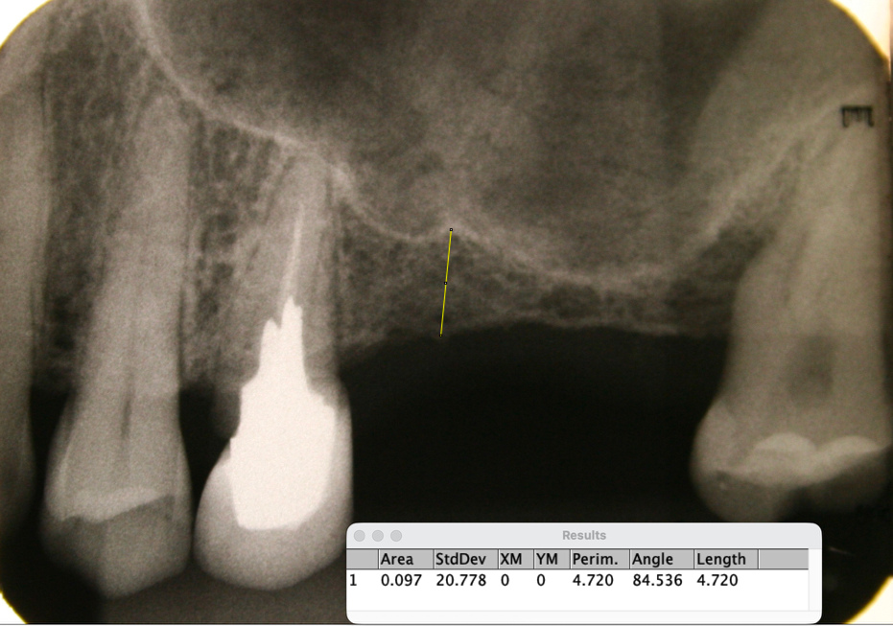
Fig. 4. Measurement of region 26 ( 4.72mm) – T1
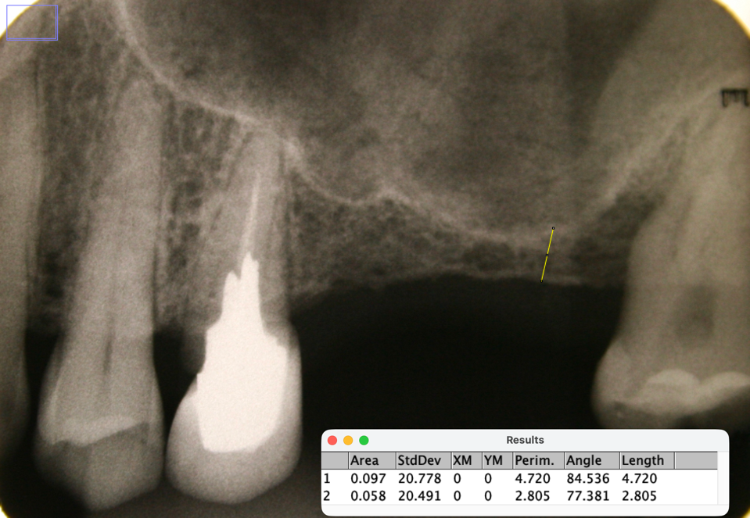
Fig. 5. Measurement of region 27 (2.80mm) – T1
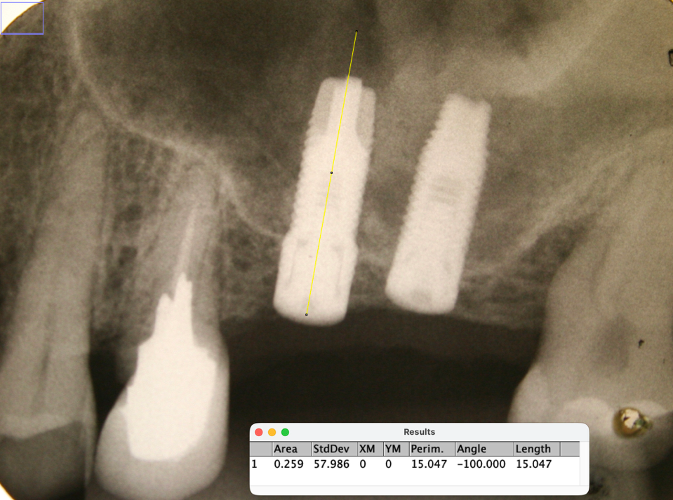
Fig. 6. Postoperative measurement of region 26 (15.04mm) – T2
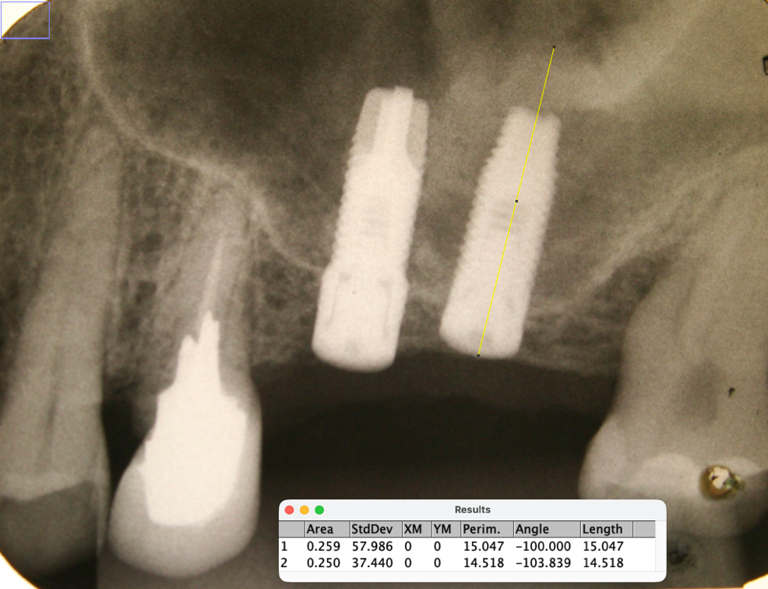
Fig. 7. Postoperative measurement of region 27 (15.04mm) – T2
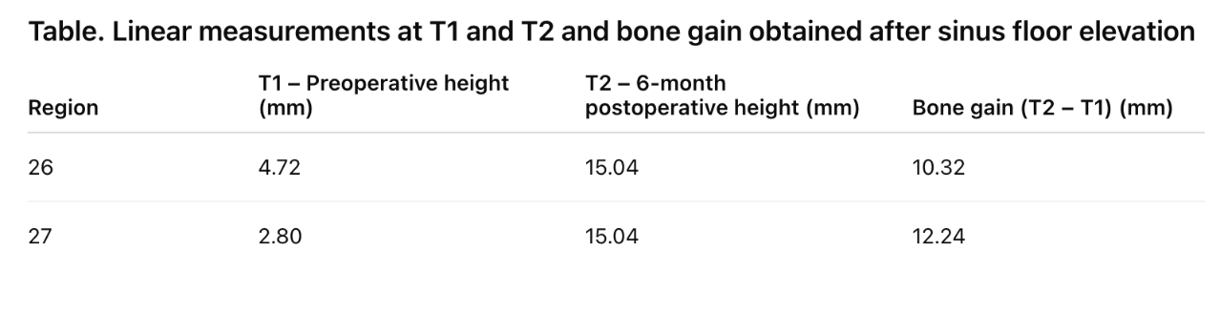
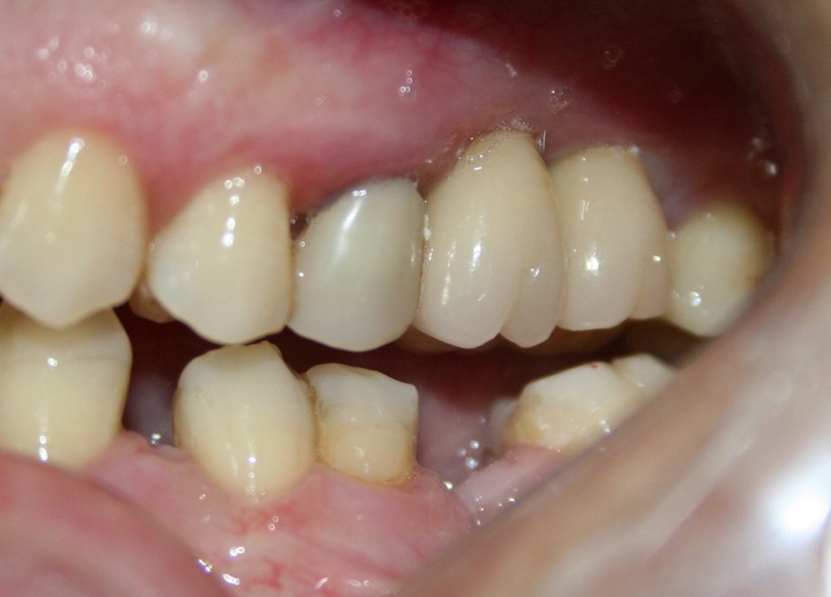
Fig. 8. Final outcome
The modified technique resulted in very expressive bone gain and treatment success rate of 100% over a long follow-up period of 14 years, with no complications reported by the patient.
2.2 Case Report 2:
A 36-year-old female patient was examined at the Brazilian Dental Association – Regional Santos, in the city of Santos, State of São Paulo, Brazil, on 04/04/2015, seeking an alternative to rehabilitate tooth 16. For the initial diagnosis, a periapical radiograph and intraoral photographs were obtained, and a panoramic radiograph was requested.
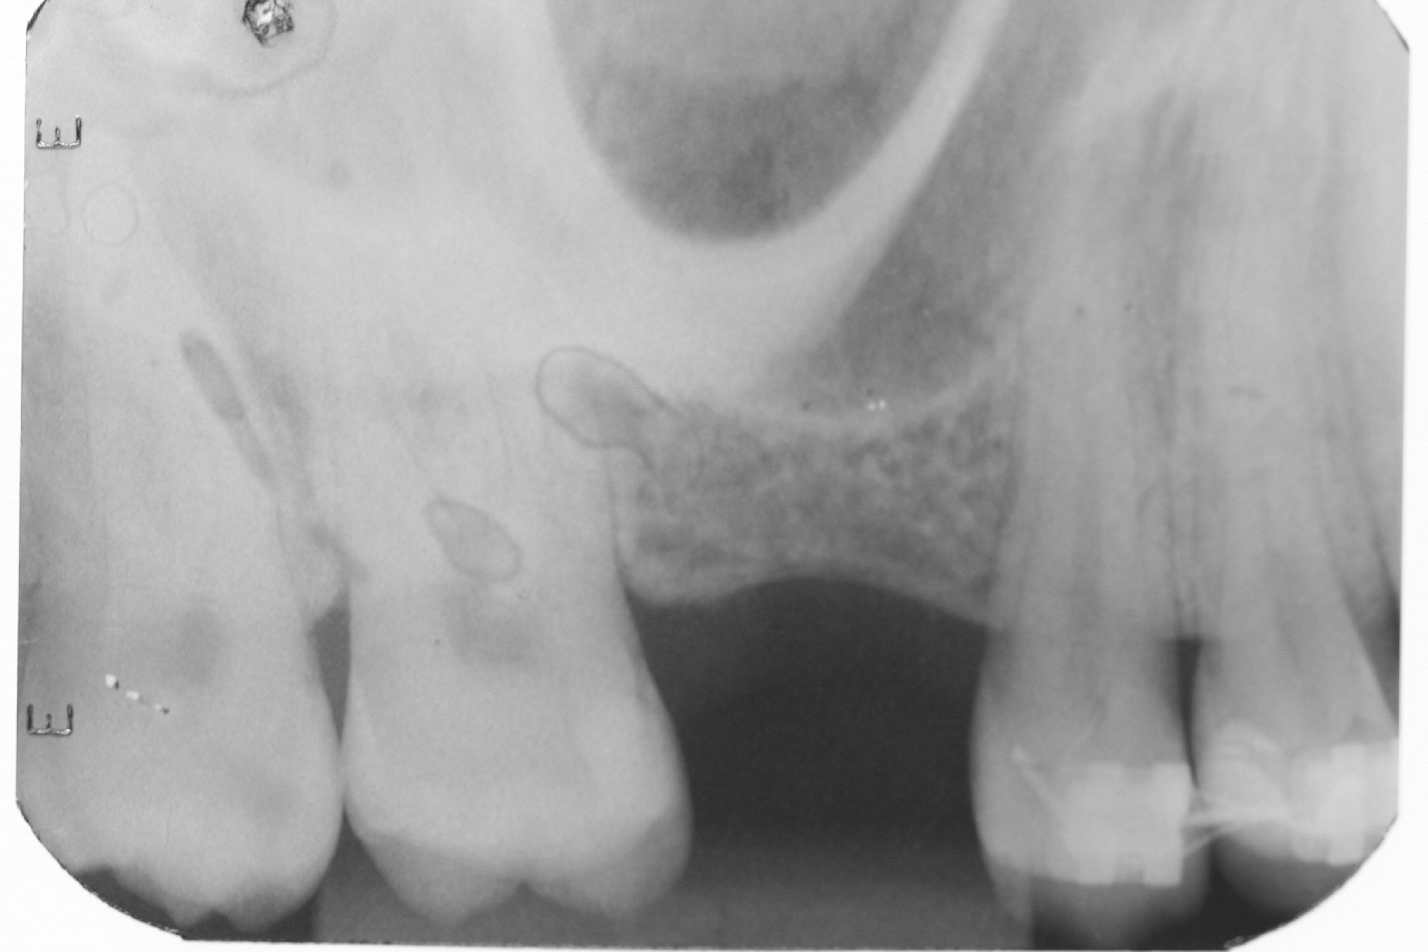
Fig. 9. Periapical radiograph showing preoperative conditions

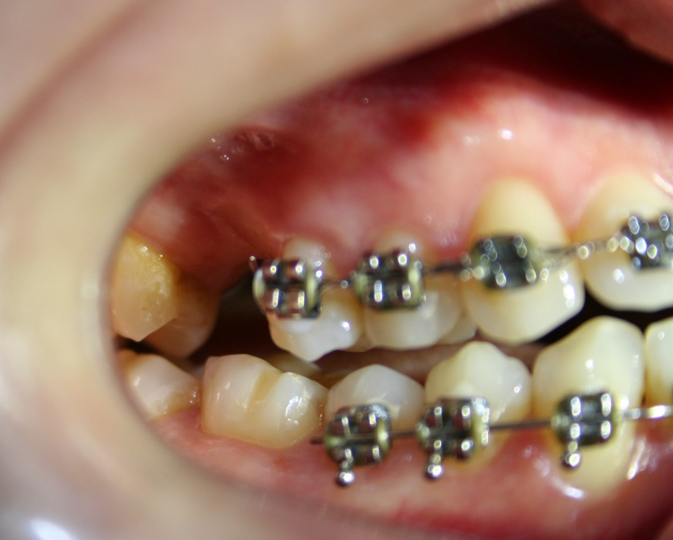
Fig. 10. Intraoral photograph of the initial diagnosis.
After clinical and radiographic evaluation, rehabilitation with a dental implant was proposed. Coagulation tests, fasting blood glucose, glycated hemoglobin, calcium and phosphorus levels were all within normal limits, as well as the complete blood count. Preoperative instructions were provided, and the patient was prescribed amoxicillin 500 mg, one tablet every 8 hours for 7 days, starting 2 days before surgery, and two tablets of dexamethasone 4 mg one hour before the surgical procedure, after which the surgery date was scheduled. On 05/05/2015, the patient attended the postgraduate center for the procedure and was instructed to perform intraoral antisepsis with a 1-minute rinse using 0.12% chlorhexidine, in addition to extraoral antisepsis with 2% chlorhexidine. Infiltrative anesthesia was performed with one cartridge of 4% articaine hydrochloride in regions 15 to 17 on both buccal and lingual aspects. Supracrestal incisions were made from regions 15 to 17, with intramuscular releasing incisions. After syndesmotomy, the first drill was strategically positioned more palatally, and drilling was performed to a depth of 5 mm. Subsequent drilling with a 2.3-mm bur was carried out 2 mm shorter than the first drill. After this process, 2.5-mm and then 2.8-mm osteotomes were used. With the use of osteotomes, access was created for insertion of the HA graft material (Osteogen®, Intra-Lock) mixed with saline solution, using a bone carrier and compaction with osteotomes, without exceeding the measurement of the first drilling. An H.I. connection implant measuring 3.75 × 10 mm (Dentoflex) was placed, followed by cover screw placement and simple suturing with silk thread. Primary stability achieved at insertion torque in region 16 was 35 N·cm³, even using the modified technique when the available bone height from the crest to the sinus cortical floor was less than 6 mm.
After 6 months of osseointegration, the patient returned for second-stage surgery, which was performed under infiltrative anesthesia with half a cartridge of 2% lidocaine hydrochloride and a short supracrestal incision without papillary involvement. A 3.5-mm healing abutment was placed, and after 1 week of soft tissue healing, the patient returned for implant impression using condensation silicone. Two weeks later, the prosthesis was finally cemented, with a torque of 32 N·cm³ applied to the abutment, according to the manufacturer’s instructions, and protection of the intermediary screw.
Following clinical procedures, measurements between the first and second surgical stages were performed using the ImageJ software as follows: periapical radiographic images were imported into the program and calibrated using the “Set Scale” function. Calibration was carried out based on the known height of the inserted implant prior to measurements. This procedure ensured accurate measurements, allowing the difference in millimeters between the initial height from the alveolar crest to the maxillary sinus floor to be determined at the preoperative period (T1) and at 6 months postoperatively (T2), as shown in Figs. 5–8. The linear measurements at T1 and T2 and the bone gain obtained are presented in Table 2.
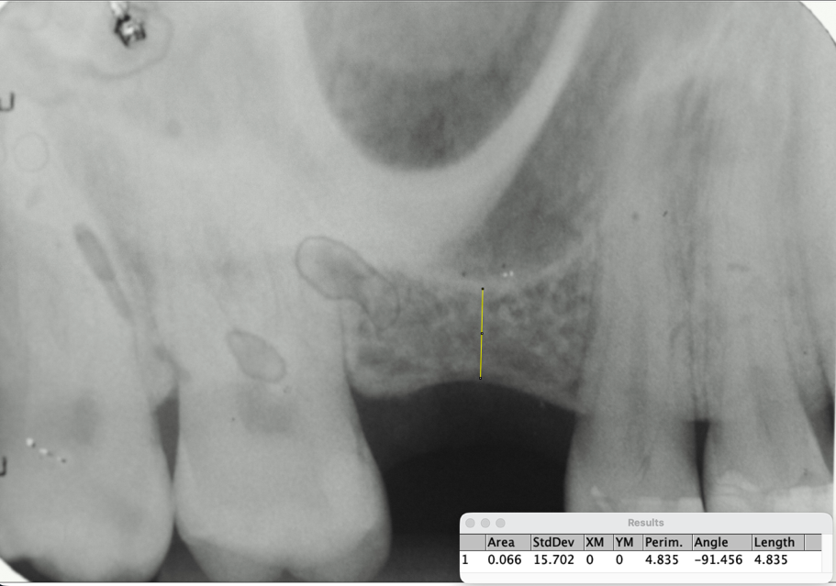
Fig. 11. Measurement of region 16 (4.83mm) – T1
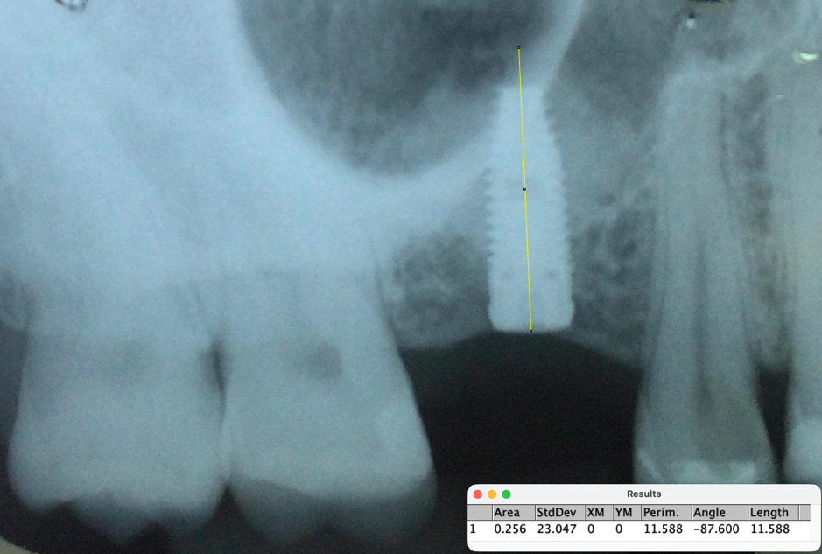
Fig. 12. Postoperative measurement of region 16 (11.58mm) – T2

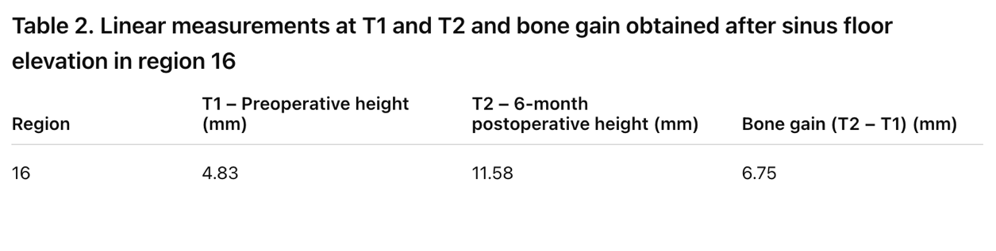
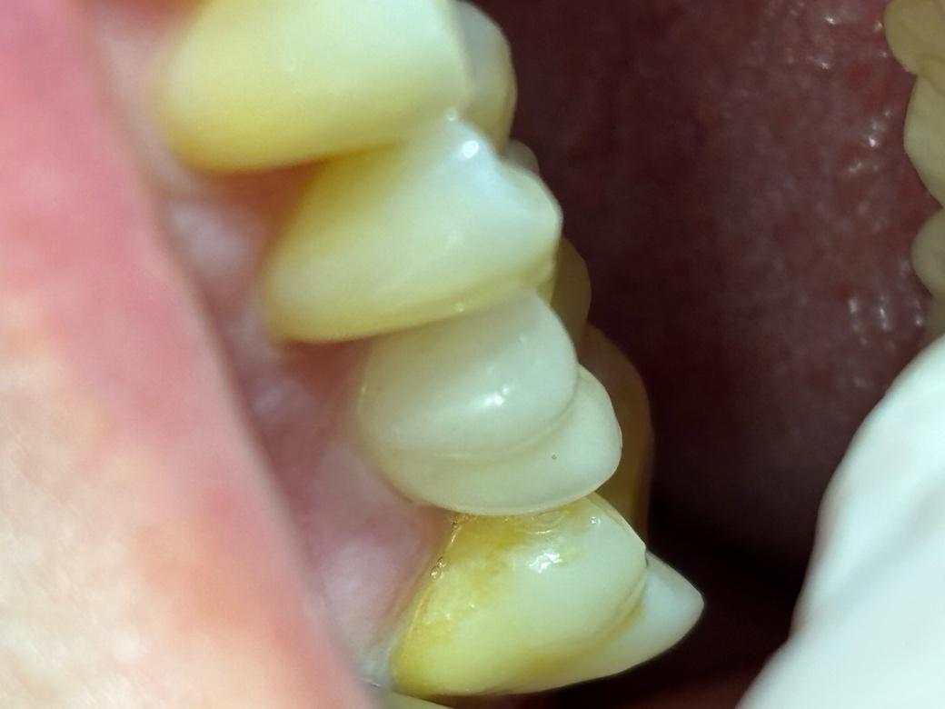
Fig. 9. Final outcome
This technique also resulted in a 100% success rate over a long follow-up period of 9 years, with no complications reported by the patient.

3. discussion

Several relevant factors must be considered to achieve such effective and long-lasting outcomes. The first and most important is meticulous planning of the bone perimeter, in order to exploit potential advantages of adjacent areas and of the sinus anatomy itself. Therefore, these cases demonstrate that it is possible to modify the original Summers technique, traditionally indicated for situations in which the residual bone height to the maxillary sinus cortical wall is 5–6 mm, to be applied in sites with residual bone height ranging from 3 to 5 mm (Lyu, 2023 ). Analysis of the present cases revealed the presence of posterior teeth adjacent to the surgical site, providing a bony framework to support the grafts, unlike situations with free-end bone perimeters, in which the graft would be highly vulnerable. The use of appropriate instruments for this type of procedure is also relevant for the prevention of complications. Elevating osteotomes, whose design favors preservation of the Schneiderian membrane, represent a positive influencing factor (Li, Hu and Han, 2017). Another important issue is the more palatal positioning of the first drilling and the reduction performed in the subsequent drill, since increasing drill diameter increases the risk of membrane perforation. A study demonstrated that in 29.6% of cases in which an implant was lost, sinus membrane perforation was reported (Tetsch, Tetsch, Lysek, 2010). It is well established in the literature that membrane perforation is a concerning complication affecting long-term graft and implant stability and survival. However, this limitation can be substantially reduced with guided surgery, due to precise drill calibration and ideal drill length (Canullo et al., 2023), a resource that was not available at the time these cases were performed. Nevertheless, implant success rates using OSFE are highly predictable and offer advantages such as reduced trauma and bleeding, less pain, and faster recovery compared with other available techniques such as LSFE (Kang, Liu, 2022). It is worth emphasizing that the association of HA with autogenous bone in Case 1 was essential to increase both the quantity and quality of the inserted graft, highlighting the importance of anatomical exploration for more promising outcomes, especially in maxillary sinuses with extensive bone loss. In addition, hydroxyapatite presents degradation rates of the grafted material of up to 100%, being transformed into vital bone within up to 16 weeks, when compared with DBBM, which shows considerable residual particles within the same period (Casarez-Quintana et al., 2022).
A recent systematic review with meta-analysis indicated that widely used xenogeneic biomaterials, such as DBBM and DPBM, present consistent performance in bone neoformation and stability, ranking among the materials with the most predictable outcomes in maxillary sinus floor elevation procedures (Khijmatgar et al., 2023). However, newer HA-based materials (OSSIX Bone – Dentsply Sirona) have stood out for their predictability in the formation of new vital bone and for having a firmer consistency that expands hydraulically like a sponge, in addition to not dispersing into particles during handling (Canullo et al., 2023), which is particularly interesting for maxillary sinus elevation cases due to the risk of Schneiderian membrane rupture.
4. Conclusion

Maxillary sinus floor elevation using the modified Summers technique proved to be very safe and predictable and, consequently, demonstrated excellent clinical longevity after prosthetic rehabilitation when properly planned and when the anatomical and systemic limitations of the patient are respected. Within the outlined treatment planning, three factors were determinant for success:
- Use of autogenous bone graft, maintaining biological properties of paramount importance for guided bone regeneration, in Case 1;
- Presence of posterior teeth adjacent to the placed implants, allowing a safe bony framework for containment and stability of the graft in both cases;
- Fabrication of splinted prostheses;
- Long-term follow-up of the patients, significantly minimizing the risks of occlusal overload or peri-implantitis.

AcknowledgEments

The authors would like to thank the Brazilian Dental Association – Santos for providing the facilities required for this study. We also thank the Santo Amaro University, São Paulo, Brazil, and its Master's Degree faculty team, which encouraged and assisted in the research processes.

Competing interests

The authors have declared that no competing interests exist.

Authors’ Contributions

Alexandre de Lima Alves conceived the study, performed the surgical procedures, collectedthe data, wrote the manuscript and approved the final version. Yeon Jung Kim contributed to data analysis and manuscript revision. Valter Castro Alves assisted in the surgical procedures and protocol development. All authors read and approved the final manuscript.

Consent

Written informed consent was obtained from the patients for publication of this case report and any accompanying images.

Ethical approval

Ethical approval for this study was obtained from the Research Ethics Committee under CAAE number 79602124.1.0000.0081, approval opinion number 6.909.102.

Disclaimer (Artificial intelligence)
Option 1:
Author(s) hereby declare that NO generative AI technologies such as Large Language Models (ChatGPT, COPILOT, etc.) and text-to-image generators have been used during the writing or editing of this manuscript.

References

- Aludden H, Mordenfeld A, Hallman M, Christensen A-E, Starch-Jensen T. Osteotome-Mediated Sinus Floor Elevation With or Without a Grafting Material: A Systematic Review and Meta-analysis of Long-term Studies (≥5-Years). Implant Dentistry. 2018;27(4):488–497. doi:10.1097/ID.0000000000000798.
- Anon JB, Rontal M, Zineich SJ. The maxillary sinus. In: Anon JB, Rontal M, Zineich SJ, eds. Anatomy of the Paranasal Sinuses. New York: Thieme; 1996:18-21.
- Bouwman WF, Bravenboer N, ten Bruggenkate CM, Eijsackers FA, Stringa N, Schulten EAJM. Tissue Level Changes after Maxillary Sinus Floor Elevation With Three Types of Calcium Phosphate Ceramics: A Radiological Study With a 5-Year Follow-Up. Materials (Basel). 2021;14(6):1471. doi:10.3390/ma14061471.
- Canullo L, Del Fabbro M, Colantonio F, Iacono R, Raffone C, Pedetta A, Khijmatgar S, Shapira L. Sinus floor augmentation using crestal approach in conjunction with hydroxyapatite/cross-linked collagen sponge: A pilot study. Clin Implant Dent Relat Res. 2023;25(5):974-983.
- Casarez-Quintana A, Mealey BL, Kotsakis G, Palaiologou A, et al. Comparing the histological assessment following ridge preservation using a composite bovine-derived xenograft versus an alloplast hydroxyapatite-sugar cross-linked collagen matrix. J Periodontol. 2022;93(11):1691–1700.
- Corbella S, Taschieri S, Del Fabbro M. Long-Term Outcomes for the Treatment of Atrophic Posterior Maxilla: A Systematic Review of Literature. Clin Implant Dent Relat Res. 2015;17(1):120-132.
- Del Fabbro M, Corbella S, Weinstein T, Ceresoli V, Taschieri S. Implant Survival Rates After Osteotome-Mediated Maxillary Sinus Augmentation: A Systematic Review. Clinical Implant Dentistry and Related Research. 2012;14(Suppl 1):e159–e168. doi:10.1111/j.1708-8208.2011.00399.x.
- Farina R, Franzini C, Trombelli L, Simonelli A. Minimal Invasiveness in Transcrestal Elevation of the Maxillary Sinus Floor: A Systematic Review. Periodontology 2000. 2022;91:145–166.
- Farina R, Franceschetti G, Travaglini D, et al. Morbidity Following Transcrestal and Lateral Sinus Floor Elevation: A Randomized Trial. Journal of Clinical Periodontology. 2018;45(9):1128–1139. doi:10.1111/jcpe.12985.
- Hirschfeld L, Wasserman B. A Long-Term Survey of Tooth Loss in 600 Treated Periodontal Patients. J Periodontol. 1978;49:225–237.
- Kang N, Liu C. Modified Osteotome Sinus Floor Elevation Technique for Multiple Edentulous Spaces: A Non-Randomized Controlled Trial. Int J Environ Res Public Health. 2022;19:8019.
- Khijmatgar S, Mousa MA, José A, Rousseau M, Aldehlawi FA, Corticoli N, et al. Comparative efficacy of different bone graft materials in maxillary sinus augmentation: A systematic review and network meta-analysis. Materials. 2023;16(4):1376.
- Li Y, Hu P, Han Y, et al. Comparative Ex Vivo Study of Three Sinus Elevation Instruments for Transcrestal Schneiderian Membrane Detachment. Bioengineered. 2017;8(4):359–366.
- Lyu M., Xu D., Zhang X., and Yuan Q., “Maxillary Sinus Floor Augmentation: A Review of Current Evidence on Anatomical Factors and a Decision Tree,” International Journal of Oral Science 15, no. 1 (2023): 41, 10.1038/s41368-023-00241-6.
- Smiler DG, Johnson P, Lozada J, et al. Sinus lift grafts and endosseous implants. Treatment of the atrophic posterior maxilla. Dent Clin North Am. 1992;36:151–186.
- Summers RB. A new concept in maxillary implant surgery: The osteotome technique. Compendium. 1994;15:152–154.
- Summers RB. The osteotome technique: Part 3—Less invasive methods of elevating the sinus floor. Compendium. 1994;15:698–700.
- Tatum H Jr. Maxillary and sinus implant reconstructions. Dent Clin North Am. 1986;30(2):207-229.
- Testori T, Weinstein RL, Taschieri S, Del Fabbro M. Risk factor analysis following maxillary sinus augmentation: a retrospective multicenter study. Int J Oral Maxillofac Implants. 2012;27:1170–1176.
- Testori T, Weinstein T, Taschieri S, Wallace SS. Risk factors in lateral window sinus elevation surgery. Periodontol 2000. 2019;81(1):91–123.
- Ulm C, Solar P, Krennmair G, Matejka M, Wutzke G. Incidence and suggested surgical management of septa in sinus-lift procedures. Int J Oral Maxillofac Implants. 1995;10:462–465.
- Valente NA. Anatomical considerations on the alveolar antral artery as related to the sinus augmentation surgical procedure. Clin Implant Dent Relat Res. 2016;18(5):1042–1050.
- Ye S, Pan Y, Chen L, et al. Long-term outcomes of implants with osteotome sinus floor elevation: A systematic review. J Dent Sci. 2021;16(1):31–38.

Abbreviations

HA – Hydroxyapatite
DPBM – Deproteinized Porcine Bone Mineral
DBBM – Deproteinized Bovine Bone Mineral
OSFE – Osteotome Sinus Floor Elevation
LSFE – Lateral Sinus Floor Elevation
β-TCP – β-Tricalcium Phosphate

