Original Research Article

Achieving Optimal Patient Outcomes After Frontal Sinus Endoscopy

.
ABSTRACT

Aims: Evaluating the Role of Biodegradable Drug-Eluting Stents in Enhancing Outcomes after Frontal Endoscopic Sinus Surgery.
Study design: Prospective case control study.
Place and Duration of Study: The Department of Otorhinolaryngology in Almoosa Specialist Hospital, Al Ahsa, Saudi Arabia, and Helwan University Hospital (Badr Hospital), Egypt. From March 2025 to December 2025.
Methodology: A total of 42 adult participants were enrolled and randomly assigned to either the Propel stent group (n=21) or the control group (n=21). Participants were monitored for nine months through clinical and radiographic evaluations, focusing on outcomes such as patency of the ostium, presence of adhesions, and recurrence of polyps.
Results: After nine months, the Propel stent group exhibited significantly higher ostium patency rates compared to the controls. Additionally, lower rates of stenosis, retained secretions, adhesions, and polyp formation were observed in the Propel stent group.
Conclusion: Propel stents significantly enhance frontal sinus patency and reduce the occurrence of postoperative adhesions and polyp recurrence in comparison to non-drug-eluting stents.

Keywords: Functional Endoscopic Sinus Surgery, Biodegradable drug-eluting Propel stents, Frontal sinus.

1. INTRODUCTION

Frontal sinus disease that persists despite medical treatment is typically addressed with Functional Endoscopic Sinus Surgery (FESS), which is the favored minimally invasive surgical approach (1,2). A major challenge in FESS success is the high likelihood of the frontal recess narrowing again (restenosis) after surgery. This is largely due to the recess's naturally constricted anatomy and surgical factors such as intraoperative trauma, which can lead to scarring and stenosis, ultimately compromising the procedure’s long-term effectiveness (1,3,5). Postoperative openings (neo-ostia) smaller than 5 mm are strongly associated with restenosis risk.
To preserve the openness of the ostium during the critical healing phase, frontal sinus stents have been used for over a hundred years. Initial materials, like rubber and gold, have been replaced by modern alternatives, including Silastic tubing and drug-eluting stents (1,6).
The newest development involves biodegradable, drug-releasing implants that resorb over time. These are small spring like coiled drug (Mometasone furoate) eluting devices delivering the drug directly to the tissues which keeps the frontal sinus ostia patent along with preventing polyp regrowth and improving the healing. It is useful in preventing complications & in revision surgeries by releasing the drug for 4-6 weeks as they dissolve. These implants locally deliver corticosteroids, which reduce inflammation and prevent scar tissue formation, thereby facilitating clear sinus healing. Two types are available: PROPEL Mini for Frontal sinuses & PROPEL Original for Ethmoidal sinuses. This innovation is expected to improve surgical outcomes and potentially lower the recurrence of nasal polyps. While some research suggests they may not always surpass conventional sinus packing, they offer a significant advantage for complex cases by allowing targeted drug delivery and avoiding systemic steroid side effects (6–13).
Despite this progress, there are currently no universally accepted protocols for using frontal sinus stents, making their application dependent on the surgeon’s judgment and intraoperative observations. Continued high-quality research is essential to determine the long-term safety and efficacy of these biodegradable drug-eluting devices (7,14,15).

2. material and methods

This prospective case-control study was conducted at two centers: the Department of Otorhinolaryngology in Almoosa Specialist Hospital, Al Ahsa, Saudi Arabia, and Helwan University Hospital (Badr Hospital), Egypt.
The study was conducted in full compliance with the ethical principles outlined in the Declaration of Helsinki and adhered to all applicable national and institutional guidelines. Approval was obtained from both the Helwan University Faculty of Medicine’s Research Ethics Committee and Almoosa Academic Affairs Institutional Review Board before initiation. All participants were provided with a clear and comprehensive explanation of the study’s objectives, procedures, and potential benefits. Written informed consent was obtained only after this discussion in lay Arabic language, ensuring participants understood that their involvement was entirely voluntary. Confidentiality of all personal and medical information was strictly maintained throughout the study.
Eligible participants included adults with a high clinical suspicion of restenosis in the frontal sinus drainage pathway due to underlying severe pathology: a long history of frontal sinus disease, moderate to severe current symptoms, prior sinus surgery, significant radiological findings on computed tomography (CT) (Fig. 1), or trauma-associated fibrosis. We excluded patients who had mild cases, short history of the disease, minor symptoms, or minimal imaging findings. Anyone known or suspected of being allergic to mometasone furoate or the materials used in the implants, such as lactide, glycolide, or caprolactone copolymers was also excluded. In addition, children and pregnant women were excluded.
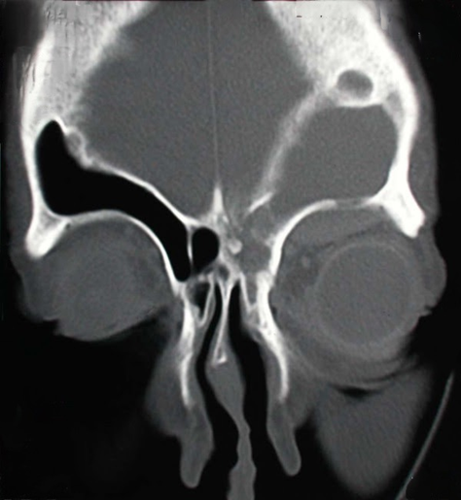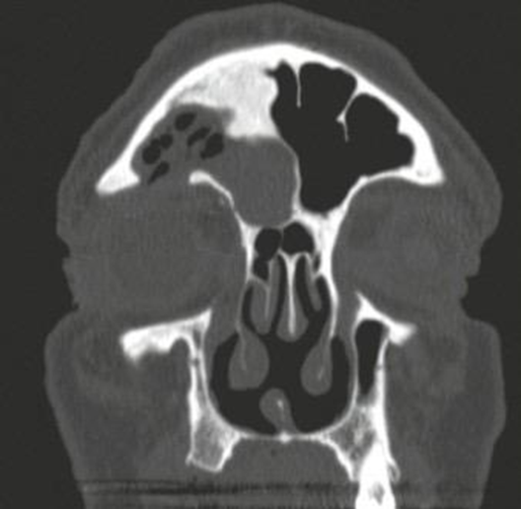
Figure 1: Coronal cuts CT scan nose and paranasal sinuses showing complicated frontal sinusitis with subperiosteal abscess collection.
Randomization and Blinding:
Randomization was carried out using a computer-generated random table. Allocation was concealed in sequentially numbered, opaque, sealed envelopes that were opened only after patient enrollment. The randomization process was conducted by an independent researcher not involved in patient care or outcome assessment. To minimize observer bias, clinicians evaluating frontal sinus ostium patency, inflammation, retained secretion, adhesions, polyp formation and sinonasal mucosa healing were blinded to group allocation. They were not involved in the randomization process or intervention application.
Eligible patients were randomly assigned into two equal groups; the case group (n = 21) received biodegradable drug-eluting frontal sinus stents Propel (Intersect ENT, Inc., Menlo Park, California, USA) during FESS, and the control group (n = 21) received non-drug-eluting stents with either Merocel (Medtronic Xomed, Jacksonville, Florida, USA) or Rains (Medtronic Xomed, Jacksonville, Florida, USA).
Patients were followed for nine months postoperatively using both clinical and endoscopic assessments, as well as radiological evaluation via CT.
Outcome measures included ostium patency, inflammation, retained secretions, adhesions, mucosal healing, and polyp recurrence.
The sample size was calculated using R software version 4.5.1 (R Foundation for Statistical Computing, Vienna, Austria), based on a 95% confidence level, an expected prevalence of chronic frontal sinusitis with polyposis of 4%, a 5% margin of error, and a target population size of 110. The minimum required sample size was estimated to be n = 39, rounded to 42 to allow for drop-out.
Data were statistically analyzed using R software version 4.5.1. Numerical variables were presented as means ± standard deviations. Between-group comparisons for categorical data were conducted using chi-square tests. The unpaired t-test was used for comparisons of numerical data. Statistical significance was defined as a p-value < 0.05. (Fig. 2)
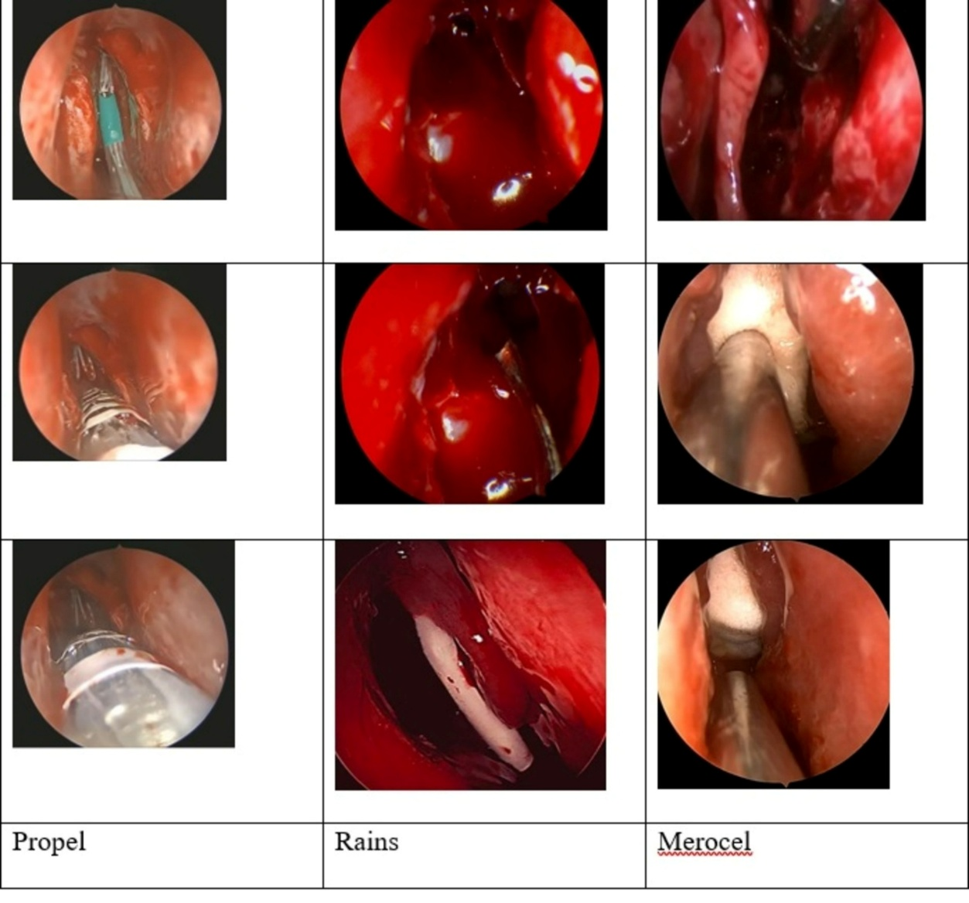
(Figure 2): Frontal Endoscopic Sinus Surgery with insertion of stent. A) Propel stent, B) Rains stent, C) Merocel stent.

3. resuLTs and discussion

Baseline characteristics
A total of 42 patients were included, with 21 in the case group and 21 in the control group (Table 1). The mean age was comparable between groups (46.19 ± 6.95 years versus 48.05 ± 9.00 years, p = 0.338). The gender distribution showed a slight predominance of males in both groups (61.9% versus 52.38%, p = 0.755). There were no statistically significant differences in smoking status, asthma, atopy, diabetes mellitus (DM), or The American Society of Anesthesiologists (ASA) classification between the two groups.
(Table 1): Baseline characteristics
Characteristic | Case Group (N=21) | Control Group (N=21) | P-value
Age |  |  | 0.338
Mean +/- SD | 46.19 +/-6.95 | 48.05 +/- 9.00
Median (IQR) | 46.00 (11.00) | 50.00 (14.00)
Gender | N (%) | N (%) | 0.755
Female | 8 (38.1%) | 10 (47.62%)
Male | 13 (61.9%) | 11 (52.38%)
Smoker | 7 (33.33%) | 6 (28.57%) | 1.000
Asthma | 6 (28.57%) | 4 (19.05%) | 0.717
Atopy | 7 (33.33%) | 10 (47.62%) | 0.530
DM (Diabetes Mellitus) | 7 (33.33%) | 6 (28.57%) | 1.000
ASA Classification |  |  | 1.000
ASA I | 1 (4.76%) | 1 (4.76%)
ASA II | 20 (95.24%) | 20 (95.24%)
SD=Standard Deviation, DM= Diabetes Mellitus, ASA=The American Society of Anesthesiologists.
Surgical indications and operative data
The distribution of diagnoses is comparable between groups, p = 1.00 (Table 2). Chronic frontal sinusitis plus deviated nasal septum and inferior turbinate hypertrophy was observed in 28.57% of the case group and in 33.33% of the controls. Other diagnoses, including chronic frontal sinusitis with nasal polyps, frontal mucocele, and frontal osteoma, were not significantly different between groups.
All patients underwent FESS with application of a stent. Propel stents were exclusively used in the case group (100%), whereas the control group received either Merocel (42.86%) or Rains stents (57.14%) (p < 0.001). For the control group only, postoperative stent removal was performed under local anesthesia using endoscopic guidance, with Merocel removed at 1 week and Rains at 1 month (Table 2).
(Table 2): Surgical indications and operative data
Characteristic | Case Group (N=21) | Control Group (N=21) | P-value
 | N (%) | N (%)
Diagnosis
Chronic frontal sinusitis + DNS/ITH* | 6 (28.57%) | 7 (33.33%) | 1.00
Chronic frontal sinusitis with nasal polyps | 7 (33.33%) | 8 (38.1%) | —
Chronic frontal sinusitis with polyps + DNS/ITH* | 4 (19.05%) | 4 (19.05%) | —
Frontal mucocele | 3 (14.29%) | 2 (9.52%) | —
Frontal osteoma | 1 (4.76%) | 0 (0%) | —
Operation |  |  | 0.755
FESS* and septoturbinoplasty with stent | 10 (47.62%) | 11 (52.38%)
FESS with application of stent | 11 (52.38%) | 10 (47.62%) | —
Type of Stent
Merocel |  | 9 (42.86%)
Propel | 21 (100%) | 0 (0%) | —
Rains |  | 12 (57.14%) | —
FESS = Functional Endoscopic Sinus Surgery
DNS = Deviated Nasal Septum
ITH = Inferior Turbinate Hypertrophy
Postoperative outcomes at 9 months
At the 9-month follow-up (Table 3), the case group demonstrated significantly better frontal sinus ostium patency, with 95.24% patent compared to 38.1% in controls (p < 0.001). Ostium stenosis was more frequent in controls (47.62% versus 4.76%). Ostial obstruction occurred in 14.29% of the control group but in none of the case group.
Excessive retained secretions were observed in 23.81% of the control group, but none in the case group (p = 0.009). Similarly, excessive adhesions occurred only in the control group (23.81% versus 0%, p = 0.001). Polyp formation was detected in 28.57% of controls but none of the case patients (p = 0.021).
(Table 3): Post-operative follow-up at 9-months
Outcome Measure | Case Group (N=21) | Control Group (N=21) | P-value
 | N (%) | N (%)
Frontal Sinus Ostium |  |  | <0.001
Patent | 20 (95.24%) | 8 (38.1%)
Stenosed | 1 (4.76%) | 10 (47.62%)
Obstructed | 0 (0%) | 3 (14.29%)
Inflammation |  |  | 0.184
No | 20 (95.24%) | 16 (76.19%)
Yes | 1 (4.76%) | 5 (23.81%)
Retained Secretions |  |  | 0.009
No retained secretion | 21 (100%) | 14 (66.67%)
Mild retained secretions | 0 (0%) | 2 (9.52%)
Excessive retained secretions | 0 (0%) | 5 (23.81%
Adhesions |  |  | 0.001
No adhesion | 21 (100%) | 9 (42.86%)
Mild adhesions | 0 (0%) | 7 (33.33%)
Excessive adhesions | 0 (0%) | 5 (23.81%)
Polyp Formation |  |  | 0.021
No polyp formation | 21 (100%) | 15 (71.43%)
Polyp formation | 0 (0%) | 6 (28.57%)
Healed Sinonasal Mucosa |  |  | 0.045
Healed | 20 (95.24%) | 14 (66.67%)
Not healed | 1 (4.76%) | 7 (33.33%)

The rate of completely healed sinonasal mucosa was higher in the case group (95.24% versus 66.67%, p = 0.045). All Propel stents were completely absorbed by the 9-month follow-up (Fig. 3) and (Fig. 4).

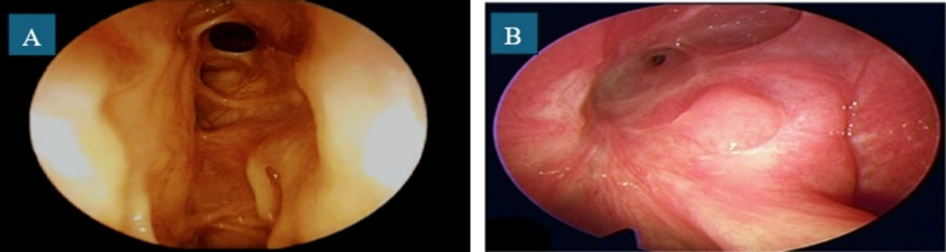
(Figure 3): Postoperative outcomes at 9 months, (A) Case group. (B) Control group.
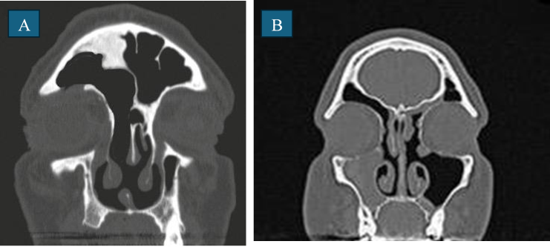(Figure. 4): Coronal cuts CT nose and paranasal sinuses showing postoperative outcomes at 9 months, (A) Case group. (B) Control group.

In this study, the effectiveness and safety of biodegradable drug-eluting stents (Propel) were compared to non-drug-eluting stents (Merocel and Rains) for preserving frontal sinus ostium patency after FESS in patients with different frontal sinus diseases.
According to the findings of this study, both groups had similar demographic and baseline data. There were no significant differences in gender, age, BMI, smoking, or comorbidities such as diabetes, asthma, and atopic disease. This homogeneity lowers the likelihood of confounding and improves the reliability of comparable results. In addition, the distribution of surgical indications was not substantially different between the two groups, indicating equal baseline pathology. The types of operations performed were also comparable between groups.
The frontal sinus represents one of the most anatomically complicated and surgically problematic locations in endoscopic sinus surgery due to the narrow drainage channel, morphological heterogeneity, and susceptibility to postoperative restenosis (15).
A striking finding was the significantly higher frontal sinus ostium patency in the case group (95.24% vs. 38.1%, p < 0.001) at nine months postoperatively. These results are in accordance with the findings of previous studies, which indicate that drug-eluting stents help to reduce fibrosis and the risk of restenosis (16).
In contrast, the control group experienced higher rates of stenosis (41.18%) and obstruction (17.65%), reflecting the common occurrence of postoperative scarring in the frontal recess (17). Additionally, adhesion formation was utterly absent in the case group compared to 57.14% of controls (p = 0.001). Hence, the benefit of sustained drug delivery in reducing fibroblast proliferation and collagen deposition is underscored (16,18).
The incidence of polyp formation was also significantly lower in the case group (0% vs. 28.57%, p = 0.021), which is clinically meaningful given that polyp recurrence is a common cause of re-intervention. Also, almost all patients (95.24%) in the case group demonstrated complete sinonasal mucosal healing, compared to 66.67% in the control group (p = 0.045), reflecting enhanced postoperative recovery and mucosal integrity with the drug-eluting device.
While signs of inflammation showed a non-significant (p = 0.184) trend favoring the case group, the retained secretions are significantly (p = 0.009) lower, 0% versus 34.33% in the control group.
These findings document the benefits of biodegradable, corticosteroid-eluting stents in optimizing surgical outcomes for frontal sinus disease. Previous studies have demonstrated the capacity of such implants to reduce synechiae formation, polyp recurrence, and ostial restenosis (15,16–18). Furthermore, the complete biodegradation of the Propel stent, typically observed by six months’ post-implantation, annihilates the need for additional procedures to remove the stent, as in traditional materials, such as Merocel or Rains.
However, despite these promising results, the role of stents in sinonasal surgery remains debated due to variability in study designs, follow-up durations, and definitions of success (17,18). This study provides important evidence supporting the routine use of drug-eluting stents in high-risk patients, especially those with complex anatomy, extensive polyposis, or a history of prior surgery that increases the likelihood of restenosis. However, certain limitations should be noted. The relatively small sample size may have limited our ability to detect differences in less common complications.
To validate these findings and develop standardized guidelines regarding stent indications, optimal patient selection, and long-term safety, further multicenter randomized controlled trials involving larger patient populations and extended follow-up periods are recommended.
In conclusion, using biodegradable, drug-eluting Propel stents during FESS dramatically improves frontal sinus ostium patency, minimizes adhesions and polyp recurrence, and improves mucosal healing when compared to traditional non-drug-eluting stents.

4. Conclusion

The use of biodegradable, drug-eluting Propel stents during FESS considerably improves frontal sinus ostium patency, minimizes adhesions and polyp recurrence, and fosters mucosal healing compared to conventional non-drug-eluting stents.

Ethical approval

“All authors hereby declare that all experiments have been examined and approved by the appropriate ethics committee and have therefore been performed in accordance with the ethical standards laid down in the 1964 Declaration of Helsinki.”
Ethical Approval Details:
IRB committee name: Almoosa Health Group.
Approval number (ARC-25.3.11)
Approval date (06/03/2025)

Disclaimer
“All authors hereby declare that NO generative AI technologies such as Large Language Models (ChatGPT, COPILOT, etc.) and text-to-image generators have been used during the writing or editing of this manuscript.

Study limitations:
The researchers highlighted a couple of key reasons why the study's findings should be viewed with caution:
• Limited Number of Participants: Because the study was conducted with a small sample size, the results need to be interpreted carefully and are not yet definitive.
• Need for Broader Confirmation: To truly establish a universal recommendation or guidelines for using these stents, the authors suggest the necessity of larger, follow-up research. This means conducting multicenter trials with more patients and observing the outcomes over a longer period.

References

1. Algahtani S, Alhajlah A, Abuharb AI, Alzarroug AF, Almughira AI, Alsywina N, et al. Outcomes of Functional Endoscopic Sinus Surgery in Chronic Rhinosinusitis: A Systematic Review and Meta-Analysis. Cureus. 2024 Feb;16(2):e53952. https://doi.org/10.7759/cureus.53952
2. Noon E, Hopkins C. Review article: outcomes in endoscopic sinus surgery. BMC Ear Nose Throat Disord. 2016 Aug 5;16:9. https://doi.org/10.1186/s12901-016-0030-8
3. Alharbi A, Alhussain F, Alyamani A, Aljohani M, Alsergani A, AbaAlkhail M, et al. Complications of endoscopic sinus surgery for chronic rhinosinusitis in a tertiary care teaching hospital in Saudi Arabia. Saudi Med J. 2023 Jun;44(6):601–6. https://doi.org/10.15537/smj.2023.44.6.20230911
4. Kar M, Bayar Muluk N, Alqunaee M, Manole F, Cingi C. Functional Endoscopic Sinus Surgery: Key Points for Safer Surgery. Ear Nose Throat J. 2024 Nov 1;103(3_suppl):5S-14S. https://doi.org/10.1177/01455613241287280
5. Papadopoulou AM, Chrysikos D, Samolis A, Tsakotos G, Troupis T. Anatomical Variations of the Nasal Cavities and Paranasal Sinuses: A Systematic Review. Cureus. 2021 Jan 15;13(1):e12727. https://doi.org/10.7759/cureus.12727
6. Brar T, Brown A, Miglani A, Lal D, Marino MJ. Outcomes of Frontal Sinus Stenting With Steroid Impregnated Microsponge Versus Steroid-Eluting Implant. Am J Rhinol Allergy. 2023 Nov;37(6):679–85. https://doi.org/10.1177/19458924231186901
7. Samargandy S, Grose E, Yip J, Lee JM. Endoscopic sinus surgery outcomes in patients with chronic rhinosinusitis and immunoglobulin deficiencies. Journal of Otolaryngology - Head & Neck Surgery. 2023 Jun 29;52:43. https://doi.org/10.1186/s40463-023-00648-3
8. Romano FR, Anselmo-Lima WT, Kosugi EM, Sakano E, Valera FCP, Lessa M, et al. Rhinosinusitis: Evidence and experience – 2024. Braz J Otorhinolaryngol. 2025 May 20;91(5):101595. https://doi.org/10.1016/j.bjorl.2025.101595
9. Cataldo Russomando A, Vogt Sionov R, Friedman M, Gati I, Eliashar R, Steinberg D, et al. Sinonasal Stent Coated with Slow-Release Varnish of Chlorhexidine Has Sustained Protection against Bacterial Biofilm Growth in the Sinonasal Cavity: An In Vitro Study. Pharmaceutics. 2021 Oct 25;13(11):1783. https://doi.org/10.3390/pharmaceutics13111783
10. Zhao XY, Chen M, Cheng L. Current and Emerging Treatment Options in Sinus and Nasal Diseases: Surgical Challenges and Therapeutic Perspectives. J Clin Med. 2023 Feb 13;12(4):1485. https://doi.org/10.3390/jcm12041485
11. Faoury M. Enhanced Evaluation of Bioresorbable Steroid-Releasing Stents and Corticosteroid-Infused Nasal Dressings in Postoperative Management of Chronic Rhinosinusitis. Journal of Otorhinolaryngology, Hearing and Balance Medicine. 2025 Dec;6(2):11. https://doi.org/10.3390/ohbm6020011
12. Lim DJ, Cho DY. The next generation of sinus stents for chronic rhinosinusitis: A systematic review. Precis Future Med. 2022 Sep 7;6(3):161–9. https://doi.org/10.23838/pfm.2022.00065
13. Goshtasbi K, Abouzari M, Abiri A, Yasaka T, Sahyouni R, Bitner B, et al. Efficacy of steroid-eluting stents in management of chronic rhinosinusitis after endoscopic sinus surgery: updated meta-analysis. Int Forum Allergy Rhinol. 2019 Dec;9(12):1443–50. https://doi.org/10.1002/alr.22443
14. Khan MA, Alshareef WA, Marglani OA, Herzallah IR. Outcome and Complications of Frontal Sinus Stenting: A Case Presentation and Literature Review. Case Rep Otolaryngol. 2020;2020:8885870
https://doi.org/10.1155/2020/8885870

15. Bandino F, Pendolino A, Bates J, Qureishi A, Martinez-Devesa P. Frontal sinus stenting in endoscopic sinus surgery: the 10-year Oxford experience. J Laryngol Otol. 2024 Jan;138(1):60–6.
16. Goshtasbi K, Abouzari M, Abiri A, Yasaka T, Sahyouni R, Bitner B, et al. Efficacy of steroid-eluting stents in management of chronic rhinosinusitis after endoscopic sinus surgery: updated meta-analysis. Int Forum Allergy Rhinol. 2019 Dec;9(12):1443–50.
17. Hwang SH, Kim SW, Basurrah MA, Kim DH. Efficacy of Steroid-Impregnated Spacers After Endoscopic Sinus Surgery in Chronic Rhinosinusitis: A Systematic Review and Meta-Analysis. Clin Exp Otorhinolaryngol. 2023 May;16(2):148–58.
18. Lim DJ, Cho DY. The next generation of sinus stents for chronic rhinosinusitis: A systematic review. Precis Future Med. 2022 Sep 7;6(3):161–9.

