Therapeutics Potential of Chlorella sorokiniana Bioactives Against Sulphur Ester Dioxygenase (4CVY) in Multidrug-Resistant Mycobacterium tuberculosis

ABSTRACT
Multidrug-resistant tuberculosis (MDR-TB) disease is caused by Mycobacterium tuberculosis that are resistant to at least one of the most effective TB medicines (Isoniazid and Rifampicin) used in treatment regimens. It remains one of the deadliest infectious diseases and a major threat to the health sector globally. The enzyme sulfur ester dioxygenase (PDB ID: 4CVY crystal structure) plays a crucial role in its survival and virulence by reducing sulfate to sulfide. Thus, it helps the organism obtain essential sulfur for growth. Meanwhile, Chlorella sorokiniana, a microalga has a significant biotechnological potential in combatting MDR-TB due to its rich nutritional profile and bioactive compounds.
AIM: This study was undertaken to investigate the therapeutic potential of bioactive compounds from Chlorella sorokiniana as novel drug candidates targeting the sulfur ester dioxygenase enzyme (PDB ID: 4CVY), a key factor in the survival and virulence of multidrug-resistant Mycobacterium tuberculosis.

Study Design: This study employed a laboratory-based experimental approach completed with insilico analyses involving the use of molecular docking tools.
Place and Duration of Study: This research was conducted at the Microbial Resources Research Laboratory, Department of Pure and Applied Biology, Ladoke Akintola University of Technology Ogbomoso, Nigeria over a twelve-month period from January 2024 to December 2024.

Methodology: Water Samples were collected from different fish ponds located at Randa, Taki Area, Ogbomoso, Oyo State, Nigeria. Chlorella sorokiniana was isolated from the pond water samples obtained from the fish pond and subsequently cultivated in Bristol medium broth under controlled laboratory conditions with exposure to natural light at an ambient temperature of 30 ± 2 °C for 2–3 weeks. The resulting metabolites were characterized and subjected to phytochemical analysis. Gas Chromatography–Mass Spectrometry (GC-MS; GC-MS QP instrument) was used to identify the present bioactive compounds, while Fourier Transform Infrared Spectroscopy (FTIR) was used to confirm the presence of functional groups, including hydroxyl, carbonyl, and amine groups, which are known to contribute to bioactivity. Molecular docking studies of the identified metabolites were performed against the target protein sulfur ester dioxygenase (PDB ID: 4CVY) using PyRx software. Isoniazid, a first-line anti-tuberculosis drug, was employed as a reference drug standard. Furthermore, ADMET (Absorption, Distribution, Metabolism, Excretion, and Toxicity) properties of the bioactive compounds were predicted using the SWISSADME computational tool.
Results: A total of eight (8) bioactive compounds were initially obtained from Chlorella sorokiniana through the GCMS analysis. Based on their docking scores, five metabolites demonstrated higher binding affinities compared to Isoniazid, namely 1H-pyrrole-2,5-dione, 1(4-chlorophenyl); 6-octadecenoic acid, (Z)-; and 9,15-octadecadienoic acid, methyl ester (Z,Z)-. These compounds exhibited notable antibacterial potential, with molecular docking analysis revealing strong interactions with the sulfur ester dioxygenase enzyme (4CVY). The ADMET predictions further supported the drug-likeness and pharmacological potential of these metabolites obtained using computational tools SWISSADME.
Conclusion: The findings of this study revealed Chlorella sorokiniana as a promising natural source of bioactive metabolites with potential therapeutic activity against MDR-TB sulphur ester dioxygenase 4CVY.
Keywords: Chlorella sorokiniana, sulphur ester dioxygenase (4CVY), MDR-TB, bioactive compounds, microalgae.
INTRODUCTION
Tuberculosis (TB) is a disease caused by Mycobacterium tuberculosis (MTB) and it remains one of the deadliest, infectious diseases globally posing a persistent threat to the health sector (WHO, 2024). Drug-resistant tuberculosis (TB) disease is caused by TB bacteria that are resistant to at least one of the most effective TB medicines used in treatment regimens (WHO, 2025). WHO noted that TB continues to be the leading cause of death responsible for over one million deaths annually with profound impacts on families and communities (WHO, 2025). Among the critical priority pathogens listed by the World Health Organization, M. tuberculosis strains resistant to Rifampicin and Isoniazid represent a significant global threat (Andarge et al., 2021). Consequently, the study of the mechanisms of resistance to new anti-tubercular drugs and the discovery of new effective molecules are two crucial points in tuberculosis drug discovery (Recchia et al., 2025).
Over the previous years, efforts have been made to reestablish focus on TB, although the situation created by the pandemic has raised many concerns about future changes, increasing the possible risk of multidrug-resistant TB (MDR-TB) (WHO, 2024). Drug resistance in TB, particularly multidrug-resistant TB (MDR-TB), has complicated disease management and contributes substantially to global antimicrobial resistance, with resistant TB accounting for nearly one in three deaths linked to AMR (ARC, 2022).
Transmission of TB occurs through airborne particles from one person to another. The TB germs are released into the air when an infected individual coughs, speaks, or sings. These germs can remain in the air for several hours, depending on the environment (Prestini et al., 2015). TB germs are more likely to spread indoors or other places with poor air circulation (such as a closed vehicle) than outdoor. People who have spent time with someone sick with drug-resistant TB disease can become infected with these resistant TB germs (CDC, 2025).
There are several types of drug-resistant TB disease.
Mono-resistant TB disease is caused by TB bacteria that are resistant to only one anti-TB drug.
Poly-resistant TB disease is caused by TB bacteria that are resistant to at least two anti-TB drugs (but not both Isoniazid and Rifampin).
Multidrug-resistant TB (MDR-TB) disease is caused by TB bacteria that are resistant to both Isoniazid and Rifampin, the two most effective first-line TB drugs (Lange et al., 2018).
Pre-extensively drug-resistant TB (pre-XDR-TB) disease is a type of MDR-TB caused by TB bacteria that are resistant to: Isoniazid, Rifampin, and a Fluoroquinolone or Isoniazid, Rifampin, and a second-line injectable (Amikacin, Capreomycin, and Kanamycin).
Extensively drug-resistant TB (XDR-TB) is a rare type of MDR-TB caused by TB bacteria that are resistant to: Isoniazid and Rifampin, a Fluoroquinolone, and a second-line injectable (Amikacin, Capreomycin, and Kanamycin) or Isoniazid, Rifampin, a Fluoroquinolone, and Bedaquiline or Linezolid (CDC, 2025).
Sulphur Ester Dioxygenase (PDB ID: 4CVY) of drug- resistant Mycobacterium tuberculosis is a protein that plays a pivotal role in the bacterium’s metabolism of sulphur-containing compounds, which are essential for bacterial survival, particularly under stress-induced conditions like drug treatment. Targeting such enzymes offer a promising approach for the development of novel anti-TB agents in combating multidrug-resistant (MDR) tuberculosis (Recchia et al., 2025).

Chlorella sorokiniana and its Bioactive Metabolites
Chlorella sorokiniana, a fast-growing green microalga, exhibits significant biotechnological potential due to its rich nutritional composition (proteins, lipids and carbohydrate) and wide spectrum of bioactive compounds (Chen et al., 2021). C. sorokiniana is one such microalga that is gaining popularity due to its rich nutritional profile (Lin et al., 2020). Additionally, C. sorokiniana is a notable source of carbohydrates, primarily in the form of complex polysaccharides, which serve as a source of energy. While its lipid content is relatively low compared to some other microalgae species, C. sorokiniana still provides essential fatty acids such as omega-3 and omega-6, contributing to cardiovascular health and overall well-being (Safitri et al., 2023). As photosynthetic organisms, microalgae utilize solar energy to transform carbon dioxide into useful biomass that is high in fats, proteins, vitamins, and minerals (Shihira and Atcc, 2003). In addition to its high protein content, complex carbohydrates, and essential fatty acids like omega-3 and omega-6, C. sorokiniana also possesses a remarkable profile of bioactive compounds that help mitigate oxidative stress (Singh et al., 2021). It possesses the antioxidant -carotenoids, such as lutein, beta-carotene, and zeaxanthin, which play a crucial role in neutralizing free radicals (Chung et al., 2012). Furthermore, C. sorokiniana contains chlorophyll and other polyphenolic compounds with potent antioxidant properties, contributing to improved cellular protection and overall health. These antioxidant compounds enhance the microalgae’s ability to promote health by reducing oxidative damage and inflammation (Pereira et al., 2024). In details, Chlorella species have been proposed as botanical foods to modulate human immune responses and have been shown to offer potential health benefits (Bito et al., 2020). Importantly, C. sorokiniana exhibits several beneficial pharmacological activities in vitro including anticancer, antibacterial, and antiviral effects (Tsamesidis et al., 2024). Building on this, this research aims to investigate the inhibitory potential of bioactive compounds derived from C. sorokiniana against the 4CVY of Mycobacterium tuberculosis using a computational drug discovery approach.
Bioactive Compounds in Chlorella sorokiniana
Phytochemical analysis of C. sorokiniana has identified a wide range of bioactive compounds, including terpenoids, phenolics, alkaloids, fatty acids, and peptides. These compounds exhibit significant antimicrobial and antitubercular potential.
- Phenolic compounds: C. sorokiniana contains a diverse array of phenolics such as caffeic acid, ferulic acid, and gallic acid, known for their strong antioxidant and antimicrobial effects (Khan et al., 2018). Phenolic compounds may interfere with microbial cell wall synthesis and inhibit key metabolic enzymes like IpdAB.
- Fatty acids: Several studies have identified polyunsaturated fatty acids (PUFAs), including linoleic acid, α-linolenic acid, and palmitic acid in C. sorokiniana. These lipids can disrupt bacterial membranes and modulate immune responses [Gouveia et al., 2010]. Docking studies have also shown that fatty acids can bind effectively to active sites of TB enzymes, suggesting their role as potential inhibitors (Figueroa et al., 2016).
- Terpenoids and carotenoids: Compounds such as lutein and β-carotene exhibit immunomodulatory and antimicrobial properties. Terpenoids may inhibit bacterial respiration or enzyme activity, including steroid-degrading enzymes like IpdAB [Safi et al., 2014].
- Peptides and proteins: Bioactive peptides isolated from Chlorella sorokiniana have shown antimicrobial activities against Gram-positive and Gram-negative bacteria. Some of these peptides are thought to penetrate bacterial membranes or inhibit intracellular proteins (Abdel-Raouf et al., 2012).

2. MATERIALS AND METHODS

2.1 Description of Study Site
The study was conducted using water samples from earthen fishponds used for catfish production located at Randa area, Ogbomosho, Oyo State, Nigeria (GPS coordinates: Latitude 9°07′00″ N, Longitude 8°29′00″ E), opposite Total Filling Station, Takie. Tbe preliminary assessment of the site showed the presence of algal bloom and this facilitated its suitability for the research work as shown in Figure 1.

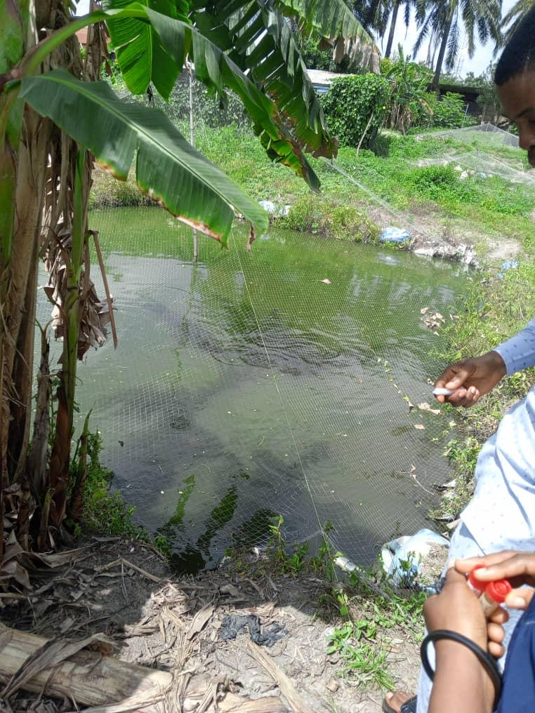
Figure 1: Image of the collection site

2.2 Collection and cultivation of Chlorella sorokiniana
Water samples were collected from earthen fishponds and the samples were initially filtered using a fine mesh sieve to minimize debris. The filtrates were afterwards cultured under submerged fermentation protocol using the shake-flask technique, in Bristol medium broth. Cultures were maintained under controlled laboratory conditions, exposed to natural light source and incubated at ambient temperature (30 ± 2°C) for 2–3 weeks according to Dewi et al., 2021. The extraction of the metabolites was done using ethanol and the spent medium free of biomass at ratio 2:1 respectively. It was left overnight at room temperature and then centrifuged at 4000 rpm for 15 minutes. The resulting cell-free supernatant was decanted aseptically into sterile labeled tubes and stored at ambient temperature.
2.3 Media and Composition
Specifically, 10g of sodium nitrate, 7g of potassium phosphate dibasic, 3g of potassium phosphate monobasic, 3g of magnesium sulphate, 1g of calcium chloride, and 1g of sodium chloride were each weighed using a weighing balance and dissolved separately in 400mL of distilled water contained in 6 different beakers (Hussain, 2020). From each salt solution, 10ml was siphoned into a conical flask containing 900mL of distilled water and stirred thoroughly. Subsequently, 15g of agar-agar was added into the conical flask (Safiet et al., 2014). The medium was then homogenized on a hot plate while stirring to ensure uniform distribution. The prepared medium was then covered with cotton wrapped with aluminum foil and sterilized by autoclaving at 121⁰C for 15 minutes (Plaza., et al 2010). Table 1 shows Bristol medium composition.
Table 1: Composition of Bristol medium (940 ml of distilled water + stock solution).
 | Ml | Stock solution | gram/400 ml H2O
 | 10 | NaNO3 | 10
 | 10 | CaCl2 | 1
 | 10 | MgSO4 | 3
 | 10 | K2HPO4 | 3
 | 10 | KH2PO4 | 7
 | 10 | NaCl | 1

2.3.1 Inoculation and Cultivation of Chlorella sorokiniana
Isolation of C. sorokiniana was performed to obtain pure microalgal cultures from pond water samples using the pour plate method. 15ml of sterile Bristol medium was aseptically dispensed into different sterile petri dishes. Thereafter, 1ml of each pond sample was inoculated into the plates containing the medium using a sterile syringe. The plates were allowed to solidify within a laminar flow chamber to minimize contamination. After solidification, the Petri dishes were sealed with adhesive tape. The isolated plates were incubated in an open space with adequate illumination and at room temperature (30 ± 2 °C) with adequate illumination for 2–3 weeks at the Microbial Resources Laboratory, Ladoke Akintola University of Technology, Ogbomoso, Oyo State, Nigeria (Kang et al., 2012; Costa et al., 2023). The culture was subjected to constant agitation to prevent cell sedimentation and ensure uniform exposure to light and nutrients (Mata et al., 2010).
Growth was monitored daily for visual indicators of algal proliferation, such as deepening green coloration and increased turbidity. After 7–10 days of cultivation, visible greenish colonies were sub-cultured aseptically onto fresh BG-11 medium to obtain unialgal cultures. Aseptic techniques were strictly maintained throughout the process to avoid contamination, as recommend by Andersen (2000).
2.3.2 Microscopic Identification of Chlorella sorokiniana
Preliminary identification of the cultivated microalgae was performed using light microscopy. Following 7-10 days of incubation in BG-11 medium, samples were aseptically withdrawn from actively growing cultures and mounted on clean glass slides. A drop of the algal suspension was placed on each slide and covered with a sterile coverslip for observation.
The morphological characteristics of the isolates was performed using a compound microscope (Uniscope XSG-109L) at magnifications of 400× and 1000×. Identification was based on distinct features such as unicellular organization, spherical to oval cell morphology, absence of flagella, presence of a single cup-shaped chloroplast, and cell size ranging from 3–10 µm, which are diagnostic of C. sorokiniana (Borowitzka, 2016; John et al., 2012).
2.4 Detection of Bioactive Molecules of Chlorella sorokiniana
The phytochemical composition of the algal extract was analyzed and bioactive compounds were identified using Gas Chromatography- Mass spectrometry (GC-MS) (Hussein et al., 2020). Dried algal biomass (2 g) was subjected to solvent extraction using methanol in a Soxhlet apparatus for 6 hours. The obtained extract was filtered through Whatman No. 1 filter paper and subsequently concentrated using a rotary evaporator at 40°C under reduced pressure.
The concentrated methanolic extract (1µL) was injected into a GC-MS system (Agilent 7890B GC coupled with 5977B MS detector) fitted with an HP-5MS capillary column (30 m × 0.25 mm i.e., 0.25 µm film thickness). Helium was used as the carrier gas at a constant flow rate of 1.0 mL/min. The oven temperature was programmed as follows: an initial temperature at 60°C (held for 2 min), ramped to 280°C at 10°C/min, and maintained for 10 minutes. The injector and detector temperatures were set at 250°C.
Mass spectra were obtained by electron ionization at 70eV and the identification of compounds was carried out by comparing the obtained mass spectral data with those available in the National Institute of Standards and Technology (NIST) database. (Hossain et al., 2021). The identified bioactive compounds were further categorized based on their pharmacological relevance, including fatty acids, terpenes, esters, phenolics, and sterols. (Pancha et al., 2019).

2.5 Fourier Transform Infrared Spectroscopy
Fourier Transform Infrared (FTIR) Spectroscopy was used to identify the functional groups present in the bioactive compounds of Chlorella sorokiniana. Fourier-transform infrared (FTIR) spectroscopy was performed on dried biomass. Approximately 10 mg of dried algal biomass was homogenized with 100 mg of spectroscopic-grade potassium bromide (KBr) and compressed into a thin, transparent pellet using a hydraulic press, following the protocol described by Pavia et al., (2014).
The pellet was scanned within the range of 4000–400 cm⁻¹ using a Shimadzu IRTracer-100 FTIR spectrometer. Characteristic absorption peaks were recorded and interpreted to identify the presence of major functional groups such as hydroxyl (-OH), carbonyl (C=O), amide (N-H), alkene (C=C), and aliphatic (C-H) groups. These functional groups are indicative of biomolecules such as lipids, proteins, carbohydrates, and other secondary metabolites (Elshobary et al., 2020). The spectral data were analyzed using Spectra Manager software for peak identification.
2.6 Blasting of the Obtained Result
Bioinformatic analysis of the obtained sequence data was performed using the Basic Local Alignment Search Tool (BLAST) available on the National Center for Biotechnology Information (NCBI) website (www.ncbi.nim.nih.gov). The computational algorithm for the sample query sequence (DNA, RNA, and protein) was done to identify the sequence similarities, homologous sequence and the phylogenetic analysis.
2.7 Molecular Docking
Molecular docking was carried out to investigate the interaction between selected bioactive compounds of C. sorokiniana and the 4CVY protein of Mycobacterium tuberculosis. The three-dimensional crystal structure of the enzyme Sulphur Ester Dioxygenase (PDB ID: 4CVY) was retrieved from the Protein Data Bank (PDB). The extracted Protein Data Bank coordinates were prepared for docking studies by removal of ligand, heteroatoms, and water molecules using BIOVIA (Discovery studio visualizer 2021). The ligand structures of Isoniazid (one of the first-line anti-tuberculosis drug) and the five (5) bioactive compounds identified in the filtrated broth medium were retrieved from the PubChem database and prepared using Auto-dock tools (Erazua et al., 2024). The prepared ligands of each bioactive molecule were docked with 4CVY enzyme using PyRx resulting in the generation of binding models and binding affinity data. The resulting receptor-ligand complexes were visualized in both two-dimensional and three-dimensional formats using BIOVIA Discovery Studio Visualizer (2020) such that the Receptor-Ligand interaction and the amino residues involved in the binding interaction were clearly visualized (Ahmad et al., 2023).

2.8 ADMET PREDICTIONS
ADMET represents Absorption, Distribution, Metabolism, Excretion, and Toxicity. ADMET prediction involves computational methods designed to estimate how a compound behaves within a biological system including its uptake, distribution across tissues, metabolic pathways, clearance, and potential toxicity.
Such predictions are typically generated through in silico approaches, including quantitative structure–activity relationship (QSAR) and quantitative structure–property relationship (QSPR) models, as well as advanced machine learning algorithms such as support vector machines, random forests, and neural networks. More recently, deep learning techniques, including graph neural networks (GNNs), have also been employed to enhance predictive accuracy. In this study, ADMET profiles of the identified bioactive compounds from Chlorella sorokiniana were evaluated using the SwissADME web-based tool.

3.0 RESULTS
3.1 Isolation, Cultivation and Characterization of Isolates
- Isolation and Cultivation
Pure cultures of Chlorella sorokiniana were successfully isolated from pond samples, with the microalga displaying rapid cell division, forming four new cells every 17–24 hours. This rapid growth highlights its potential suitability for large-scale cultivation in both pharmaceutical and agricultural applications. The results obtained from GC-MS, FTIR, molecular docking, and ADMET predictions are presented below. Representative growth stages and identification procedures are shown in Plates 1–4. Plate 1 depicts the growth of C. sorokiniana on Bristol medium slants, while Plate 2 illustrates submerged culture growth in Bristol medium alongside the control. Plate 3 presents the pure isolates cultivated under controlled laboratory conditions, and Plate 4 shows the microscopic identification of C. sorokiniana.
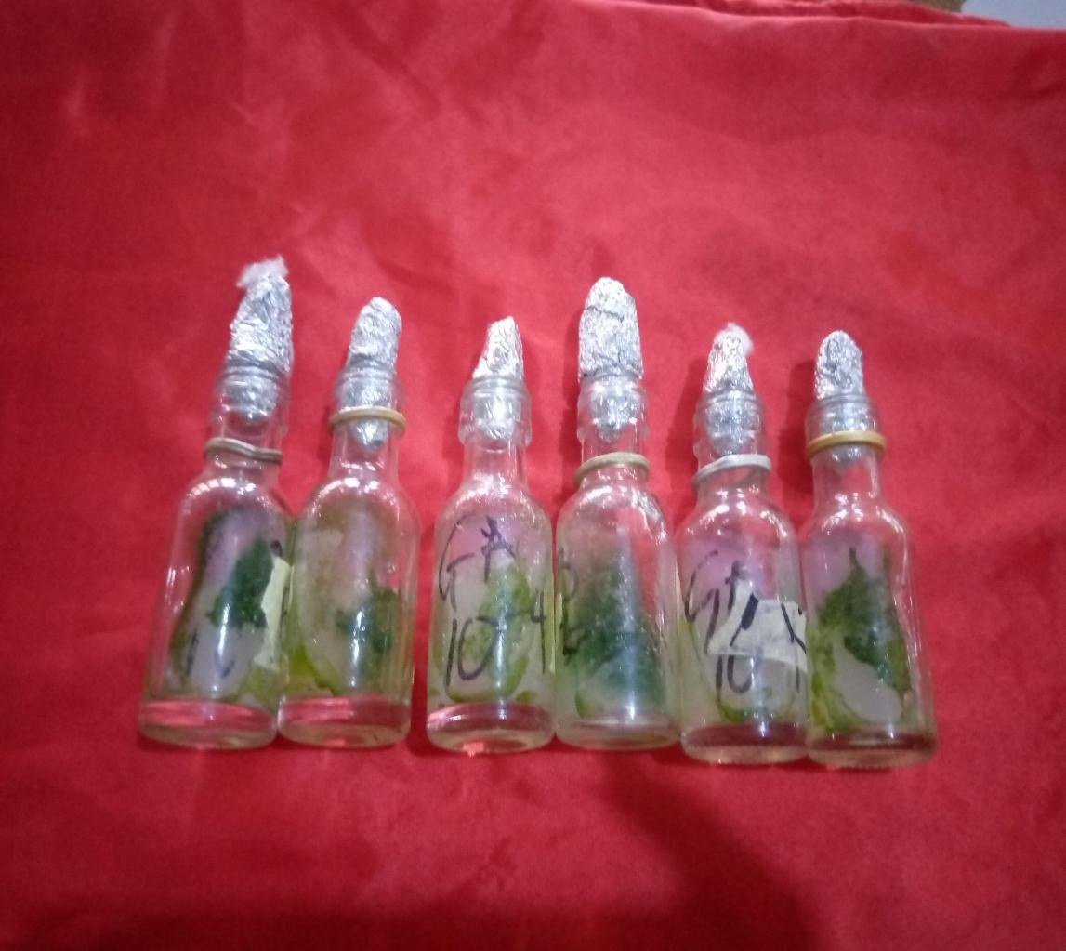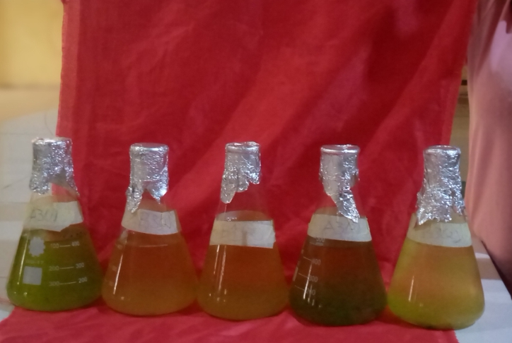
Plate 1: Growth of Micro-algae in slants of Bristol medium
Plate 2: Submerged culture of Micro-algae in Bristol medium and the Control
A total of three (3) compounds were identified from Chlorella sorokiniana. The bioactive compound (metabolites) obtained is labelled plate 1 and 2 above (Kang et al., 2012).
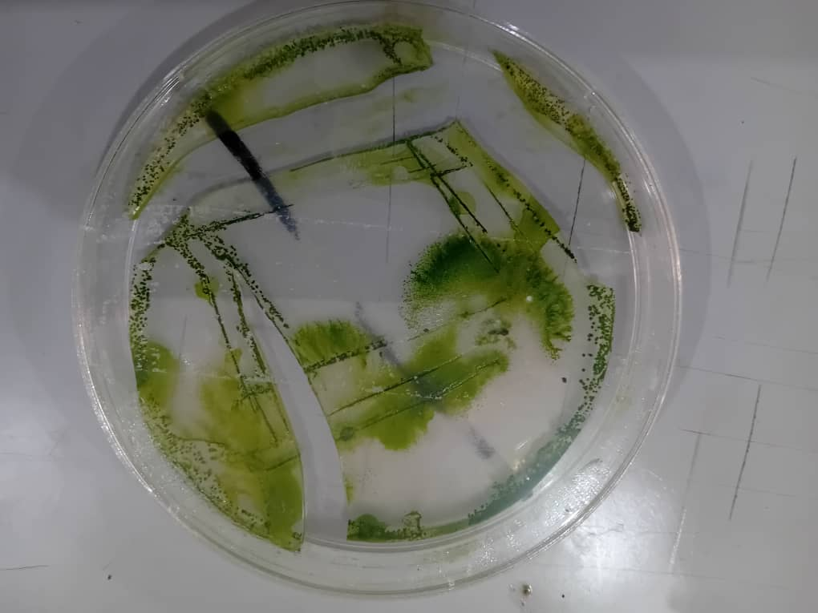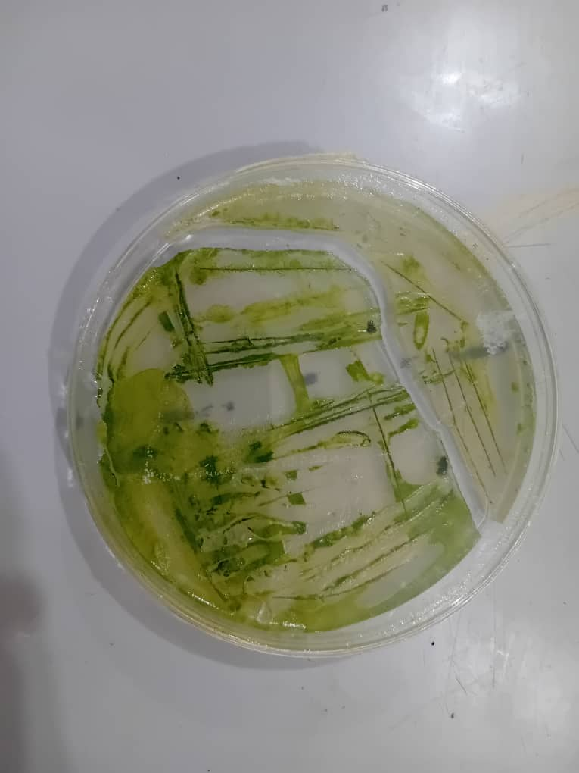
Plate 3: Pure isolates on plate cultivated under a controlled laboratory setting
3.1.2 Microscopy Identification
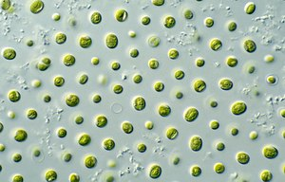
Plate 4: Microscopic identification of Chlorella sorokiniana using Uniscope XSG- 109L SERIES.

Table 2: Blasting Result Obtained
Likely Organism | Maximum score | Total score | Query cover | E-value | Percentage Identity | Length | Accession number
Chlorella sorokiniana | 938 | 938 | 99% | 0.0 | 99.81% | 1703 | MH818004.1
Chlorella sorokiniana | 938 | 938 | 99% | 0.0 | 99.81% | 1713 | KY054944.1
Chlorella sorokiniana | 938 | 938 | 99% | 0.0 | 99.81% | 1708 | OP297209.1
Chlorella sorokiniana | 938 | 938 | 99% | 0.0 | 99.81% | 1740 | GQ122327.1
Chlorella sorokiniana | 937 | 937 | 98% | 0.0 | 100.00% | 561 | OM792200.1

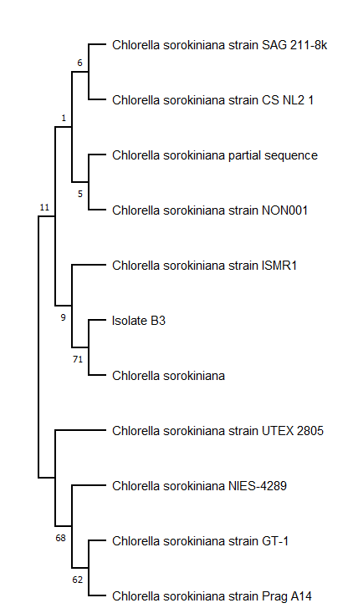
Figure 2: The phylogenetic tree illustrates the evolutionary relationships among various Chlorella sorokiniana strains and related species.
3.2 Phylogenetic analysis Result
The phylogenetic tree as shown in Figure 2 above illustrates the evolutionary relationships among various Chlorella sorokiniana strains and related species, with branch points (nodes) representing divergence from common ancestors. Bootstrap values on the branches indicate confidence in each grouping, where higher values suggest stronger support. For instance, Isolate B1 clustered closely with Chlorella sorokiniana strain SAG 211-8k (bootstrap 10), indicating a close evolutionary relationship. Other strains, such as CMBB151, NZmm3W1, and isolate 161, formed clusters with moderate support (bootstrap 7–8), while Chlorella vulgaris isolate CV NL2 2 is grouped with Chlorella sorokiniana isolate BE1, implying a closer evolutionary relationship to each other than to the remaining strains analysed (Tamura et al., 2011).
3.3 Gas Chromatography–Mass Spectrometry (GC-MS)
The GC-MS analysis of the C. sorokiniana metabolites revealed several bioactive compounds, including 9,15-octadecadienoic acid, methyl ester (Z,Z)-, 6-octadecenoic acid (Z), and 1H-pyrrole-2,5-dione, 1-(4-chlorophenyl). These compounds are known for their antibacterial properties, highlighting their potential as biocontrol agents against pathogenic microorganisms.
Retention times, peak areas, and corresponding compounds were recorded and are presented in Table 2. Among the detected metabolites, 6-octadecenoic acid (Z) exhibited the highest abundance, with a percentage peak area of 6.89% at a retention time of 14.886 minutes. This was followed by 9,15-octadecadienoic acid, methyl ester (Z,Z)-, with a percentage peak area of 5.76% at 14.978 minutes, and 1H-pyrrole-2,5-dione, 1-(4-chlorophenyl), with 0.69% at 12.66 minutes.
In addition to these major compounds, the GC-MS analysis identified several classes of bioactive molecules, including polysaccharides, peptides, carotenoids, and fatty acids, many of which have been previously reported for their antimicrobial and antioxidant properties (Parimalachelvan et al., 2023).

3.4 Fourier Transform Infrared Spectroscopy
FTIR analysis confirmed the presence of key functional groups in the metabolites of Chlorella sorokiana, such as hydroxyl, carbonyl, and amine, which contribute to the bioactivity of these compounds. The infrared spectrum of the isolate displayed distinct absorption peaks corresponding to characteristic molecular vibrations, as presented in the spectra diagram below.
The observed peaks and their corresponding functional groups included: C–Br bending at 420.5 cm⁻¹, CO–O–CO stretching at 1049.31 cm⁻¹, C–O stretching at 1230.63 cm⁻¹, and S=O stretching between 1384.94–1408.08 cm⁻¹. Additional peaks were recorded for C–H bending (1454.38 cm⁻¹), C=O/C=N stretching (1558.54 cm⁻¹), and C=C stretching/N–H bending (1635.69 cm⁻¹). Absorptions in the range of 2897.18–2989.76 cm⁻¹ corresponded to C–H stretching, while a broad band at 3448.84 cm⁻¹ was attributed to O–H stretching. Furthermore, a distinct peak at 2353.23 cm⁻¹ indicated O=C=O stretching.
The relative intensity of these absorption bands reflects the abundance of the corresponding functional groups, supporting the presence of lipids, proteins, and other secondary metabolites within the algal extract.

3.5 Molecular Docking of the Obtained Metabolites of Chlorella sorokiniana and Isoniazid
Molecular docking studies were performed using AutoDock Tools, PubChem (for ligand retrieval), and PyRx. The three-dimensional crystal structure of Mycobacterium tuberculosis Sulphate Ester Dioxygenase (PDB ID: 4CVY) was retrieved from the Protein Data Bank (PDB) and prepared for docking using BIOVIA Discovery Studio Visualizer. Figure 4 illustrates the 3D structure of the 4CVY protein, including its primary binding site (highlighted in a black circle). This binding pocket directly participates in the catalytic reaction by accommodating substrate molecules and facilitating chemical transformation. The protein consists of two chains, designated as A and B.
Docking of the standard anti-tuberculosis drug, Isoniazid, against 4CVY revealed the interaction profile and binding conformation, as visualized in Figure 5.
Similarly, docking analyses of bioactive compounds derived from Chlorella sorokiniana—including 6-octadecenoic acid (Z)-, 9,15-octadecadienoic acid, methyl ester (Z,Z)-, 1H-pyrrol-2,5-dione, 1-(4-chlorophenyl), and were visualized in Figures 6–8.
Analysis of the receptor–ligand interactions revealed the involvement of multiple bond types, including van der Waals forces, conventional hydrogen bonds, carbon–hydrogen bonds, alkyl interactions, π–alkyl, and π–σ interactions. These molecular interactions contribute to the stability of the complexes and provide insights into the potential inhibitory activities of the algal metabolites against the 4CVY enzyme.

Table 3: List of bioactive compounds present in Chlorella sorokiniana
Probable compounds | Active binding Affinity
1-cyclohexylnonene | -5.5
15-hydroxypentadecanoic acid | -5.6
9,15-octadecadienoicacid, methyl ester, (Z,Z)- | -5.7
6-octadecenoic acid, (Z) | -5.9
1H-pyrrole-2,5-dione, 1-(4-chlorophenyl) | -6.9
Isoniazid | -5.8

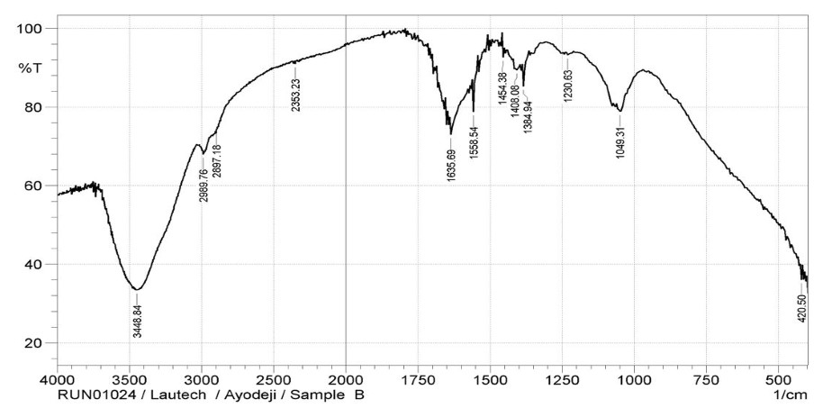
Figure 3: FTIR Spectra diagram showing the peak numbers of the metabolites

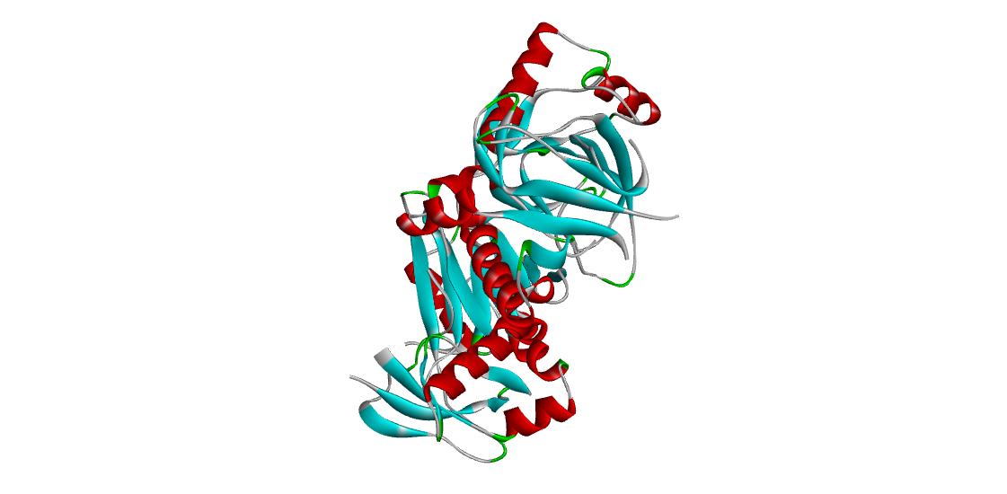
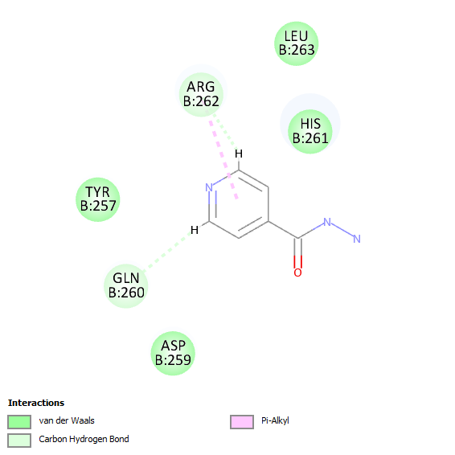
Figure 4: The 3D structure of Mycobacterium tuberculosis protein, Sulphur ester dioxygenase (4CVY) active binding site
Figure 5: The 2D visualization of 4CVY enzyme of Mycobacterium tuberculosis docked against the standard drug, Isoniazid.
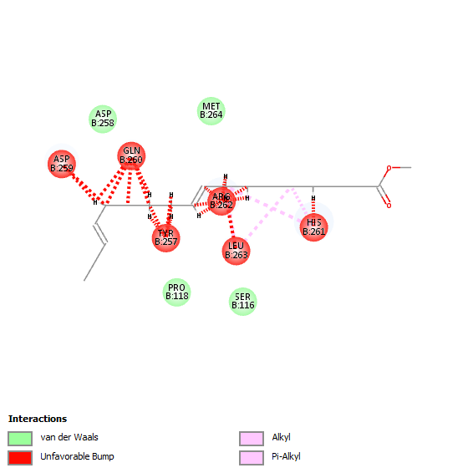

Figure 6: The 2D visualization picture of Prepared 4CVY docked with 9,15-octadecadienoic acid, methyl ester, (Z,Z)- obtained from Chlorella sorokiniana.

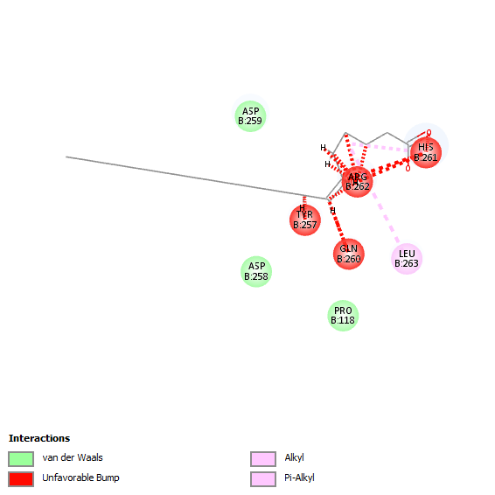Figure 7: The 2D visualization picture of Prepared 4CVY docked with 6-octadecenoic acid, (Z)- obtained from Chlorella sorokiniana.

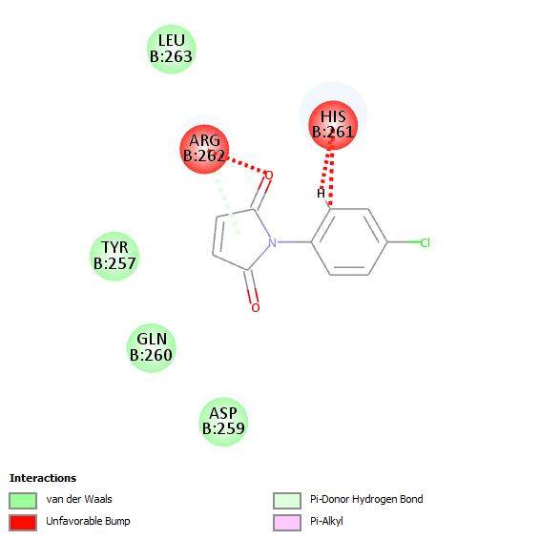
Figure 8: The 2D visualization picture of Prepared 4CVY docked with 1H-pyrrole-2,5-dione, 1-(4-chlorophenyl) obtained from Chlorella sorokiniana.

3.6 ADMET Predictions of the Obtained Bioactive Compounds Compared with Isoniazid
The ADMET properties of the bioactive compounds derived from Chlorella sorokiniana were evaluated and compared with the standard drug, Isoniazid. The results are summarized in Tables 4–9.
Toxicity predictions included Ames mutagenicity (AMES), Maximum Tolerated Dose (MTD), human Ether-à-go-go–Related Gene inhibition (hERG I and II), Oral Rat Acute Toxicity (ORA), Oral Rat Chronic Toxicity (ORC), hepatotoxicity, skin sensitization, Tetrahymena pyriformis toxicity, and minnow toxicity. For sample 1, all compounds showed negative AMES results, similar to Isoniazid. MTD values varied across compounds in both samples. Importantly, none of the compounds exhibited hERG I or II inhibition, indicating a low risk of cardiotoxicity. Tridecanoic acid, 12-methyl-, methyl ester (sample 1) and 6-octadecenoic acid (Z) (sample 2) showed the lowest ORC values, suggesting higher chronic toxicity risk. No compounds were predicted to be hepatotoxic. In terms of skin sensitization, all compounds in sample 2 showed positive effects except 1-cyclohexylnonene.
Metabolism-related predictions (Tables 8 and 9) revealed isoform-specific inhibitory effects. In sample 1, tridecanoic acid, 12-methyl-, methyl ester and 9,12-octadecadienoic acid, methyl ester were predicted to inhibit CYP3A4. In sample 2, 9, 15-octadecadienoic acid, methyl ester (Z,Z)- and 6-octadecenoic acid (Z) showed inhibitory activity against CYP1A2.
Excretion potential and renal interactions (Tables 6 and 8) showed variability in clearance pathways among the compounds. Distribution properties (Tables 8 and 6) indicated differences in blood–brain barrier penetration and plasma protein binding, influencing systemic availability.
Absorption-related predictions (Tables 6 and 8) included water solubility, intestinal absorption, and skin permeability. Compared with Isoniazid, most compounds demonstrated poor solubility but high skin permeability. Tridecanoic acid, 12-methyl-, methyl ester (sample 1) and 1-cyclohexylnonene (sample 2) had the highest intestinal absorption rates.
Medicinal chemistry properties (Tables 6 and 8) showed that in sample 1, none of the compounds triggered BRENK alerts, although all exhibited at least one lead-likeness violation, except for 9,12-octadecadienoic acid, methyl ester, which showed no violations and had favorable synthetic accessibility. In contrast, in sample 2, all compounds exhibited at least one lead-likeness violation and BRENK alerts, except for acetic acid, trifluoro-dodecyl.
Collectively, these results indicate that while the algal metabolites possess promising bioactive potential, some limitations in solubility, metabolic interactions, and lead-likeness must be addressed before further drug development.

Table 4: Toxicity of the bioactive compounds present in Chlorella sorokiniana and Isoniazid
Properties /  Compounds | 9,15-octadecadienoic acid, methyl ester, (Z,Z)- | 6-octadecenoic acid, (Z) | 1H-pyrrole-2,5-dioe, 1-(4-chlorophenyl) | Isoniazid
AMES | No | No | No | No
MTD | -0.019 | -0.810 | 0.251 | 1.166
hERG I | No | No | No | No
hERG II | No | No | No | No
ORA | 1.617 | 1.417 | 2.228 | 2.304
ORC | 3.004 | 3.259 | 1.899 | 1.395
Hepatotoxicity | No | No | No | No
Skin Sen. | Yes | Yes | Yes | Yes
T. pyriformis | 1.603 | 0.676 | 1.448 | -0.134
Minnow | -1.600 | -1.438 | 1.373 | 3.12
______________________________________________________________________

Table 5: Metabolism of the bioactive compounds present in Chlorella sorokiniana and Isoniazid

Properties /  Compounds | 9,15-octadecadienoic acid, methyl ester, (Z,Z)- | 6-octodecenoic acid, (Z) | 1H-pyrrole-2,5-dioe, 1-(4-chlorophenyl) | Isoniazid
CYP2D6-sub | No | No | No | No
CYP3A4-sub | Yes | Yes | No | No
CYP1A2-inh | Yes | Yes | No | No
CYP2C19-inh | No | No | No | No
CYP2C9-inh | No | No | No | No
CYP2D6-inh | No | No | No | No
CYP3A4-inh | No | No | No | No

Table 6: Excretion potential of the bioactive compounds present in Chlorella sorokiniana and Isoniazid
Properties /  Compounds | 9,15-octadecadienoic acid, methyl ester, (Z,Z)- | 6-octadecenoic acid, (Z) | 1H-pyrrole-2,5-dione, 1-(4-chlorophenyl) | Isoniazid  (Control)
Total Clearance | 2.035 | 1.884 | 0.029 | 0.076
Renal OCT2 | No | No | No | No
_______________________________________________________________________

Table 7: Distribution potential of the bioactive compounds present in Chlorella sorokiniana and Isoniazid
___________________________________________________________________________
Properties /  Compounds | 9,15 octadecadienoic acid, methyl ester, (Z,Z)- |  | 6-octadecenoic acid, (Z) | 1H-pyrrole-2,5-dione, 1-(4-chlorophenyl) | Isoniazid  (Control)
VDSS |  | 0.272 | -0.558 | 0.054 | -0.352
Fu |  | 0.028 | 0.052 | 0.387 | 0.728
BBB- Perm |  | 0.767 | -0.168 | 0.440 | 0.002
CNS- Perm |  | -1.463 | -1.654 | -2.179 | -3.351

Table 8: Absorption potential of the bioactive compounds found in Chlorella sorokiniana and Isoniazid
Properties /  Compounds | 9,15-octadecadienoic acid, methyl ester, (Z,Z)- | 6-octadecenoic acid, (Z) | 1H-pyrrole-2,5-dione, 1-(4-chlorophenyl) | Isoniazid  (Control)
Water sol | -7.343 | -5.924 | -2.214 | -1.6
Caco-2 Perm | 1.612 | 1.563 | 1.771 | 0.52
IA | 92.66 | 91.823 | 95.794 | 92.601
Skin Perm | -2.719 | -2.725 | -2.229 | -3.351
P-glycop-sub. | No | No | No | No
P-glycop I-inh | No | No | No | No
P-glycop II-inh | Yes | No | No | No
__________________________________________________________________________________
Table 9: Medicinal Chemistry of the bioactive compounds present in Chlorella sorokiniana and Isoniazid

Properties /Compounds | 9,15-octadecadienoic acid, methyl ester, (Z,Z)- | 6-octadecenoic acid, (Z) | 1H-pyrrole-2,5-dione, 1-(4-chlorophenyl) | Isoniazid (Control)
PAINS | 0 alert | 0 alert | 0 alert | 0 alert
Brink | 1 alerts | 1 alert | 1 alert | 2 alerts
Lead likeness | No; 2 violation | No; 2 violations | No; 1 violations | No; 1 violation
Synthetic accessibility | 3.08 | 3.07 | 1.88 | 1.24

4.0 DISCUSSION
The global rise of multidrug-resistant Mycobacterium tuberculosis (MDR-TB) continues to undermine the effectiveness of standard treatment regimens and highlights the urgent need for novel therapeutic interventions (WHO, 2025; Lamprecht et al., 2025). In the present study, bioactive compounds isolated from Chlorella sorokiniana were evaluated for their inhibitory potential against sulfur ester dioxygenase (4CVY), a key enzyme that enables sulfur metabolism and contributes to the survival of drug-resistant M. tuberculosis strains (Recchia et al., 2025; Di Napoli et al., 2025).
Bioactive compounds and inhibitory potential
GC-MS profiling identified metabolites including 6-octadecenoic acid (Z), 9,15-octadecadienoic acid methyl ester (Z,Z)-, and 1H-pyrrole-2,5-dione, 1-(4-chlorophenyl). Docking analysis revealed that these compounds bound with stronger affinities than Isoniazid, a first-line anti-TB drug. The interactions, mediated through hydrogen bonds, hydrophobic contacts, and van der Waals forces, suggest possible interference with sulfur assimilation pathways vital for mycobacterial persistence. Comparable inhibitory effects of natural metabolites on essential M. tuberculosis enzymes have been reported in recent studies (Singh et al., 2024; Rodríguez-Fernández et al., 2023), reinforcing the potential of these algal compounds as lead structures for anti-TB drug design.
Pharmacokinetic and toxicity profiles
In silico ADMET predictions demonstrated that the top-performing compounds had high gastrointestinal absorption, low predicted hepatotoxicity, and no inhibition of hERG channels, suggesting low cardiotoxic risk. Nevertheless, limitations such as reduced solubility and skin sensitization risks were observed. These pharmacological features are consistent with prior reports on microalgal metabolites, which often exhibit broad-spectrum bioactivity with favorable safety margins (Friedrich & Puchala, 2021; Domínguez-Gámez et al., 2024). Further optimization through structural modification could enhance solubility and bioavailability without compromising efficacy.
C. sorokiniana as a drug reservoir
Microalgae have emerged as valuable biotechnological resources due to their diverse metabolic outputs and eco-friendly cultivation (Borowitzka, 2013). C. sorokiniana in particular is rich in fatty acids, carotenoids, peptides, and phenolic compounds that possess antioxidant, antimicrobial, and immunomodulatory effects (Barkia, Saari, & Manning, 2019; Saini, Manchanda, Chaudhary, & Singh, 2024). The compounds identified in this study reinforce the species’ potential as a sustainable reservoir for antimycobacterial drug discovery, aligning with previous findings that natural metabolites can act as effective enzyme inhibitors and modulators of bacterial survival (Kotliarova et al., 2024).
Comparative advantage over existing therapies
The therapeutic landscape of TB is increasingly complicated by drug resistance. Although Isoniazid remains a frontline treatment, resistance mechanisms have severely reduced its clinical effectiveness (Lange et al., 2018). The superior docking scores of C. sorokiniana metabolites compared with Isoniazid suggest potential as novel inhibitors or as adjuvants in combination therapy. This approach mirrors current strategies that emphasize alternative metabolic targets, such as purine biosynthesis and sulfur metabolism, as promising routes for MDR-TB treatment (Lamprecht et al., 2025; Recchia et al., 2025).
Implications and future perspectives
This study provides evidence that C. sorokiniana metabolites can interact with essential mycobacterial enzymes and demonstrate drug-like properties in silico. However, while docking and ADMET analyses offer strong preliminary data, experimental validation through in vitro and in vivo assays remains crucial. Further structure–activity relationship (SAR) optimization may improve the pharmacokinetic limitations observed. Ultimately, the integration of microalgae into drug discovery pipelines not only offers new therapeutic opportunities but also promotes sustainable and environmentally responsible bioprospecting.

5.0 CONCLUSION
In summary, this study demonstrates that Chlorella sorokiniana is a promising source of bioactive compounds with potential antimicrobial activity against by multidrug-resistant Mycobacterium tuberculosis (MDR-TB). The ability of its phytochemicals to effectively interact with the 4CVY protein suggests a new avenue for anti-TB drug development, particularly against drug-resistant strains. These results provide a solid foundation for further exploration of microalgae as reservoirs of novel antimycobacterial agents. Future studies should focus on in vitro validation, mechanistic assays, and in vivo preclinical testing to establish the therapeutic efficacy, safety, and potential clinical relevance of these compounds.

Disclaimer (Artificial intelligence)
Author(s) hereby declare that NO generative AI technologies such as Large Language Models (ChatGPT, COPILOT, etc.) and text-to-image generators have been used during the writing or editing of this manuscript.

REFERENCES

- Ahmed, N., Sheikh, M. A., Ubaid, M., Chauhan, P., Kumar, K., & Choudhary, S. (2024). Comprehensive exploration of marine algae diversity, bioactive compounds, health benefits, regulatory issues, and food and drug applications. Measurement: Food, 100163.
- Allué-Guardia A, García JI and Torrelles JB (2021) Evolution of Drug-Resistant Mycobacterium tuberculosis Strains and Their Adaptation to the Human Lung Environment. Front. Microbiol. 12:612675. doi: 10.3389/fmicb.2021.612675
- Andarge DB, Anticho TL, Jara GM, Ali MM. Prevalence of Mycobacterium tuberculosis infection and rifampicin resistance among presumptive tuberculosis cases visiting tuberculosis clinic of Adare General Hospital, Southern Ethiopia. SAGE Open Med. (2021);9:1–7. https://orcid.org/0000-0001-7786-3400
- Andarge DB, Anticho TL, Jara GM, Ali MM. Prevalence of Mycobacterium tuberculosis infection and rifampicin resistance among presumptive tuberculosis cases visiting tuberculosis clinic of Adare General Hospital, Southern Ethiopia. SAGE Open Med. (2021);9:1–7. https://orcid.org/0000-0001-7786-340
- Antimicrobial Resistance Collaborators. Global burden of bacterial antimicrobial resistance in 2019: A systematic analysis. Lancet 2022, 399, 629−655.
- Becker E. W. Microalgae for human and animal nutrition. Handbook. Microalgal Cult., John Wiley and Sons, Ltd. (2013), pp. 461-503, 10.1002/9781118567166.ch25
- Bito, T., Okumura, E., Fujishima, M. and Watanabe, F. Potential of chlorella as a dietary supplement to promote human health. Nutrients 12, 1–21 (2020).
- Borowitzka, M. A. (2013). Sustainable aquaculture: The potential of algae. Journal of Applied Phycology, 25(2), 459-465. https://doi.org/10.1007/s10811-012-9790-3
- Center for Disease Control (CDC) 2025
- Chen, W. Wang Z, Santoyo S. Effect of dietary supplementation with Chlorella sorokiniana meal on the growth performance, antioxidant status, and immune response of rainbow trout (Oncorhynchus mykiss). J. Appl. Phycol. 33, 3113–3122 (2021).
- Chung, K. T., Wong, T. Y., and Wei, C. I. (2012). Antioxidant properties of Chlorella sorokiniana and its potential application in food systems. Journal of Applied Phycology, 24(6), 2023-2030.DOI: 10.1007/s10811-012-9889-z
- Deborah Recchia, Giovanni Stelitano, Anna Egorova, Gherard Batisti Biffignandi, Karin Savkova,Radka Kafkova, Stanislav Huszar, Antonio Marino Cerrato, Richard A. Slayden, Jason E. Cummings,Nicholas Whittel, Allison A. Bauman, Gregory T. Robertson, Laura Rank, Fabio Urbina, Thomas R. Lane,Sean Ekins, Olga Riabova, Elena Kazakova, Katarina Mikušova, Davide Sassera, Giulia Degiacomi,Laurent Robert Chiarelli, Vadim Makarov,* and Maria Rosalia Pasca - ACS Infect. Dis. 2025, 11, 986−997
- Domínguez-Gámez, M., Hernández-Carmona, A. M., Rodríguez-Monroy, M., and Hernández-Rodríguez, C. (2024). In vitro antitumor, antioxidant, and haemolytic activities of Chlorella sorokiniana UTEX 1230 crude methanol extracts and fractions. Applied Sciences, 14(20), 9613.
- Friedrich, M., and Puchala, J. (2021). Antioxidant and antimicrobial activities of Chlorella sorokiniana extracts. Microorganisms, 9(7), 1456.DOI: 10.3390/microorganisms9071456
- Gouveia L, Batista AP, Sousa I, Raymundo A, Bandarra NM. Functional microalgae compounds in health and disease prevention. Biomed Res Int. 2010;2010:354798. doi:10.1155/2010/354798.
- Griffin JE, Gawronski JD, Dejesus MA, Ioerger TR, Akerley BJ, Sassetti CM. Cholesterol catabolism by Mycobacterium tuberculosis requires transcriptional and metabolic adaptations. PLoS Pathog. 2012;8(5):e1002809. doi:10.1371/journal.ppat.1002809.
- Ioannis Tsamesidis, Anastasia Pappa, Aggelos Charisis, Zoi Prentza, Konstantinos Theocharis, Apostolos Patsias, Dimitrios Foukas, Christos Chatzidoukas and Eleni P. Kalogianni (2024) 14:31588 | https://doi.org/10.1038/s41598-024-76998-3
- Ira Arundina , Neni Frimayanti , Meircurius Dwi Condro Surboyo , Theresia Indah Budhy , and Benni Iskandar (2024)-Octadecenoic and Oleic Acid in Liquid Smoke Rice Husk Showed COVID-19 Inhibitor Properties.
- Khan MI, Safi CM, Mohan LA. Bioactive compounds from microalgae and their antioxidant and antimicrobial properties. J Med Food. 2018;21(12):1171–1180. doi:10.1089/jmf.2018.0037.
- Klejdus, B.; Lojková, L.; Plaza, M.; Snóblová, M. and Sterbová, D. (2010). Hyphenated technique for the extraction and determination of isoflavones in algae: Ultrasound-assisted supercritical fluid extraction followed by fast chromatography with tandem mass spectrometry. J. Chromatogr., 1217: 7956– 7965.
- Lange, C., Chesov, D., Heyckendorf, J., Leung, C. C., Udwadia, Z., and Dheda, K.
(2018). Drug-resistant tuberculosis: an update on disease burden, diagnosis and
treatment. Respirology 23,656–673. doi;10.1111/resp.13304
- Li X, Liu M, Safitri S (2023). Characterization of Chlorella sorokiniana for biomass and lipid production. Frontiers in Microbiology
- Lin, S. H. et al. Chlorella sorokiniana extract prevents cisplatin-induced myelotoxicity in vitro and in vivo. Oxid. Med. Cell. Longev. (2020).
- M.S. Raghu, C.B. Pradeep Kumar, K. Yogesh Kumar ^{c}, M.K. Prashanth, Mohammad Y. Alshahrani, Irfan Ahmad, Ranjana Jain Bioorganic and Medicinal Chemistry Letter, 2022
- Owen, Lucy, White, Alex W., Laird, Katie, 2019. Characterization and screening of antimicrobial essential oil components against clinically important antibiotic-resistant bacteria using thin layer chromatography-direct bioautography hyphenated with GC-MS, LC-MS and NMR.\Phytochem. Anal. 30 (2), 121–131. https://doi.org/10.1002/pca.v30.210.1002/pca.2797
- Pancha, I., Chokshi, K., Ghosh, A., Mishra, S., and Paliwal, C. (2019). Biochemical, FTIR, and GC-MS analyses reveal significant lipid accumulation in nutrient-stressed Chlorella sorokiniana. Bioresource Technology, 271, 70-76.
- Pandey AK, Sassetti CM. Mycobacterial persistence requires the utilization of host cholesterol. Proc Natl Acad Sci U S A. 2008;105(11):4376–4380. doi:10.1073/pnas.0711159105.
- Parimalachelvan G, Nagendran N, Balakrishnan S (2023). Assessment of anticancer properties if Chlorella sorokiniana against A375, A549 and HeLa cell lines using GC-MS analysis and MTT assay. Sci academique 4(1): 55-71.
- Pereira, L., Cotas, J. and Valado, A. Antioxidants from microalgae and their potential impact on human well-being. Explor Drug Sci. 2, 292–321 (2024).
- Plaza M., S. Santoyo, L. Jaime, “Screening for bioactive compounds from algae,” Journal of Pharmaceutical and Biomedical Analysis, vol. 51, no. 2, pp. 450–455, 2010.
- Plaza, M., Santoyo, S., Jaime, L., García-Blairsy Reina, G., Herrero, M., Señoráns, F.J., Ibáñez, E., (2010). Screening for bioactive compounds from algae. J. Pharm Biomed.Anal.51(2), 450455.https://doi.org/10.1016/j.jpba.2009.03.016.
- Plaza, Merichel, Santoyo, Susana, Jaime, Laura, Avalo, Belkis, Cifuentes, Alejandro Reglero, Guillermo, García-Blairsy Reina, Guillermo, Señoráns, Francisco Javier, Ibáñez, Elena, (2012). Comprehensive characterization of the functional activities of pressurized liquid and ultrasound-assisted extracts from Chlorella vulgaris. LWT Food Sci. Technol. 46 (1), 245–253. https://doi.org/10.1016/j.lwt.2011.09.024.
- Prakash J. W., M. Johnson, and S. Jeeva, “Antimicrobial activity of certain fresh water microalgae from Thamirabarani River, Tamil Nadu, South India,” Asian Pacific Journal of Tropical Biomedicine, vol. 1, supplement, no. 2, pp. S170–S173, 2011.
- Prestini F., Pezzotti, P., Pantosti A., (2015). Antimicrobial resistance: A global multifaceted phenomenon. Pathogenic Global Health https://doi.org/10.1179/2047773215Y.0000000030
- Priyadarshani I. and B. Rath, “Commercial and industrial applications of micro algae—a review,” Journal of Algal Biomass Utilization, vol. 3, no. 4, pp. 89–100, 2012.
- Rajan, R., Patel, V., and Singh, D. (2022). In silico and in vitro studies on algal metabolites against tuberculosis enzymes. Computational Biology and Chemistry, 96, 1076
- Randhir, A., Laird, D.W., Maker, G., Trengove, R., Moheimani N.R., 2020. Microalgae: a potential sustainable commercial source of sterols. Algal Res. 46, 101772
- RCSB Protein Data Bank. (2024). Structure of Mycobacterium tuberculosis Rv3406. https://www.rcsb.org/structure/4CVY
- RG Dewi, D Srikaton, S Sitorus, GN Sevie, P Bunga, S Permata. Cultivation of Botryococcus braunii Microalgae for hydrocarbon production and CO₂ Bio-fixation. 2021 IOP Conference series: Materials science and Engineering 1143(1), 012014
- S.-K. Kim, “Biological activities and health benefit effects of natural pigments derived from marine algae,” Journal of Functional Foods, vol. 3, no. 4, pp. 255–266, 2011\
- Safi C, Liu D-Z, Yap B HJ, et al. A two-stage ultrafiltration process for separating multiple components of Tetraselmis suecica after cell disruption. J Appl Phycol. 2014;26(6):2379-2387. doi:10.1007/s10811-014-0271-0
- Safi C, Liu D-Z, Yap B HJ, Martin GJO, Vaca-Garcia C, Pontalier P-Y. A two-stage ultrafiltration process for separating multiple components of Tetraselmis suecica after cell disruption. J Appl Phycol. 2014;26(6):2379–2387. doi:10.1007/s10811-014-0271-0.
- Shihira, C. and Atcc, K. Chlorella sorokiniana. in River Research and Applications 829–833 (2003).
- Singh, P., Verma, S., and Kumar, N. (2021). Bioactive metabolites of Chlorella and their pharmacological applications Phytomedicine,83,153469. https://doi.org/10.1016/j.phymed.2021.153469
- Singh, R., Kumar, R., & Singh, B. (2021). Algae as a source of novel antitubercular agents: Current status and future prospects. Journal of Medicinal Food, 24(2), 123-135. https://doi.org/10.1089/jmf.2020.0233
- Trott, O., and Olson, A. J. (2010). "Auto Dock Vina: Improving the speed and accuracy of docking with a new scoring function." Journal of Computational Chemistry, 31(2), 455–461.
- World Health Organisation (WHO) 2025. Global burden of tuberculosis Research
- World Health Organization, Geneva, Switzerland. 2024.
- World Health Organization. Global tuberculosis report 2024.
- Barkia, I., Saari, N., & Manning, S. R. (2019). Microalgae for high-value products towards human health and nutrition. Marine Drugs, 17(5), 304. https://doi.org/10.3390/md17050304

- Borowitzka, M. A. (2013). Sustainable aquaculture: The potential of algae. Journal of Applied Phycology, 25(2), 459–465. https://doi.org/10.1007/s10811-012-9790-3

- Di Napoli, G., Fissore, A., Salladini, E., Raccuia, E., Oliaro-Bosso, S., Ruggiero, A., Berisio, R., Medina, M., Velazquez-Campoy, A., Adinolfi, S., & Marengo, M. (2025). Mycobacterium tuberculosis sulfurtransferase SseA is activated by its neighboring gene product Rv3284. FEBS Letters, 599(16), 2362–2376. https://doi.org/10.1002/1873-3468.70117

- Domínguez-Gámez, M., Hernández-Carmona, A. M., Rodríguez-Monroy, M., & Hernández-Rodríguez, C. (2024). In vitro antitumor, antioxidant, and haemolytic activities of Chlorella sorokiniana UTEX 1230 crude methanol extracts and fractions. Applied Sciences, 14(20), 9613. https://doi.org/10.3390/app14209613
- Friedrich, M., & Puchala, J. (2021). Antioxidant and antimicrobial activities of Chlorella sorokiniana extracts. Microorganisms, 9(7), 1456. https://doi.org/10.3390/microorganisms9071456

- Kotliarova, M. S., Kurbatova, Y. V., Ivanenko, N. N., Kholodkova, E. V., Pospelov, A. N., & Evstigneeva, A. S. (2024). Toward Mycobacterium tuberculosis virulence inhibition. Microorganisms, 13(1), 21. https://doi.org/10.3390/microorganisms13010221

- Lamprecht, D. A., Wall, R. J., Leemans, A., Truebody, B., Sprangers, J., Fiogbe, P., Davies, C., Wetzel, J., Daems, S., Pearson, W., Pillay, V., Saylock, S., Ricketts, M. D., Davis, E., Huff, A., Grell, T., Lin, S., Gerber, M., Vos, A., Dallow, J., Willcocks, S. J., Roubert, C., Sans, S., Desorme, A., Chappat, N., Ray, A., Pereira Moraes, M., Washington, T., D’Erasmo, H., Sancheti, P., Everaerts, M., Monshouwer, M., Esquivias, J., Larrouy-Maumus, G., Draghia Akli, R., Fletcher, H., Pym, A. S., Aldridge, B. B., Sarathy, J. P., Clancy, K. W., Stoops, B., Dhar, N., Steyn, A. J. C., Jackson, P., Aguilar-Pérez, C., & Koul, A. (2025). Targeting de novo purine biosynthesis for tuberculosis treatment. Nature, 644(8075), 214–220. https://doi.org/10.1038/s41586-025-09177-7\

- Lange, C., Chesov, D., Heyckendorf, J., Leung, C. C., Udwadia, Z., & Dheda, K. (2018). Drug-resistant tuberculosis: An update on disease burden, diagnosis and treatment. Respirology, 23(7), 656–673. https://doi.org/10.1111/resp.13304

- Recchia, D., Stelitano, G., Egorova, A., Batisti Biffignandi, G., Savková, K., Kafková, R., Huszár, S., Marino Cerrato, A., Slayden, R. A., Cummings, J. E., Whittel, N., Bauman, A. A., Robertson, G. T., Rank, L., Urbina, F., Lane, T. R., Ekins, S., Riabova, O., Kazakova, E., Mikušová, K., Sassera, D., Degiacomi, G., Chiarelli, L. R., Makarov, V., & Pasca, M. R. (2025). Mycobacterium tuberculosis sulfate ester dioxygenase Rv3406 is able to inactivate the RCB18350 compound. ACS Infectious Diseases, 11(4), 986–997. https://doi.org/10.1021/acsinfecdis.4c01030

- Rodríguez-Fernández, P., Laucho, A., García, P., Moya, F., Marcos, J. F., & Manresa, Á. (2023). MptpB inhibitor improves the action of antibiotics against Mycobacterium tuberculosis. ACS Infectious Diseases, 9(9), 1823–1834. https://doi.org/10.1021/acsinfecdis.3c00446

- Saini, D. K., Manchanda, G., Chaudhary, R. G., & Singh, R. P. (2024). Microalgal metabolomes and recent biotechnological advances for their industrial application. Microbiology Research, 15(4), 138. https://doi.org/10.3390/microbiolres15040138

- Singh, M., Kaushik, M., Kumar, V., Yadav, R. K., Yadav, N., & Kumar, A. (2024). Discovery of potent antimycobacterial agents targeting lumazine synthase (RibH) in Mycobacterium tuberculosis. Scientific Reports, 14, 63051. https://doi.org/10.1038/s41598-024-63051-6
  - World Health Organization (WHO). (2025). Global

