Phenolic profile and effects of seed extracts from two lactogenic plants of Northern Côte d’Ivoire (Cyperus esculentus L. and Setaria italica P. Beauv.) on mammary gland development

ABSTRACT
Context: Breast milk, which plays a vital role in preventing childhood illnesses, has shown a decline in production among many women.
Objective: The present study aims to optimize mammary gland development through the use of local food plants, specifically Cyperus esculentus and Setaria italica.
Methods: Phenolic compounds were quantified in aqueous and 70% hydroethanolic seed extracts of each plant using spectrophotometry. The effects of these extracts on mammary development were evaluated in four groups of adult Wistar rats: two groups were treated orally with mixtures of aqueous and hydroethanolic extracts of the two plants at 200 mg/mL, respectively; one group was treated with a standard lactogen (Serenatal A); and a control group remained untreated for one week.
Results: The analysis of phenolic compounds in the extracts revealed total polyphenol contents ranging from 9.17 ± 0.12 to 22.07 ± 0.97 mg GAE/g of dry extract, while total flavonoid and tannin levels ranged from 1.22 ± 0.03 to 5.41 ± 0.02 mg QE/g of dry extract and from 2.70 ± 0.14 to 6.27 ± 0.02 mg EAT/g of dry extract, respectively. Examination of the mammary glands showed more prominent and hypertrophied teats in animals treated with plant extracts, similar to those observed in rats treated with Serenatal A, compared to untreated controls.
Conclusion: These findings highlight the lactogenic effect of the seeds of both plant species, supporting their traditional use.

Keywords: Breast development, phenolic compounds, C. esculentus, S. italica

1. INTRODUCTION
Breastfeeding plays a crucial role in the health and well-being of infants, providing essential nutrients and strengthening the immune system. It represents a complete, balanced, and economically accessible source of nutrition that meets the infant’s physiological needs (Richard et al., 2016). According to the World Health Organization (WHO, 2022), exclusive breastfeeding is strongly recommended during the first six months of life. Globally, a gradual decline in breastfeeding practices has been observed over the past few decades, with the current rate estimated at 48% (WHO, 2023). In West Africa, for instance, only 20% of infants are exclusively breastfed (UNICEF, 2023).
In Côte d’Ivoire, the breastfeeding rate remains low, estimated at 12% in 2017 (Adépo et al., 2017) and approximately 34% for exclusive breastfeeding in 2021 (UNICEF, 2023). This low rate can be explained, on the one hand, by socio-professional constraints faced by breastfeeding mothers, particularly in urban areas, and on the other hand, by insufficient breast milk production, which constitutes the main problem (Youassao et al., 2013). A direct consequence of this situation is the development of malnutrition, which increases children’s vulnerability to disease and compromises their overall growth and development (UNICEF, 2023). In this context, to stimulate breast milk production, women often resort to medical and paramedical treatments (Zizzo et al., 2021). However, although these treatments are effective, they present limitations such as potential side effects and the high cost of certain therapies in the medium and long term (McBride et al., 2021; Balkam, 2022). Therefore, the immediate alternative available to women is the use of recipes based on food plants from the local pharmacopoeia to stimulate milk production (Akouedegni et al., 2013; Hama Garba et al., 2023). Several studies have demonstrated that plant extracts can enhance milk production (Youssao et al., 2013). This is particularly the case for the seeds or tubers of Cyperus esculentus (Cyperaceae) and Setaria italica (Poaceae), two herbaceous plants cultivated in northern Côte d’Ivoire as well as in various tropical and subtropical regions (Kadjo et al., 2025). Traditional consumption of the seeds of these plants to promote breast milk production in women has already been reported in several studies (Thakur et al., 2023). The aim of the present study is therefore to optimize mammary gland development through the use of food plants derived from the local pharmacopoeia.

2. MATERIALS AND METHODS
2.1. Plant material
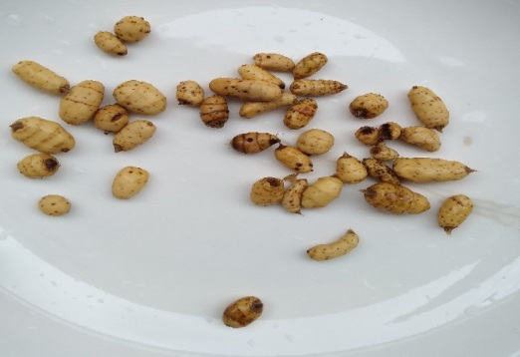
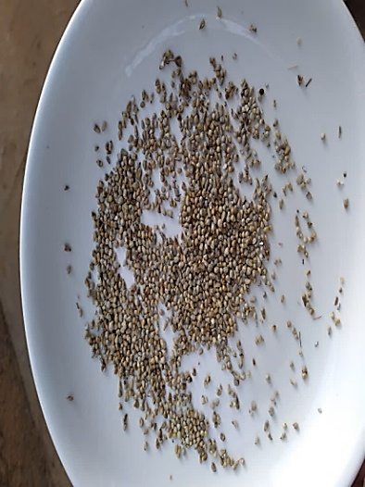
Plant material consisted of seeds of C. esculentus and S. italica (Fig. 1), purchased in April 2024 from the main market in the city of Korhogo, Côte d’Ivoire. The seeds were authenticated at the Department of Plant Biology, Peleforo Gon Coulibaly University of Korhogo. After purchase, they were air-dried at room temperature (22 ± 2 °C) for two months, protected from light and heat. For each species, the dried seeds were ground using a Moulinex-type mechanical grinder to obtain a fine powder, which was subsequently used to prepare the different extracts.
.

B
A

(A : S. italica seeds; B : C. esculentus seeds)
Fig 1: Seeds of the tested plants

2.2. Animal material
The mammary development tests of the extracts were carried out on 24 nulliparous, 14-week-old female Wistar rats with an average weight of 135 ± 7.7 g. The animals were maintained under conditions minimizing stress and sleep disturbances, with optimized hygiene and feeding practices (Adépo et al., 2017).
2.3. Preparation of seed extracts
Two types of extraction (aqueous and hydroethanolic) were performed on each seed powder by maceration. Specifically, 100 g of each seed powder was macerated in 1 L of distilled water or 70% ethanol under magnetic stirring for 24 hours. After homogenization, each mixture was first strained through a square of white cloth, then filtered twice through absorbent cotton and once through Whatman No. 3 filter paper. Finally, the filtrates were concentrated in an oven at 50 °C until complete solvent evaporation, yielding the aqueous and 70% hydroethanolic dry extracts of the seeds of both plants (Zirihi et al., 2003).

2.4. Determination of phenolic constituents in seed extracts
2.4.1. Total polyphenols
The total polyphenol content of each seed extract was determined according to the method described by Kouamé et al. (2021). To 30 μL of extract, 2.5 mL of a 1/10 dilution of Folin–Ciocalteu reagent was added. The mixture was incubated in the dark at room temperature for 2 minutes, after which 2 mL of a sodium carbonate solution (75 g/L) was added. The resulting solution was then incubated at 50 °C for 15 minutes. Following incubation, absorbance was measured spectrophotometrically at 760 nm against a blank. Gallic acid was used as the reference standard, and results were expressed as milligrams of gallic acid equivalent per gram of dry extract (mg GAE/g dry extract).
2.4.2. Total flavonoids
The total flavonoid content of the extracts was determined according to the method described by Yakupova and Ziyatdinova (2023). Specifically, 0.75 mL of a 5% sodium nitrite solution and 0.75 mL of a 10% aluminum chloride solution were added to 2.5 mL of a 1/500 (w/v) extract solution. After 5 minutes of incubation, 5 mL of a 1 M sodium hydroxide solution was added. The final volume was adjusted to 25 mL and vigorously stirred. Absorbance was measured spectrophotometrically at 510 nm against a blank. Quercetin was used as the reference standard, and results were expressed as milligrams of quercetin equivalent per gram of extract (mg QE/g extract).
2.4.3. Condensed tannins
The tannin content was determined according to the method described by Kouamé et al. (2021). For this purpose, 50 mL of each seed extract was mixed with 1.5 mL of a 4% vanillin solution in methanol. The resulting mixture was vigorously stirred, followed by the addition of 750 μL of concentrated hydrochloric acid. The mixture was then left to stand at room temperature for 20 minutes, after which absorbance was measured spectrophotometrically at 550 nm against a blank. A stock solution of tannic acid was used as the reference standard, and results were expressed as milligram equivalents of tannic acid per gram of extract (mg EAT/g extract).
2.5. Evaluation of effects of extracts on mammary development in rats
Evaluation of effects of the extracts on mammary development in rats was carried out according to method described by Adepo et al (2017) with some modifications. Rats were randomized into 4 batch of 6 rats. These rats received the following treatments while fasting:
- batch 1: 5 mL of a mixture of aqueous extracts (200 mg/ mL ), consisting of 50% C. esculentus and 50 % S. italica
- batch 2: 5 mL of a mixture of hydro-ethanolic extracts (200 mg/ mL), consisting of 50 % C. esculentus and 50 % S. italica
- batch 3: 5 mL of Serenatal A at the usual dose of 80 mg/ mL Serenatal A is a food supplement that helps improve breastfeeding and strengthen the baby's growth, available in pharmacies.
- batch 4: (Control): 5 mL of distilled water.
Different treatments lasted 7 days and were administered orally using a feeding syringe. At the end of treatments, the morphology of mammary areola and nipples of each rat was observed and described.
2.6. Statistical analysis of data
Statistical analysis of the results and graphs were generated using Word and Excel 2016. Analysis of variance was performed using multiple ANOVA. Difference between means was determined using Duncan's test at a significance level of 5%. All trials were conducted in triplicate for each sample, and results are expressed as means ± standard error of the mean (SEM).
3. RESULTS
3.1. Phenolic compound content of extracts
3.1.1. Total polyphenols
Calibration curve of gallic acid (y = 0.6484x - 0.0025; R² ⁼ 0.995) allowed us to determine the total polyphenol content (Fig 2). It appears that the highest total polyphenol content was obtained with the aqueous extract of C. esculentus seeds ( 22.07 ± 0.97 mg GAE/g extract ) followed by aqueous extracts of S. italica (13.7 ± 0.18 mg GAE/g) and hydroethanolic extract (13.66 ± 2.23 mg GAE/g extract) of S. italica . Finally, hydroethanolic extract of C. esculentus had lowest content (9.17 ± 0.12 mg GAE/g).

Fig 2: Total polyphenol content of seed extracts

AqCE : Total aqueous extract of C. esculentus seeds ; HeCE : Hydro-ethanolic extract of C. esculentus seeds ; AqSI : Total aqueous extract of S. italica seeds ; HeSI : Hydro-ethanolic extract of S. italica seeds . Histograms with different letters are statistically different. (p > 0.05).
3.1.2. Total flavonoids
From quercetin calibration curve (y = 0.6455x - 0.0075; R2 ⁼ 0.9983), total flavonoid contents were determined and presented in Fig 3. Analysis of the results revealed that the aqueous extract of C. esculentus had the highest content (5.41 ± 0.02 mg QE/g of extract), followed by the hydro-ethanolic (3.03 ± 0.11 mg QE/g of extract) and aqueous (2.29 ± 0.01 mg QE/g of extract) extracts of S. italica , and finally hydro-ethanolic (1.22 ± 0.03 mg QE/g of extract) extract of C. esculentus . Statistical analysis showed that there is a significant difference between total flavonoid content of all these extracts (P < 0.05).
3.1.3. Condensed tannins
The tannin contents, determined from the curve established with different concentrations of tannic acid (y = 0.0004x + 0.062; R2 ⁼ 0.9933) are shown in Fig 4. These results show that the tannin content in the aqueous extracts of both seeds was higher than that in the hydro-ethanolic extracts, with a significant difference between the two (P < 0.05). Specifically, the content in the aqueous extracts was 6.27 ± 0.02 mg EAT/g and 4.46 ± 0.07 mg EAT/g for the seeds of C. exulentus and S. italica , respectively . As for the hydro-ethanolic extracts of the two seeds, the content was 2.70 ± 0.14 mg EAT/g for C. italica . esculentus and 2.80 ±0.03 mg EAT/g of S. italica extract .

Fig 3: Total flavonoid content of seed extracts

AqCE : Total aqueous extract of C. esculentus seeds ; HeCE : Hydro-ethanolic extract of C. esculentus seeds ; AqSI : Total aqueous extract of S. italica seeds ; HeSI : Hydro-ethanolic extract of seeds of S. italica . Histograms with different letters are statistically different. (p > 0.05).

Fig 4: Total tannin content content of seed extracts

AqCE : Total aqueous extract of C. esculentus seeds ; HeCE : Hydro-ethanolic extract of C. esculentus seeds ; AqSI : Total aqueous extract of S. italica seeds ; HeSI : Hydro-ethanolic extract of S. italica seeds . Histograms with different letters are statistically different. (p > 0.05).
3.2. Effects of the extracts on mammary development in rats
Fig 5 shows observations of the ventral surface of treated and untreated rats. After 7 days of treatment, rats treated with the combined (50:50) extracts of C. esculentus and S. italica seeds showed a change in mammary morphology, compared to untreated control animals where no changes were observed. Indeed, the mammary glands of rats in batch 1 treated with aqueous extracts of C. esculentus and S. italica seeds and batch 4, rats treated with the reference product (Serenatal A) exhibited more hypertrophied and localized breast enlargement in the abdominal region. Their nipples were also much more prominent with stronger pigmentation. These changes were also observed in animals from batch 3 treated with hydro-ethanolic extracts, but to a lesser extent.

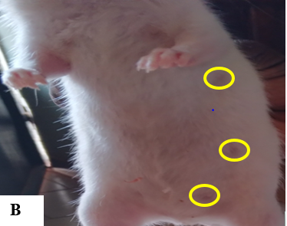
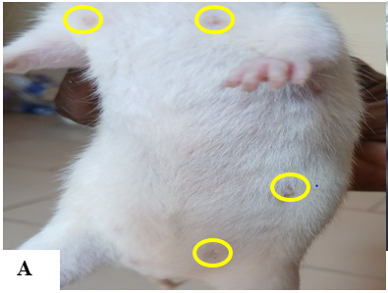

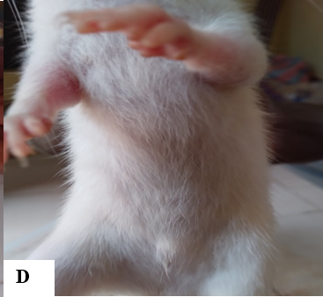
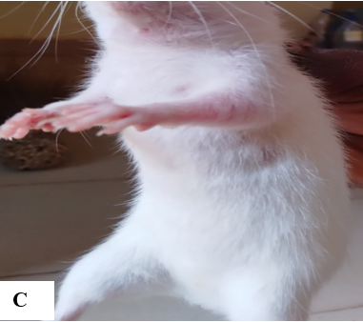

Fig 5: Effects of extracts on mammary development in rats

A: Ratte from batch 1, treated with aqueous extracts of C. esculentus and S. italica ; B: Rat from batch 3, treated with Serenatal A (standard ); C: Rat from batch 2, treated with hydroethanolic extracts of C. esculentus and S. italica D : Ratte from lot 1 control, untreated

4. DISCUSSION
Maceration was the extraction technique used to obtain the extracts in this study. This technique accelerates the extraction process and minimizes the contact time between the solvent and the plant material while preserving the bioactivity of phenolic compounds (Kamarudin et al., 2016). Phenolic compounds (total polyphenols, total flavonoids, and tannins) in the different extracts from the seeds of C. esculentus and S. italica were analyzed, and the results showed that both aqueous and 70% hydroethanolic seed extracts of these species are rich in phenolic compounds. Specifically, the total polyphenol content ranged from 9.17 ± 0.12 to 22.07 ± 0.97 mg GAE/g of dry extract, while the flavonoid and tannin contents ranged from 1.22 ± 0.03 to 5.41 ± 0.02 mg QE/g of dry extract and from 2.70 ± 0.14 to 6.27 ± 0.02 mg EAT/g of dry extract, respectively. These findings regarding the phenolic composition of the studied seeds are consistent with those reported by several researchers. For instance, Alloka-Kouamé et al. (2022) recorded similar levels of total polyphenols, flavonoids, and tannins in whole tubers and defatted flour of C. esculentus, with respective values of 3.7–4.57 mg GAE/g, 5.99–14.5 mg QE/g, and 3.03 mg AC/g. Likewise, Kumar et al. (2022) reported levels of approximately 1 mg GAE/g, 0.6 mg QE/g, and 0.7 mg AT/g for total polyphenols, flavonoids, and condensed tannins in S. italica seeds. Based on these results, it appears that aqueous extracts contained higher levels of phenolic compounds than hydroethanolic extracts. This could be explained by the fact that the solubility of phenolic compounds is influenced by the polarity of the solvent used for extraction. According to Kakesse et al. (2022), total polyphenols are more soluble in water than in organic solvents, which supports the observation that water, as a polar solvent, can extract a greater diversity of chemical compounds (Piba et al., 2021).
Results of the tests on rats showed that those treated with a mixture of aqueous extracts of C. esculentus and S. italica exhibited significantly larger mammary glands, accompanied by hyperpigmentation of the teats, similar to that observed in rats treated with the standard lactogenic product (Serenatal A). These morphological changes may be attributed to the chemical composition of the seeds of the studied plants. Indeed, phytochemical analysis of the seed extracts revealed the presence of phenolic compounds such as flavonoids and tannins. According to Adépo et al. (2017), these phytomolecules may confer lactogenic effects to the tested extracts by serving as a basic matrix for phytohormones. Due to their estrogenic properties, they could influence lactation by increasing prolactin secretion in rats. These substances may therefore stimulate prolactin biosynthesis and, consequently, induce mammary development (Ekman et al., 2015). The results obtained are consistent with those of Adépo et al. (2017), who demonstrated that aqueous extracts of Euphorbia hirta L. and Secamone afzelii exhibited significant lactogenic effects through mammary development in rats. Furthermore, several studies have reported that the seeds of C. esculentus and S. italica are rich in carbohydrates, proteins, lipids, fiber, trace elements, vitamins (C, B1, B6), sterols, and other nutrients essential for breast milk production (N’Diaye et al., 2018; Srilekha et al., 2019). Regular consumption of these seeds by breastfeeding mothers could enhance both the quality and quantity of breast milk (Thakur et al., 2023). To demonstrate the lactogenic effect in addition to the mammogenic effect, it is necessary to evaluate the impact of seed extracts on prolactin secretion and milk production in female rats.
5. CONCLUSION
In this study, the phenolic composition of aqueous and hydro-ethanolic extracts of C. esculentus and S. italica seeds was determined, and their effects on mammary development in female rats were evaluated . The results showed that these extracts induced mammary development and pigmentation in unmated female rats. These changes could be linked to their high total polyphenol content, particularly flavonoids and condensed tannins. This suggests that these extracts may possess lactogenic properties, justifying their traditional use in treating agalactia . Future work will focus on evaluating the effects of extracts on production of prolactin, the lactation hormone.
ETHICAL APPROVAL
Female rats used for the mammary development tests were bred and treated in accordance with guidelines of official ethics and animal experimentation oversight committee of Ivory Coast.
DISCLAIMER (ARTIFICIAL INTELLIGENCE)
Author (s) hereby declared that NO generative AI technologies such as Large Language Models ( ChatGPT , COPILOT, etc.) and text -to-image generators have been used during the writing or editing of this manuscript .

REFERENCES

Adepo, Y.P., Bolou, G.E.K., et Akoa, E.E.F. (2017). Effect on breast development and phytochemical analysis of two lactogenic plants from the traditional Ivorian pharmacopoeia: Euphorbia hirta L. and Secamone afzelii ( Roem . & Schult .). Int. J. Biol. Chem. Sci., 11,1872-1877. https://doi.org/10.4314/ijbcs.v11i4.35
Akouedegni, C. G., Tossa, I. G., Daga, F. D., Koudandé, D. O., et Hounzangbé-Adoté, M. S. (2012). Synthèse des connaissances sur les plantes galactogènes et leurs usages en République du Bénin. Bull. Rech. Agron. Bénin., 24-35.
Alloka-Kouamé , G.A., Diané , F., Bagui-Broune , M., Kouassi , N.C., Mamyrbekovia-Békro , J.A., et Békro, Y.A. (2022). Phytochemical and nutritional composition of tubers whole grains of C.esculentus and flour degreased. Am. J. Pharm Tech Res., 12(2): 1-15.
Balkam, J. J. (2022). Galactagogues and lactation: Considerations for counseling breastfeeding mothers. MCN Am. J. Matern. Child Nurs., 47(3), 130–137. https://doi.org/10.1097/NMC.0000000000000810
Ekman , B., Wahlberg , J et Landberg , E. (2015) . Urine oligosaccharide pattern in patients with hyperprolactinaemia . Glycoconj. J., 32 (8), 635-641. https://doi.org/10.1007/s10719-015-9610-x
Hama Garba, R., Idrissa, M., Sadou, H., Sahabi, B., Idi Issa, A. M., Amadou Arouna, N., et Bazanfare, M. N. (2023). Plantes médicinales et soins du couple mère-enfant au Niger : formulation du Djitti pour nourrisson et des recettes galactogènes pour mères allaitantes. Psy Cause, (84), 23–39. https://doi.org/10.3917/psca.084.0023
Kadjo, M. L. M. R., Koko, K. B., Yéboué, K. H., Anin-Atchibri, L. A et Ahui-Bitty, M. L. (2025). Galactogenic effect of milk powder from nutsedge tubers (Cyperus esculentus) in lactating rats. World J. Adv. Res. Rev., 27(2), 1215–1225. https://doi.org/10.30574/wjarr.2025.27.2.2886
Kakesse, M., Wangso, H., Oksom, J.B.S., Bakaranga , V.I., Nadjioroum , N.A., et Otchom ,B.B. (2022) . Phytochemical evaluation, in vitro antioxidant and anti-inflammatory potential of Commelina leaf extracts benghalensis Linn. ( Commelinaceae ). Int. J. Biol. Chem. Sci., 16 (6), 2673-268.
Kamarudin , N.A., Markom , M., et Latip , J. (2016) . Effects of Solvents and Extraction Methods on Herbal Plants Phyllanthus niruri , Orthosiphon stamineus and Labisia pumila ., Indian J. Sci. Technol, 9 (21), 1-5. https://doi.org/10.17485/ijst/2016/v9i21/95235
Kouamé, T.K., Siaka, S., Kassi, A.B.B., et Soro,Y. (2021) . Determination of total polyphenol, total flavonoid and tannin content of young, unopened leaves of Piliostigma thonningii ( Caesalpiniaceae ). Int. J. Biol . Chem . Sci ., 15(1): 97-105. https://doi.org/10.4314/ijbcs.v15i1.9
Kumar, R. R., Singh, N., Singh, S., Vinutha, T., Krishnan, V., Goswami, S., Kumar, B., Jat, S. L., Yogeesh, L. N., Singh, S. P., Mishra, G. P., Satyavathi, C. T., Sachdev, A., et Praveen, S. (2022). Nutritional supremacy of pearl- and foxtail millets: Assessing the nutrient density, protein stability and shelf-life of flours in millets and cereals for developing nutri-stable foods. J. Plant Biochem. Biotechnol., 31(4), 837–852. https://doi.org/10.1007/s13562-021-00761-2
McBride, G. M., Stevenson, R., Zizzo, G., Rumbold, A. R., Amir, L. H., et Keir, A. K. (2021). Use and experiences of galactagogues while breastfeeding among Australian women. Plos one, 16(7), 1-15. https://doi.org/10.1371/journal.pone.0254049
N'Diaye , B., Ayessou , N.C., Cissé , I.K.O., Baldé, S., Cissé , M., Diop , C.M et Sakho , M. (2018). Potentials Technological evaluation by biochemical evaluation of tuber flour of tiger nut (C. esculentus L.). African Science, 14 (2): 209-214. http://www.afriquescience.info/numeros/volume14/N2/209-214.pdf
Piba , S.C., Konan, P.A.K., Kone , L.N., Kouame, A.G., Kouakou, R.K.D., et Tra , H.F.B. (2021) . Phytochemistry , antioxidant activity and acute toxicity of medicinal plants used against the sequelae of stroke in Côte d'Ivoire. Int. J. Biol. Chem. Sci., 15 (2), 652-663. https://doi.org/10.4314/ijbcs.v15i2.2
Richard, C., Lewis, E.D., et Field, C.J. (2016). Evidence for the essentiality of arachidonic and docosahexaenoic acid in the postnatal maternal and infant diet for the development of the infant's immune system early in life. Appl . Physiol . Nutr . Metab., 41(5), 461-75. https://doi.org/10.1139/apnm-2015-0660
Srilekha, K., Uma Maheswari, K., Kamalaja, T et Neela Rani, R. (2019). Evaluation of physical, functional and nutritional quality parameters of kodo millet flour. J. Pharmacogn. Phytochem., 8(4), 192–195. https://www.phytojournal.com/archives/2019/vol8issue4/PartC/8-4-10-600.pdf
Thakur, M., Khedkar, R., Singh, K., et Sharma, V. (2023). Ethnopharmacology of botanical galactagogues and comprehensive analysis of gaps between traditional and scientific evidence. Curr. Res. Nutr. Food Sci. J., 11(2), 589–604. https://doi.org/10.12944/CRNFSJ.11.2.11
UNICEF. (2023). Global breastfeeding scorecard increase around the world through improved protection and support, 14p. https://iris.who.int/handle/10665/375796
WHO. (2022). Global Strategy for Breastfeeding of Infants and Young Children, 30p. https://www.who.int/publications/i/item/9241562218
WHO. (2023). Global breastfeeding scorecard: rates of breastfeeding increase around the world through improved protection and support, 40p. https://iris.who.int/handle/10665/375796
Yakupova, E.N., et Ziyatdinova, G. K. (2023). Modern methods and current trends in the analytical chemistry of flavanones. J. Anal. Chem., 78(4), 403–425. https://doi.org/10.31857/S0044450223040163
Youssao , A.K.I., Dahouda , M., Attakpa , E.Y., Koutinhouin , G.B., Ahounou, G.S., Toleba , S.S., et Balogoun, B.S. (2013). Diversity of Borgou cattle farming systems in the Sudanian zone of Benin. Int. J. Biol. Chem. Sci., 7 (1), 125-146. https://doi.org/10.4314/ijbcs.v7i1i.11
Youssao , A.K.I., Dahouda , M., Attakpa , E.Y., Koutinhouin , G.B., Ahounou, G.S., Toleba , S.S., et Balogoun, B.S. (2013). Diversity of Borgou cattle farming systems in the Sudanian zone of Benin. Int. J. Biol. Chem. Sci., 7 (1), 125-146. https://doi.org/10.4314/ijbcs.v7i1i.11
Zirihi, N. G., Kra, A. K. M., et Guédé-Guina, F. (2003). Evaluation of the antifungal activity of extracts of Terminalia catappa, Manilkara zapota, Morinda morindoides and their mixture (MISCA) used in Côte d’Ivoire in traditional medicine. African Journal of Traditional, Evid. Based Complement. Altern. Med., 2(2), 31–39.
Zizzo, G., Rumbold, A.R., et Grzeskowiak, L. E. (2021). Fear of stopping” vs “wanting to get off the medication”: Exploring women’s experiences of using domperidone as a galactagogue – a qualitative study. Int. Breastfeed. J., 16(1), 1–12. https://doi.org/10.1186/s13006-021-00438-5

