Evaluation of Genotypic variation of Sorghum varieties in the southwestern Niger

Abstract
Background: Sorghum (Sorghum bicolor L. Moench) is grown in semi-arid regions, valued for its adaptation and drought tolerance. Understanding genotype × environment interactions is essential for developing stable, high-yielding cultivars.

Methods: Eight sorghum genotypes were evaluated during the 2019 and 2020 growing seasons using a randomized complete block design with five replications. Data were collected on plant height, days to flowering, biomass, panicle weight, grain weight, 1000-grain weight. Data underwent ANOVA, Tukey's HSD (p<0.05), and mixed-model analysis.

Results: Significant (p < 0.001) genotypic variation was observed for all traits. Genotype × year interaction was significant for most traits, indicating differential performance across year. PCA captured 63.6% variance (PC1 37.9%, PC2 25.7%), revealing trade-offs like taller plants with heavier grains but later flowering. These results highlight exploitable genetic diversity for Sahelian breeding, prioritizing stable, early-maturing, high-biomass/yield genotypes to boost productivity amid rainfall variability.

Conclusion: Substantial genetic variability exists among the evaluated sorghum genotypes. High heritability for key traits suggests good potential for genetic improvement through selection. Identified stable genotypes provide valuable genetic resources for sorghum breeding programs targeting yield improvement and stability.

Keywords: Sorghum bicolor, genotype and environment interaction, heritability, stability analysis, genetic improvement

Introduction
Sorghum (Sorghum bicolor L. Moench) ranks among the five major cereal crop globally, serving as a staple food in semi-arid tropical regions (FAO, 2025). Its remarkable drought tolerance, heat resistance, and water-use efficiency make it particularly valuable in the context of climate change and increasing water scarcity (Ab, 2012). Despite its importance, sorghum productivity remains below potential in many regions, partly due to limited utilization of genetic diversity (Walker & Alwang, 2015). Genetic improvement of sorghum requires a comprehensive evaluation of diverse germplasm for key agronomic traits under varying environmental conditions (Wang et al., 2016). Traits such as plant height, days to flowering, biomass production (for dual-purpose forage-grain), and grain yield are crucial determinants of adaptation and productivity in smallholder farming systems.
Understanding the genetic control of these traits, as measured by heritability estimates, and identifying genotypes with stable performance across environments are essential steps in cultivar development.
Crop breeding requires an adequate knowledge of germplasm and environment for evaluation and testing, and preliminary trials. There is a significant genetic diversity in Niger Republic (Maina et al., 2018), which remains to be evaluated in diverse agroclimatic zones.
This variability, shaped by centuries of farmer selection for stress resistance and tolerance (drought, striga, midge), and grain quality (e.g., white-grained types, yellow endosperm types), remains underexploited. This substantial diversity, if major adaptive traits are characterized, could have been an asset to better understand the variability of the varieties as well as identifying the target population of environments for future improvement.
This study aimed to: (i) evaluate the performance of eight sorghum genotypes for four important agronomic traits over two growing seasons and (ii) identify superior genotypes with stable performance for use in future breeding programs.

Materials and Methods

Plant Materials and Experimental Design
Eight sorghum varieties (IRAT‑204, Ja‑Dawa, Lankonsau, Lepon-Rakumi, Mota‑Fara, Ni343, Ni344, and Sepon-82), mostly caudatum botanical type, were evaluated in this study. The genotypes are selected from the West African Sorghum Association Panel (WASAP) previously studied (Faye et al., 2021; Maina et al., 2022) with contrasting plant architecture, maturity, and end-use types (grain vs dual-purpose). The experiment was conducted on sandy soil during the 2019 and 2020 growing seasons at ICRISAT Sadoré, Niger (13.15 N, 2.18 E).
A randomized complete block design (RCBD) with five replications was used. Each plot consisted of two 3-meter rows spaced 75 cm apart with 50 cm between plants within rows. Standard cultural practices for sorghum production in the region were followed, including fertilization.

Data Collection and analysis
Plant height (cm) was measured from ground level to the flag leaf on representative plants and averaged. Vegetative biomass (g plant⁻¹) was weighed on dry vegetative biomass at harvest per plant. 1000-grain weight (g) was weighed on 1000 grain weight for each genotype. Days to 50% flowering was calculated as the number of days from sowing until approximately 50% of plants in a plot reached flowering. Statistical analyses were performed using R version 4.3.3 (R Core Team, 2013). We fitted the model using the lme4 package, with genotypes as a fixed effect and year as a random effect (Bates et al., 2015). Analysis of variance (ANOVA) was performed, and treatment means were compared using Tukey’s HSD test at the 5% significance level.

Results and discussion
Phenotypic variation
Flowering time, inflorescence architecture, and plant height are adaptive traits conferring local adaptation (Morris et al., 2013). Repetitions for both traits were not significant, which suggests less variability within the repetitions in each year. Plant height was stable across years, showing no significant year effect or genotype-by-year interaction, and had moderate variability (CV = 15.3%). The variance explained by genotypes accounts for 88.5% (p < 0.001) (Table 1). Taller genotypes are mainly landraces, which are preferred by farmers and end-users in some regions (Walker & Alwang, 2015).
The flowering time was predominantly under genetic control (73.0%; p < 0.001) but was also significantly influenced by both the growing year (9.1%; p < 0.001) and the genotype-by-year interaction (6.1%; p < 0.05)(Table 1). Certain genotypes respond differently across seasons, necessitating multi-environment testing for confirmation, especially for farmer-preferred landraces and late maturing. While in this study, we focused on early and medium days to flowering, some landraces (e.g MDK) in the country have late flowering (~120 days). Among the breeding objectives, early and medium flowering varieties would be acceptable in semi-arid regions where water scarcity is prevalent with unpredictable rainfall, especially in the Sahel (Biasutti, 2019).
Taking into account the dual purpose of sorghum, vegetative biomass and grain yield play a vital role in smallholder farming systems for forage and food. Biomass production exhibited the highest relative variability among the traits studied (CV = 46.2%) (Table 1). Genetic differences between genotypes explained a substantial 64.6% (p < 0.001) of the variation. Significant year effect was observed (8.9%; p < 0.001), indicating a strong response to the environment. However, the absence of a significant genotype-by-year interaction suggests that genotype rankings for biomass were consistent across the two years. The 1000‑grain weight showed the highest degree of genetic control, with 92.0% (p < 0.001) of its variation attributable to genotype (Table 1). The trait displayed no significant variance from year or genotype-by-year interaction, confirming it as the most stable and highly heritable trait in this study.

Table 1: Summary statistics and variance components of agronomic traits.
Trait | Range | Mean ± SD | CV% | Genotype Variance | Year Variance | G×E Variance
Plant Height (cm) | 116.0 - 212.0 | 162.0 ± 24.7 | 15.3% | 88.5%*** | 0.0% | 1.6%
Flowering | 60.0 - 75.0 | 67.1 ± 4.2 | 6.3% | 73.0%*** | 9.1%*** | 6.1%***
Biomass (g) | 30.6 - 180.3 | 90.8 ± 41.9 | 46.2% | 64.6%*** | 8.9%*** | 0.0%
1000 grain weight (g) | 16.6 - 44.9 | 30.4 ± 8.4 | 27.7% | 92.0%*** | 0.0% | 0.0%

Variation of the genotypes

Lepon-Rakumi was the tallest genotype (~203 cm), suitable for high stover production and possibly lodging risk. Sepon-82 produced the highest biomass (~159 g) despite medium-tall stature, pointing to a thick, leafy architecture (Figure 1A-2A). Ja‑Dawa recorded the largest grain size (~40 g per 1000 grains), an important yield component. Mota‑Fara was the earliest to flower (~63 days), implying potential for drought escape, whereas Ni344 was the latest (~73 days). Mota‑Fara, flowering around 63 days, is clearly earlier than most other genotypes (up to 10 days earlier than Ni344). Early flowering could be an adaptation strategy in Sahelian sorghum, allowing crops to escape terminal drought when rainfall ceases early (Upadhyaya et al., 2017; Emendack et al., 2018; Maina et al., 2022). Selection for earlier flowering has historically been associated with increased yield stability in marginal environments. Ni344, with its later flowering (73 days), may be better suited to environments with longer growing seasons or more reliable late rainfall.

For vegetative biomass (Figure 2A), the range among genotypes was even more pronounced, extending from 56.7 g for Ni343 to 159.3 g for Sepon-82. Sepon-82 was exceptional, producing nearly double the biomass of the second‑highest genotype, Lankonsau (120.9 g). This created a distinct performance gap, with Sepon-82 and Lankonsau forming a high‑biomass tier, followed by Ja‑Dawa (101.1 g), while the remaining five genotypes all yielded below 80 g. The substantial variation, particularly the outstanding biomass accumulation of Sepon-82, highlights clear genetic differences in vegetative vigor and suggests this genotype could be a valuable donor for improving total biological yield in a breeding program. Crosses are being made to improve (striga resistance, midge tolerance, drought tolerance) Sepon-82 and IRAT-204 in the Nigerien breeding program (Kane et al., 2022; MAGEL, 2025).

For 1000‑grain weight, the genotypes displayed considerable genetic variation, ranging from 19.6 g for Sepon-82 to 39.9 g for Ja‑Dawa. Ja‑Dawa produced the heaviest grains, outperforming the next highest genotype, Lankonsau (38.0 g) (Figure 2B). This trait formed a clear hierarchy, with Ja‑Dawa and Lankonsau representing a high‑weight group (38–40 g), followed by Mota‑Fara (34.1 g) in an intermediate position, while the remaining genotypes, particularly Ni343 (22.8 g) and Sepon-82 (19.6 g), constituted a lower‑weight group (Figure 2B). The results indicate that grain size is highly genotype‑dependent, with Ja‑Dawa offering the greatest potential for direct selection to improve this yield component in semi-arid regions of Niger (Mi, 2018).

Table 2: Average performance of the genotypes over two years
Genotype | Plant height (cm) | Days to flowering | 1000-grain weight (g) | Vegetative Biomass (g)
IRAT‑204 | 121.3 | 67.0 | 24.5 | 72.2
Ja‑Dawa | 176.9 | 66.0 | 39.9 | 101.1
Lankonsau | 154.9 | 68.4 | 38.0 | 120.9
Lepon-Rakumi | 202.8 | 68.3 | 27.7 | 69.5
Mota‑Fara | 180.1 | 63.1 | 34.1 | 69.1
Ni343 | 164.9 | 64.6 | 22.8 | 56.7
Ni344 | 145.7 | 73.0 | 27.2 | 77.7
Sepon-82 | 158.9 | 69.4 | 19.6 | 159.3

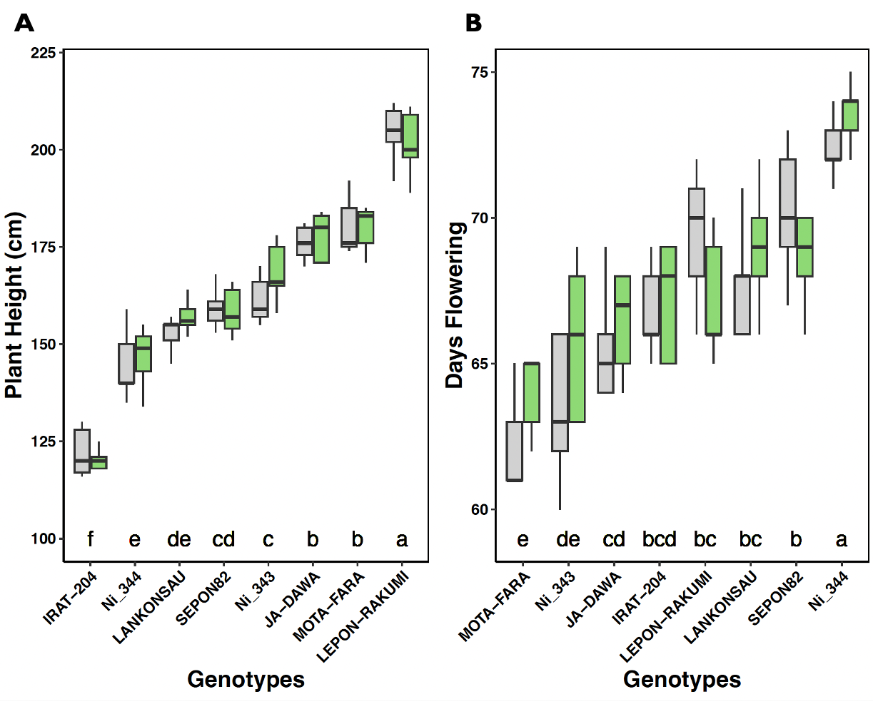
Figure 1: Genotypic variation in plant height (A) and days to flowering (B) over two years.
Different letters represent significant differences from Tukey's HSD comparisons (p-value < 0.05). The grey boxplots represent the variation in 2019, and the green boxplots represent the variation in 2020. Different letters represent significant differences from Tukey's HSD comparisons (p-value < 0.05).

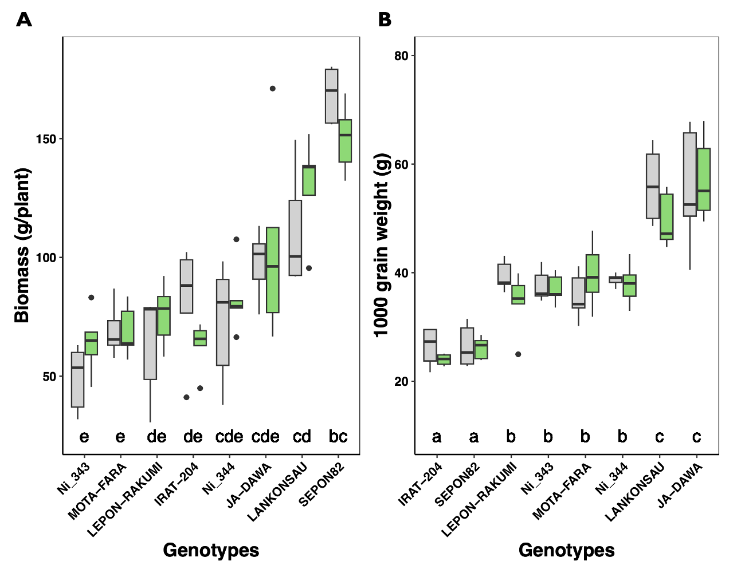
Figure 2: Genotypic variation in biomass (A) and 1000-grain weight (B) over two years. The grey boxplots represent the variation in 2019, and the green boxplots represent the variation in 2020. Different letters represent significant differences from Tukey's HSD comparisons (p-value < 0.05).

Substantial variation was observed among genotypes for biomass and 1000-grain weight (Figure 2A). Genotypes differed in their levels of biomass accumulation and grain weight (source to sink) (Mocoeur et al., 2015), and mean separation analysis grouped genotypes into distinct classes. These results indicate the presence of exploitable genetic variability for yield-related traits within the evaluated germplasm (Aissata & Ardaly, 2022; Agele et al., 2025). Principal Component Analysis (PCA) using phenological and agro-morphological traits showed that the first two principal components accounted for 63.6 % of total variance: Axis 1 (37.9 %) and Axis 2 (25.7 %) (Figure 3A). Plant height has a positive correlation with 1000 grain weight (r=0.27) while a negative correlation was observed for both flowering and biomass (-0.23 and -0.09, respectively) (Figure 3B). This indicates that taller plants tended to produce more grains, especially for the landraces (Lepon Rakumi and Ja-dawa), which are usually late-maturing. In contrast, plant height was negatively correlated with flowering time (r = −0.23) and biomass (r = −0.09) (Figure 3B), suggesting a limited association between plant stature, phenology, and biomass accumulation within the eight genotypes studied. Flowering time exhibited weak correlations with other traits, showing a slight positive association with biomass (r = 0.19) and a negative correlation with 1000-grain weight (r = −0.20).

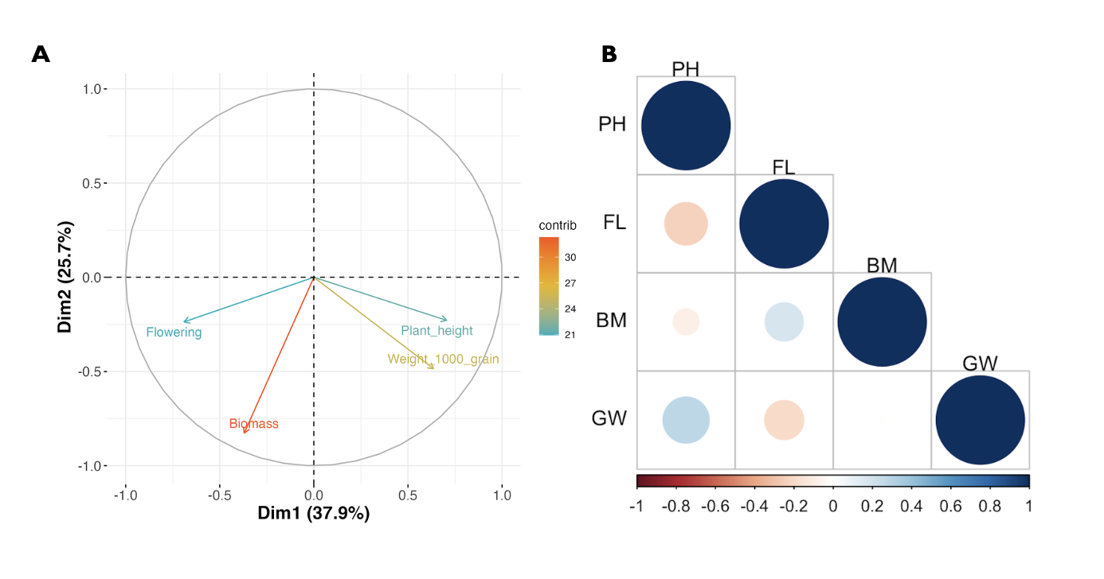
Figure 3: Principal Component Analysis (PCA) (A) and Correlation matrix of agronomic traits (B)

West African agriculture, most of the time, relies on rainfed cropping systems and subsistence agriculture. Thus, research toward the development of varieties that fit the needs of local smallholder farmers is of significant importance. One of the criteria for farmers is to have improved varieties that fit the best in their agroclimatic zones with their preferred traits (Mi, 2018) such as early maturing and medium plant height (Figure 1A-1B). In this context, studies have been conducted in different locations to capture the most local adaptation (Lynam et al., 2011; Walker & Alwang, 2015). The need to produce drought-tolerant and high-yielding varieties has become the main objective of breeders and researchers to fit the needs of farmers.
Breeding efforts focused on developing new varieties; however, the specific preference of a farmer (in some agroclimatic zones of West Africa, for example) remains less adopted (Ndjeunga et al., 2015; Walker & Alwang, 2015; Acevedo et al., 2020). Linking new technologies in genomics to breeding efforts will help develop new better-adapted and adopted varieties to farmers and end-users. Moreover, identifying variants associated with drought tolerance in sorghum may provide new markers for improving sorghum in semi-arid regions. Their consistent performance under varying environmental conditions suggests broad adaptation, a desirable characteristic for sorghum cultivars targeting diverse agro-ecologies of Niger (Maina et al., 2018). While we use in this study two botanical types (caudatum and durra-caudatum), the Nigerien sorghum collection is composed of four botanical types (Maina et al., 2018; Faye et al., 2021) distributed across the country.

Conclusion
This study demonstrated significant genetic variability among eight sorghum genotypes for important agronomic traits. High heritability estimates for plant height, flowering time, and 1000-grain weight indicate good potential for genetic improvement through selection. The findings contribute to sorghum genetic improvement by providing information on genetic parameters, trait relationships, and identification of superior genotypes. Those genotypes could be used in the breeding pipeline for new population development.
Disclaimer (Artificial intelligence)
Option 1:
Author(s) hereby declare that NO generative AI technologies such as Large Language Models (ChatGPT, COPILOT, etc.) and text-to-image generators have been used during the writing or editing of this manuscript.
References
- Ab, K. (2012). Crop Adaptation to Biotic and Abiotic Conditions: Going Wild with Next Generation Sequencing Technologies. Agrotechnology, 02. https://doi.org/10.4172/2168-9881.1000e103
- Acevedo, M., Pixley, K., Zinyengere, N., Meng, S., Tufan, H., Cichy, K., Bizikova, L., Isaacs, K., Ghezzi-Kopel, K., & Porciello, J. (2020). A scoping review of adoption of climate-resilient crops by small-scale producers in low- and middle-income countries. Nature Plants, 6, 1231–1241. https://doi.org/10.1038/s41477-020-00783-z
- Agele, S., Taiwo, G., & Akinseye, M. (2025). Growth and yield responses of sorghum (Sorghum bicolor [L.] Moench) varieties to sowing time in a rainforest zone of Nigeria. Scientific Reports, 15, 34084. https://doi.org/10.1038/s41598-025-14447-5
- Bates, D., Mächler, M., Bolker, B., & Walker, S. (2015). Fitting Linear Mixed-Effects Models Using lme4. Journal of Statistical Software, 67, 1–48. https://doi.org/10.18637/jss.v067.i01

- Aissata, M. I., & Ardaly, A. O. (2022). Combining ability studies of Nigerien sorghum landraces for yield. International Journal of Agricultural Policy and Research, 10(5), 98-109. https://doi.org/10.15739/IJAPR.22.012
- Biasutti, M. (2019). Rainfall trends in the African Sahel: Characteristics, processes, and causes. Wiley Interdisciplinary Reviews: Climate Change. https://doi.org/10.1002/wcc.591
- Emendack, Y., Burke, J. J., Sanchez, J., Echevarria Laza, H., & Hayes, C. M. (2018). Agro-morphological characterization of diverse sorghum lines for pre-and post-flowering drought tolerance. Australian Journal of Crop Science, 12(1), 135–150. https://doi.org/10.21475/ajcs.18.12.01.pne790
- FAO. (2020). FAOSTAT. Food and Agriculture Organization of the United Nations. http://www.fao.org/faostat/en/#home
- Faye, J. M., Maina, F., Akata, E. A., Sine, B., Diatta, C., Mamadou, A., Marla, S., Bouchet, S., Teme, N., Rami, J.-F., Fonceka, D., Cisse, N., & Morris, G. P. (2021). A genomics resource for genetics, physiology, and breeding of West African sorghum. The Plant Genome. https://doi.org/10.1002/tpg2.20075
- Kane, N. A., Foncéka, D., & Dalton, T. J. (Eds.). (2022). Crop Adaptation and Improvement for Drought-Prone Environments. New Prairie Press. https://newprairiepress.org/ebooks/49
- Lynam, J., Gilbert, E., Elliot, H., & Bliss, F. (2011). Evolving a plant breeding and seed system in sub-Saharan Africa in an era of donor dependence: A report for the Global Partnership Initiative for Plant Breeding Capacity Building. FAO Plant Production and Protection Paper 210 https://www.fao.org/3/i2067e/i2067e.pdf
- MAGEL. (2025). Rapport d’évaluation de la campagne agricole d’hivernage 2024 et Perspectives Alimentaires 2024-2025. Ministère de l'Agriculture et de l'Elevage. https://magel.ne/category/publications/
- Maina, F., Bouchet, S., Marla, S.R., Hu, Z., Wang, J., Mamadou, A., Abdou, M., Saïdou, A.-A., & Morris, G.P. (2018). Population genomics of sorghum (Sorghum bicolor) across diverse agroclimatic zones of Niger. Genome. https://doi.org/10.1139/gen-2017-0131
- Maina, F., Harou, A., Hamidou, F., & Morris, G.P. (2022). Genome-wide association studies identify putative pleiotropic locus mediating drought tolerance in sorghum. Plant Direct, 6, e413. https://doi.org/10.1002/pld3.413
- Mi, A. (2018). Characteristization of Sorghum Production Constraints and Ideal Plant and Variety Traits as Perceived by Farmers in Niger. JSM Biotechnology and Biomedical Engineering. https://doi.org/10.47739/2333-7117/1084
- Mocoeur, A., Zhang, Y.-M., Liu, Z.-Q., Shen, X., Zhang, L.-M., Rasmussen, S. K., & Jing, H.-C. (2015). Stability and genetic control of morphological, biomass and biofuel traits under temperate maritime and continental conditions in sweet sorghum (Sorghum bicolour). Theoretical and Applied Genetics. https://doi.org/10.1007/s00122-015-2538-5
- Morris, G. P., Ramu, P., Deshpande, S. P., Hash, C. T., Shah, T., Upadhyaya, H. D., Riera-Lizarazu, O., Brown, P. J., Acharya, C. B., Mitchell, S. E., Harriman, J., Glaubitz, J. C., Buckler, E. S., & Kresovich, S. (2013). Population genomic and genome-wide association studies of agroclimatic traits in sorghum. Proceedings of the National Academy of Sciences, 110, 453–458. https://doi.org/10.1073/pnas.1215985110
- National Research Council. (1996). Lost Crops of Africa: Volume I: Grains. The National Academies Press. https://doi.org/10.17226/2305
- Ndjeunga, J., Mausch, K., & Simtowe, F. (2015). Assessing the effectiveness of agricultural R&D for groundnut, pearl millet, pigeonpea, and sorghum in West and Central Africa and Eastern and Southern Africa. In T.S. Walker & J. Alwang (Eds.), Crop improvement, adoption, and impact of improved varieties in food crops in sub-Saharan Africa (pp. 123–147). CABI. https://doi.org/10.1079/9781780644011.0123
- Smith, C. W., & Frederiksen, R. A. (2000). Sorghum: Origin, History, Technology, and Production. John Wiley & Sons. https://www.wiley.com/en-us/Sorghum%3A+Origin%2C+History%2C+Technology%2C+and+Production-p-9780471242311
- Upadhyaya, H.D., Dwivedi, S.L., Vetriventhan, M., Krishnamurthy, L., & Singh, S.K. (2017). Post-Flowering Drought Tolerance Using Managed Stress Trials, Adjustment to Flowering, and Mini Core Collection in Sorghum. Crop Science, 57, 310–321. https://doi.org/10.2135/cropsci2016.04.0280
- Walker, T. S., & Alwang, J. (2015). Crop Improvement, Adoption and Impact of Improved Varieties in Food Crops in Sub-Saharan Africa. CABI. https://doi.org/10.1079/9781780645011.0000
- Wang, Y.-H., Upadhyaya, H.D., & Dweikat, I. (2016). 5 - Sorghum. Genetic and Genomic Resources for Grain Cereals Improvement (pp. 227–251). Academic Press, San Diego.

