Spatio-Temporal Dynamics of Bushfires in The Gadabedji Biosphere Reserve

ABSTRACT
In Niger, bushfires pose a serious threat to food security and biodiversity. The Gadabedji Biosphere Reserve, located north of the Maradi Region in the Sahelian savanna zone of central Niger, is particularly threatened, notably by late and uncontrolled fires. This study aimed to better understand the severity of bush fires in the RBG between 1993 and 2023. More specifically, it analyzes the spatio-temporal distribution of fires and burned surfaces within the RBG reserve and identifies the main factors explaining this distribution. To achieve this, medium-resolution satellite data were used, namely Landsat-5 & 4 Thematic Mapper images, Landsat-7 Enhanced Thematic Mapper, and Operational Land Imager, corresponding to the periods before and after the fires. A marked periodicity of extreme fire years is observed, notably in 2003 and 2023. However, in 2013, the intensity remained low. The central zone is particularly vulnerable to fires and accounts for nearly 80% of the active fires detected across its entire surface. The annual burned surface rate varies, depending on the scale, from 0.05% to 7.33% for the studied area and from 0.01% to 40% within the central zone. The topomorphology of the study area influences the propagation of bush fires: burned areas are primarily found at medium and high altitudes, on slopes and sectors with high density of herbaceous cover. To mitigate the severity and impacts, it is necessary to develop adapted risk management plans to be implemented before, during, and after bush fires.
Keywords: dNBR, bush fires, Landsat, RGB, food security and biodiversity

1. INTRODUCTION
Today, the degradation of natural ecosystems is one of the major environmental issues and can be defined as the alteration of their structure, functioning, or capacity to support biodiversity (Soulama et al., 2015). This degradation often leads to a decline in the diversity of animal and plant species, jeopardizing ecological balance (Mahamane et al., 2007). Indeed, population growth has led to increasing pressure on forest ecosystems, mainly due to anthropogenic activities such as bushfires, indiscriminate wood exploitation, animal straying, and traditional agricultural practices (Morou, 2010). Protected areas are specifically designed spaces to ensure the protection and conservation of biodiversity. Their role in preserving biological diversity is now fully recognized at the international level (Parks et al., 2013). They play a crucial role as refuges for many species and represent a valuable resource for local communities through the goods and services they provide. This recognition of the importance of biodiversity conservation has led to the adoption of regulatory measures aimed at protecting forest lands (Abdourhamane et al., 2013). It is noteworthy that, although classification represents a conservation and protection measure that grants a reserve a specific and restrictive regime concerning its exploitation and exercising customary usage rights, these protected spaces continue to face encroachment due to anthropogenic and agro-pastoral activities (Gueguim et al., 2018).Thus, the Gadabedji Biosphere Reserve is subjected to overexploitation due to demographic pressure, intensive overgrazing, and bushfires, leading to the gradual disappearance of natural resources. All these factors contribute to the process of degradation and desertification (Iro, 2015). The Gadabedji Biosphere Reserve is characterized by a significant abundance of forest cover (Morou, 2010), which presents a highly favorable environment for the occurrence and spread of fires (Baddi, 2013). According to the 2022 activity report of the monitoring service for water and forests in Gadabedji, more than 10,000 ha are degraded by bushfires each year within the central core. Fires, primarily of anthropogenic origin (Hough et al., 1993 and Opha, 2009), contribute between 13% and 40% to global greenhouse gas (GHG) emissions in carbon equivalent. The phenomenon takes on notable dimensions in protected areas, where the use of fire is often associated with poaching (Kabore, 2010). Reserve managers and scientists agree that strengthening fire use control is a key component of any conservation strategy and enhancing protected areas (Eva et al., 2003). To achieve this, reliable quantitative information on the extent of burned areas, the types of vegetation covered by fire, and the seasonality of fires within protected areas is essential (Gueguim et al., 2018). New technologies such as remote sensing and geographic information systems play an important role in monitoring, evaluating, and preventing forest fires (Cherki & Gmira, 2001). The assessment of the extent and intensity of forest fires has been the subject of numerous studies, relying on field investigation approaches or geomatic methodologies. Indeed, (Parks et al., 2014) proposed the relativized burn ratio (RBR) as a new alternative measure of burn severity based on Landsat images. Through the processing of Landsat 8 images, (Nouar B. et al., 2022) assessed fire-induced changes. In Galicia, Spain (Lim et al., 2019) modeled forestry fire risks using remote sensing and GIS to implement preventive measures and reduce forest fire risks. Additionally, (Boulghobra, 2021) studied the extent of forest fires in the Aurès (eastern Algeria) using multi-date Landsat 8 images, the delta normalized burn ratio (dNBR), and the relativized delta normalized burn ratio (RdNBR).
The objective of this study is to evaluate the degree of severity of bushfires in the Gadabedji Biosphere Reserve from 1993 to 2023, utilizing satellite images and geographic information systems. Assessing the extent of bushfires will help analyze the factors influencing the spread of forest fires and provide insights for planning the management and preservation of the forest landscapes of the reserve.
2. MATERIALS AND METHODS
2.1 Presentation of the Study Area
Established on April 26, 1955, the Gadabedji Biosphere Reserve is located in the northern region of Maradi, in the Sahelian savannas of central Niger. It is situated between 7°01' and 7°09' East longitude and between 14°59' and 15°72' North latitude, adjacent to the village of Gadabedji, the capital of the municipality of the same name. Approximately 75 km from Dakoro and 50 km from Bermo, the reserve is bordered to the north by the department of Ingal (Agadez region), to the south by the rural municipalities of Bader Goula and Soly Tagriss, to the east by the department of Tanout (Zinder region), and to the west by the rural commune of Bermo (Figure 1). Located in the center of the country, the site covers 1,413,624.265 ha, including a central zone of 69,022.093 ha, and comprises a mosaic of savannas, depressions, valleys, and sand dunes. Since July 2017, the RTFG has been designated by the International Coordination Council (CIC) of the UNESCO Program as a Biosphere Reserve.
Due to its rich biological diversity, the management of the Reserve requires concerted solutions that allow the reconciliation of biodiversity conservation with its sustainable use, but also strict protection activities. To this end, its current status imposes shared governance with communities and a configuration that includes the three zones required for a Biosphere Reserve:
- The strict protection zone or central core, also known as the integral zone, where no human activity can be authorized.
- The buffer zone and multiple-use zone, which is the part where activities that have no negative impact on biodiversity are regulated.
- The transition zone, the area with multiple uses also called village territories, where local communities live and directly impact the forest.
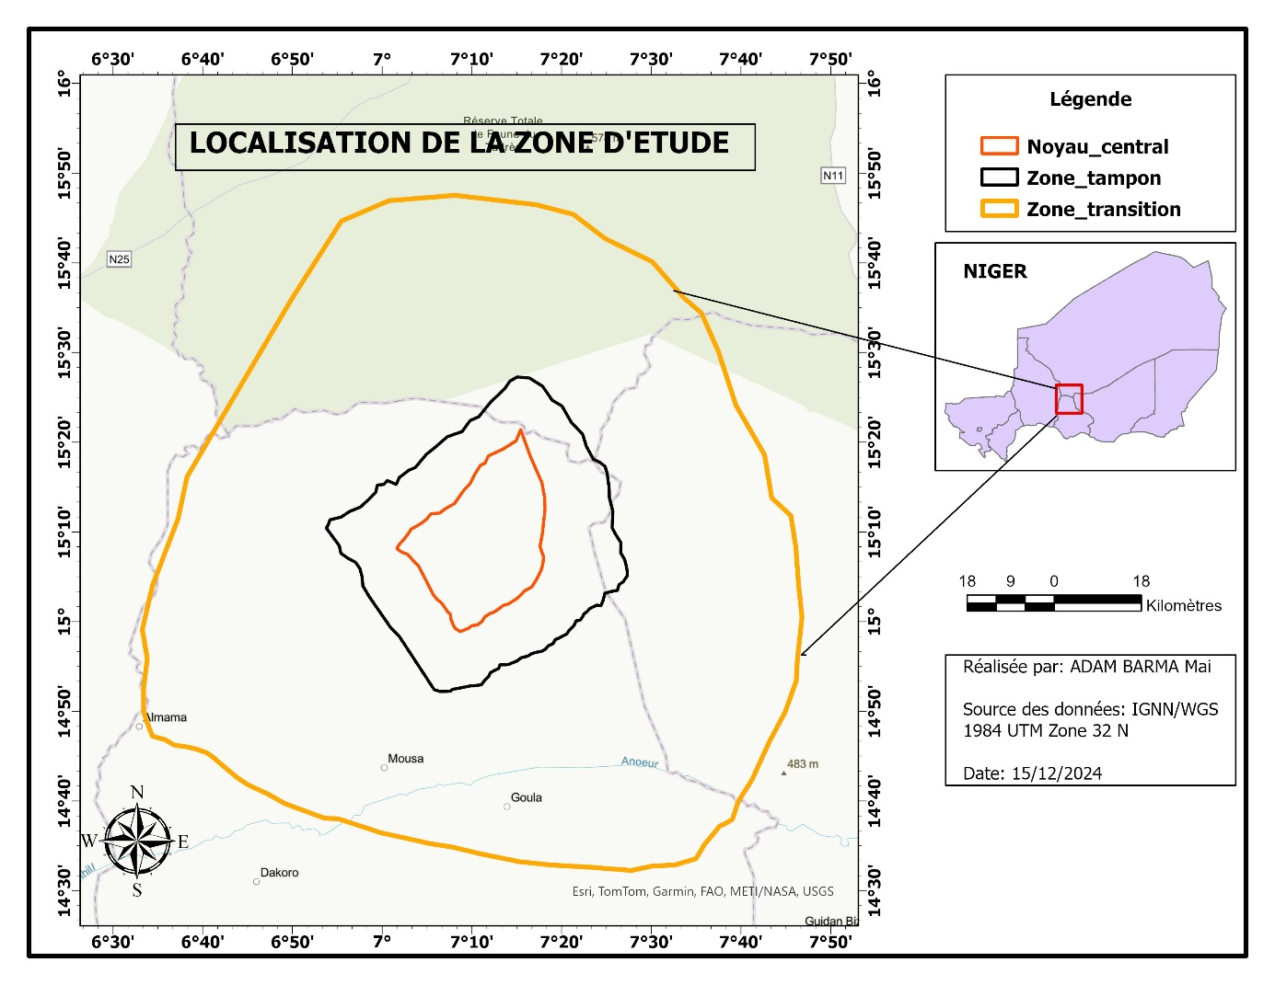
Figure 1: Geographic location of the study area

2.2 Satellite Imagery
To assess the spatiotemporal dynamics of bushfires from 1993 to 2023 in the studied area, we utilized bi-temporal satellite images corresponding to the phases before and after each year, specifically for 1993, 2003, 2013, and 2023. Medium-resolution optical images were used, namely Landsat-5 & 4 (Thematic Mapper), Landsat-7 (Enhanced Thematic Mapper), and Landsat 8 (Operational Land Imager), corresponding to the periods before and after the fires. In total, 32 images were utilized after creating an image mosaic for each date. These remote sensing data, freely accessible at: https://earthexplorer.usgs.gov/, showed very low cloud cover (less than 5%). Furthermore, the images were calibrated to surface reflectance and atmospherically corrected to eliminate distortions related to acquisition conditions. Each satellite image includes multispectral bands covering the visible and infrared spectrum, with wavelengths ranging from blue (0.4500,510 μm) to shortwave infrared (SWIR2) (2,1102,290 μm). In addition to satellite images, ecological monitoring data from the Gadabédji Biosphere Reserve were used for this study for the period from 2012 to 2018.

2.3 Data Processing
The collected data were processed using Excel Office 365 software to generate the illustrated histograms and tables. The maps illustrating the severity of active fires were created using ArcGIS Pro software.

2.3.1 Fire Intensity versus Burn Severity
Fire intensity represents the energy released by organic matter during the combustion process (Keeley, 2009). It also refers to active fire intensity. Burn severity, on the other hand, describes the impact of fire intensity on the functioning of the ecosystem of the burned area. The observed effects often vary within the same area and among different ecosystems (Keeley, 2009). Burn severity can also be described as the degree of alteration or disturbance of an area by fire. Figure 2 illustrates the difference between fire intensity and burn severity.
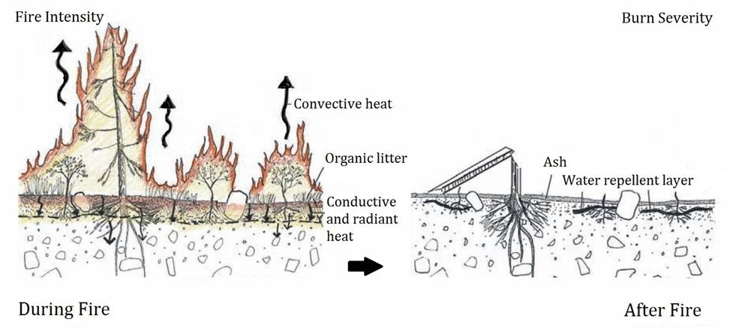
Figure 2 : Illustration of fire intensity versus burn severity (Source: US Forest Service).

2.3.2 Normalized Burn Ratio (NBR)
The extraction of areas damaged by bushfires in the study area was carried out using the normalized burn ratio (NBR), which ranges from -1 to 1; this index is based on the near-infrared (NIR) and shortwave infrared (SWIR2) bands of Landsat images and depends on the maximum reflectance of vegetation and mineral soil to assess the amount of existing vegetation before and after the bushfire (Konkathi et al., 2021).
Healthy vegetation exhibits very high reflectance in the near-infrared (NIR) and low reflectance in the SWIR (Figure 3), in contrast to what is observed in areas devastated by fire. Recently burned areas show low reflectance in the near-infrared (NIR) and high reflectance in the SWIR. In other words, the difference between the spectral responses of healthy vegetation and burned areas reaches its maximum in the NIR and SWIR regions of the spectrum.
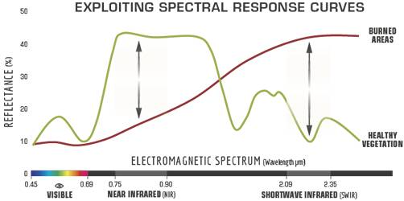
Figure 3: Comparison of spectral response of healthy vegetation and burned areas. Source: US Forest Service.
To leverage the extent of the spectral difference, the NBR uses the ratio between the NIR and SWIR bands, according to the formula below:
$$NBR =\frac{NIR-SWIR2}{NIR+SWIR2}$$

A high NBR value indicates healthy vegetation, while a low value indicates bare soil and recently burned areas. Unburned areas are typically assigned values close to zero.

2.3.4 Burn Severity
The difference between the NBR before and after the fire, obtained from the images, allowed for the calculation of the delta NBR (dNBR or ΔNBR), which is then used to estimate burn severity (Keeley JE, 2009). A high dNBR value indicates greater damage, whereas areas with negative dNBR values may indicate regrowth after a fire. The formula used to calculate dNBR is illustrated below:
dNBR = NBR_{prefire-}NBR_{postfire}

3. RESULTS and DISCUSSION

3.1. Evolution of Burned Areas Based on Burn Severity (dNBR) in 1993, 2003, 2013, and 2023
The diachronic analysis of fires has identified the extent of bushfire spread in the Gadabédji Biosphere Reserve, considering the bushfires that occurred over a thirty-year period (1993 to 2023) within the three components of the reserve: the central zone, the buffer zone, and the transition zone (Figure 1).
Burned surfaces have been recorded throughout the years of the study. However, the dynamics of the fires change from one year to another. From the central area to the periphery and the buffer zone, the distribution and intensity of the fires are not always the same over time and space. Indeed, the evolution of the annual rate of burned surface shows that at the level of the RBG, this rate, which varies between 0.005% and 7.33% of the reserve's area, differs significantly from that of the central area, where relatively high values have been recorded, ranging between 0.00 ha and 48,361.34 ha (Tables 1 and 4).
Tables 1, 2, 3, and 4 present the percentages and the distribution of burn severity levels, established based on the reclassification of the RdNBR map from the years 1993, 2003, 2013, and 2023. The burned surfaces are also evaluated and delineated (Figures 4 and 5).
Table 1: Distribution of burned areas based on burn severity (dNDBR) in 1993.
Severity Classes (1993) | Areas in ha
Severity Classes (1993) | Central Zone | Buffer Zone | Transition Zone | Total (ha) | Total (%)
Enhanced growth, high | 0,00 | 33,08 | 0,00 | 33,08 | 0,00
Enhanced growth, low | 0,00 | 0,00 | 0,00 | 0,00 | 0,00
Unburned | 69022,09 | 163861,39 | 1180008,94 | 1412892,42 | 99,95
Low severity | 0,00 | 18,20 | 37,03 | 55,23 | 0,00
Low to moderate severity | 0,00 | 0,00 | 187,44 | 187,44 | 0,01
Moderate to high severity | 0,00 | 0,00 | 19,78 | 19,78 | 0,00
High severity | 0,00 | 98,25 | 403,70 | 501,95 | 0,04
Subtotal of burned areas | 0,00 | 98,25 | 610,92 | 709,17 | 0,05
Total | 69022,093 | 163977,837 | 1180656,89 | 1413656,8 | 100

Table 2: Distribution of burned areas based on burn severity (dNDBR) in 2003.
Severity classes (2003) | Areas in ha
Severity classes (2003) | Central Zone | Buffer Zone | Transition Zone | Total (ha) | Total (%)
Enhanced growth, high | 12,10 | 26,05 | 551,03 | 589,18 | 0,042
Enhanced growth, low | 0,00 | 0,00 | 0,00 | 0,00 | 0,000
Unburned | 39398,80 | 162752,22 | 1179454,78 | 1381605,80 | 97,733
Low severity | 0,00 | 412,45 | 651,08 | 1063,53 | 0,075
Low to moderate severity | 29611,19 | 754,57 | 0,00 | 30365,76 | 2,148
Moderate to high severity | 0,00 | 0,00 | 0,00 | 0,00 | 0,000
High severity | 0,00 | 0,00 | 0,00 | 0,00 | 0,000
Subtotal of burned areas | 29611,19 | 754,57 | 0,00 | 30365,76 | 2,148
Total | 69009,993 | 163919,237 | 1180105,855 | 1413035,1 | 100

Table3: Distribution of burned areas based on burn severity (dNDBR) in 2013.
Severity classes (2013) | Areas in ha
Severity classes (2013) | Central Zone | Buffer Zone | Transition Zone | Total (ha) | Total (%)
Enhanced growth, high | 0,00 | 31,08 | 13,67 | 44,75 | 0,00
Enhanced growth, low | 0,00 | 0,00 | 0,00 | 0,00 | 0,00
Unburned | 57550,27 | 163899,23 | 1180632,15 | 1402081,65 | 99,18
Low severity | 15,05 | 14,98 | 0,00 | 30,03 | 0,00
Low to moderate severity | 11456,77 | 0,00 | 11,07 | 11467,84 | 0,81
Moderate to high severity | 0,00 | 0,00 | 0,00 | 0,00 | 0,00
High severity | 0,00 | 0,00 | 0,00 | 0,00 | 0,00
Subtotal of burned areas | 11456,77 | 0,00 | 11,07 | 11467,84 | 0,81
Total | 69022,093 | 163914,207 | 1180643,215 | 1413579,5 | 100

Table 4: Distribution of burned areas based on burn severity (dNDBR) in 2023.
Severity classes (2023) | Areas in ha
Severity classes (2023) | Central Zone | Buffer Zone | Transition Zone | Total (ha) | Total (%)
Enhanced growth, high | 0,00 | 221,71 | 334,11 | 555,82 | 0,04
Enhanced growth, low | 0,00 | 0,00 | 458,30 | 458,30 | 0,04
Unburned | 18000,00 | 157722,79 | 1140868,57 | 1141968,57 | 92,33
Low severity | 2660,75 | 7,03 | 1567,31 | 4235,09 | 0,34
Low to moderate severity | 11363,79 | 29,12 | 3211,08 | 14603,99 | 1,18
Moderate to high severity | 17563,34 | 5231,55 | 22783,98 | 45578,87 | 3,68
High severity | 19434,21 | 733,09 | 10333,54 | 30500,84 | 2,47
Subtotal of burned areas | 48361,34 | 5993,76 | 36328,60 | 90683,70 | 7,33
Total | 69022,09 | 163723,577 | 1178764,475 | 1236887,4 | 100
According to the RdNVR maps, there has been no significant increase, neither low nor high; it is the classes corresponding to the non-burned zones that predominate, with respective percentages of 99.95% (1993), 97.733% (2003), 99.18% (2013), and 92.33% (2023). The largest burned area was recorded in 2023: 90,683.70 hectares impacted, which represents 7.33% of the study area, including 48,361.34 hectares at the level of the central core, 5,993.76 hectares at the level of the buffer zone, and 36,328.60 hectares at the level of the central core. The areas subjected to severe burns rose to 501.95 hectares in 1993 and to 30,500.84 hectares in 2023. As for the zones of moderate to high severity and low to moderate severity, they are comprised between 0.01% and 3.68%.
Figure 4b shows that the burned areas extend over most components of the reserve; the transition zone and the central core are the most affected by the bushfires of 2023. However, the images from 1993 (Figure 6a) show a small extent of areas burned by fire. In addition to the presence of an ignition source, the triggering and propagation of forest fires depend on climatic factors (wind speed and direction, temperature, humidity, etc.) as well as the physical and ecological context of the ecosystem, including altitude, slope, exposure, type of vegetation, among others (Nouar Boulghobra et al., 2022). The spatio-temporal distributions of fire severity and burned areas for the periods 1993-2003 and 2013-2023 show that the fires primarily occur in grassy steppes and in areas of human activity near the central core, from where they then propagate to other vegetation formations (Figure 2023 b). Other authors, notably Koffi et al. (1995), showed that after four years of monitoring the dynamics of fires in Central Africa, the tropical savanna becomes the most exposed ecosystem once climatic conditions favor the ignition of fires.
b
a
Figure 4: Map of RdNBR showing the severity of bushfire in 1993 (a) and 2003 (b).
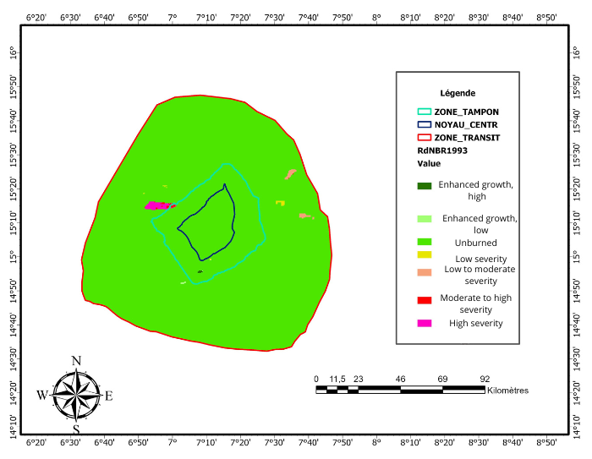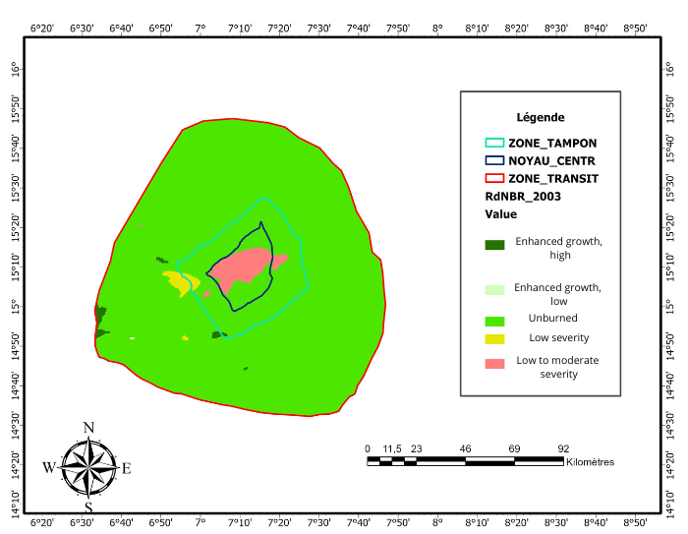

b
a
Figure 5: Map of RdNBR showing the severity of wildfire in 2013 (a) and 2023 (b).
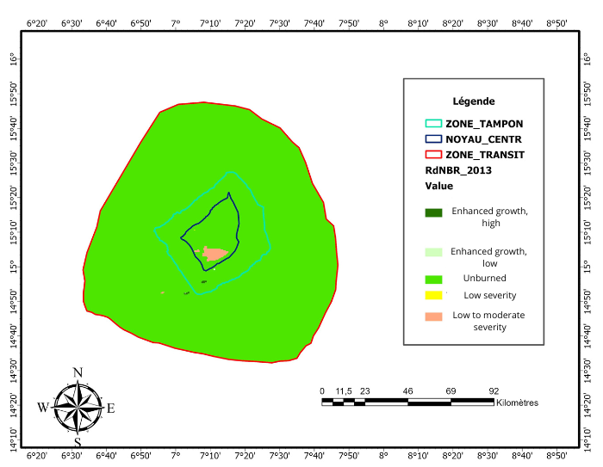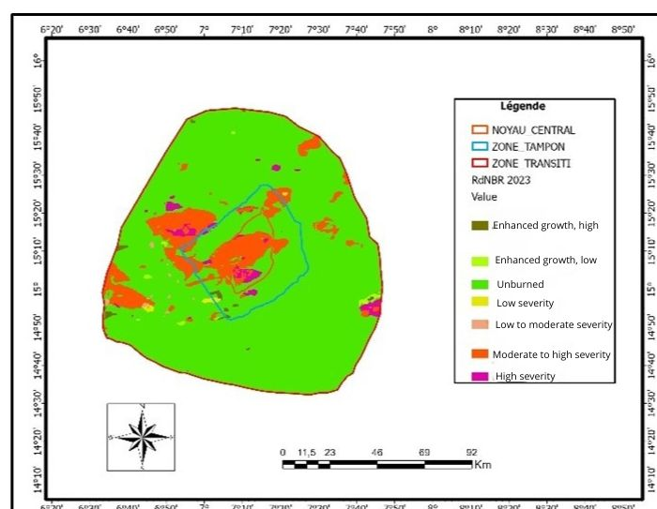

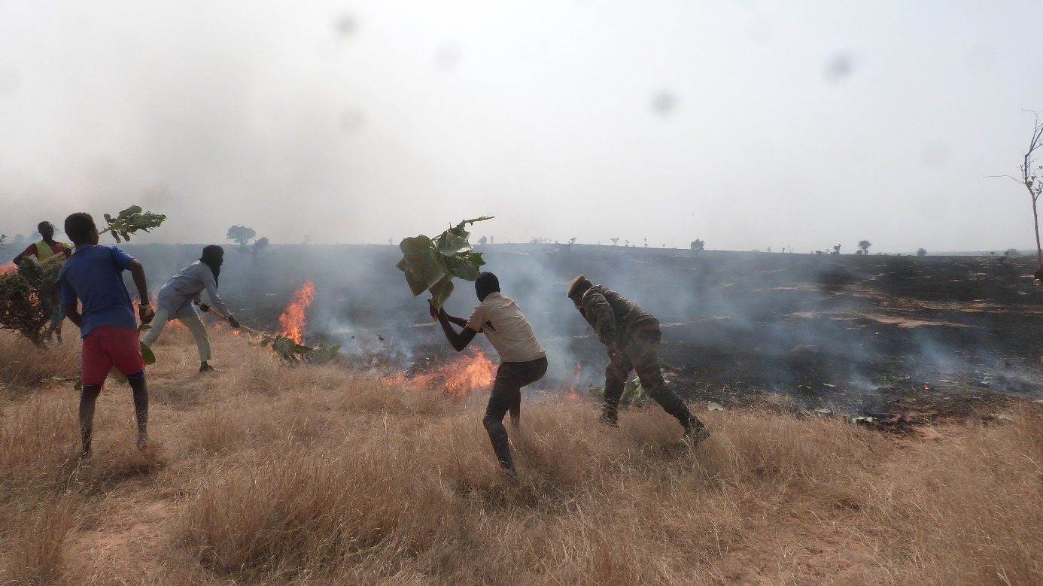
Figure 6: Fight against bushfire in the Gadabedji biosphere reserve.
The correlation between the localization and severity of fires, the distribution of burned areas, and the land occupation of different plant formations (herbaceous steppe and dense wooded steppe) leads to the same conclusion: bushfires primarily affect herbaceous steppes and dune formations that are covered with dense grass or continuous herbaceous cover, which are therefore more exposed to bushfires. These results align with those of GUEGUIM (2018), who noted that in Cameroon, savannas are the most exposed to fires, while forests are hardly affected and only experience significant fires during periods of severe drought, at the end of the dry season or during exceptional dry spells. The landscapes of the study area present favorable conditions for the initiation and propagation of fires due to the predominance of steep slopes in the inter-dune areas, predominantly covered with dense herbaceous mats. It is observed that the vast majority of burned areas correspond to forest formations located on steep slopes (20 to 50%); these sectors primarily consist of herbaceous and shrubby steppes. Regarding the density of vegetation cover, it is noted that 40% of the burned areas concern formations with low density (NDVI 0.10 to 0.40), 55% of formations have medium to high density (NDVI 0.40 to 0.60), and less than 5% affect areas with dense vegetation. These observations confirm the work of Nouar et al. (2022) and Rahmani et al. (2019), which highlight that the propagation of forest fires depends on several ecological and morpho-topographical factors, notably slope, altitude, and vegetation cover density. Understanding the spatiotemporal dynamics of active fires and burned areas allows for strategically guiding the distribution of prevention and firefighting resources, as well as planning the objective monitoring of protected areas (Bao et al., 2015).
4. Conclusion
The spatiotemporal analysis of wildfires in the RBG shows that regulatory measures for fire management have not reduced the frequency of late starts or uncontrolled fires. The risk remains high and affects a large part of the reserve. The burned areas detected by satellite are generally underestimated compared to ground observations. Indeed, sectors identified as unburned contain numerous burned patches: the actual affected area is therefore significantly larger than what is detected. The distribution of active fires is not homogeneous. This pattern reveals that the spread of fires depends on several factors that either facilitate or hinder their progression, heavily influenced by anthropogenic factors. Securing the boundaries of a protected area helps limit the spread of wildfires from already burned zones to protected areas. To reduce the severity and spread of bushfires, it is necessary to adopt and implement appropriate strategies and integrated risk and damage reduction plans before, during, and after wildfires. Monitoring and spatiotemporal analysis of fires at national, regional, and local levels are also essential for effectively organizing early warning systems and improving fire prevention and management. This study shows that fire management is both an essential element and a specific issue of land use planning, particularly for protected areas.

Disclaimer (Artificial intelligence)
Option 1:
Author(s) hereby declare that NO generative AI technologies such as Large Language Models (ChatGPT, COPILOT, etc.) and text-to-image generators have been used during the writing or editing of this manuscript.
References
- Abdourhamane H, Morou B, Rabiou H. and Mahamane A., 2013. Floristic characteristics, diversity and structure of woody vegetation in South-Central Niger: the case of the Dan Kada Dodo-Dan Gado classified forest complex. Int. J. Biol. Chem. Sci., 7(3): 1048-1068.
- DOI: http://dx.doi.org/10.4314/ijbcs.v7i3.13
- Baddi A. 2013. Contribution to the evaluation of Ecosystem Services provided by the Gadabédji Total Wildlife Reserve (RTFG), Bermo Department (Maradi Region). Master's thesis in sustainable land management, Department of Training and Research, Agrhymet Regional Center. 78p.
- Boulghobra., 2021. N. Sentinel 2 imagery and burn ratios for assessing the July 5, 2021 wildfires severity in the region of Khenchela (northeast Algeria). Geographia Technica 2021, 16(2), 95-104. DOI: https://doi.org/10.21163/GT_2021.162.08
- Cherki, K., & Gmira, N. (n.d.). Post-fire regeneration dynamics and fire severity in Mediterranean forests: the case of the Mâamora forest, northern Morocco. January 2013 Revue d'Écologie (La Terre et La Vie). 68p. DOI: https://doi.org/10.3406/revec.2013.1699
- Eva HD, Grégoire J-M, Mayaux P, Cheva D. 2003. Monitoring of Vegetation Fires in Protected Areas of Sub-Saharan Africa: Contribution of Spatial Techniques and Satellite Data for Fire Monitoring in Sub-Saharan Africa. Office for Official Publications of the European Communities: Luxembourg.
- Gueguim, C. D., Tchamba, N. M., & Fotso, C. R. (2018). Spatio-temporal dynamics of bushfires in the Mbam and Djerem National Park (Cameroon). International Journal of Biological and Chemical Sciences, 12(2), 728. DOI: https://doi.org/10.4314/ijbcs.v12i2.10
- Hough JL. 1999. Why burn the bush? Social approaches to bush-fire management in West African national parks. Biological Conservation, 65(1): 23-28. DOI: https://doi.org/10.1016/0006-3207(93)90192-4
- Iro M. 2015. Role of the Gadabedji total wildlife reserve in local development in Niger. Master's thesis in Natural Resource Management and Biodiversity, University of Abomey Calavi, Faculty of Agricultural Sciences: 81 p.
- Kabore A. 2010. Bush for some, protected area for others: History of settlement, perceptions of nature and protected area policy in the Burkinabe Gourma: the example of the Pama Partial Wildlife Reserve. Doctoral thesis, Graduate Institute of International and Development Studies. Geneva, 386 p. Koffi B, Grégoire J-M, Mahé G, Lacaux J-P. 1995. Remote sensing of bush fire dynamics in Central Africa from 1984 to 1988: analysis in relation to regional vegetation and pluviometric patterns. Atmospheric Research, 39(1–3): 179-200. DOI: https://doi.org/10.1016/0169-8095(95)00011-F
- Keeley, J.E. (2009). Fire intensity, fire severity and burn severity: A brief review and suggested usage. International Journal of Wildland Fire, 18(1), 116–126. DOI: https://doi.org/10.1071/WF07049
- Konkathi, P., Shetty, A. (2021). Inter comparison of post-fire burn severity indices of Landsat-8 and Sentinel-2 imagery using Google Earth Engine. Earth Sci Inform, 645-653. DOI: https://doi.org/10.1007/s12145-020-00566-2
- Lim, C. H., Kim, Y. S., Won, M., Kim, S. J., & Lee, W. K. (2019). Can satellite-based data substitute for surveyed data to predict the spatial probability of forest fire? A geostatistical approach to forest fire in the Republic of Korea. Geomatics, Natural Hazards and Risk, 10(1), 719–739. DOI: https:doi.org/10.1080/19475705.2018.1543210
- Mahamane, A., Saadou, M., Bakasso, Y., Abassa, I., Aboubacar, I., & Karim, S. (2007). Diachronic analysis of land use and vegetation characteristics in the commune of Gabi (Maradi region, Niger). Drought, 18(4), 296–304. DOI: https://doi.org/10.1684/sec.2007.0105.
- Moskwa, E., Bardsley, D. K., Robinson, G. M., & Weber, D. (2018). Generating narratives on bushfire risk and biodiversity values to inform environmental policy. Environmental science & policy, 89, 30-40. DOI : 10.1016/j.envsci.2018.07.001
- Morou B., 2010. Impacts of land use on giraffe habitat in Niger and challenges for the conservation of the last giraffe herd in West Africa, 231p. DOI: 10.4236/ojf.2024.142011
- Opha PD. 2009. Linking fire and climate: interactions with land use, vegetation, and soil. Current Opinion in Environmental Sustainability, 1(2): 161-169. DOI: https://doi.org/10.1016/j.cosust.2009.10.008
- Parks, S.A., Dillon, G.K., Miller, C. A New Metric for Quantifying Burn Severity: The Relativized Burn Ratio. Remote Sens. 2014, 6, 1827-1844. DOI: https://doi.org/10.3390/rs61212509
- Soulama, S., Kadeba, A., Nacoulma, B. M. I., Traore, S., Bachmann, Y., & Thiombiano, A. (2015). Impact of anthropogenic activities on the vegetation dynamics of the Pama Partial Wildlife Reserve and its surroundings (southeast Burkina Faso) in a context of climate variability. Int. Journal of Applied Biosciences., 87, 8047-8064. DOI: 10.4314/jab.v87i1.6
- Rahmani, S., Benmassoud, H. Modeling of forest fire risk spatial distribution in the region of Aures, Algeria. Geoadria 2019, 24(2), 79-91. DOI: https://doi.org/10.15291/geoadria.2846

