The Science Behind Seed Vigour and Why It Matters

Abstract
Under actual field conditions, successful crop establishment and overall productivity are determined by seed vigour and seed quality, thus a very important attribute of seed quality. Collected in contrast to the percentage of germination, which is used to report the performance of the seed under ideal laboratory conditions, seed vigour is used to report the ability of the seed to germinate quickly and uniformly, establish a healthy and synchronized stand of plants and withstand biotic and abiotic stresses. A complex interplay of physiological, biochemical and genetic processes which modulates reserve mobilisation, membrane integrity, metabolic efficiency and the pathways of stress responsiveness controls seed vigour in germination and early seedling development. The high-vigour seeds are characterized by a high performance in unfavorable environmental factors like drought, saline environment, extreme temperatures and non-optimal soils, which helps in maintaining stable yields. With the current problem of climate change and growing production limitations, seed vigour is crucial to sustainability in agriculture and food security. The measures to enhance seed vigour are the breeding, seed production and storage practices, and seed enhancement technology. The combination of these methods can enhance the performance of the seed in different environments and help to create the system of crops resistant to various weather conditions and able to adapt to the new patterns of climate changes.
Keywords: Seed vigour, Crop establishment, Climate resilience

1. Introduction
Seed vigour represents the hidden biological strength that determines how well a seed performs beyond simple germination. While germination percentage indicates whether a seed can sprout under ideal laboratory conditions, seed vigour reflects the seed’s capacity to emerge rapidly, uniformly, and establish healthy seedlings under a wide range of environmental stresses, including drought, salinity, low temperature, and poor soil conditions (ISTA, 2023). In real farming situations, where conditions are rarely optimal, seed vigour is often a more reliable predictor of crop success than germination alone. Numerous field-based studies have demonstrated that seed lots with similar germination percentages can differ greatly in field emergence and yield performance due to differences in vigour, highlighting the practical importance of this trait (Hampton and TeKrony, 1995). At its core, seed vigour is governed by complex physiological and biochemical processes occurring within the seed. High-vigour seeds possess intact cell membranes, efficient respiration systems, active enzyme machinery, and well-maintained energy reserves, enabling faster metabolic activation during imbibition (Copeland and McDonald, 2001). These seeds repair cellular damage quickly upon hydration, resulting in rapid radicle protrusion and early seedling growth. In contrast, low-vigour seeds suffer from membrane leakage, oxidative stress, and delayed metabolism, leading to weak or uneven field emergence. The integrity of membrane systems is particularly critical, as membrane deterioration during ageing results in solute leakage, reduced mitochondrial efficiency, and impaired ATP synthesis during early germination (McDonald, 1999).
Seed vigour is also closely associated with the metabolic readiness of the embryo. High-vigour seeds exhibit faster activation of hydrolytic enzymes such as α-amylase, proteases, and lipases, which mobilize stored reserves efficiently to support early seedling growth (Bewley et al., 2013). This rapid reserve mobilization ensures that seedlings can elongate their roots and shoots quickly, allowing early access to soil moisture and nutrients. Conversely, poor vigour delays enzyme activation, limiting reserve utilization and increasing the vulnerability of seedlings to environmental stresses during establishment. Seed ageing is a critical factor influencing vigour loss. During storage, seeds undergo gradual deterioration due to lipid peroxidation, protein degradation, nucleic acid damage, and accumulation of reactive oxygen species (ROS), even before viability loss becomes evident (Bewley et al., 2013). Interestingly, seeds may still show acceptable germination percentages while their vigour has already declined significantly. This explains why crops often fail to establish uniformly despite using “certified” seeds that meet minimum germination standards. Research has shown that ageing-related damage first affects membrane stability and mitochondrial function, long before embryo death occurs, making vigour a more sensitive indicator of seed quality than germination alone (Walters et al., 2010). Oxidative stress plays a central role in vigour deterioration. As seeds age, the balance between ROS production and antioxidant defense systems becomes disrupted. High-vigour seeds maintain more efficient antioxidant enzymes such as superoxide dismutase, catalase, and peroxidases, which protect cellular components from oxidative damage (Bailly, 2004). In contrast, low-vigour seeds accumulate excessive ROS, leading to lipid peroxidation, enzyme inactivation, and DNA fragmentation. These biochemical changes impair cellular repair mechanisms during imbibition, delaying germination and reducing seedling robustness. The importance of seed vigour becomes especially evident under stress conditions. Low-moisture soils, fluctuating temperatures, saline patches, and compacted seedbeds demand robust physiological resilience during early growth stages. High-vigour seeds exhibit greater tolerance to abiotic stress by sustaining energy supply, maintaining membrane stability, and activating stress-responsive enzymes more effectively (Finch-Savage and Bassel, 2016). As a result, they show better seedling survival, stronger root systems, and improved nutrient uptake during the critical establishment phase. Under drought or salinity stress, vigorous seeds have been shown to maintain higher osmotic adjustment and better root elongation, allowing seedlings to access deeper soil moisture (Farooq et al., 2017).
Seed vigour also plays a decisive role in determining early root system architecture. Rapid and uniform emergence promotes early root branching, longer primary roots, and greater root surface area, which enhance water and nutrient acquisition (Lynch, 2013). This early advantage often persists throughout the crop life cycle, influencing plant competitiveness, biomass accumulation, and yield formation. Poor-vigour seeds, on the other hand, frequently develop shallow or uneven root systems, increasing susceptibility to drought and nutrient deficiencies later in the season. From an agronomic perspective, seed vigour directly influences plant population density, crop uniformity, and final yield. Uneven emergence caused by low-vigour seeds leads to intra-crop competition, poor canopy development, and inefficient use of inputs such as fertilizers and irrigation. Late-emerging plants often remain suppressed throughout the growing season and contribute less to yield, while still competing for resources (Egli and Rucker, 2012). Studies consistently show that high-vigour seed lots result in earlier flowering, improved stress recovery, and higher yield stability, particularly in climate-vulnerable regions.
Seed vigour is also closely linked with seedling establishment under conservation agriculture and reduced tillage systems. In such systems, seeds are often sown into cooler soils with higher residue cover, conditions that challenge early emergence. High-vigour seeds are better equipped to overcome mechanical impedance and suboptimal soil temperatures, ensuring satisfactory stand establishment (Finch-Savage et al., 2010). This makes vigour a key trait for sustainable and resource-efficient farming systems. In seed testing and quality control, vigour assessment has therefore gained increasing importance. Traditional germination tests fail to capture subtle differences in physiological quality that determine field performance. As a result, vigour tests such as accelerated ageing, electrical conductivity, cold test, and controlled deterioration have been developed to predict field emergence more accurately (ISTA, 2023). These tests are now widely used in seed certification and breeding programs to ensure the delivery of high-performance seeds to farmers. In the context of climate change, seed vigour has emerged as a foundational trait for resilient agriculture. Erratic rainfall, heat waves, soil salinization, and declining soil health demand seeds that can “push through” adversity during the earliest and most vulnerable stage of crop growth. Climate models predict increased frequency of extreme weather events, making rapid and uniform crop establishment more critical than ever (IPCC, 2022). Under such scenarios, high-vigour seeds act as a biological buffer, reducing the risk of crop failure at the establishment stage. Seed vigour also has important implications for food security and seed system sustainability. High-vigour seeds reduce the need for re-sowing, lower seed rates, and improve the efficiency of agricultural inputs, thereby enhancing profitability for farmers. In smallholder systems, where access to irrigation and inputs is limited, vigour can make the difference between crop success and failure (Powell and Matthews, 2012). Thus, improving seed vigour contributes not only to productivity but also to livelihood resilience. Strengthening seed vigour through improved seed production practices, proper harvesting at physiological maturity, optimized drying and storage conditions, and advanced seed enhancement technologies is therefore essential. Seed priming, bio-priming, and nano-priming approaches have shown significant potential to restore or enhance vigour by improving antioxidant activity, membrane repair, and metabolic efficiency (Paparella et al., 2015; Farooq et al., 2019). Such technologies are increasingly being integrated into modern seed systems to deliver climate-smart, high-performance seeds, seed vigour is not merely a laboratory parameter but a comprehensive biological attribute that determines crop establishment, resilience, and yield stability. It serves as a form of biological insurance, safeguarding crops against environmental uncertainty and stress. As agriculture faces mounting challenges from climate change, resource scarcity, and soil degradation, prioritizing seed vigour in research, breeding, and seed management will be fundamental to achieving sustainable and resilient food production systems.

2. The Biology That Builds Strong Seeds
The strength of a seed is the result of a highly coordinated sequence of biological events that occur during seed development, maturation, and subsequent storage. These processes collectively determine the seed’s capacity for rapid germination, uniform emergence, and successful seedling establishment after sowing. Strong seeds are characterized by efficient reserve accumulation, preserved cellular integrity, and a high level of metabolic readiness, all of which contribute to superior field performance (Bewley et al., 2013; Marcos-Filho, 2015).
During seed development and filling, carbohydrates, proteins, and lipids are synthesized and deposited in precise proportions within storage tissues. These reserves serve as the primary energy and nutrient source for germination and early seedling growth before photosynthesis becomes functional. Well-developed seeds accumulate reserves more uniformly and in forms that are readily mobilized, ensuring faster radicle protrusion and early seedling growth. Poorly developed or stressed seeds, in contrast, show incomplete reserve deposition, leading to delayed or weak seedling emergence (Copeland and McDonald, 2001).
At the cellular level, membrane structure and integrity play a decisive role in determining seed strength. In high-quality seeds, cellular membranes remain intact and selectively permeable, minimizing solute leakage during imbibition and maintaining proper compartmentalization of metabolic processes. Stable membranes also support efficient mitochondrial function, allowing rapid initiation of respiration and ATP production immediately after hydration. Membrane deterioration, which commonly occurs in low-vigour or aged seeds, disrupts energy metabolism and slows germination (Bewley et al., 2013; Bailly, 2004). Strong seeds are further distinguished by well-developed antioxidant defense systems. Enzymes such as catalase, superoxide dismutase, and peroxidases play a critical role in scavenging reactive oxygen species generated during seed maturation, storage, and early germination. By limiting oxidative damage to lipids, proteins, and nucleic acids, these antioxidant systems delay seed ageing and preserve vigour over time (Finch-Savage and Bassel, 2016; Bailly et al., 2008).
Hormonal regulation is another fundamental biological determinant of seed strength. Abscisic acid (ABA) governs seed maturation, reserve accumulation, and the acquisition of desiccation tolerance, while gibberellins (GA) promote the synthesis of hydrolytic enzymes required for mobilization of stored starch, proteins, and lipids during germination. A finely balanced ABA–GA interaction ensures that seeds remain dormant and stable during storage but respond rapidly to favorable conditions after sowing, resulting in synchronized germination and uniform seedling emergence (Nonogaki et al., 2010).
Recent advances in seed biology have highlighted the role of epigenetic regulation, transcriptional control, and stress memory in determining seed strength. Epigenetic modifications established during seed development can influence gene expression during germination, allowing seeds to respond more efficiently to environmental stresses encountered in the field. These mechanisms effectively “prime” seeds for future challenges, enhancing resilience under sub-optimal conditions (Finch-Savage et al., 2017). Collectively, these interconnected biological processes explain why seed strength is established long before sowing. Strong seeds are biologically pre-programmed during development to withstand storage, initiate rapid germination, and support early seedling growth, underscoring the central role of seed biology in determining crop establishment and productivity.
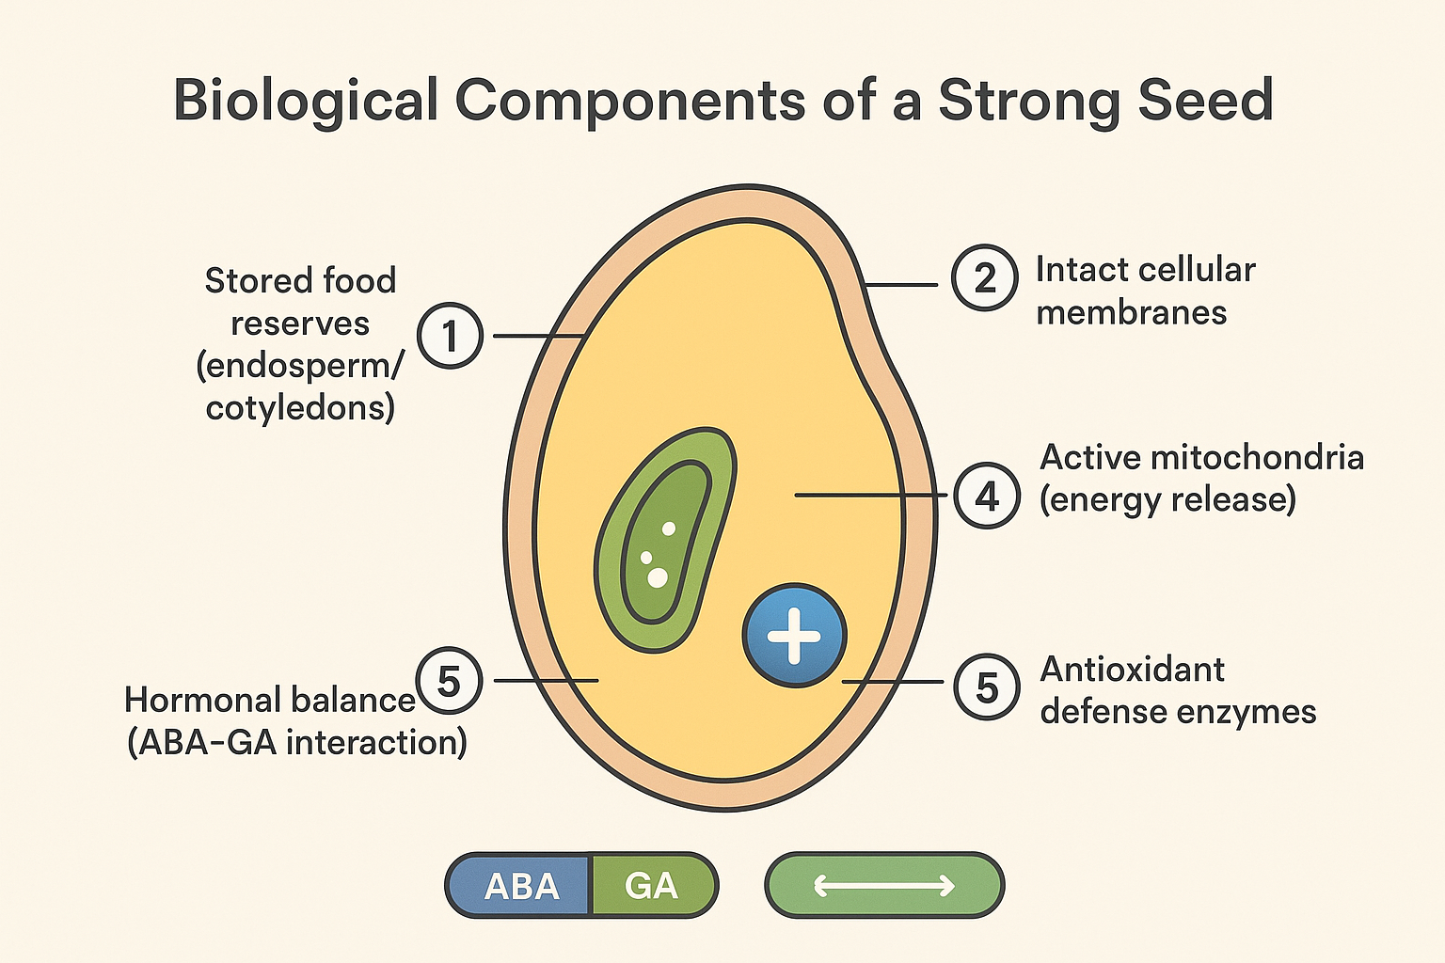
Figure 1. Biological Components of a Strong Seed (Nonogaki et al., 2010)
3. Why Seed Vigour Determines Field Success
Seed vigour is a decisive factor governing crop establishment and performance under actual field conditions, where environmental factors are highly variable and often stressful. While standard laboratory germination tests assess seed viability under optimal and controlled conditions, they fail to reflect the complex and dynamic realities of agricultural fields. In contrast, seed vigour represents the sum of those seed properties that determine the potential for rapid, uniform emergence and development of normal seedlings across a wide range of environmental conditions (ISTA, 2023; Hampton & TeKrony, 1995). This distinction explains why seed lots with similar germination percentages often perform very differently once sown in farmers’ fields. Field environments commonly expose seeds to multiple abiotic and biotic stresses, including moisture deficit, temperature extremes, soil compaction, salinity, nutrient imbalance, and pathogen attack. These stresses frequently occur simultaneously during the early stages of crop establishment, making this phase one of the most vulnerable in the crop life cycle. High-vigour seeds exhibit enhanced physiological and biochemical efficiency, such as superior membrane integrity, higher respiratory activity, efficient reserve mobilization, and stronger antioxidant defense systems. Together, these attributes enable vigorous seeds to withstand stress and establish seedlings more successfully than low-vigour seeds (Finch-Savage & Bassel, 2016; Marcos-Filho, 2015). Rapid and synchronized emergence is a critical outcome of high seed vigour, as the early growth phase strongly influences crop competitiveness and yield potential. Vigorous seeds germinate quickly and uniformly, allowing seedlings to establish before soil moisture declines or temperature conditions become unfavorable. This rapid establishment provides an early growth advantage that often persists throughout the crop season. In contrast, delayed or uneven emergence caused by poor seed vigour results in asynchronous plant development, reduced crop uniformity, and inefficient use of available resources. Vigorous seedlings typically develop deeper and more extensive root systems along with stronger shoots, facilitating superior water and nutrient uptake and early canopy establishment. Early root elongation allows seedlings to access deeper soil moisture, particularly under rainfed or drought-prone conditions. Improved shoot growth and early canopy closure enhance light interception and reduce evaporation losses from the soil surface. This allows crops to compete more effectively with weeds and utilize agronomic inputs such as fertilizers and irrigation more efficiently. Conversely, low-vigour seeds often emerge slowly and unevenly, resulting in poor plant stand, delayed growth, and increased intra-crop competition, ultimately reducing productivity (Egli & Rucker, 2012; AOSA, 2009). Seed vigour also plays a vital role in stress recovery during early crop establishment. In many production systems, crops experience transient stresses such as early-season drought, cold injury, waterlogging, or soil crusting shortly after sowing. High-vigour seedlings recover more rapidly from such stresses due to efficient energy utilization, stable cellular membranes, and faster repair mechanisms. These seeds possess better mitochondrial function and higher ATP availability, which supports rapid metabolic adjustment once favorable conditions return (Bewley et al., 2013). The ability to recover quickly from early stress events has important implications for later developmental stages. Uniform and vigorous early growth contributes to synchronized flowering, balanced canopy development, and improved partitioning of assimilates to reproductive organs. As a result, crops established from high-vigour seeds often exhibit greater yield stability across seasons, even under variable climatic conditions. In contrast, seedlings originating from low-vigour seeds frequently remain weak and uncompetitive throughout the season, contributing less to final yield despite surviving initial establishment. Seed vigour is particularly critical under modern conservation agriculture and reduced-tillage systems, where seeds are often sown into cooler soils with higher residue cover. These conditions can delay emergence and increase disease pressure. High-vigour seeds are better equipped to overcome mechanical resistance, suboptimal temperatures, and pathogen challenges, ensuring satisfactory stand establishment in such systems (Finch-Savage et al., 2010). Thus, seed vigour supports not only productivity but also the adoption of sustainable farming practices. From a crop management perspective, seed vigour directly influences planting decisions, seed rate requirements, and input efficiency. High-vigour seeds reduce the need for higher seed rates to compensate for poor emergence, thereby lowering seed costs. They also improve the efficiency of applied fertilizers and irrigation by ensuring that a greater proportion of inputs contribute to productive plants. In resource-limited and smallholder farming systems, this efficiency can significantly enhance profitability and resilience. In the context of climate change, the importance of seed vigour has become even more pronounced. Increasing climatic variability has led to unpredictable rainfall patterns, rising temperatures, and frequent extreme weather events. Under such conditions, the ability of seeds to establish rapidly and withstand early stress is critical for minimizing yield losses. Seed vigour thus acts as a biological buffer, linking seed quality to climate resilience and food security (Powell & Matthews, 2012). In climate-stressed and resource-limited farming systems, seed vigour serves as a crucial biological link between seed quality and field productivity. It determines not only whether a crop emerges but how well it competes, survives stress, and ultimately yields. Therefore, ensuring high seed vigour is not only essential for successful crop establishment but also for achieving sustainable, resilient, and climate-smart agricultural production systems.

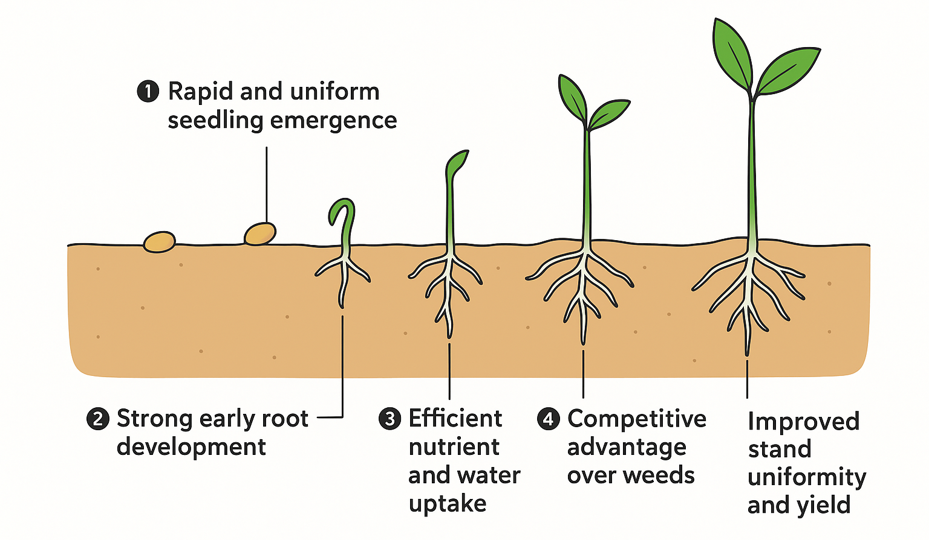

Figure 2. Role of Seed Vigour in Field Success (Egli and Rucker, 2012).

4. Seed Vigour Under Stressful Conditions
Seed vigour assumes its greatest importance when crops are exposed to stressful field environments such as drought, salinity, temperature extremes (low or high), poor soil aeration, and compacted or degraded soils. Under such adverse conditions, seed germination is often delayed, emergence becomes uneven, and seedling mortality increases substantially. Because early crop establishment represents the most vulnerable phase of the plant life cycle, the physiological quality of seeds becomes a decisive factor determining plant survival and subsequent productivity. Recent research consistently emphasizes that seed vigour, rather than laboratory germination percentage alone, provides a more reliable indicator of field performance under stress-prone environments (Finch-Savage & Bassel, 2023; Marcos-Filho, 2024). Stress conditions impose severe constraints on seed metabolic reactivation during imbibition. Drought and salinity reduce water availability and create osmotic stress, while temperature extremes disrupt enzyme activity and membrane fluidity. In such conditions, high-vigour seeds exhibit superior physiological and biochemical resilience, enabling them to withstand stress during imbibition and early seedling growth. Vigorous seeds are better equipped to resume metabolism rapidly, maintain cellular homeostasis, and sustain early growth processes under unfavorable conditions, thereby ensuring successful establishment (Nonogaki et al., 2024).
One of the primary advantages of high-vigour seeds under stress is their ability to rapidly activate metabolic processes after imbibition. Vigorous seeds maintain better membrane integrity, which reduces electrolyte leakage and preserves cellular compartmentalization during hydration. Membrane stability is especially critical under drought and salinity stress, where osmotic imbalance accelerates lipid peroxidation and membrane disintegration. Recent studies have shown that high-vigour seeds exhibit enhanced membrane repair mechanisms during early imbibition, allowing faster restoration of cellular organization and metabolic efficiency under stress (Rajjou et al., 2023). Efficient mobilization of seed reserves further distinguishes high-vigour seeds from low-vigour counterparts under stressful conditions. Vigorous seeds rapidly activate hydrolytic enzymes involved in the breakdown of stored carbohydrates, proteins, and lipids, ensuring a continuous supply of energy and metabolic substrates for radicle protrusion and early seedling growth. This metabolic efficiency is particularly important under sub-optimal temperatures or limited soil moisture, where energy demands for cellular repair and stress adaptation are high. In contrast, low-vigour seeds show delayed enzyme activation and inefficient reserve utilization, leading to slow emergence and weak seedling development (Nonogaki et al., 2024).
Oxidative stress regulation is another central component of seed vigour under adverse environments. Abiotic stresses such as drought, salinity, and temperature extremes enhance the production of reactive oxygen species (ROS), which can damage lipids, proteins, and nucleic acids if not efficiently scavenged. High-vigour seeds possess stronger antioxidant defense systems, including higher activities of superoxide dismutase, catalase, and peroxidases, which limit oxidative damage during germination and early seedling growth. Enhanced redox regulation allows vigorous seeds to maintain metabolic balance and transition more efficiently from quiescence to active growth under stress (Mittler et al., 2023; Rajjou et al., 2023).
Seed vigour also plays a decisive role in root system development under stressful field conditions. Under drought and salinity stress, high-vigour seeds give rise to seedlings with faster radicle emergence, greater root elongation, and improved root branching. Early and vigorous root growth allows seedlings to access deeper soil moisture and nutrients, improving water relations and reducing the negative effects of osmotic stress. Recent studies highlight that vigorous early root development enhances hydraulic conductivity and nutrient uptake efficiency, conferring a long-term advantage in stress-prone environments (Lynch, 2024). Conversely, seedlings emerging from low-vigour seeds often exhibit shallow and poorly developed root systems, making them highly susceptible to early-season drought and nutrient deficiency. Temperature stress further underscores the importance of seed vigour in determining field establishment success. Under low-temperature conditions, enzymatic activity, membrane fluidity, and respiration rates are reduced, often resulting in delayed and uneven emergence. High-vigour seeds demonstrate better tolerance to chilling stress through improved membrane stability, efficient mitochondrial respiration, and faster repair of cold-induced cellular damage. As a result, they exhibit quicker and more uniform emergence under cool soil conditions (Finch-Savage et al., 2023). Similarly, under high-temperature stress, vigorous seeds show enhanced thermotolerance through stable protein function, effective antioxidant protection, and sustained metabolic activity, which collectively support seedling survival and establishment.
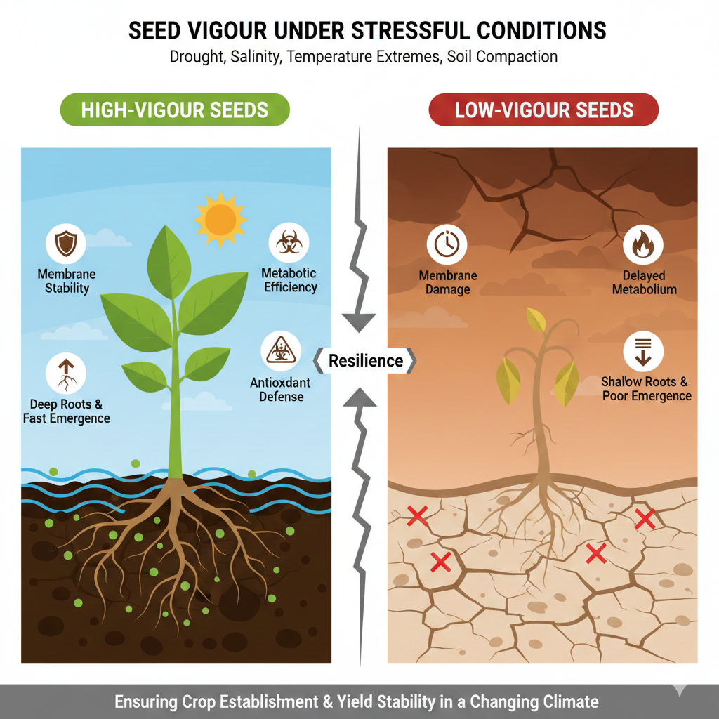
Fig. 3- Seed Vigour Under Stressful Conditions (Finch-Savage et al., 2023)

The importance of seed vigour under stress has become increasingly pronounced in the context of climate change. Rising temperatures, erratic rainfall patterns, increasing soil salinization, and frequent extreme weather events are intensifying stress exposure during early crop growth stages. Climate variability often results in unpredictable sowing conditions, making rapid and uniform establishment essential for reducing yield risk. Under such scenarios, seed vigour functions as a biological buffer that safeguards early crop establishment and minimizes the impact of transient or chronic stress on crop performance (IPCC, 2023).
Crops established from high-vigour seeds consistently demonstrate superior plant stand, synchronized growth, improved stress recovery, and greater yield stability at maturity. Uniform early growth promotes balanced canopy development, efficient resource use, and reduced intra-crop competition. In contrast, poor establishment from low-vigour seeds leads to uneven growth, inefficient use of inputs, and greater vulnerability to biotic and abiotic stresses throughout the growing season (Marcos-Filho, 2024), seed vigour plays a central role in determining crop performance under stressful environmental conditions by enhancing membrane stability, metabolic efficiency, antioxidant protection, root system development, and stress recovery capacity. As agriculture increasingly operates under climatic uncertainty and resource limitations, prioritizing seed vigour through improved breeding strategies, seed production practices, and seed enhancement technologies will be essential for ensuring reliable crop establishment and sustainable agricultural productivity.

5. Strengthening Seed Vigour for Future Farming
Strengthening seed vigour is central to building resilient, productive, and climate-smart agricultural systems, particularly under the growing pressure of abiotic and biotic stresses associated with climate change. Seed vigour, which governs rapid germination, uniform emergence, and early seedling establishment, is largely determined before sowing and plays a decisive role in crop performance under field conditions. Enhancing seed vigour therefore represents a cost-effective and sustainable approach to securing yield stability in future farming systems. Seed vigour can be improved through an integrated strategy involving advanced breeding approaches, quality seed production practices, efficient storage systems, and modern seed enhancement technologies (Finch-Savage and Bassel, 2016). At the genetic level, contemporary breeding programs increasingly prioritize traits associated with early seedling robustness, including rapid and synchronized germination, efficient reserve mobilization, and tolerance to environmental stresses. The identification and incorporation of stress-resilient genes, along with physiological and molecular markers linked to seed vigour, enable the development of crop varieties better adapted to heat, drought, salinity, and marginal soil conditions (Bewley et al., 2013). Such varieties ensure reliable crop establishment even under suboptimal field environments, thereby reducing the risk of early crop failure.
Beyond genetics, agronomic management during seed production plays a crucial role in safeguarding seed vigour. Adequate nutrition, effective pest and disease control, and timely harvesting at physiological maturity are essential to produce high-quality seeds with strong vigour potential. Improper management during these stages can lead to mechanical damage, pathogen infection, or incomplete seed development, all of which negatively affect vigour. Post-harvest handling and storage are equally critical, as exposure to high temperature and humidity accelerates seed ageing through oxidative stress, membrane deterioration, and loss of metabolic efficiency. Maintaining low-moisture and low-temperature storage conditions, along with appropriate packaging, is particularly important in tropical and subtropical regions to preserve seed vigour over extended periods. Regular monitoring of seed quality using vigour tests, in addition to standard germination tests, ensures that only physiologically sound seed reaches farmers. In recent years, emerging seed enhancement techniques such as seed priming, coating, and bio-stimulant application have shown considerable promise in strengthening seed vigour. Seed priming enhances metabolic preparedness and speeds up germination, while bio-priming with beneficial microorganisms improves nutrient acquisition, disease resistance, and tolerance to environmental stresses. Collectively, these interventions improve seed–soil interactions, enhance establishment success, and reduce dependence on external inputs. Strengthening seed vigour thus represents a proactive and forward-looking strategy to achieve stable yields, resource-efficient agriculture, and sustainable food production under increasing climate uncertainty.

Table.1. Strategies for Strengthening Seed Vigour

Approach | Key Practice | Benefit to Farming
Genetic improvement | Breeding for early vigour and stress tolerance | Uniform emergence and yield stability
Quality seed production | Optimal nutrition and timed harvest | Higher initial physiological quality
Scientific storage | Low moisture and controlled temperature | Reduced deterioration and ageing
Seed enhancement | Priming, bio-priming, and coating | Improved stress tolerance and establishment
Quality assessment | Use of vigour tests | Reliable field performance

6.Conclusion
Seed vigour emerges as a critical biological trait that links seed quality with reliable field performance, particularly under variable and stressful environmental conditions. Unlike germination percentage alone, seed vigour determines rapid and uniform emergence, early seedling strength, stress tolerance, and ultimately yield stability. It is shaped by genetic makeup, physiological integrity, proper storage, and targeted seed enhancement practices long before sowing. In the face of climate change, where crops are increasingly exposed to drought, heat, salinity, and erratic rainfall, seed vigour acts as a biological insurance mechanism. Strengthening seed vigour is therefore essential for resilient, productive, and future-ready agricultural systems.

Disclaimer (Artificial Intelligence):
The author(s) declare that generative artificial intelligence (Gemini AI) was used only for figure generation, and no AI tools were used for writing or editing the manuscript text.

References

- Association of Official Seed Analysts (AOSA). (2009). Seed vigor testing handbook (Contribution No. 32). AOSA. https://analyzeseeds.com/product/2009-seed-vigor-testing-handbook/
- Bailly, C. (2004). Active oxygen species and antioxidants in seed biology. Seed Science Research, 14(2), 93–107.
https://doi.org/10.1079/SSR2004159
- Bailly, C., El-Maarouf-Bouteau, H., and Corbineau, F. (2008). From intracellular signaling networks to cell death. Plant Physiology, 148, 102–112. https://doi.org/10.1016/j.crvi.2008.07.022
- Bewley, J. D., Bradford, K. J., Hilhorst, H. W. M., & Nonogaki, H. (2013). Seeds: Physiology of development, germination and dormancy (3rd ed.). Springer.
https://doi.org/10.1007/978-1-4614-4693-4
- Copeland, L. O., & McDonald, M. B. (2001). Principles of seed science and technology (4th ed.). Springer.
https://doi.org/10.1007/978-1-4615-1619-4
- Egli, D. B., & Rucker, M. (2012). Seed vigor and the uniformity of emergence in soybean. Seed Science and Technology, 40(3), 349–361.
https://doi.org/10.15258/sst.2012.40.3.08
- Ellis, R. H., & Roberts, E. H. (1980). Improved equations for the prediction of seed longevity. Annals of Botany, 45(1), 13–30.
https://doi.org/10.1093/oxfordjournals.aob.a085797
- Farooq, M., Usman, M., Nadeem, F., Rehman, H., Wahid, A., Basra, S. M. A., & Siddique, K. H. M. (2019). Seed priming in field crops: Potential benefits, adoption and challenges. Crop and Pasture Science, 70(9), 731–771.
https://doi.org/10.1071/CP18604
- Farooq, M., Wahid, A., & Siddique, K. H. M. (2017). Improving tolerance of crops to abiotic stress through seed priming. Plant Physiology and Biochemistry, 115, 66–79.
https://doi.org/10.1016/j.plaphy.2017.03.025
- Finch-Savage, W. E., & Bassel, G. W. (2016). Seed vigour and crop establishment: Extending performance beyond adaptation. Journal of Experimental Botany, 67(3), 567–591. https://doi.org/10.1093/jxb/erv490
- Finch-Savage, W. E., & Bassel, G. W. (2023). Seed vigour and crop establishment under environmental stress. Journal of Experimental Botany, 74(9), 2561–2575.
https://doi.org/10.1093/jxb/erv490
- Finch-Savage, W. E., Clay, H. A., Lynn, J. R., & Morris, K. (2010). Towards a genetic understanding of seed vigour in small-seeded crops using natural variation in Arabidopsis thaliana. Plant Science, 179(6), 582–589.
https://doi.org/10.1016/j.plantsci.2010.07.005
- Finch-Savage, W. E., Footitt, S., & Clay, H. A. (2023). Environmental regulation of seed performance and vigour in crops. Plant Physiology, 192(3), 1481–1495.
https://doi.org/10.1093/plphys/kiad176
- Finch-Savage, W. E., Footitt, S., and Douterelo-Soler, I. (2017). Seed dormancy cycling. Journal of Experimental Botany, 68, 843–858. https://doi.org/10.1093/jxb/erw477
- Hampton, J. G., & TeKrony, D. M. (1995). Handbook of vigour test methods (3rd ed.). International Seed Testing Association. https://www.seedtest.org/en/handbook-for-vigour-test-methods-3rd-edition-1995--0-0-0-0-290-290.html
- Intergovernmental Panel on Climate Change (IPCC). (2022). Climate change 2022: Impacts, adaptation and vulnerability. Cambridge University Press.
https://doi.org/10.1017/9781009325844
- International Seed Testing Association (ISTA). (2023). International rules for seed testing. ISTA, Bassersdorf, Switzerland. https://doi.org/10.15258/istarules.2023.I
- IPCC. (2023). Climate change 2023: Synthesis report. Intergovernmental Panel on Climate Change.
https://doi.org/10.59327/IPCC/AR6-9789291691647
https://www.ipcc.ch/report/ar6/syr/downloads/report/IPCC_AR6_SYR_LongerReport.pdf

- Lynch, J. P. (2013). Steep, cheap and deep: An ideotype to optimize water and N acquisition by maize root systems. Annals of Botany, 112(2), 347–357.
https://doi.org/10.1093/aob/mcs293
- Lynch, J. P. (2024). Root system responses to abiotic stress: Implications for seedling establishment. Trends in Plant Science, 29(2), 180–193.
https://doi.org/10.1016/j.tplants.2023.09.004
- Marcos-Filho, J. (2015). Seed vigor testing: An overview of the past, present and future perspective. Scientia Agricola, 72(4), 363–374.
https://doi.org/10.1590/0103-9016-2015-0007
- Marcos-Filho, J. (2024). Seed vigour testing and its relevance under climate variability. Seed Science Research, 34(1), 1–15.
https://doi.org/10.1017/S0960258523000127
- McDonald, M. B. (1999). Seed deterioration: Physiology, repair and assessment. Seed Science and Technology, 27(1), 177–237.
- Mittler, R., Zandalinas, S. I., & Fichman, Y. (2023). Reactive oxygen species signalling in plant stress responses. Nature Reviews Plant Biology, 4(1), 23–38.
https://doi.org/10.1038/s44185-022-00043-4
- Nonogaki, H., Bassel, G. W., & Bewley, J. D. (2024). Seed germination and vigour in a changing environment. Annual Review of Plant Biology, 75, 155–178.
https://doi.org/10.1146/annurev-arplant-102223-042315
- Nonogaki, H., Bassel, G. W., and Bewley, J. D. (2010). Germination—still a mystery. Plant Science, 179, 574–581. https://doi.org/10.1016/j.plantsci.2010.02.010
- Paparella, S., Araujo, S. S., Rossi, G., Wijayasinghe, M., Carbonera, D., & Balestrazzi, A. (2015). Seed priming: State of the art and new perspectives. Plant Cell Reports, 34(8), 1281–1293. https://doi.org/10.1007/s00299-015-1784-y
- Powell, A. A., & Matthews, S. (2012). Seed ageing/repair hypothesis leads to new testing methods. Seed Science and Technology, 40(3), 386–399.
https://doi.org/10.15258/sst.2012.40.3.11
- Rajjou, L., Duval, M., & Gallardo, K. (2023). Redox regulation of seed vigour and stress tolerance. Plant, Cell & Environment, 46(5), 1398–1412.
https://doi.org/10.1111/pce.14641
- Walters, C., Hill, L. M., & Wheeler, L. J. (2010). Dying while dry: Kinetics and mechanisms of deterioration in desiccated organisms. Integrative and Comparative Biology, 50(5), 751–758. https://doi.org/10.1093/icb/45.5.751

