Original Research Article
Correlation Analysis of Vegetative and Flowering Traits with Yield and Kernel Quality in Walnut (Juglans regia L.)

ABSTRACT
Understanding the association among vegetative growth, flowering behaviour, yield and kernel quality traits is essential for improving selection efficiency in walnut breeding programmes. The present investigation was conducted during the 2023–2024 growing season at the Walnut Orchard, Faculty of Agriculture, Wadura, SKUAST-K, to evaluate phenotypic correlations among vegetative morphological traits, flowering phenology, yield, and kernel quality attributes in twenty-one walnut (Juglans regia L.) genotypes maintained under uniform orchard management conditions. Vegetative traits such as time of bud break, leaf length, leaf width, leaflet length, leaflet width, and number of leaflets were recorded, along with flowering parameters, yield per tree, nut physical traits, and kernel biochemical characteristics including protein and oil content. Correlation coefficients were computed to assess the magnitude and direction of associations among the studied traits. The results revealed that yield per tree exhibited weak and non-significant associations with most vegetative traits, including bud break (r = −0.17), leaf length (r = 0.06), and leaflet length (r = 0.04), indicating a limited direct influence of vegetative morphology on productivity. Several vegetative traits showed significant negative correlations with nut size parameters, particularly leaf length and leaf width with nut diameter at suture and cheek. Leaflet width, however, exhibited a significant positive correlation with kernel protein content (r = 0.44), suggesting its role in influencing kernel biochemical quality. Flowering phenology demonstrated stronger and significant positive associations with kernel recovery percentage, notably first male bloom (r = 0.45), peak male bloom (r = 0.46), last male bloom (r = 0.46), and first female bloom (r = 0.52). Flowering overlap also showed a positive association with yield, highlighting the importance of reproductive synchrony in walnut. In conclusion, flowering behaviour was found to be more closely associated with kernel recovery and yield stability than vegetative growth traits. The study suggests that flowering-related traits and selected vegetative parameters influencing kernel quality may serve as reliable indirect selection criteria in walnut improvement programmes. Future research should focus on validating these associations across environments and integrating phenological and biochemical traits with molecular markers to enhance selection efficiency in walnut breeding.
Key words: Walnut, vegetative morphology, correlation analysis, flowering behaviour, kernel quality.

- INTRODUCTION
Walnut (Juglans regia L.) is an important temperate nut crop with high economic and nutritional value, which is extensively cultivated for its kernels which are rich in oil, protein, and other nutrients. In addition to the nutritive value, walnut cultivation contributes significantly to the living standards of people in the temperate regions (Mukarram et al., 2024). Despite its high importance walnut productivity as well as the quality varies extensively due to genetic diversity, environmental factors and cultural practices (Devin and Bujdoso, 2022). Enhancement in the quality of the kernel and production is a prime objective of walnut breeding programme. Productivity is a complicated trait which is affected by a set of morphological, phenological and physiological attributes, making it less effective for direct selection (Manthos et al., 2023; Einollahi and Khadivi ,2024).
For walnuts grown in plantations, the kernel quality and yield potential can pay an even more role in terms of economic performance. Such traits are linked to growth habit, flowering and development of the walnuts (Lone et al., 2023). The role of vegetative morphological parameters like bud break timing as well as parameters like leaf and leaflet size in regulating photosynthetic potential and allocation of assimilates is very fundamental. In walnuts, reproductive effectiveness is highly dependent on flo9wering coordination based on dichogamy requirements to ensure synchronization between male and female flowering phases (Kumar et al., 2024). Understanding the interaction between vegetative parameters and yield parameters is essential for identifying the useful parameters in walnut improvement.
Correlation helps to identify the traits that are positively or negatively associated with yield or quality traits (Panahi et al., 2022). But correlation analysis does not elucidate the relationship between cause and effect, besides the fact that related traits can affect the yield indirectly. Although several studies have described the relationships between the traits related to the nut, kernel, and flower in the walnut species, there is a lack of information available about the relationship between the vegetative morphological traits related to the yield or quality parameters in temperate regions. Specifically, there is a lack of understanding about the relationship between the bud break, leaf, and leaflet traits related to the yield parameters or the kernel quality (Einollah and Khadivi, 2024).
In the light of the above considerations, the present study was conducted to examine the relationship of bud break, leaf length, leaf width, leaflet length, leaflet width, and the number of leaflets with the parameters of yield, nut, kernel, flowering, and quality of walnut (Juglans regia L.). The findings of this study are expected to provide valuable information for identifying key traits for walnut improvement programme.
2. MATERIALS AND METHODS
2.1 Experimental Site and Climatic Conditions
The present investigation was carried out during the 2023–2024 growing season at the Walnut Orchard, Faculty of Agriculture, Wadura, Sher-e-Kashmir University of Agricultural Sciences and Technology of Kashmir (SKUAST-K), Jammu and Kashmir, India. The experimental site is located at an altitude of approximately 1,610 meters above mean sea level and falls under the temperate climatic zone of the Kashmir Valley. The region is characterized by cold winters, mild summers, and adequate chilling hours required for proper dormancy release and flowering in walnut. Standard orchard management practices, including irrigation, fertilization, and plant protection measures, were uniformly applied throughout the experimental period to minimize environmental variability.
2.2 Plant Material and Experimental Design
The experimental material consisted of twenty-one walnut (Juglans regia L.) genotypes maintained in the institutional orchard of SKUAST-K. Trees selected for the study were healthy, vigorous, and of comparable age, grown under uniform spacing and management conditions. The study was conducted using a randomized observational approach, wherein multiple trees per genotype were evaluated to ensure reliable phenotypic assessment and reduce experimental error.
2.3 Recording of Vegetative Morphological Traits
Vegetative morphological observations were recorded during the active growing season following standard descriptors. The traits studied included time of bud break, leaf length, leaf width, leaflet length, leaflet width, and number of leaflets per compound leaf. Bud break was recorded as the date when approximately 50% of vegetative buds showed visible green tissue emergence. Leaf and leaflet dimensions were measured using a digital vernier caliper, and mean values were calculated from representative samples collected from each genotype.
2.4 Assessment of Flowering Phenology
Flowering phenological traits were recorded to evaluate reproductive behaviour and synchrony. Observations included first male bloom, peak male bloom, last male bloom, first female bloom, peak female bloom, and last female bloom. Additionally, the duration of female flower overlap with staminate bloom was recorded to assess flowering synchronization. All flowering observations were documented on a calendar date basis and later converted into numerical values for statistical analysis.
2.5 Yield, Nut, and Kernel Quality Parameters
Yield per tree was recorded at harvest by weighing the total nut yield from each tree. Nut physical characteristics such as nut weight, nut length, nut diameter at suture and cheek, and shell thickness were measured using standard procedures. Kernel weight and kernel recovery percentage were determined after shelling the nuts. Kernel biochemical traits, including protein and oil content, were estimated using standard analytical protocols as described by AOAC (2000).
2.6 Statistical Analysis
Phenotypic correlation coefficients (r) were calculated to determine the magnitude and direction of associations among vegetative morphological traits, flowering characteristics, yield, and kernel quality parameters. The significance of correlation coefficients was tested at 5% and 1% probability levels using standard statistical procedures. All statistical analyses were performed using appropriate statistical software to ensure accuracy and reliability of the results.

3. RESULTS AND DISCUSSION
The phenotypic correlation coefficients among the variables of vegetative, flowering, yields and quality parameters are given in Table 1. The majority of the variables under vegetation showed low to moderate correlation values with the variables related to yields as well as the physical parameters of the nut, though the phenology of flowering demonstrated relatively stronger association with the kernel recovery percentage. The time of bud break showed a low non-significant correlation with the given yields (r = −0.17) and most of the physical parameters for the nut. However, significant positive correlation values between the bud break phenology and the parameters: first male bloom(r = 0.54), peak male bloom (r = 0.50), last male bloom (r = 0.54), first female bloom (r = 0.55), peak female bloom (r = 0.44) as well as flowering overlap phenology (r = 0.44), measures were found, indicating the indirect contribution of the initial or synchronized bud break to the increase of the overlap duration between the male as well as female flowering, which is a vital component for the successful process of pollination of the walnut trees.
Leaf length was found to have a highly significant negative relationship with nut diameter at suture (correlation coefficient= −0.54) and nut diameter at cheek (correlation coefficient = −0.52). Whereas, was found to have a highly significant positive relationship with the first male bloom (correlation coefficient = 0.57), peak male bloom (correlation coefficient = 0.50), last male bloom (correlation coefficient = 0.54), first female bloom (correlation coefficient = 0.55), and peak female bloom (correlation coefficient = 0.44).
Leaf width was found to be highly significantly and negatively correlated with nut diameter at suture (-0.54) and nut diameter at cheek (-0.53) whereas, it was non-significantly correlated with other traits. Likewise, the values of leaflet length recorded positive correlations with first male bloom, which was (0.55), peak male bloom (0.49), last male bloom (0.54), first female bloom (0.53) and peak female bloom (0.43). Leaflet length was also found to be negatively correlated with the persistence of female flowers (r =-0.38). Leaflet width showed significant positive correlation with the protein content of the kernel (r = 0.44) although highly significant negative correlation exists between width of leaflets and overlap of female flowering and staminate inflorescences (r = -0.56). The variable number of leaflets is not significantly associated with most of the characters measured.
Flowering characteristics were generally displayed to possess relatively stronger and more significant associations with kernel recovery percentage. First male flowering (r = 0.45), peak male bloom (r = 0.46), last male bloom (r = 0.46), and first female flowering (r = 0.52) revealed significantly positive associations with kernel recovery percent, underscoring the significance and role of flower characteristics in determining the kernel efficiencies and recoveries. It is clear that genotypes with synchronized and longer flowering phases are associated with enhanced fertilization and kernel development and are responsible for improved recoveries to a higher extent. Flowering coordination and association with kernel characteristics has been established in walnut and other nut trees, to emphasize reproduction and the role of successful nut-production phases and efficiencies in determining the quality and yield.
Yield per tree was generally weakly associated with vegetative growth traits, indicating a limited direct influence of leaf morphology on productivity in walnut. Bud break showed a weak negative association with yield (r = −0.17), whereas the correlation of yield with leaf length was almost negligible (r = 0.06). Similarly, the associations of yield with leaflet length (r = 0.04) and leaf width (r = −0.04) were also weak. Furthermore, the number of leaflets was also weakly associated with yield (r = −0.05), suggesting that variability in leaf number did not have a major impact on yield under the studied conditions. The high correlation between the timing of bud break and the floral traits indicates that the dormancy breaks in vegetative buds influences the control of flowering time in walnut trees (Charrier et al., 2011; Bernard et al., 2020). The early bud break, in this case promotes the male and female phases in the emergence of the flowers, which can influence pollination process in temperate regions.
Leaf length, leaf width, leaflet length and leaflet width were vegetative traits that depicted the strong negative, non-significant correlation with the nut size characters, such as nut diameter at suture and cheek. The result indicated that an increase in vegetative growth does not necessarily increase the nut growth, possibly affected by the competition from the vegetative and reproductive sinks for assimilates. This was witnessed in some other nut trees, (Marino et al., 2023). Similar studies in walnut and other fruit crops were witnessed in earlier studies, in which the result showed that a large vegetative growth does not exhibit positive correlation with the fruit/nut size (Christopoulos et al., 2021). The positive correlation of leaflet width and kernel protein concentration depicted the positive influence of the vegetative traits on the kernel biochemical constituents. The non-significant correlation of the vegetative traits with the total yield of the trees depends on various factors such as synchronicity of flowers (Abedi and Parvaneh, 2016; Bogdziewicz et al., 2020).
Flowering phenology was found as the most relevant component that influenced kernel recovery percentage. The significant positive correlation of kernel recovery with first male bloom, peak male bloom, last male bloom, and first female bloom indicates that timely and longer flowering phases favor better fertilization and kernel filling. These results agree with the previous studies indicating the importance of flowering synchronization and duration in determining kernel development and nut quality in walnut (Marrano et al., 2019; Gurjar et al., 2025). The strong association of first female bloom with kernel recovery further supports that early receptivity of female flowers may favor effective fertilization, leading to higher kernel proportion (Banyal et al., 2023). Yield per tree had a significant positive relation with flowering overlap that again underlined the role of reproductive synchrony in yield determination. Sufficient coincidence between male and female flowering phases guarantees efficient pollen transfer and fertilization, culminating in improved fruit set and stability of yield (Mutke et al., 2012). In this regard, previous studies have alsos reported flowering overlap as the key yield determinant factor in walnut and other wind-pollinated nut crops (Soleimani et al., 2023).
Table 1 shows the value of correlation coefficients between the various trait characters in both vegetative and flower phases and those related to yield and quality. The nature and trend in the correlation coefficients are also demonstrated in the heatmap below (Fig. 1). The graph indicates the intensity and signs associated with the correlation coefficients in the various traits involves in the study. The correlation in the various characters was higher in vegetative features, and those related to yield and quality /kernel biochemical constituents.
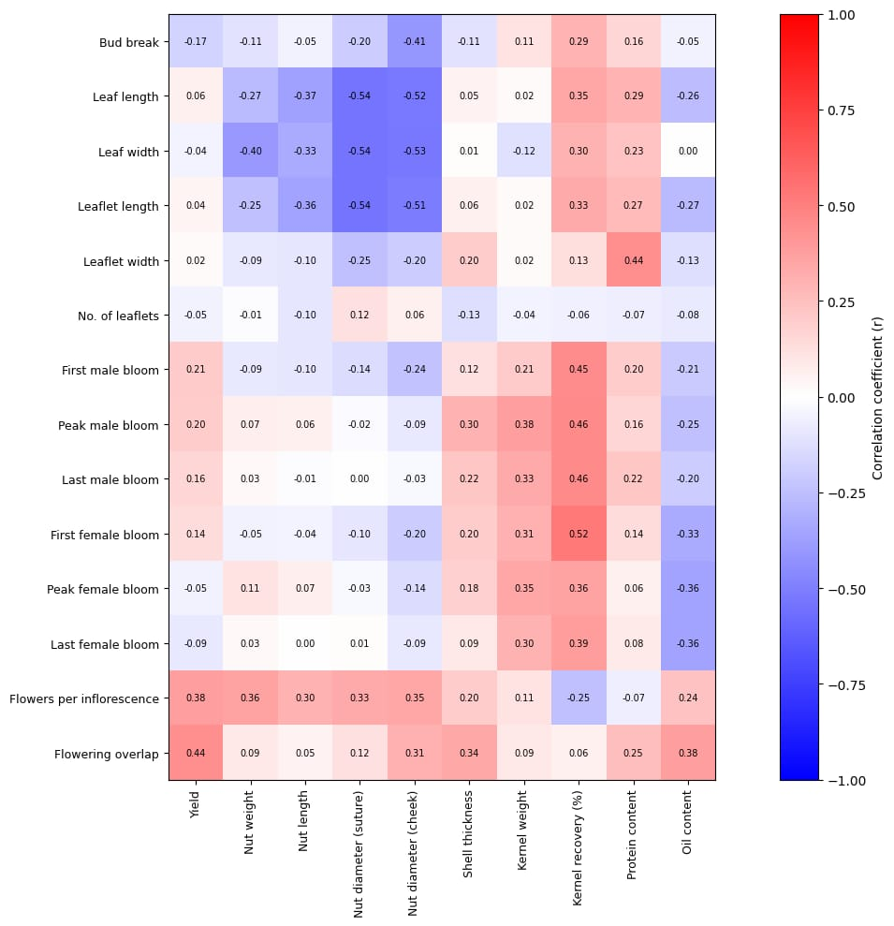
Fig. 1. Heatmap showing phenotypic correlation coefficients (r) among vegetative morphological, yield and quality traits in walnut
Note: Red indicates positive correlations and blue indicates negative correlations, while colour intensity represents the magnitude of the correlation coefficient (r).
5. CONCLUSION
The present investigation clearly demonstrated that vegetative morphological traits in walnut exhibit a limited direct association with yield per tree, whereas flowering phenology plays a comparatively more decisive role in determining kernel recovery and yield stability. Traits such as time of bud break, leaf and leaflet dimensions, and leaflet width were found to be more closely linked with flowering synchrony and kernel quality attributes than with overall productivity. The weak correlations observed between vegetative traits and yield indicate that increased vegetative growth does not necessarily translate into higher yield in walnut, likely due to competition between vegetative and reproductive sinks. Among the studied parameters, flowering traits particularly the timing and duration of male and female bloom and the extent of flowering overlap showed significant positive associations with kernel recovery percentage, emphasizing the importance of reproductive synchronization for efficient fertilization and kernel development. Additionally, the positive association between leaflet width and kernel protein content suggests that certain vegetative traits may influence kernel biochemical composition, thereby contributing to nut quality improvement. Overall, the findings highlight flowering behaviour as a key selection criterion for improving kernel recovery and yield efficiency in walnut breeding programmes. Vegetative traits influencing flowering and kernel quality may be effectively utilized as indirect selection indicators. Future research should focus on multi-location and multi-year validation of these associations and on integrating phenological, morphological, and quality traits with molecular and genomic tools to enhance selection precision and accelerate genetic improvement in walnut.

Trait | Yield | Nut weight | Nut Length | Nut Diameter Suture | Nut Diameter Cheek | Shell Thickness | Kernel weight | Kernel percentage | Protein Content | Oil Content
First Male Bloom | 0.21 | -0.09 | -0.10 | -0.14 | -0.24 | 0.12 | 0.21 | 0.45** | 0.20 | -0.21
Peak Male Bloom | 0.20 | 0.07 | 0.06 | -0.02 | -0.09 | 0.30 | 0.38 | 0.46** | 0.16 | -0.25
Last Male Bloom | 0.16 | 0.02 | -0.01 | 0 | -0.03 | 0.22 | 0.33 | 0.46** | 0.22 | -0.20
First Female Bloom | 0.14 | -0.05 | -0.04 | -0.10 | -0.20 | 0.2 | 0.31 | 0.52** | 0.14 | -0.33
Peak Female Bloom | -0.05 | 0.11 | 0.07 | -0.03 | -0.14 | 0.18 | 0.35 | 0.36 | 0.06 | -0.36
Last Female Bloom | -0.09 | 0.03 | 0 | 0.01 | -0.09 | 0.09 | 0.30 | 0.39 | 0.08 | -0.36
Female flower per inflorescence | 0.38 | 0.36 | 0.30 | 0.33 | 0.35 | 0.20 | 0.11 | -0.25 | -0.07 | 0.24
Duration of female flower overlapped by staminate bloom | 0.44** | 0.09 | 0.05 | 0.12 | 0.31 | 0.34 | 0.09 | 0.06 | 0.25 | 0.38
Table 1: Correlation coefficients among vegetative morphological, yield and quality traits of walnut genotypes

DISCLAIMER (ARTIFICIAL INTELLIGENCE)
Author(s) hereby declare that NO generative AI technologies such as Large Language Models (ChatGPT, COPILOT, etc.) and text-to-image generators have been used during the writing or editing of this manuscript.
REFERENCES
- Abedi, B., & Parvaneh, T. (2016). Study of correlations between horticultural traits and variables affecting kernel percentage of walnut (Juglans regia L.). Journal of Nuts, 7(1), 35-44.
- AOAC, 2000. Official Methods of Analysis, 17th ed. Association of Official Analytical Chemists, Washington, DC.
- Banyal, S. K., Patial, U. R., & Banyal, A. K. (2023). Pollination Management. In Temperate Nuts (pp. 149-170). Singapore: Springer Nature Singapore.
- Bernard, A., Marrano, A., Donkpegan, A., Brown, P. J., Leslie, C. A., Neale, D. B., ... & Dirlewanger, E. (2020). Association and linkage mapping to unravel genetic architecture of phenological traits and lateral bearing in Persian walnut (Juglans regia L.). BMC genomics, 21(1), 203.
- Bogdziewicz, M., Pesendorfer, M., Crone, E. E., Pérez‐Izquierdo, C., & Bonal, R. (2020). Flowering synchrony drives reproductive success in a wind‐pollinated tree. Ecology Letters, 23(12), 1820-1826.
- Charrier, G., Bonhomme, M., Lacointe, A., & Améglio, T. (2011). Are budburst dates, dormancy and cold acclimation in walnut trees (Juglans regia L.) under mainly genotypic or environmental control?. International journal of biometeorology, 55(6), 763-774.
- Christopoulos, M. V., Kafkaletou, M., Karantzi, A. D., & Tsantili, E. (2021). Girdling effects on fruit maturity, kernel quality, and nutritional value of walnuts (Juglans regia L.) alongside the effects on leaf physiological characteristics. Agronomy, 11(2), 200.
- Devin, S. R., & Bujdoso, G. (2022). Walnut genotypes for high density orchards. Horticulturae, 8(6), 490.
- Einollahi, F., & Khadivi, A. (2024). Morphological and pomological assessments of seedling-originated walnut (Juglans regia L.) trees to select the promising late-leafing genotypes. BMC Plant Biology, 24(1), 253.
- Gurjar, T. D., Pandey, A. K., & Rodge, R. R. (2025). Floral Biology, Pollination, and genetic resources in nut crops. In Temperate Nut Crops (pp. 51-108). Apple Academic Press.
- Kumar, A., Dangi, G., Kumar, P., Sharma, D. P., Sharma, G., Sajwan, P., ... & Gundogdu, M. (2024). Exploring pollination mechanisms in walnut: Production and breeding perspectives. South African Journal of Botany, 171, 673-681.
- Lone, F. A., Ganaie, M. I., Ganaie, S. A., Rather, J. A., & Bhat, M. S. (2023). Economic and profitability analysis of walnut production in Kashmir Valley, India. Asian Journal of Agriculture and Development, 20(2), 69-82.
- Manthos, I., Rouskas, D., Sotiropoulos, T., & Botu, M. (2023). Description of two promising walnut (Juglans regia L.) selections with lateral bud fruitfulness and large nuts. Horticulturae, 9(7), 820.
- Marino, G., Guzmán-Delgado, P., Santos, E., Adaskaveg, J. A., Blanco-Ulate, B., Ferguson, L., ... & Fernández-Suela, E. (2023). Interactive effect of branch source-sink ratio and leaf aging on photosynthesis in pistachio. Frontiers in Plant Science, 14, 1194177.
- Marrano, A., Sideli, G. M., Leslie, C. A., Cheng, H., & Neale, D. B. (2019). Deciphering of the genetic control of phenology, yield, and pellicle color in Persian walnut (Juglans regia L.). Frontiers in plant science, 10, 1140.
- Mukarram, S. A., Wandhekar, S. S., Ahmed, A. E. M., Pandey, V. K., Csaba, O., Lajos, D., ... & Bela, K. (2024). Exploring the Ecological Implications, Gastronomic Applications, and Nutritional and Therapeutic Potential of Juglans regia L. (Green Walnut): A Comprehensive Review. Nutrients, 16(8), 1183.
- Mutke, S., Calama, R., González-Martínez, S. C., Montero, G., Javier Gordo, F., Bono, D., & Gil, L. (2012). 4 mediterranean stone pine: Botany and horticulture. Horticultural reviews, 39(1), 153-201.
- Panahi, B., Tajaddod, S., Mohammadzadeh Jallali, H., Hejazi, M. A., & Zeinalabedini, M. (2022). Variability and association among some pomological and physiochemical traits in spring frost tolerant genotypes of Persian walnut (Juglans regia L.) and selection of genotypes with superior traits based on machine learning algorithms. Genetic Resources and Crop Evolution, 69(3), 959-971.
- Soleimani, A., Rabiei, V., Hassani, D., Mozaffari, M. R., & Dastjerdi, R. (2023). Yield related traits in some Persian walnut cultivars: Analysis of genetic and genetic by environment interaction. Advances in Horticultural Science, 37(4).

