Multivariate Analysis in Indian mustard (Brassica juncea (L.) Czern & Coss.)

Abstract
The present study evaluated 30 Indian mustard (Brassica juncea (L.) Czern & Coss.) genotypes in a randomized block design with three replications for 13 traits at research farm of the Faculty of Agriculture Science and Technology, AKS University, Satna (M.P.) India. ANOVA showed highly significant (p ≤ 0.05) differences among genotypes for all traits. Genetic variability was highest for number of seeds per siliqua (GCV 17.56%, PCV 18.04%), followed by main raceme length (GCV 17.26%, PCV 17.50%) and number of siliquae on main raceme (GCV 17.03%, PCV 17.40%), whereas days to maturity showed low variability (GCV 0.87%, PCV 1.17%). Broad-sense heritability ranged from 50.60% (oil content) to 99.40% (siliqua length) and genetic advance as percent of mean was highest for seeds per siliqua (35.21%). Genotypic and phenotypic correlations revealed that seed yield per plant was positively associated with primary branches, secondary branches, seeds per siliqua and test weight, while days to 50% flowering and days to maturity showed negative associations with yield. Path analysis indicated high model adequacy (residual effects: 0.2323 genotypic and 0.2570 phenotypic) and identified secondary branching, seeds per siliqua, and test weight as important yield determinants through positive direct and strong indirect effects. Genetic divergence grouped the genotypes into six clusters, with three solitary clusters indicating highly distinct genotypes; siliqua length contributed the most to divergence (36.90%), followed by main raceme length (14.25%) and plant height (14.14%).
Keywords: Mustard, Multivariate analysis, correlation, path coefficient, genetic divergence.

1. Introduction
Indian mustard (Brassica juncea (L.) Czern & Coss.) is a major rabi oilseed crop valued for edible oil and protein, and it also contributes to fodder, green manure and several industrial uses (Singh et al., 2013). Quantification of genetic variability using parameters such as genotypic and phenotypic coefficients of variation, heritability and genetic advance provides an objective basis to identify traits with sufficient additive genetic variance and predictable response to selection (Singh et al., 2013). However, genetic improvement also depends on understanding whether improvement in seed yield can be achieved indirectly through correlated traits, since correlations reveal the strength and direction of association among characters under a given environment (Singh et al., 2023). Since correlation does not distinguish whether an association is due to direct influence or mediated through other traits, path coefficient analysis is used to partition correlations into direct and indirect effects and identify causal traits that should be prioritized in selection indices for yield improvement (Ali et al., 2024).​
The effective hybridization programs require genetically diverse parents to maximize heterosis and generate wide segregation. Multivariate genetic divergence analysis using Mahalanobis $D^{2}$ statistics and Tocher’s clustering remains a widely used approach to group genotypes, quantify inter- and intra-cluster distances and identify divergent parents for recombination breeding in Indian mustard (Kumar et al., 2019). Accordingly, the present study was undertaken to estimate genetic variability, heritability and genetic advance; to assess genotypic and phenotypic associations and their direct/indirect contributions to seed yield through path analysis; and to determine genetic divergence among 30 Indian mustard genotypes using Mahalanobis $D^{2}$ and Tocher’s method for identifying reliable selection criteria and diverse parents for yield improvement (Singh et al., 2013).
2. Materials and Methods
The experimental material comprised 30 Indian mustard (Brassica juncea L.) genotypes evaluated during the rabi season at the at research farm of Faculty of Agricultural Science and Technology, AKS University, Satna (M.P.) India. The field trial was laid out in a Randomized Block Design (RBD) with three replications. Each genotype was grown in a separate plot in each replication, and observations were recorded from representative competitive plants in each plot for computing plot means used in subsequent statistical analyses. Crop geometry can be reported as per your actual trial (e.g., 45 cm row spacing and 15 cm plant spacing are commonly used in mustard field evaluations) (Jan et al., 2018).​
2.3. Statistical analysis
Statistical analyses were performed in R and Python. ANOVA (RCBD) and variability parameters (GCV, PCV, $h^{2}$, GAM) were computed in R, and correlation coefficients were partitioned into direct and indirect effects on seed yield using the path.analysis() function from the agricolae package. Genetic divergence was quantified using Mahalanobis $D^{2}$ distances and genotypes were grouped by Tocher’s optimization clustering using the tocher() routine available in the biotools package. Python was used for data cleaning, reshaping, and reproducible data handling using pandas dataframes prior to statistical computations.
Data analysis was performed using R 4.4.1 (agricolae, metan packages) and Python 3.12 (statsmodels, pandas, scipy). Mean comparisons were made using LSD test at 5% level of significance.
3. Results and Discussion
3.1. Analysis of variance
The mean sum of squares from the analysis of variance (ANOVA) for thirteen quantitative traits in 30 Indian mustard (Brassica juncea L.) genotypes evaluated in a randomized block design with three replications is presented in Table 1. Highly significant differences (p ≤ 0.01) among genotypes were observed for all traits studied days to 50% flowering, days to maturity, plant height, number of primary and secondary branches per plant, length of main raceme, siliqua length, number of siliquae on main raceme, number of seeds per siliqua, 1000-seed weight, oil content, harvest index, and seed yield per plant (Aslan et al., 2025). The treatment mean squares showed a wide range, from 0.31 for number of primary branches per plant to 277.22 for length of main raceme and 163.82 for number of siliquae on the main raceme (Sharma et al., 2025).
3.2. Mean performance
Descriptive statistics for thirteen quantitative traits recorded on 30 Indian mustard (Brassica juncea L.) genotypes are summarized in Table 2. Days to 50% flowering ranged from 58.00 days (NRCDR-2, VARUNA) to 71.00 days (PUSA BOLD) with a mean of 63.57 days and low CV (1.98%), demonstrating precise estimation of flowering behavior and the presence of both early and late phenological groups useful for environment-specific adaptation and terminal heat escape strategies. Days to maturity also showed narrow but meaningful variation (120.33–125.67 days; mean 122.91; CV 1.37%), suggesting that even small maturity differences can be captured reliably and exploited depending on target production windows. Plant height exhibited a wide and practically useful range from 89.76 cm (PUSA MAHAK) to 156.11 cm (PUSA JAGNNATH) with a mean of 112.48 cm (CV 2.90%) (Singh et al., 2019).
Yield-contributing architecture traits showed moderate variability, with primary branches ranging from 4.03 (VASUNDHARA, SHRADDHA) to 5.25 (PM-25) (mean 4.56; CV 7.83%) and secondary branches ranging from 2.26 (SARITA-333) to 4.15 (RVM-3) (mean 2.97; CV 8.53%), highlighting genotypes with higher branching potential that may provide more reproductive sites and thus support higher yield, consistent with trait association studies in Indian mustard. Length of main raceme varied widely from 37.95 cm (VASUNDHARA) to 70.12 cm (SHRADDHA) (mean 54.92 cm; CV 5.06%), indicating substantial diversity in the principal pod-bearing axis and potential to improve pod load through selection. Siliqua length showed a narrow but reliable range (3.48–5.65 cm; mean 4.34 cm; CV 2.16%), implying strong repeatability and usefulness as a stable yield component, whereas siliquae on main raceme displayed broad variation (29.67–58.33; mean 42.48; CV 6.18%), indicating scope for improving pod density on the main raceme (Singh et al., 2025).
3.3. Genetic parameters
Genetic parameters estimated for the thirteen traits in Indian mustard revealed substantial and useful variability, with genotypic (GCV) and phenotypic (PCV) coefficients ranging from 0.87% and 1.17% (days to maturity) to 17.56% and 18.04% (number of seeds per siliqua), respectively (Table 3), indicating that reproductive sink traits possessed the widest genetic dispersion and thus greater scope for improvement through selection (Kumar et al., 2019). In general, PCV values were only marginally higher than the corresponding GCV values for most traits, suggesting relatively low environmental influence and that phenotypic expression largely reflected genetic potential, a trend also documented in recent mustard variability studies (Jahan et al., 2025). The highest variability was expressed for number of seeds per siliqua (GCV 17.56%, PCV 18.04%), followed by siliqua length (16.58%, 16.63%), main raceme length (17.26%, 17.50%), and siliquae on main raceme (17.03%, 17.40%), highlighting these characters as highly responsive yield components and amenable to selection (Jahan et al., 2025).​
Environmental coefficient of variation (ECV) ranged from 1.37% (days to maturity) to 8.66% (harvest index), with low ECV for traits such as siliqua length (2.16%), days to 50% flowering (1.98%), and plant height (2.90%), indicating high experimental precision and comparatively stable expression of these traits. In contrast, higher ECV for harvest index (8.66%), secondary branches (8.53%), and test weight (7.41%) suggested relatively greater environmental sensitivity for these traits, and therefore selection for branching and partitioning efficiency may benefit from multi-environment evaluation (Jahan et al., 2025).​
Broad-sense heritability estimates ranged from 50.60% (oil content) to 99.40% (siliqua length), indicating that most traits were predominantly under genetic control (Table 4.3). Very high heritability (>90%) for siliqua length (99.40%), plant height (98.80%), main raceme length (97.20%), siliquae on main raceme (95.70%), seeds per siliqua (94.70%), days to 50% flowering (95.60%), and test weight (90.30%) suggests that phenotypic selection for these traits would be highly effective, consistent with recent Indian mustard studies reporting high heritability for yield-contributing traits and seed weight (Kumar et al., 2025). Moderate heritability for seed yield per plant (77.10%), harvest index (86.50%) and secondary branches (88.80%) indicate appreciable additive variance but with some environmental contribution, whereas moderate heritability for days to maturity (54.90%) and oil content (50.60%) suggests that stable selection for these traits may require repeated multi-season testing (Priyanka et al., 2024).​
Genetic advance as percent of mean (GAM) ranged from 1.33% (days to maturity) to 35.21% (seeds per siliqua), demonstrating large differences among traits in expected response to selection. High GAM (>30%) for seeds per siliqua (35.21%), main raceme length (35.05%), siliqua length (34.07%), and siliquae on main raceme (34.32%), particularly when considered with their high heritability, indicates predominance of additive gene action and strong prospects for rapid improvement through direct selection (Kumar et al., 2025). Moderate GAM for plant height (31.22%), test weight (25.52%), and harvest index (24.20%) suggests reasonable scope for improvement under selection pressure, though these traits may show more environment-dependent expression than the highly heritable siliqua traits (Sharma et al., 2025).
3.4. Character associations analysis
Correlation analysis is a key step in mustard improvement because it quantifies the strength and direction of association among traits and helps identify secondary characters that can be used for indirect selection for seed yield (Fig. 1 & 2). However, correlations alone may not always reflect true cause effect relationships due to the involvement of indirect effects; therefore, correlation results are most informative when interpreted jointly with path analysis (Aktar et al., 2019).​
Days to 50% flowering showed a consistent pattern at both levels: it was positively and highly significantly correlated with days to maturity (genotypic $r_{g}={0.7572}^{**}$; phenotypic $r_{p}={0.5259}^{**}$) and plant height ($r_{g}={0.3661}^{**}$; $r_{p}={0.3576}^{**}$), but it was negatively associated with key yield-building traits secondary branches ($r_{g}=-{0.5078}^{**}$; $r_{p}=-{0.4745}^{**}$), seeds per siliqua ($r_{g}=-{0.4809}^{**}$; $r_{p}=-{0.4661}^{**}$)and ultimately seed yield per plant ($r_{g}=-{0.4645}^{**}$; $r_{p}=-{0.3981}^{**}$), indicating that delayed flowering increased duration/stature but reduced branching, seed set and yield (Geetam et al., 2025; Sarda, 2025). Days to maturity also followed this trend: it correlated positively with flowering ($r_{g}={0.7572}^{**}$; $r_{p}={0.5259}^{**}$) but showed negative and mostly highly significant associations with secondary branches ($r_{g}=-{0.5718}^{**}$; $r_{p}=-{0.3814}^{**}$), main raceme length ($r_{g}=-{0.4977}^{**}$; $r_{p}=-{0.3343}^{**}$), siliquae on main raceme ($r_{g}=-{0.6981}^{**}$; $r_{p}=-{0.5041}^{**}$), seeds per siliqua ($r_{g}=-{0.5286}^{**}$; $r_{p}=-{0.3719}^{**}$), test weight ($r_{g}=-{0.4953}^{**}$; $r_{p}=-{0.3631}^{**}$) and seed yield per plant ($r_{g}=-{0.3802}^{*}$; $r_{p}=-{0.2394}^{**}$), suggesting that longer duration in this set was generally linked to weaker sink traits and lower yield (Jan et al., 2024).​
Seed yield per plant exhibited positive associations with major yield components at both levels, with stronger magnitudes at the genotypic level and slightly reduced magnitudes at the phenotypic level: primary branches ($r_{g}={0.4798}^{**}$; $r_{p}={0.4466}^{**}$), secondary branches ($r_{g}=0.3038$; $r_{p}={0.2735}^{**}$), siliquae on main raceme ($r_{g}={0.2815}^{**}$; $r_{p}={0.2539}^{**}$) and seeds per siliqua ($r_{g}=0.5405$; $r_{p}={0.4696}^{**}$), indicating that branching and seed set are key drivers of yield. Test weight showed a particularly strong positive association with yield at the phenotypic level ($r_{p}={0.6255}^{**}$), which aligns with recent Indian mustard studies reporting 1000-seed weight as a strong correlate of seed yield (Gupta et al., 2019). Plant height tended to be unfavorable for yield (genotypic $r_{g}=-{0.3621}^{*}$; phenotypic $r_{p}=-{0.2781}^{**}$) even though it was positively associated with main raceme length ($r_{g}={0.5348}^{**}$; $r_{p}={0.5227}^{**}$) and oil content ($r_{g}={0.4301}^{**}$; $r_{p}={0.3122}^{**}$), indicating that taller plants supported growth traits and oil content but were less efficient for yield formation in this material (Sarda, 2025; Plant Archives, 2025). Overall, genotypic and phenotypic correlations were largely in the same direction, but phenotypic values were generally lower, indicating environmental moderation of trait relationships under field conditions (Nur-E-Nabi et al., 2019).
3.5. Path analysis
Path coefficient analysis partitions correlation coefficients into direct and indirect effects and therefore helps to identify those component traits that have true causal influence on seed yield per plant (Tables 4 & 5). This approach is widely recommended in mustard because correlation alone may reflect indirect relationships, whereas path analysis clarifies which traits should be emphasized in selection indices (Jan et al., 2024).​
Genotypic and phenotypic path analyses showed good adequacy of the fitted model for seed yield per plant, with residual effects of 0.2323 (genotypic) and 0.2570 (phenotypic), indicating that most of the yield variation was explained by the component traits included in the analysis. Days to 50% flowering showed contrasting direct effects at the two levels (positive at genotypic level, 0.2678; negative at phenotypic level, −0.1779), but its overall association with yield remained negative because indirect adverse effects via maturity duration and seed-filling traits outweighed its direct contribution (Singh et al., 2025). Days to maturity expressed a strong direct negative effect at the genotypic level (−0.8476) but a small positive direct effect at the phenotypic level (0.2070)(Perween, 2024).​ Among the yield components, secondary branches per plant emerged as the most consistent determinant of seed yield, showing positive direct effects at both genotypic (0.5863) and phenotypic (0.1298) levels, which agrees with recent findings where secondary branching had the maximum positive direct effect on seed yield (Perween, 2024). Seeds per siliqua showed positive direct effects at both levels (0.2838 genotypic; 0.0566 phenotypic), confirming seed as a reliable yield driver (Jahan et al., 2025).
3.6. Diversity Analysis
Genetic diversity assessment based on Mahalanobis $D^{2}$ statistics and Tocher’s clustering indicated substantial divergence among the 40 maize genotypes, demonstrating that the experimental material contained multiple genetically distinct groups suitable for parent selection in hybridization programs (Table 6-8, Figure: 3-4). This approach is widely used in crop diversity studies to maximize intra-cluster homogeneity and inter-cluster heterogeneity, and higher inter-cluster distances are generally interpreted as greater divergence with better prospects for heterosis and transgressive segregation in subsequent generations.
Genetic diversity analysis using Mahalanobis $D^{2}$ statistics and Tocher’s clustering is widely applied to classify genotypes into genetically distinct groups, with the aim of minimizing intra-cluster distances and maximizing inter-cluster distances for identifying divergent parents. This approach helps breeders choose genetically distant parents to enhance heterosis and widen segregation, while traits with high percent contribution indicate the primary drivers of divergence and can be prioritized in selection (Adhikari et al., 2022).
The 30 Indian mustard genotypes were grouped into six clusters, indicating considerable divergence in the experimental material. Cluster I was the largest (12 genotypes: PUSA26, PUSA BAHAR, MAYA, PUSA VIJAY, PUSA VARDAN, PM-25, SWRN JYOTI, SHRADDHA, TEJASVI, RH-725, JM-3 and SEJ-2), suggesting comparatively closer genetic affinity among these entries. Cluster II contained 9 genotypes (RVM-2, RH30, PM-26, SARITA-333, PUSA JAYKISHNA, KRISHNA, VARUNA, KALA SONA and NRCDR-2), representing a second major group with moderate divergence. Cluster III comprised six genotypes (ROHINI, RH747, VASUNDHARA, PUSA MAHAK, KRANTI and PUSA BOLD), indicating useful separation from the first two clusters and potential for broadening the genetic base through crossing (Chaudhary et al., 2019). Clusters IV, V and VI were solitary clusters (RVM-3, GIRIRAJ and PUSA JAGNNATH, respectively), reflecting the distinctiveness of these single genotypes and their potential value as donors of unique allele combinations (Ali et al., 2017).
Cluster mean performance revealed clear trait-based strengths across clusters. Cluster IV was earliest for days to 50% flowering (58.33 days) and also recorded the highest seed yield per plant (19.65 g), along with high seeds per siliqua (126.56), highest test weight (5.04 g), highest oil content (40.92%), and high harvest index (37.68%), indicating that this genotype represents an excellent donor for combining earliness, yield and quality. Cluster VI expressed the tallest plants (156.11 cm) and highest siliquae on main raceme (54.22) and showed high oil content (40.32%) and high harvest index (37.74%), suggesting usefulness for biomass-linked traits and strong sink capacity. Cluster II recorded the highest mean siliqua length (5.25 cm) and relatively high test weight (4.62 g), making it a potential donor for pod size and seed filling. Cluster III generally showed lower values for several yield components and the lowest mean yield (15.41 g), indicating limited immediate potential as a direct yield donor but usefulness for divergence-based crossing if combined with superior clusters (Khan et al., 2013).
Percent contribution analysis highlighted that siliqua length was the largest contributor to total divergence (36.90%), followed by main raceme length (14.25%) and plant height (14.14%), together explaining more than 65% of the divergence pattern. Moderate contributions were recorded from seed yield per plant (6.50%), primary branches (5.50%), siliquae on main raceme (4.60%), days to maturity (4.50%) and seeds per siliqua (4.14%), showing that both sink traits and phenology also influenced clustering. Traits such as harvest index (1.61%), test weight (1.15%), oil content (3.50%), days to 50% flowering (2.53%) and secondary branches (0.69%) contributed comparatively less to divergence, indicating lower discriminatory power among genotypes for these characters (Singh et al., 2025).
Conclusion
The study confirmed substantial genetic variability among the 30 Indian mustard genotypes for all 13 traits, indicating good scope for genetic improvement through selection and hybridization. High heritability coupled with high genetic advance for major sink traits (notably seeds per siliqua, siliqua length, main raceme length and siliquae on main raceme) suggests predominance of additive gene action and supports their use as effective selection criteria for yield improvement. Correlation–path analyses identified secondary branches, seeds per siliqua and test weight as key yield determinants through positive direct and strong indirect effects, whereas delayed flowering and maturity generally showed negative associations with yield, indicating that early, well-partitioning ideotypes are desirable under the study environment. Genetic divergence grouped the material into six clusters and highlighted solitary clusters as highly distinct.

Conflict of interest: There is no conflict of interest.

Disclaimer (Artificial intelligence)

Author(s) hereby declare that NO generative AI technologies such as Large Language Models (ChatGPT, COPILOT, etc.) and text-to-image generators have been used during the writing or editing of this manuscript.

Reference
Adhikari, A., Punetha, H., & Pant, U. (2022). Genetic diversity analysis using agro-morphological traits of Brassica juncea subspecies rugosa (Pahari rai) from North-Eastern Himalayan region. Electronic Journal of Plant Breeding, 13(3), 790-799.
Aktar, T., Nuruzzaman, M., Rana, M. S., Huda, M. M., Hossain, M. A., & Hassan, L. (2019). Genetic parameters and diversity studies of yield and yield contributing characters in Brassica genotypes: Genetic parameters and divergence in Brassica. Journal of the Bangladesh Agricultural University, 17(3), 295-300.
Ali, N., Farhatullah, N. U. K., Rabbani, M. A., Hussain, I., Ali, S., KHAN, S. A., & Kakar, M. Q. (2017). Genetic diversity of Brassica rapa L. indigenous landraces based on cluster and principal component analyses. Pak. J. Bot, 49(5), 1891-1901.
Ali, N., Qayyum, A., Sher, A., Nadeem, F., Fiaz, S., Kumar, S. & Ercisli, S. (2024). Analyzing phenotypic diversity in Brassica rapa genotypes based on morpho-physiological characteristics using multivariate analyses. Genetic Resources and Crop Evolution, 71(5), 2053-2064.
Aslam, H. R. M. W., & Qayyum, A. (2025). Evaluation of brassica genotypes for morphological and biochemical attributes. SABRAO Journal of Breeding & Genetics, 57(3).
Gupta, M. C., Sharma, A. K., Singh, A. K., Roy, H. S., & Bhadauria, S. S. (2019). Assessment of Genetic Diversity in Thirty-Five Genotypes of Oilseed Brassica Species using Principal Component Analysis. Int. J. Curr. Microbiol. App. Sci, 8(1), 378-386.
Jahan, I., Rasul, M. G., Rashad, M. M. I., Sarkar, A., & Farhan, S. M. M. (2025). Genetic diversity analysis of mustard (Brassica rapa L.) in Bangladesh. SABRAO J. Breed. Genet, 57(3), 911-923.
Jan, S. A., Shinwari, Z. K., Ali, N., & Rabbani, M. A. (2018). Morphometric analysis of Brassica Carinata elite lines reveals variation for yield related traits. Pak. J. Bot, 50(4), 1521-1524.
Jan, S. A., Shinwari, Z. K., Shinwari, A. K., Iqbal, A., & Hussain, Z. (2024). Multivariate analysis of yield related traits in Brassica rapa germplasm. Pak. J. Bot, 56(4), 1491-1495.
Khan, M. H., Ali, M. M., Vhuiyan, S. R., & Mahmud, F. (2013). Genetic divergence in rapeseed-mustard (Brassica rapa L.). Bangladesh Journal of Agricultural Research, 38(3), 417-423.
Kumar, R., Kaur, S., Bala, K., Kaur, S., & Sharma, L. (2019). Assessment of genetic variability, correlation and path analysis for yield traits in F1 hybrids of Indian mustard (Brassica juncea L.). Agriways, 7(1), 1-7.
Kumar, R., Singh, H., Kaur, S., Singh, I., & Kaur, R. (2017). Quantitative analysis for yield and its components in IC lines of Indian mustard [Brassica juncea (L.) Czern and Coss.]. Journal of Pharmacognosy and Phytochemistry, 6(5), 2257-2260.
Nur-E-Nabi, M., Haq, M. E., Ahmed, M., Hossain, M. M., Shefat-al-Maruf, M., Mahmud, F., & Harun-Ur-Rashid, M. (2019). Genetic variability, correlation and path coefficient analysis in advanced generation of Brassica napus L. J of Sci Res and Rep, 1-12.
Priyanka, Singh, A., Singh, A. K., & Kumar, A. (2024). Genetic diversity and inter-relationship between different traits in diverse leafy mustard (Brassica juncea var. rugosa) genotypes’. Vegetos, 1-7.
Sharma, A., Tripathi, M. K., Dangi, D., Mishra, R., Solanki, R., Tomar, S. S. & Singh, J. (2025). Multivariate analysis of genetic diversity in Brassica species for yield and agronomical traits. Journal of Experimental Agriculture International, 47(8), 334-350.
Sharma, A., Tripathi, M. K., Dangi, D., Mishra, R., Solanki, R., Tomar, S. S. & Singh, J. (2025). Genetic analysis for yield improvement in Brassica species: Insights from variability and trait relationships. Journal of Scientific Research and Reports, 31(8), 749-766.
Singh, I., Kumar, R., Kaur, S., Singh, H., & Kaur, R. (2019). Combining ability studies using diallel mating design in Indian mustard [Brassica juncea (L.) Czern & Coss.]. Indian Journal of Agricultural Research, 53(3), 366-369.
Singh, N., Vasudev, S., Kumar Yadava, D., Kumar, S., Naresh, S., Ramachandra Bhat, S., & Vinod Prabhu, K. (2013). Assessment of genetic diversity in Brassica juncea Brassicaceae genotypes using phenotypic differences and SSR markers. Revista de biología Tropical, 61(4), 1919-1934.

Table: 1: Skeleton of ANOVA table for the experiment design of mustard genotypes
Traits | Source of Variation
Traits | Replication (df=2) | Treatment (df=29) | Error (df=58)
Days to 50% flowering | 3.63 | 36.23** | 1.59
Days to maturity | 2.18 | 6.25** | 2.82
Plant height | 4.71 | 82.94** | 10.63
Number of primary branches per plant | 0.26 | 0.31** | 0.13
Number of secondary branches per plant | 0.38 | 0.57** | 0.06
Length of main receme | 55.29 | 277.22** | 7.73
Length of siliqua | 0.01 | 1.56** | 0.01
Number of siliquae on main raceme | 141.05 | 163.82** | 6.90
Number of seeds per siliqua | 26.83 | 97.50** | 5.44
Test weight | 0.00 | 1.07** | 0.10
Oil content | 0.69 | 6.41** | 3.17
Harvest index | 40.60 | 57.90** | 7.84
Seed yield per plant | 0.51 | 5.90** | 1.35
*, ** indicate significance at the 0.05 and 0.01 probability levels, respectively
Table: 2. Mean and range of 30 Indian mustard genotypes
Genotype Name | DFF | DM | PH | NPB | NSB | MRL | SL | NSM | NSS | TW | OC | HI | SYP
VASUNDHARA | 66.33 | 125.00 | 110.41 | 4.37 | 2.38 | 37.95 | 4.30 | 33.55 | 86.33 | 4.74 | 39.62 | 34.19 | 17.75
PM-26 | 63.67 | 123.00 | 112.96 | 4.36 | 3.05 | 63.98 | 5.34 | 37.77 | 93.00 | 4.93 | 40.22 | 27.55 | 17.63
RVM-3 | 58.33 | 120.67 | 89.99 | 4.80 | 4.15 | 52.32 | 3.97 | 53.99 | 126.56 | 5.04 | 40.92 | 37.68 | 19.65
RH-725 | 61.33 | 124.67 | 90.79 | 4.70 | 3.16 | 58.59 | 3.57 | 37.89 | 100.78 | 4.77 | 39.83 | 40.83 | 15.86
RVM-2 | 62.67 | 124.67 | 124.77 | 4.58 | 3.15 | 64.43 | 5.37 | 43.22 | 95.55 | 4.00 | 38.93 | 29.76 | 17.57
VARUNA | 58.33 | 120.33 | 89.97 | 4.80 | 3.16 | 61.91 | 5.20 | 45.00 | 104.55 | 5.03 | 38.95 | 30.88 | 16.96
PUSA JAGNNATH | 60.67 | 120.67 | 156.11 | 4.48 | 3.27 | 64.06 | 4.15 | 54.22 | 102.11 | 4.10 | 40.32 | 37.74 | 15.71
GIRIRAJ | 70.33 | 123.67 | 145.98 | 4.25 | 3.27 | 63.03 | 4.86 | 49.33 | 115.89 | 4.49 | 39.80 | 26.18 | 16.21
PUSA VIJAY | 63.00 | 125.67 | 122.60 | 4.48 | 2.61 | 55.70 | 3.86 | 39.29 | 117.77 | 4.29 | 40.43 | 32.07 | 16.48
SWRN JYOTI | 61.67 | 122.67 | 128.80 | 4.70 | 2.38 | 64.77 | 3.50 | 49.00 | 97.55 | 4.54 | 39.08 | 31.92 | 16.02
SHRADDHA | 70.00 | 123.00 | 129.85 | 4.03 | 2.71 | 70.12 | 3.81 | 58.33 | 95.44 | 4.17 | 40.45 | 28.71 | 15.73
JM-3 | 63.00 | 121.33 | 108.87 | 4.91 | 3.49 | 68.97 | 3.69 | 42.33 | 135.73 | 4.88 | 37.44 | 29.20 | 17.36
PM-25 | 63.33 | 121.67 | 117.68 | 5.25 | 3.15 | 66.40 | 3.51 | 40.22 | 82.66 | 4.89 | 40.65 | 27.82 | 17.44
PUSA JAYKISHNA | 62.00 | 124.00 | 104.26 | 4.58 | 3.27 | 41.53 | 5.32 | 32.66 | 112.21 | 4.49 | 39.62 | 33.96 | 17.52
KRANTI | 63.33 | 123.67 | 125.19 | 5.15 | 3.49 | 53.79 | 4.45 | 38.66 | 78.77 | 2.42 | 40.03 | 29.85 | 12.02
SEJ-2 | 69.33 | 124.00 | 116.03 | 4.58 | 2.38 | 49.32 | 3.70 | 32.34 | 99.78 | 4.35 | 40.39 | 36.04 | 14.94
KRISHNA | 62.67 | 123.00 | 102.27 | 4.92 | 3.27 | 43.45 | 5.65 | 37.89 | 91.22 | 4.16 | 37.34 | 38.98 | 16.22
NRCDR-2 | 58.00 | 121.00 | 90.41 | 4.58 | 3.38 | 52.84 | 5.09 | 56.78 | 142.11 | 4.92 | 40.19 | 28.20 | 18.66
MAYA | 62.67 | 122.67 | 107.20 | 4.69 | 2.59 | 53.35 | 3.69 | 38.22 | 107.78 | 3.71 | 39.31 | 26.75 | 16.68
ROHINI | 66.67 | 125.33 | 92.85 | 4.03 | 2.60 | 39.71 | 4.20 | 42.33 | 88.00 | 4.33 | 39.25 | 27.49 | 16.03
PUSA VARDAN | 63.00 | 123.00 | 126.18 | 4.47 | 3.38 | 57.48 | 3.72 | 47.33 | 101.11 | 4.20 | 40.51 | 34.89 | 15.77
PUSA26 | 62.67 | 123.00 | 115.42 | 4.69 | 3.04 | 49.96 | 3.48 | 39.33 | 99.78 | 4.63 | 39.90 | 32.58 | 15.33
PUSA MAHAK | 62.33 | 122.33 | 89.76 | 4.70 | 2.82 | 41.37 | 3.50 | 38.00 | 79.66 | 4.40 | 38.95 | 34.56 | 14.96
PUSA BOLD | 71.00 | 124.33 | 108.44 | 4.92 | 2.71 | 39.22 | 5.02 | 38.33 | 52.89 | 2.65 | 39.45 | 39.83 | 15.47
RH747 | 63.00 | 122.67 | 91.68 | 4.26 | 3.38 | 43.74 | 3.99 | 44.22 | 94.44 | 4.10 | 33.00 | 29.38 | 16.24
TEJASVI | 63.67 | 122.33 | 120.99 | 4.69 | 2.72 | 62.13 | 4.24 | 29.67 | 100.11 | 4.32 | 39.39 | 29.47 | 15.33
KALA SONA | 61.00 | 120.67 | 90.23 | 4.03 | 2.82 | 52.69 | 4.71 | 53.33 | 109.44 | 4.77 | 39.34 | 34.60 | 16.53
SARITA-333 | 69.33 | 122.67 | 120.59 | 4.48 | 2.26 | 54.98 | 5.24 | 40.78 | 83.22 | 4.83 | 38.87 | 34.63 | 15.23
RH30 | 62.00 | 123.33 | 126.08 | 4.14 | 2.82 | 65.77 | 5.35 | 41.00 | 79.44 | 4.43 | 39.89 | 38.40 | 18.18
PUSA BAHAR | 61.67 | 122.33 | 118.04 | 4.03 | 2.37 | 54.06 | 3.69 | 39.45 | 96.44 | 4.47 | 38.90 | 25.78 | 16.37
Min. | 58.00 | 120.33 | 89.76 | 4.03 | 2.26 | 37.95 | 3.48 | 29.67 | 52.89 | 2.42 | 33.00 | 25.78 | 12.02
Max. | 71.00 | 125.67 | 156.11 | 5.25 | 4.15 | 70.12 | 5.65 | 58.33 | 142.11 | 5.04 | 40.92 | 40.83 | 19.65
Mean | 63.57 | 122.91 | 112.48 | 4.56 | 2.97 | 54.92 | 4.34 | 42.48 | 99.01 | 4.37 | 39.37 | 32.33 | 16.40
C.V. | 1.98 | 1.37 | 2.90 | 7.83 | 8.53 | 5.06 | 2.16 | 6.18 | 7.17 | 7.41 | 4.52 | 8.66 | 7.09
S.E. | 0.73 | 0.97 | 1.88 | 0.21 | 0.15 | 1.60 | 0.05 | 1.52 | 4.10 | 0.19 | 1.03 | 1.62 | 0.67
C.D. 5% | 2.06 | 2.75 | 5.33 | 0.58 | 0.41 | 4.54 | 0.15 | 4.29 | 11.61 | 0.53 | 2.91 | 4.58 | 1.90
3. Genetic parameters of Indian mustard
Parameter | GCV | PCV | ECV | h² (Broad Sense) | Gen. Adv as % of Mean (5%)
Days to 50% Flowering | 5.35 | 5.47 | 1.98 | 95.60 | 10.77
Days to Maturity | 0.87 | 1.17 | 1.37 | 54.90 | 1.33
Plant Height (cm) | 15.25 | 15.34 | 2.90 | 98.80 | 31.22
Number of Primary Branches per Plant | 5.47 | 7.09 | 7.83 | 59.40 | 8.68
Number of Secondary Branches per Plant | 13.86 | 14.71 | 8.53 | 88.80 | 26.90
Length of Main Raceme (cm) | 17.26 | 17.50 | 5.06 | 97.20 | 35.05
Length of Siliqua (cm) | 16.58 | 16.63 | 2.16 | 99.40 | 34.07
Number of Siliquae on Main Raceme | 17.03 | 17.40 | 6.18 | 95.70 | 34.32
Number of Seeds per Siliqua | 17.56 | 18.04 | 7.17 | 94.70 | 35.21
Test Weight (g) | 13.04 | 13.72 | 7.41 | 90.30 | 25.52
Oil Content (%) | 2.64 | 3.71 | 4.52 | 50.60 | 3.88
Harvest Index | 12.64 | 13.59 | 8.66 | 86.50 | 24.20
Seed Yield per Plant (g) | 7.51 | 8.56 | 7.09 | 77.10 | 13.59

Table 4. Estimates of genotypic direct (diagonal bold) and indirect path coefficient between 12 characters in Indian mustard
Trait | DFF | DM | PH | NPB | NSB | MRL | SL | NSM | NSS | TW | OC | HI
DFF | 0.2678 | 0.2028 | 0.0981 | -0.07 | -0.136 | -0.0374 | 0.0088 | -0.0611 | -0.1288 | -0.0982 | -0.0026 | -0.0168
DM | -0.6418 | -0.8476 | -0.1674 | 0.1635 | 0.4846 | 0.4218 | -0.0418 | 0.5917 | 0.4481 | 0.4198 | -0.0856 | -0.0642
PH | -0.1307 | -0.0705 | -0.357 | 0.0422 | 0.0626 | -0.1909 | 0.0138 | -0.0376 | 0.048 | 0.0979 | -0.1535 | 0.0419
NPB | 0.265 | 0.1956 | 0.1199 | -1.0137 | -0.4868 | -0.0421 | 0.104 | 0.3817 | 0.0819 | 0.3413 | -0.0688 | -0.2842
NSB | -0.2977 | -0.3352 | -0.1029 | 0.2815 | 0.5863 | 0.0895 | 0.0743 | 0.2229 | 0.2508 | 0.0129 | -0.0146 | 0.0391
MRL | -0.0312 | -0.1115 | 0.1198 | 0.0093 | 0.0342 | 0.224 | -0.0165 | 0.0845 | 0.0654 | 0.0583 | 0.0774 | -0.0676
SL | 0.0043 | 0.0064 | -0.005 | -0.0134 | 0.0165 | 0.0096 | 0.1302 | -0.0025 | -0.0139 | -0.0071 | -0.0101 | 0.0172
NSM | 0.2322 | 0.7102 | -0.1072 | 0.3831 | -0.3867 | -0.3839 | 0.0194 | -1.0173 | -0.43 | -0.1876 | -0.103 | 0.0824
NSS | -0.1365 | -0.15 | -0.0381 | -0.0229 | 0.1214 | 0.0829 | -0.0302 | 0.12 | 0.2838 | 0.1614 | 0.0346 | -0.0766
TW | 0.0225 | 0.0304 | 0.0169 | 0.0207 | -0.0013 | -0.016 | 0.0033 | -0.0113 | -0.035 | -0.0615 | -0.0048 | 0.0056
OC | -0.003 | 0.0305 | 0.13 | 0.0205 | -0.0075 | 0.1044 | -0.0234 | 0.0306 | 0.0369 | 0.0237 | 0.3022 | 0.0496
HI | -0.0155 | 0.0187 | -0.029 | 0.0693 | 0.0165 | -0.0746 | 0.0326 | -0.02 | -0.0667 | -0.0224 | 0.0405 | 0.2472
RESIDUAL EFFECT = 0.2323
Table 5. Phenotypic direct (diagonal bold) and indirect path coefficient between 12 characters in Indian mustard
Trait | DFF | DM | PH | NPB | NSB | MRL | SL | NSM | NSS | TW | OC | HI
DFF | -0.1779 | -0.0936 | -0.0636 | 0.0347 | 0.0844 | 0.0227 | -0.0053 | 0.0373 | 0.0829 | 0.0602 | -0.0064 | 0.0079
DM | 0.1089 | 0.207 | 0.0283 | -0.0327 | -0.0789 | -0.0692 | 0.0066 | -0.1043 | -0.077 | -0.0752 | 0.0121 | 0.0148
PH | -0.032 | -0.0122 | -0.0894 | 0.0086 | 0.0147 | -0.0467 | 0.0033 | -0.0092 | 0.0116 | 0.023 | -0.0279 | 0.0099
NPB | 0.0014 | 0.0011 | 0.0007 | -0.0071 | -0.0026 | -0.0001 | 0.0006 | 0.002 | 0.0004 | 0.0016 | -0.0006 | -0.0013
NSB | -0.0616 | -0.0495 | -0.0214 | 0.0481 | 0.1298 | 0.0172 | 0.0151 | 0.0456 | 0.0539 | 0.0056 | -0.0076 | 0.0114
MRL | 0.0026 | 0.0069 | -0.0108 | -0.0004 | -0.0027 | -0.0206 | 0.0015 | -0.0075 | -0.0056 | 0.005 | -0.0052 | 0.0056
SL | 0.0078 | 0.0084 | -0.0097 | -0.0209 | 0.0307 | -0.0195 | 0.2644 | -0.0048 | -0.0277 | -0.0134 | -0.017 | 0.033
NSM | -0.0343 | -0.0825 | 0.0168 | -0.0464 | 0.0575 | 0.0598 | -0.003 | 0.1637 | 0.0648 | 0.0288 | 0.0171 | -0.0139
NSS | -0.0264 | -0.021 | -0.0073 | -0.0035 | 0.0235 | 0.0153 | -0.0059 | 0.0224 | 0.0566 | 0.0296 | 0.0035 | -0.0147
TW | -0.1906 | -0.2043 | -0.145 | -0.1241 | 0.0243 | 0.137 | -0.0285 | 0.0989 | 0.2948 | 0.5628 | 0.038 | -0.0444
OC | 0.0021 | 0.0034 | 0.0184 | 0.0047 | -0.0034 | 0.015 | -0.0038 | 0.0062 | 0.0037 | 0.004 | 0.059 | 0.007
HI | 0.0019 | -0.0031 | 0.0047 | -0.0077 | -0.0038 | 0.0118 | -0.0054 | 0.0037 | 0.0112 | 0.0034 | -0.0051 | -0.0431
RESIDUAL EFFECT = 0.2570
Table 6. Distribution of genotypes into six cluster
Cluster | Number of Genotypes | Genotypes
I | 12 | PUSA26 (22), PUSA BAHAR (30), MAYA (19), PUSA VIJAY (9), PUSA VARDAN (21), PM-25 (13), SWRN JYOTI (10), SHRADDHA (11), TEJASVI (26), RH-725 (4), JM-3 (12), SEJ-2 (16)
II | 9 | RVM-2 (5), RH30 (29), PM-26 (2), SARITA-333 (28), PUSA JAYKISHNA (14), KRISHNA (17), VARUNA (6), KALA SONA (27), NRCDR-2 (18)
III | 6 | ROHINI (20), RH747 (25), VASUNDHARA (1), PUSA MAHAK (23), KRANTI (15), PUSA BOLD (24)
IV | 1 | RVM-3 (3)
V | 1 | GIRIRAJ (8)
VI | 1 | PUSA JAGNNATH (7)
Table 7. Cluster values for Indian Mustard genotypes
Trait | I | II | III | IV | V | VI
DFF | 63.78 | 62.19 | 65.44 | 58.33 | 70.33 | 60.67
DM | 123.03 | 122.52 | 123.89 | 120.67 | 123.67 | 120.67
PH | 116.87 | 106.84 | 103.05 | 89.99 | 145.98 | 156.11
NPB | 4.60 | 4.50 | 4.57 | 4.8 | 4.25 | 4.48
NSB | 2.83 | 3.02 | 2.90 | 4.15 | 3.27 | 3.27
MRL | 59.24 | 55.73 | 42.63 | 52.32 | 63.03 | 64.06
SL | 3.70 | 5.25 | 4.24 | 3.97 | 4.86 | 4.15
NSM | 41.12 | 43.16 | 39.18 | 53.99 | 49.33 | 54.22
NSS | 102.91 | 101.19 | 80.02 | 126.56 | 115.89 | 102.11
TW | 4.44 | 4.62 | 3.77 | 5.04 | 4.49 | 4.10
OC | 39.69 | 39.26 | 38.38 | 40.92 | 39.80 | 40.32
HI | 31.34 | 33 | 32.55 | 37.68 | 26.18 | 37.74
SYP | 16.11 | 17.17 | 15.41 | 19.65 | 16.21 | 15.71
Table 8. Percent contribution of 13 traits of Indian mustard
Source | Times Ranked 1st | Contribution %
Days to 50% flowering | 11 | 2.53
Days to maturity | 2 | 4.5
Plant height | 105 | 14.14
Number of primary branches | 9 | 5.5
Number of secondary branches | 3 | 0.69
Length of main raceme | 62 | 14.25
Length of siliqua (cm) | 204 | 36.9
Number of siliquae on main raceme | 20 | 4.6
Number of seeds per siliqua | 18 | 4.14
Test weight | 5 | 1.15
Oil content | 16 | 3.5
Harvest index | 7 | 1.61
Seed yield per plant | 5 | 6.5
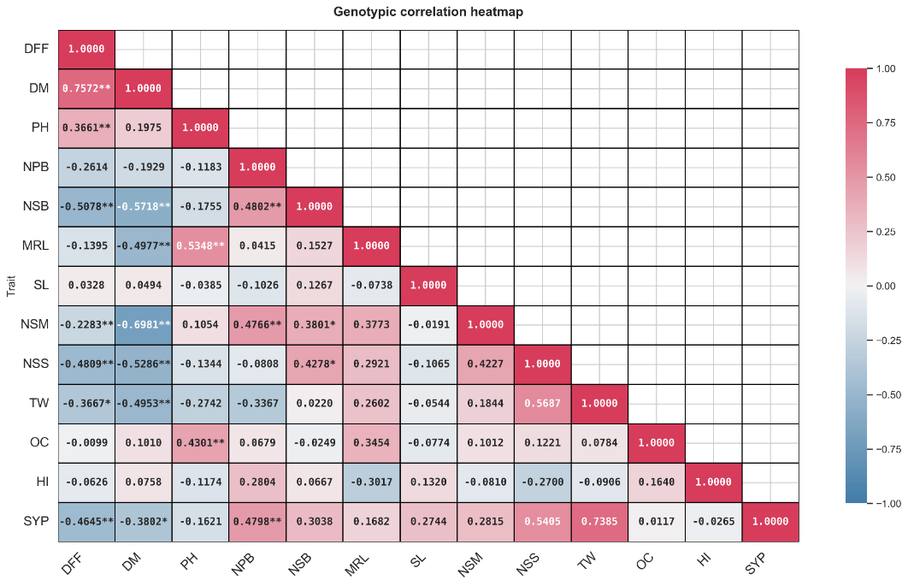
Figure 4.1. Genotypic correlation heatmap in Indian mustard
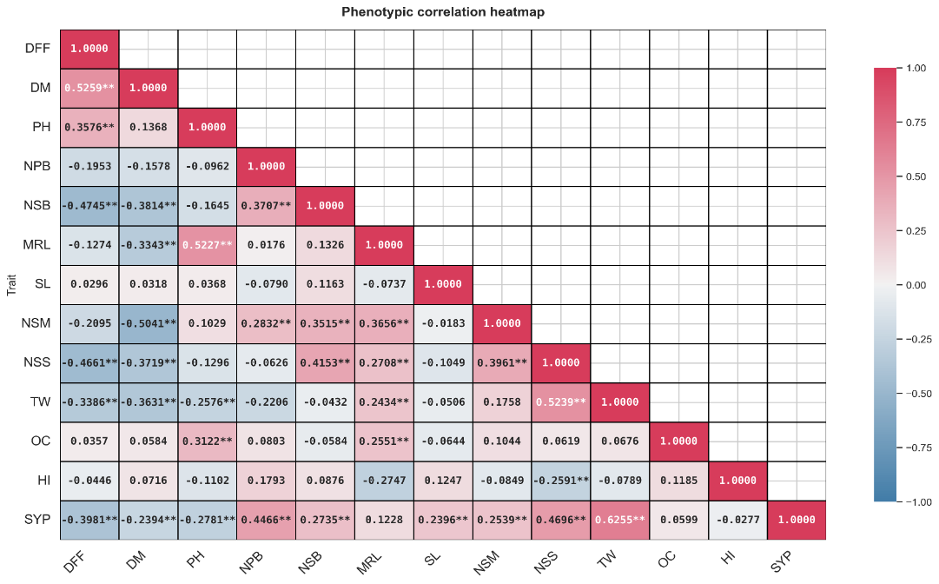

Figure 4.2. Phenotypic correlation heatmap in Indian mustard
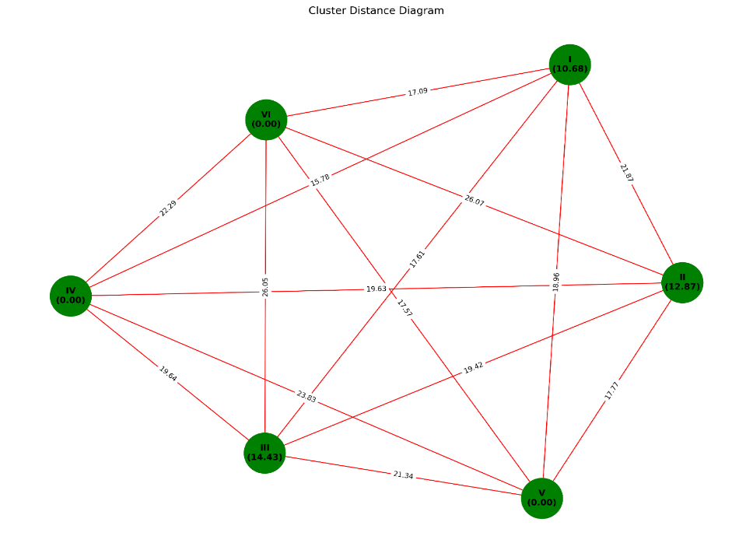
Figure 3: Cluster diagram of Indian mustard

