Original Research Article
Integrated Phytochemical Profiling, Biological Activities, and In-Silico Mechanistic Insights of Plumeria obtusa Pod Essential Oil

Abstract

Essential oils, extracted from various parts of the plant, have been studied for their potential health benefits, showcasing impressive biological properties. This study presents an integrated phytochemical, biological, and in-silico evaluation of the essential oil extracted from Plumeria obtusa pods. The essential oil was obtained by hydrodistillation and characterized using GC-MS analysis, which identified eight volatile constituents predominantly composed of oxygenated monoterpenoids, with menthol and linalool as major components. The essential oil exhibited significant antioxidant activity, as demonstrated by DPPH and hydrogen peroxide (H₂O₂) radical scavenging assays, indicating effective free radical neutralization mechanisms. The anti-inflammatory activity significantly highlighted the suppression of inflammatory responses, indicating the potential of the essential oil as a natural anti-inflammatory agent. In addition, the essential oil showed promising anticancer activity, which was mechanistically validated through molecular docking analysis by employing Parkin (PDB ID: 4I1H), and its interaction with key constituents such as (Z)-lanceol acetate (-6.1 kcal/mol) and α-copaene (-6.0 kcal/mol) that exhibited nearly same binding interactions comparable to the reference drug (-7.1 kcal/mol). PASS prediction analysis confirmed high probabilities for antioxidant, anti-inflammatory, and anticancer activities of the major compounds. Furthermore, in-silico ADMET, toxicity profiling, and BOILED-Egg analysis demonstrated favorable drug-likeness, high oral bioavailability, blood–brain barrier permeability, and low predicted toxicity for most constituents. Moreover, in-vitro study via MTT (3-(4,5-dimethylthiazol-2-yl)-2,5-diphenyltetrazolium bromide) assay in colorectal cancer cell line (HCT-116, IC₅₀ value= 278.501 µL/mL) also validates our results in correlation to antineoplastic activity present in essential oil of Plumeria obtusa pods. Thus, this study provides the first comprehensive insight into the therapeutic potential of P. obtusa pod essential oil, highlighting its promise as a multifunctional natural source for drug development against cancer.

Keywords: Plumeria obtusa, Essential oil, Antioxidant, Anti-inflammatory, Anti-cancer, ADMET, In-silico studies

- Introduction
For centuries, essential oils and plant extracts have served as vital reservoirs of bioactive molecules with multifaceted therapeutic potentials, including antioxidant, antimicrobial, anti-inflammatory, and anticancer activities. These volatile and non-volatile secondary metabolites, integrated within traditional health systems worldwide, contribute to modulation of oxidative stress and inflammation, which are fundamental drivers of chronic diseases such as cancer and inflammatory disorders. Monoterpenes are distinguished by their exceptionally high hydrocarbon levels, rendering them the most abundant component in essential oils (Sheetal et al., 2023). Essential oils are complex mixtures of primarily monoterpenes, sesquiterpenes, and other volatile compounds, which exhibit broad biological activities encompassing antioxidant, antibacterial, stimulant, antimicrobial, diuretic, nematicidal, anticancer, and antifungal activities. This highlights their remarkable versatility in therapeutic applications and their extensive study for health-promoting properties across diverse plant species (Ooyedikachi et al., 2021; Arya et al., 2023; Manojkumar et al., 2024).
Plumeria obtusa L. (Apocynaceae), commonly known as white frangipani, is an evergreen shrub or small tree with fragrant flowers, traditionally cultivated for ornamental purposes and utilized in ethnomedicine. Across traditional systems, various parts of the plant including bark, leaves, and flowers have been applied to treat skin ailments, fever, pain, and digestive disorders, reflecting its historical medicinal relevance (Bihani et al., 2021). The plant's bark is made into a plaster to treat tumors, and its latex is a versatile remedy for skin issues, as well as a natural treatment for various health concerns, including fluid retention, heart conditions, digestive issues, and high blood pressure (Goyal et al., 2012; Chopra et al., 1956; Hartwell, 1982). Recent phytochemical investigations reveal that P. obtusa harbors a diverse array of bioactive compounds, including iridoids, terpenoids, flavonoids, phenolic acids, steroids, and volatile constituents. The flower's essential oil comprises the dominant compounds that include linalool, sulfurous acid, dodecyl 2-propyl ester, alpha-terpineol, geraniol, phenylethyl alcohol, 1-(6,6-dimethylbicyclo-[3.1.0]-hex-2-en-2-yl)-ethanone, benzyl salicylate, benzyl benzoate, and germacrene. In contrast, the essential oil from the leaves contains components, with the dominant compounds being hexadecane, octadecane, tetradecane, hexacosane, eicosane, phytol, muurolol, 2,3-dihydrobenzofuran, 2-methoxy-4-vinylphenol, 1,2-Benzenedicarboxylic acid, butyl 8-methyl nonyl ester (Mamattah et al., 2023). These phytoconstituents underpin its wide pharmacological profile, which encompasses antimicrobial, antioxidant, anti-inflammatory, antiproliferative, and wound-healing effects, thereby validating many traditional uses and substantiating its therapeutic value. Plumeria obtusa leaves possess a multitude of therapeutic properties, including anti-inflammatory, antifungal, antioxidant, antimicrobial, and anticancer effects (Dogra, 2016; Bihani et al., 2021). The flowers of Plumeria obtusa have been found to exhibit a range of pharmacological properties, including antimicrobial, antioxidant, fever-reducing, pain-relieving, and liver-protecting activities (Sura et al., 2016; Islam & Aktar, 2019; Sahoo et al., 2021).
Although antioxidant properties of P. obtusa have been documented, including free-radical scavenging activity using the DPPH assay and inhibition of lipid peroxidation indicative of potential mechanisms to mitigate oxidative damage. The antioxidant capacity of leaf oil, presumed to involve flavonoids such as rutin, quercetin, and kaempferol, suggests a mechanistic basis for free radical neutralization that warrants deeper biochemical characterization (Salar et al., 2022). The anti-inflammatory potential of P. obtusa has also been reported through in-vitro and in-vivo models of lipopolysaccharide-induced inflammation, where P. obtusa extracts attenuated nitric oxide production and modulated key inflammatory mediators, including COX-2 expression (Eloutify et al., 2023).
Recent studies have investigated based on the molecular level, upregulation and downregulation of various gene expressions such as Parkin, may enhance the cancer susceptibility. Parkin (PDB: 4I1H), encoded as PARK2 gene, is widely recognized for its role in mitochondrial quality control and mitophagy (Liu et al., 2018; Kim & Ronai, 2024; Kumari et al., 2024). Research studies have established Parkin as a critical tumor suppressor involved in multiple cancer-related pathways (Kumari et al., 2023; Kim & Ronai, 2024). Parkin regulates cell cycle progression, apoptosis, DNA damage response, genomic stability, cellular metabolism, inflammation, and immune surveillance. Genetic alterations, including deletions, mutations, and epigenetic silencing of Parkin, have been frequently reported in breast, lung, colorectal, pancreatic, and liver cancers, resulting in uncontrolled proliferation, resistance to apoptosis, metabolic reprogramming, and tumor progression (Liu et al., 2018; Ding et al., 2019; Kumari et al., 2024). Studies have further demonstrated the restoration or activation of Parkin suppresses oncogenic signaling, enhances interferon-mediated antitumor immunity, inhibits NF-κB and STAT3 signaling, and promotes cytotoxic T-cell responses within the tumor microenvironment (Kim & Ronai, 2024). These findings highlight Parkin as a multifunctional tumor suppressor with both tumor-intrinsic and immune-mediated antitumor roles. Parkin has emerged as a promising molecular target for anticancer drugs, particularly in identifying small molecules capable of modulating its activity or stabilizing its functional conformation. These findings underscore P. obtusa as a promising candidate with anticancer activity, validated antioxidant mechanisms, and anti-inflammatory interactions elucidated through molecular docking interactions. However, comprehensive mechanistic studies and bioactive compound isolation remain essential to fully elucidate the therapeutic potential and safety profile of P. obtusa-derived agents (Bihani et al., 2021; Salar et al., 2025).
Importantly, this work reports for the first time the anticancer potential of P. obtusa EO, which has been previously underexplored in the literature. Although cytotoxic activity has been observed in related Plumeria such as ursolic and oleanolic acids (pentacyclic triterpenoids) in P. obtusa showing inhibitory effects on melanoma cell proliferation and in other species such as P. rubra demonstrating antiproliferative effects in colon cancer models, explicit studies detailing anticancer efficacy in P. obtusa are limited, and rigorous in-vitro validation remains necessary to support translational relevance. Previous studies provide indirect evidence of cytotoxic potential of triterpenes isolated from P. obtusa, hinting at mechanistic antiproliferative pathways that could be exploited in cancer therapeutics (Alvarado et al., 2018).
Hence, to assess our present research we have employed various methods such as; biochemical, in-vitro and in-silico, which underscore that bioactive compounds like (Z)-lanceol acetate, α-copaene, menthol and linalool found in the EO of Plumeria obtusa pods display as a promising candidate containing anticancer activity, antioxidant mechanisms, as well as anti-inflammatory properties.
2. Materials and Methods
2.1 Collection of Plant Material
Fresh green pods of Plumeria obtusa L. (genus Plumeria, family Apocynaceae) were collected from Pantnagar (29.2104° N, 78.9619° E), situated in the Tarai region of Udham Singh Nagar district, Uttarakhand, India. The collection was carried out during the month of September to ensure appropriate physiological maturity of the plant material. The harvested pods were cleaned to remove extraneous matter and shade-dried at ambient temperature to preserve heat-sensitive phytoconstituents. Botanical authentication was performed by Dr. D. S. Rawat, Taxonomist, and a voucher specimen (GBPUH-1929) was deposited in the herbarium of the Department of Biological Sciences for future reference.
2.2 Extraction of essential oil from plant
The shade-dried green pods of Plumeria obtusa were subjected to hydro-distillation using a Clevenger-type apparatus for 4h to extract the essential oil. Distillation was performed with distilled water under controlled heating conditions to facilitate efficient recovery of volatile components. The obtained essential oil was separated and dried over anhydrous sodium sulphate (Na₂SO₄) to remove any residual moisture. The dried oil was subsequently transferred into amber-colored glass vials to minimize photo-degradation and stored at 4 °C in a refrigerator until further analysis. The percentage yield of the essential oil was calculated on a dry weight basis and recorded as 0.6% (0.35 mL/100 g dry matter).
2.3 Chemical Composition Analysis of Essential oil
To check the chemical composition of the extracted essential oil GC-MS was performed with Shimadzu QP 2010 Plus using GCMS-QP 2010 Ultra DB-5 and GCMS-QP 2010 Ultra Rtx-5MS columns (30 m × 0.25 mm i.d., 0.25 µm). The following experimental conditions used helium as the carrier gas (flow rate = 1.21 mL/min, split ratio = 10.0). The oven temperature was programmed from at 50–280 °C with a temperature gradient of 3 °C/min up to 210 °C (isotherm for 2 min), then 6 °C/min up to 280 °C. Identification of essential oil components was done by comparing their relative retention index (RI) values with mass spectra NIST (NIST version 2.1) and WILEY (7th edition) libraries, and by matching the fragmentation patterns of the mass spectral data with those reported in the literature (Adams, 2007; Acree & Chickos, 2022).
2.4 Antioxidant Activity
Different in vitro tests at various concentrations were performed to evaluate concentration dependent antioxidant activity of the essential oil, and the results were presented as mean ± SD of triplicate.
2.4.1 DPPH Radical Scavenging Activity
This assay involved mixing test sample concentrations (25-100 µL/mL) with 5 mL of freshly prepared 0.004% ethanolic DPPH solution and incubating it in the dark for half an hour. Triplicate samples were prepared, and then absorbances were taken at 517 nm in a UV spectrophotometer (Thermo Fisher Scientific, Evolution-201, Waltham, MA, USA) against a blank. Ascorbic acid was used as the standard in the same concentrations as the tested essential oil (25-100 µL/mL). The % inhibition of DPPH free radical of oils and standard was calculated using the provided formula.
$$\% DPPH Radical Scavenging Activity=\left[{(A}_{0}-A_{t}\right)/A_{0}] ×100$$
Where $A_{0}$ represents the absorbance value of the control sample, and $A_{t}$ represents the absorbance value of test sample. The dose-response curve was plotted with percentage inhibition against concentration. A higher percentage of inhibition value indicates a higher radical scavenging activity. Percent inhibition was plotted against concentrations, and the equation for the line was used to obtain the IC₅₀ (half-maximal inhibitory concentration) values. Notably, a lower IC₅₀ value corresponds to a higher level of radical scavenging activity (Blois, 1958; Diniz do Nascimento et al., 2020; Karakoti et al., 2022).
2.4.2. Hydrogen Peroxide (H₂O₂) Radical Scavenging Activity
Hydrogen peroxide radical scavenging activity occurs through the donation of electrons from antioxidant molecules to hydrogen peroxide (H₂O₂), effectively neutralizing it through conversion to water (Kakar et al., 1985; Karakoti et al., 2022). This method involves combining 60 mL of 1mM FeSO₄ .7H₂O with 90 mL of a 1mM aqueous solution of 1,10-phenanthroline. The aforementioned mixture was then supplemented with 2.4 mL of 0.2 mM phosphate buffer (pH 7.8). Subsequently, 150 mL of 0.17 M hydrogen peroxide, and 1 mL of the test sample were tested at various concentrations (25-100 µL/mL). Following a 5-minute incubation period, and absorbance was taken at 560 nm against blank. Here, L-ascorbic acid (25-100 µL/mL) was taken as a positive control. The percentage scavenging of H₂O₂ was calculated by using the following formula:
$$\% H_{2}O_{2} radical scavenging activity=\left[{(A}_{0}-A_{t}\right)/A_{0}] ×100$$
Where $A_{0}$ represents the absorbance value of the control sample, and $A_{t}$ represents the absorbance value of test sample. The dose-response curve was plotted with percentage inhibition against concentration. A higher percentage of inhibition value indicates a higher H₂O₂ radical scavenging activity (Moller et al., 2021; Karakoti et al., 2022). Percent inhibition was plotted against concentrations, and the equation for the line was used to obtain the IC₅₀ (half-maximal inhibitory concentration) values.
2.5 Anti-inflammatory activity
Anti-inflammatory activity, a biological response to harmful stimuli is the capacity of a substance or treatment to alleviate inflammation. This is achieved by anti-inflammatory agents, which can be pharmaceutical or natural that inhibit specific pro-inflammatory molecules in the body (Dharmendra et al., 2019). The egg albumin method was employed to assess anti-inflammatory activity. To 2 mL of test sample at concentrations ranging from (25-100 µL/mL), a mixture of 2.8 mL of 0.002 M phosphate buffer and 0.2 mL of egg albumin was added. The reaction mixture was subjected to a two-step temperature treatment, involving incubation at 37°C for 15 minutes, followed by a 5-minute heat treatment at 70°C, and subsequent cooling to room temperature. Absorbance readings were taken at 660 nm, using a reagent blank as the control and Diclofenac sodium as the reference standard. Subsequent calculations of percentage inhibition were performed using the provided equation:
$$\% Inhibition=\left[{(A}_{0}-A_{t}\right)/A_{0}] ×100$$
Where $A_{0}$ represents the absorbance value of the control sample, and $A_{t}$ represents the absorbance value of test sample. The dose-response curve was plotted with percentage inhibition against concentration. Percent inhibition was plotted against concentrations, and the equation for the line was used to obtain the IC₅₀ (half-maximal inhibitory concentration) values. A lower IC₅₀ value corresponds to a more potent anti-inflammatory response.
2.6 Anticancer activity
HEK-293 (normal human embryonic kidney) and HCT-116 (human colorectal carcinoma) cells cell lines were obtained from the National Centre for Cell Science (NCCS), Pune, India. The cells were cultured under standard conditions in Dulbecco’s Modified Eagle Medium (DMEM) supplemented with 10% fetal bovine serum (FBS) and 1× Pen-Strep antibiotic solution to support optimal growth and prevent microbial contamination. Cultures were maintained at 37 °C in a humidified atmosphere containing 5% CO₂, providing physiological conditions conducive to cell viability and proliferation. For cytotoxicity assessment, the cell lines were seeded at a density of 5,000 cells per well in 96-well microtiter plates containing 100 μL of complete DMEM per well. After overnight incubation to allow cell adherence, the cells were washed with phosphate-buffered saline (PBS) and treated with varying concentrations (0-200 µL/mL) of essential oil extracted from Plumeria obtusa pods for 48 hours at 37 °C. Following treatment, the culture medium was aspirated, and cell viability was evaluated using the MTT assay. Briefly, 20 μL of MTT solution (5 mg/mL) was added to each well and incubated to permit the formation of formazan crystals by metabolically active cells. The resulting formazan was solubilized by adding 200 μL of dimethyl sulfoxide (DMSO) per well, and absorbance was measured at 570 nm using a Bio-Rad spectrophotometer after a 10-minute incubation (Riley et al., 2013; Verdeguer et al., 2020; Dos Santos et al., 2022).
All experiments were performed in triplicate to ensure reproducibility. Relative cell viability (%) was calculated by comparing the absorbance of treated wells to that of untreated controls, thus quantifying the cytotoxic and anti-proliferative effects of Plumeria obtusa pod essential oil on HEK-293 cell lines.
2.7 In-silico Studies
2.7.1 Molecular Docking Calculations
Molecular docking was performed to predict and rationalize the probable molecular mechanisms underlying the anticancer activity of the major phytoconstituents identified in the essential oil of Plumeria obtusa pods. Three-dimensional (3D) crystal structures of the target proteins were retrieved from the RCSB Protein Data Bank (PDB) (Dallakyan & Olson, 2015). Molecular docking was performed against the human E3 ubiquitin ligase Parkin (PDB ID: 4I1H). Parkin was selected as a molecular target based on its established role as a tumor suppressor frequently dysregulated in multiple cancers and its involvement in regulating apoptosis, cell cycle control, mitochondrial homeostasis, and antitumor immune responses (Liu et al., 2018; Kim & Ronai, 2024; Kumari et al., 2024). The target protein was pre-processed using BIOVIA Discovery Studio 2022 to remove water molecules, heteroatoms, cofactors, ligands, and non-essential chains, resulting in a refined structure containing only the protein backbone with polar hydrogen atoms (Hernandez et al., 2024). The phytochemicals selected for docking were based on their higher relative abundance in the essential oil composition of Plumeria obtusa pods, as identified by GC-MS analysis. The ligands included 2,2-dimethyltetrahydrofuran (CID:136791), 2-ethylbutanal (CID:7359), 3-hexen-2-one (CID:5367744), linalool (CID:6549), menthol (CID:1254), α-copaene (CID:70678558), 3,7-dimethylnonane (CID:28458), and (Z)-lanceol acetate (CID:91748704).
Molecular docking analyses were performed using PyRx 0.8 to assess the binding affinities and interaction profiles of selected bioactive compounds (Dallakyan & Olson, 2015; Rani et al., 2024). The two-dimensional (2D) structures of all selected ligands were retrieved from the PubChem database (https://pubchem.ncbi.nlm.nih.gov) accessed on 15 December 2025 in SDF format. In PyRx, the prepared protein structure was imported as the macromolecule, while the ligands were treated as flexible molecules with defined rotatable bonds. A three-dimensional grid box encompassing the entire protein surface along the X, Y, and Z axes was generated to define the docking search space. Docking was executed using the Vina Wizard module, with exhaustiveness parameters set to ensure reliable sampling of ligand conformations. For each ligand-protein complex, multiple docking poses were generated, and the best-ranked conformations were selected based on the lowest binding energy values (kcal/mol). The top scoring docked complexes were further visualized and analyzed using BIOVIA Discovery Studio-2021 Client to elucidate key intermolecular interactions, including hydrogen bonding, hydrophobic interactions, π–π stacking, van der Waals forces, and alkyl interactions. Strong binding affinities and stable ligand-protein interactions indicate the potential of selected phytochemicals to interfere with cancer-related molecular targets, thereby supporting their role in growth inhibition and cytotoxic activity (Rani et al., 2023; Rani et al., 2024). Thus, to substantiate experimental observations and to elucidate the probable molecular mechanisms governing the anticancer potential of P. obtusa pod essential oil constituents, molecular docking was performed.
2.7.2 In-Silico ADMET Study
The pharmacokinetic and toxicological evaluation of bioactive compounds derived from the essential oil of P. obtusa pods represents a critical step in assessing their suitability as potential drug candidates. The ADMET (Absorption, Distribution, Metabolism, Excretion, and Toxicity) properties of selected phytochemicals were systematically evaluated using established web-based computational platforms to predict their pharmacological feasibility and safety profiles (Arya et al., 2023).
The chemical structures of the selected compounds were initially drawn using ChemDraw Ultra 8.0, and subsequently converted into SMILES format for computational analysis. The drug-likeness, physicochemical properties, and pharmacokinetic parameters, including gastrointestinal absorption, blood-brain barrier permeability, lipophilicity, solubility, and compliance with Lipinski’s rule of five were predicted using the SwissADME online server (http://www.swissadme.ch/, accessed on 15 December 2025) following the recommended protocol. The SwissADME predictions provided insights into the oral bioavailability and overall drug-likeness of the selected compounds. In parallel, the ProTox-II web server (http://tox.charite.de/protox_II, was accessed on 15 December 2025) was utilized to evaluate the toxicity profiles of the selected phytochemicals. It calculates the prediction-based toxicity endpoints based on molecular similarity, fragment-based analysis, and machine-learning models (James et al., 2023; Manojkumar et al., 2024). Parameters assessed included acute oral toxicity (LD₅₀ values), toxicity class, hepatotoxicity, cytotoxicity, mutagenicity, carcinogenicity, and immunotoxicity, thereby providing a comprehensive toxicological risk assessment.
2.7.3. In-Silico Pass Prediction Study (PASS)
For the prediction of activity spectra for substances (PASS), the major compounds from essential oils were selected based on their percentage content. The SMILES format of the phytoconstituents was used to predict and simulate to PASS online web app, which estimates the probable activity (P_{a}) and probable inactivity (P_{i}) of any compound, and it is applied to “drug-like” substances (Diniz et al., 2020). Compounds with P_{a}>P_{i} are the only constituents measured for possessing a particular biological activity (Arya et al., 2023).
2.8 Statistical Analysis
All the trials were conducted in triplicates and the data were statistically analyzed using RStudio software (Version 2021.09.2, developed by RStudio Team, PBC, Boston) as mean ± standard deviation (SD), calculated from independent experiments. Statistical significance among the groups was determined based on p-value analysis (Two-Way ANOVA), and a p value < 0.05 was considered to indicate a statistically significant difference. IC₅₀ (half-maximal inhibitory concentration) values were obtained through plot of percent inhibition against concentrations, and the equation for the line using GraphPad Prism 10 software (Version 10.2.0, Boston, MA, USA).
3. Results and Discussion
3.1 Chemical Composition
GC-MS analysis of the essential oil obtained from Plumeria obtusa pods led to the identification of 8 chemical constituents, accounting for the complete volatile profile of the oil (Table 1). The identified compounds belonged to diverse chemical classes, including monoterpenoids, aliphatic aldehydes, aliphatic ketones, sesquiterpenes, hydrocarbons, heterocyclic ethers, and sesquiterpene esters, highlighting the compositional complexity of the oil (Bihani et al., 2021). The oil was predominantly rich in oxygenated monoterpenoids, with menthol (22.47%) and linalool (18.37%) together accounting for 40.84% of the total composition. These compounds are well recognized for their antioxidant and anti-inflammatory potential. 3-Hexen-2-one (15.19%), an aliphatic ketone, and 2-ethylbutanal (14.04%), an aliphatic aldehyde, were present in substantial amounts, indicating a significant contribution of oxygenated low-molecular-weight compounds. 2,2-Dimethyltetrahydrofuran (10.16%), classified as a heterocyclic ether, and α-copaene (10.52%), a sesquiterpene, were detected in moderate proportions. Minor constituents included 3,7-dimethylnonane (5.58%), a hydrocarbon, and (Z)-lanceol acetate (3.67%), a sesquiterpene ester. Overall, monoterpenoids constituted the dominant class (40.84%), followed by aliphatic ketones (15.19%), aliphatic aldehydes (14.04%), heterocyclic ethers (10.16%), sesquiterpenes (10.52%), hydrocarbons (5.58%), and sesquiterpene esters (3.67%). The predominance of oxygenated terpenoids suggests a strong contribution to the observed biological activities of P. obtusa pod essential oil.
Table 1 : Chemical composition of Essential Oil of P. obtusa pods
S.No. | PubChem CID | Compound Name | Molecular Formula | R.I. | % Composition | Chemical Class
1 | 136791 | 2,2-Dimethyltetrahydrofuran | C₆H₁₂O | 868 | 10.16 | Heterocyclic Ether
2 | 7359 | 2-Ethylbutanal | C₆H₁₂O | 806 | 14.04 | Aliphatic aldehyde
3 | 5367744 | 3-Hexen-2-one | C₆H₁₀O | 873 | 15.19 | Aliphatic ketone
4 | 6549 | Linalool | C₁₀H₁₈O | 1101 | 18.37 | Monoterpenoid
5 | 1254 | Menthol | C₁₀H₂₀O | 1184 | 22.47 | Monoterpenoid
6 | 70678558 | α-copaene | C₁₅H₂₄ | 1375 | 10.52 | Sesquiterpene
7 | 28458 | 3,7-Dimethylnonane | C₁₁H₂₄ | 986 | 5.58 | Hydrocarbon
8 | 91748704 | (Z)-Lanceol acetate | C₁₇H₂₆O₂ | 1856 | 3.67 | Sesquiterpene ester

(1) 2,2-Dimethyltetrahydrofuran | (2) 2-Ethylbutanal
(3) 3-Hexen-2-one | (4) Linalool
(5) Menthol | (6) α-copaene
(7) 3,7-Dimethylnonane | (8) (Z)-Lanceol acetate

Figure 1: Structures of phytoconstituents identified in Essential oil of P. obtusa pods
3.2 Antioxidant Activity
The essential oil obtained from the pods of P. obtusa demonstrated significant antioxidant potential, evidenced by its concentration-dependent scavenging ability in both DPPH and H₂O₂ assays. The oil showed strong, dose-dependent radical neutralization comparable to standard antioxidants (BHT and Ascorbic acid). The dose-dependent increase in antioxidant activity observed in both assays reflects the cumulative and synergistic effects of the identified constituents. The biological response observed indicates that the antioxidant capacity is due to the synergistic effect of its major and minor phytoconstituents. The synergistic interactions among monoterpenes within essential oils are well established and can substantially amplify their biological activities, often surpassing the effects exerted by the individual constituents alone (Bakkali et al., 2008).
3.2.1. DPPH Radical Scavenging Activity
The essential oil of P. obtusa pods demonstrated strong, dose-dependent DPPH radical scavenging activity. As shown in Table 2, the essential oil exhibited a progressive increase in antioxidant activity across concentrations, relative to the taken BHT standards. The inhibition increased from 35.7% at 25 μL/mL to 89.5% at 100 μL/mL, approaching the activity of the standard BHT (99.2% at 100 μL/mL). The oil exhibited an IC₅₀ of 43.41 μL/mL, indicating considerable radical quenching potency.
Table 2 : Percent DPPH Radical Scavenging Antioxidant activity of Essential Oil of P. obtusa Pods
Concentration | DPPH
Concentration | % Inhibition | BHT (Standard)
25 (µL/mL) | 35.7±0.08 | 44.0±0.14
50 (µL/mL) | 51.4±0.07 | 63.2±0.21
75 (µL/mL) | 82.1±0.11 | 86.7±0.08
100 (µL/mL) | 89.5±0.16 | 99.2±0.27
IC₅₀ Value | 43.41±0.12 | 33.05±0.17
The phytochemical constituents revealed the dominance of oxygenated monoterpenoids particularly menthol (22.47%) and linalool (18.37%), both of which contain hydroxyl groups capable of donating labile hydrogen atoms. Linalool in particular, is known to undergo facile HAT, forming resonance-stabilized radical intermediates that favor the neutralization of free radicals (Ruberto & Baratta, 2000). Menthol has been reported to act as a moderate antioxidant in addition to unsaturated constituents such as 3-hexen-2-one and α-copaene when interacting with DPPH, thereby contributing to overall scavenging potential (Ruberto & Baratta, 2000; Dogra, 2016). The DPPH radical, being a stable nitrogen-centered radical, is reduced either by Hydrogen Atom Transfer (HAT) or Single Electron Transfer followed by Proton Transfer (SET-PT) mechanisms, despite lacking aromatic stabilization. HAT involves the homolytic cleavage of O-H bond, resulting in the separation of a hydrogen atom and radical species (A-O.) (Equation 1), whereas SET-PT mechanism involves the loss of an electron, which leads to the formation of the radical cation (A-OH^{+.}), then loses a proton in second step (Equations 2 and 3) (Gülçin and Alwasel, 2023).
A-OH → A-O. + H. (1)
A-OH → A-OH^{+.} + e⁻ (2)
A-OH^{+.} → A-O. + H⁺ (3)

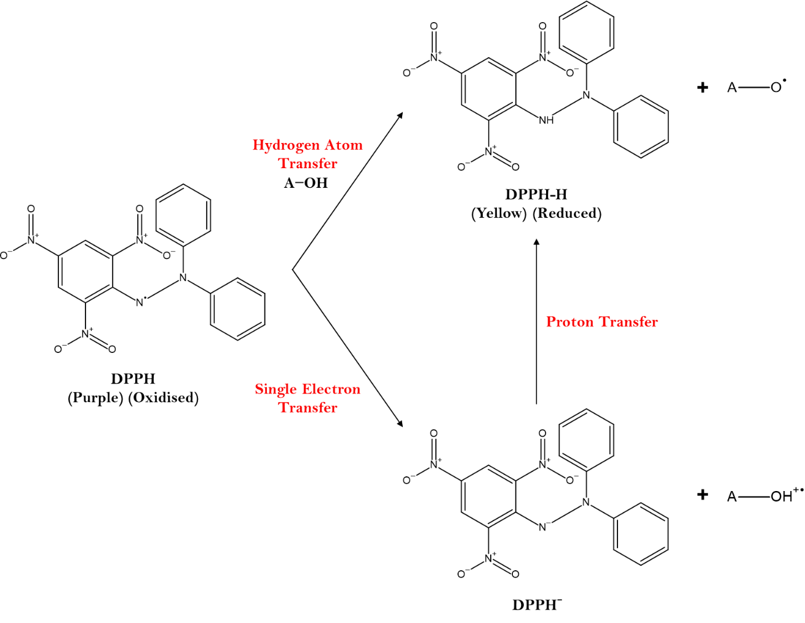
Figure 2: Diagrammatic view of HAT, SET and SET-PT mechanisms depicting reduction of DPPH radical exhibiting antioxidant activity
Additionally, unsaturated constituents participate in radical-adduct formation (RAF) with DPPH, thereby contributing an increase in scavenging potential (Ruberto & Baratta, 2000). Although hydrocarbons and simple ethers show weak intrinsic antioxidant activity, their presence at low levels does not diminish the strong influence of the dominant oxygenated compounds. Thus, the significant DPPH activity can be attributed mainly to HAT and SET-PT mechanisms from linalool and menthol, while unsaturated sesquiterpenes may contribute via RAF (Gülçin & Alwasel, 2023).
3.2.2. Hydrogen Peroxide (H₂O₂) Radical Scavenging Activity
The essential oil also displayed pronounced hydrogen peroxide (H₂O₂) radical scavenging ability, producing 93.2% inhibition at 100 μL/mL, with an IC₅₀ of 39.49 μL/mL. Table 3 represents the dose-dependent radical scavenging activity of the essential oil.
Table 3 : Percent Hydrogen peroxide (H₂O₂) Radical Scavenging activity of Essential Oil of P. obtusa Pods
Concentration | H₂O₂
Concentration | % Inhibition | Ascorbic Acid (Standard)
25 (µL/mL) | 40.8±0.16 | 48.7±0.12
50 (µL/mL) | 53.4±0.09 | 72.3±0.43
75 (µL/mL) | 80.4±0.71 | 87.2±0.81
100 (µL/mL) | 93.2±0.18 | 98.6±0.13
IC₅₀ Value | 39.49±0.31 | 23.02±0.28

These results indicate that the oil can effectively participate in detoxification of H₂O₂, an important reactive oxygen species involved in oxidative stress. Although H₂O₂ itself is relatively weakly reactive, its decomposition in the presence of transition metals results in the formation of the highly reactive hydroxyl radical (•OH) via the Fenton reaction. Therefore, the scavenging of H₂O₂ indirectly prevents the propagation of oxidative chain reactions (Gülçin & Alwasel, 2023).
Unlike phenolic antioxidants, monoterpenes do not typically act as strong electron donors; however, oxygenated monoterpenoids such as menthol and linalool can undergo electron transfer to reduce H₂O₂ or interact directly with reactive intermediates formed during its decomposition. The high proportion of these components in the oil likely underlies the observed activity. Similar mechanisms have been proposed for other terpene-rich essential oils, suggesting that even non-phenolic volatile components can effectively quench H₂O₂ through SET-mediated reduction or radical interception pathways (Bakkali et al., 2008).
Moreover, unsaturated sesquiterpenes such as α-copaene may react with hydroxyl radicals generated from H₂O₂, thus reinforcing the oil’s ability to inhibit oxidative cascades. While the essential oil lacks strong metal-chelation capacity usually mediated by phenolic hydroxyl groups the observed inhibition suggests that the oil primarily acts through ROS interception, rather than metal-binding mechanisms (Gülçin & Alwasel, 2023; Mawumenyo et al., 2023).
3.3 Anti-inflammatory activity
The essential oil of P. obtusa pods exhibited a clear, concentration-dependent anti-inflammatory effect, with inhibition increasing from 31.9% at 25 μL/mL to 84.7% at 100 μL/mL, approaching the activity of diclofenac sodium (88.3% at 100 μL/mL). The calculated IC₅₀ value (49.38 μL/mL) demonstrates substantial anti-inflammatory potency and is consistent with the biological potential of terpene-rich essential oils (Manisha et al., 2024). This biological response is strongly supported by the oil’s GC-MS profile, which revealed a high proportion of oxygenated monoterpenoids particularly menthol (22.47%) and linalool (18.37%) alongside α-copaene (10.52%) and 3-hexen-2-one (15.19%).
Table 4 : Anti-inflammatory activity of Essential Oil of P. obtusa Pods
Concentration | Anti-inflammatory activity of Plumeria obtusa pods essential oil
Concentration | % Inhibition | Diclofenac sodium (Standard)
25 (µL/mL) | 31.9±0.07 | 37.5±0.14
50 (µL/mL) | 48.2±0.12 | 61.7±0.08
75 (µL/mL) | 73.8±0.19 | 79.2±0.06
100 (µL/mL) | 84.7±0.35 | 88.3±0.27
IC₅₀ Value | 49.38±0.22 | 37.96±0.15
Monoterpenoids such as menthol and linalool are well recognized for their ability to modulate inflammatory responses, largely by influencing cyclooxygenase activity (COX-1 and COX-2) and reducing the synthesis of prostaglandin E₂ (PGE₂), a key mediator of inflammation (Peana et al., 2002). Linalool has also been shown to downregulate major inflammatory signaling pathways, including NF-κB and MAPK, thereby lowering the expression of inducible enzymes such as COX-2 (Peana et al., 2002; Xiao et al., 2024). The presence of hydroxyl groups in these monoterpenes enables them to interact with the COX active site through hydrogen bonding and hydrophobic interactions, which help explain the strong inhibitory activity observed for the essential oil in comparison with diclofenac. Additionally, the antioxidant properties of the oil particularly its ability to scavenge DPPH and H₂O₂ likely enhance its anti-inflammatory effect, as reactive oxygen species are known to activate COX-2 and other inflammatory pathways (Xiao et al., 2024). This indicates the anti-inflammatory activity of P. obtusa pod essential oil arises from the combined actions of oxygenated monoterpenoids and unsaturated sesquiterpenes, which jointly modulate COX enzymes, reduce oxidative stimuli, and help stabilize protein structures involved in inflammation.
3.4 Anticancer Activity
The selective antiproliferative potential of P. obtusa pod EO was assessed using HEK-293 (normal human embryonic kidney) cells and HCT-116 (human colorectal carcinoma) cells. To assessed the biocompatibility of P. obusta in HEK-293 normal cells and has observed that the P. obusta is non-toxic to HEK-293 normal cells till 300 µ μL/mL by the determination of IC₅₀ (inhibitory concentration at 50%) which is also found to be in different plant studies such as in liver cancer (Alla et al., 2024) was 467.99 μL/mL respectively (Figure 3(A)). The biocompatibility of P. obusta has been found in HEK-293 normal cells which further resulted in the exploration of the anti-proliferation activity of P. obusta against HCT-116 cells. Therefore, we have determined the anti-proliferation feature of P. obusta in CRC cells. Conversely, treatment of HCT-116 cells resulted in a pronounced dose-dependent reduction in cell viability, with an IC₅₀ value of approximately 278.501 µL/mL (48 hrs) and a strong concentration-response relationship (R² = 0.9704). Importantly, concentrations that preserved substantial viability in HEK-293 cells produced significantly higher growth inhibition in HCT-116 cells, demonstrating selective antiproliferative activity toward cancer cells rather than generalized cytotoxicity.

Figure 3 (A): Plot (% cytotoxicity versus different doses of essential oil) of IC₅₀ value for essential oil of P. obusta pods calculated through the graph equation (y=0.098x + 3.778, R²=0.8702).

Figure 3 (B). Plot (% cytotoxicity versus different doses of essential oil) of IC₅₀ value for essential oil of P. obusta pods in HCT116 cancer cells calculated through the graph equation (y=0.1626x-4.7157, R²=0.9704)
This selective response can be mechanistically correlated with the phytochemical composition of the essential oil. GC-MS analysis revealed a high proportion of oxygenated monoterpenoids, particularly menthol (22.47%) and linalool (18.37%), together accounting for ~40.8% of the total oil composition, along with sesquiterpenes such as α-copaene (10.52%) and (Z)-lanceol acetate (3.67%). These compounds are widely reported (Chen et al., 2022; Li et al., 2025; Teng et al., 2025) to exert selective antiproliferative effects through mitochondrial dysfunction, oxidative stress modulation, cell cycle arrest, and apoptosis induction, pathways to which colorectal cancer cells such as HCT-116 are particularly susceptible due to altered redox balance and metabolic alterations (Ding et al., 2019).
Moreover, molecular docking against E3 ubiquitin ligase Parkin (PDB ID: 4I1H), a well-established tumor suppressor involved in cell cycle regulation, mitochondrial quality control, and apoptosis revealed stable binding interactions of key phytochemicals with functionally relevant residues (Ding et al., 2019). Role of Parkin dysregulation in colorectal and other cancers, these interactions provide mechanistic plausibility for the selective antiproliferative effects observed in HCT-116 cells (Rani et al., 2025). The combination of selective in-vitro cancer cell inhibition, confirmed biocompatibility toward normal cells, quantitative phytochemical dominance of anticancer-relevant compounds which supports the anticancer potential of P. obtusa pod EO and justifies its further evaluation in advanced cancer mechanism.
3.5 Molecular Docking Analysis
Molecular docking calculations were performed to investigate the binding affinity and interaction profiles of the major phytochemicals identified in P. obtusa pod essential oil against E3 ubiquitin ligase Parkin (PDB ID: 4I1H), a key molecular target associated with anticancer activity. The docking results revealed distinct interaction patterns with functionally relevant amino acid residues within the active site of the protein (Figure 4 & Table 5). Among the evaluated compounds, (Z)-lanceol acetate demonstrated the strongest binding affinity with a binding energy of -6.1 kcal/mol, forming stable interactions with key residues including TRP447, TYR143, LYS412, LYS427, and ARG234, mediated through π–alkyl, alkyl, and van der Waals interactions (James et al., 2023b; Manojkumar et al., 2024). Similarly, α-copaene exhibited a high binding affinity of -6.0 kcal/mol, interacting with residues such as SER233, TRP447, TYR143, LYS412, and ARG234, suggesting strong hydrophobic stabilization within the binding pocket. These phytoconstituents exhibit moderately good binding energies (-6.1 and -6.0 kcal/mol) for (Z)-lanceol acetate and α-copaene compared to the reference compound 5-fluorouracil (-7.1 kcal/mol), suggesting potential modulatory interactions. Menthol showed moderate binding with a binding energy of -5.0 kcal/mol, forming hydrogen bond interactions with GLN252 and hydrophobic contacts with ALA230, TRP183, VAL465, and VAL250, indicating stable ligand accommodation. Linalool also displayed moderate binding affinity (-4.7 kcal/mol), interacting with multiple residues including HIS227, ARG256, LEU228, TRP183, VAL465, and VAL250, highlighting its potential to engage key regions of the Parkin protein. Moderate binding affinities were observed for 3,7-dimethylnonane (-4.5 kcal/mol) and 3-hexen-2-one (-4.1 kcal/mol), which interacted primarily through hydrophobic and van der Waals interactions involving residues such as LEU228, TRP183, HIS227, VAL465, VAL250, and GLN252. In contrast, 2,2-dimethyltetrahydrofuran and 2-ethylbutanal exhibited comparatively poor binding affinities (-3.9 kcal/mol each), though they still engaged important residues including TRP183, ASP184, HIS227, LEU228, VAL250, and GLN252, suggesting weaker but notable interactions. The reference compound 5-fluorouracil exhibited a binding energy of -7.1 kcal/mol, confirming its strong interaction with the Parkin protein and serving as a benchmark for comparison. The docking results suggest that selected constituents of Plumeria obtusa pod essential oil can interact effectively with the active or functionally relevant regions of E3 ubiquitin ligase Parkin, providing a molecular basis for their predicted anticancer potential and supporting their further exploration as natural modulators of ubiquitin-mediated signaling pathways (Manojkumar et al., 2024).

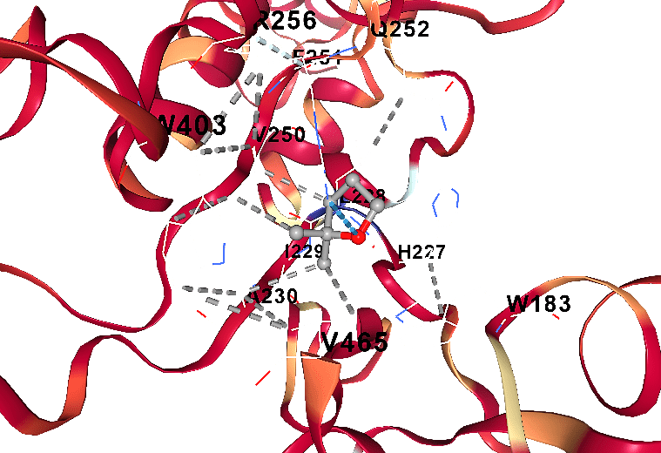 | 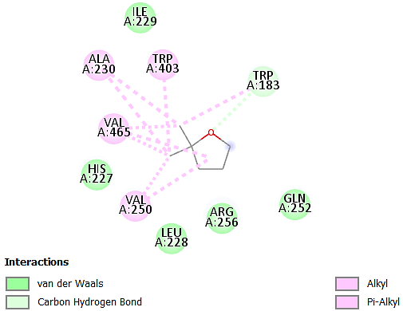
- 3D and 2D Protein-Ligand Interaction of 4I1H-2, 2-Dimethyltetrahydrofuran
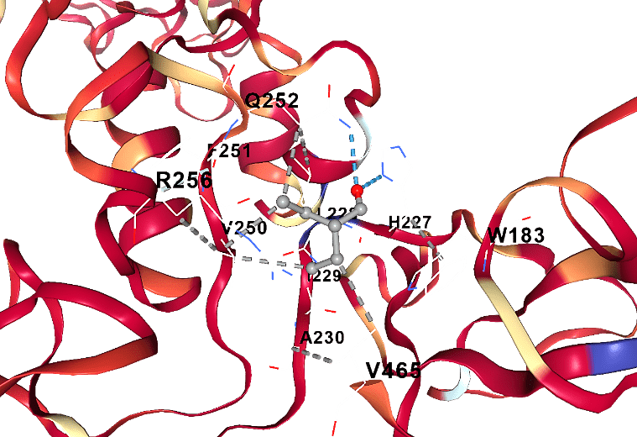 | 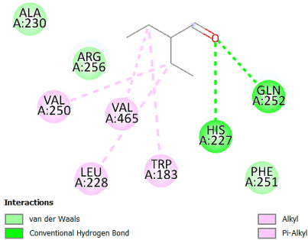
(B) 3D and 2D Protein-Ligand Interaction of 4I1H-2-Ethylbutanal
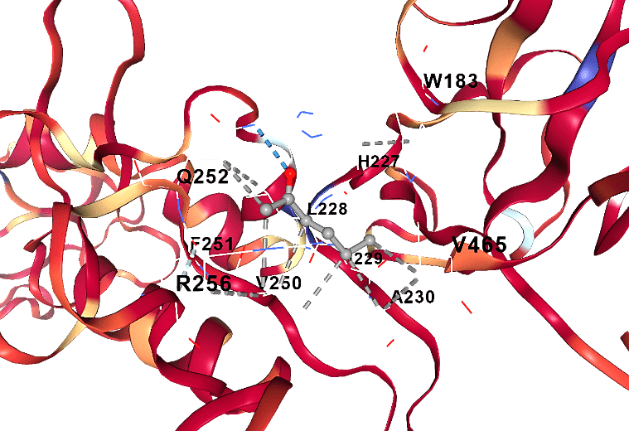 | 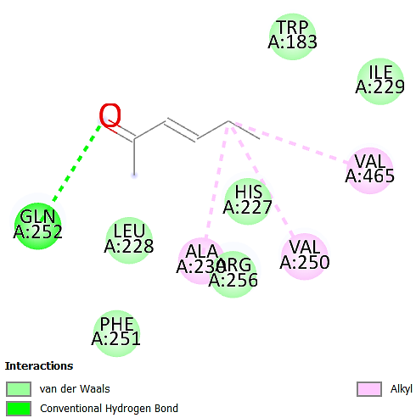
(C) 3D and 2D Protein-Ligand Interaction of 4I1H-3-Hexen-2-one
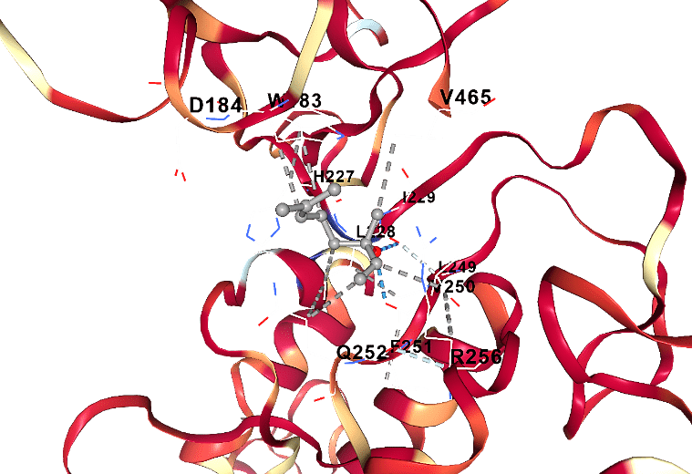 | 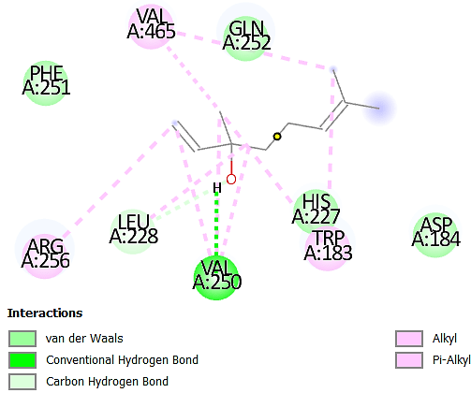
(D) 3D and 2D Protein-Ligand Interaction of 4I1H-Linalool
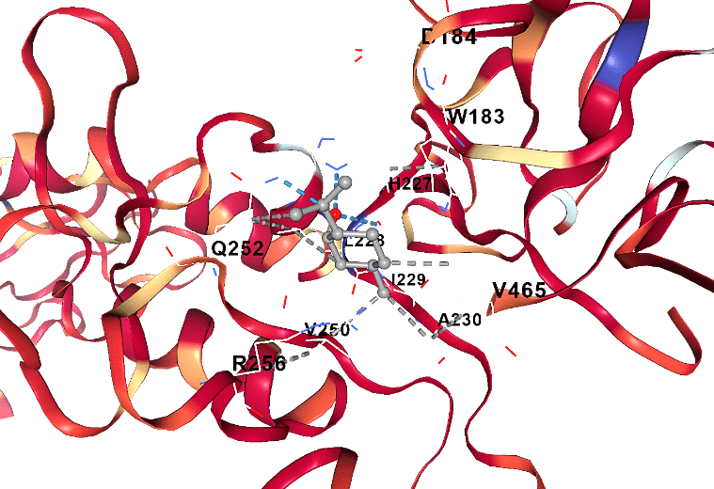 | 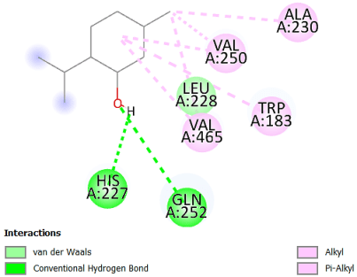
(E) 3D and 2D Protein-Ligand Interaction of 4I1H-Menthol
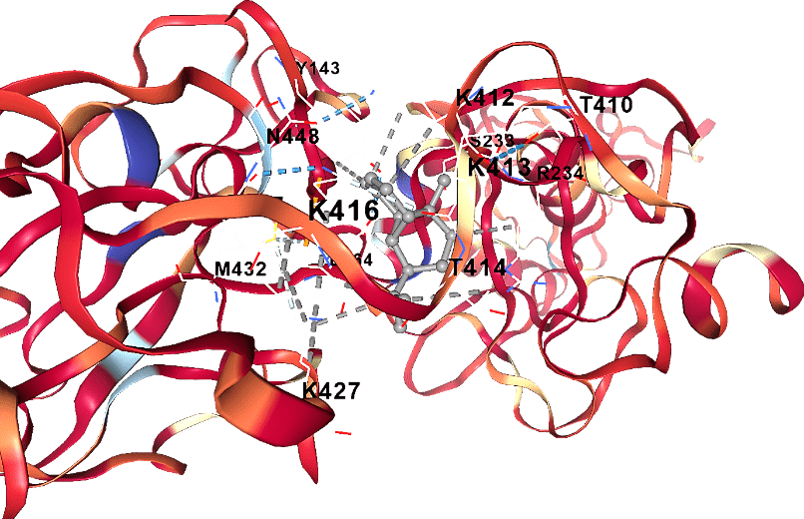 | 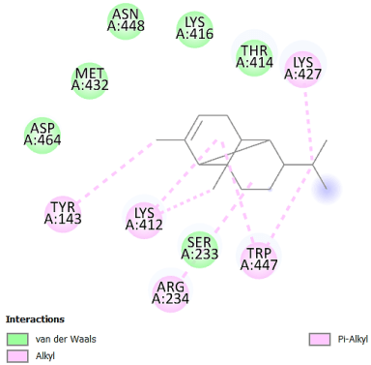
(F) 3D and 2D Protein-Ligand Interaction of 4I1H-α-copaene
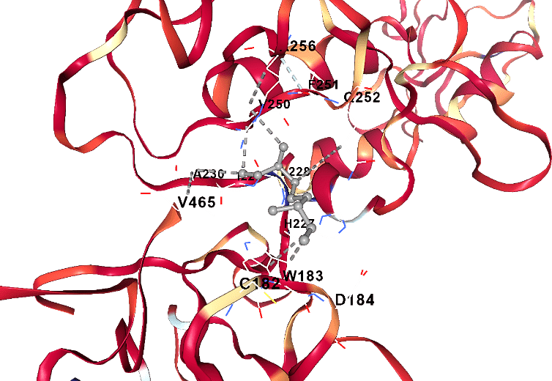 | 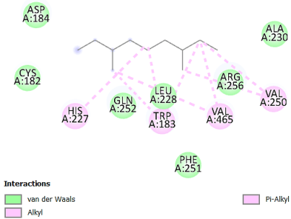
(G) 3D and 2D Protein-Ligand Interaction of 4I1H-3,7-dimethylnonane
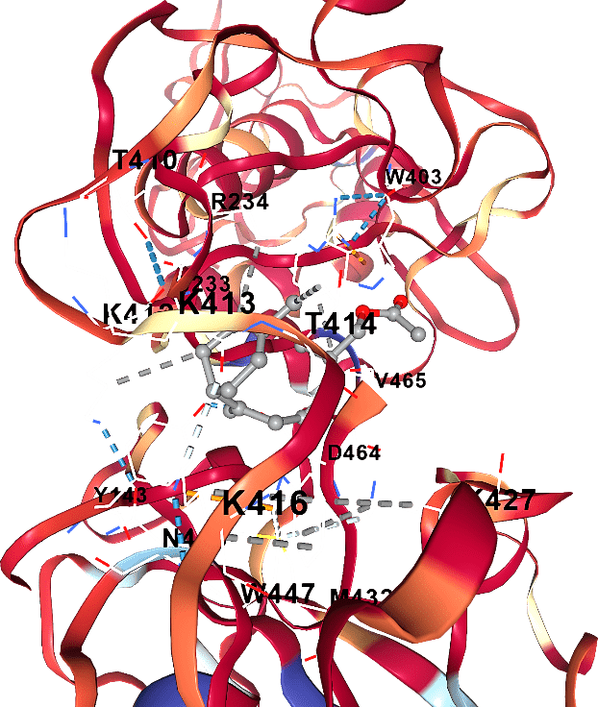 | 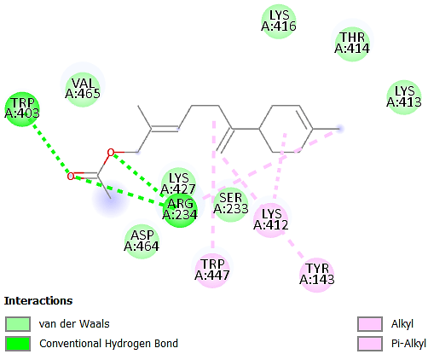
(H) 3D and 2D Protein-Ligand Interaction of 4I1H-(Z)-Lanceol acetate
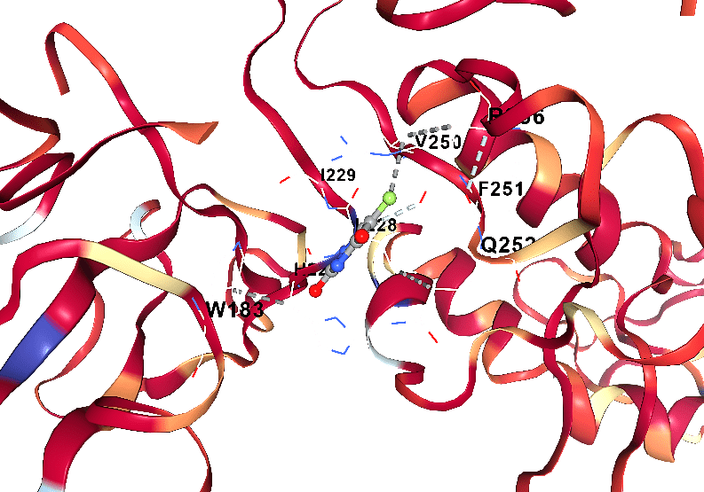 | 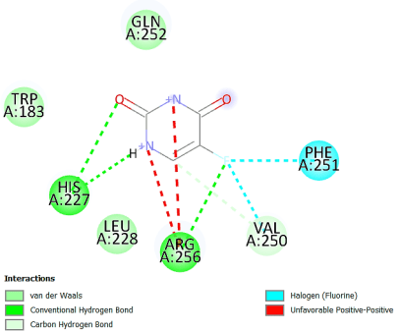
(I) 3D and 2D Protein-Ligand Interaction of 4I1H-5- fluorouracil
Figure 4: Receptor- Ligand Interaction diagrams of docked compounds at active site of selected protein (PDB ID:4I1H)

Activity | Compound Name | Binding Energy (kcal/mol) | Amino acid residues | Interactions
 |  |  |  | Van der Waals | Pi-alkyl | Alkyl | H-Bond
E3 Ubiquitin ligase Inhibition of Parkin (Anticancer) | 2,2-Dimethyltetrahydrofuran | -3.9 | CYS182 TRP183 ASP184 HIS227 LEU228 ILE229 ALA230 VAL250 PHE251 GLN252 ARG256 TRP403 | TRP183 | TRP403 ALA230 | VAL465 VAL250 | HIS227
E3 Ubiquitin ligase Inhibition of Parkin (Anticancer) | 2-Ethylbutanal | -3.9 | CYS182 TRP183 ASP184 HIS227 LEU228 ILE229 ALA230 VAL250 PHE251 GLN252 ARG256 VAL465 | PHE 251 | LEU 228 TRP183 | VAL250 VAL465 | GLN252 HIS227
E3 Ubiquitin ligase Inhibition of Parkin (Anticancer) | 3-Hexen-2-one | -4.1 | TRP183 ASP184 HIS227 LEU228 ILE229 ALA230 VAL250 PHE251 GLN252 CYS253 ARG256 | HIS227 | - | ALA230 VAL250 VAL465 | GLN252
E3 Ubiquitin ligase Inhibition of Parkin (Anticancer) | Linalool | -4.7 | CYS182 TRP183 ASP184 LEU187 HIS227 LEU228 ILE229 ALA230 LEU249 VAL250 PHE251 GLN252 CYS253 ARG256 TRP403 | HIS227 | ARG256 LEU228 | VAL465 TRP183 | VAL250 LEU228
E3 Ubiquitin ligase Inhibition of Parkin (Anticancer) | Menthol | -5.0 | SER181 CYS182 TRP183 ASP184 HIS227 LEU228 ILE229 ALA230 VAL250 PHE251 GLN252 CYS253 | HIS227 LEU228 | ALA230 TRP183 | VAL465 VAL250 | GLN252
E3 Ubiquitin ligase Inhibition of Parkin (Anticancer) | α-copaene | -6.0 | TYR143 SER233 ARG234 ASN235 ILE236 THR237 VAL244 GLU399 GLN400 ARG402 ALA405 ALA406 | SER233 | TRP447 TRP143 | LYS427 LYS412 ARG234 | -
E3 Ubiquitin ligase Inhibition of Parkin (Anticancer) | 3,7-Dimethylnonane | -4.5 | CYS182 TRP183 ASP184 VAL186 LEU187 PHE208 PHE209 PHE210 THR222 SER223 VAL224 ALA225 | ARG256 LEU228 GLN252 | HIS227 TRP183 | VAL465 VAL250 | -
E3 Ubiquitin ligase Inhibition of Parkin (Anticancer) | (Z)-Lanceol acetate | -6.1 | GLU409 THR410 LYS412 LYS413 THR414 THR415 LYS416 GLU426 LYS427 ASN428 GLY429 GLY430 | SER233 LYS427 | TRP447 TYR143 | LYS412 | ARG234 TRP403
E3 Ubiquitin ligase Inhibition of Parkin (Anticancer) | 5-fluorouracil  (Reference Compound) | -7.1 | ASP184 LEU187 HIS227 LEU228 ILE229 ALA230 LEU249 VAL250 PHE251 GLN252 CYS253 ARG256 VAL465 | VAL250 | - | - | HIS227 ARG256
Table 5: Docked conformations of compounds in the binding cavity of E3 Ubiquitin ligase Inhibition of Parkin (PDB ID:4I1H) with binding energies, chain residues and nature of interaction.
3.6 ADME and Toxicity Predictions
A comprehensive in-silico ADME, toxicity, and BOILED-Egg analysis was performed for the major phytochemicals identified in the essential oil of P. obtusa pods to evaluate their drug-likeness, pharmacokinetic suitability, metabolic liability, and safety profile as shown in Table 6. All compounds 2,2-dimethyltetrahydrofuran, 2-ethylbutanal, 3-hexen-2-one, linalool, menthol, α-copaene, 3,7-dimethylnonane, and (Z)-lanceol acetate exhibited low molecular weights (100.16-262.39 g/mol), optimal topological polar surface area values (TPSA: 0.00-26.30 Å²), and acceptable lipophilicity (consensus LogP: 1.42-4.40, WLOGP: 1.54-4.58), indicating favorable membrane permeability and oral bioavailability. All compounds complied with Lipinski’s rule of five with no major violations, displayed uniform bioavailability scores (0.55), and were predicted to be water-soluble, supporting formulation feasibility (James et al., 2023b; Manojkumar et al., 2024). SwissADME predictions indicated high gastrointestinal absorption for most compounds, particularly linalool, menthol, 2-ethylbutanal, 3-hexen-2-one, and (Z)-lanceol acetate, while α-copaene and 3,7-dimethylnonane exhibited comparatively lower GI absorption due to higher hydrophobicity. All compounds were predicted to be blood-brain barrier permeant and none were identified as P-glycoprotein substrates, suggesting minimal efflux liability and improved systemic and central availability. Metabolic liability assessment revealed negligible inhibition of major cytochrome P450 isoforms (CYP3A4, CYP2D6, CYP2C9, CYP1A2), with limited CYP inhibition predicted only for (Z)-lanceol acetate, indicating a generally low risk of drug-drug interactions. The BOILED-Egg model (Figure 5) corroborated these findings, with most compounds residing within the white region indicative of high intestinal absorption, while several including linalool, menthol, and 3-hexen-2-one were positioned within the yolk region, reflecting strong BBB permeability; importantly, none of the compounds were predicted to undergo P-gp-mediated efflux. Toxicological evaluation using ProTox-II classified the compounds predominantly within toxicity classes III–V, with predicted LD₅₀ values ranging from 750 to 5000 mg/kg, reflecting low acute toxicity and wide therapeutic margins. All compounds were predicted to be non-hepatotoxic, non-mutagenic, non-cytotoxic, and non-immunotoxic, although mild probabilities of carcinogenicity were predicted for 3-hexen-2-one and α-copaene, and moderate immunotoxicity probability for (Z)-lanceol acetate, warranting further experimental validation. The integrated ADMET profiling, toxicity assessment, and BOILED-Egg analysis strongly support the favorable pharmacokinetic behavior, drug-likeness, and safety of P. obtusa pod essential oil constituents, complementing the molecular docking and biological activity findings and underscoring their promise as candidates for further therapeutic development.
Table 6: ADMET profiles of phytoconstituent compounds of essential oil of P. obtusa pods.
 |  | Compounds
 | Parameters | 2,2-Dimethyltetrahydrofuran | 2-Ethylbutanal | 3-Hexen-2-one | Linalool | Menthol | α-copaene | 3,7-Dimethylnonane | (Z)-Lanceol acetate
Physicochemical Properties | TPSA $\left({\dot{A}}^{2}\right)$ | 9.23 | 17.07 | 17.07 | 20.23 | 20.23 | 0.00 | 0.00 | 26.30
Physicochemical Properties | Consensus log P_{o/w} | 1.59 | 1.54 | 1.42 | 2.66 | 2.58 | 3.62 | 4.40 | 4.19
Physicochemical Properties | Mol wt (g/mol) | 100.16 | 100.16 | 98.14 | 154.25 | 156.27 | 204.35 | 156.31 | 262.39
Physicochemical Properties | nRB | 0 | 3 | 2 | 4 | 1 | 1 | 6 | 7
Physicochemical Properties | nHA | 1 | 1 | 1 | 1 | 1 | 0 | 0 | 2
Physicochemical Properties | nHD | 0 | 0 | 0 | 1 | 1 | 0 | 0 | 0
Physicochemical Properties | WLOGP | 1.58 | 1.62 | 1.54 | 2.67 | 2.44 | 4.27 | 4.25 | 4.58
Physicochemical Properties | Water solubility | Soluble | Soluble | Soluble | Soluble | Soluble | Soluble | Soluble | Soluble
Physicochemical Properties | Molar Refractivity | 29.97 | 31.16 | 30.68 | 50.44 | 49.23 | 67.14 | 54.99 | 81.58
Pharmacokinetics | GI absorption | High | High | High | High | High | Low | Low | High
Pharmacokinetics | BBB Permeant | Yes | Yes | Yes | Yes | Yes | Yes | Yes | Yes
Pharmacokinetics | P-gp substrate | No | No | No | No | No | No | No | No
Pharmacokinetics | CYP1A2 inhibitor | No | No | No | No | No | No | No | Yes
Pharmacokinetics | CYP2C19 inhibitor | No | No | No | No | No | Yes | No | Yes
Pharmacokinetics | CYP2C9 inhibitor | No | No | No | No | No | No | No | Yes
Pharmacokinetics | CYP2D6 inhibitor | No | No | No | No | No | No | No | No
Pharmacokinetics | CYP3A4 inhibitor | No | No | No | No | No | No | No | No
Pharmacokinetics | Log K_{p} (cm/s) Skin permeation | -6.07 | -5.86 | -6.05 | -5.13 | -4.84 | -4.37 | -3.28 | -4.68
Drug Likeliness | Lipinski | Yes | Yes | Yes | Yes | Yes | Yes | Yes | Yes
Drug Likeliness | Lipinski violation | 0 | 0 | 0 | 0 | 0 | 1 | 1 | 0
Drug Likeliness | Bioavailability score | 0.55 | 0.55 | 0.55 | 0.55 | 0.55 | 0.55 | 0.55 | 0.55
Toxicological Properties | Hepatotoxicity | Inactive | Inactive | Inactive | Inactive | Inactive | Inactive | Inactive | Inactive
Toxicological Properties | Carcinogenicity | Active (Pb=0.57) | Inactive | Active (Pb=0.57) | Inactive | Inactive | Active (Pb= 0.56) | Inactive | Inactive
Toxicological Properties | Cytotoxicity | Inactive | Inactive | Inactive | Inactive | Inactive | Inactive | Inactive | Inactive
Toxicological Properties | Immunotoxicity | Inactive | Inactive | Inactive | Inactive | Inactive | Inactive | Inactive | Active (Pb=0.59)
Toxicological Properties | Mutagenicity | Inactive | Inactive | Inactive | Inactive | Inactive | Inactive | Inactive | Inactive
Toxicological Properties | Respiratory | Inactive | Inactive | Inactive | Inactive | Active (Pb= 0.66) | Inactive | Active (Pb=0.85) | Inactive
Toxicological Properties | Ecotoxicity | Active (Pb=0.60) | Active (Pb= 0.54) | Active (Pb= 0.52) | Active (Pb= 0.56) | Active (Pb= 0.55) | Active (Pb= 0.90) | Active (Pb=0.78) | Active (Pb=0.62)
Toxicological Properties | BBB Barrier | Active (Pb= 0.98) | Active (Pb= 0.99) | Active (Pb= 0.99) | Active (Pb= 0.92) | Active (Pb= 0.92) | Active (Pb= 1.0) | Active (Pb=1.0) | Active (Pb=0.89)
Toxicological Properties | Predicted LD₅₀ (mg/kg) | 3400 | 1600 | 3200 | 2200 | 940 | 3700 | 750 | 5000
Toxicological Properties | Toxicity Class | V | IV | V | V | IV | V | III | V
TPSA: topological polar surface area, nRB: no. of rotatable bonds, nHA: no. of H-bond acceptor, nHD: no. of H-bond donor, WLOGP: water partition coefficient, GI absorption: gastrointestinal absorption, BBB: blood-brain barrier, P-gp: permeability glycoprotein, CYP: cytochrome P450, Toxicity class: [class I: fatal if swallowed (LD50≤5), class II: fatal if swallowed (5<LD50≤50), class III: toxic if swallowed (50<LD50≤300), class IV: harmful if swallowed (300<LD50≤2000), class V: may be harmful if swallowed (2000<LD50≤5000), class VI: non-toxic (LD50>5000)].
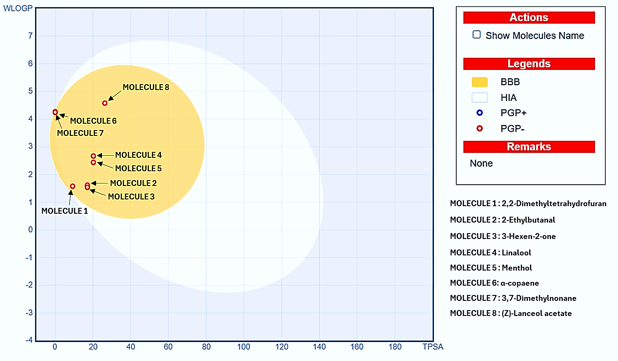
Figure 5: Boil egg prediction graph of the phytocompounds from P. obtusa pod essential oils
3.7 In Silico PASS Prediction of Bioactivities of Plumeria obtusa Pod Essential Oil Constituents
PASS analysis was employed to predict the antioxidant, anti-inflammatory (COX-1 and COX-2), and anticancer potential of the major constituents identified in P. obtusa pod essential oil. Biological relevance was inferred based on the probability of activity (P_{a}) exceeding the probability of inactivity (P_{i}) (Table 7). For antioxidant activity, higher P_{a} values were observed for α-copaene (0.476), linalool (0.380), and menthol (0.345), indicating strong radical-scavenging potential, while 3-hexen-2-one (0.196), 3,7-dimethylnonane (0.382), and (Z)-lanceol acetate (0.239) exhibited moderate probabilities. 2,2-Dimethyltetrahydrofuran showed comparatively lower antioxidant prediction. Predicted anti-inflammatory activity revealed notable P_{a} values against COX-1 for α-copaene (0.476), linalool (0.251), and menthol (0.251), suggesting potential modulation of prostaglandin biosynthesis. In contrast, higher P_{a} values toward COX-2 were observed for 3,7-dimethylnonane (0.350) and (Z)-lanceol acetate (0.061), indicating possible selectivity toward inducible inflammatory pathways. For anticancer activity, (Z)-lanceol acetate (Pa = 0.494) exhibited the highest predicted probability, followed by linalool (0.439), 3-hexen-2-one (0.425), and menthol (0.301). Moderate P_{a} values for α-copaene and 3,7-dimethylnonane suggest their supportive role through synergistic mechanisms (Arya et al., 2023). These predictions correlate well with docking results against the anticancer target (PDB ID: 4I1H). Overall, PASS prediction demonstrated that most constituents exhibited P_{a} > P_{i} across multiple bioactivities, reinforcing the pharmacological relevance of P. obtusa pod essential oil and supporting the experimental and molecular docking findings.
Table 7: In-Silico PASS prediction of phytoconstituents from P. obtusa pod essential oils
Sr. No. | Compound | Pass $(Pa>Pi)$
Sr. No. | Compound | Antioxidant Activity | Anti-inflammatory Activity |  | Anti-cancer Activity
Sr. No. | Compound | Antioxidant Activity | COX-1 | COX-2 | Anti-cancer Activity
1 | 2,2-Dimethyltetrahydrofuran | 0.013>0.005 | 0.083>0.071 | 0.130>0.037 | 0.319>0.051
2 | 2-Ethylbutanal | - | 0.154>0.028 | - | 0.238>0.089
3 | 3-Hexen-2-one | 0.196>0.029 | 0.445>0.003 | 0.108>0.048 | 0.425>0.027
4 | Linalool | 0.380>0.014 | 0.251>0.009 | 0.265>0.031 | 0.439>0.025
5 | Menthol | 0.345>0.019 | 0.251>0.009 | 0.305>0.015 | 0.301>0.058
6 | α-copaene | - | 0.476>0.064 | 0.021>0.006 | 0.208>0.112
7 | 3,7-Dimethylnonane | 0.382>0.014 | 0.266>0.008 | 0.350>0.008 | 0.244>0.098
8 | (Z)-Lanceol acetate | 0.239>0.039 | 0.162>0.025 | 0.061>0.043 | 0.494>0.020
4. Conclusion
The present study provides a comprehensive evaluation of the essential oil extracted from Plumeria obtusa pods through integrated phytochemical, biological, and in-silico approaches. GC-MS analysis revealed a chemically diverse profile dominated by oxygenated monoterpenoids (40.84%), including menthol (22.47%) and linalool (18.37%), along with aliphatic aldehydes, ketones, and sesquiterpenes, suggesting a strong basis for bioactivity. Biological assays confirmed significant antioxidant potential through DPPH and H₂O₂ scavenging mechanisms, alongside notable anti-inflammatory activity, while the essential oil also demonstrated promising anticancer efficacy with key constituents such as (Z)-lanceol acetate and α-copaene. Molecular docking analyses substantiated these biological findings by revealing favorable interactions of major constituents with key molecular target (E3 ubiquitin ligase Parkin) linked to cancer pathways that exhibited nearly same binding interactions as (Z)-lanceol acetate (-6.1 kcal/mol) and α-copaene (-6.0 kcal/mol) comparable to the reference drug (-7.1 kcal/mol). PASS prediction further supported the multifunctional bioactivity of the identified compounds, showing high probabilities for antioxidant, anti-inflammatory, and anticancer activities. Additionally, in-silico ADMET, toxicity profiling, and BOILED-Egg analysis demonstrated favorable pharmacokinetic behavior, oral bioavailability, low predicted toxicity, and minimal metabolic liabilities for most constituents, underscoring their drug-likeness and safety. This study represents the first systematic report highlighting the therapeutic potential of Plumeria obtusa pod essential oil, supported by experimental validation and mechanistic in-silico evidence. The findings establish a strong foundation for further isolation of active constituents, detailed mechanistic studies, and in-vivo investigations, positioning P. obtusa pod essential oil as a promising natural source for the development of antioxidant, anti-inflammatory, and anticancer agents.
Disclaimer
Author(s) hereby declare that NO generative AI technologies such as Large Language Models (ChatGPT, COPILOT, etc) and text-to-image generators have been used during writing or editing of this manuscript.
Conflict of Interest
The authors declare that they have no competing interests.
Ethical approval
Not applicable
Availability of Data and Materials
The Datasets used and analysed during this study are available from the corresponding auther on request.
Disclaimer (Artificial intelligence)

Author(s) hereby declare that NO generative AI technologies such as Large Language Models (ChatGPT, COPILOT, etc.) and text-to-image generators have been used during the writing or editing of this manuscript.

References
- Acree, W. J., & Chickos, J. S. (2022). Phase Transition Enthalpy Measurements of Organic and Organometallic Compounds. In NIST Chemistry WebBook, NIST Standard Reference database Number 69, Gaithersburg, MD, USA.
- Adams, R. P. (2007). Identification of Essential oil Components by Gas Chromatography/Mass Spectrometry. Allured Publishing Corporation: Carol Stream, 544-545.
- Alla, J. R., Badampudi, S. K., Niharika, D. G., Reddy, M. A., Rao, S. N., Kumari, R., & Kumar, L. S. (2024). Design, synthesis and biological evaluation of indazole carboxamide analogues as potential anticancer agents. Journal of Molecular Structure, 1325, 140949.
- Alvarado, H. L., Calpena, A. C., Garduño-Ramírez, M. L., Ortiz, R., Melguizo, C., Prados, J. C., & Clares, B. (2018). Nanoemulsion Strategy for Ursolic and Oleanic Acids Isolates from Plumeria Obtusa Improves Antioxidant and Cytotoxic Activity in Melanoma Cells. Anti-Cancer Agents in Medicinal Chemistry, 18(6), 847–853.
- Arya, S., Mahawer, S. K., Karakoti, H., Kumar, R., Prakash, O., Kumar, S., Latwal, M., Panday, G., Srivastava, RM., Santana, & Rawat, D. S. (2023). Study of the Variability of the Chemical Profile, and Biological Activity Approaches of Hedychium coronarium J. Koenig Essential Oil from Different Habitats of Uttarakhand, India. Journal of Food Quality, 1–19.
- Bakkali, F., Averbeck, S., Averbeck, D., & Idaomar, M. (2008). Biological effects of essential oils-a review. Food Chem Toxicology, 46(2), 446-75.
- Banerjee, P., Eckert, A.O., Schrey, A. K., & Preissner, R. (2018). ProTox-II: a webserver for the prediction of toxicity of chemicals. Nucleic Acids Research, 46(1), 257-263.
- Bihani, T., Tandel, P., & Wadekar, J. (2021). Plumeria obtusa L.: A systematic review of its traditional uses, morphology, phytochemistry and pharmacology. Phytomedicine Plus, 1(2), 100052.
- Blois, M.S. (1958). Antioxidant determinations by the use of a stable free radical. Nature, 181, 1199–1200.
- Chen, L., Liu, Y., Li, Y., Yin, W., & Cheng, Y. (2022). Anti-Cancer Effect of Sesquiterpene and Triterpenoids from Agarwood of Aquilaria sinensis. Molecules, 27(16), 5350.
- Chopra, R. N., Nayar, S. L., & Chopra, I. L. (1956). Glossary of Medicinal Plants. New Delhi CSIR, 1984.
- Dallakyan, S., & Olson, A.J. (2015). Small Molecule Library Screening by Docking with PyRx. Chemical Biology, Human Press, New York, NY, USA, 243-250.
- Dharmendra, S., Ghaedi, M., Naghiha, R., Saheli, A., & Jannesar, R. (2019). Antibacterial, Antifungal and E. Coli DNA Cleavage of Euphorbia Prostrata and Pelargonium Graveolens Extract and their Combination with novel Nanoparticles. Brazilian Journal of Pharmaceutical Science, 54.
- Ding, D., Ao, X., Liu, Y., Wang, Y. Y., Fa, H.G., Wang, M. Y., He, Y. Q., & Wang, J.-X. (2019). Post-translational modification of Parkin and its research progress in cancer. Cancer Communications, 39, 1.
- Diniz do Nascimento, L., Moraes, A. A. B. D., Costa, K. S. D., Pereira Galúcio, J. M., Taube, P. S., Costa, C. M. L., & Faria, L. J. G. D. (2020). Bioactive natural compounds and antioxidant activity of essential oils from spice plants: New findings and potential applications. Biomolecules, 10, 988.
- Dogra, N. (2016). Phytochemical analysis and In vitro antioxidant studies of Plumeria obtusa L. Leaves. Indian Journal of Pharmaceutical Sciences, 78(1), 169.
- Dos Santos, I. V. F., Borges, R. S., Silva, G. M., De Lima, L. R., Bastos, S., Ramos, R. S., Silva, L. B., Da Silva, C. T. P., & Dos Santos, C. B. R. (2022). Hierarchical Virtual Screening Based on Rocaglamide Derivatives to Discover New Potential Anti-Skin Cancer Agents. Frontiers in Molecular Biosciences, 9: 836572.
- Eloutify, Y. T., El-Shiekh, R. A., Ibrahim, K. M., Hamed, A. R., Al-Karmalawy, A. A., Shokry, A. A., Ahmed, Y. H., Avula, B., Katragunta, K., Khan, I. A., & Meselhy, M. R. (2023). Bioactive fraction from Plumeria obtusa L. attenuates LPS-induced acute lung injury in mice and inflammation in RAW 264.7 macrophages: LC/QToF-MS and molecular docking. Inflammopharmacology, 31(2), 859-875.
- Fometa, S. S., Shittu, S., Herman, R. A., & Ayepa, E. (2019). Essential oils and their applications- A mini review. Advance in Nutrition and Food Science. 2572-5971.
- Goyal, R. K., Goyal, G., Goyal, S., & Mittal, S. (2012). Pharmacognostical evaluation of bark of Plumeria alba. International Journal of Natural Product and Science, 1, 178.
- Gülçin, İ., & Alwasel, S. (2023). DPPH radical scavenging assay. Processes, 11(8), 2248-2248.
- Hartwell, J. L. (1982). Plants used Against Cancer: A Survey. Quarterman Publication, 408.
- Hernandez, R.D., Genio, F. A. F., Casanova, J. R., Conato, M. T., & Paderes, M.C. (2024). Antiproliferative Activities and SwissADME Predictions of Physicochemical Properties of Carbonyl Group-Modified Rotenone Analogues. Chemistry Open, 13(1): e202300087.
- Islam, M. S., & Aktar, R. (2019). A Study on different plants of Apocynaceae Family and their Medicinal Uses. Universal Journal of Pharmaceutical Research, 4, 1.
- James, J. P., Ail, P. D., Crasta, L., Kamath, R., Shura, M. H., & Sindhu T.J. (2023). In Silico ADMET and Molecular Interaction Profiles of Phytochemicals from Medicinal Plants in Dakshina Kannada. Journal of Health and Allied Sciences.
- Li, J., Li, X., & Liu, H. (2025). Sesquiterpene lactones and cancer: new insight into antitumor and anti-inflammatory effects of parthenolide-derived Dimethylaminomicheliolide and Micheliolide. Frontiers in Pharmacology, 16, 1551115.
- Liu, J., Zhang, C., Hu, W., & Feng, Z. (2018). Parkinson’s disease‐associated protein Parkin: an unusual player in cancer. Cancer Communications, 38(1), 1-8.
- Manojkumar, S., Thandeeswaran, M., Thangavel, S. K., Arjunan, A., Muthuselvam, M., Kalaiarasi, G., & Gnanajothi, K. (2024). Phytochemical Screening, In Silico Molecular Docking, ADME Properties, and In Vitro Antioxidant, Anticancer, and Antidiabetic Activity of Marine Halophyte Suaeda maritima (L.) Dumort. ACS Omega.
- Kakar, R., Kalra, J., Mantha, S.V., & Prashad, K. (1995). Lipid Peroxidation and Activity of antioxidant Enzymes in diabetic rats. Molecular cell Biochemistry, 151, 113-119.
- Karakoti, H., Mahawer, S. K., Tewari, M., Kumar, R., Prakash, O., de Oliveira, M. S., & Rawat, D. S. (2022). Phytochemical Profile, In Vitro Bioactivity Evaluation, In Silico Molecular Docking and ADMET Study of Essential Oils of Three Vitex Species Grown in Tarai Region of Uttarakhand. Antioxidants, 11(10), 1911.
- Kim, H., & Ronai, Z. A. (2024). Parkin paves the path to antitumor immunity: Expanding Parkin’s role as a tumor suppressor. Journal of Clinical Investigation, 134, 22.
- Kumari, R., Shakya, A. K., Alam Rizvi, M. M., & Ram, Dr. S. (2024). Anti-cancer Potential of Bioactive Compounds from Moringa oleifera against PARK2 in Oral Cancer protein: In silico Approach. Journal of Ayurveda and Holistic Medicine, 12, 1.
- Mamattah, K. M., Adomako, A. K., Mensah, C. N., & Borquaye, L.S. (2023). Chemical Characterization, Antioxidant, Antimicrobial, and Antibiofilm activities of Essential oils of Plumeria alba (Forgot-Me-Not). Biochemistry research International, 1040478.
- Manisha, B., Ar, S., & An, A. (2024). In-vitro anti-inflammato ry and antioxidant activity on flower of Plumeria rubra. Journal of Medicinal Plants Studies, 12(5), 49-53.
- Mawumenyo, M., Adomako, A. K., Mensah, C. N., & Borquaye, L. S. (2023). Chemical Characterization, Antioxidant, Antimicrobial, and Antibiofilm Activities of Essential Oils of Plumeria alba (Forget-Me-Not). Biochemistry Research International, 2023, 1–10.
- Moller, A. C., Parpa, C., Said, B., Werner, E., Flores, S., Villena, J., & Madrid, A. (2021). Antioxidant and anti-proliferative activity of essential oil and main components from leaves of Aloysia polystachya harvested in Central Chile. Molecules, 26, 131.
- Ooyedikachi, V. B., Awah, F. M., Chukwv, C. N., & Ejiofor, E. (2021). Essential oil of Cymbopogon Citrates grown in Umuahia: A viable candidate for Anti-inflammatory and antioxidant therapy. Food Technology, 15, 1.
- Peana, A. T., D’Aquila, P. S., Panin, F., Serra, G., Pippia, P., & Moretti, M. D. L. (2002). Anti-inflammatory activity of linalool and linalyl acetate constituents of essential oils. Phytomedicine, 9(8), 721–726.
- Rani, M., Kumari, R., Singh, S. P., Devi, A., Bansal, P., Siddiqi, A., Alsahli, M. A., Almatroodi, S. A., Rahmani, A. H., & Rizvi, M. M. A. (2023). MicroRNAs as master regulators of FOXO transcription factors in cancer management. Life Sciences, 321, 121535.
- Rani, M., Kumari, R., Ram, S., Rizvi, M., & Madhu. (2024). Exonal Polymorphism in Cancer Risk. Ann Oncol Case Rep, 4(1), 1018.
- Rani, M., Kumari, R., Ram, S., & Rizvi, M.M.A. (2025). Anti-Neoplastic Activity of Tetrahydrocurcumin in Liver Cancer by Modulating FOXO1/Parkin Tumour Suppressor Genes through In-Silico Iand In-Vitro Approaches. Clinical Oncology Case Report, 7(7), 359p.
- Riley, B. E., Lougheed, J. C., Callaway, K., Velasquez, M., Brecht, E., Nguyen, L., Shaler, T., Walker, D., Yang, Y., Regnstrom, K., Diep, L., Zhang, Z., Chiou, S., Bova, M., Artis, D. R., Yao, N., Baker, J., Yednock, T., & Johnston, J. A. (2013). Structure and function of Parkin E3 ubiquitin ligase reveals aspects of RING and HECT ligases. Nature Communications, 4, 1982.
- Ruberto, G., & Baratta, M. T. (2000) Antioxidant Activity of Selected Essential Oil Components in Two Lipid Model Systems. Food Chemistry, 69, 167-174.
- Sahoo, A., Das, B., Jena, S., Roy, A., Panda, P.C., & Nayak, S. (2021). Phytochemical composition of Flower’s Essential oil of Plumeria alba Grown in India. Journal of Essential oil Bearing Plants, 24(4), 671-676.
- Salar, S., Singh, M., Yadav, D. K., Kumar, V., Ekbbal, R., & Kumar, S. (2025). Ethnopharmacological Insights on Plumeria obtusa L.: A Comprehensive Review of its Phytochemistry and Pharmacological Properties. Current Bioactive Compounds, 21.
- Salar, S., Sharma, P., Lamba, H. S., Sharma, J., & Kaur, A. (2022). Exploration of antioxidant activity of Plumeria obtusa L. Annals of Phytomedicine, 11, 2.
- Sharma, O. P., & Bhatt, T.K. (2009). DPPH antioxidant assay revisited. Food Chemistry. 1113(4), 1202-1205.
- Sheetal, S. M., Julie, D. B., & Ali, Z. (2023). Essential oils: A new perspective. Indian Former, 10(3), 56-59.
- Sura, J., Dwivedi, S., & Dubey, R. (2016). Pharmacological, Phytochemical and Traditional uses of Plumeria Alba, An Indian Medicinal Plant. Journal of pharmaceutical and Biosciences, 1(1), 14-17.
- Teng, C., Chen, J. W., Shen, L. S., Chen, S., & Chen, G.Q. (2025). Research advances in natural sesquiterpene lactones: overcoming cancer drug resistance through modulation of key signaling pathways. Cancer Drug Resistance, 8(13), 178.
- Verdeguer, M., Sanchez-Moreiras, A.M., & Araniti, F. (2020). Phytotoxic Effects and Mechanism of Action of Essential Oils and Terpenoids. Plants (Basel, Switzerland), 9(11), 1571.
- Xiao, H., Gui, Y., Li, X., Dai, W., Feng, C., Li, G., & Luo, J. (2024). Explore on screening COX-2 inhibitors from the essential oil of Solanum lyratum Thunb. by molecular docking and molecular dynamics simulation. Heliyon, e37652–e37652.

