Evaluation of slow freezing and vitrification methods of cryopreservation in in vitro produced buffalo embryos

ABSTRACT
Cryopreservation has been a revolutionary tool of assisted reproductive techniques to preserve valuable germplasm. The study was performed to measure the cleavage rate and the effect of cryopreservation techniques (slow freezing and vitrification) on in vitro produced buffalo embryos. Cumulus oocytes complexes were recovered by manual aspiration method. In vitro maturation (IVM), fertilization (IVF), and culture (IVC) were performed using commercially available Vitrogen (Brazil) media in benchtop incubator having 5% O2, 5% CO2, and optimum N2 with 90% humidity. Total 29 sessions were performed during November 2022 to June 2023 and 655 (23 ± 1.21 ovaries/session) ovaries were processed. Total 2515 follicles were observed including 1387 (55.15; 48.0 ± 1.81; 55.15%) small, 982 (34.0 ± 1.27; 39.05%) medium and 146 (5.0 ± 2.25; 5.8%) large follicles. Total 1679 COCs were recovered from 2515 follicles with recovery rate of 66.75%. Total 1640 COCs were used for IVM, IVF and IVC. After 72 h of the IVC 63.1 % (1015/1640) cleavage rate were observed and on day six after IVC 20 % (295/1640) blastocyst rate were observed. Blastocysts of grade I & II were randomly assigned either fresh, vitrified and slow freezing group. The re-expansion rate in frozen-thaw and vitrified-devitrified group blastocysts were observed at different time intervals. The total re-expansion rate of frozen-thawed BLs was 91.46%, which was significantly lower than 96% of vitrified-devitrified BLs. Further to study the hatching rate fresh (control) group was included and hatching were observed at 2, 12, and 24 hrs. Apoptosis rate were assessed using the TUNEL assay. TUNEL assay revealed a significant apoptosis in frozen-thaw blastocysts compared to vitrified-devitrified group (13.73 ± 0.67 vs 8.99 ± 0.71). Hence, vitrification is more competent method for cryopreservation of in vitro produced transferable buffalo embryos.
1. Introduction
In India total population of buffaloes is 109.85 million and stands first worldwide. Buffalo (Bubalus bubalis) has a pivotal position in Indian agriculture by contributing 49 % to the milk industry and contributing to meat and draught power (BAHS, 2019). However, their reproductive efficiency is poor due to delayed puberty, silent heat, prolonged inter-calving interval, longer postpartum ovarian quiescence, seasonality and lowered conception rates particularly when bred artificially (Gordon, 1996; Singh et al., 2009). Hence, many research groups and breeding agencies tried various Assisted Reproductive Technologies (ART) and their combinations to increase the number of offspring from genetically superior buffaloes in order to decrease the generation interval and spread germplasm globally (Berglund, 2008). Application of superovulation and embryo transfer technologies (ETT) in the buffalo has marginal success (Madan et al., 1994). Hence, increasing interest in the production of embryos using third-generation ART like in vitro embryo production (IVEP) technology is a rapidly growing field in the bovine ART (Suthar, 2008; Suthar and Shah, 2009; Do et al., 2019). At the same time, it is difficult to get good recipient with optimum nutrition, reproductive health and synchronized status for IVEP practitioners. Cryopreservation techniques have been greatly improved for IVEP embryos, making on-farm transfers very convenient and facilitating the storage and shipment of these embryos. The successful storage and survival of cells depend critically on the ability to induce and reverse low-temperature states in a controlled manner that minimizes or ameliorates transition-related damage (Bojic et al., 2021). So, to test which method of cryopreservation is the best study was planned to determine the effect of slow-freezing and vitrification on re-expansion rate, hatching rate and apoptosis rate on in vitro produced embryos from slaughter ovaries.
2. Materials and methods
2.1. Experimental design
Ovaries were collected from the slaughterhouse and immature COCs were obtained and classified according to the classification described by Das et al., 1996. These recovered COCs were matured, fertilized and cultured. After the 72h of culture cleavage rate was checked. On 6th day of IVC, Early Blastocyst (EBl), Blastocyst (Bl) and Expanded Blastocyst (ExBl) of grades I and II were segregated and allocated in three groups. The first group was maintained as a control, the second and third groups were cryopreserved either by slow freezing or vitrification and stored in LN₂. Thawing and devitrification of Bls were performed and observed at 0 hr, 2 hr, 12hr, 24 hr and 48 hr for viability, re-expansion and hatching. Further, from each group representative Bls were also offered to the TUNEL assay to study the apoptotic index.
2.2 In vitro embryo production
Buffalo ovaries obtained from the slaughterhouse washed with a normal saline having 1% (w/v) antibiotic (10000 IU/ml penicillin, 10000 µg/ml streptomycin and 25 µg/ml amphotericin B; Gibco, USA; Vassena et al., 2003) and stored in isothermal container with normal saline at 34-36 °C during transit. Cumulus–oocyte complexes (COCs) were aspirated from follicles having 3 to 8 mm diameter. The COCs were classified, based on their morphology as described by Das et al., 1996. After washing COCs were transferred into pre-equilibrated IVM media drop and placed in benchtop incubator having 5% CO_{2,} 5% O₂ and balanced N₂ with set at 38.5°C for 22 hours. The maturation of COCs were assessed based on the cumulus expansion. Matured COCs were transferred to fertilization medium. The frozen semen doses of buffalo bulls, motile spermatozoa were obtained using Semen Pre media and used at a total concentration of 02 x 10⁶ sperm/ml introduced in the IVF media drops with the COCs and incubated at 38.5°C in benchtop incubator with 5% O2, 5% CO2 and 90% N2 for 18-22 hours. After coincubation, the presumptive zygotes were washed and denuded gently to remove all the cumulus cells. Once all the zygotes were denuded, they were pre-equilibrated IVC media. After washing presumptive zygotes were transferred into pre-equilibrated IVC drops and placed in benchtop incubator for 6 days.

2.3 Cryopreservation
On day six Early Blastocysts (EBl), Blastocysts (Bl) and Expanded Blastocysts (ExBl; EBL, Bl and ExBl define jointly BLs) of grade I and II were subjected to slow freezing or vitrification.

2.3.1 Slow freezing and thawing
Bls were cryopreserved using ethylene glycol (EG) and sucrose (Ref 029102; IMV France). at room temperature. Bls were segregated from IVC drops and kept in holding media and transferred to freezing media and equilibrated for 8 min at room temperature. BLs were individually mounted in 250 µL straws (Product Code 006430; IMV technologies, France), respecting proportion of 4:2:4. The first column was composed of freezing media, the second column contained embryos with freezing media and the third column was composed of freezing. The column containing Bl (EBl, Bl and ExBl) was separated from each other’s by 2-4 mm of air. The straws were closed with marker stick, marked with the details of the Bl as per formats prescribed by IETS and immediately straws were loaded in pre-cooled cryochamber of the freezing machine. Straws were placed in the cryochamber of the freezer (Crysalys, IMV technologies, France), and commanded as start, after 8 min equilibration time at −6 °C. The seeding was manually induced at -6 °C. Post-seeding the command start was given so that the temperature dropped to -32°C at a rate of −0.5°C/min., and hold the embryos at -32°C. At the end of the program, straws were directly plunged in LN₂ and stored until thawing was performed.
For thawing the Bls, the straws were exposed to RT in air for 10 sec and then plunged into the water bath at 32°C for 30 sec and transferred to IVC medium and incubated in bench top incubator for re-expansion and hatching.

2.3.2 Vitrification and warming
Bls were vitrified using vitrification kit (Vitrogen, Brazil) at the room temperature 25°C as directed in manufacturer’s guideline. Briefly vitrification media V1 and V2 were drawn out from the vitrification kit for each batch of embryos in 2 ml centrifuge tubes and warmed at room temperature for around 30 minutes. BLs were transferred to V1 media for 8 minutes. Subsequently BLs were transferred to V2 media drop and equilibrated for 40 seconds. After transferring in V2 media drop, BLs loaded immediately in vitrification device and extra media was removed using denuding pipette and keeping it as little as approximately 0.3 μl on the tip of the device. The device was then plunged immediately into LN₂ and closed with precooled lid. Subsequently, the device was transferred into pencil goblet in canisters of LN₂ tank for storage till devitrification.
Warming was of vitrified Bls were performed using de-vitrification media (Vitrogen, Brazil) as per the manufacturer’s guideline briefed hereafter. Micro drops were prepared with D1, D2 and D3 in 100 mm Petri dish. The vitrified devices were open within LN₂ and then immediately were kept in D1 drop. The BLs were recovered by observing under stereo zoom microscope and kept for 1 min. Subsequently, the Bls were transferred using denuding pipette in D2 for 3 minutes and D3 for 5 minutes. Bls were subsequently transferred to IVC for re-expansion, hatching rate for further analyses.

2.4 TUNEL assay
TUNEL assay was performed following the manufacturer’s instructions (APO-BrdU TUNEL Assay Kit, Molecular Probes, Invitrogen, Catalog number A23210). In brief, bovine embryos were washed twice in wash buffer (ABO-BRDU Kit) along with 1% polyvinylpyrrolidone (PVP) then Bls were fixed in 4% paraformaldehyde (PFA) in PBS at RT for 60 min. After washing Bls permeabilized with 0.5% triton-x 100 for 30min at RT wash again in DPBS. Treat the sample with DNA labeling solution for 60 min at 37°C for incubation on orbital shaker. At the end of incubation embryo were rinsed with rinse buffer. After washing twice in rinse buffer (ABO-BRDU Kit), embryos were incubated in the dark for 30 min at room temperature with antibody solution (fluorescein-labeled anti-BrdU monoclonal antibody and rinse buffer). Countered stained with 0.5% Propidium iodide (PI) for 30 min in darkroom at RT. TUNEL-positive nuclei appeared bright yellowish-green and the PI staining allowed counting the total cell number and identification, localization and quantification of normal, fragmented or condensed nuclei. Bls of the positive control were treated with DNase solution (100 U/mL) for 30 min at 37°C before incubation with DNA labeling solution. In negative control, the step of antibody labelling was excluded in this assay.
3. Results and Discussion
3.1 Cleavage and blastocyst rate
In the present study, total 1640 presumptive zygotes were kept in IVC medium. After 72 h the cleavage was assessed, which is depicted in Table 1 and elucidated in Figure 1. The different cleavage stages are elucidated in Figure 2. Total 1015 presumptive zygotes were cleaved, with an observed cleavage rate of 63.1% (1015/1640) and 295 (20%; 295/1640) reached either early blastocysts or blastocyst stages (BLs) on day 6. The observed BLs of day 6 were randomly allocated to fresh, slow-freezing and vitrification groups (Table 1 and 2) to evaluate re-expansion, hatching, and apoptosis rate. The reported cleavage rate in different studies ranges from 14 to 84.4 % (Abdoon et al., 2001; Ahmed et al., 2023). Ahmed et al. (2023) reported a cleavage rate from 79 to 84.4% in blastocysts of buffaloes, which is higher than the present study, while others have reported 46 to 55 % (Mostager et al. (2017), 14 to 32 % (Lakshmi et al., 2020), 43 to 55% (Kumar et al., 2020), 39.2 % (Patil et al., 2022) and 40.84 ± 2.51 % (Pitroda et al., 2021) which is lower than the present study. Many factors can influence cleavage rate such as media quality, drop size, incubator environment, semen quality, capacitation, season, etc.
Blastocyst rate in the present study is in accordance with 19.9 ± 4.2% (Neglia et al. 2003), 20.7% (Vu, 2006), 19.6% (Ocampo et al., 2016) and 20.4±2.5% (Sadeesh et al., 2016). A few studies also reported blastocyst rate 22.9 to 26.98 % (Chohan and Hunter 2002; Ravindranatha et al., 2003). Many factors can affect blastocyst rate such as source of oocytes (i.e., slaughter origin or OPU), media, culture conditions, sire, capacitation, oocyte and zygote handling and incubation environment (Suthar and Shah, 2009; Suresh et al., 2009).
3.2 Re-expansion rate of blastocysts using different cryopreservation methods
The vitrification of BLs is elucidated in Figure 3. To observe re-expansion rate 47 frozen-thawed and 50 vitrified-devitrified BLs were used. The significant effect of hours was observed on re-expansion rate in both the frozen-thawed and vitrified-devitrified BLs (Figure 3). In both groups, re-expansion of BLs occurred at 2h, followed by 12h and 24h (P < 0.05). Further higher re-expansion rate was achieved in vitrified-devitrified BLs than in the slow-freezing BLs (P < 0.001). The representative pictures of re-expansion of fresh, after frozen-thawed and devitrification is elucidated in Figure 5, 6 and 7, respectively. The re-expansion rate at 2h of frozen-thawed BLs was 74% which was significantly lower than that of devitrified BLs (84%: P = 0.0001; Table 3). Further, the total re-expansion rate of frozen thawed BLs was 91.46% which was significantly lower than devitrified BLs (96%: P = 0.001; Figure 3).
Using slow freezing the reported survival rate (re-expansion rate) at 24 h in this study is higher than reported range 36.9 to 71.3 % (Mahmoudzadeh et al., 1995; Lim et al., 2008; Assumpção et al., 2018; Hayashi et al., 2019; Najafzadeh et al., 2021) while the reported re-expansion rate of BLs in slow- freezing wise which found lower than the present study, while re-expansion rate reported by Caamaño et al. (2015) was higher than the present study at 2h (94.1 ±4.9), 24h (92.6 ± 4.9).
The reported re-expansion rate of vitrified-devitrified BLs were in accordance with 91.0 % (Hufana-Duran et al., 2004); 96.3% (Xu et al., 2006); 2 h 95.4 ± 4.9 and 24h 94.5 ± 4.9 (Caamaño et al., 2015) in bovines. Furthermore, some studies reported lower re-expansion rate than the present study which includes 46 to 70% (De Rosa et al., 2006; 50.3 to 76.4 % (Taniguchi et al., 2007) 45 to 72 % (Manjunatha et al., 2009ab), 29 to 59% (Rahangdale et al., 2021). Similar to present study vitrified-devitrified BLs demonstrated higher re-expansion rate compared with freeze-thawed BLs. This result is in accordance with previous studies (De Rosa et al., 2006).
3.3 Hatching rate of blastocysts using different cryopreservation methods
To observe the hatching rate 47 frozen-thawed BLs, 50 vitrified-devitrified and 34 fresh BLs were examined for their hatching rate at 2h, 12h, 24h and 48 h. An effect of hours was observed on hatching rate of BLs in all three groups (P < 0.05; Table 4) and higher hatching rate was observed between 24 h to 48 h in all three groups (P = 0.001; Figure 8). The higher hatching rate was observed in fresh (79.41%) than the vitrified-devitrified (76%) and frozen-thawed (68.09 %; P < 0.001). Further higher hatching rate was observed in vitrified-devitrified BLs (76%) than in frozen-thawed BLs (68.09 %; P < 0.05).
The reported hatching rate using freeze-thaw BLs 43.3% (Mahmoudzadeh et al., 1995), 40% (Nedambale et al., 2003), 44.65 ± 5.94% (Nicacio et al., 2012), 20% (Villamil et al., 2012) and 32.5 ± 10.2 % (Caamaño et al., 2015) is lower than reported in the present study, while 66.0% reported by Do et al. (2019) is in accordance with the current finding.
The reported hatching rate using vitrified-devitrified BLs were 68.2 % (Saha et al., 1996), 52.5 % (Oliveira et al., 2020), and 78.4 ± 2.0 % (Rodero et al., 2021). These results of past studies are lower than the present finding. Moreover, higher hatching rates (80 to 91 %) were also reported by different studies, i.e., Morula 91% Early BL, 80% BL, 90% (Hufana-Duran et al. 2004), 84.4% (Xu et al., 2006) and 90.2 % (Do et al., 2019) using different vitrification techniques. Further, Hufana-Duran et al. (2004) reported 75% hatching rate for expanded BL which is in accordance with the present study.
3.4 Apoptotic index in fresh, frozen-thawed and vitrified-devitrified blastocysts
Cryopreservation of embryos can affect the viability, hatching rate and ultimately pregnancy rate. It also damages the ultrastructure, organelles morphology, physiological and biochemical functions of Bls. In human vitrification is method of choice for embryo preservation while in bovines, slow-freezing is used for embryo preservation. However reported success rate of slow-freezing is from 7 % to 34 % and is much poorer in Indian conditions (Suthar and Shah, 2009) Considering that during last decade, many studies researched and demonstrated promising results with cattle embryonic vitrification, however, there is scarce information on buffalo embryonic vitrification. In normally developing bovine blastocysts some cells spontaneously undergo programmed cell death/apoptosis which is characterized by cytoplasmic and nuclear fragmentation, chromatin condensation, DNA fragmentation cell elimination and phagocytosis. This process can be aggravated by cryopreservation. This phenomenon can be detected using TUNEL assay. Further DNA fragmentation plays critical role and constraining factor in successful establishment of pregnancy and birth. Interestingly IVEP embryos are much more susceptible to cryopreservation than the in vivo produce bovine embryos. Hence the tunnel assay was used to evaluate apoptosis rate in frozen-thaw and vitrified embryos keeping fresh embryos as a control. The findings of the TUNEL assay is depicted in table 5. In the present study, 47 frozen-thawed BLs, 50 vitrified-devitrified and 34 fresh BLs were examined for apoptosis rate using TUNEL assay. Further 10 BLs from each group kept for positive and negative control for the TUNEL study. The representative pictures of TUNEL assay is elucidated in Figure 9, 10 and counting of blastomeres using Image J software is elucidated in Figure 11. Fresh groups BLs demonstrated lower TUNEL reacted cells compared to freeze-thaw and vitrified-devitrified Bls (P < 0.005; Table 5). Further freeze-thaw Bls demonstrated significantly higher apoptosis rate than the vitrified-devitrified Bls (P < 0.05). Similarly, ICM and TE cells in fresh Bls demonstrated significantly lower TUNEL positive (reacted) cells than in ICM and TE cells of freeze-thaw and vitrified-devitrified BLs (P < 0.05). Further ICM and TE cells of freeze-thaw Bls demonstrated significantly lower TUNEL positive (reacted) cells than in ICM and TE cells of vitrified-devitrified BLs (P < 0.05). This suggest that the DNA fragmentation was lower in fresh compared with freeze-thaw and vitrified-devitrified treated BLs. Further freeze-thaw Bls were having higher DNA fragmentation and Apoptosis than the vitrified-devitrified BLs. Further in this study DNA fragmentation and apoptosis was noted in ICM and TE cells of fresh, frozen-thawed and vitrified-devitrified cells however freeze thawed BLs demonstrated higher TUNEL reaction/apoptosis.
Overall, this study suggest BL viability, re-expansion and hatching rate is batter in vitrification compared with frozen-thawed BLs. Further the total TUNEL assay suggest that apoptosis rate is less in vitrified-devitrified BLs than the frozen-thawed Bls hence Vitrification is better option to preserve buffalo Bls.
4. Conclusions
The following conclusions are drawn from the present study
- In the present study COCs recovery rate was 2.6 per ovary, cleavage rate was 63.1% and blastocyst rate was 20% (n=295).
- Effect of hours was observed on re-expansion, blastocyst rate and apoptosis rate in both cryopreservation methods treated blastocysts. The study revealed vitrified-devitrified embryos demonstrated significantly higher re-expansion rate than the slow-freezing treated blastocysts.
- In this study frozen thawed and vitrified-devitrified Bls hatching observed during 12 to 24 h. The fresh (Control) group blastocysts has demonstrated significantly higher hatching rate compared with the Bls treated with frozen-thawed or vitrified-devitrified cryopreservation methods. Further vitrified-devitrified Bls demonstrated significantly higher hatching rate compared with frozen-thawed blastocysts.
- TUNEL assay demonstrated significantly higher number of apoptotic cells in frozen-thawed blastocyst then the vitrified-devitrified or control group blastocysts. Overall control group demonstrated lower number of apoptotic cells then the vitrified or frozen-thawed blastocysts.
- Overall vitrified-devitrified blastocysts having more competence than the frozen-thawed blastocyst and appears more suitable method for cryopreservation of IVEP transferable embryos.
Table.1. Number of presumptive zygotes in IVC and their cleavage and blastocyst rate
achieved during 29 sessions
Sr No | Zygote in IVC | No. of zygote cleaved | Cleavage rate % | No. of Blastocyst | Blastocyst %
1 | 47 | 37 | 78.7 | 14 | 29.79
2 | 20 | 15 | 75 | 8 | 40
3 | 36 | 29 | 80.6 | 13 | 36.11
4 | 63 | 40 | 63.5 | 8 | 12.7
5 | 75 | 60 | 80 | 10 | 13.33
6 | 102 | 77 | 75.5 | 14 | 13.73
7 | 36 | 24 | 66.7 | 12 | 33.33
8 | 41 | 30 | 73.2 | 9 | 21.95
9 | 75 | 31 | 41.3 | 11 | 14.67
10 | 50 | 28 | 56 | 10 | 20
11 | 58 | 37 | 63.8 | 12 | 20.69
12 | 62 | 32 | 51.6 | 10 | 16.13
13 | 78 | 48 | 61.5 | 7 | 8.97
14 | 98 | 61 | 62.2 | 14 | 14.29
15 | 53 | 26 | 49.1 | 16 | 30.19
16 | 69 | 36 | 52.2 | 6 | 8.7
17 | 78 | 31 | 39.7 | 8 | 10.26
18 | 34 | 26 | 76.5 | 12 | 35.29
19 | 59 | 29 | 49.2 | 11 | 18.64
20 | 43 | 27 | 62.8 | 9 | 20.93
21 | 47 | 36 | 76.6 | 11 | 23.4
22 | 53 | 29 | 54.7 | 12 | 22.64
23 | 47 | 30 | 63.8 | 6 | 12.77
24 | 49 | 36 | 73.5 | 6 | 12.24
25 | 61 | 34 | 55.7 | 6 | 9.84
26 | 58 | 29 | 50 | 9 | 15.52
27 | 53 | 34 | 64.2 | 10 | 18.87
28 | 49 | 30 | 61.2 | 11 | 22.45
29 | 46 | 33 | 71.7 | 10 | 21.74
Total | 1640 | 1015 | 63.1 % | 295 | 20 %
(Mean ± SE) | (56.55 ± 3.33) | (35 ± 2.27) | (63.10±2.09) | (10.17 ±0.49) | (19.97 ± 1.58)
Table 2. Grading of blastocysts (early blastocyst, blastocyst) on day 6 after in vitro
culture
Sessions | Grade I | Grade II | Grade III | Grade IV | Total  blastocysts
1 | 6 | 6 | 2 | 0 | 14
2 | 5 | 2 | 1 | 0 | 8
3 | 4 | 4 | 5 | 0 | 13
4 | 2 | 3 | 3 | 0 | 8
5 | 4 | 3 | 3 | 0 | 10
6 | 4 | 7 | 3 | 0 | 14
7 | 4 | 5 | 3 | 0 | 12
8 | 3 | 5 | 1 | 0 | 9
9 | 4 | 6 | 1 | 0 | 11
10 | 2 | 4 | 4 | 0 | 10
11 | 5 | 4 | 3 | 0 | 12
12 | 2 | 6 | 2 | 0 | 10
13 | 2 | 4 | 1 | 0 | 7
14 | 2 | 5 | 7 | 0 | 14
15 | 4 | 7 | 5 | 0 | 16
16 | 2 | 2 | 2 | 0 | 6
17 | 4 | 3 | 1 | 0 | 8
18 | 6 | 4 | 2 | 0 | 12
19 | 3 | 4 | 4 | 0 | 11
20 | 4 | 3 | 2 | 0 | 9
21 | 3 | 4 | 3 | 1 | 11
22 | 5 | 3 | 4 | 0 | 12
23 | 0 | 1 | 5 | 0 | 6
24 | 2 | 2 | 2 | 0 | 6
25 | 3 | 2 | 1 | 0 | 6
26 | 3 | 2 | 4 | 0 | 9
27 | 4 | 2 | 3 | 1 | 10
28 | 3 | 5 | 2 | 1 | 11
29 | 3 | 4 | 2 | 1 | 10
Total | 98  (33.22%) | 112  (37.97%) | 81  (27.46%) | 4  (1.36%) | 295
Mean ± SE | 3.4 ± 0.2 | 3.9 ± 0.3 | 2.8 ± 0.3 | 0.1 ± 0.1

Table 3. Re-expansion rate of devitrified or frozen thawed blastocysts
Group | N | Re-expansion (2h) | Re-expansion (12h) | Re-expansion (24h) | Total  re-expansion
Vitrification | 50 | 41 (82%) ª | 4 (8%) ª | 3 (6%) ª | 48 (96.0%) ª
Slow frozen | 47 | 35 (74%) ^{b} | 5 (10.6%) ª | 3 (6.38%) ª | 43 (91.49%) ^{b}
^{a,b} Colum with different superscripts differ significantly at 0.05 level.
Table 4. Hatching rate (%) of devitrified and frozen thawed Blastocysts
Group | Number of BLs | Hatching (2h) | Hatching (12h) | Hatching (24h) | Hatching (48h) | Total hatched
Fresh  (N; %) | 34 | 0 | 2  (5.88) | 13  (38.24) | 12  (35.3) | 27 (79.41)ª
Vitrification  (N; %) | 50 | 0 | 0 | 10  (20) | 28  (56.0) | 38 (76.0)^{b}
Slow freezing  (N; %) | 47 | 0 | 0 | 9  (19.15) | 23  (48.9) | 32 (68.09)^{c}
^{a,b} Colum with different superscripts differ significantly at 0.05 level.

Table 5. Apoptosis rate in inner cell mass (ICM) and trophectoderm (TE) cells in fresh, vitrified and slow frozen blastocysts using TUNEL assay
Group | No. | ICM | T +ve ICM | TE | T +ve TE | Total cells | T +ve | Apoptotic index
Fresh | 35 | 42.01 ± 0.79ª | 2.84 ± 0.28 ª | 100.98 ± 0.85ª | 6.50 ± 0.514ª | 142.99 ± 1.17ª | 9.34 ± 0.67 ª | 6.60 ± 0.51 ª
Vitrified | 20 | 36.2 ± 1.1^{b} | 3.15 ± 0.39 ª | 98.43 ± 1.83ª | 8.79 ± 0.72^{b} | 134.63 ±1.63^{b} | 11.94 ± 0.94 ^{b} | 8.99 ± 0.71 ^{b}
Slow frizzing | 24 | 27.89 ± 1.03^{c} | 2.76 ± 0.37ª | 95.91 ± 1.11^{b} | 14.23 ± 0.67^{c} | 123.80 ± 1.53^{c} | 16.99 ± 0.88^{c} | 13.73 ± 0.67^{c}
TUNEL positive inner cell mass: T +ve ICM; TUNEL positive Trophectoderm cells: T+ve TE; Total TUNEL positive: T +ve
^{a,b,c} Colum with different superscripts differ significantly at 0.05 level.

Figure 1. Session wise number of presumptive zygotes in IVC and their cleavage and
blastocyst rate

Figure 2. Different cleavage stages of zygotes from 2 cell to hatched blastocysts
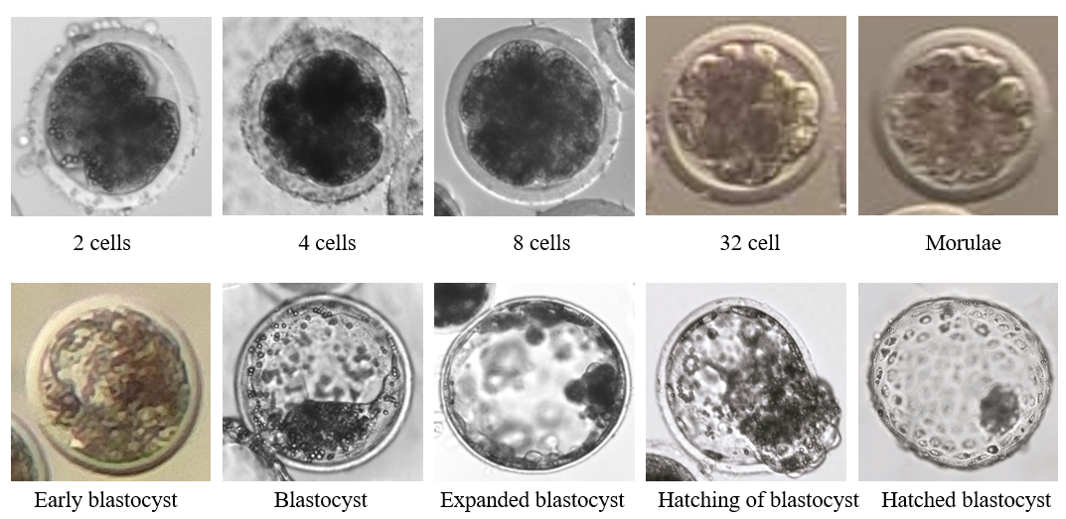
Figure 3. Re-expansion rate of devitrified and frozen thawed blastocysts

Figure 4 Shrunken blastocysts after the cryopreservation
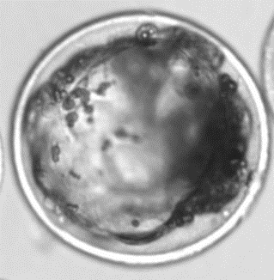
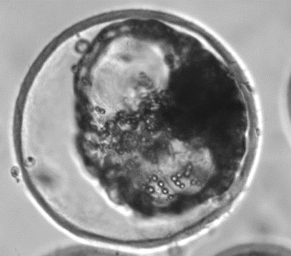

Blastocyst after vitrification Blastocyst after slow freezing

Figure 5 Re-expansion of blastocysts after the devitrification and thawing
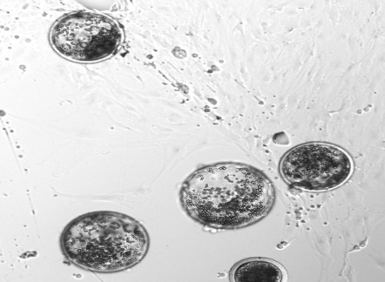
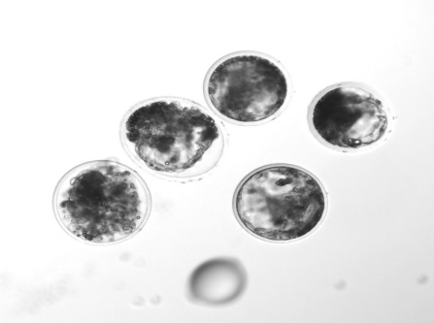

Re-expansion of devitrified blastocysts Re -expansion of thawed blastocysts

Figure 6. Hatching of fresh and vitrified group
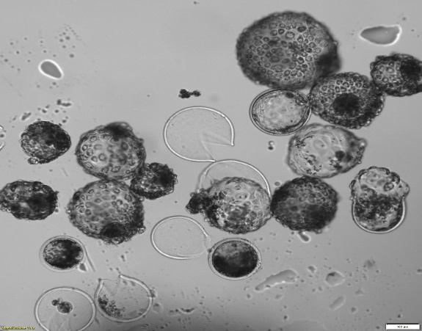
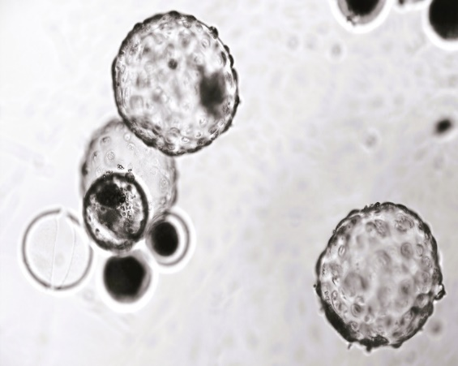

Fresh hatched blastocysts Vitrified hatched blastocysts
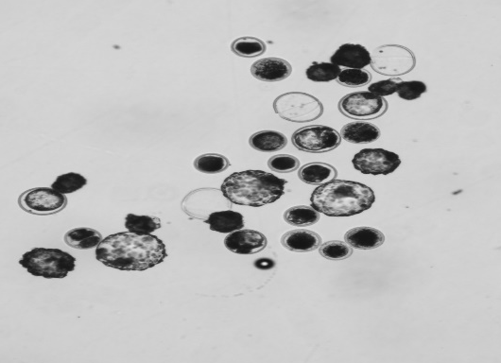
Figure 7. Hatching in slow freezing group

Slow freezing hatched blastocysts
Figure 8. Line chart showing hatching rate of devitrified and frozen thawed blastocysts

Figure 9. Representative pictures of TUNEL assay using florescence microscope with
high power (40 X)
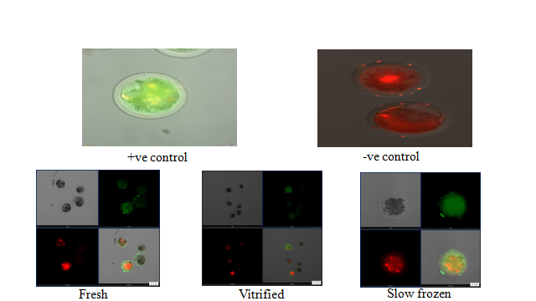

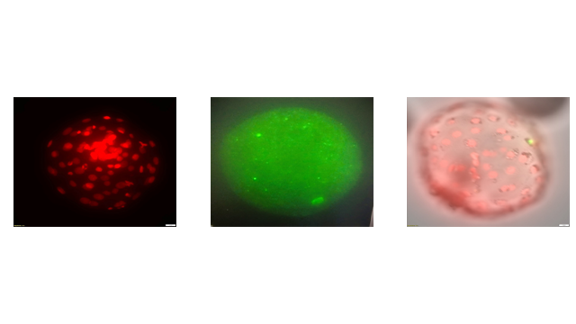
Figure 10. TUNEL assay reactive, non-reactive and hybrid image in hatched blastocyst.

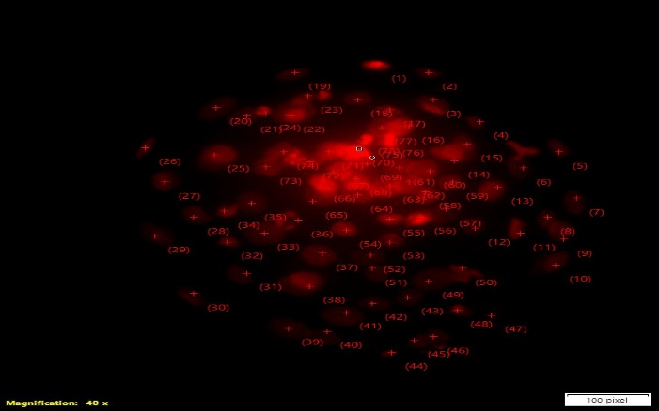
Figure 11. Cell counting in hatched blastocyst using image J software in 40X magnification

Disclaimer (Artificial intelligence)

Author(s) hereby declare that NO generative AI technologies such as Large Language Models (ChatGPT, COPILOT, etc.) and text-to-image generators have been used during the writing or editing of this manuscript.

REFERENCES

- Abdoon, A. S., Kandil, O. M., Otoi, T., & Suzuki, T. (2001). Influence of oocyte quality, culture media and gonadotropins on cleavage rate and development of in vitro fertilized buffalo embryos. Animal Reproduction Science, 65(3-4), 215-223. https://doi.org/10.1016/S0378-4320(01)00079-3
- Ahmed, A. E., Sindi, R. A., Yousef, N. A., Hussein, H. A., Badr, M. R., Syaad, K. M. A., & Ali, M. E. (2023). Impact of epidermal growth factor and/or β-mercaptoethanol supplementations on the in vitro produced buffaloes' embryos. Frontiers in Veterinary Science, 10, 1138220. https://doi.org/10.3389/fvets.2023.1138220

- Caamaño, J. N., Gómez, E., Trigal, B., Muñoz, M., Carrocera, S., Martín, D., & Díez, C. (2015). Survival of vitrified in vitro–produced bovine embryos after a one-step warming in-straw cryoprotectant dilution procedure. Theriogenology, 83(5), 881-890. https://doi.org/10.1016/j.theriogenology.2014.11.021

- De Rosa, A., Di Palo, R., Attanasio, L., Monaco, E., Campanile, G., & Gasparrini, B. (2006). 89 OPEN PULLED STRAW VITRIFICATION FOR IN VITRO-PRODUCED BUFFALO (BUBALUS BUBALIS) EMBRYOS. Reproduction, Fertility and Development, 18(2),153-153.
https://doi.org/10.1071/RDv18n2Ab89
- Do, V. H., Catt, S., Kinder, J. E., Walton, S., & Taylor-Robinson, A. W. (2019). Vitrification of in vitro-derived bovine embryos: targeting enhancement of quality by refining technology and standardizing procedures. Reproduction, Fertility and Development, 31(5), 837-846. https://doi.org/10.1071/RD18352

- Hayashi, T., Kansaku, K., Abe, T., Ueda, S., & Iwata, H. (2019). Effects of resveratrol treatment on mitochondria and subsequent embryonic development of bovine blastocysts cryopreserved by slow freezing. Animal Science Journal, 90(7), 849-856. https://doi.org/10.1111/asj.13219
- Hufana-Duran, D., Pedro, P. B., Venturina, H. V., Hufana, R. D., Salazar, A. L., Duran, P. G., & Cruz, L. C. (2004). Post-warming hatching and birth of live calves following transfer of in vitro-derived vitrified water buffalo (Bubalus bubalis) embryos. Theriogenology, 61(7-8), 1429-1439. https://doi.org/10.1016/j.theriogenology.2003.08.011
- Lim, K. T., Jang, G., Ko, K. H., Lee, W. W., Park, H. J., Kim, J. J., & Lee, B. C. (2008). Improved cryopreservation of bovine preimplantation embryos cultured in chemically defined medium. Animal reproduction science, 103(3-4), 239-248. https://doi.org/10.1016/j.anireprosci.2006.12.020
- Mahmoudzadeh, A. R., Van Soom, A., Bols, P., Ysebaert, M. T., & de Kruif, A. (1995). Optimization of a simple vitrification procedure for bovine embryos produced in vitro: effect of developmental stage, two-step addition of cryoprotectant and sucrose dilution on embryonic survival. Reproduction, 103(1), 33-39.https://doi.org/10.1530/jrf.0.1030033
- Mahmoud, K., & Seidel, J. (2010). Viability and DNA fragmentation assessment of bovine embryos vitrified by different methods. Researcher, 2, 14-20.
- Manjunatha, B. M., Gupta, P. S. P., Ravindra, J. P., Devaraj, M., & Nandi, S. (2008). In vitro embryo development and blastocyst hatching rates following vitrification of river buffalo embryos produced from oocytes recovered from slaughterhouse ovaries or live animals by ovum pick-up. Animal reproduction science, 104(2-4), 419-426. https://doi.org/10.1016/j.anireprosci.2007.06.030
- Manjunatha, B. M., Gupta, P. S. P., Ravindra, J. P., Devaraj, M., & Nandi, S. (2009). Effect of vitrification medium composition and exposure time on post-thaw development of buffalo embryos produced in vitro. The veterinary journal, 179(2), 287-291. https://doi.org/10.1016/j.tvjl.2007.08.031
- Manjunatha, B. M., Ravindra, J. P., Gupta, P. S. P., Devaraj, M., Honnappa, T. G., & Krishnaswamy, A. (2009). Post-thaw development of in vitro produced buffalo embryos cryopreserved by cytoskeletal stabilization and vitrification. Journal of Veterinary Science, 10(2), 153-156. https://doi.org/10.4142/jvs.2009.10.2.153
- Mostager, A., Montaser, A. E. M., Badr, M. R., Hegab, A. E. R. O., & Zaabel, S. M. (2017). Improvement of buffalo embryo development in vitro; effect of different culture media. Mansoura Veterinary Medical Journal, 18(1), 45-50.https://doi.org/10.21608/mvmj.2017.126864
- Najafzadeh, V., Secher, J. B. M., Pihl, M., Ærenlund, A., Jørgensen, N., Jensen, K. K., ... & Hyttel, P. (2021). Vitrification yields higher cryo-survival rate than slow freezing in biopsied bovine in vitro produced blastocysts. Theriogenology, 171, 44-54. https://doi.org/10.1016/j.theriogenology.2021.04.020
- Nedambale, T. L., Dinnyes, A., Groen, W., Dobrinsky, J. R., Tian, X. C., & Yang, X. (2004). Comparison on in vitro fertilized bovine embryos cultured in KSOM or SOF and cryopreserved by slow freezing or vitrification. Theriogenology, 62(3-4), 437-449. https://doi.org/10.1016/j.theriogenology.2003.10.020
- Nicacio, A. C., Simões, R., de Paula-Lopes, F. F., de Barros, F. R. O., Peres, M. A., Assumpção, M. E. O. D. A., & Visintin, J. A. (2012). Effects of different cryopreservation methods on post-thaw culture conditions of in vitro produced bovine embryos. Zygote, 20(2), 117-122. https://doi.org/10.1017/S0967199410000717
- Oliveira, C. S., da Silva Feuchard, V. L., de Freitas, C., da Silva Rosa, P. M., dos Reis Camargo, A. J., & Saraiva, N. Z. (2020). In-straw warming protocol improves survival of vitrified embryos and allows direct transfer in cattle. Cryobiology, 97, 222-225. https://doi.org/10.1016/j.cryobiol.2020.02.007
- Patil, S. P., Hadiya, K. K., Layek, S. S., Gorani, S., Raj, S., Karuppanasamy, K., & Gupta, R. O. (2022). Ovum Pick-Up and In vitro Embryo Production from Stimulated Vs Non-Stimulated Buffaloes. Indian Journal of Veterinary Sciences & Biotechnology, 18(1), 95-100.
- Rahangdale, S., Kumar, D., Singh, A. P., Jeena, L. M., & Sarkhel, B. C. (2021). Post-rewarming developmental competence of in vitro produced buffalo (Bubalis bubalis) embryos vitrified using the solid surface technique. Cryoletters, 42(1), 13-18.

- Rodero, M. I., García-Martínez, T., Ordóñez-León, E. A., Vendrell-Flotats, M., Olegario Hidalgo, C., Esmoris, J., & Mogas, T. (2021). A shorter equilibration period improves post-warming outcomes after vitrification and in straw dilution of in vitro-produced bovine embryos. Biology, 10(2), 142. https://doi.org/10.3390/biology10020142
- Saha, S., Otoi, T., Takagi, M., Boediono, A., Sumantri, C., & Suzuki, T. (1996). Normal calves obtained after direct transfer of vitrified bovine embryos using ethylene glycol, trehalose, and polyvinylpyrrolidone. Cryobiology, 33(3), 291-299. https://doi.org/10.1006/cryo.1996.0029

- Taniguchi, M., Ikeda, A., Arikawa, E., Wongsrikeao, P., Agung, B., Naoi, H., & Otoi, T. (2007). Effect of cryoprotectant composition on in vitro viability of in vitro fertilized and cloned bovine embryos following vitrification and in-straw dilution. Journal of Reproduction and Development, 53(4), 963-969.https://doi.org/10.1262/jrd.2023-034

- Yu, X. L., Deng, W., Liu, F. J., Li, Y. H., Li, X. X., Zhang, Y. L., & Zan, L. S. (2010). Closed pulled straw vitrification of in vitro–produced and in vivo–produced bovine embryos. Theriogenology, 73(4),474-479. https://doi.org/10.1016/j.theriogenology.2009.10.004
- Xu, J., Guo, Z., Su, L., Nedambale, T. L., Zhang, J., Schenk, J., & Du, F. (2006). Developmental potential of vitrified Holstein cattle embryos fertilized in vitro with sex-sorted sperm. Journal of dairy science, 89(7), 2510-2518.https://doi.org/10.3168/jds.S0022-0302(06)72326-8
- Pitroda, M. H., Khillare, K. P., Amle, M. B., Meshram, M. D., Mali, A. B., Rangnekar, M. N., & Zawar, S. (2021). Cleavage rate of in vitro matured oocytes fertilized with conventional semen in buffaloes. Indian Journal of Animal Research, 1(10).
- Lakshmi, V., Kulkarni, S., Satisha, K. B., Yatish, H., Girish, M. H., Kumar, G. N. & Das, A. (2020). Effect of Alpha-Tocopherol Supplementation in TCM199 Medium on In vitro Maturation and Cleavage of Buffalo Oocytes. Indian Journal of Veterinary Sciences & Biotechnology, 15(4), 66-70. https://doi.org/10.21887/ijvsbt.15.4.14
- Kumar, S., Ohashi, O., Vale, W., Melo, L., & Freitas, V. (2020). State-of-the-art and emerging technologies for in vitro embryo production in buffaloes. Journal of Advanced Veterinary Research, 10(3), 186-192.
- Patil, S. P., Hadiya, K. K., Layek, S. S., Gorani, S., Raj, S., Karuppanasamy, K. & Gupta, R. O. (2022). Ovum Pick-Up and In vitro Embryo Production from Stimulated Vs Non-Stimulated Buffaloes. Indian Journal of Veterinary Sciences & Biotechnology, 18(1), 95-100.
- Suresh, K. P., Nandi, S., & Mondal, S. (2009). Factors affecting laboratory production of buffalo embryos: a meta-analysis. Theriogenology, 72(7), 978-985. https://doi.org/10.1016/j.theriogenology.2009.06.017
- Neglia, G., Gasparrini, B., di Brienza, V. C., Di Palo, R., Campanile, G., Presicce, G. A., & Zicarelli, L. (2003). Bovine and buffalo in vitro embryo production using oocytes derived from abattoir ovaries or collected by transvaginal follicle aspiration. Theriogenology, 59(5-6), 1123-1130. https://doi.org/10.1016/S0093-691X(02)01170-6
- Ocampo, L. C., Rigos, L. M., & Ocampo, M. B. (2016). Factors influencing the maturation, fertilization and development of swamp buffalo oocyte in vitro. Research Opinions in Animal and Veterinary Sciences, 6(1), 24-31.
- Sadeesh, E. M., Sikka, P., Balhara, A. K., & Balhara, S. (2016). Developmental competence and expression profile of genes in buffalo (Bubalus bubalis) oocytes and embryos collected under different environmental stress. Cytotechnology, 68, 2271-2285. https://doi.org/10.1007/s10616-016-0022-y
- Chohan, K. R., & Hunter, A. G. (2003). In vitro maturation and fertilization of water buffalo oocytes. Buffalo Journal, 19(1), 91-102.
- Ravindranatha, B. M., Nandi, S., Raghu, H. M., & Reddy, S. M. (2003). In vitro maturation and fertilization of buffalo oocytes: effects of storage of ovaries, IVM temperatures, storage of processed sperm and fertilization media. Reproduction in Domestic Animals, 38(1), 21-26. https://doi.org/10.1046/j.1439-0531.2003.00390.x
- BAHS. (2019). Basic animal husbandry statistics 2019. Department of Animal Husbandry and Dairying. Government of India.
- Berglund, B. (2008). Genetic improvement of dairy cow reproductive performance. Reproduction in domestic animals, 43, 89-95. https://doi.org/10.1111/j.1439-0531.2008.01147.x
- Bojic, S., Murray, A., Bentley, B. L., Spindler, R., Pawlik, P., Cordeiro, J. L., & De Magalhães, J. P. (2021). Winter is coming: the future of cryopreservation. BMC biology, 19(1), 1-20.
- Caamaño, J. N., Gómez, E., Trigal, B., Muñoz, M., Carrocera, S., Martín, D., & Díez, C. (2015). Survival of vitrified in vitro–produced bovine embryos after a one-step warming in-straw cryoprotectant dilution procedure. Theriogenology, 83(5), 881-890. https://doi.org/10.1016/j.theriogenology.2014.11.021
- Do, V. H., Catt, S., Kinder, J. E., Walton, S., & Taylor-Robinson, A. W. (2019). Vitrification of in vitro-derived bovine embryos: targeting enhancement of quality by refining technology and standardizing procedures. Reproduction, Fertility and Development, 31(5), 837-846. https://doi.org/10.1071/RD18352
- Gordon, I. 1996. Controlled reproduction in cattle and buffaloes. CABI, Wallingford, UK. vol. 1. pp. 452.
- Singh, B., Chauhan, M. S., Singla, S. K., Gautam, S. K., Verma, V., Manik, R. S., ... & Mukesh, M. (2009). Reproductive biotechniques in buffaloes (Bubalus bubalis): status, prospects and challenges. Reproduction, Fertility and Development, 21(4), 499-510. https://doi.org/10.1071/RD08172
- Suthar, V. S. (2008). In vitro embryo production (IVEP) through transvaginal ultrasound-guided aspiration of follicles in crossbred cattle. M. V. Sc (Doctoral dissertation, Thesis submitted to Anand Agricultural University).
- Suthar, V. S., & Shah, R. G. (2009). Bovine In vitro embryo production: an overview. Veterinary world, 2(12), 478-479.
- Villamil, P. R., Lozano, D., Oviedo, J. M., Ongaratto, F. L., & Bó, G. A. (2018). Developmental rates of in vivo and in vitro produced bovine embryos cryopreserved in ethylene glycol based solutions by slow freezing or solid surface vitrification. Animal Reproduction (AR), 9(2), 86-92.
- 47.Vassena, R., Mapletoft, R. J., Allodi, S., Singh, J., & Adams, G. P. (2003). Morphology and developmental competence of bovine oocytes relative to follicular status. Theriogenology, 60(5), 923-932.
- https://doi.org/10.1016/S0093-691X(03)00101-8

