Morphological Variability And Yield Traits Association In Backcross Derived Rice Population for Anaerobic Germination Tolerance

ABSTRACT
In the current study BC₂F₁ Backcross population derived from cross between DRR Dhan 60 (elite recurrent parent) and Kho (donor with anaerobic germination (AG) tolerance) was evaluated in an augmented block design along with parental checks for genetic variability and trait association for yield-related traits. The objective was to assess AG1 QTL introgression potential into DRR Dhan 60. Genetic parameters including phenotypic and genotypic coefficients of variation, broad sense heritability (h²bs), and genetic advance (GAM) were evaluated. Results revealed significant variability in key traits, with high heritability (>80%) for plant height (PH), panicle length, and kernel length. Grain yield per plant (GYP) showed strong positive correlation with Plant height (PH) and moderate correlations with flag leaf dimensions, suggesting these traits as effective selection markers. The population displayed recovered genetic background stability from DRR Dhan 60 while introducing AG1-derived variation. Findings demonstrate that Plant height and yield components are prime targets for direct selection, whereas other traits may require later-generation selection. This work provides a framework for developing climate-resilient, direct-seeded rice varieties.
Keywords: Rice breeding, Anaerobic germination tolerance, Backcross population, Quantitative trait loci (QTL), Genetic variability, Direct-seeded rice.
INTRODUCTION
Rice (Oryza sativa L.) stands as a fundamental pillar of global food security, serving as the primary dietary energy source for over 50 % of the human population and contributing more than 20% of the world's total dietary energy intake (FAO,2023). As the global population continues its upward trajectory, the demand for food is projected to increase substantially, placing immense pressure on agricultural systems worldwide (Mondal et al., 2020). This continuous increase in demand underscores the critical need for sustained innovation in rice breeding. The development of new, high-yielding, and resilient rice varieties is not merely an agricultural goal but a fundamental imperative to ensure adequate food supply and maintain global food security in the coming decades. This ongoing challenge highlights the pivotal role of genetic improvement in agricultural research, as breeders strive to push the boundaries of productivity and adaptability in this crucial staple crop.
Despite its global importance, rice production is constantly challenged by a myriad of abiotic and biotic factors that impede yield potential (Mondal et al.,2020). Among the most significant abiotic stresses, flooding and water logging pose severe threats, particularly during the critical stages of seed germination and early seedling growth. This is especially true in direct-seeded rice (DSR) systems, where seeds are sown directly into flooded or waterlogged fields, leading to poor crop establishment and substantial yield losses (Pandey and Kumar,2021). The increasing adoption of DSR systems, driven by its efficiency and water-saving benefits compared to traditional transplanting methods, further intensifies the need for rice varieties capable of tolerating these conditions.
Anaerobic germination(AG) tolerance emerges as a crucial adaptive trait for successful DSR cultivation in flood-prone environments (Ismail et al.,2012).This trait enables rice seedlings to germinate and emerge above the water surface even under hypoxic or anoxic conditions (Rathod et al.,2024).The underlying mechanisms of AG tolerance involve rapid coleoptile elongation, which acts as a "snorkel" to reach the water surface and facilitate gas exchange, along with a primary metabolic shift from aerobic to anaerobic respiration to generate the necessary energy for sustained growth (Rathod et al.,2024).Beyond flooding, rice production also contends with other significant abiotic stresses such as low soil phosphorus(P) deficiency, which limits nutrient uptake and overall plant vigor, and various biotic stresses like bacterial blight (BB) and the brown plant hopper (BPH), a destructive phloem-sucking herbivore that can cause up to 80% yield loss (Ashkani et al., 2016). The complex interplay of these stresses necessitates a multi-faceted breeding approach to develop robust and adaptable rice cultivars.
To effectively address the multifaceted challenges in rice production, modern breeding strategies are indispensable. Marker-assisted backcross breeding(MABB) offers a promising and precise approach to combine desirable traits, such as high yield and multiple stress tolerances, into elite rice varieties (Collard and Mackill, 2008).This method involves using an elite, high-performing variety as a recurrent parent and systematically incorporating well-defined quantitative trait loci (QTLs) or genes from a donor parent (Neeraja et al., 2007).The process allows for the targeted transfer of specific desirable genetic segments while efficiently recovering the superior genetic background of the recurrent parent, minimizing linkage drag and accelerating the breeding cycle (Swamy and Kumar, 2013).The development of multi-stress tolerant rice varieties through gene pyramiding, where multiple resistance or tolerance genes/QTLs are combined into a single genetic background, represents a strategic evolution in plant breeding (Badri et al., 2022).This approach moves beyond single-trait improvement to develop "climate-smart" varieties capable of withstanding complex and co-occurring stresses, which are becoming increasingly prevalent due to climate change (Bandumula et al.,2020).This signifies a paradigm shift in breeding objectives, emphasizing holistic resilience over isolated trait enhancement, a crucial step for ensuring sustainable agriculture in a changing global environment.
This study focuses on a specific BC₂F₁ backcross population derived from a cross between DRR Dhan 60 and Kho. DRR Dhan 60, an elite high-yielding variety, serves as the recurrent parent, while Kho, a traditional landrace, is the donor parent chosen for its known tolerance to anaerobic germination. The primary objective of this investigation is to conduct a detailed genetic analysis of yield and yield-attributing traits within this BC₂F₁ population. This includes assessing genetic variability, understanding inter-trait correlations, and evaluating the potential for genetic improvement. A key implicit objective of this breeding effort is to facilitate the introgression of the AG1 QTL from Kho into the DRR Dhan 60 background. This strategic combination aims to enhance DRR Dhan 60's already desirable traits with crucial early stage flooding tolerance, thereby broadening its adaptability to diverse and challenging cultivation environments, particularly those involving direct-seeded rice systems.
DRR Dhan 60 is a distinguished elite rice cultivar developed by the ICAR-Indian Institute of Rice Research (ICAR-IIRR), recognized for its high yield potential and fine-grain type. This variety is a product of Marker-Assisted Selection (MAS) breeding, a modern approach that leverages molecular markers for precise gene introgression. DRR Dhan 60 is particularly notable for its robust tolerance to low soil phosphorus(P)and strong resistance to bacterial blight (BB), a devastating rice disease.Its genetic profile includes three major bacterial blight resistance genes: Xa21, xa13, and xa5. Furthermore, it carries the major QTL Pup1, which is associated with tolerance to low soil phosphorus conditions. This combination of resistances makes DRR Dhan 60 a highly valuable genetic resource.
Kho, also widely known as Khao Hlan On (KHO), is a traditional landrace of rice that has gained significant recognition in breeding programs as a valuable donor for anaerobic germination (AG) tolerance (Shin et al.,2020). This landrace exhibits superior performance under flooded conditions, demonstrating faster germination rates and higher coleoptile emergence compared to susceptible varieties (Etsiko et al.,2014). This inherent tolerance is physiologically linked to its remarkable ability to rapidly degrade starch into soluble sugars, a critical process for energy generation under oxygen-deficient environments, and to maintain high α-amylase activity even under anoxic stress (Rathod et al.,2024).
The AG1 QTL, specifically designated as qAG-9-2, represents a major quantitative trait locus conferring anaerobic germination tolerance in rice, with its origin traced back to the donor parent Khao Hlan On (Mwakyusa et al.,2023).This significant QTL is genetically mapped to the long arm of chromosome 9 and has been shown to explain a substantial portion of the phenotypic variation observed for flooding tolerance, with reported contributions as high as 33.5% (Miro et al., 2017)
MATERIALS AND METHODS
A BC₁F₁ population derived from a cross between DRR Dhan 60 and Kho was backcrossed with the recurrent parent DRR Dhan 60 to develop BC₂F₁ cross material. Genetic variability parameters, correlation, and Principal Component Analysis (PCA) were evaluated in this BC₂F₁ population for yield and yield-related traits.
The experiment was conducted at ICAR- Indian Institute of Rice Research, Hyderabad, Telangana. The BC₂F₁ population was evaluated in an augmented block design along with parental checks DRR Dhan 60 and Kho. The experimental material was grown in one row with a spacing of 20 x 15 cm following standard agronomic practices to ensure optimal crop growth. Observations were recorded for 16 quantitative traits including Days to 50% flowering (DFF), Plant height (PH), Number of tillers (NT), Productive tillers per plant (PT), Flag leaf length (FLL),flag leaf width (FLW), Panicle length(PL), Total spikelets (TS), Filled spikelets (FS), Unfilled spikelets (UFS), spikelet fertility (SF%),Test weight (X1000GW), single plant yield (GYP), kernel length (KL), Kernel breadth (KB) and Kernel length/breadth ratio (L.B. ratio).
The obtained data were analysed using the following statistical methods. First, averages were computed from the raw data and subjected to further analysis. Analysis of Variance (ANOVA) was performed using R statistical software with the 'augmented RCBD' package. Phenotypic coefficient of variation (PCV) and genotypic coefficient of variation (GCV) values were calculated according to the method described by Burton and Devane (1953), with results categorized using the classification system proposed by Sivasubramanian and Madhavamenon (1973) as: low (<10%), medium (10-20%), and high (>20%).
Broad-sense heritability (h²bs) and genetic advance were computed following standard quantitative genetic procedures (Falconer and Mackay, 1996; Johnson et al., 1955). Heritability estimates were classified as: low (<30%), moderate (30-60%), or high (>60%), while genetic advance as percentage of mean (GAM) was grouped as: low (<10%), moderate (10-20%), or high (>20%), consistent with established protocols (Robinson et al., 1949). Trait associations were examined through correlation analysis using R v4.3.0. Furthermore, principal component analysis (PCA), biplots were also generated in order to visualize the data effectively.
GENETIC ANALYSIS OF THE BC₂F₁ POPULATION (DRR DHAN 60×KHO)
Genetic variability is a cornerstone for any successful plant breeding program, as it represents the raw material from which breeders can select and develop improved varieties. To quantify the extent of this variability and predict the potential for genetic gain under selection, several key parameters are routinely estimated. These include the phenotypic coefficient of variation (PCV), genotypic coefficient of variation (GCV), broad-sense heritability (h²bs) and genetic advance as percentage of mean (GAM). PCV reflects the total observed variation for a trait, while GCV indicates the portion of variation attributable to genetic factors. Heritability estimates the proportion of phenotypic variation that is genetically determined and thus transmissible to the next generation. Genetic advance, on the other hand, predicts the expected improvement in a trait under a given selection intensity.
RESULTS AND DISCUSSION
Analysis of Variance (ANOVA)
The Analysis of Variance (ANOVA) was conducted to assess the genetic variability among the individuals within the DRR Dhan 60×Kho BC₂F₁ population for the traits studied (Table I, Table II, Figure 1). The results from the "Treatment:Test" effect indicated highly significant variability for Panicle Length (PL) and Kernel Length (KL), highlighting their strong genetic control and promising potential for effective selection. For other traits, including Days to 50%Flowering (DFF), Plant Height (PH), Number of Tillers (NT), Productive Tillers (PT), Flag Leaf Length (FLL), Flag Leaf Width (FLW),Total Spikelets (TS),Filled Spikelets (FS), Unfilled Spikelets (UFS), Spikelet Fertility (SF), Test weight (X1000GW), Grain Yield per Plant (GYP) and Kernel Breadth (KB) the analysis revealed a notable level of phenotypic consistency among the test lines. This consistency is a positive outcome of the backcrossing strategy, demonstrating successful recovery of the recurrent parent's genetic background and providing a stable foundation for further breeding efforts.
Furthermore, the "Treatment:Test vs. Check" comparison showed significant variability for Plant Height (PH), Panicle Length (PL), Grain Yield per Plant (GYP) and Kernel Length (KL). These significant differences indicate the successful introduction of new genetic variation for these crucial traits, offering clear opportunities for selection to enhance overall performance. The presence of significant variability in these key traits underscores the potential for effective selection strategies within this backcross population, paving the way for the development of superior lines.

Table I. Analysis of variance for yield and yield attributing traits in backcross derived lines
Source | Df | Mean Square
Source |  | DFF | PH | NT | PT | FLL | FLW | PL | TS
Treatment(ignoring Blocks) | 11 | 6.41 | 958.14 | 5.36 | 6.45 | 63.21 | 0.02 | 1.94 | 4122.23
Treatment:Check | 1 | 9 | 100 | 0.25 | 0.25 | 52.56 | 0.01 | 4 | 17689
Treatment : Test | 9 | 5.43 | 689.39 | 3.17 | 3.39 | 71.2 | 0.03 | 1.5 | 3016.68
Treatment:Test vs Check | 1 | 12.6 | 4235 | 30.18 | 40.18 | 1.85 | 0.02 | 3.78 | 505.4
Block (eliminating Treatments) | 1 | 0.62 | 0.54 | 0.25 | 0.25 | 0.06 | 0.02 | 1 | 529
Residuals | 1 | 1 | 4 | 2.25 | 2.25 | 1.56 | 0.01 | 0.25 | 784

Table II. Analysis of variance for yield and yield attributing traits in backcross derived lines
Source | Df | Mean Square
Source |  | FS | UFS | SF | X1000GW | GYP
Treatment (ignoring Blocks) | 11 | 2884.4 | 604.63 | 65.83 | 2.46 | 308.43
Treatment : Check | 1 | 8372.25 | 1722.25 | 73.27 | 7.87 | 25
Treatment : Test | 9 | 2561.78 | 371.57 | 42.28 | 1.11 | 209.58
Treatment : Test vs Check | 1 | 300.18 | 1584.58 | 270.32 | 9.28 | 1481.48
Block (eliminating Treatments) | 1 | 182.25 | 1332.25 | 95.8 | 0.09 | 0.21
Residuals | 1 | 110.25 | 1482.25 | 112.59 | 0.21 | 1

Figure1 : Box-plots depicting Phenotypic distribution of yield-related traits in the BC₂F₁ population

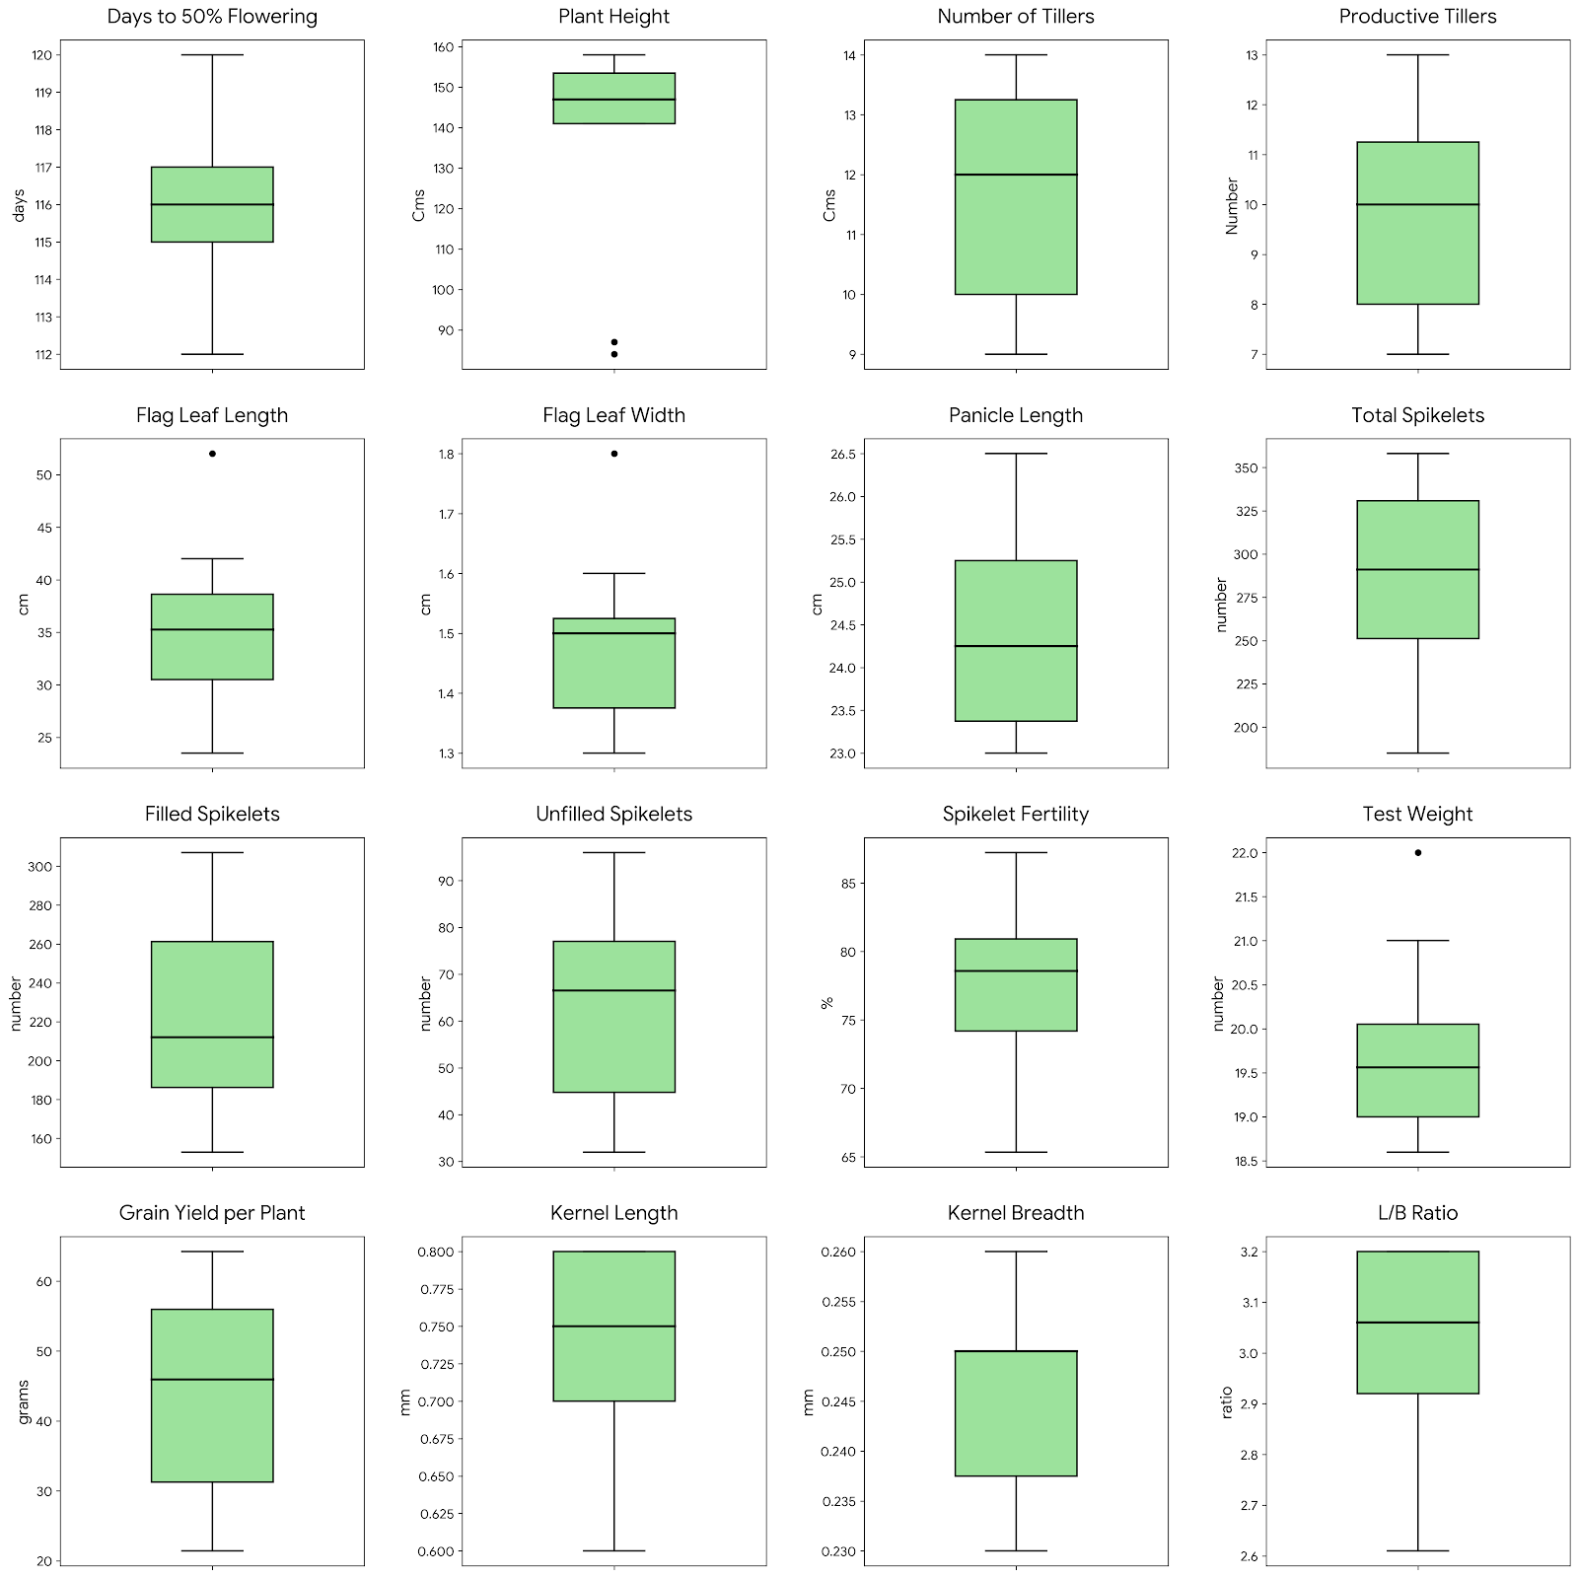

Interpretation of Genetic Variability and Heritability in the DRR Dhan 60×Kho BC₂F₁ Population
The assessment of genetic parameters revealed significant variability, providing a foundation for effective selection. The relationship between the Genotypic Coefficient of Variation (GCV), Phenotypic Coefficient of Variation (PCV), and estimated Genetic Advance offers a clear roadmap for crop improvement strategies.The estimates of genetic variability parameters and heritability of the current study are as given in the Table III.
The study observed that for all quantitative traits, the Phenotypic Coefficient of Variation (PCV) was marginally higher than its corresponding Genotypic Coefficient of Variation (GCV). This indicates that while the environment influenced the expression of these traits, the genetic component remained the primary driver of the observed diversity.Traits such as Grain Yield per Plant (GYP) and Flag Leaf Length exhibited high GCV values, suggesting a wide genetic base. Conversely, traits like Days to 50% Flowering showed a narrow GCV, indicating that the population is relatively uniform for phenological maturity, which may limit the potential for further selection-based shifts in flowering time within this specific group.Broad-sense heritability was found to be high for the majority of the traits studied. However, the most critical findings emerged from the coupling of heritability with Grain Yield per Plant and Filled Spikes demonstrated high heritability alongside high GAM. This specific combination is a strong indicator of additive gene action. From a breeding perspective, this is the most favorable scenario, as it implies that the superior performance of selected individuals is highly likely to be transmitted to their progeny, making simple mass selection or progeny selection highly effective. Traits like Plant Height and Panicle Length exhibited high heritability but relatively low GAM. This suggests the presence of non-additive gene action (epistasis or dominance). These traits would be better improved through heterosis breeding or by creating segregating populations through hybridization.
The gap between GCV and PCV was most pronounced in Number of Tillers and Productive Tillers. This disparity suggests that tillering capacity is highly sensitive to environmental fluctuations such as plant density, nutrient availability, and soil moisture. Consequently, selecting for high tillering plants in a single environment or a single season may result in false positives, where the performance is due to favorable micro environments rather than superior genetics. For these traits, selection efficiency would be improved by multi-location testing or by using index-based selection.Based on these results, Grain Yield per Plant and Flag Leaf Area serve as the most reliable primary selection indices. The high genetic gain associated with these traits ensures that the breeder can achieve rapid population improvement. For traits governed by non-additive effects or high environmental sensitivity, more complex breeding schemes such as recurrent selection or the development of hybrids are recommended to overcome the limitations of simple selection.

Table III: Analysis of variance and genetic variability components in the experimental population
Trait | Mean | GCV | PCV | GCV | hBS | GA | GAM
DFF | 116.25 | 1.81 | 2.01 | 1.81 | 81.6 | 3.92 | 3.38
PH | 128.08 | 20.44 | 20.5 | 20.44 | 99.42 | 53.85 | 42.04
NT | 12.04 | 7.95 | 14.78 | 7.95 | 28.95 | 1.06 | 8.83
PT | 10.13 | 10.54 | 18.18 | 10.54 | 33.61 | 1.28 | 12.61
FLL | 34.2 | 24.4 | 24.67 | 24.4 | 97.81 | 17.03 | 49.78
FLW | 1.47 | 8.68 | 11.04 | 8.68 | 61.86 | 0.21 | 14.09
PL | 24.46 | 5.01 | 5.01 | 5.01 | 100 | 2.53 | 10.34
TS | 270.08 | 17.5 | 20.34 | 17.5 | 74.01 | 83.86 | 31.05
FS | 213.71 | 23.17 | 23.68 | 23.17 | 95.7 | 99.92 | 46.76
X1000GW | 19.53 | 4.86 | 5.39 | 4.86 | 81.29 | 1.76 | 9.03
GYP | 36.98 | 39.06 | 39.15 | 39.06 | 99.52 | 29.72 | 80.39
KL | 0.74 | 9.1 | 9.1 | 9.1 | 100 | 0.14 | 18.77

Correlation Analysis of Yield and Yield-Attributing Traits
Understanding the relationships between different traits is a crucial step in plant breeding, as it allows for the development of effective indirect selection strategies. When traits are correlated, selecting for one trait can lead to a simultaneous improvement in another, particularly if the target trait is difficult or expensive to measure directly. Correlation studies provide quantitative measures of these interrelationships, indicating both the strength and direction of association.
The correlation coefficients for yield and yield-attributing traits in the DRR Dhan 60×Kho BC₂F₁ population are presented in Figure 2. Grain yield per plant (GYP) exhibited a strong positive phenotypic correlation with Plant Height (PH) (0.7886) similar to results reported by Singh et al., (2017), Kumar et al., (2014). GYP also showed positive correlations with Flag Leaf Length (FLL )(0.2876) and Flag Leaf Width (FLW) (0.2588), indicating that larger flag leaves, which are crucial for photosynthesis and grain filling, are generally associated with higher yield as reported by Quilloy et al., (2021).This suggests that in this specific genetic background, yield optimization may be more effectively achieved by focusing on traits like plant height and flag leaf dimensions, which directly contribute to photosynthetic capacity and grain filling. This nuanced understanding allows for the development of highly targeted selection strategies, ensuring that breeding efforts are precisely aligned with the specific genetic potential of this population. Further physiological investigation into these relationships will provide deeper insights for maximizing yield components. Number of Tillers (NT) and Productive Tillers (PT) were highly positively correlated (0.8870), which is biologically consistent. Similarly, Filled Spikelets (FS) and Total Spikelets (TS) were highly correlated (0.8953),indicating that lines with a greater total number of spikelets also tend to have a higher proportion of filled ones, which is favorable for yield.Test Weight (X1000GW) was positively correlated with Total Spikelets (TS) (0.4471) and Filled Spikelets (FS)(0.3311) Kernel Length (KL) and Kernel Breadth (KB) showed a positive correlation (0.5506).
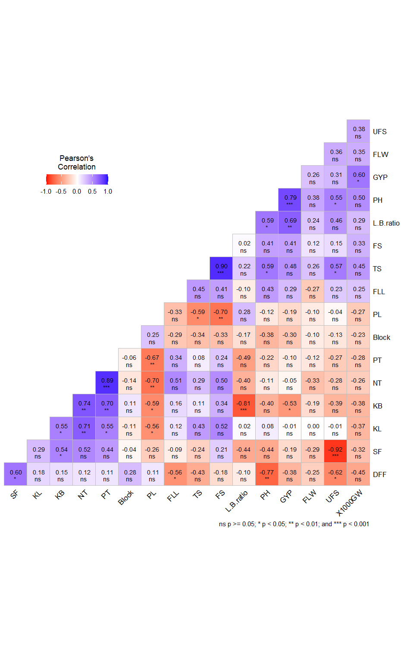
Figure 2. Correlogram illustrating phenotypic associations among yield and yield contributing traits
Principal Component Analysis (PCA)
Principal Component Analysis (PCA) is an indispensable multivariate statistical tool in genetic analysis, widely employed for dissecting complex datasets and identifying the major axes of variation among breeding lines. Its primary utility lies in reducing the dimensionality of data by transforming a set of correlated variables into a smaller set of uncorrelated variables, known as principal components (PCs), which collectively capture most of the data's variance. PCA helps in visualizing data effectively, revealing underlying patterns and relationships that might not be apparent from univariate or simple correlation analyses.
Principal Component Analysis (PCA)was conducted to dissect the complex relationships among the 16 quantitative traits and identify the major sources of variation within the DRR Dhan 60×Kho BC₂F₁ population (Table IV, Figure 3). The analysis revealed 10 principal components, with the first four PCs cumulatively explaining a substantial 86.45% of the total phenotypic variance, indicating they capture the most significant dimensions of genetic diversity. Comparable cumulative variance with four major principal components was reported previously by Gireesh et al., (2017) and Lakshmi et al., (2019).
Table IV: Eigen values and contribution of variability for the principal component axis
 | PC1 | PC2 | PC3 | PC4 | PC5 | PC6 | PC7 | PC8 | PC9 | PC10
Eigenvalue | 7.105 | 3.02 | 2.2 | 1.49 | 0.85 | 0.53 | 0.43 | 0.31 | 0.02 | 4.923
Variance% | 44.41 | 18.91 | 13.8 | 9.31 | 5.35 | 3.35 | 2.69 | 1.99 | 0.15 | 3.07
Cumulative% | 44.41 | 63.32 | 77.12 | 86.44 | 91.79 | 95.14 | 97.84 | 99.84 | 100 | 100
DFF | -0.159 | -0.409 | -0.298 | -0.053 | -0.340 | -0.027 | -0.081 | -0.200 | -0.087 | -0.594
PH | 0.328 | 0.174 | 0.049 | 0.061 | 0.321 | -0.011 | -0.147 | 0.303 | -0.450 | -0.296
NT | 0.317 | -0.082 | 0.126 | -0.289 | -0.271 | -0.224 | -0.105 | -0.029 | -0.608 | 0.258
PT | 0.264 | 0.027 | 0.304 | 0.133 | -0.472 | -0.268 | -0.075 | -0.350 | 0.120 | 0.070
FLL | 0.203 | 0.099 | 0.389 | -0.423 | 0.154 | -0.194 | -0.245 | 0.130 | 0.359 | -0.482
FLW | 0.061 | 0.049 | -0.123 | 0.720 | 0.147 | -0.329 | -0.440 | -0.056 | -0.024 | -0.091
PL | -0.295 | 0.159 | -0.057 | -0.236 | -0.082 | -0.054 | -0.690 | 0.096 | 0.174 | 0.344
TS | 0.341 | -0.039 | -0.130 | -0.030 | 0.185 | 0.375 | -0.122 | -0.237 | 0.072 | 0.012
FS | 0.308 | -0.221 | -0.127 | -0.076 | 0.287 | 0.271 | -0.144 | -0.230 | 0.005 | 0.199
UFS | 0.165 | 0.470 | -0.037 | 0.114 | -0.226 | 0.357 | 0.030 | -0.071 | 0.192 | -0.076
SF | 0.023 | -0.540 | -0.046 | -0.079 | 0.293 | -0.212 | -0.051 | -0.008 | 0.206 | 0.140
TW | 0.108 | -0.305 | 0.426 | 0.305 | -0.098 | 0.060 | 0.180 | 0.475 | 0.184 | 0.135
GYP | 0.333 | -0.182 | 0.160 | 0.088 | -0.095 | 0.146 | -0.110 | -0.238 | 0.184 | 0.000
KL | 0.286 | 0.021 | -0.402 | -0.060 | -0.159 | -0.153 | 0.061 | 0.247 | 0.164 | -0.098
KB | 0.237 | 0.230 | -0.300 | -0.093 | 0.163 | -0.526 | 0.342 | -0.124 | 0.230 | 0.162
LB. ratio | 0.256 | -0.120 | -0.369 | -0.021 | -0.332 | 0.128 | -0.146 | 0.492 | 0.116 | 0.104

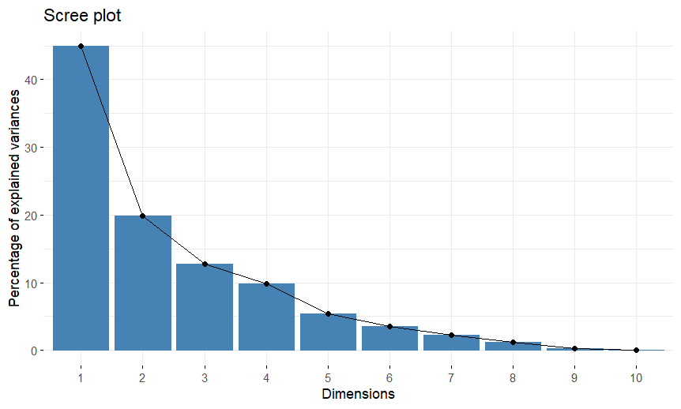
Figure 3. Scree plot depicting eigenvalues and percentage of explained variance for the principal components
Analysis of component loadings provides insights into the specific traits contributing most to each principal component . In Figure 4 PCA biplot, PCA graph of different traits for first two principal components shows that PC1(44.41%of variance) showed strong positive loadings for Plant Height (PH), Number of Tillers (NT), Total Spikelets (TS), Filled Spikelets (FS) and Grain Yield per Plant (GYP). PC2 (18.91%of variance) was primarily influenced by Days to 50% Flowering (DFF), Unfilled Spikelets (UFS), and Spikelet Fertility (SF). PC3(13.81%of variance) showed notable contributions from Flag Leaf Length (FLL),1000 Seed Weight (TW), Kernel Length (KL), Kernel Breadth (KB) and Kernel L/B ratio (L.B. ratio). PC4 (9.32%of variance) was strongly influenced by Flag Leaf Width (FLW).These findings were in similar to findings reported by earlier workers (Liu et al., 2021), indicating that these traits are the primary drivers of morphological and yield-related diversity within the BC₂F₁ population, offering clear targets for selection to enhance overall performance and adaptability.
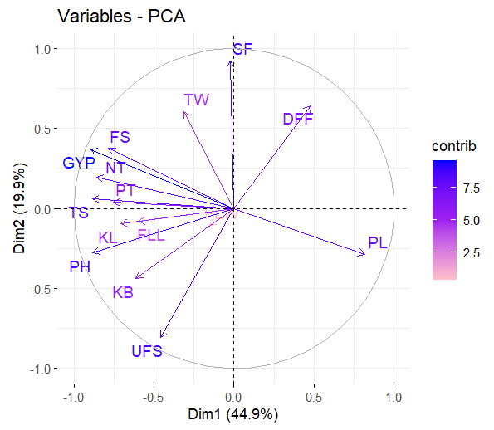
Figure 4. PCA biplot illustrating the relationship between yield traits across the first two principal components
DISCUSSION
The genetic analysis of the BC₂F₁ population successfully revealed significant variability and strong trait associations, providing valuable insights for the selection of superior genotypes. The high estimates of broad-sense heritability for key morphological traits such as plant height (PH), panicle length, and kernel length indicate a predominant role of genetic factors in their expression. This finding is crucial, as it suggests that selection for these traits in early generations would be highly effective, leading to substantial genetic gains. high broad-sense heritability coupled with high Genetic Advance as percent of Mean (GAM) was observed for Grain Yield per Plant and Filled Spikelets. This specific combination serves as a definitive indicator of additive gene action.Conversely, traits like Plant Height and Panicle Length exhibited high heritability but low GAM, pointing toward non-additive gene action.
Strong positive correlation was observed between grain yield per plant (GYP) and plant height. This relationship suggests that taller plants in this population tend to produce higher yields, making plant height a highly effective primary selection criterion. Similarly, the moderate positive correlations of GYP with flag leaf length and width further reinforce the potential of these traits as secondary markers for selecting high-yielding lines. These findings align with established principles of quantitative genetics and provide a clear, practical strategy for breeders to select for enhanced yield. The BC₂F₁ population's successful recovery of the desirable genetic background from the elite recurrent parent (DRR Dhan 60), while simultaneously exhibiting new variation derived from the AG1 gene, demonstrates the efficacy of the backcross breeding approach. This confirms that the AG1-derived variation was effectively introgressed without compromising the superior agronomic characteristics of the recurrent parent. This dual outcome is a major success of the breeding strategy and lays a solid foundation for further breeding efforts.
CONCLUSION
In conclusion, this study provides a comprehensive genetic assessment of a BC₂F₁ rice population, successfully validating the efficacy of using a backcross breeding strategy to combine desirable traits from different parents, further generation advancement through selfing is required to achieve trait fixation. This population serves as a critical baseline for identifying promising recombinants that will be validated in subsequent and generations.The successful introgression of the AG1-derived anaerobic germination (AG) tolerance into the elite background of DRR Dhan 60 represents a significant step towards developing climate-resilient, direct-seeded rice varieties.
DISCLAIMER

Author(s) hereby declare that NO generative AI technologies such as Large Language Models (ChatGPT, COPILOT, etc.) and text-to-image generators have been used during the writing or editing of this manuscript.

REFERENCES:
Ashkani, S., Rafii, M.Y., Shabanimofrad, M., Ghasemzadeh, A., Ravanfar, S.A. and Latif, M.A. (2016) 'Molecular breeding strategy and challenges towards improvement of blast disease resistance in rice crop', Frontiers in Plant Science, 6, pp. 886-896.
Badri, J., Lakshmidevi, G., JaiVidhya, L.R.K., Prasad, M.S., Laha, G.S., Lakshmi, V.J., Isetty, S.R., Padmashree, R., Balakrishnan, D., Varanasi, Y.V.P. and Jukanti, A.K. (2022) 'Multiparent-derived, marker-assisted introgression lines of the elite Indian rice cultivar "Krishna Hamsa" show resistance against bacterial blight and blast and tolerance to drought', Plants, 11(5), pp. 622-635.
Bandumula, N., Subba Rao, L.V., Sundaram, R.M., Muthuraman, P., Swamy, A.V.S.R., Abdul Fiyaz, R., Chiranjeevi, M. and Chaitanya, U. (2020) 'An estimate on the adoption of ICAR-IIRR released varieties and their impact on rice production in India during 2015-20', Journal of Rice Research, 13(2), pp. 67-75.
Burton, G.W. and Devane, D.E. (1953) 'Estimating heritability in tall fescue (Festuca arundinacea) from replicated clonal material', Agronomy Journal, 45(10), pp. 478-481.
Collard, B.C.Y. and Mackill, D.J. (2008) 'Marker-assisted selection: an approach for precision plant breeding in the twenty-first century', Philosophical Transactions of the Royal Society B: Biological Sciences, 363(1491), pp. 557-572.
Estioko, L.P., Miro, B., Baltazar, A.M., Merca, F.E., Ismail, A.M. and Johnson, D.E. (2014) 'Differences in responses to flooding by germinating seeds of two contrasting rice cultivars and two species of economically important grass weeds', AoB Plants, 6, plu064.
FAO (2023) The state of food security and nutrition in the world (SOFI) 2023. Rome: Food and Agriculture Organization.
Falconer, D.S. and Mackay, T.F.C. (1996) Introduction to quantitative genetics, 4th edn. Harlow: Pearson Prentice Hall.
Gireesh, C., Husain, S.M., Shivakumar, M., Satpute, G.K., Kumawat, G., Arya, M., Agarwal, D.K. and Bhatia, V.S. (2017) 'Integrating principal component score strategy with power core method for development of core collection in Indian soybean germplasm', Plant Genetic Resources: Characterization and Utilization, 15(3), pp. 230-238.
Ismail, A.M., Johnson, D.E., Ella, E.S., Vergara, G.V. and Baltazar, A.M. (2012) 'Mechanisms associated with tolerance to flooding during germination and early seedling growth in rice (Oryza sativa)', Annals of Botany, 109(1), pp. 197-209.
Johnson, H.W., Robinson, H.F. and Comstock, R.E. (1955) 'Estimates of genetic and environmental variability in soybeans', Agronomy Journal, 47(7), pp. 314-318.
Kumar, A., Dixit, S., Ram, T., Yadaw, R.B., Mishra, K.K. and Mandal, N.P. (2014) 'Breeding high-yielding drought-tolerant rice: genetic variations and conventional and molecular approaches', Journal of Experimental Botany, 65(21), pp. 6265-6278.
Lakshmi, V.J., Sreedhar, M., Vanisri, S., Anantha, M.S., Rao, L.V.S. and Gireesh, C. (2019) 'Multivariate analysis and selection criteria for identification of African rice (Oryza glaberrima) for genetic improvement of indica rice cultivars', Plant Genetic Resources: Characterization and Utilization, 17(6), pp. 499-505.
Liu, Z., Zhu, Y., Shi, H., Qiu, J., Ding, X. and Kou, Y. (2021) 'Recent progress in rice broad-spectrum disease resistance', International Journal of Molecular Sciences, 22(21), 11658.
Miro, B., Longkumer, T., Entila, F.D., Kohli, A. and Ismail, A.M. (2017) 'Rice seed germination underwater: morpho-physiological responses and the bases of differential expression of alcoholic fermentation enzymes', Frontiers in Plant Science, 8, 1857.
Mondal, S., Khan, M.I.R., Entila, F., Dixit, S., Sta. Cruz, P.C., Ali, M.P., Pittendrigh, B., Septiningsih, E.M. and Ismail, A.M. (2020) 'Responses of AG1 and AG2 QTL introgression lines and seed pre-treatment on growth and physiological processes during anaerobic germination of rice under flooding', Scientific Reports, 10, 10214.
Mwakyusa, L., Heredia, M.C., Kilasi, N.L., Madege, R.R., Herzog, M. and Dixit, S. (2023) 'Screening of potential donors for anaerobic stress tolerance during germination in rice', Frontiers in Plant Science, 14, 1261101.
Neeraja, C.N., Maghirang-Rodriguez, R., Pamplona, A., Heuer, S., Collard, B.C.Y., Septiningsih, E.M., Vergara, G., Sanchez, D., Xu, K., Ismail, A.M. and Mackill, D.J. (2007) 'A marker-assisted backcross approach for developing submergence-tolerant rice cultivars', Theoretical and Applied Genetics, 115(6), pp. 767-776.
Pandey, A. and Kumar, A. (2021) 'Breeding rice for direct-seeded conditions: challenges and opportunities', Theoretical and Applied Genetics, 134(5), pp. 1327-1350.
Quilloy, F.A., Labaco, B., Casal, C. and Dixit, S. (2021) 'Crop establishment in direct-seeded rice: traits, physiology, and genetics', in Rice improvement. Cham: Springer, pp. 171-202.
Rathod, R., Dinesh, A. and Sreedhar, M. (2024) 'Genetic assessment of germplasms for anaerobic germination in rice', Asian Journal of Soil Science and Plant Nutrition, 10(1), pp. 272-285.
Robinson, H.F. (1949) 'Expected overlap between relatives in corn under assortative mating', Genetics, 34(5), pp. 552-556.
Shin, N.H., Han, J.H., Jang, S., Song, K., Koh, H.J., Lee, J.H., Yoo, S. and Chin, J.H. (2020) 'Early vigor of a pyramiding line containing two quantitative trait loci, phosphorus uptake 1 (Pup1) and anaerobic germination 1 (ag1) in rice (O. sativa L.)', Agriculture, 10(10), 453.
Sivasubramanian, S. and Madhavamenon, P. (1973) 'Genetic analysis of quantitative characters in rice through diallel crosses', Madras Agricultural Journal, 60(7-9), pp. 1097-1108.
Swamy, B.P.M. and Kumar, A. (2013) 'Genomics-based precision breeding approaches to improve drought tolerance in rice', Biotechnology Advances, 31(8), pp. 1308-131

