GIS analysis of prevalence of foliar disease caused by Microdochium sorghiin in Sorghum of Uttarakhand and adjoining areas of Uttar Pradesh

ABSTRACT
Zonate leaf spot of sorghum, caused by Microdochium sorghi, has emerged as an important foliar disease affecting sorghum production in humid and warm regions. The present study was conducted to assess the prevalence, incidence, severity, and spatial distribution of zonate leaf spot in major sorghum-growing areas of Uttarakhand and adjoining districts of Uttar Pradesh during two consecutive Kharif seasons (2021 and 2022). Field surveys were carried out across 62 villages covering nine districts of Uttarakhand and three districts of Uttar Pradesh. Disease incidence and severity were recorded following standard survey procedures, and severity was assessed using a 1–9 disease rating scale. During 2021, disease incidence and severity ranged from 10.0 to 88.0% and 5.12 to 83.33%, respectively, while in 2022, they ranged from 13.0 to 88.0% and 6.14 to 86.50%. The highest disease incidence and severity were consistently recorded in Pantnagar and Khatima of Udham Singh Nagar district, whereas the lowest were observed in Kiri Gaon of Pithoragarh district. One village, Devkatiya, remained free from zonate leaf spot during both years. Pooled analysis revealed that Udham Singh Nagar district recorded the highest mean disease incidence (78.94%) and severity (65.75%), while Pithoragarh district recorded the lowest mean incidence (5.75%) and severity (2.81%). Out of 62 surveyed fields, 61 were infected, indicating a high disease prevalence of 98.38%. The widespread occurrence and high prevalence of zonate leaf spot highlight its increasing importance as a major constraint to sorghum production. Variations in disease intensity across locations were influenced by agro-climatic conditions, crop variety, cultural practices, and microclimatic factors. The findings emphasize the need for continuous monitoring and the development of effective, location-specific disease management strategies.

KEYWORDS: Disease incidence, Disease prevalence, Disease severity, Field survey, Microdochium sorghi, Sorghum, Zonate leaf spot.
1. INTRODUCTION
Sorghum [Sorghum bicolor (L.) Moench] is a diploid, photosynthetically efficient C₄ crop, commonly referred to as the “king of millet” or “great millet” due to its large grain size. Believed to have originated in Africa, sorghum is cultivated as a multipurpose crop for human consumption, animal feed, and as an important source of biomass for cellulosic ethanol production. Despite its wide genetic diversity and adaptability to adverse abiotic and biotic stresses, sorghum productivity is severely constrained by several diseases, resulting in substantial yield losses. Major diseases affecting sorghum worldwide include stalk rot, downy mildew, grain mould, rust, head smut, leaf blight, anthracnose, and zonate leaf spot (Mengistu et al., 2018). Among these, zonate leaf spot caused by Microdochium sorghi (Bain and Edgerton ex Deighton) U. Braun, 1995 (syn. Gloeocercospora sorghi) is a polycyclic disease prevalent in wet sorghum-growing regions globally. The disease was first reported on sweet sorghum in Louisiana (Sharma, 1983). The pathogen produces large conidia measuring 50–125 × 1–3 μm, with up to 10 septa. G. sorghi infects sorghum, maize, millet, and other grasses (Frederiksen and Odvody, 2000). Under humid and wet conditions, zonate leaf spot can cause severe yield and quality losses, particularly in forage and sweet sorghum, damaging up to 85% of the photosynthetic leaf area (Anahosur, 1986; Prom and Isakeit, 2022). The disease is initiated by the germination of soil-borne sclerotia, followed by rain-splashed dispersal of conidia (Odvody and Madden, 1984). Symptoms develop on seedlings, leaves, sheaths, and peduncles. Initial symptoms appear as small, non-diagnostic lesions on lower leaves, which later expand into circular or target-shaped lesions on the leaf lamina and semi-circular lesions along leaf margins. Lesions exhibit alternating concentric bands of dark purple, red, tan, or straw colour, depending on the host genotype, although some lesions may lack a typical target appearance and resemble physiological spotting (Purohit et al., 2013). Under favourable conditions, disease progression leads to extensive leaf blighting, and microsclerotia persist on seeds and in soil, contributing to disease survival.
Disease surveys provide valuable information on the occurrence and distribution of zonate leaf spot. The pathogen has been reported from several sorghum-growing regions, including Africa, Asia, and the Americas (Braun, 1995; Stewart et al., 2019). In India, G. sorghi is widely distributed across multiple states with potential expansion into new regions (Anitha et al., 2020). Surveys conducted in Tanzania, Uganda, Kenya, China, Nigeria, and Senegal have reported disease incidences ranging from 10% to as high as 97%, with yield losses reaching up to 30% under severe infections (Ogolla et al., 2018; Jiang et al., 2018; Prom et al., 2020; Prom and Isakeit, 2022; Prom et al., 2023). These reports underscore the increasing significance of zonate leaf spot as a major constraint to sorghum production. Systematic disease surveys are therefore essential for understanding disease prevalence, distribution, and severity, which form the basis for effective integrated disease management strategies across diverse agro-ecological regions (Koima et al., 2022).
2. MATERIALS AND METHODS
2.1 Disease survey, sampling, prevalence, severity, and symptomatology of zonate leaf spot of sorghum
Field surveys were conducted to assess the distribution, prevalence, and severity of zonate leaf spot of sorghum in major sorghum-growing areas of Uttarakhand and adjoining regions of Uttar Pradesh during two consecutive Kharif seasons (2021 and 2022). Surveys were carried out from September to October in both seasons. The disease was assessed in nine districts of Uttarakhand and three adjoining districts of Uttar Pradesh.
At each location, two fields were selected systematically along accessible roads at intervals of 8–10 km. For each surveyed field, information on the cropping system, crop growth stage, GPS coordinates, and disease parameters was recorded. Disease assessment was performed by walking through each field following a W-shaped sampling pattern, with five observation points per field to ensure uniform coverage (Ngugi et al., 2002). At each observation point, plants were visually examined for symptoms of zonate leaf spot.
$$Disease incidence=\frac{Number of plants showing disease symptoms}{Total number of plant observed}×100$$
Disease severity was assessed by using the standard scale (1 to 9) as described by Thakur et al. (2007) in Table 1 and the Percentage Disease Index (PDI) was calculated using the following formula suggested by Wheeler (1969):
$$Percent disease index (PDI)=\frac{Sum of individual ratings}{Total unit assessed ×Maximum grade}×100$$

$$Disease prevelence \left(DP\right)=\frac{Number of fields with the disease}{Total number of fields}×100$$
Table 1. Zonate leaf spot of sorghum disease severity standard rating scale
Disease severity rating scale (Thakur et al., 2007)
Score | Description | Reaction
1 | No symptoms or presence of chlorotic flasks | Immune
2 | 1-5% leaf area covered with lesion | Highly Resistant
3 | 6-10% leaf area covered with lesion | Resistant
4 | 11-20% leaf area covered with lesion | Moderately Resistant
5 | 21-30%leaf area covered with lesion | Moderately Susceptible
6 | 31-40% leaf area covered with lesion | Susceptible
7 | 31-50% leaf area covered with lesion | Susceptible
8 | 51-75% leaf area covered with lesion | Highly Susceptible
9 | >75 % leaf area covered with lesion | Highly Susceptible
3. RESULTS AND DISCUSSION
A total of 62 villages were surveyed, and disease incidence and severity data along with their respective geographic coordinates were compiled (Table 2). The spatial distribution of zonate leaf spot across surveyed locations was illustrated (Fig. 3).
During field inspections, characteristic symptoms of zonate leaf spot were recorded on different parts of the sorghum plant, including leaves, leaf sheaths, and panicles. On leaves, early symptoms appeared as small circular spots with a reddish-brown, water-soaked appearance. As disease development progressed, these spots enlarged into distinct lesions with a light-brown centre surrounded by a reddish margin. Lesions located near the leaf margins appeared semi-circular, whereas those closer to the midrib were predominantly circular. A characteristic zonate pattern, consisting of alternating light and dark concentric rings, was clearly observed within the lesions. Under severe infection, lesions coalesced and covered a large portion of the leaf surface (Fig. 1).
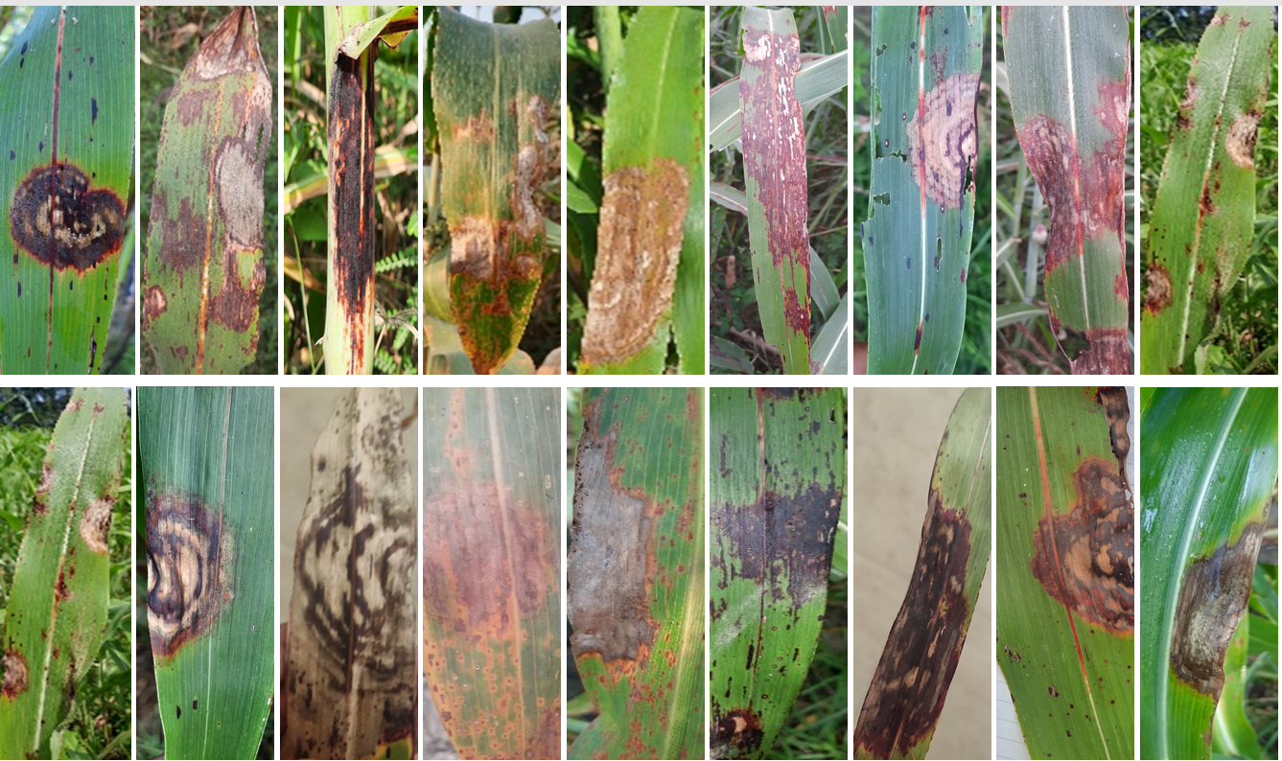
Fig 1: Variation in disease symptoms of zonate leaf spot observed on sorghum during survey at farmers’ field
3.1 Disease incidence and severity of zonate leaf spot during 2021
During the Kharif season of 2021, zonate leaf spot incidence across the surveyed regions ranged from 10.0 to 88.0%, while disease severity varied from 5.12 to 83.33%. The highest disease incidence (85%) and severity (83.33%) were recorded in Pantnagar, followed closely by Khatima in Udham Singh Nagar district, which recorded 84% incidence and 74.25% severity. In contrast, the lowest disease incidence (10.0%) and severity (5.12%) were observed in Kiri Gaon of Pithoragarh district. Notably, one location, Devkatiya village, remained free from zonate leaf spot infection during the 2021 season.
3.2 Disease incidence and severity of zonate leaf spot during 2022
In the Kharif season of 2022, disease incidence ranged from 13.0 to 88.0%, while severity ranged from 6.14 to 86.50%. The highest incidence (88.0%) and severity (81.47%) were recorded in Pantnagar, followed by Khatima (85.0% incidence and 76.64% severity) in Udham Singh Nagar district. Similar to the previous year, the lowest disease incidence (13.0%) and severity (6.14%) were observed in Kiri Gaon of Pithoragarh district. Devkatiya village again remained free from zonate leaf spot during the 2022 survey, indicating a consistent absence of disease at this location (Fig. 2 and Fig. 3).
3.3 Pooled analysis of disease incidence and severity (2021–2022)
Pooled analysis of data from both years revealed considerable spatial variation in zonate leaf spot incidence and severity across districts and villages. The highest mean disease incidence was recorded in Pantnagar (86.50%), followed by Khatima (84.50%), Nanakmatta (81.50%), Lalkuan and Rudrapur (80.50%) in Udham Singh Nagar district, and Haldwani (80.0%) in Nainital district. Similarly, the highest mean disease severity was recorded in Pantnagar (82.40%), followed by Kichha (74.63%) and Lalkuan (71.62%). Conversely, the lowest mean disease incidence and severity were recorded in Kiri Gaon of Pithoragarh district (11.50% and 5.63%, respectively), followed by Patiyon village in Rudraprayag district (13.85% incidence and 7.34% severity). Overall, higher disease pressure was observed during the Kharif season of 2021 compared to 2022. Devkatiya village remained free from zonate leaf spot throughout the two-year survey period.
3.4 District-wise distribution of zonate leaf spot
Zonate leaf spot was observed in almost all sorghum-growing areas surveyed, with disease intensity ranging from moderate to severe. The pooled mean disease incidence across districts ranged from 5.75 to 78.94%, while severity ranged from 2.51 to 82.40%. Udham Singh Nagar district recorded the highest mean disease incidence (78.94%) and severity (65.75%), followed by Nainital district (68.31% incidence and 53.90% severity). In contrast, Pithoragarh district recorded the lowest mean disease incidence (5.75%) and severity (2.81%).
Within districts, substantial village-level variation was observed. In Almora district, the highest mean disease incidence (52.50%) and severity (43.25%) were recorded in Chaukhutiya, whereas Boragaon recorded the lowest values (36.50% incidence and 16.44% severity). In Champawat district, Tanakpur village recorded the highest mean incidence (60.28%) and severity (45.39%), while Fularagaon showed the lowest disease levels (16.48% incidence and 10.47% severity).
In Dehradun district, Herbertpur recorded the highest mean disease incidence (59.55%), whereas the highest severity (44.44%) was observed in Bhatwari. Sahaspur recorded the lowest mean incidence (39.50%), while Doiwala recorded the lowest severity (29.48%). In Haridwar district, Dhanori recorded the highest mean incidence (47.98%), and Bahadarabad recorded the highest severity (47.53%), while Devipur showed the lowest disease levels.
In Nainital district, Motahaldu recorded the highest mean disease incidence (80.50%) and severity (71.62%), while Teenpani recorded the lowest incidence (55.50%) and Motahaldu recorded the lowest severity (45.27%). Rudraprayag district exhibited comparatively lower disease pressure, with maximum incidence and severity recorded in Marghat (17.45% and 9.76%) and minimum values in Patiyon village (Fig. 2 and Fig. 3)
3.5 Disease distribution in adjoining districts of Uttar Pradesh
In Rampur district, the highest mean disease incidence was recorded in Manaspur (64.0%), while the highest severity was observed in Jagatpur (42.47%). Dhamora recorded the lowest mean incidence (45.50%) and severity (32.30%). In Moradabad district, the highest mean disease incidence and severity were recorded in Chamraua (68.50%) and Faridpur (52.50%), respectively, whereas Mangupura and Rafatpur recorded the lowest incidence and severity. In Bareilly district, Bilwa and Abheypur recorded the highest mean disease incidence (53.50% and 53.00%), while the highest severity was recorded in Baheri (40.96%) and Abheypur (37.00%). The lowest disease levels were observed in Bhoripur.
3.6 Disease prevalence and epidemiological interpretation
Out of the 62 farmer fields surveyed during the 2021 and 2022 seasons, 61 fields were found to be infected with zonate leaf spot, indicating a high disease prevalence of 98.38%. Udham Singh Nagar district exhibited 100% disease prevalence with consistently high incidence and severity levels. The prevalence and severity of zonate leaf spot were notably higher in areas characterized by warm temperatures and high humidity, which favour the survival and spread of the pathogen.
The observed variation in disease incidence and severity across locations can be attributed to differences in agro-climatic conditions, sorghum cultivars (predominantly local fodder landraces), sowing dates, crop growth stages, cropping patterns, cultural practices, altitude, and microclimatic conditions during the crop-growing season. The widespread occurrence and high prevalence of zonate leaf spot across surveyed regions emphasize its increasing importance as a major constraint to sorghum production and highlight the need for region-specific disease management strategies.

Table 2: Survey on Disease incidence and severity of zonate leaf spot of sorghum in Uttarakhand and adjoining areas of Uttar Pradesh
District | Location/  Village | Latitude/  Longitude | Altitude (m) | Disease incidence (%) |  | Mean | Disease severity (%) |  | Mean
 |  |  |  | 2021 | 2022 | Mean | 2021 | 2022 | Mean
Udham Singh Nagar (Uttarakhand) | Pantnagar | 29°00'30.4"N  79°30'46.3"E | 227.52 | 85 | 88 | 86.50 | 83.33 | 81.47 | 82.40
Udham Singh Nagar (Uttarakhand) | Kichha | 28°53'48.6"N  79°30'08.1"E | 203.64 | 77 | 79 | 78.00 | 73.54 | 75.71 | 74.63
Udham Singh Nagar (Uttarakhand) | Bara | 28°51'54.6"N  79°37'15.2"E | 204.81 | 70 | 71 | 70.50 | 68.78 | 43.66 | 56.22
Udham Singh Nagar (Uttarakhand) | Sesaiya | 28°52'53.2"N  79°40'32.2"E | 205.56 | 75 | 74 | 74.50 | 68.77 | 64.9 | 66.84
Udham Singh Nagar (Uttarakhand) | Sitarganj | 28°54'42.3"N  79°42'14.2"E | 212.53 | 74 | 76 | 75.00 | 63.47 | 73.45 | 68.46
Udham Singh Nagar (Uttarakhand) | Nanakmatta | 28°56'16.4"N  79°49'02.5"E | 209.89 | 83 | 80 | 81.50 | 64.59 | 74.26 | 69.43
Udham Singh Nagar (Uttarakhand) | Khatima | 28°56'49.6"N  79°57'58.2"E | 214.36 | 84 | 85 | 84.50 | 74.25 | 76.64 | 75.45
Udham Singh Nagar (Uttarakhand) | Rudrapur | 29°01'06.2"N  79°23'15.9"E | 226.58 | 79 | 82 | 80.50 | 63.14 | 61.33 | 62.24
Udham Singh Nagar (Uttarakhand) | Kashipur | 29°11'22.3"N  78°57'18.1"E | 231.42 | 81 | 78 | 79.50 | 66.87 | 30.17 | 48.52
Udham Singh Nagar (Uttarakhand) | Mean |  |  | 78.67 | 79.22 | 78.94 | 69.64 | 64.62 | 67.13
Nainital (Uttarakhand) | Kaladhungi | 29°15'57.4"N  79°20'58.3"E | 367.28 | 74 | 76 | 75.0 | 63.4 | 55.36 | 59.38
Nainital (Uttarakhand) | Lalkuan | 29°07'57.2"N  79°31'20.9"E | 328.45 | 82 | 79 | 80.5 | 71.25 | 71.98 | 71.62
Nainital (Uttarakhand) | Haldwani | 29°12'18.3"N  79°30'42.6"E | 416.49 | 82 | 78 | 80.0 | 53.84 | 51.26 | 52.55
Nainital (Uttarakhand) | Nainital | 29°23'01.0"N  79°26'00.5"E | 1849.21 | 62 | 68 | 65.0 | 53.26 | 51.25 | 52.26
Nainital (Uttarakhand) | Jangi Bangar | 29°07'15.5"N  79°31'16.0"E | 314.89 | 54 | 62 | 58.0 | 53.24 | 56.14 | 54.69
Nainital (Uttarakhand) | Motahaldu | 29°08'31.1"N  79°31'21.9"E | 342.39 | 59 | 55 | 57.0 | 46.28 | 44.25 | 45.27
Nainital (Uttarakhand) | Teenpani | 29°11'03.3"N  79°31'15.9"E | 398.76 | 53 | 58 | 55.5 | 43.25 | 49.36 | 46.31
Nainital (Uttarakhand) | Kathgodam | 29°15'46.6"N  79°32'33.1"E | 518.97 | 78 | 73 | 75.5 | 46.98 | 51.28 | 49.13
 | Mean |  |  | 68 | 68.62 | 68.31 | 53.93 | 53.86 | 53.90
Almora (Uttarakhand) | Chaukhutia | 29°53'31.2"N  79°21'20.4"E | 959.22 | 56 | 49 | 52.50 | 41.25 | 45.25 | 43.25
Almora (Uttarakhand) | Gulabkoti | 30°30'02.2"N  79°30'06.7"E | 2166.29 | 45 | 51 | 48.00 | 22.35 | 24.45 | 23.40
Almora (Uttarakhand) | Bijepur | 29°47'00.1"N  79°25'50.1"E | 1353.89 | 38 | 46 | 42.00 | 19.61 | 22.36 | 20.99
Almora (Uttarakhand) | Pan | 29°48'10.0"N  79°25'02.5"E | 1234.93 | 48 | 53 | 50.50 | 19.48 | 18.15 | 18.82
Almora (Uttarakhand) | Boragaon | 29°48'10.0"N  79°25'02.5"E | 1534.15 | 32 | 41 | 36.50 | 13.65 | 19.23 | 16.44
 | Mean |  |  | 43.8 | 48 | 45.90 | 23.26 | 25.88 | 24.58
Chamoli (Uttarakhand) | Joshimath | 30°33'38.3"N  79°33'20.7"E | 1688.53 | 15 | 23 | 19.00 | 22.1 | 19.12 | 20.61
Chamoli (Uttarakhand) | Pipalkot | 30°26'00.6"N  79°25'42.3"E | 1322.55 | 24 | 31 | 27.50 | 15.28 | 21.78 | 18.53
Chamoli (Uttarakhand) | Gairsain | 30°03'11.1"N  79°17'27.6"E | 1632.14 | 73 | 81 | 77.00 | 58.14 | 65.78 | 61.96
Chamoli (Uttarakhand) | Tartoli | 30°24'36.3"N  79°24'59.0"E | 1203.15 | 51 | 46 | 48.50 | 17.98 | 18.65 | 18.32
Chamoli (Uttarakhand) | Paini | 30°31'48.1"N  79°31'06.1"E | 1563.47 | 41 | 46 | 43.50 | 15.78 | 18.78 | 17.28
 | Mean |  |  | 40.8 | 45.4 | 43.10 | 25.85 | 28.82 | 27.33
Pithoragarh (Uttarakhand) | Kiri Gaon | 29°33'57.6"N  80°12'49.7"E | 1520.14 | 10 | 13 | 11.50 | 5.12 | 6.14 | 5.63
Pithoragarh (Uttarakhand) | Devkatiya | 29°36'37.7"N  80°14'04.6"E | 1567.51 | 0 | 0 | 0.00 | 0 | 0 | 0
 | Mean |  |  | 5 | 6.5 | 5.75 | 2.56 | 3.07 | 2.81
Champawat (Uttarakhand) | Tanakpur | 29°04'47.7"N  80°06'47.4"E | 262.59 | 64 | 57 | 60.28 | 46.89 | 43.89 | 45.39
Champawat (Uttarakhand) | Banbasa | 28°59'14.8"N  80°03'58.4"E | 232.45 | 57 | 63 | 60.35 | 45.91 | 41.25 | 43.58
Champawat (Uttarakhand) | Lohaghat | 29°24'11.6"N  80°04'43.7"E | 1678.54 | 26 | 18 | 22.02 | 20.09 | 16.74 | 18.42
Champawat (Uttarakhand) | Barkot | 30°48'11.3"N  78°12'09.5"E | 1301.44 | 19 | 18 | 18.38 | 10.87 | 14.85 | 12.86
Champawat (Uttarakhand) | Pati | 30°28'47.6"N  78°36'09.3"E | 1645.65 | 20 | 19 | 19.16 | 11.45 | 12.25 | 11.85
Champawat (Uttarakhand) | Fularagaon | 29°19'07.4"N  80°06'05.5"E | 1652.74 | 17 | 16 | 16.48 | 11.65 | 9.28 | 10.47
 | Mean |  |  | 34 | 32 | 32.78 | 24.48 | 23.04 | 23.76
Rudraprayag (Uttarakhand) | Marghat | 30°16'58.0"N  78°58'32.0"E | 1900.25 | 21 | 13 | 17.45 | 10.54 | 8.99 | 9.765
Rudraprayag (Uttarakhand) | Patiyon | 30°28'02.4"N  79°02'11.1"E | 1338.17 | 14 | 13 | 13.85 | 8.45 | 6.23 | 7.34
 | Mean |  |  | 17.85 | 13.45 | 15.65 | 9.50 | 7.61 | 8.55
Dehradun  (Uttarakhand) | Sudhowala | 30°20'34.5"N 77°55'27.5"E | 1396.22 | 58 | 53 | 55.28 | 45.29 | 43.59 | 44.44
Dehradun  (Uttarakhand) | Herbertpur | 30°26'37.9"N 77°44'32.7"E | 448.45 | 63 | 56 | 59.55 | 43.57 | 39.28 | 41.43
Dehradun  (Uttarakhand) | Sahaspur | 30°23'33.3"N 77°48'00.3"E | 470.22 | 41 | 37 | 39.15 | 35.55 | 35.00 | 35.28
Dehradun  (Uttarakhand) | Doiwala | 30°10'18.7"N 78°06'41.6"E | 472.37 | 39 | 46 | 42.46 | 26.48 | 32.48 | 29.48
 | Mean |  |  | 50.36 | 47.86 | 49.11 | 37.72 | 37.59 | 37.66
Haridwar (Uttarakhand) | Dhanori | 29°56'44.4"N  77°57'23.5"E | 594.21 | 53 | 43 | 47.98 | 43.15 | 42.58 | 42.87
Haridwar (Uttarakhand) | Bahadarabad | 29°55'21.6"N  78°01'27.5"E | 269.33 | 52 | 43 | 47.87 | 46.28 | 48.78 | 47.53
Haridwar (Uttarakhand) | Sarai | 29°53'56.5"N  78°06'15.4"E | 272.11 | 47 | 39 | 42.94 | 35.98 | 38.47 | 37.23
Haridwar (Uttarakhand) | Sultanpur | 29°45'58.8"N  78°06'41.0"E | 252.87 | 25 | 19 | 22.23 | 31.12 | 26.48 | 28.80
 | Badshapur | 29°48'22.2"N  78°08'13.2"E | 249.53 | 26 | 21 | 23.92 | 19.87 | 23.14 | 21.51
 | Devipur | 29°48'22.2"N  78°08'13.2"E | 357.11 | 20 | 25 | 22.52 | 15.14 | 13.45 | 14.30
 | Mean |  |  | 50.36 | 37.24 | 31.89 | 34.57 | 31.92 | 32.15
Rampur  (Uttar Pradesh) | Jagatpur | 28°51'27.5"N  79°02'32.1"E | 200.12 | 63 | 54 | 58.57 | 46.47 | 38.48 | 42.475
Rampur  (Uttar Pradesh) | Benazeerpura | 28°47'56.2"N  79°00'04.1"E | 187.15 | 55 | 53 | 53.83 | 43.80 | 39.48 | 41.64
Rampur  (Uttar Pradesh) | Rampur | 28°46'58.6"N  78°59'34.2"E | 189.09 | 56 | 72 | 64.00 | 35.89 | 40.25 | 38.07
Rampur  (Uttar Pradesh) | Dinpur | 28°42'18.8"N  79°05'35.1"E | 188.37 | 65 | 56 | 60.50 | 43.57 | 37.58 | 40.575
Rampur  (Uttar Pradesh) | Dhamora | 28°40'53.2"N  79°06'47.2"E | 181 | 45 | 46 | 45.50 | 36.14 | 28.47 | 32.305
 | Mean |  |  | 56.76 | 56.20 | 56.48 | 41.17 | 36.85 | 39.01
Moradabad  (Uttar Pradesh) | Chamraua | 28°48'58.8"N  78°53'14.6"E | 191.47 | 75 | 62 | 68.50 | 38.47 | 34.89 | 36.68
Moradabad  (Uttar Pradesh) | Laxmipur | 28°49'48.0"N  78°51'14.5"E | 194.19 | 56 | 45 | 50.50 | 35.89 | 34.25 | 35.07
Moradabad  (Uttar Pradesh) | Rafatpur | 28°49'17.9"N  78°49'46.6"E | 191.17 | 45 | 41 | 43.00 | 33.14 | 28.78 | 30.96
Moradabad  (Uttar Pradesh) | Faridpur | 28°47'08.7"N  78°45'22.5"E | 192.14 | 63 | 60 | 61.50 | 51.33 | 54.28 | 52.805
Moradabad  (Uttar Pradesh) | Mangupura | 28°49'05.0"N  78°42'04.3"E | 199.66 | 45 | 43 | 44.00 | 43.45 | 40 | 41.725
 | Mean |  |  | 56.80 | 50.20 | 53.50 | 40.46 | 38.44 | 39.45
Bareilly  (Uttar Pradesh) | Baheri | 28°45'28.4"N  79°29'41.7"E | 196.22 | 45 | 51 | 48.00 | 38.78 | 43.14 | 40.96
Bareilly  (Uttar Pradesh) | Bhairpur Khajuria | 28°34'32.1"N  79°27'59.3"E | 182.17 | 49 | 56 | 52.50 | 35.69 | 33.45 | 34.57
Bareilly  (Uttar Pradesh) | Bhori Pura | 28°31'12.7"N  79°27'08.9"E | 180.11 | 48 | 46 | 47.00 | 33.26 | 29.58 | 31.42
Bareilly  (Uttar Pradesh) | Abheypur | 28°28'16.9"N  79°26'34.9"E | 178.94 | 49 | 57 | 53.00 | 38.78 | 37.18 | 37.98
Bareilly  (Uttar Pradesh) | Bilwa | 28°26'33.7"N  79°26'03.4"E | 177.89 | 49 | 58 | 53.50 | 34.58 | 35.58 | 35.08
 | Mean |  |  | 48 | 53.6 | 50.80 | 36.21 | 35.78 | 36.00

Fig 2. (a) Disease incidence and (b) disease severity during the surveys conducted in 2021 and 2022.
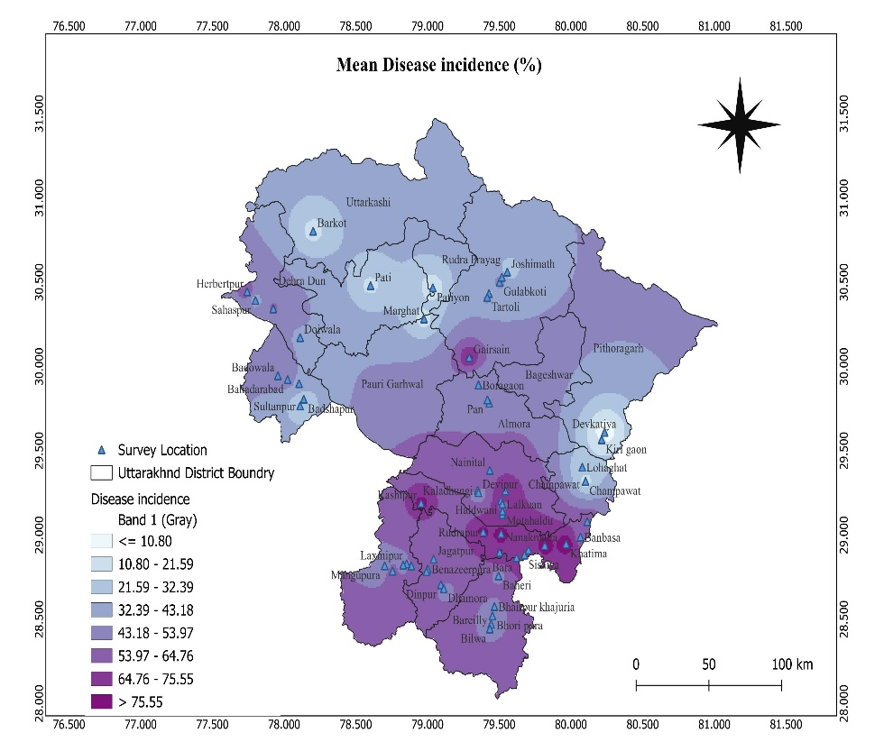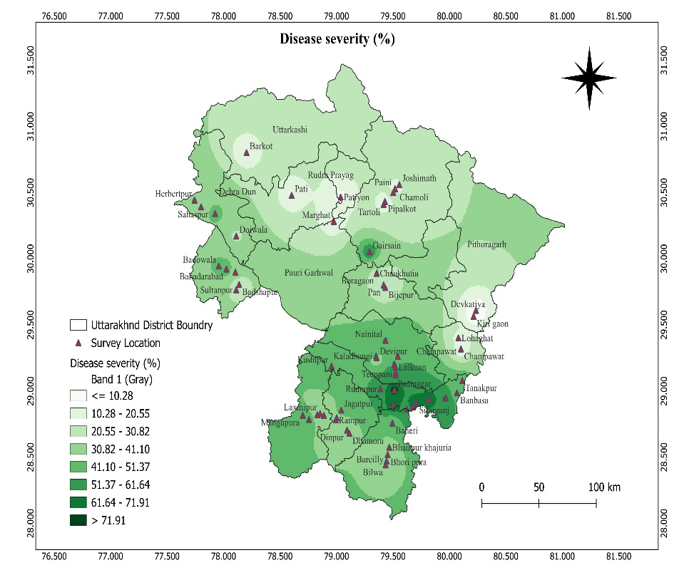
B
A
Fig. 3 Prevalence and distribution of zonate leaf spot in different sorghum growing areas of Uttarakhand and adjoining areas of UP a) Mean Disease incidence and b) Mean Disease severity of M. sorghi during Kharif season 2021 and 2022
4. CONCLUSION
The present study provides a comprehensive assessment of the prevalence, incidence, and severity of zonate leaf spot of sorghum in Uttarakhand and adjoining districts of Uttar Pradesh over two consecutive Kharif seasons. The disease was found to be widely distributed across the surveyed regions, with a very high prevalence of 98.38%, indicating its endemic nature in sorghum-growing areas. Significant spatial variation in disease incidence and severity was observed among districts and villages, with Udham Singh Nagar district recording the highest disease pressure, while Pithoragarh district consistently exhibited the lowest levels of infection. The persistence of high disease incidence and severity in areas characterized by warm and humid conditions suggests a strong influence of agro-climatic factors on disease development. The predominance of local fodder sorghum landraces, variations in sowing time, crop growth stage, cultural practices, altitude, and microclimate further contributed to the observed differences in disease intensity. The consistent absence of disease in Devkatiya village across both seasons indicates the possible role of local environmental or management factors that warrant further investigation.
Overall, the widespread distribution and high severity of zonate leaf spot underscore its status as a major constraint to sorghum production in the region. The findings highlight the importance of regular disease surveillance and provide a baseline for developing integrated disease management strategies, including the identification of resistant genotypes and location-specific management practices to mitigate yield losses caused by Microdochium sorghi.

Disclaimer (Artificial intelligence)

Author(s) hereby declare that NO generative AI technologies such as Large Language Models (ChatGPT, COPILOT, etc.) and text-to-image generators have been used during the writing or editing of this manuscript.

REFERENCES
- Anahosur, K. H. 1986. Chemical control of foliar diseases of sorghum. Indian Phytopathol., 39: 526–528.
- Anitha, K., Das, I. K., Holajjer, P., Sivaraj, N., Reddy, C. R. and Balijepalli, S. B. 2020. Sorghum diseases: diagnosis and management. Sorghum in the 21st century: food–fodder–feed–fuel for a rapidly changing world, 565-619.
- Braun, U. 1995. A monograph of Cercosporella, Ramularia and allied genera (Phytopathogenic hyphomycetes) Eching: Ihw-Verlag, 1: p. 271.
- Frederiksen, R. A. and Odvody, G. N. 2000. Compendium of Sorghum Diseases, Phytopathology Press., p. 78.
- Jiang, Y., Xu, J., Hu, L., Liu, K. J., Xu, X. D., Liu, Z. and Meng, W. L. 2018. First report of sorghum zonate leaf spot caused by Gloeocercospora sorghi in China. Plant Dis., 102(5): 1033-1033.
- Koima, I. N., Kilalo, D. C., Orek, C. O., Wagacha, J. M. and Nyaboga, E. N. 2022. Survey of fungal foliar and panicle diseases in smallholder sorghum cropping systems in different agro-ecologies of lower eastern Kenya. Microbiol. Res. 13(4): 765-787.
- Mengistu, G., Shimelis, H., Laing, M. and Lule, D. 2018. Breeding for anthracnose (Colletotrichum sublineolum Henn.) resistance in sorghum: challenges and opportunities. Aust. J. Crop. Sci., 12: 1911–1920.
- Ngugi, H. K., King, S. B., Abayo, G. O. and Reddy, Y. V. R. 2002. Prevalence, incidence, and severity of sorghum diseases in Western Kenya. Plant Dis., 86: 65-70.
- Odvody, G. N. and Madden, D. B. 1984. Leaf sheath blights of Sorghum bicolor caused by Sclerotium rolfsii and Gloeocercospora sorghi in South Texas. Phytopathol., 74:264-268.
- Ogolla, F.O. Muraya, M. M. and Onyango, B. O. 2018. Incidence and severity of turcicum leaf blight caused by Exserohilum turcicum (pass.) Leonard and Suggs) on sorghum populations in different regions of Tharaka Nithi County, Kenya. J. Sci. Eng. Res., 6: 104–111.
- Prom, L. K. and Isakeit, T. 2022. Incidence of Zonate Leaf Spot on Sorghum Accessions Under Disease-Conducive Growing Conditions Burleson County, Texas. Journal of Agriculture and Crops, 8(1): 35-38.
- Prom, L. K. and Isakeit, T. 2022. Incidence of Zonate Leaf Spot on Sorghum Accessions Under Disease-Conducive Growing Conditions Burleson County, Texas. Journal of Agriculture and Crops, 8(1): 35-38.
- Prom, L. K., Adamou, H., Issa, A., Abdoulkadri, A. A. and Issa, K. 2020. Survey of the prevalence and incidence of foliar and panicle diseases of sorghum across production fields in Niger. J. Plant Pathol., 19: 106-113.
- Prom, L. K., Sarr, M. P., Diatta, C., Sall, M., Bodian, S., Fall, C., Gualbert, S. D. and Magill, C. 2023. A Survey of the Major Sorghum Production Regions for Foliar and Panicle Diseases during the 2022 Growing Season in Senegal, West Africa. Am. J. Plant Sci., 14(8): 829-844.
- Purohit, J., Singh Y., Bisht, S. and Srinivasaraghvan, A. 2013. Evaluation of antagonistic potential of Trichoderma harzianum and Pseudomonas fluorescens isolates against Gloeocercospora sorghi causing zonate leaf spot of sorghum. The Bioscan, 8(4): 1327-1330.
- Sharma, H. L. A. 1983. Technique for identifying and rating resistance to foliar diseases of sorghum under field conditions. Proce. Ind. Acad. Science., 42(2): 278-283.
- Stewart, S., Rodríguez, M., Mattos, N. and Abreo, E. 2019. First Report of Zonate Leaf Spot in Sorghum Caused by Microdochium sorghi in Uruguay. Agrociencia (Uruguay), 23(2): 94-98.
- Thakur, R. P. 2007. Anthracnose in Thakur R., P., Reddy. and B, Mathur K (Eds) Screening Techniques for Sorghum Diseases, ICRISAT. Pantacheru, India, pp53-57.
- Wheeler, B. E. J. 1969. An introduction to plant diseases. The English Language Book Society and John Wiley and Sons Limited, London. 386p.

