Original Research Article
ISOLATION AND MOLECULAR CHARACTERIZATION OF FUNGI ASSOCIATED WITH MAIZE FROM FIVE FARMS IN OSOGBO, OSUN STATE, NIGERIA

ABSTRACT
Maize (Zea mays L.) is a vital staple in Nigeria, yet tropical conditions frequently promote fungal contamination in stored grains. This study isolated and characterized fungi from 15 maize samples across five farms in Osogbo, Osun State, Nigeria using phenotypic and molecular techniques. Morphological characterization of isolates, particularly the predominant Aspergillus spp., revealed rapid to moderate growth with colors ranging from olive-green to black and textures varying from granular and powdery to velvety or cottony. These surface variations reflect the specific arrangement and abundance of conidial structures.
To achieve definitive taxonomic resolution, the concentration and purity of extracted genomic DNA were assessed using a NanoDrop spectrophotometer, ensuring samples were contaminant-free (A260/A280 ≈ 1.8) for downstream PCR amplification. Molecular analysis of the Internal Transcribed Spacer (ITS) region confirmed eleven distinct species, including Aspergillus flavus, A. niger, and Fusarium solani, with 100% homology to NCBI sequences. Fungal growth rates ranged from 1.3 ± 0.06 to 4.5 ± 0.21 cm/week, with the highest contamination observed at Ejigbo Farm.
The study highlights significant food safety concerns due to widespread contamination by fungi in the region, and underscores an urgent need for improved post-harvest handling, enhanced storage infrastructure, and regular surveillance programs to safeguard public health.
Keywords:Maize, Aspergillus, Fusarium, Molecular characterization, Food security, Nigeria.

- INTRODUCTION
In developing nations like Nigeria, agriculture is the cornerstone of economic stability and food security. Maize (Zea mays L.) is a vital staple, serving as a primary carbohydrate source and a livelihood for millions (IARC, 2019; Adelusi, 2022). However, the tropical climate—characterized by high humidity and warmth—combined with traditional postharvest practices, creates an ideal environment for fungal proliferation (Magan and Aldred, 2020).
True national sovereignty and public health depend on the four pillars of food security: availability, access, utilization, and stability. When any pillar is compromised by contamination, it triggers significant public health risks and economic losses (Udomkun et al., 2017; Liu et al., 2020). Fungal pathogens are particularly disruptive; they act as ubiquitous spoilage agents throughout the value chain, impairing nutritional quality and producing toxins that threaten human and animal health (Sokefun et al., 2018). These contaminants not only hinder Nigeria’s food safety efforts but also undermine the United Nations Sustainable Development Goals (SDGs) regarding hunger and well-being.
Despite the severity of these risks, monitoring and mitigation strategies in Nigeria remains largely ineffective. Consequently, there is an urgent need to identify the specific pathogens threatening local supplies. This research aims to characterize the fungi associated with stored maize obtained from five distinct farms in and around Osogbo, Osun State, Nigeria.
- MATERIALS AND METHODS
2.1 Sample Collection
Samples of Maize (Zea mays) were obtained from five identified farms (F) from Osogbo and environs in Osun State, Nigeria: F1: Boredun (7.78010N, 4.62730E); F2: Ayekale (7.79530N, 4.54080E); F3: Okinni (7.800990N, 4.52630E); F4: Ejigbo (7.90450N, 4.30520E); F5: ObaOke (7.90300N, 4.57920E). The samples (1kg each were collected from three (3) different points (P) within each farm, in sterile zip lock bags, and transported to the laboratory for further analysis. The samples were stored in a desiccator containing a desiccant to prevent moisture absorption until analysis.

2.2 Media Preparation
The culture media used were Potato Dextrose Agar (PDA), Potato Dextrose broth (PDB), Mann Rogosa Sharpe (MRS) Agar, and Coconut Agar. The media were prepared according to manufacturer’s instructions and sterilized by autoclaving at 121 °C for 15 minutes (Davies et al., 1987)

2.3 Isolation, Purification, and Enumeration of Maize Mycoflora
Fungal species were isolated following the modified method of Agarwal and Sinclair (1993). Seed samples were categorized into two treatments: surface-disinfected (1% sodium hypochlorite for 2 min) and untreated. Following disinfection, all seeds were rinsed with sterile water, blotted dry, and plated onto Potato Dextrose Agar (PDA). Each treatment consisted of five seeds per dish, replicated in duplicate, and incubated for 5–7 days at 25±2°C. Pure cultures were obtained using single-spore techniques and sub-cultured onto Coconut Agar supplemented with streptomycin (0.03g/100ml) to inhibit bacterial growth. For long-term preservation, isolates were stored in McCartney bottle slants at 4°C.
Fungal growth was quantified by measuring hyphal length over time using phase-contrast microscopy. Digital images were processed via MATLAB image analysis software to extract precise growth data. The fungal growth rate for each sample was calculated as:
Growth rate Pt = P0+ (KxT)

Where Pt = average length at time t
P0 = length at time zero
k = constant growth rate
T = elapsed time in weeks from time zero.

2.3 Identification of the Isolates
The isolated organisms were identified using a two-pronged approach: phenotypic characterization and molecular studies.
    - Phenotypic Characterization of Isolates
These were based on both morphological and microscopic observations of the isolates. The colonial morphology that was observed according to Yafetto et al. (2019) includes: the rate of growth, surface texture, and mycelia color changes. Microscopic observation was done using the wet-mount method. A drop of Lactophenol cotton blue was placed on a clean glass slide, small portion of the mycelia was introduced with an inoculating needle, covered with a clean and clear cover slip, then observed under x40 magnification for the nature of hyphae (septate and septate), hyphae color, presence of sexual spores (sporangiospores, conidia or anthrospores), characteristics and dispositions of mature fruiting structures (sporangia, sporodochia, pyenidia, and corenia). The fungal isolates were preliminarily identified in reference to relevant identification manuals (Kidd et al., 2016). The pure isolates obtained were subjected to molecular analysis.
2.3.2 Molecular Characterization of the Isolates
Molecular identification of the isolates was conducted, beginning with genomic DNA extraction.
2.3.2.1 Genomic DNA Extraction
The DNA isolation and purification were done on the isolates using the Quick DNA MiniPrep kit (Zymo Research) and following the manufacturer’s protocol. 400μl of lysis buffer was added to 200μl of each isolate, followed by incubation at 55 °C for 10 minutes. The solution was then transferred into the Zymo II spin column and centrifuged at 12000xg for 1 min. The solution was transferred into another collection tube. 500ul gDNA Wash Buffer was added and centrifuged at 120000xg for 1 minute. The solution was placed into a new clean 1.5ml micro centrifuge tube, and 50μl DNA Elution Buffer was added and centrifuged at 12000xg for 1 minute to elute the purified DNA.

2.3.2.2 DNA Quantification
The eluted pure DNA was quantified with the NanoDrop One UV-spectrophotometer (Thermofisher Scientific, Inc.), where the concentration and purity were generated. The result was compared to detect the isolated DNA, which is contaminant-free with absorbance A260/A280 =1.8. Also, making it fit for other downstream processes, such as PCR.

2.3.2.3 Polymerase chain reaction amplification protocol
This protocol describes PCR amplification of the fungal Internal Transcribed Spacer (ITS) region using universal (ITS1 - 5.8s - ITS4) primers. The reaction mixture was prepared in a 20μl volume containing 10μl of OneTaq Quick-Load 2X Master Mix (New England Biolabs Inc.), 1μl each of ITS1 forward primer (5'-TCC GTA GGT GAA CCT GCG G-3') and ITS4 reverse primer (5'-TCC GCT TAT TGA TAT GC-3'), 7μl of nuclease-free water, and 1μl of DNA template. The components were gently mixed and transferred to a pre-heated Eppendorf Nexus Gradient Mastercycler. The amplification program consisted of initial denaturation at 94°C for 5 minutes, followed by 35 cycles of denaturation at 94°C for 30 seconds, primer annealing at 50°C for 30 seconds, and extension at 68°C for 10 minutes. The extended extension time of ten minutes accommodated the variable length of ITS regions across different fungal species, typically ranging from 450 to 900 base pairs. Appropriate negative controls were included in each run to detect potential contamination, and all reagents were maintained on ice during reaction setup to preserve enzyme activity and prevent nucleic acid degradation (Ohabughiroet al., 2020).

2.3.2.4 Gel Electrophoresis
PCR products were separated on a 2% agarose gel and visualized using CYBR Gold staining to confirm successful amplification. The amplified products were subsequently purified using the ExoSAP enzymatic cleanup protocol, which removes excess primers and dNTPs through treatment with Exonuclease I and Shrimp Alkaline Phosphatase. The purified PCR products were then sequenced, and the nucleotide sequences obtained were analyzed using the Basic Local Alignment Search Tool (BLAST) against the National Center for Biotechnology Information (NCBI) database to enable accurate fungal identification.

- RESULTS AND DISCUSSION
3.1 Fungal Growth Level of the Samples
Table 1 presents data on the fungal growth levels in maize samples collected from five different farms. The average mycelial fungal growth rates were measured in centimeters per week (cm/wk), which was an indication of fungal growth in the maize samples. These hyphae growths were measured and recorded from samples collected at three distinct sampling points (P1, P2, and P3) within each farm. At Boredun Farm (F1), the average fungal growth was observed between 1.3 ± 0.06 and 2.8 ± 0.10cm/week; Ayekale Farm (F2) showed fungal growth across all three sampling points, with average values ranging between 1.7 ± 0.05 and 3.5 ± 0.11 cm/week. At Okinni Farm (F3), the fungal growth varied widely between 1.7± 0.02 and 3.3 ± 0.19 cm/week. The fungal growth from Ejigbo Farm (F4) from the three collection points ranges between 3.7 ± 0.12 and 4.5 ± 0.21 cm/week. Oba-Oke Farm (F5) showed a fungal growth rate range between 1.2 ± 0.01 and 4.0 ± 0.16 cm/week.
Table 2 presents the morphological characteristics and suspected identities of fungal isolates obtained from five different farm locations, designated as F1 through F5, with each location represented by three sampling points (P1, P2, and P3). The data reveal a consistent pattern of fungal contamination across all sampled farms, with Aspergillus species emerging as the predominant genus identified in the majority of isolates.
Table 1: Fungal contamination level of the samples from different farms
Farms Molds Linear growth rate of hyphae (cm/week)
P 1 P2 P3
F1 | 2.8 ± 0.10ᵃ | 1.8 ± 0.11ᵇ | 1.3 ± 0.06ᶜ
F2 | 3.2 ± 0.18ᵇ | 1.7 ± 0.05ᶜ | 3.5 ± 0.11ᵃ
F3 | 1.7 ± 0.02ᶜ | 3.3 ± 0.19ᵃ | 2.7 ± 0.14ᵇ
F4 | 4.5 ± 0.21ᵃ | 4.0 ± 0.14ᵃᵇ | 3.7 ± 0.12ᵇ
F5 | 4.0 ± 0.16ᵃ | 1.2 ± 0.01ᶜ | 3.3 ± 0.10ᵇ
Keys: F1: Boredun; F2: Ayekale; F3: Okinni; F4: Ejigbo; F5: Oba Oke; Points (P) of collection of maize, Samples in the different farms: P1; P2; P3. Values within the same row sharing the same superscript letter are not significantly different (p < 0.05) based on Tukey's HSD test. The Standard Deviation (SD) for the Molds Linear growth rate of hyphae for all 15 data points is approximately 0.387 cm/week; the estimated Mean Deviation (MD) for the Molds Linear growth rate of hyphae data, given a sample size (n) of 15, is 0.309 cm/week.

Table 2: Morphological appearance of fungal contaminants associated with samples

S/N | Farms |  | Morphological characteristics | Suspected Isolate(s)
 | Boredun(F1) | P1  P2  P3 | Moderate growth, velvety colonies, olive-green conidial heads  Moderate growth, yellow to dark green with olive-green conidial heads, brown mycelium with blue spores  Moderate growth, yellow to dark green with olive-green conidial heads, brown mycelium with blue spores. | Aspergillus spp.  Aspergillus spp.  Aspergillus spp.
 | Ayekale (F2) | P1  P2  P3 | Moderate growing, white-to-green colonies, cottony surface, reddish-brown exudates.  Moderate growth, yellow to dark green with olive-green conidial heads, brown mycelium with blue spores  Slow to moderate growth, yellow to dark green with olive-green conidial heads, brown mycelium with blue spores | Aspergillus spp.  Aspergillus spp.  Aspergillus spp.
 | Okinni (F3) | P1  P2  P3 | Moderate growing, white-to-green colonies, cottony surface, reddish-brown exudates.  Moderate growing, white-to-green colonies, cottony surface, reddish-brown exudates.  Fast-growing, white-to-pink mycelium, Black conidial heads with black spores. | Aspergillus spp.  Aspergillus spp.  Fusarium spp.
 | Ejigbo (F4) | P2  P3 | Moderate growing, white-to-green colonies, cottony surface, reddish-brown exudates.  Moderate growth, velvety colonies, olive-green conidial heads  Moderate growth, velvety colonies, olive-green conidial heads | Aspergillus spp.  Aspergillus spp.  Aspergillus spp.
 | Oba Oke (F5) | P1  P2  P3 | Moderate growth, velvety colonies, olive-green conidial heads  Moderate growth, velvety colonies, olive-green conidial heads  Fast-growing, white-to-pink mycelium, Black conidial heads with black spores. | Aspergillus spp.  Aspergillus spp.  Fusarium spp.

The morphological appearance on culture media typically displayed rapid to moderate growth rates that vary among different species. The colonies range in color from white, yellow, and various shades of green to brown, gray, and black. The colony texture varied considerably, presenting as granular, powdery, velvety, or cottony surfaces that reflect the abundance and arrangement of conidial structures. Colony reverse colors, observed from the underside of culture plates, showed distinctive pigmentation ranging from pale yellow to reddish-brown or even black, with some species producing characteristic exudates or soluble pigments that diffuse into the surrounding medium. The radial growth pattern is typically uniform with well-defined margins, as the colony matures in samples from Boredun (F1), Ayekale (F2), Okinni (F3), and Ejigbo (F4) farms. This consistent morphological profile strongly suggests the widespread presence of Aspergillus species across the surveyed agricultural areas, indicating either similar environmental conditions or potential cross-contamination between farms. Also, some of the colonies' coloration was highly variable and species-specific, ranging from white, cream, or pale pink to vivid shades of orange or yellow, often with the central portions displaying more intense pigmentation than the colony margins, which is a characteristic feature of many Fusarium species. The pigments were produced that diffuse into the culture medium, creating distinctive reverse colors visible from the underside of the plate, which appeared pale. The mycelial growth pattern typically showed abundant aerial hyphae with a velvety texture; the margin of the colonies was irregular with diffuse or filamentous edges, reflecting the vigorous vegetative growth characteristic of Fusarium species.
Microscopically, the species were characterized by septate, hyaline hyphae that branched dichotomously and produced specialized asexual reproductive structures. The conidiophores arose from a foot cell in the vegetative mycelium and terminated in a vesicle, which is hemispherical. The conidia were typically spherical to ellipsoidal, measured between 2.5 and 5.0 micrometers in diameter, with smooth or roughened wall ornamentation. The conidial heads were radiated, with conidial chains diverging in all directions. The septate hyphae typically measured 3 to 8 micrometres in width and contained specialized structures, which were typical of Aspergillus species. The microscopic morphology also revealed several distinctive features that facilitate genus and species identifications. The vegetative hyphae are septate, lightly pigmented, and measure 3 to 6 micrometres in width, exhibiting regular branching patterns. The spores are produced in sporodochia, which appear as orange to cream-colored masses on the culture surface, a characteristic typical of Fusarium species. The identification of Fusarium species alongside Aspergillus species in samples from (F3) and (F5) farms adds another dimension to the fungal diversity observed.
Table 3 presents the percentage occurrence of fungal growth in maize samples from different farms, revealing significant variations in contamination patterns between Aspergillus and Fusarium species across the five sampled locations. The data demonstrates that the Farm (F1), Farm (F2), and farm (F4) exhibited the highest Aspergillus contamination at all the sampling points (20.0 0%). The predominance of Aspergillus species across all farms, with F1, F2, and F4 each showing identical contamination rates of 20.0%, F3 and F5 (13.33%), suggested that this genus represented a consistent threat to maize quality across different agricultural settings.
Results indicated that Fusarium contamination was not widespread, appearing in only two of the five farms surveyed. Specifically, F3 and F5 each yielded one positive sample, whereas F1, F2, and F4 remained entirely free of the pathogen. This localized occurrence translated to a total contamination rate of 6.67%, suggesting that Fusarium is a site-specific rather than a pervasive threat in this study area.
Table 3: Percentage occurrence of fungal growth in samples from different farms
Farms | Aspergillus spp. | Fusarium spp.
Farms | (%)
F1 | 20.00 | -
F2 | 20.00 | -
F3 | 13.33 | 6.67
F4 | 20.00 | -
F5 | 13.33 | 6.67

Keys: F1: Boredun; F2: Ayekale; F3: Okinni; F4: Ejigbo; F5: Oba Oke

3.2 Genotypic identification of mold isolates
The amplicons of the isolates on a 2.0% Agarose gel are shown in Figure 1. Once obtained, the sequences were blasted and submitted to the NCBI gene library. The detailed information of the eleven fungi isolates and their associated unique geneBank accession numbers are shown in Table 4. The isolates were identified to be AspergillusnidulansS1, AspergillusflavusOW1, AspergillusinsolitusS3, AspergillusversicolorS2, AspergillusflavusOW2, FusariumsolaniM1, AspergillusparasiticusOW3, AspergillusnidulansM2, AspergillusterreusM3, AspergillusnigerM4, andFusariumsolaniMS3with accession numbers (Table 4).
The phylogenetic relationship among the Fusarium solani isolates is shown in Figure 2, which demonstrates the evolutionary relationships among Fusarium solani isolates using molecular sequence data. The tree shows a clear monophyletic clustering, indicating that all analyzed sequences belong to the Fusarium solani species complex, Fusarium solani(LT746273), Fusarium solani(PQ686294), Fusarium solani(PX376709), and Fusarium solani (MT453275), within the Nectriaceae family. Also, the phylogenetic relationship among the Aspergillus species is shown in Figure 3, the isolates principally cluster with the Aspergillaceae family, related to A. insolitusS3(PQ686290), A. parasiticusOW3(PX427487), A. parasiticus(MH868619), A. flavus(KM115164), A. flavus(AY373848), A. flavusOW1 (PX427486) A. flavusOW2(PX427485), A. nidulans (OM250078.1) A. nidulansS1(PQ686286), A. terreusM3 (PQ686288), A. insolitus(EU140822), A. insolitus(NG_065493), A. niger(NG_065763), A. nidulans(MF004311.1), A. nidulansM2 (PX376711), A.nigerM4 (PQ686293) and A. niger (MN420840.1). The isolates from the maize samples form a well-supported clade that is distinct but closely related to known reference strains obtained from NCBI.

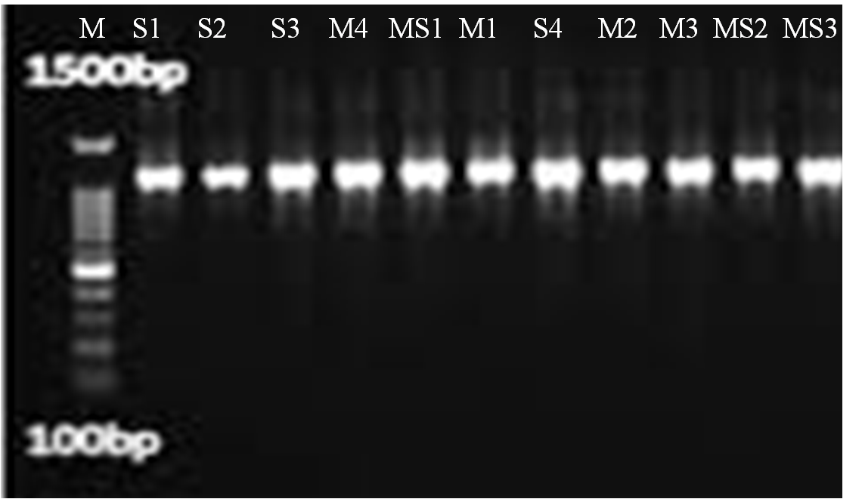
600bp
100bp
M S1 S2 S3 M4 MS1 M1 S4 M2 M3 MS 2 MS3

Figure 1: Amplicons on 2.0% Agarose Gel
Key: M: Ladder; S1: F1 P1 isolate; OW1: F1 P2 isolate; S3: F2 P1 isolate; S2: F2 P3 isolate; OW2: F3 P2 isolate; M1: F3 P3 isolate; OW3: F4 P1 isolate; M2: F4 P2 isolate; S2: F4 P3 isolate; M4: F5 P1 isolate; MS3: F5 P3 isolate
.
Table 4: Identified Fungal Strain with NCBI GeneBank
S/N | Isolate codes | Location of collection | % Similarity | Identity | Accession Number
1. | S1 | F1P1 | 100 | Aspergillusnidulans | PQ686286
2. | OW1 | F1P2 | 100 | Aspergillusflavus | PX427485
3. | S3 | F2P1 | 100 | Aspergillusinsolitus | PQ686290
4. | S2 | F2P3 | 100 | Aspergillusversicolor | PX376713
5. | OW2 | F3P2 | 100 | Aspergillusflavus | PX427486
6. | M1 | F3P3 | 100 | Fusariumsolani | PX376709
7. | OW3 | F4P1 | 100 | Aspergillusparasiticus | PX427487
8. | M2 | F4P2 | 100 | Aspergillusnidulans | PX376711
9. | M3 | F4P3 | 100 | Aspergillusterreus | PQ686288
10. | M4 | F5P1 | 100 | Aspergillusniger | PQ686293
11. | MS3 | F5P3 | 100 | Fusariumsolani | PQ 686294
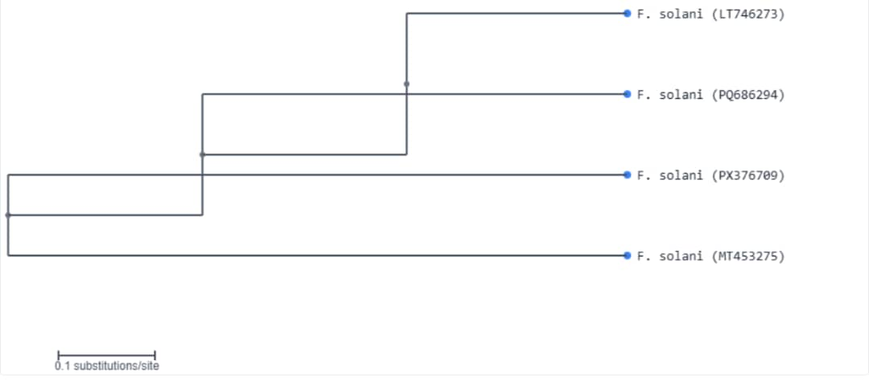
Figure 2: The phylogenetic tree showing the relationship between F. solani(LT746273), F. solaniMS3 (PQ686294), F. solaniM1(PX376709), and F. .solani (MT453275).

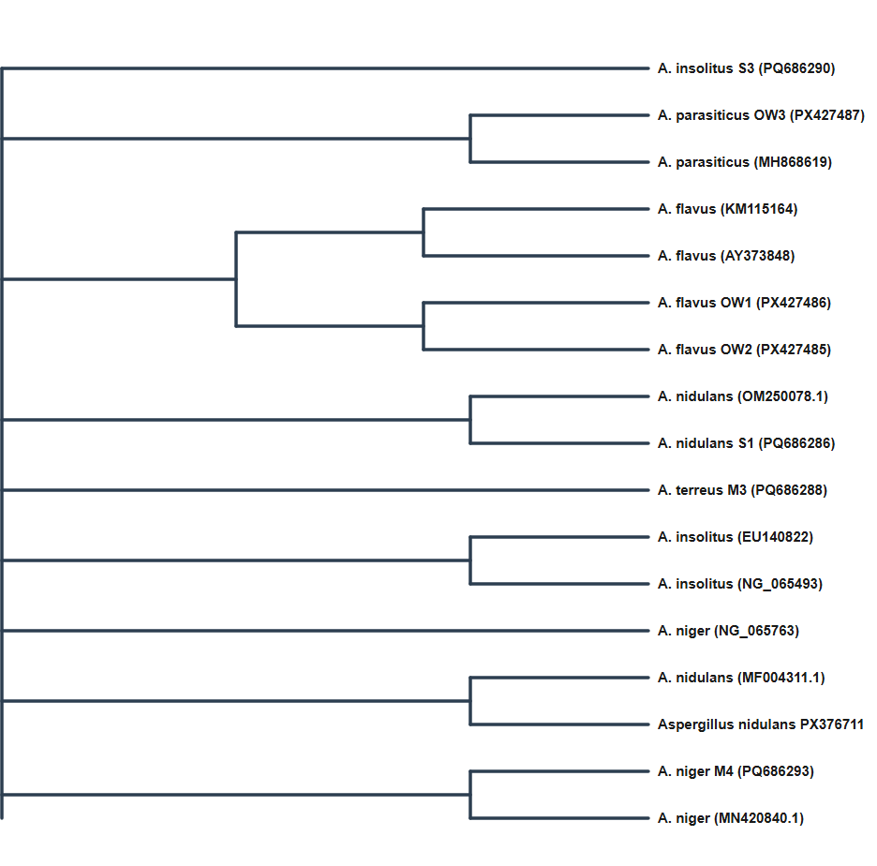
Figure 3: The phylogenetic tree showing the relationship between A. insolitusS3(PQ686290), A. parasiticusOW3(PX427487), A. parasiticus(MH868619), A. flavus(KM115164), A. flavus(AY373848), A. flavusOW1 (PX427486) A. flavusOW2(PX427485), A. nidulans (OM250078.1) A. nidulansS1(PQ686286), A. terreusM3 (PQ686288), A. insolitus(EU140822), A. insolitus(NG_065493), A. niger(NG_065763), A. nidulans(MF004311.1), A. nidulansM2 (PX376711), A. nigerM4 (PQ686293) and A.niger (MN420840.1).

3.3 Discussion
The fungal presence showed considerable variation between farms and even within different points of the same farm, indicating the heterogeneous nature of distribution. This observation aligns with findings by Atnafuet al. (2024), who emphasized that fungal contamination in subsistence farming systems exhibits significant spatial heterogeneity influenced by localized storage conditions and handling practices. The presence of fungi at all three sampling points in Ejigbo Farm indicates potentially systemic issues at this location, warranting immediate intervention measures to prevent continued contamination and protect food safety (Liu et al., 2020).
The observed fungal growth rates underscore the complex interplay between environmental conditions and fungal proliferation in agricultural settings. Ejigbo Farm exhibited the highest fungal growth rates (3.7-4.5 cm/week) across all sampling points. The positive association of fungal colonization aligns with established knowledge that fungi compete for resources and establish ecological dominance (Medina et al., 2017). The water activity and temperature conditions that promote rapid mycelial extension typically overlap with those optimal for fungal biosynthesis, particularly for Aspergillus species, which require water activity >0.82 and temperatures between 25-30°C for growth (Paterson and Lima, 2010). The substantial intra-farm variability in fungal growth rates exemplified by Oba-Oke Farm, where rates varied from 1.2 cm/week at one point to 4.0 cm/week at another, reflects the microclimatic variations that characterize tropical storage environments. These localized differences in aeration, grain moisture distribution, and structural integrity create distinct ecological niches supporting differential fungal development (Hell et al., 2000). Such heterogeneity has critical implications for risk assessment and sampling protocols, as contamination often concentrates in "hot spots" where moisture and fungal activity converge, necessitating stratified sampling approaches to achieve representative results (Krskaet al., 2008).
The morphological diversity observed, ranging from white-green to dark green colonies with varying textures, indicates the presence of multiple species within the genus. The molecular characterization successfully identified eleven distinct mycotoxigenic species with 100% homology to NCBI GeneBank sequences, providing definitive taxonomic resolution that morphological methods alone cannot achieve. The predominance of Aspergillus species (81.8% of isolates) across all study farms reflects the ecological adaptability and competitive advantages these fungi possess in tropical agricultural environments (Frisvadet al., 2019). This aligns with the work of Olatunji and Oladipo (2025), who also reported the predominance of Aspergillus species (53.85%) in Digitariaexilis. The identification of Fusariumsolani (18.2% of isolates) at farm F4 and farm F5 adds complexity to the mycological landscape (Smith et al., 2016).
Research by Chen et al. (2023) demonstrated that mixed fungal contaminations are common in tropical storage systems where fluctuating environmental conditions favor sequential or simultaneous colonization by different genera, creating complex profiles that complicate risk assessment and mitigation strategies. The phylogenetic clustering of study isolates with geographically diverse reference strains suggests these fungi exhibit cosmopolitan distribution patterns maintained through anthropogenic dispersal via contaminated grain trade and agricultural practices (Battilaniet al., 2016).
- CONCLUSION
This comprehensive study on fungi in stored maize from Osun State, Nigeria, revealed significant food safety concerns with widespread contamination across all sampled farms. These findings underscore the urgent need for improved post-harvest handling practices, enhanced storage infrastructure, and regular surveillance programs in the region. The immediate intervention strategies are imperative to safeguard food security and public health in Nigeria's agricultural communities. Future research should focus on evaluating the efficacy of locally appropriate mitigation measures and establishing comprehensive monitoring systems to reduce fungal contamination in the food chain.
Disclaimer (Artificial intelligence)
Option 1:
Author(s) hereby declare that NO generative AI technologies such as Large Language Models (ChatGPT, COPILOT, etc.) and text-to-image generators have been used during the writing or editing of this manuscript.

REFERENCES
Adelusi, O. A., Gbashi, S., Adebiyi, J. A., Makhuvele, R., Aasa, A. O., Oladeji, O. M. and Njobeh, P. B. (2022). Seasonal diversity and occurrence of filamentous fungi in smallholder dairy cattle feeds and feedstuffs in South Africa.Journal of Fungi, 8(11), 1192.
Agarwal, V.K. and Sinclair, J.B. (1997).Principles of Seed Pathology.2nd Edition, CRC Press/Lewis Publishers, Boca Raton, Florida.
Ayelign, A., and De Saeger, S. (2020). Mycotoxins in Ethiopia: Current status, implications to food safety and mitigation strategies. Food Control, 113, 107-163.
Battilani, P., Toscano, P., Van der Fels-Klerx, H.J., Moretti, A., Leggieri, M.C., Brera, C., Rortais, A., Goumperis, T. and Robinson, T. (2016). Aflatoxin B1 contamination in maize in Europe increases due to climate change. Scientific Reports, 6, 24328.
Chen, X., Abdallah, M. F., Landschoot, S., Audenaert, K., De Saeger, S., Chen, X., and Rajkovic, A. (2023). Aspergillusflavus and Fusariumverticillioides and Their Main Mycotoxins: Global Distribution and Scenarios of Interactions in Maize. Toxins, 15(9), 577.
Frisvad, J.C., Hubka, V., Ezekiel, C.N., Hong, S.B., Nováková, A., Chen, A.J., Arzanlou, M., Larsen, T.O., Sklenář, F., Mahakarnchanakul, W., Samson, R.A. and Houbraken, J. (2019). Taxonomy of Aspergillus section Flavi and their production of aflatoxins, ochratoxins, and other mycotoxins.Studies in Mycology, 93, 1-63.
Hell, K., Cardwell, K.F., Setamou, M. and Poehling, H.M. (2000). The influence of storage practices on aflatoxin contamination in maize in four agroecological zones of Benin, West Africa. Journal of Stored Products Research, 36, 365-382.
IARC (2019). Monograph on the Evaluation of Carcinogenic Risks to Humans: Some Naturally Occurring Substances: Food Items and Constituents, Heterocyclic Aromatic Amines and Mycotoxins. International Agency for Research on Cancer, Lyon, France, 56, p. 489.
Kidd, P. S., Álvarez-López, V., Becerra-Castro, C., Cabello-Conejo, M., and Prieto-Fernández, Á. (2016).“Potential role of plant-associated bacteria in plant metal uptake and implications in phytotechnologies,” Journal in Advances in Botanical Research, 83: 87–126.
Krska, R., Schubert-Ullrich, P., Molinelli, A., Sulyok, M., MacDonald, S., and Crews, C. (2008). Mycotoxin analysis: an update. Food Additives and Contaminants, 25, 152- 163.
Liu, S.J., Wu, Y.N., and Chan, L. (2020). Application of metabonomics approach in food safety research—A review. Food Reviews International, 36(6), 547-558.
Magan, N. and Aldred, D. (2020). Post-harvest control strategies: Minimizing mycotoxins in the food chain. International Journal of Food Microbiology, 119(1-2), 131-139.
Medina, A., Rodríguez, A. and Magan, N. (2017). Climate change and mycotoxigenic fungi: impacts on mycotoxin production. Current Opinion in Food Science, 5, 99-104.
Nayak, S., Samanta, S., & Mukherjee, A. K. (2020). Beneficial role of Aspergillus sp. in agricultural soil and environment. Frontiers in soil and environmental microbiology, 17-36.
Ohabughiro, N. B., Braide, W., Okorondu, S. I., and Nwanyanwu, C. E. (2020). Molecular Characterization of Fungi Isolated from Stored Food Products in Imo State, Nigeria. Nigerian Journal of Microbiology, 67:1-8
Olatunji, T. J.; Oladipo, I. C. (2025). Isolation and molecular identification of fungal contaminants of Digitariaexilis from five farms in Kwara state, Nigeria. International Journal of Advanced Research in Biological Sciences. 12(11): 47-60
Payne, G. A., & Brown, M. P. (1998). Genetics and physiology of aflatoxin biosynthesis. Annual Review of Phytopathology, 36(1), 329–362. https://doi.org/10.1146/annurev.phyto.36.1.329
Paterson, R.R.M. and Lima, N. (2010). How will climate change affect mycotoxins in food? Food Research International, 43, 1902-1914.
Smith, M.C., Madec, S., Coton, E. and Hymery, N. (2016).Natural co-occurrence of mycotoxins in foods and feeds and their in vitro combined toxicological effects. Toxins, 8, 94.
Sokefun, E., Ayepola, O.O., and Olasehinde, G.I. (2018).Mycotoxins: Food Production and Exportation in Nigeria. Earth and Environmental Science, 210, 012018. doi:10.1088/1755-1315/210/1/012018.
Udomkun, P., Nimo, A., Nagle, M., Müller, J., Vanlauwe, B. and Bandyopadhyay, R. (2017). Innovative technologies to manage Aflatoxins in foods and feeds and the profitability of application—A review.Food Control, 76, 127-138
YafettoL.,Adator, E. H., Ebuako, A. A., Ekloh, E., and Afeti, F. Y. (2019). Microbial quality of raw beef and chevon from selected markets in Cape Coast, Ghana. Journal of Biology and Life Science 10 (1): 78 – 97.

