Popillia cyanea Hope, 1831 (Coleoptera: Scarabaeidae): A New and Emerging Pest of Cowpea (Vigna unguiculata L.) in Garhwal range of Uttarakhand, India

Abstract
Background: Cowpea (Vigna unguiculata L.) is a vital legume crop in tropical regions, valued for its nutritional and agricultural benefits. However, insect pests like the scarab beetle Popillia cyanea cause significant yield losses, and their adaptability to new hosts poses a threat to cowpea production.
Aim: The study aims to document the first occurrence of Popillia cyanea Hope, 1831 (Coleoptera: Scarabaeidae) feeding on cowpea (Vigna unguiculata L.) in Uttarakhand, India, and to describe its feeding behaviour and associated damage symptoms.
Study Design: A field-based observational study was carried out on cowpea during the Rabi season of 2025.
Methodology: Systematic field observations were carried out in cowpea fields to record the incidence, feeding behaviour, and damage symptoms caused by adult beetles. Observations focused on the time of activity, aggregation behaviour, plant parts affected, and the nature of foliage damage. Species identification was based on characteristic morphological features, including metallic-green colouration and typical scarab beetle morphology.
Results: Adult beetle P. cyanea caused severe defoliation on flowers, young leaves, and tender shoots of cowpea. Feeding occurred mainly during early morning and late evening, with beetles aggregating in small groups on the canopy. Leaf skeletonisation and reduced photosynthetic area resulted in noticeable growth retardation and yield loss, indicating P. cyanea as an emerging pest of cowpea in the region.
Conclusion: The study documents P. cyanea as an emerging pest of cowpea in Uttarakhand, India, highlighting the need for monitoring and eco-friendly management strategies to mitigate its impact on cowpea production.
Keywords: Vigna unguiculata, Defoliation damage, Emerging pest, Uttarakhand, Pest incidence
INTRODUCTION
Cowpea (Vigna unguiculata L.) is a highly valued leguminous crop grown extensively across tropical and subtropical regions of the world (FAO, 2020). It is cultivated for its multipurpose use as a vegetable, pulse, fodder, and green manure crop (Singh et al., 2015). Major pulse crops grown in India include pigeonpea, mungbean, urdbean, chickpea, horse gram and cowpea. Among these, cowpea from the Fabaceae family is one of the oldest known food sources (Ansar et al., 2024). In India, cowpea is an integral component of traditional farming systems, particularly in dryland and rainfed areas, due to its ability to fix atmospheric nitrogen, improve soil fertility, and provide nutritious food for humans and livestock (Raju et al., 2018). Despite its resilience, cowpea productivity is often constrained by several biotic stresses, among which insect pests pose a major challenge to sustainable cultivation (Jackai & Daoust, 1986). In India, crop damage has been estimated because insect pests range from 10-30% per year, out of which 26% is due to insect pests (Hajam & Kumar, 2022).
More than 100 insect species have been reported to attack cowpea at various growth stages, causing considerable yield reduction (Singh & Allen, 1979). Among these, foliage feeders and pod borers are the most destructive, leading to partial or complete defoliation of plants (Kalaisekar et al., 2017). Defoliation reduces photosynthetic activity and adversely affects pod formation and seed filling (Sharma et al., 2010). Continuous pest incidence throughout the growing season has forced farmers to rely heavily on chemical insecticides, which not only increase production costs but also create ecological and health concerns (Isman, 2006).
Scarab beetles belonging to the genus Popillia (Family: Scarabaeidae, Subfamily: Rutelinae) are polyphagous and voracious feeders (Fleming, 1972). Adult beetles typically attack the foliage of a wide range of host plants, including cereals, ornamentals, fruit trees, and vegetables (Duffy, 1968). Their characteristic feeding behaviour involves scraping and consuming the leaf lamina, leaving only the network of veins, which results in the typical skeletonised appearance of damaged leaves (Fleming, 1972). The larvae of some species, commonly known as “white grubs,” inhabit the soil and feed on plant roots, further aggravating crop losses (Ritcher, 1966).
Popillia cyanea Hope, 1831, is a metallic-green scarab beetle widely distributed throughout India and adjoining Southeast Asian countries (Arrow, 1917). It has been reported as a pest on roses, maize, sugarcane, and several ornamental and fruit crops (Shukla & Rao, 2005). An emerging pest can be defined as any pest that has been reported in a particular area on a specific crop and has shown a significant increase in its population, with the potential to cause substantial economic damage over time. These pests may have previously existed in the region but were not considered a major threat until their populations expanded and their impact on crops became more pronounced. (Bhowmik & Yadav, 2025). However, until recently, no published record existed regarding its infestation on cowpea in India. During recent field surveys conducted in cowpea fields of Uttarakhand, adult P. cyanea beetles were observed feeding on young leaves and tender shoots, resulting in severe foliar damage. The beetles aggregated in groups during the early morning and late evening hours, indicating a specific feeding rhythm and aggregation behaviour.
The present study documents, for the first time, the occurrence of Popillia cyanea feeding on cowpea in Uttarakhand, India. This new host association not only broadens the known host range of the species but also highlights its potential as an emerging pest of economic importance in pulse-based cropping systems. The increasing adaptability of P. cyanea to new hosts underscores the need for systematic monitoring, accurate identification, and the development of eco-friendly management strategies to prevent future outbreaks.
MATERIAL AND METHODS
Field surveys were conducted during the Rabi season of 2025 in cowpea (Vigna unguiculata L.) fields located at the Genetic and Plant Breeding Research Farm, College of Hill Agriculture, Ranichauri, Uttarakhand and in different cowpea-cultivated plots in nearby localities of the Garhwal region, Uttarakhand, India. The crop was grown under natural field conditions without the application of insecticides. Adult beetle activity was monitored through direct field observations. Feeding behaviour on cowpea foliage and flowers was predominantly recorded during the early morning and late evening hours, indicating crepuscular feeding activity. The affected plants exhibited characteristic symptoms of leaf skeletonisation, wherein only the network of veins remained intact while the lamina was completely removed. In addition, feeding damage on flower petals and tender buds was also recorded, indicating that the beetles prefer both vegetative and reproductive parts of the plant.
Specimens of the suspected insect were carefully collected using an insect sweep net and preserved in 70% ethanol for laboratory examination. Morphological identification was carried out based on external characters, including body colour, elytral pattern, and antennal club structure, following standard taxonomic keys for Scarabaeidae. For confirmation, the collected specimens were submitted to the Zoological Survey of India (ZSI), Kolkata, where the insect was identified and authenticated as Popillia cyanea Hope, 1831 (Coleoptera: Scarabaeidae).
Environmental parameters such as temperature, humidity, and crop stage were recorded at the time of collection. Photographs of both field infestation and adult beetles were taken using a digital camera for documentation. The extent of defoliation and feeding pattern was visually assessed and recorded for qualitative analysis. The collected data were used to describe the nature of damage, host plant association, and behavioural observations of P. cyanea under field conditions.
RESULT AND DISCUSSION
During field surveys in cowpea fields of Tehri Garhwal, Uttarakhand, adult Popillia cyanea H. (Coleoptera: Scarabaeidae) were recorded feeding on foliage and flowers. Beetle abundance was quantified by recording the number of adults per plant and plants infested per square meter, and feeding damage was assessed using a visual scale (0 = no damage, 1 = <10%, 2 = 11–25%, 3 = 26–50%, 4 = 51–75%, 5 = >75% leaf area damaged). Beetles were metallic green with a coppery tinge on the elytra, measuring 10–12 mm in length. Aggregations were primarily observed on young leaves and tender shoots, with peak activity during early morning (6:30–8:00 a.m.) and late evening (5:30–7:00 p.m.).
The characteristic feeding damage appeared as leaf skeletonisation, where only the veins of the leaf lamina remained intact while the mesophyll tissue was completely scraped off. The affected leaves turned brown, dried up rapidly, and eventually fell from the plant. In severe infestations, plants exhibited a scorched appearance with considerable loss of foliage, thereby reducing photosynthetic area and affecting plant vigour. In addition to foliage feeding, the beetles were also seen nibbling on the flower petals and tender floral buds, which could potentially interfere with pollination and pod setting. The occurrence of P. cyanea on cowpea marks a new host association for this scarab beetle in India. Previously, Popillia cyanea had been recorded feeding on ornamental plants such as roses, as well as on maize and certain fruit trees. The present finding indicates an expansion of its host range and adaptation to leguminous crops like cowpea. The shift in feeding preference might be associated with the availability of succulent foliage during the monsoon season and the presence of overlapping habitats where cowpea is cultivated near alternate host plants.
Field observations were conducted to quantify the gregarious feeding behaviour of adult beetles by recording the number of infested plants per square metre, the mean number of beetles per plant, and the extent of feeding damage using a visual damage scoring scale. The beetles were found to aggregate and feed collectively on specific portions of the plant canopy. Such aggregation not only intensifies localised damage but also facilitates mating and subsequent egg-laying in nearby soil. Although larval damage (root feeding by grubs) was not recorded in the present study, it cannot be ruled out in future investigations, since other Popillia species are known to have soil-dwelling larvae that feed on plant roots. The increasing occurrence of P. cyanea in cowpea fields suggests that the species may be in the process of establishing itself as a potential emerging pest of this crop in Uttarakhand. Considering the ecological adaptability of scarab beetles and their polyphagous feeding habits, continuous monitoring is essential to assess their population dynamics, life cycle, and host preference under changing agro-ecological conditions. Integrated pest management (IPM) approaches, including light trapping, conservation of natural predators, and judicious use of eco-friendly insecticides, may be required to prevent the establishment of this pest on a large scale.
CONCLUSION
The present study reports, for the first time, the occurrence of Popillia cyanea (Coleoptera: Scarabaeidae) feeding on cowpea (Vigna unguiculata L.) in Uttarakhand, India. Adult beetles were observed causing typical foliar skeletonisation and flower damage, resulting in a reduction of photosynthetic surface and potential yield loss. This new host association broadens the known host range of P. cyanea and highlights its potential as an emerging pest of economic importance in pulse-based cropping systems. The beetle’s polyphagous feeding behaviour, adaptability to different ecological conditions, and preference for tender plant parts make it a possible threat to cowpea cultivation in the region.
It is, therefore, essential to undertake detailed studies on the biology, life cycle, population dynamics, and seasonal abundance of this species. Further, eco-friendly management strategies such as pheromone or light traps, conservation of natural enemies, and use of botanical insecticides should be explored to prevent large-scale infestations. Early detection and timely intervention will be critical in mitigating possible outbreaks of P. cyanea on cowpea and other leguminous crops in the future.

Disclaimer (Artificial intelligence)

Author(s) hereby declare that NO generative AI technologies such as Large Language Models (ChatGPT, COPILOT, etc.) and text-to-image generators have been used during the writing or editing of this manuscript.

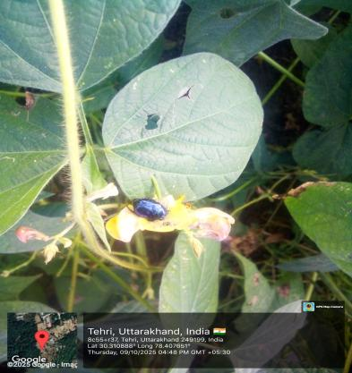 | 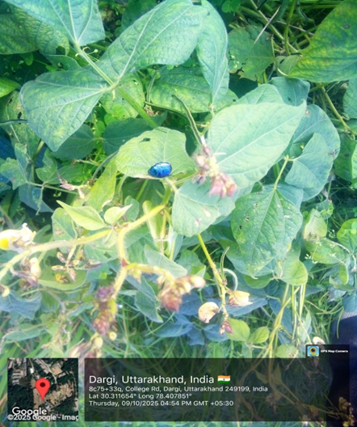
Fig. 1: Flower Feeding Fig. 2: Leaf Skeletonization

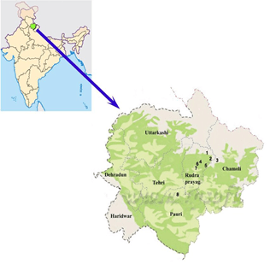 | 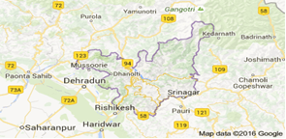
 | 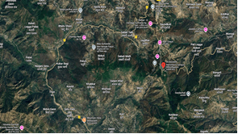
Fig. 3: GPS Map Showing the Survey Area
ACKNOWLEDGEMENTS
The authors sincerely thank the Dean, College of Hill Agriculture, Camp at Ranichauri, VCSG UUHF for providing the necessary facilities and Institutional support to conduct this study. Special thanks are extended to Dr. Devanshu Gupta, Scientist (Zoological Survey of India), for his expert assistance in taxonomic identification and confirmation of this beetle. The authors also acknowledge all individuals who directly or indirectly contributed to the successful completion of this research.
REFERENCES
- Arrow, G.J. (1917). The Fauna of British India, including Ceylon and Burma. Coleoptera. Lamellicornia. Taylor and Francis, London.
- Duffy, E.A.J. (1968). A Monograph of the Beetles Associated with Stored Products. Ministry of Agriculture, Fisheries and Food, London.
- FAO. (2020). FAOSTAT Statistical Database. Food and Agriculture Organization of the United Nations. Retrieved from http://www.fao.org/faostat/en/
- Fleming, W.E. (1972). Biology of the Japanese beetle. USDA Technical Bulletin 1449.
- Isman, M.B. (2006). Botanical insecticides, deterrents, and repellents in modern agriculture and an increasingly regulated world. Annual Review of Entomology, 51, 45-66.
- Jackai, L.E.N., & Daoust, R.A. (1986). Insect pests of cowpea. Annual Review of Entomology, 31, 95-119.
- Kalaisekar, A., Padmaja, P., Bhagwat, V.R., & Patil, J.V. (2017). Insect pests of millets: systematics, biology, and management. Academic Press.
- Raju, A.J., Yadav, P., & Singh, M. (2018). Cowpea cultivation: an overview of agronomic practices and pest management. Journal of Pulses Research, 9(1), 1-12.
- Richter, A. (1966). White Grubs and Their Control. USDA Circular No. 1197.
- Sharma, H.C., Ortiz, R., & St. Clair, D.A. (2010). Advances in cowpea insect pest management. Crop Protection, 29(2), 104-110.
- Shukla, A.K., & Rao, V.S. (2005). New host records and biology of Popillia cyanea Hope (Coleoptera: Scarabaeidae). Journal of Entomological Research, 29(3), 229-234.
- Singh, B.B., & Allen, D.J. (1979). Cowpea pests and their control in Africa. International Institute of Tropical Agriculture Bulletin, No. 8.
- Singh, B.B., Chambliss, O.L., & Sharma, B. (2015). Recent advances in cowpea research. In Proceedings of the International Cowpea Conference, 2015.
- Hajam, Y. A., & Kumar, R. (2022). Management of stored grain pest with special reference to Callosobruchus maculatus, a major pest of cowpea: A review. Heliyon, 8(1).
- Ansar, A., T, S., Radhakrishnan, G., & Jayapal, A. (2024). Impact of Key Insect Pests on Cowpea and their Relationship with Weather Parameters. International Journal of Environment and Climate Change, 14(11), 683–692.
- Bhowmik, S., & Yadav, S. K. (2025). Emerging insect pests of pulse crops in India-A brief review. Journal of Food Legumes, 38(1), 26-35.

