“Morphological Diagnosis of Macrophomina phaseolina, the Causal Agent of Charcoal Rot Disease in Cluster bean [Cyamopsis tetragonoloba (L.) Taub], and a Study of Its Pathogenicity.”

Abatract: Cluster bean charcoal rot incited by Macrophomina phaseolina (Tassi) Goid. is an important pathological problem in cluster bean growing areas of Rajasthan. Initial symptoms of charcoal rot were yellowing of leaves and plants wilt drying a week. Diseased plants do not pull out easily. The tissue at the collar region ruptures and becomes soft. After infection, a dark brown coloured lesion is seen on the stem at ground level later on black coloured-like structure (sclerotia) may be seen on the stem and root. Isolation was done from diseased root parts and the pathogen was purified using hyphal tip cut techniques and was identified as Macrophomina phaseolina based on its morphology and colony characters. The young hyphae of the fungus were observed to be hyaline, thin-walled light brown to dark brown and having more septa. Branches from the main hyphae are generally formed at the right angle to parent hyphae with constriction of the point of origin. Pathogenicity was also proved through Koch’s postulates techniques under pot conditions by using normal soil, autoclave soil, field soil + inoculum and autoclave soil + inoculum technique methods. Field soil + inoculum were found effective followed by autoclave soil. The maximum per cent disease incidence (62.50%) was recorded with the field soil + inoculum technique followed field soil (57.14 %) techniques. The minimum per cent disease incidence (0.03 %) was recorded with the autoclave soil technique. Minimum germination per cent was observed in field soil + inoculum (67.67 %) followed by field soil (71.67 %).
Key words: Isolation, Inoculation, Pathogenicity, Koch’s Postulate, Macrophomina phaseolina

Introduction
Cyamopsis tetragonoloba (L.) Taub., commonly known as Guar, is a native legume crop of India and holds significant agricultural importance, particularly in arid and semi-arid regions, due to its exceptional drought and high-temperature tolerance (Mahla et al., 2024; Madni et al., 2021, Kumar and Rodge, 2012). Cluster bean is used for various purposes, viz., vegetable, cattle feed and fodder or green manuring. Cluster bean is rich in protein and fibre content, hence offering several health benefits in vegetable form and its tender green pods are also a cheap source of nutrients. Further cluster bean seeds are using as high protein cattle feed (Rai and Dharmatti, 2013). The green pods of cluster beans are notably rich in energy, moisture, protein, vitamins and minerals making them a valuable dietary source (Naga et al., 2014). Seeds of cluster bean contain 22–33% gum (Choudhary et al., 2014) and consist of three parts: the testa (14-17%), the endosperm (35-42%) and germ (43-47%). Among these biotic stresses, diseases, insects, nematodes and parasitic weeds account for significant crop losses. The major diseases affecting cluster beans include charcoal rot, Alternaria blight, anthracnose, bacterial blight and powdery mildew. Among them, charcoal rot is one of the most serious and widely distributed diseases worldwide. The fungus affects a wide range of crops and weeds leading to great economic losses and is reported to cause yield losses of 30-40% in cluster bean (Lodha et al., 1986). Charcoal rot caused by Macrophomina phaseolina (Tassi) Goid has emerged as a major biotic threat in several regions of the country, causing considerable economic yield losses. M. phaseolina (Tassi) Goid. is one of the most devastating necrotrophic, seed- and soil-borne pathogenic fungus that belongs to the Botryosphaeriaceae family (Dell’Olmo et al., 2022; Ortiz et al., 2023). Dry root rot disease in cluster bean is most evident during the reproductive phases of plant growth, although the fungus can be isolated from plant roots throughout the season (Bruton et al., 1987). This disease is most prevalent under hot, dry climates during the post-flowering period of the crop. A temperature of 30°C is considered favorable for disease development. The degree of infection increases with higher soil temperatures and low soil moisture. Germination of microsclerotia occurs at temperatures between 28-35°C. Disease incidence on the stem is observed close to the ground, with dark brown lesions and bark shredding around the collar region. The abrupt death of plants in patches is also recorded. Infected stems can be easily pulled out, leaving the rotten root in the ground. In later stages, the infection spreads to pods, leading to premature pod opening. Infected seedlings may continue to develop without visible symptoms. Older plants infected with M. phaseolina show reduced leaf and seed size and early senescence. Severe infection causes ramification, yellowing and death of the leaves. Pods, petioles, stems and roots develop a gray or silver coloration due to microsclerotia formation in these tissues. M. phaseolina survives as microsclerotia on infected plant debris in the soil, serving as the primary source of inoculum and persisting for up to three years (Sharma et al., 2021). Since, the disease has become a serious problem due to soil and seed borne nature as well as huge economical losses caused by Charcoal rot pathogen, accurate identification of fungus species that causing Charcoal rot disease of clusterbean can provide a useful guide to effective control this disease.
MATERIALS AND METHODS
Survey and collection of samples
The infected cluster bean plant showing typical symptoms of root rot like yellowing, sudden wilting, drying and complete root tissues rotten or decayed when uprooted the plant. Charcoal rot affected plants of cluster bean were collected from surveyed areas of Rajasthan during kharif season 2024 by following roving method of survey viz., Sri Ganganagar, Bikaner, Nagour, Jaipur and Jodhpur. During the survey Charcoal rot -infected plant sample was obtained from field that show the highest disease incidence.
Isolation of the Pathogen
The Isolation of the pathogen was done at Department of Plant Pathology, College of Agriculture Jodhpur, Agriculture University Jodhpur, infected stem root of cluster bean containing microsclerotia of the fungus were cut into small pieces, 5 to 6 mm, with the help of sterilized scalpel blade no. 20 and each infected sample was surface sterilized in 1 % of sodium hypochlorite solution (which was prepared from 4% of NaOCl by adding 25% NaOCl in 75% of sterilized distilled water) for 1 minute and then rinsed 3 times in sterile distilled water for 1 min each, rinsed samples were dried on autoclaved filter paper and plated on to antibiotics containing potato dextrose agar plates (PDA, Hi media pvt. Ltd. Ind). Streptomycin and tetracycline antibiotics were used to inhibit the growth of unwanted bacteria over isolated PDA plates.The inoculated plates were incubated at 27±2ºC in BOD incubator for 24-48 hours. Hyphal tips started growing within this period of incubation and then single hyphal tips from each plate was transferred to fresh PDA plates using a sterile dissecting needle, after examining the mother culture under stereomicroscope for diagnostic feature of M. phaseolina. The principal growth characters like morphological, cultural and formation of microsclerotia were considered for identification of pure cultures of M. phaseolina. These characters were compared as described by Hartman et al., 2015 and identified as M. phaseolina depending on the observed traits.
Purification of the pathogen
The isolated fungus was purified by a single hyphal tip technique. A circular disc of 5 mm was cut with the help of a sterilized cork borer from 7 days 7-day-old culture of Macrophomina phaseolina and placed on a sterilized PDA containing a Petri plate and incubated at 27±1 °C temperature. After 24 hours of incubation, the PDA Petri plate with M. phaseolina was placed under low power objective of the microscope. The tip of the hypha marked with the help of dummy objective. These tips were carefully transferred to sterilized Potato Dextrose Agar (PDA) slants to obtained pure culture. PDA slant were incubated at 27± 1 °C temperature in BOD incubator.
Identification of the pathogen
The purified culture, obtained from the infected stem and root of the cluster bean was identified based on morphological and colony characters and was examined with the help of a microscope. For further confirmation, a pure culture of the pathogen was sent to the Indian Type Culture Collection (ITCC), Division of Plant Pathology, IARI, New Delhi- 110 012 and it was identified as M. Phaseolina.
Pathogenicity test
For proving pathogenicity, isolated and purified Macrophomina phaseolina cultures were multiplied on sterilized sorghum grains and proved pathogenicity by following Koch’s postulates through field soil, autoclave soil, field soil + inoculum and autoclave soil + inoculum, inoculation techniques. Soil collected from the field was autoclaved at 1.045 kg/cm² pressure for 30 minutes for three consecutive days. The pots were also surface sterilized with 2 per cent formalin solution before filling the soil inoculum mixture. The inoculum multiplied on sorghum grains was added in the earthen pots (30 cm diameter) @ rate of 20 g/pot and suitably moistened and allowed for 72 hours to stabilize the inoculum before sowing cluster bean seeds. About ten cluster bean surface sterilized seeds with 1 per cent sodium hypochlorite solution were sown in each pot with six replications and maintained in a cage house with need-based irrigation. The pots without inoculum were served as control. Observations on disease symptoms were recorded periodically. Re-isolation of the pathogen was made from infested seedlings, identified under microscopic observation and the culture thus obtained was compared with that of the original culture (Radha krishanan and Sen, 1985) and the pathogenicity (Koch’s postulates) was proved and observation of diseased and healthy plants were recorded and PDI was calculated by formula,
Per cent disease incidence = | Number of infected plants | X 100
Per cent disease incidence = | Total number of plants | X 100

RESULTS & DISCUSSION

Collection, isolation and purification of the pathogen
Disease-infected plants of cluster bean were collected in Kharif 2023, from different cluster bean growing areas. The infested root samples were gently washed in tap water to remove the soil particles adhering to the root surface. The washed root parts were cut into small pieces and surface sterilized in 0.1% sodium hypochlorite solution in Petri plates for 1-2 minutes followed by repeated washing in sterilized distilled water. The surface sterilized pieces were transferred aseptically on Potato Dextrose Agar (PDA) medium in Petri plates and kept in a BOD incubator for 7 days at 27±2°C for growth of the pathogen.
Identification of the pathogen
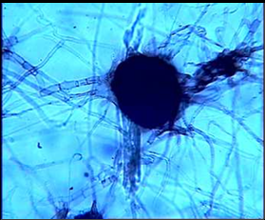
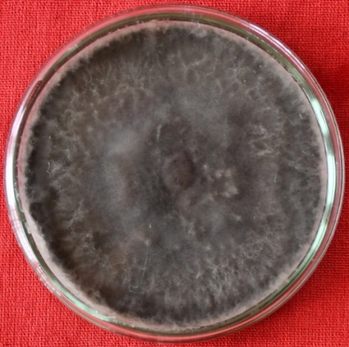
Identification of the isolated fungus was done based on cultural and morphological characteristics of sclerotia. The young hyphae of the fungus were observed to be hyaline, thin-walled light brown to dark brown and having more septa. Branches from the main hyphae are generally formed at the right angle to parent hyphae with constriction of the point of origin. The colour of the sclerotia was light brown in the beginning which became darker with age and finally brown to black, sclerotia varied in shape irregular or spherical or oval, or oblong, measuring from 90-120 x 60-150 μm with an average of 82.5 to 105 μm in size. Pycnidia were observed only on the host surface. These were larger than sclerotia, dark brown to black, rough, globose, or irregular, beaked and ostiolate. Based on the morphological character of this fungus has been identified as Macrophomina phaseolina. It was further confirmed by the Indian Type Culture Collection (ITCC), Division of Plant Pathology, IARI, New Delhi as Macrophomina phaseolina (Tassi) Goid. with the ID No.11989.24.

Pure culture of Aspergillus niger

(b) Right angel branching of hyphae
- Culture of Macrophomina phaseolina
(c) Sclerotia formation

Figure 1. Identification of Macrophomina phaseolina

Pathogenicity Test
The Macrophomina phaseolina (Tassi) Goid. isolated from infected roots of cluster bean plants found pathogenic when field soil, autoclave soil, field soil + inoculum and autoclave soil + inoculum technique was used to inoculate artificially cluster bean plants under pot house conditions. The characteristic symptoms of charcoal rot appeared after 30 days. The most recognizable symptoms were the sudden death of cluster bean seedlings. First leaves started withering and drying and the charcoal rot was followed gradually killing the whole plant. Roots of the diseased plant showed brown to blackish lesions. Isolation from artificially inoculated plants yielded M. phaseolina (Tassi) Goid. which was identical to the original one.
The pathogenicity of M. phaseolina was tested by field soil, autoclave soil, field soil + inoculum and autoclave soil + inoculum techniques. The maximum per cent disease incidence (62.50%) was recorded with the field soil + inoculum technique followed field soil (57.14 %) techniques. The minimum per cent disease incidence (0.03 %) was recorded with the autoclave soil technique. Minimum germination per cent was observed in field soil + inoculum (67.67 %) followed by field soil (71.67 %).
Table:1 Pathogenicity test of charcoal rot of cluster bean against Macrophomin phaseolina under pot conditions
Inoculation techniques | Germination % | Per cent disease incidence
Field soil + Inoculum | 67.67  (55.34) | 62.50  (49.28)
Autoclave soil + Inoculum | 85.00  (67.47) | 50.00  (44.98)
Field soil | 71.67  (57.87) | 57.14  (53.89)
Autoclave soil | 90.00  (71.53) | 0.00  (0.03)
SEm± | 1.12 | 1.20
CD (p=0.05) | 3.35 | 3.58
CV% | 4.38 | 7.98
*Average of six replications.
*Figures given in parentheses are angular transformed values

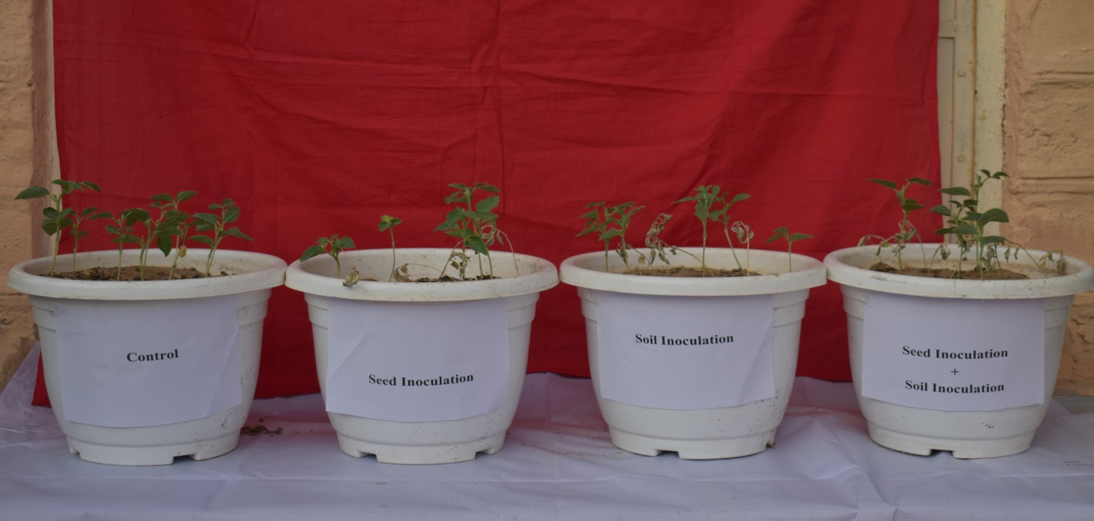

Figure 2: - Pathogenicity test of charcoal rot of cluster bean by different inoculation techniques

Collected samples of charcoal rot-infected plants from different locations were isolated to study the variability. The samples were grown on Potato dextrose agar (PDA) medium and purified using the "hyphal tip technique" under the aseptic condition in the laboratory. The pathogen formed whitish mycelial growth on Potato Dextrose Agar later, which turned brownish-black in colour and resulted in the development of black hard sclerotia in the periphery of the colony. Based on cultural and morphological characteristics viz., colony colour, formation of round, irregular and oblong type sclerotial fungus was identified as M. phaseolina. Similarly, results were found by Mehta (1951) who reported for the first-time root rot of sesame caused by M. phaseolina from Uttar Pradesh and Dhingra and Sinclair (1977) while workers on pulses and oil seed crops. Su et al., (2001) reported that the fungus M. phaseolina (Tassi) Goid causes charcoal rot, charcoal rot, dry weather wilt, seedling blight and ashy stem blight disease in over 500 plant species. Dhingra and Sinclair 1977; Lodha et al., 1986, Diourte et al., 1995) reported that M. phaseolina is a pathogen of cluster bean and several pulse crops. Sun et al., 2016 isolated four isolates of adzuki beans and identified them as M. phaseolina based on morphological and molecular characteristics. Later identification of the fungus was also confirmed by ITCC, Division of Plant Pathology, IARI, New Delhi with I.D. No. 11,989.24
The experiment was conducted under pot conditions to prove the pathogenicity of the isolated fungus. Artificial inoculum of isolated fungus was applied through field soil, autoclave soil, field soil + inoculum and autoclave soil + inoculum application method and following Koch’s postulates. The data depicted that the field soil + inoculum method resulted higher disease incidence (62.50%) followed by field soil method (57.14%). Similarly, Priyanka et al. (2022) experiment was conducted for fungal isolation, purification, identification of the pathogen and the pathogenicity test for all the twelve isolates proven by using three inoculation techniques. The significant variation in disease symptoms was noticed at 25 days after sowing in isolate MP-BKN to 45 days after sowing in isolate MP-UDZ. It was also revealed that the maximum disease incidence (60.35%) was recorded in seed cum soil inoculation technique followed by soil inoculation techniques (52.45%). Prajapati et al. (2024) were study, three inoculation methods—in vitro paper towel, in vitro agar, and soil inoculation in pots—were tested to evaluate the pathogenic potential of Macrophomina phaseolina, the causative agent of dry root rot (DRR). Among the three techniques, the paper towel inoculation method resulted in the highest seedling mortality of 66.66% in cluster beans and 86.67% in cowpeas within just ten days, demonstrating its effectiveness. The agar inoculation technique, while successful, required 15 days to confirm pathogenicity, with seedling mortality rates of 63.33% for cowpeas and 53.33% for cluster beans. In contrast, the soil inoculation method showed comparatively lower mortality rates, with 36.66% for cluster beans and 26.67% for cowpeas.
CONCLUSION
The present Studies “Investigation and Biological Management of Charcoal rot [Macrophomina phaseolina (Tassi.) Goid.] of Cluster bean [Cyamopsis tetragonoloba (L.) Taub]" and its Management” The entire study carried out successfully, and its objectives as reflected in the following conclusions drawn from there; The pathogen associated with charcoal rot of cluster bean was isolated, purified and identified as Macrophomina phaseolina and its pathogenicity was proved to field soil, autoclave soil, field soil + inoculum and autoclave soil + inoculum inoculation techniques.

Disclaimer (Artificial intelligence)

Author(s) hereby declare that NO generative AI technologies such as Large Language Models (ChatGPT, COPILOT, etc.) and text-to-image generators have been used during the writing or editing of this manuscript.

REFERENCES
- Bruton, B.D., Jeger, M.J. and Reuveni, R. 1987. Macrophomina phaseolina infection and vine decline in cantaloupe in relation to planting date, soil environment, and plant maturation. Plant Disease, 71: 259-263.
- Choudhary, R.S., Yadav, R.S. and Amin, A. 2014. Productivity and economics of clusterbean (Cyamopsis tetragonoloba) as influenced by phosphorus fertilization and biofertilizers in western Rajasthan. Annals of Agricultural Research, 35(1): 62-64
- Dell’Olmo, E., Tripodi, P., Zaccardelli, M., and Sigillo, L. (2022). Occurrence of Macrophomina phaseolina on chickpea in Italy: Pathogen identification and characterization. Pathogens, 11: 842.
- Dhingra, O.D. and Sinclair, J.B. 1977. An annotated bibliography of Macrophomina phaseolina, 1905-1975. Brazil University Stdade Federal de Vicosa University of Illinois Urbana, U.S.A., Pp. 224.
- Diourte, M., Starr, J.L., Jeger, M.J., Stack, J.P. and Rosenow, D.T. 1995. Charcoal rot (Macrophomina phaseolina) resistance and the effects of water stress on disease development in sorghum. Plant Pathology, 44 (1):196-202.
- Kumar, D. and Rodge, A.B. 2012. Status, scope and strategies of arid legumes research in India: A Review. Journal of Food and Legume, 25: 255-272.
- Lodha S, Gupta G.K and Singh S. 1986. Crop disease situation and some new records in Indian arid zone. Annals of Arid Zone, 25: 311–320.
- Madni, A., Khalid, A., Wahid, F., Ayub, H., Khan, R. and Kousar, R. (2021). Preparation and applications of guar gum composites in biomedical, pharmaceutical, food, and cosmetics industries. Current Nano science, 17: 365–379.
- Mahla, H.R., Rani, R., Choudhary, K.B., Rajput, L.S. and Sharma, R. (2024). Genomics-Aided Breeding Strategies for Biotic Stress in Cluster Bean. In Genomics-Aided Breeding Strategies for Biotic Stress in Grain Legumes; Parihar, A.K., Bohra, A., Lamichaney, A., Mishra, R., Varshney, R.K., Eds.; Springer: Singapore, p. 495–518.
- Mehta, P.R. 1951. Observation on new and known diseases of crop plants. Plant Protection Bulletin, 3: 7-11.
- Mihail, J.D. and Taylor, S.T. 1995. Interpreting variability among isolates of Macrophomina phaseolina in pathogenicity, pycnidium production and chlorate utilization. Canadian Journal Botenical, 73: 1596–603.
- Naga, S.D., Yadav, L.R., Jat, M.L., Dhaka, M.S. and Jeetarwal, R.L. 2014. Impact of integrated nutrient management on growth and productivity of cluster bean (Cyamopsis tetragonoloba L.) under limited moisture conditions. Annals of Agricultural Research, New Series, 35(4): 390-394.
- Ortiz, V., Chang, H. X., Sang, H., Jacobs, J., Malvick, D. K. and Baird, R. (2023). Population genomic analysis reveals geographic structure and climatic diversification for Macrophomina phaseolina isolated from soybean and dry bean across the United States, Puerto Rico, and Colombia. Frontiers in Genetics, 14: 1103969.
- Parween, A., Sahoo, J. P., Mahapatra, M., Das, B. P., Pattnaik, S., and Sunani, S. K. (2025). Morpho-biochemical and molecular profiling for Charcoal Rot (CR) disease resistance in Mung Bean [Vigna radiata (L.) Wilczek] landraces. Molecular Biology Reports, 52(1), 1-13.
- Prajapati, K.V., Prajapati, M.R., Devi, B.M., Purohit, J., Panickar, B., Thilakar, S., Choudhary, M., Jailani, A.A.K., Chattopadhyay, A. 2024. Paper Towel Method: In Vitro Inoculation Technique for Rapid and Robust Assessment of Clusterbean and Cowpea Genotypes Against Macrophomina phaseolina. Microbiological Research, 15: 2522–2534.
- Priyanka, Mathur, A.C., Sharma, R.S., Bagri, R.K and Verma, S. 2022 Pathogenicity test of different M. phaeolina isolates. The Pharma Innovation Journal, 11(2): 1234-1237.
- Purkayastha, S., Kaur, B., Dilbaghi, N. and Chaudhury, A. 2006. Characterization of Macrophomina phaseolina, the charcoal rot pathogen of cluster bean using conventional techniques and PCR-based molecular markers. Plant Pathology, 55: 106–116.
- Radhakrishnan, P. and Sen, B. 1985. Efficacy of different methods of inoculation of Fusarium oxysporium and Fusarium solani for inducing wilt in muskmelon. Indian Phytopathology, 38(1): 70-73
- Sharma, R., Kumar, S., Mahla, H.R., Khandelwal, V., Roy, P.K. and Sundria, M.M. 2021. Mothbean. The Beans and the Peas from orphan to mainstream crops. Elsevier, Pp. 67-88.
- Su, G., Suh, S.O., Schneider, R.W. and Russin, J.S. 2001. Host specialization in the charcoal rot fungus Macrophomina phaseolina. Phytopathology, 91: 120-126.
- Sun, S., Wang, X., Zhu, Z., Wang, B., and Wang, M. 2016. Occurrence of charcoal rot caused by Macrophomina phaseolina, an emerging disease of adzuki bean in China. Journal of Phytopathology, 164(3): 212-216.

