Seasonal and Age-Related Variations in Physiological Indices of Cyprinus carpio haematopterus (Amur Common Carp) in Temperate Aquaculture

Abstract
The physiological condition of cultured fish serves as a crucial indicator of health status, reproductive maturity, and environmental adaptation. This study investigated seasonal and age-related variations in physiological indices of Cyprinus carpio haematopterus (Amur common carp) at temperate region of Pantnagar, Uttarakhand. Female specimens of three age groups (0+, 1+, 2+ years) were sampled across four seasons (July, October, January, March), and four physiological indices viz. Condition Factor (CF), Specific Condition Factor (SCF), Hepatosomatic Index (HSI), and Gonadosomatic Index (GSI) were measured. CF values ranged from 1.46±0.03 to 1.94±0.07, with highest values in spring. SCF showed remarkable stability (1.27±0.02 to 1.58±0.06), indicating consistent somatic condition independent of reproductive investment. HSI fluctuated notably (0.82±0.13 to 1.69±0.11), with autumnal elevation reflecting pre-winter energy storage. GSI exhibited pronounced seasonal variation (3.18±0.24 to 18.53±0.66), with spring peaks indicating spawning season onset. Age-dependent analysis revealed 2+ fish demonstrated higher condition indices, suggesting cumulative effects of growth and maturation. These findings provide empirical foundations for season- and age-specific aquaculture management protocols and breeding program optimization for temperate carp culture.
Keywords: Cyprinus carpio haematopterus, condition factor, hepatosomatic index, gonadosomatic index, seasonal physiology

1. Introduction
Cyprinus carpio haematopterus (Amur common carp) is a freshwater cyprinid of significant commercial importance in Asian aquaculture (Froese & Pauly, 2023). This species has been widely introduced to Indian aquaculture systems due to rapid growth rates, high feed conversion efficiency, and environmental adaptability, contributing substantially to food security and rural livelihoods. Physiological indices serve as multifunctional biomarkers reflecting health status, nutritional state, and reproductive readiness (Weatherly & Gill, 1987). The Condition Factor (CF) provides normalized assessment of body robustness while Specific Condition Factor (SCF) isolates somatic condition independent of gonadal development (Bolger & Connolly, 1989). Hepatosomatic Index (HSI) quantifies metabolic capacity and energy storage while Gonadosomatic Index (GSI) reliably indicates reproductive maturity. Seasonal environmental fluctuations particularly temperature, photoperiod, and food availability have profoundly influence fish physiology through neuroendocrine mechanisms. In order to address the age-stratified studies for female C. carpio haematopterus in temperate aquaculture for different age groups in four seasons the following objectives viz. characterization of seasonal CF, SCF, HSI, GSI patterns across an annual cycle, analyze age-dependent variations and identification of critical periods for reproductive development.

2. Materials and Methods

2.1 Study Location and Environmental Context
This study was conducted at Pantnagar University of Agriculture and Technology, Pantnagar, Uttarakhand, India (29.01°N, 79.46°E, 263 m elevation). Pantnagar experiences humid subtropical climate with distinct seasonal variations: summer (March–June, 20–35°C), monsoon (July–September, 18–28°C, high rainfall), autumn (October–November, 15–25°C), winter (December–February, 5–15°C). These variations create pronounced seasonal shifts in water temperature, photoperiod, and food availability in outdoor pond systems.

2.2 Fish Procurement and Rearing Conditions
Female C. carpio haematopterus of three age groups were maintained in outdoor earthen ponds (0.5 ha, 1.5 m depth) at densities of 3,000–4,000 fish/ha. Water quality parameters were monitored fortnightly: dissolved oxygen (5.2–6.8 mg/L), pH (7.2–7.8), total alkalinity (110–140 mg/CaCO₃). Fish were fed standard pelleted feed (crude protein 30–35%) at 2–3% body weight daily, adjusted seasonally for temperature-dependent metabolic changes (Boyd, 2015).

2.3 Sampling Protocol
Stratified random sampling was conducted during the last week of each representative month: July 25-31 (summer), October 25-31 (autumn), January 25-31 (winter), March 25-31 (spring) to capture peak seasonal physiological states while minimizing intra-seasonal variability. This temporal stratification ensured consistent photoperiod (10-14 hours) and temperature exposure (5-35°C) across age groups. At each sampling event, 8-12 female fish per age group (total n = 24-36 fish per season) were randomly selected using standardized dip nets from multiple pond locations to avoid spatial bias. Fish were immediately immobilized in aerated 0.02% benzocaine solution (pH 7.2-7.4, buffered with NaHCO₃) for 2-4 minutes until Stage III anesthesia (loss of equilibrium, no opercular movement) (Velisek et al., 2011).

2.4 Morphometric and Gonadal Measurements
Immediately post-anesthesia, morphometric measurements followed standardized protocols performed by a single observer to eliminate inter-observer variability. Total length (TL) was measured from snout tip to caudal fork tip along body axis using Mitutoyo digital calipers (Model CD-15AX, 0-150 mm range, ±0.1 mm precision). Body mass (BM), liver mass (LM), and gonad mass (GM) were recorded to ±0.01 g using Ohaus Scout SKX123 portable balance after blotting excess water with standardized absorbent paper for 10 seconds. Liver and gonads were carefully dissected, weighed intact, and preserved in 10% neutral buffered formalin. All specimens were processed within 30 minutes of capture, as cyprinid post-mortem weight error exceeds 5% beyond 45 minutes (Zar, 2010).
2.5 Physiological Indices Calculation (Bolger & Connolly, 1989)
Condition Factor (CF): CF = (BM / TL³) × 100
Specific Condition Factor (SCF): SCF = [(BM – GM) / TL³] × 100
Hepatosomatic Index (HSI): HSI = (LM / BM) × 100
Gonadosomatic Index (GSI): GSI = (GM / BM) × 100

2.6 Statistical Analysis
All statistical analyses were conducted using R statistical software (v. 4.1.2, R Core Team, 2021). Data normality was assessed using Shapiro-Wilk tests (W > 0.92, p > 0.05 for all indices) and homogeneity of variance confirmed via Levene's tests (p > 0.10). Two-way Analysis of Variance (ANOVA) was employed to partition total variance into three components namely seasonal effects (Summer, Autumn, Winter, Spring), main effect of Age Group (0+, 1+, 2+ years old groups) and Season × Age interaction, enabling detection of both independent and synergistic effects (α = 0.05). Where significant effects were detected (p < 0.05), Tukey's Honestly Significant Difference (HSD) post-hoc tests identified specific pairwise group differences while controlling family-wise Type I error rate at 0.05, preferred over Bonferroni correction due to higher statistical power for balanced designs. HSI-GSI relationships were quantified using Pearson product-moment correlations (r) to test energy trade-off hypotheses. Data are presented as mean ± standard error of the mean (SEM); percentage changes calculated as [(Value₁ - Value₂) / Value₂] × 100.

3. Results

3.1 Condition Factor (CF) Across Age Groups and Seasons
Female C. carpio haematopterus demonstrated age-dependent and season-dependent CF variations. In 0+ group, CF ranged 1.46±0.03 (winter) to 1.58±0.03 (summer), 8.2% amplitude. The 1+ group showed greater fluctuation: 1.32±0.02 (autumn) to 1.86±0.03 (spring), 40.9% amplitude. The 2+ group exhibited highest values: 1.62±0.04 (autumn) to 1.94±0.07 (spring), 19.8% amplitude (Table 1). Spring recorded highest CF (mean 1.78±0.08); autumn lowest (1.50±0.05). Seasonal pattern was significant (ANOVA: F₃,₂₇ = 12.47, p < 0.001). Age effect significant (F₂,₃₀ = 18.34, p < 0.001), with 2+ fish showing higher CF than 0+ and 1+ groups. Age × Season interaction non-significant (F₆,₂₇ = 1.89, p = 0.11).
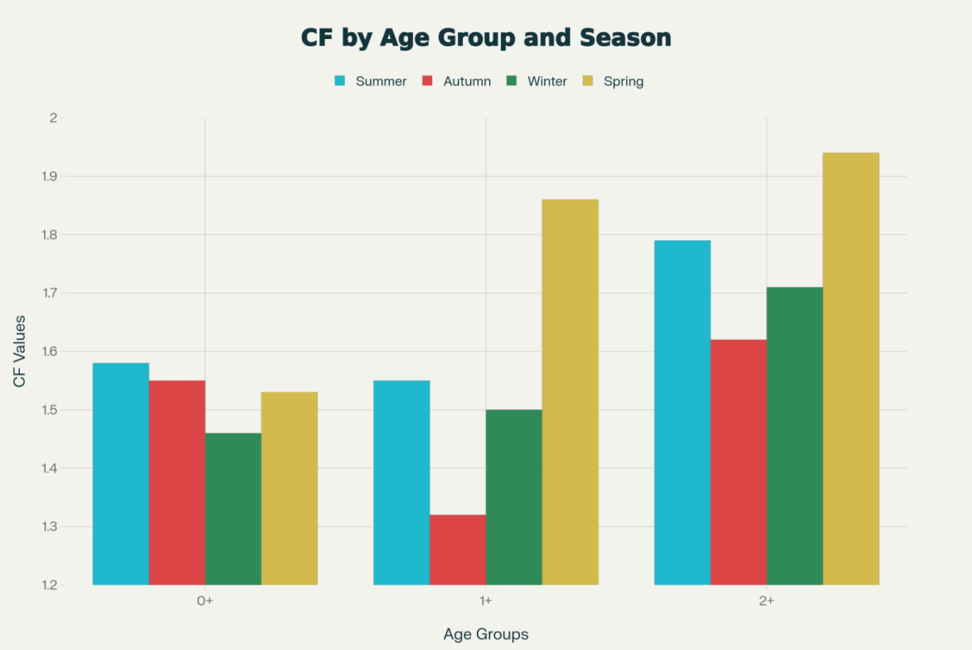
Figure 1: Seasonal variation in condition factor (CF) of female Cyprinus carpio haematopterus across three age groups showing spring maxima (1.53–1.94) and autumn minima (1.32–1.55). Spring CF peaks reflect maximal growth and body condition preceding spawning season.

3.2 Specific Condition Factor (SCF) Pattern and Interpretation
SCF demonstrated remarkable seasonal stability (1.27±0.02 to 1.58±0.06). The 1+ group showed: 1.42±0.06 (summer), 1.27±0.02 (autumn), 1.43±0.02 (winter), 1.56±0.02 (spring). The 2+ group exhibited: 1.54±0.02 (summer), 1.50±0.04 (autumn), 1.54±0.03 (winter), 1.58±0.06 (spring). SCF variation (coefficient of variation 5.3%) was significantly less pronounced than CF (10.8%). One-way ANOVA on SCF showed marginally significant differences (F₃,₂₇ = 3.12, p = 0.045). Post-hoc analysis identified autumn values as significantly lower than spring (Tukey HSD: p = 0.032). Age group comparisons showed no significant differences (F₂,₃₀ = 2.08, p = 0.14).
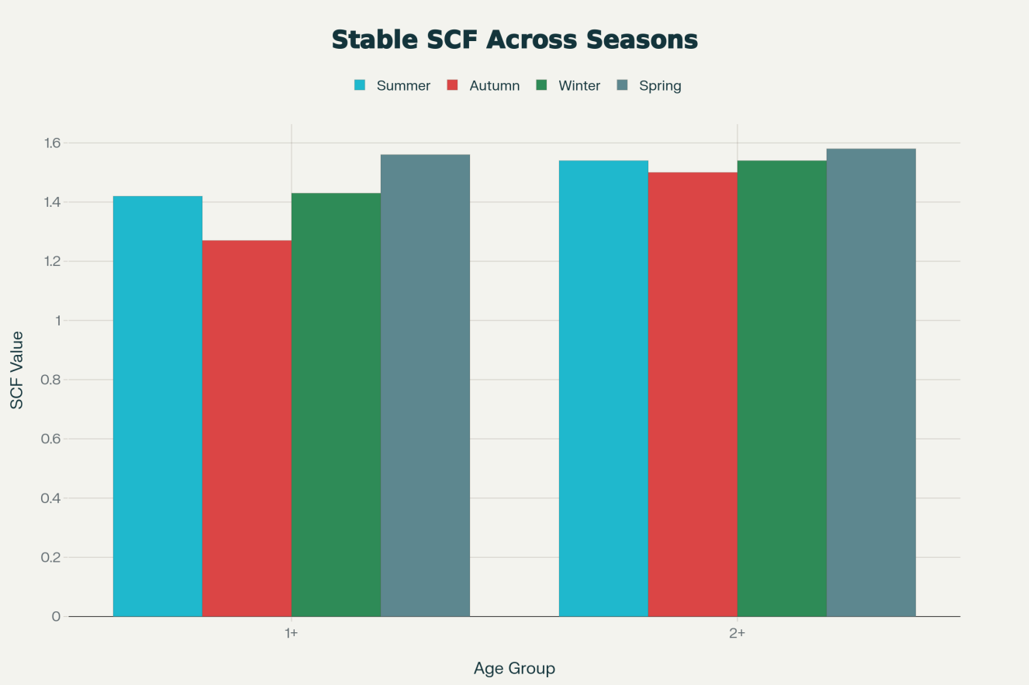
Figure 2: Specific condition factor (SCF) stability across seasons (1.27–1.58) for 1+ and 2+ age groups, demonstrating minimal seasonal variation independent of reproductive investment. This contrasts sharply with pronounced CF seasonal fluctuation, indicating CF changes primarily reflect gonadal rather than somatic tissue condition variations.

3.3 Hepatosomatic Index (HSI) Seasonal Dynamics
HSI demonstrated pronounced seasonal variation. The 1+ group: 1.32±0.09 (summer), 1.69±0.11 (autumn), 1.22±0.11 (winter), 1.02±0.07 (spring). The 2+ group: 1.09±0.09 (summer), 1.55±0.06 (autumn), 1.24±0.11 (winter), 0.82±0.13 (spring). Autumn recorded highest HSI (1.62±0.07), representing 58.8% increase from spring (1.02±0.08). Winter remained moderately elevated (1.23±0.11), declining sharply in spring (0.92±0.10). Two-way ANOVA demonstrated significant season effect (F₃,₂₇ = 19.34, p < 0.001); age effect non-significant (F₂,₃₀ = 2.45, p = 0.10). Correlation between HSI and GSI revealed negative relationship (r = -0.68, p = 0.003).
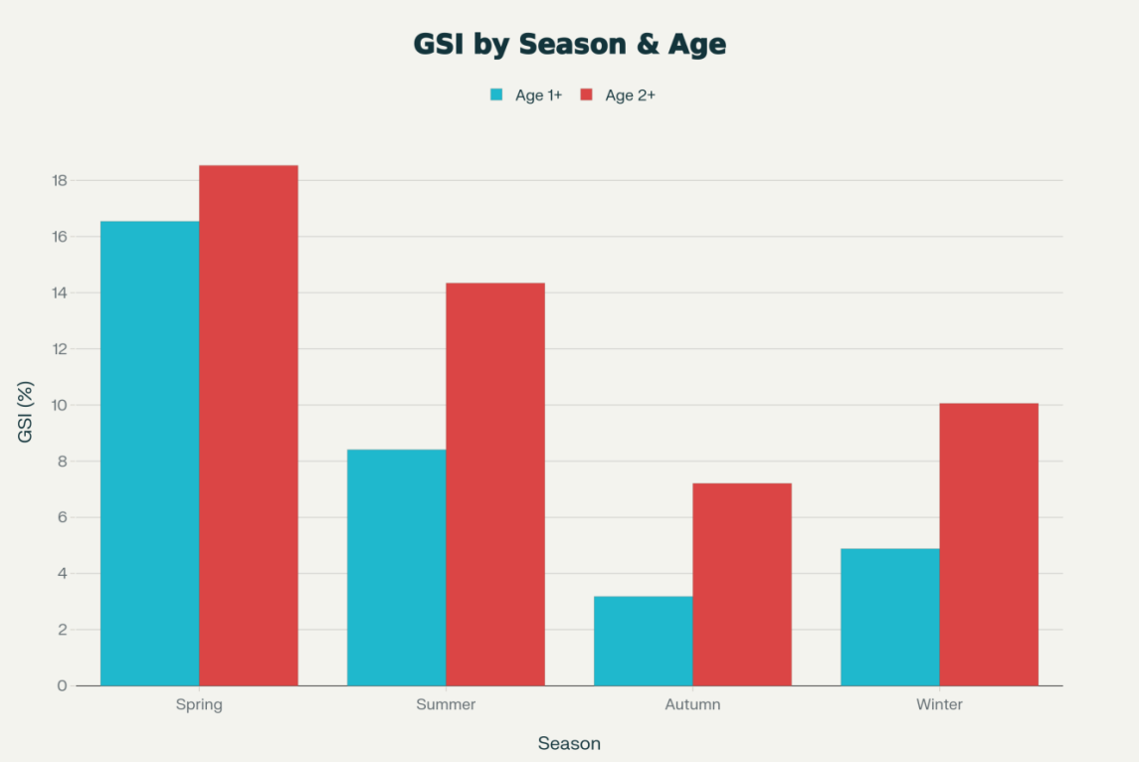
Figure 3: Inverse relationship between hepatosomatic index (HSI) and gonadosomatic index (GSI) showing HSI peaks in autumn (1.55–1.69) and declines to spring minimum (0.82–1.02), while GSI demonstrates inverse pattern with dramatic spring elevation (16.54–18.53%), indicating energy reallocation from hepatic storage to gonadal development during reproductive maturation.

3.4 Gonadosomatic Index (GSI) and Reproductive Seasonality
GSI exhibited most pronounced seasonal variation, ranging 3.18±0.24 (autumn, 1+ group) to 18.53±0.66 (spring, 2+ group). The 1+ group: 8.41±0.46 (summer), 3.18±0.24 (autumn), 4.88±0.31 (winter), 16.54±0.34 (spring). The 2+ group: 14.34±0.82 (summer), 7.21±0.21 (autumn), 10.06±0.20 (winter), 18.53±0.66 (spring).Spring exhibited significantly elevated GSI, with 2+ fish showing 158.5% higher GSI compared to autumn. Two-way ANOVA confirmed highly significant season effect (F₃,₂₇ = 142.7, p < 0.0001), age effect (F₂,₃₀ = 28.56, p < 0.0001), and Age × Season interaction (F₆,₂₇ = 6.89, p < 0.001).
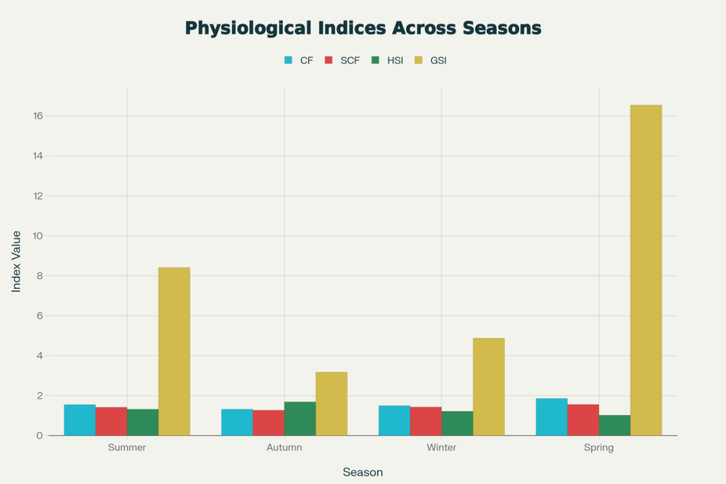
Figure 4: Comprehensive physiological summary for 1+ age group showing coordinated seasonal responses across all indices: CF peaks in spring (1.86), SCF stability (1.27–1.56), HSI autumn elevation (1.69) followed by spring decline (1.02), and GSI dramatic spring peak (16.54) with autumn trough (3.18). This demonstrates integrated physiological adaptation to temperate seasonal environmental variation.

4. Discussion
CF seasonal pattern show minimal in autumn-winter, peak in spring which aligns with thermal physiology and reproductive investment principles in temperate fishes. The 40.9% seasonal amplitude in 1+ fish substantially exceeds 8.2% in 0+ fish, indicating older, sexually mature fish exhibit greater seasonal physiological plasticity. This reflects ontogenetic resource allocation shifts: younger fish prioritize somatic growth, while older fish partition energy between growth maintenance, condition improvement, and reproduction (Stearns & Koella, 1986). Spring CF peak (1.78±0.08) represents maximal body robustness preceding spawning, facilitating optimal reproductive success through enhanced fecundity. Autumn-winter CF minima reflect gonadal development energetics coupled with reduced food intake efficiency at lower temperatures (Jobling, 1994).
SCF remarkable stability (coefficient of variation 5.3% vs. CF 10.8%) provides methodological refinement with important interpretations. By removing gonadal mass, SCF isolates "true" somatic condition independent of reproductive cycle phase (Bolger & Connolly, 1989). Near-absence of seasonal SCF variation (1.27–1.58) contrasts sharply with pronounced CF variation (1.32–1.94), demonstrating CF seasonal fluctuations primarily reflect differential gonadal investment rather than somatic tissue condition changes. For aquaculture practitioners, SCF serves as more stable nutritional status indicator, less confounded by reproductive cycle variations. Dramatic autumnal HSI peak (1.62±0.07), representing 58.8% increase from spring nadirs, provides direct evidence of hepatic energy storage accumulation for winter thermal stress and reproductive demands. In temperate cyprinids, hepatic glycogen and lipid accumulation during autumn represents critical pre-winter metabolic adaptation. Subsequent winter-to-spring HSI decline (25.2% reduction) reflects three parallel processes namely hepatic reserve mobilization for winter metabolic maintenance, stored nutrient utilization for gametogenesis and physiological recovery with spring temperature increase. Significant negative HSI-GSI correlation (r = -0.68, p = 0.003) demonstrates energy trade-off between storage and reproduction, a fundamental life history principle (Ruane et al., 2002).
The 482.6% GSI increase from autumn to spring represents dramatic physiological transformation. This explosive gametogenic response to spring conditions—photoperiod lengthening (~10 to ~14 hours) and temperature increase (~8 to ~15°C)—demonstrates potent environmental regulatory roles in temperate fish reproduction. Age-dependent GSI patterns reveal maturation trajectory divergences: 2+ fish maintain elevated GSI year-round (mean 12.54±2.19), indicating consolidated reproductive capacity. The 127% 2+ GSI elevation versus 1+ in autumn indicates 2+ fish undergo advanced reproductive commitment. These patterns justify 2+ fish selection for breeding programs, projecting superior gamete quality and offspring viability (Brooks et al., 1997). Spring GSI peaks (17.5±0.96) identify optimal spawning window for artificial reproduction programs. March-April induced spawning would achieve superior success rates versus other seasons (Mylonas et al., 2010).
Observed CF range (1.32–1.94) aligns with published values for Cyprinus carpio in temperate regions. Pronounced seasonal CF variation supports earlier findings on temperate fish physiological plasticity exceeding tropical species. HSI range (0.82–1.8) falls within published cyprinid ranges, with our maximum value (1.69±0.11) reflecting intense autumn energy storage specific to temperate aquaculture. Published GSI data for Cyprinus carpio document 3–20 ranges, encompassing our values (3.18–18.53). Our 482.6% intra-annual GSI amplitude substantially exceeds tropical population variation (50–150%), highlighting temperate reproductive intensification. Spring CF elevation (1.78±0.08) indicates maximal growth and condition. March-May harvest targeting premium market prices capitalizes on superior body condition. Autumn harvesting captures relative condition decline, reducing market competitiveness unless value-added processing employed. Feed Management: Dramatic autumnal HSI elevation (1.62±0.07) identifies autumn as critical feed allocation period. Autumn feeding reductions risk HSI compromise, predisposing fish to winter mortality and reduced spring fecundity. Maintain HSI above 1.5 during autumn-winter with bi-weekly condition monitoring. Spawning Programs: Spring GSI peaks (17.5±0.96) identify March-April as optimal artificial reproduction windows. 2+ fish selection justified by GSI age-dependent differences (30–127% higher versus 1+ fish). SCF Monitoring: Relative SCF stability (1.27–1.58) demonstrates current management adequacy for non-reproductive tissue condition. SCF trends provide earlier nutritional insufficiency diagnostic signals than CF (Ruane et al., 2002). This study analyzed exclusively female fish, precluding sex-dependent physiological analysis. Male C. carpio may exhibit distinct seasonal patterns warranting investigation. Modest sample sizes (n = 8–12/group/season) limit small effect size detection, though observed effects are generally large. Future investigations should incorporate hepatic and gonadal histology characterizing tissue-level changes and serum hormone profiles (gonadotropins, steroids) elucidating neuroendocrine mechanisms, hepatic glycogen and lipid quantification validating energy storage interpretations.

5. Conclusion
This investigation provides comprehensive seasonal and age-dependent physiological characterization of C. carpio haematopterus females in temperate aquaculture. Clear seasonal patterns emerged: CF and GSI peak in spring (growth and reproductive maturation), HSI peaks in autumn (pre-winter energy storage), SCF remains relatively constant (stable somatic condition) reflecting complex physiological adaptation to pronounced temperate seasonal variation. Age-dependent analysis reveals reproductive maturation pathway divergences, with 2+ fish exhibiting consolidated reproductive capacity (consistently elevated GSI and CF). These age differences directly optimize breeding program selection strategies, supporting 2+ fish preference for spawning stock. Physiological index monitoring of CF, SCF, HSI, GSI across seasonal cycles provides cost-effective, quantifiable assessment tools for evidence-based adaptive management, advancing temperate aquaculture from experience-based practices toward scientific rigor.
Disclaimer (Artificial intelligence)
Option 1:
Author(s) hereby declare that NO generative AI technologies such as Large Language Models (ChatGPT, COPILOT, etc.) and text-to-image generators have been used during the writing or editing of this manuscript.

References

- Bolger, T. & Connolly, P.L. (1989) The selection of suitable indices for the measurement and analysis of fish condition. Journal of Fish Biology, 34(2), pp.171–182.
- Boyd, C.E. (2015) Water quality: An introduction. 3rd edn. Springer Publishing, New York.
- Brooks, S., Tyler, C.R. & Sumpter, J.P. (1997) Egg quality in fish: What makes a good egg? Reviews in Fish Biology and Fisheries, 7(4), pp.387–416.
- Froese, R. & Pauly, D. (2023) FishBase. World Wide Web electronic publication. Available at https://www.fishbase.org
- Jobling, M. (1994) Fish bioenergetics. Chapman and Hall, London.
- Mylonas, C.C., Fostier, A. & Zanuy, S. (2010) Broodstock management and hormonal manipulations of fish reproduction. General and Comparative Endocrinology, 165(3), pp.516–534.
- Ruane, N. M., Carballo, E. C., & Komen, J. (2002). Increased stocking density influences the acute physiological stress response of common carp Cyprinus carpio (L.). Aquaculture Research, 33(10), 777-784.
- Stearns, S.C. & Koella, J.C. (1986) The evolution of phenotypic plasticity in life-history traits: Predictions of reaction norms for age and size at maturity. Evolution, 40(5), pp.893–913.
- Velisek, J., Stara, A., Kolarova, J., & Svobodova, Z. (2011). Biochemical, physiological and morfological responses in common carp (Cyprinus carpio L.) after long-term exposure to terbutryn in real environmental concentration. Pesticide Biochemistry and Physiology, 100(3), 305-313.

