Assessment of Genetic Diversity among the Maize (Zea mays L.) Genotypes Based on SSR Markers Linked to Drought Tolerance

ABSTRACT
Genetic diversity within maize germplasm is essential for the development of improved maize hybrids through breeding programs. This study was conducted to assess the genetic diversity among the twelve maize genotypes sourced from different origins, using 25 drought associated SSR markers and to identify potential parental lines for future breeding programs. The results revealed that majority of the SSR markers were polymorphic and effective in estimating the genetic variation among the selected maize genotypes. Twenty-five SSR markers amplified a total of 124 alleles and the number of alleles per locus ranged from 4 to 7 and an average of 5 alleles. Markers bnlg 1179, umc 1542, bnlg 1866 and bnlg 2190 produced the highest number of alleles (7). The amplified PCR products with 25 SSRs were ranged from 100 bp to 298 bp. The largest PCR fragment (298 bp) was generated by primer umc 1596, while the smallest fragment (100 bp) generated by bnlg 490. Polymorphism Information Content (PIC) valued varied from 0.70 to 0.84 with a mean of 0.75. While heterozygosity (H) ranged from 0.75 to 0.86, averaging 0.79. Cluster analysis based on the dendrogram grouped the 12 genotypes in to 4 major clusters, with the highest number of genotypes observed in cluster IV. These results clearly indicating that the selected genotypes possessed high level of genetic diversity as they showed high level of polymorphism of drought linked SSR markers. The identified genetic resource may be useful in future quantitative trait loci (QTL) mapping for different traits. These resources are particularly valuable for the development of abiotic stress tolerant maize varieties including drought.
Keywords: Alleles; Drought; Polymorphism; Heterozygosity; Dendrogram; Genetic diversity
- INTRODUCTION
Maize (Zea mays L.) is the third most important cereal crop after wheat and rice in terms of global grain production. Drought is one of the most important abiotic stresses limiting crop yield by 15, 40%, and 60% at vegetative, pollination and grain filling periods respectively (Khodarahmpour and Hamidi, 2012). Diversity among maize germplasm is important for identifying parental lines for successful breeding programme and development of hybrids with adaptation to a broad range of environments. Among the different types of molecular markers, simple sequence repeats (SSRs) are one of the most promising molecular markers and quite useful in assessment of genetic diversity, marker assisted selection and genetic studies such as construction of linkage maps and QTL mapping (Sserumaga et al., 2014). The present study was aimed to identify diverse genotypes of maize for genetic enhancement of drought tolerance.
Assessing genetic diversity through morphological traits in plants is susceptible to the influences of environmental factors, growth stages, and the type of plant material (Dayaman et al., 2009). To address these challenges, researchers have gradually turned to molecular markers for a more precise evaluation of genetic diversity, selection of pure lines, germplasm maintenance, and identification of parental combinations for generating segregating generations with enhanced genetic variability (Vathana et al., 2019). The conventional method of field phenotypic selection in traditional plant breeding is time-consuming and labor-intensive, leading to potential inaccuracies in evaluating new maize genotypes due to environmental influences. Such phenotypic evaluation in the field and choosing for crop improvement programs may be incorrect because which are influenced by different environmental factors. In contrast, polymerase chain reaction (PCR) based molecular markers are not affected by environmental, providing a more accurate means of identifying genetic diversity (Kashiani et al., 2012). Marker-assisted selection (MAS) employing molecular markers enables plant breeders to select target phenotypes based on genotypes, facilitating precise genetic enhancement and trait identification in crops.
Among the various molecular marker systems employed in genetic studies, several markers are widely utilized, including random amplified polymorphic DNA (RAPD), amplified fragment length polymorphism (AFLP), single nucleotide polymorphism (SNP) and simple sequence repeats (SSRs). Notably, SSR markers are particularly favored for their codominant nature, highly polymorphic, reproducibility and even distribution across the entire plant genome and which are deliver very important information about genetic diversity, genetic relationships and population structure in crop germplasms (Sserumaga et al., 2014). SSRs or microsatellites in the plant genome consists of short tandem repeated fragments of 2 to 6 nucleotides. This unique composition to their high polymorphism, which is observed in both coding and non-coding regions. The distinctive features of SSRs markers, including their polymorphic nature, make them in valuable for various applications, such as crop characterization, assessment of genetic diversity, and analysis of desired gene links (Kalivas et al., 2011; Gaballah et al., 2021; Mathiang et al., 2022). Thus, identified diverse maize germplasm with inherent mechanisms for stress tolerance, particularly to drought will be helped in developing suitable maize varieties for sustainable grain yield and which can fit into the future changed climatic conditions.

- MATERIALS AND METHODS
2.1 Plant material
Twelve maize (Zea mays L.) genotypes namely three genotypes M-16 (R1HKI-46), M-22 (R1HKI-L-287), M-24 (R1LM6) obtained from ICAR-IIMR, Ludhiana, one genotype M-59 (NSJ-221) from NBPGR, New Delhi and five genotypes DTL-3, DTL-4, DTL-4-1, DTL-9 and DTL-11 from CRIDA along with three popular maize genotypes DHM-117, Varun and Harsha from maize research centre, PJTSAU, Hyderabad. The experiment laid out in RCBD and all the 12 maize genotypes sown in row to row space of 75 cm and plant to plant 30 cm with three replications. This experiment was carried out at ICAR - Central Research Institute for Dryland Agriculture, Hyderabad, during Rabi season of 2022. The recommended fertilizer dose and cultural practices along with plant protection measures were taken to raise the crop.
2.2 Genomic DNA extraction and assessing the quantity
Total genomic DNA was extracted from young leaves of 3 to 4-week-old plants of each genotype by CTAB protocol (Doyle and Doyle, 1990) with minor modification. Approximately 1 gram of young leaves was collected and frozen in liquid nitrogen, these samples used for further analysis with CTAB (Cetyltrimethyl ammonium bromide) buffer and added pinch of PVP (Polyvinyl pyrrolidone) and incubated at 65ºC for 45 minutes with intermittent mixing for every 15 minutes. The tubes removed from the water bath and allowed to attain room temperature and an equal volume of chloroform: Isoamyl alcohol mixture (24:1) was added and mixed by inversion for 15 min. It was centrifuged at 12000 rpm for 10 min and the clear aqueous phase was transferred to a new sterile tube. To these tubes containing supernatant, again an equal volume of chloroform and isoamyl alcohol mixture (24:1) was added. It was centrifuged at 12000 rpm for 10 min and the clear aqueous phase was transferred to a new sterile tube. 1/3 volume of ice-cold isopropanol and 3M sodium acetate was added and mixed gently by inversion. From the supernatant, the DNA was precipitated by addition of chilled isopropanol incubated at -30ºC for 1 hour and then centrifuged at 10000 rpm for 20 minutes at 4ºC and the DNA pellet was washed twice with 70% alcohol. Alcohol was discarded and DNA pellet was air dried completely. Depending upon the size of the pellet, DNA was dissolved in 100-1000 µl of 1X TE (pH 8.0) and stored at 4ºC for further use. The quantification of extracted DNA was done by measuring absorbance at 260 nm wavelengths. Purity of DNA was checked by reading absorbance ratio of A260/280 for protein contamination. The genomic DNA was run on 0.8 percent agarose gel stained with ethidium bromide by adopting a standard method (Sambrook et al., 1989) and was visualized in a gel documentation system. The DNA was quantified by using Spectrophotometer. The purity and integrity of DNA were assessed to ensure that only samples with A260/A280 ratios between 1.8 and 2.0 were used for SSR genotyping.
2.3 SSR markers
Previously reported 25 total SSR markers which were reported for association with traits related to drought tolerance belonging to different series viz. bnlg, umc, and phi were selected based on repeat units and bin location to provide uniform coverage of entire maize genome. The primer pairs were selected using maize genomic data extractor website www.maizegdb.org. Twenty-five SSR primer pairs were used in the present investigation to study the genetic diversity of the twelve maize genotypes. The annealing temperature of SSR primer pairs was standardized by using temperature gradient PCR. Selection of annealing temperature is the most critical component for optimizing the specificity of a PCR reaction. PCR amplification was performed in Applied Biosystem Thermal Cycler programme. About 50 ng of DNA was used as a template. The reaction was carried out in a total PCR reaction volume of 20 μl containing the 2.0 µL (25ng) genomic DNA, 2.0 µL 10X assay buffer (GeNei), 1.60 µL Primer (20 pm) (Bioserve), 0.60 µL MgCl₂ (25 mM), 0.60 µL dNTPs (10 mM) (Fermentas), 0.40 µL Taq polymerase (3units/ml) (GeNei), 12.80 µL Sterile distilled H₂O. The reaction mixture was given a short spin for thorough mixing of the cocktail components. The amplification was carried out in a Thermal Cycler.
List 1 : The temperature profile used in the amplification was as follows
Profile 1: 94°C for 5 min Initial denaturation
Profile 2: 94°C for 0.45 min Denaturing
Profile 3: 53 to 63°C for 0.45 min Annealing
Profile 4: 72°C for 0.45 min Extension
Profile 5: 72°C for 10 minutes Final extension
Profile 6: 4°C to hold the samples for infinity.
Profiles 2, 3 and 4 were programmed to run for 35 cycles.
2.4 SSR analysis, scoring and cluster analysis
The SSR gel images and marker data were processed using Biovision Software, USA. The DNA amplification pattern obtained for the twenty-five markers system scored visually for the presence (1) or absence (0) of bands in binary form in the selected 12 maize genotypes for each SSR primer pairs. Only reproducible and polymorphic bands were considered for the analysis. Data set were used for calculation of dissimilarity matrix based on Jaccard coefficients (Jaccard, 1908). The dissimilarity matrices thus generated were utilized for construction of dendrogram based on individual and combined data of the twenty-five markers systems UPGMA (un-weighted pair-group method using the arithmetic mean) algorithm. All the data analysis was carried out using the software package NTSYS-pc 2.02 (Rohlf, 1998). To measure the information of the markers, the Polymorphism Information Content (PIC) for each SSR marker was calculated according to the formula (Botstein et al., 1980): PIC=1-ΣPi² - ΣΣPi² Pj² where ‘i’ is the total number of alleles detected for SSR marker and ‘Pi’ is the frequency of the i^{th} allele in the set of hundred genotypes investigated and j = i+1. The molecular weight data were used to calculate the number of alleles, polymorphism information content (PIC) and heterozygosity for each of the SSR primer pairs using software Power Marker 3.25 (Liu and Muse 2005).
- RESULTS
3.1 Polymorphism of simple sequence repeats in maize genotypes
The present study was done with twelve maize genotypes to determine genetical diversity among the genotypes using SSR (Simple Sequence Repeats) markers. In the present study 25 drought related SSR markers viz., bnlg1014, bnlg1179, bnlg1346, umc1542, phi053, bnlg1241, bnlg1655, bnlg1028, bnlg1209, bnlg2248, bnlg1621, bnlg1065, bnlg1225, bnlg1017, bnlg1866, umc1042, umc1719, umc1344, bnlg2190, bnlg1136, bnlg2328, umc1596, umc1447, phi014, bnlg 490 (Table 1) recorded polymorphism during their respective amplifications and results in different banding patterns among the maize germplasm. The results indicate that the majority of SSR markers displayed polymorphism. These polymorphic SSRs were then employed to analyze the genetic variation among the chosen maize genotypes. Among the twenty-five SSR markers utilized, a total of 124 alleles were amplified, with the number of alleles ranging from 4 to 7 and a mean of 5 alleles per locus. Notably, highest (7) number of alleles were amplified by markers bnlg 1179, umc 1542, bnlg 1866 and bnlg 2190 followed by 6 alleles were amplified by markers bnlg 1014, bnlg 1209 and phi014 (Fig. 1). The amplified products with 25 SSRs were ranged from 100 to 298 bp. The highest PCR fragment (298 bp) was generated by primer umc 1596 and the lowest size fragment (100 bp) by bnlg 490. Polymorphism information content (PIC) varied from 0.70 to with 0.84 a mean of 0.75, Heterozygosity (H) ranged from 0.75 to with 0.86 a mean of 0.79 (Table 2). Total of 124 alleles generated by using 25 SSR markers and the obtained PIC values.
Table 1. Details of twenty-five SSR markers and their association with drought related traits
Marker | Repeat type | Forward primer (5’-3’) | Reverse primer (5’-3’) | Bin no.* | Trait | References
bnlg1014 | AG(14) | CACGCTGTTTCAGACAGGAA | CGCCTGTGATTGCACTACAC | 1.01 | ASI,FFT,EW, GW; RWC | Gemenet et al. (2010), Zhang et al. (2012) and Nikolic et al. (2012)
bnlg1179 | AG(16) | GCGATTCAGTCCGCAGTAGT | GTACTGAACAAACCGTGGGC | 1.01 | DTI | -
bnlg1346 | AG(24) | CATCATGAAGCAATGAAGCC | CCGCGCCATTATCTAGTTGT | 5.07 | DTI | -
umc1542 | (AG)10 | TAAAGCTATGATGGCACTTGCAGA | CATATTTGCCTTTGCCCTTTTGTA | 2.02 | ASI,KN, GY | Guo et al. (2008)
phi053 | ATAC | CTGCCTCTCAGATTCAGAGATTGAC | AACCCAACGTACTCCGGCAG | 3.05 | PH, ASI, DTI | Gemenet et al. (2010)
bnlg1241 | AG (21) | ATTCTTGACATCCATCCGGT | TGTTGTTTCACTCAGCGTCC | 4.01 | PH,MFT, FFT,HKW | Guo et al.(2008)
bnlg1655 | AG(21) | ATTAAAATCTTGCTGATGGCG | TTCTGTTCCCGCCTGTACTT | 10.03 | PH,FFT + DTI | Guo et al.(2008)
bnlg1028 | AG(12) | AGGAAACGAACACAGCAGCT | TGCATAGACAAAACCGACGT | 10.06 | DTI | Guo et al.(2008)
bnlg1209 | AG(12) | GTCCCGGGCAGAATAATACC | TTCCTCCTTGAAGTGCTCGT | 9.04 | DTI | Dubey et al. (2009)
bnlg2248 | AG(30) | CCACCACATCCGTTACATCA | ACTTTGACACCGGCGAATAC | 2.03 | DTI +ASI | Guo et al.(2008)
bnlg1621 | AG(18) | CTCTTCGATCTTTAAGAGAGAGAGAG | ACACGAGGCACTGGTACTAACG | 4.06 | GY,DTI | Guo et al.(2008)
bnlg1065 | AG(21) | TGATGCTCGTTGCTTACCTG | TTGCCTCTCGTCTTCCAACT | 8.07 | GY,DTI | -
bnlg1225 | AG(14) | GCAGTAGAAGAGCGAGCGAG | CATACGCTGTCACTGCCACT | 2.06 | KY | -
bnlg1017 | AG(18) | ATTGGAAGGATCTGCGTGAC | CAGCTGGTGGACTGCATCTA | 2.02 | ASI,KN,GY | Guo et al.(2008)
bnlg1866 | AG(11) | CCCAGCGCATGTCAACTCT | CCCCGGTAATTCAGTGGATA | 1.03 | fad8, DTI | -
umc1042 | GA17 | AAGGCACTGCTACTCCTATGGCTA | CTGACCTTTGAATTCTGTGCTCCT | 2.07 | DTI | Dubey et al. (2009)
umc1719 | (GCG)5 | CCTGGAAGCACCACTGATACTAGC | AGCTCCAGCCTGCCTACCAG | 4.1 | DTI | Dubey et al. (2009)
umc1344 | (GTTC)5 | GCGCTCTGACTTAATTAGAGGAGTTG | GGCAGCAGATCTATGTCCAAGAAG | 10.07 | DTI | Dubey et al. (2009)
bnlg2190 | AG(31) | TCCTCCTTCATCCCCTTCTT | CCCAGTATCATTGCCCAATC | 10.06 | DTI | Guo et al.(2008)
bnlg1136 | AG(14) | TAACCGGATGAGCATCTTCC | CATCAGCTTCAACGAGTTCG | 6.07 | ASI | Guo et al.(2008)
bnlg2328 | AG(33) | AGCAGTGAGGAAGAAGCAGG | TTACCCTCCCTTGTCGTGAC | 2.05 | DTI | -
umc1596 | (GGC)6 | CGGCGAGGATAACATGCAGTA | TCTTGAGCTGAACACTGATCTTGG | 9.01 | GY, DTI | -
umc1447 | (CTT)4 | TAATACTCCTACTAACGGCGCTGC | TCTGTCTCCCATGCCTGAAATAAT | 5.03 | DTI | -
phi014 | GGC | AGATGACCAGGGCCGTCAACGAC | CCAGCTTCACCAGCTTGCTCTTCGTG | 8.04 | GY | -
bnlg 490 | Indeterminate |  |  | 4.04 | GY,DTI | -
ASI: Anthesis Silking Interval; DTI: Drought Tolerance Index; EW: Ear Weight; FFT: Female Flowering Time; GW: Grain weight; GY: Grain Yield; HKW: Hundred Kernel Weight; KN: Kernel Number; MFT: Male Flowering Time; PH: Plant Height; RWC: Relative Water Content

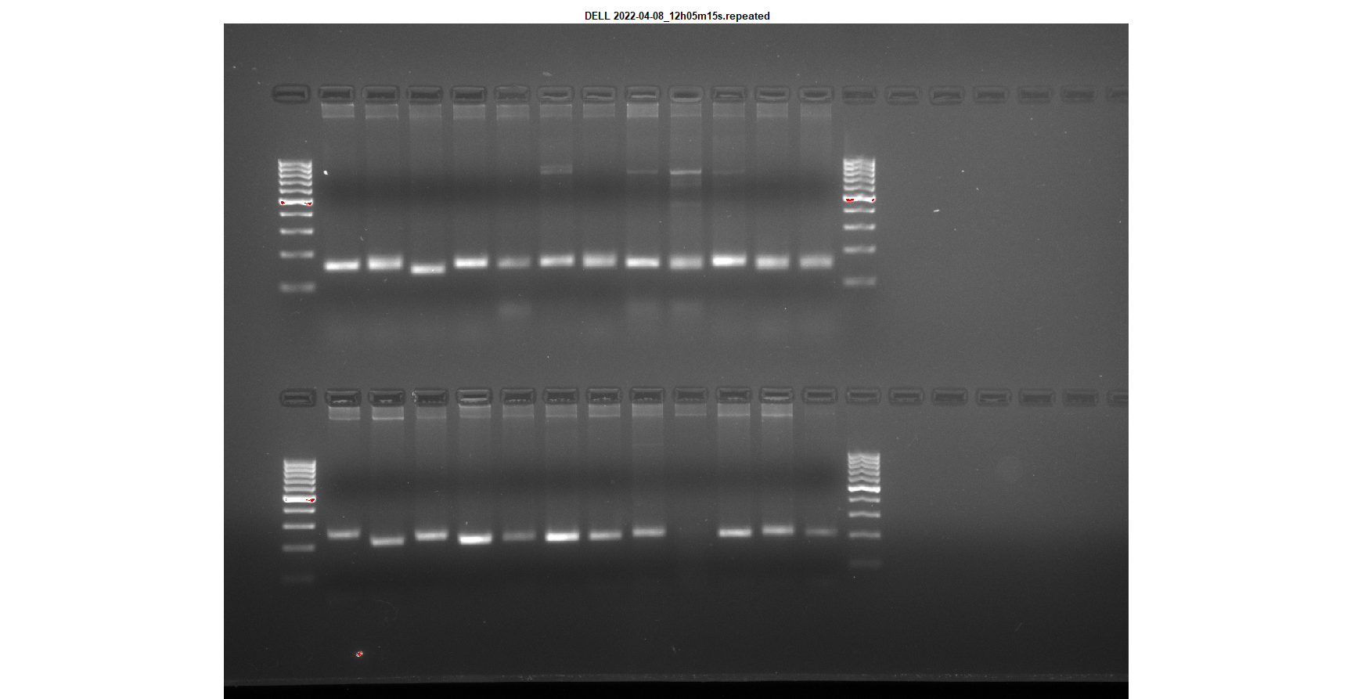
bnlg 1014
L 1 2 3 4 5 6 7 8 9 10 11 12 L
L 1 2 3 4 5 6 7 8 9 10 11 1 2 L
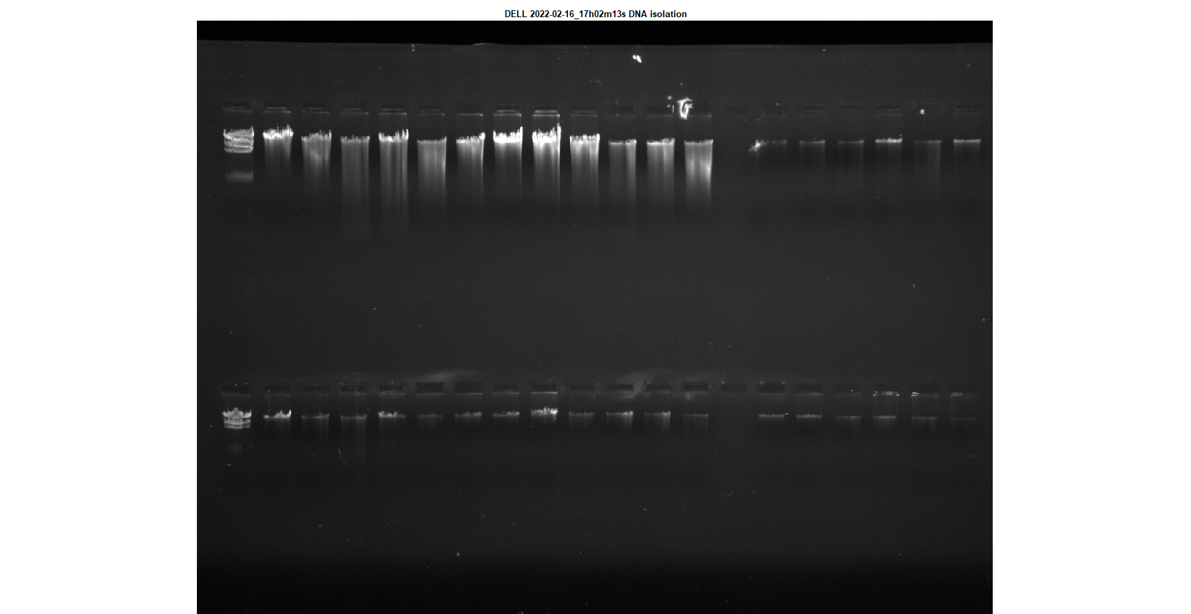
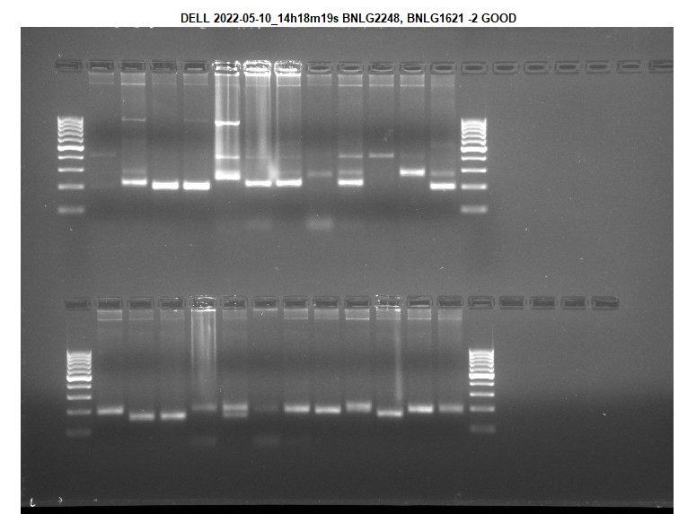
B
A
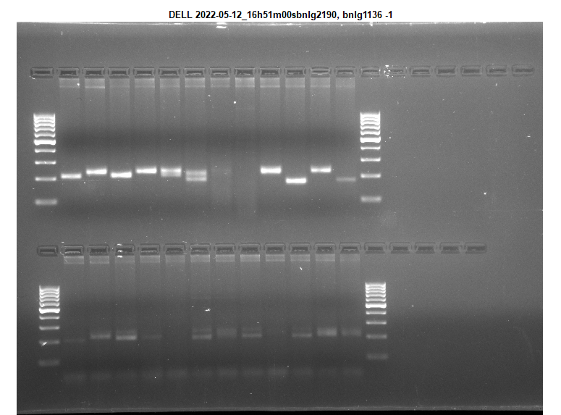
bnlg 2190
bnlg 1621
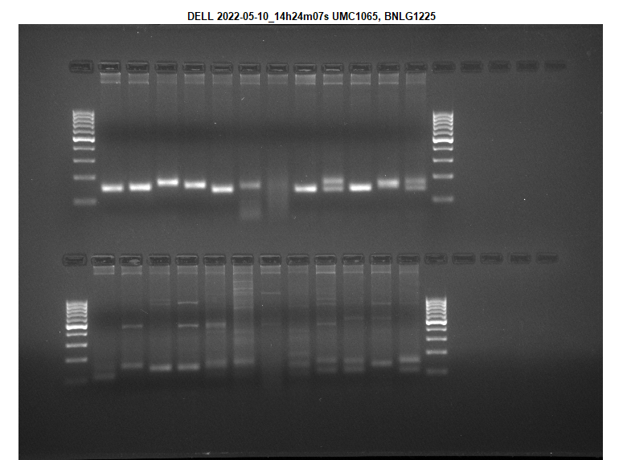
bnlg 1065
bnlg 1179

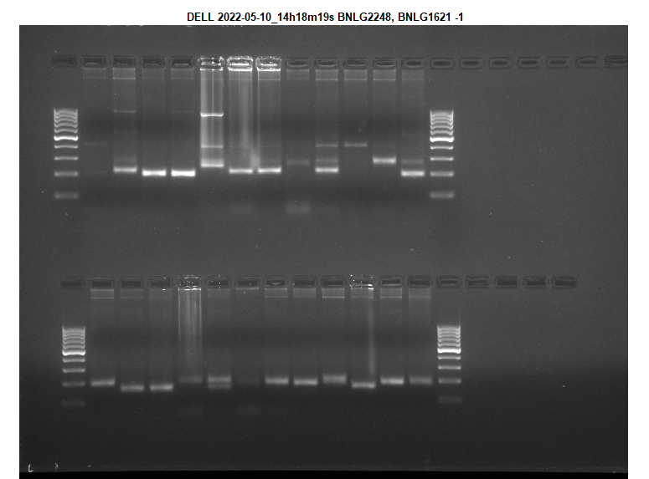
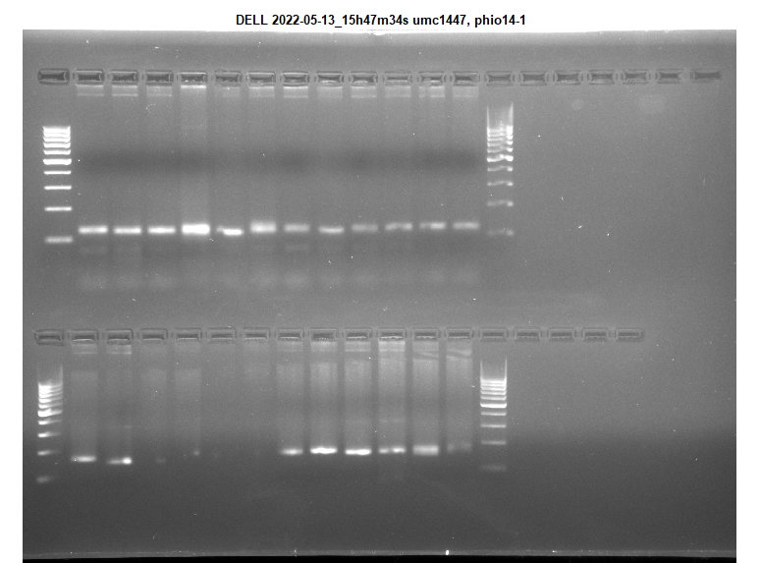
umc 1447
umc 1447
bnlg 2248
Fig. 1. A. Elution of DNA in twelve maize genotypes, B. PCR amplification profile of twelve maize genotypes produced by SSR primer bnlg 1014, bnlg 1621, bnlg 2190, bnlg 1179, bnlg 1065, umc 1447 and bnlg 2248, L- DNA Ladder (100bp), maize genotypes 1 to12 in the following order of M-22, DTL-4-1, Harsha, M-24, DHM-117, M-59, DTL-3, M-16, DTL-4, Varun, DTL-9 and DTL-11

Table 2. Characteristics of drought linked 25 SSR marker loci; repeat type, bin no., no. of alleles, product size, PIC value and heterozygosity
Markers | Repeat type | Bin no.* | No. of alleles | Product size | PIC | Heterozygosity
bnlg1014 | AG(14) | 1.01 | 6 | 146-175 | 0.81 | 0.83
bnlg1179 | AG(16) | 1.01 | 7 | 226-279 | 0.84 | 0.86
bnlg1346 | AG(24) | 5.07 | 5 | 147-200 | 0.77 | 0.80
umc1542 | (AG)10 | 2.02 | 7 | 146-200 | 0.84 | 0.85
phi053 | ATAC | 3.05 | 4 | 166-208 | 0.70 | 0.75
bnlg1241 | AG(21) | 4.01 | 5 | 156-200 | 0.77 | 0.80
bnlg1655 | AG(21) | 10.03 | 4 | 106-138 | 0.70 | 0.75
bnlg1028 | AG(12) | 10.06 | 4 | 146-166 | 0.70 | 0.75
bnlg1209 | AG(12) | 9.04 | 6 | 185-231 | 0.81 | 0.83
bnlg2248 | AG(30) | 2.03 | 4 | 196-263 | 0.70 | 0.75
bnlg1621 | AG(18) | 4.06 | 5 | 174-234 | 0.77 | 0.80
bnlg1065 | AG(21) | 8.07 | 4 | 144-175 | 0.70 | 0.75
bnlg1225 | AG(14) | 2.06 | 4 | 130-153 | 0.70 | 0.75
bnlg1017 | AG(18) | 2.02 | 4 | 163-194 | 0.70 | 0.75
bnlg1866 | AG(11) | 1.03 | 7 | 109-172 | 0.84 | 0.85
umc1042 | GA17 | 2.07 | 5 | 102-126 | 0.77 | 0.80
umc1719 | (GCG)5 | 4.1 | 5 | 122-171 | 0.76 | 0.79
umc1344 | (GTTC)5 | 10.07 | 4 | 102-119 | 0.70 | 0.75
bnlg2190 | AG(31) | 10.06 | 7 | 200-250 | 0.84 | 0.86
bnlg1136 | AG(14) | 6.07 | 4 | 237-261 | 0.70 | 0.75
bnlg2328 | AG(33) | 2.05 | 4 | 210-239 | 0.70 | 0.75
umc1596 | (GGC)6 | 9.01 | 5 | 270-298 | 0.77 | 0.80
umc1447 | (CTT)4 | 5.03 | 4 | 120-137 | 0.70 | 0.75
phi014 | GGC | 8.04 | 6 | 157-221 | 0.81 | 0.83
bnlg 490 | Indeterminate | 4.04 | 5 | 100-202 | 0.76 | 0.79
Mean |  |  | 5 |  | 0.75 | 0.79
* Location of allele in the chromosome of maize genome.

Table 3. Jaccard dissimilarity matrix for twelve maize genotypes based on SSR marker data
Genotypes | M-16 | M-22 | M-24 | M-59 | DTL-3 | DTL-4 | DTL4-1 | DTL-9 | DTL-11 | DHM-117 | VARUN | HARSHA
M-16 | 1
M-22 | 0.92 | 1
M-24 | 0.93 | 0.44 | 1
M-59 | 1.00 | 0.68 | 0.78 | 1
DTL-3 | 1.00 | 0.68 | 0.71 | 1.00 | 1
DTL-4 | 1.00 | 0.84 | 0.71 | 0.91 | 0.80 | 1
DTL-4-1 | 0.88 | 0.36 | 0.57 | 0.74 | 0.74 | 0.82 | 1
DTL-9 | 0.88 | 0.72 | 0.83 | 0.64 | 0.85 | 1.00 | 0.85 | 1
DTL-11 | 0.86 | 0.76 | 0.82 | 0.83 | 0.92 | 0.89 | 0.63 | 1.00 | 1
DHM-117 | 0.85 | 0.48 | 0.83 | 0.83 | 0.76 | 0.94 | 0.68 | 0.75 | 0.81 | 1
VARUN | 0.90 | 0.64 | 0.79 | 0.87 | 0.79 | 0.82 | 0.53 | 0.93 | 0.64 | 0.71 | 1
HARSHA | 0.86 | 0.44 | 0.60 | 0.84 | 0.71 | 0.80 | 0.64 | 0.76 | 0.95 | 0.65 | 0.79 | 1

A dendrogram resulting from UPGMA (Un-weighted Pair Group Method with Arithmetic Mean) analysis grouped twelve maize genotypes in to four major clusters depending upon their dissimilarity distances (Fig. 2).
Cluster I comprise 1 genotype viz., M-16, Cluster II contains 2 genotypes viz., M-59 and DTL-9. Cluster III contains 1 genotype viz., DTL-4. Cluster-IV contains 8 genotypes viz., DTL-11, VARUN, DTL-3, DHM-117, HARSHA, M-24, M-22, and, DTL-4-1. These results clearly indicating that the selected genotypes possessed high level of genetic diversity as they showed high level of polymorphism of drought linked SSR markers. The diversity analysis of the 12 maize genotypes in the current study indicates that the phylogeny of these genotypes is associated with four clusters of dissimilarities. The range of Jaccard dissimilarity coefficient was ranged from 0.36 (DTL-4-1) to 1.0 (M-59, DTL-3 and DTL-4) (Table 3).
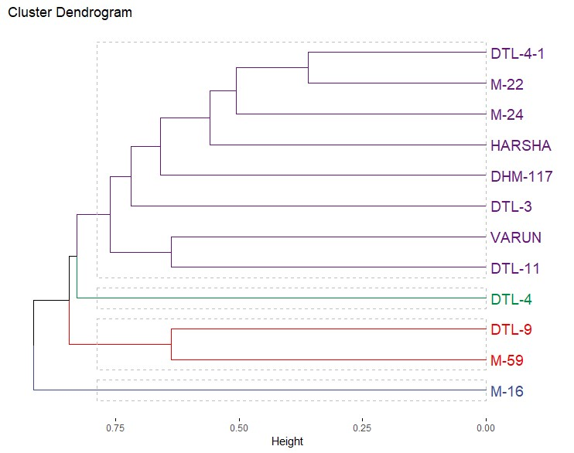
Fig. 2. Dendrogram of the twelve maize genotypes as revealed by Jaccard’s dissimilarity coefficient method of UPGMA

3.2 DISCUSSION
Genetic diversity, denoting the total variability within germplasm, is a pivotal factor in enhancing the yield potential of varieties through breeding program (Platt et al., 2010). Among the various molecular markers, SSR markers play a crucial role in providing valuable insights into genetic diversity, genetic relationships, and population structure in crop germplasm. This is due to their reproducibility, highly polymorphic, co-dominant inheritance, multi-allelic nature, and widespread distributed throughout the plant genome (Nepolean et al., 2013; Sserumaga et al., 2014). The research study on maize successfully developed a highly detailed and comprehensive set of SSR markers (Sharopova et al., 2002). The current study was conducted with twelve maize genotypes to determine genetic diversity, utilizing 25 SSR markers associated with drought resistance. The results indicated that polymorphic nature of the majority of SSR markers. These polymorphic SSRs were subsequently utilized to assess genetic variation among the maize genotypes. In total, the 25 SSR markers amplified 124 alleles, with the number of alleles per locus ranging from 4 to 7 and a mean of 5 alleles per locus. The higher (7) number of alleles were amplified by markers bnlg 1179, umc 1542, bnlg 1866 and bnlg 2190 followed by 6 alleles were amplified by markers bnlg 1014, bnlg 1209 and phi014. The amplified products with 25 SSRs were ranged from 100 to 298 bp. The highest PCR fragment (298 bp) was generated by primer umc 1596 and the lowest size fragment (100 bp) by bnlg 490.
Polymorphism information content (PIC) value of an SSR marker is an indicator of marker diversity, offering an estimate of the locus discriminatory power by considering both number and relative frequency of alleles expressed (Smith et al., 1997). In this study, the PIC values ranged from 0.70 to with 0.84 a mean of 0.75. These findings indicate a high level of polymorphism among all the examined maize genotypes. Generally, genotypes have lower PIC value described that closely related genotypes and higher PIC values indicates higher genetic diversity (Prabhakaran et al., 2010). Heterozygosity (H) ranged from 0.75 to with 0.86 with a mean of 0.79. In the current study, total of 124 alleles generated by using 25 SSR markers and the obtained PIC values. These findings align with those reported by Adu et al. (2019), where a total of 288 alleles were identified. The allele range was from 4 to 17 with an average 9.60 alleles per locus, PIC varied from 0.32 to 0.85 with a mean value of 0.68. Cluster analysis of UPGMA categorized 70 populations in to 5 clusters in their set of 70 maize germplasm by using 31 SSR markers. Ashish Kumar et al. (2012) also revealed similar findings in 91 maize genotypes by using 40 SSR markers amplified a product ranged from 58 to 410 bp and generated number of alleles varied from 2 to 5 with a mean of 3.1 alleles per locus and PIC values ranged from 0.054 to 0.82 with a mean of 0.55. Similarly, Gala et al., (2025) also reported in seven inbred maize lines by using 21 SSR markers amplified allele count per locus varied from 2 to 5, mean of 3.31 alleles per locus. Heterozygosity ranged from 0.25 to 0.96, with a mean of 0.58, while PIC ranged from 0.22 to 0.68, with an average of 0.50.
Based on UPGMA dendrogram results twelve maize genotypes were categorized in to four major clusters and cluster IV contains maximum with eight maize genotypes. These results clearly indicating that the selected genotypes possessed high level of genetic diversity as they showed high level of polymorphism of drought linked SSR markers. Cluster I had 1 genotype viz., M-16, Cluster II had 2 genotypes viz., M-59 and DTL-9. Cluster III contains 1 genotype viz., DTL-4. Cluster-IV comprises 8 genotypes viz., DTL-11, VARUN, DTL-3, DHM-117, HARSHA, M-24, M-22, and, DTL-4-1. The Jaccard dissimilarity coefficient was ranged from 0.36 (DTL-4-1) to 1.0 (M-59, DTL-3 and DTL-4). The maximum dissimilarity or in other terms higher genetic distance was observed for the genotypes of M-59, DTL-3, DTL-4, M-22 and M-24. These clusters clearly indicated that wide variability among selected genotypes (Ashish Kumar et al., 2012). Similarly, Mathiang et al. (2022) utilized 27 SSR markers in maize and identified a total of 200 alleles, averaging 7.4 alleles per locus. Heterozygosity values ranged from 0.06 to 0.91 with an average of 0.35 and the study identified high polymorphic information content (PIC) values, an averaging 0.69. UPGMA dendrogram analysis were also categorized 37 maize genotypes were classified into 3 major groups, showcasing a 43% genetic similarity. Rajpoot et al., (2025) also reported in rice that 38 SSR markers were used to categorized the 34 genotypes into three main clusters, which effectively distinguishing between tolerant and susceptible lines. The present study results clearly indicating that the selected genotypes possessed high level of genetic diversity as they showed high level of polymorphism of drought linked SSR markers. These diversified genotypes could be used to develop the drought tolerant genotypes by using plant breeding program.
- CONCLUSION
Among the selected twelve maize genotypes there is high genetic diversity was recorded as there is significant polymorphism of drought linked SSR markers was existing. In selected 12 maize genotypes, most of the drought related SSR markers are polymorphic. Among the 25 SSR markers, bnlg 1179, umc 1542, bnlg 1866 and bnlg 2190 generated highest number of alleles. The maximum Jaccard dissimilarity or in other terms higher genetic distance was observed for the genotypes of M-59, DTL-3, DTL-4, M-22 and M-24. Based on dendrogram results 12 genotypes were categorised into 4 major clusters. The selected genotypes possessed high level of genetic diversity as they showed high level of polymorphism of drought linked SSR markers. The identified genetic resource may be useful in future quantitative trait loci (QTL) mapping for different traits. These resources are particularly valuable for the development of abiotic stress tolerant maize varieties including drought.

Disclaimer (Artificial intelligence)

Author(s) hereby declare that NO generative AI technologies such as Large Language Models (ChatGPT, COPILOT, etc.) and text-to-image generators have been used during the writing or editing of this manuscript.
REFERENCES
Adu, G. B., Awuku, F. J., Amegbor, I. K., Haruna, A., Manigben, K. A., & Aboyadana, P. A. (2019). Genetic characterization and population structure of maize populations using SSR markers. Annals of Agricultural Sciences, 64(1), 47-54. https://www.sciencedirect.com /science/article/pii/S0570178319300119.
Ashish Kumar., Arunita Rakshit., Naresh, K. Mangilipelli., Varalaxmi, Y., Vijayalakshmi, T., Jainender., Vanaja, M., Yadav, S.K., Venkateswarlu, B. & Maheswari, M. (2012). Genetic diversity of maize genotypes on the basis of morpho-physiological and simple sequence repeat (SSR) markers. African Journal of Biotechnology, 11(99), 16468-16477.
Botstein, D., White, R.L., Skolnick, M. & Davis, R.W. (1980). Construction of genetic linkage map in man using restriction fragment length polymorphism. American Journal of Human Genetics 32: 314-331.
Dayaman, V., Senthil, N., Raveendran, M., Nadarajan, N., Shanmugasundram, P. & Balasubaramanian, P. (2009). Diversity analysis in selected soybean [Glycine max (L.) Merrill] using morphological and simple sequence repeat (SSR) markers. International Journal of Integrative Biology, 5: 125-129.
Doyle, J. J. & Doyle, J. L. (1990). A rapid DNA isolation procedure from small quantity of fresh leaf material. Phytochem. Bull. 119:11-15.
Galal, A.A., Safhi, F.A., & Al Aboud, N.M. et al (2025). Molecular diversity and genetic potential of new maize inbred lines across varying sowing conditions in arid environment. Scientific Reports 15, 2809. https://doi.org/10.1038/s41598-025-87021-8
Gaballah Mahmoud, M., Sajid Fiaz., Xiukang Wang., Afifa Younas., Sher Aslam Khan., Fahad Masoud Wattoo. & Muhammad Rizwan Shafiq (2021). Identification of genetic diversity among some promising lines of rice under drought stress using SSR markers, Journal of Taibah University for Science, 15:1, 468-478, DOI: 10.1080/16583 655 .2021.1989738.
Jaccard, P. (1908). Nouvelles recherches sur la distribution florale. Bulletins des séances de la Société vaudoise des sciences naturelles, 44: 223-270.
Kalivas, A., Xanthopoulos, F., Kehagia, O. & Tsaftaris, A.S. (2011). Agronomic characterization, genetic diversity and association analysis of cotton cultivars using simple sequence repeat molecular markers. Genetics and Molecular Research, 10: 208-217. https://doi.org/ 10.4238/vol10-1gmr998.
Kashiani, P., Saleh, G., Panandam, J.M., Abdullah, N.A.P. & Selamat, A. (2012). Molecular characterization of tropical sweet corn inbred lines using microsatellite markers. Maydica, 57: 154-163.
Khodarahmpour, Z. & Hamidi, J. (2012). Study of yield and yield components of corn (Zea mays L.) inbred lines to drought stress. African Journal of Biotechnology, 11, 3099-3105.
Liu, K. J. & Muse, S. V. (2005). Power Marker: integrated analysis environment for genetic marker data. Bioinformatics 21, 2128–2129.
Mathiang, E.A., Sa K.J., Park, H., Kim, Y.J. & Lee, J.K. (2022). Genetic Diversity and Population Structure of Normal Maize Germplasm Collected in South Sudan Revealed by SSR Markers. Plants, 11, 2787. https://doi.org/10.3390/ plants11202787.
Nepolean, T., Singh, I., Hossain, F., Pandey, N. & Gupta, H.S. (2013). Molecular characterization and assessment of genetic diversity of inbred lines showing variability for drought tolerance in maize. Journal Plant Biochemistry and Biotechnology, 22(1): 71-79.
Platt, A., Horton, M., Huang, Y.S., Li, Y., Anastasio, A.E., Mulyati, N.W., Agren, J., Bossdorf, D., Byers, D., Donohue, K., Dunning, M., Holub, E.B., Hudson, A., Corre, V., Loudet, O., Roux, F., Warthmann, N., Weigel, D., Riyero, L., Scholl, R., Nordborg, M., Bergelson, J. & Borevitz, J.O. (2010). The scale of population structure in Arabidopsis thaliana. PLOS Genetics, 6: e1000843.
Prabhakaran A, K Paramasivam, T Rajesh & D Rajarajan (2010). Molecular characterization of rice land races using SSR markers. Electronic Journal of Plant Breeding 1(4): 512-516.
Rajpoot, Sachin., Dhananjay, Kumar., Hrishikesh, Ojah., Khanin, Pathak., Subhankar, Saha., & Prasanta Kuma,r Das. (2025). Molecular Validation of SSR Markers and Genetic Diversity Linked to Anaerobic Germination Tolerance in Deepwater Rice (Bao) of Assam. Journal of Advances in Biology & Biotechnology, 28 (12): 227–238. https://doi.org/ 10.9734/jabb /2025 /v28i123377
Rohlf, F. J. (1998). NTSYS-pc Numerical Taxonomy and Multivariate Analysis System, Version 2.02i. Exeter Publications, New York.
Sambrook, J., Fritsch, E.R. & Maniatis, T (1989). Molecular Cloning: A Laboratory Manual (2nd ed.). Cold Spring Harbor, NY: Cold Spring Harbor Laboratory Press.

Sharopova, N., McMullen, M. D., Schultz, L., Schroeder, S., Sanchez-Villeda, H., Gardiner, J., ... & Coe Jr, E. H. (2002). Development and mapping of SSR markers for maize. Plant molecular biology, 48(5), 463-481. https://link.springer.com/ article/10.1023 /A: 1014868 625533.

Smith, J.S.C, Chin, E.C.L., Shu, H., Smith, O.S., Wall, S.J., Senior, M.L., Mitchell, S.E., Kresovitch, S. & Ziegle, J. (1997). An evaluation of the utility of SSR loci as molecular markers in maize (Zea mays L.): comparisons with data from RFLPs and pedigree. Theoretical and Applied Genetics, 95:163-173.
Sserumaga, J.P., Makumbi, D., Ji, H., Njoroge, K., Muthomi, J.W., Cheminingwa, G.N., Si-myung, L., Asea, G & Kim, H. (2014). Molecular characterization of tropical maize inbred lines using microsatellite DNA markers. Maydica, 59: 267-274.
Vathana, Y., Sa, K.J., Lim, S.E. & Leem J.K. (2019). Genetic Diversity and Association Analyses of Chinese Maize Inbred Lines Using SSR Markers. Plant Breeding and Biotechnology, 7, 186-199.

