Original Research Article
Role of vegetation structure in shaping ant assemblage in urban greenspaces of Abidjan, Côte d’Ivoire, West Africa

ABSTRACTS
Greenspaces constitute important mitigation strategies against local global warming, functioning as ecological corridors and biodiversity refugia in urban environments. They also enhance ecological resilience and urban quality of life. This study aims to address this knowledge gap by evaluating the influence of soil vegetation cover and tree density on the diversity and spatial distribution of Formicidae (ants) within the tropical urban landscape of Abidjan, Côte d'Ivoire. Sampling was conducted across seven distinct greenspaces within Abidjan using tuna baits and pitfall traps. To correlate faunal data with environmental variables, tree density and soil vegetation cover were also quantified within 5 m x 5 m standardized quadrats. The study identified a diverse ant community comprising 69 species distributed across 25 genera and five subfamilies. The data reveal significant variation in species richness, diversity indices, and relative abundance across the greenspaces. Greenspaces characterized by dense vegetation consistently yielded the highest biodiversity metrics. Results demonstrated that structural parameters, specifically tree density and soil vegetation cover exert a primary influence on community assembly. Native species dominated ant communities, representing 66.5% of total occurrence (i.e 5027 out of 7563) against 33.5% (i.e 5027 out of 7563) for invasive ant species. Well wooded areas exhibited a more balanced diversity, supporting specialized species and a stable distribution. Conversely, sparsely vegetated zones were characterized by low taxonomic diversity and were dominated by a limited number of opportunistic and invasives ant like Paratrechina longicornis (24.7%), Tapinoma melanocephalum (5.3%), Tetramorium simillimum (0.9%), Solenopsis globularia (1.2%), Monomorium floricola (0.2%) and Cardiocondyla emeryi (1.1%) adapted to anthropogenic disturbance. These findings underscore the vital role of structurally complex urban greenspaces in maintaining insect biodiversity within cities. We advocate for rigorous ecological management of these habitat, which is essential for establishing a sustainable equilibrium between urban development and wildlife conservation.

Keywords : Cities, Urban landscapes, Insect ecology, Biodiversity refugia, Formicidae, Ants.

1. INTRODUCTION
Rapid urbanization remains one of the main environmental problems of these last decades (Sonet et al., 2025), particularly in Sub-Saharan Africa (Kondi et al., 2025). Indeed, the massive conversion of natural areas into residential, industrial zones and accelerated artificialization of soils, constitute a major threat to biodiversity conservation (ONU-Habitat, 2023). The direct causes of this degradation include infrastructure expansion (roads, buildings, transport networks), pollution (air, water, soil), surface impermeabilization, and the reduction of urban tree canopy. These disturbances cause habitat fragmentation, landscape homogenization, and a drastic reduction in ecological niches, affecting species diversity and profoundly altering ecological interactions (Andersen, 1997). Notable consequences of uncontrolled urbanization include: biodiversity loss, decline of indigenous species, proliferation of opportunistic exotic species, degradation of ecosystem services, and the accentuation of climate change effects in cities (Atuahene et al., 2025). Besides, urban green areas are now widely recognized as biodiversity repositories and to provide a variety of ecosystem services (Jennings et al. 2016; Plummer et al., 2024). Dedicated to urban greenspaces, these habitats emerge as essential mitigation solutions for negative impact of rapid urbanization and climate change in cities. Indeed, urban greenspaces fulfil vital ecological functions including thermal regulation, air quality improvement, rainwater infiltration, and the maintenance and conservation of urban biodiversity serving as, ecological corridors, and refuges for numerous animal and plant species (Kouakou et al., 2018; Sondou, 2024). Greenspaces also promote the ecological resilience of cities and contribute to the quality of life for city dwellers (Ashinze et al., 2024). Their sustainable management therefore represents a strategic lever for reconciling urbanization and biodiversity conservation (Assalé and Touré, 2020).
In Côte d'Ivoire (West Africa), Abidjan, the economic capital has witnessed of an uncontrolled urbanization since the 1980s. It has resulted in a high degree of soil artificialization, reduction in vegetated surfaces, and increased fragmentation of natural habitats (Kouassi et al., 2020). Greenspaces are increasingly being converted into built areas, thus affecting urban biological diversity (Kouakou et al., 2018; Kouamé et al., 2019). Despite the recognized importance of greenspaces for biodiversity conservation, few studies have specifically explored the relationships between woody density, vegetation cover and the diversity of animal communities in African urban contexts. In urban areas, Ants are known to be excellent biological indicators because they react quickly to changes in their environment. They also play key multiple roles in terrestrial ecosystems including decomposition of organic matter, seed dispersal, and the regulation of pest insect populations (Lach et al., 2010). Their diversity and spatial distribution are closely linked to the surrounding vegetation structure. For example, a high woody density and dense vegetation cover promote a more stable microclimate and heterogenous habitats, offering greater availability of resources and shelter for ants and thereby enhancing species richness (Vasconcelos et al., 2008; Franklin 2012). In the case of Abidjan, studies conducted on urban biodiversity and ants remain rare and fragmentary. However, a few recent studies have highlighted the reduction of ecological connectivity between greenspaces affecting species distribution and their biodiversity conservation assest (Kouakou et al., 2025). This work aims to understand how vegetation cover and woody density can influence the diversity and distribution of ants in urban green spaces. We expect that greenspaces with high woody density and without bare soil promote greater ant diversity. Specifically, this study aims to: (1) inventory the ant communities in different types of greenspaces, (2) Understand the relationship between ant communities, vegetation cover, wood density, and (3) to compare ant species composition between greenspaces with low and high vegetation density.

2. MATERIALS AND METHODS
2.1 Study area
This study was carried out in Abidjan district, the economic capital of Côte d’Ivoire. Abidjan is located on the littoral in the South of Côte d’Ivoire (5°20'11" N; 4°01'36" W) and covers an area of 2119 Km2. The climate regime is subequatorial and the annual mean temperature and precipitation are 27.4 °C and 1733 mm, respectively. We conducted our study in greenspaces in the municipalities of Cocody, Adjamé and Yopougon. The greenspaces of these municipalities were selected due to the availability of greenspaces and their nearness to natural habitat of Banco National Park.

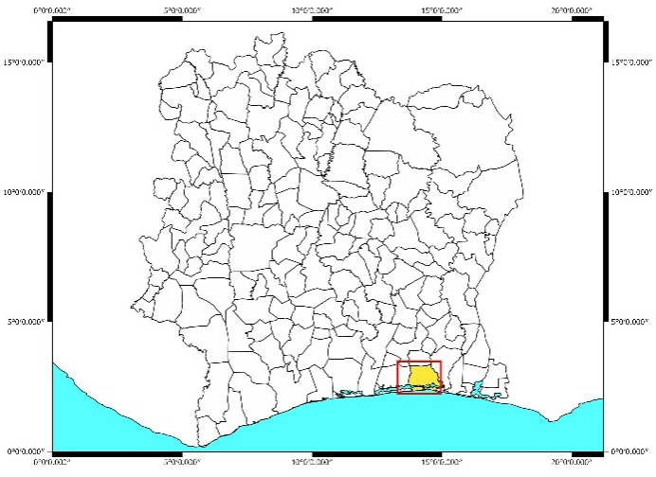

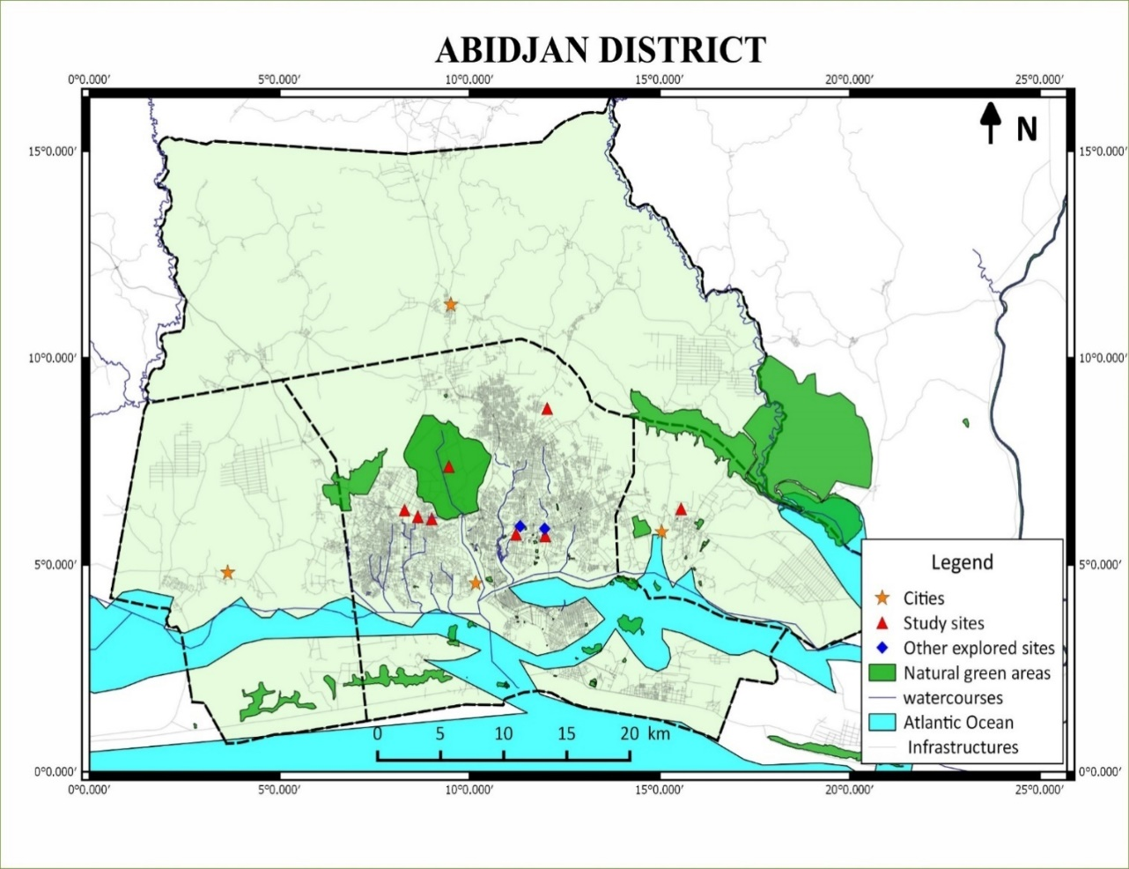

Figure 1. Location of sampled greenspaces in the municipalities of Abidjan.

2.2 Sampling and Identification
Sampling was conducted between November 2024 and June 2025 in seven greenspaces (Table 1) using pitfall traps and baiting method (King and Porter 2005). Pitfall traps were plastic beverage cups (330 ml, depth 8 cm, mouth diameter 7 cm) filled with trapping fluid constituted of 70° alcohol and few drops of glycerine. Pitfall traps were serviced 2 days after the placement. Baiting was tuna lures placed at 5 m apart from the pitfall traps (Yeo et al. 2016; Kouakou et al., 2018). Each sample was stored in an individual Eppendorf tubes of 2 ml filled with Ethanol (96%) and labelled.
Ants were observed with an OLYMPUS SZ8 microscope. We first sorted ant workers and separated on the basis of the morphology and size. Then they were pinned and primarily identified at the genus level using Fisher and Bolton (2016), the specific key of Bolton (1976, 1980, 1982, and 1987) and the personal ant reference collection from Yeo (2006) located at Lamto Ecological Station. Online resources like AntWeb (www.antweb.org) and Ant Catalogue (www.Antcat.org) were used for correct and up-to-date taxonomy and species names. All identified pinned specimens, as well as specimens in ethanol, were deposited in Lamto Ecological Research Station, Côte d’Ivoire.

2.3 Measurement of trees density and soil cover
We measured trees density as the number of individuals per square meter (ind/m²). In each greenspace, 10 m × 10 m subplots were delimited so as to ensure representative coverage of the spatial heterogeneity of the tree cover. In each subplot, all woody individuals (trees and shrubs) present were counted. Trees density was then calculated using the following Formula:
Td (ind/m²) = (N/S)

Td: Trees density, N: number of individuals counted in the plot, S: total plot size on greenspace

Trees cover was estimated as the herbaceous soil vegetation cover. It has been measured in the same 10 m × 10 m subplots used for the woody density survey, in order to ensure consistency of observations and spatial representativeness of the sites. The vegetation cover was measured by assessing the average height of the herbaceous vegetation on the ground. A graduated wooden rod measuring from 0.5 cm to 1 meter was used as a measuring tool. On each subplot, five measurement points were selected at equal distances and distributed evenly to best reflect the entire surface area. At each point, the height of the herbaceous layer was measured by placing the stick vertically on the ground and noting the maximum height reached by the grasses in centimeter (cm). These five values were then used to calculate the average height of the vegetation cover in each subplot using the following formula:
H (cm) = (h₁ + h₂ + h₃ + h₄ + h₅)/5)

H: Average height the herbaceous soil vegetation cover; h₁, h₂…. h₅: represent the heights measured (in cm) at the five measurement points

2.4 Data analysis
Statistical analyses were conducted combining the samples corresponding for the two samplings methods (Baits and pitfall traps) at the site level (i.e. greenspaces). We measured our sampling efficiency by estimating the expected species richness with a nonparametric estimator (Chao 2) included in EstimateS v9.1.0 (Colwell 2013) and performed species accumulation curves in PAST v3.09 (Hammer et al., 2001). Local diversity (alpha-diversity) was estimated using, species richness, Margalef diversity index and Evenness. Abundance and number of unique species (rare species) was also calculated for each greenspace. Before comparison of ant community between study sites, Levene’s test for homogeneity of variance was used to test the distribution of our data. With normal distribution, one-way analysis of variance (ANOVA) on repeated measure was used for multiple comparison and pairwise comparison, respectively. If not, the Friedman and Wilcoxon tests were used for comparison. T-test mean comparison was also used to examine the variation of common ant species and potential invasive ant abundance between transects of the microhabitats. Additionally, abundance of invasive ant species was plotted on a graph to display their distribution in each greenspace. Finally, the beta-diversity was estimated using Bray-Curtis index to quantify the similarity of species composition between transects of each study site. We then plotted a two-dimensional map with non-metric multidimensional scaling (NMDS) to display the ant species composition similarities among the sampled greenspaces. An analysis of similarity (ANOSIM) by 10,000 permutations was conducted to test significant differences in species composition between greenspaces. All these statistical analyses were made using Past Software v3.09 with statistical significance criteria of p ≤0.05.
3. RESULTS
3.1 Tree density and plant cover in greenspaces
Our findings indicated that tree density varied significantly among greenspaces (Kruskall-Wallis: X² = 40.6, df = 6, P = 0.0001; Table 1). Tree density was higher in greenspace of natural forest from university (FoNA) with 2.54 ind/m². The lower tree density of 0.27 ind/m² was recorded in the greenspace of Yopougon (EV 7). The results also showed that the plant cover decreased from forest of university (FoNA) and reafforested plot (ReNA) toward greenspaces of public gardens.

Table 1 Metric of trees density and cover in sampled greenspaces during study.

Greenspaces | Types of spaces | Density (ind/m²) | Vegetation cover (%)
Forest of university (FoNA) | Natural forest | 2.54 | 87.5
Reafforested Plot (ReNA) | Reafforested | 0.30 | 46.77
Yopougon 3eme pont (EV 7) | Public garden | 0.27 | 31.25
Agban (EV 6 ) | Public garden | 0.84 | 37.25
Pont Ferraille (EV 3) | Public garden | 0.65 | 16.2
Riviera 2 (EV 4) | Public garden | 0.94 | 13
Yopougon 1er pont (EV 5) | Public garden | 0.48 | 18

3.2 Sampling effort of the study
Overall, 140 samples were collected in 7 greenspaces for 69 species recorded through the district of Abidjan (Table 2). Chao 2 estimator predicted about 99 estimated ant species for a sampling coverage of 69.5%. Sampling coverage value in greenspaces was ranked between 42.22 % and 98.31%. Species accumulation curves showed an asymptotic trend for all combined habitats. This trend was also observed for all greenspaces, except for forest (FoNA) and reafforested plot (ReNA) of the university which showed an increasing number of species with each additional trap without reaching a plateau. This trend is reflected by the high number of unique species recorded in Forest (FoNA) and Reafforested plot (ReNA) of university.

Table 2. Metrics of sampling effort in the greenspaces of the study.
Forest of University (FoNA), Reafforested Plot of University (ReNA), Yopougon 3eme pont (EV 7), Agban (EV 6), Pont Ferraille (EV 3), Riviera 2 (EV 4), Yopougon 1er pont ( EV 5)

Greenspaces | FoNA | ReNA | EV 3 | EV 4 | EV 5 | EV 6 | EV 7 | All Habitat
Number of samples | 20 | 20 | 20 | 20 | 20 | 20 | 20 | 140
Observed species | 32 | 34 | 18 | 14 | 21 | 20 | 22 | 69
Estimated species (Chao 2) | 48.68 | 51.62 | 18.32 | 14.24 | 49.74 | 20.48 | 30.55 | 99.3
Sampling coverage(C) | 65.7 | 65.86 | 98.25 | 98.31 | 42.22 | 97.66 | 72.01 | 69.5
Unique species | 12 | 14 | 2 | 2 | 11 | 2 | 6 | 22

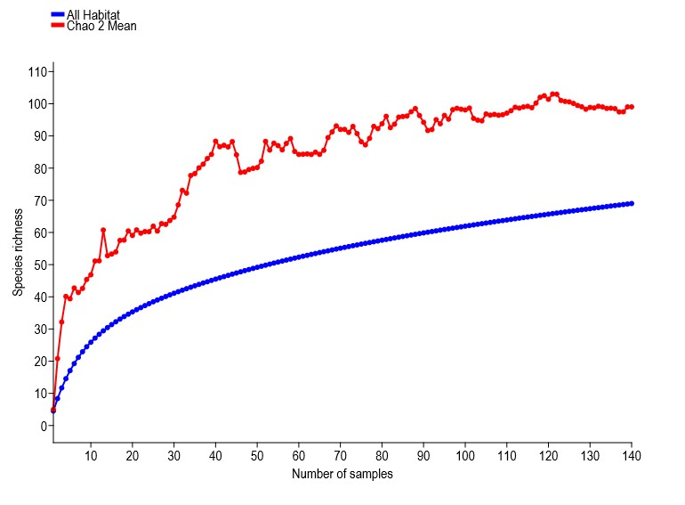
A

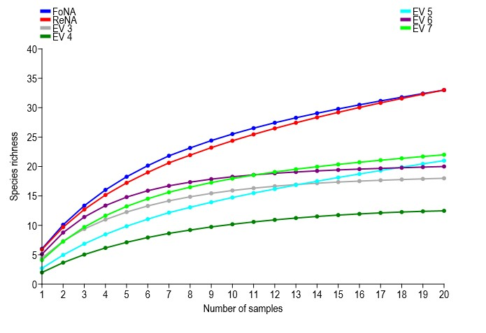
B

Figure 2. Species accumulation curves of species richness as a function of the number of samples in greenspaces. (A) all habitat combined, (B) each sampled greenspace.
Forest of University (FoNA), Reafforested Plot of University (ReNA), Yopougon 3eme pont (EV 7), Agban (EV 6), Pont Ferraille (EV 3), Riviera 2 (EV 4), Yopougon 1er pont ( EV 5)

3.3 Taxonomical composition of ant community
The study yielded 69 ant species and morphospecies belonging to 25 genus and 5 subfamilies (Table 3). The recorded subfamilies were Myrmicinae (44 species from 14 genus), Formicinae (10 species from 5 genus), Ponerinae (9 species from 4 genus), Dolichoderinae (4 species from one genus) and Dorylinae (2 species from 1genus).

Table 3. Checklist of ant species collected in different greenspaces during the study

Species | FoNA | ReNA | EV 3 | EV 4 | EV 5 | EV 6 | EV 7 | TOTAL
DOLICHODERINAE
Tapinoma lugubre | 17 | 0 | 12 | 4 | 86 | 4 | 52 | 175
Tapinoma luteum | 0 | 0 | 7 | 0 | 0 | 71 | 0 | 78
Tapinoma melanocephalum | 0 | 0 | 222 | 62 | 93 | 0 | 31 | 408
Technomyrmex andrei | 4 | 0 | 0 | 0 | 0 | 0 | 0 | 4
DORYLINAE
Dorylus sp.1 | 1 | 0 | 0 | 0 | 0 | 0 | 0 | 1
Dorylus sp.2 | 0 | 1 | 0 | 0 | 0 | 0 | 0 | 1
FORMICINAE
Camponotus acvapimensis | 0 | 54 | 0 | 0 | 0 | 18 | 12 | 84
Camponotus cinctellus | 6 | 57 | 0 | 2 | 0 | 0 | 4 | 69
Camponotus maculatus | 7 | 55 | 0 | 10 | 9 | 2 | 6 | 89
Camponotus vividus | 1 | 0 | 0 | 0 | 0 | 0 | 0 | 1
Lepisiota sp.3 | 0 | 2 | 7 | 0 | 0 | 44 | 0 | 53
Nylanderia boltoni | 0 | 2 | 2 | 0 | 0 | 15 | 9 | 28
Nylanderia lepida | 0 | 2 | 0 | 0 | 0 | 0 | 0 | 2
Nylanderia scintilla | 8 | 69 | 6 | 0 | 0 | 8 | 46 | 137
Oecophylla longinoda | 57 | 2 | 0 | 327 | 34 | 42 | 89 | 551
Paratrechina longicornis | 4 | 1748 | 8 | 0 | 47 | 0 | 61 | 1868
MYRMICINAE
Cardiocondyla emeryi | 2 | 23 | 16 | 2 | 26 | 4 | 13 | 86
Cardiocondyla schuckardi | 0 | 3 | 0 | 0 | 0 | 0 | 0 | 3
Carebara sp.1 | 0 | 0 | 0 | 21 | 0 | 0 | 0 | 21
Crematogaster sp.1 | 0 | 0 | 0 | 0 | 1 | 0 | 0 | 1
Crematogaster sp.2 | 1 | 0 | 0 | 0 | 2 | 0 | 0 | 3
Crematogaster sp.3 | 0 | 0 | 1 | 0 | 0 | 0 |  | 1
Crematogaster striatula | 66 | 0 | 0 | 0 | 0 | 0 | 0 | 66
Meranoplus magretti | 0 | 10 | 0 | 0 | 0 | 0 | 0 | 10
Monomorium bicolor | 0 | 3 | 283 | 17 | 1 | 0 | 0 | 304
Monomorium dolatu | 0 | 0 | 7 | 0 | 0 | 0 | 0 | 7
Monomorium exiguum | 0 | 18 | 0 | 0 | 0 | 0 | 0 | 18
Monomorium floricola | 0 | 0 | 0 | 3 | 0 | 1 | 10 | 14
Monomorium occidentale | 0 | 12 | 0 | 0 | 0 | 31 | 128 | 171
Monomorium sp.1 | 6 | 0 | 0 | 0 | 0 | 0 | 0 | 6
Pheidole excellens | 0 | 0 | 43 | 0 | 92 | 10 | 213 | 358
Pheidole sp.2 | 26 | 0 | 9 | 0 | 4 | 0 | 0 | 39
Pheidole sp.3 | 0 | 10 | 0 | 0 | 0 | 0 | 0 | 10
Pheidole sp.4 | 55 | 7 | 13 | 18 | 36 | 24 | 59 | 212
Pheidole buchholzi | 1141 | 0 | 0 | 0 | 0 | 44 | 0 | 1185
Pheidole sp.7 | 0 | 1 | 0 | 0 | 0 | 0 | 0 | 1
Pheidole sp.8 | 0 | 3 | 153 | 0 | 144 | 61 | 3 | 364
Pheidole sp.10 | 0 | 68 | 0 | 0 | 0 | 0 | 0 | 68
Pheidole sp.11 | 347 | 0 | 0 | 0 | 0 | 0 | 0 | 347
Pheidole sp.12 | 0 | 0 | 0 | 0 | 4 | 0 | 1 | 5
Pheidole sp.13 | 57 | 0 | 0 | 0 | 0 | 0 | 0 | 57
Pheidole sp.14 | 11 | 0 | 0 | 0 | 0 | 0 | 0 | 11
Pristomyrmex orbiceps | 9 | 0 | 0 | 0 | 0 | 0 | 0 | 9
Solenopsis globularia | 0 | 0 | 0 | 0 | 0 | 88 | 0 | 88
Strumigenys sp.1 | 1 | 0 | 0 | 0 | 0 | 0 | 0 | 1
Tetramorium anxium | 0 | 3 | 0 | 0 | 0 | 0 | 1 | 4
Tetramorium brevispinosum | 15 | 0 | 9 | 0 | 28 | 36 | 8 | 96
Tetramorium emenii | 0 | 8 | 0 | 0 | 0 | 0 | 0 | 8
Tetramorium minimum | 0 | 6 | 0 | 42 | 0 | 0 | 1 | 49
Tetramorium paptor | 1 | 0 | 0 | 0 | 0 | 0 | 0 | 1
Tetramorium rhetidum | 6 | 0 | 0 | 0 | 8 | 0 | 0 | 14
Tetramorium sepositum | 0 | 0 | 0 | 0 | 0 | 0 | 2 | 2
Tetramorium sericeiventre | 0 | 11 | 0 | 0 | 0 | 0 | 0 | 11
Tetramorium setigerum | 0 | 1 | 0 | 0 | 0 | 0 | 0 | 1
Tetramorium simillimum | 12 | 0 | 12 | 20 | 22 | 4 | 2 | 72
Tetramorium sp.2 | 6 | 0 | 0 | 0 | 0 | 0 | 0 | 6
Tetramorium sp.3 | 0 | 2 | 0 | 0 | 0 | 0 | 0 | 2
Tetramorium versiculum | 0 | 18 | 0 | 0 | 0 | 0 | 0 | 18
Tetramorium zapyrum | 0 | 14 | 1 | 0 | 1 | 0 | 0 | 16
Tetamorium zambesium | 0 | 0 | 0 | 0 | 1 | 0 | 0 | 1
PONERINAE
Asphinctopone silverstrii | 0 | 1 | 0 | 0 | 0 | 0 | 0 | 1
Euponera brunoi | 1 | 0 | 0 | 8 | 0 | 0 | 0 | 9
Hypoponera sp.1 | 1 | 0 | 0 | 0 | 0 | 0 | 0 | 1
Hypoponera sp.2 | 0 | 1 | 0 | 0 | 0 | 0 | 0 | 1
Leptogenys conradti | 4 | 0 | 0 | 0 | 0 | 0 | 0 | 4
Leptogenys occidentalis | 11 | 0 | 0 | 0 | 0 | 0 | 0 | 11
Mesoponera ambigua | 0 | 2 | 0 | 0 | 0 | 0 | 0 | 2
Odontomachus troglodytes | 36 | 136 | 0 | 0 | 2 | 12 | 0 | 186
Paltothyreus tarsatus | 5 | 17 | 0 | 5 | 3 | 1 | 1 | 32
Total abundance | 1925 | 2370 | 811 | 541 | 644 | 520 | 752 | 7563

3.4 Influence of tree density and cover on ant communities
3.4.1 Effect on ant species diversity, richness and abundance
Overall, we found a significant variation of species richness (Friedman: X² = 12.3, df = 6, P = 0.002) and abundance ( X² = 14.6, df = 6, P = 0.001) between greenspaces (Table 4). The forest (FoNA) and reafforested plot (ReNA) of university recorded the highest species richness and abundance, while the lowest number of species collected were recorded in greenspaces of Riviera 2 (EV 4) and Pont Ferraille (EV 3). Margalef index and Evenness matched the trend with the species richness and abundance. On contrary, Simpson dominance index showed higher values in the forest (FoNA) and reafforested plot (ReNA) of university compared to the public garden greenspaces (Table 4). However, the values of Simpson dominance index were higher in public garden than in Forest and Reafforested Plot of university. An opposite pattern was observed with the value of Evenness which were higher in recorded in greenspace with public garden than in Forest and Reafforested Plot of university
Tree density and cover are correlate with Margalef diversity index, species richness and abundance of the ant community (Figure 3). Tree density positively influences ant diversity (ANOVA: F = 10.46, df = 6, P = 0.018), species richness (F = 10.82, df = 6, P= 0.016) and abundance (F = 7.7, df = 6, P = 0.03). Additionally, trees cover positively influences ant species diversity (F = 13.61, df = 6, P = 0.0014), species richness (F = 38.32, df = 6, P= 0.00) and abundance (F = 31.21, df = 6, P = 0.001).

Table 4. Diversity metrics of ants in greenspaces
Forest of University (FoNA), Reafforested Plot of University (ReNA), Yopougon 3eme pont (EV 7), Agban (EV 6), Pont Ferraille (EV 3), Riviera 2 (EV 4), Yopougon 1er pont ( EV 5)

 | FoNA | ReNA | EV 3 | EV 4 | EV 5 | EV 6 | EV 7 | t | Pvalue
Abundance | 1926 | 2369 | 811 | 541 | 644 | 520 | 752 | - | -
Species Richness | 32 | 34 | 18 | 14 | 21 | 20 | 22 | - | -
Simpson dominance | 0.61 | 0.45 | 0.76 | 0.61 | 0.87 | 0.91 | 0.85 | -2.9 | 0.002*
Margalef index | 4.23 | 4.12 | 2.54 | 2.07 | 3.09 | 3.04 | 3.17 | -3.55 | 0.001*
Evenness | 0.15 | 0.11 | 0.34 | 0.33 | 0.5 | 0.65 | 0.44 | -4.02 | 0.007*

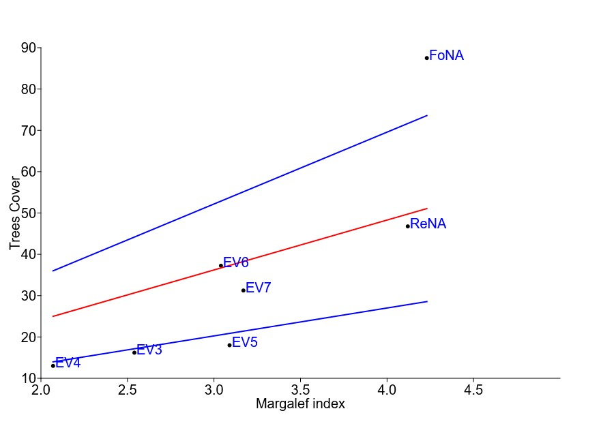
A

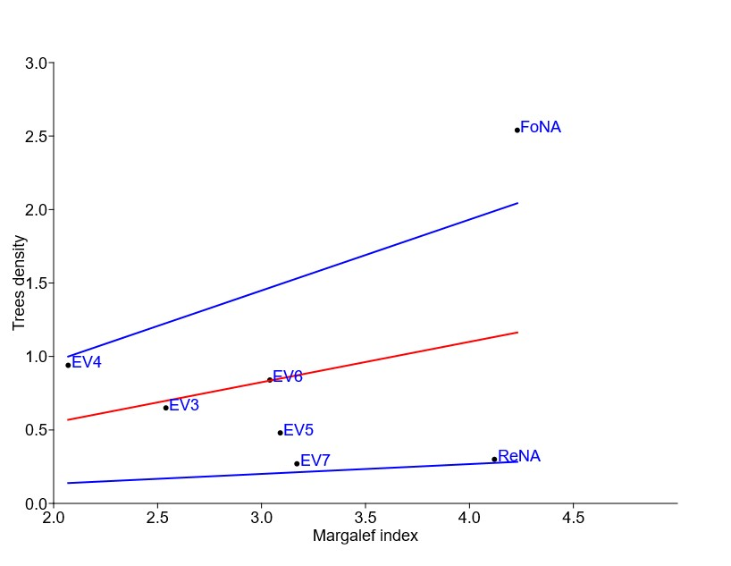
B

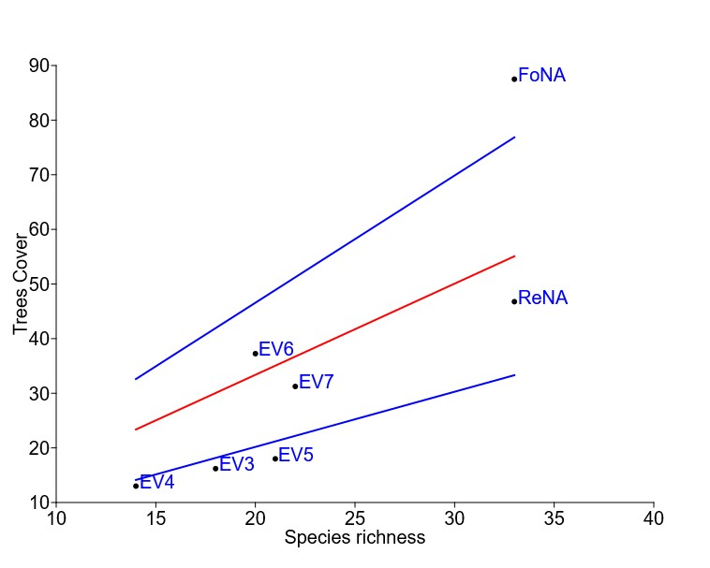
C

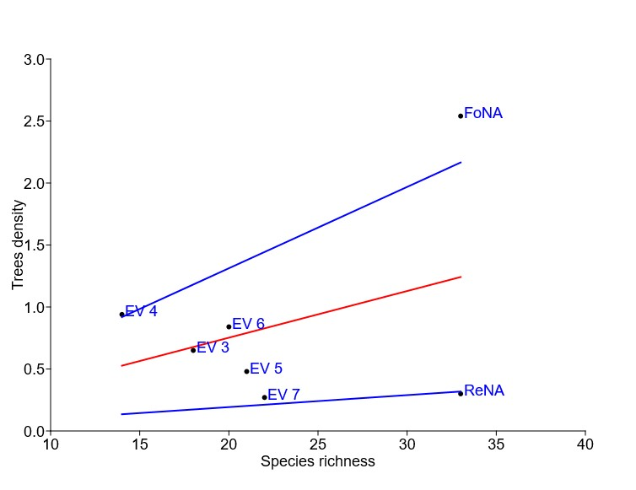
D

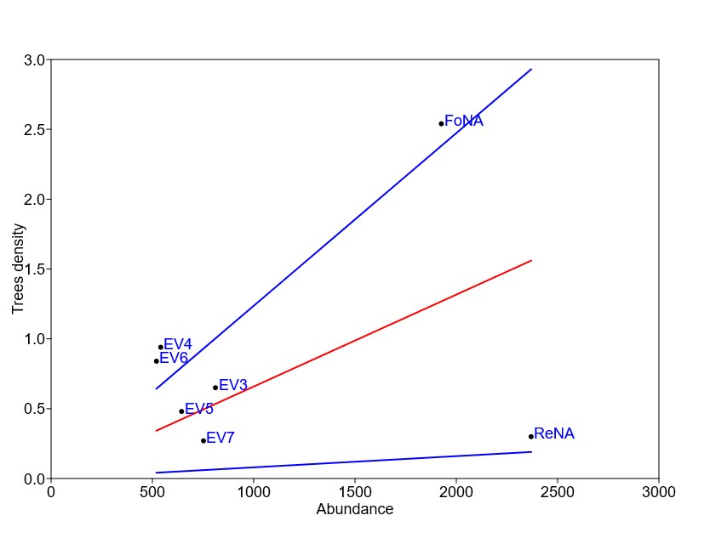
E

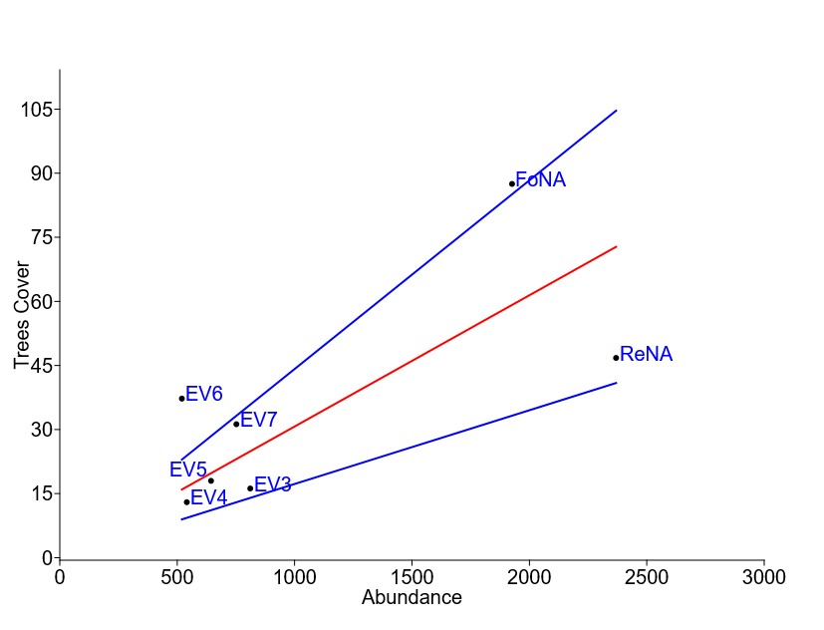
F

Figure 3. Effect of greenspace vegetation features on ant communities. Trees cover and density on Margalef diversity index (A & B), Species richness (C & D) and on Abundance (E & F). Forest of University (FoNA), Reafforested Plot of University (ReNA), Yopougon 3eme pont (EV 7), Agban (EV 6), Pont Ferraille (EV 3), Riviera 2 (EV 4), Yopougon 1er pont ( EV 5)
3.5 Ant species composition
The study revealed a significant difference in the ant community composition across the different greenspaces with an overall average Bray-Curtis dissimilarity ranking from 60% to 78 % based on SIMPER analysis (ANOSIM: R = 0.83, p = 0.0001). NMDS showed four ant communities, a community constituted of greenspaces of “Pont Ferraille” (EV 3), “Yopougon 1er pont “(EV 5), “Agban” (EV 6) and “Yopougon 3eme pont” (EV 7), and three distinct communities that are “Riviera 2 “(EV 4), “Forest of University” (FoNA) and “Reafforested Plot of University” (ReNA). Out of the 82 species collected, 25 ant species were common between these greenspaces. Sixteen and thirteen of these common species thrive in Forest (FoNA) and Reafforested Plot of University (ReNA), respectively. The most abundant common species were the invasive Paratrechina longicornis (24.69% of total abundance) followed by Pheidole buchholzi (15.70%), Oecophylla longinoda (7.28%), Pheidole sp. 8 (4.81%), Monomorium bicolor (4.01%), Pheidole sp. 4 (2.81%), Tapinoma lugubre (2.32%), Odontomachus troglodytes (2.43), Monomorium occidentale (2.26%). The study also detected other invasive ants like Cardiocondyla emeryi, Tapinoma melanocephalum, Monomorium floricola, Solenopsis globularia and Tetramorium simillimum that occurred in greenspaces sampled (Figure 5).
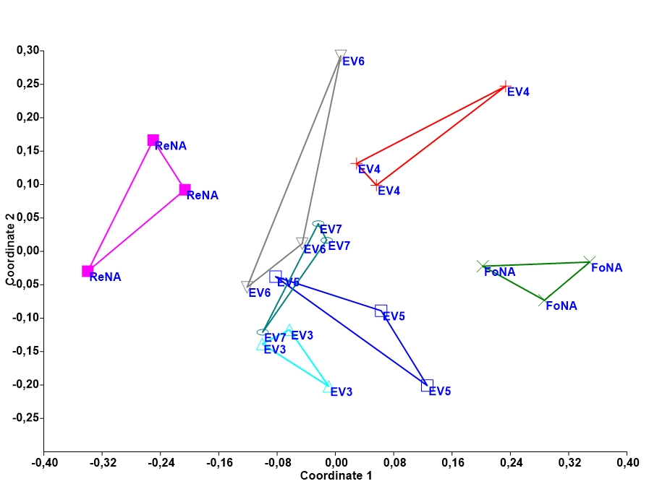

Figure 4. Non-metric multidimensional scaling (NMDS) plot showing ant community composition following the greenspaces. Forest of University (FoNA), Reafforested Plot of University (ReNA), Yopougon 3eme pont (EV 7), Agban (EV 6), Pont Ferraille (EV 3), Riviera 2 (EV 4), Yopougon 1er pont ( EV 5)

Figure 5. Abundance of invasive ant species in greenspaces.
Forest of University (FoNA), Reafforested Plot of University (ReNA), Yopougon 3eme pont (EV 7), Agban (EV 6), Pont Ferraille (EV 3), Riviera 2 (EV 4), Yopougon 1er pont ( EV 5)

4. DISCUSSION
This study assesses the structure of vegetation across different types of urban greenspace and its potential influence on ant community composition. Our findings reveal significant structural differences between greenspaces derived from natural forests (e.g., the university forest) and public gardens. Greenspaces retaining a more natural, and heterogeneous habitat (such as the university forest) consistently exhibited higher tree density and soil vegetation cover than typical public gardens. Additionally, notable distinctiveness was observed even within the public garden category. For instance, public garden of Rivera 2 (destroyed in 2025 for transport hub building) recorded a high tree density with low vegetation cover. In contrast, the public garden of “Yopougon 3eme pont” showed a high tree density and low soil vegetation cover. The distinctiveness observed here about vegetation features may be explained by the different pressures caused by human occupancy in these greenspaces from urban areas (Yeo et al., 2013). In fact, there is a limited access to the greenspace of university while in public gardens, population pressures were high due to daily frequenting and occupancy by population informal activities like market, car repair point, florist and flower growers. In the same way, Kouakou et al., (2018) demonstrated that greenspaces occupancy and degradation was more marked in public gardens than botanical gardens and greenspaces with limited access.
Our study recorded an overall sampling coverage of around 70 % with an asymptotic trend predicted by species accumulation curves for all sampled greenspaces, suggesting that the effectiveness of our sampling is acceptable. On the other hand, the low value of sampling coverage recorded for “Yopougon 1er pont” (EV 5) implies that additional samplings is required for better evaluate the ant community in this greenspace. In fact, this greenspace recorded the highest number of unique species after the Reafforested plot (ReNA) and the university forest (FoNA), implying that it could host a greater ant diversity than the one observed during this study. Our assessment of the ant community demonstrated a rich community of 69 species recorded belonging to 25 genera and five subfamilies. The community was dominated by Myrmicinae, the Formicinae and Ponerinae while Dolichoderinae and Dorylinae were less abundant. These findings corroborate previous studies conducted in urban and anthropized habitats (Yeo et al., 2016; Kouakou et al., 2025). The dominance of Myrmicinae, Formicinae and Ponerinae, may be likely result from a relationship between their biological traits and environmental conditions characterizing the urban area, showing that these habitats can have a selective effect on ant species. For example, the marked prevalence of Myrmicinae is fundamentally linked to their status as numerically dominant taxa globally (Hölldobler & Wilson 1990, Bolton 1994). Additionally, species within this subfamily frequently exhibit generalist life history strategies, enabling facile adaptation and resilience in the face of the frequent and varied anthropogenic disturbances characteristic of the urban environment (Holway et al., 2002). The occurrence of ant species belonging to the Formicinae and Dolichoderinae subfamilies may be primarily governed by their ecological preference for open and thermally favourable habitats, conditions which are often realized in fragmented urban ecosystems (Yeo 2006, Wielgoss et al., 2010, Kone 2013). The presence of the Ponerinae and Dorylinae subfamilies in urban areas may represent a form of ecological adaptation or, more precisely, persistence despite the pressures of urbanization. This is particularly notable given that species in these subfamilies are predominantly specialist predators (Hanisch et al., 2020). Their continued presence may suggest a capacity for either exploiting available niche resources or exhibiting a greater tolerance for urban stressors.
Our results also suggest that greenspaces vegetation features greatly influence the ant communities in urban areas. A marked difference was found in the ant species richness and abundance across surveyed greenspaces. The population parameters were positively correlated with tree density and soil vegetation cover. These findings corroborate the works of Novotony et al. (2003), Franklin (2012) and Neves et al. (2014) who demonstrated that trees richness and density enable the coexistence of a larger number of insect species because they represent heterogeneity and availability of resources. It is the case in our study where urban greenspaces with more complex and heterogenous habitats recorded the highest species richness and diversity like reported in Nooten et al., (2019). For example, in this study, we found that ant diversity, species richness and abundance were higher in Reafforested plot (ReNA) and forest of University (FoNA) than public garden greenspaces. These two habitats recorded about 49% (34 out of 69 species) and 46% (out of 69 species) of total number of species recorded in our study. These findings are also in line with Vasconcelos et al. (2008) and Wildermuth et al. (2023) who demonstrated that heterogenous habitat like forests with complex structure can promote arthropod diversity and abundance due to availability of spatial and climatic niches and decreasing competition pressure. However, it should be noted that conversely to these studies, here in this study the reforested plot (ReNA) and the university forest (FoNA) recorded lower values for the Evenness and Simpson's dominance index, while these indices recorded higher values in the greenspaces of public gardens, suggesting an irregular distribution of species abundance and, consequently, a strong dominance of a few species in the ant communities found in these greenspaces. A tangible example is showed with the high prevalence of the native ant Ph. buchholzi which account for 59% of total species abundance in the university forest (FoNA) and the invasive ant Pa. longicornis which represents 74% of total species abundance in the reforested plot (ReNA) greenspaces. Ph. buchholzi is common in primary and secondary forest of Afrotropical region (Yeo et al., 2011; Ambakina et al 2025). As for Pa. longicornis, this species is an opportunistic and highly competitive invasive species widely distributed with negative impact in residential areas, agricultural sectors and natural environments (Vanderhaegen et al., 2019; Lee et al., 2021).
The results on species composition matched with observation on species richness and diversity of ant community in the type of greenspaces. We found that a strong variation in species composition with four ant communities according the trees density and soil vegetation cover in our study. Greenspaces with relative high tree density that are the university forest (FoNA), the reforested plot (ReNA) and “Riviera 2” (EV 4) represented separately three distinct ant communities as showed the NMDS of figure 4, while the greenspaces of “Yopougon 3eme Pont” (EV 7) , “Agban” (EV 6), “Yopougon 1er Pont” (EV 5) and “Pont ferraille” (EV 3 ) formed one community. These finding may suggest that the vegetation characteristics of these greenspaces may also influence the identity of species in this study. They are consistent with Trigos-Peral et al. (2020) and Kouakou et al. (2025) who reported that greenspaces typologies, their vegetation features and the level of disturbances are important drivers of ant and spider species composition in urban environment. This trend was also reported in Zeng et al., 2023 who reported that pollinator diversity and abundance were improved by the presence of spontaneous herbs and low-intensity management in urban greenspaces of Hefei city in China. In our study for instance, we found that tramp and invasives ant species like Tetramorium simillimum, Tapinoma melanocephalum, Cardyocondyla emeryi, Monomorium floricola, Solenopsis globularia and heat tolerant and opened spaces species like Monomorium bicolor, Pheidole sp.8, Tapinoma luteum, Tapinoma lugubre, Camponotus acvapimensis, Camponotus cinctellus occurred highly in public garden greenspaces while missing or was less abundant in more heterogenous habitats like greenspaces of university forest (FoNA) and reafforested plot (ReNA). The high occurrence of these species may be due to their competitive behaviour and tolerance to disturbances created by anthropogenic activities in public garden greenspaces as mentioned by Bestelmeyer et al. 2015. Unexpectedly, some indigenous species like Oecophylla longinoda, Pheidole buchholzi, Tetramorium brevispinosum and Odontomachus troglodytes, adapted to forests and heterogenous environments strongly persist in public garden greenspaces. The persistence of these species may be attributed to their adaptation to anthropogenic disturbances within urban greenspaces. This suggests that such habitats function as critical ecological refugia, facilitating the survival of native ant species within modified landscapes. These finding confirmed the recent investigation of Gentili et al., 2024 who pointed out the urban greenspaces as crucial refugial habitats for biodiversity in urban environments.

5. CONCLUSION
This study provides evidence that greenspaces with heterogenous and complex vegetations characteristics in urban environments are crucial for conservation of diverse ant community and by congruence biodiversity in tropical urban environments. Overall, we demonstrated that Abidjan district sheltered different typologies of greenspaces that have not the same vegetation features. Greenspaces with heterogenous and complex habitats characteristics like high trees density and soil vegetation cover, sheltered a greater ant abundance and species richness than the ones composed of public garden and under anthropogenic pressure. Furthermore, this study offers critical insights into the conservation of urban green spaces and underscores the utility of ants as bioindicators for assessing the ecological impacts of woody habitat fragmentation within Afrotropical urban landscapes.

6. DISCLAIMER (ARTIFICIAL INTELLIGENCE)

Author(s) hereby declare that NO generative AI technologies such as Large Language Models (ChatGPT, COPILOT, etc.) and text-to-image generators have been used during the writing or editing of this manuscript.

7. REFERENCES
- Ambakina, H., Gómez, K., Monzenga, J. C., Kouakou, L. M., & Dekoninck, W. (2025). The extraordinary diversity of ants (Hymenoptera: Formicidae) of leaf litter in the Yangambi Biosphere Reserve, Tshopo, Democratic Republic of the Congo. Belgian Journal of Entomology, 159. doi:10.3897/bdj.12.e132915
- Andersen, A. N. (1997). Ants as indicators of ecosystem restoration following mining: a functional group approach. Conservation outside nature reserves, 319-25.
- Ashinze, U. K., Edeigba, B. A., Umoh, A. A., Biu, P. W., & Daraojimba, A. I. (2024). Urban green infrastructure and its role in sustainable cities: A comprehensive review. World Journal of Advanced Research and Reviews, 21(2), 928-936.
- Assalé, F. A. & M. Touré. 2020. Espaces publics d’Abidjan à l’épreuve dans l’exercice des activités commerciales informelles. Etudes Caribéennes Avril-Aout 2020: 45 –46.
- Atuahene, E., Asamoah, S., & Owusu Ansah, N. (2025). A review of the role and challenges of green ecology management in sub-Saharan Africa. GeoJournal, 90(3), 128.
- Bestelmeyer, B. T., Okin, G. S., Duniway, M. C., Archer, S. R., Sayre, N. F., Williamson, J. C., & Herrick, J. E. (2015). Desertification, land use, and the transformation of global drylands. Frontiers in Ecology and the Environment, 13(1), 28-36. https://doi.org/10.1890/140162
- Bolton, B. 1976. The ant tribe Tetramoriini (Hymenoptera: Formicidae): Constituent genera, review of smaller genera, and review of Triglyphothrix Forel. Bulletin of British Museum (Natural Hististory) Entomology 34: 283–379.
- Bolton, B. 1980. The ant tribe Tetramoriini (Hymenoptera: Formicidae): The genus Tetramorium Mayr in the Ethiopian zoogeographical region. Bulletin of British Museum (Natural Hististory) Entomology 40: 193–384.
- Bolton, B. 1982. Afrotopical species of the myrmicine Cardiocondyla, Leptothorax, Melissotarsus, Messor and Cataulacus (Formicidae) in the Ethiopian region. Bulletin of British Museum (Natural Hististory) Entomology
- Bolton, B. 1987. A review of the Solenopsis genusgroup and revision of Afrotropical Monomorium Mayr (Hymenoptera: Formicidae). Bulletin of British Museum (Natural Hististory) Entomology 54: 263–452.
- Bolton, B. 2024. An online catalog of ant of the world. <Availaible: https://www.antcat.org; last accessed 27 May 2024.>
- Chenal, J., & Colombo, V. P. (2024). Urban Growth and Land Artificialization in Secondary African Cities: A Spatiotemporal Analysis. Urban Sci., 8(4), 207. DOI: 10.3390/urbansci8040207
- Colwell RK (2013) EstimateS: Statistical estimation of species richness and shared species from samples. Version 9.1. User’s Guide and application published at: http://purl.oclc.org/estimates
- Fisher B. L. & B. Bolton. 2016. Ants of Africa and Madagascar: A guide to the genera. University of California Press, Berkeley, CA, 512 pp
- Franklin, K. (2012). The remarkable resilience of ant assemblages following major vegetation change in an arid ecosystem. Biological Conservation, 148(1), 96-105.
- Gentili, R., Quaglini, L. A., Galasso, G., Montagnani, C., Caronni, S., Cardarelli, E., & Citterio, S. (2024). Urban refugia sheltering biodiversity across world cities. Urban Ecosystems, 27(1), 219-230.
- Hammer, O., Harper, D., & Ryan, P. (2001). PAST: Paleontological statistics software package for education and data analysis. Palaeontologia Electronica, 4, 1–9
- Hanisch, P. E., Drager, K., Yang, W. H., Tubaro, P. L., & Suarez, A. V. (2020). Intra‐and interspecific variation in trophic ecology of ‘predatory’ants in the subfamily Ponerinae. Ecological Entomology, 45(3), 444-455. https://doi.org/10.1111/een.12817.
- Hölldobler, B., Wilson, O. E. (1990). The Ants. Cambridge: Belknap, 733 pp.
- Holway D.A., Lach L., Suarez A.V., Tsutsui N.D. & Case T.J. (2002). The causes and consequences of ant invasions. Annual review of Ecology and Systematics 33: 181–233. https://doi.org/10.1146/annurev.ecolsys.33.010802.150444
- Jennings, V., L. Larson & J. Yun. 2016. Advancing sustainability through urban greenspace: Cultural ecosystem services, equity, and social determinants of health. International Journal of. Environment Research and Public Health 13: 196.
- King, J. R., & Porter, S. D. (2005). Evaluation of sampling methods and species richness estimators for ants in upland ecosystems in Florida. Environmental Entomology, 34(6), 1566-1578.
- Kondi, A. G., Koungbanane, D., Bamba, M., & Ouma, C. (2025). Sustainable Solutions for Growing Cities in Sub-Saharan Africa: Trends in Urban Energy Demand. In African Green Transition Through Innovative Pathways (pp. 127-163). Springer, Cham.
- Kouakou, L. M. M., K. Yeo, M. Kone, K. Ouattara, A. K. Kouakou, T. Delsinne & W. Dekoninck. 2018. Espaces verts comme une alternative de conservation de la biodiversité en villes: le cas des fourmis (Hyménoptère: Formicidae) dans le District d’Abidjan (Côte d’Ivoire). Journal of Applied Biosciences 131: 13358–13381.
- Kouakou, L. M. M., Toure, M., Kouadio, K. I., Konan, Y. M. C., Yode, D. C. V., Nsengimana, V., Barrot, B., J. C. Latta & Konate, S. (2025). Changes in Ant Community Assemblages within Urban Greenspaces from Central towards Peripheral Municipalities in Abidjan Metropolis, Côte d'Ivoire. Journal of Agricultural and Urban Entomology, 41(1), 50-68. https://doi.org/10.3954/JAUE25-03
- Kouamé, A. A., Jaboyedoff, M., Goula Bi Tie, A., Derron, M. H., Kouamé, K. J., & Meier, C. (2019). Assessment of the potential pollution of the Abidjan unconfined aquifer by hydrocarbons. Geosciences, 9(2), 60.
- Kouassi, H. K., Chamara, H. J., N’DA, A. K., & Mitsuru, O. (2020). Implications of Urbanization and Impact of Population Growth on Abidjan City, Cote d’Ivoire. African Journal of Land Policy and Geospatial Sciences, 3(1), 245-255.
- Lach, L., Parr, C. & Abbott, K. (2010). Ant ecology. Oxford University Press, USA, xviii + 402p
- Lee, W. H., Jung, J. M., Lee, H. S., Lee, J. H., & Jung, S. (2021). Evaluating the invasion risk of longhorn crazy ants (Paratrechina longicornis) in South Korea using spatial distribution model. Journal of Asia-Pacific Entomology, 24(2), 279-287. https://doi.org/10.1016/j.aspen.2021.01.007
- Narendra A., Gibb, H. & Ali,T.M. (2011). Structure of ant assemblages in Western Ghats, India: role of habitat, disturbance and introduced species. Insect Conservation and diversity 4 (2): 132–141. https://doi.org/10.1111/j.1752-4598.2010.00113.x
- Neves, F. S., Silva, J.O., Espírito-Santo, M.M., Fernandes, G.W. (2014). Insect herbivores and leaf damage along successional and vertical gradients in a tropical dry forest. Biotropica 46:14–24
- Nooten, S., Schultheiss, P., Rowe, R. C., Facey, S. L., & Cook, J. M. (2019). Habitat complexity affects functional traits and diversity of ant assemblages in urban green spaces (Hymenoptera: Formicidae). Myrmecological News, 29.
- Novotny, V., Basset, Y., Kitching, R. (2003). Herbivore assemblages and their food resources. In: Basset Y, Novotny V, Miller SE, Kitching RL (eds) Arthropods of tropical forests—spatio-temporal dynamics and resource use in the canopy. Cambridge University Press,Cambridge, pp 40–53
- Organisation des Nations Unies de l’Habitat (ONU-Habitat). 2023. ONU Habitat Côte d’Ivoire Rapport pays 2023. Nations Unies, Abidjan, Côte d’Ivoire. <Availaible: https://cotedivoire.un.org/sites/default/files/2024-07/ONU-Habitat%20C%C3%B4te%20d%E2% 80%99Ivoire%20Rapport%20Pays%202023_0.pdf; last assessed 20 Décembre 2025.
- Plummer, K. E., D. Dadam, T. Brereton, E. B. Dennis, D. Massimino, K. Risely, G. M. Siriwardena & M. P. Toms. 2024. Trends in butterfly populations in UK gardens—New evidence from citizen science monitoring. Insect Conserv. Divers. 17: 345–357.
- Rappa, N. J., Staab, M., Ruppert, L. S., Frey, J., Bauhus, J., & Klein, A. M. (2023). Structural elements enhanced by retention forestry promote forest and non-forest specialist bees and wasps. Forest Ecology and Management, 529, 120709. https://doi.org/10.1016/j.foreco.2022.120709
- Sondou, T., Anoumou, K. R., Aholou, C. C., Chenal, J., & Pessoa Colombo, V. (2024). Urban growth and land artificialization in secondary African cities: A spatiotemporal analysis of Ho (Ghana) and Kpalimé (Togo). Urban Science, 8(4), 207.
- Sonet, M. S., Hasan, M. Y., Kafy, A. A., & Shobnom, N. (2025). Spatiotemporal analysis of urban expansion, land use dynamics, and thermal characteristics in a rapidly growing megacity using remote sensing and machine learning techniques. Theoretical and Applied Climatology, 156(2), 79.
- Trigos-Peral, G., Rutkowski, T., Witek, M., Ślipiński, P., Babik, H., & Czechowski, W. (2020). Three categories of urban green areas and the effect of their different management on the communities of ants, spiders and harvestmen. Urban Ecosystems, 23(4), 803-818. https://doi.org/10.1007/s11252-020-00949-9
- Vanderhaegen, K., Naturinda, Z., Kouakou, L. M. M., Vanderheyden, A., & Dekoninck, W. (2019). First record of the invasive longhorn crazy ant, Paratrechina longicornis(Latreille, 1802)(Hymenoptera: Formicidae) from Mt. Elgon, eastern Uganda. BioInvasions Records, 8(3), 505-514. Records 8(3): 505–514, https://doi.org/10.3391/bir.2019.8.3.05
- Vasconcelos, H. L., Leite, M. F., VILHENA, J. M., Lima, A. P., & Magnusson, W. E. (2008). Ant diversity in an Amazonian savanna: relationship with vegetation structure, disturbance by fire, and dominant ants. Austral Ecology, 33(2), 221-231.
- Wielgoss, A., Tscharntke, T., Buchori, D., Fiala, B., & Clough, Y. (2010). Temperature and a dominant dolichoderine ant species affect ant diversity in Indonesian cacao plantations. Agriculture, Ecosystems & Environment, 135(4), 253-259. https://doi.org/10.1016/j.agee.2009.10.003
- Wildermuth, B., Donges, C., Matevski, D., Penanhoat, A., Seifert, C.L., Seidel, D., Scheu, S., Schuldt, A., 2023a. Tree species identity, canopy structure and prey availability differentially affect canopy spider diversity and trophic composition. Oecologia 203, 37–51. https://doi.org/10.1007/s00442-023-05447-1
- Yeo, K., Kouakou, L.M., Dekoninck W., Ouattara, K. & Konate S. (2016). Detecting intruders: assessment of the anthropophilic ant fauna (Hymenoptera: Formicidae) in the city of Abidjan and along access roads in Banco National Park (Côte d’Ivoire). Journal of Entomology and Zoology Studies 4 (4): 351–359
- Yeo, K., Konate, S., Tiho, S., & Camara, S. K. (2011). Impacts of land use types on ant communities in a tropical forest margin (Oumé–Côte d’Ivoire). African Journal of Agricultural Research, 6(2), 260-274. DOI: 10.5897/AJAR09.479
- Yeo, K., (2006). Dynamique spatiale et diversité des fourmis de la litière et du sol dans une mosaïque foret-savane en cote d’ivoire. Thèse de Doctorat en cotutelle. Université Pierre Marie Curie et Université d’Abobo-Adjamé. 212 p
- Zeng, H., Wang, J., Guan, M., Lu, Y., Liu, H., & Zhao, D. (2023). Effects of vegetation structure and environmental characteristics on pollinator diversity in urban green spaces. Urban Forestry & Urban Greening, 84, 127928. https://doi.org/10.1016/j.ufug.2023.127928

