Field Efficacy of Biocontrol Agents in Managing Banded Sheath Blight in Little Millet and Foxtail Millet

Abstract
A field experiment was conducted to evaluate the efficacy of selected biocontrol agents against banded sheath blight of little millet (Panicum sumatrense) and foxtail millet (Setaria italica) caused by Rhizoctonia solani Kuhn. The study was performed under sick plot conditions using little millet variety BG-1 and foxtail millet variety SiA-3282. Bioagents, including Trichoderma viride (NCIM 1053), Pseudomonas fluorescens (NCIM 2207), and Bacillus subtilis (NCIM 2329), were applied as seed treatments and soil amendments mixed with farmyard manure (FYM) to enhance microbial establishment and soil health. Among the treatments, soil application of a combined microbial consortium (T7; 335 g each per 25 kg FYM) consistently recorded the lowest sheath blight disease incidence (17.07% in little millet, 13.15% in foxtail millet) and the highest grain yield (7.91 q ha⁻¹ and 10.92 q ha⁻¹) and fodder yield (17.28 t ha⁻¹ and 24.27 t ha⁻¹). Individual applications of T. viride (T5) and P. fluorescens (T4) were moderately effective, reducing disease intensity and improving yield, indicating the potential of single bioagents under field conditions. The superior performance of the combined treatment is likely due to synergistic mechanisms, including mycoparasitism, antibiosis, nutrient competition, and induction of systemic resistance in host plants. The study demonstrates that microbial consortia can effectively suppress banded sheath blight while enhancing crop productivity, offering a sustainable and eco-friendly alternative to chemical fungicides. These findings are particularly relevant for smallholder farmers practicing low-input millet cultivation in rainfed and marginal environments. Adoption of such integrated microbial strategies could contribute to improved food security, enhanced farm productivity, and environmentally safe management of soil-borne pathogens in small millet cropping systems.
Keywords: Rhizoctonia solani, little millet, foxtail millet, biological control, microbial consortia

Introduction
Small millets, including little millet (Panicum sumatrense Roth ex Roem. & Schult.) and foxtail millet (Setaria italica L.), are climate-resilient crops that play a vital role in ensuring food and nutritional security in India, especially in rainfed, hilly, and tribal farming systems (Patro et al., 2020a; Patro et al., 2020b). These crops are valued for their short crop duration, drought tolerance, high nutritional content, and low input requirements, making them ideal for sustainable agriculture. Little millet grains are rich in proteins, dietary fiber, minerals, and bioactive compounds, while foxtail millet is a rich source of micronutrients, antioxidants, and essential amino acids, contributing to human health and nutrition (Kumar et al., 2021).
Despite their adaptability, small millet productivity is severely constrained by biotic stresses, among which banded sheath blight caused by Rhizoctonia solani Kuhn has emerged as a major yield-limiting factor. The disease is characterized by band-like lesions on leaf sheaths, reduced photosynthetic area, lodging, and ultimately grain and fodder yield reduction. The pathogen survives in soil as sclerotia and mycelium, enabling persistence across cropping seasons, making management challenging (Kabdwal et al., 2023).
Rhizoctonia solani Kuhn is a soil-borne, filamentous fungus in the family Ceratobasidiaceae (Basidiomycota), reproducing mainly through sclerotia and mycelial fragments. It is genetically and pathologically diverse, classified into anastomosis groups (AGs) with distinct host ranges and virulence. In small millets, banded sheath blight is primarily caused by AG-1 and AG-4 isolates, which vary in aggressiveness and adaptability (Das et al., 2020). Understanding its diversity is essential for developing effective management strategies, including the application of biocontrol agents and resistant varieties.
Chemical fungicides, though effective under controlled conditions, are often uneconomical, environmentally hazardous, and unsuitable for low-input smallholder farming systems (Aydın, 2022). Consequently, biological control using antagonistic microorganisms has gained attention as a sustainable, eco-friendly alternative. Microbial antagonists such as Trichoderma viride, Pseudomonas fluorescens, and Bacillus subtilis suppress R. solani through mycoparasitism, antibiosis, competition for nutrients, and induction of systemic resistance in host plants (Harman et al., 2004; Kloepper et al., 2004; Poveda & Eugui, 2022).
Several studies have demonstrated the efficacy of biocontrol agents in cereals and millets. Patro et al. (2018) reported effective management of R. solani in foxtail millet and little millet under controlled conditions, while Jambhulkar et al. (2024) highlighted the diversity and antagonistic potential of Trichoderma strains from different crop rhizospheres. Similarly, Saini et al. (2025) and Safari Motlagh et al. (2022) demonstrated both in vitro and field antagonism of endophytic fungi and Pseudomonas strains against R. solani. Despite these advances, field-level evaluation of combined biocontrol agents in little millet and foxtail millet remains limited, and data on yield benefits under natural disease pressure are scarce.
Therefore, the present study was undertaken to evaluate the field efficacy of individual and combined biocontrol agents against banded sheath blight in little millet and foxtail millet, aiming to identify the most effective and sustainable management strategy for these small millet crops.

Materials and Methods

Experimental Site and Crop Varieties
The field experiment was conducted during the cropping season at the experimental farm of the Department of Plant Pathology, Ranchi Agriculture College, Birsa Agricultural University, Kanke, Ranchi, Jharkhand, India, geographically situated at 23.44265° N latitude and 85.31744° E longitude. The experimental site falls under the eastern plateau and hill region of India and represents a typical agro-climatic condition of the region. The study was conducted under sick plot conditions to maintain uniform and consistent disease pressure throughout the experimental period, thereby enabling reliable evaluation of disease incidence and severity. Little millet (Panicum sumatrense) variety BG-1 and foxtail millet (Setaria italica) variety SiA-3282 were selected for the study due to their agronomic importance and adaptability to the local agro-ecological conditions. The soil of the experimental field was loamy in texture, well-drained, and moderately fertile, with soil pH ranging from 6.8 to 7.2. Such soil conditions are considered favorable for millet cultivation as well as for the establishment and progression of soil-borne pathogens, thus facilitating disease development and accurate assessment of treatment effects.
Source of Bioagents
The microbial bioagents used were obtained from the National Collection of Industrial Microorganisms (NCIM), Pune, India. The strains and accession numbers included: Trichoderma viride (NCIM 1053), Pseudomonas fluorescens (NCIM 2207), and Bacillus subtilis (NCIM 2329).
Revival and Formulation
Trichoderma viride was revived on Potato Dextrose Agar (PDA) at 28 ± 2°C for 5–7 days, while Pseudomonas fluorescens and Bacillus subtilis were revived on Nutrient Agar or King’s B medium at 28 ± 2°C for 24–48 hours. Talc-based formulations were prepared by mixing spores or cells with sterile talc powder in a 1:4 ratio (w/w) with 1% carboxymethyl cellulose (CMC) as an adhesive. Final concentrations were 1 × 10^7 spores/g talc for T. viride and 1 × 10^8 CFU/g talc for the bacterial strains. Formulations were stored in airtight bags at room temperature until application.

Treatments and Experimental Design
Eight treatments comprising seed treatment and soil application of different biocontrol agents, along with an untreated control, were evaluated to assess their effectiveness. The experiment was conducted following a Randomized Block Design (RBD) with three replications to ensure statistical validity. Each experimental plot measured 3 × 4 m, and crops were planted with a row spacing of 30 cm.
Chart 1: Treatment Details
Treatment No. | Treatment Details
T1 | Seed Treatment with T. viride @ 10 g/kg
T2 | Seed Treatment with B. subtilis @ 10 g/kg
T3 | Seed Treatment with P. fluorescens @ 10 g/kg
T4 | Soil Application of P. fluorescens @ 1 kg formulation mixed in 25 kg FYM
T5 | Soil Application of T. viride @ 1 kg formulation mixed in 25 kg FYM
T6 | Soil Application of B. subtilis @ 1 kg formulation mixed in 25 kg FYM
T7 | Soil Application of value-added P.f. + T.v. + B.s. @ 335 g each mixed in 25 kg FYM
T8 | Control
P.f.: Pseudomonas fluorescens; T.v.: Trichoderma viride; B.s.: Bacillus subtilis.
Application of Treatments
Seed treatment was carried out by coating seeds with the respective bioagent formulations before sowing to ensure early root colonization and protection against soil-borne pathogens. Soil application involved mixing the bioagent formulations thoroughly with well-decomposed farmyard manure (FYM) and uniformly broadcasting the mixture in the field at the time of sowing. Farmyard manure served as an effective carrier for microbial agents and also enhanced soil organic matter, nutrient availability, and overall microbial activity, thereby creating a favorable rhizosphere environment and improving suppression of soil-borne plant pathogens (Patro et al., 2018).

Observations Recorded
Disease intensity of banded sheath blight was assessed at two critical growth stages: panicle initiation and grain filling at 40 to 65 days after sowing, which are highly susceptible to R. solani infection. Disease incidence was expressed as a percentage using standard protocols:
$$\text{Disease incidence }\left(\text{DI}\right)\text{ \%= (Number of infected plants/Total plants) × 100}$$
Grain yield (q ha⁻¹) and fodder yield (t ha⁻¹) were recorded at harvest. Data were statistically analyzed, and critical difference (CD) was calculated at 5% level of significance.

Results and Discussion

Effect of Biocontrol Agents on Banded Sheath Blight
Significant differences in disease suppression were observed among the top three treatments. The combined application of P. fluorescens, T. viride, and B. subtilis (T7) consistently recorded the lowest disease incidence, with 17.07% in little millet and 13.15% in foxtail millet. This represented a reduction of 60% and 63%, respectively, compared to the untreated control.
Among single-agent soil applications, T5 (T. viride) exhibited moderate efficacy, reducing disease incidence to 24.27% in little millet and 17.96% in foxtail millet, corresponding to reductions of 43–44% over control. T4 (P. fluorescens) also performed moderately, with disease incidences of 26.93% and 24.26%, demonstrating that individual microbial agents are effective but less so than the combined consortia.
The superior performance of T7 is likely due to synergistic interactions among bioagents. T. viride suppresses pathogens through mycoparasitism, P. fluorescens through antibiosis and siderophore-mediated competition, and B. subtilis through induction of systemic resistance in host plants (Harman et al., 2004; Poveda & Eugui, 2022). The combined action creates a hostile environment for pathogen proliferation, ensuring consistent disease suppression throughout crop growth.

Treatments | Little millet |  |  | Foxtail millet
Treatments | Banded sheath blight (%) | Grain Yield  (q/ha) | Fodder yield  (t/ha) | Banded sheath blight (%) | Grain Yield  (q/ha) | Fodder yield  (t/ha)
T1 | 26.53 | 7.06 | 13.58 | 28.33 | 9.21 | 18.72
T2 | 32.80 | 5.85 | 12.54 | 30.18 | 9.21 | 17.48
T3 | 38.13 | 5.64 | 11.73 | 33.14 | 6.53 | 17.21
T4 | 26.93 | 6.25 | 14.82 | 24.26 | 9.32 | 21.19
T5 | 24.27 | 6.89 | 16.05 | 17.96 | 9.80 | 22.03
T6 | 34.40 | 5.84 | 14.20 | 26.85 | 6.62 | 19.95
T7 | 17.07 | 7.91 | 17.28 | 13.15 | 10.92 | 24.27
T8 | 42.67 | 4.63 | 11.11 | 35.19 | 6.50 | 18.85
SEm | 1.18 | 24.44 | 0.72 | 1.50 | 24.22 | 0.39
CD at 5% | 3.63 | 74.84 | 1.56 | 4.58 | 74.17 | 1.20
CV% | 6.73 | 16.69 | 15.67 | 7.81 | 12.17 | 8.56
Table 1: Management of banded sheath blight of little millet & Foxtail millet through bio-control agents

Effect on Grain and Fodder Yield
The effectiveness of disease suppression was clearly manifested through significant improvements in both grain and fodder yields of little millet and foxtail millet. Among all the treatments, T7 consistently outperformed others, recording the highest grain yield of 7.91 q ha⁻¹ in little millet and 10.92 q ha⁻¹ in foxtail millet. Similarly, the maximum fodder yields were obtained in T7-treated plots, with 17.28 t ha⁻¹ in little millet and 24.27 t ha⁻¹ in foxtail millet. These superior yields highlight the strong protective effect of T7 against disease pressure, enabling the crops to express their full yield potential. T5, involving Trichoderma viride, produced intermediate yield levels, indicating its moderate effectiveness in disease suppression and crop growth promotion. Grain yields under T5 reached 6.89 q ha⁻¹ in little millet and 9.80 q ha⁻¹ in foxtail millet, while fodder yields were 16.05 t ha⁻¹ and 22.03 t ha⁻¹, respectively. This improvement over lower-performing treatments suggests that T. viride contributed to pathogen suppression as well as enhanced root growth and nutrient uptake. Treatment T4, based on Pseudomonas fluorescens, resulted in comparatively lower yields, though still superior to untreated control. Grain yields of 6.25 q ha⁻¹ in little millet and 9.32 q ha⁻¹ in foxtail millet, along with fodder yields of 14.82 t ha⁻¹ and 21.19 t ha⁻¹, respectively, indicate partial disease control and growth promotion. Overall, the results demonstrate a strong positive relationship between reduced disease intensity and yield enhancement. Effective disease management, particularly under T7, helped preserve functional leaf area, minimized lodging, and improved photosynthetic efficiency. These factors collectively enhanced biomass production, assimilate partitioning, and grain filling, ultimately leading to higher grain and fodder yields in both millet crops.

The present study highlights that combined soil application of P. fluorescens, T. viride, and B. subtilis (T7) is the most effective strategy for suppressing banded sheath blight in little millet and foxtail millet. The superior performance is likely due to synergistic interactions among the microbial agents, which include antibiosis, mycoparasitism, nutrient competition, and induction of systemic resistance (Patro et al., 2018; Poveda & Eugui, 2022; Jambhulkar et al., 2024).
The moderate efficacy of single-agent treatments (T5 and T4) confirms that individual bioagents can suppress disease but are less consistent compared to microbial consortia. Trichoderma viride (T5) primarily inhibits pathogen growth through mycoparasitism, while Pseudomonas fluorescens (T4) functions mainly through antibiotic production and competition for iron. When combined in T7, these mechanisms likely act synergistically, resulting in superior disease suppression and higher yield.
The grain and fodder yield improvements observed in T7-treated plots correlate with reduced disease intensity. Lower infection levels in T7 plots preserved leaf area, minimized lodging, and enhanced photosynthetic efficiency, ultimately improving biomass and grain accumulation. Similar results were reported by Patro et al. (2020a, 2020b) for little millet and foxtail millet, indicating that resistant varieties and biocontrol interventions are complementary approaches.
Endophytic fungi and Pseudomonas strains have demonstrated significant antagonistic activity against R. solani under both laboratory and field conditions (Safari Motlagh et al., 2022; Sahgal et al., 2024; Saini et al., 2025). The current study confirms that field-level efficacy of bioagents in small millets can be maximized through combined applications, providing a practical alternative to chemical fungicides.
The environmental and agronomic benefits of this approach are significant. Use of microbial consortia reduces chemical input dependency, minimizes soil and water contamination, and supports climate-smart agriculture. Moreover, enhanced grain and fodder yields contribute to improved food security and smallholder farmer livelihoods, highlighting the socio-economic relevance of integrating biocontrol agents into small millet cropping systems.
Overall, these findings indicate that top-performing microbial consortia (T7) can serve as a foundation for developing commercial bioinoculant formulations targeted toward small millet cultivation under rainfed conditions.
Conclusion and Future Directions
The present study clearly demonstrated that soil application of the microbial consortium T7, consisting of Pseudomonas fluorescens, Trichoderma viride, and Bacillus subtilis, at the time of sowing was highly effective in suppressing banded sheath blight in both little millet and foxtail millet. The consortium significantly reduced disease incidence and severity, which was reflected in substantial improvements in grain and fodder yields, highlighting the synergistic interaction among the constituent bioagents. The combined application of bacterial and fungal antagonists likely enhanced pathogen suppression through multiple mechanisms such as antibiosis, competition for nutrients and space, mycoparasitism, and induction of systemic resistance in plants. In contrast, individual treatments such as T4 (P. fluorescens) and T5 (T. viride) showed moderate levels of disease control and yield enhancement, indicating that while single bioagents possess considerable biocontrol potential, their effectiveness is comparatively lower than that of a well-formulated consortium. The superior performance of T7 underscores the importance of exploiting microbial synergy for sustainable disease management in small millets. These findings suggest that microbial consortia can serve as eco-friendly alternatives to chemical fungicides, contributing to enhanced crop productivity and environmental safety. Future research should focus on optimizing consortium formulations to improve their efficacy, shelf life, and field stability across diverse agro-climatic conditions. Moreover, integrating microbial consortia with resistant millet varieties, appropriate crop rotations, and improved agronomic practices may further strengthen disease management strategies. Long-term studies assessing ecological impacts, soil microbiome dynamics, and farmer-friendly delivery systems will be essential for large-scale adoption and for promoting resilient and sustainable small millet-based cropping systems.

Declaration:

Author(s) hereby declare that NO generative AI technologies such as Large Language Models (ChatGPT, COPILOT, etc.) and text-to-image generators have been used during the writing or editing of this manuscript.

References
- Aydın, M. H. (2022). Rhizoctonia solani and its biological control. Turkish Journal of Agricultural Research, 9(1), 118–135.
- Das, S., Plyler-Harveson, T., Santra, D. K., et al. (2020). A longitudinal study on morpho-genetic diversity of pathogenic Rhizoctonia solani from sugar beet and dry beans of western Nebraska. BMC Microbiology, 20, 354.
- Harman, G. E., Howell, C. R., Viterbo, A., Chet, I., & Lorito, M. (2004). Trichoderma species—opportunistic, avirulent plant symbionts. Nature reviews microbiology, 2(1), 43-56.
- Kabdwal, B. C., Sharma, R., Kumar, A., et al. (2023). Efficacy of different combinations of microbial biocontrol agents against sheath blight of rice caused by Rhizoctonia solani. Egyptian Journal of Biological Pest Control, 33, 29.
- Kloepper J.W., Ryu C-M, Zhang S., 2004. Induced systemic resistance and promotion of plant growth by Bacillus spp. Phytopathology 94:1259-1266.
- Jambhulkar, P. P., Singh, B., & Raja, M., et al. (2024). Genetic diversity and antagonistic properties of Trichoderma strains from crop rhizospheres and their biocontrol efficacy. Scientific Reports, 14, 8610.
- Patro, T. S. S. K., Georgia, K. E., Raj Kumar, S., Anuradha, N., Sandhya Rani, Y., Triveni, U., & Jogarao, P. (2020). Identification of foxtail millet varieties against banded blight disease incited by Rhizoctonia solani Kuhn. Journal of Pharmacognosy and Phytochemistry, 9(5), 1265–1267.
- Patro, T. S. S. K., Georgia, K. E., Raj Kumar, S., Anuradha, N., Sandhya Rani, Y., & Triveni, U. (2020). Evaluation of resistant sources of little millet varieties against banded blight disease incited by R. solani Kuhn. Journal of Pharmacognosy and Phytochemistry, 9(5), 1229–1230.
- Patro, T. S. S. K., Meena, A., Divya, M., & Anuradha, N. (2018). Biological control of Rhizoctonia solani, the causal agent of sheath blight in foxtail millet (Setaria italica). Journal of Pharmacognosy and Phytochemistry, 7(4), 3164–3167.
- Patro, T. S. S. K., Meena, A., Divya, M., & Anuradha, N. (2018). Management of banded blight using biological control agents against Rhizoctonia solani Kuhn in little millet (Panicum sumatrense). Journal of Pharmacognosy and Phytochemistry, 7(3), 2664–2667.
- Poveda, J., & Eugui, D. (2022). Combined use of Trichoderma and beneficial bacteria: Development of microbial synergistic bioinoculants in sustainable agriculture. Biological Control, 176, 105100.
- Sahgal, M., Saini, N., Jaggi, V., Brindhaa, N. T., Kabdwal, M., Singh, R. P., & Prakash, A. (2024). Antagonistic potential and biological control mechanisms of Pseudomonas strains against banded leaf and sheath blight disease of maize. Scientific Reports, 14, 13580.
- Safari Motlagh, M. R., Jahangiri, B., Kulus, D., Tymoszuk, A., & Kaviani, B. (2022). Endophytic fungi as potential biocontrol agents against Rhizoctonia solani J.G. Kühn, the causal agent of rice sheath blight disease. Biology, 11(9), 1282.
- Saini, Saurabh, S. K. Biswas, Anju Shukla, Prabha Siddharth, Girijesh Kumar Jaisval, Akash Kumar Kamal, Shivam Kumar, and Utkarsh Upadhyay. 2025. “In Vitro Assessment of Bio-Agents and Their Culture Filtrate for Sustainable Management of Rhizoctonia Solani”. International Journal of Plant & Soil Science 37 (10):239-45. https://doi.org/10.9734/ijpss/2025/v37i105779.

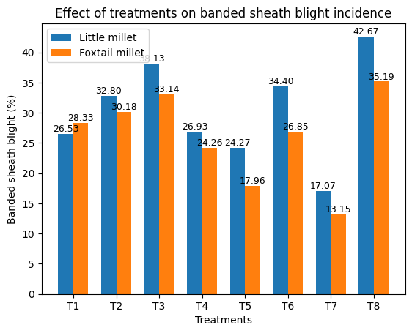
Figure 1. Effect of different treatments on banded sheath blight incidence (%) in little millet and foxtail millet.

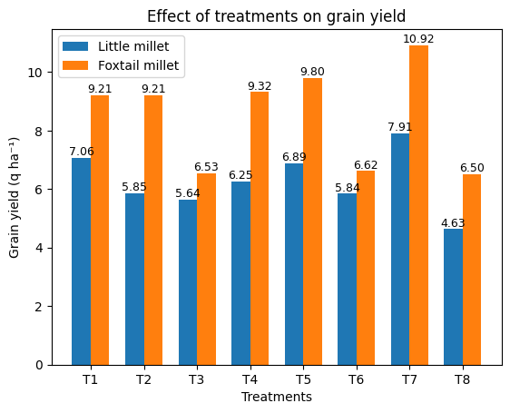
Figure 2. Effect of different treatments on grain yield (q ha⁻¹) of little millet and foxtail millet.

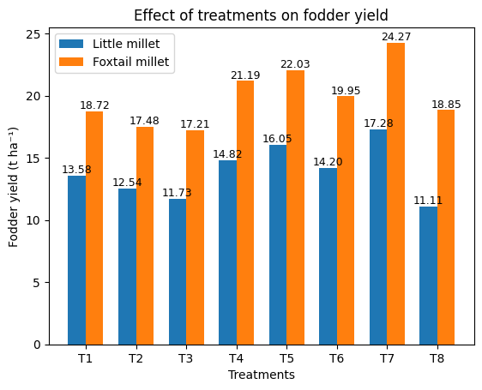

Figure 3. Effect of different treatments on fodder yield (t ha⁻¹) of little millet and foxtail millet.

