Original Research Article

Effect of Integrated Nutrient Management on Growth, Yield and Quality of Papaya (Carica papaya L.) cv. Red Lady under Semi-Arid Agro-Climatic Conditions of Central Telangana,India

ABSTRACT
A field experiment was conducted during 2022–2024 at DDS Krishi Vigyan Kendra, Zaheerabad, Telangana, to evaluate the effect of integrated nutrient management (INM) on growth, yield, fruit quality, and soil fertility of papaya (Carica papaya L.) cv. Red Lady under lateritic soil conditions. The experiment was laid out in a randomized block design with ten treatments comprising different combinations of recommended chemical fertilizers and bio-enriched vermicomposts prepared using poultry manure, neem cake, Azospirillum, and PGPR mix-1, with three replications. Results revealed that INM treatments significantly influenced vegetative growth, yield attributes, fruit quality parameters, and post-harvest soil nutrient status. Among the treatments, application of 25% NPK through PGPR mix-1 enriched vermicompost combined with 75% of the recommended dose of fertilizers (T₄) recorded the highest plant height, number of fruits per plant, average fruit weight, and total yield (52.93 kg plant⁻¹). The same treatment also produced superior fruit quality, registering maximum total soluble solids (15.64°Brix), pulp percentage (90.28%), and ascorbic acid content, along with the lowest titratable acidity (0.10%). Post-harvest soil analysis indicated improved organic carbon content and higher availability of nitrogen, phosphorus, and potassium under INM treatments compared to sole chemical fertilization and control. The integration of organic and microbial inputs enhanced nutrient-use efficiency and contributed to improved soil fertility. The study demonstrates that partial substitution of chemical fertilizers with bio-enriched vermicompost is an effective, eco-friendly, and sustainable nutrient management strategy for improving papaya productivity and soil health under semi-arid conditions of Telangana, with potential applicability to similar tropical agro-ecological regions.

Keywords: Integrated Nutrient Management (INM); Vermicompost; PGPR; Biofertilizers; Sustainable agriculture; Fruit yield; Soil fertility

- INTRODUCTION
Papaya (Carica papaya L.) is one of the most economically and nutritionally important fruit crops cultivated across tropical and subtropical regions of the world. Globally, India ranks among the largest producers, contributing nearly 40% of the world’s papaya production. The fruit’s high nutritive value rich in vitamin A, vitamin C, carbohydrates, minerals, and digestive enzyme papain makes it valuable for human health, medicine, and industry (Babalola et al., 2024). In Telangana, particularly in the semi-arid districts such as Sangareddy and Medak, papaya cultivation has gained prominence due to its short gestation period and adaptability to diverse soils and climatic conditions. However, productivity is often limited by poor nutrient management practices and soil degradation resulting from the excessive use of chemical fertilizers. Papaya is a heavy feeder of nutrients owing to its continuous vegetative and reproductive growth cycles. The crop requires a balanced and sustained supply of macronutrients (N, P, K) and micronutrients throughout its growing period. In India, the recommended dose of fertilizers for papaya (240:240:480 g NPK plant⁻¹ year⁻¹) is often applied in an unbalanced or excessive manner, leading to problems such as nutrient leaching, soil acidification, reduced microbial activity, and contamination of groundwater resources. Integrated Nutrient Management (INM) is an ecologically balanced approach that combines organic, inorganic, and biological sources of nutrients to maintain soil fertility, enhance nutrient use efficiency, and sustain long-term productivity (Kumari et al., 2023).
INM seeks to minimize the dependence on chemical fertilizers by integrating locally available organic resources such as FYM, vermicompost, poultry manure, neem cake, and biofertilizers with recommended doses of inorganic nutrients. This approach not only improves crop yield and quality but also enhances soil microbial activity, structure, and nutrient cycling, thereby supporting sustainable agriculture. According to Bindu & Renjan (2024), the application of microbial consortium-enriched organic manures in papaya resulted in significant improvements in fruit number, fruit weight, and pulp quality, compared to conventional fertilizer use. Their study highlighted that enriching vermicompost with plant growth-promoting rhizobacteria (PGPR) and using 75% of the recommended chemical fertilizer dose produced superior results in yield and biochemical characteristics, including higher total soluble solids (TSS) and carotenoid content. This demonstrates that a judicious combination of bio-enriched composts and mineral fertilizers can enhance both productivity and quality in papaya cultivation systems.
Organic manures play an indispensable role in INM systems by improving soil organic carbon, enhancing water retention, and supplying slow-release nutrients (Smita et al., 2025). Vermicompost, produced through the decomposition of organic matter by earthworms, has been shown to enhance the availability of essential nutrients like nitrogen, phosphorus, potassium, calcium, and magnesium, while simultaneously promoting beneficial soil microbes. Studies have indicated that vermicompost enriched with bioinoculants such as Azospirillum, Azotobacter, Phosphate Solubilizing Bacteria (PSB), and PGPR can substantially improve nutrient uptake and fruit quality parameters in papaya (Singh & Tripathi, 2020). In papaya cv. ‘Red Lady’, the combination of 50% NPK with 20 kg FYM, 100 g Azospirillum, and 100 g PSB achieved the maximum fruit yield and improved physicochemical properties such as TSS, firmness, and sugar content. These results validate that partial substitution of chemical fertilizers with organic and biological inputs ensures sustained nutrient supply while improving soil biological activity. Similarly, Sethy et al. (2025) observed that the integrated application of 100% recommended fertilizer dose (RDF) along with PSB, Azospirillum, and Azotobacter enhanced foliar nutrient content, soil microbial population, and fruit yield in papaya cv. ‘Coorg Honey Dew’. They recorded the highest benefit-cost ratio (3.3) with a 75% RDF treatment integrated with biofertilizers, illustrating that balanced nutrient application through INM is both agronomically and economically advantageous.
Microbial inoculants, such as PGPR and PSB, enhance nutrient availability by solubilizing phosphorus, fixing atmospheric nitrogen, and releasing growth-promoting hormones. For instance, Singh & Tripathi (2020) demonstrated that applying 75% RDF with Azotobacter, PSB, and vermicompost increased plant biomass, leaf number, fruit set, and yield, while improving soil organic carbon, nitrogen, and potassium availability. These interactions not only enhance nutrient efficiency but also restore degraded soils. In addition, microbial enrichment of vermicompost with PGPR strains has been shown to induce systemic resistance against certain diseases and enhance enzyme activity in the rhizosphere, leading to healthier root systems and better nutrient uptake (Bindu & Renjan, 2024). The adoption of INM practices has been reported to reduce fertilizer application by 25–50% without compromising yield. In papaya, integrating 75% RDF with biofertilizers and vermicompost yielded 31% higher fruit production compared to conventional fertilization methods, while maintaining superior fruit quality (Manjunath et al., 2023). This reduction in chemical input not only lowers production costs but also minimizes the carbon footprint of papaya cultivation, making it more sustainable in the long run. Moreover, Silva et al. (2019) found that combining organic amendments such as biochar and green manure with papaya cultivation improved soil fertility and nutrient retention, contributing to higher biomass accumulation and healthier plants. Such practices align with the principles of regenerative agriculture, promoting long-term soil productivity and ecological balance.
Telangana’s lateritic soils are typically acidic and deficient in major nutrients, particularly nitrogen and phosphorus. The declining organic matter content due to continuous cropping and poor residue management further exacerbates the issue. The adoption of integrated nutrient management is particularly relevant for this region, as it addresses soil fertility constraints while maintaining economic viability for small and marginal farmers. The use of locally available organic sources such as poultry manure, neem cake, and FYM enriched with microbial consortia offers a feasible and low-cost alternative to sole reliance on synthetic fertilizers. In this context, the present study was conducted at DDS Krishi Vigyan Kendra, Zaheerabad (Sangareddy District, Telangana) to evaluate the comparative effects of different INM combinations on the growth, yield, and quality of papaya cv. Red Lady. This variety, being high-yielding and gynodioecious, is suitable for intensive cultivation systems but also requires precise nutrient management for optimal performance. The experiment sought to identify the most effective integration of chemical fertilizers with bio-enriched vermicomposts using microbial inoculants such as Azospirillum, PGPR mix, and neem cake. The objective of this study was to evaluate the effectiveness of integrated nutrient management involving bio-enriched vermicompost and reduced chemical fertilizers on growth, yield, fruit quality, and soil fertility of papaya (Carica papaya L.) cv. Red Lady under lateritic soil conditions of Central Telangana, with the aim of developing a sustainable, eco-friendly, and productivity-oriented nutrient management strategy.

2. MATERIALS AND METHODS
2.1 Experimental Site
The field experiment on Integrated Nutrient Management (INM) in papaya was conducted during 2022–24 at DDS Krishi Vigyan Kendra (KVK), Zaheerabad, located in Sangareddy district, Telangana, India. The region lies at latitude 17°38'47'' N and longitude 77°38'47'' E, with an altitude of 622 m above mean sea level, and experiences a semi-arid tropical climate characterized by hot summers, mild winters, and an average annual rainfall of 680 mm. The soil at the experimental site was lateritic, acidic (pH 4.92), and low in available nitrogen (275 kg ha⁻¹), phosphorus (15 kg ha⁻¹), and potassium (165 kg ha⁻¹). The low organic carbon content (0.36%) indicated the need for organic and microbial interventions to sustain productivity.

2.2 Experimental Design and Treatments
The experiment was conducted using a Randomized Block Design (RBD) with ten treatments and three replications. Each plot contained six plants, spaced at 2 m × 2 m, ensuring sufficient sunlight, aeration, and root expansion. The papaya cultivar ‘Red Lady’ (Carica papaya L.) was chosen due to its high yield potential, red-orange pulp, and adaptability to semi-arid climates. The treatments were formulated to study the impact of integrating organic manures, microbial inoculants, and inorganic fertilizers on papaya performance. The detailed treatment structure is presented in chart 1.

Chart 1: The detailed treatment structure
Treatment Code | Description
T₁ | 100% Recommended Dose of Fertilizers (RDF): 240 N: 240 P₂O₅: 480 K₂O g plant⁻¹ + 10 kg FYM
T₂ | N (25%) as Poultry Manure-enriched Vermicompost + N (75%), P, and K of T₁
T₃ | N (25%) as Neem Cake-enriched Vermicompost + N (75%), P, and K of T₁
T₄ | NPK (25%) as PGPR Mix-1-enriched Vermicompost + N, P, and K (75%) of T₁
T₅ | N (25%) as Azospirillum-enriched Vermicompost + N (75%), P, and K of T₁
T₆ | N (50%) as Poultry Manure-enriched Vermicompost + N (50%), P, and K of T₁
T₇ | N (50%) as Neem Cake-enriched Vermicompost + N (50%), P, and K of T₁
T₈ | NPK (50%) as PGPR Mix-1-enriched Vermicompost + N, P, and K (50%) of T₁
T₉ | N (50%) as Azospirillum-enriched Vermicompost + N (50%), P, and K of T₁
T₁₀ | Absolute Control (no fertilizers or manures applied)

2.3 Nutrient Sources and Application
The Recommended Dose of Fertilizers (RDF) applied was 240 g N, 240 g P₂O₅, and 480 g K₂O per plant per year, split into four equal applications at 60-day intervals starting from 30 days after planting (DAP). NPK were supplied through urea, single superphosphate, and muriate of potash, respectively. Organic inputs FYM, poultry manure, neem cake, and vermicompost were analyzed for NPK content prior to application. The bio-enriched vermicomposts were prepared by inoculating vermicompost with Azospirillum lipoferum, Phosphate Solubilizing Bacteria (Bacillus megaterium), Pseudomonas fluorescens, and Bacillus subtilis (PGPR mix). Each microbial inoculant was applied at the rate of 1 kg culture per 100 kg compost and incubated for 15 days before use. Manures were incorporated into the top 15 cm of soil during pit preparation, while chemical fertilizers were applied as per treatment schedule. Drip irrigation was employed for efficient water and nutrient delivery.

2.4 Observations and Characters Studied
Growth attributes: Plant height, stem girth, number of functional leaves, and leaf area.
Yield and fruit attributes: Number of fruits per plant, average fruit weight, fruit length, fruit girth, fruit volume and total yield per plant.
Fruit quality parameters: Total soluble solids, titratable acidity, ascorbic acid, pulp percentage, flesh thickness, reducing sugars, and total sugars.
Soil and microbial parameters: Available nitrogen, available phosphorus, available potassium, organic carbon, soil pH, electrical conductivity, and microbial population.

2.5 Statistical Analysis
Data were analyzed using using OPSTAT and SPSS (Version 26). Treatment means were compared using the Critical Difference (CD) at the 5% significance level (p ≤ 0.05).

3. RESULTS AND DISCUSSION
3.1 Effect of Integrated Nutrient Management on Growth Parameters
The data revealed that the application of integrated nutrient management significantly influenced the vegetative growth of papaya plants, indicating that the balanced supply of nutrients from both organic and inorganic sources is critical for achieving optimal plant vigor (Table 1). Among the ten treatments, T₄ (25% NPK as PGPR mix-1 enriched vermicompost + 75% RDF) recorded the maximum plant height (246.75 cm) (Fig. 1), stem girth (42.8 cm), and number of functional leaves (50.6) at 24 months after planting. Treatments T₆ (50% poultry manure-enriched vermicompost + 50% RDF) and T₈ (50% PGPR-enriched vermicompost + 50% RDF) were statistically at par with T₄, whereas the absolute control (T₁₀) recorded the minimum growth performance.
The superior vegetative growth under T₄ may be attributed to the synergistic effects of PGPR (Plant Growth-Promoting Rhizobacteria), which enhance root architecture, nutrient solubilization, and hormone production such as auxins and gibberellins (Bindu & Renjan, 2024). The microbial enrichment in vermicompost increases nitrogen mineralization and microbial biomass, contributing to higher nutrient uptake efficiency and enhanced chlorophyll content. Furthermore, partial substitution of chemical fertilizers by organic and biofertilizer sources creates a more stable nutrient release pattern, ensuring continuous nutrient supply throughout the crop growth cycle. Similar observations were reported by Singh and Tripathi (2020), who found that the combined application of 75% RDF with Azotobacter, PSB, and vermicompost significantly improved papaya plant height, girth, and number of leaves compared to full RDF or unfertilized control. Chawla and Sadawarti (2020) also concluded that integrated nutrient management enhances microbial proliferation and improves soil structure, promoting better vegetative growth. The lowest growth under control (T₁₀) was expected due to nutrient deficiency and reduced microbial activity, confirming the heavy nutrient requirement of papaya (Kirad & Barche, 2010).

Table 1. Effect of Integrated Nutrient Management on Growth Parameters of Papaya cv. Red Lady
Treatment | Plant Height (cm) | Stem Girth (cm) | No. of Functional Leaves | Leaf Area (cm²)
T₁ | 210.45 | 35.25 | 43.4 | 6,200
T₂ | 223.50 | 37.18 | 45.6 | 6,880
T₃ | 229.60 | 38.24 | 46.8 | 7,040
T₄ | 246.75 | 42.80 | 50.6 | 7,890
T₅ | 235.22 | 39.76 | 48.1 | 7,320
T₆ | 238.42 | 40.25 | 48.8 | 7,480
T₇ | 232.48 | 39.18 | 47.6 | 7,210
T₈ | 241.72 | 41.65 | 49.2 | 7,650
T₉ | 236.44 | 39.88 | 47.9 | 7,310
T₁₀ | 189.85 | 32.42 | 38.6 | 5,980
SEm± | 4.31 | 0.72 | 0.84 | 122.4
CD (5%) | 8.57 | 1.45 | 1.68 | 245.8

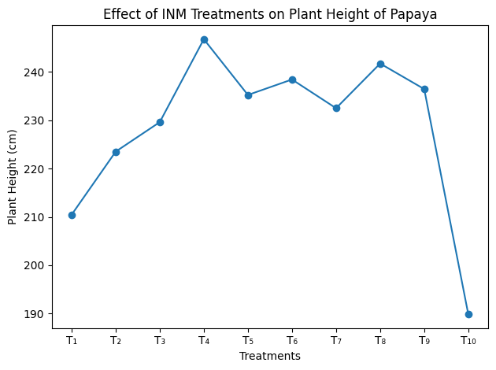
Fig. 1: Effect of Integrated Nutrient Management on plant height of Papaya cv. Red Lady

3.2 Effect on Yield and Yield Attributes
Integrated nutrient management exhibited a significant impact on yield parameters such as number of fruits per plant, average fruit weight, and total yield per plant (Table 2). The highest fruit yield (52.93 kg plant⁻¹) was recorded under T₄, followed by T₆ (48.76 kg plant⁻¹) and T₈ (47.85 kg plant⁻¹). The lowest yield was recorded in the absolute control (T₁₀) with only 21.34 kg plant⁻¹ (Fig.2).
The improved yield in T₄ may be attributed to the enhanced nutrient uptake and reproductive physiology mediated by PGPR inoculants, which promote efficient conversion of photosynthates into reproductive growth and fruit setting (Singh & Tripathi, 2020). PGPR species such as Pseudomonas fluorescens and Bacillus subtilis enhance nutrient cycling and produce siderophores that improve iron and phosphorus uptake, thereby enhancing fruit number and size (Bindu & Renjan, 2024). Similar findings were reported by several researchers who observed that integrating 75% RDF with microbial inoculants like Azospirillum and PSB enhanced papaya fruit yield and nutrient content. Kirad and Barche (2010) also confirmed that 75% RDF + 25% vermicompost + rhizosphere bacteria culture yielded higher fruit numbers and weights than full RDF alone, indicating improved nutrient use efficiency. The significant decline in yield under T₁₀ highlights the critical need for external nutrient supplementation in papaya cultivation.

Table 2. Effect of INM on Yield Attributes of Papaya cv. Red Lady
Treatment | No. of Fruits/Plant | Avg. Fruit Weight (g) | Total Yield (kg/Plant)
T₁ | 47.6 | 910.2 | 43.31
T₂ | 49.2 | 932.4 | 45.88
T₃ | 50.1 | 950.8 | 47.63
T₄ | 54.3 | 975.5 | 52.93
T₅ | 52.0 | 945.7 | 49.17
T₆ | 53.2 | 958.2 | 48.76
T₇ | 51.6 | 940.1 | 46.97
T₈ | 53.8 | 962.1 | 47.85
T₉ | 52.1 | 949.3 | 47.06
T₁₀ | 38.2 | 754.3 | 21.34
SEm ± | 0.88 | 11.45 | 0.92
CD (5%) | 1.76 | 23.10 | 1.84

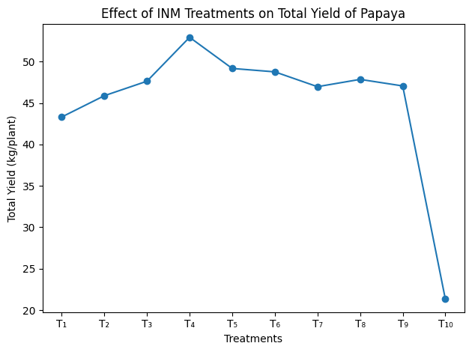
Fig. 2: Effect of INM on Yield A of Papaya cv. Red Lady

The higher yields under integrated nutrient systems suggest that microbial-enriched organics not only improve nutrient availability but also enhance soil microflora, leading to better pollination, fruit retention, and nutrient partitioning (Agrawal & Sahu, 2021). The improved organic matter under INM also enhances soil aggregation and moisture retention, which are critical for sustaining papaya yield under tropical conditions (Srivastava et al., 2019).

3.3 Effect on Fruit Quality Parameters
The quality of papaya fruits, expressed in terms of TSS, pulp percentage, ascorbic acid content, and titratable acidity, was significantly improved by integrated nutrient management (Table 3 and Fig. 3). The highest TSS (15.64° Brix) and pulp content (90.28%) were recorded in T₄, followed by T₆ and T₈. Titratable acidity was lowest (0.10%) in T₄, indicating improved sugar-acid balance, which directly contributes to consumer preference and marketability.
Enhanced fruit quality under INM is primarily due to improved nutrient balance and microbial activity, which promote better carbohydrate metabolism and accumulation of soluble solids in the fruit (Thomas, 2025). Organic amendments also provide secondary and micronutrients, improving vitamin and sugar synthesis. Similar improvements in quality traits have been reported by Agrawal and Sahu (2021) in papaya, where integrated systems improved sweetness, firmness, and shelf life.
These findings also agree with Chawla and Sadawarti (2020), who found that INM enhances enzymatic activities involved in sugar and ascorbic acid synthesis, improving fruit palatability and nutritional quality. The present findings align with the results of Singh and Tripathi (2022), who reported that RDF 75% + Azotobacter + PSB + vermicompost enhanced sugar accumulation and reduced fruit acidity in papaya.

Table 3. Effect of INM on Fruit Quality of Papaya cv. Red Lady
Treatment | TSS (°Brix) | Pulp (%) | Ascorbic Acid (mg/100 g) | Titratable Acidity (%)
T₁ | 13.42 | 86.42 | 61.2 | 0.15
T₂ | 14.15 | 88.10 | 65.4 | 0.13
T₃ | 14.36 | 88.64 | 66.1 | 0.12
T₄ | 15.64 | 90.28 | 69.8 | 0.10
T₅ | 14.72 | 89.35 | 68.2 | 0.11
T₆ | 15.10 | 89.60 | 68.5 | 0.11
T₇ | 14.48 | 88.83 | 67.2 | 0.12
T₈ | 15.22 | 89.84 | 68.8 | 0.11
T₉ | 14.91 | 89.22 | 67.7 | 0.12
T₁₀ | 11.35 | 84.11 | 58.3 | 0.18
SEm ± | 0.21 | 0.64 | 0.92 | 0.006
CD (5%) | 0.42 | 1.28 | 1.85 | 0.012

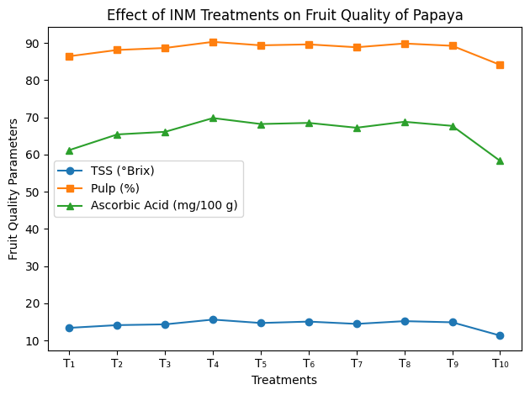
Fig. 3: Effect of INM on Fruit Quality of Papaya cv. Red Lady

3.4 Post-Harvest Soil Fertility and Sustainability
Post-harvest soil analysis indicated that the integrated nutrient management practices markedly improved soil fertility status (Table 4 and Fig. 4). Organic carbon, available nitrogen, phosphorus, and potassium increased significantly under INM treatments compared to full RDF and the control. The maximum organic carbon (0.57%) and available N (298 kg ha⁻¹) were recorded under T₈, while T₆ and T₄ followed closely.
This improvement may be attributed to the cumulative effect of organic inputs and microbial inoculants that facilitate mineralization, humus formation, and nutrient retention. The presence of organic residues enhances cation exchange capacity (CEC), improving nutrient holding and reducing losses (Srivastava et al., 2019). According to recent study INM treatments involving PSB, Azotobacter, and Azospirillum improved soil microbial activity and nutrient availability while maintaining soil pH within the optimal range. Similar improvements in soil organic matter and nutrient status have been reported in other fruit crops such as mango and citrus under INM regimes (Chaurasia et al., 2025).

Table 4: Effect of INM on Post-Harvest Soil Fertility of Papaya cv. Red Lady
Treatment | Organic Carbon (%) | Available N (kg/ha) | Available P (kg/ha) | Available K (kg/ha)
T₁ | 0.41 | 260 | 19 | 185
T₂ | 0.46 | 273 | 22 | 198
T₃ | 0.48 | 276 | 23 | 201
T₄ | 0.53 | 291 | 27 | 218
T₅ | 0.49 | 279 | 24 | 204
T₆ | 0.55 | 294 | 26 | 213
T₇ | 0.51 | 281 | 25 | 208
T₈ | 0.57 | 298 | 28 | 220
T₉ | 0.52 | 282 | 25 | 209
T₁₀ | 0.36 | 241 | 16 | 170
SEm ± | 0.015 | 3.85 | 0.72 | 4.65
CD (5%) | 0.031 | 7.70 | 1.45 | 9.30

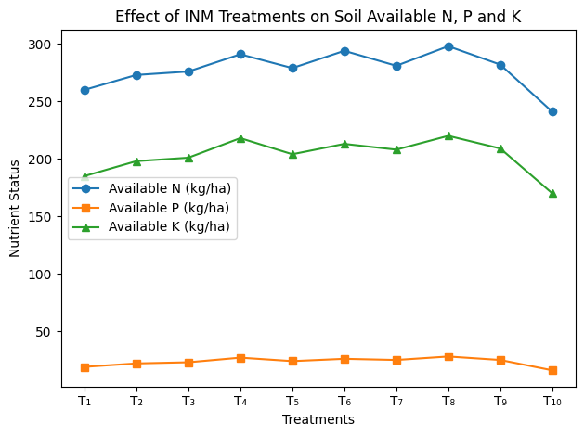
Fig. 4: Effect of INM on Post-Harvest Soil Fertility of Papaya cv. Red Lady

These results indicate that organic and microbial sources not only supply nutrients but also improve soil structure and biological health, ensuring sustainable fertility restoration (Zala et al., 2024). The combination of vermicompost and biofertilizers fosters a dynamic soil microbial ecosystem that supports long-term productivity.

The study clearly demonstrates that the partial substitution (25–50%) of chemical fertilizers with bio-enriched vermicompost significantly improves plant growth, yield, fruit quality, and soil health. Among all treatments, T₄ (PGPR mix-1 enriched vermicompost + 75% RDF) proved most effective, producing superior vegetative growth, fruit yield (52.93 kg/plant), and quality (15.64°Brix, 90.28% pulp). Treatments T₆ and T₈, with higher organic substitution levels, improved soil fertility and microbial activity, though yields were marginally lower than T₄. The integration of organic and biofertilizer components enhances nutrient-use efficiency, reduces chemical load, and promotes sustainable production a finding consistent with long-term studies on INM across various fruit crops (Srivastava et al., 2019; Bindu & Renjan, 2024). The integration of microbial-enriched vermicompost with reduced chemical fertilizers significantly improved growth, yield, fruit quality, and soil fertility of papaya. Among all treatments, T₄ emerged as the best-performing treatment, balancing high productivity with soil sustainability. Therefore, the adoption of 75% RDF + 25% bio-enriched vermicompost can be recommended for papaya growers in Telangana to achieve higher yields with improved soil health and fruit quality, ensuring long-term ecological and economic sustainability.

4. CONCLUSION
The present study conclusively demonstrated that integrated nutrient management (INM) significantly enhances growth, yield, fruit quality, and soil fertility of papaya (Carica papaya L.) cv. Red Lady under lateritic soil conditions of Central Telangana. Among the evaluated treatments, the application of 25% NPK through PGPR mix-1 enriched vermicompost combined with 75% of the recommended dose of fertilizers (T₄) proved most effective, resulting in superior vegetative growth, maximum fruit yield, improved fruit quality attributes such as higher total soluble solids, pulp percentage, and ascorbic acid content, along with reduced acidity. This treatment also maintained favorable soil nutrient status, indicating improved nutrient-use efficiency and sustainability. Treatments involving higher substitution of chemical fertilizers with organic sources further enhanced soil organic carbon and nutrient availability, highlighting the long-term benefits of organic and microbial inputs for soil health restoration. The findings emphasize that partial replacement of chemical fertilizers with bio-enriched organic amendments can reduce dependence on synthetic inputs without compromising productivity. From a future perspective, the adoption of INM practices offers a viable pathway for sustainable papaya cultivation in semi-arid and nutrient-deficient regions. Long-term studies focusing on soil biological dynamics, carbon sequestration, and economic analysis across multiple cropping cycles are recommended to further validate and refine INM-based nutrient strategies for tropical fruit production systems.
.

DISCLAIMER (ARTIFICIAL INTELLIGENCE)
Author(s) hereby declare that NO generative AI technologies such as Large Language Models (ChatGPT, COPILOT, etc.) and text-to-image generators have been used during the writing or editing of this manuscript.

REFERENCES
- Agrawal, B., & Sahu, G. D. (2021). Effect of organic manure and bio-fertilizer on growth and yield of papaya (Carica papaya L.) cv. red lady. Int. J. Fauna Biol. Stud, 8, 91-93. https://doi.org/10.22271/23940522.2021.v8.i1b.798
- Bindu, B., & Renjan, B. (2024). Integrated nutrient management of papaya (Carica papaya L.): Application of microbial consortium enriched organic manures for yield and fruit quality enhancement. International Journal of Plant & Soil Science, 36(8), 187-195. https://doi.org/10.9734/ijpss/2024/v36i84849
- Chaurasia, J., Tripathi, V. K., Pandey, S., Kumar, A., & Tripathi, R. (2025). Examining the Impact of Integrated Fertility Management in Fruit Crops: A Literature Review. Journal of Scientific Research and Reports, 31(1), 260-278. https://doi.org/10.9734/jsrr/2025/v31i12766
- Chawla, R., & Sadawarti, R. K. (2020). Effect of Integrated Nutrient Management on Vegetative Growth, Fruit Yield and Quality of Fruit Crops. Int. J. Curr. Microbiol. App. Sci, 9(10), 2222-2235. https://doi.org/10.20546/ijcmas.2020.910.269
- Dwivedi, V., & Agnihotri, S. (2018). Effect of integrated nutrient management on growth, yield and economics of guava (Psidium guajava L.) cv. Allahabad Safeda. International Journal of Current Microbiology and Applied Sciences, 7(6), 3449-3453. https://doi.org/10.20546/ijcmas.2018.706.404
- Manjunath, B. L., Gutam, S., & Raghupathi, H. B. (2023). Standardisation of fertigation in papaya for higher productivity and profitability. Journal of Horticultural Sciences, 18(1), 104-112. https://doi.org/10.24154/jhs.v18i1.2133
- Mukherjee, A. K., Tripathi, S., Mukherjee, S., Mallick, R. B., & Banerjee, A. (2019). Effect of integrated nutrient management in sunflower (Helianthus annuus L.) on alluvial soil. Current Science, 117(8), 1364-1368. https://doi.org/10.18520/cs/v117/i8/1364-1368
- Silva, R. V. D., Rodrigues, L. A., Silva, M. G. D., Silva, B. G. D., & Martins, M. A. (2019). Biochar and mucuna increase papaya plant growth and nutrition, as well as soil fertility. Pesquisa Agropecuária Tropical, 49, e55210. https://doi.org/10.1590/1983-40632019v4955210
- Singh, A., & Tripathi, V. K. (2020). Influence of integrated nutrient management on growth, yield and quality parameters of papaya (Carica papaya L.). Journal of Pharmacognosy and Phytochemistry, 9(5), 2022–2026. https://doi.org/10.22271/phyto.2020.v9.i5ab.12639
- Srivastava, A. K., Paithankar, D. H., Venkataramana, K. T., Hazarika, B., & Patil, P. (2019). INM in fruit crops: Sustaining quality production and soil health. The Indian Journal of Agricultural Sciences, 89(3), 379-395. https://doi.org/10.56093/ijas.v89i3.87577
- Zala, D. A., Dadarwal, R. S., Jat, R. D., Prakash, R., & Asif, M. (2024). Optimizing Integrated Nutrient Management (INM) for Enhanced Growth and Yield of Chickpea (Cicer arietinum L.) Under Irrigated Conditions. Journal of Experimental Agriculture International, 46(12), 872-881. https://doi.org/10.9734/jeai/2024/v46i123196
- Babalola, B. A., Akinwande, A. I., Otunba, A. A., Adebami, G. E., Babalola, O., & Nwufo, C. (2024). Therapeutic benefits of Carica papaya: A review on its pharmacological activities and characterization of papain. Arabian Journal of Chemistry, 17(1), 105369. https://doi.org/10.1016/j.arabjc.2023.105369
- Kumari, S., Kumar, R., Chouhan, S., & Chaudhary, P. L. (2023). Influence of various organic amendments on growth and yield attributes of mung bean (Vigna radiata L.). International Journal of Plant & Soil Science, 35(12), 124-30. https://doi.org/10.9734/IJPSS/2023/v35i122975
- Smita, K., Dhamni, P., Shivani, Khushboo, S., Chandan, K. P., Rama, D. B., … Ajaz, A. L. (2025). Influence of various organic amendments on yield, nutrient uptake and protein content of mung bean (Vigna radiata L.). Plant Science Today, 12(sp4), 01-16. https://doi.org/10.14719/pst.10607

