In vitro Evaluation of Fungicides, Botanicals and Bio-control agents against Stagonosporopsis cucurbitacearum Causing Gummy Stem Blight
Abstract
Gummy Stem Blight (GSB), caused by Stagonosporopsis cucurbitacearum, is a highly destructive disease of cucurbitaceous crops such as cucumber, melon, bitter gourd and ridge gourd, leading to substantial yield losses under favorable conditions. The present investigation was carried out at Horticultural Research Station, Anantharajupeta, YSR, Kadapa district, Andhra Pradesh, during 2020-21. The study aimed to evaluate the in vitro efficacy of selected synthetic fungicides, plant-based botanicals and bioagents against Stagonosporopsis cucurbitacearum. Seven fungicides were tested at concentrations ranging from 50 to 750 ppm using the poisoned food technique. Mancozeb recorded the highest mean mycelial growth inhibition (77.17%) and complete inhibition at 500 and 750 ppm respectively. Among six botanicals evaluated at 5%, 10% and 15% concentrations, Azadirachta indica (neem) exhibited the greatest antifungal activity, with 93.70% inhibition at 15%. In dual culture assays, Trichoderma harzianum demonstrated the strongest antagonism against the pathogen (98.05%), followed by T. viride (93.33%). The findings underscore the potential of integrating chemical, botanical and biological components into an Integrated Disease Management (IDM) framework for sustainable and environmentally sound control of GSB in cucurbit crops.
Keywords: Gummy Stem Blight, Stagonosporopsis cucurbitacearum, fungicides, botanicals and bioagents
Introduction
Cucurbitaceous vegetables, which include ridge gourd (Luffa acutangula), bitter gourd (Momordica charantia), melon (Cucumis melo), and cucumber (Cucumis sativus), are a significant class of horticultural crops grown all over the world for their nutritional and commercial importance. However, Gummy Stem Blight (GSB), a devastating disease mainly caused by Stagonosporopsis cucurbitacearum (syn. Didymella bryoniae, anamorph: Phoma cucurbitacearum) and closely related Stagonosporopsis species, severely limits their productivity (Keinath et al., 2021; Santos et al., 2021). Particularly in warm, humid climates, the pathogen can cause stem cankers, leaf necrosis, fruit rot, vine withering and ultimately plant collapse by infecting several plant parts, including leaves, stems, and fruits (Rennberger and Keinath, 2018; Keinath, 2017). The pathogen has been widely reported across tropical, subtropical, and temperate regions, and is known to infect a broad range of cucurbit hosts, causing stem cankers, leaf necrosis, fruit rot, and ultimately leading to vine collapse (Garampalli et al., 2016). First identified in France in 1891, the disease has since been documented in many countries, including the USA, UK, Japan, Germany and India, with yield losses ranging from 17% - 43% under severe epidemics (Keinath and Duthie, 1998).

Synthetic fungicides, which offer quick disease suppression, have historically been used to control gummy stem blight (GSB) (Keinath, 2025). However, the pathogen has developed resistance to many of the fungicides used for its control (Stevenson et al., 2004, Thomas et al., 2012). Consequently, integrated disease management (IDM) strategies are becoming more significant. To achieve efficient and eco-friendly disease management, these methods combine the prudent application of fungicides with botanicals and biological control agents (Wackett, 2013; Gava and Pinto, 2016). The current study assessed the effectiveness of a few fungicides, botanicals derived from plants, and bioagents against Stagonosporopsis cucurbitacearum in vitro.
Material and methods
Fungicides
“A total of seven different fungicides at five different concentrations (50ppm, 100ppm, 250ppm, 500ppm and 750ppm) and five different botanicals at three different concentrations 5%, 10% and 15% were evaluated against Stagonosporopsis cucurbitacearum using poisoned food technique” (Grower and Moore, 1962) under in vitro. In this technique, test pathogen was inoculated on the medium containing test chemical. “PDA was used as a basal medium. Appropriate quantity of fungicidal and botanical suspensions of different concentrations were prepared aseptically in 100 ml of PDA in 250 ml flasks by dissolving requisite quantities of each fungicide and botanical in warm sterilized PDA media. Flask containing media without fungicide or botanical was used as control. About 20 ml of sterilized media was poured in each 9 cm sterilized Petri dish. After solidification of media, the plates were aseptically inoculated with 5 mm mycelial disc, cut from the periphery of 7 days old culture of fungi with the help of sterilized cork borer and then placed at the centre of poisoned PDA. Suitable control was maintained simultaneously by growing the fungus on chemical free PDA. Three replications were used for each concentration of all fungicides. The petri plates were incubated at 25±1°C and the observations on mycelial growth of test fungus were recorded after full growth of the pathogen in the control plate. Per cent inhibition of radial growth of fungus due to different fungitoxicant treatments at different concentrations were computed” using the following formula given by Vincent (1947).
Bioagents
“Bioagents were evaluated for their antagonism against the pathogen through dual culture technique. Sterilized PDA media (15 to 20 ml) was poured aseptically into sterilized petri dishes. Mycelial disc of 5 mm diameter of the pathogen from seven days old culture was placed on one side of the plate” (Skidmore and Dickson, 1976) and then 5 mm mycelial disc of fungal bioagent was placed on other side of the plate four centimetres away from the pathogen. “For bacteria, a line of streak was done on the other edge of Petri dish” (Utkhede and Rahe, 1983). For each isolate three replications were maintained. Plate with pathogen alone was served as control. The plates were incubated at room temperature for seven days and observed daily until the control exhibits full growth of the pathogen.
The percent of inhibition of the pathogen will be calculated using the formula Vincent (1947)
$$Percent inhibition \left(PI\right)=C-T\backslash C×100$$
PI = Per cent inhibition
C = Growth of the pathogen in control (mm)
T = Growth of the pathogen in dual culture (mm)
Results and discussion
Fungicides
Seven fungicides chlorothalonil, mancozeb, hexaconazole, copper oxychloride, azoxystrobin, thiophanate-methyl, and propineb were evaluated in vitro for their inhibitory effects on Stagonosporopsis cucurbitacearum over a range of concentrations (50ppm, 100ppm, 250ppm, 500ppm, 750ppm). All fungicides significantly reduced the mycelial growth of the pathogen, with inhibition generally increasing as concentration increased (Table 1; Figure 1).
Among the fungicides tested, Chlorothalonil was the least effective, with the lowest recorded inhibition (29.32%) at 50 ppm and a mean inhibition of 35.48%, indicating limited suppressive effect on pathogen growth at the tested doses. Intermediate inhibition levels were observed for hexaconazole, copper oxychloride, and thiophanate-methyl, indicating moderate inhibitory capacity that increased with concentration. Mancozeb exhibited the highest overall mean inhibition (77.17%), demonstrating strong antifungal activity even at lower concentrations and complete inhibition at 500 ppm and 750 ppm. Propineb and azoxystrobin also performed effectively, with propineb achieving total suppression at 750 ppm and azoxystrobin showing very high inhibition (96.13%) at the same concentration. These results suggest broad efficacy of these agents against GSB.
Several researchers have reported the effectiveness of chemical fungicides in the management of gummy stem blight in cucurbits (Lo, 2010; Yang, 2011). The results of the present investigation are in close conformity with earlier studies, which identified mancozeb as one of the most effective fungicides against Stagonosporopsis cucurbitacearum (Hopkins, 2002; Bharath et al., 2005; Mangala et al., 2018).
“The effectiveness of fungicides in suppressing pathogenic fungi is partly attributed to their ability to stimulate the production of phenolic compounds in plants. These phenolic compounds play a defensive role by inhibiting the activity of fungal cell wall–degrading enzymes” (Mandavia et al., 1999). In the present study, the superior performance of mancozeb, azoxystrobin is consistent with the findings of Utkhede and Koch (2004) and Rahman et al. (2019), (Savitha and Garampalli, 2022) in reducing infections caused by Stagonosporopsis cucurbitacearum. Strobilurin fungicides are known for their broad-spectrum activity against all major groups of plant pathogenic fungi (Ypema and Gold, 1999). These fungicides act in a site-specific manner by disrupting mitochondrial respiration through inhibition of electron transfer in the bc₁ complex. The combined action of these mechanisms explains the superior control of the pathogen observed in this study, as supported by earlier reports (Balba, 2007; Rodrigues et al., 2013; Yuan et al., 2024).
Botanicals
Six plant extracts Eucalyptus globulus (Eucalyptus), Zingiber officinale (ginger), Allium sativum (garlic), Azadirachta indica (neem), Ocimum sanctum (tulsi), and Gliricidia sepium were evaluated at three concentrations (5%, 10%, and 15%) against Stagonosporopsis cucurbitacearum using the poisoned food technique. All the botanicals significantly inhibited the mycelial growth of the pathogen compared to the untreated control, with inhibition increasing proportionately with concentration (Table 2; Figure 2).
Among the plant extracts tested, eucalyptus extract was the least effective, showing the lowest inhibition (27.77%) at 5% concentration. While, neem leaf extract recorded the highest mean inhibition (78.51%), followed by garlic extract (68.88%), indicating strong antifungal potential. The maximum inhibition (93.70%) was observed with neem at 15% concentration, demonstrating its superior efficacy against the pathogen. Moderate inhibition was recorded with garlic, ginger, tulsi, and Gliricidia sepium. Overall, the results clearly indicate that higher concentrations of plant extracts were more effective in suppressing fungal growth, suggesting a dose-dependent antifungal activity.
The present study demonstrated that all tested plant extracts significantly inhibited the mycelial growth of Stagonosporopsis cucurbitacearum, with inhibition increasing with concentration, indicating a dose-dependent antifungal effect. Among the botanicals, eucalyptus extract showed lower efficacy, particularly at lower concentrations, which may be due to limited stability or availability of active compounds under in vitro conditions (Patel et al., 2021). In contrast, neem leaf extract showed the highest efficacy, followed by garlic extract, which is in agreement with earlier reports on their antifungal potential (Sangdee and Kawicha (2006) and Seixas et al. (2012). Recent studies have further confirmed that neem-derived compounds such as azadirachtin, quercetin, and β-sitosterol disrupt fungal cell membranes and metabolic processes, resulting in strong growth suppression (Bello et al., 2018).
The high inhibitory activity of garlic extract may be attributed to allicin, a sulfur-containing compound known to interfere with fungal enzyme systems and membrane integrity, as supported by recent findings (Borelli et al., 2020). Moderate inhibition observed with ginger, tulsi, and Gliricidia sepium is likely due to the presence of phenolics and flavonoids that affect fungal growth and induce defense responses (Shai et al., 2024).
Bioagents
Five bioagents, including three fungi (Trichoderma asperellum, Trichoderma viride, Trichoderma harzianum) and two bacteria (Bacillus subtilis, Pseudomonas fluorescens) were evaluated for their antagonistic effect against Stagonosporopsis cucurbitacearum. Per cent inhibition of mycelial growth ranged from 62.50% to 98.05%. P. fluorescens was the least effective (62.50%). While, T. harzianum showed the highest inhibition (98.05%), statistically on par with T. viride (93.33%) (Table 3; Figure 3).
Results obtained are in agreement with findings of Kaewkham et al. (2016), Patel et al. (2017), Nuangmek et al. (2021) Intana et al. (2022) reported that Trichoderma was best in exhibiting antagonistic action against Stagonosporopsis cucurbitacearum by performing coiling, vacuolization and penetration. Trichoderma sps. have been reported to exhibit antibiosis and secrete many antifungal compounds, cell wall degrading enzymes and compete for space and nutrients according to the findings of (Wonglom et al., 2019; Baiyee et al., 2019; Guzman Guzman et al. 2023; Tyagi et al. 2024). Pseudomonas sp. were reported to prevent pathogens by production of antibiotics, fungal cellwall lysing enzymes, hydrogen cyanide and siderophores as reported by (Raio and Puopolo, 2022; Dutta et al. 2022). Bacillus sps. have also been reported to produce antibiotic substances and lytic enzymes, which could directly inhibit pathogens according to Su et al. 2020; Zhang et al. (2023). The comparatively lower performance of P. fluorescens may be related to reduced antibiotic production or slower action under in vitro conditions.
Conclusion
The present study demonstrates that, seven fungicides were tested at concentrations ranging from 50 to 750 ppm using the poisoned food technique. Mancozeb recorded the highest mean mycelial growth inhibition (77.17%) and complete inhibition at 500 and 750 ppm. Among six botanicals evaluated at 5%, 10% and 15% concentrations, Azadirachta indica (neem) exhibited the greatest antifungal activity, with 93.70% inhibition at 15%. In dual culture assays, Trichoderma harzianum demonstrated the strongest antagonism against the pathogen (98.05%), followed by T. viride (93.33%). These results indicate strong potential for integrating chemical, botanical, and biological components in the management of gummy stem blight. Although this was a laboratory-based study, the findings provide a valuable scientific basis for further greenhouse and field evaluations, which will help in developing effective, economical and environmentally safe disease management strategies for cucurbit crops.
Disclaimer (Artificial Intelligence)
Author(s) hereby declare that NO generative AI technologies such as Large Language Models (ChatGPT, COPILOT, etc.) and text-to-image generators have been used during the writing or editing of this manuscript.
Acknowledgement
The authors immensely thank the Dean of Post Graduate Studies, for providing the necessary facilities to conduct the research. The author is also thankful to the Professor and Head, Department of Plant Pathology, Dr. YSRHU, Andhra Pradesh, for providing facilities throughout the research work and time required to pursue degree.
Competing interests
Authors have declared that no competing interests exist.
References
- Baiyee, B., Pornsuriya, C., Ito, S. I. and Sunpapao, A. (2019). Trichoderma spirale T76-1 displays biocontrol activity against leaf spot on lettuce (Lactuca sativa L.) caused by Corynespora cassiicola or Curvularia aeria. Biological Control, 129: 195–200.
- Balba, H. (2007). Review of strobilurin fungicide chemicals. Journal of Environmental Science and Health, 42: 441–451.
- Bello, M. G. D., Knight, R., Gilbert, J. A. and Blaser, M. J. (2018). Preserving microbial diversity. Science, 362(6410): 33–34.
- Bharath, B. G., Lokesh, S., Rai, V. R., Prakash, H. S., Yashovarma, B. and Shetty, H. S. (2005). Role of foliar spray in the infection biology and management of fungal diseases of watermelon (Citrullus lanatus). World Journal of Agricultural Sciences, 1(2): 105–108.
- Borelli, T., Hunter, D., Padulosi, S., Amaya, N., Meldrum, G., Beltrame, D. M. de O., Samarasinghe, G., Wasike, V. W., Güner, B., Tan, A., Dembélé, Y. K., Lochetti, G., Sidibé, A. and Tartanac, F. (2020). Local solutions for sustainable food systems: the contribution of orphan crops and wild edible species. Agronomy, 10(2): 231.
- Dutta, S., Yu, S. M. and Lee, Y. H. (2022). Assessment of the contribution of antagonistic secondary metabolites to the antifungal and biocontrol activities of Pseudomonas fluorescens NBC275. Plant Pathology Journal, 36: 491–496.
- Garampalli, R. H., Gopalkrishna, M. K., Li, H. X. and Brewer, M. T. (2016). Two Stagonosporopsis species identified as causal agents of gummy stem blight epidemics of gherkin cucumber (Cucumis sativus) in Karnataka, India. European Journal of Plant Pathology, 145: 507–512.
- Gava, C. A. T. and Pinto, J. M. (2016). Biocontrol of melon wilt caused by Fusarium oxysporum Schlect f. sp. melonis using seed treatment with Trichoderma spp. and liquid compost. Biological Control, 97: 13–20.
- Grower, R. K., & Moore, J. D. (1962). Toxicity of chemicals to fungi. Phytopathology, 52, 876–880.
- Guzmán-Guzmán, P., Kumar, A., de Los Santos-Villalobos, S., Parra-Cota, F. I., Orozco-Mosqueda, M. D. C., Fadiji, A. E. and Santoyo, G. (2023). Trichoderma species: our best fungal allies in the biocontrol of plant diseases—A review. Plants, 12(3): 432.
- Hopkins, D. L. (2002). Control of gummy stem blight of watermelon with plant defense activators combined with fungicides. Canadian Journal of Plant Pathology, 67: 125–127.
- Intana, W., Wonglom, P., Suwannarach, N. and Sunpapao, A. (2022). Trichoderma asperelloides PSU-P1 induced expression of pathogenesis-related protein genes against gummy stem blight of muskmelon (Cucumis melo) in field evaluation. Journal of Fungi, 8(4): 156–159.
- Kaewkham, T., Hynes, R. K. and Siri, B. (2016). The effect of accelerated seed aging on cucumber germination following seed treatment with fungicides and microbial biocontrol agents for managing gummy stem blight by Didymella bryoniae. Biocontrol Science and Technology, 26(8): 1048–1061.
- Keinath, A. P. (2017). Gummy stem blight. In: Keinath, A. P., Wintermantel, W. M. and Zitter, T. A. (Eds.), Compendium of Cucurbit Diseases and Pests, 2nd Edition. American Phytopathological Society Press, St. Paul, MN, pp. 59–60.
- Keinath, A. P. (2021). Premix fungicides that reduce development of fruiting bodies but not leaf lesions by Stagonosporopsis citrulli on watermelon leaves in the field. Plant Disease, 105(5): 1415–1421.
- Keinath, A. P. and Anco, D. J. (2025). Progression of gummy stem blight epidemics on watermelon with and without fungicide inputs. Plant Disease, 109(1): 132–137.
- Keinath, A. P. and Duthie, J. A. (1998). Yield and quality reductions in watermelon due to anthracnose, gummy stem blight, and black rot. In: Pandalai, S. G. (Ed.), Recent Research Developments in Plant Pathology, Vol. 2. Research Signpost, Trivandrum, India, pp. 77–90.
- Lo, C. C. (2010). Effect of pesticides on soil microbial community. Journal of Environmental Science and Health, Part B, 45: 348–359.
- Mandavia, M. K., Gajera, H. P., Andharia, J. H., Khandar, R. R. and Parameswaran, M. (1999). Cell wall degrading enzymes in host–pathogen interaction of Fusarium wilt of chickpea: inhibitory effect of phenolic compounds. Indian Phytopathology, 52: 285–288.
- Mangala, K., Gopalkrishna and Garampalli, R. H. (2018). Efficacy of fungicides and culture filtrate of native bioagents against Didymella bryoniae causing gummy stem blight disease in gherkin. International Journal of Pure and Applied Bioscience, 6(1): 1122–1132.
- Nuangmek, W., Aiduang, W., Kumla, J., Lumyong, S. and Suwannarach, N. (2021). Evaluation of a newly identified endophytic fungus, Trichoderma phayaoense for plant growth promotion and biological control of gummy stem blight and wilt of muskmelon. Frontiers in Microbiology, 12: 634772.
- Patel, D. R., Patel, R. M., Patel, P. H. and Dabhi, M. V. (2021). Evaluation of different botanicals against red pumpkin beetle, Aulacophora foveicollis Lucas infesting cucumber. International Journal of Current Microbiology and Applied Sciences, 10(02): 3133–3140.
- Patel, M. J., Solanki, V. A., Rakholia, K. B. and Khunt, M. D. (2017). Efficacy of biocontrol agents against Didymella bryoniae under field conditions. Trends in Biosciences, 10(40): 8547–8551.
- Rahman, M. Z., Khbria, M. G., Talukder, M. M. R., Akhter, M. S. and Amin, M. F. (2019). Evaluation of fungicides for control of gummy stem blight of watermelon caused by Didymella bryoniae. Journal of Plant Pathology, 35(1–2): 47–52.
- Raio, A. and Puopolo, G. (2022). Pseudomonas chlororaphis metabolites as biocontrol promoters of plant health and improved crop yield. World Journal of Microbiology and Biotechnology, 37: 99.
- Rennberger, G. and Keinath, A. P. (2018). Susceptibility of fourteen new cucurbit species to gummy stem blight caused by Stagonosporopsis citrulli under field conditions. Plant Disease, 102: 1365–1375.
- Rodrigues, E. T., Lopes, I. and Pardal, M. A. (2013). Occurrence, fate and effects of azoxystrobin in aquatic ecosystems: a review. Environment International, 53: 18–28.
- Sangdee, A. and Kawicha, P. (2006). Primary selection of essential oil from some medicinal plants to inhibit Didymella bryoniae, causal agent of gummy stem blight disease of watermelon. Khon Kaen Agriculture Journal, 34(3): 185–192.
- Santos, G. R. D., Tschoeke, P. H., Sarmento, R. A., Oliveira, E. E., Rodrigues-Silva, N., Dalcin, M. S., Haddi, K. and Silva, R. S. (2021). Impact of growing seasons and pesticides used on the occurrence and severity of gummy stem blight in melon cultivation in Brazil. Microbiology Spectrum, 161(1): 171–184.
- Savitha, R. S. and Garampalli, R. H. (2022). Identification and molecular characterization of Stagonosporopsis cucurbitacearum causing gummy stem blight disease on Coccinia grandis—a first report from Karnataka. Indian Journal of Advanced Scientific Research, 13(5): 70–78.
- Seixas, P. T. L., Castro, H. G., Cardoso, D. P., Chagas Junior, A. F. and Nascimento, I. R. (2012). Bioactivity of essential oils on the fungus Didymella bryoniae of cucumber. Brazilian Journal of Applied Technology for Agricultural Science, 5(3): 61–66.
- Shai, K. N., Chakale, M., Materechera, S. A., Amoo, S. O. and Aremu, A. O. (2024). Utilisation of botanicals for the management of pests and diseases affecting crops in sub-Saharan Africa: a review. Journal of Natural Pesticide Research, 4: 100066.
- Stevenson, K. L., Langston, D. B. Jr. and Seebold, K. W. (2004). Resistance to azoxystrobin in the gummy stem blight pathogen documented in Georgia. Plant Health Progress, 5(1): 1.
- Su, Y., Liu, C., Fang, H. and Zhang, D. (2020). Bacillus subtilis: a universal cell factory for industry, agriculture, biomaterials and medicine. Microbial Cell Factories, 19: 173.
- Thomas, A., Langston, D. B. Jr., Sanders, H. and Stevenson, K. L. (2012). Relationship between fungicide sensitivity and control of gummy stem blight of watermelon under field conditions. Plant Disease, 96(12): 1780–1784.
- Tyagi, A., Tamang, T. L., Kashtoh, H., Mir, R. A., Mir, Z. A., Manzoor, S. and Ali, S. (2024). A review on biocontrol agents as sustainable approach for crop disease management: applications, production and future perspectives. Horticulturae, 10(8): 805.
- Vincent, J. M. (1947). Distortion of fungal hyphae in the presence of inhibitors. Nature, 159, 850.
- Wackett, L. P. (2013). Microbial biocontrol agents. Microbial Biotechnology, 6: 443–444.
- Wonglom, P., Daengsuwan, W., Ito, S. I. and Sunpapao, A. (2019). Biological control of Sclerotium fruit rot of snake fruit and stem rot of lettuce by Trichoderma sp. T76-12 and the mechanisms involved. Physiological and Molecular Plant Pathology, 107: 1–7.
- Yang, C. (2011). Fungicide: modes of action and possible impact on non-target microorganisms. ISRN Ecology, 2011: 130289
- Ypema, H. L. and Gold, R. E. (1999). Kresoxim methyl: modification of a naturally occurring compound to produce a new fungicide. Plant Disease, 83: 4–17.
- Yuan, C., Zhang, T., Tian, J., Deng, T., Xin, H., Liu, Y. and Xue, W. (2024). A potential antifungal agent: insight into the antifungal mechanism against Phomopsis sp. Arabian Journal of Chemistry, 17(1): 105480.
- Zhang, N., Wang, Z., Shao, J., Xu, Z., Liu, Y., Xun, W., Miao, Y., Shen, Q. and Zhang, R. (2023). Biocontrol mechanisms of Bacillus: improving the efficiency of green agriculture. Microbial Biotechnology, 16: 2250–2263.

Table 1. In vitro efficacy of fungicides against Stagonosporopsis cucurbitacearum
Treatments | 50 ppm |  | 100 ppm |  | 250ppm |  | 500 ppm |  | 750 ppm |  | Mean % inhibition | Mean  Growth(mm)
Treatments | Growth (%) | Inhibition (%) | Growth (%) | Inhibition (%) | Growth (%) | Inhibition (%) | Growth (%) | Inhibition (%) | Growth (%) | Inhibition (%) | Mean % inhibition | Mean  Growth(mm)
Chlorothalonil | 63.61  (52.9) | 29.32  (32.78) | 61.94 (51.91) | 31.17  (33.94) | 57.69 (49.42) | 35.90  (36.80) | 57.10 (49.08) | 36.55  (37.20) | 49.99 (44.99) | 44.45  (41.81) | 35.48  (36.56) | 58.07  (49.66)
Mancozeb | 45.41 (42.37) | 49.54  (44.73) | 40.38 (39.45) | 55.13  (47.94) | 16.92 (24.29) | 81.20  (64.31) | 0 .00  (0) | 100  (90.00) | 0.00  (0) | 100  (90.00) | 77.17  (72.23) | 20.54  (21.22)
Hexaconazole | 32.21 (34.58) | 64.21  (53.26) | 31.16 (33.93) | 65.37  (53.95) | 29.73 (33.04) | 66.96  (54.92) | 29.56 (32.94) | 67.15  (55.03) | 8.36 (16.81) | 90.71  (72.27) | 70.88  (57.34) | 26.20  (30.26)
Copper oxy chloride | 59.83 (50.67) | 33.52  (35.35) | 58.77 (50.05) | 34.70  (36.08) | 58.32 (49.79) | 35.20  (36.38) | 57.62 (49.38) | 35.97  (36.85) | 54.89 (47.81) | 39.01  (38.64) | 35.68  (36.68) | 57.89  (49.54)
Azoxystrobin | 43.83 (41.46) | 51.30  (45.74) | 43.13 (41.05) | 52.07  (46.18) | 21.38 (27.54) | 76.24  (60.84) | 14.52 (22.4) | 83.86  (66.36) | 3.48 (10.75) | 96.13  (78.66) | 71.92  (58.00) | 25.27  (28.64)
Thiophanate methyl | 59.36 (50.39) | 34.04  (35.66) | 42.94 (40.94) | 52.28  (46.31) | 38.20 (38.17) | 57.55  (49.35) | 38.12 (38.13) | 57.64  (49.40) | 33.56 (35.4) | 62.71  (52.38) | 52.84  (46.63) | 42.44  (40.61)
Propineb | 46.97 (43.26) | 47.81  (43.74) | 35.14 (36.36) | 60.95  (51.32) | 32.36 (34.67) | 64.04  (53.16) | 5.69 (13.8) | 93.67  (75.47) | 0.00 (0) | 100  (90.00) | 73.29  (58.80) | 24.03  (25.62)
Mean | - | 38.71  (38.71) | - | 43.96  (41.53) | - | 52.13  (46.22) | - | 59.35  (50.39) | - | 66.62  (54.71) | - | -
Factors | CD at 5 % |  |  |  |  | SE m
Factor (A) | 1.343 |  |  |  |  | 0.476
Factor (B) | 1.061 |  |  |  |  | 0.376
Factor (A×B) | 3.002 |  |  |  |  | 1.065
*Figures in parentheses are arc sine transformed values

Table 2. In vitro efficacy of botanicals against Stagonosporopsis cucurbitacearum
Treatments | 5 % concentration |  |  | 10 % concentration |  | 15% concentration |  | Mean% inhibition | Mean Growth (%)
Treatments | Growth (%) | Inhibition (%) |  | Growth (%) | Inhibition (%) | Growth (%) | Inhibition (%) | Mean% inhibition | Mean Growth (%)
Eucalyptus | 65.00 (53.73)* | 27.77  (31.80) |  | 47.66 (43.66) | 47.03  (43.30) | 29.66 (33) | 67.03  (54.96) | 47.28  (43.44) | 47.44  (43.46)
Ginger | 50.33 (45.19) | 44.07  (41.59) |  | 35.33 (36.47) | 60.74  (51.20) | 31.33 (34.04) | 65.18  (53.84) | 56.66  (48.83) | 39.00  (38.57)
Garlic | 48.00  (43.85) | 46.66  (43.08) |  | 26  (30.66) | 71.11  (57.49) | 10.00  (18.43) | 88.88  (70.54) | 68.88  (56.09) | 28.00  (30.98)
Neem | 34.33 (35.87) | 61.85  (51.85) |  | 18.00 (25.1) | 80.00  (63.44) | 5.66 (13.76) | 93.70  (75.48) | 78.51  (62.38) | 19.33  (24.91)
Tulasi | 36.33 (37.07) | 59.63  (50.55) |  | 33.33 (35.26) | 62.96  (52.51) | 31.33 (34.04) | 65.18  (53.84) | 62.59  (52.29) | 33.66  (35.46)
Glyricidia | 51.33 (45.76) | 42.96  (40.95) |  | 48.33 (44.04) | 46.29  (42.87) | 26.66 (31.09) | 70.37  (57.02) | 53.21  (46.84) | 42.11  (40.3)
Mean B | - | 40.42  (36.89) |  | - | 52.59  (46.52) | - | 64.33  (58.25) | -
Factors | CD at 5 % |  | SE m
Factor (A) | 0.732 |  | 0.255
Factor (B) | 0.479 |  | 0.167
Factor (A×B) | 1.267 |  | 0.442
*Figures in parentheses are arc sine transformed values

Table 3. In vitro efficacy of bioagents against Stagonosporopsis cucurbitacearum
S. No. | Bioagents | Mean radial growth of pathogen (mm) | Per cent inhibition
1. | Trichoderma asperellum | 18.75 | 79.16  (62.84)*
2. | Trichoderma viride | 6 | 93.33  (75.16)
3. | Trichoderma harzianum | 1.75 | 98.05  (82.20)
4. | Bacillus subtilis | 19 | 78.88  (62.72)
5. | Pseudomonas fluorescens | 33.75 | 62.50  (52.24)
6. | Control | 90
 | SE m | 1.033
 | C.D. at 5% | 3.094
*Figures in parentheses are arc sine transformed values

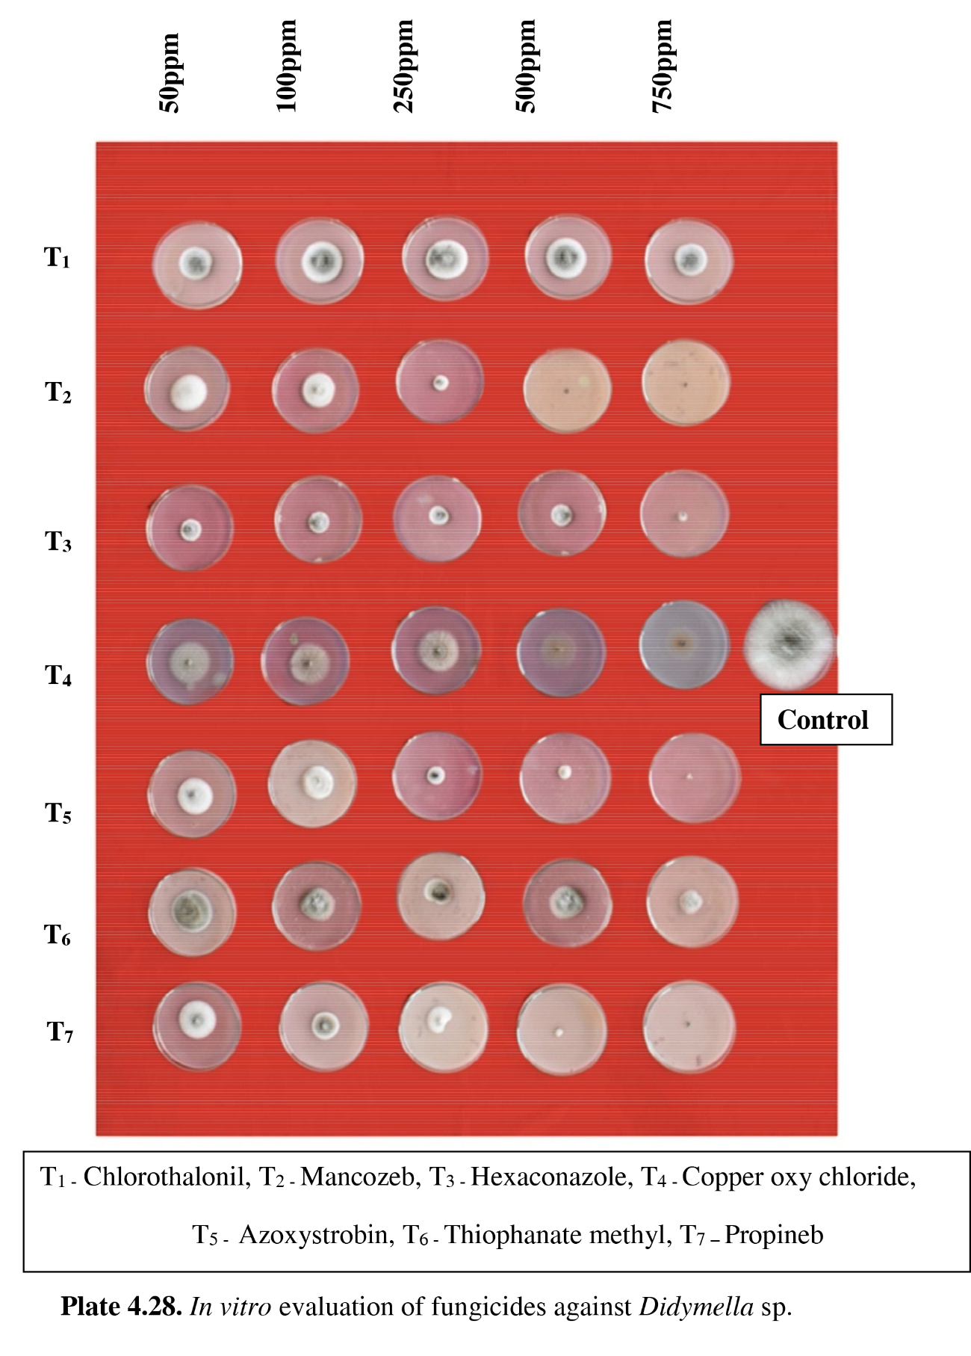
Figure 1. In vitro evaluation of fungicides against Stagonosporopsis cucurbitacearum

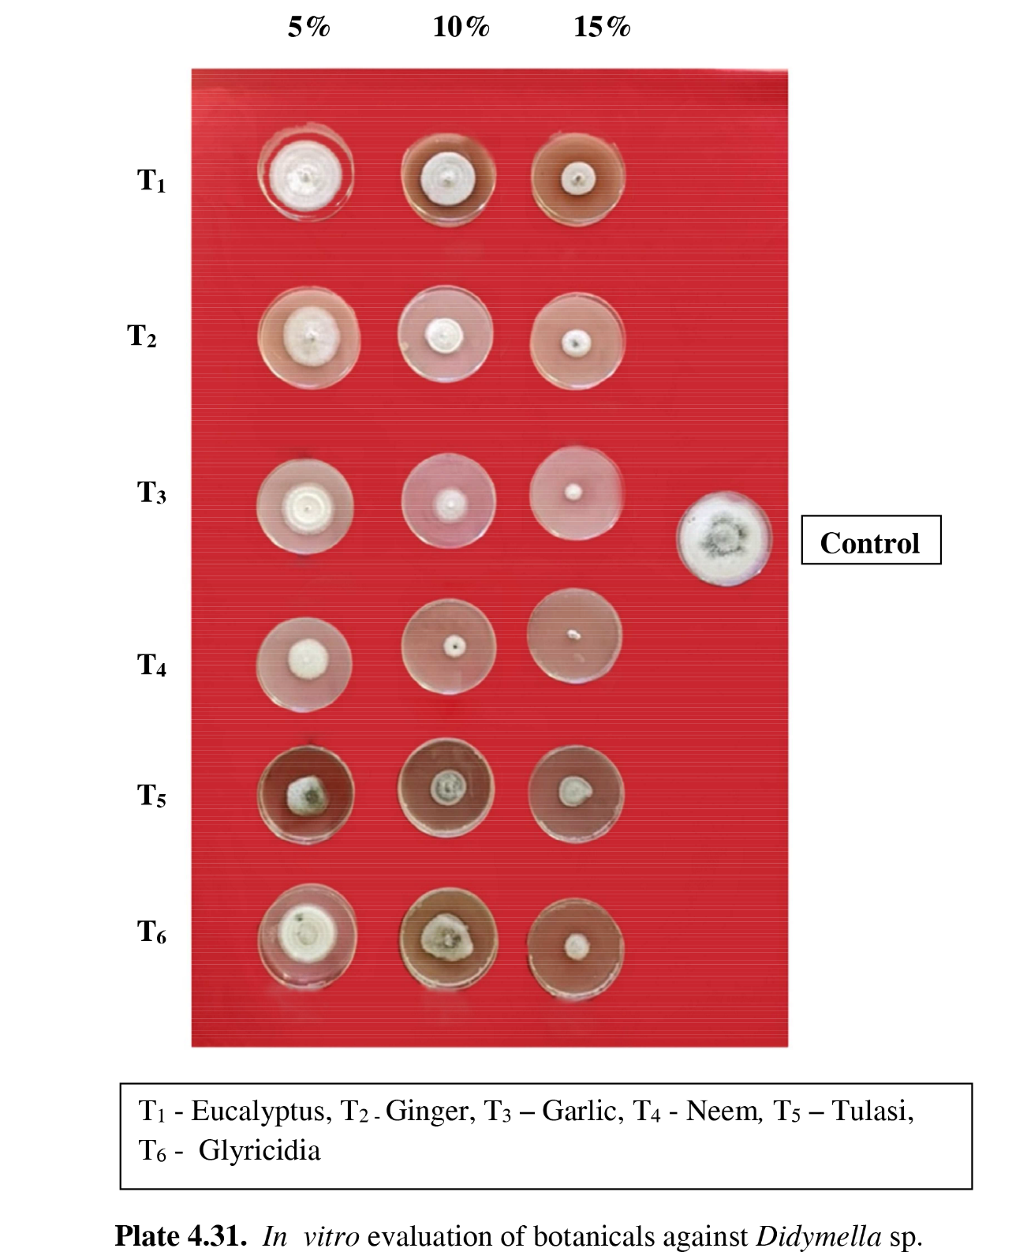
Figure 2. In vitro evaluation of botanicals against Stagonosporopsis cucurbitacearum

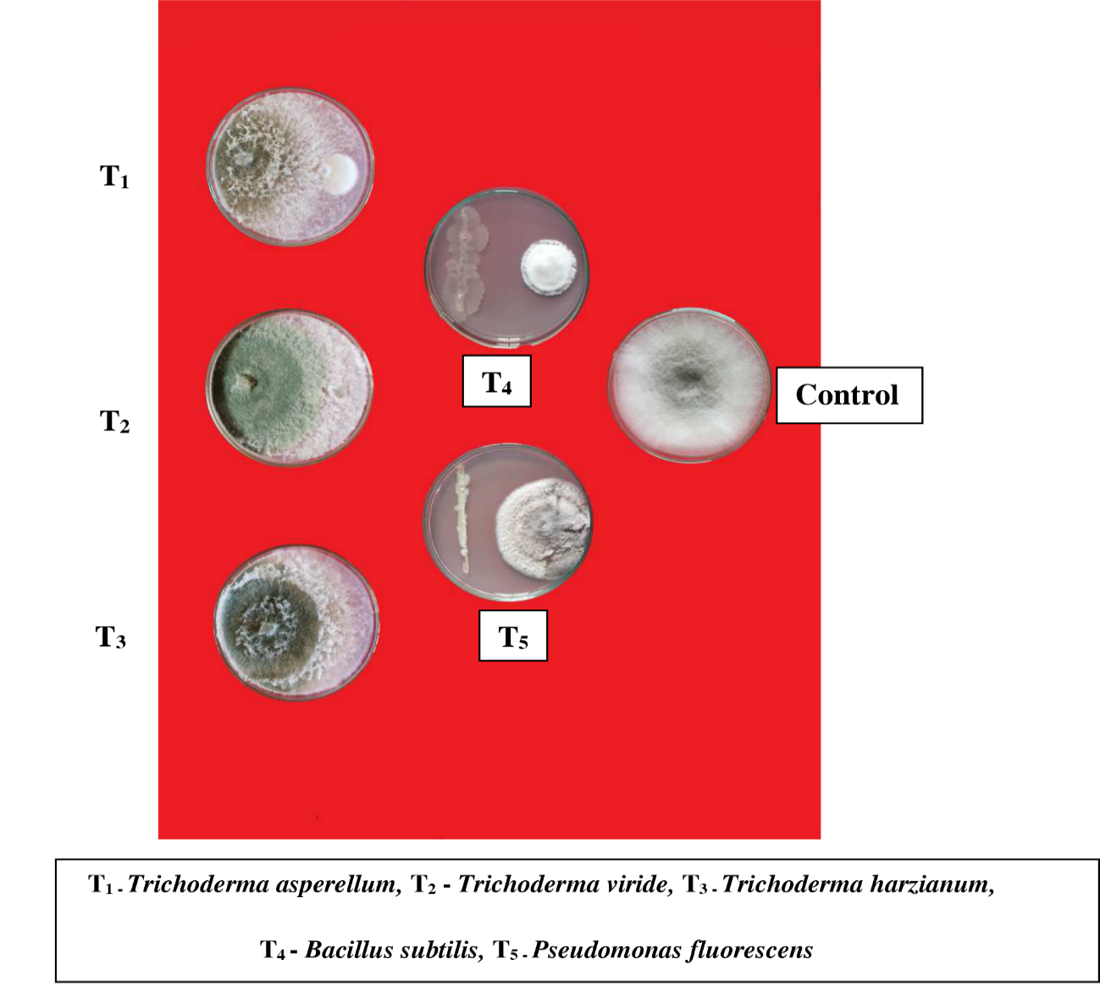
Figure 3. In vitro evaluation of bioagents against Stagonosporopsis cucurbitacearum

