Evaluation of Roselle (Hibiscus sabdariffa L) Genotypes for High
Yield and Earliness under Northeast Indian Conditions

ABSTRACT
Roselle (Hibiscus sabdariffa L.), belonging to Malvaceae family, is an erect, bushy, herbaceous sub-shrub where tender leaves and fruits known as calyces are used as vegetable and also converted into value added products. Eight roselle selections including two commonly grown checks i.e. one improved variety, JorRS 09-01 (SC) and one local cultivar (LC) used as checks were evaluated for their performance and variability at the Horticulture Experimental Farm of Assam Agricultural University, Jorhat consecutively for three years. All recommended practices were followed to raise the crop. The best performing selection and two checks were tested in multilocation trials at different Research Stations and KVKs representing three zones of Assam viz. NBPZ, LBVZ and HZ. The investigation revealed that the genotype, JorRS10-02 exhibited the significantly highest average leaf yield of 168 q/ha and fruit yield of 200 q/ha. There was an increase in yield of leaf and fruit by 8.2% and 19.6% respectively over the best check variety (SC). The leaves became ready for picking at 45 - 50 days and fruits at 100-110 days after planting. The consumer preference for JorRS 10-02 was more than the check varieties and was suitable for processing purpose. The leaves of this variety were green and fruits were red in colour. The variety was around 25 – 30 days earlier in picking of leaves and fruits for culinary purpose. The variety was suitable as leafy vegetable and for processing purpose. Similar performance had been recorded in MLTs, which was later confirmed in the OFTs conducted in farmers’ fields of 4 different districts. Based on the performance in yield and consumer preference JorRS 10-02 might be recommended for release in the state of Assam and North Eastern Region. However, there is a vast scope for quality improvement of these genotypes through an appropriate breeding program.
Keywords: Roselle, Hibiscus sabdariffa, Variety, JorRS 10-02, Yield, Earliness.

1. INTRODUCTION
Roselle (Hibiscus sabdariffa L) is an underutilized and underexploited annual vegetable as well as fiber crop. The tetraploid species of roselle is having chromosome number 2n=4x=72. It belongs to the family Malvaceae and genus Hibiscus. The genus is generally consisted of more than 300 species. Based on growth habit or end use, cultivated roselle is mainly classified into two types namely Hibiscus sabdariffa var. sabdariffa and Hibiscus sabdariffa var. altissimia. The first type is mainly grown for edible calyx and second type is grown for fiber production [21]. The close relatives of Hibiscus sabdariffa L. are Abelmoscus esculentus i.e. okra and Hibiscus cannabinus which is commonly known as Kenaf. It is believed to have originated in West Africa from where it was introduced to India and other parts of the world. It is commonly known as Mesta, Red sorrel, White sorrel, Jelly okra, Red zinger etc. Locally roselle is known by many names in different languages such as Patwa in Hindi, Tengamora in Assamese, Pundibija in Kannada, and Mandharam in Tamil [19].
The crop of roselle is mainly cultivated in tropical and subtropical regions [15]. The largest producers and exporters of roselle are China and Thailand. Sudan’s roselle quality is said to be the best within the world but their export quantity is very less. In India, roselle is mainly grown in Andhra Pradesh, West Bengal, Odisha, Tamil Nadu, Karnataka, Maharastra and Northeast (NE) India. In NE India, roselle is grown as a home garden crop. It is mainly grown for its red acidic succulent calyces which can be used for making jam, jelly, syrup, ice-cream, cake etc. The red colour of roselle calyces makes it a popular ingredient of a commercial beverage, soft drinks and herbal tea. It is a rich source of natural dye. Leaves and calyces are also used for culinary purpose. Roselle has been regarded as a rich medicinal source. Roselle tea is also very rich in vitamin C, minerals and various antioxidants including flavonoids, gossypetine, hibiscetine and sabdaretine. The fresh calyces are rich in riboflavin, niacin, carotene and minerals like calcium and iron. The seeds of roselle contain high protein also which can be used to prepare soups and sauces by roasting and grinding. Roselle stem is an excellent source of bast fibre [20].
In the North Eastern Region, many types of roselle are observed in wild as well as in cultivated condition. Although lot of variability is there in roselle but proper study of the germplasm has not been made so far for its better utilization in a wider scale. The research work on roselle particularly on breeding aspects is quite limited in the North Eastern India. Therefore, present study was undertaken with the objective of studying some collected germplasm and genotypes to identify widely adaptable, high yielding, early genotypes for commercial cultivation.

2. MATERIAL AND METHODS
A total of eight (8) roselle selections as maintained in AAU, Jorhat viz., JorRS 10-01, JorRS 10-02, JorRS 10-03, RS 12-04, RS 12-05, RS 12-06, JorRS 09-01 and RLC-10 were used in the present investigation (Table 1). With these materials including JorRS 09-01 as standard check (SC) and RLC-10 as local check (LC) varieties, the field experiment was conducted as Station Trials at the Horticultural farm of the Assam Agricultural University, Jorhat during Rabi seasons of 2016-17 to 2018-19. The seeds were sown on the nursery beds in the month of June every year. At 30 days after sowing the seedlings were transplanted in the main field following a spacing of 75 cm between rows and 60 cm between plants in the rows. The experiment was laid out in a randomized block design with 3 replications. The size of the plot was 3.0 m x 2.4 m accommodating 16 plants per plot. The FYM @ 7-8 t/ha and N:P2O5:K2O @ 40:20:20 kg/ha respectively were applied for providing required nutrients for the crop. The observations were recorded on days to first picking of leaves and fruits from transplanting, plant height (cm), number of branches per plant, leaf length (cm), leaf petiole length (cm), number of lobes per leaf, leaf yield per plant (kg), number of fruits per plant, fruit length (cm), fruit width (cm) and fruit yield per plant (g). The quality characters were judged based on leaf colour, organoleptic taste and consumer preference. Morphological and quantitative characterization was also done as per standard descriptor [11]. Standard procedure [16] was followed for statistical analysis of yield and component characters. The promising varieties were tested in Multilocation Trial (MLT)s conducted in 2 research stations and 2 KVKs of AAU located in 3 different zones of Assam viz., Lower Brahmaputra Valley Zone (LBVZ), North Bank Plain Zone (NBPZ) and Hill Zone (HZ). The On Farm Trial (OFT)s were conducted in Farmers’ Fields (12) located in 4 different districts of 3 zones viz., UBVZ, LBVZ and HZ.
3. RESULTS

3.1 Green Leaf Yield, Crop Duration and Quality Characters in Station Trials
The statistically analyzed mean data for leaf yield (q/ha) of the genotypes in the three years’ station trials are presented in Table 2. The pooled data for crop duration and quality character such as leaf colour are also presented. From the mean green leaf yield data, the better performing genotypes among 8 were found to be JorRS 10-02 and JorRS 10-03 with mean green leaf yield of 168.3 and 164 q/ha respectively. The mean leaf yield in the best check variety ‘JorRS 09-01’ was 155.6 q/ha. In these trials there was yield increase of 8.2% in JorRS 10-02 and 5.4% in JorRS 10-03 over the best check variety ‘JorRS 09-01’. The crop duration was 50 days in JorRS 10-02 and 55 days in JorRS 10-03 whereas it was 60-62 days only in the check varieties from transplanting to first harvest of the green leaves. The colour of leaves is dark green in JorRS 10-02 and JorRS 09-01 and, light green in other two varieties.
3.2 Fruit Yield Performance in Station Trials
The performance of genotypes for fruit yield is presented in Table 3. The pooled data for crop duration, quality characters judged by organoleptic taste and consumer preference of fruits are also presented. From the mean fruit yield data the better performing genotypes among 8 were found to be JorRS 10-02 and JorRS 10-03 with mean fruit yield of 200.5 and 177.8 q/ha respectively. The mean fruit yield in the best check variety ‘JorRS 09-01’ was 168.4 q/ha. In these trials there was yield increase of 19.06% in JorRS 10-02 and 5.58% in JorRS 10-03 over the best check variety ‘JorRS 09-01’. The crop duration was 102 days in JorRS 10-02 and 125 days in JorRS 10-03 whereas it was only 127 - 130 days in the check varieties from transplanting to first harvest of the edible fruits. The organoleptic taste was good and consumer preference was better in the JorRS 10-02 as compared to others.
3.3 Green Leaf and Fruit Yield Performance in Multilocation Trials
The performance of the best genotype JorRS 10-02 in the Multilocation trials is presented in Table 4. The MLTs conducted in 4 locations revealed average leaf yield of 166 q/ha in JorRS 10-02 and 154.7 q/ha in JorRS 09-01 (SC) which was 7.3% higher than the check variety. The genotype JorRS 10-02 showed average fruit yield of 277.5 q/ha over locations which was 21.2% higher than the check variety (229 q/ha). Among the locations, the performance of the test variety in respect of leaf and fruit yield was the best in KVK, Kokrajhar.
3.4 Performance of the roselle genotypes in the On Farm Trial (OFT)s
The results of the OFTs conducted in 12 fields covering 4 different districts are presented in Table 5. Among the different fields, leaf yield performance of 180 q/ha in JorRS 10-02 was the highest in Karbi Anglong district. The mean leaf yield of JorRS 10-02 was 169.5 q/ha which was 12% higher than the check variety (JorRS 09-01). The fruit yield performance of 264 q/ha in JorRS 10-02 was the highest in Kamrup district. The average fruit yield of 243 q/ha in JorRS 10-02 over districts and fields was 17.4% higher than the check variety.
3.5 Morphological and Quantitative Characteristics
Morphological and quantitative characteristics of the test (JorRS 10-02) and check (JorRS 09-01) varieties are presented in Table 6. Both the genotypes were bushy and sub-shrub having green leaves with reddish vein. The plant height in the test variety was more (2.5 m) than the check variety (2.1 m). However leaf length was more (14 cm) in check variety than the test variety (12.5 cm). Fresh flower colour was yellow with maroon eye in JorRS 10-02 whereas it was yellow with rose eye in JorRS 09-01. The fruit colour was red in both the varieties. The fruits per plant and branches per plant were 140 and 14 respectively in the test variety whereas it was 108 and 12, respectively in the check variety. Other descriptive features were almost similar in both the varieties.
4. DISCUSSION
4.1 Green Leaf Yield, Crop Duration and Quality Characters in Station Trials
The analysis of variance for mean plant yield of the genotypes in the three years’ station trials revealed significant differences among the genotypes (Table 2). Perusal of mean green leaf yield data indicated better performing genotypes among 8 to be JorRS 10-02 and JorRS 10-03. The mean green plant yield (q/ha) in JorRS 10-02 was 168.3 and in JorRS 10-03 was 164 which are numerically close to each other. There was however 5 – 9% increases in yield in both the varieties over the best check variety JorRS 09-01. The earlier study [2, 8,13] revealed a significant variation among number of selections of Roselle in both qualitative and quantitative agro-morphological traits. There were reports [7,8] of recommendation of JorRS 09-01 for commercial cultivation. In our study, both the varieties took earlier duration for leaf harvesting from transplanting i.e. 50 -55 days as compared to standard check JorRS 09-01. This indicated that in both the test varieties particularly in JorRS 10-02, the leaves were available for home consumption as well as marketing purpose quite earlier than the check variety. These genotypes were reported to be promising in earlier findings also [5, 6].
4.2 Fruit Yield Performance in Station Trials
The yield of edible fruits (Calyce) as presented in Table 3 reveals 19.06% increase in JorRS 10-02 and 5.58% increase in JorRS 10-03 over the best and standard check JorRS 09-01. Hence, there was considerable improvement in yield in these two varieties. There are many reports of improving yield of leaves and fruits in the newly developed genotypes of roselle [1, 2, 18]. The colour of leaves was dark green, organoleptic taste was good and consumer preference was also better in the tested varieties particularly in JorRS 10-02.
This crop is reported to be useful in lowering diabetics, reducing blood viscosity, maintaining balance cholesterol level in the body and it improves blood circulation [17]. Roselle tea is also very rich in vitamin C, minerals and various antioxidants including flavonoids, gossypetine, hibiscetine and sabdaretine. The fresh calyces are rich in riboflavin, niacin, carotene and minerals like calcium and iron [10]. Although in our study it was not our objective, but it is the time of hours to identify genotypes with good chemical constituent and medicinal properties also.
4.3 Green Leaf and Fruit Yield Performance in Multilocation Trials
The results of MLTs conducted in 4 locations covering 3 different agro-climatic zones revealed that the average leaf and fruit yield in JorRS 10-02 was 166 and 277.5 q/ha respectively. The leaf and fruit yields in the tested variety were 7.3% and 21.2% increase over the standard check JorRS 09-01. However, there was a considerable variation in yield performance of the varieties in different locations. Two locations for leaves and one location for fruits have reported higher yield performance than their respective averages in the tested variety. This variation might be due to variations in soil and agro-climatic conditions. The study carried out earlier [4,14] reported significant variation in growth and yield of roselle genotypes under different agro-climatic situations.
4.4 Plant Yield Performance in On Farm Trials
The results of the OFTs (Table 5) conducted in 12 farmers’ fields covering 4 districts of Assam showed higher mean yield performance in the tested variety than the check ‘JorRS 09-01’. The overall increase in yield was 12% for leaves and 17.4% for fruits in JorRS 10-02 over the check variety. These results confirmed that the tested variety was considerably superior to the check variety and was the best among all entries.
From the study of the varieties under different field conditions, JorRS 10-02 was superior in terms of yield, earliness and in most of the characters. The physiological reasons for the superiority of one variety over another are the positive interactions between environmental conditions and the genetic factors of the variety, which contribute to tolerance of abiotic and biotic stresses. This, in turn, leads to improvements in various parameters.
4.5 Morphological and Quantitative Characteristics
The morphological and quantitative characteristics of the tested variety along with the best check variety JorRS 09-01 are described in Table 6. There are datasets for qualitative characteristics also [9]. In our study, both the varieties viz., JorRS 10-02 and JorRS 09-01 (Check) were having green leaf pigmentation with reddish veins. The variety JorRS 10-02 was characterized by higher plant height, more leaf petiole length, yellow flower with maroon eye, red fruits, more fruits per plant, more branches/plant and fruit width as compared to the check variety. However, the check variety JorRS 09-01was having longer leaves, more flower width, more epicalyx, more calyx length and more 100-seed weight. Similar reports have been made from earlier studies [6, 7, 8] also. There are many other reports of morpho-agronomic and molecular variations in roselle genotypes [12, 22]. The processed product i.e. jam prepared from roselle calyces was very attractive under general observation and found tasty when consumed with bread and chapatti.
These have been recommended in the ZREAC and ATCM meeting held at AAU for release in the state of Assam and North Eastern India [3, 6]. Many reports have been published in literatures as cited above at different times about these varieties. In view of the consumer preference and taste, the varieties are spreading very fast and getting popularity throughout the entire NE states.

5. CONCLUSION
Based on the results mentioned above, the variety JorRS 10-02 has been found to be very good showing high yielding potentiality (169.5 q leaves and 243 q fruits per ha in OFT). The leaf and fruit yields were 12 to 20% higher than the best check variety JorRS 09-01. It has shown better performance in most of the quantitative characters. The quality characters judged by leaf colour, organoleptic taste were also good. The variety was earlier by 20 – 30 days in harvesting of edible leaves as well as fruits from transplanting making the leaves and fruits early available in the market and fetching higher price. Preliminary study on processing quality of fruits revealed a very good result particularly on preparation of jam. However, the varieties warrant more studies particularly on quality characteristics, medicinal properties and on various genetic parameters including more genotypes for further improvement. Gene profiling may also be done through molecular studies.

Disclaimer (Artificial intelligence)
Option 1:
Author(s) hereby declare that NO generative AI technologies such as Large Language Models (ChatGPT, COPILOT, etc.) and text-to-image generators have been used during the writing or editing of this manuscript.
Option 2:
Author(s) hereby declare that generative AI technologies such as Large Language Models, etc. have been used during the writing or editing of manuscripts. This explanation will include the name, version, model, and source of the generative AI technology and as well as all input prompts provided to the generative AI technology
Details of the AI usage are given below:
1.
2.
3.

REFERENCES
- Akter, K., Islam, M. A., Fakir, M. S. A., Hoque, M. N., Mehfuj, M. A., Yasmin, A., Harine, I. J., &Naher, M. S. (2022). Comparative morpho-agronomic study of Roselle genotypes based on their growth and yield traits. Research in Agriculture, Livestock and Fisheries, 9(1), 17-28. https://doi.org/10.3329/ralf.v9i1.59531
- Ankrah, N. A., Tetteh, A. Y., Coffie, N., &Niagiah, A. (2018). Characterization of Roselle (Hibiscus sabdariffa L. var. altissima Wester) Accessions in Northern Ghana by Agro-morphological Traits. Journal of Agricultural Science, 10(9), 64-75. https://doi.org/10.5539/jas.v10n9p64
- Anonymous.AAU News letter; 2021.
- Baudoin, W. T. J., Fouelefack, F. R., Liejip, N. C. L., Biakdjolbo, W. E., &Mafouo, T. E. (2025). Morphoagronomic and Phenological Characteristics of Roselle (Hibiscus sabdariffa L.) Grown in Sudano‐Sahelian Zone of Cameroon. International Journal of Agronomy, 2025(1), 5568972. https://doi.org/10.1155/ioa/5568972
- Bora, G. C. (2023). Four decades of Crop Improvement Research on Vegetable Crops in AAU – An Introspection. In Book of Abstracts Vol II published in ICBFSS&CS – 2023) wef 25 – 28 th May, 2023 at AAU, Jorhat, (p:14-17 ), pp 278.
- Bora, G. C., Baruah, M., &Rajkhowa, D. (2025). Recommended High Yielding Vegetable Crop Varieties for Farmers: Achievements of Vegetable Improvement Research in Assam Agricultural University, India. In L. Chen (Ed.), Current Research Progress in Agricultural Sciences, Vol. 8 (pp. 123–140). BP International. https://doi.org/10.9734/bpi/crpas/v8/4232
- Bora G C., Saikia J., Phukan D B. and Baruah, M. (2013). “Roselle as a popular leafy vegetable crop” An English bulletin published by the Director of Research, AAU, Jorhat (Bul. No. AAU/DR/13/BU/55/2013-14).
- Bora G. C., Saikia L., Talukdar P., Paul S.K., MalemKh., Kalita U.C., Khangia B., Saikia A., Deka P., Deka A. and Hazarika G.N. (2014). JorRS 09-01 : An excellent roselle variety suitable for commercial cultivation in Assam. In Book of Abstracts published in International Conference on ‘Horticulture for Nutritional Livelihood and Enviromental Security in Hills : Opportunity and Challenges’ held in UBKVV, Kalimpomg, Darjeeling, India on May 22-24, 2014 D04 PP D-2-3.(AB).
- Caballero, P. C., Encisogaray, C. R., Macchi L., G., Nakayama, H. D., González C., M. C., Santacruz O., V. R., Cantero G., I., Ríes, A., & Oggero, A. S. (2024). Dataset on the qualitative characteristics of roselle varieties (Hibiscus sabdariffa L.). Data in Brief, 54, 110480. https://doi.org/10.1016/j.dib.2024.110480
- Chinatu, L. N., Akpan, A. U., Echereobia, C. O., & Harriman, J. C. (2016). Assessment of chemical composition of flower, variability, heritability and genetic advances in Hibiscus sabdariffa. Journal of Biology and Genetical Research, 2(2), 15-23.
- Daudu, O. A. Y., Falusi, O. A., Dangana, M. C., Abubakar, A., Muhammad, M. L., Gado, A. A., Kolo, J. T., & Nwosu, D. J. (2019). Descriptors for Roselle (Hibiscus sabdariffa L.). International Journal of Applied Biological Research, 10(1), 60-68.
- Hossain, A. K. M. S., Tareq, M. Z., Islam, M. S., Meah, M. B., Sadat, M. A., & Haque, M. S. (2021). Assessment Of Morpho- Moloecular Variation In Kenaf. Tropical Agrobiodiversity (TRAB), 2(2), 59-66. https://doi.org/10.26480/trab.02.2021.59.66
- Kodomi, G. M., Simon, S. Y., & Aminu, D. (2020). Estimates of gene action, heritability and principal component analysis (PCA) for yield and yield attributes in some roselle (Hibiscus sabdariffa L.) cultivars. International Journal of Agriculture and Biosciences, 9(1), 30 – 35.
- Lal, M., Begum, T., & Gupta, T. (2024). Assessment Through Multilocation Trial for Unique Germplasm of Hibiscus sabdariffa L. with Special Reference to Flower and Fruit Colour. Ekin Journal of Crop Breeding and Genetics, 10(2), 119-126. https://dergipark.org.tr/en/pub/ekin/issue/84400/1389000
- Mahadevan, N., Shivali, & Kamboj, P. (2009). Hibiscus sabdariffa Linn.–An overview. Natural Product Radiance, 8(1), 77–83. http://nopr.niscair.res.in/bitstream/123456789/3769/1/NPR%208%281%29%2077-83.pdf
- Panse V. G. and Sukhatme P.V. (1978). Statistical methods for Agricultural workers.ICAR, New Delhi.
- Qi, Y., Chin, K. L., Malekian, F., Berhane, M., & Gager, J. (2005). Biological characteristics, nutritional and medicinal value of roselle, Hibiscus sabdariffa. Circular-urban forestry natural resources and environment, 604, 1-2.
- Richardson, M. L., &Arlotta, C. G. (2021). Differential yield and nutrients of Hibiscus sabdariffa L. genotypes when grown in urban production systems. Scientia Horticulturae, 288, 110349. https://doi.org/10.1016/j.scienta.2021.110349
- Roselle (Hibiscus sabdariffa L.), Flowers of India. https://www.flowersofIndia.net
- Roselle (Plant), Wikipedia. https://en.wikipedia.org
- Sharma, H.K., Sarkar, M., Choudhury, S. B., Kumar, A.A., Maruthi, R.T., Mitra, J. & Karmakar, P.G. (2016). Diversity analysis based on agro-morphological traits and microsatellite based markers in global germplasm collections of roselle (Hibiscus sabdariffa L.). Industrial Crops and Products, 89, 303 – 315.
- Tilet, T., Magule, T., Abate, B., & Lire, H. (2024). Morpho-agronomic and physiological characterization of African roselle (Hibiscus sabdariffa L.) accessions at Hawassa, Ethiopia. https://doi.org/10.21203/rs.3.rs-4098035/v1
Table 1. List of genotypes included in the experiment
Sl. No. | Genotypes | Distinguishing feature | Sl. No. | Genotypes | Distinguishing feature
1 | JorRS 10-01 | medium height, moderate branching | 5 | RS 12-05 | Short plant, less branching
2 | JorRS 10-02 | Tall plant, more branching | 6 | RS 12-06 | Medium height, moderate branching
3 | JorRS 10-03 | Short plant, moderate branching | 7 | JorRS 09-01  (SC) | Medium height, moderate branching
4 | RS 12- 04 | Medium height, more branching | 8 | RLC-10(LC) | Medium height, moderate branching

Table 2. Leaf yield performance of Roselle genotypes in the Station trials
Genotypes/Trials | JorRS 10-02 | JorRS 10-03 | JorRS 09-01 (SC) | RLC-10 (LC) | CD (5%) | CV (%)
Station Trial (ST)s | Leaf yield (q/ha) |  |  |  | CD (5%) | CV (%)
IVT | 158 | 154 | 150 | 155 | 7.5 | 15.4
AVT-I | 176 | 168 | 159 | 158 | 8.4 | 12.3
AVT-II | 178 | 170 | 158 | 151 | 9.8 | 16.5
Mean over STs | 168.3 | 164 | 155.6 | 154.7 |  | -
PC increase over best check | 8.2 | 5.4 | - | - | - | -
Days to leaf picking from transplanting | 50 | 55 | 60 | 62 | 5.0 | 8.5
Leaf colour | Dark green | Light green | Dark green | Light green | - | -
IVT: Initial Varietal Trial; AVT-I: Advance Varietal Trial – I; AVT-II: Advance Varietal Trial –II; PC: Percentage
Table 3. Fruit (Calyce) yield performance of Roselle genotypes in the Station trials
Genotypes/Trials | JorRS 10-02 | JorRS 10-03 | JorRS 09-01 (SC) | RLC-10 (LC) | CD (5%) | CV (%)
Station Trial (ST)s | Fruit (Calyce) yield (q/ha) |  |  |  | CD (5%) | CV (%)
IVT | 183.5 | 160.5 | 150.4 | 157.5 | 18.3 | 25.3
AVT-I | 198.5 | 182.3 | 170.5 | 165.2 | 16.4 | 22.4
AVT-II | 219.6 | 190.6 | 184.3 | 150.3 | 15.4 | 18.5
Mean over STs | 200.5 | 177.8 | 168.4 | 157.7
PC increase over best check | 19.06 | 5.58 | - | - | - | -
Days to fruit harvest from transplanting | 102 | 125 | 127 | 130
Organoleptic taste | good | moderate | good | moderate | - | -
Consumer preference | better | good | better | good | - | -
IVT: Initial Varietal Trial; AVT-I: Advance Varietal Trial – I; AVT-II: Advance Varietal Trial –II; PC: Percentage

Table 4. Performance of Roselle genotypes in the Multilocation Trial (MLT)s conducted in different
agro-climatic zones of Assam
Agroclimatic zones | Leaf yield (q/ha) |  | Fruit yield (q/ha)
Genotypes | JorRS 10-02 | JorRS 09-01(SC) | JorRS 10-02 | JorRS 09-01(SC)
NBPZ (KVK, Napam) | 140 | 158 | 238 | 234
LBVZ (HRS, Kahikuchi) | 152 | 160.4 | 235 | 210
LBVZ (KVK, Kokrajhar) | 205 | 145.2 | 414 | 254
HZ (RARS, Diphu) | 170 | 155.2 | 223 | 220
Mean | 166 | 154.7 | 277.5 | 229
PC increase over check | 7.3 | - | 21.2 | -
NBPZ: North Bank Plain Zone; LBVZ: Lower Brahmaputra Valley Zone; HZ: Hill Zone; KVK: Krishi Vigyan Kendra; HRS: Horticultural Research Station; RARS: Regional Agricultural Research Station

Table 5. Performance of Roselle genotypes in the On Farm Trial (OFT)s conducted in different
Farmers’ fields covering four districts of Assam
Districts/ Farmers’ Fields | Leaf yield (q/ha) |  | Fruit yield (q/ha)
Genotypes | JorRS 10-02 | JorRS 09-01 (SC) | JorRS 10-02 | JorRS 09-01 (SC)
Kokrajhar (4 Farmers’ Fields) | 173 | 153 | 240 | 204
Jorhat (4 Farmers’ Fields) | 162 | 142 | 246 | 200
Kamrup (2 Farmers’ Fields) | 165 | 140 | 264 | 214
KarbiAnglong (2 Farmers’ Fields) | 180 | 165 | 223 | 210
Mean | 169.5 | 150 | 243 | 207
PC increase over check | 12 | - | 17.4 | -

Table 6. Descriptor of 2 Roselle Genotypes
Sl. No. | Characteristics | Genotypes |  | Sl. No. | Characteristics | Genotypes
Sl. No. | Characteristics | JorRS 10-02 | JorRS  09-01 (SC) | Sl. No. | Characteristics | RS 10-02 | JorRS  09-01 (SC)
1 | Habit | Sub-shrub | Sub-shrub | 15 | Calyx colour | Red | Red
2 | Plant type | Bushy | Bushy | 16 | Sepals number | 5 | 5
3 | Stem shape | Cylindrical | Cylindrical | 17 | Epicalyx | 9 | 10
4 | Plant height (m) | 2.5 | 2.1 | 18 | Calyx length (cm) | 3.2 | 3.5
5 | Leaf arrangement | Alternate | Alternate | 19 | Fruit type | Capsule | Capsule
6 | Leaf lobbing | 5,3 | 5,3 | 20 | No. of fruit chamber | 5 | 5
7 | Leaf length (cm) | 12.5 | 14.0 | 21 | Fruit colour | Red | Red
8 | Leaf pigmentation | Green with reddish vein | Green with reddish vein | 22 | Shape of seed | Kidney | Kidney
9 | Leaf petiole length(cm) | 5.2 | 5.0 | 23 | Seed colour | White | White
10 | Leaf margin | Toothed | Toothed | 24 | Mature seed colour | Brown | Brown
11 | Flowering habit | Singly | Singly | 25 | Fruits per plant | 140 | 108
12 | Flower width (cm) | 4.2 | 4.5 | 26 | Fruit width (cm) | 2.5 | 2.3
13 | Flower colour (fresh) | Yellow maroon eye | Yellow rose eye | 27 | Banches per plant | 14 | 12
14 | Flower colour (withered) | Pink | Pink | 28 | 100 seed weight (g) | 4.2 | 4.5

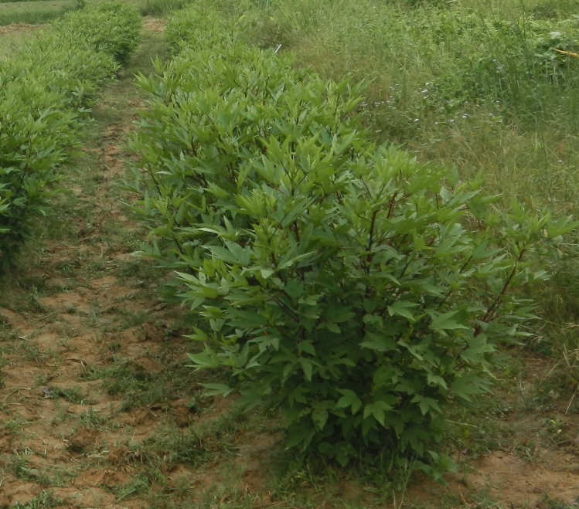
Figure 1. Roselle edible leaves
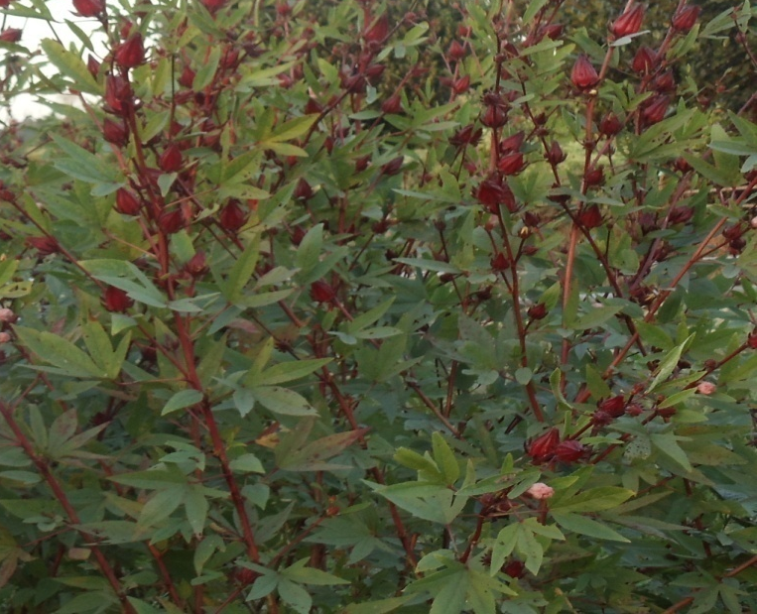
Figure 2. Roselle edible fruits (Calyces)

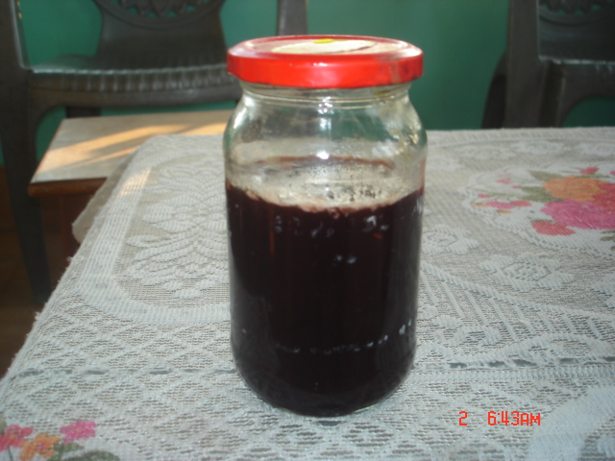
Figure 3. Jam prepared from Roselle fruits

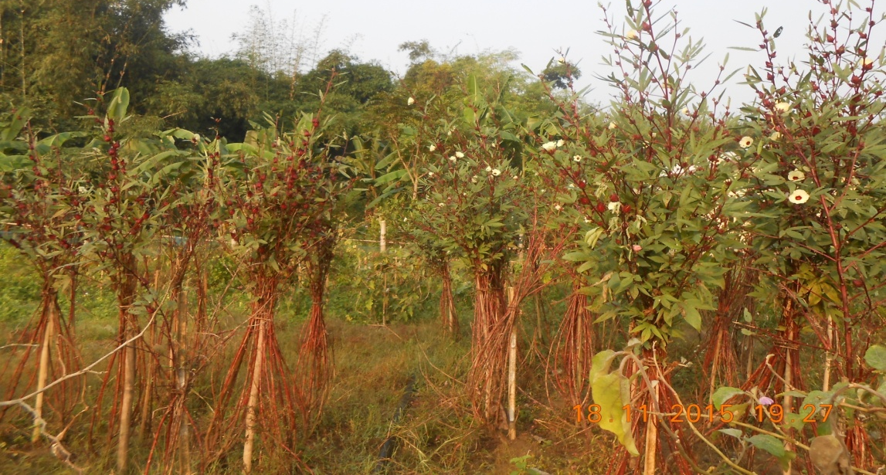
Ealy Genotype
Late Genotype
Figure 4: Genotypes showing Early and Late flowering

