Original Research Article
Genetic identification of soybean segregants null for Kunitz Trypsin Inhibitor (KTI) and Lipoxygenase-2 (LOX2)

Abstract
The present investigation entitled was conducted at the Post Graduate Research Farm, Mahatma Phule Krishi Vidyapeeth, Rahuri and State Level Biotechnology Centre, Rahuri – 413 722 during the academic year 2024-25. The objectives included in this study was to depict the molecular markers linked to the quality traits viz., KTI and LOX2 and identify desirable segregants in soybean. A total of 100 F₂ segregants 50 each from Cross I (JS 22 12 × NRC 142) and Cross II (JS 22 16 × NRC 142) were evaluated using three quality trait markers viz., titi gene specific was linked to KTI locus while remaining two, lox2 gene specific and Satt 656 linked to Lox-2 gene locus. The markers were used to identify segregants free from KTI and LOX2 genes. Out of 100 F₂ segregants, 11 (#3, #5, #6, #8, #9, #15, #17, #20, #22, #38, #41) segregants from Cross I and 7 (#3, #9, #16, #26, #41, #44, #47) segregants from Cross II (JS 22 16 × NRC 142) were identified as free from KTI and LOX2 factors. These identified segregants were subsequently advanced to develop homozygous lines exhibiting null activity for both KTI and LOX2.
Keywords : Segregants, KTI, LOX2, homozygous, Lipoxygenase-2
Introduction
Oilseed crops have played a pivotal role in strengthening the national economy since ancient times (Kaushik et al., 2015). Among these, soybean (Glycine max L. Merrill) is recognized as the most important leguminous oilseed crop worldwide. It accounts for approximately 25% of global edible oil production and provides nearly two-thirds of the protein concentrate used in livestock feed formulations. Soybean is a self-pollinated species with a diploid chromosome number of 2n = 40 and is taxonomically classified under the family Leguminosae (syn. Fabaceae) and subfamily Papilionaceae (Parmar and Ramgiry, 2012).
Soybean is recognized as a nutritionally rich legume crop with significant global importance. Commercial soybean cultivars typically contain around 40% high-quality protein, well-balanced in essential amino acids, making it a valuable plant-based alternative to animal protein sources. The seeds also comprise approximately 20% oil, predominantly consisting of polyunsaturated fatty acids, including omega-6 and omega-3, which are beneficial for human health. In addition, soybeans contain about 6–7% minerals and 5–6% dietary fiber. The protein quality of soybean is considered comparable to that of meat, milk, and eggs (Kaushik et al., 2015). Globally, soybean contributes nearly 25% of total edible oil production and accounts for about two-thirds of the protein concentrate used in livestock feed. Furthermore, it serves as an essential component in feed formulations for poultry and aquaculture species (Pathrikar et al., 2022)
For several centuries, soybean has served as a vital dietary component and a substitute for animal- and cereal-based foods such as meat, milk, cheese, bread, and edible oil in East and Southeast Asian countries, including China, Japan, Korea, Manchuria, the Philippines, and Indonesia. Owing to its remarkable nutritional attributes and agronomic versatility, soybean has traditionally been referred to as the “Cow of the Field” and the “Gold from Soil” in these regions (Horvath, 1926). The nutritional and health-promoting properties of soybean are well established. The seeds are an abundant source of high-quality protein and oil, the latter containing approximately 85% unsaturated fatty acids, including 55% polyunsaturated fatty acids (PUFAs). Among these, linoleic (omega-6) and linolenic (omega-3) acids are essential fatty acids that play crucial roles in human health yet cannot be synthesized endogenously (Balasubramaniyan and Palaniappan, 2003). Furthermore, soybean contains 4 –5% vitamins and antioxidants, including ascorbic acid (9–10 mg/100 g in sprouted soybean) and β-carotene (0.2 mg/100 g in sprouted soybean). It also provides approximately 0.3% isoflavones, primarily daidzein and genistein which are phytoestrogenic compounds associated with various health benefits. Owing to these multifaceted nutritional and functional properties, soybean has been aptly designated as the “Wonder Seed,” “Miracle Crop,” and “Golden Bean” of the twentieth century (Sivashankari et al., 2021). In addition, soybean serves as a valuable source of minerals, vitamins, folic acid, and isoflavones, which have been implicated in delaying or mitigating the progression of several chronic diseases (Wilson, 2004).
The manufacturing of contemporary soybean processed items, including soybean milk flour, isolated soy protein, concentrated soy protein and structural protein, has witnessed consistent growth. Simultaneously, there has been an increase in the production of functional soybean foods such as phospholipids, saponins, isoflavones, oligosaccharides and edible fiber. This evolution in the composition of processed soybean products has also facilitated the advancement of emulsified and soluble soybean products, such as meat substitutes, milk alternatives, flour variations, instant and frozen foods, candies and beverages. This commercial production has enabled the extraction of high-value-added components like phospholipids, saponins and isoflavones, which can be obtained as functional health foods. Soybean serves multiple purposes. Soybean oil, obtained through refining and advanced processing techniques, finds application in the production of edible oils like cooking oil and salad oil, among others. Additionally, soybean oil is utilized in the manufacturing of ink for printers and biodiesel (Singh, 2010).
Soybeans offer significant potential in addressing protein malnutrition, yet their utilization is hindered by the presence of anti-nutritional trypsin inhibitors and an unwanted off-type flavor. The Kunitz trypsin inhibitor (KTI) interferes with the activity of the digestive protease enzyme trypsin, while the unpleasant off-type flavor is attributed to three lipoxygenase enzymes (Lox-1/2/3), each regulated by a single major gene. Even the slightest damage to soybean seeds triggers the oxidation of polyunsaturated fatty acids like linoleic and linolenic acid, leading to the undesirable flavor. The genetic elimination of these undesirable traits in soybean varieties relies on a combination of biochemical assays of raw soybean seeds and the use of molecular markers for assisted selection. Molecular markers linked to malfunctioning alleles of both the kti and lox2 genes eliminate the need for destructive biochemical analysis of seeds.
Hence, to address the aforementioned challenges, the present investigation was undertaken and the obtained results are systematically presented in this section.
Material and methods
The experimental materials consisted segregating materials derived from three soybean genotypes (Table 1) namely JS 22 12, JS 22 16 and NRC 142. The experimental materials viz., JS 22 12 and JS 22 16 were provided by Soybean Breeder, Agricultural Research Station, Kasbe Digraj, Sangli. The NRC 142 was procured from ICAR-Indian Institute of Soybean Research, Indore. All three genotypes were used to effect two crosses namely Cross I JS 22 12 × NRC 142 and Cross II JS 22 16 × NRC 142 to generate F₁, F₂ and F₃ segregating generations and the true hybrids were identified using DUS test with help of marker characteristics of male and female parents.

Table 1 : List of genotypes used in experiment
Sr. No. | Genotype | General Characteristics | Developed by
1. | JS 22 12 | Early maturity, multiple stress tolerant | Jawaharlal  Nehru Krishi Vishwavidyalaya, Jabalpur
2. | JS 22 16 | Early maturity, multiple stress tolerant | Jawaharlal  Nehru Krishi Vishwavidyalaya, Jabalpur
3. | NRC 142 | Free from kti and lox2 gene (Double Null) | Indian Institute of Soybean Research,  Indore
The resulting segregating material viz., F₂ and F₃ were planted under field with 5m row and 45 × 10 cm spacing. The proper care regarding irrigation, intercultural operations and nutrient management was taken timely.
The molecular study of soybean includes segregating population mainly F₂ individuals of two crosses. The total 100 F₂ plants from two crosses were selected for molecular analysis. Among the 100 F₂ plants, 50 F₂ plants are from Cross I JS 22 12 × NRC 142 and another 50 F₂ plants from Cross II JS 22 16 × NRC 142. The details of primer used for the analysis are given in Table 2, the primer selected on the basis of previous study that reported they were significantly linked to the particular gene loci.
Table 2 : Details of primer selected for molecular analysis
1. | Primers related to quality trait in soybean
A] | Kunitz Trypsin Inhibitor–3 gene (KTI–3 gene)
Sr. No | Primers | Annealing Temp.(ºC) | Forward sequence (5’-3’) | Reverse sequence (3’-5’) | References
1 | Gene Specific  (titi) | 50 | CTTTTGTGCCTTCACCACCT | GAATTCATCATCAGAAACTCTA | Kumar et al., (2011)
B] | Lipooxygenase – 2 gene (LOX-2 gene)
3 | Gene Specific  lox2 | 50 | GTTCATAGGTTAAATACTCAA | TTTCAACAAGCTCTTCAAT | Rawal et al., (2020),
4 | Satt 656 | 58.1 | GCGTACTAAAAATGGCAATTATTTGTTG | TTGCTCCGTATTTTCCAGCT | Kumar et al., (2021)

Optimization of PCR amplification
Gradient PCR amplification of gene specific primer was carried out so as to standardize the annealing temperature of each primer. The PCR programme was set in Applied Biosystem Model #9902 Thermal Cycler.

Table 3 : Components of PCR reaction mixture
Sr. No. | Components | Stock Concentraion | Working Concentration | Volume for one tube
1 | PCR buffer | 10X | 1X | 2 µl
2 | MgCl₂ | 25 mM | 15 mM | 1 µl
3 | dNTPs | 100 mM | 10 mM | 0.5 µl
4 | Taq Polymerase | 5U/µl | 2.5U/µl | 0.5 µl
5 | Primer | 100 pmol | 10 pmol | 2 µl
6 | Genomic DNA | 50 ng | 20 ng | 1.5 µl
7 | Sterile double distilled water | - | - | 12.5 µl
 | Total |  |  | 20 µl

The reaction volume for PCR was setup and master mix was prepared for each primer by using above reagent in appropriate quantity as in Table 3. In each tube 1.5 µl genomic DNA was added to complete the 20 µl reaction volume. Finally PCR tubes were placed in thermal cycler for amplification of genomic DNA using PCR cycles presented in Table 4.
Table 4 : PCR cycle for primers related to quality traits in soybean
Step No. | Temp. (°C) | Duration | Cycles | Function
1 | 94 | 5 min | - | Initial denaturation
2 | 94 | 30 sec | 30 Cycles | Denaturation
3 | 50-58.1 | 30 sec | 30 Cycles | Annealing
4 | 72 | 30 sec | 30 Cycles | Extension
5 | 72 | 10 min | - | Final extension
6 | 4 | Pause | - | Final hold

Result and discussion
To assess the molecular markers associated with quality traits in soybean, genomic DNA was extracted from 100 F₂ plants derived from four different crosses using the Cetyl Trimethyl Ammonium Bromide (CTAB) method described by Keim et al., in 1988. The extracted DNA samples were subsequently treated with RNase and Proteinase K to remove RNA and protein contaminants, ensuring high purity. DNA quality was evaluated through agarose gel electrophoresis, which revealed sharp and intact bands, indicating good integrity, while spectrophotometric analysis using a NanoDrop confirmed satisfactory purity ratios. The DNA concentration, as determined by the NanoDrop spectrophotometer, ranged from 100 to 2000 ng/µl. For downstream PCR amplification, all DNA samples were standardized to a final working concentration of 50 ng/µl
The molecular profiling of quality traits in soybean studied by using three markers. Out of four the two markers viz., titi gene specific was linked to KTI locus while remaining two viz., lox2 gene specific and Satt 656 linked to Lox-2 gene locus. The result obtained was discussed detailed below in this section.
In this study, the evaluation of 100 F₂ segregants belonging to the two crosses, 50 segregants from each cross, namely JS 22 12 × NRC 142 (Cross I) and JS 22 16 × NRC 142 (Cross II) was carried out.
Molecular analysis for gene specific titi primer for cross JS 22 12 × NRC 142 (Cross I) and JS 22 16 × NRC 142 (Cross II)
The gene-specific titi primer amplified a band of 420bp in the parent NRC 142, which is KTI-free and has the dysfunctional titi allele. The other parents, JS 22 12 and JS 22 16, did not amplify as they have a functional KTI gene. In first cross (JS 22 12 × NRC 142), 35 out of 50 plants that amplified the 420bp band (Plate 1) had the dysfunctional ti allele either in homozygous (titi) or heterozygous (Titi) conditions.
In the second cross (JS 22 16 × NRC 142), 36 out of 50 plants had the dysfunctional ti allele either in homozygous (titi) or heterozygous (Titi) conditions (Plate 2, Table 5).
The similar findings were reported by earlier workers Pawale et al., (2021) research, the rust-resistant varieties Phule Agrani, P. Sangam, and P. Kimya were developed by genetically deleting the Kunitz trypsin inhibitor (KTI) from the parent lines NRC-101 and NRC-102. This deletion resulted in a non-functional 'titi' allele of the seed-specific KTI3 gene. Using specific 'titi' markers, the researchers identified this genotype in the 131 plants they studied. Gel electrophoresis of PCR products revealed a 420 base pair amplicon in the KTI-free parent lines, NRC-101 and NRC-102.
Panzade et al., (2025) study also found similar results to the NRC 142 parent. When their cross segregants were analyzed, the presence of 420 base pair amplification indicated the absence of the lox-2 gene, which aligned with the study's overall findings.
Table 5 : Details of null allele specific titi primer for cross JS 22 12 × NRC 142 (Cross I) and JS 22 16 × NRC 142 (Cross II)
Cross | No. of F₂ segregants studied | Allele amplified | Individuals
JS 22 12 × NRC 142 | 50 | TiTi | No amplicon
JS 22 12 × NRC 142 | 50 | titi +Titi  (420bp)  (35) | #2, #3, #5, #6, #8, #9, #10, #12, #14, #15, #17, #18, #19, #20, #22, #23, #24, #25, #27, #28, #29, #30, #31, #33, #34, #37, #38, #39, #41, #42, #44, #45, #46, #47, #50
JS 22 16 × NRC 142 | 50 | TiTi | No amplicon
JS 22 16 × NRC 142 | 50 | titi +Titi  (420bp)  (36) | #1, #3, #4, #6, #7, #8, #9, #10, #12, #13, #15, #16, #18, #19, #20, #22, #23, #25, #26, #28, #29, #31, #32, #33, #34, #36, #37, #39, #41, #42, #44, #45, #46, #47, #49, #50

Molecular marker analysis for Lipoxygenase-2 gene using gene specific lox2 molecular marker
In this molecular study, the study of 100 F₂ segregants from two crosses namely JS 22 12 × NRC 142 (Cross I) and JS 22 16 × NRC 142 (Cross II) 50 segregants from each cross were taken. The analysis revealed that Lipoxygenase 2 free parent NRC 142 amplified the 600bp allele; while Lox-2 expressing parents, JS 22 12 and JS 22 16 did not amplify as they have a functional Lox2 gene. In first cross (JS 22 12 × NRC 142), 36 out of 50 plants that amplified the 600bp band (Plate 3) had the dysfunctional lox2 allele either in homozygous (lox2lox2) or heterozygous (Lox2lox2) conditions. In the second cross (JS 22 16 × NRC 142), 36 out of 50 plants had the dysfunctional lox2 allele either in homozygous (lox2lox2) or heterozygous (Lox2lox2) conditions (Plate 4, Table 6).
Jin et al., (2012) in their 2012 described variations in the molecular sequence of the soybean lipoxygenase-2 gene. Their research showed that lipoxygenase-free soybean cultivars produced DNA fragments (amplicons) of varying lengths when different primer sets were used in PCR. Notably, when a primer specific to the lox2 gene was employed, the lipoxygenase-free parent cultivars yielded an amplicon fragment of 600 base pairs.
Panzade et al., (2025) also reported the similar result as NRC 142 parent when employed in cross their segregants showed the amplification at 600bp indicates free from lox-2 gene which was the conformity of our study.
Table 6 : Details of gene specific lox2 primer for cross JS 22 12 × NRC 142 (Cross I) and JS 22 16 × NRC 142 (Cross II)
Cross | No. of F₂ segregants studied | Allele amplified | Individuals
JS 22 12 × NRC 142 | 50 | Lox2 Lox2 | No amplicon
JS 22 12 × NRC 142 | 50 | Lox2lox2+lox2lox2  (600 bp)  (36) | #1, #3, #4, #5, #6, #8, #9, #11, #12, #13, #14, #15, #16, #17, #18, #19, #20, #22, #23, #25, #26, #28, #30, #31, #32, #34, #35, #36, #38, #39, #41, #43, #44, #45, #48, #50
JS 22 16 × NRC 142 | 50 | Lox2 Lox2 | No amplicon
JS 22 16 × NRC 142 | 50 | Lox2lox2+lox2lox2  (600 bp)  (36) | #2, #3, #5, #6, #8, #9, #10, #12, #14, #16, #17, #18, #19, #20, #21, #22, #23, #24, #25, #26, #28, #29, #30, #32, #33, #35, #37, #38, #40, #41, #43, #44, #46, #47, #49, #50

Kumar et al., (2021) reported Soybean genotypes free from both KTI and Lox2 were developed by introgressing the Lox2 null allele from NRC 109 (lox2lox2) into KTI-free genotypes from JS 97-52 and NRC 7. Foreground selection across multiple generations (F₁, F₂, BC₁F₁, BC₁F₂, BC₂F₁, BC₂F₂) used null allele-specific and SSR markers to identify homozygous recessive (titilox2lox2) plants. Background selection with 239 and 241 SSR markers identified 9 and 13 lines stacked with null alleles for both KTI and Lox2, with >97% and >96% recurrent parent genome content, respectively.
Molecular marker analysis for Lipoxygenase 2 gene using Satt 656 molecular marker
In this study, the Satt 656 primer was used to analyze different 100 F₂ soybean segregants for two crosses JS 22 12 × NRC 142 (Cross I) and JS 22 16 × NRC 142 (Cross II) and 50 F₂ segregants were studied from each cross. The results showed a 170 base pair amplicon in the lipoxygenase 2 expressing parent viz., JS 22 12 and JS 22 16, while the lipoxygenase 2 free parent NRC142 displayed a 173 base pair amplicon. In first cross (JS 22 12 × NRC 142), 16 out of 50 plants that amplified the 173 bp band had the dysfunctional lox2 allele in homozygous (lox2lox2), 21 were heterozygous (Lox2lox2) as they amplified both alleles (170bp + 173bp) and rest 13 amplified a 170bp band were Lox2 expressing homozygous (Lox2Lox2) individuals (Plate 5). In the second cross (JS 22 16 × NRC 142), 12 out of 50 plants that amplified the 173bp band had the dysfunctional lox2 allele in homozygous (lox2lox2), 24 were heterozygous (Lox2lox2) as they amplified both alleles (170bp + 173bp) and rest 14 amplified a 170bp band were Lox2 expressing homozygous (Lox2Lox2) individuals (Plate 6, Table 7).

Table 7 : Details of Satt 656 primer for cross JS 22 12 × NRC 142 (Cross I) and JS 22 16 × NRC 142 (Cross II)
Cross | No. of F2 segregants studied | Allele amplified | Individuals
JS 22 12 × NRC 142 | 50 | Lox2Lox2  (170bp)  (13) | #2, #11, #12, #13, #14, #18, #19, #21, #28, #30, #31, #33, #42
JS 22 12 × NRC 142 | 50 | Lox2lox2  (170bp and 173bp)  (21) | #7, #10, #23, #24, #25, #26, #27, #29, #34, #35, #36, #37, #39, #40, #43, #44, #45, #46, #47, #49, #50
JS 22 12 × NRC 142 | 50 | lox2lox2  (173bp)  (16) | #1, #3, #4, #5, #6, #8, #9, #15, #16, #17, #20, #22, #32, #38, #41, #48
JS 22 16 × NRC 142 | 50 | Lox2 Lox2  (170bp)  (14) | #1, #2, #11, #17, #18, #19, #20, #21, #22, #25, #28, #30, #33, #39
JS 22 16 × NRC 142 | 50 | Lox2lox2  (170bp and 173bp)  (24) | #4, #6, #7, #8, #10, #12, #15, #21, #23, #24, #27, #29, #32, #34, #35, #37, #38, #40, #42, #45, #46, #48, #49, #50
JS 22 16 × NRC 142 | 50 | lox2lox2  (173bp)  (12) | #3, #5, #9, #14, #16, #26, #31, #36, #41, #43, #44, #47

Rawal et al., (2020) in their study focused on removing the lipoxygenase-2 gene from the soybean cultivar ‘JS 97-52’ by introducing a null allele from PI 596540 using marker-assisted introgression. Foreground selection with a lox2-specific marker was used in early backcross generations, while a combination of this marker and SSR marker Satt 656 was used to identify homozygous recessive plants in later generations. Background selection with 150 markers resulted in 12 Lox2-free soybean lines with a high recovery of the ‘JS 97-52’ genome, confirmed by assays
The resembling result was also reported by the Panzade et al., (2025) in their study with various segregants of cross having NRC 142 as male parent showed the amplification of 170bp and 173bp alleles in segregants for presence of lipoxygenase activity and lacking such activity respectively.
Kumar et al., (2022) also worked with lox-2 gene identifying markers with various generation and demonstrated result which was comparable to our findings.
Combine study of KTI and Lox-2 free segregants for cross JS 22 12 × NRC 142 (Cross I)
The combine molecular study of Cross I JS 22 12 × NRC 142 involves utilization of three markers viz., gene specific titi, Gene specific lox2 and Satt 656. Under this scenario total 50 F₂ progeny studied among that only 11 F₂ progeny/segregants (#3, #5, #6, #8, #9, #15, #17, #20, #22, #38, #41) found to be amplified the both homozygous recessive ti and lox2 alleles. As a result this F₂ progeny were free from KTI and Lipoxygenase activity hence they called “Double Null” lines and can able to utilized in breeding program of soybean improvement.
Combine study of KTI and Lox-2 free segregants for cross JS 22 16 × NRC 142 (Cross II)
The combine molecular study of Cross II JS 22 16 × NRC 142 involves utilization of three markers viz., gene specific titi, Gene specific lox2 and Satt 656. The total 50 F₂ segregants were analysed using above three markers. Out of 50 only 7 F₂ progeny/ segregants (#3, #9, #16, #26, #41, #44, #47) found to be showing both homozygous recessive titi and lox2 allele. Hence these segregants free from both KTI and Lipoxygenase activity so called them “Double Null”. So they can also incorporated in next breeding scheme.
Conclusion
The 100 F₂ segregants form two crosses viz., Cross I (JS 22 12 × NRC 142) and Cross II (JS 22 16 × NRC 142) were used for evaluation using three quality traits related markers viz., Gene Specific titi, Gene Specific lox2 and Satt 656 to identify the segregants free from KTI and LOX2 genes. The study revealed that from Cross I (JS 22 12 × NRC 142) out of 50 F₂ segregants 11 F₂ segregants (#3, #5, #6, #8, #9, #15, #17, #20, #22, #38, #41) and from Cross II (JS 22 16 × NRC 142) out of 50 F₂ segregants 7 F₂ segregants (#3, #9, #16, #26, #41, #44, #47) found to be free from KTI and LOX2 anti-nutritional factors.
Future prospectus
These identified segregants were subsequently advanced through successive generations using the pedigree selection approach to achieve genetic fixation. The primary objective was to develop stable, homozygous lines exhibiting complete null activity for both Kunitz Trypsin Inhibitor (KTI) and Lipoxygenase-2 (LOX2) genes. The absence of these anti-nutritional and off-flavor causing enzymes was confirmed through specific biochemical assays and molecular marker analysis, ensuring that the resulting lines possess improved nutritional and sensory qualities desirable for food and processing applications.

Disclaimer (Artificial intelligence)
Option 1:
Author(s) hereby declare that NO generative AI technologies such as Large Language Models (ChatGPT, COPILOT, etc.) and text-to-image generators have been used during the writing or editing of this manuscript.

References
- Balasubramaniyan, P., & Palaniappan, S. P. (2003). Principles and practices of agronomy, 45-46.
- Horvath, A. A. (1926). Changes in the blood composition of rabbits fed on raw soy beans. J. Biol. Chem. 68 (2) : 343-355.
- Jin, H. S., Van, K., Kim, K. D., Lee, Y. H., Jun, T. H., & Lee, S. H. (2012). Molecular sequence variations of the lipoxygenase-2 gene in soybean. Theoretical and Applied Genetics, 124(4), 613-622. https://doi.org/10.1007/s00122-011-1733-2
- Kaushik, D. K., Patel, S. R., Chandrawanshi, S. K., Khavse, R., & Chaudhary, J. L. (2015). Study on agrometeorological indices for soybean crop under different sowing dates in Chhattisgarh region of India. Indian Journal of Agricultural Research, 49(3), 282-285. https://doi.org/10.5958/0976-058X.2015.00046.3
- \Keim, P., Olson, T. C., & Shomaker, R. C. (1988). A rapid protocol for isolating soybean DNA Soybean Genetic Newsletter, 15 : 150-152.
- Kumar, V., Rani, A., Anshu, A. K., & Tayalkar, T. (2021). Marker-assisted stacking of null Kunitz trypsin inhibitor and off-flavour generating lipoxygenase-2 in soybean. The Journal of Agricultural Science. https://doi.org/10.1017/s0021859621000526
- Kumar, V., Rani, A., Mourya, V., Rawal, R., Verma, K., Shivakumar, M., Lal, S. K., & Talukdar, A. (2011). Marker-assisted selection for development of kunitz trypsin inhibitorfree soybean varieties: I. Parental polymorphism survey using SSR markers. Indian Journal of Genetics and Plant Breeding, 71(4), 372-376. https://www.isgpb.org/journal/index.php/IJGPB/article/view/850
- Kumar, V., Rani, A., Tayalkar, T., Jha, P., Mittal, P., Anshu, A. K., & Rawal, R. (2022). Genetic elimination of lipoxygenase‐2 improves sprouting and tocopherols, and removal of Kunitz trypsin inhibitor enhances in vitro protein digestibility in soybean (Glycine max). Plant Breeding, 141(1), 63–70. https://doi.org/10.1111/pbr.12998
- Panzade, S. A., Chimote, V. P., Shinde, C. S., & Aher, A. R. (2025). Identification of Soybean (Glycine max L.) Segregants for Kunitz Trypsin Inhibitor and Lipoxygenase Free Gene Using Linked Molecular Markers. Plant Cell Biotechnology and Molecular Biology, 26(1-2), 33-44. https://doi.org/10.56557/pcbmb/2025/v26i1-29076
- Parmar, D., & Ramgiry, S. R. (2012). Stability Analysis for Growth and Yield Attributes in Soybean (Glycine max (L.) Merrill). Soybean Research, 10, 18. https://www.soybeanresearch.in/volume-10-2012/
- Pathrikar, D. T., Perke, D. S., & More, S. S. (2022). Growth rates in area, production and productivity of soybean in Marathwada region of Maharashtra state. The Pharma Innovation Journal, 11(1S), 1009-1012. https://www.thepharmajournal.com/archives/2022/vol11issue1S/PartB/11-1-10-800.pdf
- Rawal, R., Kumar, V., Rani, A., & Gokhale, S. M. (2020). Genetic elimination of off-flavour generating lipoxygenase-2 gene of soybean through marker assisted backcrossing and its effect on seed longevity. Plant Breeding and Biotechnology, 8(2), 163–173. https://doi.org/10.9787/PBB.2020.8.2.163
- Singh, G. (2010). The soybean: Botany, production and uses. CABI. https://doi.org/10.1079/9781845936440.0000
- Sivashankari, M., Pare, A., Vijayakumar, S., Sadvatha, R. H., & Borkar, N. (2021). Value addition of Soybean. Food and Scientific Reports, 2(17), 60-65. https://foodandscientificreports.com/article/value-addition-of-soybean
- Wilson, R. F. (2004). Seed composition. In H. R. Boerma & J. E. Specht (Eds.), Soybeans: Improvement, Production, and Uses (3rd ed., pp. 621–677). ASA-CSSA-SSSA. https://doi.org/10.2134/agronmonogr16.3ed.c13

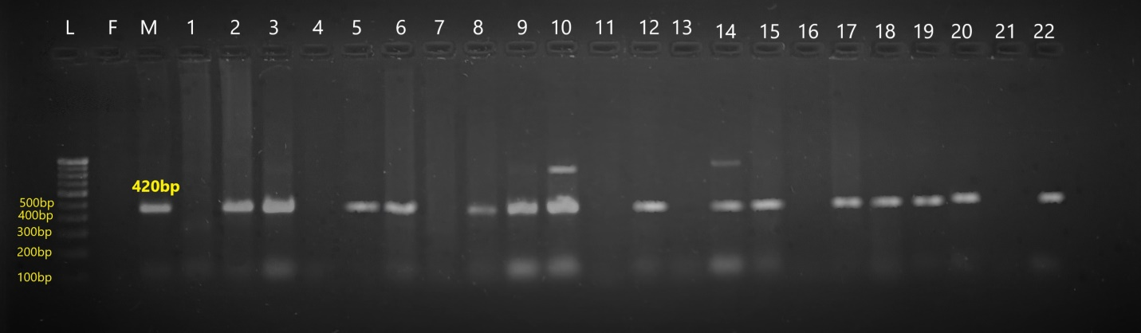
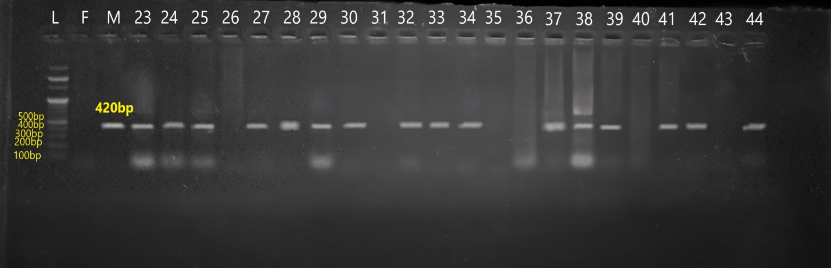
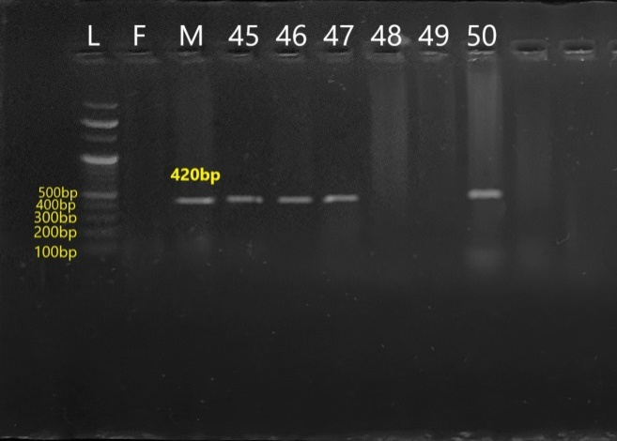

Plate 1 : Amplification profile 50 F₂s segregants of gene specific titi marker for Cross I JS 22 12 (P₁) × NRC 142 (P₂)
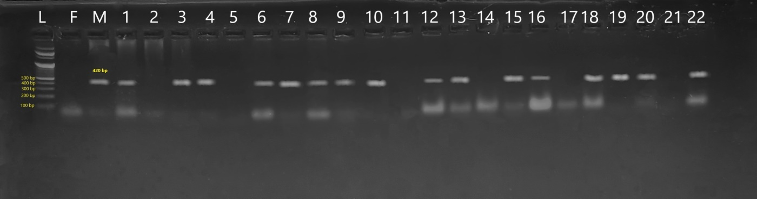
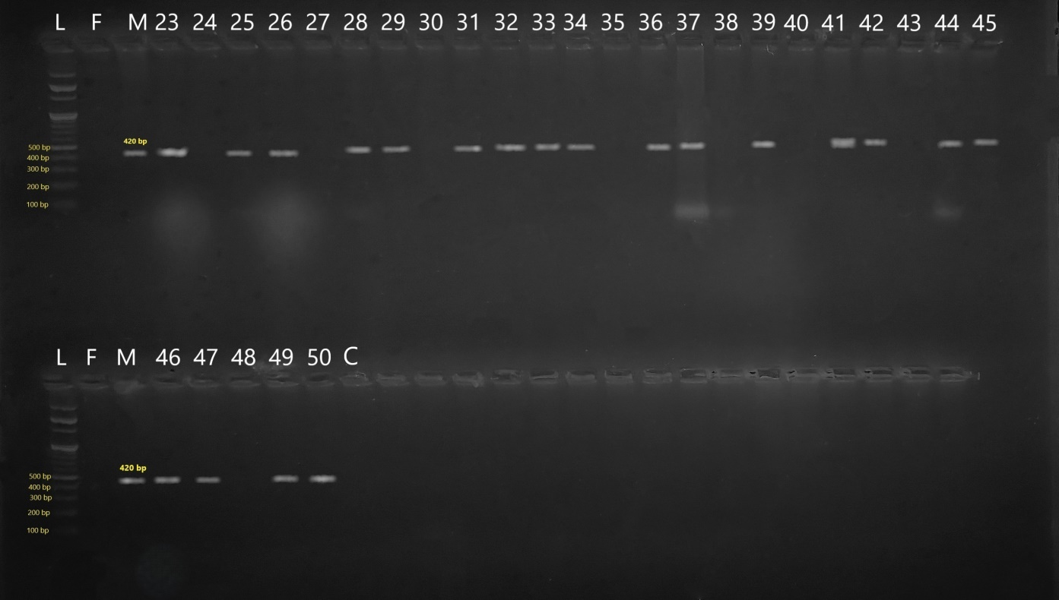

Plate 2 : Amplification profile 50 F₂s segregants of gene specific titi marker for Cross II JS 22 16 (P₁) × NRC 142 (P₂)
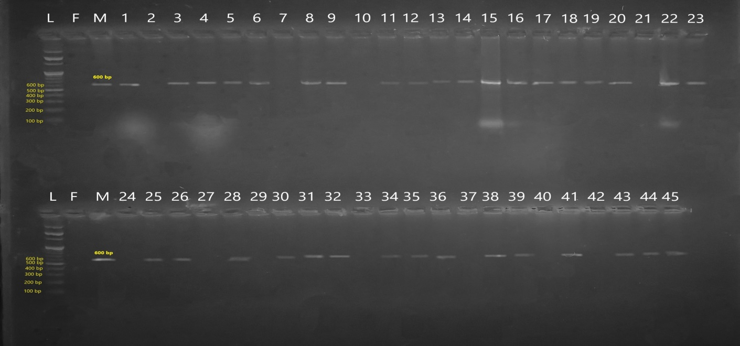
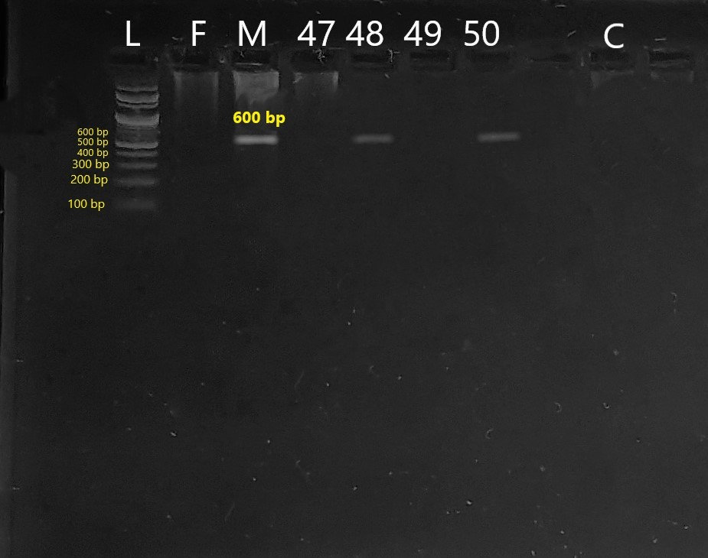

Plate 3 : Amplification profile 50 F₂s segregants of gene specific lox2 marker for Cross I JS 22 12 (P₁) x NRC 142 (P₂)

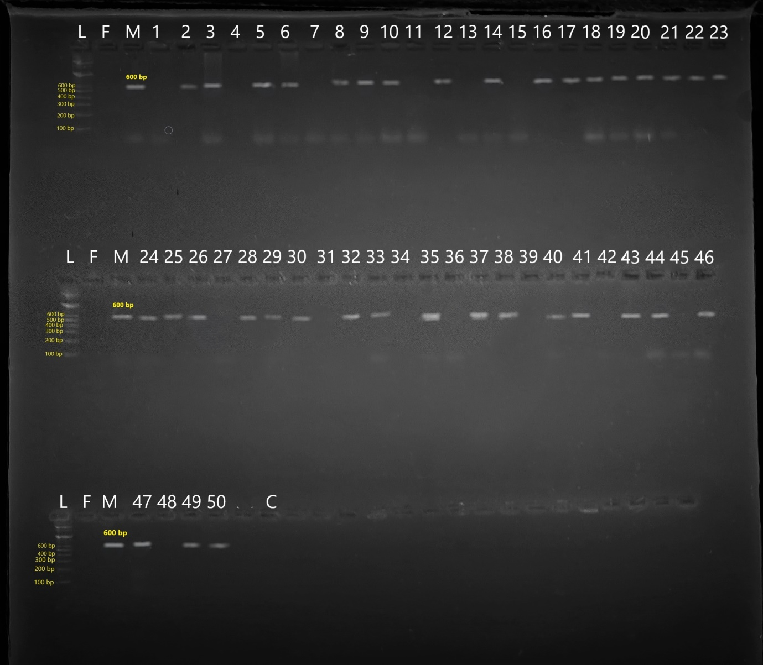

Plate 4 : Amplification profile 50 F₂s segregants of gene specific lox2 marker for Cross II JS 22 16 (P₁) × NRC 142 (P₂)

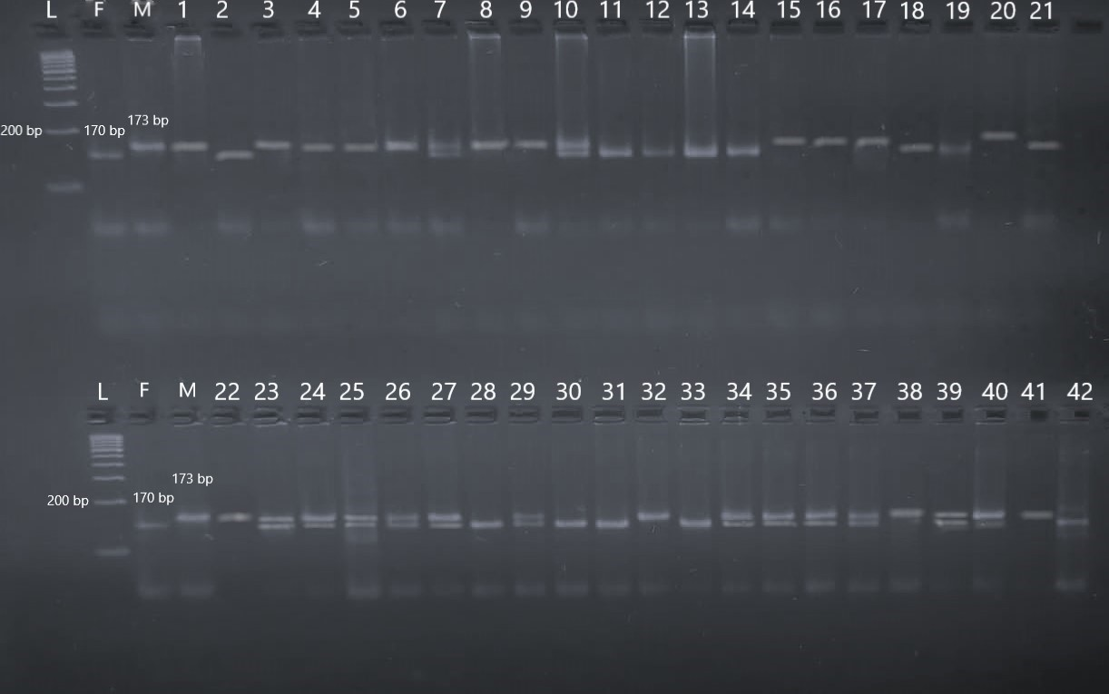
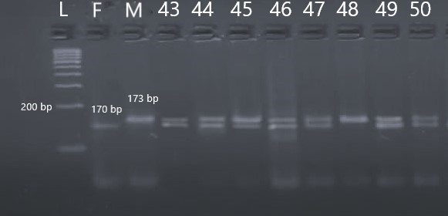

Plate 5 : Amplification profile 50 F₂s segregants of gene specific Satt 656 marker for Cross I JS 22 12 (P₁) × NRC 142 (P₂)

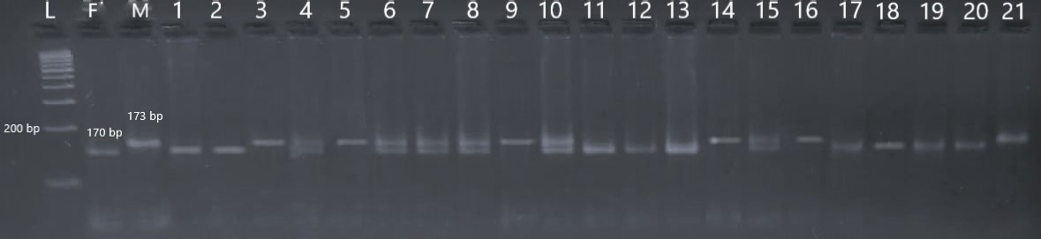
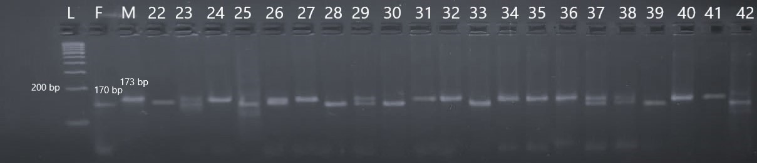
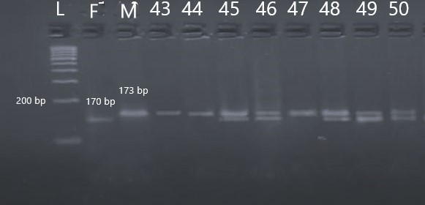

Plate 6 : Amplification profile 50 F₂s segregants of gene specific Satt 656 marker for Cross II JS 22 16 (P₁) × NRC 142 (P₂)

