Case report
“Management of Salter–Harris Type I Radius–Ulna Fracture Using Stainless Steel Elastic Nailing in a Dog: A Case Report”
.
ABSTRACT
A 10-month-old female German Shepherd (21 kg) was presented with non-weight-bearing lameness of the right forelimb 1 day after a bike accident. Physical examination revealed pain and crepitus in the distal third of the radius and ulna, with all other clinical parameters within normal limits. Under general anaesthesia, one 2 mm stainless steel elastic nail (SSEN) was inserted in the radius and one 2 mm SSEN in the ulna. The limb was additionally supported with a caudal splint and bandage for 2 weeks, and the dog received antibiotics and anti-inflammatory drugs. Sutures were removed on day 14 without any evidence of infection, and the dog was periodically re-examined for radiographic healing and weight bearing. The animal recovered uneventfully, with good limb function, and the implants were not removed.
In this growing dog, elastic nailing was selected to minimise potential complications associated with bone plating, such as restriction of carpal joint motion and damage to the growth plate. Compared with rigid plating, elastic nailing is associated with a lower risk of reduced carpal range of motion and physeal disturbance. This case supports elastic intramedullary nailing as a useful alternative to plate fixation for distal radius-ulna fractures in young dogs, providing stable fixation, good clinical outcome, and preservation of joint function.

Keywords: Radius-ulna fracture, Elastic nailing, dog, medullary canal

1. INTRODUCTION

Dogs' forelimbs typically support proportionately more body weight (60.4%) than the hind limbs (Fish et al., 2020); therefore, compared to the pelvic limb, management of forelimb fractures—particularly of the radius and ulna—is often more challenging and complicated. Among various approaches, bone plating has been advocated as one of the most popular techniques for managing canine radial-ulnar fractures. However, the use of such rigid fracture fixation procedures is limited in young growing dogs, particularly with distal radius-ulna fractures due to the smaller distal fragment and open physis (Jackson & Pacchiana, 2004). Besides, external coaptation has limited usefulness and is recommended in dogs with minor non-displaced diaphyseal radius-ulna fractures (Harasen, 2003). Elastic nailing, which has now been routinely adopted in medical practice, offers balanced mechanical stability while preserving the biological environment at the fracture site. Controlled flexibility promotes callus formation, whereas less precise, indirect reduction will reduce operative trauma (Perren, 2002).
Fractures of the radius and ulna are the most prevalent in the pectoral limb, occurring in 65.25% of cases, mostly in young puppies up to six months old (Shiju Simon et al., 2011). Kushwaha et al., (2011) found that dogs under one year had the greatest frequency of long bone fractures, with 50% occurring in dogs under six months old. Spitz had the greatest frequency of fractures (35.14%), followed by unidentified breeds (27.03%), German Shepherds (21.62%), Labradors (5.40%), and other breeds (10.81%). The most common cause discovered was falls from height (43.24%), followed by vehicle traffic accidents (27.03%). The radius-ulna was shown to be the second most broken bone (12.5%), after only the femur (65%). In order to assess the hospital incidence pattern and bone-wise signalling of appendicular fractures in 1242 dogs presented at the Guru Angad Dev Veterinary and Animal Sciences University, Gupta et al., (2024) carried out a three-year retrospective research (2019–2021). Over a three-year period, the total hospital incidence of appendicular fractures was 6.53%. The number of fracture cases showed an upward trend, peaking in 2021 at 46.62%. Male dogs (66.46%) and non-descript dogs (46.49%) were most impacted. The most common causes of fractures were falls from heights and car accidents. Appendicular bone fractures were more common in young pups under a year of age. Of all the cases, the femur was the most often broken long bone (40%). Most fractures were non-comminuted, distal, and closed.
According to Saka et al., (2014), plate fixation is still the most effective treatment for adult forearm diaphyseal fractures. However, recently developed intramedullary nails could provide a better option for these fractures. The union rate of the new IM forearm nails was similar to that of plate fixation. Additionally, the incisions were smaller than those required for plate fixation, and no periosteal stripping was required. Positive functional results are obtained when instant free movement is permitted without further assistance. The research recommended that adult patients with diaphyseal fractures be treated with intramedullary nails in the forearm. Fractures of the radius and ulna in pediatric patients are treated using titanium or stainless-steel elastic nails, with one nail implanted in each bone (Khuntia et al., 2020).
Prabhukumar et al., (2020) treated two nondescript dogs, aged 7 and 12 months, who had a short oblique overriding and transverse overriding fracture of the radius-ulna. The dogs weighed 10.5 and 13.5 kg. A precurved stainless steel elastic intramedullary nail (1.5 mm in the first and 2.0 mm in the second dog) was placed in the radial bone medullary canal, filling 60% of the narrowest medullary canal. In both instances, a plaster cast was inserted for 15 days after surgery to increase stability. Both instances began weight bearing after the first week after surgery and achieved full weight bearing by the sixth and eighth weeks, respectively. This research found that a single stainless steel elastic nail, along with extra external coaptation support, may efficiently handle. This research shows that a single stainless steel elastic nail, along with extra external coaptation support, may successfully treat radius-ulna fractures in young dogs. Kumar et al., (2020) investigated the idea and extent of elastic osteosynthesis in long bone fractures, specifically in young dogs, employing elastic nails implanted in a dynamic intramedullary cross manner. This approach conserved the milieu surrounding the fracture site by avoiding significant soft tissue dissection and periosteal stripping, resulting in faster fracture healing.
Gupta et al., (2023) studied the comparison of titanium elastic nails and stainless steel elastic nails in femoral fractures of young dogs.
There is lack of literature on use of elastic nailing in radius ulna fractures in dogs.

2. case presentation

A 10-month-old female German Shepherd was presented to the Multi-Speciality Veterinary Hospital, Guru Angad Dev Veterinary and Animal Sciences University, Ludhiana, 1 day after a bike accident, with non-weight-bearing lameness of the right forelimb. Physical examination and haemato-biochemical parameters were within normal limits, except for pain and crepitus in the distal third of the radius and ulna. Radiographs revealed a Salter–Harris Type I fracture (through the growth plate). The narrowest medullary canal measured 5.8 mm in the mediolateral view and 7.6 mm in the craniocaudal view, with a distal fragment length of approximately 9 mm. As the dog was young, elastic intramedullary nailing was selected to minimise bone exposure and soft tissue disruption, thereby promoting faster healing and preserving the growth plate.

The surgery was performed under general anaesthesia. The dog was premedicated with xylazine(1mg/kg) and atropine(0.04mg/kg) intramuscularly, induced on propofol (4mg/kg) intravenously and maintained on isoflurane. The animal was positioned in left lateral recumbency with the fractured limb facing up. The lateral approach was used. The surgery was planned to insert two 2mm elastic nails in radius, but due to fear of fragmentation in the smaller distal fragment(9mm), the decision was changed intraoperatively to insert one elastic nail each in radius and ulna. After stabilisation with elastic nailing, subcutaneous sutures were applied using Vicryl 2-0 and skin sutures with staples. Postoperatively, the dog was administered cefotaxime(22mg/kg) for 5 days and meloxicam(0.2mg/kg) for 3 days intramuscularly. The immediate postoperative radiograph revealed satisfactory reduction of fracture fragments. The dog was followed periodically for radiography and lameness assessment. Also, required follow-ups were given by the owner on mobile, wherever possible.
Clinical lameness score (0-5) as previously described by Cook et al., (1999) was given at the final follow-up examination as follows:
0 - No observable lameness
1 - Intermittent, mild weight-bearing lameness with little if any change in gait
2 - Consistent, mild weight-bearing lameness with little change in gait
3 - Moderate weight-bearing lameness - obvious lameness with noticeable―head bob‖ and change in gait
4 - Severe weight-bearing lameness - toe-touching only
5 - Non-weight-bearing

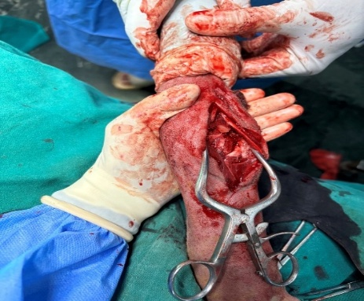
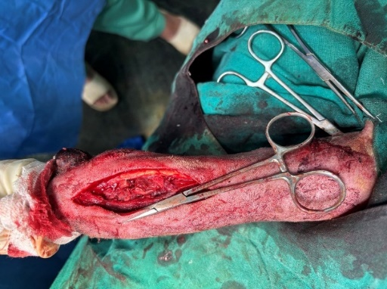
a
b
a: Lateral incision showing fractured radius ulna
b: Reduced fractured fragments after insertion of nails

Fig. 1: Fractured radius ulna and Reduced fractured fragments with inserted nails

3. results and discussion

In the present case, sequential clinical and functional assessments demonstrated excellent recovery following elastic intramedullary nailing with stainless steel implants for a distal radius-ulna fracture in a young, light-weight dog. The patient was examined at 14, 30, and 90 days postoperatively, with an additional owner-reported update on day 21. The dog showed toe-touching of the operated limb by day 7, progressing to moderate weight-bearing lameness with a noticeable gait abnormality by day 14. By 30 days after surgery, the dog was fully weight bearing without any visible lameness, and this satisfactory functional status was maintained at 90 days. Skin sutures were removed on the 14th postoperative day without complication. Mild osteomyelitis was present which is seen as mild overgrowth of bony fragments. The osteomyelitis resolved with time as is evident in the radiographs.

The lameness score improved steadily from 5 preoperatively to 4 on day 7, 3 on day 14, 2 on day 21, and 0 on days 30 and 90 postoperatively. This gradual, time-dependent reduction in lameness score over approximately one month reflects a predictable and favourable recovery pattern and indicates the clinical success of stainless steel elastic intramedullary nailing in this case. The pattern of improvement is consistent with the observations of Sodhi et al. (2024), who reported progressive reduction in lameness and excellent functional outcomes using titanium elastic nailing (TENs) for distal radius-ulna fractures in young, light-weight dogs.

Preservation of joint function is a key determinant of long-term success in distal antebrachial fractures. In this case, the range of motion (ROM) of the carpal joint was evaluated using a goniometer. Preoperatively, the contralateral healthy limb had a carpal flexion angle of ${60}^{∘}$ and an extension angle of ${180}^{∘}$, yielding a ROM of ${120}^{∘}$. At 3 months postoperatively, the operated limb showed a flexion angle of ${65}^{∘}$ and an extension angle of ${180}^{∘}$, with a ROM of ${115}^{∘}$. This minimal difference suggests that stainless steel elastic nailing allowed near-normal restoration of carpal ROM, with no clinically relevant restriction when compared with the healthy limb. By contrast, Sodhi (2021) reported a carpal ROM of $67.33±{42.53}^{∘}$ in dogs treated with plating, indicating greater variability and the potential for more pronounced motion deficits following plate fixation.

The present case also highlights several theoretical and practical advantages of elastic intramedullary nailing over conventional plate fixation. Although dogs treated with bone plates may demonstrate early weight bearing, previous studies have reported notable long-term complications, including plate exposure due to the limited soft tissue envelope over the distal radius and ulna and the requirement for a second incision of similar length for plate removal. Larsen et al. (1999) discussed additional challenges associated with plate-and-screw constructs in this region, such as delayed union and nonunion. These complications are often attributed to compromised vascularity of the distal metaphyseal region, the small diameter of the distal radius, and the tensile forces exerted by the digital flexor musculature. Together, these factors reduce extraosseous blood supply and may impair early revascularisation and fracture healing, while simultaneously complicating efforts to maintain biomechanical stability.

Rigid intramedullary pinning of the radius with a Steinmann pin is generally contraindicated because of the anatomical configuration of the bone and the risk of joint violation or malalignment. In this context, stainless steel elastic intramedullary nailing provides alternative that preserves endosteal and periosteal blood supply, offers adequate stability for fracture healing, and reduces the likelihood of soft tissue and implant-related complications associated with plating. The combination of rapid lameness resolution, near-normal carpal ROM, and absence of major complications in this case supports the use of stainless steel elastic nailing as an effective fixation option for distal radius-ulna fractures in appropriately selected canine patients.

4. Conclusion

In this case, a single 2 mm stainless steel elastic nail in each of the radius and ulna gave stable fixation and uneventful healing in a 20 kg dog. The dog regained normal limb use and near-normal carpal motion, indicating that elastic nailing can be a simple, low-cost alternative to plating in young dogs with radius-ulna fractures.
Because of limited soft tissue coverage, the risk of plate exposure and restricted ROM of the carpal joint, elastic nailing may be safer than plating in this region. However, published veterinary reports on this technique are still few, and further studies are needed to confirm its effectiveness and define clear indications.

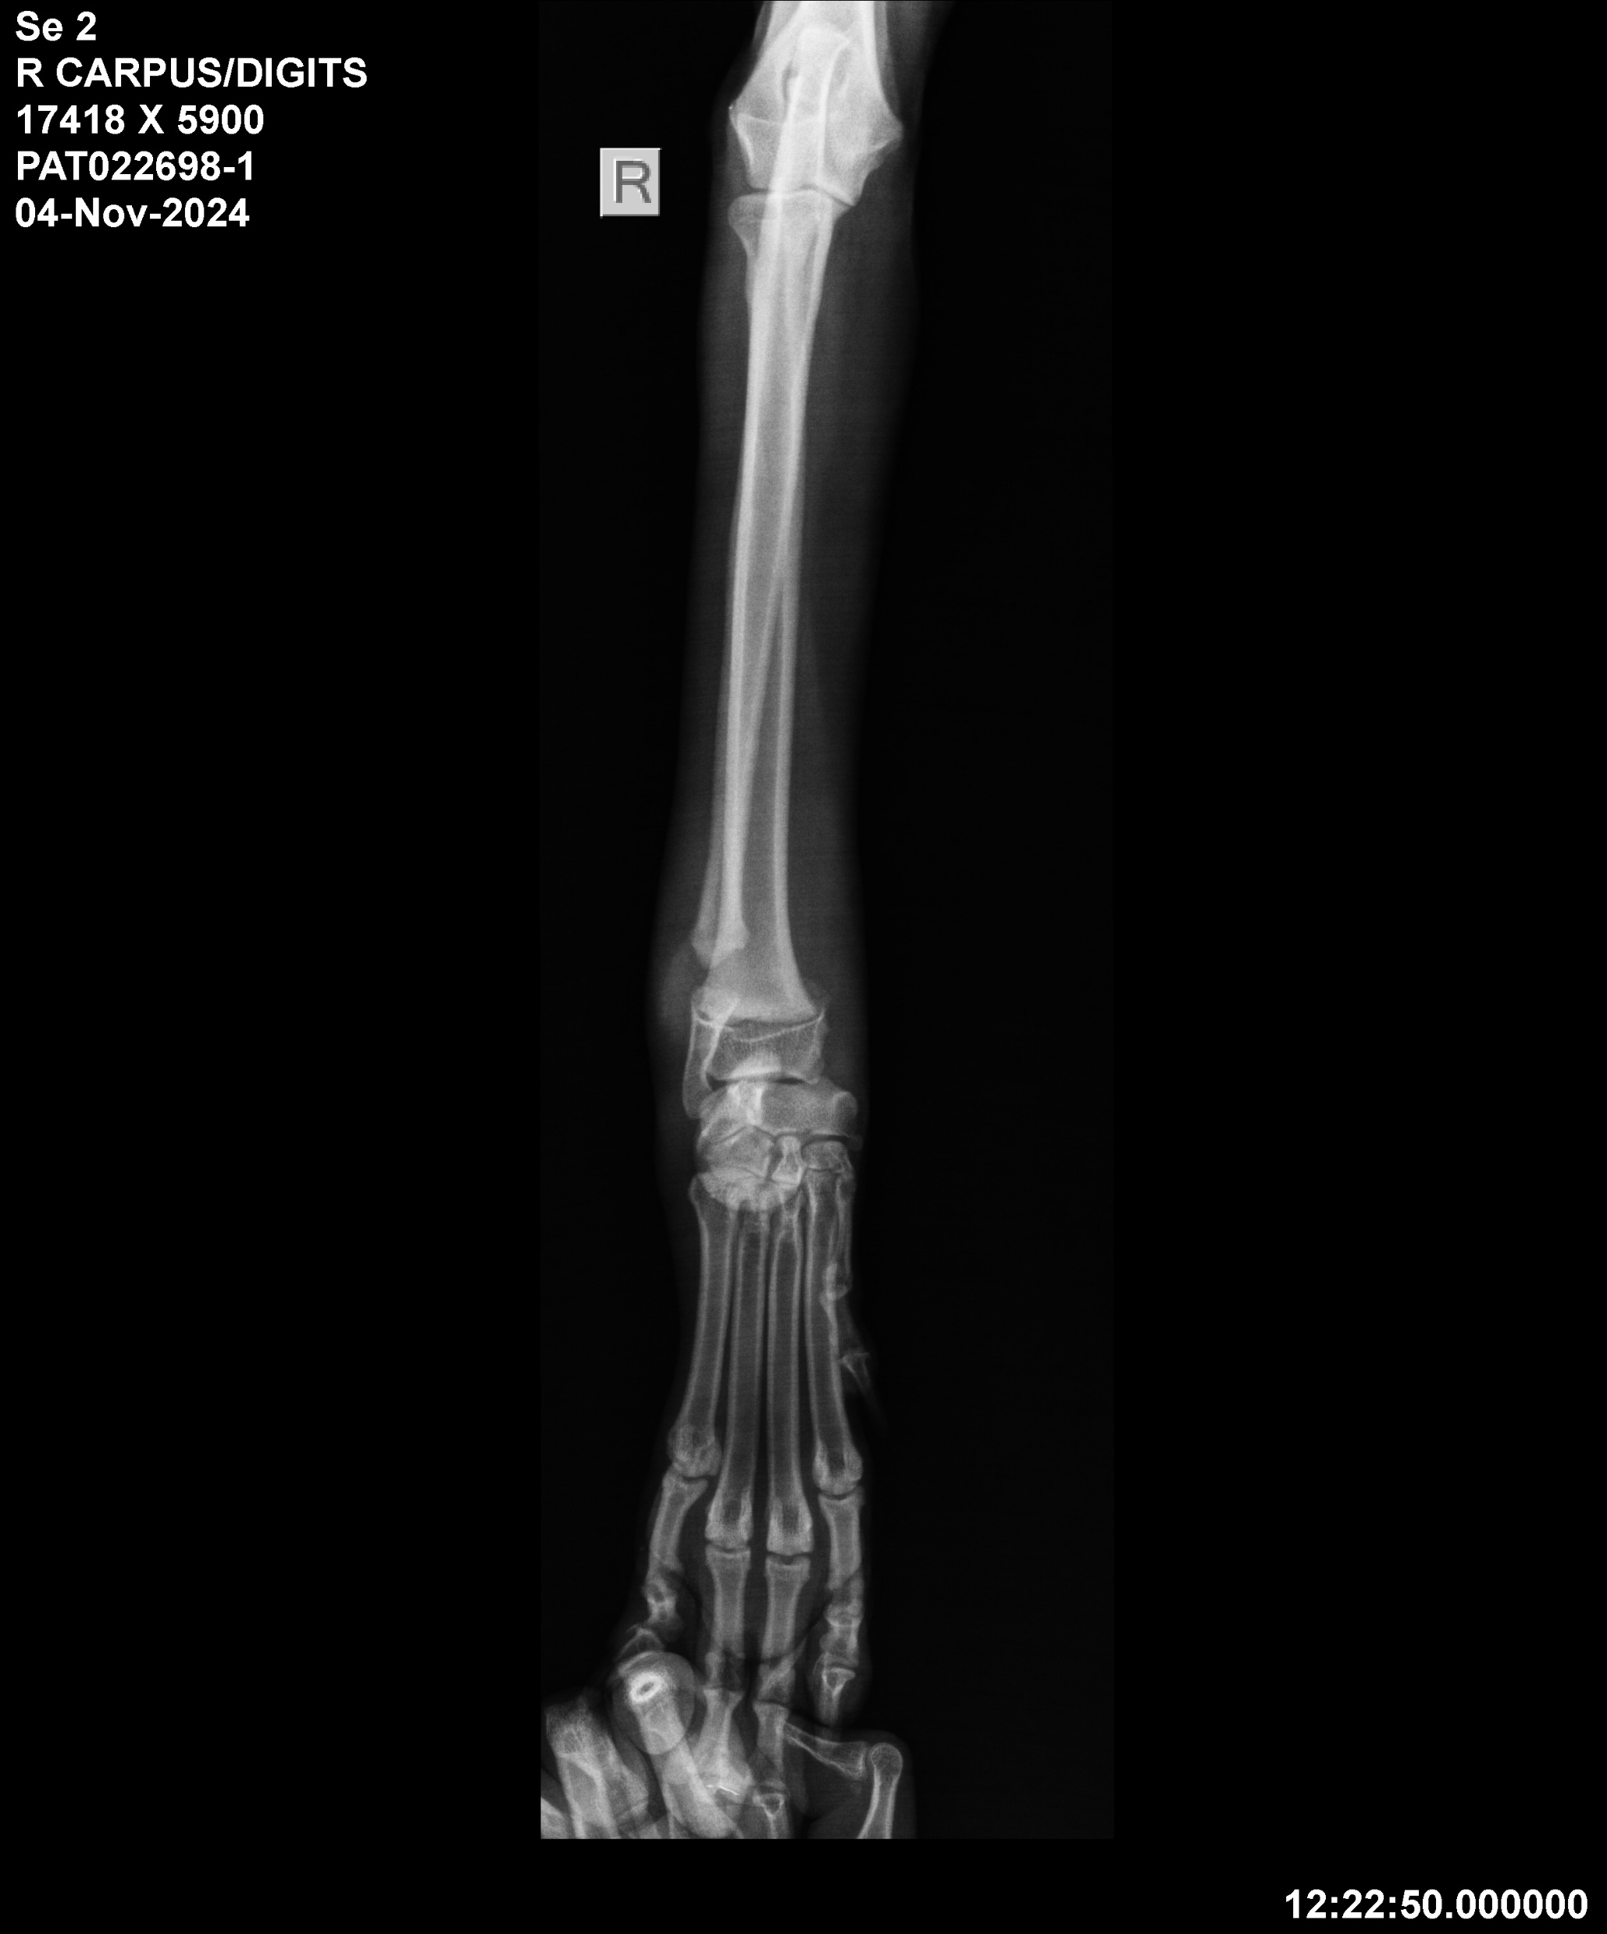
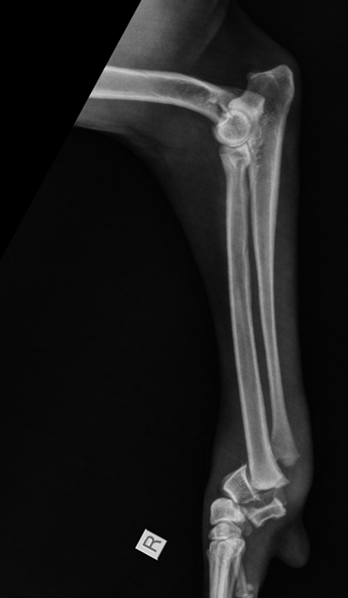
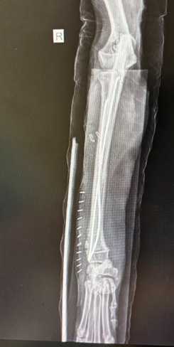
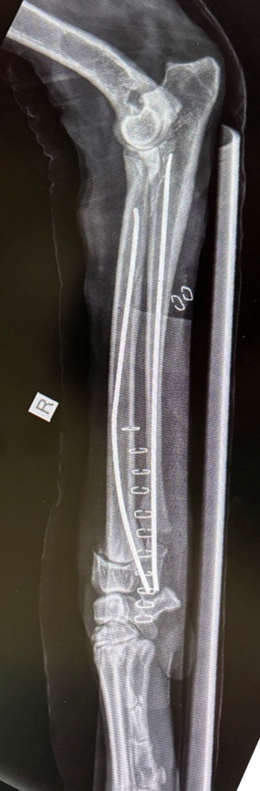
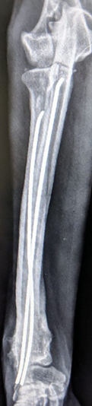
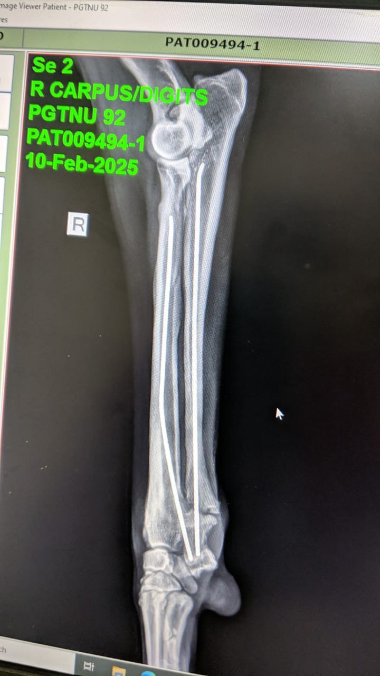
a
b
c
d
e
f
a and b: Pre operative radiographs of right radius ulna
c and d: Immediate post operative radiographs
e and f: 90 days post operative radiographs showing proper callus formation.

Fig 2: radiographic findings

Disclaimer (Artificial intelligence)
Option 1:
Author(s) hereby declare that NO generative AI technologies such as Large Language Models (ChatGPT, COPILOT, etc.) and text-to-image generators have been used during the writing or editing of this manuscript.

References

Cook, J. L., Tomlinson, J. L., & Reed, A. L. (1999). Fluoroscopically guided closed reduction and internal fixation of fractures of the lateral portion of the humeral condyle: prospective clinical study of the technique and results in ten dogs. Veterinary Surgery, 28(5), 315-321. https://doi.org/10.1111/j.1532-950x.1999.00315.x
Fish, F. E., Sheehan, M. J., Adams, D. S., Tennett, K. A., & Gough, W. T. (2021). A 60:40 split: Differential mass support in dogs. Anatomical Record (Hoboken), 304(1), 78-89. https://doi.org/10.1002/ar.24407
Gupta, N., Kumar, A., Sangwan, V., Singh, T., & Gupta, A. (2023). A comparative study between stainless steel and titanium elastic nails in the surgical management of canine juvenile femoral fractures. The Indian Journal of Animal Sciences, 93(04), 337-341.
Gupta, N., Kaur, K., Sangwan, V., & Kumar, A. (2024). Hospital Occurrence Pattern Of Appendicular Fractures In Dogs For 3 Consecutive Years (2019–2021). International Journal Of Livestock Research, 14(10), 17-29. http://ijlr.org/ojs_journal/index.php/ijlr/article/view/884
Harasen, G. (2003). External coaptation of distal radius and ulna fractures. The Canadian Veterinary Journal, 44(12), 1010-1011. https://pubmed.ncbi.nlm.nih.gov/14703093/
Jackson, L. C., & Pacchiana, P. D. (2004). Common complications of fracture repair. Clinical Techniques in Small Animal Practice, 19(3), 168-179 https://doi.org/10.1053/j.ctsap.2004.09.008
Khuntia, S., Swaroop, S., Patro, B. P., & Sahu, S. (2020). Paediatric Long Bone Fractures Managed with Elastic Intramedullary Nails: A Retrospective Study of 30 Patients. Cureus. https://doi.org/10.7759/cureus.7847
Kumar, A., Qureshi, B., & Sangwan, V. (2020). Biological Osteosynthesis in Veterinary Practice: A Review. International Journal of Livestock Research, 10(10), 24-31. https://doi.org/10.5455/ijlr.20200718
Kushwaha, R. B., Gupta, A. K., Bhadwal, M. S., Kumar, S., & Tripathi, A. K. (2011). Incidence of Fractures and their Management in Animals: a Clinical Study of 77 Cases. Indian Journal of Veterinary Surgery, 32(1), 54-56.
Larsen, L. J., Roush, J. K., & McLaughlin, R. M. (1999). Bone Plate Fixation of Distal Radius and Ulna Fractures in Small- and Miniature-Breed Dogs. Journal of the American Animal Hospital Association, 35(3), 243-250. https://doi.org/10.5326/15473317-35-3-243
Perren, S. M. (2002). Evolution of the internal fixation of long bone fractures: The scientific basis of biological internal fixation: Choosing a new balance between stability and biology. The Journal of Bone & Joint Surgery British Volume, 84(8), 1093-1110. https://doi.org/10.1302/0301-620x.84b8.13752

Prabhukumar, M. D., Dileepkumar, K. M., Devanand, C. B., Venugopal, S. K., Raj, I. V., Anoop, S., Nair, S. S., & Philip, L. M. (2020). Elastic stable intramedullary nailing for fixation of distal diaphyseal fracture of radius in two dogs. Indian Journal of Veterinary Surgery, 41(2), 134-136. https://www.researchgate.net/publication/352570000_Elastic_stable_intramedullary_nailing_for_fixation_of_distal_diaphyseal_fracture_of_radius_in_two_dogs

Saka, G., Saglam, N., Kurtulmus, T., Avci, C. C., Akpinar, F., Kovaci, H., & Celik, A. (2014). New interlocking intramedullary radius and ulna nails for treating forearm diaphyseal fractures in adults: a retrospective study. Injury, 45, s16-s23. https://doi.org/10.1016/j.injury.2013.10.040

Simon, M. S., Ganesh, R., Ayyappan, S., & Kumar, R. S. (2011). Incidence of pectoral limb fractures in dogs: A survey of 331 cases. Tamilnadu Journal of Veterinary and Animal Sciences, 7(2), 94-96. https://krishikosh.egranth.ac.in/handle/1/58100000000000000000

Sodhi, H. S. (2021). EVALUATION OF TITANIUM ELASTIC NAILS FOR THE MANAGEMENT OF RADIUS-ULNA AND FEMORAL FRACTURES IN DOGS (Doctoral dissertation, Guru Angad Dev Veterinary and Animal Sciences University).

Sodhi, H. S., Kumar, A., Anand, A., Sangwan, V., & Gupta, D. K. (2024). Titanium elastic nails for distal radius-ulna fractures in young dogs. Indian journal of animal research, 58(4), 642-647. https://doi.org/10.18805/IJAR.B-4509

