Age concerning sexuality and spermiogram of Malpura rams in semi arid tropics

Abstract
AIMS: In the realm of sustainable livestock production, extending the productive lifespan of breeding stock could be an important strategy for enhancing economic viability and resource efficiency. Such information has been unbailable for the ram native to semi-arid tropics. Hence the study aimed to evaluate the Sexuality and Spermiogram Malpura rams raised and maintained in the semi-arid subtropical region of northwest India.
PLACE OF STUDY: Animal Physiology and Biochemistry Division, ICAR-Central Sheep and Wool Research, Avikanagar, Rajasthan.
METHODOLOGY: Rams were distributed equally into two groups categorized on age: G1 (2-3 years, n=13) and G2 (6-7 years, n=13). Semen was collected biweekly over six weeks during May-July 2024. Amongst the sexual behaviors, time to mount, number of mounts, ejaculation time, nudging, pawing, and flehmen response were observed.
RESULTS: The older rams (G2) mounted more quickly (2 ± 0.35 s vs. 3 ± 0.48 s) and exhibited more frequent nudging and higher pawing behavior than the younger rams in G1. Semen volume was significantly lower in G2 (0.71 ± 0.10 ml vs. 1.15 ± 0.14 ml, p<0.05), with a higher percentage of watery samples (10.71% vs. 0%). However, sperm concentration, mass motility, viability and morphology showed no significant differences (p>0.05).
CONCLUSION: While aging reduces semen volume, possibly due to diminished seminal vesicle and accessory gland efficiency, Malpura rams aged 6-7 years remain viable for breeding owing to comparable sperm quality and enhanced sexual behavior with the younger rams of 2-3 years of age.
Keywords: Age, Malpura, Rams, Semen, Sexual behavior

- Introduction
Reproductive efficiency is a critical factor in livestock management. Among the small ruminants reared in the semi-arid plains of Rajasthan, the Malpura breed of sheep is known for its mutton quality and coarse wool production. Malpura rams are known for their hardiness, which allows them to thrive in the harsh climatic conditions of the semi-arid region. The breed’s adaptability, combined with its dual-purpose nature, makes it an integral part of the local farming systems in the region under low-input conditions where feed scarcity and heat stress are major constraints in animal production. Semen quality and sexual behavior are crucial factors for fertilizing ability, influencing herd fertility and farm productivity (Khan et al., 2024). As rams mature, notable changes occur in their sexual behavior and semen quality that can significantly impact reproductive performance. These changes are influenced by various factors, including hormonal fluctuations, physical development, and environmental conditions that ultimately govern their fertility rates in breeding programs.
In the realm of sustainable livestock production, extending the productive lifespan of breeding stock could be an important strategy for enhancing economic viability and resource efficiency. Prolonged longevity in high-performing breeding animals can significantly mitigate the costs associated with herd renewal (Byun et al., 2012). Specifically, when genetically superior individuals maintain reproductive efficacy over extended periods, fewer replacement animals need to be raised, potentially reducing operational expenses. The onset of reproductive senescence has been shown to occur between 5 and 6 years of age (Mysterud et al., 2002). Sheep are culled at an average age of 5 years (Hoffman and Valencak, 2020), and the pattern is followed in the region of this study. As a result, careful management of rams at different life stages can help maximize their reproductive potential, thereby ensuring the success of breeding programs. Age is known to affect semen characteristics, with older animals often exhibiting reduced reproductive performance due to declines in sperm quality in canines (Zmudzińska et al., 2022), roosters (Haryuni et al., 2022), and bulls (Satrio et al., 2024). Understanding the mechanisms of reproductive aging can extend the breeding utility of valuable rams, optimizing their use in artificial insemination and natural mating programs.
While it is well established that rams attain their optimal breeding age between 2 and 3 years, the reproductive viability and suitability of rams older than 5 years for breeding purposes remain largely unexplored. Thus, we aimed to evaluate the effects of age on sexual behavior and semen quality in Malpura rams, comparing younger (2-3 years) and older (6-7 years) individuals. The objective was to assess key semen characteristics (volume, consistency, sperm concentration, mass motility, viability, and morphology) and sexual behaviors (time to mount, number of mounts, ejaculation time, nudging, pawing, and flehmen response) to determine their suitability for breeding across age groups.

- Materials and methods
2.1 Experimental Design and Animals
The study was conducted over six weeks during May-June 2024 at the Experimental Animal Farm of the Indian Council of Agricultural Research-Central Sheep and Wool Research Institute, Avikanagar, located in the semi-arid region of India. The location is at an altitude of 320m above mean sea level, Longitude 75°28´E and Latitude 26°26´N. The annual temperatures range between 3° and 46°C, with annual relative humidity (RH) between 10% and 85%. During the experimental period, the average minimum and maximum temperature was 31.23°C, and 41.03°C respectively. Average relative humidity was 73.05% in the morning (8:00h) and 66.19% in the afternoon (14.00h). The average sunshine hours were 7.66 h and wind velocity was 4.1 km/h. Twenty-six healthy Malpura rams free form disease was randomly assigned to two groups based on age: G1 (2-3 years, n=13, body weight 53.05 ± 1.4 kg) and G2 (6-7 years, n=13, body weight 51.91 ± 1.8 kg). The rams were maintained under standard management conditions, with access to concentrate feed at the rate of 150g/animal/day, green fodder (millet grass, green oats, sorghum, or hybrid napier as per availability in the farm), chopped dry fodder (Cenchrus ciliaris) and clean drinking water ad libitum. Drinking water was sourced from underground borewell. Rams were housed in a well-ventilated semi open shed (60ft length x 20ft wide) with covered roof of galvanized iron sheets and a 5 ½ ft high meshed chain-link (galvanized iron) enclosure raised over a toe wall of 2 ft 3″. Internal height at the apex of the shed from the floor was 10 ft 10″. The sheds were routinely cleaned and disinfected periodically as per standard protocol of the institute. Hot weather conditions, adequate solar radiation, proper ventilation and regular cleaning prevented infestation by pests or rodents. All animals were vaccinated as per the health calendar for sheep which is strictly followed in the institute.
2.2 Semen Collection and Analysis
Semen was collected biweekly using a sterile standard artificial vagina (AV). The outer rubber of AV was 6-8″ long, having a 1.57″ diameter and an inner latex liner 10-12″ long of 1.5″ diameter. The temperature of the AV was maintained between 42-43°C. Ejaculates obtained during the first week of collection were excluded to allow clearance of aged epididymal spermatozoa and to ensure optimal semen quality in subsequent collections. Of the total 260 attempts for semen collection, 62 were unsuccessful (n=44 in G1; n=18 in G2) when rams did not either ejaculate semen or did not properly ejaculate in the collection cup. Consequently, 198 ejaculates were analyzed for volume, consistency, sperm concentration, mass motility, viability, and morphology. Semen was kept at 37°C and evaluated immediately upon collection. The volume of the semen (ml) was recorded directly from the precisely graduated 5 ml conical collection cups of borosilicate glass in which semen was collected by AV. Consistency, i.e., the concentration of semen visualized through the naked eye against natural light, was assessed by slightly tilting the collection cup. Consistency was graded as thick, medium, thin, and watery. Sperm concentration was determined in a photocolorimeter (×10⁶/ml) previously standardized for concentration against OD. Mass motility of the spermatozoa was assessed by observing wave motions of a freshly collected semen drop in a brightfield Microscope (Zeiss Primostar 1, Carl Zeiss Suzhou Co., Ltd., China) at a low magnification (10×) and scored on a scale from 0 (no motility) to 5 (excellent motility). Viability was assessed as percentages of live and dead sperms determined from a fixed-smear stained with eosin-nigrosin. Two hundred sperms were calculated from different fields in the stained smear. The colored head sperm was calculated as a dead sperm, while a colorless head sperm was considered as a live sperm (Fig.1).

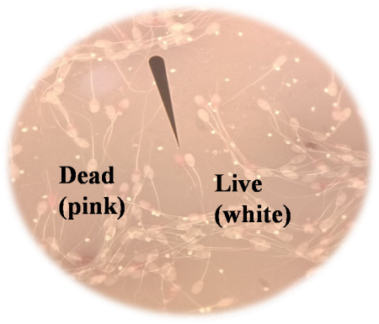
Fig.1 Plasmalemma integrity of ram sperm-Eosin Nigrosin staining
The slide prepared with eosin-nigrosin stain was used to examine the sperm morphology. For each slide, two hundred spermatozoa were examined and evaluated for head, mid-piece, and tail abnormalities (Fig.2).
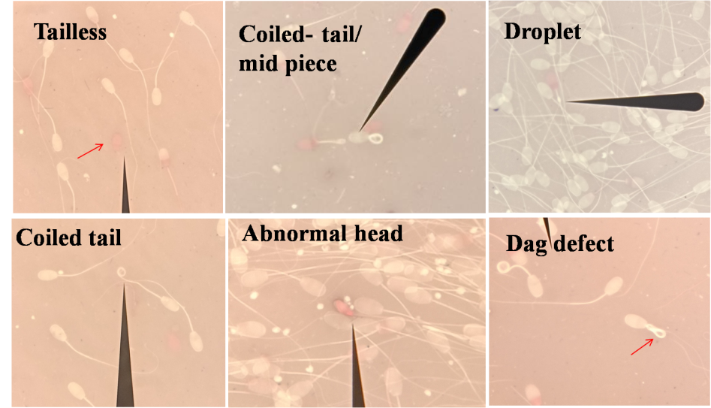
Fig.2 Assessment of Sperm plasmalemma integrity, Morphology (Eosin-Nigrosin stain)

2.3 Sexual Behavior Assessment
The rams were released one by one and allowed to mount the dummy before semen collection during which sexual behaviors were observed. During the semen collection sessions,the behavior observed included: time to mount (time from release to mounting in seconds), number of mounts (total mounts attempted before ejaculation), ejaculation time (time from successful mounting to ejaculation in seconds), nudging and pawing (frequency of dominance assertion behaviors), flehmen response (lip curl facilitating odorant transport to the vomero-nasal organ).
Rams were individually allowed to mount the dummy for semen collection. The behavioral observations included time to mount (time from release to mounting in seconds), number of mounts (total mounts attempted before ejaculation), ejaculation time (time from successful mounting to ejaculation in seconds), frequency of nudging, and pawing (frequency of dominance assertion behaviors) and flehmen response (lip curl facilitating odorant transport to the vomero-nasal organ).

2.4 Statistical Analysis
Statistical analyses were carried out in data analysis pack of Microsoft office Excel 2010 (v14.0). Test included, student’s t-test for independent sample (with unequal sample size and variances) to compare means between the two age groups for semen parameters and sexual behaviors. Morphological abnormalities were compared using a chi-square test. Significance was set at p≤0.05 or mentioned otherwise. Results are presented as mean ± standard error.

3. Results
3.1 Sexual Behavior
The intensity of different sexual behaviors as observed in the two groups is presented in Fig 3. Older rams (G2) mounted more quickly than younger rams. The number of mounts and ejaculation time were not significantly different between the groups. Older rams exhibited 23.7% more frequent nudging and a higher incidence of pawing (69.23% vs. 53.85%). The flehmen response frequency was comparable and the differences were not significant between groups
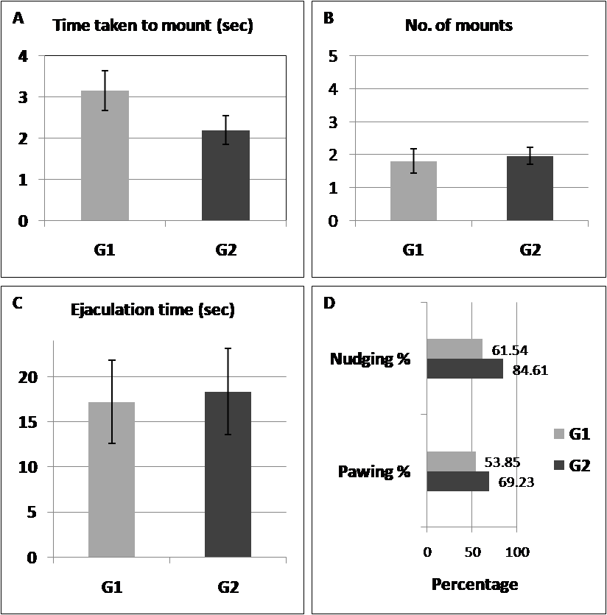
Fig. 3 (A-D) Sexual behavior of Malpura rams. Time taken to mount (sec), Number of mounts, Ejaculation time (sec), Percentage of G1 (younger) and G2 (older) rams showing nudging and pawing behavior.

3.2 Semen Quality
Semen quality parameters in different age groups of Malpura rams are given in Table 1. Younger rams produced significantly higher semen volume compared to older rams. Semen with watery consistency were observed only in the older rams (1.71%). Mass motility scores (4.62 ± 0.16 in G1 vs. 4.16 ± 0.48 in G2) and sperm viability did not differ significantly between groups. Morphological abnormalities were slightly higher in older rams but not statistically significant.
Table 1: Basic semen characteristics of Malpura rams of different age groups
Parameter | G1 (2-3 years) | G2 (6-7 years)
Semen volume (ml) | 1.15 ± 0.14 | 0.71 ± 0.10*
Concentration (10⁹/ml) | 3.85 ± 0.34 | 4.03 ± 0.47
Viability (%) | 76.38 ± 1.35 | 74.69 ± 3.62
Head abnormalities (%) | 0.56 ± 0.15 | 0.91 ± 0.36
Mid-piece abnormalities (%) | 0.67 ± 0.08 | 1.98 ± 0.87
Tail abnormalities (%) | 0.46 ± 0.07 | 1.15 ± 0.43
* values between rows differ significantly with each other p <0.05.

4. Discussion
The study revealed that aging does influences some of the reproductive parameters in Malpura rams. Quicker mounting time and increased nudging and pawing behavior in older rams suggest an increased sexual vigor, possibly due to greater experience gained over the years or a well-established instinct of dominance in the rams. These behaviors align with previous studies which have indicated that older rams may exhibit more assertive pre-copulatory behaviors (Yilmaz et al., 2009). Older rams demonstrate superior sexual behavior traits, including more frequent tail rising, vocalizations, and ejaculations compared to younger rams. This is supported by previous reports wherein rams aged three years or older outperformed two-year-old rams also characterized by longer ejaculation durations and higher ejaculation efficiency, indicating more effective mating capabilities (Yilmaz et al., 2009; Mostafa & Farghal, 2019). Maturation process leads to improved sexual performance in rams, as evidenced by the increased frequency of mounts and less mount attempts in older rams compared to younger ones (Price et al., 1991). Older rams also have higher testosterone levels and larger scrotal circumferences, which are associated with enhanced sexual behavior. For instance, older Egyptian rams showed better sexual performance and larger scrotal circumferences than younger ones (Mostafa & Farghal, 2019). However, this maturation-driven improvement noticeable in higher mount frequencies, contrasts with juvenile stability. It has also been observed that while genetics minimally influences early libido, age exerts stronger effects in adult semi-tropical rams. Abecia et al. (2022) reported no MTNR1A genotype effects on similar behaviors (e.g., pawing- 6% of events and uniform flehmen/mounting) in 8-month-old Rasa Aragonesa ram lambs under temperate conditions.
Flehmen response is linked to detection of estrus through vomeronasal organ, which is crucial for mating behaviors in rams (Hart, 1983). Studies have shown that flehmen response frequency does not significantly differ between rams exposed to different mating stimuli, such as recently mated versus non-mated rams (Maina & Katz, 1997). This consistency suggests that olfactory-driven flehmen response is a stable behavior, not easily altered by external stimuli or age. In a study of native sheep, semen volume peaked at three years and then stabilized, suggesting that older rams may experience a decline in seminal fluid production (Hassan et al., 2010). The significant reduction in semen volume in older rams observed in the present study corroborates previous findings in other species, viz., Landrace boars (Sumardani et al., 2019), stallions (Multigner et al., 1999), and men (Molina et al., 2010), where aging impacts seminal vesicle and accessory gland function. This reduction may limit the number of inseminations possible per ejaculate, affecting breeding efficiency in artificial insemination programs. In a study, aged rams (7.5 years) were found more likely to be suitable for breeding ahead of the younger aged groups (1 and 2.5 years) (Hedia and El-Shalofy, 2021).
The absence of significant differences in sperm concentration, mass motility, viability, and morphology between the older and younger rams in the current study indicates that older Malpura rams retain adequate sperm quality for breeding, consistent with studies in other breeds. Previous studies have also reported no significant differences in sperm concentration and motility between younger (2-3 years) and older (6-7 years) rams ((Rodríguez-Almeida et al., 2008, Buša et al., 2019, Andreeva & Stefanov, 2020). In a study involving rams aged 6 years, sperm motility and concentration were found to be satisfactory, supporting the notion that older rams can still produce viable sperm (Petrean et al., 2023). Non-significant age-related differences morphological characteristics are also suggestive of retention of normal sperm structure in older rams (Belkhiri et al., 2017).
Visual evaluation of the ejaculate with respect to color can be a good index for sperm concentration. The higher incidence of watery semen in older rams may reflect reduced seminal plasma contributions, potentially linked to age-related declines in accessory gland function. While morphological abnormalities were slightly higher in older rams, the lack of statistical significance suggests minimal impact on fertility, as such abnormality rates are found to be generally acceptable for breeding.
The current study was conducted in a single breed of this region. To enhance the reliability and comprehensiveness of the findings, the authors suggest future research to be undertaken in different breeds of specific geographical regions. Additionally, animals beyond 7 years of age may also be included in a large sample study in order to establish the most sustainable age of breeding rams for culling.

5. Conclusion
This study concludes that older Malpura rams (6-7 years) exhibit more frequent and intense sexual behaviors compared to younger rams (2-3 years). However, aging significantly reduces semen volume, which is possibly due to decreased seminal vesicle and accessory gland efficiency. The comparable sperm concentration, mass motility, viability, and morphology between age groups show that Malpura rams aged 6-7 years remain suitable for breeding. The study supports continued use of older rams in breeding programs upto 7 years of age, potentially extending their productive lifespan and enhancing farm efficiency.
Ethical Approval
All experimental procedures on rams conformed to the guidelines as approved by the Institute Animal Ethics Committee (CSWRI/IAEC/2024-25/01-06).
COMPETING INTERESTS
The authors declare that no competing interests exist.
Disclaimer (Artificial Intelligence)
Author(s) hereby declare that NO generative AI technologies such as Large Language Models (ChatGPT, COPILOT, etc.) and text-to-image generators have been used during the writing or editing of this manuscript.
AUTHORS’ CONTRIBUTIONS

Author ‘VK’ designed the study, wrote the protocol, performed the statistical analysis and approved the final draft of the study. Author ‘VR’ executed the study and wrote the first draft of the manuscript. ‘SSD’ and ‘ASM' managed experimental animals and analyses of the study. All authors read and approved the final manuscript.

References
- Abecia, J. A., Casao, A., Canto, F., Mura, M. C., Luridiana, S., Carvajal-Serna, M.,... & Carcangiu, V. (2022). Polymorphisms of the melatonin receptor 1A (MTNR1A) gene do not affect sexual activity, plasma testosterone concentrations or testicular characteristics of 8-month-old ram-lambs born in autumn. Journal of Animal Behaviour and Biometeorology, 10(4), 2240-2240.
- Andreeva, M., &Stefanov, R. (2020). Study of the relationship between the age of the rams and the quality of their ejaculates obtained outside the breeding season. Biotechnology in Animal Husbandry, 36(4), 437–445. https://doi.org/10.2298/BAH2004437A
- Belkhiri, Y., Bouzebda-Afri, F., Bouzebda, Z., &Mouffok, C. (2017). Age and season effects on sexual parameters in mature rams used in artificial insemination centre (Algeria). Global Veterinaria, 18(1), 31-40. https://doi.org/10.5829/idosi.gv.2017.31.40
- Buša, D., Macháč, M., Baláži, A., Svoradová, A., Vašíček, J., Jurčík, R., &Chrenek, P. (2019). Sperm motility of rams from two Slovak sheep breeds: short communication. Slovak Journal of Animal Science, 52(04), 178–180. https://sjas.ojs.sk/sjas/article/view/603
- Byun, S. O., Forrest, R. H., Frampton, C. M., Zhou, H., &Hickford, J. G. H. (2012). An association between lifespan and variation in insulin-like growth factor I receptor in sheep. Journal of Animal Science, 90(8), 2484-2487. https://doi.org/10.2527/jas.2011-4148
- Hart, B. L. (1983). Flehmen Behavior and Vomeronasal Organ Function. In D. Müller-Schwarze& R. M. Silverstein (Eds.), Chemical Signals in Vertebrates 3 (pp. 87–103). Springer US. https://doi.org/10.1007/978-1-4757-9652-0_5
- Haryuni, N., Hartutik, H., Widodo, E., Tribudi, Y. A., &Wahjuningsih, S. (2022). Impact of Aging on Sperm Quality of Sentul Roosters. JurnalIlmuTernak dan Veteriner. https://doi.org/10.14334/jitv.v27i4.3015
- Hassan, M. R., Pervage, S., Ershaduzzaman, M., &Talukder, M. (2010). Influence of age on the spermiogramic parameters of native sheep. Journal of The Bangladesh Agricultural University, 7(2), 301–304. https://doi.org/10.3329/JBAU.V7I2.4738
- Hedia, M., & El-Shalofy, A. S. (2021). Ageing affects plasma steroid concentrations and testicular volume, echotexture and haemodynamics in rams. Andrologia. https://doi.org/10.1111/and.14309
- Hoffman, J. M., &Valencak, T. G. (2020). A short life on the farm: aging and longevity in agricultural, large-bodied mammals. GeroScience, 42(3), 909–922. https://doi.org/10.1007/s11357-020-00190-4
- Khan, M. Z., Chen, W., Naz, S., Liu, X., Liang, H., Chen, Y., Kou, X., Liu, Y., Ashraf, I., Han, Y., Peng, Y., Wang, C., & Zahoor, M. I. (2024). Determinant genetic markers of semen quality in livestock. Frontiers in Endocrinology, 15. https://doi.org/10.3389/fendo.2024.1456305
- Molina, R. I., Martini, A. C., Tissera, A., Olmedo, J., Senestrari, D., Fiol de Cuneo, M., & Ruiz, R. D. (2010). Semen quality and aging: analysis of 9.168 samples in Cordoba. Argentina. Archivos Españoles de Urología, 63(3), 214–222. https://doi.org/10.4321/S0004-06142010000300007
- Mostafa, A. S., & Farghal, M. M. (2019). A study on the effect of age, breed and season on sexual behaviour, testosterone concentrations and scrotal circumference in Egyptian rams. Journal of Veterinary Medical Research, 26(1), 91–100. https://doi.org/10.21608/JVMR.2019.43340
- Multigner, L., Magistrini, M., Ducot, B., & Spira, A. (1999). Secular sperm trends in stallions between 1981 and 1996. Journal of Andrology, 20(6), 763-768.
- Mysterud, A., Steinheim, G., Yoccoz, N. G., Holand, Ø., &Stenseth, N. C. (2002). Early onset of reproductive senescence in domestic sheep Ovis aries. Oikos, 97(2), 177-183. https://doi.org/10.1034/j.1600-0706.2002.970203.x
- Petrean, A. B., Gog-Bogdan, S., Berean, D., Popescu, S., & Popescu, S. (2023). Assessment of some microscopic parameters of ram semen correlated with the age of the animals. Scientific Papers Journal Veterinary Series. https://doi.org/10.61900/SPJVS.2023.01.04
- Price, E. O., Estep, D. Q., Wallach, S. J. R., & Dally, M. R. (1991). Sexual performance of rams as determined by maturation and sexual experience. Journal of Animal Science, 69(3), 1047–1052. https://doi.org/10.2527/1991.6931047x
- Rather, M. A., Bashir, I., Kuthu, B. A., Baba, J. A., & Hamadani, A. (2021). Factors affecting greasy fleece yield in Kashmir Merino sheep. Indian Journal of Small Ruminants, 27(1), 126-128.
- Rodríguez-Almeida, F. A., Ávila Cota, C. O., Anchondo Garay, A., Sánchez-Ramírez, B., Jiménez Castro, J. A., & Almada, F. R. (2008). Sperm capacitation induced by conservation of diluted, refrigerated, or frozen ram semen. http://www.scielo.org.mx/pdf/agro/v42n4/v42n4a2.pdf
- Satrio, F. A., Karja, N. W. K., Setiadi, M. A., Kaiin, E. M., Pardede, B. P., &Purwantara, B. (2024). Age-dependent variations in proteomic characteristics of spermatozoa in Simmental bull. Frontiers in Veterinary Science, 11. https://doi.org/10.3389/fvets.2024.1393706
- Sumardani, N. L. G., Budaarsa, K., Putri, T. I., &Puger, A. W. (2019). Age affects semen volume and motility of spermatozoa Landrace boar's of Baturiti Artificial Insemination Center, Tabanan, Bali. Jurnal Veteriner, 20(3), 324-329. https://doi.org/10.19087/jveteriner.2019.20.3.324
- Yılmaz, A., Karakuş, F., &Yeşilova, A. (2009). Sexual Behaviour Characteristics in Norduz and Karakaş Rams and Changes with Age. Journal of Agricultural Sciences https://doi.org/10.1501/Tarimbil_0000001100
- Zmudzińska, A., Wisniewski, J., Młynarz, P., Olejnik, B., &Mogielnicka-Brzozowska, M. (2022). Age-Dependent Variations in Functional Quality and Proteomic Characteristics of Canine (Canislupus familiaris) Epididymal Spermatozoa. International Journal of Molecular Sciences, 23(16), 9143. https://doi.org/10.3390/ijms23169143

