Diversity analysis for morphological traits in Tomato (Solanum lycopersicum L.)

Abstract
Morphological cluster analysis in fifty eight genotypes of tomato revealed considerable genetic diversity and grouped genotypes into 12 different clusters. Selection of parents from most divergent clusters, having high cluster means and showing high performance can be used in hybridization programme for development of high yielding varieties. Maximum per cent contribution towards total genetic divergence was observed from average fruit weight followed by fruit diameter and fruit length suggesting that selection of one or two elite genotypes from such divergent clusters based on the above characters and crossing would result in more heterosis.

Key words: Tomato, Diversity, Morphological characters.

Introduction
Genetic diversity analysis assists in interpreting the genetic background and breeding value of the germplasm. Wide range of variability in shape and size and colour of mature fruits and other character are found within tomato. As a result of its wide diversity in gene pool and consequent improvement in selection and breeding, a large number of cultivars have adapted to different agro- climatic conditions (Villarel et al., 1998). A lot of diversity is also found in growth and development pattern of tomato due to altitudinal variation (Sharma and Singh, 2012). Multivariate technique using D² statistics (Mahalanobis, 1928) is a powerful tool in quantifying the degree of divergence among the genotypes which is helpful to screen the genetically diverse parents that are likely to produce high heterotic effects among crosses and also generate large spectrum of variability during segregation and recombination of genes at heterozygous polygenic blocks.
Underutilized extant diversity within and between the tomato species could serve as a valuable resource to enrich the genetic pool of cultivated tomatoes with marginalized alleles that could increase productivity and stress adaptation (Gur et al, 2004). The low genetic diversity of cultivated tomatoes necessitates the use of modern molecular techniques for the discovery of markers able to detect minor variations within tomato germplasm (Foolad and Panthee, 2012).

Materials and Methods:
Experimental Site and Plant Material
The present investigation was conducted during Kharif 2021 at the Vegetable Experimental Farm, Division of Vegetable Science, Sher-e-Kashmir University of Agricultural Sciences and Technology of Kashmir (SKUAST-K), Shalimar, Srinagar. The experimental farm is located in the temperate agro-climatic zone of Kashmir valley and represents typical conditions for tomato cultivation in the region. Laboratory analysis of quality parameters was carried out at the NSP Laboratory, Division of Genetics and Plant Breeding, SKUAST-K, Shalimar during Kharif 2022.

A total of fifty-eight diverse genotypes of tomato (Solanum lycopersicum L.) were used as experimental material. These genotypes were procured from NBPGR, New Delhi; IIVR, Varanasi; PAU, Ludhiana, and local collections of Kashmir valley. The genotypes represented a wide range of genetic backgrounds and were selected based on their potential importance in breeding programmes.

Experimental Design and Crop Management
The experiment was laid out in a Randomized Complete Block Design (RCBD) with three replications. Each genotype was grown in uniform plots with a spacing of 45 cm between rows and 30 cm between plants, following recommended agronomic practices for tomato cultivation. Standard cultural operations such as irrigation, weeding, fertilization, and plant protection measures were uniformly applied to all plots to minimize environmental variation and ensure healthy crop growth.

Data Recording
Observations were recorded on fifteen morphological, yield, and quality-related traits, following standard descriptors and procedures. The traits studied included:

Plant height (cm)
Number of primary branches per plant
Days to 50 per cent flowering
Days to first fruit harvest
Number of fruits per plant
Number of fruits per cluster
Average fruit weight (g)
Fruit length (cm)
Fruit diameter (cm)
Pericarp thickness (mm)
Fruit yield per plant (kg)
Total soluble solids (°Brix)
Titratable acidity (%)
Ascorbic acid content (mg 100⁻¹ g)
Lycopene content (mg 100⁻¹ g)

Observations on growth, flowering, and yield parameters were recorded from five randomly selected plants per genotype in each replication, while quality parameters were analyzed using representative fruit samples under laboratory conditions.

Statistical Analysis
Genetic divergence among tomato genotypes was assessed using Mahalanobis D² statistics as described by Mahalanobis (1936). The D² values were used to quantify genetic distances among genotypes based on multiple traits simultaneously. Based on the calculated D² values, the genotypes were grouped into clusters using Tocher’s method to identify genetically similar and divergent groups.

The intra-cluster and inter-cluster distances were computed to assess the extent of genetic diversity within and between clusters. Cluster mean values were calculated for all traits to identify clusters possessing superior performance for specific characters. Additionally, the percentage contribution of each trait towards total genetic divergence was estimated to determine the relative importance of individual traits in differentiating the genotypes.

All statistical analyses were carried out using standard statistical procedures appropriate for multivariate analysis.

Results and Discussion
In the present study, fifty-eight genotypes of were evaluated to estimate the genetic divergence for identification of potential parents using Mahalanobis D² statistics. The genotypes were grouped into twelve clusters. The formation of different clusters with variable number of entries in each cluster indicated diversity among genotypes. The genotypes from different agro- ecological zones were found to be scattered in different clusters, which suggested that a pattern of clustering of accessions was independent of their geographical origin. The cluster dendrogram indicated that the maximum number of genotypes fell in cluster I (17). Cluster II consisted of 12 genotypes, cluster III comprised of 10 genotypes, cluster IV consisted of 9 genotypes and cluster XI consisted of 3 genotypes. Cluster V, VI, VII, VIII, IX, X and XII each consisted of single genotypes (Table 2 and Fig. 1).
Utility of multivariate analysis in selecting genetically divergent parents for successful hybridization in tomato has been discussed by Zhang et al. (2019); Kumar et al. (2015); Dufera (2014); Bhattarai et al. (2018). The intra cluster distance ranged from 0.00 (cluster V, VI, VII, VIII, IX, X and XII) to 447.29 (cluster XI) (Table 3 and Fig. 2). The members of cluster XI exhibited maximum divergence (intra cluster distance 447.29) indicating high heterogeneity in genetic constitution of genotypes in that cluster while minimum intra cluster distance (D²) (cluster V, VI, VII, VIII, IX and XII) indicated homogeneity in genetic constitution of genotypes in that cluster. Highest inter cluster distance (D² value) was recorded between cluster III and XII (3819.03) followed by III and IV (3109.01) and VIII and XII (2594.69) indicating more heterogeneous genetic constitution of genotypes included in both clusters. In contrast, minimum inter cluster distance between cluster VI and VIII (161.70) followed by V and IX (165.84) and II and V (417.75) indicated closer relationship among the genotypes included (Farhad et al. (2010); Pujar et al. (2017)).
Cluster V recorded maximum value seed yield per fruit (0.33), number of primary branches per plant (5.53), seed yield per plant (7.56) and minimum value for number of pickings (4.13). Cluster VI recorded maximum value days to 1st flowering (39.33), days to 1st fruit set (49.07), days to 1st fruit harvest (88.13), pericarp thickness (5.21), number of fruits per plant (25.53) and minimum value for number of primary branches per plant (5.53). Cluster X recorded maximum value for number of fruits per cluster (5.07) and number of pickings (5.80). Cluster XI recorded maximum value for fruit yield per plant (1.09), fruit yield per hectare (814.15). Cluster IX recorded maximum value for fruit length (6.14). Cluster IV recorded maximum value for average fruit weight (61.86). Cluster XII recorded maximum value number for number of locules (4.73), plant height (117.05), fruit diameter (6.75) and duration of fruiting/harvest (41.67) while cluster IX recorded minimum values for number of locules (2.60), plant height (92.04), number of fruits per cluster (3.67), pericarp thickness (2.14), number of primary branches per plant (4.13), number of fruits per plant(13.87), fruit yield per plant (0.32), fruit yield per hectare (239.27). Thus, the traits showing high contribution towards genetic divergence can be improved upon by selecting the genotypes from those clusters having maximum cluster means for the respective traits, which in turn depends upon the objective of the breeding programme.
Persual of the results representing cluster means (Table 4) for different growth characters revealed that considerable differences for all the characters among clusters. Tremendous potential was found to exist for converging the elite allelic resources present in the current set of tomato genotypes through a systematic breeding and selection approach so as to recover high yielding recombinants, with good quality characteristics. Selection of the parents for hybridization should be done from different clusters having wide inter-cluster distance and those selected parents should have high per se performance for the traits contributing maximum towards divergence (Singh et al., 1996). Clusters consisting of only one genotype with specific traits could be used in hybridisation programme for the exploitation of heterosis mainly as testers for expression of maximum heterosis.
Per cent contribution is a measure of how much each trait contributes to the variation in a complex trait, such as yield or quality. Per cent contribution can help to identify the most important traits for selection and breeding, as well as to understand the genetic basis and interactions of these traits. The traits contributing maximum towards the divergence should be given great emphasis for deciding the clusters to be chosen for hybridisation and the subsequent selection of the parents from the clusters be based on their per se performance. Persual of the Table 5 representing per cent contribution of the traits indicated that highest per cent contribution was observed from average fruit weight (31.82%) followed by fruit diameter (30.85%) and fruit length (28.92%) suggesting that selection of one or two elite genotypes from such divergent clusters based on the above characters and crossing would result in more heterosis. Similar results were obtained by Maurya et al. (2019); Medagam et al. (2014); Ruthi et al. (2011); Singh et al. (2002) and Reddy et al. (2013b).

Table 1: Tomato (Solanum lycopersicum L.) genotypes used in the present study
S. No. | Genotype | Source | S. No. | Genotype | Source
 | EC 914106 | NBPGR, New Delhi | 30. | EC-163711 | NBPGR, New Delhi
 | EC 914093 | NBPGR, New Delhi | 31. | EC-521067 | NBPGR, New Delhi
 | EC 620402 | NBPGR, New Delhi | 32. | Shopian Sel-1 | Local
 | IARI-7 | IARI, New Delhi | 33. | EC-521067-B | NBPGR, New Delhi
 | EC 617047 | NBPGR, New Delhi | 34. | EC-367855 | NBPGR, New Delhi
 | EC 914114 | NBPGR, New Delhi | 35. | EC-159041 | NBPGR, New Delhi
 | Kashi Chayan | IIVR, Varanasi | 36. | EC-274122 | NBPGR, New Delhi
 | EC 914109 | NBPGR, New Delhi | 37. | EC-620389 | NBPGR, New Delhi
 | EC 620401 | NBPGR, New Delhi | 38. | EC-620372 | NBPGR, New Delhi
 | EC 914107 | NBPGR, New Delhi | 39. | EC-620373 | NBPGR, New Delhi
 | EC 914101 | NBPGR, New Delhi | 40. | EC-620775 | NBPGR, New Delhi
 | EC 914091 | NBPGR, New Delhi | 41. | EC-528368 | NBPGR, New Delhi
 | EC 914105 | NBPGR, New Delhi | 42. | EC-164625 | NBPGR, New Delhi
 | EC-241140 | NBPGR, New Delhi | 43. | EC-3176 | NBPGR, New Delhi
 | EC-165690 | NBPGR, New Delhi | 44. | EC-632943 | NBPGR, New Delhi
 | EC-145054 | NBPGR, New Delhi | 45. | EC-162516 | NBPGR, New Delhi
 | EC-164656 | NBPGR, New Delhi | 46. | EC-151568 | NBPGR, New Delhi
 | EC-144681 | NBPGR, New Delhi | 47. | EC-514109 | NBPGR, New Delhi
 | EC-145622 | NBPGR, New Delhi | 48. | EC-163605 | NBPGR, New Delhi
 | EC-157568 | NBPGR, New Delhi | 49. | EC-177343 | NBPGR, New Delhi
 | EC-620557 | NBPGR, New Delhi | 50. | KSP-5 | PAU, Ludhiana
 | EC-162518 | NBPGR, New Delhi | 51. | TIH-611 | PAU, Ludhiana
 | EC-620395 | NBPGR, New Delhi | 52. | TBR-2 | PAU, Ludhiana
 | EC-620639 | NBPGR, New Delhi | 53. | LVR-7 | PAU, Ludhiana
 | EC-249515 | NBPGR, New Delhi | 54. | R-ZT-2 | PAU, Ludhiana
 | EC-241148 | NBPGR, New Delhi | 55. | VN-1 | PAU, Ludhiana
 | EC-159053 | NBPGR, New Delhi | 56. | CLN-1621-L | IIVR, Varanasi
 | EC-145057 | NBPGR, New Delhi | 57. | EC-62038 | NBPGR, New Delhi
 | EC-162515 | NBPGR, New Delhi | 58. | EC-160194 | NBPGR, New Delhi

Table 2: Distribution of Tomato (Solanum lycopersicum L.) genotypes into clusters based on D² Statistics
Clusters | Number of genotypes in Cluster | Genotypes included
I | 17 | IARI-7, EC-620775, EC-274122, EC-367855, EC 617047, EC-620395, EC-620389, EC 914107, EC-163711, EC-145054, EC-620639, Shopian Sel-1, EC-159041, EC-177343, EC-528368, VN-1, KSP-5
II | 12 | EC 914114, EC-145622, EC-521067, EC-514109, EC 914093, EC-160194, EC-144681, EC-145057, EC 914101, EC-162516, EC 914106, EC-164656
III | 10 | EC-3176, VN-1, EC-914105, EC-62038, EC-620401, TBR-2, TIH-611, EC 914091, LVR-7, CLN-1621-L
IV | 9 | EC-157568, EC-521067-B, EC-162515, Kashi Chayan, EC 620402, EC 914109, EC-620557, EC-620373, EC-241140
V | 1 | EC-164625
VI | 1 | EC-159053
VII | 1 | EC-632943
VIII | 1 | EC-241148
IX | 1 | EC-163605
X | 1 | EC-249515
XI | 3 | EC-165690, EC-162518, EC-620372
XII | 1 | EC-151568

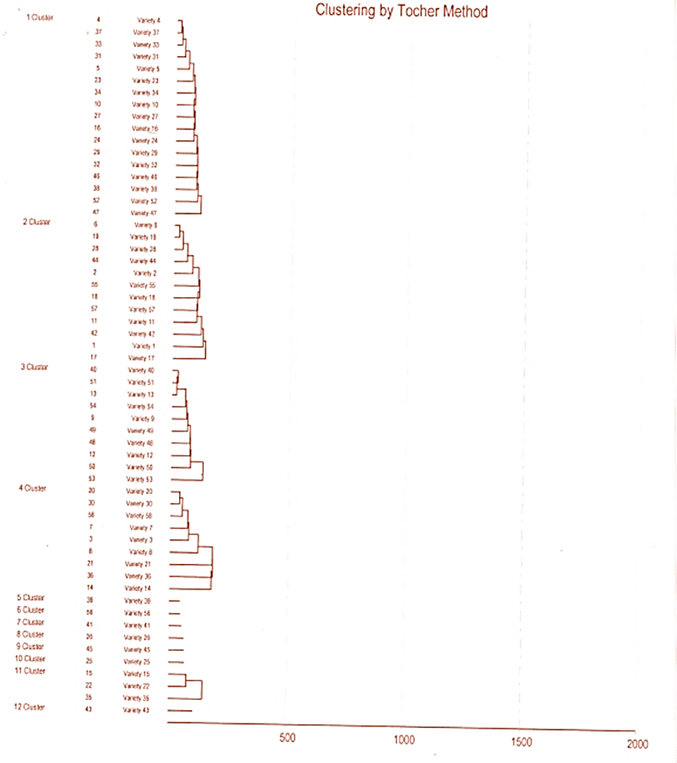
Fig. 1: Distribution of tomato` (Solanum lycopersicum L.) genotypes into different clusters as depicted by cluster dendrogram (Morphological analysis)

Table 3: Average intra cluster (Diagonal) and inter cluster (Above Diagonal) distance values in Tomato (Solanum lycopersicum L.) genotypes
 | Cluster 1 | Cluster 2 | Cluster 3 | Cluster 4 | Cluster 5 | Cluster 6 | Cluster 7 | Cluster 8 | Cluster 9 | Cluster 10 | Cluster 11 | Cluster 12
Cluster 1 | 246.17 | 530.61 | 494.47 | 1955.23 | 602.56 | 390.81 | 886.63 | 442.46 | 690.76 | 397.71 | 1243.50 | 2221.86
Cluster 2 |  | 325.53 | 1198.02 | 990.79 | 417.75 | 419.00 | 453.31 | 504.71 | 675.38 | 488.53 | 692.66 | 1232.73
Cluster 3 |  |  | 251.83 | 3109.01 | 1417.11 | 833.30 | 1907.32 | 635.82 | 1433.87 | 756.64 | 2057.88 | 3819.03
Cluster 4 |  |  |  | 433.17 | 1501.84 | 1491.18 | 874.49 | 1496.15 | 2056.13 | 1552.38 | 828.15 | 928.07
Cluster 5 |  |  |  |  | 0.00 | 506.29 | 476.68 | 771.77 | 165.84 | 779.17 | 955.35 | 1269.24
Cluster 6 |  |  |  |  |  | 0.00 | 756.08 | 161.70 | 562.14 | 488.67 | 707.94 | 2163.84
Cluster 7 |  |  |  |  |  |  | 0.00 | 997.23 | 534.63 | 1123.09 | 517.89 | 573.99
Cluster 8 |  |  |  |  |  |  |  | 0.00 | 891.90 | 560.91 | 709.88 | 2594.69
Cluster 9 |  |  |  |  |  |  |  |  | 0.00 | 1199.47 | 1051.99 | 1860.90
Cluster 10 |  |  |  |  |  |  |  |  |  | 0.00 | 1443.92 | 1789.35
Cluster 11 |  |  |  |  |  |  |  |  |  |  | 447.29 | 1646.01
Cluster 12 |  |  |  |  |  |  |  |  |  |  |  | 0.00
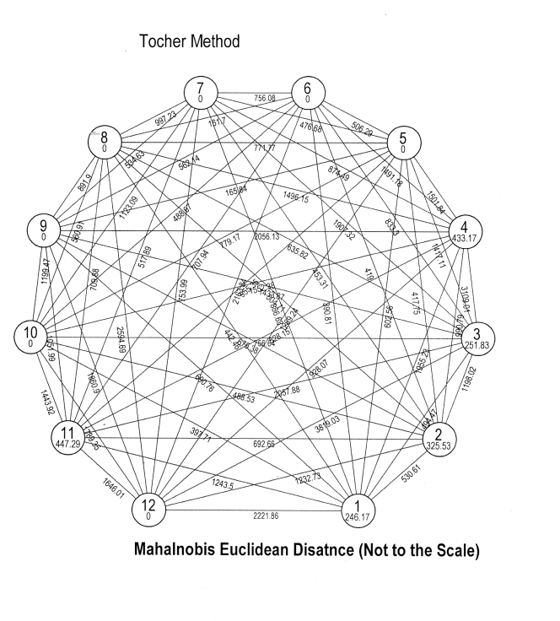
Fig. 2: Average intra cluster and inter cluster distance values in Tomato (Solanum lycopersicum L.) genotypes

Table 4: Cluster means for various growth, maturity and yield attributing characters in different clusters of Tomato (Solanum lycopersicum L.) genotypes

 | DTFF | DTFFS | DTFFH | NOL | PH  (cm) | NOFPC | PT  (mm) | FL  (cm) | FD  (cm) | SYPF (g) | 100SW  (g) | AFW  (g) | DOF/H | NOP | NOPBPP | NOFPP | FYPP (kg) | SYPP  (g) | FYPH (q)
Cluster 1 | 28.41 | 39.26 | 82.10 | 3.56 | 102.49 | 4.25 | 3.68 | 4.10 | 3.79 | 0.22 | 0.32 | 24.33 | 35.24 | 4.91 | 4.62 | 20.85 | 0.50 | 4.63 | 375.15
Cluster 2 | 31.14 | 41.34 | 82.28 | 3.60 | 102.98 | 4.22 | 3.62 | 4.77 | 4.58 | 0.25 | 0.38 | 37.35 | 37.03 | 5.12 | 5.17 | 21.47 | 0.79 | 5.47 | 586.45
Cluster 3 | 27.15 | 38.60 | 79.71 | 3.08 | 105.21 | 4.51 | 3.14 | 3.03 | 3.07 | 0.23 | 0.35 | 21.02 | 37.53 | 5.11 | 5.17 | 20.51 | 0.45 | 4.76 | 327,88
Cluster 4 | 29.31 | 41.24 | 84.71 | 3.60 | 110.42 | 4.62 | 4.13 | 5.15 | 5.98 | 0.23 | 0.35 | 61.86 | 35.17 | 4.87 | 4.59 | 14.53 | 0.88 | 3.41 | 653.33
Cluster 5 | 35.33 | 43.87 | 86.67 | 3.20 | 108.15 | 4.07 | 2.19 | 5.68 | 4.16 | 0.33 | 0.42 | 25.78 | 37.40 | 4.13 | 5.53 | 22.87 | 0.59 | 7.56 | 439.50
Cluster 6 | 39.33 | 49.07 | 88.13 | 2.80 | 115.26 | 4.07 | 5.21 | 4.78 | 3.58 | 0.23 | 0.35 | 34.87 | 34.87 | 4.80 | 5.53 | 25.53 | 0.89 | 5.821 | 663.40
Cluster 7 | 21.93 | 32.13 | 76.40 | 2.80 | 92.04 | 3.80 | 3.39 | 5.86 | 4.43 | 0.17 | 0.25 | 41.87 | 40.00 | 5.13 | 5.33 | 17.67 | 0.74 | 2.93 | 554.15
Cluster 8 | 36.20 | 46.00 | 87.93 | 2.80 | 117.05 | 4.73 | 3.44 | 4.07 | 3.51 | 0.25 | 0.34 | 41.22 | 36.87 | 4.93 | 4.13 | 21.53 | 0.89 | 5.35 | 660.43
Cluster 9 | 33.53 | 41.73 | 82.33 | 2.60 | 84.65 | 3.67 | 2.14 | 6.14 | 3.17 | 0.27 | 0.36 | 23.11 | 39.40 | 5.33 | 4.40 | 13.87 | 0.32 | 3.72 | 239.27
Cluster 10 | 36.87 | 47.27 | 81.33 | 2.67 | 109.83 | 5.07 | 5.17 | 3.60 | 5.06 | 0.25 | 0.36 | 26.31 | 36.73 | 5.80 | 5.47 | 20.13 | 0.53 | 5.04 | 393.97
Cluster 11 | 28.16 | 39.29 | 81.80 | 3.96 | 112.58 | 4.53 | 3.47 | 5.53 | 4.02 | 0.25 | 0.35 | 57.20 | 34.49 | 5.07 | 5.20 | 19.11 | 01.09 | 4.90 | 814.15
Cluster 12 | 23.13 | 36.07 | 87.40 | 4.73 | 108.33 | 3.93 | 4.17 | 6.07 | 6.75 | 0.26 | 0.35 | 43.04 | 41.67 | 4.73 | 4.93 | 21.93 | 0.94 | 5.59 | 702.67

DTFF-Number of days to 1st flowering, DTFFS-Number of days to 1st fruit set, DTFFH-Number of days to 1st fruit harvest, NOL-Number of locules per fruit, PH-Plant height, NOFPC-Number of fruits per cluster, PT- Pericarp thickness, FL- Fruit length, FD- Fruit diameter, SYPF-Seed yield per fruit, 100SW-100-seed weight, AFW-Average fruit weight, DOF/H-Duration of fruiting/harvest, NOP- Number of pickings, NOPBPP-Number of primary branches per plant, NOFPP-Number of fruits per plant, FYPP-Fruit yield per plant, SYPP- Seed yield per plant, FYPH- Fruit yield per hectare.)

Table 5: Percent contribution of individual traits towards total genetic divergence
Source | Times ranked 1st | % contribution towards total divergence
DTFF | 21 | 1.27
DTFFS | 31 | 1.88
DTFFH | 7 | 0.42
PH(cm) | 13 | 0.79
PT(mm) | 59 | 3.57
FL(cm) | 478 | 28.92
FD(cm) | 510 | 30.85
100SW(g) | 4 | 0.24
AFW(g) | 526 | 31.82
DOF/H | 2 | 0.12
NOFPP | 1 | 0.06
DTFF-Number of days to 1st flowering,
DTFFS-Number of days to 1st fruit set,
DTFFH-Number of days to 1st fruit harvest,
PH-Plant height,
PT- Pericarp thickness,
FL- Fruit length,
FD- Fruit diameter,
100SW-100-seed weight,
AFW-Average fruit weight,
DOF/H-Duration of fruiting/harvest,
NOFPP-Number of fruits per plant.

Conclusion
The present investigation revealed substantial genetic diversity among the fifty-eight tomato genotypes evaluated using Mahalanobis D² statistics. The genotypes were grouped into twelve distinct clusters, indicating wide variability that was independent of their geographical origin. The presence of high inter-cluster distances, particularly between clusters III and XII, III and IV, and VIII and XII, suggested the availability of genetically divergent parents suitable for hybridization programmes. Cluster mean analysis highlighted specific clusters possessing superior performance for yield, fruit size, plant growth, and quality traits. Among the characters studied, average fruit weight, fruit diameter, and fruit length contributed the maximum proportion to total genetic divergence, emphasizing their importance in selection and breeding strategies. Therefore, selection of elite genotypes from genetically distant clusters with desirable per se performance for these key traits is expected to enhance heterosis and generate superior recombinants. Overall, the study provides valuable information for effective utilization of tomato germplasm and offers a sound basis for parent selection in future breeding programmes aimed at improving yield and fruit quality.

Disclaimer (Artificial intelligence)
Author(s) hereby declare that NO generative AI technologies such as Large Language Models (ChatGPT, COPILOT, etc.) and text-to-image generators have been used during the writing or editing of this manuscript.

I hereby declare that statistical tools have been used to do data analysis

References
Bhattarai, K., Sharma, S., & Panthee, D. R. (2018). Diversity among Modern Tomato Genotypes at Different Levels in Fresh-Market Breeding. International Journal of Agronomy. https://doi.org/10.1155/2018/4170432
Dufera, J. T. (2014). Multivariate analysis and selection of parents for hybridization in tomato (Lycopersicon esculentum Mill.) genotypes. World Journal of Agricultural Sciences. https://doi.org/10.5829/idosi.wjas.2014.10.3.1191
Farhad, M., Zand, E. and Bagheri, A. R. 2010. Genetic variability, heritability and correlation studies in tomato (Lycopersicon esculentum Mill.). Journal of Plant Breeding and Crop Science 2(10): 296-301
Foolad, M. R., & Panthee, D. R. (2012). Marker-Assisted Selection in Tomato Breeding. Critical Reviews in Plant Sciences, 31(2), 93-123. https://doi.org/10.1080/07352689.2011.616057
Gur, A., Zamir, D. and Fluhr, R. 2004. Subspecies relationships in the tomato (Solanum lycopersicum L.) clade: AFLP fingerprinting of representative accessions. Journal of Heredity 95(6): 510-520
Kumar, S., Singh, A., Kumar, S. and Singh, D. 2015. Genetic variability and correlation studies in tomato (Solanum lycopersicum L.). International Journal of Agricultural Science and Research 5(2): 231-236
Mahalanobis, P. C. (1936). On the generalised distance in statistics. Proceedings of the National Institute of Sciences of India, 2(1), 49-55. http://hdl.handle.net/10263/6765
Maurya, A. K., Singh, A. K., Singh, S. K. and Singh, R. 2019. Correlation and path coefficient analysis for yield and its components in tomato (Solanum lycopersicum L.). International Journal of Chemical Studies 7(2): 1670-1674
Medagam, T. R., Rao, G. R. and Reddy, P. S. 2014. Correlation and path coefficient analysis in tomato (Solanum lycopersicum L.). International Journal of Agricultural Science and Research 4(2): 1-6
Pujar, S. S., Patil, S. S., Patil, S. S. and Patil, S. S. 2017. Genetic variability, heritability and genetic advance in tomato (Solanum lycopersicum L.). International Journal of Current Microbiology and Applied Sciences 6(11): 1624-1636
Reddy, B. R., Siddeswar, R. D., Reddaiah, K. and Sunil, N. 2013b. Genetic diversity studies in tomato (Solanum lycopersicum L.). IOSR Journal of Agriculture and Veterinary Science 4(4): 53-55
Ruthi, Y., Naveen, K. S., and Kumar, N. 2011. Genetic divergence in tomato (Solanum lycopersicum L.). International Journal of Plant Breeding and Genetics 5(3): 246-252
Singh, T., Singh, N., Bahuguna, A., Nautiyal, M., & Sharma, V. K. (2014). Performance of Tomato (Solanum lycopersicum L.) Hybrids for Growth, Yield and Quality Inside Polyhouse under Mid Hill Condition of Uttarakhand. American Journal of Drug Discovery and Development, 4(3), 202-209. https://doi.org/10.3923/ajdd.2014.202.209
Singh, K. K., Das, M. M., Samanta, A. K., Kundu, S. S., & Sharma, S. D. (2002). Evaluation of certain feed resources for carbohydrate and protein fractions and in situ digestion characteristics. Indian Journal of Animal Sciences, 72(9), 794-797. https://www.cabidigitallibrary.org/doi/10.1079/PA20023175606
Singh, R. K., Singh, A. K., Sharma, S. K., Singh, B. and Kumar, R. 1996. Genetic variability, heritability and genetic advance studies for yield and its contributing traits in tomato (Solanum lycopersicum L.). Journal of Applied and Natural Science 7: 52-56
Pnueli, L., Carmel-Goren, L., Hareven, D., Gutfinger, T., Alvarez, J., Ganal, M., Zamir, D., & Lifschitz, E. (1998). The SELF-PRUNING gene of tomato regulates vegetative to reproductive switching of sympodial meristems and is the ortholog of CEN and TFL1. Development, 125(11), 1979–1989. https://doi.org/10.1242/dev.125.11.1979
Zhou, R., Jiang, F., Yu, X., Abdelhakim, L., Li, X., Rosenqvist, E., Ottosen, C.-O., & Wu, Z. (2022). Dominant and Priming Role of Waterlogging in Tomato at e[CO2] by Multivariate Analysis. International Journal of Molecular Sciences. https://doi.org/10.3390/ijms232012121

