Case report
Urethral Obstruction Secondary to Feline Idiopathic Cystitis in a Persian Cat: A Case Report

Abstract
Aim: Feline Idiopathic Cystitis (FIC) is a significant component of Feline Lower Urinary Tract Disease (FLUTD), frequently presenting as acute urethral obstruction in male cats. This report describes the diagnosis, progression and management of a severe case of obstructive FIC in a young Persian tom cat.
Presentation of Case: A 9-month-old, indoor-housed male Persian cat from a multi-cat household presented with anorexia, vomiting, haematuria, stranguria and urethral obstruction. Diagnostic workup, including hematology, serum biochemistry and ultrasonography, confirmed post-renal azotemia and urethral obstruction by intra-luminal contents. Urethral patency was re-established by catheterization. The case was diagnosed as obstructive FIC based on clinical signs, sterile urine culture and exclusion of other etiologies.
Discussion: The cat developed severe, progressive anaemia, thrombocytopenia and sustained azotemia. Initial management with fluid therapy, urethral catheterization and Alpha 1 antagonist (Prazosin). The acute deterioration highlights the guarded prognosis and complexity of managing severe obstructive FIC, particularly when secondary systemic complications arise.
Conclusion: Obstructive FIC is a life-threatening condition requiring immediate intervention. While a multi-modal approach (medical, dietary and environmental approach) is essential for management and prevention, this case underscores the potential for rapid systemic deterioration, emphasizing the need for proactive environmental stress reduction and long-term care.
Keywords: Feline idiopathic cystitis, Urethral obstruction, Azotemia, Stress, Prazosin.

Introduction
Feline idiopathic cystitis (FIC) is a common cause of lower urinary tract disease in young cats and represents a complex interplay between environmental stress, neuroendocrine imbalance and altered bladder mucosal defense. The term feline interstitial cystitis (FIC) was coined by Buffington et al. (1996) to describe chronic lower urinary tract signs (LUTS) in cats where an etiology cannot be identified in any of the diagnostic tests. Therefore, FIC is always a diagnosis of exclusion (de Moraes et al_2025).
Several studies have found FIC to be the most common cause of FLUTD. Studies showed that 54–64% of all cats presenting with FLUTD were idiopathic and 20–55% of those had a urethral obstruction. Urethral plugs were diagnosed in 10–22% of cats with FLUTD and in one study, urethral plugs were found in 59% of obstructed males (Defauw et al., 2011). Obstructive forms, in which urethral plugs develop secondary to sterile inflammation, can rapidly progress to post-renal azotemia and multi-organ dysfunction if not promptly managed. As per Gunn-Moore (2003), some cats with FIC had lowered urinary excretion of glycosaminoglycans (GAG) as a result of a defective GAG layer, which is the protective layer of the bladder. This exposes the urothelium, bringing it directly in contact with the noxious substances in urine, stimulating the sensory neurons and initiating inflammation.
Studies have reported increased incidences of FIC in middle-aged, stressed, obese, indoor-housed cats fed on a dry diet. Incidences were also higher in cats using an indoor litter box and in those living in multi-cat households (Taylor, 2013). The management of FIC involves medical therapy, dietary therapy and multi-modal environmental enrichment (MEMO) therapy (Taylor et al_2025). Since there is no permanent cure for FIC(de Moraes et al_2025), the main objective of the treatment and managemental changes is to reduce the severity and frequency of recurrent LUTS and to improve the quality of life (Naarden and Corbee, 2020).
The objective of this case report is to detail the clinical, laboratory and ultrasonographic findings, as well as the treatment and outcomes, of a severe case of urethral obstruction secondary to Feline Idiopathic Cystitis in a Persian cat.

Presentation of Case
Signalment and History
A 9-month-old Persian male cat weighing 3.7 kg was presented to the Teaching Veterinary Clinical Complex, Tirunelveli, with a history of anorexia, haematuria, and stranguria. History revealed that the cat was housed indoors, lived in a multi-cat household, was fed exclusively on a dry diet, and used an indoor litter box.
Persian cats have been reported to show an increased risk for Feline Lower Urinary Tract Disease (FLUTD) (Defauw et al., 2011).
Clinical and Diagnostic Findings
General clinical examination revealed physiological parameters within normal limits. Physical examination showed severe distension of the urinary bladder without evidence of abdominal pain on day 1. The hematobiochemical parameters on day 1-5-10 and the findings of imaging and urinalysis were tabulated in table I and table II below.
Table I. Haematological and Serum Biochemical Parameters (Add Arrows)

Parameter | Day 01 (Admission) | Day 05 | Day 10 | Reference Range
Hemoglobin (g/dL) | 5.3 | 2.1 | 0.4 | 8.0 – 15.0
Packed Cell Volume (%) | 16.5 | 6.8 | 2.0 | 24.0 – 45.0
Red Blood Cells (x10^6/\mu L) | 4.98 | 1.53 | 0.33 | 5.5 – 10.0
Platelets (X 10^3/\mu L) | 113 | 39 | 22 | 150 – 500
Blood Urea Nitrogen (mg/dL) | 546.09 | 453.71 | - | 18 – 34
Creatinine (mg/dL) | 21.51 | 5.03 | 3.65 | 0.8 – 2.0

Table II. Imaging and Urinalysis Findings

Diagnostic Test | Findings
Ultrasonography | Multiple echo-textural intraluminal contents within the urinary bladder; increased acoustic shadowing throughout the urethral canal. (fig .1)
Urine Collection | Transurethral catheterisation (4.5 FG), catheter secured with stay suture. (fig .2)
Urinalysis (Macroscopic) | Reddish, turbid urine.
Urinalysis (Microscopic) | Numerous red blood cells (RBCs); few amorphous phosphate crystals.
Urine Culture | Negative (sterile).

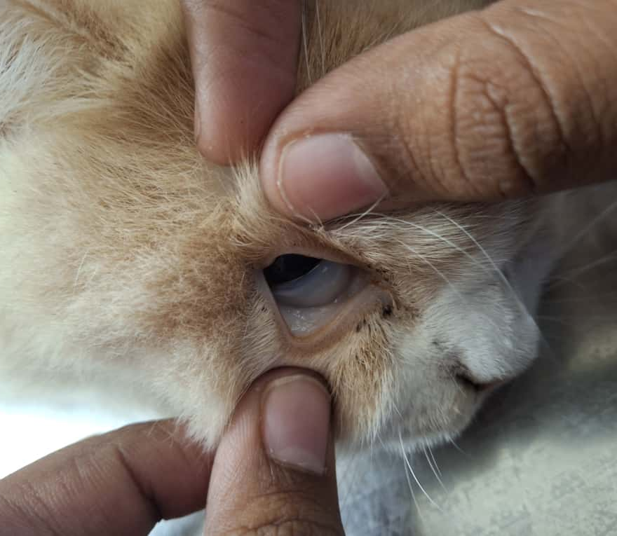 | 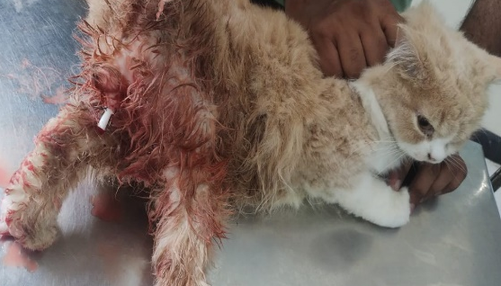
Fig 1: Shrunken eyeball with pale mucous membrane. | Fig 2: Tom cat catheterisation.
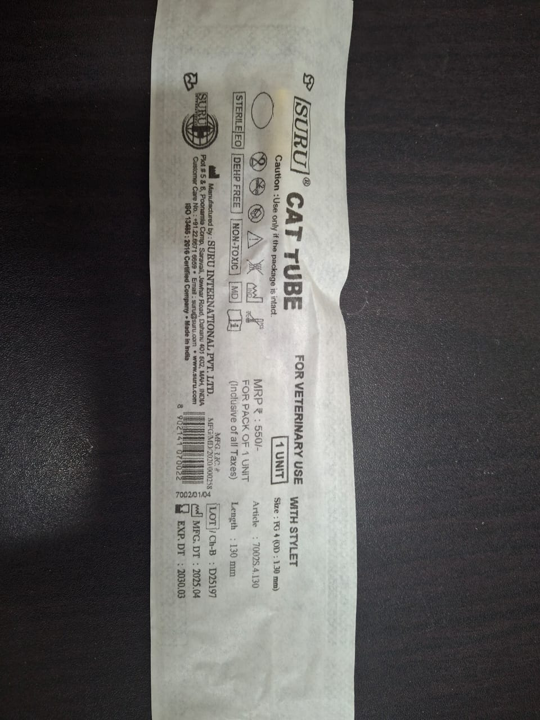 | 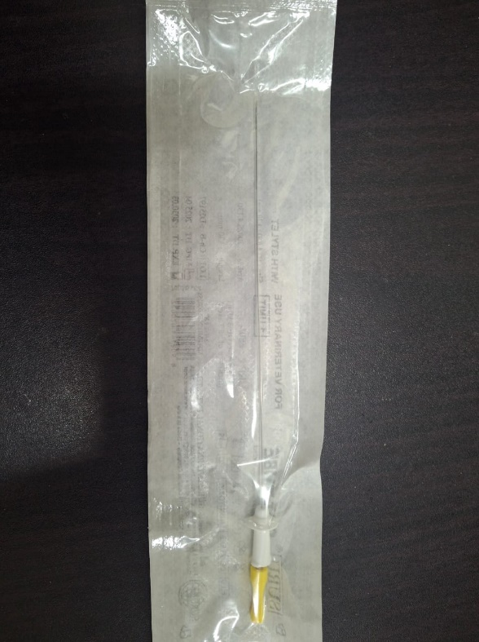
Fig3: Tom cat catheter (4 FG)

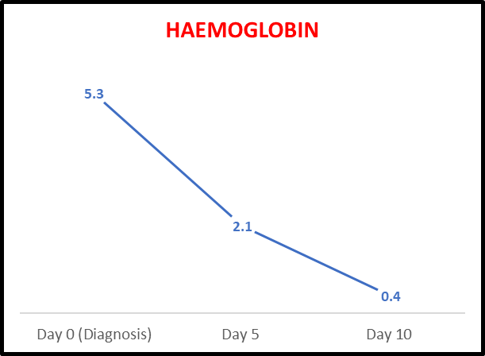 | 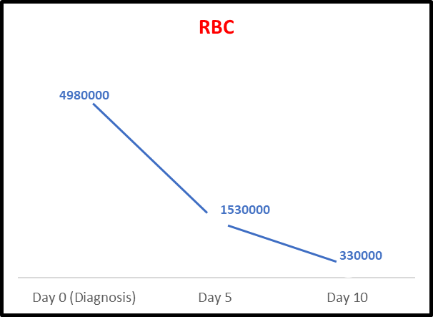
Fig 4:Severe progressive anaemia | Fig 5: Severe progressive anaemia

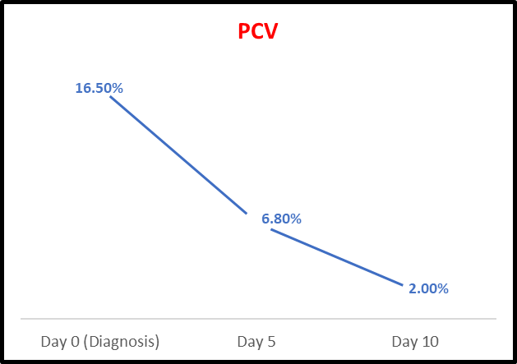 | 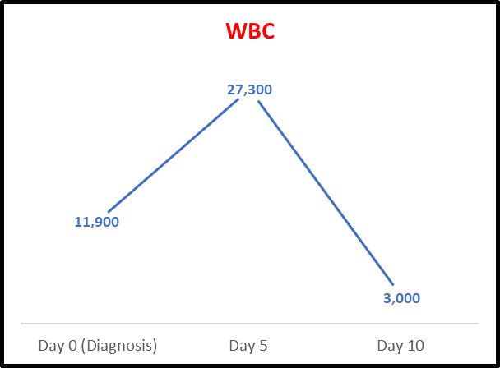
Fig6: Severe progressive anaemia | Fig7: Marked leukocyte depletion -initial inflammatory phase followed by systemic detoriation

 | 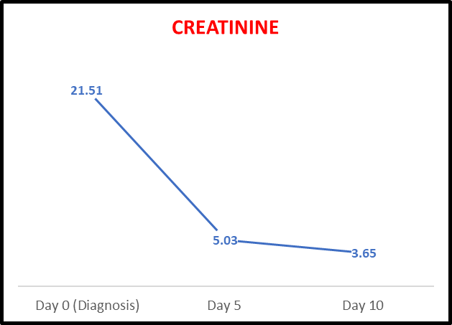
Fig 8:Marked platelet depletion | Fig 9:Partial renal recovery evident from the falling creatinine levels

Diagnostic Parameter | Finding in This Case | Interpretation
Urinalysis | Numerous RBCs, few amorphous phosphate crystals, no bacteria | Sterile haematuria → rules out bacterial cystitis
Urine Culture | Negative for bacterial growth | Supports sterile inflammation
Ultrasound | Multiple echoic intraluminal contents, no discrete stones | Rules out urolithiasis
Age/Stress Factors | Young–middle-aged Persian cat, multi-cat household, indoor stress | Classic for FIC
Diet | Predominantly dry food | Predisposing factor for FIC
Table 3: Findings based on different diagnostic parameters
Therapeutic Management
The case was initiated with bladder lavage using sterile normal saline to remove debris, blood clots and crystals from the urinary bladder (Tsuruta et al,2022). An indwelling urinary catheter (4 FG) (Fig 3) was maintained to correct metabolic derangements associated with acute kidney injury, facilitate healing of any urethral injury, reduce the risk of re-obstruction and preserve normal detrusor function, as prolonged bladder distension may result in detrusor atony. (Cosford et al,2020)
Intravenous fluid therapy was administered using Ringer lactate @ 10 ml/kg to correct dehydration. Urine output was closely monitored and fluid therapy was adjusted accordingly (Alangston et al, 2021). Balanced electrolyte solutions such as Ringer lactate were preferred over normal saline in cats with urethral obstruction, as studies have shown comparable potassium reduction with more rapid correction of acid–base disturbances (George and Grauer, 2016).
- Analgesia: Butorphanol was administered at 0.2 mg/kg intravenously every 12 hours (Steagall et al_2022).
- Urethral Relaxant: Prazosin (0.25 mg/cat orally every 12 hours) was initiated as an alpha-1 adrenergic blocker to relax the urethral sphincter and facilitate urine flow. (Hanson et al _2021)
  - Supportive therapy included the following:
- Urinary Health Supplements: Urosupport and Cystone (herbal urinary support agents) to aid bladder mucosal integrity. (Vidyashankar et al _2010)
- Anaemic Support: RBC Pet and Thrombup syrups to support red cell regeneration and platelet recovery following severe haematuria. (Weiss and wardrop,2010)
- Gastroprotection: Ranopet syrup for gastric mucosal protection and antacid support. (Marks and kook,2013)
- Antimicrobial Prophylaxis: Toxomox syrup, administered as prophylactic support following catheterisation. (Bartges_2011)
Treatment was continued based on clinical response, and the animal was monitored for ten days. Initially transient improvement was observed, the cat developed progressive azotemia, severe anaemia, and thrombocytopenia by day 10 and ultimately succumbed.
Dietary and Environmental Management (MEMO Therapy)
Dietary and managemental interventions aimed at stress reduction were instituted as preventive measures. Dietary modification included transition to a therapeutic urinary diet (Hill’s c/d Multicare) along with strategies to increase water intake. Evidence-based studies suggested that therapeutic urinary diets provide satisfactory results in FIC management (Kruger et al., 2015). Managemental changes as part of multimodal environmental enrichment (MEMO) therapy included provision of a core space, minimisation of environmental stressors such as inter-cat conflict, guests and infants, adequate feeders and water sources, proper litter box management, improved owner–animal interaction, and avoidance of sudden routine changes. In the present case, MEMO therapy has been shown improvement which may be due to the fact that it reduces catecholamine concentrations and decrease the frequency and severity of recurrent FIC episodes (Buffington et al., 2006).

Discussion
This case highlights several recognised risk factors for feline idiopathic cystitis, including young age, indoor housing, multi-cat environment, and exclusive dry diet feeding. There is no specific breed predisposition has been established for FIC, Persian cats have been reported to have an increased risk for FLUTD, making the signalment clinically relevant .( Dahmani and Zenia,2025)
The markedly elevated blood urea nitrogen and creatinine levels at presentation were indicative of severe post-renal azotemia secondary to urethral obstruction. Initially, Transient decline in creatinine was observed following catheterisation and fluid therapy, the persistence of azotemia suggested progression from post-renal compromise to intrinsic renal injury. Such deterioration reflects the severity and duration of obstruction prior to presentation and associated with poor outcome.
A notable and severe feature of this case was the progressive haematological deterioration. The cat developed profound anaemia and thrombocytopenia, with a packed cell volume of 2% and platelet count of 22,000/μL by day 10. This degree of haematological compromise is likely multifactorial, potentially resulting from massive persistent haematuria, systemic inflammation and evolving multi-organ dysfunction. The possibility of consumptive coagulopathy or disseminated intravascular coagulation (DIC) cannot be excluded in the context of severe systemic illness and renal failure. Such profound cytopenias significantly worsen the prognosis and limit therapeutic options.
Overall, this case demonstrates that obstructive FIC complicated by persistent azotemia, severe anaemia and thrombocytopenia carried an extremely guarded to poor prognosis. Despite appropriate medical intervention, progression to multi-organ failure might occur, emphasising the life-threatening nature of severe obstructive FLUTD.
While multimodal environmental enrichment therapy and dietary modification are critical for long-term management and recurrence prevention in FIC, their benefits are primarily preventive and supportive. In acute, severe cases such as the present one, MEMO therapy alone is insufficient to reverse advanced systemic complications, although it remains essential for long-term quality-of-life improvement in surviving patients.

Conclusion
This case of obstructive feline idiopathic cystitis in a young Persian cat demonstrates the potential for severe, progressive renal and haematological deterioration despite timely therapeutic intervention. The development of refractory azotemia, profound anaemia, and thrombocytopenia underscores the life-threatening nature of complicated FIC and highlights the need for early diagnosis, aggressive monitoring, and recognition of poor prognostic indicators during the acute phase of the disease.
Consent
Informed consent was obtained from the owner of the animal for clinical examination, diagnostic procedures, treatment, and publication of this case report
Ethical Approval
Ethical approval was not required for this case report as all diagnostic and therapeutic procedures were part of routine clinical management. The study did not involve experimental interventions.
Disclaimer (Artificial intelligence)

The authors declare that artificial intelligence tools were used only to assist with language polishing, formatting, and structural organization of the manuscript. All clinical data, interpretations, and conclusions were generated by the authors, who retain full responsibility for the accuracy and integrity of the work.

References:-
- Gunn-Moore, D. A. (2003). Feline lower urinary tract disease. Journal of Feline Medicine and Surgery, 5(2), 133-138. https://doi.org/10.1016/S1098-612X(02)00129-8
- Taylor, S. (2013). Management of urinary tract disorders. In BSAVA Manual of Feline Practice (pp. 377-388). https://doi.org/10.22233/9781910443149.13
- Naarden, B., & Corbee, R. J. (2020). The effect of a therapeutic urinary stress diet on the short‐term recurrence of feline idiopathic cystitis. Veterinary Medicine and Science, 6(1), 32-38. https://doi.org/10.1002/vms3.197
- George, C. M., & Grauer, G. F. (2016). Feline urethral obstruction: Diagnosis & management. Today’s Veterinary Practice, 6(4), 36-46.https://doi.org/10.1002/tvp.101
- Buffington, C. A. T., Westropp, J. L., Chew, D. J., & Bolus, R. R. (2006). Clinical evaluation of multimodal environmental modification (MEMO) in the management of cats with idiopathic cystitis. Journal of Feline Medicine and Surgery, 8(4), 261-268. https://doi.org/10.1016/j.jfms.2006.02.002
- Kruger, J. M., Lulich, J. P., MacLeay, J., Merrills, J., Paetau-Robinson, I., Brejda, J., & Osborne, C. A. (2015). Comparison of foods with differing nutritional profiles for long-term management of acute nonobstructive idiopathic cystitis in cats. Journal of the American Veterinary Medical Association, 247(5), 508-517. https://doi.org/10.2460/javma.247.5.508
- Defauw, P. A. M., Van de Maele, I., Duchateau, L., Polis, I. E., Saunders, J. H., & Daminet, S. (2011). Risk factors and clinical presentation of cats with feline idiopathic cystitis. Journal of Feline Medicine and Surgery, 13(12), 967-975. https://doi.org/10.1016/j.jfms.2011.08.001
- Vidyashankar, S., Maheshkumar, P., & Patki, P. S. (2010). Cystone – An ayurvedic polyherbal formulation inhibits adherence of uropathogenic E. coli and modulates H2O2-induced toxicity in NRK-52E cells. Journal of Experimental Pharmacology https://doi.org/10.2147/jep.s9172
- Weiss, D. J., & Wardrop, K. (2010). Drug-induced blood cell disorders. In D. J. Weiss & K. Wardrop (Eds.), Schalm’s Veterinary Hematology (6th ed., pp. 98-105). https://www.wiley.com/enus/Schalm%27s+Veterinary+Hematology%2C+6th+Edition-p9780813817989
- Marks SL, Kook PH. Gastroprotectants in cats. Journal of Feline Medicine and Surgery. 2013;15(5):387–396.
- Bartges JW,(2011), Polzin DJ. Urinary tract infections in cats. Veterinary Clinics of North America: Small Animal Practice.;41(2):281–297.
- de Moraes, R. S., Ferreira, J. F., Maia, S. R., Azevedo, M. G. P., Benevenuto, L. G. D., Ribeiro, D., ... & Guimarães-Okamoto, P. T. C. (2025). Managing urethral obstruction in male cats: a practical guide and literature review. New Zealand Veterinary Journal, 73(6), 381-396.
- Tsuruta, K., Butler, A., & Goic, J. (2022). Effect of intermittent bladder flushing on recurrence rate in feline urethral obstruction: 72 cases. The Canadian Veterinary Journal, 63(12), 1236.
- Cosford, K. L., & Koo, S. T. (2020). In-hospital medical management of feline urethral obstruction: a review of recent clinical research. The Canadian veterinary journal, 61(6), 595.
- ALangston, C., & Gordon, D. (2021). Effects of IV fluids in dogs and cats with kidney failure. Frontiers in veterinary science, 8, 659960.
- Hanson, K. R., Rudloff, E., Yuan, L., Mochel, J. P., & Linklater, A. K. (2021). Effect of prazosin on feline recurrent urethral obstruction. Journal of Feline Medicine and Surgery, 23(12), 1176-1182.
- Steagall, P. V., Robertson, S., Simon, B., Warne, L. N., Shilo-Benjamini, Y., & Taylor, S. (2022). 2022 ISFM consensus guidelines on the management of acute pain in cats. Journal of Feline Medicine and Surgery, 24(1), 4-30.
- Taylor, S., Boysen, S., Buffington, T., Chalhoub, S., Defauw, P., Delgado, M. M., ... & Korman, R. (2025). 2025 iCatCare consensus guidelines on the diagnosis and management of lower urinary tract diseases in cats. Journal of feline medicine and surgery, 27(2), 1098612X241309176.
- Dahmani, A., & Zenia, S. (2025). STUDY OF FELINE LOWER URINARY TRACT DISEASE IN BLIDA, NORTH OF ALGERIA: CLINICAL AND EPIDEMIOLOGIC FEATURES. FOLIA VETERINARIA, 69(1), 9-16.

