Cytotoxic Insights of Underexplored Apis cerana indica Bee Venom: An In-Vitro and In- Silico Study on MCF-7 Breast Cancer Cells

Abstract

Bee venom (BV) also known as apitoxin is produced and released by venom gland in the abdominal cavity of female worker bees are studied extensively for their varied biological and therapeutic properties. The current study uses in vitro and in-silico methods to examine the cytotoxic activity of Apis cerana indica bee venom against MCF-7 human breast cancer cells. The cytotoxicity was assessed using MTT assay which showed potent cytotoxicity toward MCF-7 cells, At the highest concentration of 10 µg/mL, bee venom significantly reduced cell viability to 17.74%. In contrast, at the lowest concentrations cell viability remained relatively higher at 65.33% indicating a reduced cytotoxic impact of bee venom at lower doses with an IC50 value at 0.3655 µg/mL. To further depict the molecular role in exhibiting toxicity molecular docking studies of crucial components of bee venom such as melittin and apamin were docked with cancer-associated proteins such as MUC16, Cathepsin D and Trefoil Factor 1 (TFF1). The docking results showed that apamin exhibited the highest binding affinity with MUC16 (−8.0 kcal/mol), followed by Cathepsin D (−7.5 kcal/mol) and TFF1 (−7.0 kcal/mol). In comparison, melittin showed moderate interaction with MUC16 (−7.2 kcal/mol) and lower affinities with Cathepsin D and TFF1 (−6.0 kcal/mol each) The results revealed that melittin and apamin showed binding affinity with cancer associated proteins supporting the cytotoxic effects observed in vitro. The key findings suggest that bee venom has cytotoxic effects on breast oncogenic cells. These results reveal the potential therapeutic use of bee venom in treating breast cancer.
Keywords: Apis cerana indica, Bee venom (BV), MCF-7, Molecular Docking.
Melittin, Apamin

INTRODUCTION

Honeybees are vital pollinators that contribute significantly to global food production, either directly or indirectly, with approximately one-third of our food supply reliant on their activities [1&2]. Beyond their role in agriculture, honeybee products, particularly bee venom, have garnered interest in medicinal science due to their diverse therapeutic properties. Apitherapy, the use of bee products for healing purposes, encompasses various techniques that leverage the health benefits of substances like honey, royal jelly, propolis and venom [3&4]. Despite the historical utilization of these products in ancient civilizations for medicinal purposes, modern Western medicine has seen a decline in their application, prompting a renewed exploration into their potential benefits [5] and because of the growing issue of medication resistance, which has made it necessary to look for new pharmacologically active compounds [6&7].
Bee venom (BV), a colorless and acidic substance with a bitter taste [8] has gained wide focus necessitated by its varied pharmacological characteristics including antioxidant, antibacterial, anticancer and other immune modulatory properties. The existence of bioactive metabolites such as peptides, enzymes and amines, collectively play a role in its pharmacological effects [9]. The most important components of bee venom are melittin, is known for its membrane disrupting effects and other constituents such as phospholipase A2, apamin and adolapin have been shown to induce anti-inflammatory responses and reduce pro inflammatory cytokine production [10].
The most vital application of bee venom is its cytotoxic effect on cancer cells. Research has shown that bee venom can induce apoptosis and limit the propagation of cancer cell lines include MCF- 7 breast cancer cell [11,12]. Studies on breast cancer cells have shown that bee venom disrupts cell membrane structure and promotes cell death [13]. The ability of bee venom to spare normal cells and selectively target cancer cells highlights the bee venom potential as a natural anticancer agent that could complement existing therapies. In addition to invitro research, molecular docking was used to examine how bee venom peptides, melittin and apamin, interacted with proteins linked to cancer, including mucin, trefoil factor and cathepsin.
Recent anticancer studies have demonstrated that integrating in vitro cytotoxicity assays with molecular docking and simulation-based approaches provides mechanistic insights into ligand-protein interactions and strengthens the biological relevance of computational predictions [14.
Apamin and Melittin are two of the most widely studied components of bee venom because of their potential for therapeutic use. The venom is a complex mixture of bioactive peptides and enzymes consisting 18 amino acids, apamin is a small neurotoxic peptide that selectively blocks small-conductance Ca²⁺ activated K⁺ (SK) channels [15&16]. Melittin, a 26-amino-acid amphipathic peptide, has been shown to cause apoptosis, stop tumor growth and make cancer cells more sensitive to chemotherapy. It also exhibits potent cytolytic activity [9&17].
In cancer biology, proteins such as MUC16 (also known as CA125), Cathepsin D and Trefoil Factor 1 (TFF1) are critical targets. MUC16 is a high molecular weight glycoprotein overexpressed in breast, ovarian and pancreatic cancers, playing a role in immune evasion and metastasis [18], Cathepsin D is a lysosomal aspartic protease involved in tumor progression through extracellular matrix remodeling and angiogenesis [19]. TFF1, classified within the trefoil factor family, contributes to mucosal healing and is frequently dysregulated in gastrointestinal and hormone-responsive cancers [20]. The interaction of bee venom peptides with these cancer-related proteins remains under explored and presents a promising avenue for therapeutic development. According to recent research, bee venom may also have anti-inflammatory and anticancer effects by modifying the pathways involved in cell migration and apoptosis.
The focus of the research work was to explore the potential therapeutic characteristics of honey bee venom isolated from Indian bee Apis cerana indica which is reared largely in India when compared to other species. The research work is intended to establish the pharmacological benefits of bee venom, including its anticancer roles through in vitro assay. Additionally, in-silico molecular docking was carried out to evaluate the binding potential of melittin and apamin with breast cancer-associated targets, thereby supporting the observed cytotoxic effects mechanistically.

METHODOLOGY

Identification of Bee species

The honeybee species used to study the bee venom was identified and authenticated by Dr. V.R. Swaminathan from the Tamil Nadu Agricultural University (TNAU), based on its distinct morphological features. The honeybee was authenticated as A. cerana indica was used to obtain the bee venom.

Collection of Bee Venom

Bee venom was collected from A. cerana indica colonies using an electric venom collector (Model: SB-BVC, Hi-tech Natural Products (India) Ltd.), as per the method reported by Graaf et al. (2020). The venom was obtained by electrical stimulation at 12 V for 30 min per hive, ensuring minimal harm to the bees [22]. The venom was subsequently lyophilized and preserved at -20 °C for further use.

Anti-Cancer Activity

The bee venom induced cytotoxicity on MCF-7 breast carcinoma cells was assessed using the MTT assay, based on the method by Mosmann (1983). MCF-7 cells were cultured in DMEM containing 10% FBS and antibiotics. The cells were added in a 96-well plate at a density of 1 × 10⁴ cells per well cultured at 37 °C for 24 h. Bee venom was prepared in PBS and serially diluted to final concentrations of 0.078, 0.156, 0.312, 0.625, 1.25, 2.5, 5and 10 µg/mL, including experimental wells and four control groups a blank control (media without cells), a vehicle control (DMSO), a negative control (cells with media)and a positive control (3 Sodium Dodecyl Sulphate, SDS). The plate was returned to the CO2 incubator and left for a fresh 3 hours at 37 °C, during which metabolically active cells converted the MTT into grandiloquent formazan chargers.
After incubation, 10 µl of MTT reagent (5 mg/mL) was introduced to each well and incubated for 3 h at 37 °C. The medium was carefully removed and the resulting formazan crystals were solubilized by adding 100 µl of DMSO. Absorbed value was measured at 570 nm using a plate reader. Cell viability and cytotoxicity were evaluated using the following formulas:
𝐶𝑒𝑙𝑙𝑣𝑖𝑎𝑏𝑖𝑙𝑖𝑡𝑦 = (𝐴𝑏𝑠𝑜𝑟𝑏𝑎𝑛𝑐𝑒𝑜𝑓𝑡𝑟𝑒𝑎𝑡𝑒𝑑𝑐𝑒𝑙𝑙𝑠/𝐴𝑏𝑠𝑜𝑟𝑏𝑎𝑛𝑐𝑒𝑜𝑓𝑐𝑜𝑛𝑡𝑟𝑜𝑙𝑐𝑒𝑙𝑙𝑠) × 100(1)

𝐶𝑒𝑙𝑙𝑐𝑦𝑡𝑜𝑡𝑜𝑥𝑖𝑐𝑖𝑡𝑦 = (𝐴𝑏𝑠𝑜𝑟𝑏𝑎𝑛𝑐𝑒𝑜𝑓𝑐𝑜𝑛𝑡𝑟𝑜𝑙𝑐𝑒𝑙𝑙𝑠𝐴𝑏𝑠𝑜𝑟𝑏𝑎𝑛𝑐𝑒𝑜𝑓𝑡𝑟𝑒𝑎𝑡𝑒𝑑𝑐𝑒𝑙𝑙𝑠/
𝐴𝑏𝑠𝑜𝑟𝑏𝑎𝑛𝑐𝑒𝑜𝑓𝑐𝑜𝑛𝑡𝑟𝑜𝑙𝑐𝑒𝑙𝑙𝑠) × 100(2)

Morphological changes indicative of apoptosis was observed under a light microscope, including chromatin condensation, cell shrinkage and membrane blistering.

In-silico Molecular Docking Analysis

    - Retrieval and Preparation of Protein and Ligand Structures

The 3D conformations of the targeted proteins such as MUC16 SEA domain (PDB ID: 6UVA) [24], Cathepsin D (PDB ID: 1LYB) [25] and Trefoil Factor 1 (TFF1) (PDB ID: 1HI7) [26] were taken from the RCSB Protein Data Bank (https://www.rcsb.org). The selected receptor structures were cleaned by removing water molecules, heteroatoms, co-crystallized ligands and polar compounds were added using BIOVIA Discovery Studio Visualizer 2025 [27]. The ligand structures of Apamin and Melittin were retrieved from the pubchem database (https://pubmed.ncbi.nlm.nih.gov/static-page/down_bethesda.htmL) [28] in SDF format and converted to PDBQT using Open Babel integrated within PyRx 0.8 [29]. The ligands were minimized prior to docking.

Molecular Docking

Molecular docking was carried out using AutoDock Vina implemented in PyRx 0.8, a widely employed approach for evaluating ligand-protein interactions in anticancer drug screening studies [30], a grid box was configured to enclose the known or predicted active site based on literature or co-crystallized ligands. Exhaustiveness was set to 8 and default docking parameters were used. The best binding pose was selected based on the lowest binding energy score (in kcal/mol).

Visualization and Interaction Analysis

The docked complexes were visualized using BIOVIA Discovery Studio to assess receptor-ligand interactions. Hydrogen bonds, hydrophobic contacts and electrostatic interactions were analyzed and recorded. Similar interaction-based analyses have been effectively used to interpret binding stability and anticancer potential of small molecules in in silico studies [30]. 2D interaction diagrams and 3D surface views were generated to illustrate the molecular orientation and bonding behavior of Apamin and Melittin with each target protein.

RESULTS AND DISCUSSION

Anti-Cancer Activity

    - MTT Assay on MCF-7 Cells

The present study provides the important evidence that honey bee venom from Apis cerena indica induces significant cytotoxic effects in MCF-7 breast carcinoma cells in dose dependent manner. The cytotoxic effects of bee venom on MCF-7 breast carcinoma cells were assessed using the MTT assay, which measures cell viability by quantifying mitochondrial activity. This assay focuses on the principal that viable cells reduce MTT, a yellow tetrazole to purple formazan crystal due to their active mitochondria [31]. Thus, higher absorbance readings indicate greater cell viability, while lower readings suggest increased cytotoxicity. Cell viability and cytotoxicity were quantified using equations (1) and (2), respectively, to evaluate the venom's impact on cancer cell survival.
As presented in fig. 1 & fig. 2, bee venom exhibited a concentration-dependent reduction in cell viability, paralleled by a rise in cytotoxicity. At the highest concentration of 10 µg/mL, bee venom significantly reduced cell viability to 17.74 ± SE (p < 0.05), suggesting a potent cytotoxic effect. At intermediate concentrations, 5 µg/mL and 2.5 µg/mL, cell viability was also notably lowered, registering 15.86 ± SE and 15.78 ± SE, respectively. These results confirm bee venom's strong cytotoxic activity at higher doses.
In contrast, at the lowest concentrations (0.156 µg/mL and 0.078 µg/mL), cell viability remained relatively higher, around 65.33 ± SE (p < 0.05), indicating reduced cytotoxic impact. Cytotoxicity results aligned with this trend, reaching a maximum inhibition of 84.21 ± SE (p < 0.05) at 10 µg/mL, with comparable levels at 5 µg/mL (84.13 ± SE) and 2.5 µg/mL (82.25 ± SE), affirming bee venom’s increasing cytotoxicity with dose escalation. Hence the IC50 value for cytotoxicity was found to cause 50% toxicity to the cancer cells at 0.365 µg of bee venom composition.
Significant morphological alterations were observed under a microscope in MCF-7 cells treated with bee venom. These changes included cell rounding, shrinkage and detachment, suggesting cell damage and potential induction of apoptosis. At lower concentrations, the cells maintained their typical epithelial morphology with minimal signs of damage, indicating lower cytotoxicity. Additionally, cell morphology observations in venom-treated cells revealed shrinkage, irregular shapes and severe membrane damage (fig. 5 - fig. 8), effects absent in the control cells (fig. 3 - fig. 4). These morphological changes further underscore bee venom's concentration-dependent cytotoxic impact on MCF-7 cells.
Assay controls further validated these outcomes hence the positive control (3% SDS) exhibited maximum cytotoxicity, with cell viability plummeting to 11.03 ± SE, as expected, while the untreated negative control retained 100% viability, affirming that healthy cells were unaffected. The vehicle control (DMSO) recorded a viability of 77.95 ± SE, confirming that the solvent had minimal impact on cell health.

3.1.2 Statistical Analysis and IC₅₀ Determination
The cytotoxic effect of Apis cerana indica bee venom on MCF-7 cells was further quantified through statistical analysis of the MTT assay data. Percentage cell viability values obtained from triplicate experiments were expressed as mean ± standard error (SE). Statistical significance between treated and control groups was evaluated and differences were considered significant at p < 0.05.
Dose–response analysis revealed a concentration-dependent reduction in cell viability. The half-maximal inhibitory concentration (IC₅₀) of bee venom against MCF-7 cells was calculated to be 0.3655 µg/mL, using AAT Bioquest IC₅₀ calculator and Microsoft Excel based on nonlinear regression of percentage cell viability versus log concentration. This low IC₅₀ value indicates a strong cytotoxic potential of bee venom toward breast cancer cells.
The present study demonstrates that the honey venom of Apis cerena indica have produced remarkable dose dependents cytotoxic effects on MCF-7 human breast carcinoma cells, as shown by reduced cell viability and increased cytotoxicity and prominent morphological alterations. These findings encourage the supporting evidence of bee venom as promising bioactive compound with anticancer property.
The venom treated cells reflects substantial influence of the mitochondrial metabolic activity. The MTT assay reveals the reduction in the formation of formazan suggests that bee venom has potential effect on the mitochondrial function which leads to early apoptotic and necrotic process. Similar mitochondrial dysfunction induced by bee venom has been reported in several studies where disruption of mitochondrial membrane potential leads to ATP reduction and activation of intrinsic apoptotic pathways [9 & 39]
The morphological examination of MCF-7 cells of breast carcinoma cells reveals characteristic features of cell death such as rounding, shrinkage, membrane irregularity and detachment from the culture surface. These structural changes were concentration dependant hence at lower concentration the epithelial morphology was intact which indicates the specific nature of bee venom to induce cytotoxicity at higher concentrations. The previous studies have shown that bee venom can activate caspase cascade, can induce chromatin condensation and promote phosphatidylserine externalization in breast cancer cells thus conforming apoptotic cell death as major cytotoxic mechanism [40 & 41]

The cancer studies by Kwon et al (2022) and Hassani et al (2021) demonstrated that bee venom have induced cell apoptosis through membrane destabilization and mitochondrial pathway deactivation which corroborate with the present results.
The study has used positive control as 3% SDS which has produced maximal cytotoxicity while the negative and vehicle controls or DMSO have neither shown any effect on cell viability. This indicates the assay controls are appropriate and the observed cytotoxic effects on the treated cells are only due to the cytotoxic effects of bee venom.

Molecular Docking Analysis of Bee Venom Peptides Against Breast Cancer-Associated Targets

To further support the cytotoxic effect of bee venom observed in vitro, molecular docking studies were carried out using melittin and apamin. Melittin is a major bioactive peptide of bee venom which is constitute about 40-50% of bee venom dry weight. It has lipid membrane disruption potential thus causes cell lysis. It has exhibited properties such as antimicrobial, antiviral and anticancer activities. It can also activate other signaling pathways in dose dependent manner such as apoptotic, inflammatory and necrosis [9, 36, 37 & 38]. Apamin is small peptide which form 2% of the total bee venom. The peptide is known to exhibit neurotoxicity by inhibiting small conductance Ca²⁺ activated channels in neuron thereby increasing the neuronal excitation and alters synaptic transmission. It has the ability to cross the blood-brain barrier hence considered to be the potential tool in neuroscience studies [9, 34 & 35].
These peptides were docked against cancer-associated proteins such as MUC16 (Mucin),Cathepsin D and Trefoil Factor 1 (TFF1) to evaluate their possible interaction and binding affinity.

The docking results showed that apamin exhibited the highest binding affinity with MUC16 (-8.0 kcal/mol), followed by Cathepsin D (-7.5 kcal/mol) and TFF1 (-7.0 kcal/mol). In the Apamin - MUC16 complex, apamin was localized in the SEA (Seaurchin Entrokinase agrin domain family) domain binding pocket and formed stable hydrogen bonds and electrostatic interactions with residues critical to MUC16's structural integrity (Fig. 9). Hydrogen bonding and hydrophobic interactions highlight the significant molecular contacts shown in the 2D docking interaction map of apamin with mucin. Strong polar complementarity was demonstrated by the identification of many conventional hydrogen bonds between apamin and mucin residues. The compound was further stabilized by additional carbon hydrogen bonds and van der Waals interactions. The relevance of aromatic residues in ligand stabilization is suggested by the presence of π-cation and π-sigma interactions. The overall interaction pattern supports a stable apamin-mucin complex, emphasizing the strong affinity of apamin toward mucin, despite the detection of a few unfavorable interactions.

The 2D (Fig.10) interaction diagram of the apamin-cathepsin complex shows that apamin is well bound into the cathepsin binding pocket via a dense network of intermolecular contacts. Between apamin and the surrounding residues, several typical hydrogen bonds were detected, which greatly aided in complex stabilization. Additionally, a number of residues took part in van der Waals interactions and carbon hydrogen bonds, which strengthened ligand anchoring. Furthermore, advantageous hydrophobic packing was shown by π-alkyl and π-sulfur interactions involving aromatic and sulfur-containing residues. The primary stabilizing forces outnumbered the few negative donor-donor and positive-positive interactions that were noted. Overall, the interaction profile points to a persistent and energetically advantageous apamin-cathepsin binding.
Apamin's docking with TFF1 revealed interaction across the homodimer’s flexible linker, forming hydrogen bonds that may disrupt its role in epithelial healing and cancer cell migration (Fig. 11). The interaction diagram between apamin and the trefoil factor demonstrates how apamin successfully interacts with the trefoil binding site through a number of stabilizing interactions. Strong polar contacts were indicated by the presence of prominent conventional hydrogen bonds between apamin and important trefoil residues. Van der Waals interactions and carbon hydrogen bonds were also extensively dispersed throughout the ligand. Additionally, a π-anion contact was observed, indicating advantageous electrostatic complementarity. Although there were a few minor adverse donor-donor interactions, overall binding stability was not seriously jeopardized. These results verify that apamin and trefoil factor form a stable molecular combination.
In comparison, melittin showed moderate interaction with MUC16 (-7.2 kcal/mol) and lower affinities with Cathepsin D and TFF1 (6.0 kcal/mol each). The melittin-mucin 2D interaction map displays (Fig. 12) molecular contacts, including both stabilizing and unfavorable interactions. Strong polar interactions were indicated by the observation of conventional and carbon hydrogen bonds. The ligand was encircled by a dense web of van der Waals contacts, indicating tight molecular packing. Steric limitations inside the binding site may be indicated by the numerous unfavorable donor-donor, acceptor-acceptorand steric bump interactions that were also seen. The existence of many stabilizing connections indicates a possible binding of melittin with mucin in spite of these unfavorable contacts.
The 2D interaction analysis of melittin docked with cathepsin (Fig. 13) demonstrates strong ligand-protein binding mediated by a variety of interaction types. Melittin and catalytically significant residues were shown to form many conventional hydrogen bonds, which contributed to the considerable binding affinity. The complex's electrostatic stability was further improved by attractive charge interactions. Furthermore, hydrophobic stabilization and ligand orientation were significantly influenced by π-cation, π-sigma, alkyland π-alkyl interactions. The predominance of stabilizing connections indicates that melittin binds effectively inside the cathepsin active region, despite the existence of a few unfavorable contacts.
The 2D interaction diagram (Fig. 14) of the melittin-trefoil complex shows stable ligand binding via electrostatic, hydrogen bondingand hydrophobic interactions. A number of carbon hydrogen bonds and conventional hydrogen bonds were found, which added to the binding specificity. Melittin and trefoil residues exhibited good electrostatic complementarity due to attractive charge and π-anion interactions. Alkyl and π-alkyl interactions also improved hydrophobic stability. Melittin is well accommodated within the trefoil binding pocket, generating a stable and energetically favorable complex, according to the interaction profile.
The molecular docking analysis helps establish a possible mechanism behind the observed cytotoxic effects, supporting experimental findings, as similarly reported in recent anticancer studies [14].
Although apamin exhibited a comparatively higher docking binding affinity than melittin, the interaction profile revealed fewer electrostatic and catalytic-site contacts. In contrast, melittin demonstrated extensive hydrogen bonding, electrostatic interactions and hydrophobic stabilization involving functionally critical residues of cathepsin, suggesting superior inhibitory potential despite a relatively lower docking score.

CONCLUSION

To conclude, the present study demonstrated the potential of Apis cerana indica bee venom as a natural therapeutic agent, exhibiting notable cytotoxic properties in vitro, this study proved that the cytotoxic effects on cancer cells could be a promising alternative in cancer therapeutics. In addition, molecular docking of melittin and apamin with cancer-associated proteins such as Mucin, Trefoil Factor and Cathepsin revealed strong binding affinities, especially between apamin and Mucin (-8.0 kcal/mol), supporting the observed cytotoxic effect and providing a molecular basis for its anticancer potential. In this study, though bee venom has shown remarkable effects in cytotoxicity of breast carcinoma cells, it is limited to a single cancer cell line. Hence future studies should focus on normal mammalian epithelial cells and the molecular studies should analyse the caspase activation pathway, mitochondrial metabolic pathway, gene expressing profiling along with invivo studies will provide in-depth insights into pharmacological and therapeutic properties of bee venom

Competing Interest: The authors declare that they have no competing interests.

Disclaimer (Artificial intelligence)
Option 1:
Author(s) hereby declare that NO generative AI technologies such as Large Language Models (ChatGPT, COPILOT, etc.) and text-to-image generators have been used during the writing or editing of this manuscript.
Option 2:
Author(s) hereby declare that generative AI technologies such as Large Language Models, etc. have been used during the writing or editing of manuscripts. This explanation will include the name, version, model, and source of the generative AI technology and as well as all input prompts provided to the generative AI technology
Details of the AI usage are given below:
1.
2.
3.

6. REFERENCES

- Bava R, et al. In vitro evaluation of acute toxicity of five Citrus spp. essential oils towards the parasitic mite Varroa destructor. Pathog. 2021; 10: 1182.
https://doi.org/10.3390/pathogens10091182.
- Castagna F, et al. Green veterinary pharmacology for honey bee welfare and health: Origanum heracleoticum L. (Lamiaceae) essential oil for the control of the Apis mellifera varroatosis. Vet Sci. 2022; 9: 124. https://doi.org/10.3390/vetsci9030124.
- Abdela N, Jilo K. Bee venom and its therapeutic values: a review. Adv Life Sci Technol. 2016; 44: 18-22.
- Weis WA et al. An overview about apitherapy and its clinical applications. Phytomedicine Plus. 2022; 2: 100239. https://doi.org/10.1016/j.phyplu.2022.100239.
- Münstedt K, Bogdanov S. Bee products and their potential use in modern medicine. J ApiProd ApiMed Sci. 2009; 1: 57-63. https://doi.org/10.3896/ibra.4.01.3.01.
- Boukraa L. Bee products: the rediscovered antibiotics. Anti-Infect Agents. 2015; 13: 36-41. https://doi.org/10.2174/2211352513666150318233855.
- Szweda P, Kot B. Bee products and essential oils as alternative agents for treatment of infections caused by S. aureus. InTech eBooks. 2017. https://doi.org/10.5772/65978.
- Vahidinia Z et al. Bee venom as a promising therapeutic strategy in central nervous system diseases. Neuropeptides. 2024; 107:102451. https://doi.org/10.1016/j.npep.2024.102451
- Oršolić N. Bee venom in cancer therapy. Cancer Metastasis Rev. 2011; 31:173-94. https://doi.org/10.1007/s10555-011-9339-3.
- Son D et al. Therapeutic application of anti-arthritis, pain-releasingand anti-cancer effects of bee venom and its constituent compounds. Pharmacol Ther. 2007; 115:246-70. https://doi.org/10.1016/j.pharmthera.2007.04.004.
- Heinen TE et al. Arthropod venoms and cancer. Toxicon. 2011; 57:497-511. https://doi.org/10.1016/j.toxicon.2011.01.002

- Liu CC et al. Application of bee venom and its main constituent melittin for cancer treatment.
Cancer Chemother Pharmacol. 2016; 78:1131-1130. https://doi.org/10.1007/s00280-016-
3160-1
- Bindlish A, Sawal A. Bee sting venom as a viable therapy for breast cancer: a review article.
Cureus. 2024; 16: e55454. https://doi.org/10.7759/cureus.54855.
- Habermann E. Bee and wasp venoms. Science. 1972; 177: 314-322. https://doi.org/10.1126/science.177.4046.314.
- Gu H et al. Therapeutic effects of apamin as a bee venom component for non-neoplastic disease. Toxins. 2020; 12: 195. https://doi.org/10.3390/toxins12030195.
- Raghuraman H, Chattopadhyay A. Melittin: a membrane-active peptide with diverse functions. Biosci Rep. 2006; 27: 189-223. https://doi.org/10.1007/s10540-006-9030-z.
- Felder M et al. MUC16 (CA125): tumor biomarker to cancer therapy, a work in progress. Mol Cancer. 2014; 13: 129. https://doi.org/10.1186/1476-4598-13-129.
- Fusek M, Větvička V. Dual role of cathepsin D: ligand and protease. Biomed Pap. 2005; 149: 43-50. https://doi.org/10.5507/bp.2005.003.
- Thim L. Trefoil peptides: from structure to function. Cell Mol Life Sci. 1997; 53: 888-903. https://doi.org/10.1007/s000180050108.
- De Graaf D C et al. Standard methods for Apis mellifera venom research. J Apic Res. 2020; 60: 1-31. https://doi.org/10.1080/00218839.2020.1801073.
- Bogdanov S. Bee venom: Composition, health, medicine-A review. Bee Prod Sci. 2012; 1-20.
- Mosmann T. Rapid colorimetric assay for cellular growth and survival: application to proliferation and cytotoxicity assays. J Immunol Methods. 1983; 65: 55-63. https://doi.org/10.1016/0022-1759(83)90303-4.
- White B, Bräutigam C, Newman D, Wilson I A. Crystal structure of a human MUC16 SEA domain reveals insight into the nature of the CA125 tumor marker. Proteins Struct Funct Bioinf. 2022; 90: 1210-1218. https://doi.org/10.1002/prot.26303.
- Baldwin E T, Bhat T N, Gulnik S, Hosur M V, Sowder R C, Cachau R E, Collins J, Silva A M, Erickson J W. Crystal structures of native and inhibited forms of human cathepsin D: implications for lysosomal targeting and drug design. Proc Natl Acad Sci USA. 1993; 90: 6796-6800. https://doi.org/10.1073/pnas.90.14.6796
- Williams M A, Westrop G D, Ellis I R, Bandari P, Loughlin J, Fazal F, McLellan A, Cowan A, Odell E, Ganesan A, Parkinson E K, Prime S S, Lord J M. The solution structure of the disulphide-linked homodimer of the human trefoil protein TFF1. FEBS Lett. 2001; 493: 70-
4.https://doi.org/10.1016/s0014-5793(01)02276-1

- BIOVIA Discovery Studio Visualizer v20.1. Dassault Systèmes, San Diego, USA. 2020.
- Kim S, Chen J, Cheng T, Gindulyte A, He J, He S, Li Q, Shoemaker B A, Thiessen P A, Yu B, Zaslavsky L, Zhang J, Bolton E E. PubChem in 2021: new data content and improved web interfaces. Nucleic Acids Res. 2021; 49: D1388-D1395. https://doi.org/10.1093/nar/gkaa971.
- Dallakyan S, Olson AJ. Small-molecule library screening by docking with PyRx. Methods Mol Biol. 2014;243-50. https://doi.org/10.1007/978-1-4939-2269-7_19.
- Ghasemi M et al. The MTT assay: Utility, limitations, pitfallsand interpretation in bulk and single-cell analysis. Int J Mol Sci. 2021;22:12827. https://doi.org/10.3390/ijms222312827.
- Kwon N Y et al. Anticancer activity of bee venom components against breast cancer. Toxins.
2022;14:460. https://doi.org/10.3390/toxins14070460.
- Hassani Z M et al. Melittin inhibits the expression of key genes involved in tumor microenvironment formation by suppressing HIF-1α signaling in breast cancer cells. Med Oncol. 2021;38:7. https://doi.org/10.1007/s12032-021-01526-6.
- Ferreira R S et al. Africanized honey bee (Apis mellifera) venom profiling: Seasonal variation of melittin and phospholipase A2 levels. Toxicon. 2010;56:355-362. https://doi.org/10.1016/j.toxicon.2010.03.023.

7. TABLES AND FIGURES:
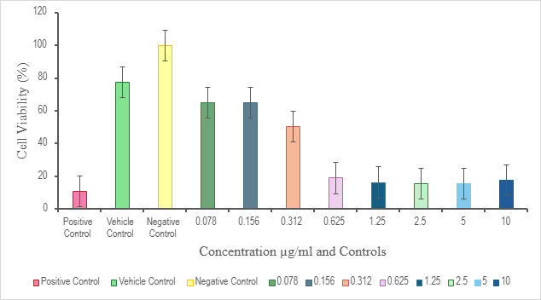
Fig. 1: The graphical representation of cell viability of MCF-7 breast cancer cells treated with bee venom at varying concentrations (0.078-10 µg/mL), measured using the MTT assay. Values are presented as mean ± standard deviation (n = 3), showing a concentration-dependent decrease in cell viability.

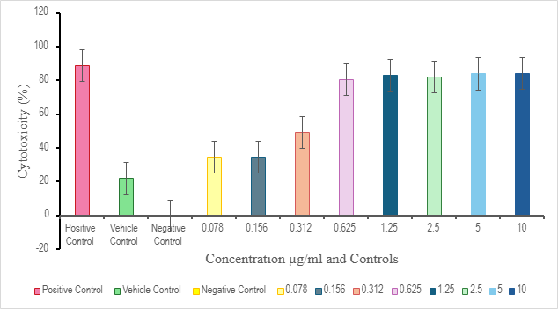

Fig. 2: The cytotoxic effect of bee venom on MCF-7 breast cancer cells measured by the MTT assay at various concentrations (0.078-10 µg/mL). Values are presented as mean ± standard deviation (n = 3), demonstrating a concentration-dependent increase in cytotoxicity.
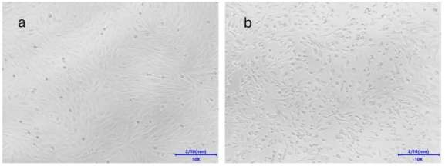

Fig. 3: Microscopic images of MCF-7 breast carcinoma cells as controls. (a) Negative control showing typical cell morphology with intact structure, (b) Vehicle control treated with DMSO, displaying minimal morphological changes.

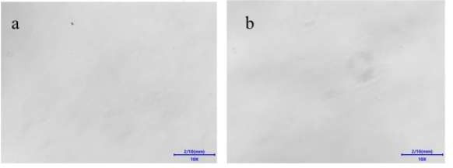

Fig. 4: Microscopic images of MCF-7 cells for positive and blank controls. (a) The positive control (3% SDS) exhibited maximum cytotoxicity (b) Blank control showing a media without cells.
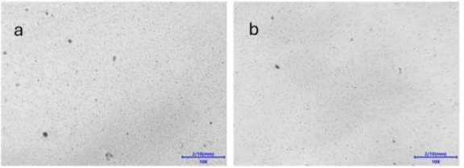

Fig. 5: Microscopic images of MCF-7 cells subjected with high doses of bee venom. (a) 10 µg/mL bee venom treatment showing severe morphological changes, including cell rounding, shrinkage and detachment. (b) 5 µg/mL bee venom treatment with moderate signs of cell damage.

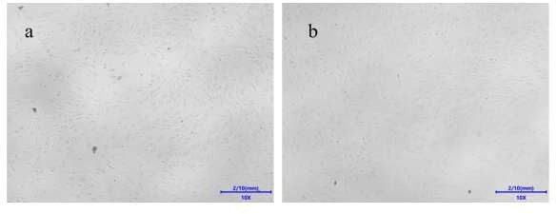

Fig. 6: Microscopic images of MCF-7 cells subjected with mid-range doses of bee venom. (a) 2.5 µg/mL and (b) 1.25 µg/mL treatments, showing initial signs of cell rounding and detachment with moderate cell viability.
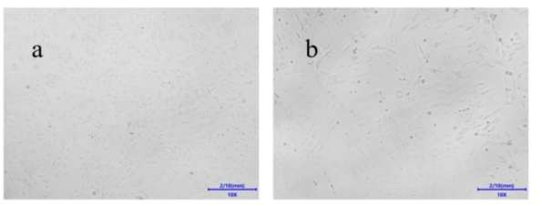
Fig. 7: Microscopic images of MCF-7 cells subjected with lower doses of bee venom. (a) 0.625 µg/mL and (b) 0.312 µg/mL, where cell morphology remains largely intact with minimal cytotoxic effects observed.

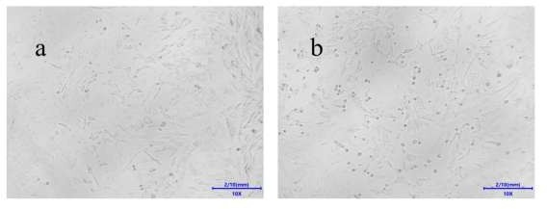

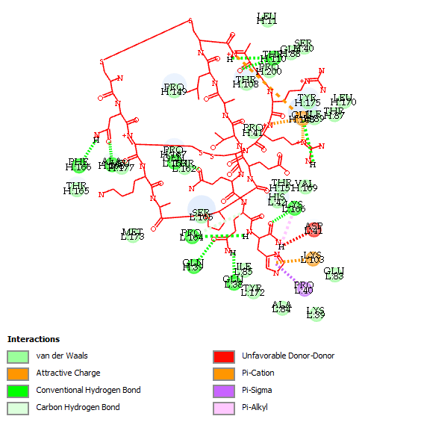
Fig. 8: Microscopic images of MCF-7 cells subjected with minimal doses of bee venom. (a) 0.156 µg/mL and (b) 0.078 µg/mL, showing typical cell morphology with minimum observable cytotoxic effects.

Fig. 9: Molecular docking analysis of apamin, a bioactive peptide from bee venom, with the SEA domain of the MUC16 receptor (PDB ID: 6UVA), which is implicated in tumor growth and metastasis. Detailed 2D interaction network highlighting the distribution of conventional hydrogen bonds, carbon-hydrogen bonds, π-interactions and van der Waals contacts contributing to the stabilization of the apamin-MUC16 complex.

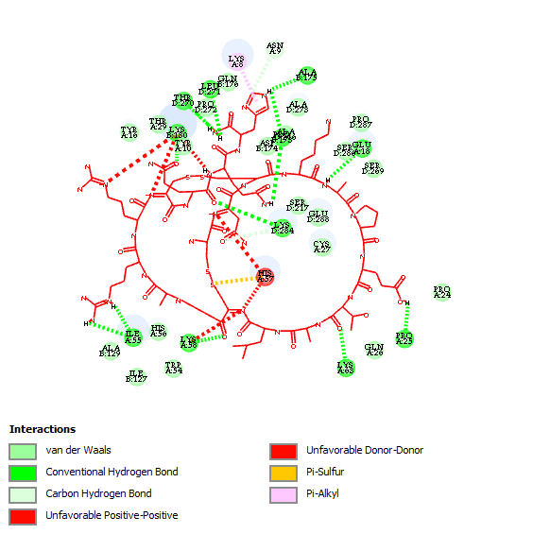

Fig. 10: Molecular docking analysis of apamin, a bioactive peptide from bee venom, with the lysosomal aspartic protease Cathepsin D (PDB ID: 1LYB), a protein implicated in cancer progression and intracellular protein degradation. Detailed 2D interaction network highlighting the hydrogen bond interactions and non-bonded contacts that contribute to the stabilization of the apamin-Cathepsin D complex.
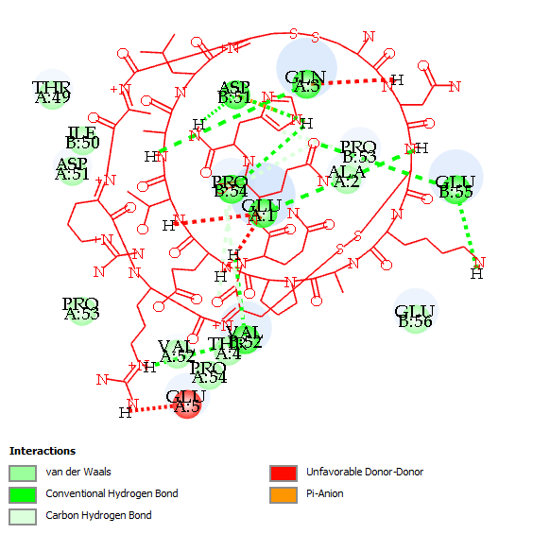

Fig. 11. Molecular docking analysis of apamin, a bioactive peptide from bee venom, with the Trefoil Factor Family protein 1 (TFF1) (PDB ID: 1HI7), a protein associated with mucosal protection and cancer-related epithelial processes. Detailed 2D interaction profile highlighting hydrogen bonds and non-bonded contacts that contribute to the stability of the apamin-TFF1
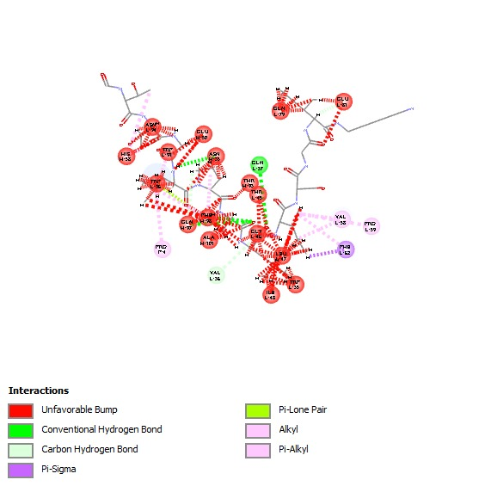

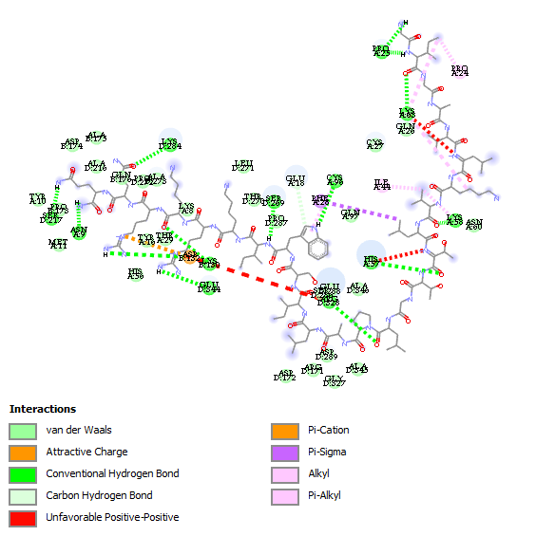
Fig. 12: Molecular docking visualization of Melittin, a principal component of bee venom, with the SEA domain of the MUC16 receptor (PDB ID: 6UVA), a tumor-associated glycoprotein. Hydrogen bond interactions formed between melittin and the active site residues of the SEA domain, indicating potential binding affinity relevant to anticancer mechanisms.

Fig. 13: Molecular docking analysis of melittin, a principal bioactive peptide of bee venom, with the SEA domain of the MUC16 receptor (PDB ID: 6UVA), a tumor-associated glycoprotein implicated in cancer progression. Detailed 2D interaction profile highlighting the hydrogen bond interactions contributing to the stability of the melittin-MUC16 complex.

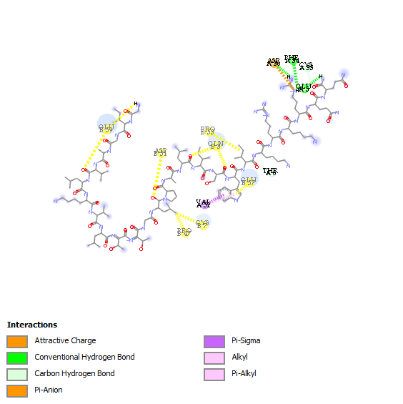

Fig. 14: Molecular docking analysis of melittin, a principal peptide component of bee venom, with the Trefoil Factor 1 (TFF1) homodimer (PDB ID: 1HI7), a protein associated with mucosal protection and epithelial homeostasis. Detailed 2D interaction profile highlighting hydrogen bond formation that contribute to the stability of the melittin-TFF1 complex.

