Evaluating Brood Area Dynamics in Honeybee Colonies: The Role of Colony Vitality and Seasonal Climate Variability

Abstract
Brood rearing is a dynamic and essential process that reflects the internal physiological state of the colony and its external environmental conditions. The rate and extent of brood production are heavily influenced by factors such as ambient temperature, humidity, food availability, and colony strength. Maintaining consistent colony health across diverse initial strengths and navigating the unpredictable spring weather of Kashmir posed challenges to data collection. Brood capped area varied with the strength of the bee colonies and showed significant increase throughout the spring season; and started decreasing with the onset of summer season in mid may during both the study years. Significantly maximum capped brood area across all the treatments was computed in the month of May as 811.62 cm² followed by 644.95 cm² during the month of April and a significant minimum brood area of 263.66 cm² in the month of March during both the spring season. Brood area of Apis cerana workers exhibited a significant and positive correlation with minimum and maximum temperature and a non-significant and negative correlation with minimum and maximum relative humidity during both the years and the rainfall showed a non-significant and negative correlation with brood area during the spring season 2021 and a non-significant and positive correlation in 2022. These findings contribute valuable baseline data on the brood rearing patterns of native Apis cerana in Kashmir, offering insights for optimized beekeeping practices and a foundation for future studies on the impact of climate variability on these crucial pollinators.

Keywords: Apis cerana, brood area, colony strength, spring season, bee frames, temperature.

INTRODUCTION
The Union Territory of Jammu and Kashmir, located in the northern Himalayas, boasts a wide range of agro-climatic zones that span from temperate to sub-tropical regions. This environmental diversity has endowed the region with an exceptionally rich variety of bee forage flora, including fruit trees, wildflowers, forest species, and agricultural crops. These resources play a crucial role in supporting and sustaining apiculture in the region, laying a strong foundation for the growth of the beekeeping industry (Dalio, J. S. 2013). The seasonal availability of pollen and nectar from various floral sources across different altitudes allows for a relatively extended foraging period for honeybee colonies, making Jammu and Kashmir one of the most promising areas for scientific and commercial beekeeping. Beekeeping as a non-land-based farming strategy provides nutritional food, economic security, and environmental stability in the state's hilly regions. Apis cerana and its subspecies are endangered in Jammu and Kashmir, as well as throughout Asia. It's been reported that Apis cerana in the region are not only larger, but they generate more honey than other Himalayan kinds. At the heart of a productive and thriving honeybee colony lies the brood—the immature bees that develop from eggs laid by the queen. The brood includes all stages of immature bees: eggs, larvae, and pupae, which collectively represent the future workforce of the colony. These bees are responsible for critical tasks such as foraging, nursing, guarding, and honey production. In addition, brood cells often contain traces of nectar and honey that serve as essential nutritional reserves for adult bees (Phiancharoen et al., 2011). A well-developed brood area indicates a healthy, expanding colony with the capacity to exploit nectar flows effectively. Conversely, without adequate brood development, colonies become weak, unproductive, and vulnerable to collapse. Moreover, the absence of honeybee colonies cannot be easily compensated for by other pollinators, given the efficiency and specificity of honeybees in crop pollination.
Brood rearing is a dynamic and essential process that reflects the internal physiological state of the colony and its external environmental conditions. The rate and extent of brood production are heavily influenced by factors such as ambient temperature, humidity, food availability, and colony strength. In the plains, optimal brood-rearing conditions include a maximum daytime temperature around 34.40°C, along with long periods of bright sunshine and stable weather patterns (Painkra, et al., 2017). Such conditions encourage the queen to lay eggs and the worker bees to invest in brood care. Rainy periods have been shown to influence the behavior of bees in the nest (Switanek et al., 2017) .However, fluctuations in climatic parameters can lead to reduced brood rearing or even brood mortality (Nürnberger et al., 2019) . Specifically for Apis cerana indica, which is widely reared in India and the Himalayan regions, research has shown that the brood population demonstrates a significant negative correlation with both minimum and maximum temperatures, relative humidity, and rainfall. These stressors can inhibit brood development by affecting hive thermoregulation and resource availability. On the other hand, a positive correlation has been found between brood area and the number of sunshine hours, which enhances foraging activity and the colony’s energy budget (Das and Rahman, 2000).
Although beekeepers do not intervene directly in brood development, routine monitoring of brood patterns is essential. It helps in assessing colony strength, identifying queen performance, and predicting colony growth. Proper brood assessment enables timely management practices such as supplementary feeding, swarm control, or queen replacement. Hence, understanding the brood dynamics in relation to environmental conditions is critical, which formed the basis for undertaking the present study.
MATERIALS AND METHODS
Studies on the capped brood area of Apis cerana F. during spring season in Kashmir was conducted at village Harwan (34.15º North and 74.88º East) during the years 2021 and 2022. An experiment was laid in randomized complete block design with three treatments comprising 6, 8 and 10 frame bee colonies to record the incremental brood area in both the seasons of active bee flora of spring 2021 and 2022. Brood area was recorded at 10 day intervals throughout the blooming period of the available flora to study the treatment effect under natural conditions. Brood area was recorded in terms of capped brood area with the help of frame sized wire grid. The frame with wire grid squares was placed on the comb and the number of squares of wire grid, covering the brood was counted. Each square in the wire grid was of dimension 6.45 cm². The recorded parameter, total brood area was correlated with the various weather parameters like maximum and minimum temperature, relative humidity and rainfall. The data on the weather parameters during the period of investigations was obtained from Division of Agro-metrology, SKUAST-K. The correlation coefficient was worked out by using Karl Pearson’s co-efficient test.
RESULTS AND DISCUSSION
The capped brood area varied with the strength of the bee colonies and showed significant increase throughout the spring season and started decreasing with the onset of summer season in mid may during both the study years. The data on capped worker brood area in different treatments recorded at ten days interval from the month of March till ending May during spring season 2021 revealed that the maximum overall mean capped worker brood area was recorded in treatment T₃ (ten frame colonies) as 607.03 cm², followed by the brood area of 519.83 cm² with treatment representing eight frame colonies (T₂); whereas, the treatment T₁ (six frame colonies) had 389.38 cm² brood area during the spring season 2021.
Data over the different months revealed that significantly maximum capped worker brood area in treatment T₁ was recorded in the month of May (531.25 cm²), followed by April (450.29 cm²) and significantly minimum mean brood area was recorded in the month of March (186.63 cm²) during spring season 2021. However, in treatment T₂ significantly maximum capped worker brood area was recorded in the month of May (726.19 cm²), followed by April (582.73 cm²) and significantly minimum mean brood area was recorded in the month of March as 250.59 cm². Though, in treatment T₃, a significantly maximum capped worker brood area was recorded in the month of May (831.24 cm²), followed by a brood area of 678.87 cm² in the month of April; and significantly minimum mean capped brood area was recorded in the month of March as 310.98 cm². A significantly maximum capped brood area across all the treatments was computed in the month of May as 692.23 cm² followed by 570.63 cm² during the month of April and a significant minimum brood area of 249.40 cm² in the month of March during the spring season, 2021.
During the spring season 2022, maximum overall mean capped worker brood area was recorded in treatment T₃ (ten frame colonies) as 768.08 cm², followed by the brood area of 669.93 cm² with treatment representing eight frame colonies (T₂); whereas, the treatment T₁ (six frame colonies) had 512.90 cm² brood area. Data over the different months revealed that significantly maximum capped worker brood area in treatment T₁ was recorded in the month of May (719.34 cm²), followed by April (598.51 cm²) and significantly minimum mean brood area was recorded in the month of March (220.83 cm²) during spring season 2022. However, in treatment T₂ significantly maximum capped worker brood area was recorded in the month of May (972.31 cm²), followed by April (736.30 cm²) and significantly minimum mean brood area was recorded in the month of March as 301.19 cm². Though, in treatment T₃, a significantly maximum capped worker brood area was recorded in the month of May (1089.42 cm²), followed by a brood area of 823.18 cm² in the month of April; and significantly minimum mean capped brood area was recorded in the month of March as 391.66 cm². A significantly maximum capped brood area across all the treatments was computed in the month of May as 927.02 cm² followed by 719.33 cm² during the month of April and a significant minimum brood area of 304.55 cm² in the month of March during the spring season, 2022.
The perusal of pooled data of two seasons revealed that significantly, the maximum overall mean capped worker brood area was recorded in treatment T₃ (ten frame colonies) as 451.14 cm², followed by the brood area of 594.85 cm² with treatment representing eight frame colonies (T₂); whereas, the treatment T₁ (six frame colonies) had 687.56 cm² brood area during both the spring seasons. Data over the different months revealed that significantly maximum capped worker brood area in treatment T₁ was recorded in the month of May (625.29 cm²), followed by April (524.40 cm²) and significantly minimum mean brood area was recorded in the month of March (202.73 cm²). However, in treatment T₂ significantly maximum capped worker brood area was recorded in the month of May (849.25 cm²), followed by April (659.44 cm²) and significantly minimum mean brood area was recorded in the month of March as 275.89 cm². Though, in treatment T₃, a significantly maximum capped worker brood area was recorded in the month of May (960.33 cm²), followed by brood area of 751.03 cm² in the month of April; and significantly minimum mean capped brood area was recorded in the month of March as 351.32 cm². A significantly maximum capped brood area across all the treatments was computed in the month of May as 811.62 cm² followed by 644.95 cm² during the month of April and a significant minimum brood area of 263.66 cm² in the month of March during both the spring season.
The authors reported maximum brood area in month of May. Haran et al. (2024) also reported similar results with maximum bee population in the month of May. Manzoor et al. (2019) too reported maximum brood area during May and minimum brood area during March. Taha et al. (2013) reported the influence of colony strength on productivity of economic parameters of colony and reported that the stronger colonies produce more honey, pollen and brood as compared to weaker colonies which are in corroboration with the present findings.
The maximum temperature showed a significant and positive correlation with brood area (0.84) at 1% level of significance during the spring season 2021. The minimum temperature showed a significant and positive correlation with brood area (0.73) at 5% level of significance. The maximum relative humidity showed a non-significant and negative correlation with brood area (-0.54) during the spring season 2021. Similarly, the minimum relative humidity showed a non-significant and negative correlation with brood area during the spring seasons 2021. The rainfall showed a non-significant and negative correlation with brood area (-0.13) during the spring season 2021.
During spring season 2022, the maximum temperature showed a significant and positive correlation with the brood area (0.82) at 1% level of significance. Similarly, the minimum temperature showed a significant and positive correlation with brood area (0.86) at 1% level of significance .The relative humidity showed a non-significant but negative correlation with brood area (-0.64). The rainfall showed a non-significant and positive correlation with brood area (0.03) during the spring season 2022. These results are more or less in conformity with Painkra et al. (2017) who reported the maximum temperature had significant and positive correlation with brood area and the relative humidity had significant but negative correlation with brood area, the minimum temperature had a significant and positive correlation with brood area at different locations.
Conclusion
The dynamics of capped brood area in Apis cerana colonies across two spring seasons revealed that brood area varied significantly with colony strength, the highest capped brood area was recorded in ten-frame colonies, followed by eight and six-frame colonies. Seasonal patterns revealed a peak in brood area during May, correlating positively with maximum and minimum temperatures while showing nuanced relationships with relative humidity and rainfall. These findings underscore the importance of colony size and seasonal weather conditions in influencing brood development, crucial for effective honeybee management strategies in varying climatic contexts.
DISCLAIMER (ARTIFICIAL INTELLIGENCE)
Author(s) hereby declare that NO generative AI technologies such as large language models (chatGPT, COPILOT etc) and text-to-image generators have been used during writing or editing of this manuscript.
Conflict of Interest
The author(s) declares no conflict of interest.
References
Dalio, J. S. (2013). Foraging activity of Apis mellifera on Parthenium hystophorus. Journal of Pharmacy and Biological Sciences, 7(5), 01-04.
Le Conte, Y. & Navajas, M. (2008). Climate change: impact on honey bee populations and diseases. Revue scientifique et technique-Office International des Epizooties, 27(2), 499.
Moritz, R. F. A. & Southwick, E. E. (2012). Bees as Superorganisms: An Evolutionary Reality. Springer Science & Business Media.
Haran, R., Sumathi, E., Iqbal, J., Krupesh, S., Parthasarathi, G., Vijay, S., ... & Zeshan, A. (2024). Field Exploration for Colony Selection: Evaluating Hygienic Behavior in Apis cerana indica Colonies. Insects, 15(8), 598.
Manzoor M, Sheikh A H and Mathivanan V. (2019). Evaluation of indigenous honey bee Apis cerana-Srinagar (J&K) vs. Coimbatore (Tamil Nadu). Indian Journal of Entomology, 81(3), 627-629.
Nürnberger, F., Härtel, S., & Steffan-Dewenter, I. (2019). Seasonal timing in honey bee colonies: phenology shifts affect honey stores and varroa infestation levels. Oecologia, 189(4), 1121-1131.
Painkra, M. K., Shaw, S. S., Thakur, R. K. and Nag, Y. (2017). Influence of Weather Parameters on Colonies Performance Parameters of Indian Bee, Apis cerena indica. International journal of current Microbiology and Applied Sciences, 6(11), 2375-2380.
Paini, D. R. (2004). Impact of the introduced honey bee (Apis mellifera) (Hymenoptera: Apidae) on native bees: a review. Austral Ecology, 29(4), 399–407.
Phiancharoen, M., Duangphakdee, O. and Hepburn, H. R. (2011). Biology of nesting. Honeybees of Asia, 109-131.
Rana, B. S. and Goyal, N. P. (1994). Comparative brood rearing activity of Apis mellifera and A. cerana indica at Nauni (Solan), midhills of Himachal Pradesh, Indian Bee Journal, 56(1-2), 24-28.
Switanek, M., Crailsheim, K., Truhetz, H., & Brodschneider, R. (2017). Modelling seasonal effects of temperature and precipitation on honey bee winter mortality in a temperate climate. Science of the Total Environment, 579, 1581-1587.
Taha, A. and Katoni, N. S. (2013). Relationship between population size and productivity of honey bee colonies. Journal of Entomology, 10(3), 163-169.

Mean capped brood area (cm²)
 | 2021 |  |  |  |  | 2022 |  |  |  |  | 2021 & 2022
Date of Observation | T₁ | T₂ | T₃ |  | Mean | T₁ | T₂ | T₃ |  | Mean | T₁ | T₂ | T₃ | Mean
March 01 (I₁) | 109.86 | 144.64 | 201.78 | 152.10 |  | 94.64 | 151.78 | 230.35 | 158.92 |  | 102.25 | 148.21 | 216.07 | 115.51
March 11 (I₂) | 184.857 | 250.00 | 325.82 | 253.55 |  | 183.92 | 283.03 | 391.96 | 286.30 |  | 184.39 | 266.51 | 358.89 | 269.93
March 21 (I₃) | 265.17 | 357.14 | 405.35 | 342.55 |  | 383.92 | 468.75 | 552.67 | 468.44 |  | 324.55 | 412.94 | 479.01 | 405.55
Sub mean | 186.63 | 250.59 | 310.98 | 249.40 |  | 220.83 | 301.19 | 391.66 | 304.55 |  | 203.73 | 275.89 | 351.32 | 263.66
April 1 (I₄) | 349.10 | 466.96 | 525.89 | 447.31 |  | 524.10 | 625.89 | 721.42 | 623.80 |  | 436.60 | 546.42 | 623.66 | 535.56
April 11 (I₅) | 450.89 | 582.14 | 675.89 | 569.64 |  | 604.46 | 727.67 | 830.35 | 720.82 |  | 527.67 | 654.67 | 753.12 | 645.15
April 21(I₆) | 550.89 | 699.10 | 834.82 | 694.93 |  | 666.96 | 855.35 | 917.78 | 813.36 |  | 608.92 | 777.23 | 876.30 | 754.15
Sub mean | 450.29 | 582.73 | 678.87 | 570.63 |  | 598.51 | 736.30 | 823.18 | 719.33 |  | 524.40 | 659.44 | 751.03 | 644.95
May 1(I₇) | 611.60 | 811.60 | 976.78 | 800.00 |  | 819.64 | 1091.96 | 1218.78 | 1043.46 |  | 715.62 | 951.78 | 1097.78 | 921.72
May 11(I₈) | 557.14 | 762.50 | 855.35 | 713.00 |  | 786.60 | 1016.96 | 1133.42 | 978.99 |  | 671.87 | 889.73 | 994.39 | 851.99
May 21 (I₉) | 425.00 | 604.46 | 661.60 | 563.68 |  | 551.78 | 808.00 | 916.07 | 758.61 |  | 488.39 | 706.23 | 788.83 | 661.15
Sub mean | 531.25 | 726.19 | 831.24 | 692.23 |  | 719.34 | 972.31 | 1089.42 | 927.02 |  | 625.29 | 849.25 | 960.33 | 811.62
Overall mean | 389.38 | 519.83 | 607.03 | 504.08 |  | 512.90 | 669.93 | 768.08 | 650.30 |  | 451.14 | 594.85 | 687.56 | 573.41
C.D. (p≤0.05)
C.D. (p≤0.05) | Factors |  |  | C.D. |  | Factors |  |  | C.D. |  | Factors |  | C.D.
C.D. (p≤0.05) | Treatment(T) |  |  | 9.34 |  | Treatment(T) |  |  | 28.51 |  | Treatment(T) |  | 18.13
C.D. (p≤0.05) | Time interval (I) |  |  | 16.17 |  | Time interval (I) |  |  | 49.39 |  | Time interval (I) |  | 31.40
C.D. (p≤0.05) | T×I |  |  | 28.02 |  | T×I |  |  | 85.55 |  | T×I |  | 54.39
Table 1: Mean Capped brood area in T₁ (six), T₂ (eight) and T₃ (ten) frame colonies during spring season 2021 and 2022
Table 2: Correlation of weather parameters with mean brood area during spring seasons
Parameters | Mean Brood area
Parameters | 2021 | 2022
Max. Temperature | 0.84** | 0.82**
Min. Temperature | 0.73* | 0.86**
Max. RH | -0.54 | -0.64
Min. RH | -0.32 | -0.37
Rainfall | -0.13 | 0.03
*Significant at 5% level of significance (p≤0.05)
**Significant at 1% level of significance (p≤0.01)

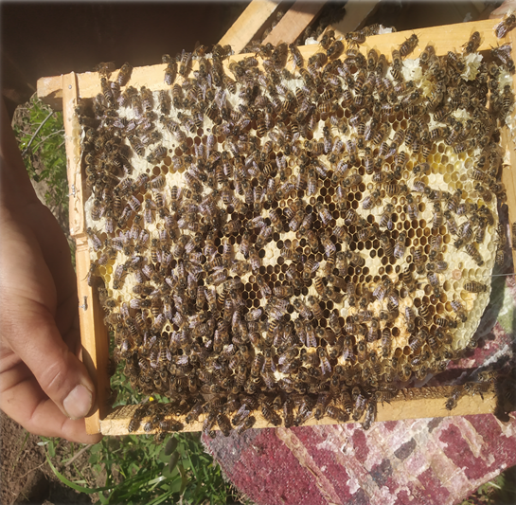
Fig. 1. Observation of colony performance parameters
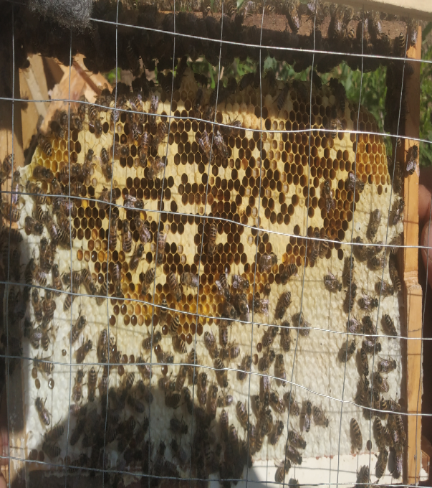
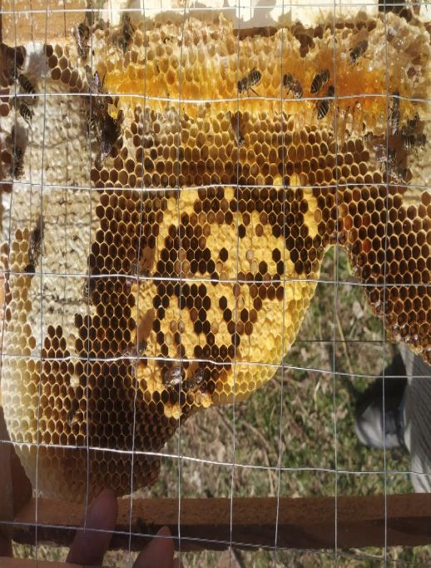

Fig. 2. Measuring brood area with the help of wire grid

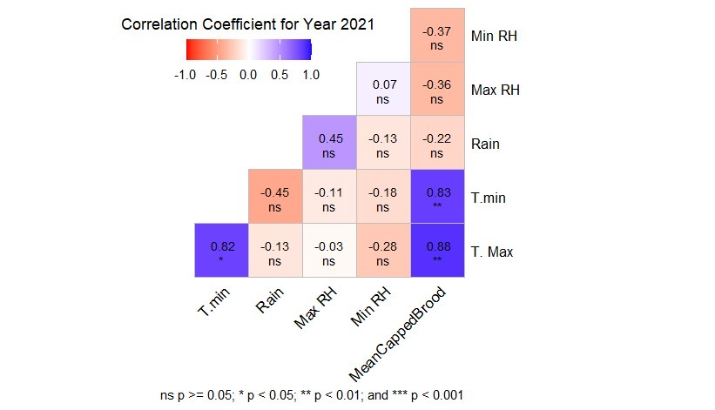
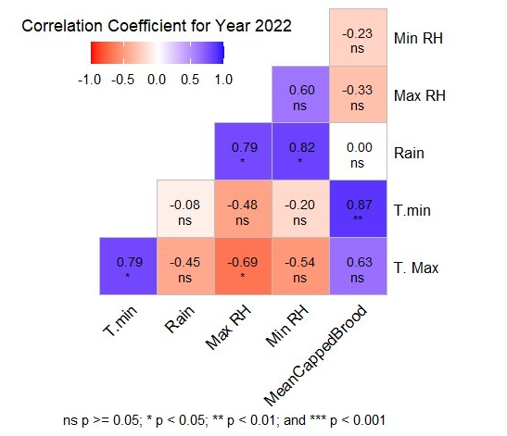
Fig. 3: Correlation of weather parameters with mean capped brood area during spring season 2021
and 2022 respectively

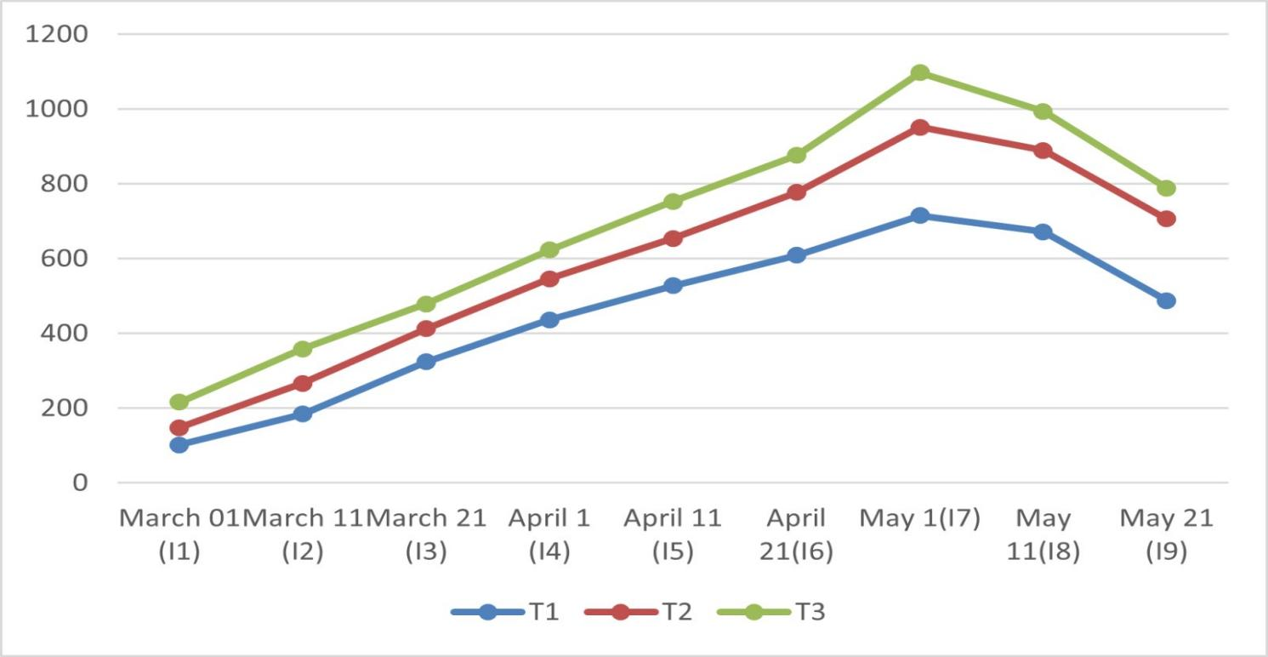
Fig. 4: Mean capped brood area in T₁ (six), T₂ (eight) and T₃ (ten) frame colonies during spring season
2021 and 2022

Fig. 4: Mean capped brood area in T₁ (six), T₂ (eight) and T₃ (ten) frame colonies during spring season
2021 and 2022

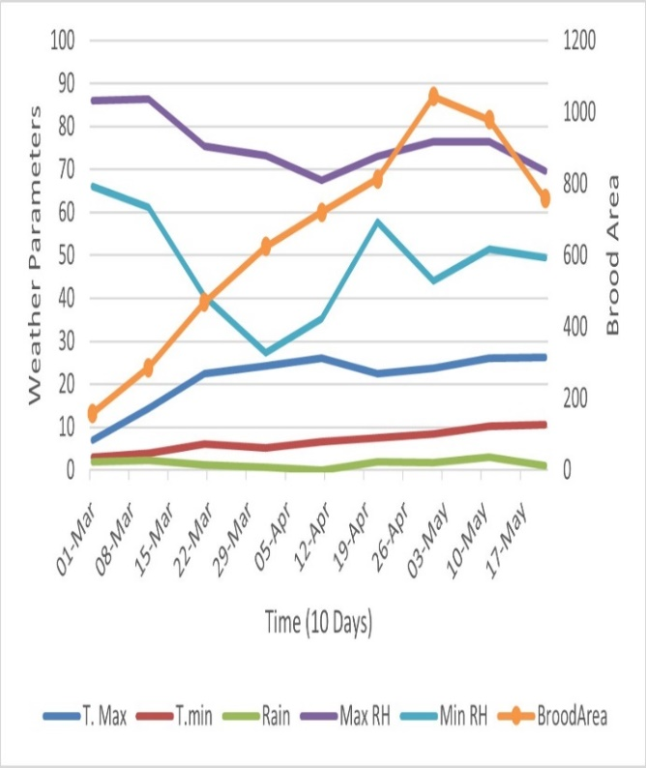
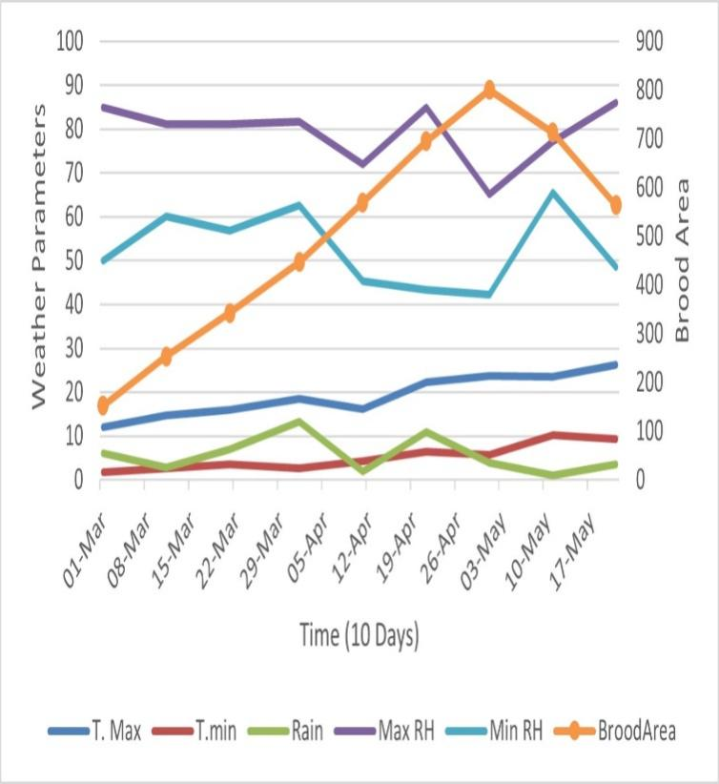
Fig. 5: Mean capped brood area at ten day intervals in different months during spring season 2021 and 2022 respectively

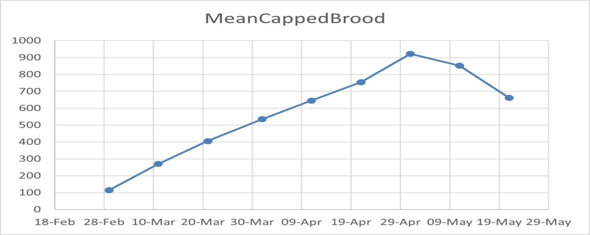
Fig. 6: Pooled mean capped brood area at ten day interval in different months during both spring seasons

