Investigation of the catalytic performance of an activated smectite on the esterification réaction of acetic acid by butan-2-ol

Abstract
In this work, a solid-phase acid catalyst was prepared from a natural Cameroonian smectite and sulfuric acid. The natural clay was treated by refluxing it in sulfuric acid for 4 hours at 80°C under constant stirring. The catalyst obtained after washing and drying was used for the esterification reaction of acetic acid by a secondary alcohol (butan-2-ol). The natural clay and the catalyst obtained were characterized by Fourier Transform Infrared spectroscopy, which allowed us to confirm that the natural clay consists of OH groups which constitute its framework, water molecules and cations in its interlayer spaces and Si-O bonds constituting its basic structure. The examination of the FTIR spectrum of the catalyst allowed us to note a remarkable decrease in the intensity of the absorption bands attributable to the water molecules of the interlayer space on the one hand and to the Al-Fe-OH and Al-Mg-OH bonds on the other hand; proof that our natural clay has indeed undergone a structural modification by exchanging its interlayer space cations for H+ protons. After optimizing the parameters influencing the reaction kinetics and yield, the optimal temperature was found to be 80°C; the optimal reaction time 120 minutes; the optimal catalyst mass 200 mg; the best molar ratio 1:2 (1 eq of acetic acid and 2 eq of butan-2-ol, respectively); and the optimal stirring speed 400 rpm. Using equimolar proportions, we obtained an optimal yield of 78.41%. This yield is significantly higher than the 60% reported in the literature when the reaction is carried out after approximately 30 hours without considering kinetics.
Keywords: Esterification, smectite, butan-2-ol, catalysis, activation

Introduction
Esters comprise a broad category of oxygenated organic compounds ranging from aliphatic to aromatic esters. They are commonly used as plasticizers, solvents, perfumes, flavoring chemicals, and also as precursors for some pharmaceuticals, agrochemicals, and several other chemicals [1]. Esterification is a transformation that produces esters from a carboxylic acid and an alcohol. Compared to primary alcohols, the esterification of secondary and tertiary alcohols is much more difficult due to steric hindrance around the substrate oxygen atom from the alcohol [2].
The esterification reaction is also limited by the slow reaction rate and the reverse reaction which is the hydrolysis of the ester. To improve the kinetics and even the yield of this transformation, conventional homogeneous catalysts such as HCl, H₂SO₄, H₃PO₄ are widely used in industry. Unfortunately, this widespread use is not without environmental consequences due to the corrosive nature of these strong acids, the possibility of side reactions, and also the fact that the catalyst cannot be easily separated from the reaction mixture. Nowadays, due to the stringency of regulations and conventions ratified by nations for environmental protection, chemical industries need to develop more economical and less environmentally polluting synthesis methods. The use of heterogeneous acid catalysts offers an alternative and has already attracted the attention of several research teams in recent years [1, 3,4].
A wide variety of heterogeneous catalysts has already been the subject of several research studies reported in the literature, including clays, niobic acid, heteropolyacids, etc. [3]. Clays are widely used, easily accessible and inexpensive materials. Whether in their natural or modified states, clays are versatile materials that serve as catalysts or precursors for a variety of chemical transformations. The microstructure of clays can be modified as needed to meet specific needs in synthetic chemistry. Clays are nanoparticles whose structure is organized into sheets. These sheets have negative charges that are neutralized by the cations (Na⁺, K⁺, Ca²⁺, Mg²⁺, etc.) occupying the inter-sheet space [5,6]. The impressive ability of clays to be structurally modified so easily lies in the fact that it is possible to replace the cations in the interlayer space through cation exchange. This ion exchange property offers scientists enormous scope for modifying the properties of clays, such as acidity, pore size, specific surface area, polarity, etc [5,7].
In this work, a natural smectite of Cameroonian origin will be activated by sulfuric acid and will be applied to the optimization of an esterification reaction. This smectite, both in its natural and modified state, has already been the subject of several scientific studies: Tcheumi et al., 2019 [8], on the modification of Sabga clay with β-cyclodextrin to detect paraquat; Mbokana et al., 2017[9]; Mbokana et al., 2020[10] , on the modification of the same clay with an organosilane to detect carbendazim and glyphosate; Kengne, 2020[11] , on the development of nanocomposites based on this clay for application to the electroanalysis of carbendazyme; Kemmegne et al.,2024[12], on the intercalation into interlayer space of natural smectite clay of a supramolecular complex of porphyrin for modified glassy carbon electrodes with the aim of simultaneous sensing of dopamine, acetaminophen and tryptophan. However, the majority of scientific work carried out on this natural clay of Cameroonian origin focuses on its applications in electrochemistry. Very little work found in the literature focuses on the catalytic properties of this local material.
The objective of this work is to activate the catalytic properties of this clay by sulfuric acid and to apply it as a catalyst in the esterification reaction of acetic acid by butan-2-ol. We will determine the optimal conditions to maximize ester yield using classical optimization
2. Methodology
2.1 Materials and reagent
All reagent used were analytical grade and used as received. Sulfuric acid (93%), Sodium hydroxide (99%) were purchased from Merck. Baryum nitrate (98%) and phenolphtaleine were purchased from prolabo. Butan-2-ol (99%) from Guandang. Ethanoic acid ( 96%) from Riedel de Haen. The Cameroonian clay was collected in Sabga hill and characterized as reported by Tonle et al., 2003[13].
2.2 Clay activation
After grinding and sieving the natural clay, 20g was mixed with 200ml of 2M sulfuric acid. The mixture was then heated to reflux with constant stirring at 80°C for 4 hours. After cooling, the product obtained was filtered and then washed with distilled water until the barium nitrate test was negative. The washed product was then filtered and then dried in an oven for 24 hours at 120°C. The activated clay was finally ground, then sieved and stored away from moisture[14].
2.3 Expérimental protocol
The experimental esterification device consists of a 250mL flask fixed on a water cooler and kept stirring using a magnetic stirrer.
For the esterification reaction, we first prepared a mixture of 10 mL of acetic acid, 12.6 mL of butan-2-ol, and 200 mg of activated clay. This mixture was heated to reflux at 80°C with constant stirring for 120 minutes. The reactants introduced were in equimolar quantities (molar ratio 1:1), i.e., 0.1694 moles of acetic acid and 0.1694 moles of butan-2-ol. We then repeated the procedure by varying the following parameters: molar proportion of reactants, temperature, reaction time, catalyst mass, and stirring speed.
The yield of the esterification reaction is each time given by the following relationship:
$$yield\left(\%\right)=\frac{n_{a0}-n_{at}}{n_{a0}}×100$$
Where n_{a0} is the initial quantity of acetic acid introduced into the reactor and n_{at} the quantity of unesterified acetic acid in the reactor at time t. n_{ao} and n_{at} are determined by volumetric titration of acetic acid with 2M sodium hydroxide using phenolphthalein as a color indicator. We used classical optimization which consists of varying one factor at a time while keeping the others constant [ 15].
3. Results and discussion
3.1 Physicochemical characterization of materials
Fourier Transform Infrared Spectroscopy (FTIR) was used for the physicochemical characterization of natural clay and activated clay (catalyst). It was used to identify the different functional groups present on natural clay and activated clay. Figure 1 below shows the FTIR spectra recorded between 4000 cm⁻¹ and 400 cm⁻¹ of natural clay (ANa) and the catalyst (ANaA).
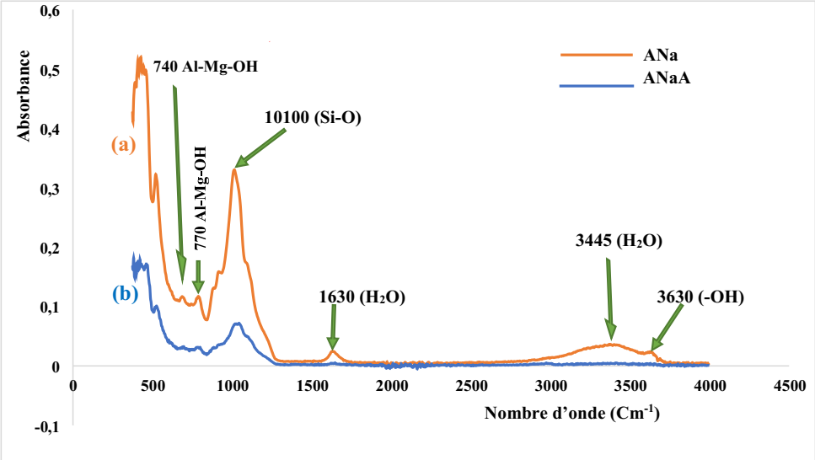

Figure 1: FTIR spectrum: (a) natural clay; (b) clay activated by sulfuric acid
The FTIR spectrum of natural clay presented in Figure 1 (a) reveals various absorption bands: a band at 3630 Cm⁻¹ attributable to the stretching vibrations of the OH groups which constitute the framework of natural clay; a band centered around 3445 Cm⁻¹ corresponding to the stretching vibrations of the water molecules physisorbed by the clay; another absorption band at 1630 Cm⁻¹ attributable to the deformation vibrations of the water molecules located in the interlayer space; the intense absorption bands centered at 1100 Cm⁻¹ and 1052 Cm⁻¹, attributable to the elongation vibrations of the SiO bonds that constitute the structure of the clay; the absorption bands centered at 740 Cm⁻¹ and 770 Cm⁻¹, attributable to the deformation vibrations of the Al-Fe-OH and Al-Mg-OH bonds of the interlayer space of the clay. These results are in agreement with those in the literature [8, 10].
From the analysis of the FTIR spectrum of activated clay (Figure 1 (b)), the following findings emerge: a considerable decrease in the intensity of the absorption bands at 1630 Cm⁻¹ and 3630 Cm⁻¹ and the absence of the band at 3445 Cm⁻¹, which reflects the loss of water molecules by the natural clay[14 ]; a considerable decrease in the intensity of the peaks centered at 740 Cm⁻¹ and 770 Cm⁻¹ is also observed, which reflects the substitution of the interlayer cations (Fe²⁺ and Mg²⁺, etc.) by H⁺ protons from sulfuric acid[16 ]. These results allow us to conclude that our natural clay has indeed undergone activation by sulfuric acid, notably by a cation exchange mechanism between the interlayer cations of the clay and the H⁺ protons of the acid on the one hand and by a surface adsorption mechanism on the other hand.
3.2 Optimization of the esterification reaction using the classical optimization method
The esterification of ethanoic acid by butan-2-ol is a condensation reaction that leads to the formation of a molecule of 1-methylpropyl ethanoate and a molecule of water. This reaction is very slow and very limited when it is not catalyzed. In this work, a Cameroonian natural smectite was activated and used to accelerate the kinetics of this reaction and improve its yield. A plausible mechanism to explain the catalysis process of the esterification reaction by activated clay is similar to that of catalysis of the esterification reaction of acetic acid and butan-2-ol by phosphoric acid-activated montmorillonite [ 1 ]. It is summarized in figure 2.
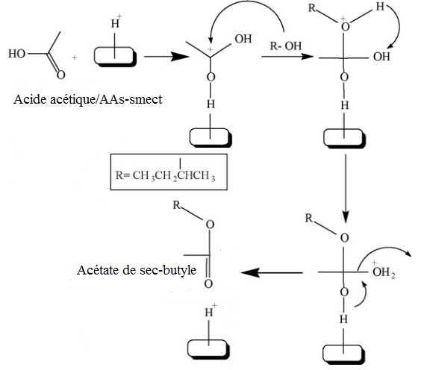
Figure 2: Mechanism of catalysis of the esterification of acetic acid and butan-2-ol by acid-activated smectite.
3.2.1 Influence of the temperature of the reaction medium on the yield of esterification
In order to study the influence of temperature on the reaction yield, we varied the temperature of the reaction medium between 30°C and 90°C. The results obtained are represented by the graph in Figure 3.
Figure 3: Influence of the temperature of the reaction medium (molar ratio 1:1, reaction time 120 minutes, catalyst mass 200 mg, stirring speed 400 rpm)

From the analysis of figure 3, it appears that the yield of the esterification of acetic acid by butan-2-ol increases with temperature up to 80°C and then begins to drop as the temperature continues to rise. This can be explained by the fact that increasing the reaction temperature promotes the formation of carbanion ions from acetic acid. This ion, once formed, reacts with the alcohol to form the ester, as shown in the reaction mechanism in figure 2 [1]. Furthermore, increasing the temperature decreases the viscosity of the mixture, allowing the reactants to mix better, which accelerates the reaction and improves its yield [ 17]. However, the drop in reaction yield beyond 80°C could be explained by the fact that beyond 80°C, the alcohol begins to evaporate from the reaction medium, slowing down the reaction and therefore, most studies recommend working at a temperature lower than the boiling point of the alcohol used [18]. The optimal temperature for achieving the best esterification yield is 80°C.
In addition to the influence of reaction medium temperature, we also studied the influence of reaction time on the yield.

3.2.2 Influence of reaction time on esterification yield
To study the influence of reaction time on the esterification yield, we varied the reaction time between 30 and 180 minutes. The results obtained are recorded in Figure 4.
Figure 4: Influence of reaction time (molar ratio 1:1, temperature 80°C, catalyst mass 200 mg, stirring speed 400 rpm)
Analysis of this graph reveals that the esterification yield increases with reaction time, reaching a maximum after 120 minutes. We also note that the reaction yield decreases slightly as the reaction time continues to increase. This result can be explained by the fact that, under the action of the catalyst and at optimal temperature, the acetic acid molecules are gradually converted into ester until the transformation reaches equilibrium after 120 minutes of reaction. However, at equilibrium, if the reaction time is prolonged, the reverse reaction, namely ester hydrolysis, is likely to occur, competing with esterification [1], which may explain the slight decrease in esterification yield after 120 minutes.
The optimal reaction time obtained in this work is 120 minutes. Besides the reaction time, we also studied the influence of the catalyst mass in the reaction mixture.
3.2.3 Influence of catalyst mass on esterification yield
A catalyst is a substance that accelerates a chemical transformation and remains intact at the end of the reaction. There are several types of catalysis. In this work, the catalysis model studied is heterogeneous catalysis using clay activated by concentrated sulfuric acid. To study the influence of the catalyst on the esterification yield, we varied the catalyst mass between 0 and 400 mg. The results obtained are shown in Figure 5.
Figure 5: Influence of the catalyst mass (reaction time 120 minutes, temperature 80°C, molar ratio 1:1, stirring speed 400 rpm)
Analysis of this graph shows that the esterification yield increases with clay mass, reaching a maximum for 200 mg of activated clay, then decreases slightly as the catalyst mass continues to increase. This can be explained by the fact that, as the amount of catalyst in the reaction medium increases, the number of active sites in the clay capable of protonating the acetic acid molecule also increases. Acetic acid molecules diffuse into the pores of the interlayer space of the activated clay to be protonated by the H⁺ protons present there following the clay activation process. However, the product molecules (ester) can remain adsorbed within the pores of the catalyst interlayer space and thus restrict the diffusion of new acid molecules into the interlayer space; which may explain the slight decrease in yield after 200 mg [ 1]. On the other hand, any excess catalysis has no influence on the kinetics of the reaction.
The kinetics of the esterification reaction are limited by the fact that acetic acid must first be adsorbed by the clay before being protonated in the interlayer space [19]. This analysis therefore shows that the optimal catalyst mass required to achieve a better esterification yield is 200 mg. Another parameter likely to influence the yield of this transformation, which we studied, is the influence of the stirring speed of the reaction medium.
3.2.4 Influence of stirring speed on esterification yield.
Stirring the reaction mixture has a positive effect on the overall kinetics and yield of the reaction. To study the influence of stirring speed on the reaction yield, we varied the stirring speed of the reaction medium between 100 and 500 rpm. The results obtained are summarized in Figure 6.
Figure 6: Influence of stirring speed (reaction time 120 minutes, temperature 80°C, molar ratio 1:1, catalyst mass 200 mg)

Analysis of this figure shows that the yield of the esterification reaction increases overall with stirring speed. This is naturally explained by the fact that the greater the stirring, the greater the number of effective collisions between the acetic acid and butan-2-ol molecules. This promotes the conversion of the acid and alcohol molecules into esters.
This analysis shows that the optimal stirring speed for best esterification yield is 400 rpm.
Another factor that can influence esterification yield that we studied is the influence of the molar ratio of reactants on esterification yield.

3.2.5 Influence of the molar ratio of the reactants
One of the most important factors influencing ester yield is the acid-to-alcohol molar ratio. To study the influence of the molar ratio on esterification yield, we performed the experiment for the following acetic acid-to-2-butanol ratios: 1:1, 1:2, and 2:3. The results are shown in Figure 7.
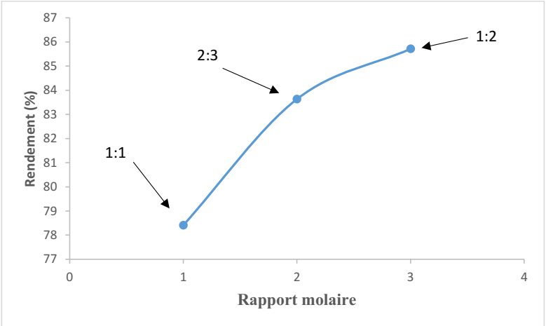
Figure 7: Influence of the molar ratio of the reactants (reaction time 120 minutes, temperature 80°C, catalyst mass 200 mg, stirring speed 400 rpm)

From the analysis of this figure, it appears that the esterification yield increases with the amount of alcohol when the amount of acid is fixed in the molar ratio. This can be explained by Le Chatelier's law, which states that in a system in equilibrium, increasing the amount of one of the components shifts the equilibrium in the direction of its consumption, which increases the yield of the esterification reaction. Furthermore, when the molar ratio is high, this increases the number of effective collisions between the acid and alcohol molecules.
In this work, the optimal molar ratio for obtaining the highest esterification yield (85.71%) is the 1:2 acetic acid/2-butanol ratio.
3.3.5 Reproducibility of the method
To verify the reliability and validity of our method, we conducted a series of four identical experiments under optimal conditions of temperature, time, stirring speed, and catalyst mass. The experiments were performed using a 1:1 molar ratio to allow for comparison with the literature [20 ]. The literature indicates that the yield is around 60% when the molar ratio is 1:1 for the esterification reaction using a secondary alcohol such as butan-2-ol. The results obtained are summarized in table 1:
Table 1: Reproducibility of the experiment (reaction time 120 minutes, temperature
80°C, molar ratio 1:1, catalyst mass 200 mg, stirring speed 400 rpm)
Experiences | Experience 1 | Experience 2 | Experience 3 | Experience 4
n_{a0}(mol) | 0.1556 | 0.1556 | 0.1556 | 0.1592
n_{at} (mol) | 0.0336 | 0.0340 | 0.0336 | 0.0344
yield (%) | 78.41 | 78.15 | 78.41 | 78.39

In light of this table, we note that for a series of four experiments carried out independently under optimal conditions, we obtain practically the same results; which leads us to conclude without risk of error that the proposed method is reproducible, and therefore reliable.

Conclusion
The objective of this work was to develop an acid catalyst by activating a natural clay of cameroonian origin and to apply it to optimize the esterification reaction of acetic acid with butan-2-ol. The physicochemical characterization of the natural clay and the activated clay by Fourier Transform Infrared (FTIR) spectroscopy allowed us to confirm the modification of the natural clay’s structure through cation exchange between the cation in the clay’s interlayer space and H+ protons from sulfuric acid. The catalyst thus obtained was used to optimize the esterification of acetic acid and butna-2-ol. After optimizing the parameters that could influence the kinitics and yield of the reaction, we found that : the optimal temperature is 80°C ; the optimal reaction time is 120 minutes ; the optimal mass of the catalyst is 200 mg. The optimal molar ration is 1:2, with 1 eq of acetic acid and 2 eq of butan-2-ol; the optimal stirring speed is 400 rpm. By combining these parameters, we obtained an optimal yield of 78.41%, which is significantly higher than he theoretical yield reported in the literature, which is 60% for approximately 30 hours of reaction without the use of kinetic factors. By repeating the procedure four times in succession under optimal conditions, we obtained practically the same result, justifying the reproducibility of this experiment.

Completing interests
Authors have declared that no competing interests exist

COMPETING INTERESTS DISCLAIMER:
Authors have declared that they have no known competing financial interests OR non-financial interests OR personal relationships that could have appeared to influence the work reported in this paper.
Disclaimer (Artificial intelligence)
Option 1:
Author(s) hereby declare that NO generative AI technologies such as Large Language Models (ChatGPT, COPILOT, etc.) and text-to-image generators have been used during the writing or editing of this manuscript.
Option 2:
Author(s) hereby declare that generative AI technologies such as Large Language Models, etc. have been used during the writing or editing of manuscripts. This explanation will include the name, version, model, and source of the generative AI technology and as well as all input prompts provided to the generative AI technology
Details of the AI usage are given below:
1.
2.
3.

References
[1] Siddhartha K. B., Dipak K. D. (2010). Heteropoly acid patanorted modified Montmorillonite
clay: An effective catalyst for the esterification of acetic acid with sec-butanol,
Applied Catalysis A, General, 378, 221–226. https://doi.org/10.1016/j.apcata.2010.02.026
[2] Shih I. L., Chiu L. C., Lai T. C., Liaw W. C., Tai D. F. (1997). Enzyme catalyzed esterification of N-protected amino acids with secondary alcohols, Biotechnology letters, 19, 857-859. https://doi.org/10.1023/A:1018329402408
[3] Siddhartha K. B., Dipak K. D. (2011). Activated clay supported acid catalysts for esterification
of acetic acid with butanol, Applied clay science, 53, 347-352. https://doi.org/10.1016/j.clay.2011.01.019
[4] Siddhartha K. B., Madan G. P., Dipak K. D. (2009). Esterification of Acetic Acid with nButanol Using Heteropoly Acid Supported Modified Clay Catalyst, Catal Lett, 133,
185–191.
[5] Gopalpur N. (2011). Organic synthesis using clay and clay-supported catalysts, Applied
Clay science, 53,106-138. https://doi.org/10.1016/j.clay.2010.09.016
[6] Tcheumi H.L. (2011). Synthesis and characterization of a smectic modified by intercalation of gemini surfactants or grafting of organosilanes and its application to the electroanalysis of
organic pollutants, Doctoral Thesis, University of Yaoundé I, Cameroon.
[7] Kemmegne Mbouguen J.C., Tonle Kenfack I., walcarius A., Ngameni E. (2011), Electrochemical response of ascorbic and uric acids at organoclay film modified glassy carbon electrodes and sensing applications, Talanta 85(1), 754-762 https://doi.org/10.1016/j.talanta.2011.04.064
[ 8] Tcheumi H.L., Tassontio V.N., Tonle I.K., Ngameni E. (2019). Surface functionalization of smectite-type clay by facile polymerization of β-cyclodextrin using citric acid cross
linker : application as sensing material for the electrochemical determination of
paraquat, Applied clay science, 173, 97-106. https://doi.org/10.1016/j.clay.2019.03.013
[9] Mbokana J.G.Y., Dedzo G.K., Ngameni E. (2017). Solvent effect on the grafting of an
organophilic silane onto smectite-clay: Application as electrode modifiers for
pesticide detection, Electroanalysis, 29, 1-10. https://doi.org/10.1002/elan.201700144
[10] Mbokana J.G.Y., Dedzo G.K., Ngameni E. (2020). Grafting of organophilic silane in the
interlayer space of acid-treated smectite: Application to the direct electrochemical
detection of glyphosate, Applied clay science, 188, 105513. https://doi.org/10.1016/j.clay.2020.105513
[11] Kengne T. J. D. (2020). Electroanalysis of carbendazim using a carbon paste electrode modified with a composite based on a natural smectite of Cameroonian origin and carbon nanotubes, Master's thesis, Faculty of Science, University of Yaoundé I, Cameroon.
[12] Kemmegne-Mbouguen J.C., Tamne G.B., Ngo-Ngwem M.C., Toma H.E., Araki K., , Constantino V.R.L., Angnes L. (2024), Glassy carbon electrode modified with a film of tetraruthenated nickel (II) porphyrin located in natural smectite clay’s interlayer for the simultaneous sensing of dopamine acetaminophen and tryptophan,RSC Advances, 14(27), 19592-19602 https://doi.org/10.1039/D4RA03253E
[13] Tonle I.K. (2003). Electrochemical sensors based on Cameroonian smectite clays
functionalized with thiol and amine groups: Development, characterization and
application to the trapping of polluting heavy metals, Doctoral Thesis,
University of Yaoundé I, Cameroon.
[14] Zorica P. T., Svetlana B. M., Biljana M. B., Vesna A. P., Aleksandar R. D., vjetlana B. C.(2011). Modification of smectite structure by sulfuric acid and characteristics of the
modified smectite, Journal of Agricultural Sciences, 56, 25-35. https://doi.org/10.2298/JAS1101025T
[15]Tamne G.B., Nanseu-Njiki C.P., Bodoki E., Sandulescu R., Oprean R., Ngameni E., Removal of nitroaniline from water/ethanol by electrocoagulation using Response Surface Methodology, Clean - Soil Air Water 2016, 44 (4), 430-437. https://doi.org/10.1002/clen.20150069
[16] Bailey S., Brindley G., Johns W., Martin R., Ross M. (2001). Summary of national and
international recommendations on clay mineral nomenclature. Clay and Clay
Minerals. 19, 129-132. https://doi.org/10.1346/CCMN.1971.0190210

[ 17] Van Gerpen J., Shanks B., Pruszko R., Clements D., Knothe G. (2004). Biodiesel Production Technology, NREL/SR, 510, 36244. https://www.nrel.gov/docs/fy04osti/36244.pdf
[18] Sharma Y.C., Singh B. (2008). Development of biodiesel fromkaranja, a treefound in rural
India, Fuel, 87, 1740-1742. https://doi.org/10.1016/j.fuel.2007.08.001
[19] Soumaya B. N., Mahmoud T., Mohamed H. F. (2009). Activation of a Tunisian smectite clay with sulfuric acid: catalytic role of the acid adsorbed by the clay, Journal of the Tunisian Chemical Society, 11, 191-203. http://www.sctunisie.org/pdf/JSCT_v11-24.pdf
-
[ 20 ] Arnaud, P., Les cours de Paul Arnaud- Cours de Chimie Organique, 21e éditions Dunod, 2025.

