Charcoal prepared from Detarium microcarpum peel is an effective, low-cost adsorbent for the removal of methylene blue (MB) dye from aqueous solutions.
Abstract
In an effort to promote the valorization of organic waste, Detarium microcarpum—an important fruit species in southern Chad whose use is generally limited to food consumption and traditional medicinal applications owing to its therapeutic properties—was employed as a precursor for the synthesis of activated carbon. Chemical activation was carried out using potassium hydroxide (KOH). Adsorption experiments conducted with methylene blue, a cationic dye, demonstrated a removal efficiency of 98.43% at pH 11 within 10 minutes at a temperature of 35 °C. The effects of various experimental parameters, including adsorbent mass, point of zero charge (pH_{PZC}), solution pH, contact time, initial dye concentration, and temperature, were systematically investigated These analyses confirmed the basic nature of the reaction upon activation. This material has good porosity and a very high methylene blue decolorization capacity, which suggests the possibility of obtaining high-quality activated carbons from this biomass for the depollution of pollutants and especially for the treatment of wastewater.

Keywords: Activated carbon, adsorption, methylene blue, Detarium microcarpum

- Introduction
Water pollution from industrial discharges is a serious problem in several countries. This pollution can cause harmful effects on the environment. To reduce the harmful effects of these pollutants, several wastewater treatment processes, including physicochemical ones, are implemented, in particular the adsorption technique [1]. To achieve this, several techniques have been used for the removal of certain pollutants; adsorption on activated carbon is currently the most suitable technique for the removal of pollutants in aqueous phase. This technique is widespread because of its high capacity to purify contaminated water, linked to the large specific surface area and the development of the porosity of the adsorbents. It is widely recognized that the adsorption of pollutants on activated carbon synthesized from plant waste has become an analytical method of choice, very effective and simple in its use [2]. Activated carbon, or activated charcoal, is any carbon that has undergone a particular preparation and which, as a result, possesses to a high degree the property of adsorbing fluids brought into contact with it. It is an amorphous structure composed mainly of carbon atoms, generally obtained after a high-temperature carbonization step and exhibiting a very large specific surface area which gives it a strong adsorbing power. The raw materials are transformed into activated carbon through two steps: carbonization (pyrolysis) and activation.
Carbonization is the thermal decomposition of carbonaceous materials: materials other than carbon are eliminated and activation consists of developing the porous structure and creating the generally oxidized surface functions that are at the origin of the interactions between the solid and the adsorbed molecules.
The aim of this work is to evaluate the effectiveness and capacity of Detarium microcarpum peel from organic waste to remove methylene blue (BM), an organic dye, from wastewater. Various experimental parameters were analyzed, including the mass of adsorbent, pH, contact time, initial BM concentration, and temperature.

2. Materials and Methods
2.1- Materials
The materials and products used are:
A Cary 100 UV-Visible spectrophotometer (Varian, USA), operating at room temperature (23 – 25 °C) and equipped with a dual-beam device, was used for the analyses. A Metrohm 692 pH meter (Herisau, Switzerland) was also used. The aqueous solutions were prepared from distilled water, and the pH values ​​were determined using sodium hydroxide (NaOH, 0.1 M, 98%) and hydrochloric acid (HCl, 0.1 M, 37%). Muffle furnace, Grinder, RETSCH brand sieve (500 µm diameter).
2.2- Method
2.2.1 Synthesis of activated carbon
The collected Detarium microcarpum peels were thoroughly washed to remove impurities until clear wash water was obtained, followed by rinsing with distilled water. The samples were then dried in an oven at 105 °C for 24 h. The dried material was ground using a mortar and pestle and subsequently sieved to obtain particles with a size of 500 µm. A mass of 100 g of the pretreated Detarium microcarpum peel powder (500 µm) was carbonized in a furnace at 400 °C with a heating rate of 5 °C·min⁻¹ for 1 h. After cooling in a desiccator, the resulting char was impregnated with potassium hydroxide (KOH) for 24 h using a mass ratio of 3:1 (3 g of KOH per 1 g of biomass). The mixture was then electrically agitated at 150 rpm for 24 h at a temperature of 40 °C. After filtration, the product was extensively washed with distilled water to achieve neutralization. This washing process was continued until the pH of the filtrate ranged between 6.5 and 7. Finally, the material was dried in an oven at 105 °C for 24 h to obtain the activated carbon, denoted as AC-DM-KOH.

2.2.2 Analysis methods:
Adsorption experiments were performed batchwise under various conditions of initial pH, temperature, and dye concentration. A fixed mass of adsorbent was added to beakers containing 50 mL of methylene blue solution (50 mg·L⁻¹). After pH adjustment, the suspensions were stirred for 180 min at 25 °C using a multi-station stirrer. The absorbance of the filtered solutions was measured by UV-visible spectrophotometry at the wavelength corresponding to the maximum absorbance of the dye (λ = 664 nm). The adsorption capacity and removal efficiency of methylene blue were determined according to equations (1) and (2), respectively.
Q_{ads} = $\frac{\left(C0 - Ce\right).V}{m(CA)}$ (1)
R= (co - ce)/co×100 (2)

qe : Equilibrium adsorption capacity (mg g-1)
Co : Dye’s initial concentration (mg L-1)
Ce : Dye’s equilibrium concentration (mg L-1)
m : Adsorbant mass (g)
V : Dye’s solution volume (L)

2.2.2. 1 Sorption isotherms :
50 mg of adsorbent were added to 50 mL of dye solution, at concentrations ranging from 10 to 100 mg·L⁻¹, in order to study the adsorption isotherms. A contact time of 24 h was used to allow the system to reach equilibrium. The resulting experimental data were fitted to Langmuir (Equation (3)) and Freundlich (Equation (4)) isotherm models. The Langmuir model is particularly useful for describing the monomolecular adsorption of a solute, forming a monolayer on the surface of an adsorbent. The Freundlich model takes into account multilayer adsorption and is particularly well-suited to describing reversible processes on heterogeneous surfaces. It is commonly used to represent systems where the adsorbent surface is energetically non-uniform.
$\frac{1}{qe}$ = $\frac{1 }{(QmKLCe)}$ + $\frac{1}{Qm}$ (3)

Log qe = log K + 1/n log Ce

2.2.2. 2 Kinetics studies
Kinetic modeling allows us to understand the mechanisms involved in the adsorption process. Pseudo-first-order and pseudo-second-order models are commonly used. The pseudo-first-order model assumes that the rate of occupancy of adsorption sites is proportional to the number of unoccupied sites. The pseudo-second-order model stipulates that adsorption follows second-order kinetics and involves chemisorption as the rate-limiting step. Equations (5) and (6) represent the two models, respectively :
ln (qe — qt) = ln qe — k1.t (5)
1/qt = 1/K2.qe² + (1/qe).t (6)

3. Results and Discussion
3.1. Effect of pH at the zero-charge point :
The zero charge point pH (PHpzc) is a very important parameter in adsorption phenomena which corresponds to the pH value for which the net charge of the surface of the adsorbents is zero. The results of the batch method for the determination of PHpzc are visualized in Figure 1. The zero charge point was estimated at pH = 6.78 for CA-DM-KOH. For pH values ​​> PHpzc, the surface of CA-DM-KOH is negatively charged, which promotes the adsorption of BM. However, for pH < PHpzc, the surface of CA-DM-KOH is positively charged, therefore likely to repel cationic dyes.
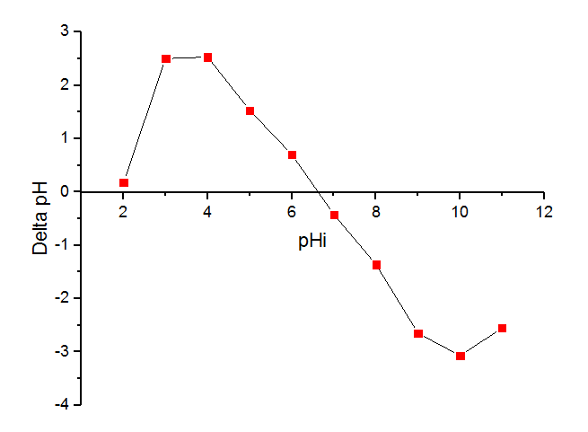

Figure .1 pH effect at the zero-charge point
3.2. Effect of pH
The results obtained were studied in the range from pH 7 to 12, with an initial concentration of 50 mg/L for a mass of CA-DM-KOH of 0.1g at room temperature. The addition of HCl or NaOH allowed the adjustment of these pH values. In Figure 2, the amount of BM adsorbed is 98.32% for a pH=11. The adsorption efficiency increases with pH. Indeed, a basic environment is rather favorable to the adsorption of BM (cationic pollutant) onto the synthesized activated carbon.
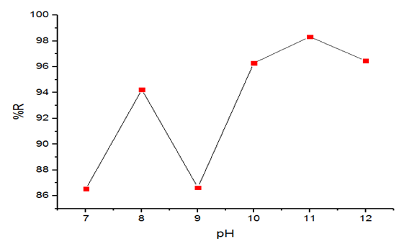

Figure 2: Effect of pH (Co: 50 mg/L; m: 0.1 g; pH 7 to 12)
3.3. Effect of contact time :
The results show that the adsorption capacity of BM increases rapidly in the first 10 minutes with an elimination rate of 98.43% until reaching a saturation plateau. This could be explained by the high availability of active sites on the surface of the adsorbent, then it remains almost constant after 40 minutes of contact. This result is significantly higher than that obtained by Wyasu et al. (2020) and Husaini et al. (2023) during the first 15 minutes of heavy metal removal. For the remainder of our work, the optimal contact time of 10 minutes will be used as a reference time [3]-[4].
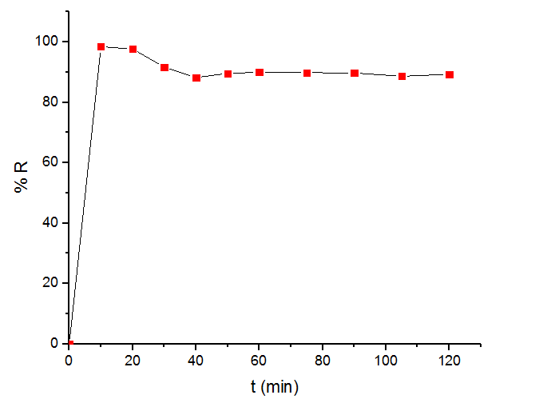

Figure 3: Effect of contact time (C0: 50 mg L-1; m: 0.7 g; pH: 11; T: 25 °C).
3.4. Effect of mass :
Figure 4 shows that the adsorption yield of BM increases with the mass of adsorbent in the range varying from 0.1 to 1g. The results indicate that the elimination rate increases progressively with increasing dose of CA-DM-KOH. Thus, the optimal mass is 0.7g, for a 99.16% elimination rate of BM. We note that from the mass of 1g onwards the adsorbed quantities of BM no longer change. This cannot be explained by an agglomeration of particles on the surface of the material. This result is significantly higher than that obtained by (GUERGAZI S et al, 2013) on tyrosine with an elimination rate of 96.87% [5]-[6].
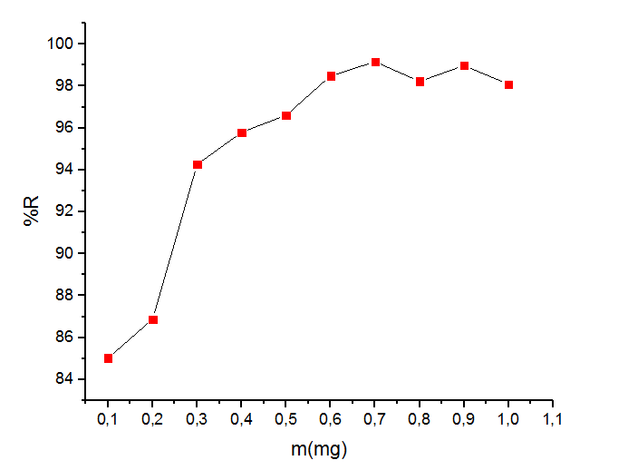

Figure 4. Mass effect with CA-DM-KOH (pH=11; m: 0.7g; t: 10 min; T: 25°C)
3.5. Effect of initial concentration :
The variation of the concentration of the BM solution from 10 to 100mg/L in contact with the optimum mass of 0.7g, under agitation for 10 minutes, indicated an adsorption capacity of 98.79% for a concentration of 40mg/L.
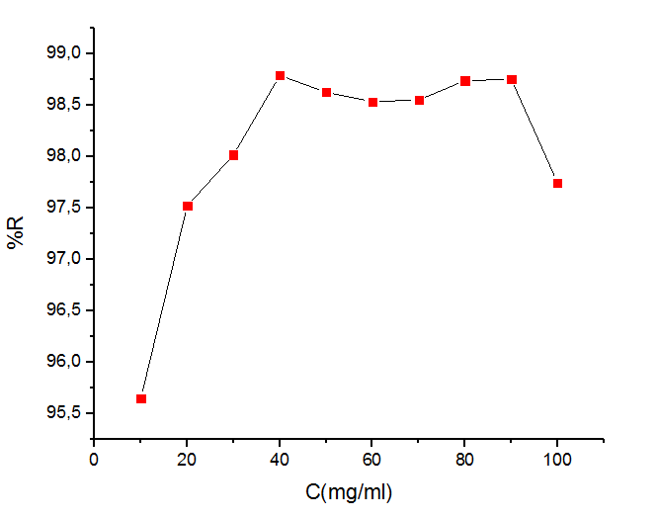

Figure 5: Effect of initial concentration with CA-DM-KOH (m: 0.7 g; pH: 11; T: 25 °C; t: 10 min).
3.6. Effect of temperature :
The effect of temperature was studied in the range of 25-75 °C. Figure 6 shows that at a temperature of 35°C, the removal rate of methylene blue by activated carbon is 99.31%.This is significantly higher than those of (KHELIFI O et al,2016) and (F.Sakr et al,2014). The temperature increase hinders the development of the adsorption phenomenon [7]-[8]-[1].
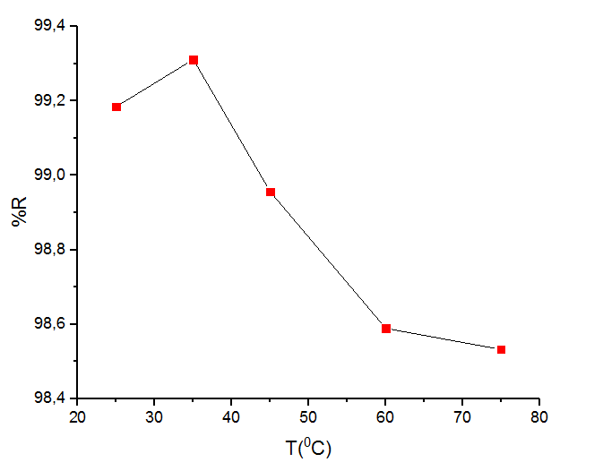

Figure 6: Effect of temperature with CA-DM-KOH (C0: 50 mg L-1; m: 0.7g; pH: 11; t: 10 min).

3.7. Adsorption isotherm models :
The results indicate that the Freundlich model is the most suitable for describing the adsorption of methylene blue (BM) on CA-DM-KOH, unlike the Langmuir model which proved less appropriate. This indicates that adsorption does not occur in a monolayer on a homogeneous surface, as assumed by the Langmuir model, but rather on a heterogeneous surface, with adsorption sites of varying energies, in accordance with the Freundlich model. Thus, under experimental conditions, adsorption is influenced by energy variability and the non-uniform distribution of active sites on the surface of activated carbon. See Figures 7 and 8 and Tables 1 and 2.
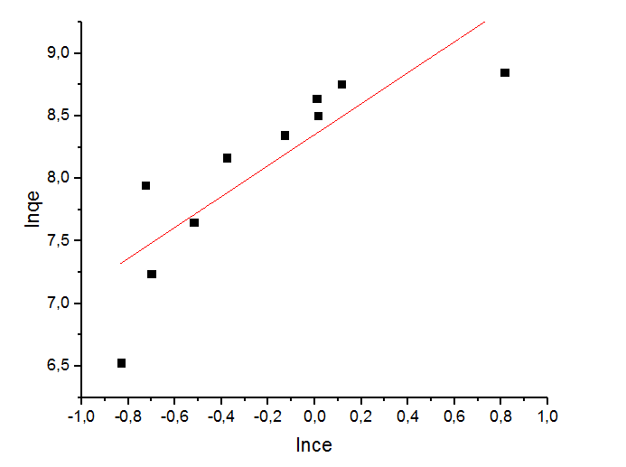
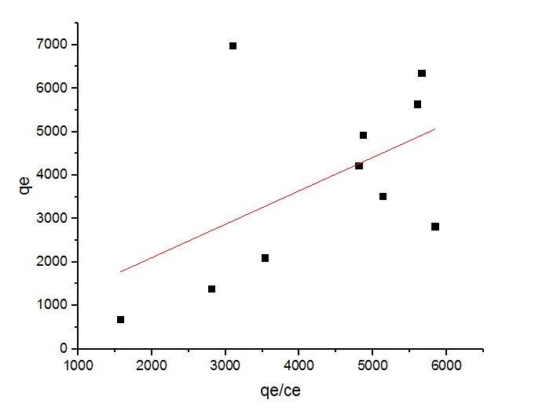

Figure 7: Langmuir isotherm Figure 8: Freundlich isotherm
Table 1. Langmuir constants for adsorption isotherm model.
Activated charcoal | Langmuir model
Activated charcoal | R² | R_{L} | K_{L} | Q_{m}
Activated charcoal | 0,27 | 3,72.10⁻⁸ | 5,38.10⁵ | 1,77.10⁻³

Table 2. Freundlich constants for adsorption isotherm model.
Actived charcoal | Freundlich model
Actived charcoal | R² | K_{F} | n | 1/n
Actived charcoal | 0,70 | 2,24.10⁸ | 0,808 | 1,237

3.8. Kinetic models of adsorption :
Analysis of the results shows that the pseudo-first-order kinetic model for BM adsorption on activated carbon does not match the experimental results, due to the low value of the correlation coefficient. On the other hand, the pseudo-second order model has an excellent correlation coefficient (R² = 0.99), very close to 1. Therefore, the kinetic data are better described by the pseudo-second order model. These results are consistent with those obtained by Abdallah et al. for the adsorption of BM on eucalyptus and by Yaya et al. for the adsorption of pseudoboehmite [9]-[10]. Figures 9, 10 and Tables 3 and 4.

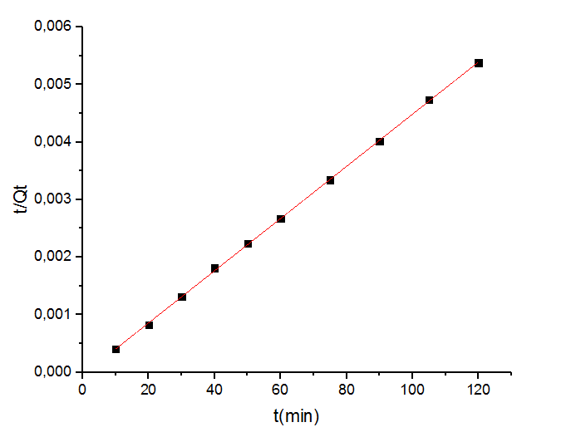
Figure 9: Pseudo-first-order model for BM adsorption kinetics

Figure 10: Pseudo-second order model for adsorption kinetics.

Table 3: Pseudo-first-order model.
Actived charcoal | Pseudo-first-order model.
Actived charcoal | R² | K₁ | q_{e}
Actived charcoal | 0,49 | 4,05.10⁻³ | 6,8.10¹⁹

Table 4: Pseudo-second order model.
Actived charcoal | Pseudo-second order model
Actived charcoal | R² | K₂ | q_{e}
Actived charcoal | 0,99 | 0,876 | 2,2.10⁴

3.9. Thermodynamic parameters:
The thermodynamic parameters of methylene blue adsorption on the surface of CA-DM-KOH were determined at different temperatures. The Gibb’s free energy (ΔG⁰), entropy (ΔS⁰), and enthalpy (ΔH⁰) changes for the adsorption were determined by :

$lnk_{l}=(∆S^{0})/R-(∆H^{0})/RT$ (7)

$∆G^{0}=∆H^{0}-T∆S^{0}$ (8)
where T is the solution temperature (K), R is the universal gas constant (8.314 J.K -1.mol -1) and Kl is the equilibrium constant. The calculated thermodynamic parameters are demonstrated in Table 5. the standard enthalpy (ΔH⁰) < 0 means that the fixation reaction on the prepared activated carbon is exothermic; the standard entropy ΔS°> reveals the disorder at the solid-liquid interface due to the mobilities of the adsorbed molecules; The standard free energy ΔG°< indicates the spontaneity of adsorption of BM by the activated carbon. This result is similar to that obtained by (Abdallah et al, 2016) during the adsorption of BM on the surface of eucalyptus.
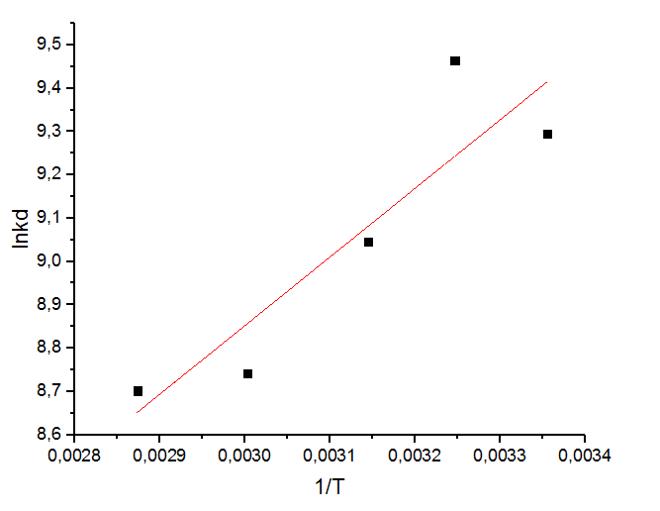

Figure 11: Representation of Ln Kd as a function of 1/T.
Table 5: Thermodynamic parameters
T (°K) | (ΔH⁰) (kJ.mol⁻¹) | ΔS° (kJ.mol⁻¹. K-1) | ΔG° (kJ.mol-1)
298 | -13,169 | 34,083 | -23,327
308 | -13,169 | 34,083 | -23,327
318 | -13,169 | 34,083 | -23,327
333 | -13,169 | 34,083 | -23,327
348 | -13,169 | 34,083 | -23,327

4. CONCLUSION :
The results of methylene blue (BM) adsorption on activated Detarium microcarpum peel (CA-DM-KOH) showed rapid retention (10 minutes). This is due to the high availability of active sites on the surface of the adsorbent. The pH and ambient temperature allowed for high adsorption rates, on the order of 99.46%. Modeling of adsorption isotherms revealed that the Langmuir model is not suitable for describing the adsorption of methylene blue (BM) on CA-DM-KOH due to its low correlation coefficient, unlike the more appropriate Freundlich model. The study of thermodynamic parameters confirmed the spontaneous and exothermic nature of the adsorption process. We can therefore suggest the use of CA-DM-KOH synthesized from this material for the decolorization of dyes and, in particular, for the treatment of wastewater in order to preserve the environment.

Disclaimer (Artificial intelligence)
Author(s) hereby declare that NO generative AI technologies such as Large Language Models (ChatGPT, COPILOT, etc.) and text-to-image generators have been used during the writing or editing of this manuscript.

5. REFERENCES
[1] F. Sakr, A. Sennaoui, M. Elouardi, M. Tamimi, A. Assabbane*: Study of the adsorption of Methylene Blue on a cactus-based biomaterial. http://www.jmaterenvironsci.com/
[2] FELIX KINI, SYLVAIN OUEDRAOGO, INNOCENT PIERRE GUISSOU: Nutritional and therapeutic properties of the fruit of Detarium microcarpum Guill. & Perr. http://www.globalsciencebooks.info/Online/GSBOnline/V4SI1/FVCSB_4(SI1)26-30o.pdf
[3] Gideon Wyasu, H.T Rumah, and Sunday Moses Received 09 July 2020/Accepted 19August 2020/Published online: 31 August 2020. Communication in Physical Sciences 2020, 5(4): 611-618 Batch adsorption of Hg2+ and As3+ ions in Hospital wastewater using activated carbon from Balanites aegyptiaca and Detarium microcarpum https://www.commphyssc.com.ng/index.php/cps/article/view/103
[4] Husaini et al, 2023: Modeling and Equilibrium Studies for the Adsorption of Congo red Using Detarium microcarpum Seed Shell Activated Carbon. https://doi.org/10.48422/IMIST.PRSM/ajees-v9i3.40602
[5] KHELIFI O.1, MEHREZ I.2, YOUNSI M.3, NACEF M.1, AFFOUNE A.M.1: Adsorption of methyl orange on a mango kernel-based biosorbent. http://larhyss.net/ojs/index.php/larhyss/article/view/616
[6] GUERGAZI S.*, AMIMEUR D., ACHOUR S.*: Removal of humic substances from two Algerian surface waters by adsorption on activated carbon and bentonite. https://www.asjp.cerist.dz/en/article/3680
[7] Aarfane, A., Salhi, A., El Krati, M., Tahiri, S., Monkade, M., Lhadi, E.K., & Bensitel, M. (2014). Kinetic and thermodynamic study of the adsorption of Red195 and Methylene Blue dyes on fly ash and bottom ash in aqueous medium. *Journal of Materials and Environmental Science*, *5*, 1927-1939. .
[8] KHELIFI O.1,2, MEHREZ I.1, BEN SALAH W.1, BEN SALAH F.1, YOUNSI M.1, NACEF M.2, AFFOUNE A.M.2: Study of the adsorption of methylene blue (MB) from aqueous solutions on a biosorbent prepared from Algerian date kernels. https://www.asjp.cerist.dz/en/article/2016/13/4/135-148
[9] Yassmina Bakhtaoui, Majda Ben Ali, Nabila El Azzouzi, Moussa Ouakki, Patrick Martin, Bousalham Srhir: Removal of methylene blue by adsorption on biochar derived from solid residues of the olive oil industry.
[10] Idriss Mahamat Yaya1*, Djonbe Tchonnon Valery1, Ech-chahad Abdellah2: Adsorption of Methylene Blue from Water Solution on Mesoporous Pseudoboehmite (γ-AlOOH) Synthesized Via a Mineral Route. Advances in Nanoparticles, 2025, 14(4), 142-157
https://doi.org/10.4236/anp.2025.144009
[11] Mira Abdallah1,2, Akram Hijazi*1, Mostafa Hamieh2, Mohamad Alameh1, Joumana Toufaily2, Hassan Rammal1: Study of the adsorption of methylene blue on a eucalyptus-based biomaterial according to particle size. https://www.jmaterenvironsci.com/Document/vol7/vol7_N11/432-JMES-2335-Abdallah.pdf

