Original Research Article
Nitrogen pollution and fecal contamination of well water in Divo (Southwest Ivory Coast): characterization and health implications

ABSTRACT
Access to quality drinking water is a major public health issue, particularly in urban and peri-urban areas of developing countries. Its use for food or hygiene purposes requires excellent physicochemical and microbiological quality. Thus, to assess the quality of well water in the city of Divo in western Côte d'Ivoire, an evaluation of the physico-chemical and bacteriological quality was carried out and focused on 18 wells in this locality. The methodology adopted is based on a sampling campaign of several wells in the city of Divo, followed by laboratory analyses. The physicochemical parameters measured include temperature, pH, conductivity, nitrogen ions (NH₄⁺, NO₂⁻, NO₃⁻), chlorides and orthophosphates. The bacteriological analysis targeted mesophilic aerobic germs (MAGs), Escherichia coli, faecal streptococci, Salmonella and Shigella. A fecal contamination index (FCI) was calculated. The results reveal significant nitrogen pollution, marked by high levels of ammonium (55.1 ± 13.2 mg/L), nitrites (7.7 ± 5.1 mg/L) and nitrates (34.1 ± 22.6 mg/L). The average pH is acidic (5.3 ± 0.6), the mineralization low (average conductivity of 6.2 ± 4.4 μS/cm), and the high temperatures (31.2 ± 0.2 °C), reflecting the vulnerability of shallow aquifers. Microbiologically, 98% of the samples contained GAM, 26.31% E. coli, and all were positive for Salmonella and Shigella. The average TFR above 150 confirms a high level of faecal contamination. These results indicate that the majority of well water in Divo is unfit for consumption without treatment. Measures to protect wells, water treatment and community awareness are essential to safeguard public health.
Keywords : Well water, Nitrogen pollution, Faecal contamination, Physico-chemical quality, Contamination index, Divo, Côte d'Ivoire

Graphical abstract

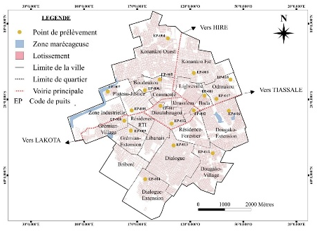 | 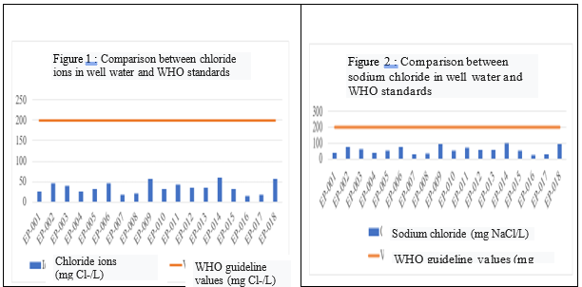
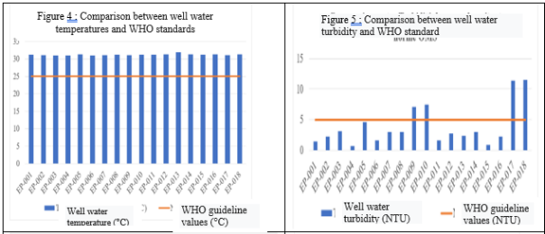 |  | 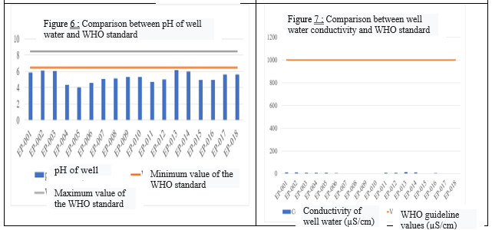

INTRODUCTION
Water is a fundamental element of life and its quality is of vital importance to human health. It is commonly used for consumption, cooking and personal hygiene. As a result, water quality is a primary public health concern. Drinking water must therefore comply with rigorous drinking water standards, which guarantee its safety and drinkability (Rodier et al., 1984). Unfortunately, it is unfortunate that not all water sources are suitable for human consumption due to the quality problems they may face. Indeed, the consumption of poor quality water can lead to a range of pathologies such as dysentery, hepatitis, typhoid fever, cholera, and even severe and sometimes fatal diarrhoea (Copeland, 2009). Thus, each year, these diseases are responsible for approximately 1.2 million deaths worldwide, according to the World Health Organization (WHO, 2021).
In several regions of Côte d'Ivoire, particularly in rural and peri-urban areas, wells are a main source of water supply for the population (Kré, 2024, Gnagne et al., 2024). In addition, institutional reports indicate that 57.8% of rural households had access to at least basic water supply services, implying that the other party is using unimproved water sources, including unprotected wells (SWA, 2022). Several studies have been carried out to assess the quality of groundwater. For example, in the precarious neighbourhoods of Abidjan, Yapo et al. (2010) found significant microbiological contamination and high levels of nitrate and ammonium due to the lack of sanitation systems. In Aboisso, a study by Seki et al. (2024) revealed poor physicochemical quality of well water, marked by high turbidity, high iron concentration, and bacterial contamination. Similarly, in the region of Azaguié and Grand-Morié, Orou et al. (2016) showed the vulnerability of groundwater to pollution from domestic and agricultural sources. The work of Yapo et al. (2016) also highlighted the presence of pesticides and nitrates in well water, attributed to the excessive use of chemical fertilizers in food crop areas.
However, most of these studies focus on large urban centers or areas with high agricultural activity, and do not take into account inland cities such as Divo, which are subject to rapid population growth and increasing urbanization. In addition, this work is sometimes limited to a partial analysis (microbiological or physico-chemical only), or does not take into account the specific realities of each area in terms of sources of pollution or water uses.
In this context, it has become necessary to carry out a targeted study on the quality of well water in Divo, a town located in the southwest of Côte d'Ivoire, which is facing recurrent difficulties in the supply of drinking water by the public network. Faced with these shortcomings, people are increasingly turning to wells, with no real guarantee as to the quality of the water they consume. A rigorous evaluation of the physico-chemical and microbiological parameters of these waters is therefore essential in order to identify potential health risks, to raise awareness among the population and to propose corrective actions in terms of public health and resource management.
II. Materials and Methods
2.1 Sampling sites
The sampling points were strategically chosen to cover the entire city of Divo, with nine (09) neighborhoods selected for sampling (from North to South and East to West) (Figure 1).

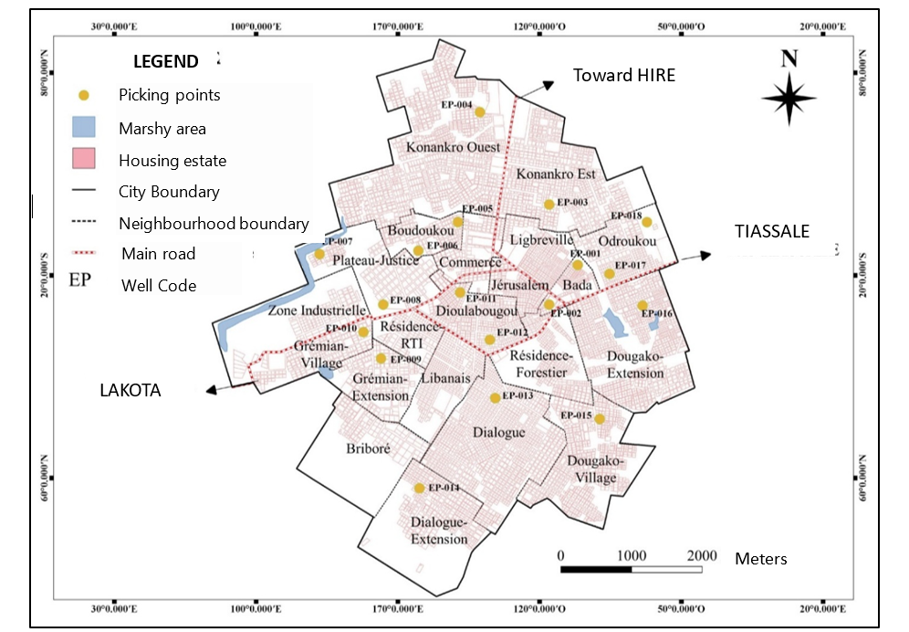
Figure 1: Different well water sampling points in the city of Divo

These samples therefore represent significantly all wells, and preventive measures have been taken to avoid further contamination.
After the sampling, the samples were sent to the laboratory as quickly as possible, preserving the initial conditions. Upon receipt, the analyses were carried out in the laboratory specialising in water treatment.
Table 1 presents the coding and some characteristics of the well water withdrawn from the Divo neighbourhoods.

Table 1: Coding and characteristics of well water withdrawn from Divo
Code  wells | Stations | Depth (m) | Roof Covering | Condition of the well wall | Likely sources of pollution
EP-001 | Bada district (1) | 15 | Wood | Cemented | Proximity to the toilets
EP-002 | Bada District (2) | 18 | Wood | Cemented | Garbage
EP-003 | Konankro district (1) | 21 | Slab | Cemented | Stagnant water
EP-004 | Konankro District (2) | 22 | Slab | Cemented | Stagnant water
EP-005 | Boudoukou district (1) | 19 | Wood | Cemented | Proximity to the toilets
EP-006 | Boudoukou district (2) | 20 | Without coverage | Cemented | Water infiltration
EP-007 | Plateau district (1) | 16 | Slab | Cemented | Unidentified
EP-008 | Plateau district (2) | 15 | Slab | Cemented | Unidentified
EP-009 | Gremian district (1) | 20 | Wood | Cemented | Garbage
EP-010 | Gremian District (2) | 15 | Slab | Cemented | Water infiltration
EP-011 | Dioulabougou district (1) | 10 | Without coverage | Uncemented | Proximity to the toilets
EP-012 | Dioulabougou district (2) | 7 | Without coverage | Uncemented | Proximity to the toilets
EP-013 | Dialogue District (1) | 14 | Without coverage | Cemented | Household waste and stagnant water
EP-014 | Dialogue Neighborhood (2) | 15 | Without coverage | Cemented | Proximity to the toilets
EP-015 | Dougako district (1) | 14 | Slab | Cemented | Stagnant water
EP-016 | Dougako district (2) | 16 | Wood | Cemented | Proximity to the toilets
EP-017 | Odroukou district (1) | 15 | Wood | Cemented | Stagnant water
EP-018 | Odroukou district (2) | 14 | Wood | Cemented | Stagnant water

2.2 Sample Collection
Well water was collected using a clean bucket and then transferred to plastic bottles (1.5 L) previously washed and rinsed with distilled water. The geographical coordinates of each point were recorded with a hand-held GPS.

2.3 In situ measurement
The physicochemical parameters were measured directly in the field and are recorded in Table 2.
Table 2: Equipment and methods for measuring parameters in situ
Parameters | Device | Norm | Special condition
ph | HANNA pH meter | NF T 90-008 (1953) | Calibration pH 4 / 7 / 10
Temperature and ORP potential | HANNA pH meter | NF T 90-008 (1953) | -
Conductivity | HANNA Conductivity Meter | NF T 90-031 (1977) | -
Turbidity | ORION AQUAFAST Turbidity Meter | NF T 90-033 (1985) | -

2.4 Laboratory Equipment and Analytical Procedures
The analyses were carried out in the laboratory. A HACH DR 2010 Spectrophotometer (JASCO optics), reagents recorded in Table 3 and a Class A glassware (volumetric flasks, beakers, cruets) thoroughly cleaned and rinsed with distilled water were used.
A tabular summary of the methods for the determination of the main ions analyzed (NO₂⁻, NO₃⁻, P-PO₄³⁻, NH₄⁺, Cl⁻) is given in Table 3.
Table 3: Summary of the methods for the determination of the main ions analysed.
Parameter | Assay method | Principle | Reagents used | Wavelength | Reference Standard | Calculation formula
Nitrite (NO2⁻) | Salicylate spectrophotometry | Stained reaction with salicylate | Sodium azide, acetic acid, salicylate (0.01 g/mL), sulfuric acid, alkaline solution, distilled water | 415 nm | NF T90-012 | Direct reading (calibration curve)
Nitrate (NO3⁻) | Deducted from NO2⁻ | Mathematical conversion | - | - | - | [NO3⁻]= 4.44×[NO. ₂₋]  (1)
Orthophosphate (P-PO₄₃₋) | Molybdenum blue spectrophotometry | Formation of a blue complex | Ascorbic acid, combined reagent, distilled water | 700nm | NF T90-032  (1982) | [] = ${PO}_{4}^{3-}\frac{[{P-PO}_{4}^{3-}] }{30,97}*78,97$  (2)
Ammonium (NH4+) | Nessler reagent spectrophotometry | Yellow Colored Complex | Nessler's reagent, potassium sodium tartrate double | 420nm | NF T-008 (1975) | Direct reading (calibration curve)
Chloride (Cl-) | Titrimetry (Mohr method) | Precipitation with AgNO₃ | Potassium chromate (10%), silver nitrate (0.0141 N), phenolphthalein | - | NF T-014  (1952) | [Cl⁻] = 10 × 3.55 × V(AgNO₃)  (3)
 | Titrimetry (calculation from Cl⁻) | - | - | - | - | [NaCl] = 10 × 5.85 ×V(AgNO₃)  (4)
  Sodium chloride (NaCl)

2.5 Water Quality Index (WQI)
The Water Quality Index (WQI) is an approach used to assess water quality based on the various parameters analyzed. The EQI is determined through equation (5):
$IQE=\frac{\sum_{i=1}^{n}{Qi*Wi}}{\sum_{i=1}^{n}{Wi}}$ (Talhaoui, 2020) (5)
With:
Qi is the scale for evaluating the quality of each physico-chemical parameter analyzed;
Wi is the relative weight of physico-chemical parameters in the evaluation of water quality. To determine Wi (weight of each parameter), equations (6) and (7) were used (Talhaoui, 2020):
$Wi=\frac{Ki}{Si}$ (6)
with $Ki=\sum_{i=1}^{n}{\frac{1}{(\frac{1}{Si})}}$(7)
With:
- n represents the number of parameters considered;
- Ki is the constant of proportionality;
- If is the maximum value of the WHO standard for a parameter expressed in its unit.
Finally, to determine Qi (Quality Assessment Scale), the concentration of the parameter is divided by the corresponding standard, then the result is multiplied by 100. The equation is as follows: $Qi=\frac{Ci}{Si}*100$(Talhaoui, 2020).
Or Ci: the concentration of each parameter expressed in its unit.
Five quality classes can be identified based on the values of the EQI water quality index (Table 4).
Table 4. Classification and potential use of water according to the EQI (Aher et al., 2016. Talhaoui et al., 2020).
IQE Class | Type of water | Possible use
0 - 25 | Excellent quality | Drinking water, irrigation and industry
>25 - 50 | Good quality | Drinking Water, Irrigation and Industry
>50 - 75 | Poor quality | Irrigation and industry
>75 - 100 | Very poor quality | Irrigation
˃ 100 | Non-potable water | Proper treatment required before use

2.6 Bacteriological analyses
- Sample collection and transport
The objective of this analysis was to obtain water samples representative of the microbiological quality of the well, without external contamination, for the analysis of indicator germs (E. coli, enterococci, etc.). To do this, we used a clean, disinfected or sterile bucket, avoiding any contact with the walls of the well. Sterile gloves were worn. The sterile vial was opened just before filling and resealed immediately without touching the inside of the cap or vial. Immediately, the vials were stored in a cooler at 4°C and transported to the laboratory within a maximum of 6 hours while avoiding exposure to light, heat or excessive agitation. The samples were packaged using 1-liter capacity glass bottles, previously washed with distilled water and then sterilized with Poupinel at 200°C for 02 hours. In the field, before filling the bottles, they were rinsed three times with the water to be taken. The filling of the cylinders was done in accordance with the capacity limit indicator line in order to preserve space for breathing. Each bottle has been closed with a screw cap to prevent any gas exchange with the outside. These bottles were wrapped with aluminum foil.

- Microbiological analysis
Mesophilic aerobic germs, E. coli, and fecal streptococci were enumerated by the solid enumeration method by the incorporation method.
It consists of mixing 1ml of the water sample to be analysed with solid culture media (15ml) previously melted and cooled to 45°C+/-1°C. After incubation, the colonies that develop on the surface and inside the medium are counted. Petri dishes should be examined immediately and consider dishes that contain between 30 and 300 colonies.
● Thermotolerant coliform counts, aerobic germs
Mesophilic (GAM) and faecal streptococci (according to NFV08-050, Dec. 1992)
After diluting the stock solution to 10-1,10-2,1000μl of each dilution including the stock solution was inoculated directly into the Petri dish (two (2) Petri dishes per dilution, so six (6) dishes for the search for one germ per sample). Then, the corresponding culture media, VRBL (Violet RedBile Lactose Agar) was used for the search for thermotolerant coliforms, for faecal streptococci, Slanetz and Bartley media was used and PCA (Plate Count Agar) for the search for mesophilic aerobic germs. Finally, the Petri dishes were incubated in the oven at a temperature of 37°C for faecal streptococci and mesophilic aerobic germs and at 44°C for coliforms, all thermotolerant for 24 hours.
- Enumeration of salmonella and shigella (according to the NF V08-050, 12/1992 standard)
The search for salmonella is carried out in three stages: pre-enrichment, enrichment and seeding. They were counted in solid media by the spreading method which consists of spreading 100μl of the water sample to be analyzed on the surface of an agar medium without any trace of moisture. After incubation, the colonies that develop on the surface are counted. Petri dishes should be examined immediately and consider dishes that contain between 30 and 300 colonies.
- Pre-enrichment
Using different test tubes, 1 mL of each sample was added to 9 mL of Buffered Peptone Water (BPW) which is a non-selective medium of simple concentration. Then the different test tubes were incubated at 37°C for 24 hours.
- Enrichment
After homogenization, 1 ml of each pre-enriched sample was added to different test tubes containing 9 ml of RAPPAPORT VASILIADIS SOY (RSV) BROTH medium and then incubated at 37°C for 24 hours.
- Sowing
The different samples being enriched, we inoculated by the spreading method 100 μl of each sample in the petri dishes previously containing the solid medium SS (Salmonella-Shigella Agar) and then we incubated at 37°C for 24 h.
- Germ count calculations
For the count, we chose Petri dishes containing between 30 and 300 colonies for MAGs and coliforms and then the calculations of the germ count were carried out according to the NFEN ISO-7218: (2007) standard which determines the number N of colonies according to equation (8).
N = $\frac{\sum{C}}{V \left(n_{1}+0,1n_{2}\right)d}$ (8)
N: number of microorganisms in CFU/ml
n₁ : number of boxes counted at the lowest dilution retained,
n₂: number of cans counted at the second dilution used,
d : dilution factor from which the first counts are carried out,
2.7 Fecal Contamination Index (FCI) Calculation
In the present study, we developed two indices of Fecal Contamination were considered, one allowed us to pronounce on the origin of the contamination and the other a more advanced approach to know the level of fecal contamination.
This ratio is used to estimate the probable human or animal origin of the pollution, equation (9):
Index = $\frac{Streptocoques feˊcaux (UFC/100 mL)}{E. coli (UFC/100 mL)}$ (9)
- < 0.7 : probable human origin
- > 4 : Probable animal origin
- Between 0.7 and 4 : mixed or undetermined origin
Salmonella and Shigella are not used as direct indicators of faecal contamination. These are specific pathogenic bacteria, not routine indicators. Their absence does not guarantee the absence of faecal contamination.
However, their presence can be used in expanded indices or microbiological risk scores, but this is outside the scope of conventional indices. Although it is not formalized, but can be used as a tool for inter-site comparison.
The fecal contamination index (FCI) is calculated by equation (10):
ICF=a⋅[E.coli]+⋅[Streptococci]+c⋅([Salmonella]+[Shigella]) (10)
Or [E. coli], [Streptococci] CFU/100 mL.
Coefficients a, b, c to be defined according to their importance here we have chosen: a = 1, b = 0.8, c = 20).
ICF=1⋅[E.coli]+0.8. [Streptococci]+20⋅([S+Sh])
S = 1 if Salmonella is present, 0 if absent
Sh = 1 if Shigella is present, 0 if absent
For the interpretation of the index, we propose this table 5.
Table 5: Fecal Contamination Index Grid in the Advanced Groundwater Approach
ICF Value | Level of contamination | Health Interpreting
>150 | Very high | Serious health risk, unfit for consumption, urgent treatment
100-150 | High | Significant contamination, consumption not recommended
50- 100 | Average | Monitoring required, Can be used with disinfection
< 50 | Weak | Acceptable quality for household use with care

3. RESULTS
3.1 Physicochemical Characteristics of Divo Well Water
The extreme values of the various parameters sought and their respective averages are presented in Table 6.

Table 6 : Extreme and mean values of physicochemical parameters
Parameters | WHO guide values | Units | Minimum value | Maximum value | Mean ± standard deviation
ph | 6.5 ≤ pH ≤ 8.5 | - | 4,03 | 6,16 | 5.3 ± 0.6
Temperature | ≤ 25 | °C | 31 | 31,9 | 31.2 ± 0.2
Turbidity | ≤ 5 | NTU | 0,69 | 11,53 | 3.9 ± 3.2
TDS | ≤,500 | mg/L | 0,42 | 98 | 8.9 ± 21.8
Electrical conductivity | ≤ 1000 | μS/cm | 0,70 | 15,24 | 6.2 ± 4.4
Chloride ions (Cl⁻) | ≤,200 | mgCl/L | 14,2 | 60,35 | 35.3 ± 13.7
Nitrate ions (NO3⁻) | ≤ 50 | mg/L | 2,13 | 73,08 | 34.1 ± 22.6
Nitrite ions (NO₂⁻) | ≤ 3 | mg/L | 0,48 | 16,46 | 7.7 ± 5.1
Ammonium ions (NH₄₊) | ≤ 0.5 | mg/L | 38,66 | 73,15 | 55.1 ± 13.2
Ortho-phosphate ions (P043-) | ≤ 1.5 | mg/L | 0,01 | 0,28 | 0.10 ± 0.01

3.2 Spatial monitoring of DIVO well water quality
The results of the physico-chemical parameters obtained are compared to the potability standards in order to assess the level of compliance of Divo's well water.
Figure 1 illustrates the comparison between the results of the physicochemical parameters obtained and the WHO drinking water guideline values.
The temperature of the study area ranges from 31°C (EP-003 and EP-004) to 31.9°C (EP-013), with an average of 31.2 ± 0.2°C. This average is higher than the limit value recommended by the WHO (25°C). As for turbidity, its value varies between 0.69 (EP-004) and 11.53 (EP-018) with an average of 3.9 ± 3.2 NTUs. The highest values were observed at stations EP-017 and EP-018, recording 11.42 NTU and 11.53 NTU, respectively. These values are higher than the guide values. The pH measurements of the study area range from 4.03 (EP-005) to 6.16 (EP-013). All well water analysed therefore has pH values below the WHO recommended range (6.5 to 8.5) with an average of 5.3 ± 0.6. Regarding the electrical conductivity values, they vary between 0.70 μS/cm (EP-009) and 15.24 μS/cm (EP-013). The highest were recorded at stations EP-013 and EP-002 (15.24 and 12.38 μS/cm respectively). These values are all below the WHO recommended limit value (1000 μS/cm) with an average of 6.2 ± 4.4 μS/cm (Figure 2).

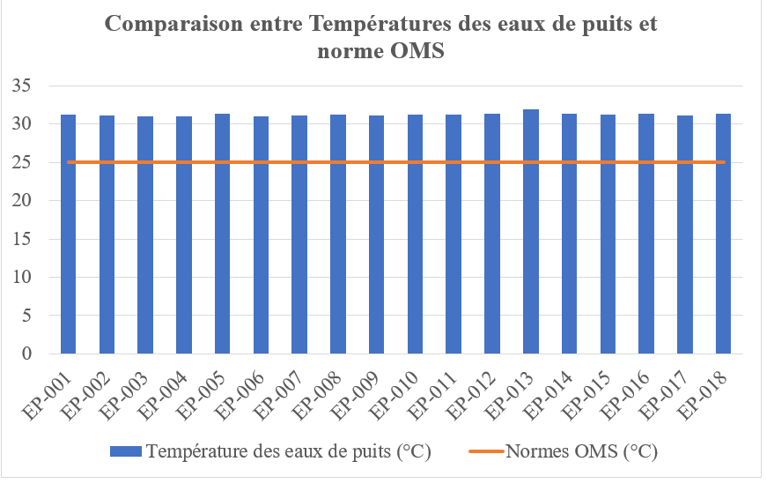 | 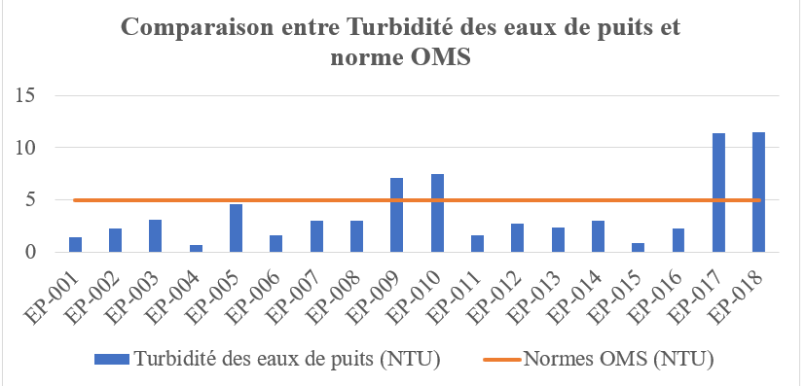
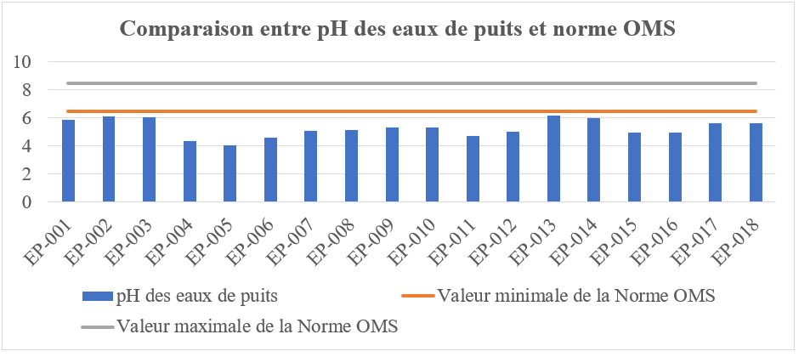 | 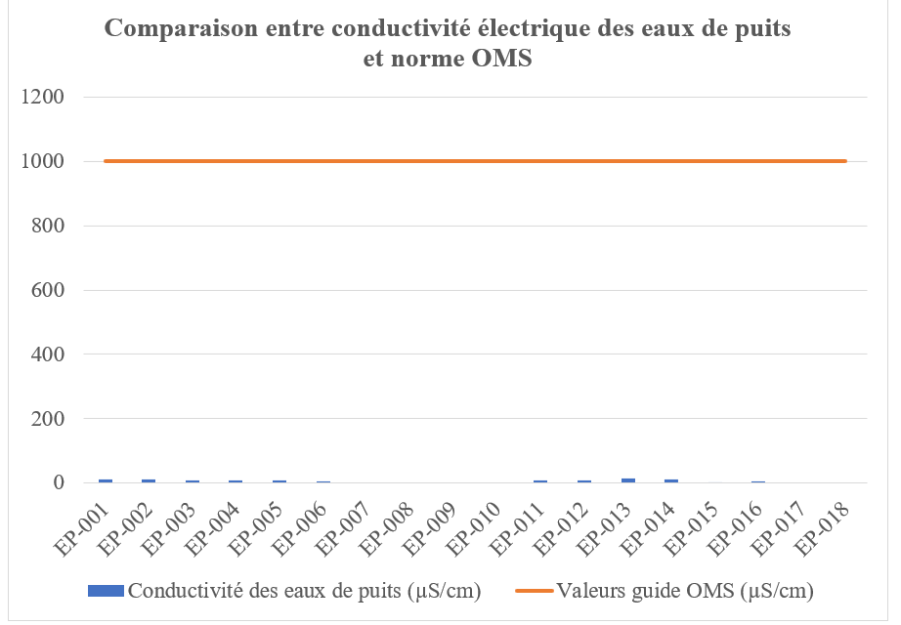
Figure 2B : Comparison between well water turbidity and WHO standard

Well water turbidity (NTU)

WHO guideline values ​​(NTU)

Figure 2D : Comparison between well water conductivity and WHO standard

Conductivity of well water (µS/cm)

WHO guideline values ​​(µS/cm)

Figure 2A : Comparison between well water temperatures and WHO standards
Well water temperature (°C)

WHO guideline values ​​(°C)

Figure 2C : Comparison between pH of well water and WHO standard

pH of well water

Minimum value of the WHO standard

Maximum value of the WHO standard

Figure 2 : Spatial evolution of physico-chemical parameters and WHO guidelines

Figure 2 illustrates the comparison between the results of the chemical parameters obtained and the WHO drinking water guides. Nitrite concentrations have substantial variations between 0.48 mg/L (EP-008) and 16.46 mg/L (EP-002) with an average of 7.7 ± 5.1 mg/L. Fourteen (14) wells have nitrite levels above the WHO recommended limit value with values ranging from 3.75 mg/L (EP-017) to 16.46 mg/L (EP-002). Only four (4) wells, with values between 0.48 mg/L (EP-008) and 0.96 mg/L (EP-009), have nitrite levels below the WHO limit value (3 mg/L). As for the nitrate contents, they range from 2.13 mg/L (EP-008) to 73.08 mg/L (EP-002) with an average of 34.1 ± 22.6 mg/L. Fourteen (14) wells have nitrate levels below the limit value of the WHO guideline with values ranging from 2.13 mg/L (EP-008) to 39.25 mg/L (EP-015). Only four (4) wells have nitrate levels above the WHO limit guide value (50 mg/L), with values between 62.07 mg/L (EP-006) and 73.08 mg/L (EP-002 and EP-005). The ortho-phosphate ion contents of the well water have an average of 0.10 ± 0.01 mg/L, the ortho-phosphate ion concentrations are all below the WHO limit guide value (1.5 mg/L). The extrema are 0.01 mg/L (EP-007) and 0.37 mg/L (EP-013). As far as ammonium ion concentrations are concerned, the values range from 38.66 (EP-010) to 73.15 (EP-011) with an average of 55.1 ± 13.2 mg/L. The highest concentrations were recorded at stations EP-011 and EP-012, reaching 73.15 mg/L and 73.04 mg/L, respectively. They are all above the WHO recommended value (0.5 mg/L) (Figure 3).
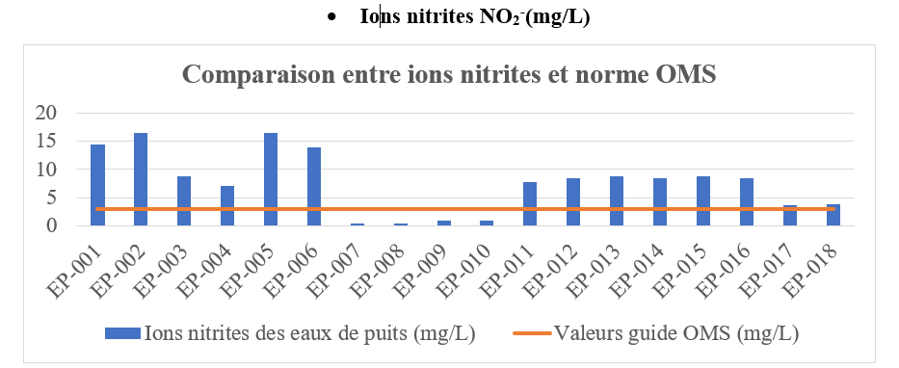 | 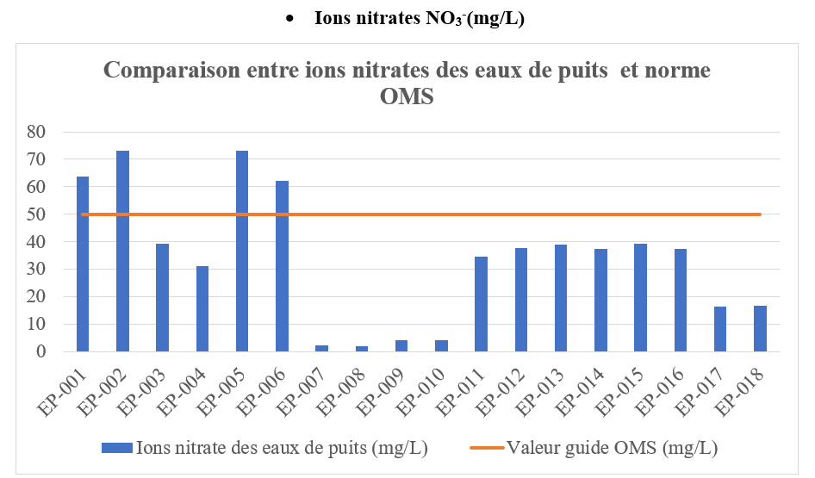
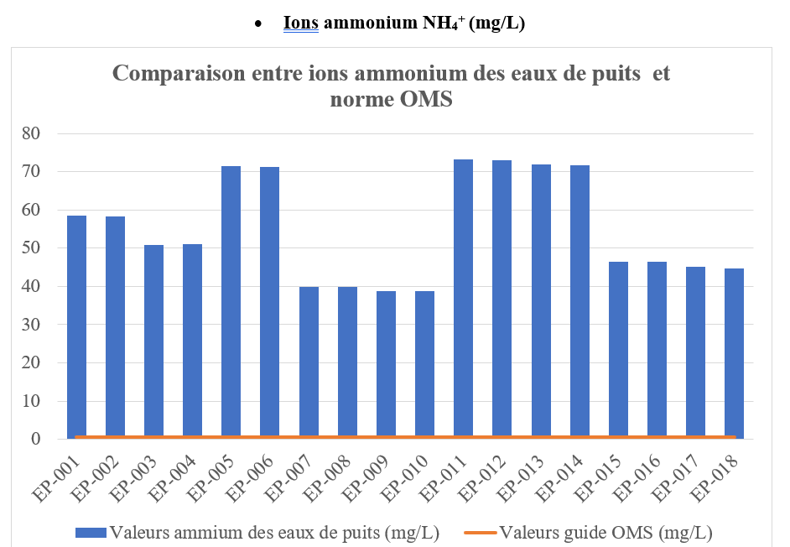 | 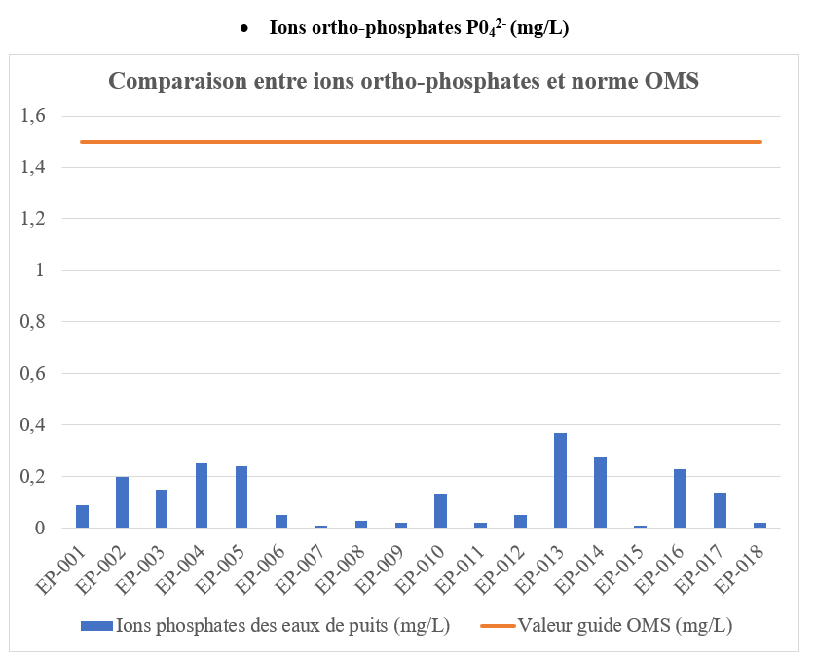
Figure 3A : Spatial evolution of nitrogen and phosphorus compounds and WHO guidelines

Figure 3B : Comparison between nitrate ions and WHO standards

Nitrite ions NO2 (mg/L)

WHO guideline values ​​(mg/L)

Nitrate ions NO3 (mg/L)

WHO guideline values ​​(mg/L)

Figure 3C : Comparison between Ammonium Ions and WHO Standard

Ammonium ions NH4+ (mg/L)

WHO guideline values ​​(mg/L)

Figure 3D : Comparison between Orthophosphate Ions and WHO Standard

Ortho-phosphate ions PO4²⁻ (mg/L)

WHO guideline values ​​(mg/L)

Figure 3: Spatial evolution of nitrogen and phosphorus compounds and WHO guidelines

Figure 3 illustrates the comparison between the results of the chloride and sodium chloride ions obtained and the WHO drinking water guideline values
The well water tested has chloride ion values that range from 14.20 mg/L (EP-016) to 60.35 mg/L (EP-014). These values are all below the WHO guideline value limit (200 mg/L) with an average of 35.3 ± 13.7 mg/L. Sodium chloride measurements range from 23.40 mg/L (EP-016) to 99.45 mg/L (EP-014). These values are all within the acceptable limits of the WHO guideline value (200 mg/L) with a mean of 58.2 ± 22.5 mg/L (Figure 4).
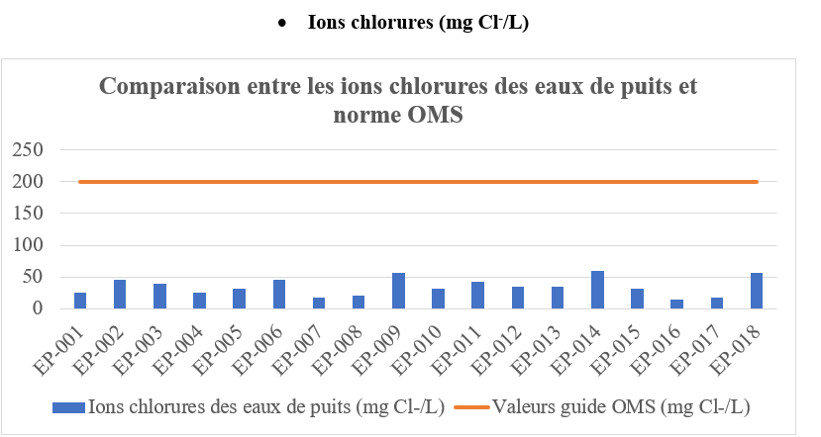 | 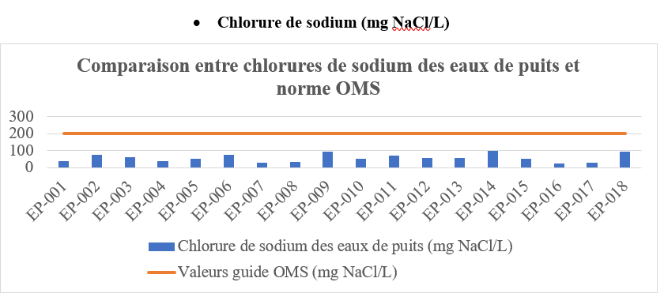
Figure 4A : Comparison between chloride ions in well water and WHO standards

Chloride ions
(mg Cl-/L)

WHO guideline values ​​(mg Cl-/L)

Figure 4B : Comparison between sodium chloride in well water and WHO standards

Sodium chloride (mg NaCl/L)

WHO guideline values ​​(mg NaCl/L)

Figure 4: Spatial evolution of chloride and sodium chloride ions and WHO guidelines
3.3 Water Quality Index (WQI)
The EQI results for the individual well waters are presented in Table 6.
The physicochemical quality of the well water in Divo is poor. Wells EP-05, EP-06, EP-011, EP-012, EP-013 and EP-014 that have in common the lack of coverage and proximity to toilets or household waste recorded higher values (above 800) of IQE. In contrast, those with slabs (EP-007 to EP-010) have relatively low values although of poor quality (EQI>100) (Table 7).
Table 7: Well Water Quality Indices Tested

Well Code | Water Quality Index (WQI) | Quality | Proper treatment required before use
EP-001 | 712,3 | Non-potable water | Proper treatment required before use
EP-002 | 713,4 | Non-potable water | Proper treatment required before use
EP-003 | 614,8 | Non-potable water | Proper treatment required before use
EP-004 | 613,0 | Non-potable water | Proper treatment required before use
EP-005 | 867,3 | Non-potable water | Proper treatment required before use
EP-006 | 862,3 | Non-potable water | Proper treatment required before use
EP-007 | 471,2 | Non-potable water | Proper treatment required before use
EP-008 | 477,4 | Non-potable water | Proper treatment required before use
EP-009 | 459,7 | Non-potable water | Proper treatment required before use
EP-010 | 458,7 | Non-potable water | Proper treatment required before use
EP-011 | 874,5 | Non-potable water | Proper treatment required before use
EP-012 | 878,0 | Non-potable water | Proper treatment required before use
EP-013 | 869,2 | Non-potable water | Proper treatment required before use
EP-014 | 851,7 | Non-potable water | Proper treatment required before use
EP-015 | 560,3 | Non-potable water | Proper treatment required before use
EP-016 | 561,7 | Non-potable water | Proper treatment required before use
EP-017 | 534,2 | Non-potable water | Proper treatment required before use
EP-018 | 532,9 | Non-potable water | Proper treatment required before use
3.4 Microbiological Characteristics of Well Water
In the municipality of Divo, the count of Escherichia Coli germs shows that 73.69% of the water from controlled wells is devoid of these faecal contamination germs, while they are present in 26.31% of wells (E13, E14, E15). After counting the samples of well water in the municipality of Divo, it appears that no samples contain faecal streptococci.
The results of the search for salmonella and shigella show a total presence of blue colonies with black anal in all 18 well water samples (Table 8).

Table 8: Summaries of Microbiological Test Results
Code  wells | Aerobic Mesophilic Germs  (GAM) in CFU/mL | Fecal streptococci  CFU/mL | Coli  CFU/mL | Salmonella | Shigella
EP-001 | 1728,57 | 0 | 0 | + | +
EP-002 | 2704,76 | 0 | 0 | + | +
EP-003 | 48583 | 0 | 0 | + | +
EP-004 | 44727,272 | 0 | 0 | + | +
EP-005 | 13363,3 | 0 | 0 | + | +
EP-006 | 45818,181 | 0 | 0 | + | +
EP-007 | ND | 0 | 0 | + | +
EP-008 | 22272,72 | 0 | 0 | + | +
EP-009 | 3100 | 0 | 0 | + | +
EP-010 | 5000 | 0 | 0 | + | +
EP-011 | ND | 0 | ND | + | +
EP-012 | ND | 0 | ND | + | +
EP-013 | 119091 | 0 | 23363 | + | +
EP-014 | 31818,181 | 0 | 48416 | + | +
EP-015 | 50409 | 0 | 2500 | + | +
EP-016 | 40454,545 | 0 | 0 | + | +
EP-017 | 15000 | 0 | 0 | + | +
EP-018 | 10863,63 | 0 | 0 | + | +

+: present, ND: Not detected.

- Origin Index Result
The value of the index used to determine the origin of the contamination is zero. This allows us to say that this contamination is of probable human origin.
- Fecal Contamination Index (FCI)
With the exception of wells coded E13, E14 and E15, all the stations have low contamination (ICF < 50). On the other hand, E13, E14 and E15 have a very high level of contamination (Table 9).
Table 9: Faecal contamination index values at different stations
Well Code | EP-001 | EP-002 | EP-003 | EP-004 | EP-005 | EP-006 | EP-007 | EP-008 | EP-009 | EP-010 | EP-011 | EP-012 | EP-013 | EP-014 | EP-015 | EP-016 | EP-017 | EP-018
ICF | 40 | 40 | 40 | 40 | 40 | 40 | 40 | 40 | 40 | 40 | 40 | 40 | 23403 | 48456 | 2540 | 40 | 40 | 40

4. DISCUSSION
The well water in the municipality of Divo shows obvious nitrogen pollution, characterized by high concentrations of ammonium (55.1 ± 13.2 mg/L) in all wells, as well as nitrite (7.7 ± 5.1 mg/L) and nitrates (34.1 ± 22.6 mg/L) in a large majority of them (77.78%). These values far exceed the WHO (2008) guidelines for drinking water, and are comparable to those observed in the regions of Agboville and Abidjan (Ahoussi et al., 2017). This contamination can be attributed to the degradation of nitrogenous organic matter by nitrifying bacteria, as well as to the proximity of pollution sources such as latrines, septic tanks, landfills or stagnant water. These conditions promote contaminating infiltration into the shallow water table. Similar causes of pollution have been observed by Aka et al. (2017) in the department of Abengourou.
From a health point of view, the presence of nitrites at such levels poses a significant risk of methemoglobinemia in infants, due to the alteration of oxygen transport by hemoglobin (WHO, 2022).
The high temperatures recorded in the wells (31.2 ± 0.2 °C) may result from the shallow depth of some structures exposed directly to solar radiation, or from the sampling period (dry season). These values are comparable to those reported by Nwala et al. (2007). Temperature indirectly influences the pH of water by accelerating the biological degradation processes, which generate CO₂, which acidifies the water through the formation of carbonic acid. The slightly acidic pH of the waters (5.3 ± 0.6) may also reflect the effect of local geology and the decomposition of organic matter (Ayad 2016). Previous studies, including those by Bawa et al. (2008) in Lomé, confirm this link between acidity and buried organic matter. In addition, the passage of groundwater over permutolite-rich rocks could release H⁺ ions, contributing to this acidity.
The mineralization of the Divo waters is very low, as indicated by the average conductivity of 6.2 ± 4.4 μS/cm. This low conductivity is confirmed by the low concentrations of chlorides (35.3 ± 13.7 mg/L), sodium chloride (58.2 ± 22.5 mg/L) and ortho-phosphates (0.10 ± 0.01 mg/L). These results suggest a short residence time of water in aquifers, limiting the dissolution of minerals, consistent with the observations of Lagnika (2014) in Pobè. On the other hand, they differ from those of Tampo et al. (2014), which highlights the influence of the geological nature of the aquifers and local hydrogeological characteristics (thickness, permeability, recharge).
From a bacteriological point of view, the study reveals a worrying situation: 98% of the wells contain mesophilic aerobic germs (MAGs), which are evidence of widespread microbiological contamination. The presence of Escherichia coli in 26.31% of the samples indicates confirmed faecal contamination. In addition, pathogenic germs such as Salmonella and Shigella have been detected, which excludes these waters from any direct use for consumption, in accordance with WHO (2008) standards.
Notably, no fecal streptococcus was detected in the samples, and wells E1 to E10 were devoid of E. coli. coli. This absence could be linked to the domestic use of sodium hypochlorite (bleach) for disinfection, which reflects a certain awareness of the risks by the population.
The Fecal Contamination Index (FCI), above 150 for E13, E14 and E15, shows a high level of faecal contamination, confirmed in 26.31% of the sites. These contaminations reflect the influence of human and animal excrement, particularly in areas where livestock, latrines and open-air wells coexist. As Vincent et al. (2011), livestock activities can highly pollute groundwater via animal excretions. In addition, the absence of a sewerage network, the infiltration of runoff water, and the poor protection of wells (presence of cracks, absence of coping) are major vulnerability factors.
The presence of E. Coli, the main indicator of fecal contamination, signals recent and potentially human-caused pollution. Fecal streptococci, although not detected here, are generally considered to be reliable markers of recent pollution, due to their low persistence in the environment (WHO, 2008). The presence of thermotolerant coliforms, on the other hand, may reflect a general deterioration in the microbiological quality of the water, not directly related to fecal contamination, since they may also come from soil and vegetation. However, their detection may indicate surface infiltration or the development of biofilm on well walls (WHO, 2008).
5. CONCLUSION
The study of Divo well water reveals a systemic deterioration in the quality of the underground resource, attesting to a major potential health crisis. All water is unfit for direct human consumption in accordance with WHO guidelines. This non-drinkability is due to a double signature of pollution. First, severe nitrogen pollution is evident, with extremely high average ammonium ion (NH4+) concentrations (55.1±13.2 mg/L), exceeding the WHO standard (0.5 mg/L) in 100% of the samples, and high nitrite (NO2⁻) concentrations in 78% of the wells. This situation, coupled with an average acidic pH (5.3 ±0.6), suggests a reducing aquifer environment subject to a massive and constant organic pollutant load. Second, contamination is confirmed by acute faecal contamination. The average Fecal Contamination Index (FCI) above 150 indicates a very high level of contamination, reinforced by the detection of Salmonella and Shigella in all eighteen (18) samples. This combination of chemical (nitrogen compounds) and microbiological (faecal pathogens) indicators demonstrates an extreme vulnerability of the shallow water table of Divo, exacerbated by poor sanitation (proximity to latrines and dumping of waste). The public health emergency requires the implementation of domestic water treatment (TDE) measures and protection of catchment structures to prevent increased risks of methemoglobinemia in infants and outbreaks of waterborne diseases.

Disclaimer (Artificial intelligence)
Author(s) hereby declare that generative AI technologies such as Large Language Models, etc. have been used during the writing or editing of manuscripts. This explanation will include the name, version, model, and source of the generative AI technology and as well as all input prompts provided to the generative AI technology
Details of the AI usage are given below:
1. Microsoft Copilot
2. Google Gémini
3. Use: mainly to assist with translation

References
- Aher, D. N., Kele, V. D., Malwade, K. D., & Shelke, M. D. (2016). Lake Water Quality Indexing To Identify Suitable Sites For Household Utility: A Case Study Jambhulwadi Lake; Pune (MS). International Journal of Engineering Research and Applications, 6(5), 16–21. http://www.ijera.com/papers/Vol6_issue5/
- Ahoussi, K. E., Soro, N., Koffi, Y. B., Soro, G., & Biemi, J. (2010). Origine de la minéralisation des eaux des aquifères discontinus sous couvert forestier de la zone Sud de la Côte d'Ivoire: cas de la région d'Abidjan-Agboville. International Journal of Biological and Chemical Sciences, 4(3), 782–797. https://doi.org/10.4314/ijbcs.v4i3.60513
- Aka, N., Bamba, S. B., Soro, G., & Soro, N. (2013). Étude hydrochimique et microbiologique des nappes d'altérites sous climat tropical humide : Cas du département d'Abengourou (Sud-Est de la Côte d'Ivoire). Larhyss Journal, (16), 31–52. https://larhyss.net/index.php/larhyss/article/view/100
- Bawa, L., Tchakala, I., & Djan, G. (2008). Determination of the chlorine demand of well and borehole water in a peri-urban district of the city of Lomé: impact on disinfection. Journal of Science and Technology, 7(2), 19–24.
- Blanfort, V., Doreau, M., Huguenin, J., Lazard, J., Porphyre, V., Soussana, J.-F., & Toutain, B. (2011). Impacts et services environnementaux de l'élevage en régions chaudes. INRA Productions Animales, 24(1), 89–112. https://doi.org/10.20870/productions-animales.2011.24.1.3239
- Copeland, C. C., Beers, B. B., Thompson, M. R., Fitzgerald, R. P., Barrett, L. J., Sevilleja, J. E., Alencar, S., Lima, A. A. M., & Guerrant, R. L. (2009). Faecal contamination of drinking water in a Brazilian shanty town: importance of household storage and new human faecal marker testing. Journal of Water and Health, 7(2), 324–331. https://doi.org/10.2166/wh.2009.081
- Gnagne, A. E. J. E. Y., Yapo, W., Ballet, T. G. N., Traore, T., & Okou, G. M. (2024). Impact of protection materials for traditional domestic wells on water quality: the case of the commune of Yopougon, Abidjan (Côte d'Ivoire). European Scientific Journal, 20(15), 129. https://doi.org/10.19044/esj.2024.v20n15p129
- Kré, Y. E., Tuo, Y., Mangoua, O. M. J., Kamenan, Y. M., & Dibi, B. (2025). Use of Multicriteria Analysis (MCA) to Map the Specific Vulnerability of Groundwater in the City of Daloa (Central-Western Ivory Coast). Journal of Geoscience and Environment Protection, 13, 353–375. https://doi.org/10.4236/gep.2025.138018
- Lagnika, M., Ibikounle, M., Montcho, J. P. C., Wotto, V. D., & Sakiti, N. G. (2014). Caractéristiques physico-chimiques de l'eau des puits dans la commune de Pobè (Bénin, Afrique de l'ouest). Journal of Applied Biosciences, 79, 6887–6897. https://doi.org/10.4314/jab.v79i1.13
- Nwala, Akaninwor J., & Abbey, B. (2007). Physico-chemical parameters of monopumps and well waters in Igbo Etche, Nigeria. Environ Soc., 78–87.
- Orou, R. K., Coulibaly, K. J., Tanoh, G. A., Ahoussi, E. K., Kissiedou, P. E. K., Soro, D. T., & Soro, N. (2016). Quality and vulnerability of alterite aquifer waters in the sub-prefectures of Grand-Morié and Azaguié in the department of Agboville in southeastern Côte d'Ivoire. Ivorian Journal of Science and Technology, 28, 243–272.
- Sanitation and Water for All. (2022). Cote d'Ivoire: Country overview. https://www.sanitationandwaterforall.org/countries/cote-divoire
- Seki, T. O., Yapo, W. T., Kpaibé, S. A. P., Meless, D. F. R., & Amin, N. C. (2024). Physicochemical and microbiological characterization of well water for drinking use in the city of Aboisso (South-East of Côte d'Ivoire). International Journal of Biological and Chemical Sciences, 18(1), 311–325. https://doi.org/10.4314/ijbcs.v18i1.26
- Talhaoui, A., El Hmaidi, A., Jaddi, H., Ousmana, H., & Manssouri, I. (2020). Calculation of the water quality index (WQI) for the evaluation of the physico-chemical quality of the surface waters of the Oued Moulouya (NE, Morocco). European Scientific Journal, 16(2), 64–85. https://doi.org/10.19044/esj.2020.v16n2p64
- Tampo, L., Ayah, M., Kodom, T., Tchakala, I., Boguido, P., Bawa, L., & Djaneye, B. (2014). Impact de la demande en chlore et de la chloration sur la désinfection des eaux de puits des quartiers de Lomé : cas des quartiers de Démakpoé et d'Agbalépédogan (Togo). Journal of Applied Biosciences, 75(1), 6272–6281. https://doi.org/10.4314/jab.v75i1.12
- World Health Organization. (2008). Guidelines for drinking-water quality, third edition incorporating the first and second addenda, volume 1, Recommendations. World Health Organization. https://www.who.int/publications/i/item/9789241547611
- World Health Organization. (2021). Number of diarrhoeal disease deaths from inadequate water, sanitation and hygiene (WHO Global Health Observatory). Retrieved from https://www.who.int/data/gho/indicator-metadata-registry/imr-details/2260
- World Health Organization. (2022). Chemical fact sheet: Nitrate/nitrite. In Guidelines for Drinking-water Quality (4th ed., addenda). Retrieved from https://www.who.int/publications/m/item/chemical-fact-sheets--nitrate-nitrite
- Yapo, O. B., Mambo, V., Seka, A., Ohou, M. J. A., Konan, F., Gouzile, V., Tidou, A. S., Kouamé, K. V., & Houenou, P. (2010). Evaluation de la qualité des eaux de puits à usage domestique dans les quartiers défavorisés de quatre communes d'Abidjan (Côte d'Ivoire): Koumassi, Marcory, Port-Bouet et Treichville. International Journal of Biological and Chemical Sciences, 4(2), 289–307. https://doi.org/10.4314/ijbcs.v4i2.58111
- Yapo, R. I., Mambo, V., Alder, A. C., Ohou-Yao, M. J., Ligban, R., Dao, D., Stamm, C., & Bonfoh, B. (2016). Caractérisation saisonnière des eaux de puits à usage maraîchère et domestique de Korhogo (Côte d'Ivoire). International Journal of Biological and Chemical Sciences, 10(3), 1433–1449. https://doi.org/10.4314/ijbcs.v10i3.41

