Chemical and Mineralogical Characterization of Chadian Diatomite for Industrial Valorization

.
ABSTRACT
Diatomite, a microporous siliceous rock, is mainly used in northern Chad for housing construction due to its abundance and thermal insulation properties. However, the potential for industrial valorization of this noble material is underexploited due to a lack of complete physicochemical characterizations. The objective of this study is to determine the chemical and mineralogical properties of Chadian diatomite deposits in order to evaluate their potential for more diversified industrial applications. Six diatomite samples were collected around the city of Mao (Kanem region) and subjected to characterization by X-ray fluorescence (XRF) and X-ray diffraction (XRD). Chemical analyzes show that the samples are predominantly composed of silica (SiO₂), with contents ranging from 49.94% to 88.97%, along with significant amounts of alumina (Al₂O₃, 3.48−5.62%) and iron oxide (Fe₂O₃, 1.32−3.37%). Two deposits (Koulola and Youlo) stand out due to high levels of calcium oxides (13.08% and 5.46%) and magnesium oxides (up to 4.38%), suggesting calcareous contamination. Mineralogical analyzes (Rietveld method) confirm the dominance of quartz (30.05−83.89%) in the majority of samples, as well as the presence of illite, plagioclase, and hematite. Notably, the Koulola deposit is dominated by plagioclase (41.93%) at the expense of quartz. The comparison with industrial specifications reveals that the Djoulou, Mobye, Motto, and Tchidi deposits, with silica contents exceeding 78%, are particularly well-suited for valorization in less demanding applications than filtration, such as mineral fillers, abrasives, and thermal insulation. This study provides the first database for promoting the exploitation of these resources in Chad.

Keywords: Diatomite, Chad, Characterization, Chemical and Mineralogical properties, Valorization.
1. INTRODUCTION
Diatomite (SiO₂⋅nH₂O), also known as diatomaceous earth, are light, porous siliceous sedimentary rocks, primarily composed of fossilized frustules of unicellular algae (diatoms) (Arik, 2003; Korunic Z., 1998; Paschen, 1986). Their unique structure gives these rocks high porosity (up to 90% voids) (Lemonas, 1997), low density, and a significant specific surface area. These characteristics make it a versatile material highly valued in numerous industrial applications, notably as a filtration medium (beverages, chemicals), as an absorbent, as a filler for plastics and paints, or as thermal insulation (Bakr & Elden, 2010; Jonas et al., 2023; Reka et al., 2014).
Although diatomite has a remarkable set of physical, chemical and mineralogical properties, its composition varies significantly depending on its geological origin and the degree of contamination by impurities such as clays, carbonates and iron oxides. In Chad, significant deposits of diatomite are present, notably in the Kanem region. Currently, the exploitation of this resource is rudimentary and local, almost exclusively limited to the production of bricks for housing construction in the northern part of the country (Jonas et al., 2023). This undervaluation results from the lack of precise characterization data, which is nevertheless essential for its integration into more structured industrial sectors.
The characterization of diatomites is essential to determine their suitability for various industrial applications. It requires precise quantification of major oxides (notably silica) and secondary mineral phases (quartz, clays, and carbonates) that act as impurities.
This research aims to address this lack of data by characterizing the chemical and mineralogical properties of six diatomite deposits collected from the Mao region in northwestern Chad. The results obtained will be compared to the specifications and operating ranges in force in producing countries in order to establish a local database and evaluate the potential for industrial valorization of these natural resources.
.
2. material and methods
The raw diatomite samples were collected from six (6) distinct quarries located around the city of Mao, in northwestern Chad, in the Kanem region. These sites are locally known for the artisanal exploitation of the material in the production of construction bricks. Representative composite samples (approximately each) were collected for each deposit. The six sampling sites are abbreviated to facilitate reading, and their geographical coordinates are listed in Table 1, with their locations mapped in Figure 1.
Table 1: Geographical coordinates of six diatomite-sampling sites
Sampling sites | Site abbreviations | Geographical coordinates
Sampling sites | Site abbreviations | Latitudes | Longitudes
Diatomite from Djoulou | DD | 14.12418532 | 15.39092795
Diatomite from Koulola | DK | 14.09649670 | 15.32784601
Diatomite from Mobye | DM | 14.10834213 | 15.32317897
Diatomite from Motto | DMo | 14.11986662 | 15.30248061
Diatomite from Tchidi | DT | 14.09371776 | 15.31411060
Diatomite from Youlo | DY | 14.14272835 | 15.30461716
Figure 2 presents the map of the locations of diatomite sampling sites in the Mao region in northwestern Chad.
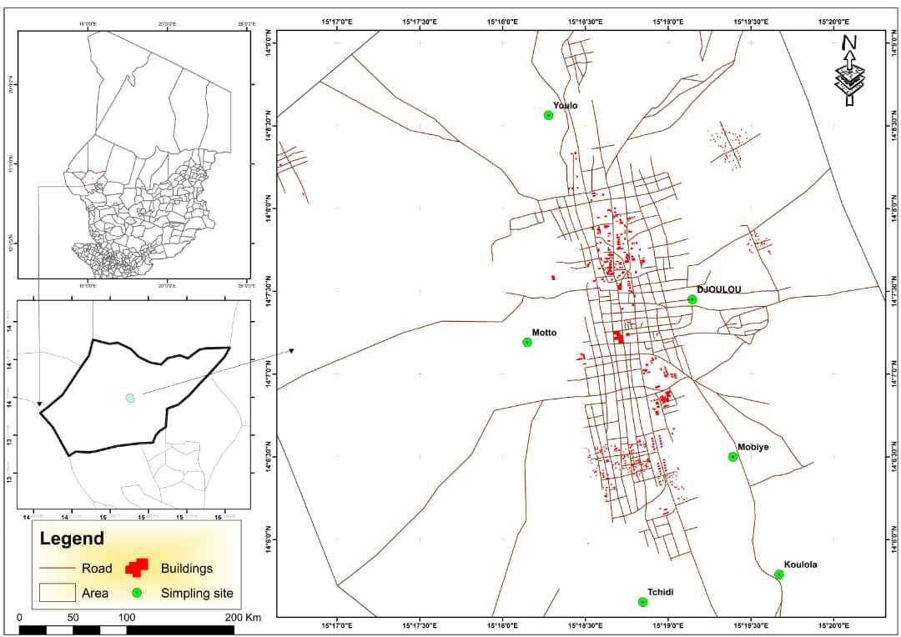
Fig.1: Map showing the locations of diatomite sample collection sites
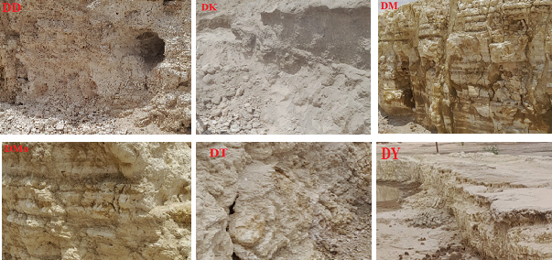
Fig. 2: Six diatomite deposits studied
The raw samples were air-dried, then crushed and finely ground using an agate mortar to obtain homogeneous powders. A fraction of each sample was dried at 105°C for 24 hours in preparation for chemical analyzes.
2.1 Determination of chemical composition (XRF)
X-ray fluorescence spectrometric analysis (XRF) was performed on the dried samples to determine the concentration of major and minor oxides. The analyzes were conducted using a Philips Magix Pro spectrometer (PW-2440) at the Geoscience Laboratory of the University of Johannesburg (South Africa). The samples were prepared in the form of vitrified pellets to ensure the homogeneity of the matrix. The analysis allowed for the quantification of the elemental composition (in mass percentage of oxides) and the determination of Loss on Ignition (LOI) by gravimetric after calcination at 1000°C. The data related to oxides and geochemical indices (notably the chemical alteration index, CIA) are reported in section 3.1.
2.2 Determination of mineralogical composition (XRD)
The mineralogical composition of diatomite was determined by X-ray diffraction (XRD) on disoriented powders. The apparatus used was a Philips diffractometer (PW-1710 diffractometer applying Cu-radiation) equipped with a copper anti-cathode tube (CuKα; λ=1.5406 λ=1.5406 Å). The samples were scanned in the 2θ angular range from 5∘ to 80∘ with a step size of 0.0167 (2θ) and a counting time of 85.725 s.
The diffraction peaks were determined in accordance with Bragg's law: 2dSinθ = nλ, where d is the interplanar spacing, θ is the half-angle of deviation, n is the reflection order (usually n=1) and λ is the wavelength of the X-rays (Phillips & Das, 1997).
The mineral phases were identified by comparison with data from the Powder Diffraction File (PDF, formerly ASTM) database (Phillips & Das, 1997). Semi-quantitative mineral quantification was performed using the Rietveld method (Pillière, 2002), developed under the Maud programmer, which minimizes the error between the measured diffract gram and the calculated diffract gram.
3. results and discussion
3.1 Chemical analyses
Table 2 presents the geochemical compositions of the six Chadian diatomite samples, including loss on ignition (LOI) and relevant geochemical ratios, compared with bibliographic data. The six samples are predominantly composed of silica (SiO₂), alumina (Al₂O₃) and iron oxide (Fe₂O₃), with traces of BaO, CaO, K₂O, MgO, MnO, Na₂O, P₂O₅ and TiO₂.
Table 2: Chemical data for diatomite samples collected and some references
Chemical composition (%) | Samples |  |  |  |  |  | (Al-Ghouti et al., 2007; Flores-Cano et al., 2013; Ibrahim & Selim, 2012; Safa et al., 2012; Yuan et al., 2004)
Chemical composition (%) | DD | DK | DM | DMo | DT | DY | China | Egypt | Algeria | Mexico | Morocco
Al2O3 | 5.62 | 3.70 | 3.48 | 5.08 | 3.93 | 3.52 | 5,75 | 4.24 | 5.3 | 13.52 | 7.3
BaO | - | 0.06 | - | - | - | - | - | - | - | - | -
CaO | 0.34 | 13.08 | 0.43 | 0.54 | 0.47 | 5.46 | 0.24 | 6.17 | 7.2 | 0.66 | 10
Fe2O3 | 2.80 | 3.37 | 2.20 | 1.97 | 1.32 | 2.42 | 1.41 | 1.07 | 3.8 | 3.37 | 4.3
K2O | 1.16 | 2.17 | 0.40 | 0.45 | 0.39 | 1.47 | 0.06 | - | 0.54 | 0.3 | 1.2
MgO | 0.37 | 4.38 | 0.20 | 0.20 | 0.16 | 1.74 | 0.21 | - | 2.6 | 0.42 | 1.0
MnO | - | 0.25 | - | - | - | 0.11 | - | - | - | - | -
Na2O | 0.90 | 3.09 | 0.08 | 0.07 | 0.24 | 1.29 | 0.06 | - | 0.65 | 0.17 | 1.8
P2O5 | 0.12 | 0.12 | - | - | - | 0.11 | - |  | - | - | -
SiO2 | 82.93 | 49.94 | 88.97 | 85.46 | 88.81 | 74.53 | 82.95 | 83.6 | 72.1 | 70.38 | 72.0
SO3 | 0.14 | 0.81 | - | 0.30 | 0.44 | 0.39 | - | - | - | - | -
TiO2 | 0.29 | 0.25 | 0.21 | 0.31 | 0.25 | 0.24 | 0.69 | - | 0.37 | - | -
LOI | 5.34 | 18.29 | 4.00 | 4.42 | 4.01 | 8.32 | 7.93 | 4.86 | 7.44 | 11.18 | 2.4
Sum | 100 | 99.50 | 100 | 98.81 | 100 | 98.2 | 99.3 | 99.94 | 100.0 | 100.0 | 100.0
$\frac{{SiO}_{2}}{{Al_{2}O}_{3}}$ | 14.75 | 13.49 | 25.5 | 16.82 | 22.59 | 21.2
$\frac{{SiO}_{2}}{{Al_{2}O}_{3}+{{Fe}_{2}O}_{3}}$ | 9.84 | 7.06 | 15.66 | 12.12 | 16.91 | 12.6
CIA | 69.46 | 16.78 | 79.27 | 82.73 | 78.13 | 29.9
3.2.1 Major oxide contents
Generally speaking, silica (SiO₂) content is dominant, ranging from 49.94% to 88.97%. The lowest content is observed in sample DK (49.94%), while the highest is in sample DM (88.97%). The DD, DM, DMo and DT deposits have SiO₂ contents above 78%. The alumina (Al₂O₃) and iron oxide (Fe₂O₃) contents are relatively low and homogeneous (3.48–5.62% and 1.32–3.37% respectively).
The DK sample exhibits a unique composition, distinguished by very high levels of calcium oxide (CaO: 13.08%), magnesium oxide (MgO: 4.38%) and loss on ignition (LOI: 18.29%). These values are strongly indicative of the presence of carbonate phases (calcite, dolomite) or other calco-magnesian minerals, which constitute significant impurities compared to silica. The DY sample also shows higher CaO (5.46%) and LOI (8.32%) contents than the other siliceous diatomites.
3.2.2 Geochemical indices and recovery potential
Industrial valuation criteria are paramount. For high-purity filtration, the requirements are strict: SiO₂>90% and Fe₂O₃<1.3% (Delfau, 1979; Haddoum et al., 2014; Indira, 2011). None of the raw samples meets these criteria.
However, for use as mineral fillers or abrasives (less noble applications), the criteria are more flexible (Delfau, 1979; Indira, 2011; Jonas et al., 2024; Meradi, 2015): SiO₂ between 70% and 90%, Al₂O₃ between 2% and 10% and Fe₂O₃ around 5% (max). DM, DMo, DT and DD deposits (with SiO₂>78%) meet these specifications. These results are consistent with the compositions of diatomites marketed by other producing countries (Chang et al., 2020; Ipekoğlu & Mete, 1990; Meradi, 2015).
The SiO₂/Al₂O₃ ratios (greater than 13 for siliceous samples) indicate a marked enrichment in silica (Bhatia & Crook, 1986), confirming the nature of these materials. The chemical alteration index (CIA), calculated from the chemical composition, shows high values for DD (69.46), DM (78.27), DMo (82.73) and DT (78.13), indicating that these deposits have undergone prolonged and significant chemical alteration (Babechuk et al., 2014). Conversely, the low values for DK (16.78) and DY (29.98) indicate either a low degree of alteration or a masking of this index by the incorporation of unaltered primary minerals, such as carbonates and plagioclase (confirmed by XRD).
3.2 Mineralogical analyses
The X-ray diffractograms (Figures 3, 4, and 5) allowed for the identification of the crystalline phases contained in the raw samples. The six diatomites are polyphasic, mainly composed of Quartz (SiO₂), clay minerals (Illite, Kaolinite), and Feldspars (Plagioclase, K-feldspar). The presence of Hematite (Fe₂O₃) and traces of other minerals confirms the heterogeneity of the samples.
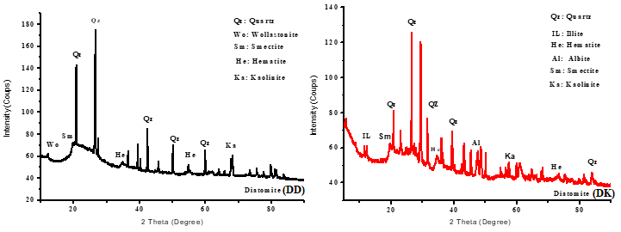
Fig. 3: X-ray diffraction patterns of raw diatomites (DD) and (DK)
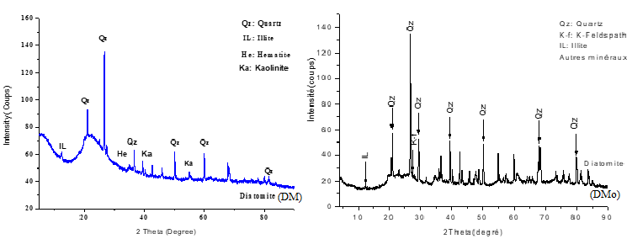
Fig. 4: X-ray diffraction patterns of raw diatomites (DM) and (DMo)
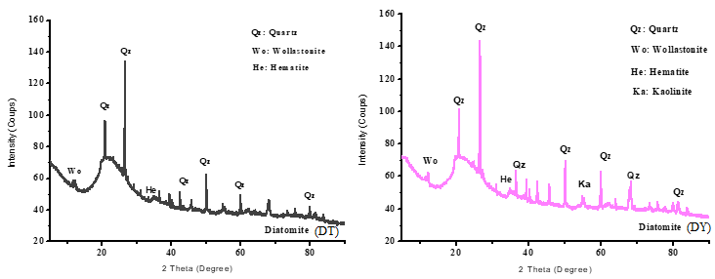
Fig. 5: X-ray diffraction patterns of raw diatomites (DT) and (DY)
Table 3 presents the semi-quantitative estimates of minerals obtained using the Rietveld method.
Table 3: Quantitative estimation of minerals in six samples
Samples | Illite % | K-feldspar % | Plagioclase  % | Kaolinite % | Quartz % | Hematite % | Other minerals %
DD | 10.05 | 6.87 | 1.69 | - | 73.36 | 5.75 | 2.28
DK | 11.79 | 9.06 | 41.93 | - | 30.05 | 5.82 | 1.53
DM | 3.46 | 2.37 | 2.13 | 2.43 | 83.85 | 4.51 | 1.27
DMo | 3.90 | 2.67 | 2.68 | 5.42 | 78.33 | 4.04 | 2.96
DT | 3.38 | 2.31 | 2.33 | 3.49 | 83.19 | 2.71 | 2.59
DY | 7.73 | 5.71 | 19.11 | - | 60.64 | 4.97 | 1.84
- Mineralogical estimation and chemical consistency
Quantitative estimation confirms the dominance of quartz in the DD, DM, DMo and DT samples, with contents ranging from 73.36% to 83.85%. Quartz, being the crystalline form of silica, is the key mineral sought in diatomite. The high quartz content is directly correlated with the high SiO₂ content observed by XRF for these four deposits.
The DK sample is the exception, where plagioclase (41.93%) is dominant, followed by quartz (30.05%). This predominance of plagioclase (a calcium-sodium mineral) is perfectly consistent with the high CaO and Na₂O levels measured in chemical analysis (Table 2), reinforcing the hypothesis of contamination by detrital minerals.
Other minerals identified, such as illite (3.38–11.79%) and feldspars, as well as hematite (iron oxide), are the main sources of impurities. Hematite (2.71–5.82%) is responsible for the Fe₂O₃ content and often influences the color of the rock.
In conclusion, mineralogical analyses confirm that the DD, DM, DMo and DT deposits are mainly siliceous diatomite, while the DK and DY samples are diatomite that are more contaminated with secondary mineral phases, which is crucial for any mining decision.
4. Conclusion
Diatomite is a multifaceted mineral resource, but its use in Chad is currently limited to local construction due to a lack of precise data on its properties. In response to this observation, six diatomite deposits in the Mao region underwent in-depth chemical and mineralogical characterization.
XRF analyzes revealed that silica (SiO₂), alumina (Al₂O₃), and iron oxide (Fe₂O₃) are the major oxides in all samples. Cependant, les échantillons DK (Koulola) et DY (Youlo) se distinguent par des pourcentages nettement plus élevés d'oxyde de calcium et d'oxyde de magnésium, accompagnés d'une perte au feu élevée, indiquant une contamination par des phases carbonatées. The chemical alteration index (CIA) confirmed a more advanced degree of alteration for the Djoulou, Mobye, Motto, and Tchidi deposits.
Mineralogical analyzes by XRD identified and quantified the dominance of quartz in the DD, DM, DMo, and DT deposits (quartz content >73%), in contrast to the DK sample, where plagioclase is the dominant mineral (41.93%).
Compared to industrial standards, the four deposits (DD, DM, DMo, and DT) have silica and impurity contents that, although below the strict requirements for high-purity filtration, make them perfectly suitable for use in less demanding applications. They meet the specifications for use as fillers, abrasives, or thermal insulation materials. The DK and DY deposits, due to their high limestone contaminant content, would require purification steps or would be directed toward applications specific to limestone diatomite.
The results of this study provide a solid scientific basis for promoting and guiding the industrial exploitation of Chadian diatomite.

Disclaimer (Artificial intelligence)
Option 1:
Author(s) hereby declare that NO generative AI technologies such as Large Language Models (ChatGPT, COPILOT, etc.) and text-to-image generators have been used during the writing or editing of this manuscript.
Option 2:
Author(s) hereby declare that generative AI technologies such as Large Language Models, etc. have been used during the writing or editing of manuscripts. This explanation will include the name, version, model, and source of the generative AI technology and as well as all input prompts provided to the generative AI technology
Details of the AI usage are given below:
1.
2.
3.

References
- Al-Ghouti, M. A., Khraisheh, M. A. M., Ahmad, M. N., & Allen, S. J. (2007). Microcolumn studies of dye adsorption onto manganese oxides modified diatomite. Journal of Hazardous Materials, 146(1‑2), 316‑327. https://doi.org/10.1016/j.jhazmat.2006.12.024
- Babechuk, M. G., Widdowson, M., & Kamber, B. S. (2014). Quantifying chemical weathering intensity and trace element release from two contrasting basalt profiles, Deccan Traps, India. Chemical Geology, 363, 56‑75. https://doi.org/10.1016/j.chemgeo.2013.10.027
- Bakr, G. M. M., & Elden, H. (2010). Diatomite : Its Characterization, Modifications and Applications. Asian Journal of Materials Science, 2(3), 121‑136. https://doi.org/10.3923/ajmskr.2010.121.136
- Bhatia, M. R., & Crook, K. A. W. (1986). Trace element characteristics of graywackes and tectonic setting discrimination of sedimentary basins. Contributions to Mineralogy and Petrology, 92(2), 181‑193. https://doi.org/10.1007/BF00375292
- Chang, J., Zhang, J., Tan, B., Wang, Q., Liu, N., & Xue, Q. (2020). New insight into the removal of Cd(II) from aqueous solution by diatomite. Environmental Science and Pollution Research, 27(9), 9882‑9890. https://doi.org/10.1007/s11356-020-07620-y
- Delfau, M. (1979). Mémento substances utiles (matériaux de carrière) Diatomite. http://infoterre.brgm.fr/rapports/79-SGN-158-MTX.pdf
- Flores-Cano, J., Ramos, R., Padilla, E., & Mendoza-Barron, J. (2013). Adsorption of Heavy Metals on Diatomite : Mechanism and Effect of Operating Variables. Adsorption Science & Technology, 31, 275‑292. https://doi.org/10.1260/0263-6174.31.2-3.275
- Haddoum, S., Selmi, E. H., & Chitour, C. E. (2014). Élaboration de catalyseurs à base de bentonite et de kieselguhr pour le craquage catalytique des coupes pétrolières. Comptes Rendus Chimie, 17(7), 746‑751. https://doi.org/10.1016/j.crci.2014.03.017
- Ibrahim, S., & Selim, A. Q. (2012). HEAT TREATMENT OF NATURAL DIATOMITE. Physicochemical Problems of Mineral Processing. https://www.semanticscholar.org/paper/HEAT-TREATMENT-OF-NATURAL-DIATOMITE-Ibrahim-Selim/e833f9521442a24cad7a59f1d683223ee168c8e9
- Indira, B. (2011). Indian Minerals Yearbook, Part II, 50th Edition, 2-4.
- Ipekoğlu, U., & Mete, Z. (1990). Determination of the properties of various diatomite deposits within Aegean Region of Turkey. Geologija, 33(1), 447‑459. https://doi.org/10.5474/geologija.1990.011
- Jonas, T., Ngamsou, D. T., Samson, M., Soultan, M., Nanimina, A. M., Lamaï, N., & Querry, M. (2023). Influence of Diatomite on the Physico-Mechanical Properties of Compressed Earth Blocks. Physical Science International Journal, 27(3), 38‑50. https://doi.org/10.9734/psij/2023/v27i3794
- Jonas, T., Soultan, M., Ronelngar, M. F., Abdel-Khadir, M. S., Nanimina, A. M., & Querry, M. (2024). Hygrothermal Properties of a Composite Based on Clay Soils and Diatomite. Open Journal of Civil Engineering, 14(03), 363‑373. https://doi.org/10.4236/ojce.2024.143019
- Lemonas, J. F. (1997). Diatomite. 76, 72‑75.
- Meradi, H. (2015). Contribution to characterization of the diatomite for industrialapplication. https://www.academia.edu/123298843/Contribution_to_characterization_of_the_diatomite_for_industrialapplication
- Phillips, R. J., & Das, S. K. (1997). Improved a fax mould fluxes for high speed casting with emphasis on special requirements for thin slab casting. 51st ATM - 35th NMD of the Indian Institute of Metals at Jamshedpur.
- Pillière, H. (2002). L’analyse par diffraction de RX, Mesures 746.
- Reka, A., Anovski, T., Bogoevski, S., Pavlovski, B., & Boškovski, B. (2014). Physical-chemical and mineralogical-petrographic examinations of diatomite from deposit near village of Rožden, Republic of Macedonia. Geologica Macedonica, 28(2), Article 2.
- Safa, M., Larouci, M., Meddah, B., & Valemens, P. (2012). The sorption of lead, cadmium, copper and zinc ions from aqueous solutions on a raw diatomite from Algeria. Water Science and Technology: A Journal of the International Association on Water Pollution Research, 65(10), 1729‑1737. https://doi.org/10.2166/wst.2012.183
- Yuan, P., Wu, D., He, H., & Lin, Z. (2004). The hydroxyl species and acid sites on diatomite surface : A combined IR and Raman study. Applied Surface Science, 227. https://doi.org/10.1016/j.apsusc.2003.10.031

