Mapping Obesity in the United States: Statewise Demographic Trends and Implications

ABSTRACT

Background
Obesity is a major public health challenge associated with numerous chronic conditions, including diabetes, polycystic ovarian syndrome(PCOS), hypertension, stroke, gastroesophageal reflux disease( GERD), metabolic dysfunction-associated steatotic liver disease (MASLD), cancer, and depression. The prevalence in the United States continues to rise and varies significantly across racial, geographic, and demographic groups. This study analyzes obesity trends from 2011 to 2023, focusing on regional and population-level differences to better understand the distribution and inferred clinical implications of obesity, using a multi-level, population-based framework to identify obesity determinants and guide targeted, evidence-based lifestyle interventions

Methods
Data were obtained from the National Health and Nutrition Examination Survey (NHANES) between 2011 and 2023. Obesity prevalence was stratified by race/ethnicity and geographic region (South, Midwest, West, Northeast). Descriptive statistics and graphical illustrations were used to identify trends. Findings were contextualized with peer-reviewed literature addressing the associations between obesity ,medical conditions, and sociodemographic variables.

Results
Obesity prevalence was highest in the South and Midwest, with women exhibiting slightly higher median values than men. The regression model shows a strong relationship between year and obesity rate (R = 0.956, R² = 0.914), meaning 91.4% of the changes in obesity rates can be explained by the year. The model fits well (Adjusted R² = 0.906, Standard Error ≈ 0.70), and the obesity rate is increasing by about 0.561% per year in the South among Non-Hispanic Black adults (p = 0.060), the overall model is still statistically significant, and the coefficients have strong significance (p < 0.0001). Overall, this model suggests a clear upward trend and can be used to forecast future obesity rates if the pattern continues. Adjusted R² (0.906) accounts for the number of predictors in the model, and it's slightly lower than R², suggesting the model is robust and doesn't overfit the data, with Standard Error of the Estimate = 0.70048 that represents the average distance that the observed values fall from the regression line indicating better predictive accuracy(p < 0.0001,95% CI 0f 0.447 to 0.675).

Conclusion
The continuing rise of obesity prevalence, particularly in minority populations such as African Americans, has critical implications for GI health. The study indicates that generally, obesity is concentrated in Non-Hispanic Black and Hawaiian/Pacific Islander populations. Obesity is generally more prevalent in southern and midwestern regions. Screening, prevention, and management strategies for GI disorders should be redefined to integrate obesity reduction interventions, including pharmacologic therapies, dietary counseling, and lifestyle modifications. Providers serving high-risk communities must adopt these approaches to improve outcomes and reduce obesity-related GI morbidity.
Keywords: Obesity, Basal metabolic Index, Overweight, race/ethnicity, prevalence, mapping trend.

INTRODUCTION

Obesity has become one of the most pressing public health challenges in the United States and globally, with profound implications for individual health, healthcare systems, and societal productivity. While national prevalence figures highlight the magnitude of the problem, they obscure the uneven distribution of obesity across the country. Rates of obesity vary significantly between states and among different demographic subgroups, reflecting complex interactions between geographic, demographic, socioeconomic, environmental, psychosocial, and healthcare-related factors (1). Understanding these geodemographic disparities is essential for designing effective, community-engaged interventions to address the obesity epidemic.
Research consistently shows that certain regions of the United States, particularly the South experience higher obesity rates compared to regions such as the West and Northeast (2). However, these regional patterns mask substantial variation within states and across smaller demographic groups. Social determinants of health, including race, ethnicity, socioeconomic status, education level, financial literacy, and access to nutritious foods, strongly influence obesity risk. These factors often cluster geographically, creating localized areas of high and low prevalence. Environmental conditions, such as the availability of safe spaces for physical activity and the density of fast-food outlets, further shape obesity patterns. Similarly, wealth disparities and differences in food affordability contribute to unequal access to healthy dietary options.
Addressing these disparities requires a comprehensive, multi-level approach tailored to the unique challenges and resources of each community. Primary care providers play a pivotal role in prevention and management, yet their efforts may be limited without a deep understanding of the geodemographic influences on obesity in their patient populations. To be effective, interventions must be culturally sensitive and context-specific, reflecting community traditions, socioeconomic realities, and environmental conditions.
This research seeks to provide a holistic analysis of obesity disparities across U.S. states. Using a population-based, multi-level framework, the study will identify the key determinants of obesity prevalence and explore how these factors interact at the individual, community, and state levels. Data sources will include demographic information, socioeconomic indicators, environmental measures, psychosocial determinants, and healthcare utilization statistics. The findings aim to equip healthcare providers, policymakers, and community organizations with actionable insights for developing targeted, evidence-based interventions. Ultimately, this work will contribute to advancing health equity, promoting healthier lifestyles, and reducing the burden of obesity nationwide (1)(2)(3)(4).

The prevalence of obesity in the United States has increased steadily over the last three decades, but the distribution of this burden is not uniform across states or demographic groups. National surveys show wide variability, with certain states reporting obesity rates exceeding 40 percent while others remain closer to 25 percent (5,6). These state-level differences often mirror patterns of socioeconomic deprivation, racial and ethnic composition, and regional lifestyle norms (7).
Demographic factors play a significant role in shaping the prevalence of obesity. Minority populations, particularly non-Hispanic Black and Hispanic adults, exhibit higher rates of obesity compared to non-Hispanic White counterparts (8,9). Furthermore, age and gender variations have been documented, with middle-aged adults and women disproportionately affected (10). However, while demographic associations are well described, the way these intersect with state-level characteristics remains underexplored.

Existing studies often rely on national-level data that obscure significant subnational disparities (11). For example, residents of states with higher poverty and unemployment rates may face unique barriers such as limited food security, reduced access to preventive care, and fewer opportunities for physical activity (12,13). Without fine-grained mapping of demographic and geographic patterns, interventions risk being overly generalized, limiting their effectiveness.
The knowledge gap lies in understanding how demographic disparities manifest differently across states and what this implies for policy and primary care delivery. Mapping these patterns at the state level can provide critical insights into which populations are most vulnerable and how resources should be allocated to reduce inequities (14). This approach underscores the necessity for targeted, context-specific interventions that consider both local environments and population-level characteristics.

Materials and Methods
Study Design and Data Source
This cross-sectional study utilized publicly available data from the Centers for Disease Control and Prevention (CDC) Behavioral Risk Factor Surveillance System (BRFSS), specifically the Nutrition, Physical Activity, and Obesity dataset. BRFSS is a nationwide, state-based telephone survey that collects self-reported information on health behaviors, chronic diseases, and preventive health practices among adults aged 18 years and older in the United States.
The initial dataset included 104,272 observations and 32 variables. Records containing missing values or footnotes indicating insufficient sample sizes were excluded according to CDC guidance. After data cleaning, the final analytic dataset consisted of 93,505 complete observations.
Study Population and Outcome Measures
The study population consisted of U.S. adults aged ≥18 years. Two primary outcome variables were extracted: Prevalence of overweight and obesity among adults.
To evaluate disparities, analyses were stratified by race/ethnicity and geographic region. Sociodemographic variables such as gender, income, education, and age were not included in regression models in order to focus comparisons solely on racial and regional differences.
Regional Classification
States and territories were grouped into standard U.S. Census regions: In conducting the exploratory data analysis, we examined performance patterns across both region and race. To enable regional comparisons, a new column was created to assign each state to its corresponding geographic region, a process completed using Python(Table 1).
Region | States/Territories
Northeast | Connecticut, Maine, Massachusetts, New Hampshire, New Jersey, New York, Pennsylvania, Rhode Island, Vermont
Midwest | Illinois, Indiana, Iowa, Kansas, Michigan, Minnesota, Missouri, Nebraska, North Dakota, Ohio, South Dakota, Wisconsin
South | Alabama, Arkansas, Delaware, Florida, Georgia, Kentucky, Louisiana, Maryland, Mississippi, North Carolina, Oklahoma, South Carolina, Tennessee, Texas, Virginia, West Virg
West | Alaska, Arizona, California, Colorado, Hawaii, Idaho, Montana, Nevada, New Mexico, Oregon, Utah, Washington, Wyoming
Territories | Puerto Rico, Guam, Virgin Islands

Table 1: Displays the regional classification of states and territories.
Northeast: CT, ME, MA, NH, NJ, NY, PA, RI, VT. Midwest: IL, IN, IA, KS, MI, MN, MO, NE, ND, OH, SD, WI. South: AL, AR, DE, FL, GA, KY, LA, MD, MS, NC, OK, SC, TN, TX, VA, WV. West: AK, AZ, CA, CO, HI, ID, MT, NV, NM, OR, UT, WA, WY. Territories: Puerto Rico, Guam, U.S. Virgin Islands.
Rationale for Meta-analytic Approach
A meta-analytical framework was used to pool state-level estimates and strengthen overall statistical inference. This approach was selected because and allows:
- Increased statistical power through aggregation across states.
- More precise estimation of overweight and obesity prevalence.
- Evaluation of heterogeneity across racial groups and geographic regions.
Data Preparation and Processing
Data cleaning and preprocessing were performed using Python (Pandas, NumPy). Records with missing data were removed, and categorical variables were standardized across states and territories. Data visualization and exploratory assessments were performed using Matplotlib and Seaborn. Additional verification and cross-tabulation were conducted in SPSS and Microsoft Excel.
Statistical Analysis
All statistical procedures followed standard epidemiological and analytical practices:
- Descriptive Statistics: Frequencies and percentages were calculated to summarize overweight and obesity prevalence across racial/ethnic and regional categories.
- Stationarity Testing: Time-series diagnostics were performed to assess the stability of obesity prevalence over time before generating forecasts.
- Bivariate Analysis: Differences between adults with and without obesity were examined using chi-square tests and summarized in Table 2.
- Multivariable Regression: Binary logistic regression was used to estimate the odds of obesity. Only variables statistically significant in bivariate analyses were included in the model. Adjusted odds ratios (ORs) and 95% confidence intervals (CIs) were reported.
- Forecasting: Trend analysis and regression-based forecasting methods were applied to estimate national obesity prevalence within time frame..
A two-sided p-value < 0.05 was considered statistically significant.
Software and Tools
Primary analyses were conducted using Python (Pandas, NumPy, Seaborn, Matplotlib, Statsmodels). SPSS (IBM Corp.) was used for confirmatory statistics, and Microsoft Excel was used for additional descriptive metrics and validation.
RESULTS
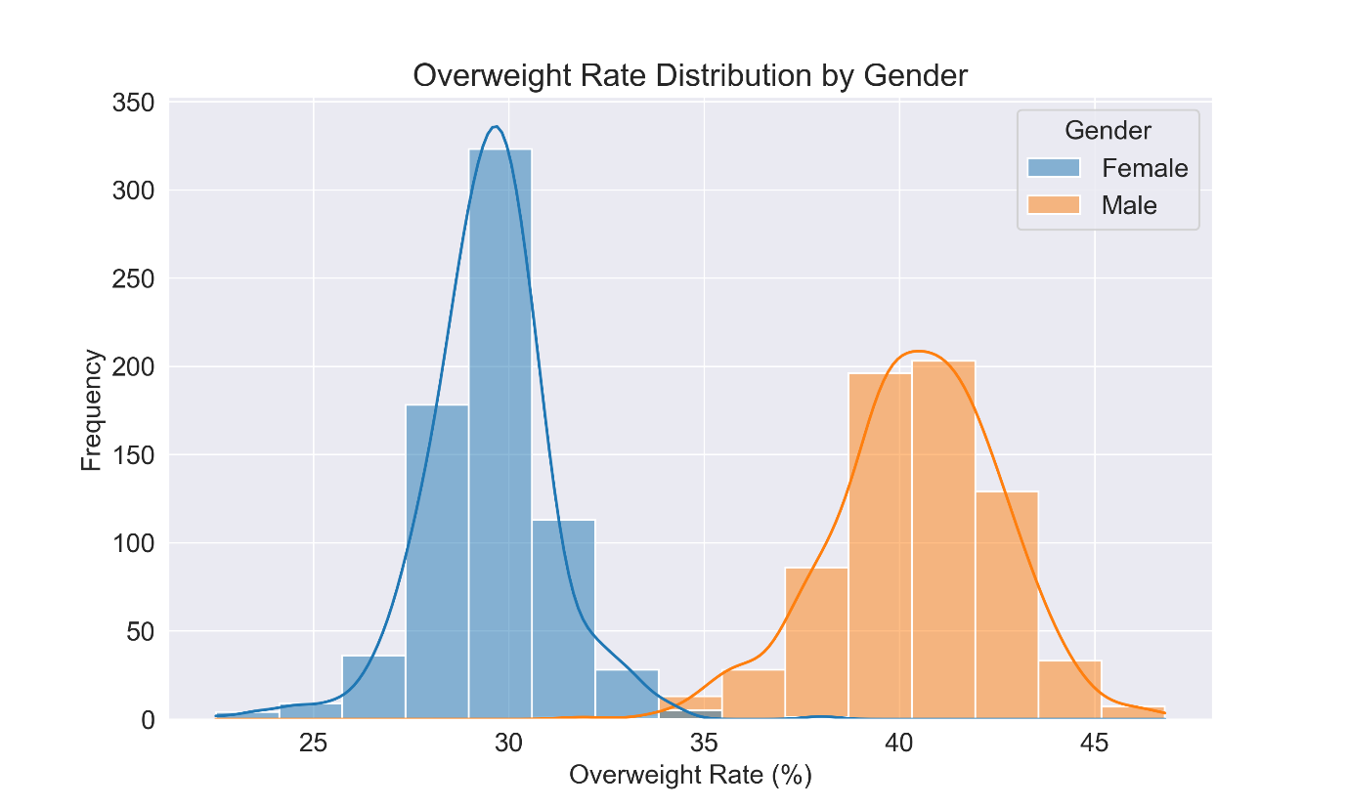

Figure 1: Comparative histogram overweight rate distribution by gender

The female Obesity Distribution revealed a Mean = 29.498, Median = 29.600, Mode = 29.800 which suggests the distribution is roughly symmetrical(Skewness = -0.085 (SE = 0.093)Kurtosis = 2.580 (SE = 0.186) .Male Obesity Distribution revealed mean = 40.420, Median = 40.500, Mode = 39.700,Skewness = -0.307 (SE = 0.093,Kurtosis = 0.354 (SE = 0.186).
Both groups have approximately symmetric distributions (not highly skewed).Females have a tighter spread and are closer to a normal distribution in shape. Males show a wider spread (flatter distribution), and their average overweight rate is significantly higher than that of females. The difference in means (40.42 versus 29.50) is substantial, which may support a statistically significant difference.
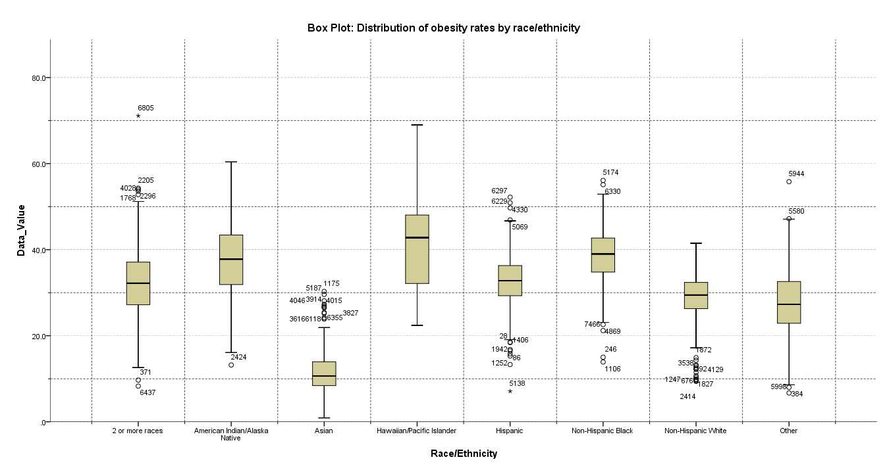
Figure 2: Box Plot distribution of obesity rates by race/ethnicity.
Asian individuals show the lowest median obesity rate and have a relatively narrow range(Mean = 11.41%). Hawaiian/Pacific Islanders exhibit the highest median obesity rate with a wide range of values( Mean = 40.63%). Non-Hispanic Black individuals also have a relatively high median rate. The "2 or more races" category includes a significant outlier at 6805.The "Other" category also has an outlier at 5944.
There is no difference(H₀ > H1) in the means across the different groups of Stratification.
Test of Homogeneity of Variances (Levene’s Test) = 45.364,(p-value = .000).There is a statistically significant difference in overweight rates across the different racial/ethnic groups (p < .001, F-value=826.634), indicating strong between-group variation relative to within-group variation. Asian adults have significantly lower overweight rates than all other groups. Hawaiian/Pacific Islander adults show the highest rates. Most pairwise differences between groups are statistically significant (p < 0.05).

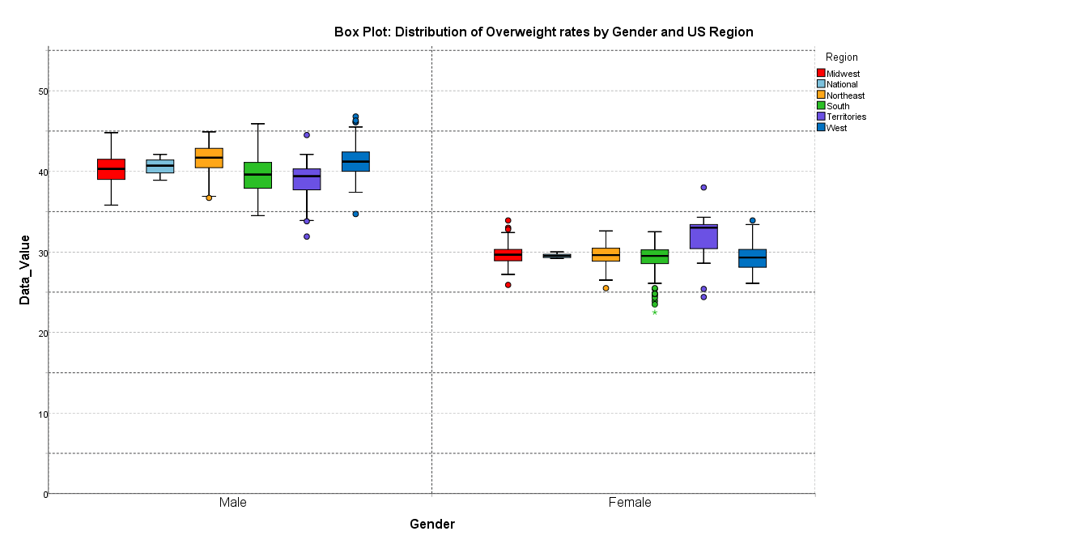
Figure 3: Box Plot distribution of overweight rates by gender and US regions.

Higher overall overweight classification rates across regions for males than females. All regions for males are clustered between ~35 and 50.West and Territories have some outliers (dots outside whiskers), suggesting data variability or anomalies. Midwest and National regions show higher medians among males (~42+).Female group has Lower distributions than males in nearly every region(range from ~22 to ~35), having more men with overweight compared to women. Northeast and South show slightly more variation and outliers. Regional Trends show Midwest, National, and West have higher medians (especially for males).Northeast and Territories show wider variability, especially for females.
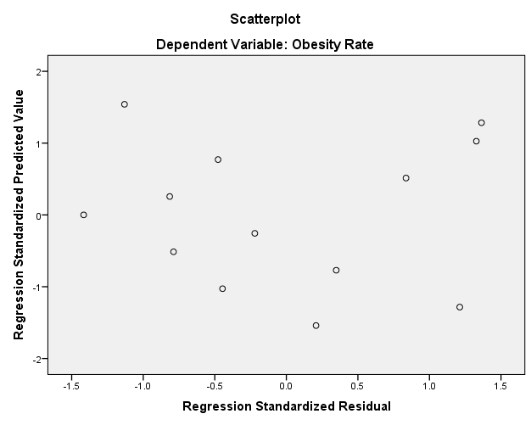
Figure 4: Scatterplot showing predictive trend value of Obesity rate

The correlation between the observed and predicted values of the obesity rate is quite strong (R = 0.956), suggesting that the regression model explains a significant portion of the variability in the obesity rate, but the R Square (R²) = 0.914,meaning approximately 91.4% of the variance in the obesity rate can be explained by the year in the regression model. This is very high value, indicating a good fit. The relationship between Year and Obesity Rate is not statistically significant at the 5% level (p = 0.060). This implies that, based on this model, we cannot conclusively say that the increase in Obesity Rate over time is solely due to the passage of years.
Adjusted R² (0.906) accounts for the number of predictors in the model, and it's slightly lower than R², suggesting the model is robust and doesn't overfit the data, with Standard Error of the Estimate = 0.70048 that represents the average distance that the observed values fall from the regression line indicating better predictive accuracy(p < 0.0001,95% CI 0f 0.447 to 0.675).Based on this regression analysis, there is a significant positive trend in the obesity rate over the years, with a steady increase of about 0.561 percentage points per year in the South region for the Non-Hispanic Black population. The model has a very high R² value (91.4%), meaning it explains most of the variance in the obesity rate. The model is statistically significant with a low p-value in the ANOVA table, and the regression coefficients are highly significant.
Given the model's good fit, it could be used for forecasting future obesity rates in the region, though the model's linear nature means it assumes the trend will continue in a similar pattern in the future. Overall, the linear regression model is a good fit for forecasting obesity rates in the South region for the Non-Hispanic Black population, and it suggest it can be used to predict future obesity rates for the next several years, assuming the trend remains similar.
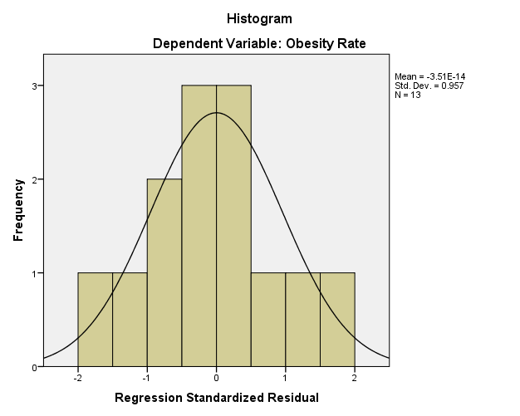

Figure 5:Histogram showing regression standardized residual of obesity rates.

The regression model indicates that there is a statistically significant positive relationship between Year and Obesity Rate, with obesity rates increasing by 0.311 each year. The model explains 48.9% of the variance in obesity rates, which is a moderate explanatory power. The Durbin-Watson statistics (1.221) suggests there may be some positive autocorrelation in the residuals, indicating that some trend might still be left unexplained by the model. However, further analysis of residuals and potential model improvements might be necessary to refine the predictions.
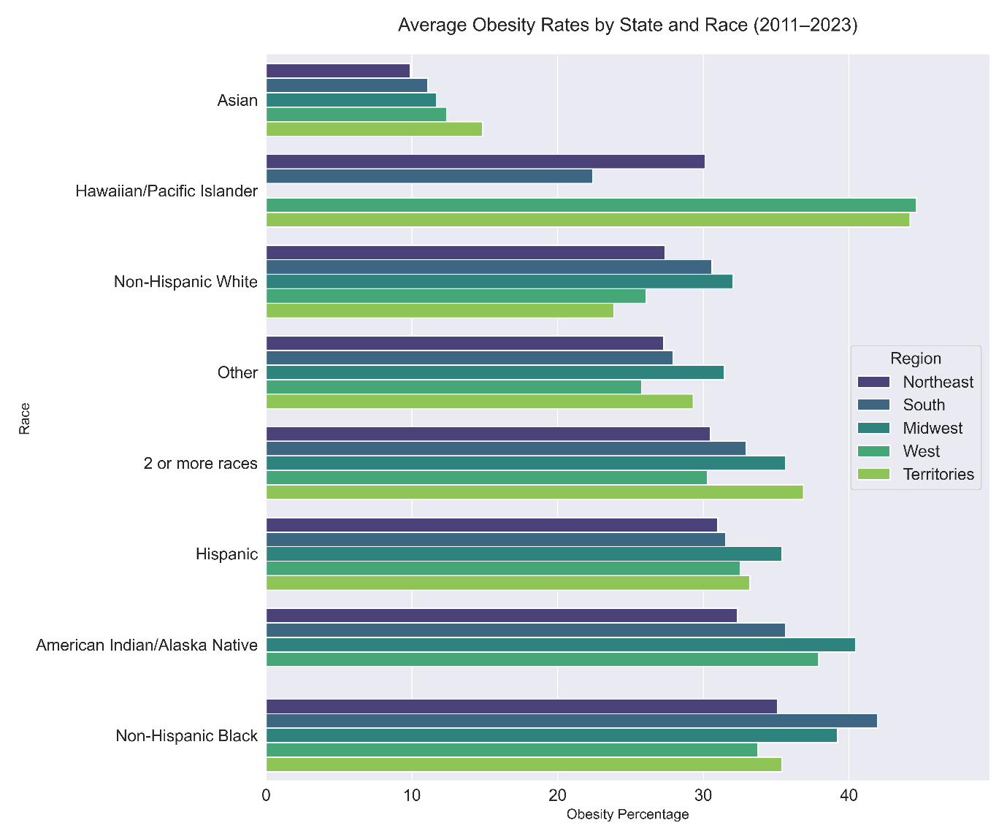
Figure 6: Graph showing average obesity rates by state and race.
Asian populations consistently have the lowest obesity rates across all regions. Non-Hispanic Black individuals generally show the highest obesity rates, with Hawaiian/Pacific Islanders also recording elevated rates in certain regions, such as the Territories and South.

Regional map showing overweight/obesity from 2011 -2023 are depited by Figure 7-21 below.Each individual visual map represents rapidcolor coding and changes for different year in view. Rapid visual of Regional Maps distribution of obesity and overweight (Figure 7-21).Hawaiian/Pacific Islander, Hispanic, Non-Hispanic Black, and American Indian/Alaska Native groups consistently show higher obesity rates, mostly above 35%.Asian individuals maintain the lowest obesity rates, starting around 20% in 2011 and slowly rising to 25% by 2023.Non-Hispanic White, Other, and those identifying as 2 or more races fluctuate between 30-35%.A sharp increase is observed for Hawaiian/Pacific Islanders in 2023, reaching 40%, potentially indicating significant lifestyle, dietary, or socio-economic factors affecting this group.
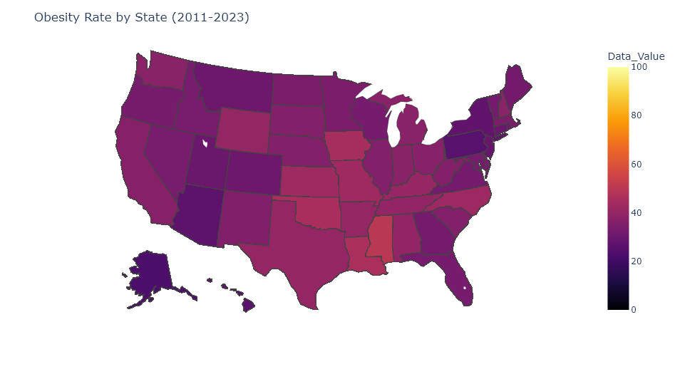
Figure 7: Obesity rate by state (2011-2023)

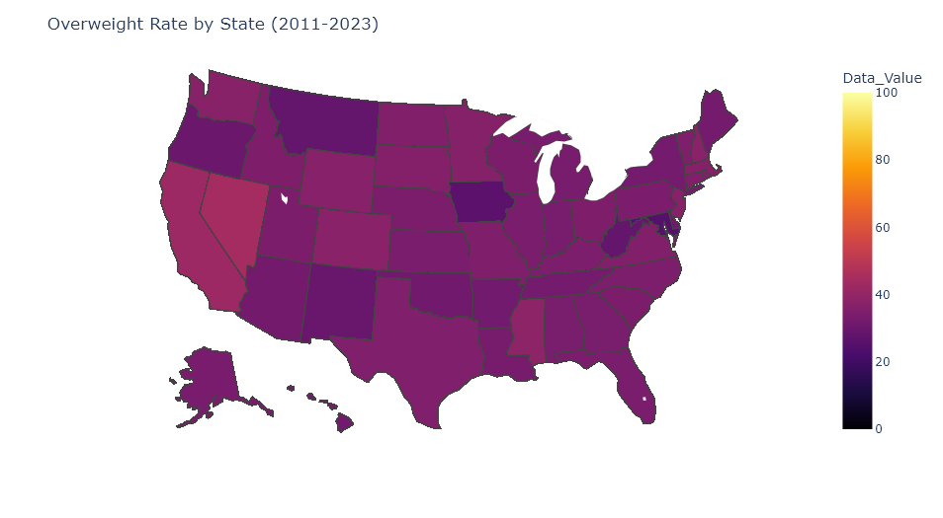
Figure 8: Overweight rate by state (2011-2023)
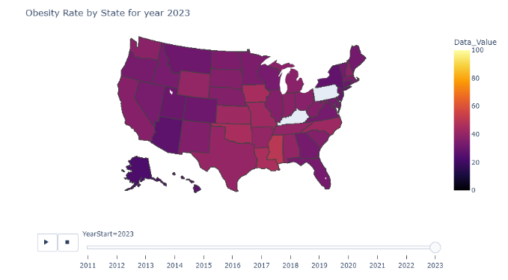
Figure 9: Obesity rate by state (2023)

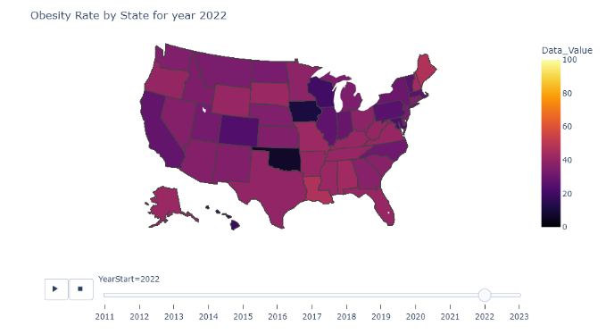
Figure 10: Obesity rate by state (2022)
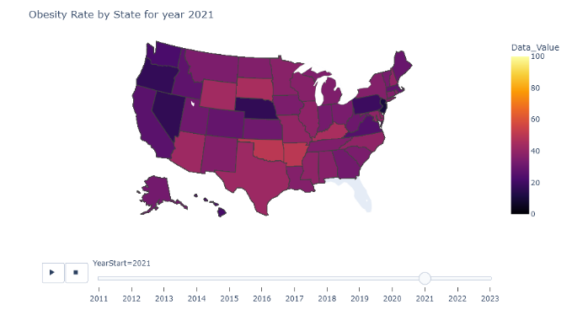
Figure 11: Obesity rate by state (2021)

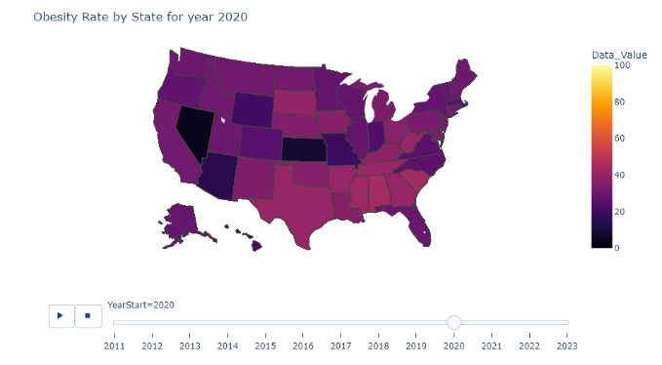
Figure 12: Obesity rate by state (2020)
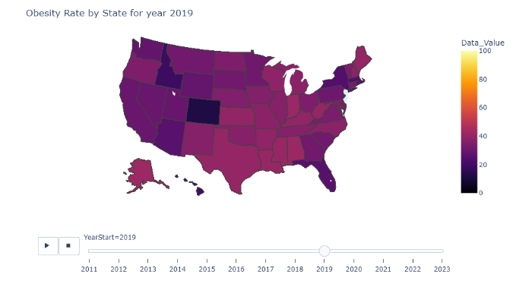
Figure 13: Obesity rate by state (2019)

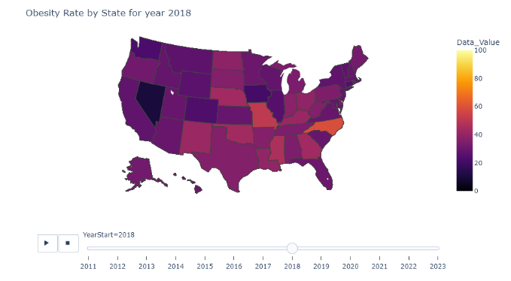

Figure 14: Obesity rate by state (2018)

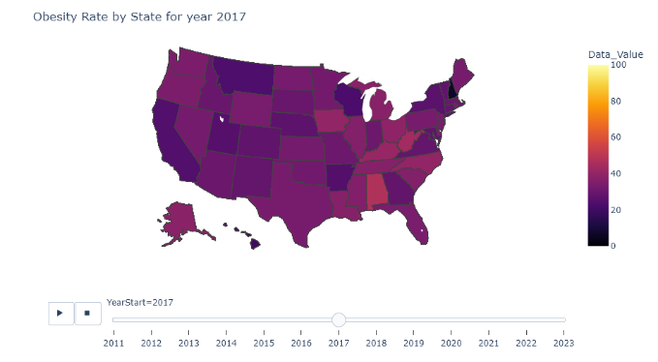
Figure 15: Obesity rate by state (2017)

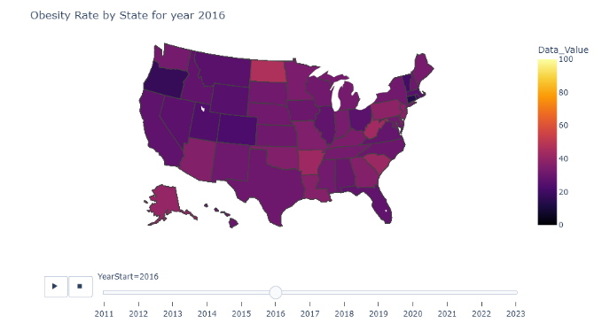
Figure 16: Obesity rate by state (2016)

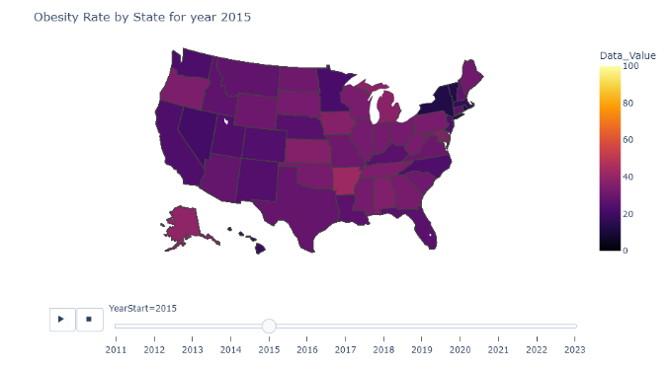
Figure 17: Obesity rate by state (2015)

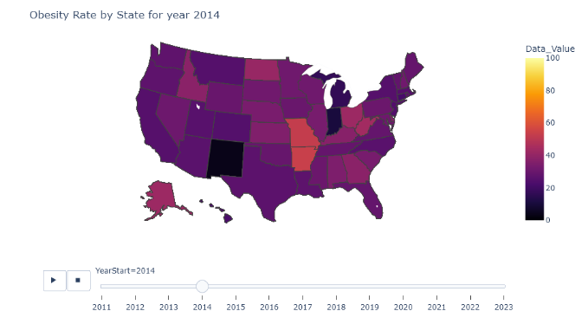
Figure 18: Obesity rate by state (2014)

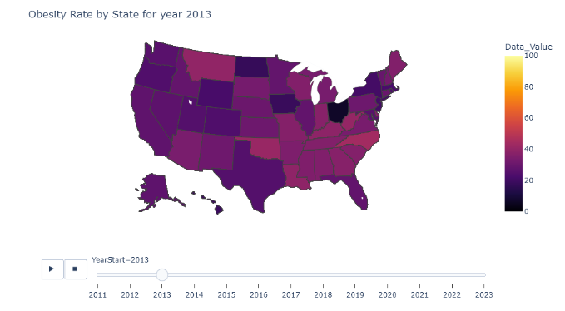
Figure 19: Obesity rate by state (2013)

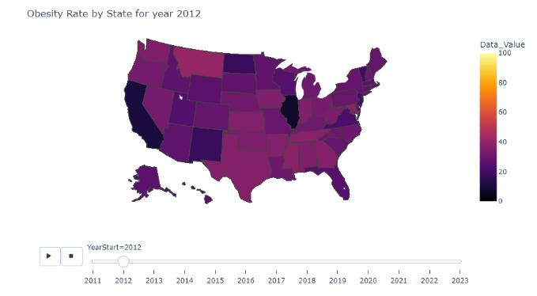
Figure 20: Obesity rate by state (2012)

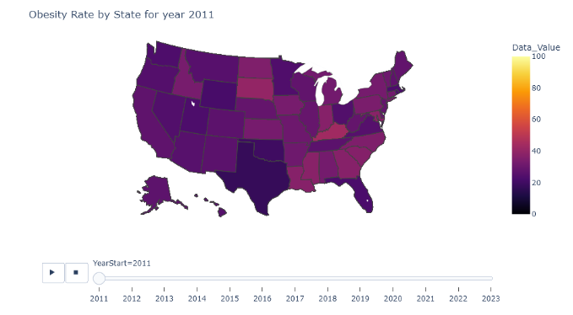
Figure 21: Obesity rate by state (2011).
Figure 7-21(Visual only) : The temporal and geographic patterns(Maps) depicted in the Figures demonstrate a sustained and progressive increase in obesity and overweight prevalence across the majority of U.S. states from 2011 to 2023, with color marks(metered) representing the variation from year to year. The visualization reveals an expanding geographic burden, with regions previously exhibiting moderate prevalence transitioning into higher prevalence categories over time, suggesting both intensification and diffusion of the obesity epidemic. Notably, persistent regional clustering is observed, particularly in the Southern and Midwestern states, consistent with known socioeconomic, racial, environmental, and healthcare access disparities. The progressive homogenization of high-prevalence color categories across multiple regions further indicates that obesity has evolved from a regionally concentrated public health issue into a widespread national challenge. These trends likely reflect the cumulative effects of urbanization, sedentary lifestyles, food environment changes, and structural inequities in health determinants. Collectively, the observed patterns underscore the urgency of coordinated, multi-level interventions and policy strategies aimed at reversing the trajectory of obesity prevalence and mitigating its long-term public health consequences.
DISCUSSION
Obesity is defined as a BMI of 30 and above. BMI is measured along the scales of underweight, normal, overweight, and obese. It combines both height and weight, however it does not take muscle into account. It is not always an accurate indicator of one’s health, particularly in the African American population.
This study explored the prevalence of obesity across U.S. states and examined its relationship with key demographic and geographic factors, revealing meaningful patterns and disparities that continue to shape the nation’s obesity burden. The findings demonstrate that obesity is influenced by a complex combination of environmental, socioeconomic, and cultural determinants rather than uniform national trends. Regions such as the South and Midwest exhibited consistently higher or steadily increasing obesity rates, highlighting persistent structural and lifestyle factors that disproportionately affect these areas. These trends underscore the need for region-specific strategies that address both community-level barriers and broader systemic influences.
The observed fluctuations in the Northeast and West suggest that obesity trends in these regions are more dynamic, potentially shaped by variable economic conditions, intermittent public health programming, and changing lifestyle behaviors. Meanwhile, the lower and more stable obesity prevalence in the U.S. Territories may reflect different socio-cultural norms, dietary patterns, or environmental exposures. These regional distinctions emphasize that a one-size-fits-all approach to obesity prevention may be insufficient; instead, interventions must consider local contexts, cultural practices, and resource availability[16,17].
Demographic analyses revealed strong associations between obesity and age, sex, race/ethnicity, income, and education. The increase in obesity prevalence among middle-aged adults aligns with evidence of cumulative lifestyle and metabolic risk factors that peak during midlife. The slight decline in older adults may be related to changes in body composition, survivor bias, or increased engagement with healthcare services. Sex differences in obesity prevalence varied across states, suggesting that regional cultural norms, occupational factors, and healthcare utilization patterns influence risk differently for men and women.
Racial and ethnic disparities were particularly prominent. Non-Hispanic Black and Hispanic adults consistently exhibited higher obesity rates than Non-Hispanic White adults, reflecting longstanding inequities in access to healthy foods, safe recreational spaces, and preventive healthcare. These patterns echo national trends and point to structural factors such as food deserts, targeted marketing of unhealthy foods, and socioeconomic disadvantages. Addressing these disparities will require culturally relevant, community-driven interventions that actively involve local leaders, healthcare institutions, and public health agencies[17,18,19].
Socioeconomic status was also strongly linked to obesity. Lower income levels were associated with higher obesity prevalence, consistent with research showing that financial constraints limit access to nutritious foods, recreational opportunities, and preventive services[[16,20]. Similarly, the protective effect of higher educational attainment highlights the importance of health literacy and informed decision-making in obesity prevention. Urban–rural disparities further reinforced the role of environmental and infrastructural factors, with rural residents facing higher obesity rates, likely due to reduced access to healthcare, fewer recreational resources, and limited availability of fresh foods[16,20,21].
The wholistic consideration of these findings highlight important implications for clinical practice, public health programming, and health policy. Primary care clinicians, especially those in high-burden states, must incorporate routine obesity screening, early lifestyle counseling, and culturally sensitive interventions into patient care. Public health agencies should collaborate with community organizations to implement sustainable programs that address the root causes of obesity, including food insecurity, poverty, and limited access to health-promoting environments. Policies that expand access to affordable, healthy foods, support physical activity infrastructure, and strengthen preventive healthcare systems will be essential for reducing disparities and improving long-term population health[21,22].
Overall, the study adds to the growing evidence that obesity in the United States is deeply shaped by regional and demographic factors. Addressing these disparities will require coordinated, equity-focused efforts involving clinicians, public health practitioners, policymakers, and communities. Without such targeted and sustained interventions, existing trends are likely to persist, further widening health inequities across the nation.
The trends demonstrate consistent and significant disparities in obesity prevalence across racial and ethnic groups in the United States. Asian adults continue to exhibit the lowest obesity rates, while Hawaiian/Pacific Islander, Hispanic, Non-Hispanic Black, and American Indian/Alaska Native populations face the highest burden. Exploratory analysis further reveals that these disparities have remained stable and in some cases widened over the years, underscoring longstanding structural and social inequities.
Regional analysis reinforces these patterns. The South persistently records the highest obesity rates, especially among Non-Hispanic Black adults. The sharp rise observed around 2022 suggests intensifying challenges in this region, likely driven by intersecting factors such as socioeconomic disadvantage, limited access to preventive healthcare, cultural influences, and environmental barriers to healthy living. These findings highlight the importance of examining obesity through the combined lens of race, place, and social determinants of health.
Beyond its epidemiologic patterns, obesity contributes substantially to clinical morbidity. Conditions such as stroke, depression, GERD, Barrett’s esophagus, nonalcoholic fatty liver disease (NAFLD), pancreatitis, and colorectal neoplasia occur more frequently in individuals with obesity, positioning the condition as a major driver of gastrointestinal disease burden. This underscores the importance of addressing obesity not only as a population-level issue but also as a critical clinical priority.
The rising burden of cardiovascular diseases (CVDs) is closely linked to the aging global population. According to the World Health Organization, adults aged 65 years and older are projected to increase substantially from 2010 to 2030, contributing to an anticipated 40.5% rise in CVD incidence. This corresponds to an estimated 27 million individuals living with hypertension, 8 million with coronary artery disease (CAD), and 3 million with heart failure during this period[15].Among all cardiovascular conditions are congenital heart disease, valvular disorders, arrhythmia, cardiomyopathies, pericardial disease, cerebrovascular disease, and peripheral artery disease. CAD remains the most prominent contributor to morbidity and mortality with significant input from obesity and overweight among growing population. In the United States alone, approximately 20.1 million adults, or 7.2% of those over age 20, are currently affected by CAD[15][21][22].
The discussion of cardiovascular risk is incomplete without addressing the substantial impact of being overweight and obesity as elucidated with plethora of cardiovascular complications and associations as emphasized above. Excess body weight is one of the most powerful modifiable risk factors for CVD and plays a central role in the development of hypertension, dyslipidemia, insulin resistance, type 2 diabetes, systemic inflammation, and endothelial dysfunction[15]. These metabolic and physiological derangements accelerate atherosclerosis and significantly increase the risk of CAD, heart failure, and stroke. Overweight individuals exhibit an elevated cardiovascular risk, but obesity magnifies this risk dramatically, creating a dose–response relationship between BMI and adverse cardiovascular outcomes. As obesity prevalence continues to rise across all racial, ethnic, and regional groups in the United States, its intersection with an aging population is expected to intensify the national cardiovascular burden.
Taken together, the demographic shift toward an older population, combined with escalating rates of overweight and obesity, underscores the urgent need for comprehensive preventive strategies. Public health interventions aimed at weight reduction, nutrition counseling, physical activity promotion, and earlier cardiovascular risk screening are essential to mitigating long-term disease burden. Addressing obesity at both individual and population levels through clinical management, policy-driven initiatives, and community-based programs that will be critical to reversing current trends and improving cardiovascular outcomes nationwide [16,18,23].
CONCLUSION
Obesity remains a growing public health challenge in the United States, disproportionately impacting Southern states and minority populations in particular the Non-Hispanic Black adults. The combined regional, racial, socioeconomic, and educational disparities revealed in this analysis reinforce the need for targeted, multi-level, and culturally responsive strategies. National, one-size-fits-all interventions are insufficient to address the localized and complex factors that drive obesity patterns.
To meaningfully reduce disparities, public health efforts should focus on strengthening access to primary care, investing in preventive and lifestyle-based interventions, expanding community engagement, and promoting culturally tailored health education. Policies that address upstream determinants such as food access, built environment, and economic stability are also essential. Continued data monitoring and the integration of more granular social and environmental variables will support more precise and equitable strategies. Ultimately, addressing obesity through comprehensive, equity-focused approaches is critical for improving both population health and clinical outcomes nationwide.
Disclaimer (Artificial intelligence)
Author(s) hereby declare that NO generative AI technologies such as Large Language Models (ChatGPT, COPILOT, etc.) and text-to-image generators have been used during the writing or editing of this manuscript.

REFERENCES

- Myers, C. A., Slack, T., Martin, C. K., Broyles, S. T., & Heymsfield, S. B. (2015). Regional disparities in obesity prevalence in the United States: A spatial regime analysis. Obesity (Silver Spring), 23(2), 481-487. https://doi.org/10.1002/oby.20963
- Baez AS, Ortiz-Whittingham LR, Tarfa H, Osei Baah F, Thompson K, Baumer Y, Powell-Wiley TM. Social determinants of health, health disparities, and adiposity. Prog Cardiovasc Dis. 2023 May-Jun;78:17-26. https://doi.org/10.1016/j.pcad.2023.04.011
- Singh, G. K., Kogan, M. D., & van Dyck, P. C. (2008). A multilevel analysis of state and regional disparities in childhood and adolescent obesity in the United States. Journal of Community Health, 33(2), 90-102. https://doi.org/10.1007/s10900-007-9071-7
- Washington, T. B., Johnson, V. R., Kendrick, K., Ibrahim, A. A., Tu, L., Sun, K., & Stanford, F. C. (2023). Disparities in Access and Quality of Obesity Care. Gastroenterology Clinics of North America, 52(2), 429-441. https://doi.org/10.1016/j.gtc.2023.02.003
- Hales, C. M., Carroll, M. D., Fryar, C. D., & Ogden, C. L. (2020). Prevalence of obesity and severe obesity among adults: United States, 2017–2018. NCHS Data Brief, (360), 1-8. https://www.cdc.gov/nchs/products/databriefs/db360.htm
- Centers for Disease Control and Prevention. (2022). Adult obesity prevalence maps. https://stacks.cdc.gov/view/cdc/124990
- Wang, Y., & Beydoun, M. A. (2007). The Obesity Epidemic in the United States—Gender, Age, Socioeconomic, Racial/Ethnic, and Geographic Characteristics: A Systematic Review and Meta-Regression Analysis. Epidemiologic Reviews, 29, 6-28. https://doi.org/10.1093/epirev/mxm007
- Ogden, C. L., Fryar, C. D., Martin, C. B., Freedman, D. S., Carroll, M. D., Gu, Q., & Hales, C. M. (2020). Trends in obesity prevalence by race and Hispanic origin—1999–2000 to 2017–2018. JAMA, 324(12), 1208–1210. https://doi.org/10.1001/jama.2020.14590
- Flegal KM, Kruszon Morse CM, Carroll MD, Fryar CD, Ogden CL. Trends in Obesity Among Adults in the United States, 2005-2014. JAMA. 2016;315(21):2284-91. https://doi.org/10.1001/jama.2016.6458
- Fryar, C. D., Carroll, M. D., & Afful, J. (2020). Prevalence of overweight, obesity, and severe obesity among adults aged 20 and over: United States, 1960–1962 through 2017–2018. NCHS Health E-Stats. https://www.cdc.gov/nchs/data/hestat/obesity_adult_17_18/obesity_adult_17_18.pdf .
- Befort, C. A., Nazir, N., & Perri, M. G. (2012). Prevalence of obesity among adults from rural and urban areas of the United States: Findings from NHANES (2005–2008). Journal of Rural Health, 28(4), 392–397. https://doi.org/10.1111/j.1748-0361.2012.00411.x
- Larson, N. I., Story, M. T., & Nelson, M. C. (2009). Neighborhood environments: disparities in access to healthy foods in the U.S. American Journal of Preventive Medicine, 36(1), 74-81. https://doi.org/10.1016/j.amepre.2008.09.025
- Drewnowski, A., & Specter, S. E. (2004). Poverty and obesity: The role of energy density and energy costs. American Journal of Clinical Nutrition, 79(1), 6-16. https://doi.org/10.1093/ajcn/79.1.6
- Hruby, A., & Hu, F. B. (2015). The epidemiology of obesity: A big picture. Pharmacoeconomics, 33(7), 673-689. https://doi.org/10.1007/s40273-014-0243-x
- Esther Akinola, Faith Ikpenwmosa Itua, Olayinka Afolayan-Oloye, Adedeji Okikiade and Eesmael Adigun Oloye. Therapeutic Use of Stem Cells in the Management of Coronary Artery Disease and Heart Failure; Current Trends, Progress, and Challenges. Cardiol. Angiol. Int. J. [Internet]. 2022 Nov. 7 [cited 2025 Nov. 17];11(4):392–415. Available from: https://journalca.com/index.php/CA/article/view/294
- Centers for Disease Control and Prevention. Adult Obesity Prevalence Maps. CDC; 2025. https://www.cdc.gov/obesity/data-and-statistics/adult-obesity-prevalence-maps.html
- National Academies of Sciences, E. a. M., Food and Nutrition Board, & National Academies of Sciences, E. a. M. a. M. D. (2016). Assessing Prevalence and Trends in Obesity. https://app.kortext.com/borrow/1276843
- Ward ZJ, Bleich SN, Cradock AL, Barrett JL, Giles CM, Flax C, et al. Projected U.S. State-Level Prevalence of Adult Obesity and Severe Obesity. New England Journal of Medicine. 2019 Dec 19;381(25):2440–50.
- Kershaw, Kiarri N et al. “Racial and ethnic residential segregation, the neighborhood socioeconomic environment, and obesity among Blacks and Mexican Americans.” American journal of epidemiology vol. 177,4 (2013): 299-309. doi:10.1093/aje/kws372
- Befort, Christie A et al. “Prevalence of obesity among adults from rural and urban areas of the United States: findings from NHANES (2005-2008).” The Journal of rural health : official journal of the American Rural Health Association and the National Rural Health Care Association vol. 28,4 (2012): 392-7. doi:10.1111/j.1748-0361.2012.00411.x
- Younossi, Zobair M et al. “Global epidemiology of nonalcoholic fatty liver disease-Meta-analytic assessment of prevalence, incidence, and outcomes.” Hepatology (Baltimore, Md.) vol. 64,1 (2016): 73-84. doi:10.1002/hep.28431
- Powell-Wiley, Tiffany M et al. “Obesity and Cardiovascular Disease: A Scientific Statement from the American Heart Association.” Circulation vol. 143,21 (2021): e984-e1010. doi:10.1161/CIR.0000000000000973
- Benjamin, E. J., Muntner, P., Alonso, A., Bittencourt, M. S., Callaway, C. W., Carson, A. P., Chamberlain, A. M., Chang, A. R., Cheng, S., Das, S. R., Delling, F. N., Djousse, L., Elkind, M. S. V., Ferguson, J. F., Fornage, M., Jordan, L. C., Khan, S. S., Kissela, B. M., Knutson, K. L., Kwan, T. W., … American Heart Association Council on Epidemiology and Prevention Statistics Committee and Stroke Statistics Subcommittee (2019). Heart Disease and Stroke Statistics-2019 Update: A Report From the American Heart Association. Circulation, 139(10), e56–e528. https://doi.org/10.1161/CIR.0000000000000659

