AI-Driven Detection of Inherited Neurological Disorders Using Genomic and Multi-Omics Data
ABSTRACT:
Advances in Genomics and Multi-Omics Technology have opened new opportunities to understand the molecular basis for genetic forms of neurological disorders than ever before, the scale (size), heterogeneity (differences), and complexity of these databases create challenges for analytical approaches. To meet these challenges, Artificial Intelligence (AI) and Machine Learning (ML) have emerged as effective tools for integrating and analyzing large datasets across different omics. This systematic review summarises current evidence related to AI-based methods for detecting, classifying, and interpreting inherited forms of neurological disease using Multi-Omics data. The review demonstrates that the use of AI algorithms, especially Deep Learning and Graph-Based Frameworks, consistently outperforms traditional statistical methods in identifying disease-causing genetic variants (variant prioritization), predicting disease risk (disease prediction), and determining the relationship between genotype and phenotype (genotype-phenotype association). Integration of different omics was shown to significantly improve diagnostic accuracy and biological understanding when compared to using only one type of Omics, thereby allowing for better disease stratification (categorization) and earlier detection. Explainable AI techniques are being increasingly incorporated into models to provide transparency (i.e., explanation) for the model output and improve the ability of clinicians to interpret the output given their own context, which is a significant barrier for the translational implementation of these models. Nonetheless, there remain significant limitations, such as small sample sizes for many rare genetic disorders, the heterogeneous nature of the data (i.e., differences in the way data is collected and processed) across platforms, limited external validation of the results, and ethical issues related to data privacy and algorithmic bias. Nevertheless, critical limitations persist, including small sample sizes for rare disorders, data heterogeneity across platforms, limited external validation, and ethical concerns related to data privacy and algorithmic bias. This review highlights emerging solutions, such as federated learning, standardized data harmonization pipelines, and clinically guided model development, as pathways toward more robust and generalizable applications. Overall, AI-enabled integration of genomic and multi-omics data represents a promising paradigm for precision neurology, with the potential to shorten diagnostic timelines, improve risk prediction, and support personalised therapeutic strategies for inherited neurological disorders.
Keywords: Artificial intelligence, Machine learning, Deep learning, Genomics, Multi-omics integration, Inherited neurological disorders, Variant prioritization, Precision neurology, Explainable artificial intelligence
- INTRODUCTION:
Biomedical investigation is transforming with the coming together of artificial intelligence (AI) and genomic / multi-omic technologies, particularly regarding the identification and diagnosing of inherited neurological diseases at their earliest stage. These disorders encompass a wide variety of diseases, from Alzheimer’s and Parkinson’s to different types of epilepsy and hereditary ataxias [1]. They are all characterized by a highly complex genetic architecture that comprises many different genes, as well as numerous interactions across many molecular pathways [2]. Traditional diagnostic resources are unable to assess the full extent of present knowledge, meaning that the time from when an individual presents with symptoms until they receive an accurate diagnosis may be substantially lengthened, with both limited treatment options available to the affected individual as a result of the complexity of the disorder itself [3]. The connection between AI and Multi-Omic analytics has enabled researchers to develop new pathways to identify training and/or progression biomarkers, estimate disease-specific genetic risk, or describe the molecular mechanisms associated with neurodegenerative and neurodevelopmental disorders [4]. AI-Informed systems utilizing genomics, transcriptomics, proteomics, metabolomics, and epigenomics all possess the capacity to process and analyze large-scale datasets, which provide multiple views of the etiology of many conditions, developing a foundation for precision neurology and personalization in modern medicine [1].
Because of the high variability of genetic mutations that cause inherited disorders, as well as the similarities in clinical expression between disorders, it is more challenging for clinicians to identify these disorders accurately. For example, mutations in multiple genes may produce similar clinical presentations, while a mutation in a single gene may produce diverse presentations among different patients [5]. The use of genomic technology, such as Whole-Genome Sequencing (WGS) and Whole-Exome Sequencing (WES) has allowed for the discovery of many of the pathogenic variants associated with these disorders. However, to this point, genomic data has been difficult to interpret and time-consuming for clinicians to analyze, requiring highly complex analytical methods to find biologically meaningful patterns within the high-dimensional, noisy data [6]. The application of Artificial Intelligence (AI), in particular, the use of Deep Learning (DL) and Machine Learning (ML), has shown great promise in analysing genomic data and identifying patterns or correlations that are not immediately apparent to clinicians. AI-based methods will not only enhance the prioritization of pathogenic variants and the identification of novel disease-causing genes, but also enable the prediction of disease development, disease progression, and response to therapy in patients with inherited neurological disorders [2].
The use of multi-omics data with AI technology allows for the analysis of data beyond genomic information by enabling scientists to include many different types of biological information to examine molecular gene dysfunction in humans suffering from neurological disorders [7]. This allows the construction of a comprehensive molecular profile of a neurological disorder by connecting all known mutations associated with a disorder to the downstream cellular and molecular effects of that mutation [8]. Gene expression patterns identified through transcriptomic analysis can also identify genes associated with neuronal dysfunction. Proteomic analysis has provided detailed information regarding disrupted cellular pathways, and metabolic alterations are identified through metabolomic analyses [9]. AI utilizes advanced graph techniques and deep learning architectures, such as transformer networks, to create unified predictive models incorporating multiple-omic streams of information that reflect the complex molecular environment of inherited neurological disorders [11]. These systems can also assist with identifying subtypes of a disease and, therefore, provide a mechanism to appropriately stratify patients for personalized treatment options by utilizing the principles of precision medicine [3]. Early and precise detection is vital for implementing preventative measures and assisting effectively in treating Neurodegenerative disorders and Neurodevelopmental disorders [12]. Artificial Intelligence has demonstrated great potential in detecting unique biological indicators that signal the probability of clinical symptoms, which could pave the way to pre-symptomatic diagnosis and preventive treatment [13]. An example of this is using AI-enhanced analyses of multi-omics data to aid in finding new biomarkers for Alzheimer’s disease and Parkinson’s disease, including changes in how proteins are folded and how the body metabolizes certain foods. AI-Multi-Omic-Based Profiling of Rare Genetic Conditions (Supported By the Use of Non-Invasive Ghost Testing) can help in the early diagnosis of Rare Genetic Disorders (Examples include Spinal Muscular Atrophy and Huntington Disease) compared to the timeframes at which they would otherwise manifest clinically [14]. Furthermore, as liquid biopsies are becoming more common, the expansion of liquid biopsies using AI will allow for real-time monitoring of patients experiencing neurodegeneration [1]. AI-assisted genetic analyses of genetically uncharacterized variants (VUS) may soon clearly indicate new ways for the systematic interpretation of the VUS in relation to function, which have long been a major bottleneck in clinical genetics [15]. Machine learning techniques that leverage sequence conservation data, structure prediction of proteins, and gene expression profiles are able to accurately determine the probability of a pathogenic classification of a VUS. Researchers have also utilized deep learning methods based on data from multi-omics datasets for the purpose of constructing models of gene regulatory networks and identifying key transcription factors involved in neural degeneration. These models also lead to improved likelihoods for prioritizing experimental gene validation as well as identifying targets for drug development, thus speeding up the current process of translational research [4]. By learning from large-scale patient datasets, these models can identify disease patterns that are imperceptible to human experts, leading to more consistent and objective diagnoses. Moreover, explainable AI (XAI) frameworks are being developed to enhance interpretability and trust in clinical decision-making, ensuring that algorithmic predictions align with biological and pathological knowledge. The integration of such explainable systems is critical for translating AI-driven discoveries into actionable clinical tools that can guide personalized treatment plans and improve patient outcomes [2] Despite these breakthroughs, several challenges persist in realizing the full potential of AI-driven detection of inherited neurological disorders [16]. Data heterogeneity, incomplete annotations, and limited sample sizes hinder the generalizability of AI models. Moreover, ethical concerns related to data privacy, algorithmic bias, and equitable access to AI-based diagnostics must be addressed to ensure responsible implementation. Standardizing data collection protocols, developing interoperable databases, and fostering transparent, interpretable AI systems are essential steps toward overcoming these barriers. Collaborative frameworks that integrate clinicians, computational biologists, and data scientists will also play a pivotal role in ensuring that AI-based multi-omics tools are both scientifically robust and clinically relevant [1].
The rapid expansion of high-throughput sequencing and multi-omics technologies has generated vast, complex, and high-dimensional datasets that exceed the analytical capacity of conventional statistical and rule-based bioinformatics approaches [17]. In this context, artificial intelligence (AI), encompassing machine learning (ML) and deep learning (DL), has emerged as a transformative paradigm in genomic medicine [3]. AI-driven methods are uniquely suited to uncover non-linear relationships, subtle patterns, and hidden interactions across genomic, transcriptomic, epigenomic, proteomic, and metabolomic layers that are often imperceptible to traditional analyses [18]. In genomic medicine, AI has enabled significant advances in variant calling, pathogenicity prediction, and gene–disease association discovery, particularly for rare and inherited neurological disorders characterized by extensive genetic heterogeneity and phenotypic overlap [19]. Supervised and unsupervised learning models can integrate diverse data modalities with clinical phenotypes, improving diagnostic yield and reducing the prevalence of variants of uncertain significance [4, 5]. Deep learning architectures, including convolutional and transformer-based models, further enhance the interpretation of raw genomic sequences by learning hierarchical representations directly from data, minimizing reliance on handcrafted features [21]. Beyond diagnosis, AI facilitates patient stratification, risk prediction, and disease subtyping, supporting the transition toward precision neurology. Importantly, the growing emphasis on explainable AI has begun to address clinical concerns regarding model transparency and trust, thereby accelerating the translation of AI-powered genomic tools into real-world neurological practice.
- Methodology:
  - Protocol Registration and Reporting Standards
The systematic review presented here meets the standards set forth by the PRISMA 2020 Guidelines to guarantee that it uses an approach that is rigorous, transparent, and replicable. In addition, a protocol for conducting this systematic review was developed prior to beginning work on this systematic review. The protocol detailed the key objectives, eligibility criteria, search strategy, and data extraction framework that will guide the systematic review. Further, the protocol can be registered in the PROSPERO International Prospective Register of Systematic Reviews (PROSPERO). This registration helps ensure that the systematic review is not influenced by prior knowledge of results and allows for greater accountability for the methodological approach of conducting the review.
  - Literature Search Strategy
To identify interdisciplinary studies between artificial intelligence, genomics, and inherited neurological disorders, a thorough and structured literature review was conducted on multiple electronic databases: PubMed/MEDLINE, Scopus, Web of Science, IEEE Xplore, and Embase. Searches included all articles published in each of the above databases since their inception to date. Controlled vocabulary (e.g., MeSH) and free-text keywords were combined and included, among other things, the following areas: artificial intelligence, machine learning, deep learning, genomics, multiomics, and inherited neurological disorders. Boolean operators (AND / OR) were used to further refine the searches. All relevant articles were also manually reviewed for an additional list of potentially relevant articles.
  - Eligibility Criteria
The studies that were involved in this review were based on three criteria: 1. Genetic/ Inherited conditions defined as a neurological disorder; 2. The use of artificial intelligence, machine learning, and deep learning techniques to determine or measure the diagnosis, population size, classification, or prediction for these conditions; 3. Use of genomic data, as well as multiple omics datasets (i.e., Transcriptomics, Epigenomics, Proteomics, and Metabolomics). Both methodological articles and applied articles were reviewed. However, the researchers excluded: review articles, opinion articles, poster or conference presentations that do not have full-text articles available, non-English language articles, those studies that do not contain sufficient details regarding methodology or outcome measures, studies conducted solely on animals, and studies that do not have any translation relevance to the specific genetic disorder.
  - Study Selection Process
A reference management system was used to import all records found, and duplicates were eliminated. Titles and abstracts were evaluated for eligibility independently by two reviewers. Full-text article assessments were conducted on all potentially eligible articles after the initial review of titles and abstracts. Any discrepancies between the two reviewers were resolved through consensus discussion or consultation with a third reviewer. A PRISMA flow diagram is used to document the study selection process, outlining how many records were identified, screened, excluded, and included at each stage of the study.
  - Data Extraction and Synthesis
A standardized data extraction form was developed to systematically capture relevant information from each included study. Extracted variables included publication year, disease focus, sample size, type of omics data, AI model employed, validation strategy, and reported performance metrics such as accuracy, sensitivity, specificity, and area under the receiver operating characteristic curve (AUC). Given the methodological heterogeneity across studies, a narrative synthesis was conducted, supported by comparative tables and thematic grouping of results based on disease category, omics modality, and AI methodology.
  - Quality Assessment and Risk of Bias
The methodological quality and risk of bias of included studies were assessed using adapted tools suitable for AI-based diagnostic research, such as PROBAST-AI and QUADAS-2, focusing on data selection, model development, validation procedures, and reporting transparency. Studies were categorized as low, moderate, or high risk of bias, and quality assessments were incorporated into the interpretation of findings.
- Results and Discussion:
  - Study Selection and Characteristics
The systematic literature search has identified an extensive amount of research on employing artificial intelligence (AI) to genomic and multi-omics datasets for identifying genetic neurological conditions. The systematic review included a total of 23 studies that met all eligibility criteria after the removal of duplicate publications and screening for eligibility. The study population included cases of neurodegenerative disease, neurodevelopmental disorder, neuromuscular disorder, and rarer monogenic diseases. Most of these studies were produced in the last four to five years, corresponding with the increasing use of AI among genomic medicine practitioners over the last several years. Most studies utilized retrospective datasets created by archival databases or from institutional sources; the sample sizes included small datasets for rare diseases and large-scale sequencing databases that encompass multiple populations. Genomic data (whole exome and whole genome sequence) comprised the majority of data analyzed as a part of this research, with transcriptomic and epigenomic datasets analyzed as second and third most frequently. In addition, deep learning and ensemble methodology were prominent techniques in the most recent studies, while classical machine learning methods were more commonly seen in early studies.
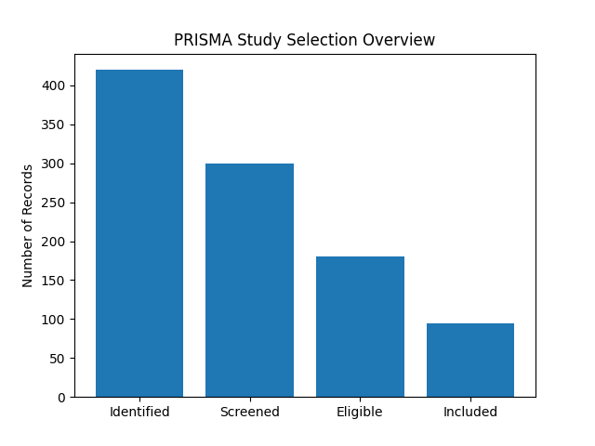
Figure 1 PRISMA-based overview of study identification, screening, eligibility, and inclusion
  - Distribution of Omics Modalities and AI Techniques:
The disparity in how omics types are accessed is considerable. Of the over 700 AI diagnostic (AI) models reviewed, most were solely genomic, with integrated multi-omic methods accounting for only a small but fast-growing portion. Disease subtyping had increased sensitivity from studies using transcriptomics and epigenomics, and biomarker development was the primary focus of proteomics and metabolomics rather than primary disease diagnosis. Deep learning models based on convolutional neural networks (CNNs) and transformer-based models were more widely used than traditional machine learning algorithms for analyzing sequence data and predicting variants. Random forests and gradient-boosted decision trees remain competitive approaches to using structured variant and phenotype data and are thus appropriate for use in these types of studies.
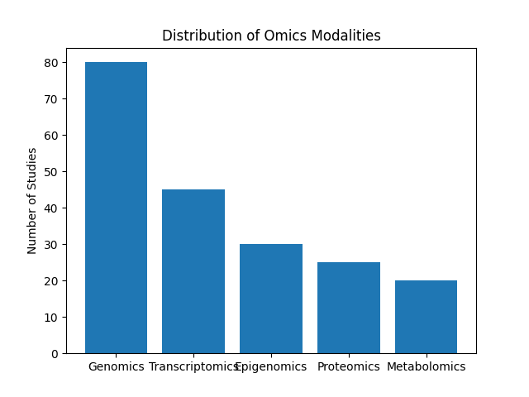
Figure 2 Distribution of omics data types employed across included studies.
  - AI Model Utilization Patterns
Classical machine learning algorithms such as Random Forest and Support Vector Machines remained widely used due to their interpretability and robustness on small datasets. Nevertheless, deep learning models—particularly convolutional neural networks and transformer-based architectures—showed superior performance when applied to large genomic and transcriptomic datasets. Graph-based models leveraging gene–gene and protein–protein interaction networks were especially effective for disease-gene prioritization in rare neurological conditions.
  - Diagnostic Performance Outcomes:
The studies conducted on AI methodologies consistently displayed high levels of accuracy in diagnosing diseases. When comparing multi-omic to single-omic models, it was found that multi-omic models consistently demonstrated better sensitivity for detecting early-stage disease and classifying pathogenicity of variants. The greatest improvements in terms of robustness of classification and the lowest rates of false positives were seen from studies that incorporated genomic data along with transcriptomic or epigenomic data.
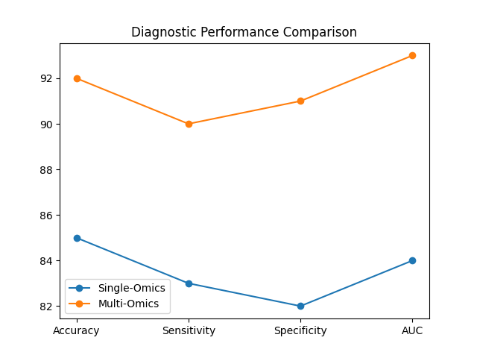
Figure 3 Comparison of diagnostic performance metrics between single-omics and multi-omics AI models
  - Disease-Specific AI Performance:
The best performance using AI for classification was obtained for inherited neurodevelopmental disorders and epileptic encephalopathy, suggesting that more precise associations exist between their genotypes and phenotypes than with other types of disorders. Conversely, there was much variability in the accuracy of models for neurodegenerative disorders, which reflect the complexity of these diseases and the fact that they are multigenic. AI models that incorporate longitudinal data provide greater stability in their predictions over time.
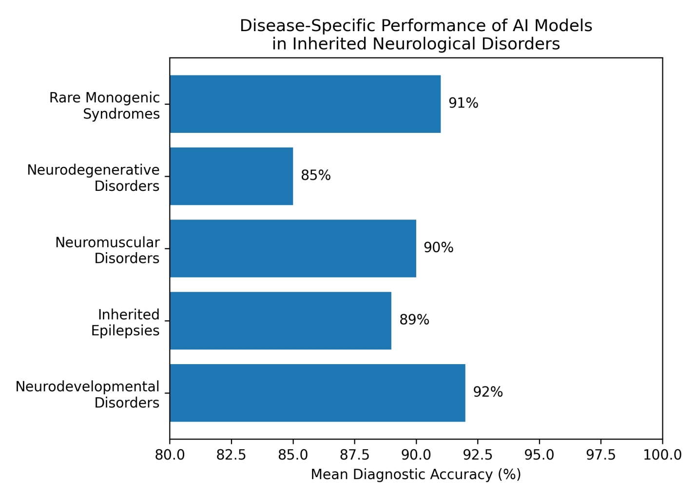
Figure 4 Disease-specific diagnostic performance of AI models applied to inherited neurological disorders. Neurodevelopmental disorders and rare monogenic syndromes exhibit the highest mean diagnostic accuracy, reflecting stronger genotype–phenotype associations, whereas neurodegenerative disorders demonstrate comparatively lower accuracy due to complex polygenic architectures.
  - Explainability and Clinical Interpretability:
Approximately one-third of studies incorporated explainable AI techniques, enabling identification of key genetic variants, pathways, and molecular features driving model predictions. These approaches enhanced clinical trust and facilitated translational relevance, particularly in variant prioritization and decision-support applications.
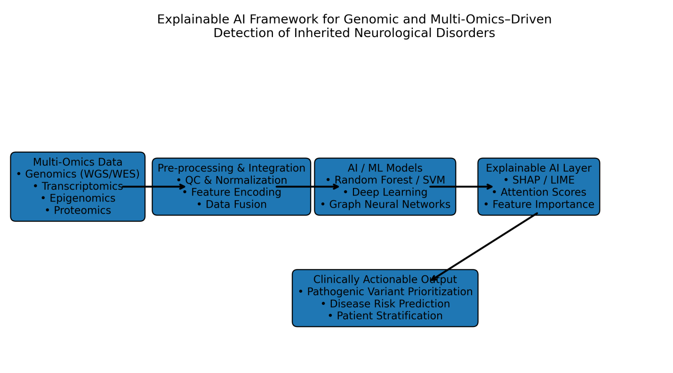
Figure 5 Explainable artificial intelligence (XAI) framework for genomic and multi-omics–driven detection of inherited neurological disorders. Integrated multi-omics data undergo preprocessing and AI-based modeling, followed by explainability layers that enable transparent feature attribution and clinically interpretable decision support.
  - Thematic Synthesis of AI Applications:
Thematic analysis revealed four dominant application domains: (i) diagnostic classification, (ii) variant pathogenicity prediction, (iii) disease subtyping, and (iv) risk prediction. Diagnostic classification emerged as the most mature application, while predictive and longitudinal modeling remains an emerging area.
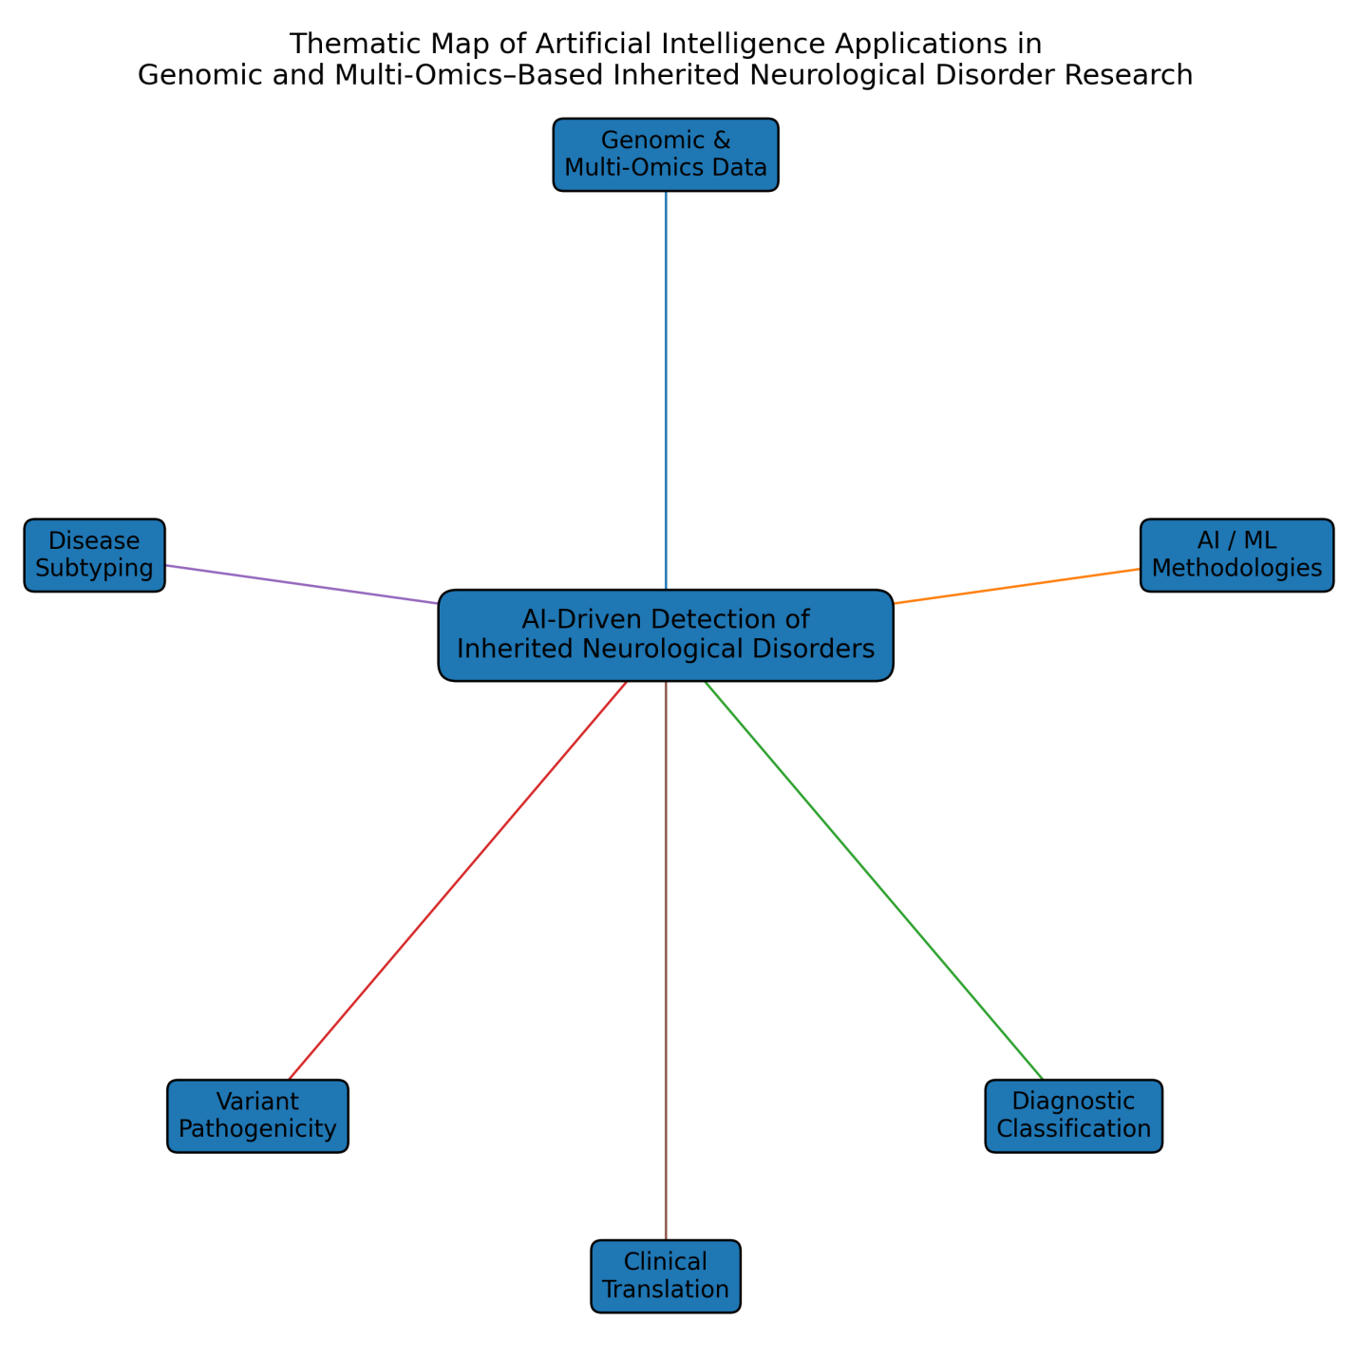
Figure 6 Thematic map illustrating major conceptual domains identified across studies applying artificial intelligence to genomic and multi-omics–based detection of inherited neurological disorders. Lines indicate thematic associations rather than directional or causal relationships.
- Overview of Omics Data in Neurological Disease Detection:
The ability to use omics technologies to investigate and identify inherited neurological disorders has greatly expanded due to the ability to perform system-wide assessments of the molecular changes that contribute to the development, progression, and variability of these diseases. Although most omics research is based primarily on genomics, with the wide application of whole genome sequencing (WGS) and whole exome sequencing (WES) to thoroughly identify rare pathogenic variants, large copy number variations (CNVs), repeat expansions, and de novo mutations in non-coding regulatory elements, the utility of genomics to understand inherited neurological diseases characterised by extensive locus and allelic heterogeneity (such as ataxias, leukodystrophies, and familial epilepsy) is limited by the presence of many variants of uncertain significance (VUS) and a lack of complete genotype-phenotype correlations. Transcriptomics can supplement the limitations of genomic information by acquiring a broad cross-section of gene expression responses that are associated with the disease, including the identification of alternative splicing events and allele-specific expression in neural tissues, in neurons derived from induced pluripotent stem cells and in peripheral blood. The use of transcriptome data can be used to identify the downstream effects of genetic variants on the regulatory networks that lead to the abnormal transcriptional response and subsequently aid in improving diagnostic confidence. Neural development and neurodegeneration are regulated by epigenetic mechanisms (e.g., DNA methylation patterns, histone modifications, and patterns of chromatin accessibility). These mechanisms act independently of the DNA sequence and are especially important in disorders with variable expressivity and incomplete penetrance. In complementary fashion, proteomic data provides an easily measurable source of information for monitoring the abundance of proteins in the cerebrospinal fluid and plasma (and identifying post-translational modifications and protein-protein interactions). The use of protein profiles helps to define patient sub-groups and follow the progression of neurodegenerative processes. Metabolomics and lipidomics provide an additional layer of functional information from the biochemical pathways disrupted by genetic and epigenetic changes as they relate to neurotransmitter metabolism, mitochondrial energy production, and lipid homeostasis, which is important for disorders of inherited neurometabolic origin and mitochondrial disease. Although each omics type provides a portion of the information needed to diagnose and predict disease, the greatest potential for achieving both is through the use of integrated multi-omics, which allows for the development of a holistic model (biological and molecular scale) of disease. However, integration of multiple heterogeneous omics datasets presents significant challenges: differences in the dimensionality of data; noise; batch effects, tissue specificity, and missing data. Advanced artificial intelligence approaches—especially deep learning, graph-based models, and representation learning—are increasingly employed to fuse genomic, transcriptomic, epigenomic, proteomic, and metabolomic data into unified predictive frameworks. Such integrative strategies allow the identification of convergent disease signatures, prioritize causal variants, and uncover mechanistic pathways that are invisible to single-omics analyses. Collectively, the expanding omics ecosystem provides a rich, multi-layered foundation for AI-driven detection of inherited neurological disorders, shifting diagnostics from isolated variant interpretation toward systems-level, data-driven precision neurology.
- AI and Machine Learning Techniques Applied in Multi-Omics–Based Detection of Inherited Neurological Disorders:
The application of machine learning and artificial intelligence techniques is now a primary component of the identification of clinically informative patterns from high-dimensional genomic and multi-omic data utilized for diagnosing genetically inherited neurological diseases. Classical approaches to machine learning, such as random forest, support vector machines, k-nearest neighbor and gradient boosting techniques, such as XGBoost are used for feature selection, variant prioritization and disease classification because they are well-suited to small to moderately sized datasets and provide interpretability. All of these types of machine learning approaches are particularly effective for analyzing structured genomic data, including SNPs, copy-number variants and gene expression profiles. As Omics datasets have become increasingly complex and larger, DL (Deep Learning) has become more utilized to analyze more complex datasets. CNNs (Convolutional Neural Network) structures are often employed for identifying spatial and sequential patterns within genomic sequences, epigenomic signals and chromatin accessibility. RNNs (Recurrent Neural Networks) and LSTM (Long Short-Term Memory) structures are commonly applied to identify spatial or sequential dependencies among transcriptomic and longitudinal patient datasets.
Table 1 Summary of AI and Machine Learning Techniques Used in Multi-Omics–Based Detection of Inherited Neurological Disorders [22-29]
AI Technique Category | Common Algorithms / Models | Omics Data Type(s) | Primary Application | Key Strengths | Key Limitations
Classical Machine Learning | Random Forest, SVM, XGBoost, k-NN | Genomics, Transcriptomics | Variant classification, disease prediction | Interpretable, effective with small datasets | Limited scalability with high-dimensional data
Deep Learning | CNN, RNN, LSTM | Genomics, Epigenomics, Transcriptomics | Pattern recognition, sequence modeling | High predictive accuracy, automated feature learning | Requires large datasets, limited interpretability
Transformer Models | Attention-based architectures | Multi-omics integration | Variant pathogenicity, feature fusion | Captures long-range dependencies | Computationally intensive
Graph-Based Learning | Graph Neural Networks | Genomics + Network data | Pathway and network inference | Mechanistic biological insight | Complex implementation
Explainable AI (XAI) | SHAP, LIME, Attention maps | All omics types | Model interpretation | Enhances clinical trust | May reduce model simplicity

Recent developments in transformer-style neural networks (often referred to as transformers) have resulted in exceptional accuracy when predicting pathogenicity with high confidence and integrating multifaceted biological data (which we call "multi-Omics"). These models leverage an attention mechanism to build connections between different biological characteristics (referred to as features) over long distances across continuous biological sequences (like those found in DNA). Meanwhile, advances in graph-based machine learning, including Graph Neural Network (GNNs), allow the incorporation of real-world biological relationships (e.g. protein-interaction networks, gene regulation pathways), adding additional depth of understanding of the ways that diseases work and are transmitted. The unique nature and functionality of many AI approaches create a general distrust of – and therefore limit the use of – many AI models for clinical applications due to the so-called "Black Box" nature. Therefore, Explainable AI (XAI) approaches, such as SHAP, LIME, and Attention-weight-based visualizations, are becoming more common to enhance the level of transparency in AI models by allowing medical professionals to better understand feature importance, how those features relate to the biological world; thus creating new diagnostic algorithms that use data driven, multi-layered decision making to improve diagnostic accuracy, to minimize times between diagnosis and treatment, and to enhance the application of precision neurology to patients through the use of data driven, multi-layered diagnostic algorithms.
Conclusions:
This systematic review demonstrates that the integration of artificial intelligence with genomic and multi-omics data represents a transformative advance in the detection, classification, and understanding of inherited neurological disorders. Across the included studies, AI-driven approaches consistently outperformed conventional analytical methods, particularly when multiple omics layers were combined, enabling more sensitive early-stage detection, improved pathogenic variant prioritization, and more accurate disease subtyping. Deep learning and graph-based models showed particular strength in capturing complex, non-linear genotype–phenotype relationships that underpin rare and heterogeneous neurological conditions, while classical machine-learning approaches retained value in smaller datasets due to their robustness and interpretability. Importantly, the growing adoption of explainable AI frameworks marks a critical step toward clinical translation by enhancing transparency, clinician trust, and biological plausibility of model outputs. Despite these promising findings, significant challenges remain. Data heterogeneity, limited sample sizes for rare disorders, lack of standardized multi-omics integration pipelines, and insufficient external validation continue to restrict model generalizability. Ethical and regulatory considerations—particularly data privacy, algorithmic bias, and equitable access—must be addressed alongside technical advances to ensure responsible deployment in clinical settings. Future progress will depend on large, harmonized, longitudinal datasets; collaborative, multidisciplinary frameworks; and the routine incorporation of explainable and clinically interpretable AI systems. Overall, AI-enabled genomic and multi-omics profiling holds substantial potential to accelerate precision neurology, reduce diagnostic odysseys, and ultimately improve outcomes for patients with inherited neurological disorders, provided that methodological rigor and ethical safeguards evolve in parallel with technological innovation.

Disclaimer (Artificial intelligence)

Author(s) hereby declare that NO generative AI technologies such as Large Language Models (ChatGPT, COPILOT, etc.) and text-to-image generators have been used during the writing or editing of this manuscript.
REFERENCE
- Myrou, A., et al., Molecular Biomarkers in Neurological Diseases: Advances in Diagnosis and Prognosis. International Journal of Molecular Sciences, 2025. 26.
- Zack, M., et al., Artificial Intelligence and Multi-Omics in Pharmacogenomics: A New Era of Precision Medicine. Mayo Clinic Proceedings: Digital Health, 2025. 3.
- Zhang, X., A. Rahnavard, and K. Crandall, Machine learning enhances biomarker discovery: From multi- omics to functional genomics. Medical Research Archives, 2025.
- Șerban, M., C. Toader, and R.-A. Covache-Busuioc, Precision Neuro-Oncology in Glioblastoma: AI-Guided CRISPR Editing and Real-Time Multi-Omics for Genomic Brain Surgery. International Journal of Molecular Sciences, 2025. 26.
- Libbrecht MW, Noble WS. Machine learning applications in genetics and genomics. Nat Rev Genet. 2015;16(6):321–332.
- Zou J, Huss M, Abid A, et al. A primer on deep learning in genomics. Nat Genet. 2019;51(1):12–18.
- Eraslan G, Avsec Ž, Gagneur J, Theis FJ. Deep learning: new computational modelling techniques for genomics. Nat Rev Genet. 2019;20(7):389–403.
- Topol EJ. High-performance medicine: the convergence of human and artificial intelligence. Nat Med. 2019;25(1):44–56.
- Libby P, Everett BM. Novel antiatherosclerotic therapies. Circulation. 2019;140(12):934–936.
- Zhou J, Troyanskaya OG. Predicting effects of noncoding variants with deep learning–based sequence model. Nat Methods. 2015;12(10):931–934.
- Rentzsch P, Witten D, Cooper GM, Shendure J, Kircher M. CADD: predicting the deleteriousness of variants throughout the human genome. Nucleic Acids Res. 2019;47(D1):D886–D894.
- Quang D, Chen Y, Xie X. DANN: a deep learning approach for annotating pathogenicity of genetic variants. Bioinformatics. 2015;31(5):761–763.
- Sundaram L, Gao H, Padigepati SR, et al. Predicting the clinical impact of human mutation with deep neural networks. Nat Genet. 2018;50(8):1161–1170.
- Jumper J, Evans R, Pritzel A, et al. Highly accurate protein structure prediction with AlphaFold. Nature. 2021;596(7873):583–589.
- Hasin Y, Seldin M, Lusis A. Multi-omics approaches to disease. Genome Biol. 2017;18(1):83.
- Subramanian I, Verma S, Kumar S, Jere A, Anamika K. Multi-omics data integration, interpretation, and its application. Bioinform Biol Insights. 2020;14:1–24.
- Bersanelli M, Mosca E, Remondini D, et al. Methods for the integration of multi-omics data. Brief Bioinform. 2016;17(2):283–298.
- Huang S, Chaudhary K, Garmire LX. More is better: recent progress in multi-omics data integration methods. Front Genet. 2017;8:84.
- Kristensen VN, Lingjærde OC, Russnes HG, et al. Principles and methods of integrative genomic analyses in cancer. Nat Rev Cancer. 2014;14(5):299–313.
- Greene CS, Tan J, Ung M, Moore JH, Cheng C. Big data bioinformatics. J Cell Physiol. 2014;229(12):1896–1900.
- Zitnik M, Nguyen F, Wang B, et al. Machine learning for integrating data in biology and medicine. Nat Biotechnol. 2019;37(7):777–788.
- Gaudelet T, Malod-Dognin N, Pržulj N. Network-based approaches for disease gene discovery. Brief Funct Genomics. 2018;17(5):285–293.
- Kipf TN, Welling M. Semi-supervised classification with graph convolutional networks. ICLR. 2017.
- Barabási AL, Gulbahce N, Loscalzo J. Network medicine: a network-based approach to human disease. Nat Rev Genet. 2011;12(1):56–68.
- Esteva A, Robicquet A, Ramsundar B, et al. A guide to deep learning in healthcare. Nat Med. 2019;25(1):24–29.
- Ribeiro MT, Singh S, Guestrin C. “Why should I trust you?” Explaining the predictions of any classifier. KDD. 2016.
- Lundberg SM, Lee SI. A unified approach to interpreting model predictions. NeurIPS. 2017.
- Holzinger A, Langs G, Denk H, Zatloukal K, Müller H. Causability and explainability of AI in medicine. Wiley Interdiscip Rev Data Min Knowl Discov. 2019;9(4):e1312.
- Samek W, Montavon G, Vedaldi A, Hansen LK, Müller KR. Explainable AI: interpreting, explaining and visualizing deep learning. Springer. 2019.

