Holistic Care for a Pediatric Patient with Kawasaki Disease Shock Syndrome Unresponsive to Intravenous Immunoglobulin:A case report

Abstract: This case report presents the application and outcomes of a systematic holistic nursing model for a pediatric patient with Kawasaki disease shock syndrome (KDSS) unresponsive to intravenous immunoglobulin (IVIG). In contrast to conventional task-oriented nursing, the holistic approach integrated advanced pathophysiology-based monitoring, proactive multi-organ support, individualized symptom management, and structured transition to home care. A 2-year-old girl with IVIG-unresponsive KDSS received two courses of IVIG (total 4 g/kg) plus glucocorticoids, alongside comprehensive holistic nursing interventions. Key outcomes included resolution of fever and shock, significant improvement in inflammatory markers (CRP, IL-6) and cardiac function (NT-proBNP), and discharge in stable condition after 12 days. Long-term follow-up confirmed a favorable cardiac prognosis. This case demonstrates that holistic nursing provides significant added value through its systematic, proactive, and continuous care framework, which is particularly crucial for managing complex, critically ill pediatric patients.

Keywords: Kawasaki disease; Kawasaki disease shock syndrome; IVIG-unresponsive; holistic nursing; pediatric nursing; post-discharge follow-up

Introduction:
Kawasaki disease (KD) is an acute systemic vasculitis predominantly affecting children under five years of age and has become the leading cause of acquired heart disease in children¹ . Kawasaki disease shock syndrome (KDSS) is a severe subtype characterized by hemodynamically unstable shock superimposed on the typical clinical manifestations of KD². Intravenous immunoglobulin (IVIG) is the first-line treatment for KD³; however, approximately 10%–20% of patients exhibit IVIG non-response, defined as persistent or recurrent fever of any degree within 36 hours to two weeks after the initial IVIG dose^{4,5}. Both IVIG-unresponsive patients and those with KDSS have a higher incidence of coronary artery lesions compared to typical KD^{6,7}, significantly increasing treatment complexity and nursing challenges. Managing these patients involves the dual challenges of “severe shock” and “refractory systemic inflammation.” Conventional nursing models, often focused on symptomatic management, may lack systematic and proactive approaches, potentially failing to meet the comprehensive needs of such critically ill children. Holistic nursing views the patient, environment, and society as an integrated system, placing the patient at the center of care to address all needs comprehensively⁸. Currently, reports focusing specifically on holistic nursing care for IVIG-resistant KDSS remain extremely limited, particularly from a nursing perspective⁹. This study summarizes the holistic nursing experience for one such patient, aiming to provide a reference for the clinical care of these children.

1 Clinical Data
1.1 General Information
A previously healthy 2-year-old girl was admitted in February 2024 with a two-day history of fever and a one-day history of rash. Her symptoms began two days prior with a high fever (peak 40.4°C) of unknown origin, temporarily responsive to antipyretics. One day before admission, a non-pruritic papular rash appeared on her back. Following administration of an unspecified oral antibiotic by her parents, the rash progressed, spreading to the chest, face, and retroauricular areas, and became pruritic.
Admission Assessment: On arrival, she was lethargic but conscious. Vital signs were as follows: temperature 37.7°C, heart rate 170 bpm, respiratory rate 47 bpm, blood pressure 74/42 mmHg, SpO₂ 90% on room air. Her weight was 10 kg. Physical examination revealed key signs consistent with Kawasaki disease: bilateral non-purulent bulbar conjunctival injection, swollen and cracked lips, a strawberry tongue, cervical lymphadenopathy, diffuse palmar erythema, and a generalized erythematous rash on the trunk.
Admission Laboratory Findings: Notable results included: C-reactive protein (CRP) 99.68 mg/L; interleukin-6 (IL-6) 246.02 pg/mL; erythrocyte sedimentation rate (ESR) 69 mm/h; alanine aminotransferase (ALT) 172 U/L, aspartate aminotransferase (AST) 331 U/L; N-terminal pro-brain natriuretic peptide (NT-proBNP) 5798 pg/mL. Complete blood count showed: white blood cells 8.81×10⁹/L, neutrophils 85.7%, hemoglobin 118 g/L, platelets 227×10⁹/L. Initial echocardiography indicated normal ventricular function and no coronary artery dilation.

1.2 Treatment Course
Based on the presence of ≥5 principal clinical criteria for KD and markedly elevated inflammatory markers, a diagnosis of typical Kawasaki disease was made. Initial treatment (Hospital Day 1) commenced with intravenous immunoglobulin (IVIG, 2 g/kg over 12 hours) and oral aspirin (30 mg/kg/day).
Diagnosis of IVIG-Unresponsive KD & KDSS: Thirty-six hours after completing the first IVIG infusion, the patient developed recurrent high fever (39.5°C) with progression of the rash and onset of limb induration, meeting the standard definition for IVIG non-response. Concurrently, she exhibited sustained hypotension (approximately 85/50 mmHg despite dopamine support), hypoxemia, and clinical signs of poor peripheral perfusion (cool mottled extremities, capillary refill time >3 seconds). This hemodynamic instability superimposed on acute KD led to the diagnosis of Kawasaki disease shock syndrome (KDSS).
Subsequent Management: A second course of IVIG (2g/kg) combined with intravenous methylprednisolone (2mg/kg/day) was initiated alongside aggressive shock resuscitation. On hospital day 7, she developed rotavirus enteritis, manifesting as watery diarrhea, which was managed supportively. Following this combined medical and systematic nursing approach, her condition steadily improved.

2 Nursing Care
2.1 Hemodynamic Monitoring and Shock Management
Close Monitoring of Vital Signs and Tissue Perfusion: The patient was placed in a resuscitation room upon admission. Continuous monitoring with ECG monitoring featuring invasive blood pressure capability was used, recording heart rate, respiratory rate, blood pressure, and SpO₂ every 30 minutes. The shock in KDSS often involves distributive shock combined with cardiogenic factors¹⁰. Therefore, monitoring focused not only on absolute blood pressure values but also on trends in waveform and pulse pressure. Initial monitoring revealed slightly narrow pulse pressure, suggesting possible reduced stroke volume; the heart rate of 170 bpm indicated compensatory tachycardia. Systemic assessment of consciousness, skin color, temperature/moisture, and femoral/dorsalis pedis pulses was performed hourly, along with precise measurement of capillary refill time (CRT). On admission, the patient was lethargic with cool, mottled extremities and a prolonged CRT of 4 seconds. After aggressive fluid resuscitation and support, within 24 hours the extremities became warm, CRT shortened to 2 seconds, and consciousness improved to alert and interactive, indicating effective improvement in tissue perfusion.
Precise Fluid Management: Increased vascular permeability in KDSS patients¹¹ necessitates a balance between fluid resuscitation and avoiding pulmonary edema¹². Two effective intravenous lines were established and maintained, with infusion rates controlled using smart infusion pumps. Strict adherence to medical orders guided adjustments in infusion rate and type based on hourly urine output and blood pressure dynamics. During colloid infusions like IVIG, the initial rate was controlled at 0.5-1.0 ml/kg/h for the first 30 minutes. After close observation ruled out chills, rash, chest tightness, or other reactions, the infusion was completed at a constant rate. Through precise regulation, urine output was maintained within the ideal range of 1-2 ml/kg/h, and no complications of fluid overload such as acute pulmonary edema or worsened heart failure occurred during hospitalization. The IVIG infusions were completed without severe adverse reactions.

2.2 Cardiovascular Protection and Complication Management
Cardiac Load Management: Myocardial cell edema and interstitial inflammation during the acute phase of KD can lead to decreased contractility, placing the patient in a state of potential cardiac insufficiency¹³. The reduced cardiac load capacity during the acute phase means any external stimulus can increase myocardial oxygen consumption and burden. Therefore, ensuring adequate rest was prioritized. The patient was placed in a single room, and a clustered nursing care schedule was created, consolidating all non-urgent nursing procedures (e.g., bathing, non-essential examinations) and medical interventions to ensure uninterrupted rest periods of 2-3 hours. Through this environmental and operational management, the patient's resting heart rate gradually decreased from 170 bpm and stabilized between 120-140 bpm during the mid-to-late hospital stay, sleep duration increased, and family reported significantly reduced irritability and crying.
Biochemical Monitoring and Care for Myocardial Injury: In addition to administering myocardial nutritional agents like sodium creatine phosphate as ordered, dynamic tracking of NT-proBNP and cardiac enzyme profiles was performed. NT-proBNP, an inactive fragment of B-type natriuretic peptide, is a clinically recognized sensitive marker for monitoring heart failure¹⁴. Its dynamic changes can reflect subtle alterations in cardiac function earlier than ECG or echocardiography. NT-proBNP decreased from an extremely high admission level of 5798 pg/mL to 850 pg/mL after one week of treatment and normalized at discharge. This dynamic decline provided key evidence for medical treatment adjustments and nursing outcome evaluation.
Long-term Warning for Coronary Artery Lesions: Although the initial echocardiogram showed no coronary abnormalities, the risk for CAL in KDSS patients is high¹⁵. Health education for the family emphasized the critical importance of long-term follow-up. The family was provided with and instructed on the “Kawasaki Disease Coronary Artery Lesion Follow-up Handbook,” using pictures and models to visually demonstrate coronary artery aneurysms. The family expressed full understanding of the extreme importance of long-term follow-up and had scheduled the first follow-up echocardiogram prior to discharge, demonstrating good compliance.

2.3 Targeted Management of Organ Dysfunction
Collaborative Nursing for Hepatic Function Protection: Significantly elevated transaminases (ALT: 172 U/L, AST: 331 U/L) indicated liver injury. Beyond hepatoprotective medications like compound glycyrrhizin injection as ordered, collaboration with the clinical nutrition department led to a personalized enteral nutrition plan featuring low-fat, easily digestible formulas to reduce hepatic metabolic burden. The patient’s transaminases (ALT/AST) showed a consistent downward trend starting on hospital day 5, approaching normal range by discharge, without development of jaundice or coagulation abnormalities.
Coagulation Monitoring and Bleeding Prevention: Both KD itself and aspirin therapy can affect coagulation, necessitating close monitoring¹⁶. Nursing involved observing for bleeding tendencies (skin, mucous membranes, puncture sites) and signs of internal bleeding (melena, hematochezia), with particular attention to dynamic changes in coagulation markers like D-dimer. Significantly elevated D-dimer suggests secondary hyperfibrinolysis and micro-thrombosis risk, and D-dimer levels hold predictive value for KDSS occurrence¹⁷. The patient's D-dimer levels gradually declined with inflammation control, and no overt bleeding or thrombotic events occurred during hospitalization.
Closed-loop Management of Secondary Infection: The patient's concurrent rotavirus infection and diarrhea complicated the condition. Contact isolation measures were immediately initiated: prominent isolation signage at bedside; dedicated thermometer, stethoscope, and blood pressure cuff in the room; all waste handled as infectious medical waste; and strict adherence to the “five moments for hand hygiene.” For diarrhea care, medical stoma powder was applied to the perianal skin after each bowel movement to create a physical barrier and prevent incontinence-associated dermatitis. Through rigorous closed-loop management, no cross-transmission of pathogens occurred within the unit. The perianal skin remained intact without diaper rash or breakdown. Diarrhea was controlled within 3 days without further complications.

2.4 Symptom Management and Comfort Care
Children in the acute phase of KD often experience persistent high fever and various discomforts. Meticulous symptom management is crucial for enhancing comfort and promoting recovery.
Fever Management: For persistent high fever, a stepped approach was used. For temperatures <38.5°C, physical cooling was prioritized (reducing clothing, adjusting room temperature to 22-24°C, tepid sponging). For temperatures ≥38.5°C, antipyretics were administered as ordered. Notably, during aspirin therapy, ibuprofen was avoided as concomitant use can antagonize aspirin's irreversible platelet inhibition effect¹⁸. During febrile episodes with profuse sweating, prompt drying and changing of damp clothing prevented chills, maintained skin cleanliness and dryness, and improved comfort. The patient's temperature normalized after the second IVIG course without recurrence.
Skin and Mucous Membrane Care: A systematic care plan addressed KD-specific manifestations: 1) Rash Care: Maintaining clean, smooth bed linen and dressing the patient in loose, soft cotton clothing. Daily documentation of rash morphology, distribution, and changes. Nails were trimmed, and antihistamines were administered as ordered during periods of significant itching to prevent scratching. The rash began to fade by treatment day 5, with reduced scratching. 2) Oral Care: For strawberry tongue and cracked lips, oral assessment and care were performed 2-3 times daily. Oral mucosa was gently cleansed with saline-moistened swabs, and vitamin AD drops or lip balm were applied to cracked lips. Diet guidance included lukewarm, non-irritating liquids or semi-liquids, using a straw to minimize lip pain during drinking. Lip fissures gradually healed, and feeding-related pain decreased. 3) Conjunctival Care: For non-purulent bulbar conjunctival injection, the family was advised to avoid strong light exposure (drawing curtains if needed). Eyes were gently cleaned from inner to outer canthus daily using sterile saline-moistened swabs. Increased discharge prompted notification for assessment of secondary infection. Conjunctival injection had largely resolved by discharge.

2.5 Medication Safety and Administration
Complex pharmacotherapy for IVIG-nonresponsive KDSS necessitates precise administration and adverse reaction monitoring.
IVIG Infusion Care: For the second IVIG course, an enhanced monitoring protocol was implemented. Pre-infusion assessment ensured no signs of fluid overload. Studies indicate a direct correlation between IVIG infusion rate and adverse reactions¹⁹. Strict adherence to the principle of slow initial rate with gradual increase was followed. Vital signs (temperature, BP, HR) were monitored continuously, and emergency medications (epinephrine, antihistamines) were prepared to prevent severe allergic reactions. No allergic reactions occurred.
Glucocorticoid Therapy Care: According to the clinical application guidelines for glucocorticoids, during the methylprednisolone pulse therapy period for pediatric patients, we focused on monitoring the following aspects²⁰: 1) Circulatory and Metabolic Monitoring: Monitoring for potential hormone-induced fluid retention, hypertension, and hyperglycemia through hourly BP checks and 4-hourly blood glucose monitoring until dose reduction to physiological levels. 2) Gastrointestinal Protection: Observing for signs of stress ulcer (abdominal distension, melena) due to high-dose steroids and ensuring timely administration of gastric mucosal protectants. 3) Infection Surveillance: Recognizing that steroids can mask infection signs, heightened vigilance included analyzing temperature trends, observing for new infection foci, and strict infection control.
Anti-platelet Therapy Management: Aspirin, a core KD treatment, required accurate administration: enteric-coated tablets were taken whole before meals to enhance absorption. Monitoring included observing for gastrointestinal upset, tinnitus (salicylism), and bleeding tendencies (bruising, epistaxis, gingival bleeding). The family was educated on the importance of long-term therapy and precautions, emphasizing against self-adjustment or discontinuation.

2.6 Nutritional and Psychosocial Support
Appropriate nutrition and psychological support are integral to recovery.
Individualized Nutritional Support: A phased nutritional plan addressed multiple factors (liver dysfunction, shock state, rotavirus infection): Acute Phase: Easily digestible, high-calorie liquids, using a small, frequent meal approach (6-8 meals/day, ≤50ml/meal) to reduce cardiac load. Liver Injury Phase: Collaboration with a dietitian adjusted the formula to low-fat, easily digestible options supporting hepatic recovery. Diarrheal Phase: Stop consuming foods containing lactose, switch to lactose-free formulas, and use oral rehydration salts to maintain electrolyte balance. Once the diarrhea stops, gradually resume normal diet. Recovery Phase: Increased high-quality protein intake promoted tissue repair, transitioning to a regular diet. The patient's weight remained stable without malnutrition.
Psychological Comfort and Family Support: Addressing the child's fear and irritability through non-verbal communication (gentle touch, comforting toys) built trust. Simple explanations preceded procedures, and distraction techniques (cartoons, toys) minimized procedural distress. Age-appropriate play was introduced when stable to support normal psychological development. The prolonged, potentially relapsing nature of KD can cause significant parental anxiety and fear. Daily clear communication updated parents on the condition, explaining treatment rationales and expected outcomes. Encouraging parental participation in daily care (feeding, hygiene, touch) enhanced their engagement. A “KD Care WeChat Group” provided ongoing professional support and a platform for parent-to-parent experience sharing. Parental anxiety significantly decreased, fostering active cooperation.

3 Discharge Planning and Long-term Follow-up
To ensure long-term outcomes, a continuous care system bridging hospital to home was established. Detailed written medication instructions were provided at discharge, clarifying aspirin administration and bleeding observation points. Guidance included temporarily discontinuing aspirin during influenza or chickenpox (viral infections) to avoid Reye’s syndrome risk due to impaired salicylic acid excretion from glycine conjugation²¹, with potential substitution by clopidogrel. A structured follow-up plan was implemented, including early post-discharge outpatient review and key time-point echocardiograms (e.g., 1, 2, 3, 6 months, 1 year) to screen for occult CAL. Families were instructed on daily monitoring of vital signs and mental status, recognizing warning signs (recurrent fever, chest pain, dyspnea) for prompt medical attention. Lifestyle guidance emphasized primarily home rest for the first month post-discharge, avoiding strenuous activity and cross-infection, and providing a high-protein, easily digestible diet. Continuous professional support and psychological counseling were offered via the WeChat follow-up group, patient association interactions, and regular phone calls to ensure adherence to the follow-up plan, ultimately aiming to improve long-term prognosis.Research has confirmed that the integrated management of doctors, nurses and patients based on the Internet platform can effectively enhance the disease awareness of the children's families, the medication compliance, and the follow-up rate. It is an effective form of continuing care²².

To provide a more intuitive illustration of the overall care pathway and its theoretical basis in this case, we have developed a management flowchart (Figure 1) and a conceptual model (Figure 2).
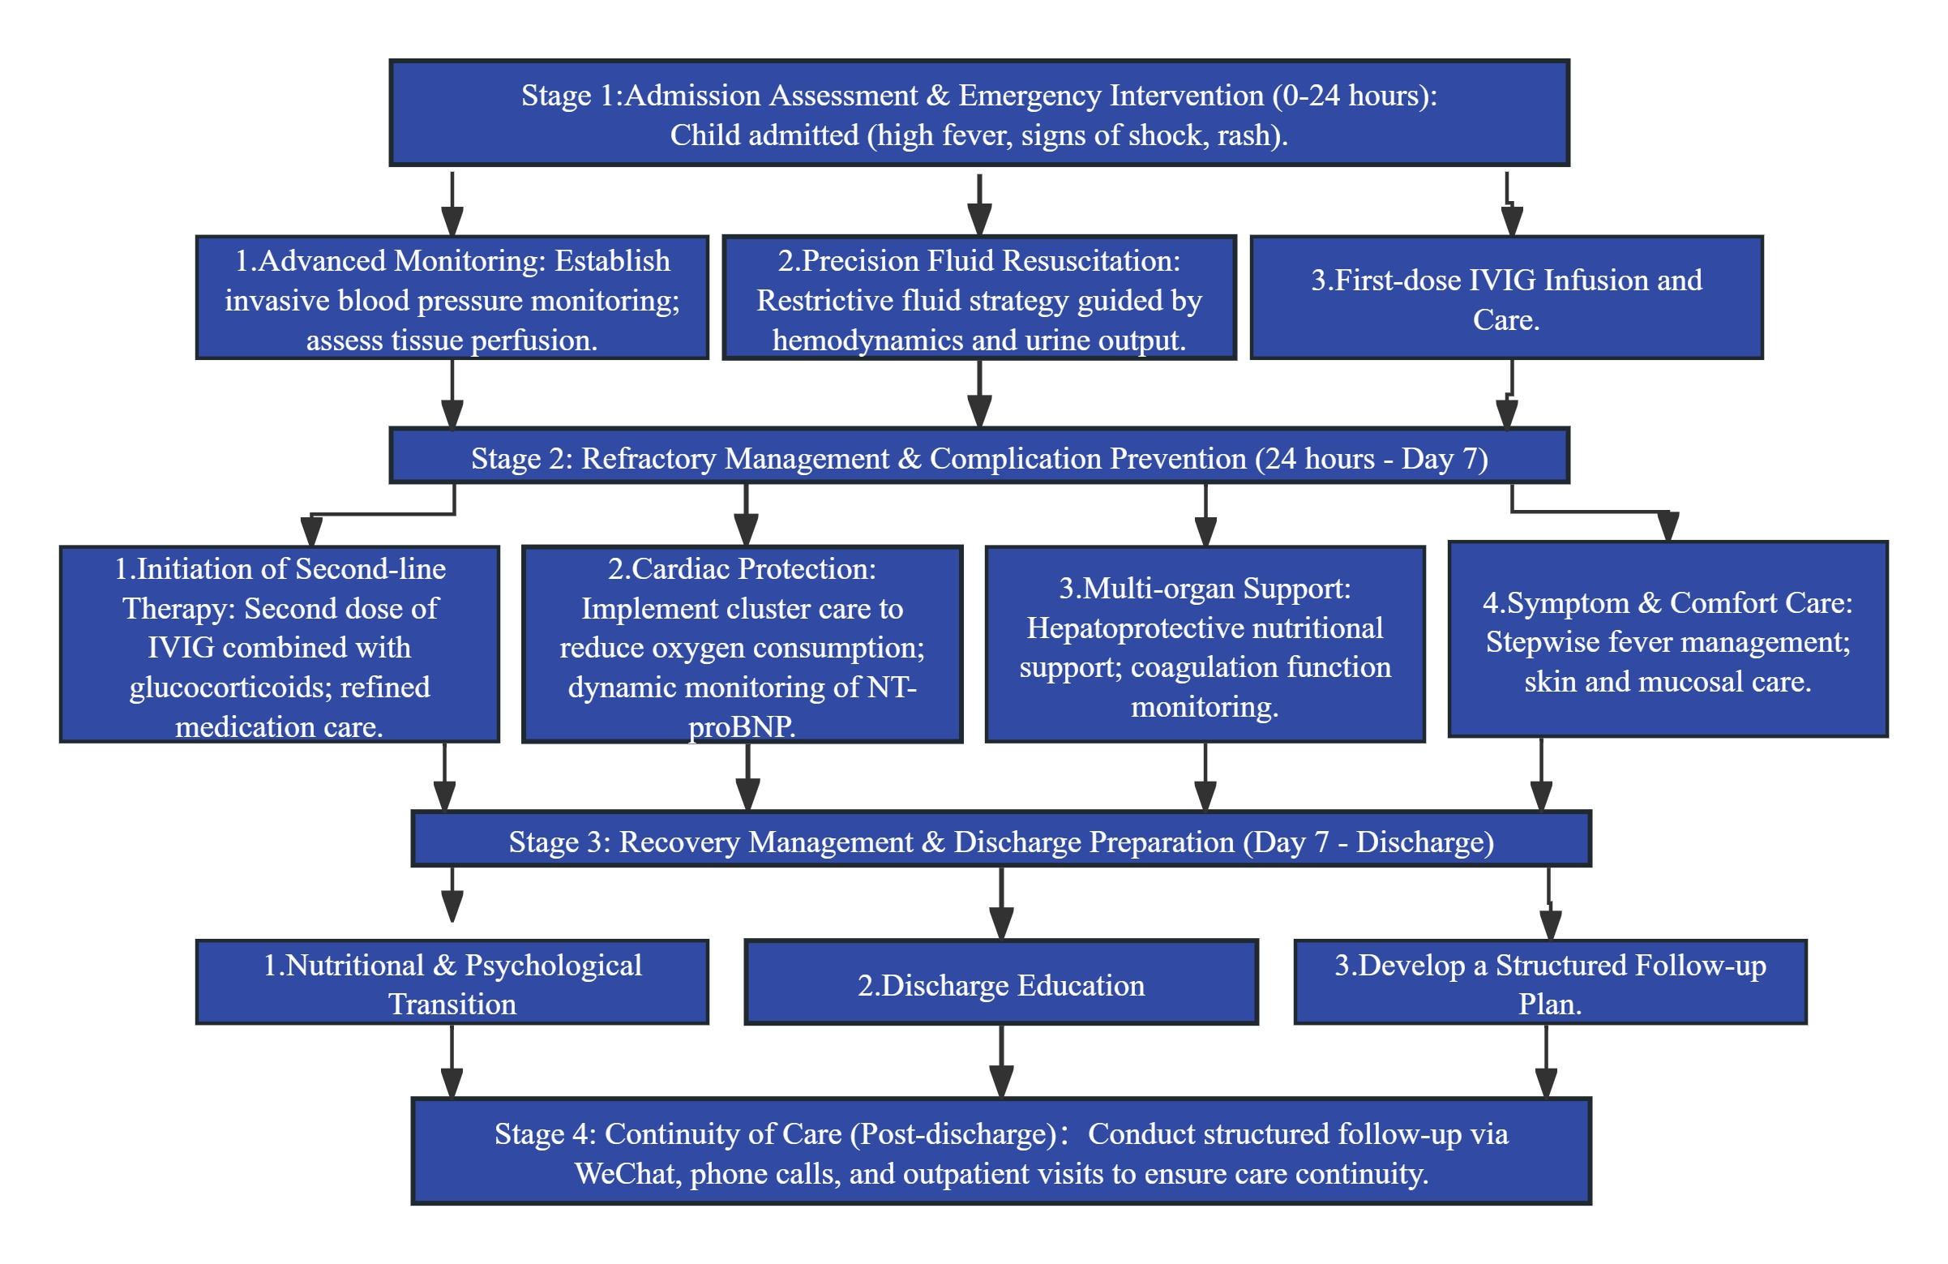Figure 1. Flowchart of Holistic Nursing Management for a Pediatric Patient with Kawasaki Disease Shock Syndrome Unresponsive to Intravenous Immunoglobulin
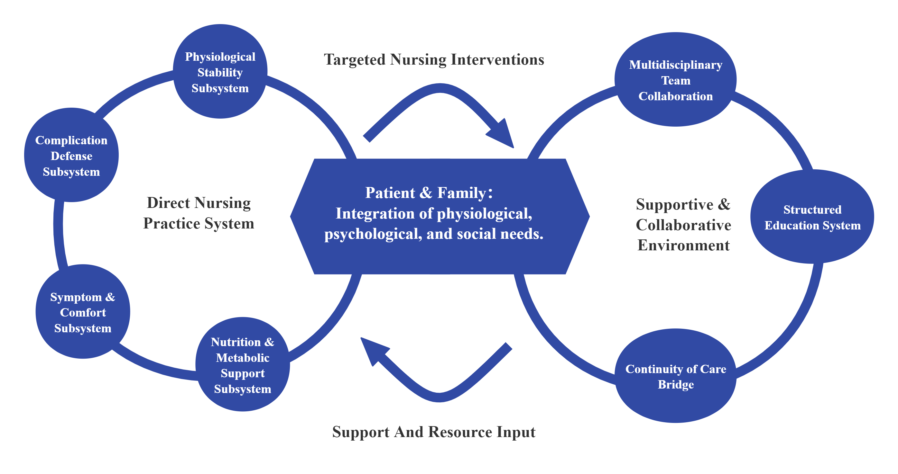
Figure 2. Conceptual Model of Holistic Nursing Care Applied in This Case
4 Discussion
The successful management of this complex case relied on a deep understanding of IVIG-unresponsive KDSS pathophysiology, enabling precision nursing that exceeded routine care.

4.1 Shock Monitoring: From Indicators to Pathophysiology-guided Regulation
Traditional shock monitoring often focuses on quantitative vital signs. The advanced aspect here was the deep understanding of the dual nature (distributive and cardiogenic) of KDSS shock, leading to more targeted monitoring. For instance, conscious monitoring of pulse pressure changes, a sensitive indicator of stroke volume, and systematic assessment of CRT and skin mottling, indicators of microcirculatory perfusion^{23,24}. In fluid management, nursing actively participated in executing a “restrictive fluid strategy” through smart pump control and strict input/output balance, beyond merely following orders, effectively mitigating the high risk of pulmonary edema in the context of increased vascular permeability. This pathophysiology-based monitoring and regulation formed the cornerstone for stabilizing the patient's internal environment.

4.2 Cardiovascular Care: From Task Execution to Risk-based Management
Cardiac protection was continuous. The clustered care and rest schedule during the acute phase was based on the physiological principle of minimizing oxygen consumption in acute myocarditis. Dynamic tracking of NT-proBNP exemplified the role of precision nursing in utilizing biomarkers to objectively identify health risks²⁵, assess efficacy, and provide early warnings. Its rapid decline served as objective evidence of nursing effectiveness. Pre-discharge family education on recognizing signs of CAL shifted the nursing focus forward, building a continuous care chain from hospital to home, which is crucial for KD patients requiring lifelong follow-up.

4.3 Organ Support: From Symptomatic to Multidisciplinary Targeted Care
In this case, the child had a clear liver injury. The nursing care went beyond simple medication as per the doctor’s advice and low-fat diet education. Instead, through collaboration with the nutrition department, an individualized nutritional support plan for liver injury was developed and implemented, directly targeting the aspect of excessive liver metabolic burden for intervention. This demonstrated the concepts of evidence-based nursing and precise nursing. During the hospitalization of this child, a rotavirus infection occurred, which increased the complexity and difficulty of the nursing care. A standardized “contact isolation closed management” process was implemented, combined with modern wound care concepts - prevention in advance, successfully achieving the dual nursing goals of “zero transmission” and “zero skin damage”.

4.4 The Core Value of Holistic Nursing in Critical Pediatric Care
The holistic nursing model²⁶, as a comprehensive, systematic approach centered on the patient and guided by modern holistic theory with the nursing process at its core, fundamentally views the patient as a whole, integrating physiological, psychological, and social needs to provide continuous, comprehensive care. This case fully demonstrates that for complex conditions like IVIG-nonresponsive KDSS, the nursing focus extends beyond executing orders to proactively and preemptively identifying and addressing problems. The nursing role has evolved from a mere order executor to a gatekeeper for patient safety, a frontline assessor of condition, a coordinator within the multidisciplinary team, and an educator and supporter for the patient and family. Integrating physiological, psychological, and social support, and seamlessly extending in-hospital care to the community through a structured follow-up plan to ensure care continuity, is a decisive factor in improving long-term prognosis²⁷.

4.5 Added Value of the Holistic Care Model Compared to Traditional Nursing Measures
Compared to traditional nursing practices, the systematic holistic nursing model implemented in this case demonstrates significant added value across multiple dimensions. At the monitoring level, traditional nursing primarily focuses on routine vital sign recording and order execution, whereas this model emphasizes pathophysiology-based precision monitoring (e.g., pulse pressure difference, capillary refill time), achieving a shift from “data recording” to “trend analysis and early warning.” At the intervention level, traditional nursing often involves reactive management of existing symptoms. This model achieves a leap from “passive response” to “proactive prevention and control” through anticipatory care (e.g., early fluid management strategies for shock, long-term coronary artery disease education) and targeted interventions (e.g., collaborative development of liver injury support protocols with the nutrition department). At the collaboration level, holistic nursing breaks down departmental silos. Through nursing-led multidisciplinary coordination (e.g., with clinical nutrition), it delivers integrated care for pediatric patients. In management scope, traditional nursing often remains confined to the hospital setting. This model, however, establishes a seamless continuity of care chain between hospital and home through structured follow-up plans, family empowerment, and remote support. Therefore, for extremely complex cases like IVIG-unresponsive KDSS, the holistic nursing model effectively addresses the limitations of traditional segmented, task-oriented care through its systematic, proactive, collaborative, and continuous approach. This model is crucial for improving both the immediate therapeutic outcomes and long-term prognosis of pediatric patients.

5 Conclusion
Managing IVIG-unresponsive KDSS is a highly complex clinical challenge. This case demonstrates that a systematically applied holistic nursing model can make distinct and critical contributions to patient outcomes. By integrating precision monitoring guided by pathophysiology, proactive prevention of complications, targeted multi-organ support, and seamless continuity of care from hospital to home, holistic nursing addresses the limitations of conventional task-oriented approaches. The model's emphasis on the patient as a whole—encompassing physiological, psychological, and social needs—was instrumental in navigating the dual challenges of refractory shock and systemic inflammation in this child.While findings from a single case require further validation, this report provides a structured, replicable framework for holistic nursing care that can guide the management of similarly critically ill pediatric patients and potentially improve both immediate and long-term prognoses.

Authors’ contributions
This work was carried out in collaboration among all authors. All authors read and approved the final manuscript.

CONSENT

This case report complies with medical ethics requirements and has obtained the informed consent of the child's guardian.

COMPETING INTERESTS DISCLAIMER:
Authors have declared that they have no known competing financial interests OR non-financial interests OR personal relationships that could have appeared to influence the work reported in this paper.

Disclaimer (Artificial intelligence)
Author(s) hereby declare that NO generative AI technologies such as Large Language Models (ChatGPT, COPILOT, etc.) and text-to-image generators have been used during the writing or editing of this manuscript.

References:

1. Houska N, Albertz M, Ing RJ. Update on Diagnosis and Management of Kawasaki Disease: A Scientific Statement From the American Heart Association. J Cardiothorac Vasc Anesth. 2025;39(5):1103-1105 https://doi.org/10.1053/j.jvca.2025.02.007
2. Zhao Z, Yuan Y, Gao L et al. Predicting Kawasaki disease shock syndrome in children. Front Immunol. 2024;15:1400046-1400046 https://doi.org/10.3389/fimmu.2024.1400046
3. Broderick C, Kobayashi S, Suto M, Ito S, Kobayashi T. Intravenous immunoglobulin for the treatment of Kawasaki disease. The Cochrane database of systematic reviews. 2023;1(1):CD014884-CD014884 https://doi.org/10.1002/14651858.CD014884.pub2
4. Yi C, Xue D, Chen J et al. Predictive value of novel nutritional inflammation indexes in IVIG-unresponsive Kawasaki disease: a retrospective study. Front Nutr. 2025;12:1651750-1651750 https://doi.org/10.3389/fnut.2025.1651750
5. H Huang, Y., Li, S., Tian, Y., et al. (2023). Evidence-based guidelines for the diagnosis and treatment of Kawasaki disease in children in China (2023). Chinese Journal of Contemporary Pediatrics, 25(12), 1198-1210. https://doi.org/10.7499/j.issn.1008-8830.2309038 .
6. Zuo Huiwen. Clinical Characteristics and Risk Factor Analysis of IVIG-Nonresponsive Kawasaki Disease [D]. Chongqing Medical University, 2023. DOI: 10.27674/d.cnki.gcyku.2023.002196.
7. Zhao Zhihui, Yuan Yue, Gao Lu, et al. Risk Factor Analysis of Kawasaki Disease Shock Syndrome [J]. Journal of Cardiovascular and Pulmonary Diseases, 2025, 44(04): 370-374+408. https://doi.org/10.3389/fimmu.2024.1400046
8. Gao Wanjun, Hu Yueshuang, Bao Tian, et al. Application Value of Holistic Nursing in the Care of Perinatal Pneumonia Patients [J]. Chinese Journal of Tuberculosis and Respiratory Diseases, 2024, 46(S2): 452-454.
9. Kuo, H. (2023). Diagnosis, Progress, and Treatment Update of Kawasaki Disease. International journal of molecular sciences, 24(18), 13948. doi: 10.3390/ijms241813948
10. Chang Hongli. Clinical Characteristics and Analysis of Related Risk Factors for Pediatric Kawasaki Disease Shock Syndrome [D]. Henan University, 2024. DOI:10.27114/d.cnki.ghnau.2024.002556.
11. Yang Xi. Meta-Analysis Comparing Clinical Features and Laboratory Indicators Between Kawasaki Disease Shock Syndrome and Non-Shock Kawasaki Disease [D]. Nanchang University, 2025. DOI:10.27232/d.cnki.gnchu.2025.001019.
12. Li Weifeng, Li Huibin. Research Progress on Early Fluid Resuscitation in Severe Burns [J]. Journal of Shandong Medical College, 2022, 44(03): 193-195.
13. Fang Lan. Clinical Study on Left Ventricular Diastolic Function in Children with Acute Kawasaki Disease and Discussion on Risk Factors for Concurrent Coronary Artery Lesions [D]. Hebei North University, 2024. DOI: 10.27767/d.cnki.ghbbf.2024.000384.
14. Wang Chao, Fu Qiuai, Wang Huihao, et al. Evaluation of Serum AFABP and NT-proBNP in Risk Stratification and Short-term Prognosis of Chronic Heart Failure [J]. Laboratory Medicine and Clinical, 2025, 22(14):1920-1925.
15. Sun Chongrui. Kawasaki Disease Shock Syndrome with Multisystem Dysfunction Presenting as Acute Pancreatitis (A Case Report) [J]. Shandong Medicine, 2025, 65(09):70-75.
16. Wang Ling, Ma Qianqian. Mechanism of Aspirin Treatment for Pediatric Kawasaki Disease [J]. Journal of Northwest Pharmaceutical Sciences, 2024, 39(06):184-188.
17. Li B, Liu X, Shao S et al. Predictive value of coagulation profiles for Kawasaki disease shock syndrome: a prospective cohort study. Front Pediatr. 2024;12:1450710-1450710 https://doi.org/10.3389/fped.2024.1450710
18.Du Zhongdong, Xie Lijian, Liu Shiping, et al. Pediatric Expert Consensus on Aspirin Use in Kawasaki Disease Treatment [J]. Chinese Journal of Contemporary Pediatrics, 2022, 24(06): 597-603. https://doi.org/10.7499/j.issn.1008-8830.2203190
19. Zha Xuan, Xu Zhoumei. Comparison of Efficacy and Safety of Immunoglobulin Infusion Rates in Pediatric Patients with Kawasaki Disease [J]. Chinese Pharmacist, 2024, 27(07):1149-1154.
20. Shaanxi, P. D. A. T., Beijing Children'S Hospital, C. M. U., Shanghai, C. M. C., Children'S, H. O. S. J., Xianyang, C. H. O. S., Suzhou Children'S Hospital, S. U.,... Editorial, B. O. C. J. (2022). Pediatric expert consensus on the application of glucocorticoids in Kawasaki disease. Zhongguo dang dai er ke za zhi = Chinese journal of contemporary pediatrics, 24(3), 225-231. doi: 10.7499/j.issn.1008-8830.2112033
21. Visagie JL, Aruwajoye GS, van der Sluis R. Pharmacokinetics of aspirin: evaluating shortcomings in the literature. Expert Opin Drug Metab Toxicol. 2024;20(8):727-740 https://doi.org/10.1080/17425255.2024.2386368
22. Li Xiaohong, Qiao Guixue, Liu Jia, & Jia Susun. (2025). Application of an Internet-Based Integrated Medical and Nursing Management Model in the Continuity of Care for Pediatric Kawasaki Disease Patients. Women and Children's Health Journal, 4(17), 107-111.
23. Wang Wenfeng. Analysis of the Value of Different Microcirculatory Indicators in Early Prediction of Prognosis in Patients with Septic Shock [D]. Jilin University, 2025. DOI:10.27162/d.cnki.gjlin.2025.006783.
24. Zhang Jian, Pan Yueshuai, Xiu Hong, et al. Research Progress on the Application of the Skin Marbling Score in Critically Ill Patients [J]. Nursing Research, 2024, 38(15): 2733-2736.
25. Ielapi N, Andreucci M, Licastro N et al. Precision Medicine and Precision Nursing: The Era of Biomarkers and Precision Health. Int J Gen Med. 2020;13:1705-1711 https://doi.org/10.2147/IJGM.S285262
26. Yang HJ. Application of Holistic Nursing Model in Stroke Patients with Chronic Kidney Disease Undergoing Hemodialysis[J]. Chinese Journal of Stroke, 2024, 19(04):482.
27. Day-Lewis, M., Son, M. B. F., & Lo, M. S. (2024). Kawasaki disease: contemporary perspectives. The Lancet. Child & adolescent health, 8(10), 781-792. doi: 10.1016/S2352-4642(24)00169-X

