Acute Severe Encephalomyelitis: A Case Report and Literature Review

Abstract
Methods: A detailed report was provided on the diagnosis and treatment of an 11-year-and-9-month-old male patient, including clinical manifestations, laboratory tests (such as cerebrospinal fluid analysis and anti-NMDAR antibody testing), neuroimaging features (diffuse abnormal signals in brain parenchyma and spinal cord as shown by cranial and spinal MRI), and the response to immunotherapy. Based on a literature review, the characteristics of the disease and clinical experience were summarized.
Results: The children had acute onset with fever, headache and vomiting as initial symptoms, and rapidly progressed to consciousness disorder, epileptic seizures and limb paralysis. The key auxiliary examinations indicated that the cerebrospinal fluid protein was significantly increased (3187 mg/L), inflammatory reaction was predominant with mononuclear cells (96%), and anti-NMDAR antibody was positive.Neuroimaging confirmed extensive involvement of the brain and spinal cord. The treatment involved intensive immunotherapy with early high-dose glucocorticoids combined with intravenous immunoglobulin (IVIG). During the treatment period, the patient developed respiratory failure and was transferred to the ICU. After multidisciplinary collaboration (intensive care medicine, neurology, infectious diseases, and rehabilitation) for active management of complications and enhanced rehabilitation therapy, the patient's condition improved.After 6 weeks of treatment, the child's neurological function was fully restored, and muscle strength returned to normal (Grade V). Long-term follow-up showed no sequelae in motor function, with good quality of life, enabling unimpeded participation in high-intensity sports activities such as basketball and middle-to long-distance running.
Conclusion: Acute encephalomyelitis complicated by anti-NMDAR encephalitis is a critical condition. Early initiation of immunotherapy and enhanced multisystem monitoring are key to improving prognosis. Children exhibit strong neural plasticity, and timely intervention can significantly promote functional recovery. This case highlights the importance of autoantibody screening and individualized immunotherapy in acute extensive central nervous system injury, providing practical evidence for the comprehensive management of severe neuroimmune diseases.
Keywords: Acute encephalomyelitis; Anti-NMDAR encephalitis; Children; Immunotherapy; Case report

Introduction: Acute Encephalomyelitis (AEM) is an acute inflammatory disease involving the brain and spinal cord, which can be triggered by post-infectious immune responses or autoimmune mechanisms (such as anti-NMDAR encephalitis). Its clinical features include fever, headache, impaired consciousness, and motor/sensory abnormalities; severe cases may present with respiratory failure. Due to the less developed blood-brain barrier in children, the disease progression is often more rapid than in adults. Without timely intervention, permanent neurological damage may occur. Anti-NMDAR encephalitis is an autoimmune encephalitis that has garnered significant attention in recent years, more common in adolescents and children, typically presenting with psychiatric abnormalities, seizures, and autonomic dysfunction. When combined with myelitis, diagnosis and treatment become more challenging. Early immunotherapy (e.g., glucocorticoids, intravenous immunoglobulin [3]) can significantly improve prognosis but requires individualized assessment of disease severity and complication risks. We report a case of an 11-year-9-month-old male child presenting with acute encephalomyelitis and positive anti-NMDAR antibodies, aiming to explore the clinical characteristics, diagnostic approach, and treatment strategies for such diseases.

Case presentation: A male child, aged 11 years and 9 months, was brought to our hospital's pediatric outpatient department on February 11, 2025, at 15:00, due to fever for 4 days and headache/vomiting for 2 days. Upon admission, there were no other symptoms or relevant clinical signs, and no significant past medical history.
Four days prior to admission, the child developed a fever (up to 39.0°C) without an obvious cause. Two days prior, he experienced paroxysmal headaches, primarily in the forehead and occipital region, accompanied by projectile vomiting (vomitus being gastric contents), fatigue, extremely poor mental state, and poor appetite. Physical examination: T: 38.4°C, P: 88 beats/min, R: 22 breaths/min, W: 37 kg. He was conscious but in extremely poor spirits, with neck stiffness, pharyngeal redness, clear lung sounds without rales, and no abnormalities in heart or abdomen. Muscle strength assessment was uncooperative, but limbs were movable. Kernig's sign and Brudzinski's sign were positive; bilateral Babinski signs were negative.
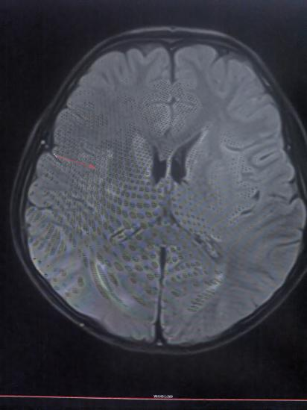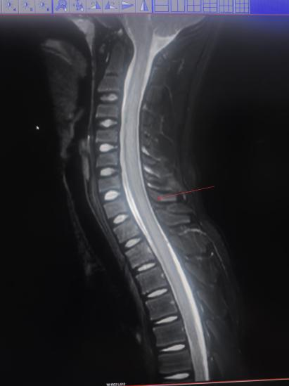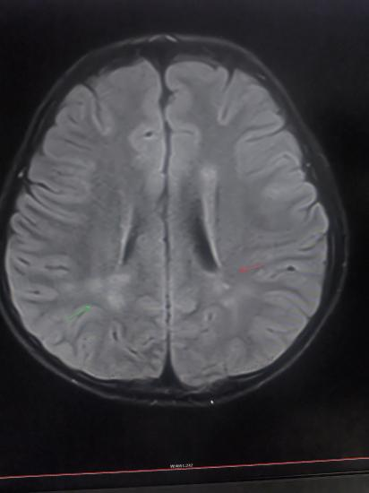

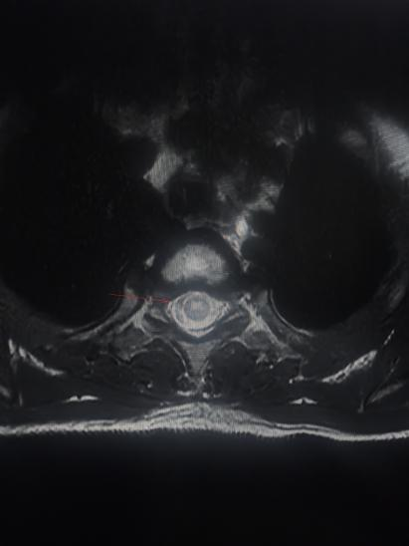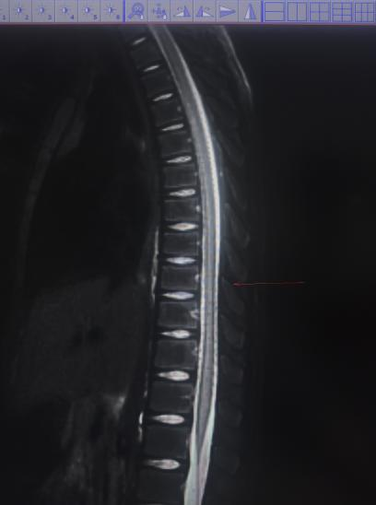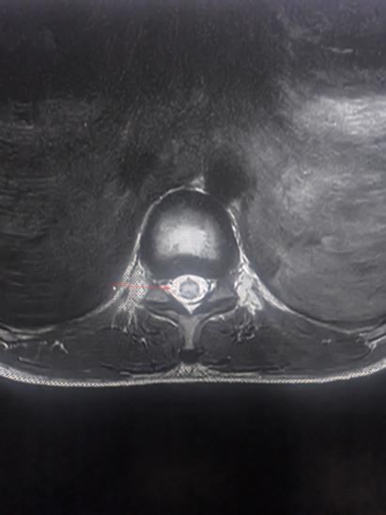
Fig 1: Spinal cord and cranial MRI at admission

After admission, treatment included ceftizoxime sodium for anti-infection, methylprednisolone (5 mg/kg/d) for anti-inflammatory therapy, intracranial pressure reduction, and supportive care. The child's temperature fluctuated recurrently around 38-39°C, with severe headaches. Auxiliary tests: high-sensitivity C-reactive protein 1.45 mg/L, white blood cell count 6.41x10^9/L, lymphocyte percentage 24.30%, monocyte percentage 14.00% (elevated), neutrophil percentage 57.50%, platelet count 207x10^9/L. Tests for influenza A/B virus nucleic acid, human rhinovirus, respiratory adenovirus, respiratory syncytial virus nucleic acid, and Mycoplasma pneumoniae nucleic acid were all negative. CSF pressure was 200 mmH₂O. CSF routine: colorless, no clot, Pandy's qualitative test 2+, nucleated cell count 175x10^6/L, differential: mononuclear 96%, polymorphonuclear 4%. Biochemistry: CSF glucose 2.4 mmol/L, chloride 120 mmol/L, CSF protein 3187.00 mg/L. On day 2 post-admission, the child experienced a generalized tonic-clonic seizure lasting about 2 minutes, followed by a drowsy state and subsequent brief staring spells lasting 1-2 seconds, along with difficulty urinating. After obtaining informed parental consent, intravenous immunoglobulin (IVIG, 1g/kg) was administered immediately to block the immune response. On day 3, he was drowsy with impaired limb movement: lower limb muscle strength grade 0^{[8]}, upper limb grade III, sensation (dulled), decreased bilateral tendon reflexes, absent superficial reflexes, and absent bilateral Babinski signs. MRI: 1. Abnormal signals in bilateral semioval centers, periventricular white matter adjacent to the posterior horns of the lateral ventricles, right frontal lobe, right basal ganglia region, and left occipital lobe. 2. Diffuse abnormal signal in the spinal cord, consistent with myelitis based on history. IVIG (1g/kg) and methylprednisolone (5 mg/kg/d) were continued.
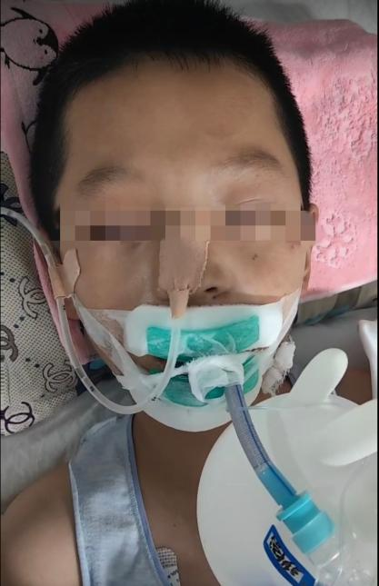
Fig 2: Initiation of Endotracheal intubation and mechanical ventilation
On day 4, the child developed dyspnea, increased sputum, increased lung markings, and scattered patchy opacities in the right lung and left lower lobe on imaging. Endotracheal intubation and mechanical ventilation were initiated. Due to pneumonia, antibiotic therapy was switched to meropenem to broaden the antimicrobial spectrum. IVIG (0.7g/kg) and methylprednisolone (5 mg/kg/d) were continued. After 5 days, methylprednisolone was tapered by 20 mg daily until reaching 60 mg, then switched to oral prednisone acetate tablet (1 mg/kg/d, tapered by 2.5 mg every 3 days until discontinuation). B vitamins and massage therapy were added. Two weeks later, repeat CSF analysis: nucleated cell count 90x10^6/L (elevated), mononuclear 86%, polymorphonuclear 14%; glucose 2.8 mmol/L, chloride 121 mmol/L, protein 774.00 mg/L. Muscle strength: bilateral upper limbs grade IV, lower limbs grade II. At three weeks, he could get out of bed; superficial sensation returned to normal; left lower limb grade II, right lower limb grade III. Rehabilitation and massage therapy were intensified.

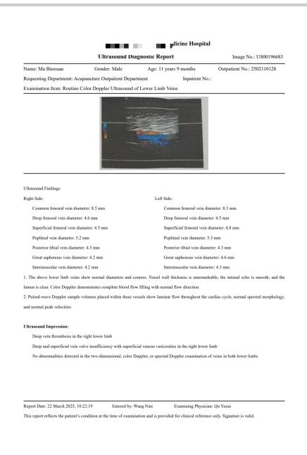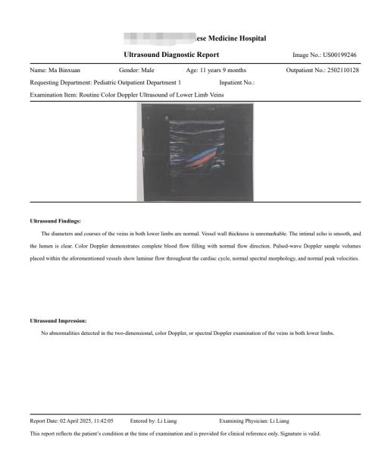
Dual lower extremity venous ultrasound Follow-up ultrasound examination of both lower extremities after discharge

Fig 3: Dual lower extremity venous ultrasound

At four weeks, right lower limb DVT occurred, treated symptomatically with low molecular weight heparin. Urination was normal, superficial reflexes normal, muscle tone normal. Upper limb strength grade IV, lower limbs grade III. At 4.5 weeks, lower limb strength improved to grade IV, and the child was discharged. Half a month after discharge (6 weeks from illness onset), follow-up showed the child moved freely with muscle strength grade V. The patient's motor function recovery was ideal after systematic treatment and rehabilitation. He has fully regained activities of daily living (ADL) and can participate without hindrance in physically demanding sports like basketball, middle-distance running, and various jumping actions (including quick jumps and direction changes). His joint range of motion is completely normal, and muscle strength and endurance suffice for these activities, with balance and coordination fully restored.
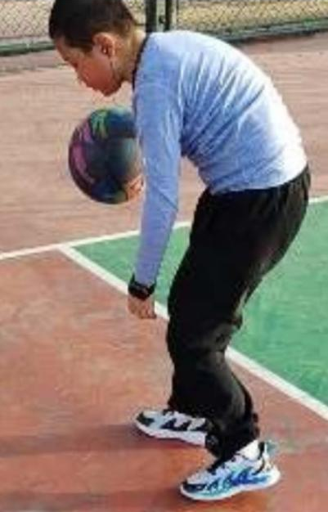
Fig 4: Boy’s Activities during the Recovery phase
Discussion:

This case involves an 11-year-9-month-old boy presenting with acute fever, headache, and vomiting, rapidly progressing to impaired consciousness and neurological deficits. Combined with CSF findings, imaging characteristics, and positive anti-NMDAR antibody results, it aligns with the diagnosis of acute encephalomyelitis combined with anti-NMDAR encephalitis ^{[10]}. This case offers the following clinical insights:
Disease Evolution Characteristics: The course showed a typical three-stage progression: prodromal phase (fever, headache) -> acute neurological impairment phase (impaired consciousness, seizures, decreased muscle strength) -> recovery phase. Notably, the neurological damage was extensive, involving brain parenchyma (bilateral semioval centers, basal ganglia), meninges, and spinal cord. The diffuse white matter abnormalities on MRI and significantly elevated CSF protein (3187 mg/L) indicate severe blood-brain barrier disruption and neuroaxonal injury.
Autoimmune Mechanism Exploration: The positive anti-NMDAR antibody suggests a core role of autoimmune response. The uniqueness lies in the overlap of encephalomyelitis features with typical anti-NMDAR encephalitis manifestations. Literature reports approximately 5-10% of anti-NMDAR encephalitis patients may have concurrent spinal cord involvement, possibly related to antibody-mediated widespread damage to glutamatergic neurons. The CSF predominance of mononuclear cells (96%) supports T-cell-mediated immune involvement.
Implications for Differential Diagnosis: Key differentials include: ① Infectious encephalomyelitis (e.g., enterovirus, HSV): ruled out by negative CSF PCR and ineffective antiviral treatment; ② Neuromyelitis Optica Spectrum Disorder (NMOSD): not supported by negative AQP4 antibody and lack of optic nerve/chiasm lesions on imaging ^{[25]}; ③ Acute Disseminated Encephalomyelitis (ADEM): the monophasic course and response to immunotherapy are more consistent with ADEM, but the positive antibody suggests a specific autoimmune mechanism.
Treatment Strategy Analysis: The early use of high-dose glucocorticoids (methylprednisolone 5 mg/kg/d) combined with IVIG (2.7g/kg total) aligns with current guidelines. However, the disease fluctuation during immunotherapy suggests some patients might need more aggressive second-line treatments (e.g., rituximab or cyclophosphamide). The hospital-acquired pneumonia and type I respiratory failure highlight the synergistic risk of immunosuppression and invasive procedures (intubation), emphasizing the importance of respiratory management in intensive care. The development of right lower limb DVT was managed with early low molecular weight heparin, addressing the neurogenic hypercoagulable state.
Prognostic Factors: Despite severe initial neurological impairment (lower limb strength grade 0), complete functional recovery (grade V) was achieved, potentially due to: ① Strong neuroplasticity in children; ② Relatively timely initiation of immunotherapy (within 4 days of onset); ③ No associated malignancy (teratoma and other NMDAR-encephalitis related tumors were ruled out). The stepwise recovery of muscle strength (improving approximately one grade per week) suggests a biological process of axonal regeneration and remyelination.
Conclusion

This case indicates that for acute-onset widespread CNS injury, early screening for autoimmune antibodies and timely escalation of immunotherapy are essential. It also underscores the importance of high-quality nursing care, rehabilitation, and massage therapy in managing severe neuroimmune diseases. Balancing immunosuppression with infection prevention is key to improving outcomes^{[23]} .
Course and Treatment Record Table
(Note: The original table content appears fragmented/erroneous. A simplified translation is provided based on discernible headers.)

Table 1: Record of Clinical Course and Treatment
 | Day1 | Day2 | Day3 | Day4 | Day5 | Day6 | Day7 | Day8 | Day9 | Day10 | Day11 | Day12 | Day13 | Day15 | Day16 | Day19 | Day22 | Day25 | Day28
Clinical  Manifestation | Fever, headache, vomiting | Fever,headache,convulsions, dysuria | Methylprednisolone 200mg, Immunoglobulin 1g/kg, Cefotaxime Sodium | Fever, headache, occasional binocular staring, dysuria, limbmovement disorders | Low-grade fever, mild headache, occasional binocularstaring,dysuria,limbmovement,disorders,tachypnea,excessivesputum,decreasedbloodoxygen saturation | Normalbodytemperature,mildheadache,occasional,binocularstaring,dysuria,limbmovementdisorders,tachypnea, excessivesputum, decreasedbloodoxygensaturation | Normalbodytemperature,mild headache,occasional binocular staring, dysuria, limb movement disorders | Normal body temperature, mild headache, occasional binocular staring, dysuria, limb movement disorders | Normalbodytemperature,noconvulsions,mildheadache,dysuria,limbmovement disorders | Normal body temperature, mild headache, dysuria, limb movement disorders | Normalbody temperature, noheadache, dysuria,limbmovementdisorders | Normal body temperature, no headache, dysuria,limb movement disorders | Same as previous | Same as previous | Same as previous
Examination Results | Hypersensitive C-reactive protein (hs-CRP): 1.45 ng/L; White blood cell (WBC) count: 6.41×10⁹/L; Lymphocyte percentage: 24.30%; Monocyte percentage: 14.00%; Neutrophil percentage: 51.50%; Platelet count: 207×10⁹/L. Nucleic acid tests for influenza A virus, influenza B virus, human rhinovirus, respiratory adenovirus, respiratory syncytial virus, and Mycoplasma pneumoniae were all negative. Cerebrospinal fluid (CSF) pressure: 200 mmH₂O. Routine CSF examination: Color: colorless; Clot: none; Pandy's protein qualitative test: 2+; Nucleated cell count: 175×10⁶/L; Nucleated cell classification: Mononuclear cells 96%, Polymorphonuclear cells 4%. Biochemical examination: CSF glucose: 2.4 mmol/L; Chloride: 120 mmol/L; CSF protein: 3187.00 mg/L. |  |  | Magnetic Resonance Imaging (MRI): 1. Abnormal signals in the bilateral centrum semiovale, periventricular white matter of the posterior horn of the lateral ventricles, right frontal lobe, right basal ganglia region, and left inferior occipital lobe. 2. Diffuse abnormal signals in the spinal cord, considering myelitis in combination with the medical history. | Chest CT: Increased bronchovascular markings in both lungs;scattered flocculent hyperdense shadows in the right lung and left lower lobe |  |  |  |  |  | Cerebrospinal Fluid(CSF):Nucleated cell count 90X10⁶/L, mononuclear cells86%, polymorphonuclearcells14%; glucose2.8mmol/L; cerebrospinal fluid chloride 121 mmol/L;cerebrospinal fluid [item missing]774.00 ng/L | Anti-NMDAR antibody IgG positive |  |  |  |  |  |  | B-ultrasound: Deep venous thrombosis of the right lower extremity
Treatment | Methylprednisolone 200mg; Cefotaxime Sodium | Methylprednisolone200mg, Immunoglobulin 1g/kg, Cefotaxime Sodium | Methylprednisolone 200mg, Immunoglobulin 1g/kg, Cefotaxime Sodium | Methylprednisolone 200mg; Immunoglobulin 0.7g/kg; Cefotaxime Sodium | Methylprednisolone 200mg; Meropenem; Ventilator-assisted ventilation | Methylprednisolone 180mg; Meropenem; Ventilator-assisted ventilation | Methylprednisolone 160mg; Meropenem; Ventilator-assisted ventilation | Methylprednisolone 140mg; Meropenem; Ventilator-assisted ventilation | Methylprednisolone120mg;Meropenem;Ventilator-assistedventilation(ventilatordiscontinued) | Methylprednisolone 100mg; Meropenem; Massage | Methylprednisolone 80mg; Meropenem; Massage | Methylprednisolone 60mg; Meropenem; Massage | Prednisolone Tablets 30mg; Cefotaxime Sodium; Massage | Prednisolone Tablets 30mg; Cefotaxime Sodium; Massage | Prednisolone Tablets 27.5mg; Tuina Massage | Prednisolone Tablets 25mg; Tuina Massage | Prednisolone Tablets 22.5mg; Tuina Massage | Prednisolone Tablets 20mg; Tuina Massage | PrednisoloneTablets17.5mg;Tuina Massage; Low-molecular-weight heparin 3.75mg/day for anticoagulant therapy

References:
[1] Zhao Guozhen, Wang Xuan. Clinical Analysis of 82 Cases of Acute Disseminated Encephalomyelitis in Children [J]. Journal of Jiangsu University (Medical Edition), 2023, 33(04): 348-351.
[2] Du J, Cao SG, Cao L, et al. A case report of Aigamod treatment for recurrent severe anti-NMDAR encephalitis with MOGAD. Journal of Stroke and Neurological Diseases, 2025,42(03):258-261. DOI: 10.19845/j.cnki.zfysjjbzz.2025.0052.
[3]Dalmau J ， Armangué T ， Planagumà J ， et al. An update on anti-NMDA receptor encephalitis for neurologists and psychiatrists ： mechanisms and models［J］. Lancet Neurol ，2019 ， 18（11）： 1045-1057.
[4] PAOLILO R B, DEIVA K, NEUTEBOOM R F, et al. Acute Disseminated Encephalomyelitis: Current Perspectives [J]. Children: Basel, 2020, 7(11): 210.
[5] Liu Yuming. Cerebrospinal Fluid Nucleic Acid Detection and Clinical Analysis of 164 Children with Central Nervous System Infections in Northwest Yunnan [D]. Dali University, 2023.
[6] Wang Yang, Zhao Hui, Li Hui. Analysis of Cerebrospinal Fluid PCR Results and Clinical Features in Patients with Suspected Central Nervous System Infection [J]. International Journal of Laboratory Medicine, 2025, 46(06): 704-708.
[7] Zhu Yimin, Liu Jing, Liu Lili, et al. Study on Etiological Characteristics of Cerebrospinal Fluid in 26 Children with Viral Encephalitis (Meningitis) [J]. Virologica Sinica, 2021, 37(03): 583-590.
[8］ Bayry J ， Kaveri SV. Kill ’em all ： efgartigimod immunotherapy for autoimmune diseases［J］. Trends Pharmacol Sci ， 2018 ， 39（11）：919-922
[9] OTALLAH S. Acute Disseminated Encephalomyelitis in Children and Adults: A Focused Review Emphasizing New Developments [J]. Mult Scler, 2021, 27(8): 1153-1160.
[10] Wu S, Shen S, Sun W, et al. FOXP3+ Macrophage-Derived Amphiregulin Promotes White Matter Repair of Experimental Autoimmune Encephalomyelitis [J]. The FASEB Journal, 2025, 39(11): e70719-e70719.
[11]Nosadini M, Thomas T, Eyre M, et al. International consensus recommendations for the treatment of pediatric NMDA R antibody encephalitis[J]. Neurol Neuroimmunol Neuroinflamm,2021, 8(5): e1052
[12］ Titulaer MJ ， Höftberger R ， Iizuka T ， et al. Overlapping demyelin⁃ ating syndromes and anti-N-methyl-D-aspartate receptor encephalitis［J］. Ann Neurol ， 2014 ， 75（3）： 411-428.
[13] Liu Jing, Jin Mei, Wang Yonggang, et al. Analysis of Neuroelectrophysiological Characteristics in Children with Acute Disseminated Encephalomyelitis [J]. Chinese Journal of Clinical Neurosciences, 2025, 33(01): 50-56.
[14]Han Wei, Jiang Li, Hong Siqi, et al. Clinical characteristics, treatment, and prognosis analysis of severe pediatric anti-NMDAR encephalitis [J]. Journal of PLA Medical Sciences, 2022,47(11):1125-1132.
[15] CLAASSEN J, SCHIFF N D, et al. Recovery from Disorders of Consciousness: Mechanisms, Prognosis and Emerging Therapies [J]. Nat Rev Neurol, 2021, 17(3): 135-156.
[16]Liu Xuehan. Study on Poor Brain Function Prognosis in Children with Severe Encephalitis in the Pediatric Intensive Care Unit [D]. Hebei Medical University, 2024. DOI: 10.27111/d.cnki.ghyku.2024.001478.
[17]Cong Fang, Zhang Chengshuai, Hu Pingping. Clinical value of psychological counseling combined with early rehabilitation nursing in children with severe encephalitis [J]. Journal of Practical Clinical Nursing, 2019,4(07):11+198.
[18] Li Hong. Clinical characteristics and risk factors of severe encephalitis with respiratory failure in children[J]. China Continuing Medical Education, 2018,10(12):85-86.
[19]Cellucci T, van Mater H, Graus F, et al. Clinical approach to the diagnosis of autoimmune encephalitis in the pediatric patient[J]. Neurol Neuroimmunol Neuroinflamm, 2020, 7(2): e663
[20] Lin KL, Lin JJ. Neurocritical care for anti-NMDA receptor encephalitis[J]. BiomedJ, 2020, 43(3): 251-258.
[21]Howard JF Jr ， Bril V ， Burns TM. Randomized phase 2 study of FcRn antagonist efgartigimod in generalized myasthenia gravis［J］. Neurology ，2019 ，92：e2661-e2673
- Wei Shaoshaonong. Prediction of MOGAD in Acute Disseminated Encephalomyelitis Based on Multimodal MRI Features [D]. Hangzhou Dianzi University, 2023.
- Deng W. Clinical characteristics and related factors of readmission in patients with anti-NMDAR encephalitis [D]. Guangzhou Medical University, 2025. DOI: 10.27043/d.cnki.ggzyc.2025.000807.
[24]Li Wei, Xie Jinyan, Yang Mingxiu, et al. A case report and literature review of HSE secondary anti-NMDAR encephalitis [J]. Guangxi Medical Journal, 2024,46(10):1617-1623.
[25] Baumann M, Sahin K, Lechner C, et al. Clinical and Neuroradiological Differences of Paediatric Acute Disseminated Encephalomyelitis with and without Antibodies to the Myelin Oligodendrocyte Glycoprotein [J]. Journal of Neurology, Neurosurgery & Psychiatry, 2015, 86(3): 265-272.
[26] Zhang M, Shen J, Zhou S, et al. Clinical and Neuroimaging Characteristics of Pediatric Acute Disseminated Encephalomyelitis with and without Antibodies to Myelin Oligodendrocyte Glycoprotein [J]. Frontiers in Neurology, 2020, 11: 593287.

