Case report

Reconstruction and closure of Oroantral Communication with buccal fat pad and Management of Chronic Sinusitis: A Case Report

.
ABSTRACT

Aim:
To describe the clinical presentation, surgical management, and outcome of implant-related oroantral communication complicated by chronic maxillary sinusitis following sinus augmentation, using a staged approach involving implant retrieval, antral lavage, and combined buccal advancement flap and buccal fat pad closure.
Methodology:
A 65-year-old male patient presented with pain and pressure in the right infraorbital region, halitosis, chronic rhinosinusitis, and mobility of implant-supported prosthesis in the right posterior maxilla. Cone beam computed tomography revealed bone loss around implant associated with chronic sinus pathology and oroantral communication. Surgical management included retrieval of the displaced implants, thorough antral lavage, placement of autologous PRF within the defect, and closure using a buccal advancement flap reinforced with harvested buccal fat pad to achieve tension-free primary closure in two steps due to active sinus infection. Postoperative evaluation was performed at regular intervals, including 7 days and 3 months.
Results:
Healing was uneventful with successful closure of the oroantral communication. The patient demonstrated complete resolution of sinonasal symptoms, absence of nasal regurgitation, and stable soft tissue healing. At 3-month follow-up, no recurrence of oroantral communication or sinus infection was observed.
Conclusion:
Combined use of implant retrieval, antral lavage, PRF, and dual soft tissue closure using buccal advancement flap and buccal fat pad provides a predictable and effective approach for the management of implant-related oroantral communication with chronic sinusitis.

Keywords: Oroantral communication; Dental implant displacement; Chronic maxillary sinusitis; Buccal fat pad; Platelet-rich fibrin

1. INTRODUCTION

Oroantral communication (OAC) is a pathological connection between the oral cavity and the maxillary sinus, most frequently encountered following posterior maxillary tooth extractions, sinus augmentation procedures, trauma, cystic enucleation, or implant-related complications¹. Failure to achieve early diagnosis and closure can result in chronic maxillary sinusitis, oroantral fistula formation, and significant impairment of oral and sinonasal function².
The posterior maxilla presents inherent anatomical and biological challenges for implant placement due to poor bone quality, sinus pneumatization, and reduced residual alveolar height³. Sinus augmentation procedures, including direct (lateral window) sinus lift, have become predictable techniques for implant rehabilitation; however, late complications such as peri-implant bone loss, implant mobility, and sinus pathology have been increasingly reported, particularly in long-term follow-up⁴,⁵.
Implant mobility following sinus augmentation may occur secondary to progressive graft resorption, peri-implantitis, chronic sinus inflammation, or biomechanical overload⁶. Smoking is a well-established risk factor that adversely affects osseointegration, impairs mucociliary clearance, compromises vascularity, and increases susceptibility to chronic rhinosinusitis⁷,⁸. Odontogenic maxillary sinusitis typically presents with halitosis, infraorbital pressure, facial pain, and persistent sinus symptoms, often refractory to medical management alone⁹.
Cone beam computed tomography (CBCT) plays a pivotal role in diagnosing implant-related sinus pathology by providing detailed assessment of peri-implant bone loss, sinus membrane thickening, and integrity of the sinus floor¹⁰. Management of implant-related OAC requires elimination of the etiologic factor, control of active sinus infection, and secure, tension-free closure using appropriate soft tissue techniques¹¹.
While the buccal advancement flap remains a commonly employed technique, its success is limited in the presence of active sinus infection and increased intra-sinus pressure¹². The buccal fat pad, owing to its rich vascularity and resistance to infection, has been advocated for closure of large, chronic, or recurrent OACs¹³. Adjunctive use of platelet-rich fibrin (PRF) has further enhanced outcomes by promoting angiogenesis and soft tissue healing¹⁴. This case report describes the staged management of implant-related OAC with chronic sinusitis following sinus augmentation.

2. Case presentation

A 65-year-old male reported with complaints of intermittent pain and pressure in the right infraorbital region, halitosis, and mobility of implant-supported prosthesis in the right posterior maxilla. The patient had been symptomatic for approximately one year and had a history of dental implant placement after Direct sinus lift 6 months prior to Implant placement in the region of teeth 16 and 17 about 15 years earlier. The patient was a chronic smoker (1–2 cigarettes/day for 15–20 years). Patient has no other medical comorbidities.
Clinical examination revealed a mobile implant prosthesis with clinical signs suggestive of oroantral communication, along with halitosis, chronic rhinosinusitis, pressure and pain in right infraorbital region since 1 year. Extraoral examination was unremarkable. Cone beam computed tomography demonstrated bone loss around dental implants, associated mucosal thickening and chronic sinus pathology.
Following informed consent, surgical intervention was planned. Under local anesthesia, a full-thickness mucoperiosteal flap was elevated. The displaced implants were retrieved, followed by thorough antral lavage to remove inflammatory debris and reduce microbial contamination.
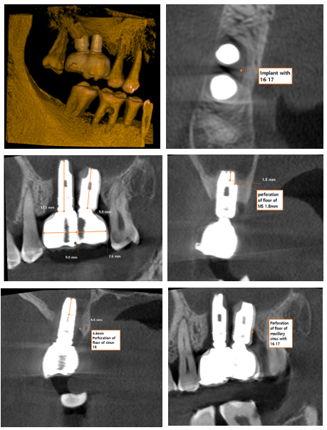
Figure-1 Preoperative cone beam computed tomographic picture of implants
Autologous platelet-rich fibrin was placed within the defect to promote soft-tissue healing and angiogenesis⁹. Closure was achieved using a buccal advancement flap.
Dehiscence was noted with the same region within 4 days due active sinus infection. Patient was treated with Antral regime by IV Antibiotics, and a second surgical procedure was planned after 15 days when the active infection subsided. Buccal fat pad was harvested along with buccal advancement flap and a tension-free primary closure was obtained.
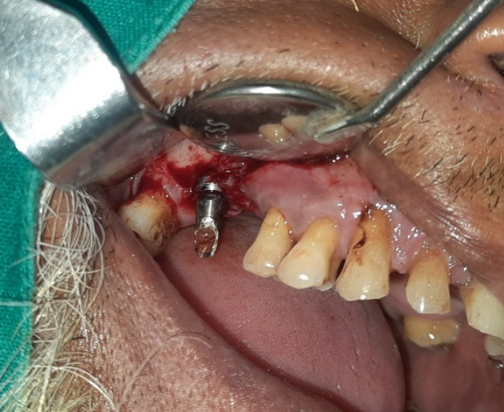
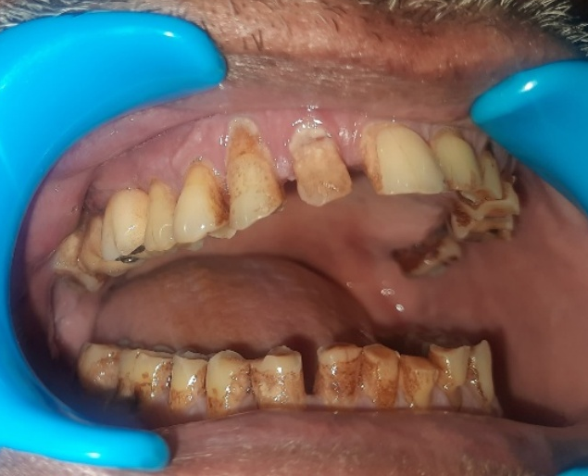
Postoperative healing was uneventful. The patient was followed up at 7 days, 2 weeks, and 3 months, with complete resolution of sinonasal symptoms and no recurrence of OAC.
Figure-3 Implant exposed
Figure-2 Preoperative Intraoral clinical picture

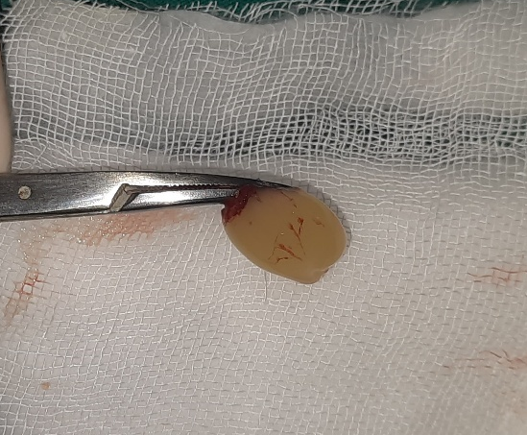
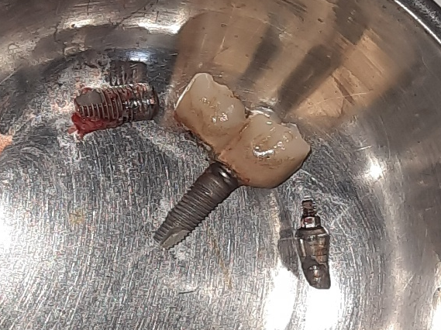
Figure-5 PRF placed in the surgical before closure
Figure-4 Implant retrieval
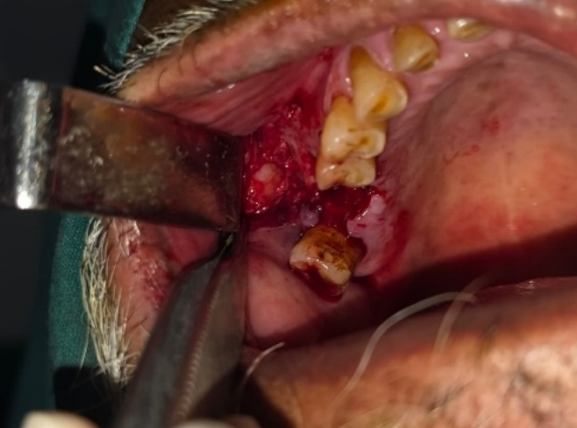
Figure-7 Buccal fat pad visible through trapezoidal incision for buccal advancement flap
Figure-6 Dehiscence on 7th postoperative day

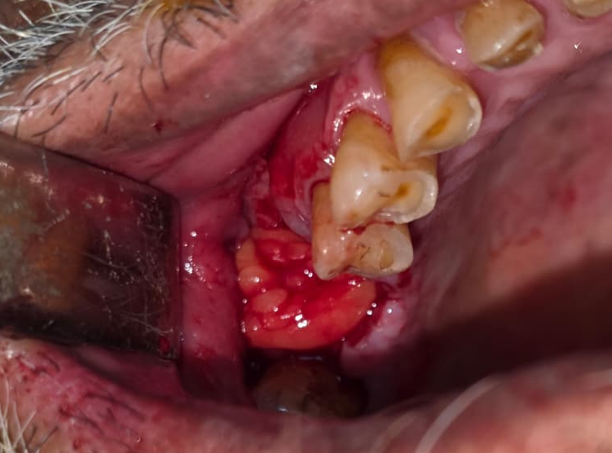
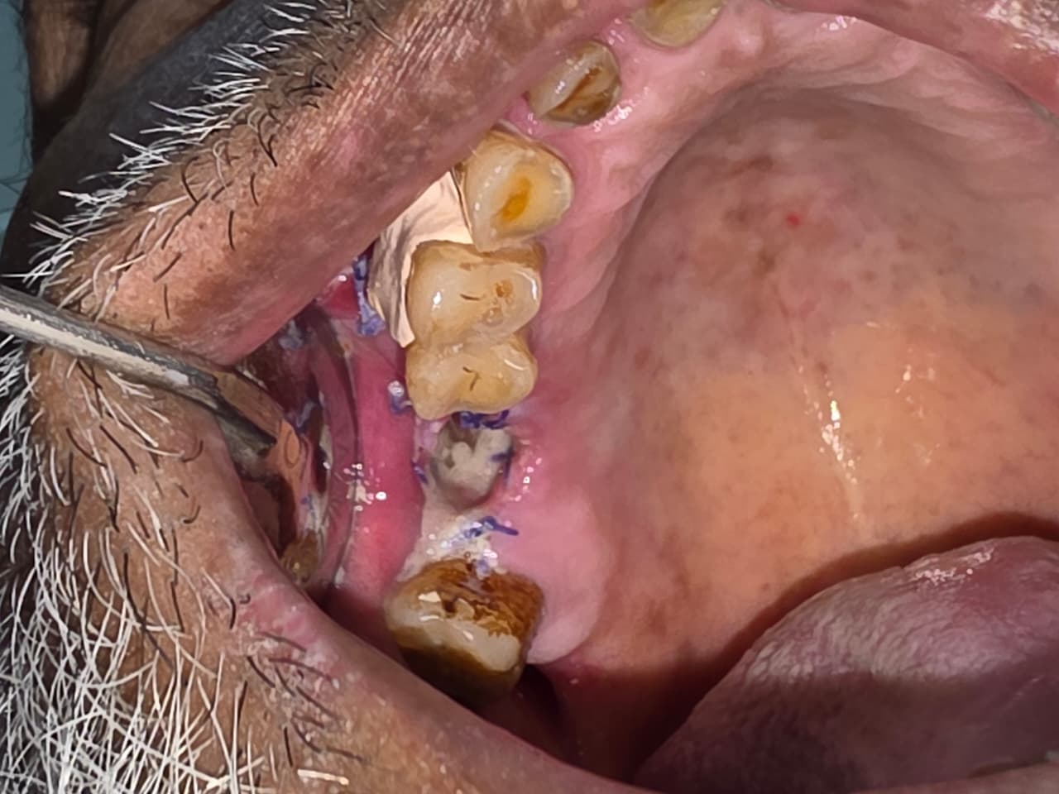
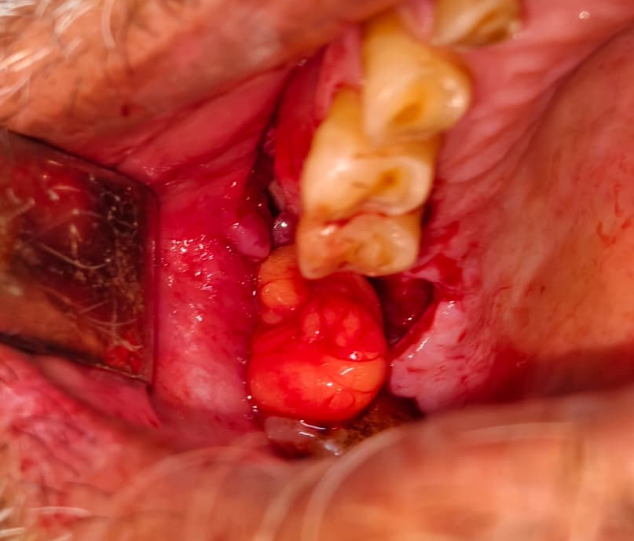
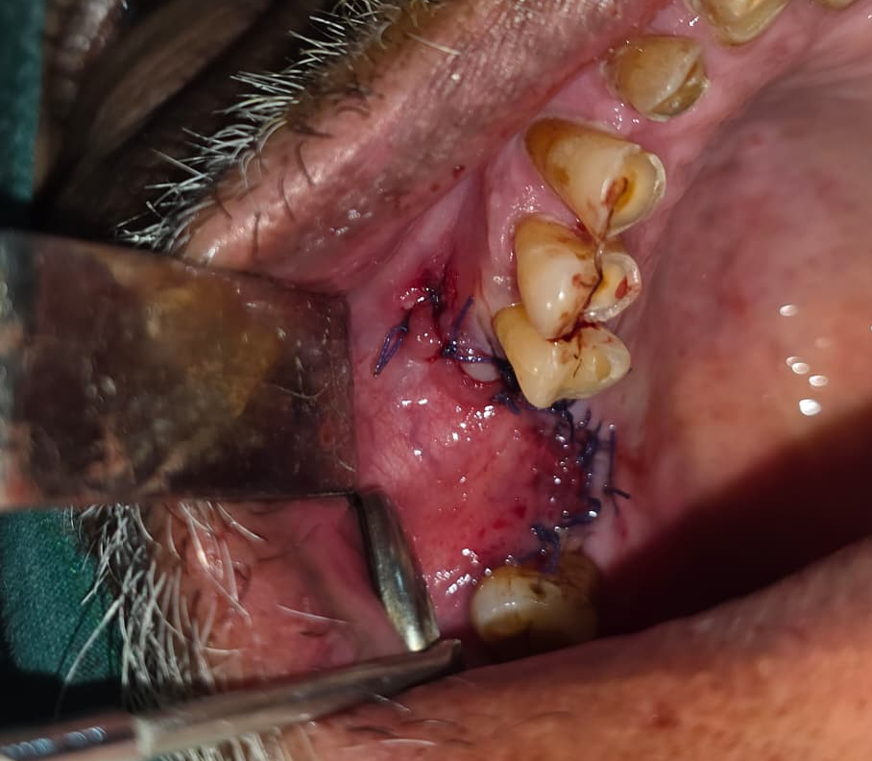
Figure-8 Buccal fat pad harvested through incision of buccal advance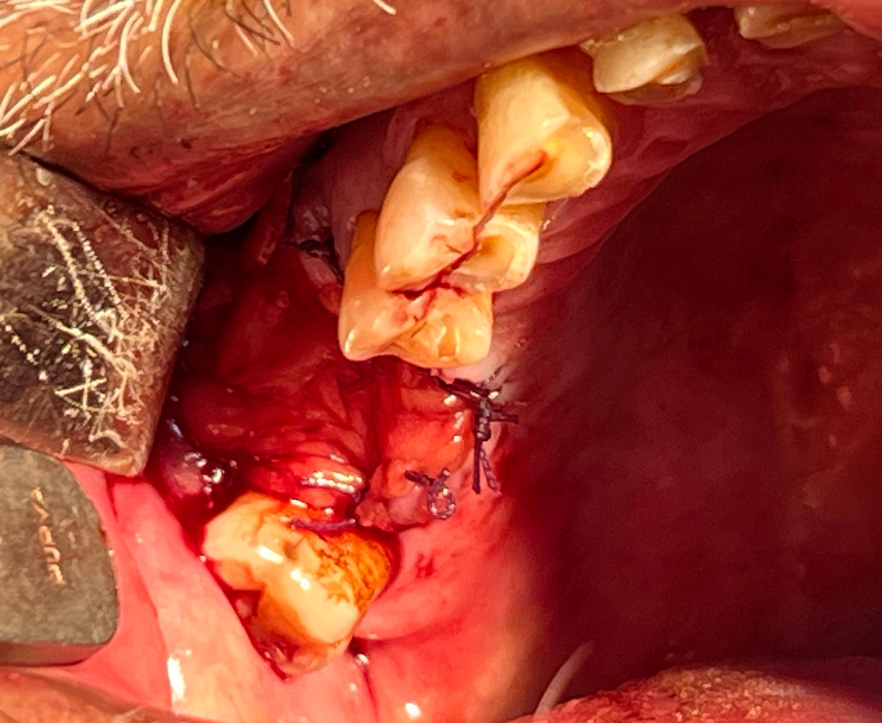
Figure-9 Buccal fat pad placed in position for closure
Figure-10 First layer closure with Buccal pad of fat
Figure-11 Two layered closure with Buccal advancement flap

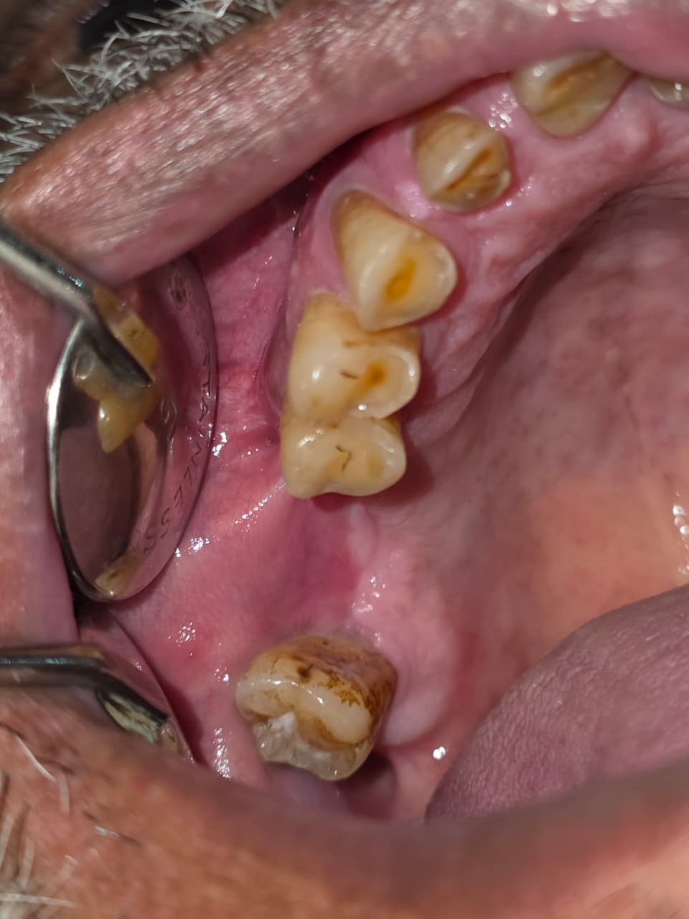
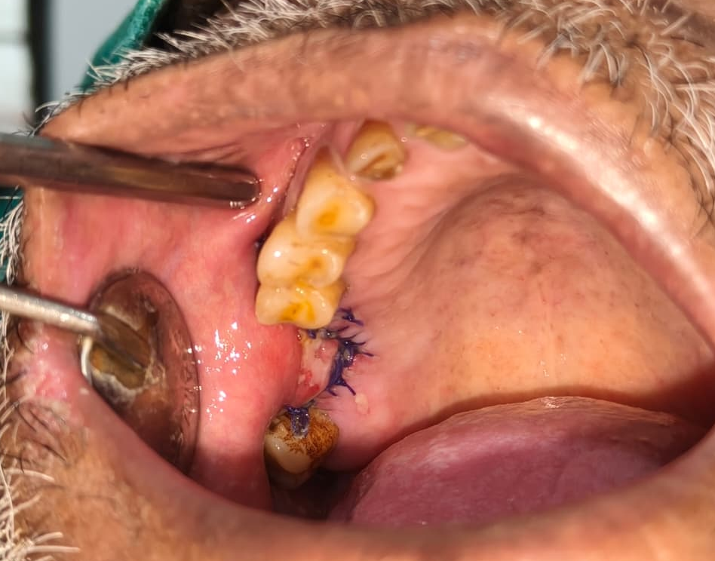
Figure-13 3 month Follow up
Figure-12 Third day follow up

3. discussion

Implant displacement and mobility within the maxillary sinus represent multifactorial complications involving anatomical, biological, and procedural variables. In the present case, delayed implant failure occurred approximately 15 years after placement following direct sinus lift, highlighting that long-term implant survival in grafted sinuses remains influenced by ongoing bone remodeling and sinus health⁴,⁵.
Progressive peri-implant bone loss compromises the integrity of the sinus floor and Schneiderian membrane, facilitating communication between the oral cavity and sinus¹⁵. Chronic smoking further exacerbates this process by impairing osteogenesis, reducing immune response, and predisposing to persistent sinus infection⁷,⁸. The constellation of halitosis, infraorbital pressure, and chronic rhinosinusitis observed in this patient is characteristic of odontogenic sinusitis and should prompt evaluation for oral–sinus communication⁹,¹⁶.
CBCT findings of peri-implant bone loss and mucosal thickening are consistent with chronic inflammatory changes of odontogenic origin¹⁰. Removal of the etiologic factor—in this case, mobile implants—is mandatory, as retained foreign bodies perpetuate sinus inflammation and impair mucociliary clearance¹⁷. Antral lavage is essential to reduce microbial load and inflammatory mediators prior to closure¹⁸.
In the present case, initial closure using buccal advancement flap and PRF failed due to persistent active sinus infection, resulting in early wound dehiscence. Literature strongly supports that closure of OAC in the presence of uncontrolled sinus infection is associated with high failure rates¹,¹¹,¹². This underscores the importance of infection control before attempting definitive closure.
Following resolution of active infection using an antral regimen and intravenous antibiotics, delayed secondary closure was undertaken. The buccal fat pad was incorporated to provide a well-vascularized tissue capable of withstanding residual infection and mechanical stress¹³,¹⁹. Combining buccal advancement flap with buccal fat pad allows tension-free closure and improves success rates in chronic and recurrent cases²⁰.
The favorable outcome observed in this case aligns with published evidence advocating staged management of infected OACs, prioritizing sinus decontamination followed by definitive closure with robust soft tissue support²¹–²³. The adjunctive use of PRF likely contributed to enhanced angiogenesis, accelerated epithelialization, and stable wound healing¹⁴,²⁴.
At 3-month follow-up, complete resolution of sinonasal symptoms and absence of recurrence confirmed the effectiveness of this staged, multimodal approach. This case reinforces the principle that implant-related OAC with chronic sinusitis should be managed as a combined oral–sinus pathology rather than a purely local defect.

4. Conclusion

Implant-related oroantral communication associated with chronic maxillary sinusitis requires comprehensive management. Retrieval of mobile implants, effective sinus decontamination, biological augmentation with PRF, and tension-free closure using combined buccal advancement flap and buccal fat pad can result in predictable healing and long-term symptom resolution.

AcknowledgEments

The authors acknowledge the Department of Oral and Maxillofacial Surgery for providing the clinical facilities necessary for the management of this case. The authors declare that no external funding or assistance was received for this study.

Disclaimer (Artificial intelligence)

Author(s) hereby declare that NO generative AI technologies such as Large Language Models (ChatGPT, COPILOT, etc.) and text-to-image generators have been used during the writing or editing of this manuscript.

References

- Visscher, S. H., van Minnen, B., & Bos, R. R. M. (2010). Closure of oroantral communications: A review of the literature. Journal of Oral and Maxillofacial Surgery, 68(6), 1384–1391. https://doi.org/10.1016/j.joms.2009.09.004
- Borgonovo, A. E., Berardinelli, F. V., Favale, M., Maiorana, C., & Re, D. (2012). Surgical options in oroantral fistula treatment. The Open Dentistry Journal, 6, 94–98. https://doi.org/10.2174/1874210601206010094
- Misch, C. E. (2008). Contemporary implant dentistry (3rd ed.). St. Louis: Mosby Elsevier.
- Galindo-Moreno, P., Padial-Molina, M., Avila, G., Rios, H. F., Hernández-Cortés, P., & Wang, H. L. (2012). Complications associated with implant migration into the maxillary sinus cavity: A systematic review. Clinical Oral Implants Research, 23(10), 115–121. https://doi.org/10.1111/j.1600-0501.2011.02345.x
- Pjetursson, B. E., & Lang, N. P. (2014). Sinus floor elevation utilizing the lateral window technique: A systematic review. Clinical Oral Implants Research, 25(Suppl. 11), 113–121. https://doi.org/10.1111/clr.12263
- Chan, H. L., Wang, H. L., Bashutski, J. D., Edwards, B., & Fu, J. H. (2013). Analysis of the risk factors associated with implant displacement into the maxillary sinus. Clinical Oral Implants Research, 24(7), 835–841. https://doi.org/10.1111/j.1600-0501.2012.02478.x
- Bain, C. A., & Moy, P. K. (1993). The association between the failure of dental implants and cigarette smoking. International Journal of Oral and Maxillofacial Implants, 8(6), 609–615.
- Palmer, R. M., Wilson, R. F., Hasan, A. S., & Scott, D. A. (2005). Mechanisms of action of environmental factors—tobacco smoking. Clinical Oral Implants Research, 16(2), 230–237. https://doi.org/10.1111/j.1600-0501.2005.01148.x
- Mehra, P., & Murad, H. (2004). Maxillary sinus disease of odontogenic origin. Otolaryngologic Clinics of North America, 37(2), 347–364. https://doi.org/10.1016/S0030-6665(03)00171-3
- Maillet, M., Bowles, W. R., McClanahan, S. L., John, M. T., & Ahmad, M. (2011). Cone-beam computed tomography evaluation of maxillary sinusitis of odontogenic origin. Journal of Endodontics, 37(6), 753–757. https://doi.org/10.1016/j.joen.2011.02.032
- Khandelwal, P., & Hajira, N. (2017). Management of oroantral communication and fistula: Various surgical options. Journal of Maxillofacial and Oral Surgery, 16(3), 260–265. https://doi.org/10.1007/s12663-016-0923-8
- Rehrmann, A. (1936). Eine Methode zur Schliessung von Kieferhöhlenperforationen. Deutsche Zahnärztliche Zeitschrift, 39, 1136–1140.
- Egyedi, P. (1977). Utilization of the buccal fat pad for closure of oroantral and/or oro-nasal communications. Journal of Maxillofacial Surgery, 5(4), 241–244. https://doi.org/10.1016/S0301-0503(77)80065-3
- Choukroun, J., Adda, F., Schoeffler, C., & Vervelle, A. (2006). An opportunity in perio-implantology: The PRF. Implantodontie, 42, 55–62.
- Raghoebar, G. M., Vissink, A., Reintsema, H., & Batenburg, R. H. (2003). Displacement of dental implants into the maxillary sinus: A clinical report. International Journal of Oral and Maxillofacial Surgery, 32(5), 521–523. https://doi.org/10.1054/ijom.2002.0395
- Felisati, G., Chiapasco, M., Lozza, P., Saibene, A. M., Pipolo, C., Borloni, R., et al. (2013). Sinonasal complications resulting from dental treatment. Acta Otorhinolaryngologica Italica, 33(4), 246–251.
- Tatum, O. H. (1986). Maxillary sinus grafting for implant reconstruction. Dental Clinics of North America, 30(2), 207–229.
- Brook, I. (2006). Sinusitis of odontogenic origin. Otolaryngology–Head and Neck Surgery, 135(3), 349–355. https://doi.org/10.1016/j.otohns.2005.10.059
- Rapidis, A. D., Alexandridis, C. A., Eleftheriadis, E., & Angelopoulos, A. P. (2000). The use of the buccal fat pad for reconstruction of oral defects. Journal of Oral and Maxillofacial Surgery, 58(2), 158–163. https://doi.org/10.1016/S0278-2391(00)90328-4
- Abuabara, A., Cortez, A. L. V., Passeri, L. A., de Moraes, M., & Moreira, R. W. F. (2006). Evaluation of different treatments for oroantral/oronasal communications. Medicina Oral, Patología Oral y Cirugía Bucal, 11(4), E319–E322.
- Punwutikorn, J., Waikakul, A., & Pairuchvej, V. (1994). Clinically significant oroantral communications—A study of incidence and management. Journal of Oral and Maxillofacial Surgery, 52(3), 247–250.
- Hernando, J., Gallego, L., Junquera, L., & Villarreal, P. (2010). Oroantral fistula closure with buccal fat pad. Medicina Oral, Patología Oral y Cirugía Bucal, 15(3), e499–e503.
- Wehrbein, H., & Diedrich, P. (1992). Progressive pneumatization of the basal maxillary sinus. International Journal of Oral and Maxillofacial Implants, 7(4), 509–515.
- Patel R, Patel P, Kalariya V, Patel H, Chavda C. Closure of Oro-Antral Communication Using Buccal Advancement Flap. World J Plast Surg. 2019 May;8(2):262-264. doi: 10.29252/wjps.8.2.262. PMID: 31309067; PMCID: PMC6620811.
- Miron, R. J., & Choukroun, J. (2017). Platelet rich fibrin in regenerative dentistry: Biological background and clinical indications. Hoboken, NJ: Wiley Blackwell.
- Ziccardi, V. B., & Betts, N. J. (1992). Complications of maxillary sinus surgery. Oral and Maxillofacial Surgery Clinics of North America, 4(2), 247–257.

