Refining the Frenum: A Multi-Technique Case Series on
Management of Aberrant Labial Frena

.
ABSTRACT

Introduction: An aberrant labial frenum, when attached close to the gingival margin or papilla, can lead to midline diastema, gingival recession, and impaired oral hygiene. Several surgical techniques have been proposed to manage such attachments, aiming to improve function and esthetics with minimal morbidity.
Presentation of Case: Four patients with maxillary aberrant frena were treated using different techniques—conventional scalpel, Z-plasty, V-Y plasty, and diode laser frenectomy. All presented with papillary attachments affecting esthetics and posing relapse risks in orthodontic cases. Procedures were done under local anesthesia with uneventful healing.
Discussion: The laser technique demonstrated superior intraoperative hemostasis and greater patient comfort. In contrast, Z-plasty and V-Y plasty were more effective in enhancing vestibular depth and achieved optimal tissue repositioning with minimal scar formation. Although the conventional scalpel technique was clinically effective, it was associated with comparatively increased bleeding and a longer healing period. Overall, technique selection should be individualized according to the type of frenal attachment, the need for tissue repositioning, and esthetic demands. Flap-based procedures such as Z-plasty and V-Y plasty are particularly advantageous in papillary and papilla-penetrating frena, as they redistribute tension and help preserve papillary integrity. Diode laser frenectomy, on the other hand, represents a minimally invasive alternative, offering rapid healing, excellent hemostasis, and superior patient comfort.
Conclusion: Overall, all methods were successful, with diode laser and flap-based approaches yielding the most favorable esthetic and functional outcomes through individualized, predictable treatment.

Keywords: Frenectomy; Z-plasty; V-Y plasty; Diode laser; Periodontal plastic surgery; Midline diastema

1. INTRODUCTION

“The frenum is a mucous membrane fold that attaches the lip and the cheek to the alveolar mucosa, the gingiva, and the underlying periosteum” [1].
“The presence of a diastema between the maxillary central incisors in adults has often been considered as an aesthetic problem. Labial thick and high attached maxillary frenum is commonly regarded as contributing etiology for maintaining midline diastema and delayed upper jaw development, so the focus on the frenum has become essential. The frena may also jeopardize the gingival health by causing a gingival recession when they are attached too closely to the gingival margin, either because of an interference with the proper placement of a toothbrush or through the opening of the gingival crevice because of a muscle pull” [2].
The frenulum is considered pathological and should be removed when:
1. an aberrant frenal attachment is present, which may cause a midline diastema;
2. a flattened interdental papilla with the frenulum closely attached to the gingival margin causes gingival recession and interferes with the maintenance of optimal daily oral hygiene;
3. an aberrant frenulum with an inadequately attached gingiva and/or a shallow vestibule is present. [1,3]
“A frenal pull may cause the gingival margin to be drawn away from the tooth surface, thus increasing the plaque accumulation in the sulcus area”.4 “The most common positions for frenula attached close to the gingival margins are between the maxillary and mandibular central incisors and in the canine/premolar areas. The aberrant frenulum can be treated by frenectomy or by frenotomy” [16].
“The abnormal frena can be diagnosed visually by moving the upper lip outwards and downwards and lower lip is moved outwards and upwards. If the gingival margin shows movement or if blanching is seen, then the test is positive and the frenum is said to be aberrant. This test is known as the Blanching test or Tension test” [17].
“Frenectomy is the complete removal of the frenulum, including its fibrous attachment to the underlying periosteum and alveolar bone. Frenotomy is a more superficial excision and/or relocation of the frenal attachment without the removal of deeply attached collagen fibers”. 4,1
“Frenectomy, is indicated if the frenulum attachment causes midline diastema, gingival recession, hindrance in maintaining oral hygiene, or if it interferes with lip movements and for prosthetic needs”.1,5,6
‘There are various surgical techniques of frenectomy which include Classical frenectomy by Archer and Kruger, Millers technique (unilateral single pedicle flap), Schuchardt Z-plasty, V-Y Plasty, Frenectomy using electrocautery, Lasers like Diode, CO2, Nd:YAG, Er:YAG and other soft tissue lasers” [17].

Case Series Presentation
2. Case 1 : V-Y PLASTY
An 18-year-old male patient reported to the department of periodontology with the chief complaint of spacing between his upper front teeth, which he found unaesthetic. On clinical examination, a tension test was carried out by applying gentle traction on the labial frenum to observe any movement of the interdental papilla or blanching of the surrounding tissues. The test was positive, indicating a papillary type of frenum attachment between the maxillary central incisors (teeth 11 and 21) (fig. 1). The patient’s medical history was non-contributory, with no record of systemic illness or intake of medications. Dental history was also unremarkable, and intraoral examination revealed healthy gingiva with no signs of inflammation or enlargement. Gingival levels were clinically adequate. After explaining the treatment options, the V–Y plasty frenectomy procedure using a scalpel was planned to correct the aberrant frenum. Informed written consent was obtained prior to surgery.
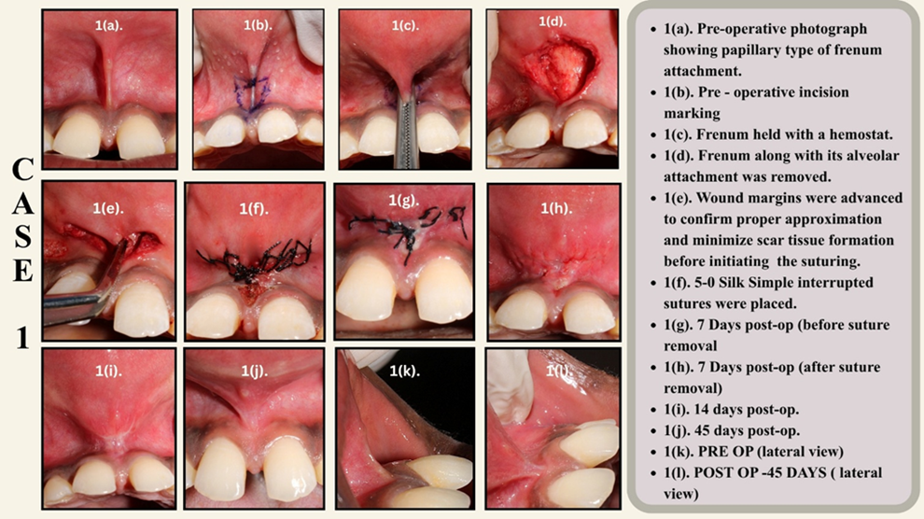

Figure 1. V-Y Plasty

Local anesthesia was achieved by administering 2% lignocaine with 1:80,000 adrenaline (LOX 2% Adrenaline) through local infiltration to anesthetize the frenum and adjacent tissues. The frenum was gently grasped with a hemostat up to the depth of the vestibule to provide tension and define the extent of attachment. Using a No. 15 Bard-Parker blade, an incision was made along the frenum, and the fibrous tissue band, including its alveolar attachment, was completely excised. This resulted in exposure of the underlying connective tissue. The frenum was then repositioned in a more apical location, and the initial V-shaped incision was carefully converted into a Y-shaped configuration to achieve a V–Y plasty. The surgical field was thoroughly irrigated with normal saline, and hemostasis was ensured under strict aseptic conditions. Simple interrupted sutures using 5-0 black silk were placed in a Y-shaped pattern to secure the repositioned tissues. Post-operatively, the patient was advised to maintain good oral hygiene and was prescribed Aceclofenac with Paracetamol (500 mg, SOS) for pain management. The patient was recalled after seven days for re-evaluation and suture removal, and subsequent follow-ups were conducted on day 7, day 14, and day 45 to assess healing and stability of the surgical site.

3. CASE 2: Z PLASTY
A 21-year-old female patient was referred from the Department of Orthodontics to the Department of Periodontics, for the management of a high papillary-type labial frenum. The patient was undergoing fixed orthodontic therapy for midline diastema, which had been successfully closed during treatment. In such cases, frenectomy may be performed before, during, or after orthodontic space closure. In this instance, the orthodontic correction was completed first, followed by the frenectomy procedure to prevent relapse.
Comprehensive medical history and routine hematological investigations revealed no contraindications for surgery. After obtaining informed written consent, the patient underwent oral prophylaxis, and the procedure was performed under local anesthesia in an aseptic environment. A ‘Z-shaped’ incision design was planned, consisting of two lateral horizontal incisions at the apex and base of the frenum at approximately 60°, and a central vertical incision connecting them, creating two triangular flaps of equal size. The 60° angulation was selected to achieve optimal tissue reorientation and extension (Fig 2).

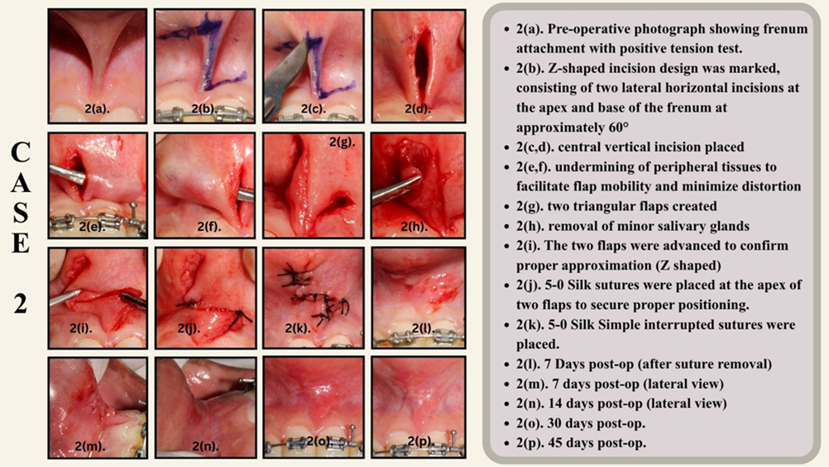
Figure 2. Z Plasty

Following adequate undermining of peripheral tissues to facilitate flap mobility and minimize distortion, the two triangular flaps were transposed to the opposite sides of their respective apices after achieving hemostasis. The flaps were secured in position using 5-0 absorbable sutures to obtain a tension free closure. Postoperative instructions were provided, and healing was evaluated after seven days, showing uneventful recovery with no discomfort or inflammation. At 45 days follow-up, the surgical site demonstrated complete healing, absence of scar formation, and stable esthetic and functional results, fulfilling both orthodontic and periodontal objectives.
4. CASE 3: CONVENTIONAL TECHNIQUE
A 19-year-old female patient was referred from the department of orthodontics to the department of periodontics following the completion of orthodontic therapy to manage the papillary type of maxillary frenal attachment. Comprehensive medical history and routine hematological investigations revealed no contraindications for surgery. A conventional scalpel frenectomy was performed under local anesthesia using a no.15 blade (figure 3.). A diamond-shaped incision was made to excise the frenum completely down to the periosteum, ensuring release of all fibrous attachments. Hemostasis was achieved with gauze pressure, and the wound edges were approximated with 5-0 silk interrupted sutures. The procedure resulted in adequate lip mobility and elimination of tension on the gingival margin. Postoperative healing was uneventful, with minimal discomfort and satisfactory esthetic and functional outcomes.

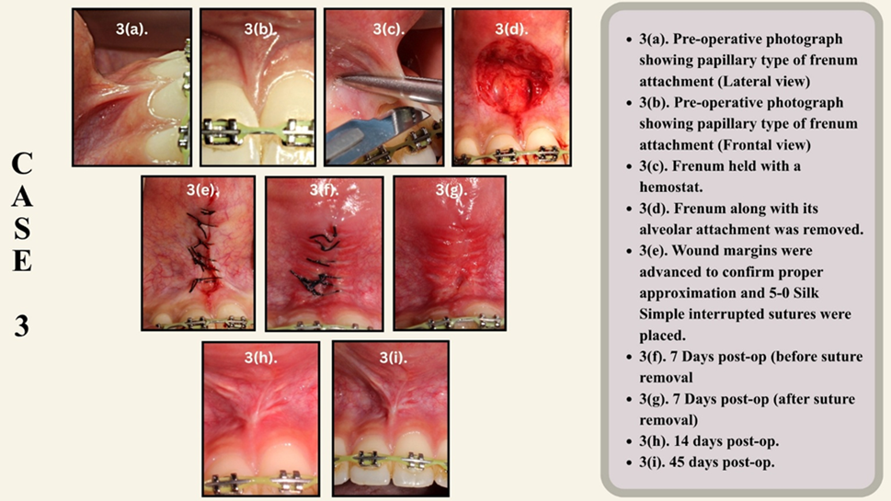
Figure 3. Conventional frenectomy

5. Case 4 : LASER TECHNIQUE

A 20-year-old female was referred from orthodontics to periodontics for treatment of a papillary labial frenum. After completing routine medical assessments and obtaining informed consent, the procedure was performed under local anesthesia using a diode laser with an 810 nm wavelength, set to continuous mode at 2 watts. Maintaining strict aseptic protocols, the fiber tip was carefully moved in a sweeping motion from the frenum base toward the attached gingiva, fully excising the fibrous band down to the periosteum.
Excellent intraoperative hemostasis was achieved, and 5-0 silk interrupted sutures were placed. Postoperative instructions included soft diet, chlorhexidine mouth rinse, and analgesics as needed were prescribed. (figure 4).

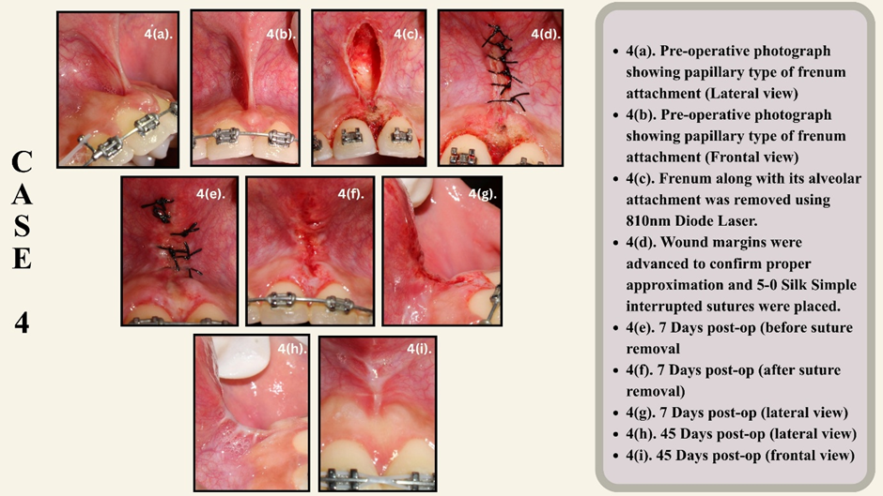
Figure 4. Laser technique frenectomy

The patient reported after 7 days with minimal pain and no bleeding or swelling during recovery. At one-week review, the site showed satisfactory healing, and by the second week, complete epithelialization and improved lip mobility were observed. The laser-assisted frenectomy provided a bloodless field, rapid healing, and superior patient comfort with pleasing esthetic results.

5. Discussion
The labial frenum is a mucosal fold that links the inner surface of the lip to the alveolar mucosa. It is deemed abnormal or aberrant when its attachment is unusually extended or disrupts normal function, aesthetics, or the health of the periodontium. Histologically, the frenum primarily consists of dense collagen and elastic fibers, along with small blood vessels and peripheral nerves, but it does not contain striated muscle fibers, as initially described by Henry and colleagues in 1976.⁷
Thus, the destructive or restrictive potential of the frenum is mechanical rather than muscular in origin, emphasizing the need for complete excision or relocation of the fibrous band rather than “muscle removal.”
In modern periodontal plastic surgery, there is a shift toward using less invasive and more accurate methods to achieve better functional and cosmetic outcomes. Since an abnormal frenum is one of the causes for a persistent midline gap between the teeth (diastema), attention to the frenum has become crucial. Treatment options for an aberrant frenum include frenectomy or frenotomy procedures.⁸
“The classical technique was introduced by Archer (1961) and Kruger (1964). This approach was advocated in the midline diastema cases with an aberrant frenum to ensure the removal of the muscle fibres which were supposedly connecting the orbicularis oris with the palatine papilla”.²
“The causes for spacing between the maxillary incisors as a result of high frenum attachment, microdontia, macrognathia, supernumerary teeth, peg laterals, missing lateral incisors, midline cysts and habits such as thumb sucking, mouth breathing and tongue-thrusting”.⁹
In most cases, an aberrant frenum requires surgical correction either before initiating orthodontic therapy or after its completion.
Performing the procedure prior to orthodontic treatment offers the benefit of easier surgical access and better visibility of the operative field.¹⁰
“An aberrant frenum can be removed by any of the modification techniques that have been proposed, however, a functional and an aesthetic outcome can be achieved by a proper technique selection, based on the type of the frenal attachment”. ¹¹
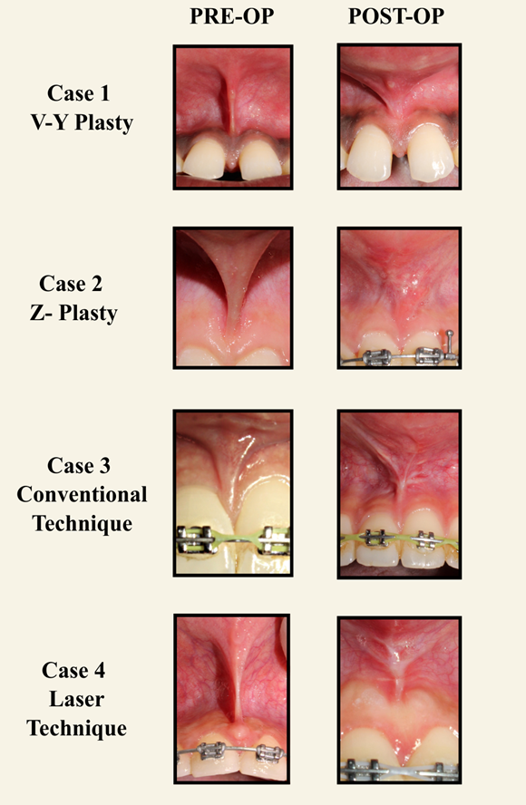
Figure 5. Pre and Post Operative pictures of all 4 techniques

Various surgical techniques have been proposed to manage aberrant frena, each with unique indications and healing profiles. The classical scalpel frenectomy remains a reliable and economical procedure, providing full control over depth and allowing combination with mucogingival grafts when attached gingiva is deficient. However, it is associated with greater intraoperative bleeding, longer procedure duration, and postoperative discomfort compared to laser techniques.¹²
For Z-plasty, several reports document its utility in papillary and papilla-penetrating frenum and in cases with shallow vestibular depth due to low insertion or broad frenum. For example, Acharya et al. demonstrated that Z-plasty in a papilla-penetrating upper labial frenum produced satisfactory functional and esthetic outcome with minimal scar formation and improved vestibular depth.¹³ In another case report, the Z-plasty technique redistributed tension lines via transposed triangular flaps, leading to good healing and esthetic integration even in a challenging high papillary frenum.¹⁴
For V-Y plasty, case reports attest that this technique is effective for papillary-type frenal attachments. Shirbhate et al. showed that V-Y plasty in a 19-year-old with a papillary frenum led to minimal scar formation and high patient satisfaction. It is a minimally invasive technique for managing aberrant high maxillary frena, offering excellent esthetic results with minimal scarring. It permits easy manipulation of fibrous tissue, enabling effective correction of papillary frenal attachments with favorable postoperative healing. The procedure is simple, time-efficient, and conserves tissue, providing reliable elongation and improved functional and esthetic outcomes compared to conventional frenectomy.¹⁵
Recent randomized controlled evidence has validated the efficacy of laser-assisted frenectomy, especially with Er:YAG and diode lasers. Sarmadi et al. (2020) demonstrated that Er:YAG laser frenectomy significantly reduced bleeding and shortened operative time by approximately 54%, without compromising wound healing or patient satisfaction. All wounds achieved epithelial coverage by 12 days in both groups, indicating comparable healing kinetics. They have also reported lower postoperative pain and analgesic use following laser procedures, attributable to the laser’s ability to coagulate small vessels and seal nerve endings.¹²
Integrating these findings, technique selection should be based on the frenum type, patient profile, and clinical objective. The following concise matrix summarizes decision guidelines (Table 1).

CASE SELECTION CRITERIA | CONVENTIONAL SCALPEL | Z-PLASTY | V-Y PLASTY | DIODE  LASER
Frenum type:  MUCOSAL  or  GINGIVAL | ✅ Simple, effective | Unnecessary tissue destruction unless tissue reposition needed | Can be  Optional | ✅ Good with less  bleeding/pain
Frenum type:  PAPILLARY | Acceptable but may cause scar at papilla | ✅ Preferred to preserve papilla  ✅ scar  reorientation benefit | ✅ Good to elongate tissue ✅Preserve vestibule | Possible (be careful to avoid papilla damage)
Frenum type:  PAPILLA-  PENETRATING | Risk of papilla loss / scar | ✅ Preferred  (Z-plasty)  ✅Best for thick fibrotic frenum with broad base | ✅ Good when vertical lengthening needed | Laser alone may not address deep fibers without flap
Need for  tissue  repositioning / vestibular depth | Requires additional flap | ✅ Ideal | ✅ Ideal | Laser alone is insufficient
Bleeding  tendency | Increased bleeding risk | Moderate | Moderate | ✅ Favorable (hemostasis)
Post-op pain | Moderate | Moderate | Moderate | Lower
Healing | Good, predictable | Good, may have scar reorienting benefit | Good | Variable by  laser
Recurrence risk if deep  fibers present | Higher if not removed completely | Lower  (flap + repositioning) | Lower | Variable  (depends on technique depth)
Cost /  equipment | Low | Low–moderate | Low–  moderate | High (laser)
Operator skill required | Basic–moderate | Advanced | Moderate | Training  required
Table 1. Concise Matrix Summarizing Factors responsible for Selection of procedure

PARAMETER | CONVENTIONAL SCALPEL | Z-PLASTY | V-Y PLASTY | DIODE LASER
Patient age / sex | 19 / Female | 21 / Female | 18 / Male | 20 / Female
Frenal type | Papillary | Papillary | Papillary | Papillary
Intra-operative bleeding | Moderate | Moderate | Moderate | Minimal
Post-operative pain (VAS Day 1) | 6/10 | 4/10 | 4/10 | 2/10
Analgesic requirement | Moderate | Mild | Mild | Minimal
Healing time | 10–14 days | 7–10 days | 7–10 days | 5–7 days
Scar formation (1-month) | Present | Absent | Present | Present
Lip mobility | Improved | Excellent | Excellent | Improved
Tension test at follow-up | Negative | Negative | Negative | Negative
Esthetic satisfaction (VAS) | 7/10 | 9/10 | 8/10 | 7/10
Vestibular depth improvement | Moderate | Marked | Marked | Moderate
Overall clinical outcome | Good | Excellent | Very good | Good
Table 2. Comparative clinical outcomes of four frenectomy techniques
Table 2 presents a standardized comparison of clinical and patient-reported outcomes among the four surgical techniques.

6. Conclusion
Frenectomy, when appropriately selected and precisely executed, plays a vital role in achieving both functional and esthetic harmony in the oral cavity. The present case series highlights that different techniques like conventional scalpel, z-plasty, v-y plasty, and laser-assisted frenectomy. Each technique offers distinct clinical advantages depending on the frenal morphology and treatment objectives. While flap-based approaches such as z- and v-y plasty are ideal for papillary or papilla-penetrating frena requiring tissue reorientation, laser-assisted techniques provide superior hemostasis, reduced postoperative discomfort, and faster healing. Ultimately, careful case selection, meticulous surgical execution, and interdisciplinary coordination between orthodontics and periodontics are key to ensuring stable, esthetic, and functionally satisfactory outcomes.

INFORMED CONSENT STATEMENT: Written informed consent has been obtained from the patient(s) to publish this paper.

Disclaimer (Artificial intelligence)

Author(s) hereby declare that NO generative AI technologies such as Large Language Models (ChatGPT, COPILOT, etc.) and text-to-image generators have been used during the writing or editing of this manuscript.

References

- Devishree, G., Gujjari, S. K., & Shubhashini, P. V. (2012). Frenectomy: A review with the reports of surgical techniques. Journal of Clinical and Diagnostic Research, 6(9), 1587-1592. https://doi.org/10.7860/JCDR/2012/4089.2572
- Jhaveri H. The Aberrant Frenum. In: Dr Hiral Jhaveri (ed), Dr PD Miller the father of periodontal plastic surgery 2006;29–34
- Breault, L. G., Fowler, E. B., Moore, E. A., & Murray, D. J. (1999). The free gingival graft combined with the frenectomy: A clinical review. General Dentistry, 47(5), 514-518. https://pubmed.ncbi.nlm.nih.gov/10687483/
- Takei HH, Azzi RR. Periodontal plastic and esthetic surgery. In: Newman MG, Takei HH, Carranza FA, editors. Carranza’s Clinical Periodontology. 9th ed. Philadelphia: W.B. Saunders Company; 2002. p. 851-875.
- Gontijo, I., Navarro, R. S., Haypek, P., Ciamponi, A. L., & Haddad, A. E. (2005). The applications of diode and Er:YAG lasers in labial frenectomy in infant patients. Journal of Dentistry for Children, 72(1), 10-15. https://pubmed.ncbi.nlm.nih.gov/16119069/
- Olivi, G., Chaumanet, G., Genovese, M. D., Beneduce, C., & Andreana, S. (2010). Er,Cr:YSGG laser labial frenectomy: A clinical retrospective evaluation of 156 consecutive cases. General Dentistry, 58(3), e126-133. https://pubmed.ncbi.nlm.nih.gov/20478790/
- Henry, S. W., Levin, M. P., & Tsaknis, P. J. (1976). Histologic features of the superior labial frenum. Journal of Periodontology, 47(1), 25-28. https://doi.org/10.1902/jop.1976.47.1.25
- Fiorotti, R. C., Bertolini, M. M., Nicola, J. H., & Nicola, E. M. D. (2004). Early Lingual Frenectomy Assisted by CO2 Laser Helps Prevention and Treatment of Functional Alterations Caused by Ankyloglossia. International Journal of Orofacial Myology and Myofunctional Therapy, 30(1), 64-71. https://doi.org/10.52010/ijom.2004.30.1.6
- Weber. Quoted in: Graber TM, editor. Orthodontic Principles and Practice. 3rd ed. Philadelphia: W.B. Saunders Co.; 1972.
- Koora, K., Muthu, M. S., & Rathna, P. V. (2007). Spontaneous closure of midline diastema following frenectomy. Journal of Indian Society of Pedodontics and Preventive Dentistry, 25(1), 23-26. https://doi.org/10.4103/0970-4388.31985
- Kaushik N, Srivastava N, Kaushik M, Sharma N, Khattar S. Esthetic management of papillary penetrating frenum using conventional technique: A case report with one-year follow-up. Int J Adv Res. 2016;4(5):1248-1255.
- Sarmadi, R., Gabre, P., & Thor, A. (2021). Evaluation of upper labial frenectomy: A randomized, controlled comparative study of conventional scalpel technique and Er:YAG laser technique. Clinical and Experimental Dental Research, 7(5), 522-530. https://doi.org/10.1002/cre2.374
- Acharya, R., Srivastava, V., Meenawat, A., & Khan, Y. S. (2023). Management of Papilla Penetrating Frenum Using Z-plasty Technique - A Case Report. UNIVERSITY JOURNAL OF DENTAL SCIENCES. https://doi.org/10.21276//ujds.2023.9.2.19
- Bajaj, P., Shirbhate, U., Subhadaresanee, C., & Thakre, S. (2024). Management of aberrant frenum by Z-plasty procedure: A case report. Cureus, 16(1), e51853. https://doi.org/10.7759/cureus.51853
- Shirbhate, U., Bajaj, P., Oza, R., & Solanki, D. (2024). Management Using V-Y Plasty Approach for Abnormal Frenal Attachment: A Case Report. Cureus, 16(4), e57663. https://doi.org/10.7759/cureus.57663
- Sæthre, T., Berg, E., Bunæs, D. F., & Leknes, K. N. (2021). Complication following frenectomy: A case report. Clinical Case Reports, 9(10), e04888.
- Bhosale, N., Khadtare, Y., Waghmare, P., Chaudhari, A., Lele, P., & Gavali, N. (2020). Frenectomy by millers technique: A case report. IP Int J Periodontol Implantol, 5(4), 177-180.

